MISSION EXTENSION USING SENSITIVE TRAJECTORIES AND
AUTONOMOUS CONTROL

NASA AISRP ANNUAL REPORT
(Period 4/1/06 - 1/10/07)

Science Mission Directorate

Report Number NASA-2-ARPT-06

Edward Belbruno
Innovative Orbital Design, Inc.
& Princeton University

January 20, 2007

I. SUMMARY

This report represents a summary of the main results obtained in the first year of a three year research project (06-07, 07-08, 08-09) within NASA’s AISRP program in the Science Mission Directorate. The main goal for this research is to find ways for spacecraft to remain in orbit about a planet for extended periods of time, moving in a more flexible manner and performing maneuvers using substantially less fuel than by standard methods. This would provide more flexible maneuvering and a way to extend mission duration and therefore data collection. The methodology utilizes very sensitive motion for spacecraft that occurs about planetary bodies when the velocity is suitably adjusted to special values. The region supporting this sensitive motion is called a weak stability boundary. Although the resulting motion is unstable in such circumstances, the instability itself is used to reduce the fuel (or equivalently the change in velocity, DV) to change the orbital motion.

The weak stability boundary was first estimated in 1987, and it is a complicated region, defined in position-velocity space. It was first defined about the Moon, which we consider here. The structure of this region has not been understood since then, and there have been some results shedding light on its nature. Earlier work done by this researcher in 1990 indicated that the motion associated with this region was both unstable, chaotic in nature, and it seemed to be resonant in nature – that is, if a trajectory started with initial conditions in this boundary wrt to the Moon, then the motion would quickly evolve into a resonant orbit about the Earth, in resonance with the Moon. Moreover, when the trajectory returned to the Moon, it would again interact with the weak stability boundary, and go into another resonance orbit about the Earth, of a different resonance type. Thus, it was observed numerically that the trajectory would pass from resonance state to resonance state – which we term a resonance hop. This hop mechanism was first described in detail in a paper I wrote with Brian Marsden in 1997 for comets in motion about the Sun, moving in resonance wrt to Jupiter. The hop is a very intriguing process and has not been at all understood. It was investigated further in 2000 by the work of J. Marsden et al using different methods, and although a little more light was shed on it, the general structure of the weak stability boundary and the general hop motion remained elusive.

The main result of this report done over the past year represents a breakthrough in the understanding of the weak stability structure and the hop motion. The results presented here are very exciting, and start to give a global understanding of the dynamics taking place. We give a way to understand the structure of the weak stability boundary by an interesting set of sections in the phase space through it, where the chaotic structure in the motion within the Earth-Moon system is seen. One obtains large regions supporting chaotic motion, called a ‘chaotic sea’. We also obtain ‘resonant islands’ within the chaotic sea supporting resonant orbits. The weak stability boundary is seen to represent a region about the Moon within the chaotic sea – where ballistic capture and escape, as well as hop motion, occurs. The computer generated figures in this report recently obtained are very interesting in appearance, and clearly show the complexity of the weak stability boundary and resulting unstable motions.

The most important result we have obtained is that the weak stability boundary supports only resonant motion and nothing else. A particle, e.g. a spacecraft, starting within it will forever be locked in resonance with the Moon as it moves about the Earth, jumping from one resonance to another. The insights obtained by the research presented here are important results within the field of dynamics and celestial mechanics. They will also facilitate obtaining new low energy transfers within the Earth-Moon system and beyond. In fact, an intriguing transfer is presented here which ballistically ejects from the Earth-Moon system, starting from a resonant motion. Such transfers have promising applications.

II. BACKGROUND

In 1986 this researcher developed a way to design a transfer trajectory for a spacecraft from Earth orbit to lunar orbit, where the spacecraft was captured into lunar orbit without the use of any capture maneuver [3]. This is called ballistic capture. This initial design took 2 years to reach the Moon, and it was for a small spacecraft using ion engines, called LGAS (Lunar Get Away Special). It was a paper study, and not used at the time due to the long time of flight. However, another much more useful transfer to the Moon using ballistic capture (sometimes called, in general, a ‘ballistic capture transfer’) was used to rescue a Japanese lunar mission by this researcher in 1991, and get their spacecraft Hiten to the Moon in October of that year. It only took about 100 days to reach the Moon. (For technical references, see [2], and for popular treatments, see [1,3,10,13].) The LGAS design was eventually used by ESA’s SMART-1 spacecraft in November 2004 [3,14]. Thus, we know that ballistic capture transfers work in practice.

Ballistic capture occurs when a spacecraft arrives at the Moon with suitable values of the velocity, depending where it is relative to the Moon. This means that at any given location near to the Moon, there will be special values for the velocity that the spacecraft will need to be captured ballistically. This yields a catalog of velocity values a spacecraft would need as a function of altitude, latitude, longitude. This ‘velocity catalog’, as a function of position, forms what is called a ‘weak stability boundary’ (WSB) around the Moon. A ballistic capture transfer is obtained by designing trajectories from the Earth which arrive at the Moon at a desired position within the WSB – i.e. with the correct velocity. There are a number of methods to do this described in [2]. (See also, [3].) Ballistic capture transfers are alternatively called WSB transfers. The transfer Hiten used is important for the relatively short time of flight, and is planned to be used for future missions to the Moon, having many advantages to Hohmann lunar transfers [2,3].

The WSB region around the Moon has the property that the motion of a spacecraft moving in it has a very sensitive motion. If you go too fast, you escape the Moon, and too slowly, you crash into it. The WSB represents a transition between ballistic capture and escape. The collinear Lagrange points L1, L2 lie within it, as do halo orbits. The Lagrange points L1-L5 have the distinguishing property that the forces of gravity of the Earth and Moon together with the outgoing centrifugal force all exactly balance on a spacecraft, provided that the spacecraft is fixed relative to the Moon. The WSB can be viewed as a region where these three forces approximately balance when the spacecraft is, more generally, in motion wrt the Moon. The use of the WSB to obtain substantial reductions in the fuel (DeltaV) required for inclination and altitude changes about the Moon was reported in an AISRP research project [6], and published in [5].

As is described in the Summary, understanding the structure of the WSB is necessary to do to be able to understand and control low energy motions about the Moon. Although the WSB was first numerically estimated in 1987, its properties have remained elusive.
The first result on the existence of a resonance hop in the Earth-Moon system was documented in [8]. This was explored further for the motion of hopping comets in motion about the Sun in [7]. This resonance motion was explored further in [11].

The results presented here are the first to globally understand the resonance motions associated with the WSB, and the general structure of this region. The WSB itself is also graphically determined as a set within a chaotic sea.

The fact that the WSB turns out to only support resonance hopping motions is very interesting, and seems to be an analog for the jumping of electrons between resonance quantum states in an atom.

The results are presented here in a very brief way, and the details are to be submitted for publication [4].

III. RESULTS

The main results we describe are:

Result 1 The structure of the phase space near the WSB is shown by a sequence of Poincare sections, and is seen to be comprised of a chaotic sea together with both elliptic KAM islands supporting stable quasi-periodic motion and resonance islands.

Result 2 The WSB generally supports only resonance motions for a range of Jacobi energies.

IV. DEMONSTRATION OF RESULTS 1, 2

Modeling:

We consider the planar circular restricted three-body problem. The Earth and Moon move in circular orbits about their common center of mass at the origin of an x,y coordinate system. This is a Moon fixed system, rotating with the Moon. The Moon is at x=1-mu, y=0, and the Earth is at x=-mu, y=0, where mu = .01215…. . A zero mass particle, say a spacecraft, labeled P0, moves in the gravity of this system. The differential equations are found in [1]. The total energy in this system of P0 is called the Jacobi energy J. The smaller it gets, the more energetic the motion of P0. If we pick a value of J, say C, the surface J = C is three-dimensional since J is a function of four variables, x, y, dx/dt, dy/dt.

Surfaces of Section for Visualization:

When we examine trajectories of P0 as a function of time t, we will assume they start on the x-axis between the Earth and Moon, where –mu < x < 1-mu, y=0, and with a velocity dx/dt =0, dy/dt >0. dy/dt is computed from the equation J(x, y, dx/dt, dy/dt) = C, for a given C, where dx/dt = 0, y=0. We make a 2-dimensional surface of section S (called a Poincare section) on the surface J=C by looking at the intersections of the trajectory of P0 with the set S = {(x, dx/dt), where dy/dt > 0 is computed from J=C, and y=0}. As the trajectory winds around and around the Earth, it will repeatedly intersect S, and each time it does, we record the point (x,dx/dt). For each initial point x0 on the x-axis with dx/dt=0, we record 1,000 iterations. We then repeat this process for 300 initial choices of x0 between –mu, 1-mu. Then we get the global section SG for the given value of C on the x-axis. The figures below show SG for different values of C, which decrease in value. We use two different types of coordinates for SG. The first are just (x,dx/dt) as described. The other use (a,omega) instead. a and omega are the osculating semi-major axis and argument of periapsis, respectively, obtained from x,y, dx/dt, dy/dt by a direct transformation. Using a,omega gives an alternate and sometimes better visualization.

Choosing C:

We choose special values of C. They are chosen as follows: Let (m.n) be an m:n resonance orbit about the Earth, m>0,n>0 are integers. This is an orbit which goes around the Earth m times in the same exact time the Moon goes around n times. So, the orbit is in resonance with the Moon. We use the 2:1 resonance orbit as a normalized reference, shown in Figure 1. For a given resonance orbit, it can have an eccentricity e, where e varies between 0 and 1 (but not 1). The value of the periapsis distance rp and apoapsis distance ra from the Earth are given by rp = a(1-e), ra = a(1+e). So, as e varies, we have a family of 2:1 orbits. The value of a is uniquely determined by m.n. As e increases towards 1, the value of ra approaches the distance to the Moon. Choosing e determines the velocity. So, for the given 2:1 orbit, e determines the initial position, velocity and hence C. Thus, for the given 2:1 resonance type, C is parameterized by e within the interval [0,1). The surfaces of section that we generate are parameterized by e or equivalently by C, and are in a sense normalized by the 2:1 resonance state.

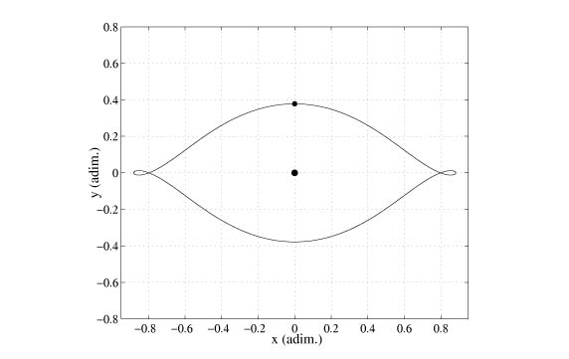

Figure 1 2:1 orbit centered at the Earth at (-mu,0) (Moon fixed frame), Moon at (1-mu,0), mu = .0122 .

The first section we show is in Figure 2. In this figure, as in all of the figures to follow, the region with random scattering of points represents chaotic motion, and is termed a ‘chaotic sea’. The section starts at nearly at the Earth and extends not quite to the Moon at x ~ 1, but to .8. This region, as the others, is quite complicated and the tree-ring like island regions represent resonance periodic orbits surrounded by invariant tori. Some of these are identified in Figure 3.

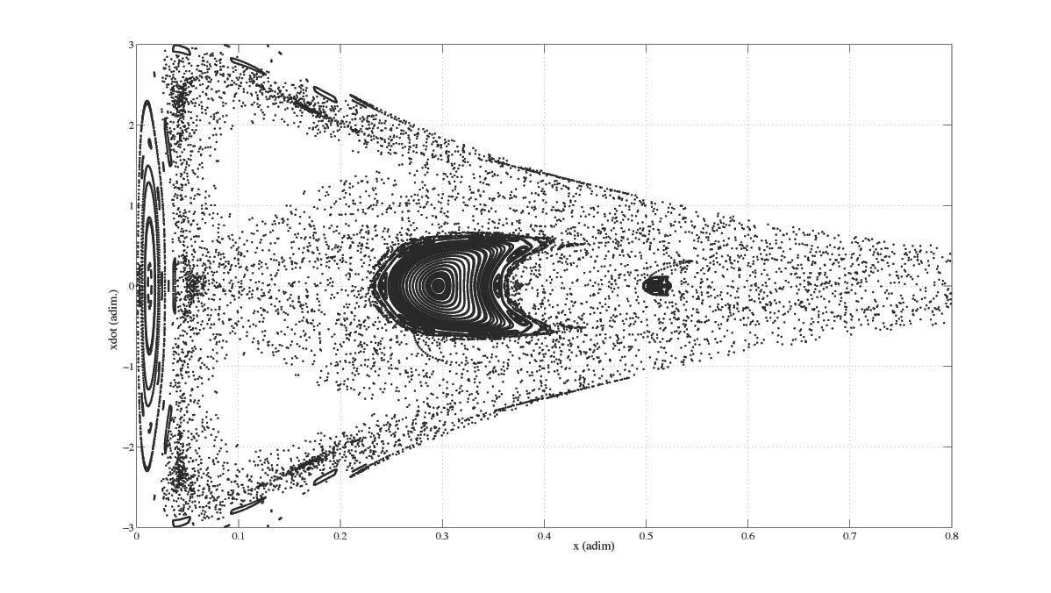

Figure 2 Surface of section (x, dx/dt). Earth at x = -mu, Moon at x = 1-mu. C = 2.9734250513 .

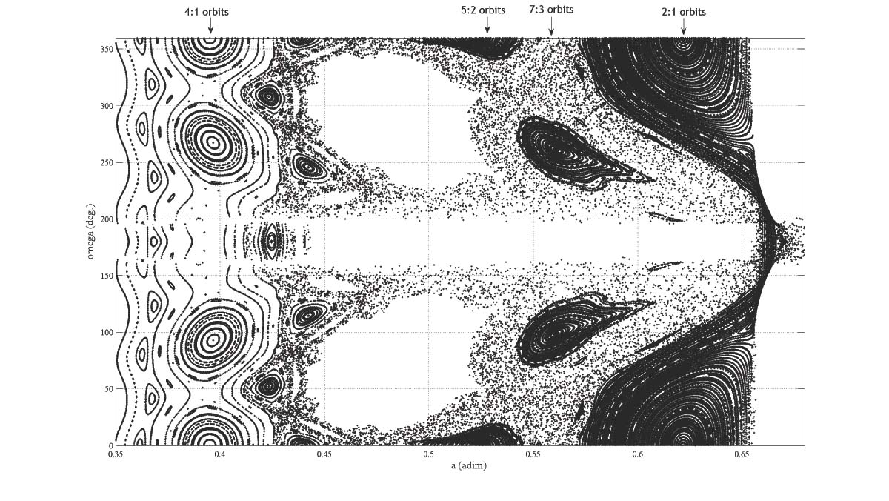

Figure 3 Surface of section (a, omega). Some resonance islands identified. C= 3.1817683176

Figure 4 is Figure 3 viewed in the coordinates (a,omega).

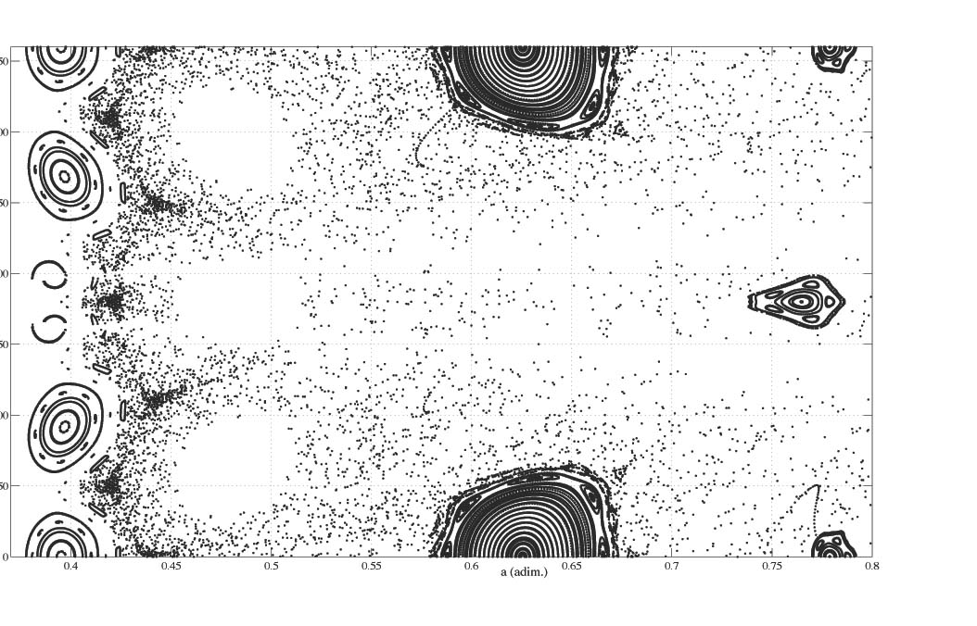

Figure 4 Surface of section (a, omega). C= 2.9734250513.

In Figure 5, the Jacobi energy has been decreased, and the resulting velocity of P0 has increased. The islands and other features have lost detail and the chaotic sea has increased

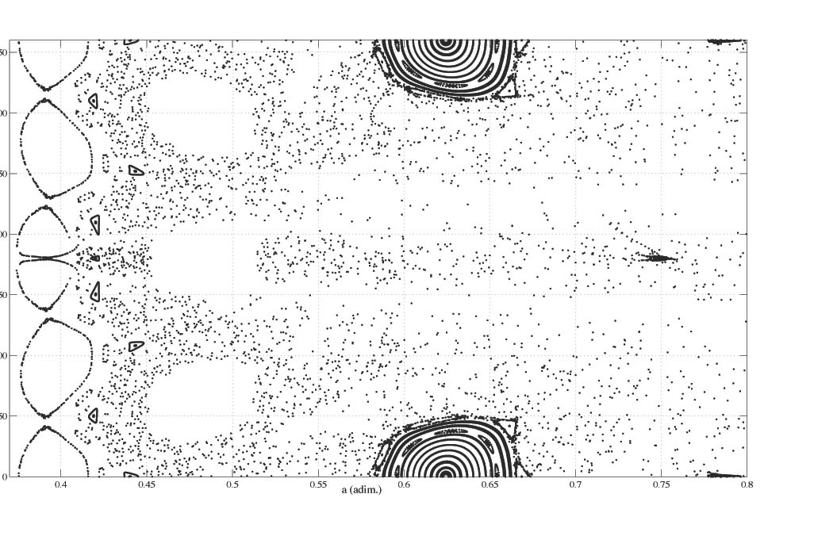

Figure 5 Surface of section (a, omega), C = 2.7349782586.

The next figure, Figure 6, shows Figure 2 increased to the Moon. Of interest in this figure is the colored region corresponding to the WSB. The WSB has the property that the motion within it is both unstable and has a Kepler energy wrt the Moon, HM < = 0. That corresponds to the green points. The red and blue points represent points very close to the WSB with slightly positive energies. Thus, the WSB is seen to exist near the Moon within the chaotic sea. We have only shown it to the left of the Moon. It also extends to the right of the Moon, but that is not presented here and will appear in [4]. This is a key figure of this report.

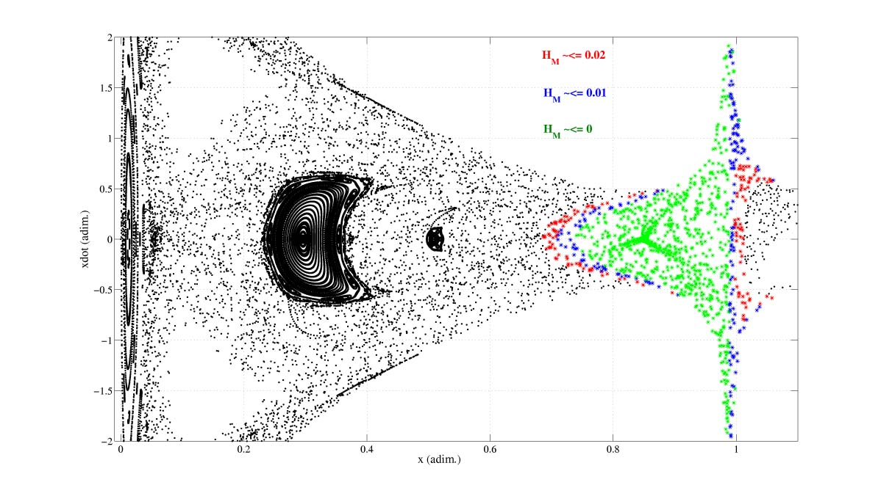

Figure 6 Surface of section (x, dx/dt). Weak stability boundary near the Moon for different ranges of HM in red, blue, green . C = 2.9734250513.

Figure 7 represents a key result of this paper, and shows another section in the coordinates (omega, T), where T is the period of the orbits intersection the section, and where e=.5. It is seen that only resonant periods occur, thus showing in this case that the WSB only supports resonant motions. Invariant manifolds are seen connecting the period curves.

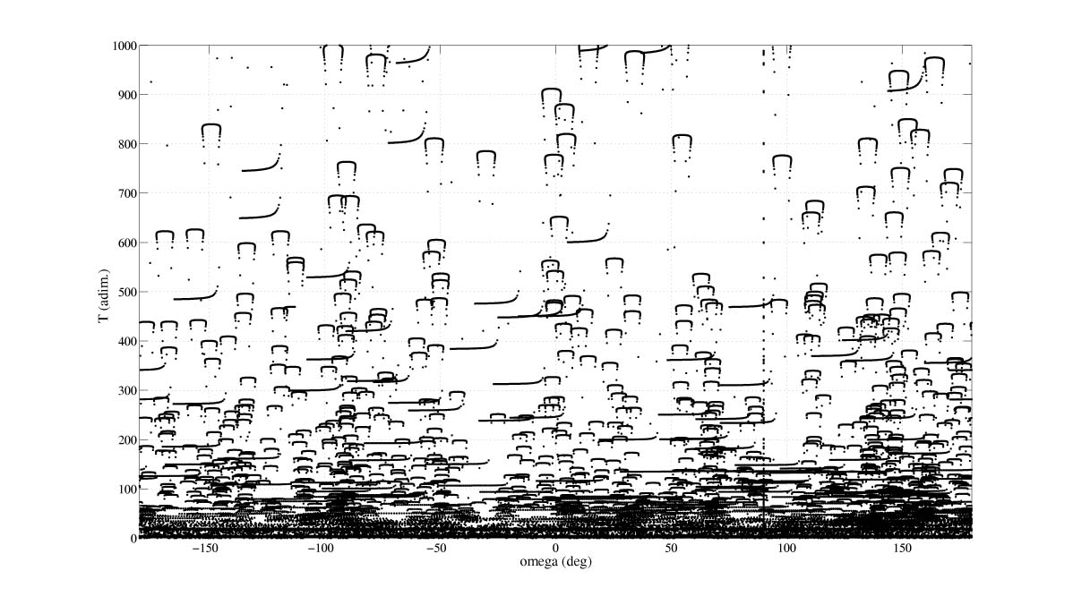

Figure 7 Surface of section showing the osculating period T of the iterates as a function of omega. As is seen, the dynamics on the section is purely resonant. C = 2.9734250513 .

The next figure, Figure 8, shows the WSB for a smaller value of C, and it has shrunk since the motion is more robust.

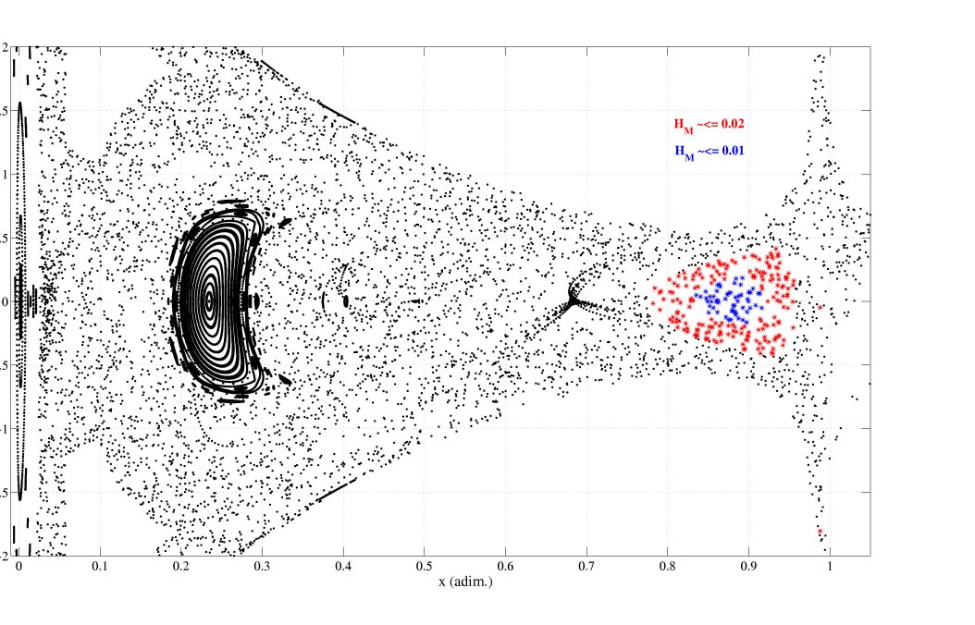

Figure 8 Surface of section (x, dx/dt). The weak stability boundary is indicated in red and blue near the Moon. C = 2.8698501942 .

VI. RELEVANCE OF RESULTS TO NASA

Understanding the phase space near and on the WSB as presented on the surface of sections shows where the trajectories move. It is seen that they generally move from resonance state to resonance state, and this insight can be used to define a control strategy when it is further understood. Also, examining such motions leads to new types of transfers with interesting applications. In [8] a new mechanism was uncovered which enabled a particle to eject from the Earth-Moon system for zero DeltaV – which holds a lot of promise for reducing fuel when transferring to asteroids, Mars and other destinations. The work done here sheds light on that dynamics, called ballistic ejection, not understood until now. The work done here shows that such a motion is due to connecting resonance motions around the Earth, in resonance with the Moon, to resonance motions about the Sun in resonance with the Earth. Many other interesting transfers may be discovered which have important mission applications.

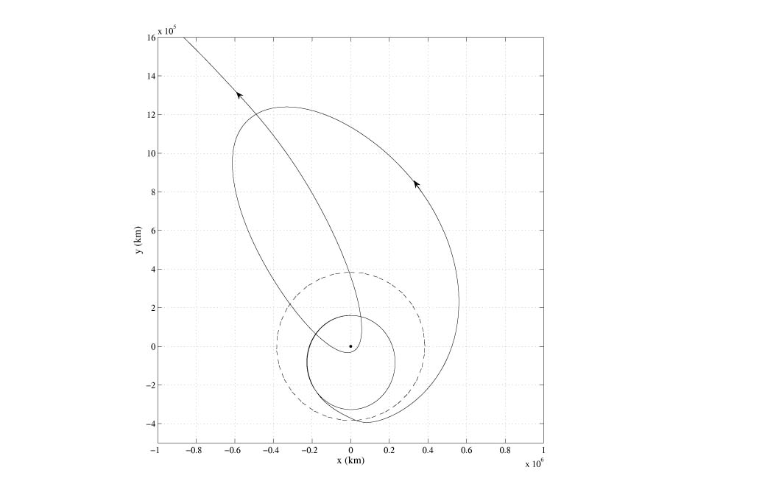

Figure 8 A ballistic escape trajectory from the Earth, starting in a 2:1, encountering the lunar WSB, moving out to approximately 1.4 million km, falling back to an Earth flyby, the escaping the Earth-Moon system, into a resonant orbit about the Sun.

V. FURTHER WORK

It is important to generate more detailed sections to understand the motions near the WSB. Eventually, this should lead to new control mechanisms for spacecraft to stay in orbit about the Moon and other bodies, as well as transfer from body to body, with negligible DeltaV using new types of transfers. The WSB is also seen to an important region supporting interesting dynamics and can reveal new mathematical insights into the three and four-body problems.

VII. REFERENCES

1. Adler, R., To the Planets on a Shoestring, Nature, V408, Nov. 30, 2000

2. Belbruno, E., Capture Dynamics and Chaotic Motions in Celestial Mechanics (subtitle: with the construction of low energy transfers), Princeton University Press, Feb. 2004. (see www.pupress.princeton.edu/titles/7687.html)

3. Belbruno, E., Fly Me to the Moon (subtitle: An Insiders Guide to the New Science of Space Travel), Princeton University Press, March 2007. (See www.pupress.princeton.edu/titles/8375.html)

4. Belbruno, E.; Tuppoto, F.; Gidea, M., Special Resonance Motions Associated to Stability Transition Regions and Applications, Manuscript – To be submitted for publication in Chaos, February 2007.

5. Belbruno, E., A New Class of Lunar Orbits and Applications, in New Trends in Astrodynamics and Application III (ed. E. Belbruno), American Institute of Physics, Feb. 2007, 1-12.

6. Mission Extension Using Sensitive Trajectories and Autonomous Control, NASA AISRP Annual Report (3/1/2005-3/1-2006), Number NASA-1-ARPT-06, February 22, 2006.

7. Resonant Hopping in Comets, Astronomical Journal, V113, 1997, 1433-1444. (With Marsden, B.)

8. Examples of Nonlinear Dynamics and Ballistic Capture and Escape in the Earth-Moon System, AIAA Paper number 90-2896, in Proceedings of the Annual Astrodynamics Conference 1990.

9. Case, J., Celestial Mechanics Theory Meets the Nitty-Gritty of Trajectory Design, (book review of ref. 1), V37, No6, SIAM News, July/August 2004, 1-3.

10. Klarreich, E., Navigating Celestial Currents, (Featured cover story), Science News, V167, No16, April 16, 2005.

11. Koon, W.S.; Lo, M.W.; Marsden, J.E.; Ross, S.D., Heteroclinic Connections Between Periodic Orbits and Resonance Transitions in Celestial Mechanics, Chaos, V10, 195-226, 2000.

12. Marsden, J.E.; Ross, S.D., New Methods in Celestial Mechanics, Bulletin of the American Mathematical Society, V43, 2006, 43-73.

13. Osserman, R., Mathematics of the Heavens, Notices of the American Mathematical Society, V52, April 2005, 417-424.

14. Racca, G., New Challenges to Trajectory Design by the use of Electric Propulsion and Other New Means of wandering in the Solar System, Celestial Mechanics and Dynamical Astronomy, V85, 2003, 1-24.

