6.2.2 VLHC-2 Cryogenic System Concept

6.2.2.1 Introduction.
This study of possible high field VLHC cryogenic systems relies heavily on previous reports about VLHC cryogenics, especially “Cryogenic Systems for the High Field RLHC Study Cases,” by M. McAshan and P. O. Mazur, and “Cryogenic Systems for the Low Field RLHC Study Cases,” by the same authors [1,2]. Comparisons are frequently made with LHC parameters not only because it is the most recent large accelerator cryogenic system design, but because the thorough analyses done in support of the LHC cryogenic system provide an excellent baseline for comparison. One of the most extensively used LHC documents was “LHC sector heat loads and their conversion to LHC refrigerator capacities,” by L. Tavian and U. Wagner [3].

6.2.2.2 System layout.
The high field VLHC design effort will use 12 cryogenic plant locations as the working assumption for the cryogenic system layout. Such an arrangement creates 24 cryogenic strings of approximately 10 km length each.

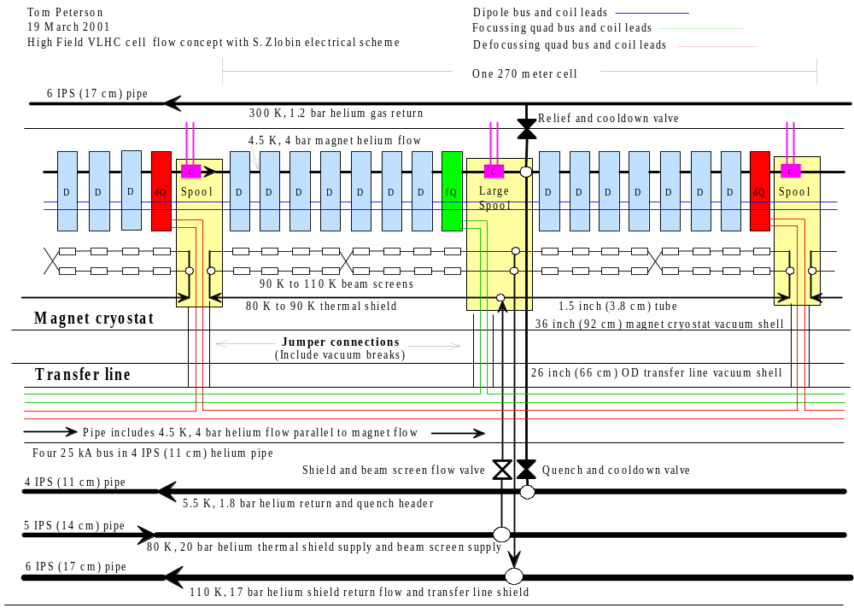

Figure 1. VLHC high field cryogenic schematic for one cell

Shown above in Figure 1 is a concept for a flow and electrical bus schematic for one cell of the high field VLHC. We avoid the use of recoolers or two-phase helium by allowing a 1 K rise in the helium flow through the magnet cold mass. Magnets are cooled by a large flow rate of supercritical, 4.5 K helium.
A nominally 80 K to 110 K helium stream cools the thermal shields and beam screens. High pressure (20 bar) helium is selected for the shield and beam screen since the higher pressure and density permit more mass flow in a given pipe size. Nevertheless, pressure drops for the 80 K to 110 K flow should be small so that most of the pressure remains available for expander work upon returning to the cold box.
This flow scheme provides four parallel beam screen cooling flow paths in each cell, two in each 135 meter long half-cell. A crossover is shown in each half-cell. The alternative to the crossover is balancing valves controlled by temperature sensors in the spool piece. Depending on how the beam screen passes through the interconnect, valves might be less costly than the crossover, but for now we will show the crossover.
This scheme puts all the large cold pipes and most of the electrical bus in a separate transfer line, so one does not have to deal with them at each magnet interconnect. It requires one jumper from the transfer line to the magnet string every 270 m for helium pipe connections, and one jumper every half-cell, or every 135 m, for electrical bus connections. Jumper connections containing electrical bus will require flow plugs to prevent helium flow short-circuits. The helium pipe containing four 25 kA bus may be cooled with a fraction of the 5.5 K, 1.8 bar return flow or with a parallel supply flow of 4.5 K, 4 bar helium. A 300 K helium gas return pipe is shown for lead flows and relief valve flow collection. A 300 K, 20 bar, helium gas line (not shown in Figure 2) might be required for inventory management.
The quench valve spacing of one every 270 meters appears to be adequate based on an analysis of quenching in 25 kA Nb₃Sn magnets [4]. Large quench valves would be required, with a port size of at least 60 cm, but quench pressures would remain under 20 bar.
All of the lines utilize helium as the coolant. Our initial decision is not to use nitrogen in the tunnel, but one might make good use of it above ground for cool-down and load leveling. Although it presents safety problems for the tunnel, one might reconsider the use of nitrogen in the tunnel in the thermal shields and/or for recooling helium from the beam screens, in order to reduce the huge helium inventory of this system.

6.2.2.3 Estimated heat loads.
The heat load numbers in Table 1 (below) are scaled from LHC heat loads as reported in reference [3]. A thermal model [5,6,7] scales static heat loads to the thermal shields and cold mass for VLHC based on LHC experience. Synchrotron radiation comes from beam dynamics studies [8]. An analysis finding optimum beam screen temperature is also reported in [8].
The heat load to the thermal shield of the arc magnets in LHC at nominally 60 K is 3.7 W/m. Scaling to our high-field Nb3Sn magnet concept, we find 4.2 W/m as the predicted static heat load to the VLHC magnet thermal shield. To the LHC transfer line at 60 K, the heat load is 2.7 W/m. Our VLHC transfer line is smaller in diameter than the LHC transfer line by 0.80, so we use 0.80x2.7 = 2.2 W/m.
For the magnet cold mass heat load estimate, static and dynamic heat loads for LHC scale up with our higher current and higher luminosity in VLHC, adding 0.15 W/m to the 0.35 W/m LHC number, yielding 0.50 W/m for VLHC. In addition, we have a warmer beam screen than LHC, adding about another 0.14 W/m (total for two beams), for a total of 0.64 W/m.
To the beam screen we estimate 10 W/m total for both beams due primarily to synchrotron radiation. Image current heating and multipacting are negligible compared to the 5 W/m/beam synchrotron radiation. As indicated in Figure 2 and in Table 1, the beam screen operational temperature in this flow scheme is between 90-110 K, at the predicted optimum range. Studies [7] have shown the optimal magnet thermal shield temperature (in terms of minimizing overall refrigeration power) to be about 65 K, consistent with the LHC selection of thermal shield temperature. In order to reduce the number of pipes through this VLHC system, the thermal shield and beam screen are placed in series with the thermal shield first. The high heat load on the beam screen results in its optimum temperature dominating that for the screen and thermal shield combined. Thus, the optimum thermal shield average temperature when in series with the beam screen is 83 K.

Table 1. Predicted heat loads and power requirements
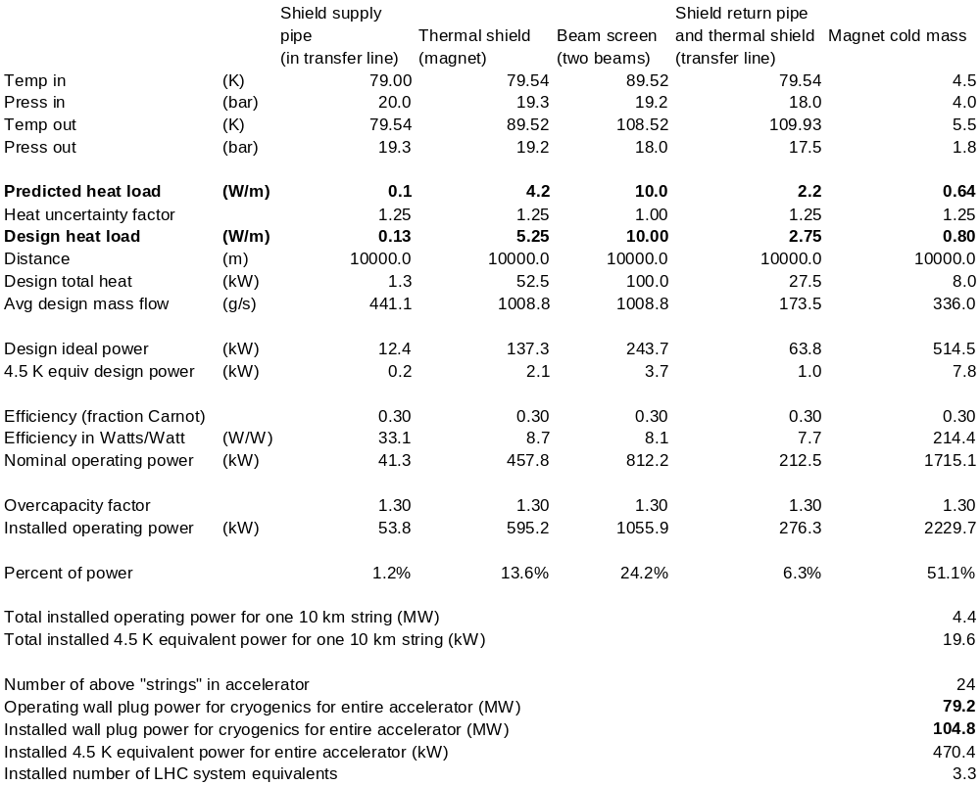

6.2.2.4 Current leads.
There are one 25 kA dipole circuit per 10 km string and two 25 kA quadrupole circuits per 20 km. The 25 kA dipole circuit requires a pair of current leads at each end of the 10 km string. Thus, each cryo plant location has eight 25 kA leads and each 10 km turnaround point has 4 leads. We assume six 100 amp corrector leads per beam per spool piece, with about 150 spools in one 10 km sector, so 900 corrector leads per sector. LHC current lead test data [9] and Fermilab HTS lead test data [10] were used to scale cooling requirements for VLHC-2 current leads. The relatively low number of high-current leads and the use of HTS leads make the total cooling power for the current leads only about 4% of the cryogenic system power.

6.2.2.5 Cooling power requirements and plant sizing.
Table 1 shows that the heat load estimates and the 240 km circumference of the VLHC give rise to a system requiring about 105 MW of installed cooling power, equivalent to about two large cryoplants at each of the 12 locations. Such a system would total about 3.3 times the cooling capacity of the LHC cryogenic system. Note the applied factors: the uncertainty factor of 1.25 on heat loads other than the beam screen, the carnot efficiency of 0.30 which is high but achievable with today’s technology (LHC reports 0.3 for their helium systems), and the overcapacity factor of 1.3. Overcapacity is the cooling capacity reserve required for maintenance, control, and non-optimal operation. LHC uses a factor of 1.5. We have reduced that to 1.3 in light of the large proportion of heat load due to synchrotron radiation, over which we have control.

6.2.2.6 Cool-down and warm-up.
Cool-down times are estimated to be on the order of two months using liquefier capacity. Each 20 km of high field VLHC has roughly 35000 tons of cold mass (about equal to LHC), requiring the removal of about 3x10^12 Joules to cool to 80 K. Some reduction in time can be gained with the use of above-ground LN2 precooling, but extremely large amounts of LN2 storage would be required. The extremely large cold mass will force long cool-down and warm-up times.

6.2.2.7 Helium inventory.
The inventory for the entire machine is estimated to be 0.65 million kg or 5 million liquid liters equivalent. This is about 85 times the Tevatron inventory, 7 times the LHC inventory, and about 0.056 of the annual U.S. production of helium, costing about $12 million. One of the problems with reducing the number of cryogenic plant sites from 12 to six is that doubling the lengths of cryogenic loops, along with doubling the mass flow to maintain the same exit temperature, requires significantly larger diameter pipes. As a result, the helium inventory for such a system is approximately twice this one, about 10 million liquid liters instead of 5 million liquid liters.

6.2.2.8 Conclusions and recommendations.
While a high field VLHC cryogenic system as described here is feasible, at $0.114/kWh, power would cost $1.00 per Watt-year, so the “installed power” shown in MW could be approximately the annual power bill in M$. Thus, one can see that it would be very desirable to reduce the installed power to significantly less than the presently estimated 105 MW. The heat load with the biggest potential for reduction by some innovative method is probably the synchrotron radiation. Developing methods for removing some significant fraction of the synchrotron radiation at room temperature could permit a dramatic reduction in cryogenic system size for a high field VLHC.
In order to make cool-down and warm-up times reasonable, one would like to significantly reduce the amount of cold mass, perhaps with warm-iron magnets.
Other recommendations for cryogenic system R&D may be found in (THE R&D SECTION).

References.

[1] M. McAshan and P. O. Mazur, “Cryogenic Systems for the High Field RLHC Study Cases,” 1996 Snowmass Study.
[2] M. McAshan and P. O. Mazur, “Cryogenic Systems for the Low Field RLHC Study Cases,” 1996 Snowmass Study.
[3] L. Tavian and U. Wagner, “LHC sector heat loads and their conversion to LHC refrigerator capacities,” LHC Project Note 140 (1998).
[4] Roger Rabehl, VLHC quench study, personal communication.
[5] C. Darve, A. Poncet, D. Willems, “Technical Note 98-19, CTM3, the latest evolution of the cryostat thermal model: thermal performance measurements of the first run from March to May 1998,” 03/1999.
[6] C. Darve, G. Ferlin, M. Gautier, L.R, Williams, LHC-Project-Note-112, “Thermal performance measurements for a 10 meter LHC dipole prototype (Cryostat Thermal Model 2),” 11/1997.
[7] Christine Darve, et. al., “VLHC Thermal Shield Cooling,” to be published as a TD note or VLHC note.
[8] Pierre Bauer, et. al., “VLHC Beam Screen Cooling,” to be published as a TD note or VLHC note.
[9] Amalia Ballarino and Albert Ijspeert, “Design and Tests on the 30 to 600 A HTS Current Leads for the Large Hadron Collider”, CERN-LHC-Project-Report-78, 24 Oct 1996.
[10] G. Citver, et. al., “Thermal tests of 6-kA HTS current leads for the Tevatron,” Advances in Cryogenic Engineering, Vol. 45B, (2000), pp. 1549 – 1556. (Also FERMILAB-Conf-99-284)

current file: /tmp/lo/0000.doc

