STUDIES OF BASIC ELECTRONIC PROPERTIES OF CdTe-BASED SOLAR CELLS & THEIR EVOLUTION DURING PROCESSING & STRESS

Quarterly Technical Status Report for the Quarter ended April 30, 2003

Under Prime Contract No. DE-AC36-99-GO10337; Subcontract No. ADJ-2-30630-05

Subcontractor: Colorado School of Mines

Principal Investigators: V. Kaydanov and T. R. Ohno

Contributors:
Professors R.T Collins, P. Sutter, and E. Sutter;

Grad. Research Associates A.S. Gilmore, S. Feldman, and F. Seymour

Contract technical monitor: Kenneth Zweibel

In the past quarter we were continuing development and improvement of approaches and techniques for studying electronic properties of defects in polycrystalline thin film solar cells. In particular, we were focusing on admittance spectroscopy (AS) for detecting and studying defect levels in the bandgap, high resolution imaging electroluminescence (EL) as a method for studying micro-nonuniformities, and scanning tunneling microscopy (STM) and spectroscopy (STS) which are aimed at mapping and studying nonuniformities on the subgrain scale. All these methods were applied to CdTe/CdS cells. In this report we describe and analyze changes in AS data and EL patterns caused by cell stressing (cells were fabricated at First Solar). Also the STM images of CdS/CdTe/ZnTe:Cu structures are presented and discussed.

Admittance Spectroscopy (AS)
We show (Figs. 1-3) and discuss here the data for two cells stressed for 7 days that present the major features and the differences supposedly caused by different stress conditions: open circuit (OC) – cell # E4-31, and reverse bias (RB) - cell # E4-34. The features at the extremely high frequencies are not discussed because their origin is ambiguous. Only the data for f ≤1MHz are analyzed below. Reducing capacitance and rising conductance toward higher frequency are due to oscillations of the trapped charge under applied AC testing voltage.
The C(f) dependence for E4-34(RB) in Fig.1 obviously tends to saturation in the frequency range of ~1MHz. If we assume the testing frequency to be much higher than the characteristic frequency for the traps of all types, then the trap contribution to capacitance is negligible, hence
measured value is equal to the “depletion” (geometrical) one. The estimated depletion width is ≈2.7μ. Measured capacitance decreases by a factor of 1.8 between 20Hz and 1MHz. It means that the total concentration of traps with the characteristic times shorter than ~10ms is of the same order, maybe even higher, than the doping level. A gradual decrease in capacitance indicates presence of more than one trap level, maybe continuous distribution of states over energy. The C(f) dependence for E4-31(OC) saturates in the same frequency range and at almost the same level. However the low frequency value (C_{LF}) is only 30% higher, which means that concentration of traps with τ>10ms in this cell is significantly lower than in E4-34(RB).
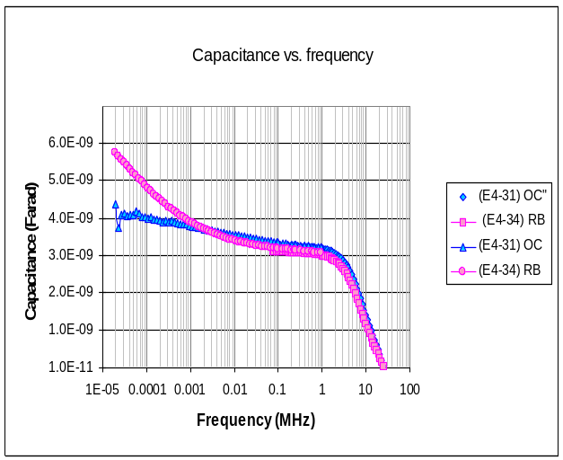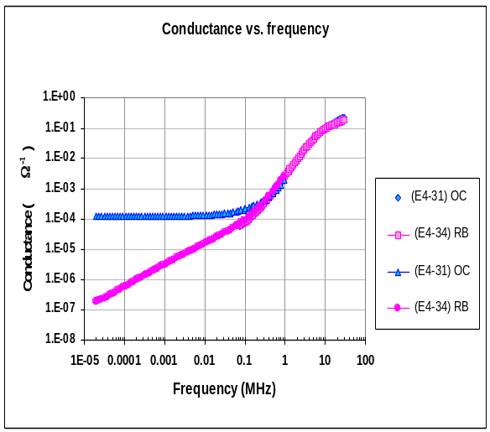 Figure 1. Capacitance versus frequency Figure 2. Conductance versus equency
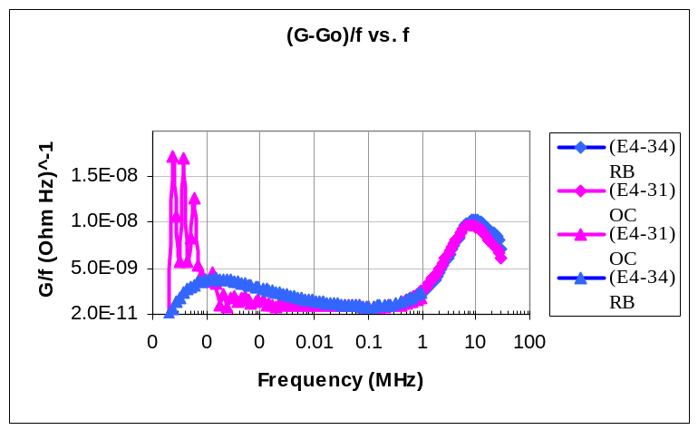

Figure 3. Conductance divided by frequency as a function of frequency

More dramatic is the difference in the G(f) dependencies for the two cells (Fig. 2). The G value for E4-34(RB), which is only of 10⁻⁷Ω⁻¹ cm⁻² at f=20 Hz, increases up to 10⁻⁴ Ω⁻¹ cm⁻² at 100KHz. The sublinear dependence (G ∝f ^{0.65}) indicates the distributed trap density of states in agreement with the shapes of C vs.f and (G/f) vs.f plots in Figs. 1 and 3. Quite different is the G(f) dependence for E4-31(OC): G_{LF} ≈10⁻⁴ Ω⁻¹ cm⁻² (compare with 10⁻⁷ for E4-34) and stays practically the same up to 100KHz. To explain this, we assume that the measured conductance has two components: G(f)=G_{d}+G_{t}(f). G_{d} is the frequency independent DC conductance of a diode. Since we measure AS in dark and at zero bias voltage, it is reasonable to assume that G_{d}=G_{zb,} zero bias conductance determined from the slope of dark J(V) curve. The trap related component G_{t} is provided by trap recharging hence varies with frequency. The G(f) dependence cannot be observed in some frequency range if G_{t}(f)/G_{d}<<1 in this range. Table 1 shows that G_{LF} > G_{zb}=G_{d} for both cells, hence the conductance growth with frequency should be expected.

Table 2. Low frequency (LF) conductance and dark “zero bias” conductance

 | G_{LF}(f=20Hz), Ω⁻¹ cm⁻² | G_{zb}, Ω⁻¹ cm⁻²
E4-31 (OC) | 1.2x10⁻⁴ | 1.75x10⁻⁶
E4-34 (RB) | 2x10⁻⁷ | 6.7x10⁻⁸

However for the cell E4-31(OC), G(f) ≈const. in the frequency range of 20Hz to 100KHz.The only explanation we can propose now is that there is a great amount of slow traps (τ>10ms) in this cell whose contribution to the measured conductance saturates at f<20Hz, hence it does not increase with the further frequency increase. This suggestion does not contradict the observed C(f) dependence for this cell (Fig.1). Indeed the contribution of traps to capacitance is negligible when their characteristic frequencies are much lower than the testing voltage frequency. Just this was suggested to explain the 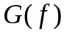dependence in this cell.
The conclusions based on the AS measurements are as follows:
- There is a large concentration of traps both in RB and OC stressed cells, comparable to doping level or even higher.
- Concentration of “fast” traps (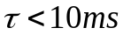) is several times greater in the RB cell than in the OC one. The trap levels are distributed in some energy range. Their density decreases for the shallower levels (“faster” traps) as follows from the shape of the graph for E4-34 in Fig. 3.
- In the OC cell the amount of “slow” traps (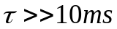) is much (at least three orders of magnitude) greater than for the RB cell.

Electroluminescence (EL)
In general, the response of EL to stress has been a significant drop in mean EL intensity.
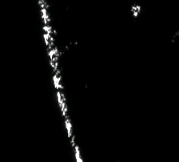
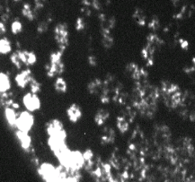
The EL pattern for FS cells changed dramatically after stressing (Fig. 4). While the as-prepared cell demonstrated a mottled, but relatively uniform EL emission pattern, in stressed cells it comes only from isolated spots. In particular, in the 7 day-stressed cells the bright EL region concentrates at the cell periphery (RB stress) or close to it (OC stress). In this region the EL intensity is so high that pixels are saturated which means that intensity here is at least 200 times higher than in the dark inner parts of a cell.
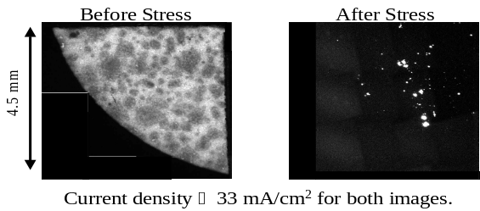
Figure 4. EL images for FS cells. From left to right: as-prepared; 56 days OC stress;
7days RB stress; 7 days OC stress. Stress in light.

Observed changes in EL mean intensity and spatial distribution can be caused by degradation of p-n junction region where recombination of injected carriers occurs, but also by the processes in other parts of a cell, particularly in the back contact region. The following discussion is focused on the latter. EL is caused by forward current, and we study it in dark environment. The analysis of dark J-V characteristics shows a significant increase in dark forward bias resistance, especially strong in the RB stressed cells. The voltage across the cell is uniform over the cell area, because high conductance TCO front contact and back contact metallization both are surfaces of constant electric potentials. Hence the current density is inversely proportional to the back contact resistance per unit area: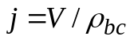. If the latter is strongly non-uniform, i.e., degraded severely over major part of the back contact area, but much less at the edge region and in some small interior spots, then the current density can vary significantly. EL intensity increases with current density (linearly or more rapidly), thus it could be very bright at the areas in the low 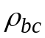regions and rather low in the areas of enhanced .
Our preliminary experiments verified these expectations. We have separated (cut) some cell interior fragments that looked rather dark in the whole cell images and measured EL intensity for the same forward current/area ratio. First, forward bias dark resistance per unit area was found considerably higher for the cut than for the whole cell. This fits the idea that the regions of bright EL provide shunting effect. Second, the EL intensity in the separated fragment was much higher than before separation, as expected. Now the pattern of brighter spots was well seen on the dark background. Thus the non-uniform degradation of the back contact specific resistance provides a significant contribution in the nonuniformity in EL distribution. Vice versa, studying EL is a convenient (nondestructive) test of the back contact resistance non-uniformity and its evolution under stressing.

Scanning Tunneling Microscopy on CdTe/CdS Solar Cells
We have previously demonstrated that reproducible scanning tunneling microscopy (STM) and spectroscopy (STS) are feasible on CdTe/CdS solar cells without the back contact metallization. While the uncoated CdTe surface is too resistive for stable tunneling, evaporation of a thin (~50 nm) p⁺-doped ZnTe back contact layer leads to a stable tunneling contact to the cell.
Current images, obtained from current-voltage (I-V) curves measured as a function of tip position over the cell (Fig. 5), clearly show non-uniform current injection into the cell. Areas of material with relatively uniform injected current coexist with high-current pathways, localized mostly but not exclusively at grain boundaries. We have performed model calculations to understand the nature of the information obtained by STM current imaging. Clearly, the conducting ZnTe layer plays a key role in enabling stable tunneling. We have evidence that it also creates a distinct and unconventional contrast mechanism. The polycrystalline structure of a cell makes it likely that vertical current transport (in the direction across the junction) is not uniform, but consists of a network of ‘current channels’ carrying a large fraction of the vertical current (Fig. 6). If the STM tip is placed directly on the top of a current channel (e.g., a grain boundary), the total resistance to current flow consists of the tunneling resistance, R_{t}, in series with the resistance of the current channel, R_{c}, beneath the tip. If, however, the tip is moved over low-conductance CdTe (e.g., within a grain) an additional series resistance R_{s} is encountered, which hinders the spreading of the injected current in the ZnTe contact to the nearest current channel. The position dependent resistance of current spreading in the ZnTe, R_{s}(x,y), provides contrast in STM current maps between regions of low and high conductance in vertical transport through the cell. A comparison of model calculations of the injected current as a function of injector tip position with experimental results shows excellent agreement, strongly supporting the proposed STM contrast mechanism. Probably a continuous rather thin back contact metallization will likely not provide such a contrast, since the resistance R_{s} of current spreading in a metal can be expected to be much smaller than both R_{c} and R_{t}. The contrast mechanism used here emphasizes the transport through the cell, and essentially ignores the information contained in the characteristics of electron tunneling across the vacuum gap between tip and ZnTe layer. We argue, however, that the tunneling characteristics relate mostly to the electronic structure of the ZnTe layer, and can be omitted if we aim at characterizing transport through the underlying polycrystalline CdTe.
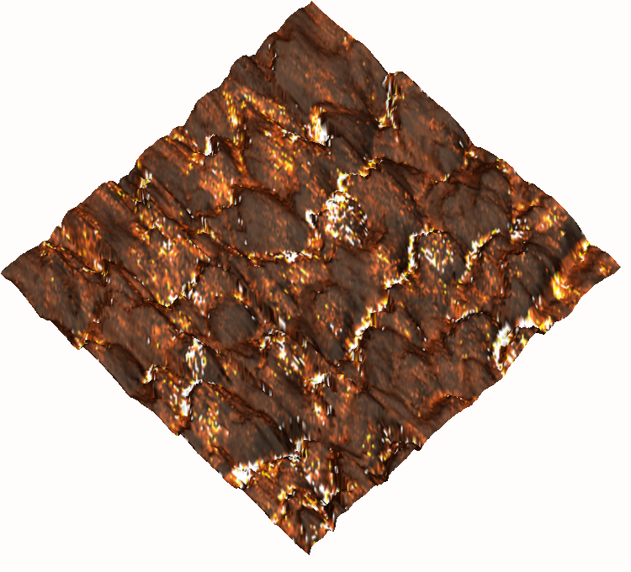

Figure 6. 6 μm × 6 μm composite STM image, consisting of an overlay of a 3D topographic
scan with a current image obtained at a tip sample bias of 1.5 V. Color scale: dark – low current; bright – high current. Zones of higher injected current are often localized at grain boundaries, but occur also within some of the grains.

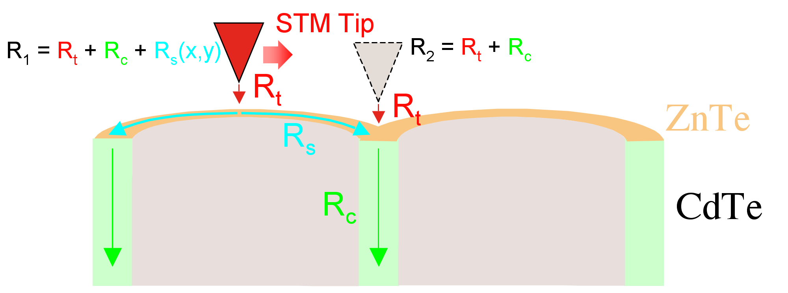

Figure 2. Schematic representation of the contrast mechanism in STM current imaging on ZnTe-terminated CdTe/CdS solar cells.

We believe that this contrast mechanism will allow evaluating non-uniform transport through complete polycrystalline solar cells in general, i.e., not limited to the system CdTe/CdS. We also foresee applications to other non-uniform structures, such as a-Si:H, in which microscopic voids coexist with denser material so that non-uniform current transport can be anticipated [1]. Near-surface transport channels have been mapped by us with spatial resolution of the order of 10 nm, i.e., about two orders of magnitude below the grain size. High-resolution current maps with resolutions down to 1 nm should be feasible in principle. Such maps will provide detailed information on current collection and transport near grain boundaries, which has been the subject of intense debate recently [2, 3]. Furthermore, our unique ability to obtain high-resolution maps of vertical transport may prove particularly powerful if used in the context of controlled cell processing. The effect of processing steps such as CdCl treatment or Cu deposition beneath the back contact can thus be studied in detail and with very high spatial resolution.

Our first STM data demonstrate that current transport in the direction toward the junction of a CdTe/CdS cell is highly non-uniform. Under operating conditions carriers will likely be generated within grains, but will be collected and transported across the junction along a network of discrete conduction paths. A large fraction of the total junction current thus flows in low-resistance paths that cover only a very small fraction of the cell area. This finding is consistent with previous models of grain boundary potentials [4], and opens up new opportunities for understanding and improving current collection in CdTe/CdS solar cells. Importantly, the current paths are not always localized at grain boundaries, but are often found within grains. This fact points to a conduction mechanism involving specific defects, possibly decorated by impurities such as Cu. The nature of these defects is still unknown. However, we believe that the statistical correlation of the microstructure and defect distribution (mapped by TEM) with maps of current paths obtained by STM will ultimately lead to the identification of the microscopic nature of the current transport mechanism in CdTe/CdS cells.

References

[1] D. L. Williamson, D. W. M. Marr, J. Yang, B. Yan, and S. Guha, Phys. Rev. B 67, 075314
(2003).
[2] M.K. Herndon, A. Gupta, V. Kaydanov, and R.T. Collins, Appl. Phys. Lett. 75, 3503 (1999).
[3] I. Visoly-Fisher, S.R. Cohen, and D. Cahen, Appl. Phys. Lett. 82, 556 (2003).
[4] L.M. Woods, D.H. Levi, V. Kaydanov, G.Y. Robinson, and R.K. Ahrenkiel, in Proc. 2nd World Conf. on PV Solar Energy Conversion, J. Schmid et al., eds., pp. 1043-1046.

