Improving the Value and Utilization of Environmental Projects Data

2007 - 2008

Environmental Public Health Leadership Institute Fellow(s):

James M. Morrison, MS, CIH, CHMM
Chemical Preparedness Coordinator, Wisconsin Division of Public Health
One W. Wilson Street, Rm. 150
Madison, WI 53701
(608) 267-3227
Morrijm1@dhfs.state.wi.us

Mentor:

Tim Murphy, PhD
Assistant Professor, University of Findlay

Acknowledgements:

I would like to acknowledge and thank my EPHLI group team members Tammy Dillard Steele, John Zentgraf and Tim Murphy (our mentor). I would also like to thank staff members of the WI DPH Bureau of Environmental and Occupational Health, the WI State Lab of Hygiene and in particular the individuals below who have been gracious with their time and insight during this project.

Debi Peters
Project Manager, WI DPH BEOH

Marni Bekkedal
Environmental Public Health Tracking Program Manager, WI DPH BEOH



EXECUTIVE SUMMARY:

How can environmental sampling data be managed so that it can be later used for other purposes? This would seem a simple and straight forward objective, but it is fraught with complexities. Persevering through these complexities however can add great value and utility to environmental health project data. Increasing the availability of usable data would aid in the investigation of environmental hazards and the monitoring of associated health impact, both essential public health services. Without a convenient method for managing environmental sample data and the ability to link to other data sets, most project data is filed away, never to be used again. Complexities in managing sampling data come in the many variations in which data is generated and in the management of data attributes such as time, location and context. This information is often collected in various ways, but not in an easily retrievable manner. It would be desirable if sample data sets could be centrally accessed, allowing investigators to review exposure patterns in space such as in a community or perhaps analyte concentrations over time.

Analysis visualization and reporting (AVR) software offers the ability to perform such analysis by allowing users to evaluate and report geo-coded data in a variety of formats. Meetings have been held with Wisconsin Division of Public Health (WI DPH) Bureau of Environmental and Occupational Health (BEOH) stakeholders throughout the project period. These meetings resulted in the identification of data partners, critical attribute elements, review of an AVR project success story, and development of a conceptual approach to a bureau-wide data management strategy. A pilot project is underway to develop the structure for a metadata table and necessary conventions to record necessary sample information. It will be made available to BEOH staff on a shared computer network drive. The data table will also link to the electronic data files. It will serve as a library of environmental sampling projects that can be evaluated for further analysis through tools such as AVR technology. The model metadata table will first be populated with data sets that BEOH currently receives electronically. Once the concept is proven, the state laboratory will be asked to generate all BEOH reports electronically. It is anticipated this concept will serve as a model for other data partners, increasing the amount and utility of environmental data available for public health study.

INTRODUCTION/BACKGROUND:
Evaluation and assessment of environmental quality and health status are integral components of public health. During evaluation and assessment of environmental exposures, questions are formed about whether a completed exposure pathway exists. Answers often require the collection and analysis of data. Typical questions to be asked may include:
- How do the results I received for this sample relate to samples of other projects analyzed through the same method?
- Is this result indicative of a typical background value in this location or does it reflect an unknown contaminant source?
- Is this mold species often detected in homes with occupant health complaints?
- How do fine particulate values in communities with outdoor wood boilers compare with those in non-compliant urban settings?
- How do water and airborne benzene levels relate to incidence of childhood cancer in WI counties?
- How do indoor air quality (IAQ) parameters of moisture, airborne mold and fine particulates relate to incidence of asthma and allergy?
- How do airborne levels of volatile organic compounds (VOCs) near a hazardous waste site compare over time?

Once the need to collect environmental project data is identified, a sampling plan is developed that evaluates the exposure pathway (relationship between a hazard and environmental route to the exposed population). The sampling method chosen is dependent on the contaminant (analyte) and the level of sensitivity required as determined by the relevant exposure guideline. BEOH makes arrangements with the Wisconsin State Laboratory of Hygiene (SLH) to get appropriate sampling media, arrange for and collect the sample, submit it to the lab using the relevant form and awaits sample results. Results are reported both electronically and in paper format. The data is evaluated against the appropriate exposure guidance value, a report is written, and projects materials are filed and the project closed.

Many environmental health professionals regularly collect data for environmental assessment purposes. The volume of data collected by the BEOH and on the behalf of BEOH is substantial. For example, well water sample data alone is over 2,000 samples annually. Data is collected for other purposes as well including air quality, spill response and exposure investigations. If this data is aggregated, what story would it tell about the state of environmental health in Wisconsin? Much like the blind men trying to characterize the elephant based on their limited perspective, we too may fail to see the big picture, unless we can link data.

The current capacity to retrieve and compile previously collected data is very limited. Environmental public health tracking seeks to link health effects with exposures and depends heavily on incomplete exposure data. Adding to the challenge, regulatory monitoring stations that provide exposure data are being reduced due to budget constraints. It would be a tremendous benefit if data collected for environmental project purposes can be managed in a manner that it can later be retrieved, aggregated with other data and evaluated. It would enable investigators to compare sample results with other prior collected samples. It would also afford the ability to evaluate sample results with other locations and possibly against reported health effects. Recently, a BEOH asthma investigator wanted to know if indoor air quality (IAQ) data is collected that may be of use to their investigation. IAQ data is routinely collected in the BEOH IAQ program including temperature, humidity, carbon dioxide, carbon monoxide as well as mold and chemical data. However this data is not collected in a manner that it could be easily compiled without going through it file by file. This unmet data request (though the data is available) galvanized this project effort.

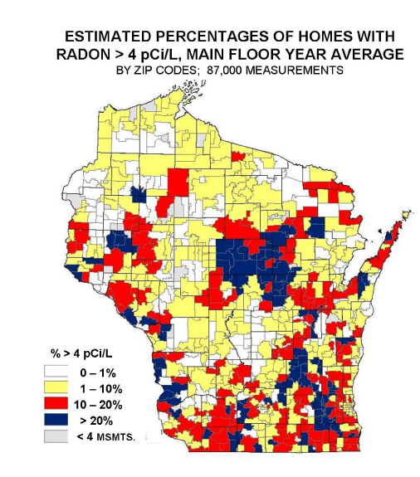
In considering the practicality of linking project data sets, two examples were encountered that seemed to validate the feasibility and benefit of doing so. These are reporting of BEOH radon data and WI Poison Control Center (PCC) data.
Figure 1. WI Radon Map

Collected with similar methodology, radon test data is reported to BEOH, compiled, geo-located and reported in graphical format to assist in interpreting relevance of individual homeowner results. This format aids in identifying locations in the state with high frequency of elevated counts. Acknowledging that BEOH project data includes results for many different analytes and purposes, the radon map nonetheless serves as a model for identifying data sets for which similar reporting can be achieved. (http://dhfs.wisconsin.gov/dph_beh/RadonProt/Radon/FinalEstPercentRadon.htm).

Analysis, Visualization, and Reporting (AVR) is a software package utilized by Wisconsin Public Health Information Network (PHIN) that provides the ability to analyze, display, report and map accumulated data and share data and technologies for analysis and visualization with other public health partners. These capabilities allow for powerful graphic reporting of data. AVR also provides data reporting, statistical analysis, and spatial analysis though Geographic Information Systems (GIS), plus other visualization, display and mapping functions through the implementation of commercial off the shelf software. Implementing these software tools allow system users to leverage public health data, transforming it into information that can readily be used for decision making. (Analysis, Visualization, and Reporting (AVR) May 2006, http://dhfs.wisconsin.gov/WiPHIN/)

Data from the PCC has been sent to BEOH electronically since 2005. This data includes information about calls the poison center receives. If an investigator wished to work with this data in the past, the data would have to be translated into a different data system. With the use of Analysis, Visualization and Reporting (AVR) software, investigators have the ability to compare call history, over time, by chemical class, or location. Tabular reports and maps can be generated as can maps illustrating geographic and temporal trends. Several examples follow that illustrate the depth of information and variety of formats with which data can be presented.

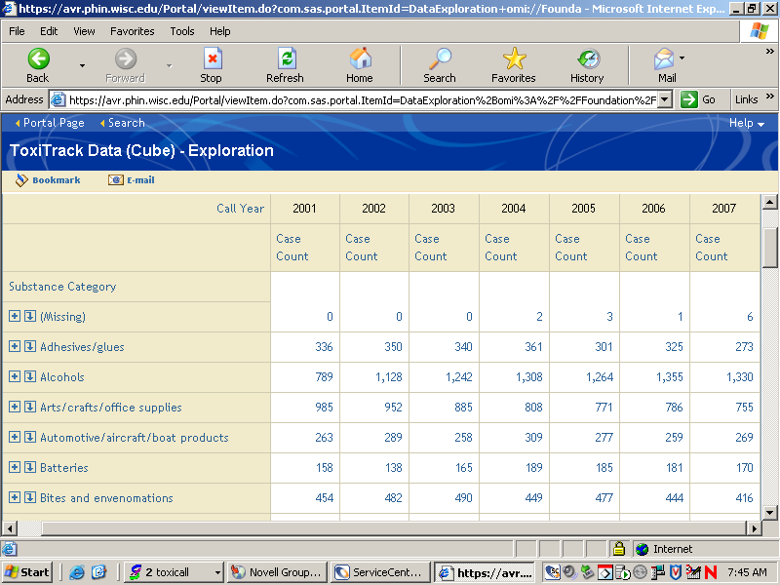
Figure 2. WI Poison Center Call Data 2001-2007

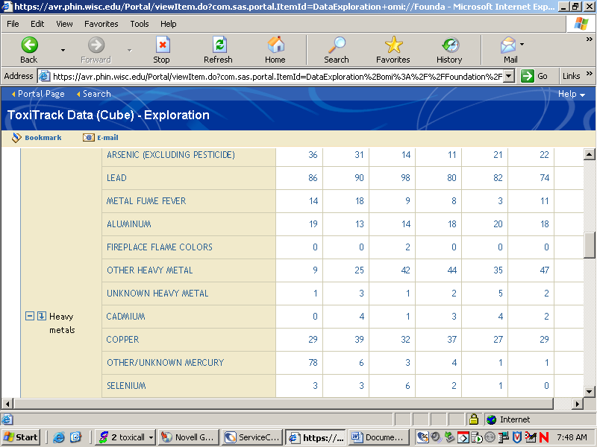
Figure 3. Drilling Down PCC Data to Heavy Metals

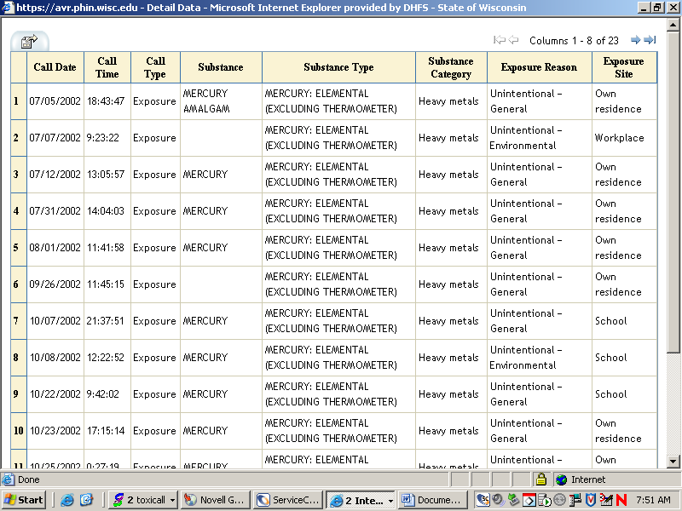
Figure 4. Drilling Down Further to Elemental Mercury Call Data

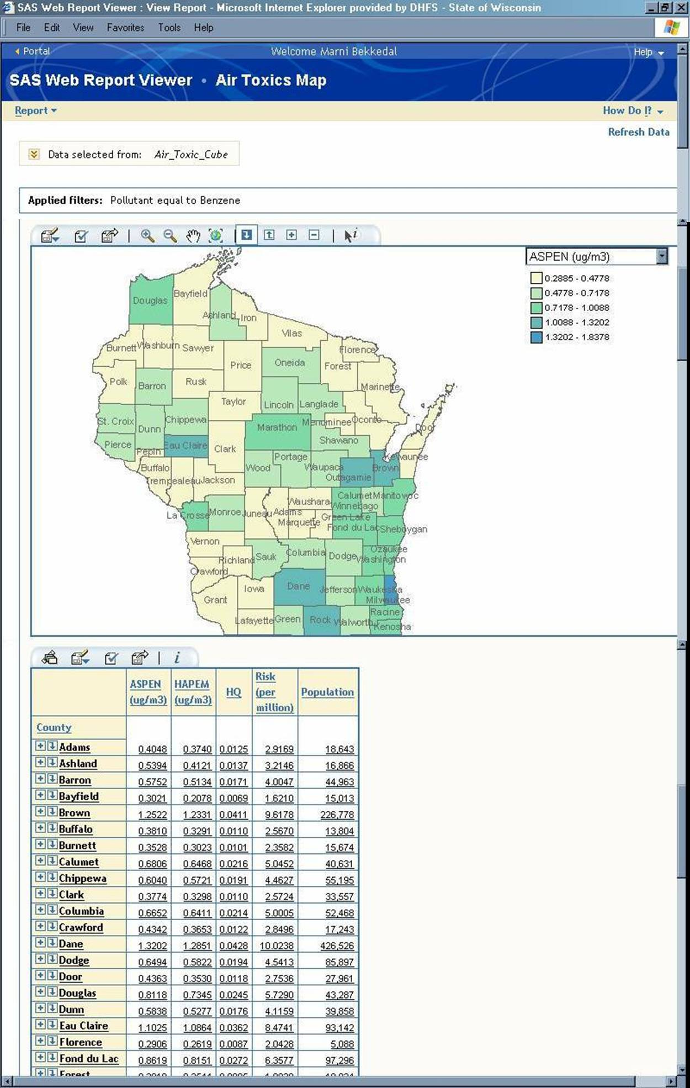
Figure 5. County Level Air Toxics Data Map and Table Demonstrating Mapping Capabilities with Data Table
While these examples demonstrate the power and benefit of analyzing and reporting aggregate data, there are a number of hurdles when using diverse project data sets. Project data can include any of the following examples some of which appear in Appendix 1.
- Fixed point (grab) samples such as single air, water or soil samples
- Time integrated samples such as airborne mold, filter/sorbent tube air samples
- Logged data collected at regular intervals over an extended period.
Most samples are analyzed by WI SLH that reports some data electronically.

The Wisconsin State Laboratory of Hygiene (SLH) is Wisconsin’s public health laboratory. BEOH works primarily with two sections of SLH, the Environmental Services Section and the Occupational Health Section. The Laboratory Information Management System (LIMS) is a data service used by SLH to acquired, organize, and report analytical data. LIMS is a helpful resource in that it allows us to see the amount and type of data collected over time. It also affords the ability to compile multiple project data sets and to download to a spreadsheet. One drawback is that much of the sample attribute information is not recorded in LIMS. In addition, data from the occupational section where much of BEOH airborne VOC and mold data is generated is not reported on LIMS.

In addition to lab-generated results, BEOH also collects a large amount of data in the field using direct-reading instrumentation. These results are recorded in project files, but not aggregated in any way. Doing so would be very interesting and could yield insights into a number of questions. For this data to be grouped in a meaningful manner, it is important to know the context in which it was collected. The most important sample attribute characteristics include time, space, method, analyte and purpose. If data sets can be evaluated and suitable shared attributes found, it may be worthwhile to group and analyze it. This leads us to the term “metadata”.

Metadata is data about data. It describes the content, quality, and context of a data resource for the purpose of facilitating identification and discovery. Through descriptive metadata a user can learn the what, why, when, who, where, and how for a data resource. (Environmental Public Health Tracking presentation, http://www.dhss.mo.gov/EPHT/Metadata_Brownbag_all_files/frame.htm#slide0041.htm)

Metadata can add tremendous value to environmental project data. Metadata:
- Helps an organization arrange and maintain its data assets.
- Limits duplication of effort by ensuring that others in the organization are aware of the existence of data resources.
- Assists in both determining and improving the quality of data resources
- Improves an organization’s ability to comply with rules, regulations, and policies relating to data access.
- Reduces the loss of institutional memory for data resources when key staff moves on.
- By providing information about an organization’s data holdings users can locate available resources relevant to an area of interest or study
- Supplies the means to document limitations about the data resource or disclaimers that are important for potential users.
The benefits of metadata are well-aligned with the objectives of this project. Prior to this project there was little awareness among investigators of what metadata is. It is however well known and integral to the goals of the environmental public health (EPH) tracking program. EPH Tracking is a critical program for the future of public health, not only because of helping to define the relationship between contaminants and health, but because it also lays the foundation for communicating public health needs and tracking progress. It is appropriate then that when EPH programs collect project data, it be done in a manner that it can be utilized by EPH tracking and others who can learn from it. This project therefore focuses on developing a metadata strategy for BEOH project data.

Problem Statement:

Can environmental assessment project data be better utilized and/or managed to support other project needs?

Key Project Variables
Several variables can be use to describe the history and opportunity behind the current project. Key variables over time include:
- Amount of available data which has increased exponentially
- Demand for data which has increased steadily
- Utilization of data which has stagnated
- IT resources (capacity) which has increased steadily

Demand for Data
Amount of Data
IT Resources/Capacity
Utilization of Project Data
Figure 6. Perceived Variable Patterns Over Time Affecting Environmental Assessment Project Data Management Practices

The amount of electronic and paper data generated by the SLH and BEOH grows, as well as the IT support infrastructure and capability to manage this data. LIMS and AVR software are examples of increased information management capability. However, utilization of the data for purposes other than which it was originally collected has remained relatively flat. Demand for aggregate data for tracking, evaluation and marketing purposes is increasing as funding agencies and legislative bodies increasingly demand evidence of need and outcome. These patterns support the management of environmental project data through metadata practices.

Underlying Systems Theory
The systems thinking archetype that best describes the conditions surrounding this project is that of shifting the burden. This refers to a situation in which resistance encountered in pursuing a desired objective re-directs actions to a simpler course that offers a short-term solution, putting off the longer term solution. In the case of this project that seeks to improve the utilization of project data, the archetype description begins with the need for project data. This can be an investigator collecting a sample in relation to an exposure investigation associated with a petroleum release or may include a researcher seeking to evaluate a possible link between asthma rates and airborne fine particulate levels throughout the state. In either case, this story begins with a need for project data.

In our first project example, it is probably not feasible that our investigator will find an existing data set that will be of benefit in establishing the current presence of say benzene at a given location. Because the amount of data collected will be small, it’s likely that funds will be available for this limited data collection activity. Now though if we turn to the second example, it is not as likely that resources will be available to collect fine particulate readings throughout the state. WI Department of Natural Resources has monitoring stations for compliance purposes in some locations, but these sites are declining in number because of federal budget declines. The asthma investigator needs then to review other available BEOH data.

BEOH regularly collects fine particulate data, but it is not managed in a way that it can be simply compiled. This dynamic is illustrated in the boxes in Figure 7. While many would support the idea of managing project data in a way it could later be used for other purposes, there are a number of impediments. Some of these are attitudes or mental models that describe concerns about moving forward with a metadata strategy. These attitudes are reflected in the balloon comments. While it is true that project-specific data is best, it’s not always realistic. The impact of holding out for better data is seen by the possible consequences of not having suitable data. In our project case, a very important question about asthma rates may not get answered.

If we consider again our sampling for VOCs, we could say for example benzene was detected at a higher than expected level. This information is of use for the investigation at hand, but may also be helpful later to an investigator looking at childhood cancer and benzene. If this limited project data set that included benzene could be associated with other similar sets, then that aggregate data may be helpful. For this to happen however, we need to have the appropriate attribute information about the data set recorded and accessible. This attribute data would include information about the time, space, analyte, method and purpose for which the sample was collected. Some, but not all of this information is currently collected, but there is no mechanism for storing it in an accessible location with other environmental project data sets. To remedy this, several fixes are recommended shown below in blue. The first fix is the development of a metadata table to store and provide access to information about BEOH environmental project data sets (metadata). Second is to request of the WI SLH that all project reports be provided electronically to facilitate data management. Third, a pilot project is proposed to demonstrate the value of a metadata practice by using the model table and a BEOH data set for processing by AVR. The success of the pilot will provide motivation to overcome some of the mental hurdles that may inhibit forward progress.

Figure 7. Improved Data Utilization Archetype Description: Shifting the Burden

Need for project data
More fragmentation of data, underutilized data grows
Review of data previously collected for other purposes
Limited fiscal resources used to purchase analytic services
Check available data
Data not usable
Enter sample info. in to metadata table.
Ask for all data in electronic format.

Develop data modules (cubes) that can be easily evaluated with AVR.
Don’t want my data shared
Project-specific data is best
If not ideal, I won’t use it
Projects don’t move forward.

Stories aggregate data can tell go untold.

Grant applications fail to include important trends.

10 Essential Environmental Health Services:

This project seeks to enhance the capability to provide several of the 10 Essential Services of Environmental Health:

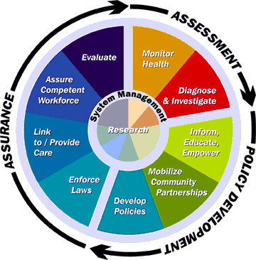
Figure 8: 10 Essential Environmental Health Services

Evaluate – Being able to take separate environmental project data sets and link them together improves our ability to have broader insight, to establish baselines and to evaluate trends. The value of an individual data point is limited, but as shown with aggregating radon or poison center data, is a powerful tool in evaluating environmental public health status.
Monitor Health – Environmental Public Health Tracking depends heavily on the availability of exposure data in order to evaluate the impact of environmental determinants on health. There should be strong links between daily health hazard assessment activity and the data needs of the tracking program. Metadata conventions can be an important method of building a strong link and facilitate marketing capability.
Diagnose and Investigate – Being able to see the bigger picture can help identify exposure trends. Understanding the relationship of a current data point in relation to similar previous data points can provide insight. For example a VOC result found to be well above past results in similar settings can be an indication of a very significant exposure.

National Goals Supported
Owing to the importance of being able to collect and analyze data, this project is supportive of numerous objectives cited in national public health guidance including the following:

- CDC Health Protection Goals
- A National Strategy to Revitalize Environmental Public Health Services
- APHA Environmental Health Competency Project: Recommendation for Core Competencies for Local Environmental Health Practitioners

CDC Health Protection Goals
Providing living and workspace that is healthy and safe requires the ability to identify and evaluate conditions that may influence health and safety. This requires the collection and analysis of data. The ability to monitor changes over time dictate the need to recall past data for comparison to current conditions and from one location to another. Metadata protocol enables collection efforts in different time and space to be linked, enabling a method of evaluating and assuring healthy and safe places.

A National Strategy to Revitalize Environmental Public Health Services
Among the goals highlighted in CDC’s, “A National Strategy to Revitalize Environmental Public Health Services”, is Goal #4, the ability to communicate and market. The intent of this goal is to improve communication and information
sharing among environmental public health agencies, communities, policy
makers, and others and enhance the significance and understanding of
environmental public health. This project can provide a mechanism for establishing baseline or “normal” environmental determinants and for measuring changes over time or location. If successful within BEOH, it can be used as a best practice among other agencies engaged in data collection for EPH.

APHA Environmental Health Competency Project: Draft Recommendations for Non-Technical Competencies at the Local Level
The importance of data analysis and interpretation is highlighted as well in APHA’s Environmental Health Competency Project: Draft Recommendations for Non-Technical Competencies at the Local Level. Understanding the meaning or significance of a single data point may be difficult without knowledge of how that data compares to other similarly collected data previous and in other locations. Whether a sample result is within an expected range or well beyond, will influence decisions about follow-up action. The ability to use AVR as a tool for analyzing and reporting data in graphical means can be a powerful means of communicating significance of aggregate data.

Figure 9. Logic Model for Improving Data Utilization

Resources/Inputs
Activities
Outputs
Objectives
Stakeholders:
-Environmental Public Health Tracking Pgm
-ATSDR 1043 Program Risk Assessors
-State Lab of Hygiene (SLH) IT Support
-SLH Management
- WI DNR SLH users

Data:
-Existing
-Project (newly acquired)
Metadata criteria
Sample submission forms
SLH Web-based data management system
Meetings:
-Identify data needs
-Identify labeling conventions for metadata
-Enlist support for project effort
Review suitability of current SLH aggregate data quality for other project needs
Identify improvements in sample submission forms for metadata use
Identify project data needs for tracking and interpretation assistance
# of meetings
List of projects that may benefit from SLH aggregate data and the data sets that can be used
Suggested revisions for SLH sample submission forms
Additional uses will be identified for existing SLH data
SLH customers will submit data that will later serve as metadata
Aggregate SLH data will be routinely evaluated and utilized in multiple fashions
WI ability to report on the state of environmental health will be enhanced
PROJECT OBJECTIVES:

Program Goal: To increase the value and utilization of data collected for environmental projects.
Health Problem: Our ability to track health effects related to environmental contaminants, to establish exposure baselines and to monitor progress are all dependent on exposure data. Because data is often limited and the resources necessary to acquire sufficient data are scarce, it is ever more critical that when other project data is collected it be managed in a manner that can serve other purposes. The large set of environmental project data collected by the WI DPH over the years is not being used for other purposes such as to aid in data interpretation or environmental public health tracking.
Outcome Objective: By June 30, 2008, a mechanism for managing descriptive information about environmental project data (metadata) will be developed and piloted using AVR such that data sets of use to a particular investigation or research project can be identified, evaluated and accessed.
Determinant: The number of data sets that may serve to aid in data interpretation or environmental public health tracking efforts and robust enough for AVR module (cube) development.

Impact Objective: A data set will be used to pilot the metadata table and evaluate the use of AVR as the access method. By December 31, 2008, BEOH will identify data projects for which SLH data will be useful and shall submit a proposal for improvements in LIMS.

Contributing Factors: Project data takes many forms and is collected in several ways. This adds to the complexity in linking data. A primary focus of data collection is the immediate project at hand, not longer term goals or relevance to other Bureau goals or data collection efforts. Data submission practices don’t necessarily include information suitable for management of metadata. Many groups submit data to the lab and do not communicate concerning broader data collection and utilization needs. It will be important to obtain consensus among other programs and agencies that BEOH works with to assure that any metadata table and field definitions arrived at are usable to our partners and can accommodate their data.

Process Objectives: BEOH stakeholders who have uses for aggregate SLH data and submit data to SLH, have met to discuss data needs and steps to assure SLH data can meet metadata criteria. A metadata table and field definitions will be developed and piloted using a data set. This data will then be evaluated using AVR. By June 30, 2008, a meeting will be held with partner agencies to identify improvements to the sample submission forms to increase metadata value. Stakeholders will be asked to evaluate the effectiveness of changes in SLH metadata.

METHODOLOGY:

If environmental project data is made available for later use, then we must record sufficient information about that data so a determination can be made about the utility for a particular purpose. This information will need to include data about the time, location, method, analytes and context in which the samples were collected. Doing so involves metadata.

Stakeholder identification
The key stakeholders for this project are those who produce, manage and may use environmental project data. Key stakeholders include:
- Project Manager of the ATSDR 1043 Program. 1043 program staff perform risk assessments of properties impacted by chemical releases throughout the state. Staff produce project data and could use aggregate data for both evaluation and to aid in data interpretation.
- Project Manager for the Environmental Public Health Tracking program. The Tracking program identifies suitable data sets to aid in evaluating the relationships between exposure to environmental agents and health effects.
- Section Chief for the Health Hazard Evaluation Section of the WI Division of Public Health. The Chemical Preparedness, ATSDR and Tracking programs are all in the Health Hazard Evaluation Section and under the Section Chief’s supervision.
- Administrative Manager for the Division of Informatics and Surveillance for the WI State Lab of Hygiene (SLH). SLH is the state’s designated public health laboratory.
- Supervisor with the Division of Informatics and Surveillance for the WI State Lab of Hygiene.
- Laboratory Coordinator with WI Department of Natural Resources.

Stakeholder Meetings
After several stakeholder meetings, it was determined it would be best to pursue and pilot a metadata strategy that would work for BEOH, before doing so with other agencies. Initial consideration was given to having the metadata management be lab based. After consulting with stakeholders however, it was apparent this needed to be user based. The lab can be instrumental in providing results in electronic format amenable to metadata standards, but it is the customer agency that must assure necessary information is collected about data sets to assure that they will be useful for later investigative and research purposes. Meetings yielded project direction both from the SLH and BEOH perspectives.

MetadataTable Development
Two SLH sample submission sheets are used by BEOH, one is for the occupational lab and the other for the environmental lab. The latter is used primarily for processing DNR samples. Many of the fields, including definitions, were incorporated into the BEOH model metadata table. With increased standardization of data fields, the more likely it is data can be shared among agencies. The translation process to allow data to be processed by AVR should be simpler as well. Table 1 lists the field and variable definitions.

One of the challenges of multiple data sets is determining how to enter data for samples that may have dozens of analytes (See lab data examples in Table 1). The intent behind the metadata table design is that CAS#s (Chemical Abstract Service numbers unique to each analyte) can be transferred into the metadata entry form. Another challenge is managing multiple report formats. Some reports are received electronically, such as those from the WI SLH Environmental Services Section. Other reports such as mold or VOC samples from the Occupational Section are received in paper form. Field-acquired data is also recorded on paper, but sometimes can be stored electronically. Where possible, links to the source electronic file will be provided. Although access to paper files can be provided in PDF format, there will be limitations as to how easily such data can be linked with other data sets. It at least though will afford the opportunity to review and access available data and make a determination as to whether the effort to have it translated for use by AVR is worthwhile.

Translation refers to the need to accommodate differences among data sets. Though samples may share the same analytic methodology, conventions for recording attribute data such as time and location may vary, necessitating code to translate these data sets into a common structure that then can be processed and reported by AVR. If investigators are looking for large data sets, they can identify possible candidates. However, if an investigator seeks to understand the relation of a current data point in relation to former ones, that activity can be done rather simply. This would be a monumental improvement over how we currently operate.

Table 1. BEOH Model Metadata Fields and Variable Definitions
Field | Variable Description
Project ID | The name of the project. May include multiple samples.
Collector Sample ID | Unique identified assigned by collector of sample
Lab ID | Unique identifier assigned by the laboratory
Date | Date in month/day/year format
Type | Grab, time integrated (e.g. pump and tube or filter), data logged
Begin Date | Date time integrated sample began or grab sample collected.
Begin Time | Time time integrated sample began or grab sample collected.
End Date | Date time integrated sample ended.
End Time | Time time integrated sample ended.
Sample Media | Air, soil, water
Sample Type | Indoor air, private well, surface water, community well, outdoor air, soil, sediment, food, biota
Method | Method number, e.g. EPA TO15, OSHA, PV2120, EPA 353.2
Mailing Address | Postal address
Collection Point | Specific location at postal address, e.g. 3rd floor northwest corner office, behind garage, outdoor tap
GIS Coordinates | Longtitude and Lattitude
Depth or Height | Measured in feet
Analyte | CAS#, table developed such that multiple CAS numbers for a single sample can be entered simply and associated with that sample.
Purpose | Reason sample was collected, e.g. investigation of exposure or release, background/control, new well, etc.
Collected By | Sample collectors name
Agency | Sample collector’s agency
Analyzed By | SLH or BEOH
Data Format | .xls, .pdf. doc, etc.
Data File | hyperlink to data file

NEXT STEPS:

The following actions are planned to move this project forward.
- Pilot the metadata table with a large private well water sample data set.
- Once the metadata field and variable definitions are defined, a form to facilitate data entry will be developed.
- Data will be entered through that form using the well water data set.
- Meet with DPH AVR staff to develop a data module (cube) through which the well water sample data can be analyzed and reported based on time and location.
- Meet with the WI SLH and other agency partners such as WI DNR to discuss the BEOH pilot. We expect these findings will lead to changes to the LIMS, interagency data sharing and collaboration on metadata practices.
- Identify BEOH data sets that are large enough that data modules (cubes) can be developed to utilize AVR technology to analyze and report on characteristics over time and location. This will open new windows into WI environmental public health.

EXPECTED OUTCOMES:
The expected outcomes of this project include:
- A model BEOH metadata table and form that will be piloted using a well water data set.
- Demonstration of the utility of metadata by applying AVR in analyzing and reporting the well water data.
- Recommendations for data management practices among agency partners such as SLH and DNR.
- Increased data available to support essential public health functions.

LEADERSHIP DEVELOPMENT OPPORTUNITIES:

Jim Morrison

The most valuable benefit of attending EPHLI is that I’ve gained a better understanding of myself, including characteristics that influence my work practices. The Institute has offered a wealth of resources that I will continue to utilize and explore. I have had the pleasure of meeting colleagues that I have called on for assistance and will continue to call on. I am proud to be a part of this cohort and grateful to EPHLI for preparing me to be part of the fabric that will lead the future of environmental health.

ABOUT THE EPHLI FELLOW(s)

Jim Morrison, is the Chemical Preparedness Coordinator for the Wisconsin Division of Public Health. He has over 15 years of experience in environmental and occupational health and safety. Mr. Morrison has a BS in Environmental Health from Illinois State University and a MS in Environmental Health Sciences from the University of Michigan. He is a Certified Industrial Hygienist and Certified Hazardous Material Manager. His work experience includes service to government, educational and consulting organizations. Areas of expertise include EHS management, indoor air quality and community exposure assessment. Recently he has been active in responding to concerns about fine particulate exposure, particularly with respect to outdoor wood boilers and elemental mercury spills.

APPENDIX 1

Sample Environmental Projects Data Reports

Environmental Project Data Example- Data-Logged PM2.5 Data
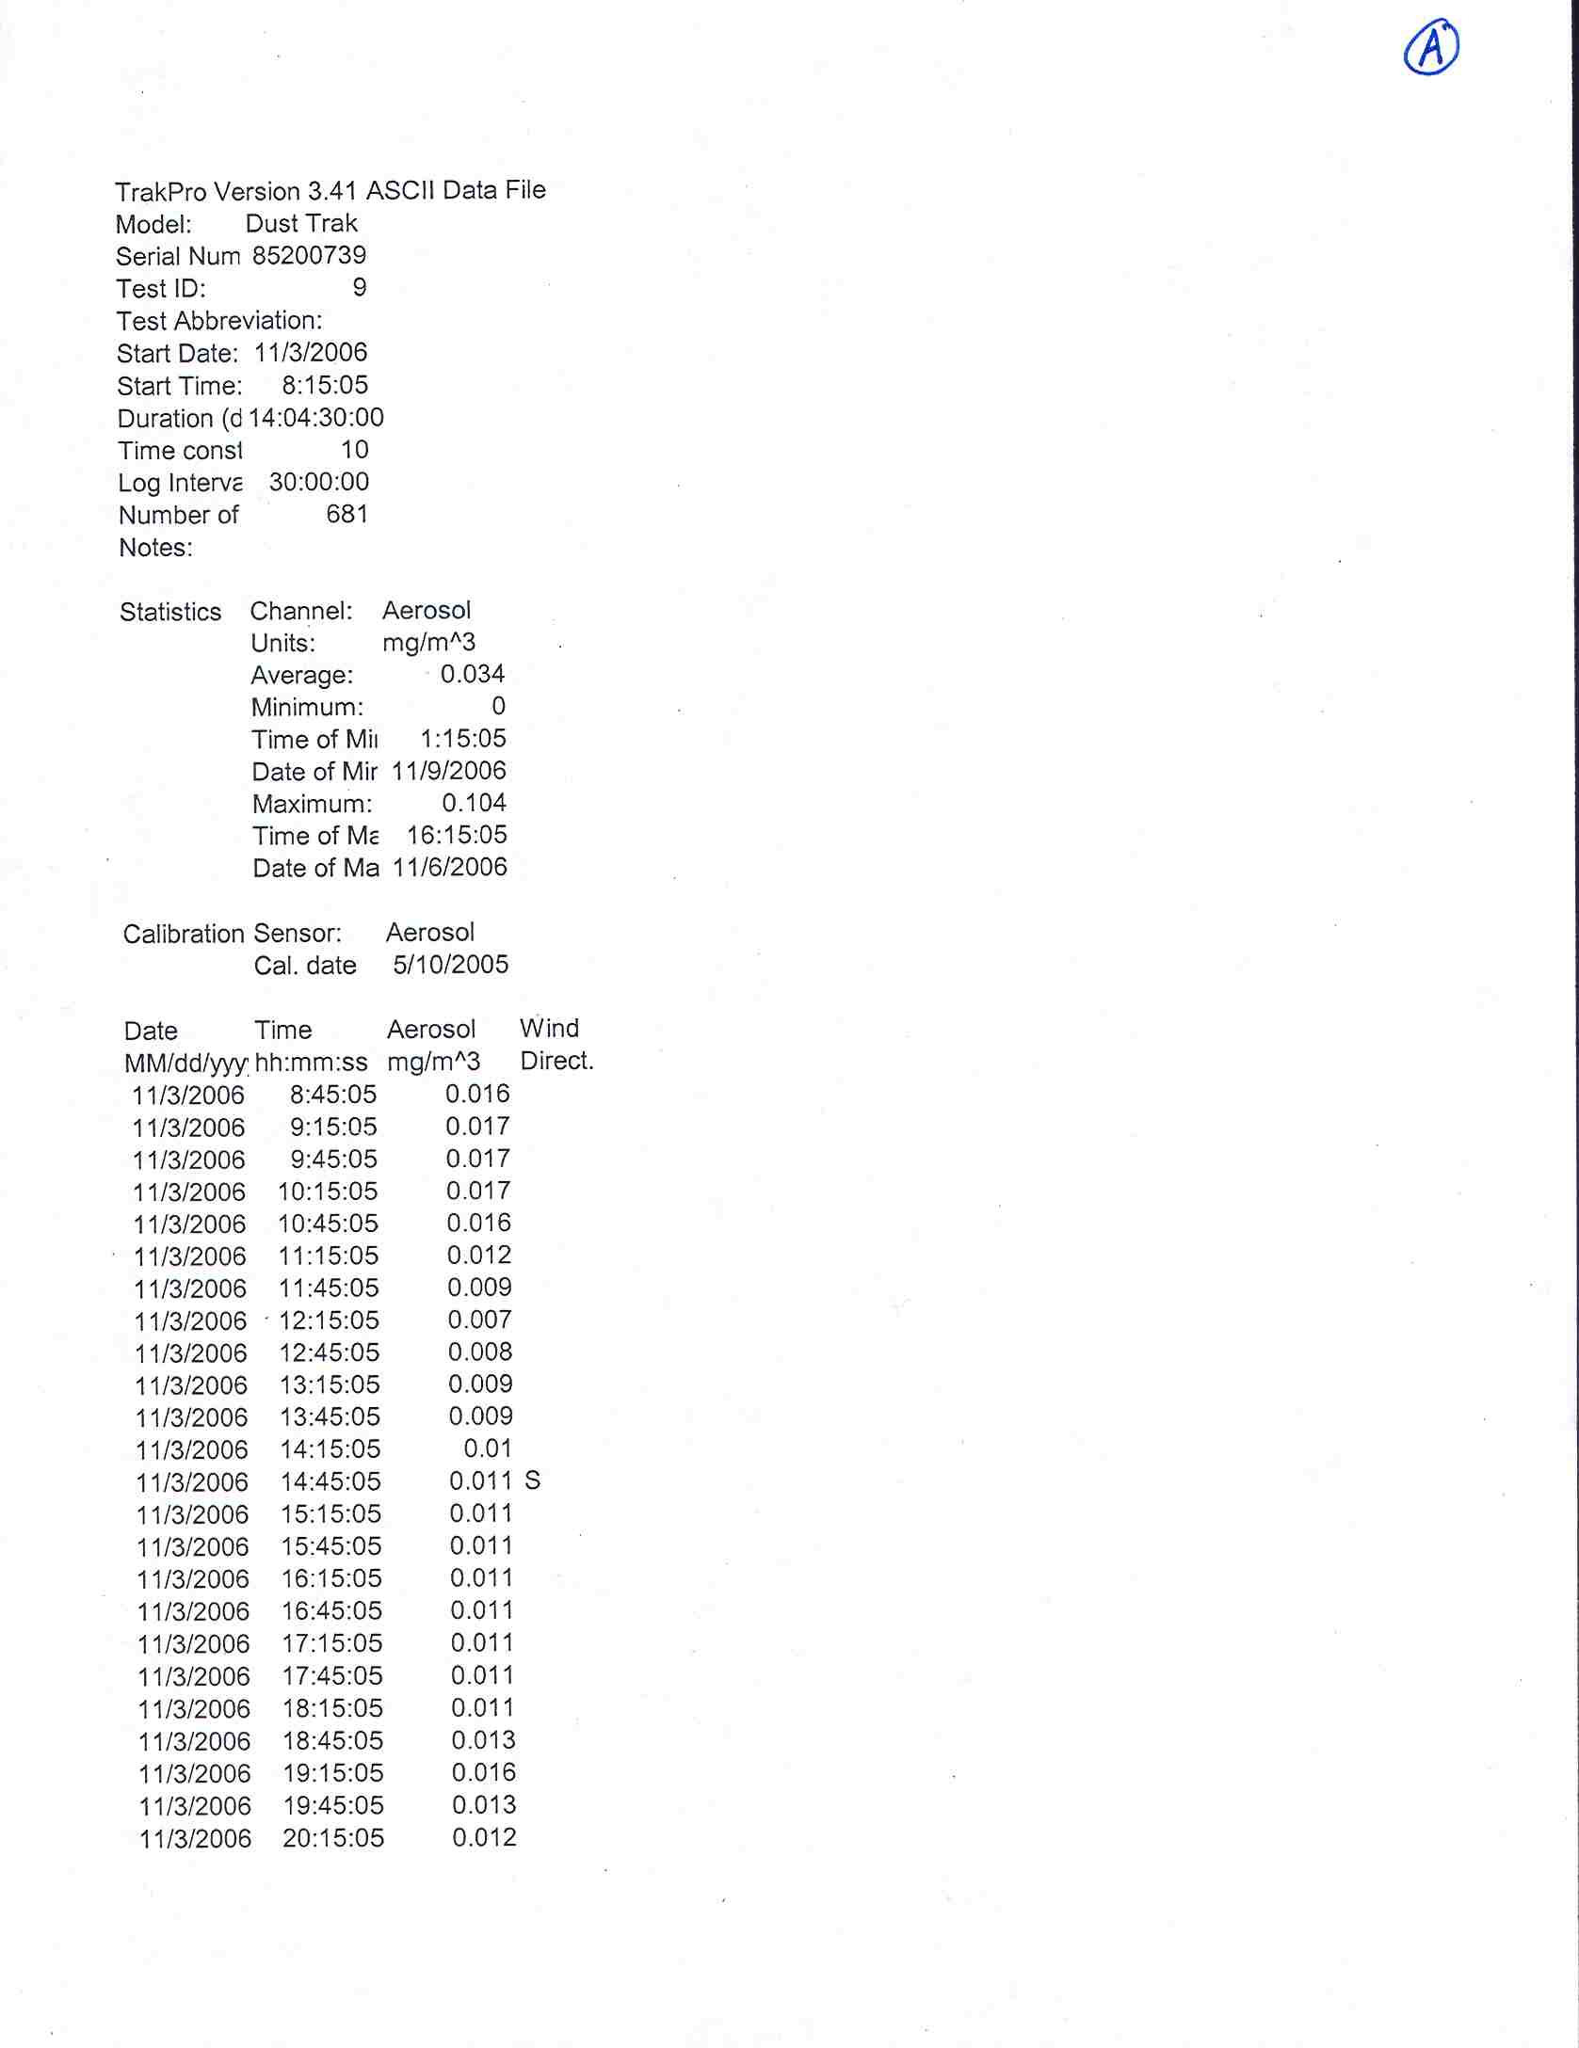
Environmental Project Data Example- Water sample VOC Data
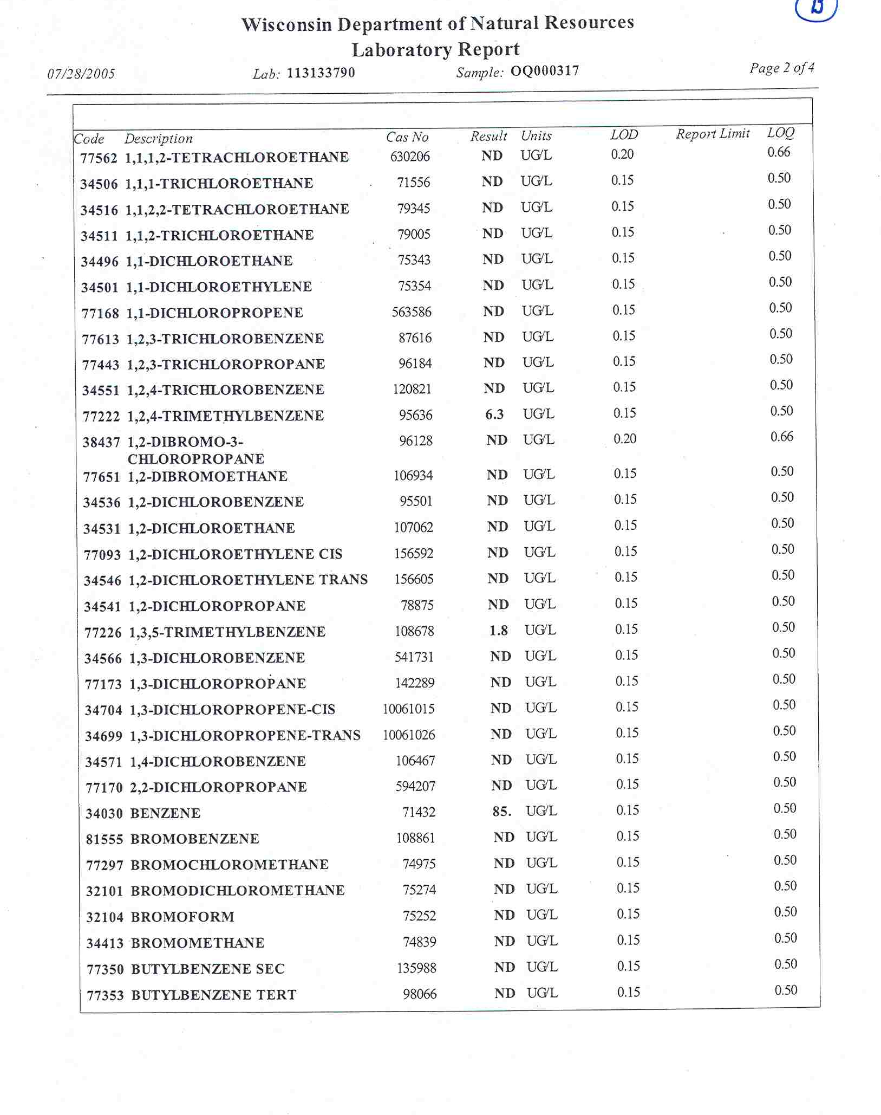
Environmental Project Data Example- Airborne VOC Data from SUMMA Can Analysis
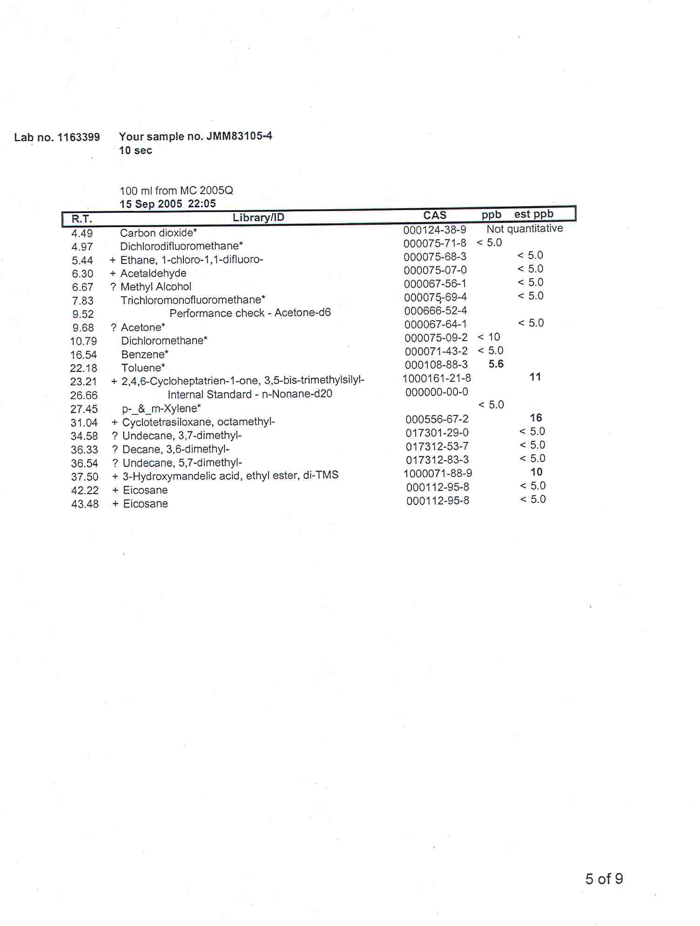
Environmental Project Data Example- Airborne Mold Data
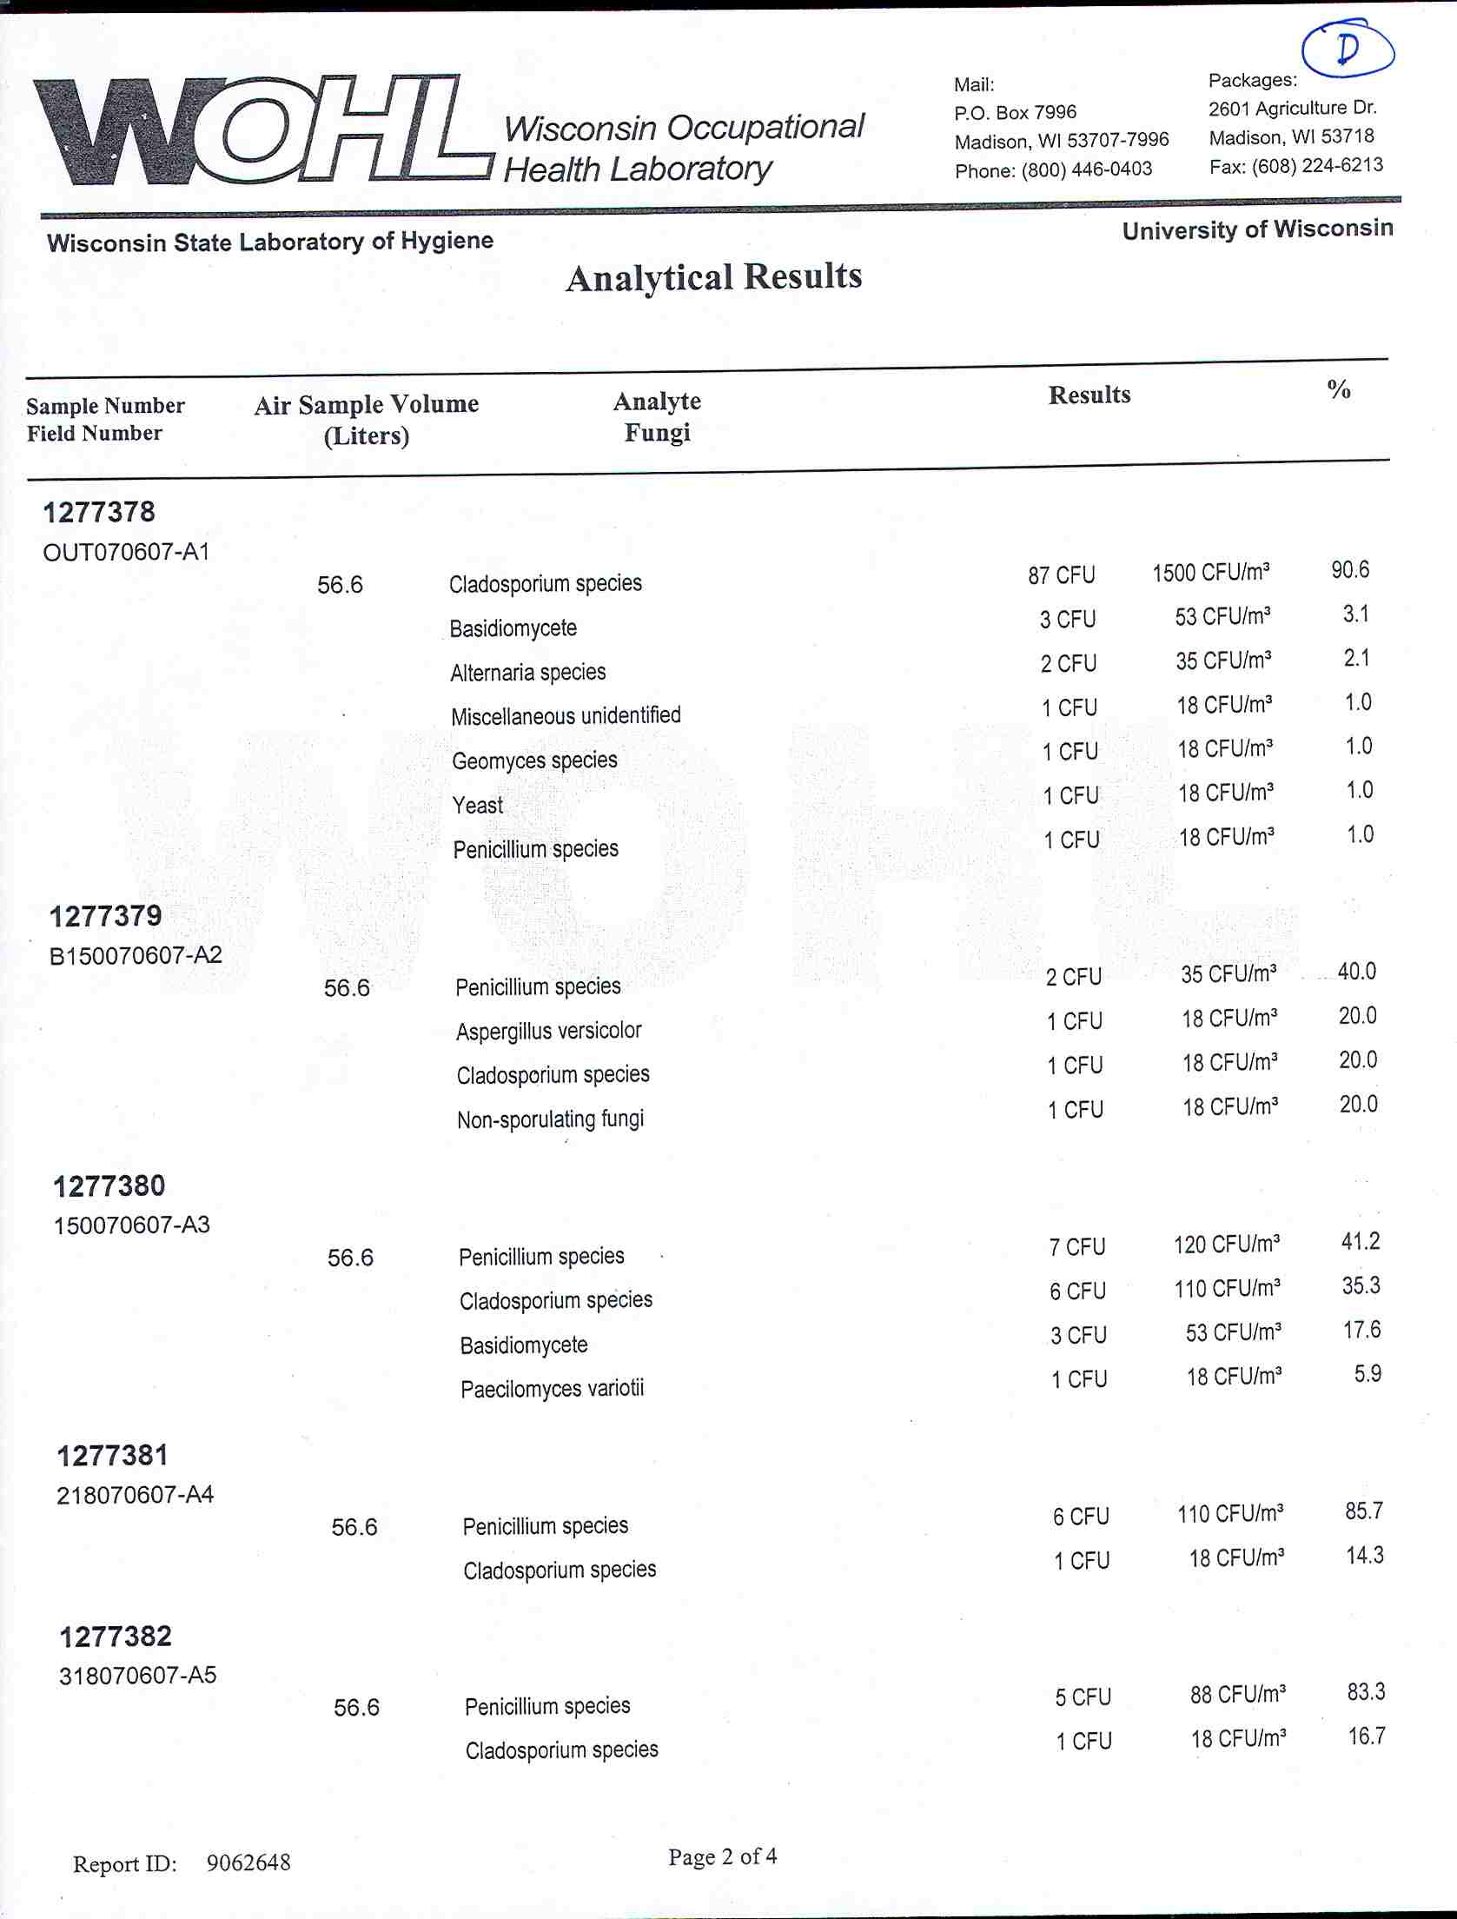
Environmental Project Data Example- Direct-Reading Instrument Data
