POLAR Spacecraft Status As of: Weds, 13 Oct 04 16:00 EST
(changes from last week in bold border)
Subsystem/  Component | NOAA-12D  AM:AN=1646  STIP data only | NOAA-14J  AM:AN=2006  STIP data only | NOAA-15K  AM:AN=1822  GAC data only | NOAA-16L  PM:AN=1424  GAC&LAC data | NOAA-17M  AM: AN=2224  GAC&LAC data | NOAA-N18  Planned PM  Plan AN=14:00L
LAUNCHED | 05/14/91 | 12/30/94 | 05/13/98 | 09/21/00 | 6/24/02 | Planned  NET 2/12/05
CNTL OBP | OBP2 | OBP2  OBP1 inoperative | OBP2 | OBP2 | OBP2 | End to End test 20 Oct
BUS | B-BUS  XSU-1 | B-BUS  XSU2 (XSU1 inop) | B-BUS  XSU-1 | B-BUS  XSU-1 | B-BUS  XSU-1
BUS VETO | NO | NO | NO | NO | NO
ADACS  X=Yaw  Y=Roll  Z=Pitch | Nominal Mode  RGmode=Monitor  Gyro chans=XYZ | Nominal Mode  Rgmode=Disabled  Gyro chans=XYZ  SS check Disabled when mode=YGC | Nominal Mode  Rgmode=Monitor  Gyro-3 Off 6/26/00 Gyro chans=AAB  N2 Low PSI invalid | Nominal Mode  Rgmode=Monitor  Gyro-3 Off 6/10/04  Gyro chans=AAA  Gyro3 TOAR 427  ESA investigation | Nominal Mode  Rgmode=Monitor  Gyro-3 Off 6/10/04  Gyro chans=AAB  Gyro3 TOAR 436 | New  ring laser gyro
RXO | PRI  BU random enables  daily bias+6.5 mS | PRI  BU random enables daily bias–7.0 mS | PRI  daily bias -8 mSec  +100 mS 31Au04 | PRI  Daily Bias –5.5 mS  -100 mS 31Au04 | PRI  Daily Bias –3 mSec
CLOCK DIV | 2 | 2 | 2 | 2 | 2
MIRP | External Synch  Rephase Enabled | External Synch  Rephase 0730 Daily | External Synch Rephase 0730 daily | External Sync  Rephase each orbit | External Sync  Rephase Enabled
TIP SIDE | 1 | 1 | 2  (since 4/23/03)  Channels 224 -227 invalid TOAR 432 | 1  Analog telem drifting  TOAR 439 | 1  Analog telem drifting
DTRs | 3, 4, 5B  Safestate 3B since 9 Jun | 1, 2B, 3A, 5 Safestate- 1B | 1, 2, 3, 4 Safestate 1B EOT | 1,2,3,4A  Safestate 3A  4B TOAR 418  (STIP only) | 1,2,3,4  Safestate=1B  DTR2-SSR  DTR5 TOAR 420 | All solid state digital recorders
VTX  (APT data) | #1 ON  137.50 MHZ  Conflict with N15 | OFF  Since 8/14/02 | OFF  19 Sept -20 Oct  Conflict with N12 | INOP  OFF since 11/15/00 | #2 ON  137.62 MHZ
BTX | #1  136.77 MHZ | #2  137.77 MHZ | #1  137.35 MHZ | #1  137.35 MHZ | #2  137.77 MHZ
STX  #1=1698.0 mhz  #2=1702.5 mhz  #3=1707.0 mhz  #4=2247.5 mhz | 1 – HRPT;  2,3 - Playback | 3 – HRPT  2, 1 – Playback | 2-Omni HRPT  4-Playback  1,2,3-Degraded | 1 – HRPT;  2– Playback;  4 – Playback  3 low power unused | 3 – HRPT  TOAR424 low power  1&2 Playback  4 – TIP
POWER  (Array offset, charge and eclipse states, sun angle)  Partial Solar Eclipse on 14 Oct 00:45-04:25Z | ArrayOff +50  since 8/31/04  Full Sun  Battery UVtrip 7/25  Sun Angle 15 bottomed out  Batts 1&2=LRC  V/T=4 (26Jul)  Shunt degraded | Array Off -55  Since 8/21/03  Eclipse all year  Sun Angle at 37 steady trend  Batts 1-3= LRC  Batts 1&3V/T=8/11  Batt2 VT=9/11 )  Shunt Degraded | Array Off -45  Since 1/25/01  Full Sun  Sun Angle 8  Bottomed out  Batts 1-3= LRC  V/T=7/9 | Array Off -40  Since 7/16/02  Eclipse all year  Sun Angle 50  downtrend to 49 on 31 Oct  Batts 1-3= LRC  V/T=4/8 | Array Off. –40  Since 1/29/04  Eclipse all year  Sun Angle at 68  Steady trend  Batts 1-3= LRC  V/T= 4/8
AVHRR | Nominal  Turned backon 7/28 Chan-2A on 8/3/04 | INOP  Scan motor stalled  14 Apr 04 | Nominal  Rare major scan motor surges. Last  Incident 8/9/03 | NOMINAL  No bar code or wave patterns. Scan motor current occasionally erratic  TCE24 OFF 4/14  Chan 3B only. | Nominal  3A-B switch enabled  Scan Motor on watch list | New brushless scan motors
AMSU-A1 |  |  | Operational  Ch14 inoperative  Ch11 inoperative | Operational  TOAR 415 on primary PLLO chans 9-14 bias shift.  TOAR 417 on Backup PLLO inop | OFF/INOP  Since 10/30/03  Inoperable Red in status. Survival heat on.
AMSU-A2 |  |  | Nominal | Nominal  Space Position-2 | Nominal
AMSU-B |  |  | Operational  Bias in All Chans.  Motor surges ,most recent 8/26/04  IPD Reports of degraded data on Chan-3 since 4/30 | Operational  Space Position-3  IPD reports channel 8 degradation | Nominal
HIRS | ON / INOP  Turned on 8/30/04  For power balance  Filter Wheel turned OFF 10/17/02. | NOMINAL  Operational  Occasional loss of Fwheel synch | VARIABLE  FW mode=Hi Powr  FW Heater OFF  Frequent Filter Motor current “mini” surges  Occasional major FM current surges, most recent 6/3/04 | Operational  Occasional major FM surges, most recent  4/29/04  IPD Reports of excess noise in space view channels 21May04  Patch Power investigation | NOMINAL  1 Pixel cross track misalignment .
MHS/MIU |  |  |  |  |  | Integrated on spacecraft  Replaces AMSUB
MSU | ON / INOP  Turned on 8/30/04  For power balance  Scan Motor OFF since 3/12/03 | Operational  Scan motor and antenna problems
SSU |  | Nominal
DCS | Nominal | Nominal | Nominal | Nominal | Nominal
SARR |  | Nominal | Operational  A-Side  All AGC Mode  Intermittent failures for 243MHz A&B | Operational  A-side  All AGC Mode  (B-side in FG mode)  243 MhZ = INOP. | Nominal  A-side  All AGC Mode
SARP |  | OFF  Power Failure | Nominal  RCVR B/W = 2 | Nominal  RCVR B/W = 2 | Nominal
SEM | ON/Nominal  Turned on 8/30/04  Elec-CH-HVPS=4  Prot-CH-HVPS=0 | Operational  Elec-CH-HVPS=0  Prot-CH-HVPS=0  1 of 4 Telescopes inoperative | Nominal  E-CDEM-HVPS=2  P-CDEM-HVPS=0 | Nominal  E-CDEM-HVPS=5  P-CDEM-HVPS=4 | Nominal  E-CDEM-HVPS=2  P-CDEM-HVPS=3
SBUV |  | Degraded  Grating motor stuck at position –930 on 7/8/04 recovery ops successful 7/9  Flex memory 3 (giant step) ops suspended indefinitely on 12/2/03  Reduced operations started 6/5/03 |  | Operational  Flex Mem-3 testing  Degraded Ozone data reported TOAR 435  TOAR 433 Backup Diffuser failure Closed 9/14/04  Cause inconclusive  Primary Diffsuer deployment problem TOAR 426  AMSU EMI causing erratic Behavior in PMT cathod, range 3 | Nominal  Anode Mode
SADPOS |  |  | N/A | ON  Enabled MFactor=50%  Plan DISABLING for 14 Oct Solar Eclipse | ON  ENABLED
THERMAL  Heaters, louvers  TCE’s | Nominal  TCE’s back to nominal configuration following 7/25/04 UVtrip. | Nominal | TCE26 & 15H  Telem invalid  TOAR 432  HIRS FW Heat OFF  TCE24L&25L (HIRS & AVHRR) failed 5/13/98  RCE thermostat failed 5/13/98  S/C in strong cooling trend | Nominal  TCE24 OFF 4/14 (AVHRR H&L) | TCE3H Batt 2A heater failed ON, turned off 8/26/03 TOAR 428  CLOSED 9/14/04 no corrective action possible.  AMSU-A1 survival heaters on 10/29/03
 | N12 | N14 | N15 | N16 | N17 | NOAA-N18

COMMENTS/CHANGES:

NOAA-12 Because of an RF conflict with N16, N12 continues to have far fewer passes resulting in less capability for ensuring
nominal health of the spacecraft. With the data currently available there does not seem to be any problems at this time.

EMOSS engineers will be monitoring spacecraft response to a solar eclipse event that will occur for 10-15 minutes per orbit on three successive orbits between 00:30 and 04:30. No reconfigurations are planned for N12 based upon predicted response by the EMOSS solar eclipse model. EMOSS POC for this situation is Carl Gliniak.

NOAA-14: The N14 power situation remained stable during the past reporting period with minimum battery voltages remaining above 20.5 most of the time. Recently, the percentage of time that N14 spends in the dark during each orbit has begun to slowly increase. This trend is expected to continue through mid-November where the darkness percentage should peak at 23% per orbit. By that time, it may be possible that a power subsystem reconfiguration will be required to maintain an adequate margin and ensure no undervoltage situation or additional shunt stress occurs. Discussions and analysis are ongoing.

EMOSS engineers will be monitoring spacecraft response to a solar eclipse event that will occur for 10-15 minutes per orbit on three successive orbits between 00:30 and 04:30. No reconfigurations are planned for N14 based upon predicted response by the EMOSS solar eclipse model. EMOSS POC for this situation is Carl Gliniak.

NOAA-15: The cooling trend on N15 appears to have bottomed out last week in conjunction with the sun angle reaching its bottom of 8 degrees (illustration 1). Currently there appear to be no subsystem health or image quality associated with the low temperatures achieved during this cooling trend.

During the past reporting period, the N15 experienced a small scan motor current surge on 12 Oct that appeared to return to nominal after several hours. There were no reports of image degradation from this event and none were apparent in EMOSS analysis or HRPT data. In addition, the HIRS filter wheel continued its standard “mini surge” behavior as it has done for many months without any reported imagery degradation. In contrast, the AMSU-B did not experience any scan motor current surges last week (illustration 2).

EMOSS engineers will be monitoring spacecraft response to a solar eclipse event that will occur for 10-15 minutes per orbit on three successive orbits between 00:30 and 04:30. No reconfigurations are planned for N15 based upon predicted response by the EMOSS solar eclipse model. EMOSS POC for this situation is Carl Gliniak.

NOAA-16: The N16 AVHRR scan motor current, had a small surge on 8 Oct that appears to be slowly returning to nominal. In conjunction with this small surge, the synch delta value actually fell to near zero where it has remained since that time This type of response from synch delta is actually the opposite of what usually transpires. Furthermore, the small current surge was in no way accompanied by a rise in scan motor temperature which is on an upward trend at this time, a trend which is aided by TCE24 remaining turned off. There did not appear to be any impact on N16 AVHRR imagery from this current surge nor was nay reported to EMOSS. Sally House and Jim Walters are EMOSS POC’s for this payload. (See illustrations 3-6).

The N16 HIRS was also stable and nominal during the past reporting period and showed no impact or thermal coupling with AVHRR during the AVHRR mini surge (illustration 7). No additional information regarding the noisy channels reported last week has been received by EMOSS engineers. Finally, the HIRS Patch power, which is currently on the EMOSS “watch list” was stable throughout the past reporting period.

The ADACS on N16, as measured by its gyro motor currents and yaw update values was also nominal during the past reporting period (illustration 8). However, the performance profile of the N16 Earth Sensors continues to exhibit behavior suggestive of direct sunlight entering the detectors (as depicted by the ESA ORS voltages and Sun Moon warning status (illustrations 9-10). This issue started on or about 30 Sept and current opinion is that it does not constitute a health issue for the ADACS at this time. In response EMOSS engineer Jim Sheperd submitted an Event Report on this issue.

An SBUV test characterizing the SBUV’s wavelength dependence of the inter-range ratio between range2 and range 3 measurements continues executing out of stored commands in Flex Memory-3 (illustration 11). This series of tests is expected to end this week after which implementation of a follow on test will be considered. Jim Walters and Sally House and EMOSS POC’s for both of these tests.

EMOSS engineers will be monitoring spacecraft response to a solar eclipse event that will occur for 10-15 minutes per orbit on three successive orbits between 00:30 and 04:30. The SADPOS software on N16 will be disabled prior to the eclipse because the EMOSS solar eclipse model predicted that the spacecraft would be less than 40% illuminated for approximately 7 minutes during on phase of this event. This value is very close to the 8 minutes at <40% illumination that is the threshold for SADPOS autonomously taking control of the solar array. To ensure an added degree of margin, EMOSS engineer Carl Gliniak will turnoff SADPOS software while the eclipse is ongoing and then turn it back on after the event is concluded.

NOAA-17: EMOSS engineers continue to closely monitor the N17 AVHRR scan motor for signs of degraded performance. During
the past week, the performance remained stable at the higher values first observed several weeks ago while its synch delta value operating profile also stabilized within the slightly more “erratic” range that it recently established. In addition, N17 AVHRR temperatures continue to operate in nominal range and values and there have been no reports or observations of degraded imagery (illustration 12). Sally House and Jim Walters are EMOSS POC’s.

The ADACS on N17 was also nominal during the past reporting period although slightly less stable (as measured by gyro currents) than that on N16 and much more stable in comparing with N16 ESA (illustration 13) Jim Sheperd is EMOSS POC.

EMOSS engineers will be monitoring spacecraft response to a solar eclipse event that will occur for 10-15 minutes per orbit on three successive orbits between 00:30 and 04:30. No reconfigurations are planned for N17 based upon predicted response by the EMOSS solar eclipse model. EMOSS POC for this situation is Carl Gliniak.

NOAA-N: EMOSS engineers began regenerating the ascent data base originally delivered in mid-June 2004. This data base is
scheduled to be re-transmitted to NASA on 22 Oct and into PACS by 2 Nov. Michelle Settles is EMOSS POC.

EMOSS engineers continue supporting reviews, analysis, testing and product preparations for the 20 Oct end to end tes.

MISC: EMOSS power engineer Carl Glinak wrote an SER on the preparations for the solar eclipse on 14 Oct as well as
presented a chalk talk to each crew regarding the important operational features for this event.

Meetings supported by EMOSS included: Internal launch readiness meeting, MOWG, Ascent data base recovery meeting, COP Reviews, N18 Monitoring Guidelines Training and COP reviews.
The next database release is scheduled for Nov. 2. All approved CCRs should be turned into Michelle no later than Oct. 25.

EMOSS engineer Jim Sheperd supported the scheduling office on the SOMS generated ephemeris loads which was used operationally for first time this past week.

EMOSS engineer Jeff Devine worked with the software office to develop and test a process that will ensure the EMOSS HAF file archive can be reformatted in DMF file that are required by ABE. The reformatting process was successful but ABE was still unable to generate graphs from the file. Work is continuing.

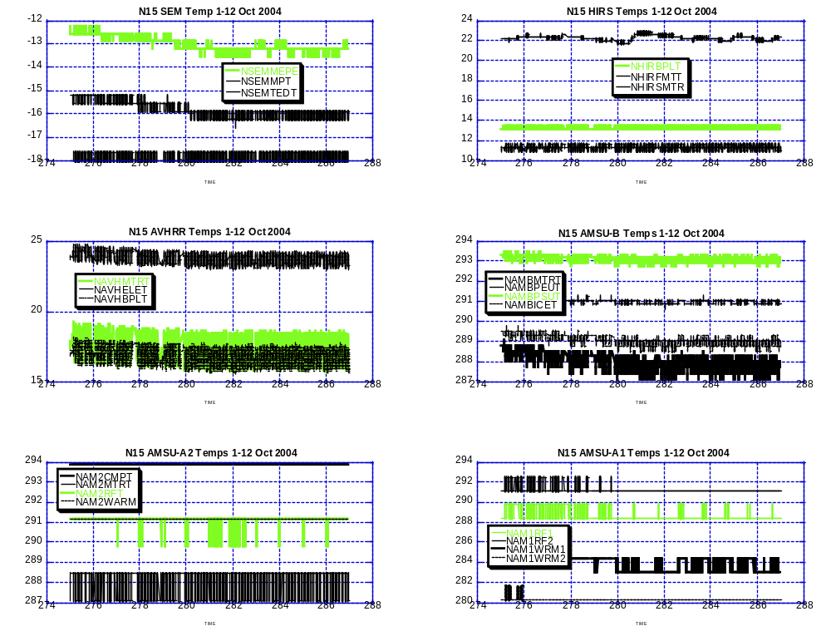

Illustration 1: N15 Selected Payload Thermal Analysis
(Downtrend appears to have ended since sun angle on spacecraft bottomed out at 8 degrees.)

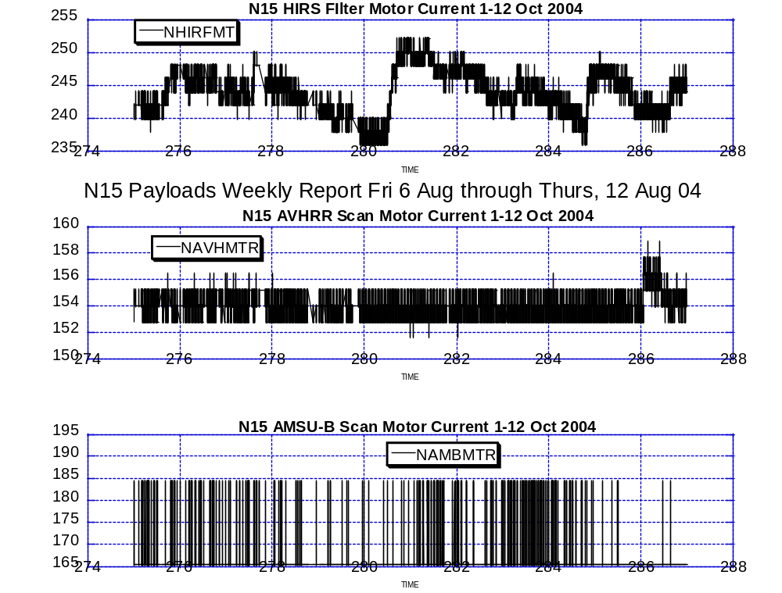

Illustration 2: N15 Payload Motor Health Analysis

(All within nominal or typical values and profiles except for that little
“hic-up” on the AVHRR on day 286.)

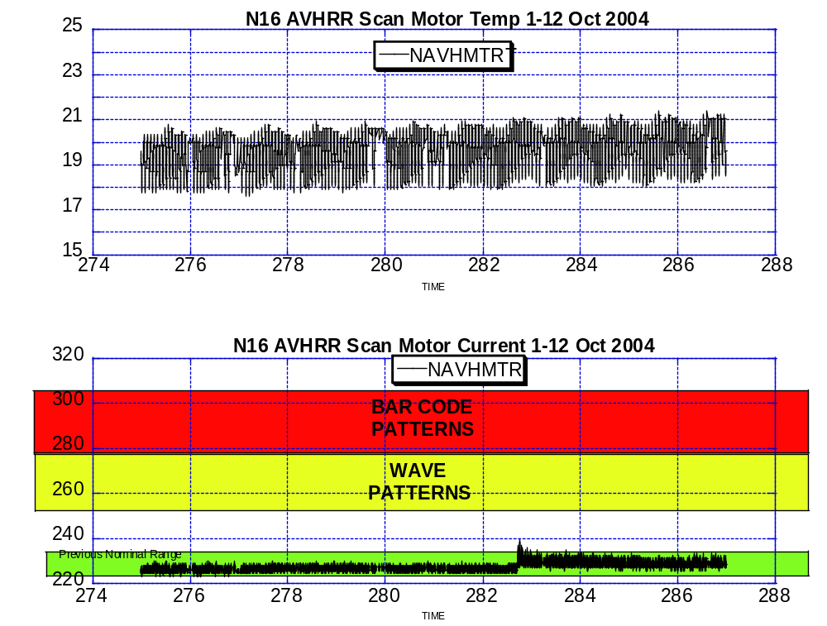

Illustration 3: N16 AVHRR Scan Motor Health Analysis
(A small bump on the road to continued nominal performance which occurred on
JDAY 282.)

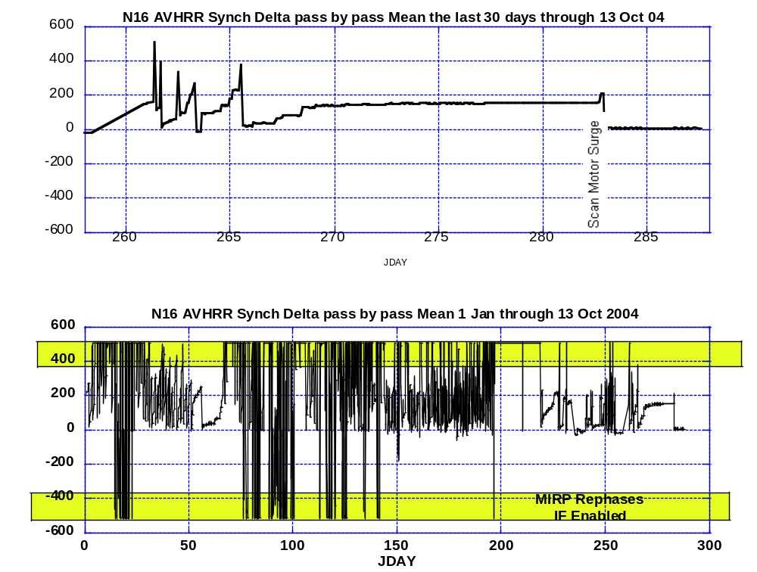

Illustration 4: N16 AVHRR Synch Delta Analysis
(An interesting development is that at the time the scan motor “surge” was occurring on 8 Oct, the synch delta fell to near zero; which is about as good as it gets. It remains there still.)

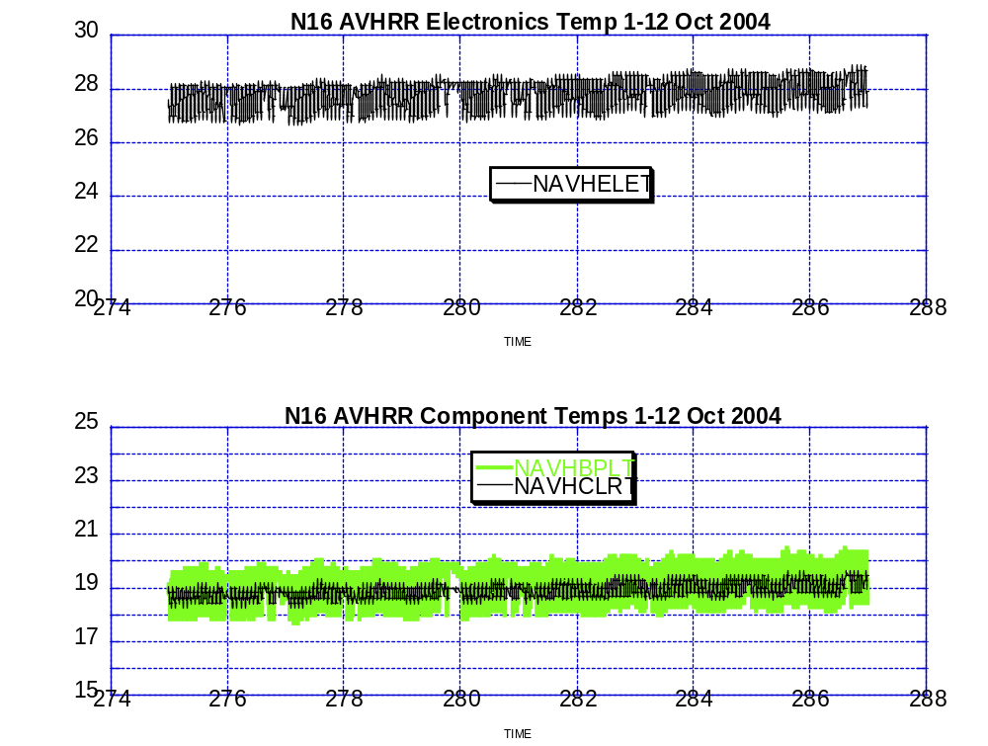

Illustration 5: N16 AVHRR Thermal Analysis

(Nominal but climbing with TCE24 remaining off. Another interesting development is that the scan motor current “surge” on 8 Oct did NOT correspond with a scan motor temperature spike.)

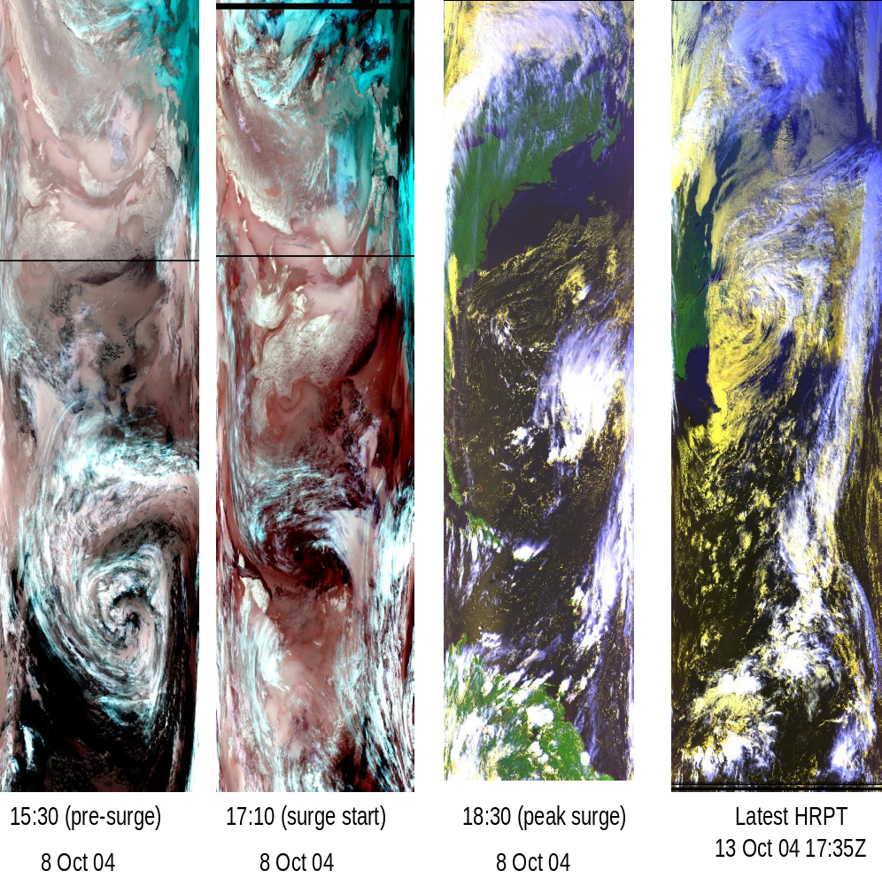

Illustration 6: N16 AVHRR Imagery Analysis (HRPT)
(Refer to the scan motor current graph on illustration 3. The first three images are one rev before, one during and one after the small scan motor current surge on 8 Oct. The last is today. Note the black line on the first two images is NOT a result of MIRP rephasing. Basically, the surge did not seem to affect image quality at all.

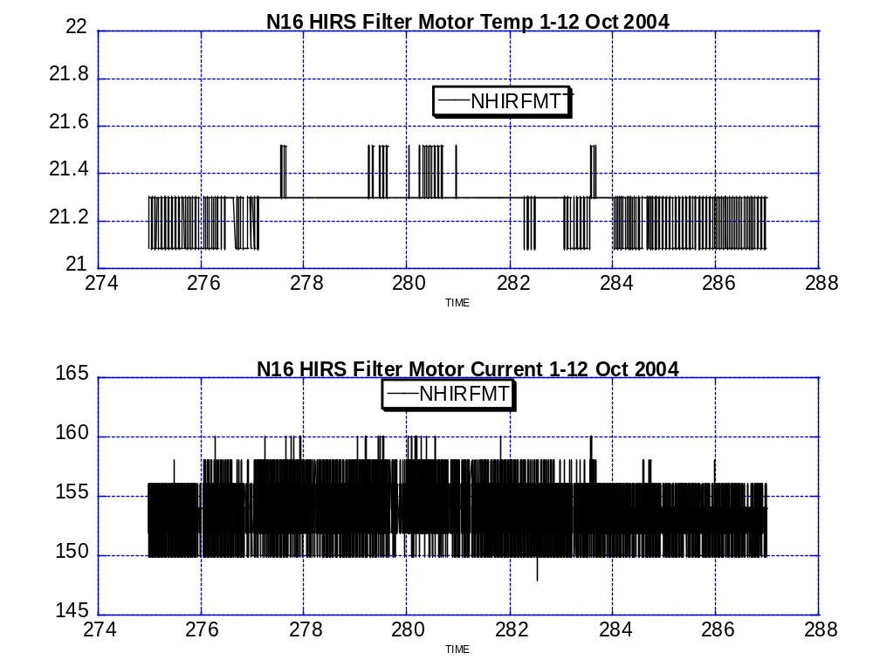

Illustration 7: N16 HIRS Health Analysis
(nominal and stable)

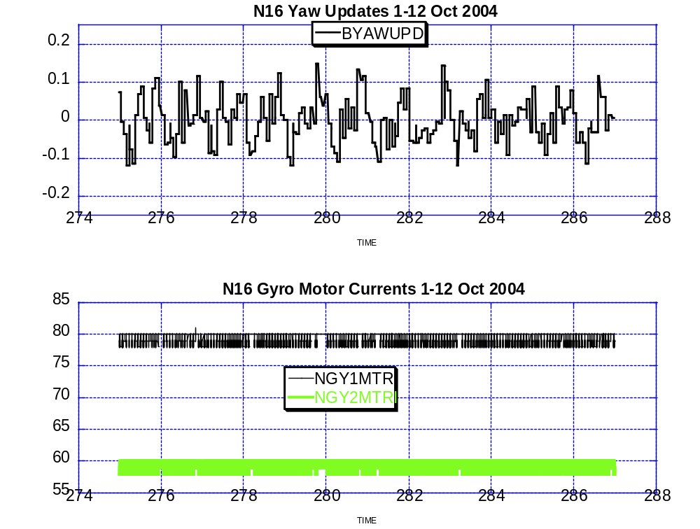

Illustration 8: N16 Attitude Control Analysis
(nominal)

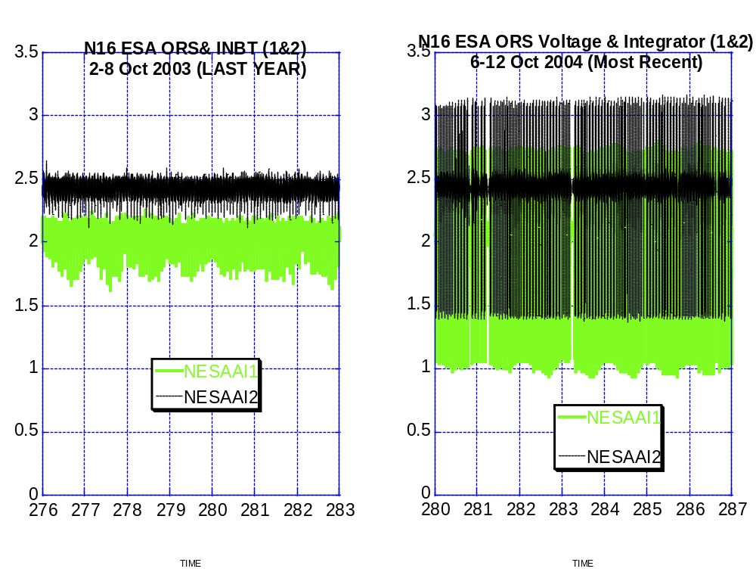

Illustration 9: N16 Earth Sensor Performance Comparison
(Recent values possibly caused by direct sunlight in the detector.)

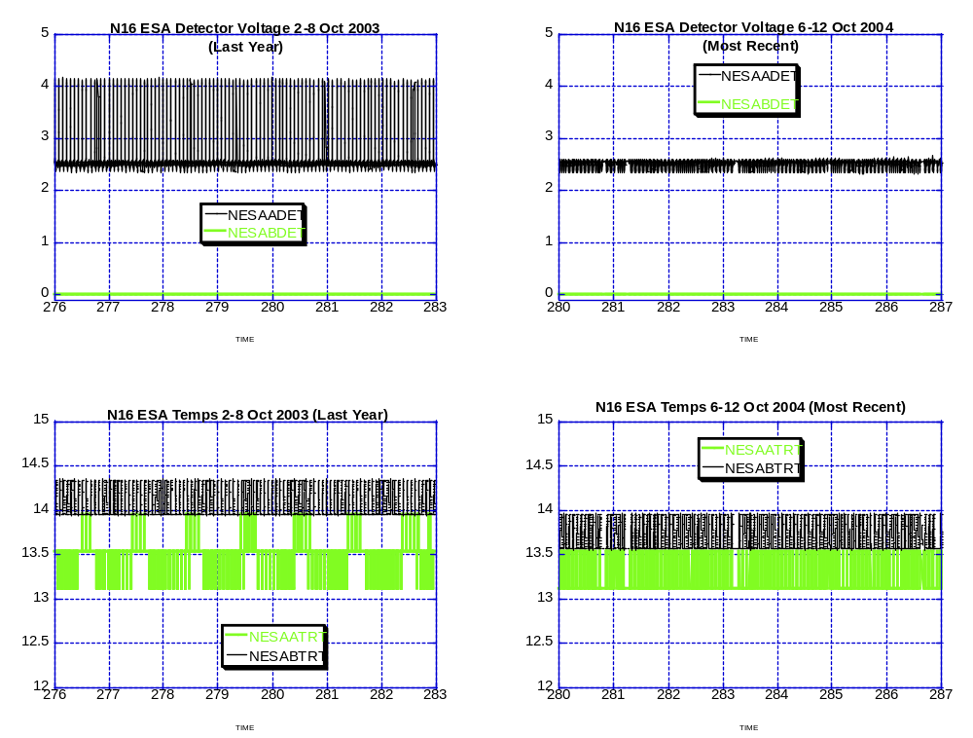

Illustration 10: ESA Thermal Health Analysis Comparison

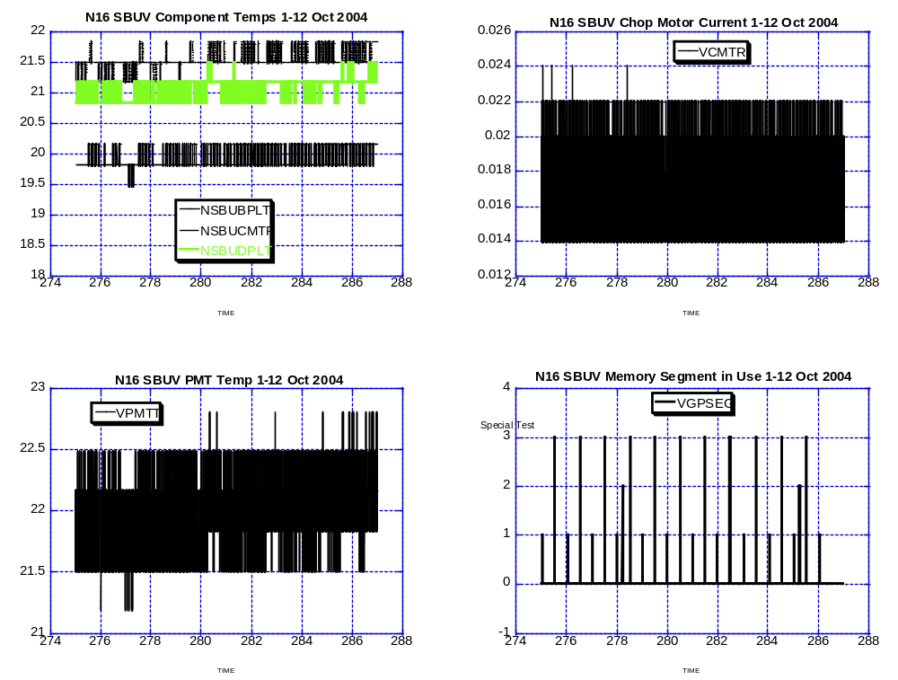

Illustration 11: SBUV Health Analysis
Flex Memory-3 Testing Continues but should be ending this week.

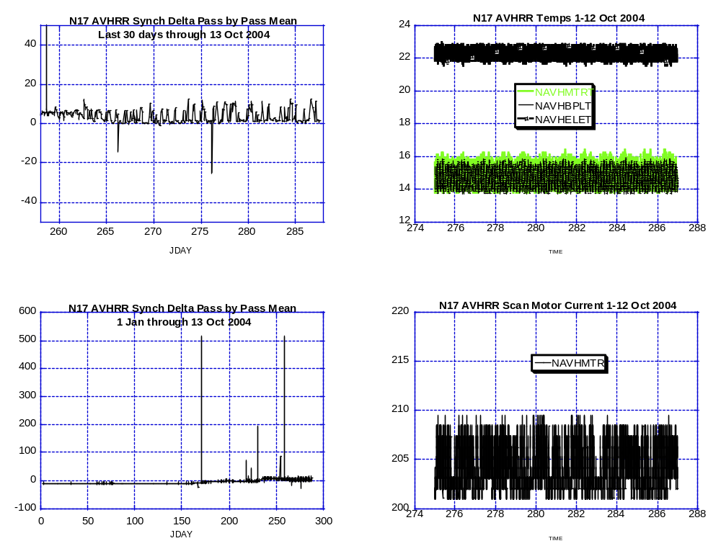

Illustration 12: N17 AVHRR Health Analysis
(holding steady but at somewhat elevated levels)

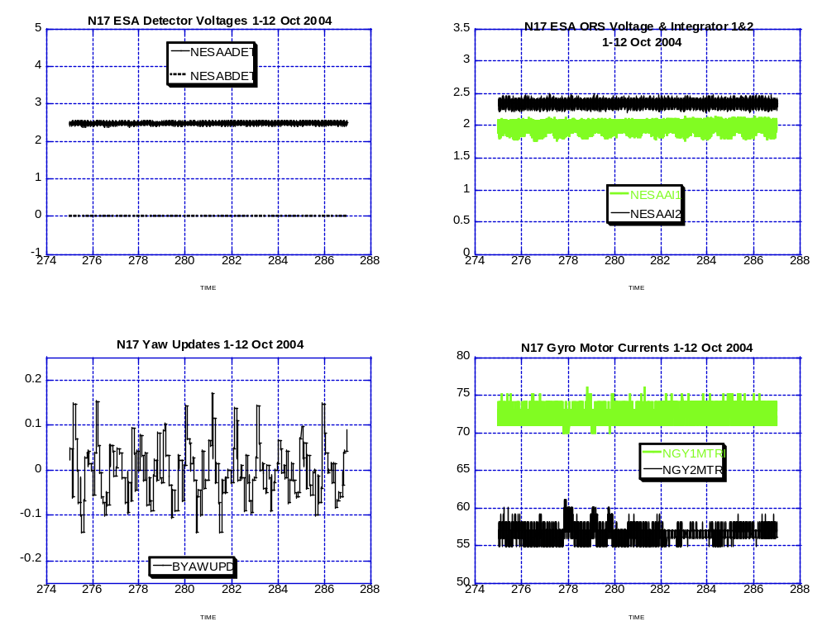

Illustration 13: N17 Attitude Stability Analysis
(Generally nominal; little less stable than N16 on the gyro currents a lot more stable on the ESA values)

N17 CPU Single Event Upset Scrub Analysis (New).

Last week and total.

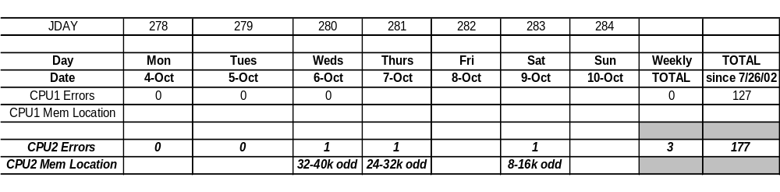

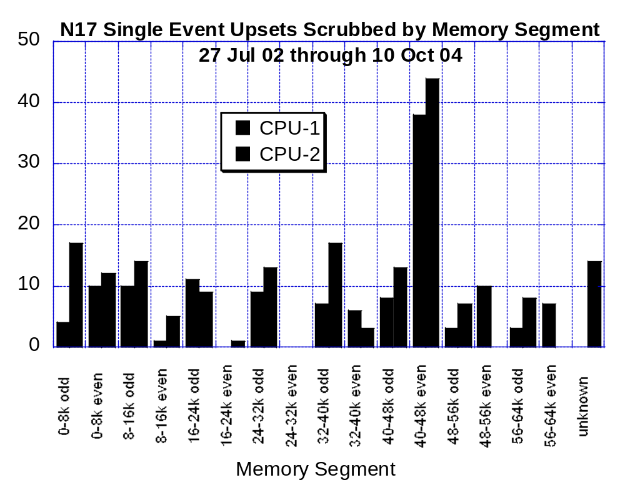

POLAR SPACECRAFT TIP CLOCK ERROR

WEEK ENDING October 8, 2004
DAY/DATE | NOAA-12 | NOAA-14 | NOAA-15 | NOAA-16 | NOAA-17
FRI. 10/01 | -085 msec * | +028 msec | +010 msec | -030 msec | -017 msec
SAT. 10/02 | -086 msec * | +024 msec | +009 msec | -031 msec | -017 msec
SUN. 10/03 | -091 msec * | +034 msec | +008 msec | -030 msec | -017 msec
MON. 10/04 | -085 msec * | +035 msec | +009 msec | -031 msec | -018 msec
TUE. 10/05 | -089 msec * | +035 msec | +007 msec | -031 msec | -019 msec
WED. 10/06 | N/A | +030 msec | +006 msec | -031 msec | -017 msec
THU. 10/07 | N/A | +031 msec | +006 msec | -031 msec | -017 msec
EMOSS POC for this chart is JIM SHEPHERD

NOAA-12 *Alternating +/- 500 millisecond clock jumps will occur at 76-day intervals as long as fractional second daily ETCUP is utilized to manage clock drift. The next +500 millisecond jump is expected on 11/16/04.
Daily ETCUP bias of +6.5 mSec started on 12/10/03.
NOAA-14: As of 1223/03 the TIP clock is corrected daily by –-7.0 msec to compensate for drift.
Subtracted 150 mSecs on 30 June
NOAA-15: As of 04/23/03 the TIP clock is corrected daily by –-8 msec to compensate for drift.
Added 100 msec to spacecraft command clock on 31 Aug 04
NOAA-16: As of 12/23/03 the TIP clock is corrected daily by –5.5 msec to compensate for drift.
Subtracted 100 msec from spacecraft command clock on 31 Aug 04.
NOAA-17: As of 12/23/03 the TIP clock is corrected daily by –3 msec to compensate for drift.
Added 125 Msecs3 Feb 04.

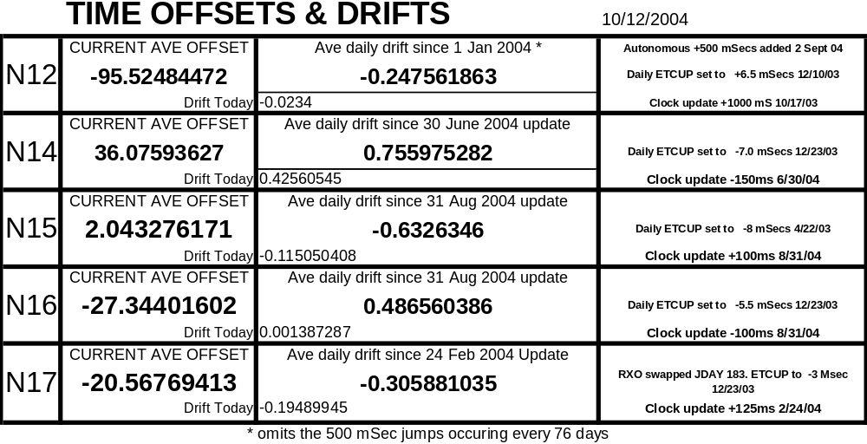

POES Engineering Contact List

Government

Renee Smith-Dearing NOAA POES Constellation Lead 301-817-4117

Dong Han: NOAA, POES Payloads 301-817-4127

Nicolaie Todirita (Todi) NOAA Ground Systems 301-817-4229

EMOSS-2 Contractor

Jeff Devine: EMOSS, POES Contractor Lead 301-817-4020

Jim Walters: EMOSS, POES Payload Engineer 301-817-4033

Angelique Riley, EMOSS, POES Comm and DHS (outgoing) 301-817-4028

Carl Gliniak, EMOSS POES Power and Thermal 301-817-4207

Jim Sheperd, EMOSS POES Attitude Control 301-817-4030

Jon Woodward EMOSS, POES Flight Software C&CS 301-817-4019

Sally House EMOSS POES Payloads (in training) 301-817-4026

William Chadwick EMOSS, POES Comm and DHS (in training) 301-817-4015

