Plant Materials Used for Biofuel

Biofuel is any fuel derived from a recently living organism, such as a plant. Biomass produced from plants is processed into liquid fuel (ethanol and biodiesel), burned to generate electricity, or chemically converted to syn-gas. A variety of agricultural crops and residue such as corn, corn stover and soybeans are harvested to be processed into biofuels.
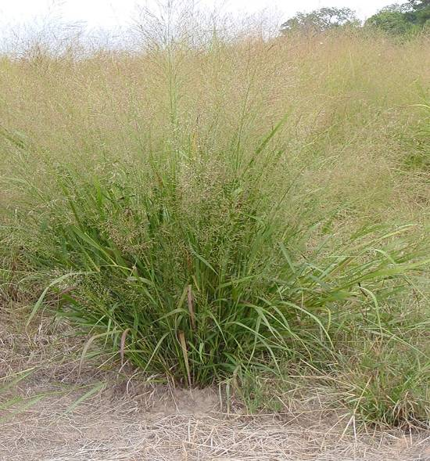
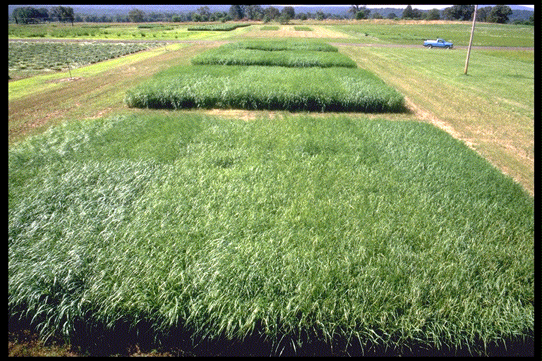
Native warm season prairie grasses and short rotational woody species have great potential to provide biofuels. Switchgrass has many conservation uses, but its high yields and biomass quality, seed availability of productive cultivars, and wide range of adaptation make it a prime candidate for integration into farming operations as a biofuel crop. Poplars, willows, sycamore and sweetgum are examples of fast-growing trees and shrubs which can be planted in production agriculture and harvested every 3 -10 years for biofuel production.
Switchgrass was one the first perennial grasses evaluated for use as a biofuel.
Early summer growth of switchgrass cultivars and breeding lines at the Booneville, Arkansas PMC.

The Plant Materials Program of the USDA Natural Resources Conservation Service (NRCS) has been collecting, evaluating, selecting, and releasing cultivars of switchgrass since the 1940’s for soil conservation, livestock forage and wildlife. These cultivars such as ‘Alamo’, ‘Kanlow’ and ‘Cave-in-Rock’, which are products of the plant materials program, are being utilized as biofuel crops in the Northern Great Plains and southeastern United States. Yields in excess of 10 tons/acre are not uncommon for this native warm season grass. ‘Cave-in Rock’ is being used in combination with coal to generate electricity as part of the Chariton Valley Biomass Project near Ottumwa, Iowa.

Additionally, several Plant Materials Centers cooperated with the U.S. Department of Energy’s Biomass Feed Stock Development Program by conducting regional testing trials and management practices for biomass production and evaluation.

Cooperative Biomass Studies at

Plant Materials Centers
Plant Materials Centers in Coffeeville, Mississippi; Booneville, Arkansas; Knox City, Texas and Manhattan, Kansas served as regional testing locations for multiple year studies comparing production and persistence of commercially available switchgrass cultivars to new selections developed by Oklahoma State University and Texas A&M University.

Plant Materials Centers in Pullman, Washington, Aberdeen, Idaho and Lockeford, California are working with university scientists and the USDA Agricultural Research Service to evaluate previous and recently released plants from their respective centers as future biofuel crops in the western United States. The Big Flats Plant Materials Center, Corning, NY in cooperation with the State University of New York, Syracuse, tested hybrid poplar selections for growth and other biofuel qualities as an energy source for the northeastern United States.

The East Texas Plant Materials Center and the Arthur Temple College of Forestry and Agriculture at Stephen F. Austin State University, Nacogdoches, Texas are evaluating the biofuel qualities of black locust, green ash, sweetgum, sycamore, cottonwood and loblolly pine in a short rotational woody cropping system. The Aberdeen (ID) PMC is evaluating accessions of poplar for production potential.
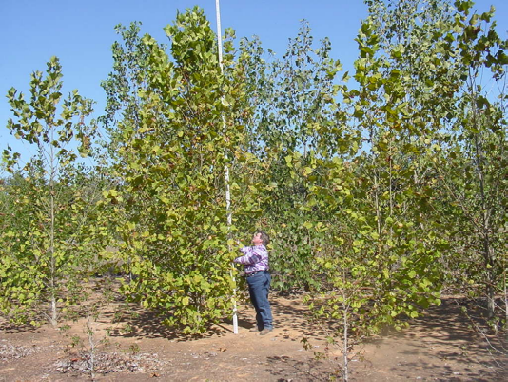
In an on-going effort to establish the best management practice for maximizing yield and biomass quality of ‘Alamo’ switchgrass, the Jamie L. Whitten Plant Materials Center in Coffeeville, Mississippi compared a one (early fall) and two harvest (mid summer and early fall) system. Their study found a one harvest system consistently produces higher yields than the two harvest system (9.4 vs. 7.5 tons/acre) in northern Mississippi.
East Texas Plant Materials Center staff measures short rotation woody plants such as cotton wood and sycamore for potential energy crops.
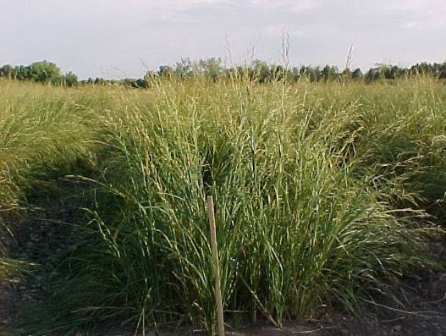
The Bismarck Plant Materials Center, in cooperation with South Dakota State University, is evaluating prairie cordgrass as a biofuel crop for the northern Great Plain region.

Future Studies
The Plant Materials Program and their cooperating partners will continue to identify potentially new herbaceous and woody biofuel species that can be integrated into typical farming operations. Management response studies will be conducted to verify selections or improve production guidelines on current and new biofuel crops.

