Slide 1 | 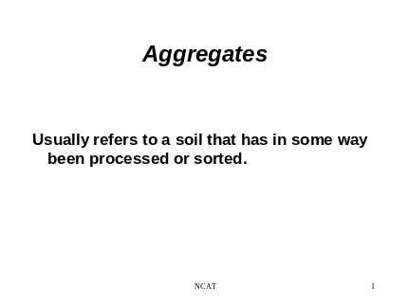 | _____________________________________________________________________________________________________________________________________________________________________________________________________________________________________________________
Slide 2 | 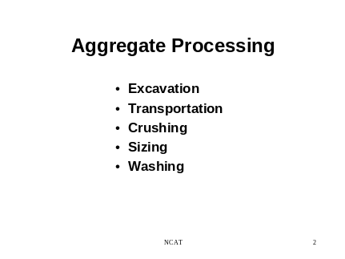 | _____________________________________________________________________________________________________________________________________________________________________________________________________________________________________________________
Slide 3 | 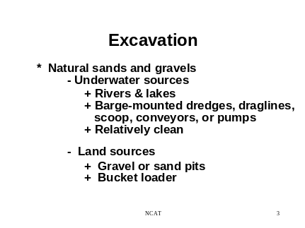 | _____________________________________________________________________________________________________________________________________________________________________________________________________________________________________________________
Slide 4 | 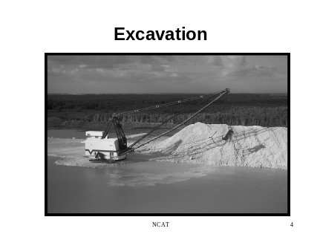 | _____________________________________________________________________________________________________________________________________________________________________________________________________________________________________________________
Slide 5 | 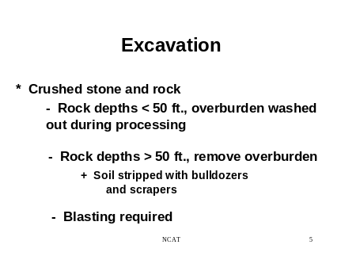 | _____________________________________________________________________________________________________________________________________________________________________________________________________________________________________________________
Slide 6 | 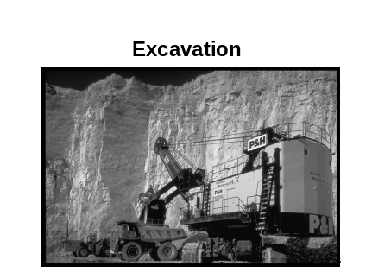 | _____________________________________________________________________________________________________________________________________________________________________________________________________________________________________________________
Slide 7 | 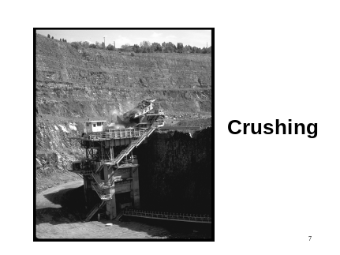 | _____________________________________________________________________________________________________________________________________________________________________________________________________________________________________________________
Slide 8 | 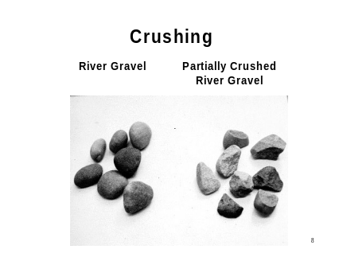 | _____________________________________________________________________________________________________________________________________________________________________________________________________________________________________________________
Slide 9 | 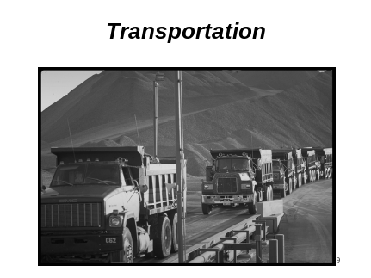 | _____________________________________________________________________________________________________________________________________________________________________________________________________________________________________________________
Slide 10 | 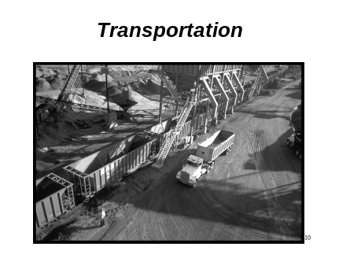 | _____________________________________________________________________________________________________________________________________________________________________________________________________________________________________________________
Slide 11 | 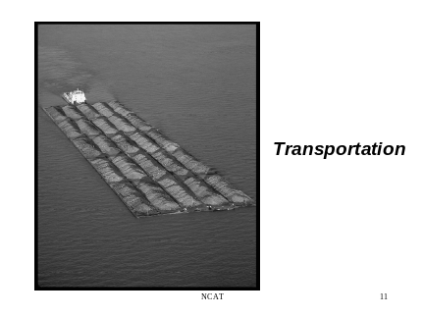 | _____________________________________________________________________________________________________________________________________________________________________________________________________________________________________________________
Slide 12 | 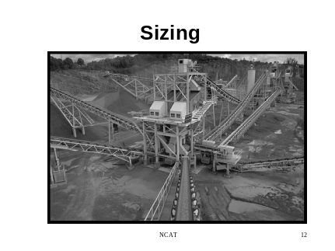 | _____________________________________________________________________________________________________________________________________________________________________________________________________________________________________________________
Slide 13 | 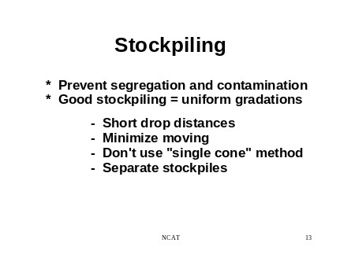 | _____________________________________________________________________________________________________________________________________________________________________________________________________________________________________________________
Slide 14 | 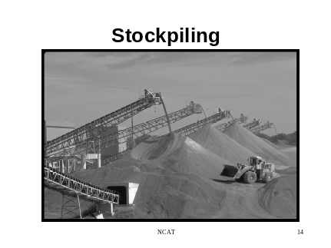 | _____________________________________________________________________________________________________________________________________________________________________________________________________________________________________________________
Slide 15 | 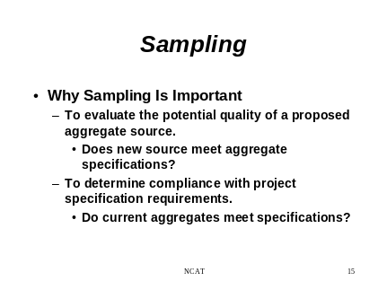 | _____________________________________________________________________________________________________________________________________________________________________________________________________________________________________________________
Slide 16 | 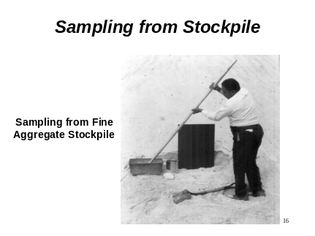 | _____________________________________________________________________________________________________________________________________________________________________________________________________________________________________________________
Slide 17 | 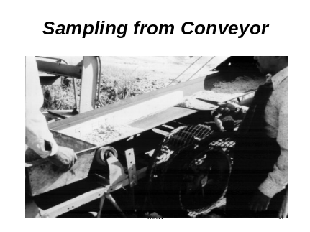 | _____________________________________________________________________________________________________________________________________________________________________________________________________________________________________________________
Slide 18 | 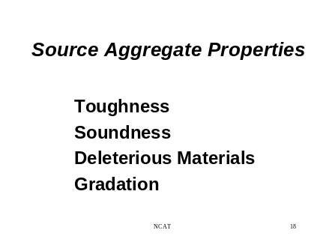 | _____________________________________________________________________________________________________________________________________________________________________________________________________________________________________________________
Slide 19 | 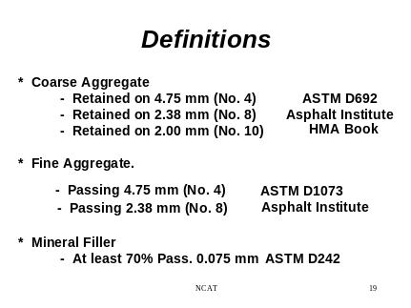 | _____________________________________________________________________________________________________________________________________________________________________________________________________________________________________________________
Slide 20 | 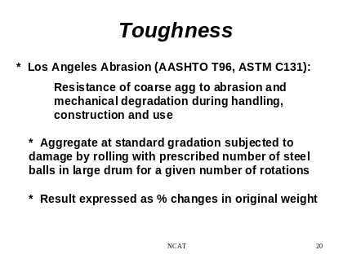 | _____________________________________________________________________________________________________________________________________________________________________________________________________________________________________________________
Slide 21 | 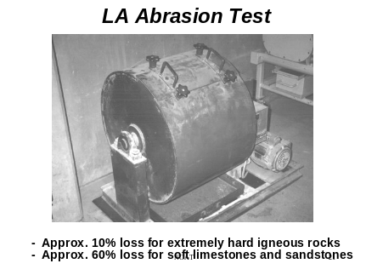 | _____________________________________________________________________________________________________________________________________________________________________________________________________________________________________________________
Slide 22 | 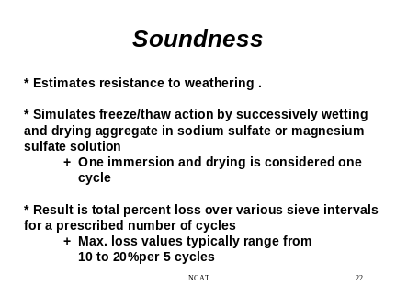 | _____________________________________________________________________________________________________________________________________________________________________________________________________________________________________________________
Slide 23 | 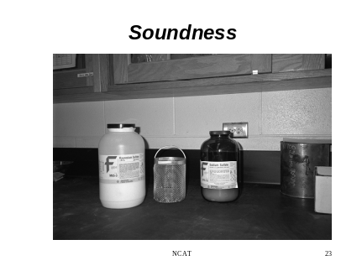 | _____________________________________________________________________________________________________________________________________________________________________________________________________________________________________________________
Slide 24 | 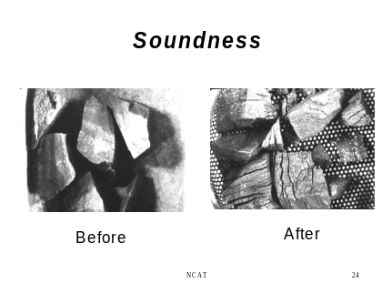 | _____________________________________________________________________________________________________________________________________________________________________________________________________________________________________________________
Slide 25 | 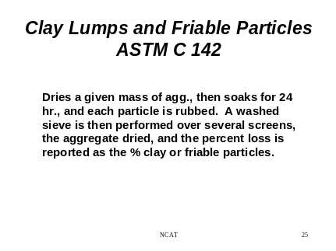 | _____________________________________________________________________________________________________________________________________________________________________________________________________________________________________________________
Slide 26 | 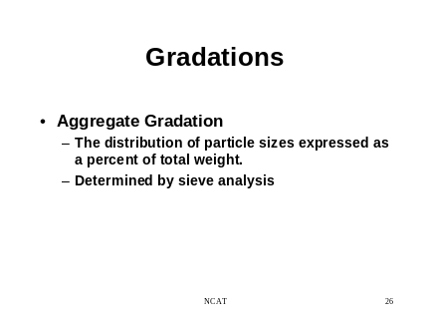 | _____________________________________________________________________________________________________________________________________________________________________________________________________________________________________________________
Slide 27 | 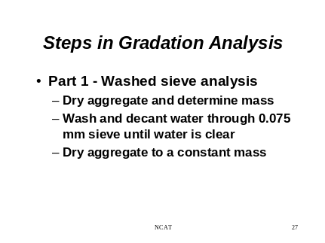 | _____________________________________________________________________________________________________________________________________________________________________________________________________________________________________________________
Slide 28 | 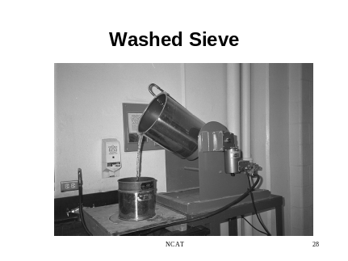 | _____________________________________________________________________________________________________________________________________________________________________________________________________________________________________________________
Slide 29 | 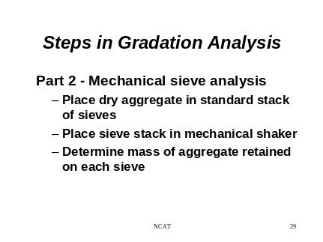 | _____________________________________________________________________________________________________________________________________________________________________________________________________________________________________________________
Slide 30 | 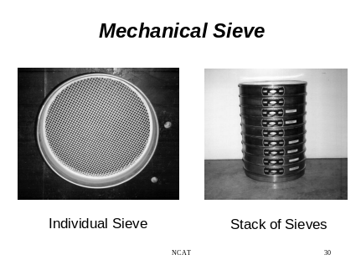 | _____________________________________________________________________________________________________________________________________________________________________________________________________________________________________________________
Slide 31 | 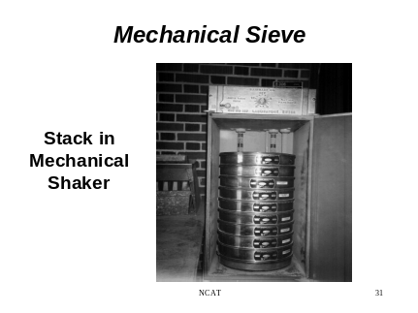 | _____________________________________________________________________________________________________________________________________________________________________________________________________________________________________________________
Slide 32 | 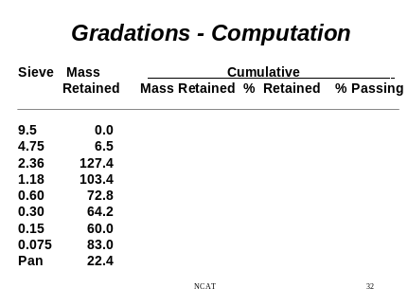 | _____________________________________________________________________________________________________________________________________________________________________________________________________________________________________________________
Slide 33 | 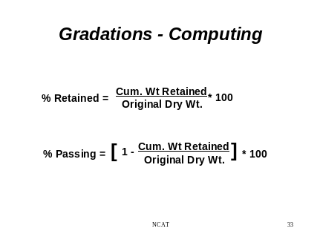 | _____________________________________________________________________________________________________________________________________________________________________________________________________________________________________________________
Slide 34 | 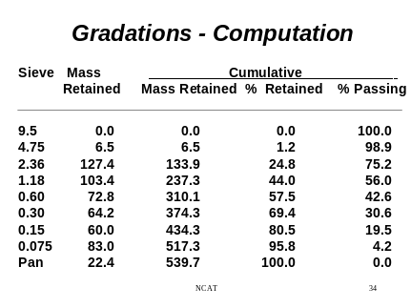 | _____________________________________________________________________________________________________________________________________________________________________________________________________________________________________________________
Slide 35 |   

