PROTON DRIVER PROPOSED LAYOUT
JUNE 2005
SITE PHOTO TOUR – RIGHT CLICK ON NUMBERED HYPERLINKS IN PHOTO TO OPEN HYPERLINK, AND TO SEE FIELD CONDITIONS
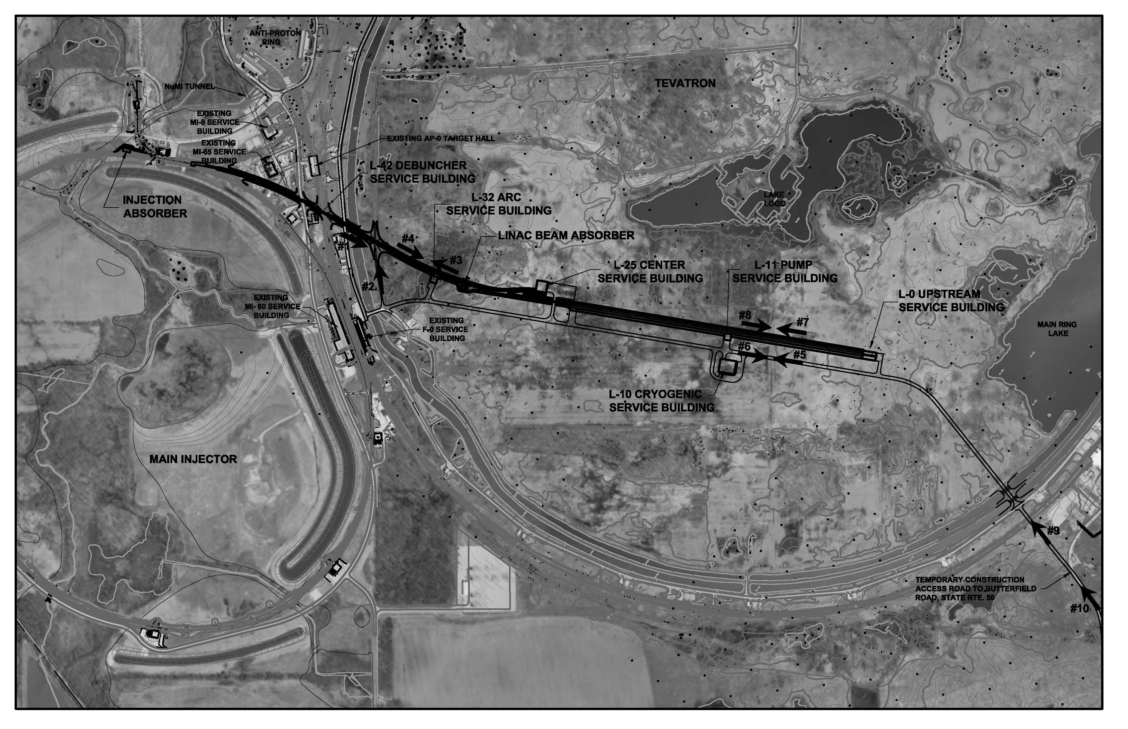

1 4
3
2
8
7
6
5

9

10
FOR MORE PHOTOS DOWN SWENSEN FARM RD, SEE NEXT PHOTO
7
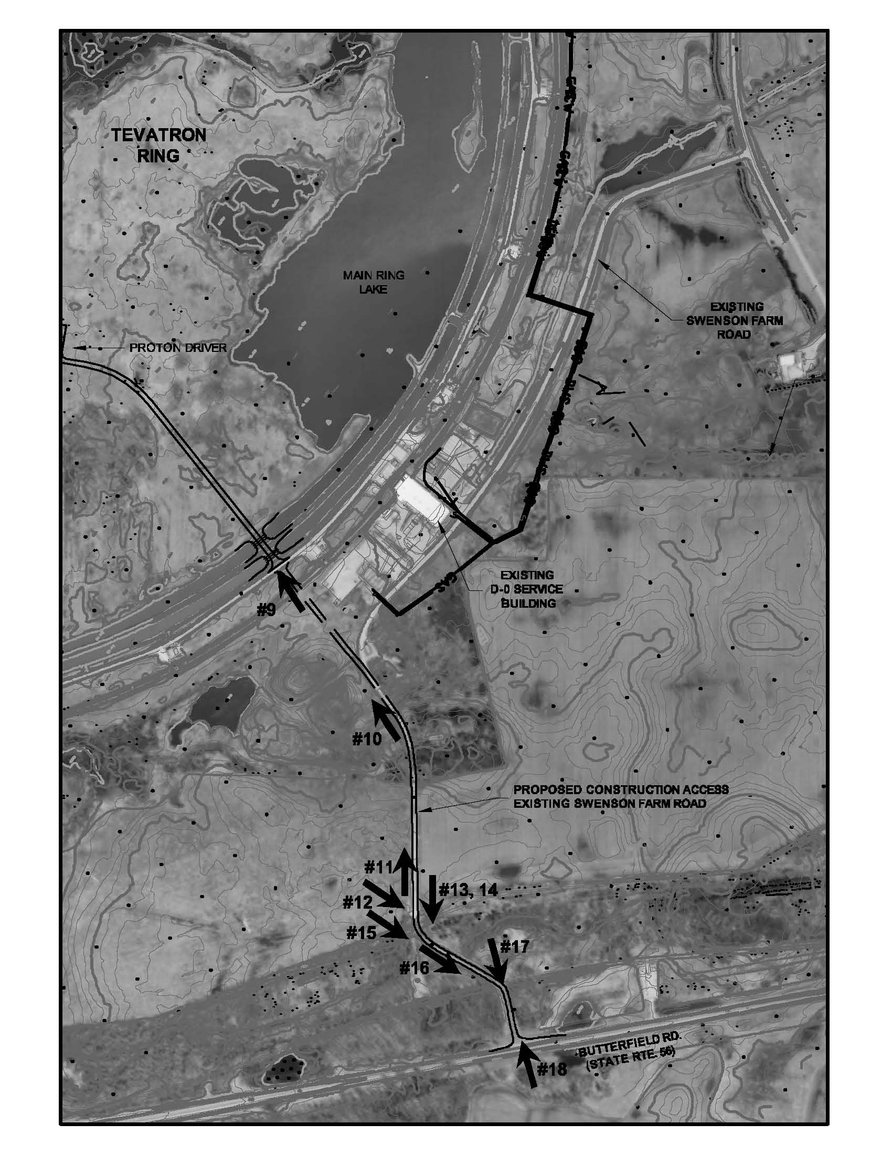

9

10

11
13 14

12
15 17

16

18
FOR MORE PHOTOS ALONG PROTON DRIVER ALIGNMENT, SEE PRIOR PHOTO

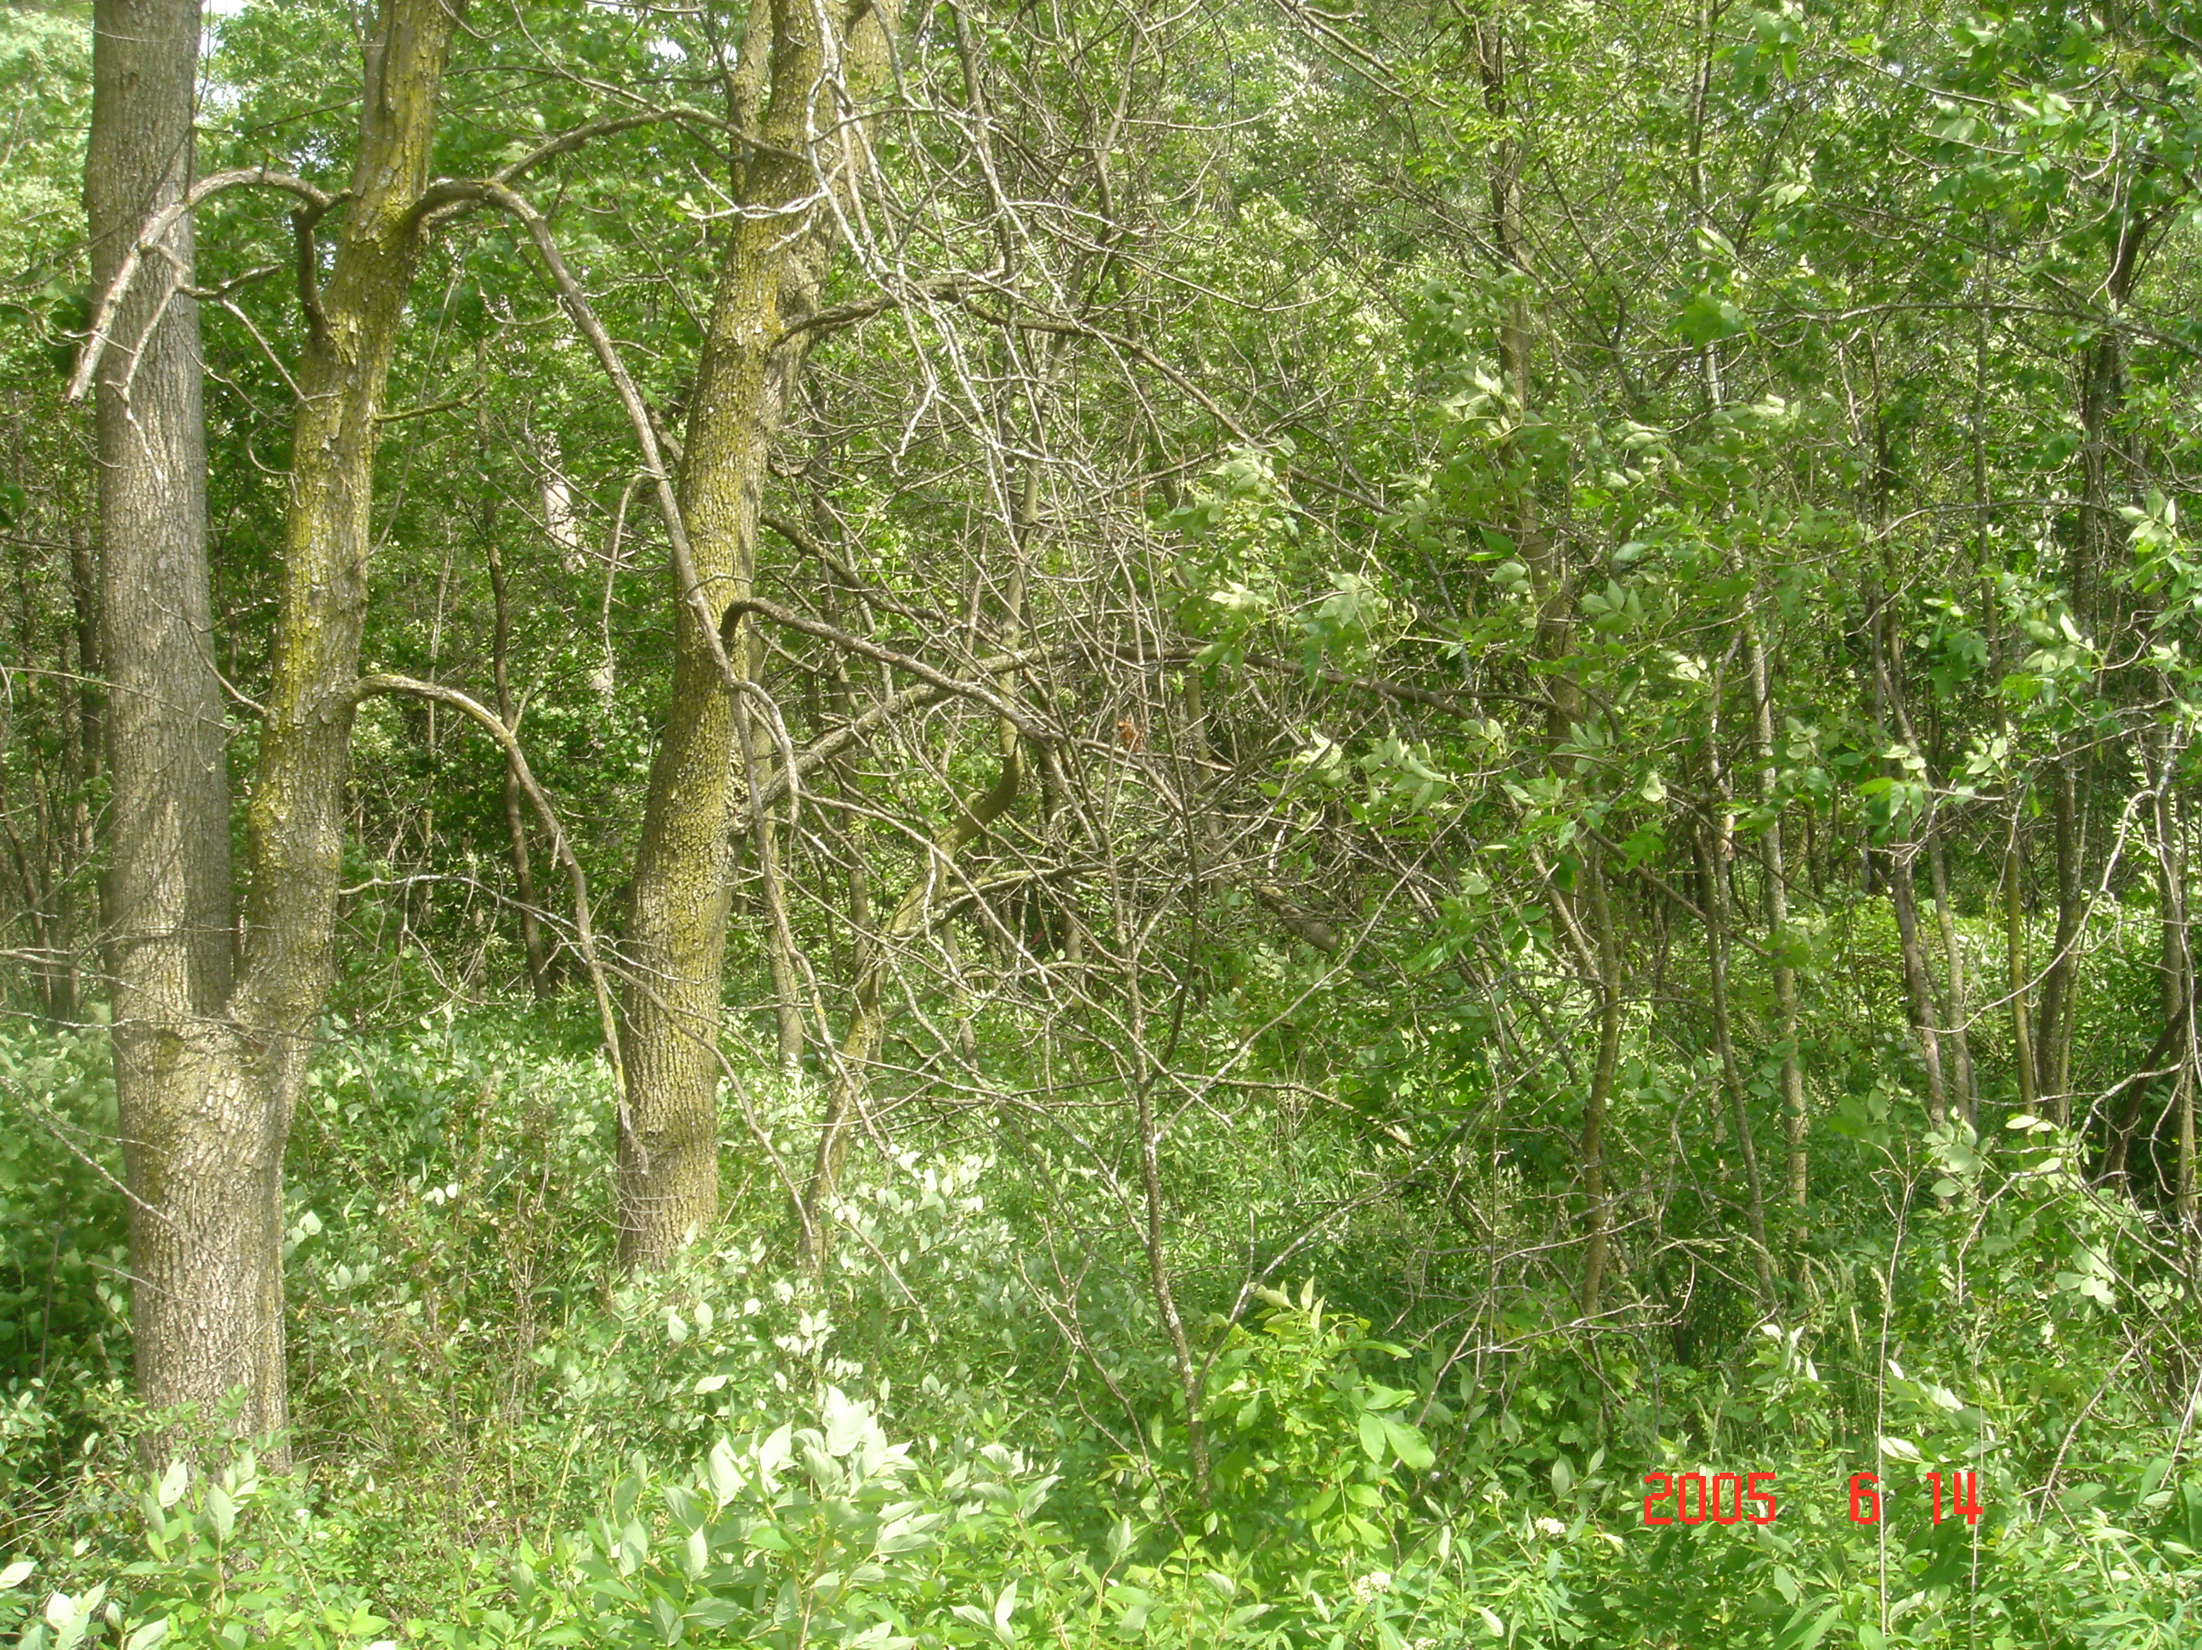

Photo #1
Proton Driver Beam Line – Looking ESE from Old Kautz Rd. into wooded area

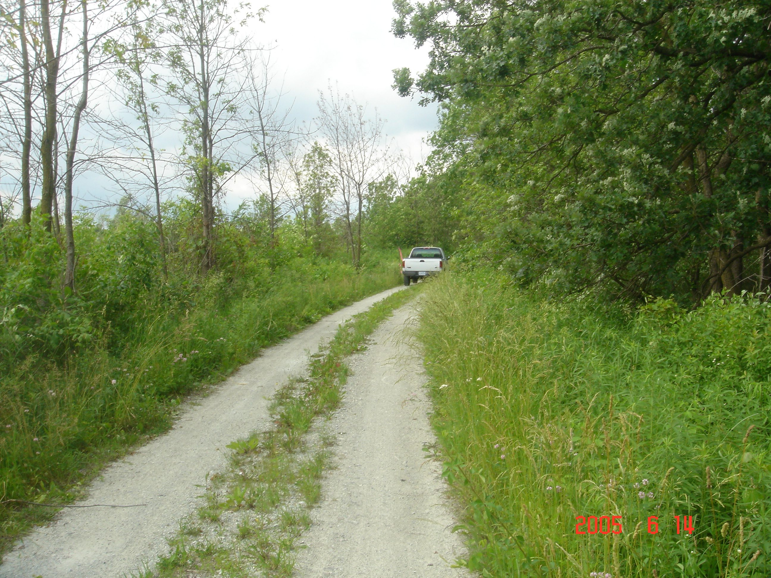

Photo #2
Proton Driver Beam Line Point along west side of Old Kautz Rd. looking north

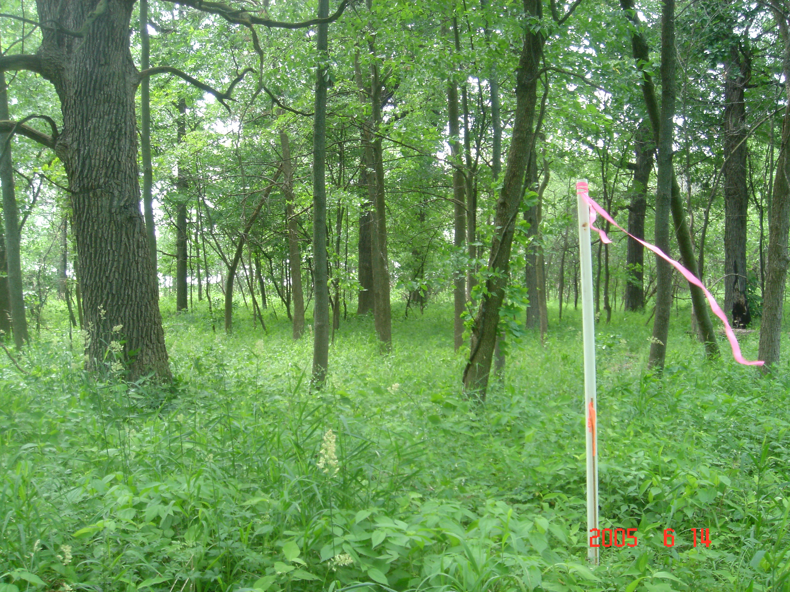

Photo #3
Proton Driver Beam Line- Beam point approx. 375’ east of Old Kautz Rd. looking west (Downstream Beam)

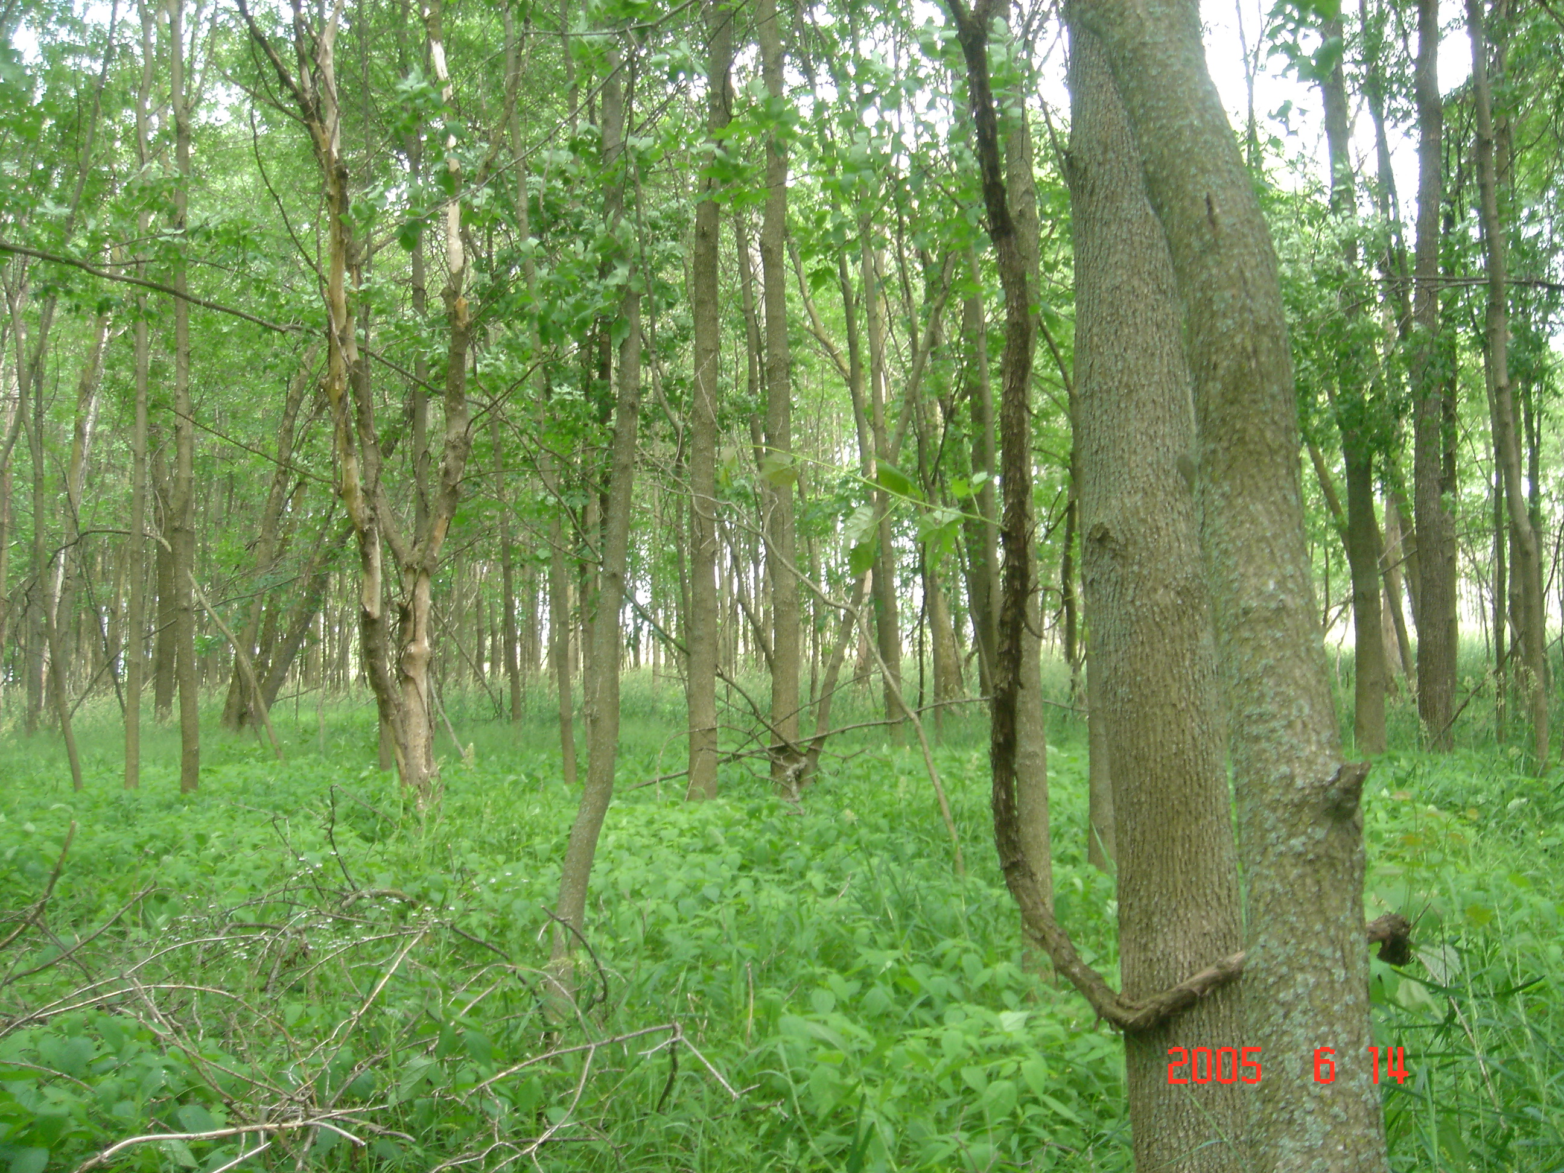

Photo #4
Proton Driver Beam Line – Same location as previous point looking east (Upstream Beam)

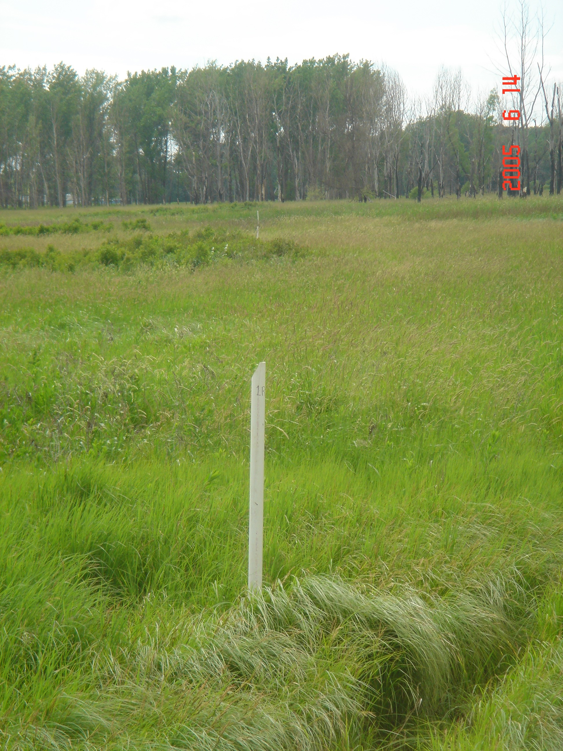

Photo #5
Proton Driver Beam Line – C/L Road Alignment approx. 350’ east of L-10 Cryo Bldg. Looking west (Downstream)

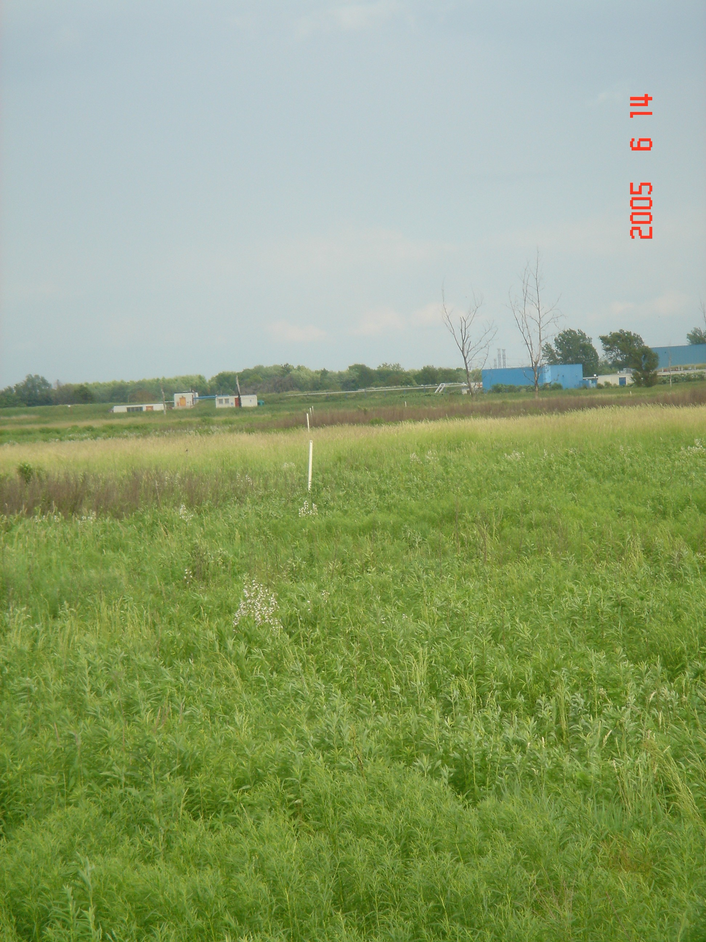

Photo #6
Proton Driver Beam Line – Road Alignment same as previous point looking east (Upstream)

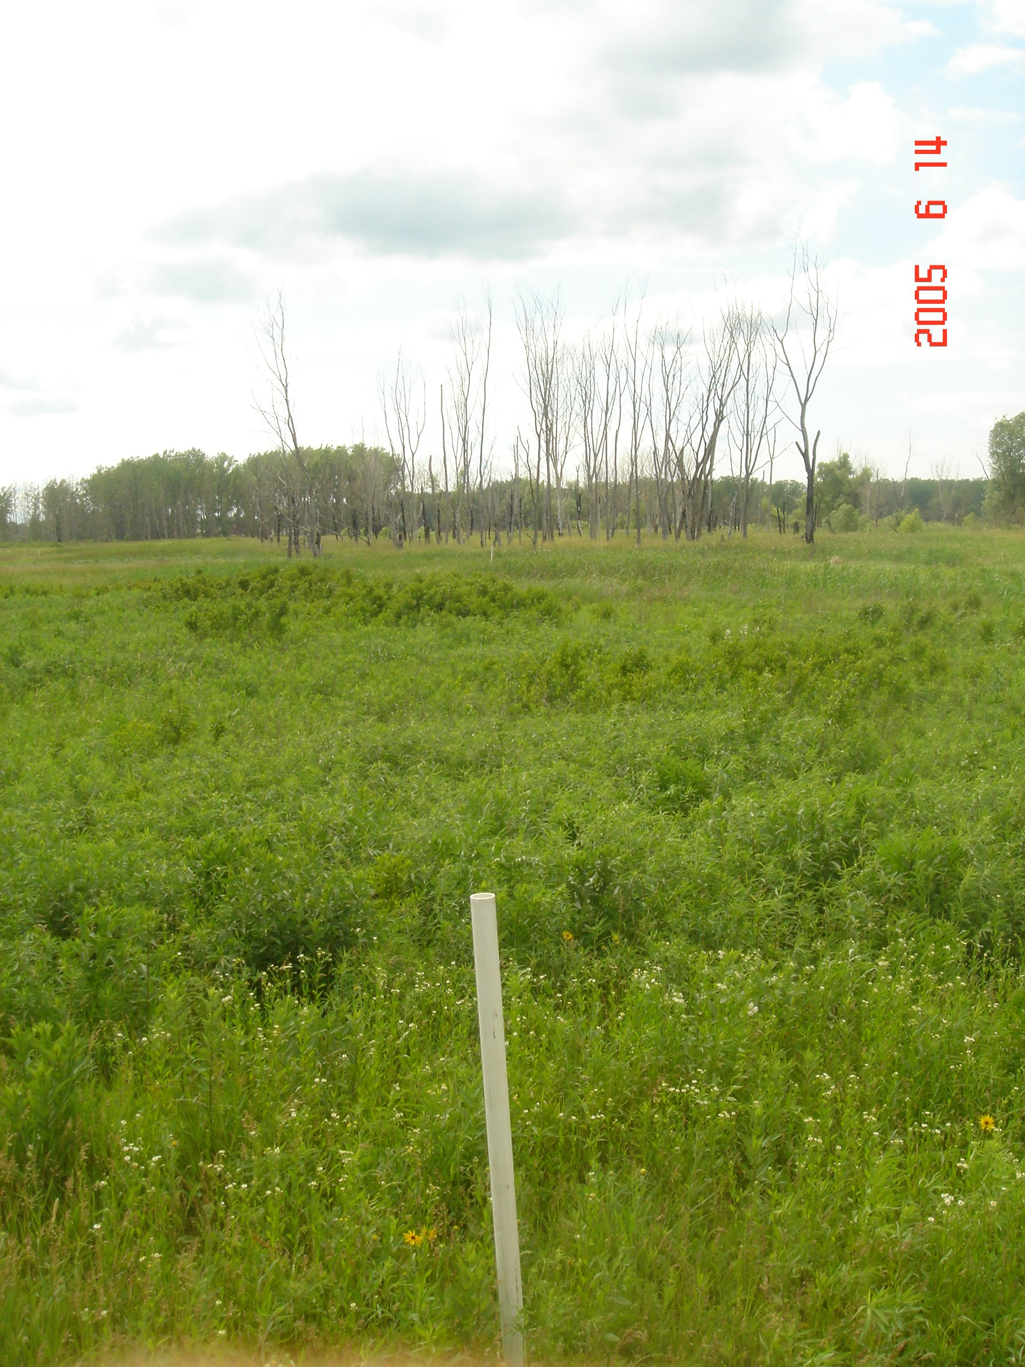

Photo #7
Proton Driver Beam Line – C/L Beam Alignment approx. 350’ east of L-10 Cryo Bldg. looking west (Downstream)

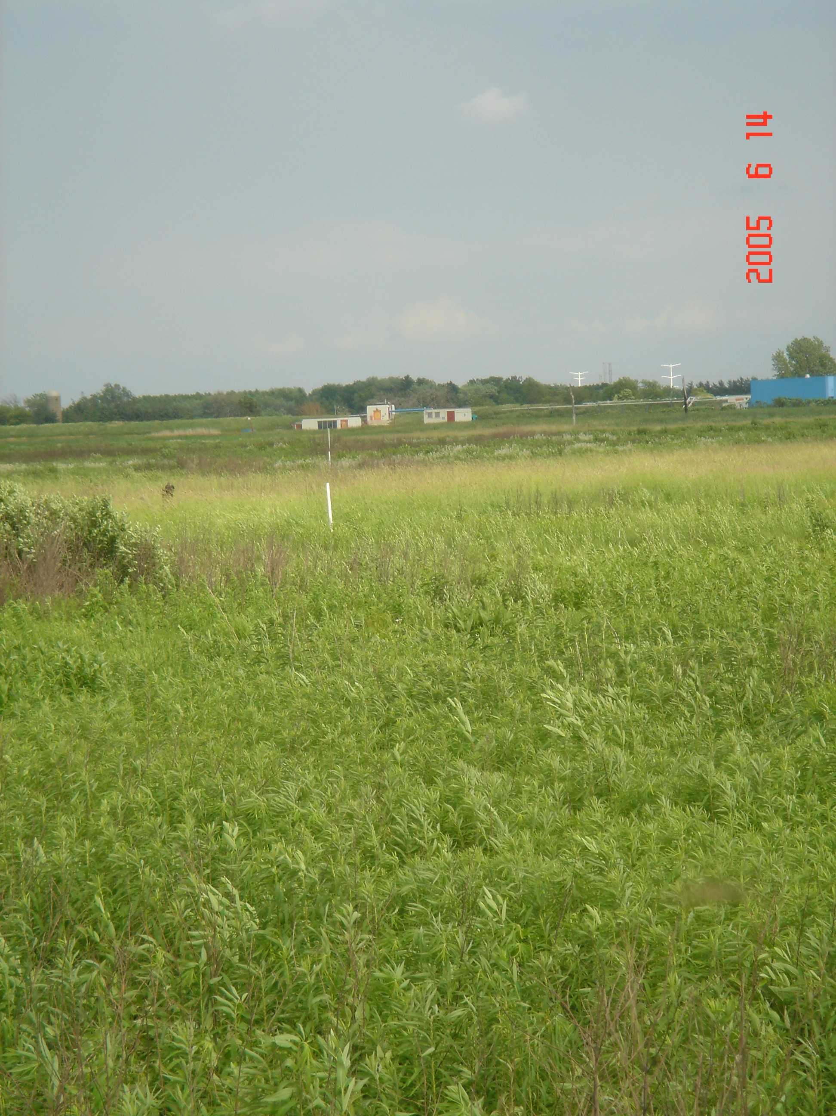

Photo #8
Proton Driver Beam Line – Same as previous point looking east (Upstream)

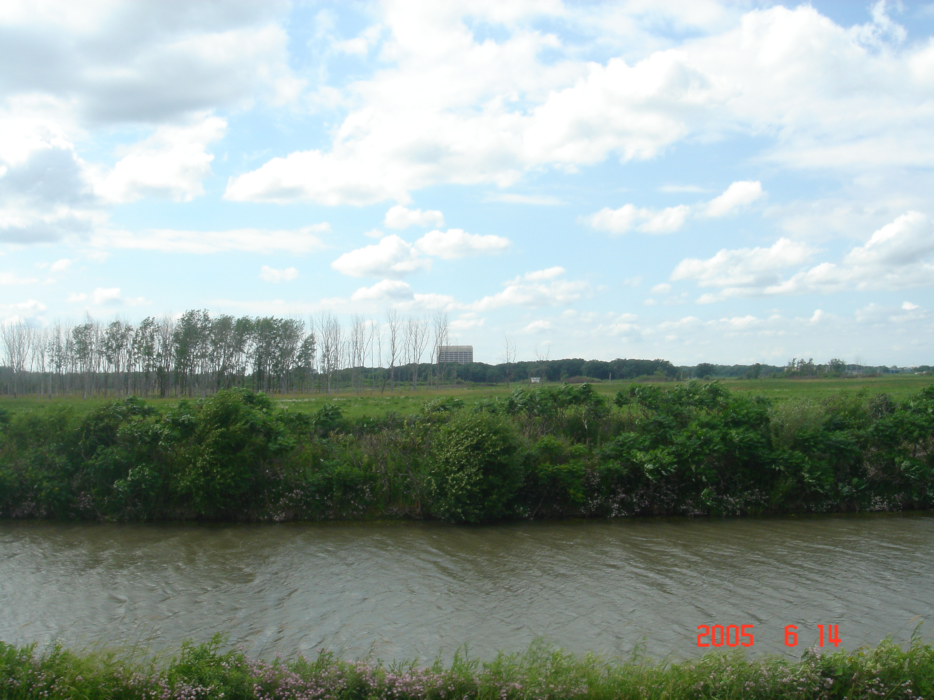

Photo #9
Proton Driver Beam Line – C/L Road Alignment from Main Ring Road intersection

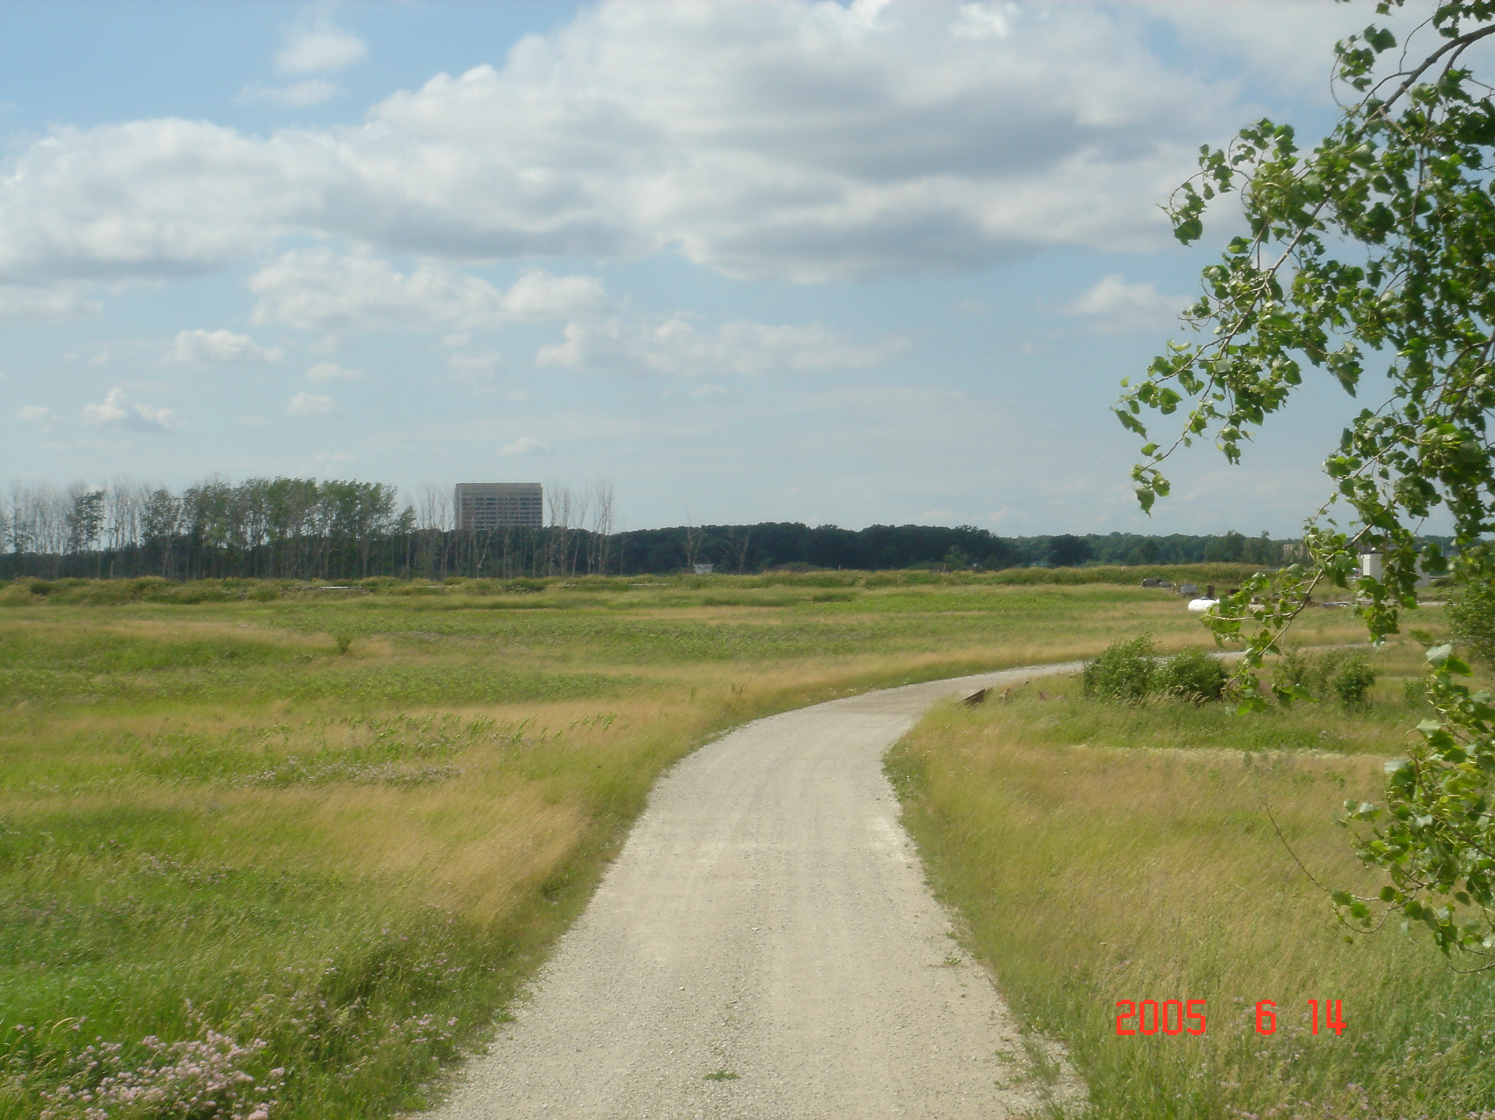

Photo #10
Proton Driver Beam Line – Photo taken looking NW along Swenson Farm Rd. and future road alignment that will tie into existing road for use as construction access.

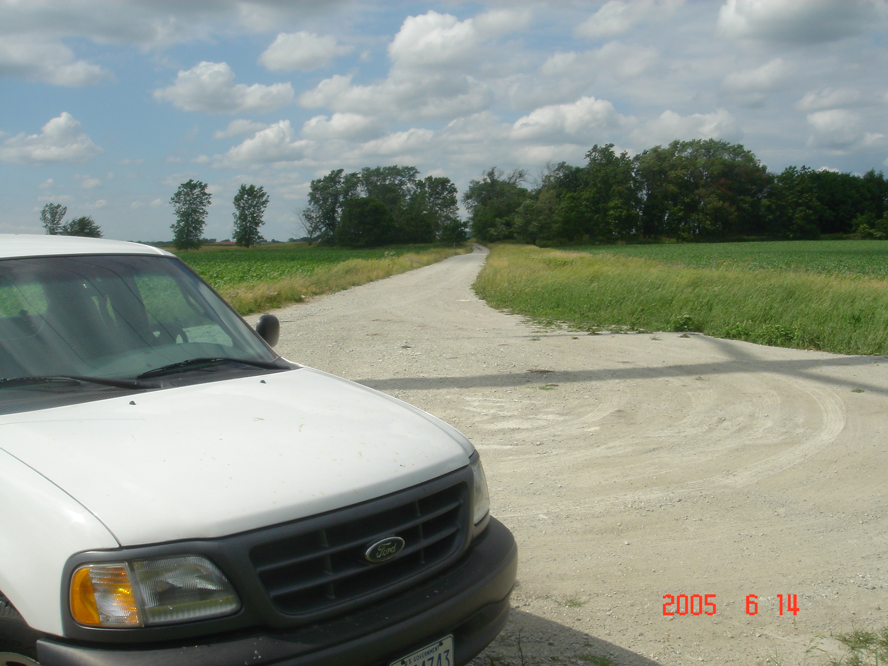

Photo #11
End of existing Swenson Farm Rd., looking north, at Kautz Rd Substation transmission line alignment.

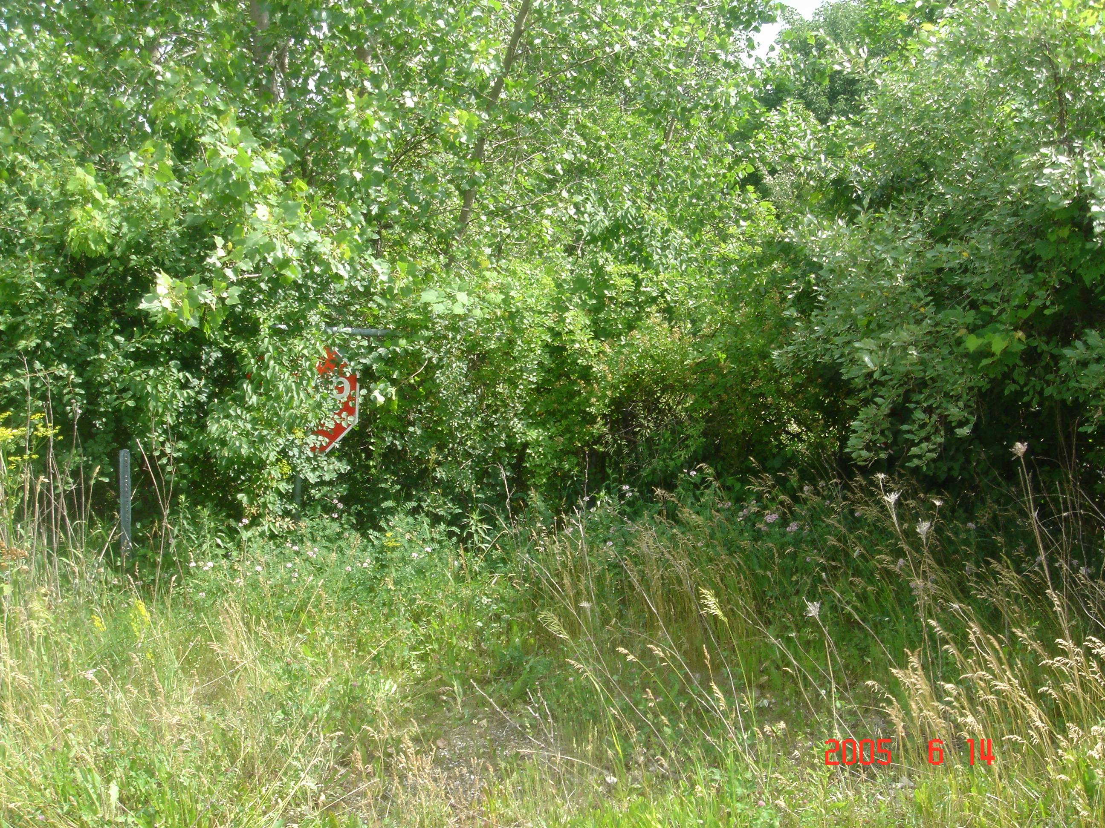

Photo #12
End of existing Swenson Farm Rd., looking south, at Kautz Rd Substation transmission line alignment. Existing double swing chain link gates shown overgrown with vegetation leading to old Construction Access road from Butterfield Rd.

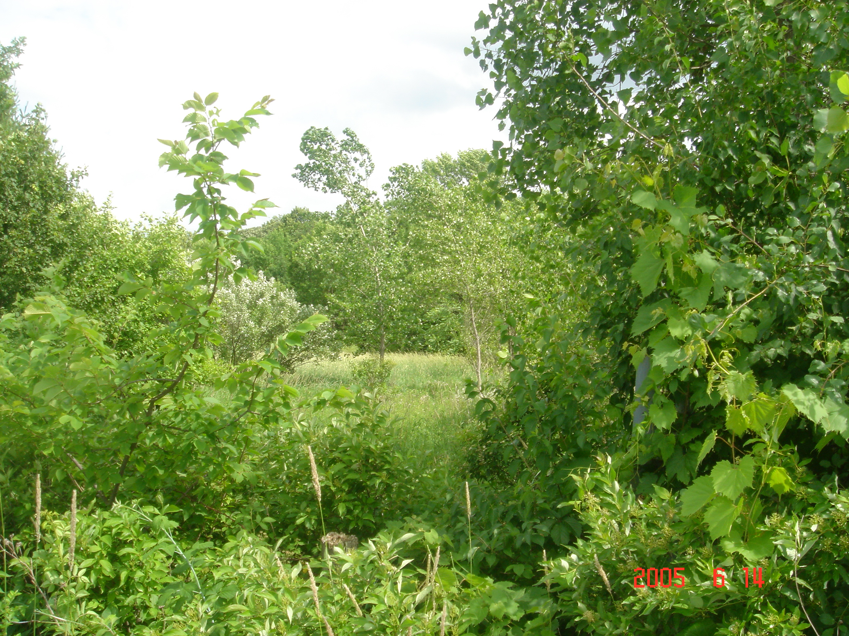

Photo #13
Old Construction Access road alignment, photo taken looking south from end of Swenson Farm Rd.

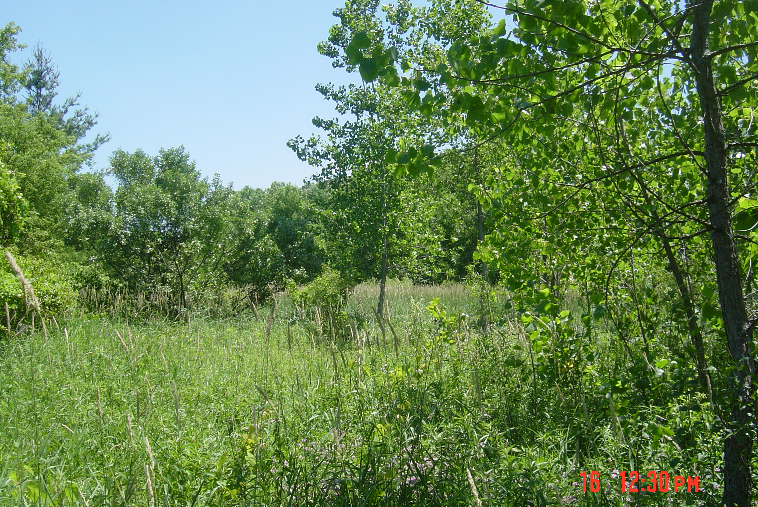

Photo #14
Just south of the end of Swenson Farm Road, facing south along old road alignment. Width of hardstand at this point is ~75 ft.

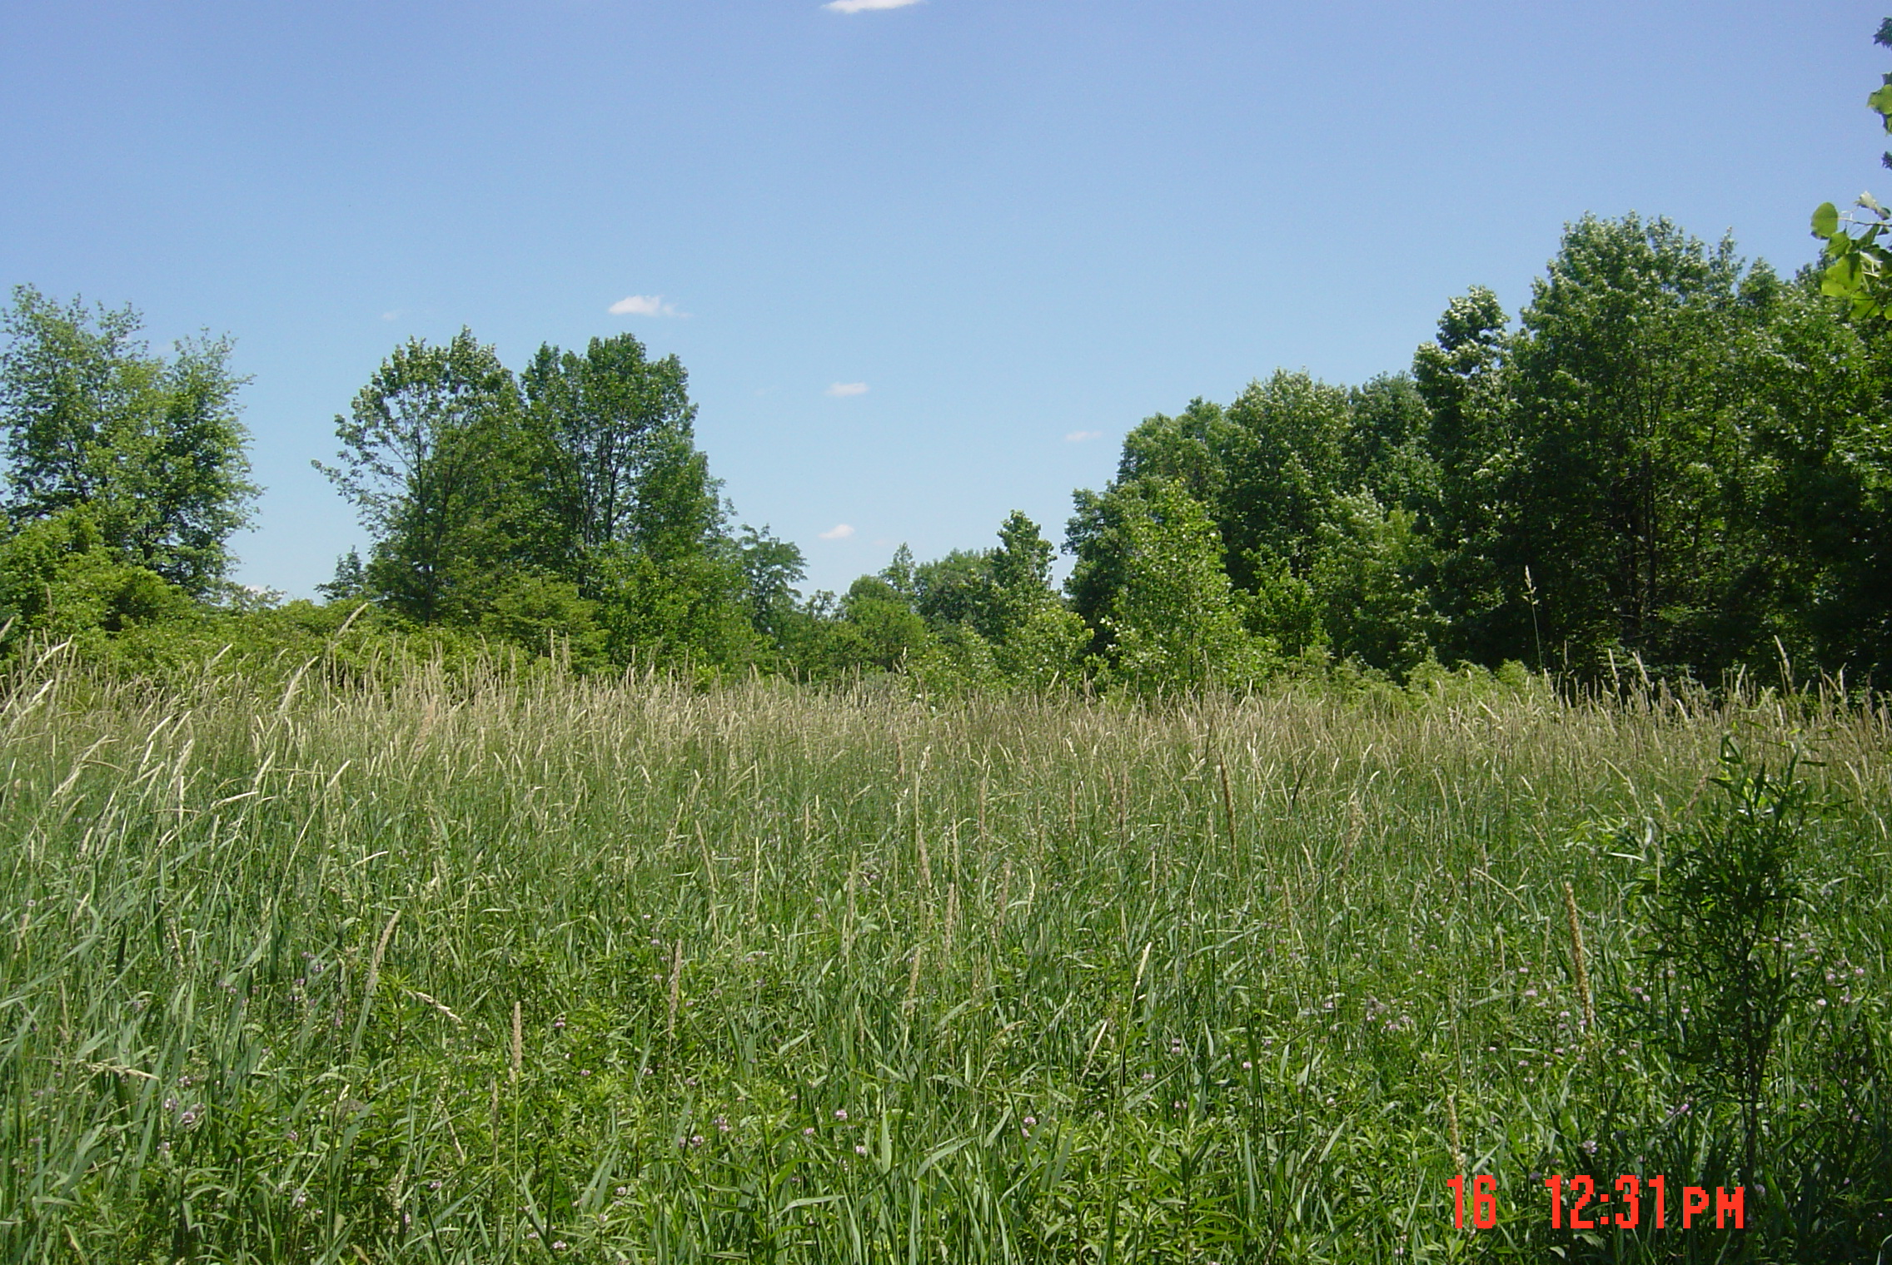

Photo #15
At the first bend, facing approx. southeast.

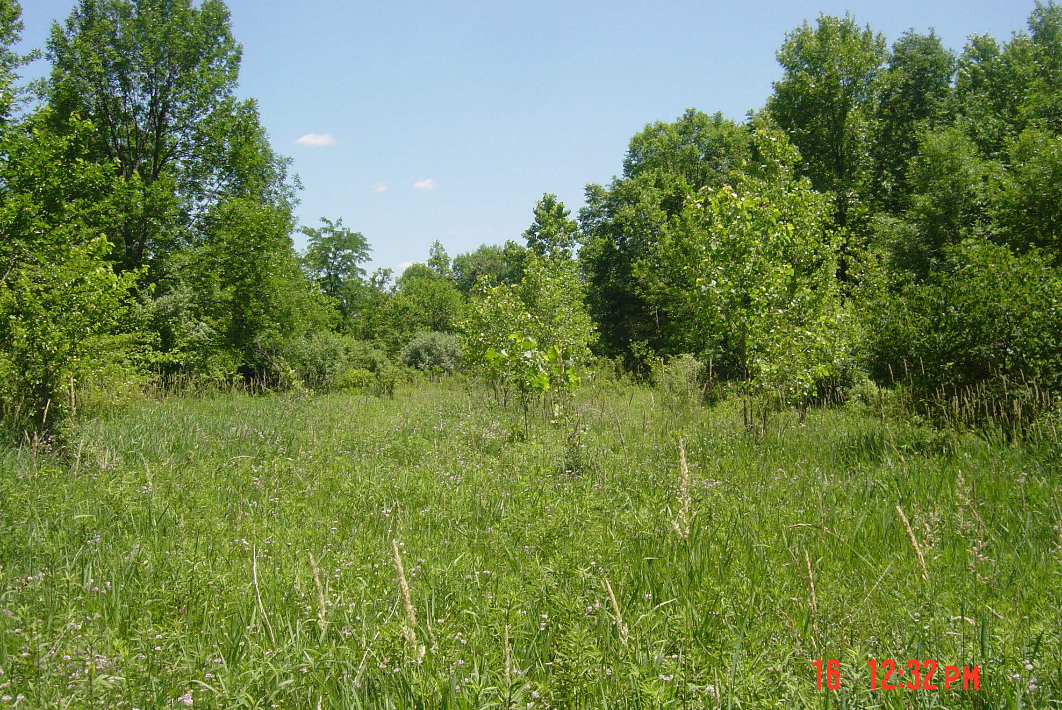

Photo #16
Approx. half way along the northwest-southeast orientation, facing southeast.

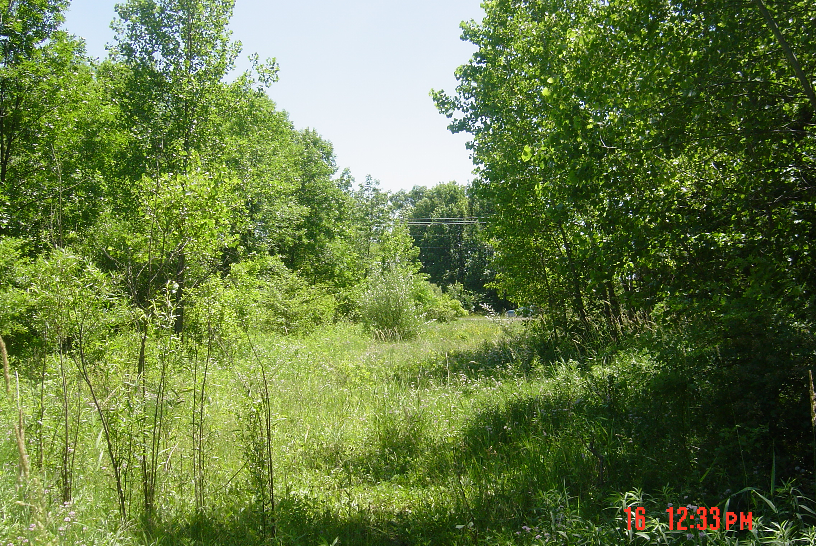

Photo #17
At the bend where the road turns back to the south, facing south. Butterfield Road is visible.

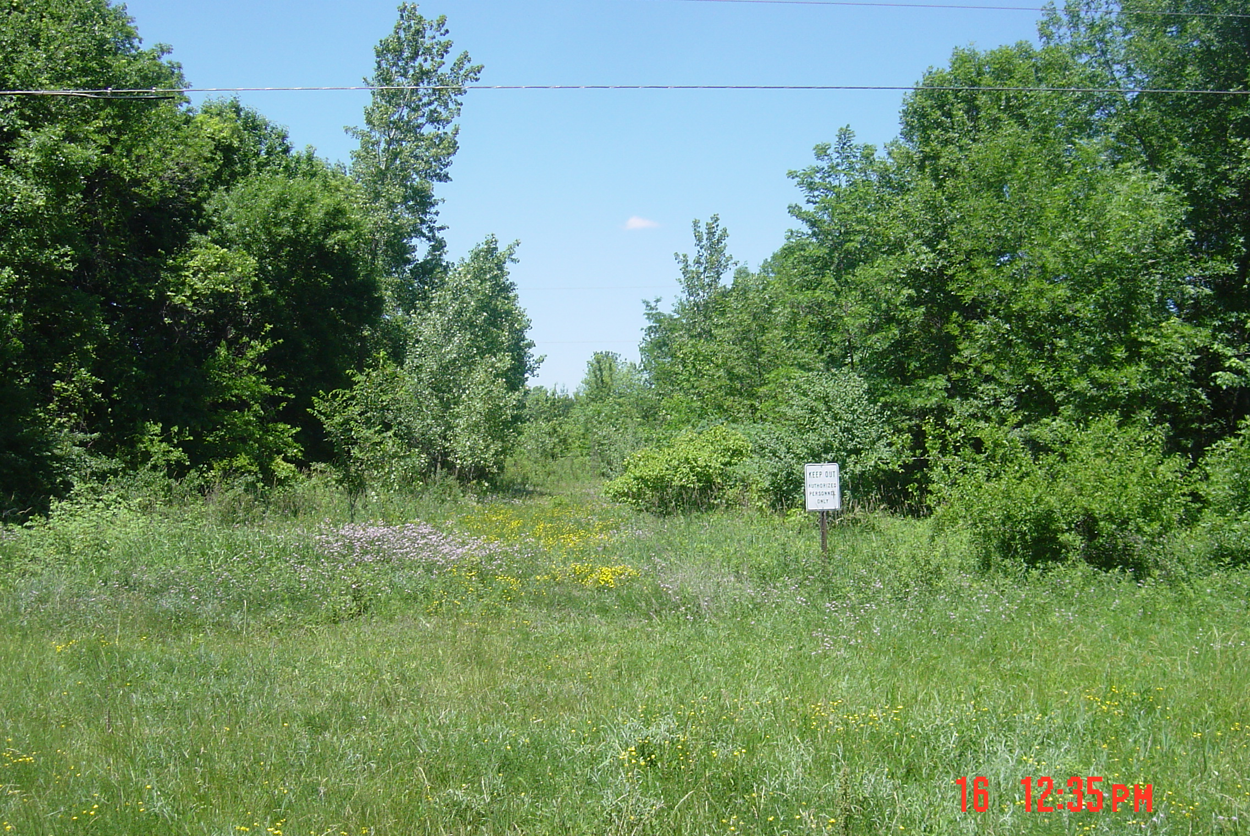

Photo #18
From Butterfield Road, facing north into the Lab along old alignment.

