GARLAND COMMUNITY COLLEGE


Garland County Community College

100 College Drive  Post Office Box 3470  Mid-America Park
Hot Springs National Park, Arkansas 71914-3470  (501) 767-9371
DIVISION OF HEALTH SCIENCE
DEPARTMENT OF EMERGENCY MEDICAL TECHNOLOGY

August 25, 1995

Dr. Wayne Blanchard
FEMA-EMI
Building N, Room 200
16825 South Seton Avenue
Emmitsburg, MD 21727

Dear Dr. Blanchard:

Thank you for your interest and support during the development of our Emergency Services Management Degree.

I am enclosing the Proposal we submitted to the Arkansas Board of Education, and the approval letter for the program we received from the Arkansas Department of Higher Education. You are free to provide copies of this document to whomever you desire, and we trust that it will be of help in gaining approval for other programs.

If I can be of further assistance, please feel free to contact me.

Sincerely,


LAWRENCE A. McWHERTER, B.S., NREMT-P
Program Director

GARLAND COUNTY COMMUNITY COLLEGE
HOT SPRINGS, ARKANSAS

EMERGENCY SERVICES MANAGEMENT
DEGREE HIGHLIGHTS

- Garland County Community College is offering an Associate in Applied Science Degree in Emergency Services Management. This degree is designed to allow Emergency Managers and related professions a resource for academic recognition of their educational work.
- This degree was designed with the cooperation of the Emergency Management Institute at Emmitsburg, Maryland, and incorporates those EMI courses which are basic to emergency management.
- The Technical Specialty courses are offered in a seminar format based on a forty hour week rather than a full semester basis. This allows wider participation in allowing us to draw students statewide rather than in the local community alone.
- With the addition of the Degree in Emergency Services Management, we now offer A.A.S. degrees in Criminal Justice, Fire Suppression, Emergency Medical Services and Emergency Services Management, which makes us a full spectrum provider of emergency education, the only such provider in the State of Arkansas.
- The Emergency Services Management Degree requires a total of 64 Student Semester Credit Hours of which 38 hours are General Education and 26 hours are Technical Specialty hours. Upon completion, the student will have a well rounded knowledge of emergency management subjects, as well as a strong background in writing, communications arts, and other subject areas related to management of emergencies.
- Altogether, this degree program will help emergency managers to attain “professional” acceptance, while academically rewarding their work.

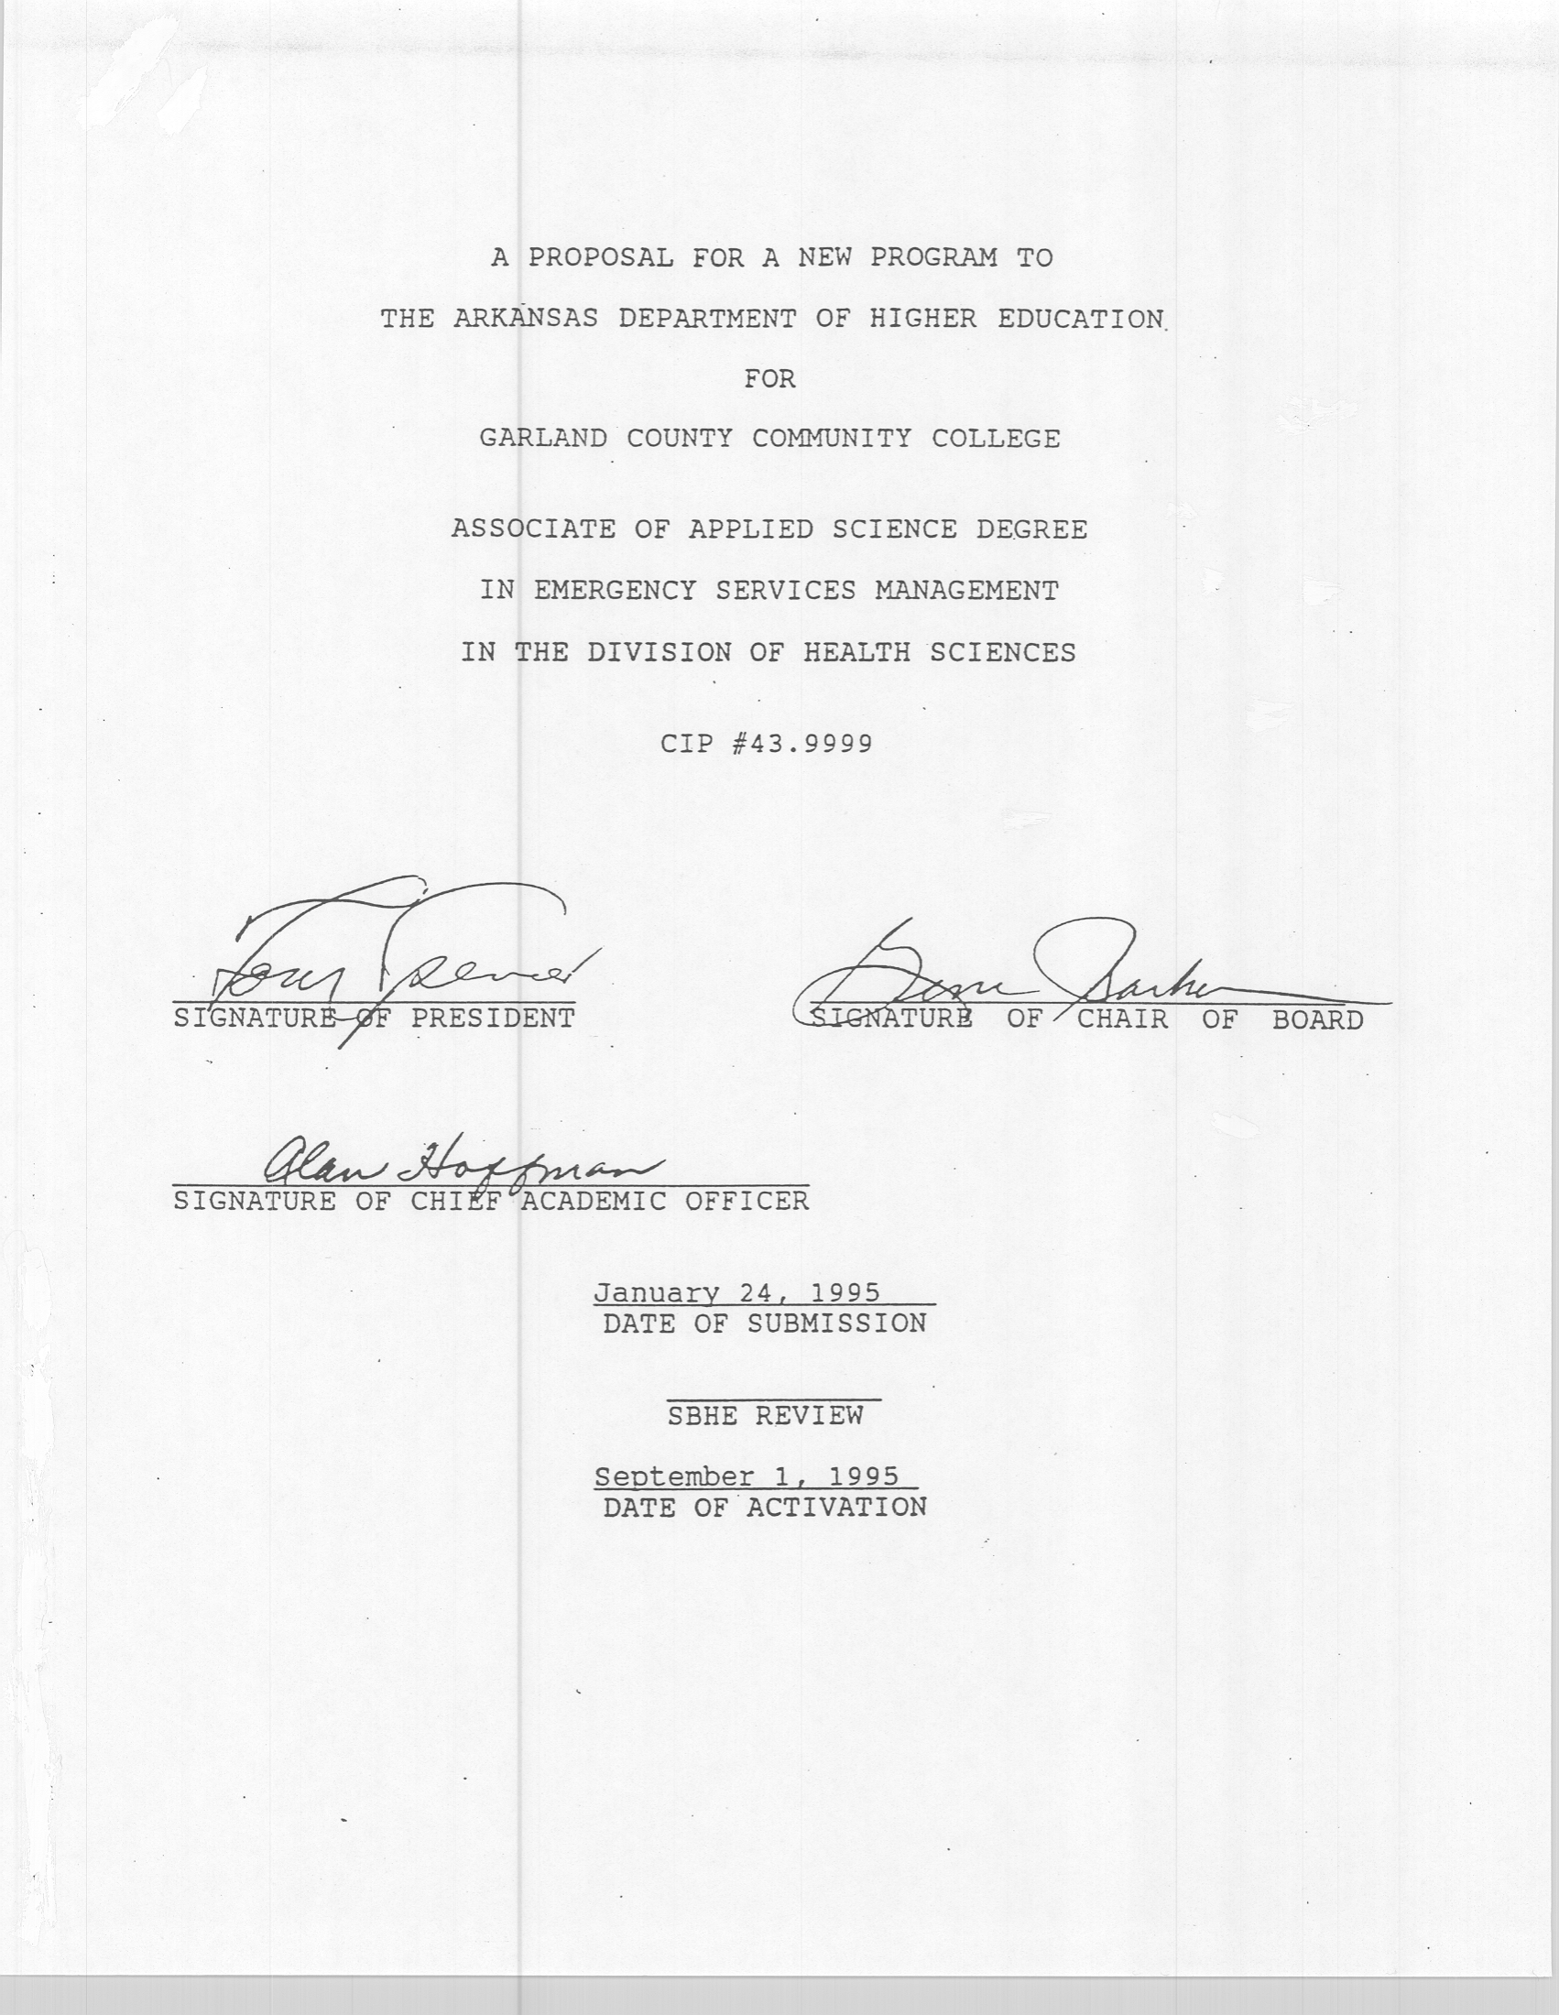

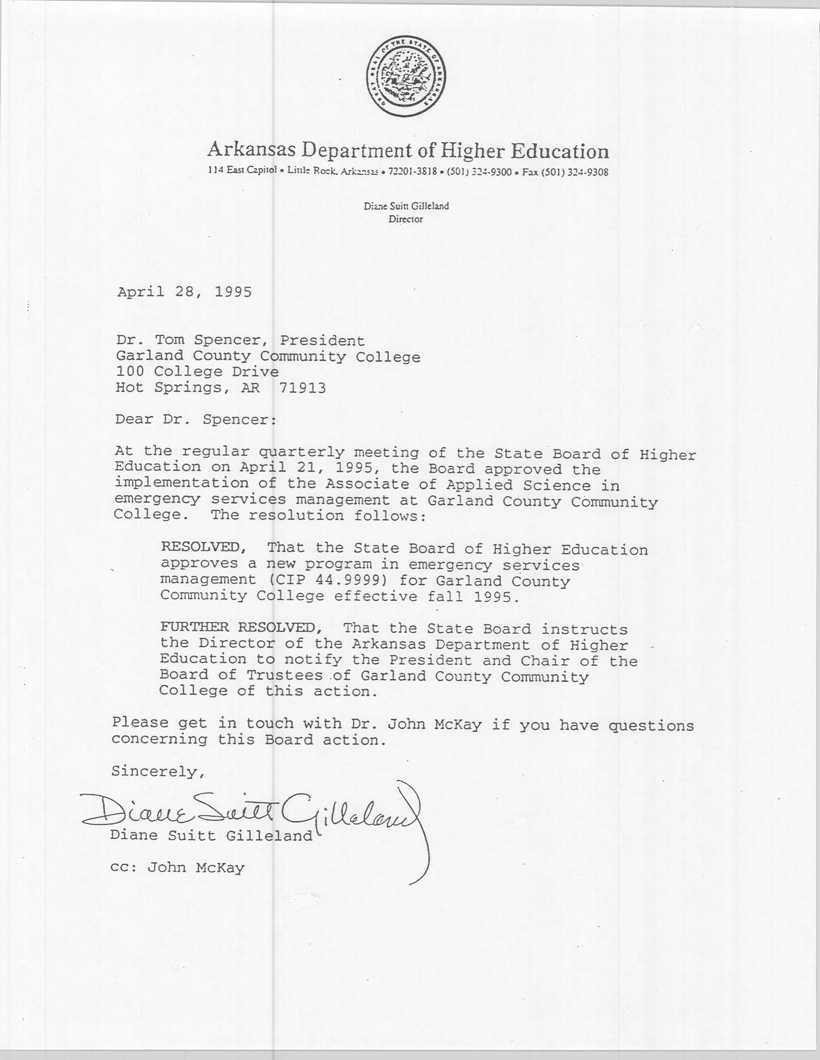
PROPOSAL INDEX

I. |  | General Description |  | 1
II. |  | Institutional Mission and Scope |  | 2
III. |  | Availability of Students |  | 5
IV. |  | Program Need |  | 5
V. |  | Program Duplication |  | 6
VI. |  | Administration of the Program |  | 6
VII. |  | Faculty Resources |  | 7
VIII. |  | Curriculum |  | 7
IX. |  | Library Resources |  | 8
X. |  | Physical Facilities |  | 10
XI. |  | Program Equipment |  | 10
XII. |  | Academic Foundations |  | 10
XIII. |  | Program Enrollment Requirements |  | 11
XIV. |  | Research Arrangements for Graduate Faculty Members |  | 11
XV. |  | Funds for Doctoral Fellowships and Assistantships |  | 11
XVI. |  | Approval |  | 11
XVII. |  | Accreditation |  | 11
XVIII. |  | Desegregation Impact |  | 12
XIX. |  | Program Cost and Financing |  | 13
XX. |  | Productivity |  | 13
“Emergency Management Curriculum” |  |  | Attachment A
“Productivity Records” |  |  | Attachment B
“Curriculum Vitae” |  |  | Attachment C
“NCA Statement of Affiliation Status” |  |  | Attachment D
“Program Cost and Financing” |  |  | Attachment E
“Emergency Management Institute Letter” |  |  | Attachment F

o
PROPOSAL NARRATIVE

- General Description

Emergency Services Management is the science of planning for, mitigating, responding, and recovering from disasters. Garland County Community College currently offers Associate in Applied Science Degrees in Emergency Medical Services, Fire Protection, and Criminal Justice. Each of our current degree programs target certain aspects of disaster response, however do not actually tie them all together. Each Emergency Response Agency (i.e., Fire, Law Enforcement, Emergency Medical Services, County OES employees, Red Cross, etc.) require the base knowledge offered by this curriculum. No institution in Arkansas currently offers such a degree curriculum.

Courses for the Technical Specialty portion of this proposed curriculum were selected based on recommendations from the staff of the Emergency Management Institute (EMI) of Emmitsburg, Maryland (Attachment F). The Emergency Management Institute is the training arm of the Federal Emergency Management Agency (FEMA), which is an entity of the United States Government. The Emergency Management Institute provides training to enhance U.S. emergency practices through a nationwide program of resident and non-resident instruction. The Emergency Management Institute have approximately 4,000 students attending EMI courses in residence annually, while providing sponsorship for training programs conducted by State agencies which train another 60,000 students per year. Most of the courses offered by the Emergency Management Institute have been recommended for credit equivalency under the Non-Collegiate Sponsored Instruction Program of the American Council on Education (ACE). Credit recommendations can be found in “THE GUIDE FOR EDUCATIONAL TRAINING PROGRAMS”.

Courses needed for the Associate of Applied Sciences Degree in Emergency Services Management are either 1) available through the Emergency Management Institute and are approved by the American Council on Education (ACE) or, 2) courses already approved by the Curriculum Committee and taught on sufficient student demand. In order to satisfy residency requirements from Garland County Community College, a student must complete a minimum of 18 student semester credit hours with the college. To fulfill degree requirements, it is our intention to accept transfer credits within the College’s policy for work done at other accredited institutions; and to accept transfer of ACE credits from agencies sponsoring the Emergency Management Institute training with appropriate documentation. Also, to insure maximum attendance possibilities at the Technical Specialty courses, it is our intention to offer these programs on a more intensive “seminar” basis, with the courses given on a 40 hour week basis, rather than a normal three hour per week for a full semester basis. We think that this will better serve the prospective student base and by doing this we will be able to draw students statewide rather than just locally

- Institutional Mission and Scope.

This proposal is consistent with the College mission and scope as quoted here from the 1994-1995 accreditation report to the North Central Association.

Garland County Community College is a public, open-door institution whose mission is:

    - to develop in each student a spirit of continuing inquiry;
    - to provide learning opportunities that help develop each student’s potential;
    - to advance general knowledge through access to a broad spectrum of academic disciplines;
    - to provide quality instruction under qualified faculty;
    - to provide a safe learning environment conducive to study and socialization;
    - to promote the expansion of higher order thinking skills in students, as well as ethical sensitivity and a personal value system;
    - to provide educational service to the community through consultation, technical assistance, continuing education, job training, and other activities for continued learning, growth and personal development.

Through this mission, the college strives to make collegiate education accessible to everyone. This commitment requires the wise use of limited resources without duplicating existing programs and services presently available in the community.

The college is committed to offering educational programs and services which help define an educated person. These characteristics include a level of education which allows someone to understand his/her culture in the larger context of the “global village.”
Additional characteristics include the development of problem-solving skills; quantification, analysis, synthesis and communication skills.

This vision, exemplified in the college’s mission, is to enhance the quality of life for each student and the Community.

Further, program objectives may be derived from the College Program Objectives:

Following this vision, program objectives are being developed, assessed, and revised to keep pace with the changing needs of students and the community. Therefore, the college is committed to provide the following essential program objectives:

- Comprehensive developmental courses and tutorial services to remediate basic skills needed by the students to function more successfully in the college and in the community.
- Occupational education/training/retraining opportunities which allow students to gain or advance in their employment, to seek a certificate or associate degree, to transfer academic course work to a university capstone program, or to meet personal objectives in gaining new knowledge.
- Enhancing transfer effectiveness, whether individual courses or associate degrees to other colleges and universities.
- General education courses, tailored for each type of associate degree, for the purpose of providing students with the basic foundation of learning

The college is also committed to providing student support services and administrative support services whereby students can achieve their educational goals and enhance their personal development. These include:

- Student service functions dependent on the state funding formula, such as the recruitment, admissions, academic advisement, testing/placement, registration, financial aid, and other activities that help students meet their college goals.
- Student support service functions dependent on federal or state grants, such as, Job Training Partnership Act, Single Parent/Homemaker, Supplemental Instructional Support program, Disabled Students, Student Support Services program, and the Learning Acceleration Center to enhance the student’s potential.
- Administrative support services that serve students, faculty, and staff, such as the library, bookstore, computer network system, administrative offices, maintenance, business office, and physical facilities.

The college is committed to acting as a leader in building connections beyond the campus and fostering partnerships within the community which are inspired by common goals. In addition to making college facilities available to the community, the college accepts the responsibility for providing:

- Activities which promote community, social, economic, and civic well being.
- Opportunities that expand cultural and artistic experiences.

In all of these endeavors Garland County Community College is committed to maintaining standards of achievement consistent with accredited collegiate institutions, and accessible learning opportunities that are made available at reasonable costs.

Underlined sections of the passages quoted above are especially applicable to this proposal.

III. Availability of Students

In a telephone conversation with our Program Director for EMS, Senator Charlie Cole Chaffin of Benton, advises that she received in excess of 200 responses from persons who were interested in a degree program during the period she was attempting to have a degree program such as this instituted in Arkansas. In polling the Arkansas Office of Emergency Services, they stated that there were 76 County Offices of Emergency Services each with one or more employees who were required to take much of the technical specialty material offered in this program.

Based on national trends toward higher education in emergency services management, it is reasonable to believe that this course offering would attract a minimum of 12 commuting students per year in this degree program. Here again, we think that the more intensive seminar format will attract students statewide.

IV. Need

Currently, there are no institutions of higher learning in the State of Arkansas offering any courses in Emergency Services Management. All county emergency managers for the Offices of Emergency Services are currently being required to take the emergency management courses, however they have no outlet to progress to a degree.

The need for good, thoroughly trained emergency managers has long been recognized, but it has taken several recent disasters to make this point fully understood. The Federal Emergency Management Agency (FEMA) through its educational arm, The Emergency Management Institute (EMI) have established curriculum necessary to educate emergency managers and are highly desirous of having educational institutions available to present these courses so that emergency managers will have a way to educationally progress. Mr. John W. McKay, Superintendent of the Emergency Management Institute has offered the help and support of his organization in fulfilling these goals. Additionally, as stated earlier, Senator Charlie Cole Chaffin has proven the need for educational recognition of emergency management.

V. Program Duplication

As stated earlier, this program currently duplicates no other program in the State of Arkansas.
The program will attract its applicants from all over Arkansas. Organizations such as the Office of Emergency Services, American Red Cross, Emergency Medical Services, County and Local Government, Law Enforcement Agencies, and private enterprise who require emergency managers are all candidates for a degree of this nature.

VI. Administration of the Program

The proposed Associate in Applied Science Degree in Emergency Services Management will be administered by the Department of Emergency Medical Services in the Division of Health Sciences. This Department currently has a Program Director (12-month contract), and is supplemented by adjunct instructors as the requirement arises. The Program Director has faculty status.

The proposed program may require one additional part time instructor, and several pieces of small equipment to be purchased through a reallocation of resources.

The Department of EMS has a dedicated classroom and support equipment which may be utilized for this program. The Criminal Justice and the Fire Protection programs also have resources available to this proposed program.

VII. Faculty Resources

- Curriculum vitae of the EMS Program Director is attached as an enclosure (Attachment C).
- Courses that are existing General Education courses at Garland County Community College require no additional personnel. Faculty teaching General Education courses at this institution have Masters degrees or higher.
- The proposed Program imposes no hardship on the faculty since the existing General Education courses are offered without regard to this program. The emergency services management courses can be done on a part-time basis by contract for the next two years. Any part time instructors would have to hold as a minimum, a bacheloriate degree with adequate emergency management background and experience. Some of the instruction is available at no cost through the Office of Emergency Services or the Emergency Management Institute.

VIII. Curriculum

A summary of degree requirements is listed on the attached enclosure (Attachment A). It should be noted that the combination of General Education (38 SSCH) with that of the Technical Specialty requirements (26 SSCH) amounts to a total of 64 SSCH.

IX. Library Resources

The following information is provided by the College’s Director of the Learning Resource Center:

- Existing library resources to support the proposed program include:
Books 143
Periodicals 6
Microform units 30
Videocasettes 8
- The library subscribes to ProQuest (UNI) computerized database for reference to the periodical literature. The library further subscribes to DIALOG ONLINE SERVICES and has access to all data files in this data base.
- Periodical titles include:
ACLS ALERT
CANADIAN JOURNAL OF MEDICAL TECHNOLOGY
EMERGENCY MEDICAL SERVICES
JEMS
JOURNAL OF CRIMINAL LAW AND CRIMINAL JUSTICE
- The quality and quantity of holdings described above is adequate to support the proposed program. Approximately 65% of the texts have been acquired new within the past 5 years.
- A minimum quality of programming will be assured if current periodical subscriptions are renewed and new texts are added at the rate of 1 to 2 per year ($50-100).

Additionally, the Emergency Management Learning Resources Center material is available by telephone or in writing from the Emergency Management Institute to support emergency management programs. The Emergency Management Learning Resource Center houses a collection of over 50,000 books, periodicals, and research documents. Access to this LRC is by calling its toll free number (1-800-638-1821) from 8:30 AM to 9:00 PM, Monday through Thursday, and 8:30 AM to 5:00 PM on Friday (EST).

There are a number of computer bulletin boards available at Garland County Community College to program students for research and “up-to-the-minute” emergency management information. Following is a list of some of these bulletin boards:

Emergency Management Institute Bulletin Board. 301-589-8366. This bulletin board allows students access to research data from the Emergency Management Institute in Emmitsburg, Maryland.

EPA Clean-Up Bulletin Board. 1-301-589-8366. This bulletin board allows students access to the latest information on Hazardous Materials mitigation.

SALEMDUG Bulletin Board. 708-739-l312. This bulletin board is the Federal State and Local Emergency Management Data Users Group from the Federal Emergency Management Agency and allows interface with other emergency managers.

U.S. Department of Justice Americans with Disabilities Bulletin Board. 1-202-514-6193. This bulletin board provides the latest information concerning Americans with Disabilities Act.

US Department of Labor. 202-219-4784. This bulletin board provides information from the U.S. Department of Labor, specifically OSHA requirements, information, and discussions.

The Federal Register Bulletin Board. 202-275-0860. This bulletin board is managed by the Federal National Archives in Washington, and gives the user information concerning Federal Register recordings and contents.

National Technical Information Service (FEDWORLD). 703-321-8020. This bulletin board provides general information concerning many federal agencies and serves as a computer gateway to other federal bulletin boards.

X. Physical Facilities

A. and B. The Department of EMS has a dedicated classroom in the new campus center on campus. This classroom is larger than the present EMS classroom. The classroom will seat 30 students. Storage areas are included in the classroom area. No laboratories are required for this program.

XI. Equipment

A. and B. No new major instructional equipment is currently needed. Audio visual equipment is utilized on a shared basis with existing programs. Equipment
not currently held by the inplace programs is supplemented by the Learning Resource Center.

C., D., and E. N/A

XII. Academic Foundation for Proposed Program

- The Garland County Community College currently offers Associate Degrees in Criminal Justice, Fire Science, and Emergency Medical Services. This proposed degree in Emergency Services Management draws from all three areas to mitigate and resolve emergency situations affecting the health and safety of the public. With the addition of the proposed program, this college will be in a position to educate all aspects of the emergency services community. Much of the material in the proposed program also compliments the other three emergency services programs thereby enhancing the overall offerings in each of the emergency services programs

- N/A

XIII. Program Enrollment Requirements

Enrollment requirements will be those already in place: the ASSET placement tests for evaluation of student readiness, high school diploma or GED with a twelfth-grade reading level, program application including three references, GCCC application, and interview.

XIV. Research Arrangements for Graduate Faculty Members

Not Applicable

XV. Funds for Doctoral Fellowships and Assistantships

Not Applicable

XVI. Approval by the President and Board of Trustees

This proposal originated with the Department of EMS and received approval of the chair of the Division of Health Sciences in the Spring of 1994. It was approved by the College Curriculum Committee in concept in the Spring of 1994. It was approved in principle by the Dean of Instruction and President of the College in the Spring of 1994. The formal proposal was submitted for final approval to the President and Board of Trustees at their regular meeting in January 1995.

XVII. Accreditation

- GCCC is currently accredited by the North Central Association of Colleges and Schools (NCA).
- The last NCA accreditation visit was in November 1991, with full ten-year accreditation. There will be a focus evaluation in October 1995, with the full site visit in 2001-02 (see attachment D).
- The following are excerpted from the REPORT OF A VISIT TO GCCC, November 18-20, 1991, and are pertinent to this proposal:

“The Team feels that there is a far greater potential for service within the College’s service area for continuing educational activities….” p. 4

“The Counseling Office gives the ASSET test and the feeling of the academic staff is that the assessment of student capabilities at point of entry into the College is both appropriate and timely.” p. 24

“STRENGTHS...Has a faculty that is knowledgeable in the fields in which it offers training, and is committed to providing quality academic and technical instruction to its students.” p. 27

XVIII. Desegregation Impact

- It is projected that enrollment in the program in its first year will be 12 of which 2 will be black or Hispanic. Assuming females as a minority grouping, the program can be expected to attract in excess of 50% of this segment of the population. Since emergency management tasks has not received a “historically ethnic, racial, or gender” specificity, this program is in the position to attract more minorities.
- The present faculty for this program is one Caucasian male.
- There is an anticipated addition of one part-time faculty person during the first two years of the program.
- Since the reputation of the college’s Health Science programs continues to be the most obvious means of attracting and recruiting students, timely and accurate information will continue to be provided to potential applicants. Many minorities are currently employed or volunteer time in the management of emergencies and minority populations are usually first in “banding together” during times of crisis and emergency therefore creating a strong demand for accurate and timely information in order to adequately fulfill employment responsibilities. GCCC actively seeks minority applicants for all its programs, and will do so in this program also. Initially, we plan to target current emergency service managers and office staff. Approximately 5 percent of these are female. The figures on racial and ethnic diversity are not currently available to us. We believe that coupled with current office staff personnel, and other emergency response agencies, we can get a diverse representation racially and ethnically.

XIX. Program Cost and Financing

See attachment E.

XX. Productivity

See attachment B.
(ATTACHMENT A)

EMERGENCY MANAGEMENT CURRICULUM
(64 SSCH)

DEPARTMENT | NUMBER | COURSE | SSCH
 |  | GENERAL EDUCATION
*ENG | 1133 | TECHNICAL REPORT WRITING | 3
*SPCH | 1103 | SPEECH | 3
*SUPM | 1183 | EFFECTIVE COMMUNICATIONS | 3
*PSYC | 1103 | GENERAL PSYCHOLOGY | 3
*SOC | 1103 | INTRODUCTION TO SOCIOLOGY | 3
*POLS | 1123 | STATE AND LOCAL GOVERNMENT | 3
*CHEM | 1115 | GENERAL CHEMISTRY | 5
***ENG | 1113 | ENGLISH COMPOSITION I | 3
***ENG | 1123 | ENGLISH COMPOSITION II | 3
***DAP | 1013 | INTRODUCTION TO DATA PROCESSING | 3
***POLS | 1113 | AMERICAN NATIONAL GOVERNMENT | 3
***MATH | 1123 | COLLEGE ALGEBRA | 3
 |  | SUBTOTAL | 38
 |  | TECHNICAL SPECIALITY
**EMS | 1102 | INTRODUCTION TO EMERGENCY MANAGEMENT | 2 (S)
**EMS | 1202 | EMERGENCY PLANNING COURSE | 2 (S)
**EMS | 1103 | EMERGENCY MANAGEMENT BASIC SKILLS SEMINAR | 3 (S)
**EMS | 1101 | DEVELOPING VOLUNTEER RESOURCES | 1 (F)
**EMS | 1201 | PUBLIC POLICY IN EMERGENCY MANAGEMENT | 1 (S)
**EMS | 1301 | FUNDAMENTALS COURSE FOR RADIOLOGICAL MONITORS | 1 (S)
**EMS | 1401 | EXERCISE DESIGN | 1 (F)
**EMS | 1501 | EXERCISE EVALUATION | 1 (F)
**EMS | 1601 | HAZARDOUS MATERIALS–A CITIZEN’S GUIDE | 1(S)
**EMS | 1503 | HAZARDOUS MATERIALS CONTINGENCY PREPAREDNESS AND PLANNING | 3 (S)
**EMS | 1701 | INCIDENT COMMAND SYSTEM/EMERGENCY OPERATIONS CENTER COURSE | 1 (F)
**EMS | 1801 | BASIC PUBLIC INFORMATION | 1 (F)
**EMS | 2002 | ADVANCED PUBLIC INFORMATION OFFICER’S COURSE | 2 (F)
**EMS | 2001 | PREPARING TO TRAIN ADULTS | 1 (F)
**EMS | 2222 | INSTRUCTIONAL PRESENTATION SKILLS | 2 (F)
**EMS | 2101 | TELECOMMUNICATIONS AND WARNING SYSTEMS IN SUPPORT OF SURVIVABLE CRISIS MANAGEMENT | 1 (F)
**EMS | 2422 | NATIONAL FLOOD INSURANCE PROGRAM COMMUNITY RATING SYSTEM | 2 (F)
 |  | SUBTOTAL | 26

* GCCC OFFERINGS WHICH ARE PART OF GENERAL EDUCATION CURRICULUM
** EMERGENCY MANAGEMENT OFFERINGS WHICH ARE PART OF TECHNICAL
CURRICULUM (EMS Course numbers are institution specific as the projection is that the
new courses will be taught in the Department of EMS temporarily)
***GCCC OFFERINGS WHICH ARE PART OF THE A.A.S CURRICULUM

COURSE DESCRIPTIONS

EMERGENCY MANAGEMENT COURSES

EMS 1102 INTRODUCTION TO EMERGENCY MANAGEMENT (2-0-2)

This course examines the need for an emergency management system and the importance of an integrated approach to managing emergencies. Participants formulate the elements of an integrated teamwork system and device specific actions for improving their own contributions to local emergency management teams. Prerequisite is Instructor Permission. (Spring)

EMS 1202 EMERGENCY PLANNING COURSE (2-0-2)

This course seeks to improve planning skills and promote the preparation of integrated emergency management plans. Established planning concepts are used within the context of emergency management. Participants experience the planning process, action planning techniques, and team building for emergency planning. Prerequisite is instructor permission. (Spring)

EMS 1103 BASIC SKILLS SEMINAR (3-0-3

This course is given in three modules - Leadership and Influence, Decisionmaking and Problem Solving, and Effective Communication. It is designed for emergency management officials. Content reinforces existing management skills and introduces management skills required for building an emergency management system. The modules strengthen leadership and communications skills and facilitate decisionmaking and problem-solving. Prerequisite is instructor permission. (Spring)

EMS 1101 DEVELOPING VOLUNTEER RESOURCES (1-0-1)

This course is designed to improve participants’ abilities to deal with a broad range of issues in the management of volunteers. Issues covered include identification of tasks provided by organized groups which require volunteer services, skill definition and specification of qualifications, publicity and recruitment, skill development and maintenance, and motivation strategy that promotes continued involvement and quality performance. Prerequisite is instructor permission. (Fall)

EMS 1201 PUBLIC POLICY IN EMERGENCY MANAGEMENT (l-0-l)

This course is designed to heighten awareness of public policy issues inherent in emergency management. Discussions and exercises cover public policy analysis, executive roles, hazard evaluation, establishing public policy, and media relations. Prerequisite is instructor permission. (Spring)

EMS 1301 FUNDAMENTALS COURSE FOR RADIOLOGICAL MONITORS (1-0-1)

This course is designed for personnel selected for duties as radiological monitors. Topics include a review of radiation fundamentals, radiation detection instruments, monitoring techniques, radiological protective actions, radiation hazards, and first responder actions. Prerequisite is instructor permission. (Spring)

EMS 1401 EXERCISE DESIGN (l-0-l)

This course provides knowledge and develops skills that will enable those attending to train a staff and to conduct an exercise that will test a community’s plan and its operational response capability. Prerequisite is instructor permission. (Fall)

EMS 1501 EXERCISE EVALUATION (1-0-1)

This course provides knowledge and develops skills that will enable those attending to manage exercise evaluation activities before, during, and after an emergency management exercise. Prerequisite is instructor permission. (Fall)

EMS 1601 HAZARDOUS MATERIALS-A CITIZEN’S GUIDE (1-0-1)

This course is an introduction to hazardous materials and is designed to acquaint the student with a basic understanding of hazardous materials operations and precautions. Prerequisite is instructor permission. (Spring)

EMS 1503 INTRODUCTION TO HAZARDOUS MATERIALS PREPAREDNESS
AND CONTINGENCY PLANNING (3-0-3)

This course continues the introduction to hazmat concepts and practices. It covers basic principles of preparedness, the role of local communities, and the hazards presented by chemicals in transportation or fixed-site threats. It further covers emergencies including transportation, use storage, and disposal of hazardous materials and episodic releases of air-toxic chemicals from fixed-site facilities. Prerequisite: Hazardous Materials-A Citizen’s Guide and instructor permission. (Spring)

EMS 1701 INCIDENT COMMAND SYSTEM/EMERGENCY OPERATIONS
CENTER COURSE (1-0-1)

This course is designed to enable participants to develop an incident command system/emergency operations center interface implementation strategy, or action plan, for their community. The course reviews the ICS and EOC models of emergency management operations, including coordination, communication and chief executive decisionmaking. It enhances knowledge and skills needed for clarifying roles, responsibilities, and relationships prior to a disaster. Prerequisite is instructor permission. (Fall)

EMS 1801 BASIC PUBLIC INFORMATION (1-0-1)

This course provides the participant an opportunity to practice and expand on public relations skills. It is a highly interactive course that includes workshops on writing, public speaking, media interviews, and awareness campaign development in emergency management. Prerequisite is instructor permission. (Fall)

EMS 2002 ADVANCED PUBLIC INFORMATION OFFICERS COURSE (2-0-2)

This advanced course builds on the foundations established in the Basic Public Information Officers Course by focusing on PIO responsibilities in large-scale emergency situations. Prerequisite is Basic Public Information Officers Course and instructor permission. (Fall)

EMS 2001 PREPARING TO TRAIN ADULTS (1-0-1)

This course contains information about the theory of how adults learn, adult learning strategies for success, learners as individuals, and being sensitive to cultural diversity. Prerequisite is instructor permission. (Fall)

EMS 2222 INSTRUCTIONAL PRESENTATION SKILLS (2-0-2)

This course prepares the participant to assist with public delivered training. It covers preparation, presentation, and evaluation skills. Prerequisite: Preparing to Train Adults and instructor permission. (Fall)

EMS 2101 TELECOMMUNICATIONS AND WARNING SYSTEMS IN
SUPPORT OF SURVIVABLE CRISIS MANAGEMENT (1-0-1)

This course covers the need for and survivability development of telecommunications and warning systems in emergency management. Prerequisite is instructor permission. (Fall)

EMS 2422 NATIONAL FLOOD INSURANCE PROGRAM COMMUNITY
RATING SYSTEM (2-0-2)

This course covers the CRS, a nationwide initiative of the Federal Insurance Administration’s National Flood Insurance Program. It describes activities eligible for credit under CRS, how a community applies, and how to provide technical assistance on CRS to community officials. Prerequisite are instructor permission.
(Fall)
SEMESTER BREAKDOWN

DEPARTMENT | NUMBER | COURSE | SSCH
 |  | FIRST SEMESTER
EMS | 1102 | INTRODUCTION TO EMERGENCY MANAGEMENT | 2
EMS | 1103 | EMERGENCY MANAGEMENT BASIC SKILLS SEMINAR | 3
EMS | 1101 | DEVELOPING VOLUNTEER RESOURCES | 1
EMS | 1601 | HAZARDOUS MATERIALS–A CITIZEN’S GUIDE | 1
SPCH | 1103 | SPEECH | 3
POLS | 1123 | STATE AND LOCAL GOVERNMENT | 3
 |  | SECOND SEMESTER
EMS | 1701 | INCIDENT COMMAND SYSTEM/EMERGENCY OPERATIONS CENTER COURSE | 1
EMS | 1801 | BASIC PUBLIC INFORMATION | 1
EMS | 2001 | PREPARING TO TRAIN ADULTS | 1
EMS | 2222 | INSTRUCTIONAL PRESENTATION SKILLS | 2
SOC | 1103 | INTRODUCTION TO SOCIOLOGY | 3
ENG | 1113 | ENGLISH COMPOSITION I | 3
 |  | THIRD SEMESTER
EMS | 1201 | PUBLIC POLICY IN EMERGENCY MANAGEMENT | 1
EMS | 1301 | FUNDAMENTALS COURSE FOR RADIOLOGICAL MONITORS | 1
EMS | 1503 | HAZARDOUS MATERIALS CONTINGENCY PREPAREDNESS AND PLANNING | 3
EMS | 12-2 | EMERGENCY PLANNING COURSE | 2
ENG | 1123 | ENGLISH COMPOSITION II | 3
DAP | 1013 | INTRODUCTION TO DATA PROCESSING | 3
POLS | 1123 | STATE AND LOCAL GOVERNMENT | 3

 |  | FOURTH SEMESTER
EMS | 1401 | EXERCISE DESIGN | 1
EMS | 1501 | EXERCISE EVALUATION | 1
EMS | 2002 | ADVANCED PUBLIC INFORMATION OFFICER’S COURSE | 2
EMS | 2101 | TELECOMMUNICATIONS AND WARNING SYSTEMS IN SUPPORT OF SURVIVABLE CRISIS MANAGEMENT | 1
EMS | 2422 | NATIONAL FLOOD INSURANCE PROGRAM COMMUNITY RATING SYSTEM | 2
CHEM | 1115 | GENERAL CHEMISTRY | 5
 |  | FIFTH SEMESTER
MATH | 1123 | COLLEGE ALGEBRA | 3
SUPM | 1183 | EFFECTIVE COMMUNICATIONS | 3
PSYC | 1103 | GENERAL PSYCHOLOGY | 3
ENG | 1133 | TECHNICAL REPORT WRITING | 3

