SUBCONTRACT TITLE: ADVANCED PROCESSING OF CdTe- AND CuIn_{X}Ga_{1-x}Se₂- BASED SOLAR CELLS

SUBCONTRACT NO: NDJ-2-30630-18

REPORT FOR: Phase II/Quarter 2

SUBMITTED TO: Ken Zweibel

National Renewable Energy Laboratory

PRINCIPAL INVESTIGATORS: C. S. Ferekides and D. L. Morel

University of South Florida

Department of Electrical Engineering

4202 East Fowler Avenue

Tampa, FL 33620

This is the progress report for the 2nd quarter of Phase II for the months of April through July 2003. The project covers two thin film technologies: CdTe and CIGS. The focus areas include: (a) CdTe – stability, novel back/front contacts, and the development of manufacturing friendly processes; (b) CIGS – development of two-step non-co-evaporation technology.

A. CdTe

Stability

Cu Effects
As described previously the stability work is now focused on correlating the amount of Cu in the back contact with device stability. Devices with varying amounts of copper in the back contact and heat treated at various temperatures have been prepared. Approximately 40 cells were selected for light soaking and they have been mounted in the vacuum oven. At this time only devices with certain performance characteristics have been included: V_{OC} 730-830 mV and FF 0.60 to 0.74. The automated apparatus for data collection (dark and light J-V) has also been completed and it will be used for the first time for this set of devices. The most recently updated data cover the first 130 hours of light soaking†. The V_{OC} and FF for several devices are shown in Fig.1 (top - 10 Å of Cu/heat treated at 240°C; middle - 10 Å of Cu/heat treated at 200°C; bottom - 5 Å of Cu/heat treated at 170°C). For each set of processing conditions four cells are being light soaked: 2 held at open-circuit (OC) and 2 @ short-circuit (SC). All performance data are taken at operating temperatures which are typically 35-45ºC above RT.

For the devices shown in Fig. 1, the V_{OC} remains essentially unchanged after 130 hours of light soaking, regardless of the processing conditions or bias. Only the device with 10 Å Cu and heat treated at the highest temperature (of 240ºC) appears to show a slight decrease in V_{OC}, but the trend will have to be verified over the next few hundred hours; this may suggest that the doping and back contact barrier two factors that can influence V_{OC} are not changing. The FF of all cells shown has already decreased significantly during the first 130 hours. In general, it remains at higher levels for the devices heat treated at the highest temperature (240ºC).
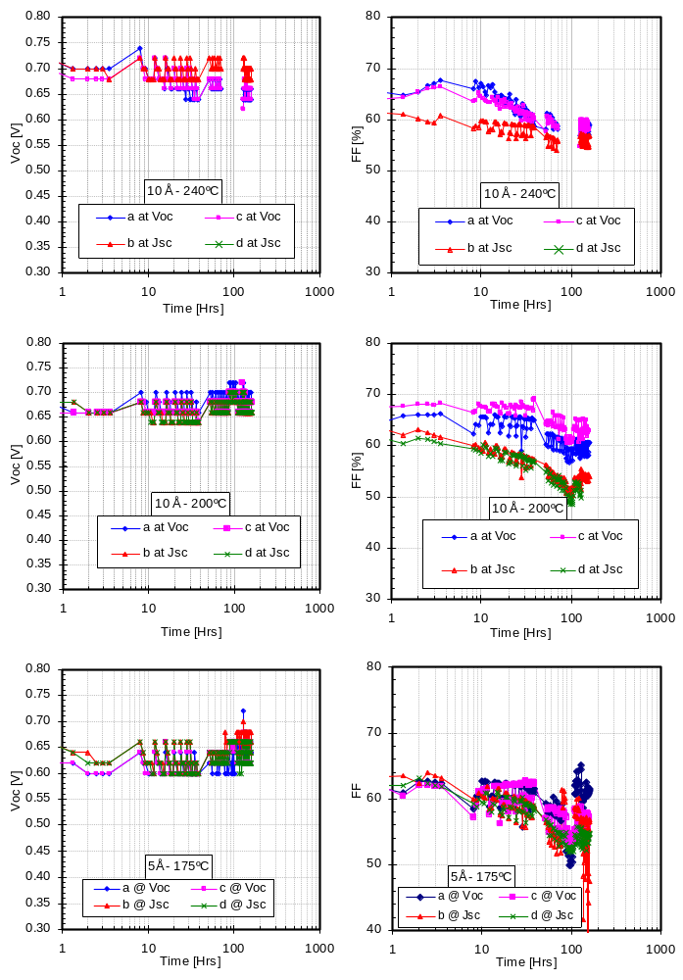
Another commonly observed behavior in CdTe devices is an initial increase in performance. Evidence for that is present in some of the cells shown in Fig. 1, where the FF exhibits an initial increase (with the V_{OC} remaining constant). However, the increase is not present in all devices, and the degree to which the FF increases varies. The eventual decrease in the FF does not exhibit a consistent trend with regards to bias; in one case (top) the FF of devices held at OC appears to decrease faster while in the other (middle) the SC conditions seem to lead to faster degradation in the FF. The OC conditions were found in the past (by us and other groups) to lead to greater degradation, and it is not clear right now whether the sample for which the SC conditions lead to faster degradation is one of a kind. A significant amount of data is currently being summarized and a more detailed report on a larger number of processing conditions will be provided in the future.

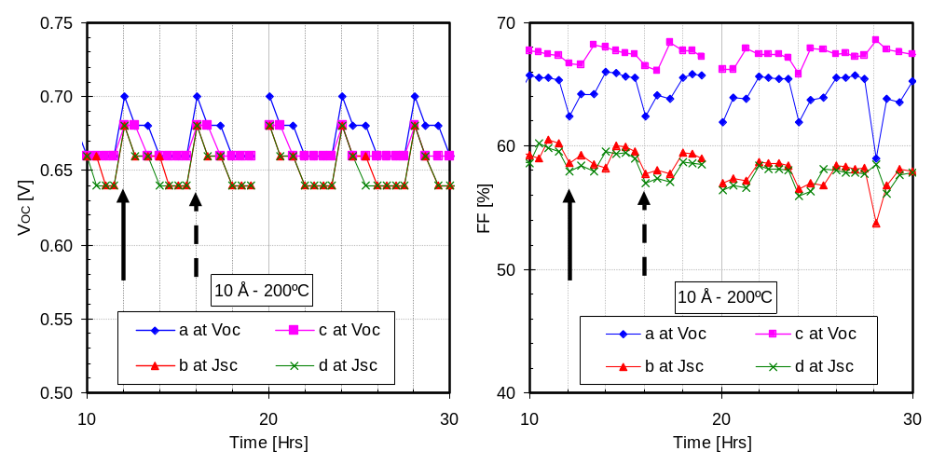
As a result of bringing on line the automated data collection system, it is now possible to perform a large number of measurements. During the initial stages of this light soaking experiments light J-V data were measured every 30 minutes. An interesting feature of the device performance variation is displayed in Fig 2 below, where the V_{OC} and FF for one of the devices of Fig. 1 (middle) are shown over a period of 20 hours (i.e. for 5 light cycles). The arrows in Fig. 2 mark the start (solid) and end (dashed) of a light cycle (ON). The V_{OC} decreasing trend during the ON cycle is consistent with the cell operating temperature rising; cell temperatures have reached 70ºC in some instances. The FF behavior however cannot be explained by the rise in the operating temperature. The FF appears to increase initially and subsequently (roughly at the mid point of the ON cycle) begins to decrease. During the latter ON cycles (i.e. closer to 30 hours) the FF increases but appears to level off rather than decrease during the second half of the cycle. Transient effects have been reported and observed before, but their impact on device stability is not well understood yet. We plan to continue to monitor these changes but at this time the plan is to maintain the ON and OFF times at 4 hours. In future experiments it may be possible to study the effect of the duration of the ON cycle in order to study the extent to which the transients observed are reversible and whether long term stability can benefit.
Figure 2. “Transient” behavior of V_{OC} and FF.

Vapor Chloride Treatment
As described in a previous report a larger vapor CdCl₂ annealing furnace has been brought on line in order to process several substrates at a time and improve our overall understanding of this process. The configuration currently used is shown in Fig. 3 below. The major change over the small area annealing furnace is the extension of the substrate zone to accommodate four 3 x 3 cm² substrates.
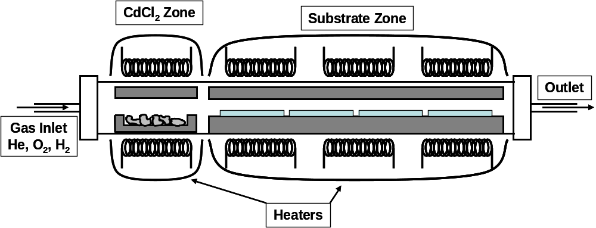
Figure 3. Multi-substrate vapor CdCl₂ chamber
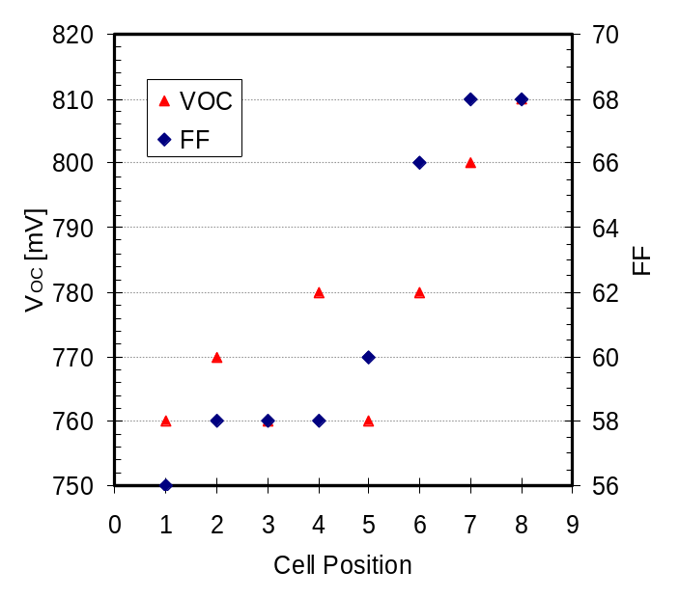
Device results obtained in the new furnace remain slightly below the performance levels achieved previously, and performance is not uniform. At this time one of the issues appears to be a temperature gradient along the sample zone that leads to a “gradient” in performance. One example is shown in Fig. 4 where the V_{OC} and FF of cells from two substrates heat-treated in CdCl₂ vapors for three minutes at a substrate temperature of 420ºC are shown (the temperature is measured at the center of the sample zone). The cell position axis indicates the location of the cells in the sample zone with #1 being the device closer to the CdCl₂ source and #8 being the device farthest from the CdCl₂ source. The sample zone has been profiled twice for different source/sample temperature combinations and the measurements have yielded a large gradient from the front to the back of the sample that to a great extent follows the performance gradient shown. The close proximity of the source and substrate zones and the large variation in their temperatures appear to hinder our efforts to minimize this temperature gradient, but changes are in the way in order to improve this apparent shortcoming in the annealing furnace.
Figure 4. Performance gradient for vapor CdCl₂ treated cells.
Large Area Deposition System

During the last few months work on films/devices prepared using the large area deposition (LAD) system has focused on identifying the cause(s) for the observed performance variation (cells prepared using this process yielded V_{OC}’s in excess of 820 mV and FF of over 70%). One of the obvious problems was the presence of pinholes which in some cases were visible to the naked eye. Figure 5 below shows SEM images from several CdTe films prepared in the LAD system. The top images are from films prepared using a gas mixture of He and O₂ exhibiting grains of about 1 μm (on average). These are similar to CdTe films deposited with the baseline small area process. The two bottom images are from specific regions in films where device performance exhibited significant scattering. These show in one case a crater with a diameter of approx. 5-7 μm (left), and in the other several (CdTe) particles embedded in the CdTe film, believed to have been ejected from the source during the deposition process. These two images demonstrate what is believed to be the major source for the variation in device performance; current efforts are focused on ways to sinter the CdTe powder in order to address this issue. It is believed that once these large defects are eliminated that performance will be very uniform over the entire 10 x 10 cm² deposition area.
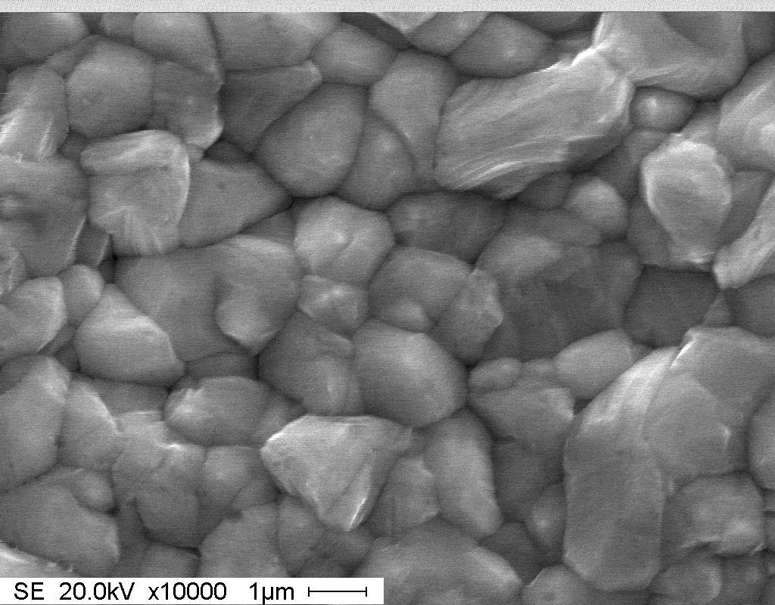
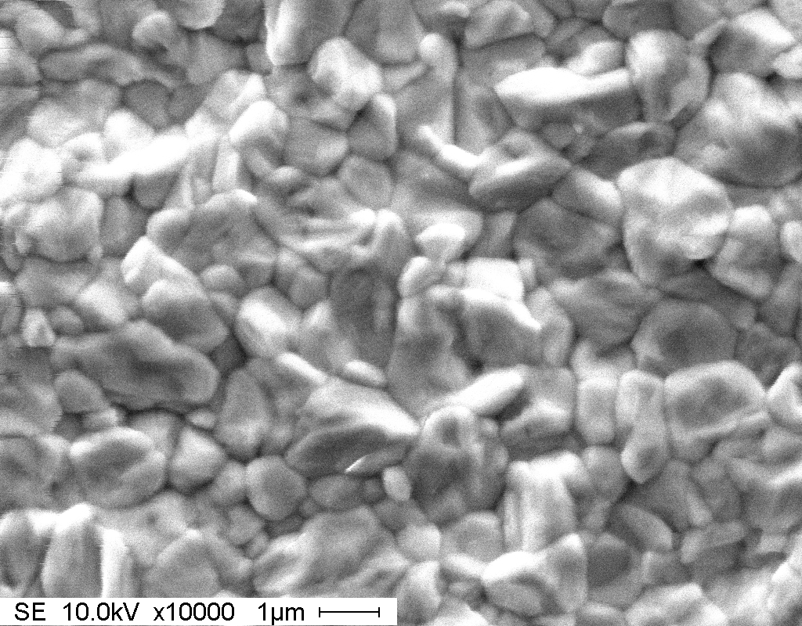
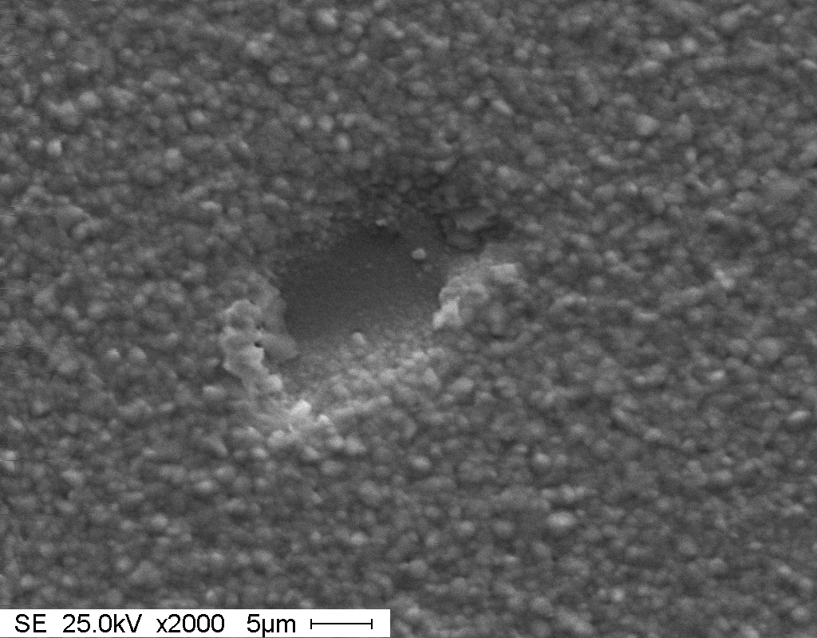
Figure 5. SEM images from CdTe films: top – films deposited in O₂-containing ambient; bottom – images from films that yielded devices with considerable variation in device performance.
An example of the cell to cell variation (from the same run) is shown in Fig. 6 below. The dark current increases (shunting) by nearly three orders of magnitude in some extreme cases. Shunting is also present in the light J-V data shown in the same figure.
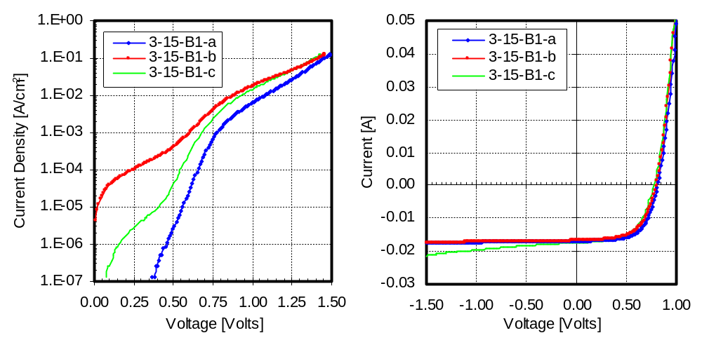
Figure 6. Dark (left) and light J-V (right) for CdTe cells on the same substrate prepared using the large area deposition system.

TCO’s/Buffer Layers

We continue to investigate devices with Zn-Sn-O-based buffer layers. The main objective is to determine the effect of the metal ratio i.e. Zn/Sn, on the device performance; a Zn/Sn ratio of 2 could produce the stoichiometric Zn₂SnO₄ phase depending on post-deposition heat treatment conditions. Zn-Sn-O films are being deposited by co-sputtering allowing for easy control/variation of the film stoichiometry; the films are used either as-deposited or after a high temperature heat treatment. Promising device results presented in the last quarterly report were for TCO/buffer structures based on Cd₂SnO₄ and Zn₂SnO₄ (Zn/Sn ratio of 2). Currently, SnO₂:F/Zn-Sn-O structures are being utilized and the ratios being study are for Zn-rich films i.e. Zn/Sn>2 (typically between 2 and 3). Device results for Zn-rich buffer layers are in general “average” with no obvious advantages in performance (V_{OC}’s and FF’s have reached the 800-820 mV and high 60’s ranges respectively). A common device limitation is high leakage currents (shunting); it is possible that the observed high leakage is due to the excess Zn diffusing into CdS and the main junction. Work on these buffer films continues with the main focus continuing to be on the effect of the Zn/Sn ratio.
B. CIGS

One of the challenges that we continue to face with our 2-step processing approach is controlling defects. As discussed on several occasions, a particular issue is the effective incorporation of Ga. We can get Ga into the space charge layer, and we can get it to bond to open the band gap. However, in doing so we seem to always increase the defect level. While we have made progress in reducing defect levels, we still have not reduced them sufficiently to achieve the level of desired performance. If we knew what the controlling defects are, this may lead to process modifications that could control them. Unfortunately, there is no direct way to determine exactly what the defects are at such low levels. Instead we must use indirect techniques that rely upon various types of input. We can measure the effect of defects on electronic properties with techniques such as photocapacitance[1]. This also helps us understand the relationship between the defects that we sense and film composition as well as the relationship between composition and device performance. These insights have lead to improvements in processing and in performance, but more needs to be done.

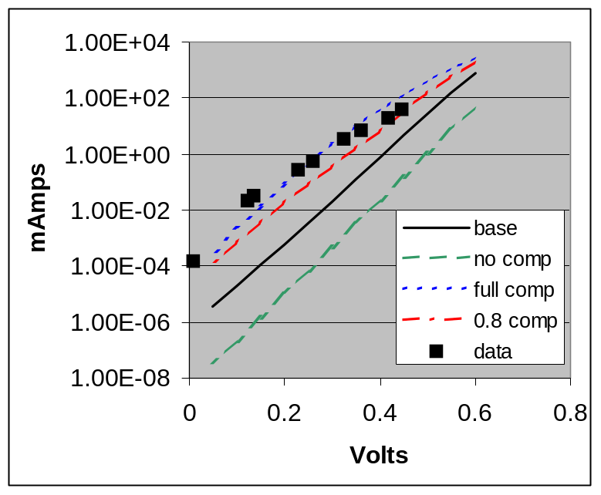
To aid our experimental efforts we rely as well upon guidance provided by simulation. In our earlier efforts much of our device modeling was based upon assumed dominance by deep levels[2]. This resulted in good agreement with experimental results and to some extent helped point the way to new wrinkles in processing. However, as we all know, models that fit a set of data are rarely unique, and in this case we did not know what the deep level was that we were using as the basis for modeling. Materials modeling by the NREL Theory Group is assisting these efforts by providing insights to likely defects in CIGS[3]. In Quarterly Report 5 of year 3 in the predecessor to this project we presented modeling results based upon use of the primary defect levels identified by the NREL Theory Group[3]. The defects with the lowest formation energies are the V_{Cu} and the M_{Cu} + 2V_{Cu} defect pair. The V_{Cu} is acceptor-like, and the defect pair is donor-like. Both are shallow, and thus compensation effects are operative. ( A full discussion of this can be found in the earlier report). What we want to pick up on here is the result that indicated a difference in dark IV curves when one or the other of these defects is dominant. In figure 1 we show an extended version of that result. The lines are simulations for varying levels of compensation. The lowest lying line is the ideal case of no defects. The device band gap is 0.95 eV, so with an expected Jsc of 40 mA/cm² extrapolation of the dark IV would result in an expected Voc of 600 mV. The solid line is the dark IV that results from fitting the power curve of one of our top-end devices. To fit the data for these devices requires about 40% compensation. The top-most line is for full compensation, and the one below it is for 80% compensation. As can be seen, as the level of compensation increases, the dark IV shifts upward and thus lowers Voc. However, at the highest compensation levels there is bending over at high voltages which reduces the expected loss. Based upon these observations we feel that the dark IV may be a telltale that indicates the level of compensation, and thus indirectly suggests the operative defects.
Figure 0. Simulated and experimental IV curves for devices with various levels of compensation.

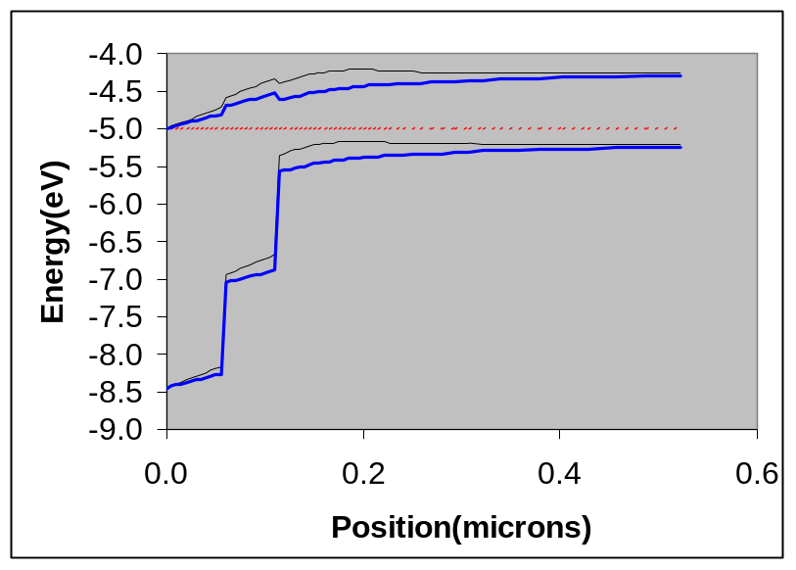
Since the results in figure 1 only involve shallow levels, there is a suggestion that deep levels may not be operative as originally thought. To sort this out we are starting to look more carefully at dark IV data. The data points( ) in figure 1 are experimental data from a device with Voc of about 425 mV. The data is from Isc –Voc plots. This eliminates contributions from series resistance allowing a more direct look at junction properties. As can be seen, the data falls near the curve for complete depletion, but seems to bend over a bit more at high voltage. If the behavior is explainable only by the shallow states used for the simulations in figure 1, then it would be between 80% and 100% compensated. In figure 2 we show the simulation of the junction region for 40% and 80% compensation. As can be seen, the space charge width increases from about 200 nm to 450 nm over this range of compensation. At full compensation, the device would be completely depleted which would result in more unusual behavior. However, 80% compensation with a space charge width of 400 – 500 nm is not unrealistic. 200 – 500 nm is typically what we observe. This model would result in a direct correlation between Voc and capacitance. That is, as compensation increases, the space charge width increases resulting in decreasing capacitance and correspondingly decreasing Voc. We have observed such behavior previously in our photocapacitance studies[1], but based on the then current model were attributing it to deep states. These new observations suggest that shallow states may be playing a role as well because of their compensation effects.
Figure 0. Simulation of junction region in CIGS for 40%(light line) and 80% (heavy line) compensation.

It now becomes important to distinguish between contributions from deep and shallow states if we are to fully understand what is going on. The near fit of the data to the shallow state simulations is suggestive, but just a start. The bend over in the data seems to favor additional mechanisms. In particular, deep states can produce such behavior[2]. A comparison of diode factor behavior for deep and shallow states is shown in figure 3 from our earlier simulation efforts. As can be seen, shallow levels(at Ec – 0.27 eV) produce low diode factors and thus steep IV curves like those in figure 1. However, mid-gap levels produce diode factors which become large in certain voltage ranges and thus can produce the kind of bend over (small slopes) seen in figure 1. A more direct comparison can be made by observing the experimental diode factor in figure 4. This is from the data in figure 1. The behavior is seen to be much more like the mid-gap simulation in figure 3 than the shallow state simulation and thus favors contributions from deep states.

Although there appears to be support for deep state contributions in the experimental data, determining what these states might be is not straightforward. What one would look for is a defect near mid-gap with low formation energy. There is no obvious answer here based upon the defect properties from the NREL theory group. To sort this out will take a considerable amount of data and analysis and some measure of luck. Before getting that specific, however, we need to first address the relative contributions from deep levels versus compensation from shallow levels. An update will be provided in future reports.

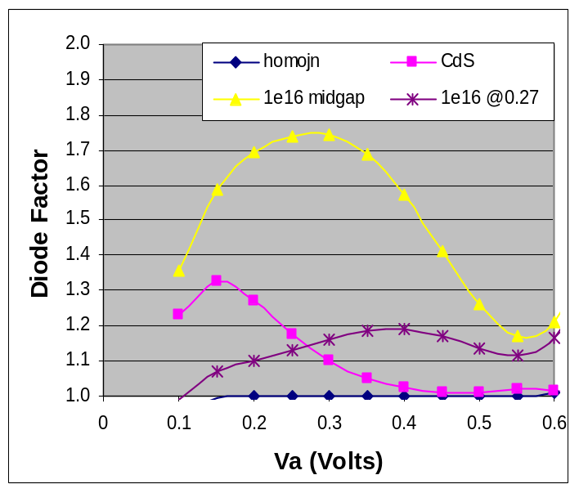
Figure 3. Simulations of diode factor for various junction configurations.
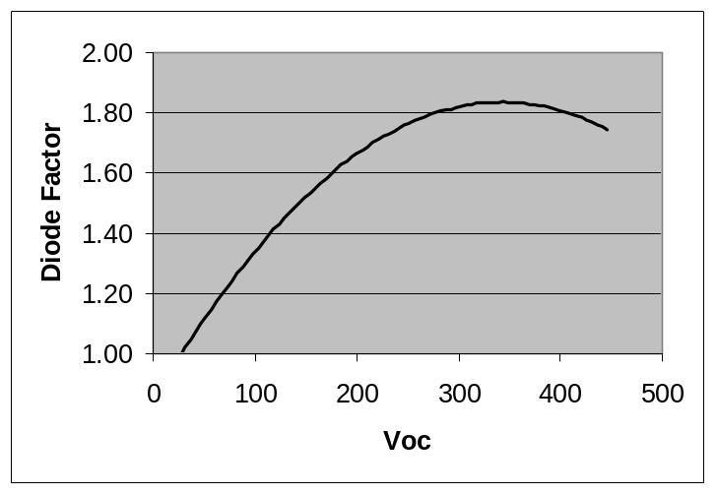
References
Figure 4. Experimental diode factor voltage dependence.

- M. Shankaradas, Y. Ying, H. Sankaranarayanan, P. Panse, C. S. Ferekides and D. L. Morel, “Photocapacitance Analysis of Defect Mechanisms in Cu(In,Ga)Se Solar Cells”, Proceedings of the 28th IEEE PVSC, Anchorage, 09/2000.
- P. Panse, H. Sankaranarayanan, R. Narayanaswamy, M. Shankaradas, Y. Ying, C. S. Ferekides and D. L. Morel, “Evaluation and Modeling of Junction Parameters in Cu(In,Ga)Se Solar Cells”, Proceedings of the 28th IEEE PVSC, Anchorage, 09/2000.
- Su-Huai Wei, S. B. Zhang, and Alex Zunger, Appl. Phys. Lett., 72(4), 3199 (1998).

† The lamps used for light soaking have failed on two occasions and the system had to be vented and repaired at approx. 80 and 130 hours. Also due to lamp failure, the intensity for approx. 25 hours was 25% below the 1 sun level.

