WASTE TREATMENT LAGOON

PRACTICE INTRODUCTION

USDA, Natural Resources Conservation Service―Practice Code 359

WASTE TREATMENT LAGOON
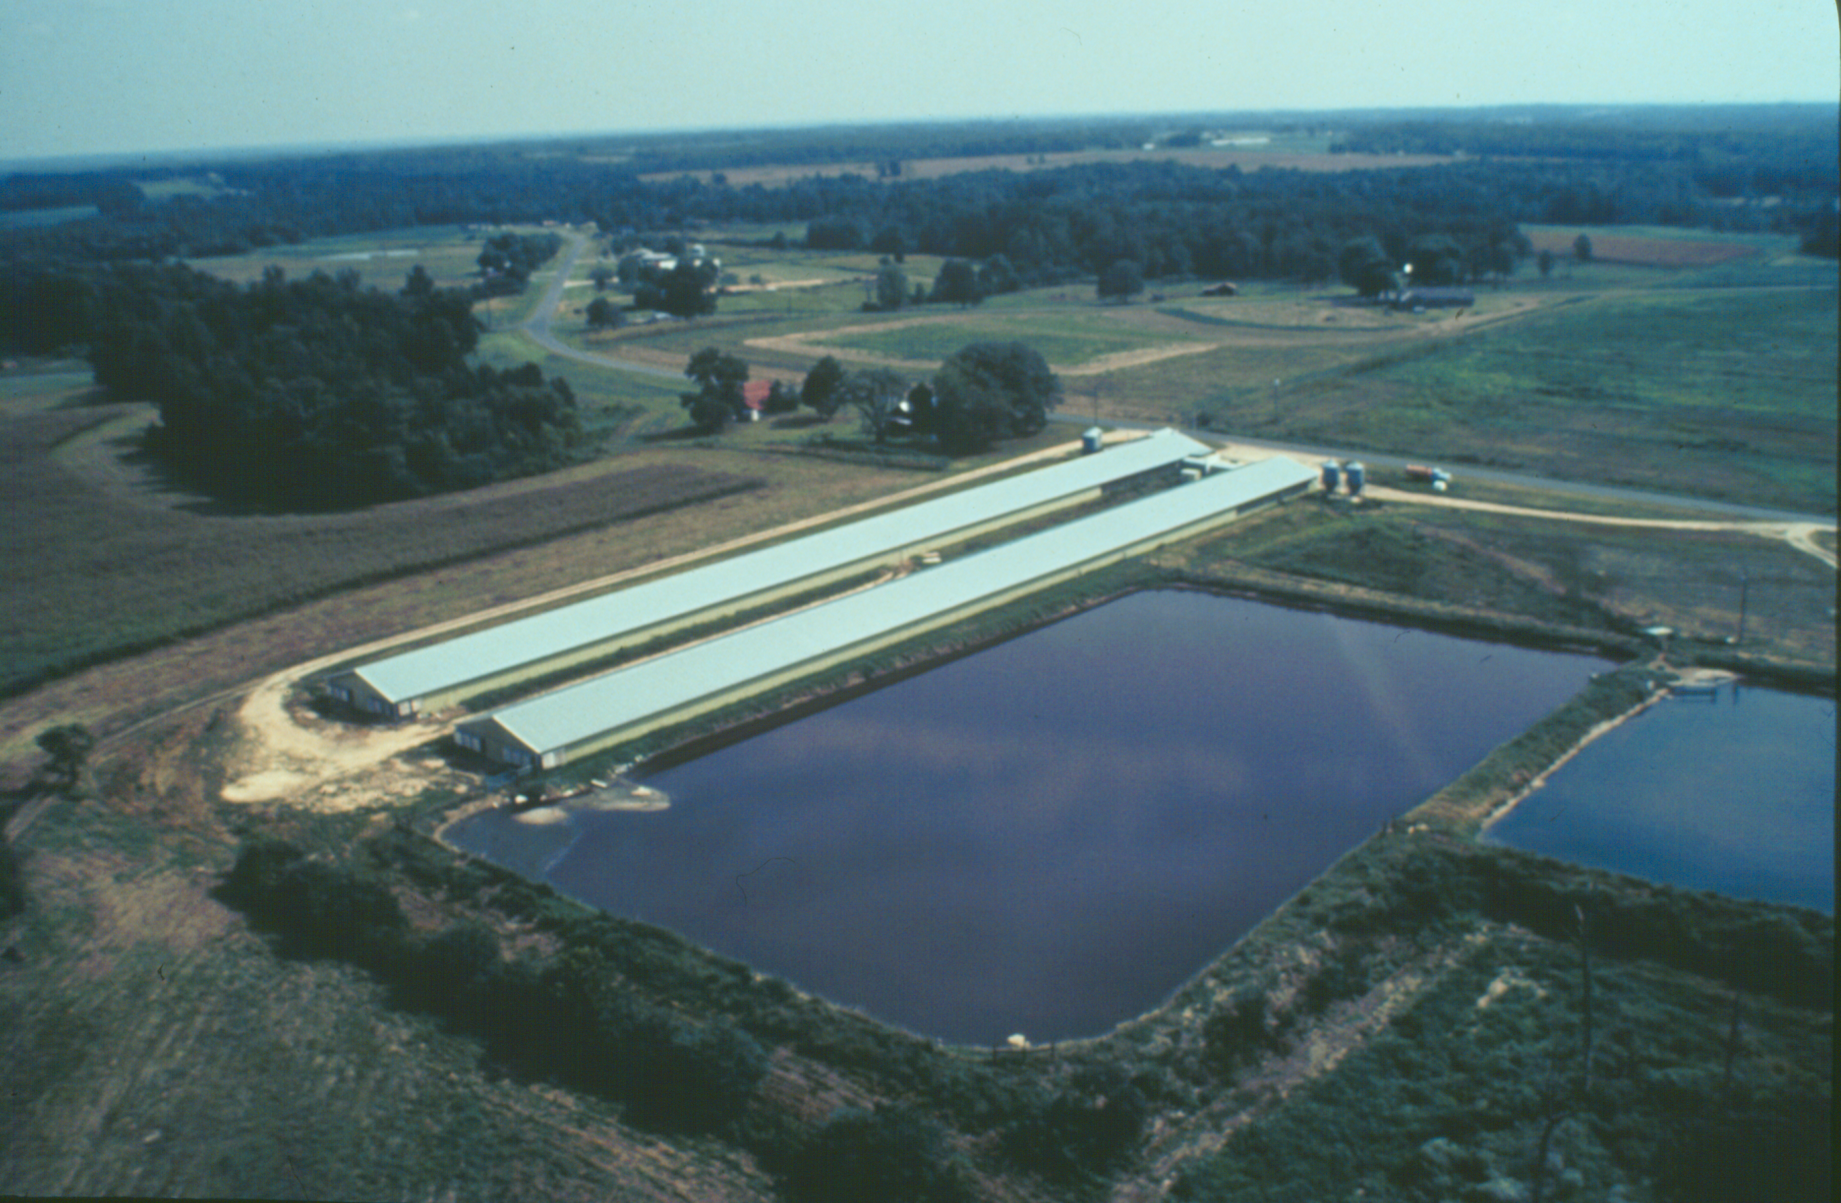
A waste treatment lagoon is an impoundment made by excavation or earth fill to provide storage for biological treatment of animal or other agriculture waste.

PRACTICE INFORMATION
The purpose of this practice is to store and biologically treat organic waste, reduce pollution, and protect water quality.
The three general types of waste treatment lagoons are:
- Anaerobic―require less surface area than naturally aerobic lagoons, but may give off offensive odors
- Naturally aerobic―require more surface area, but are relatively odor free
- Mechanically aerated―comparable in size to anaerobic lagoons, but require energy for aeration
Waste treatment lagoons are located as near the source of waste as possible but as far from human dwellings as possible. The location should also be where prevailing winds will carry odors away from residences and public areas.
To improve efficiency and reduce sludge buildup, solids should be removed from the waste before it enters the lagoon. A solids trap or separator should be installed between the waste source and the lagoon.

COMMON ASSOCIATED PRACTICES
Waste Treatment Lagoon is commonly used in a Conservation Management System with practices such as Solid/Liquid Waste Separation Facility (632), Waste Utilization (6330, and Nutrient Management (590).
For further information, refer to the practice standard in the local Field Office Technical Guide and associated specifications and job sheets.

D.6 (-) Suspended sediment, metals, pathogens, salinity to surface water
Waste Treatment Lagoon (359)
D.5 (-) Pesticides, nutrients, and organics to surface water
I.4 (+) Dissolved oxygen surface waters
C.4 (+) Aquatic health for humans and domestic and wild animals
I.5 (-) Noxious algal growth
I.6 (+) Meeting water quality standards
I.1 (+) Agribusiness
C.1 (+) Income stability (individuals and community)
C.3 (+) Stream fauna, e.g., fish, invertebrates
2. Structure/site dedicated
Initial setting: AFO is
established and wants a
lagoon for treating wastes
D.2 (+) Manure stored in lagoon
Waste Utilization (633)
Nutrient Management (590)
Waste Treatment Lagoon
5/2002
D.3 (+) Perceived nuisance
C.2 (+) (-) Air Quality of the air shed (depending on objectives/resource of concern)
C.5 (-) Health/ habitat suitability for humans
I. 3 (+) Lagoon failure, seepage
LEGEND
#. Created by practice
D. Direct effect
I. Indirect effect
C. Cumulative effect
Pathway
(+) increase; (-) decrease
Associated practice
Start
Note: Effects are qualified with a plus (+) or minus (-). These symbols indicate only an increase (+) or a decrease (-) in the effect upon the resource, not whether the effect is beneficial or adverse.

Uncover
D.4 Air Quality
(+)Greenhouse
gas
(+) Odor
(+) (-) Ammonia
(+) (-) HAP
(+) (-) Pathogens
Cover
Anaerobic
D.4 Air Quality
(-) Greenhouse
gas
(-) Odor
(+) (-) Ammonia
(+) (-) HAP
(+) (-) Pathogens
1. Manure-transfer system purchased/dedicated
D.1 (+) Infrastructure and operational costs
I.2 (+) Meeting air quality standards
Aerobic
D.4 Air Quality
(-) Greenhouse
gas
(-) Odor
(+) (-) Ammonia
(+) (-) HAP
(+) (-) Pathogens

