Implementation/Design Specification
for
Product CTOMViewer Version 0.5

Last Updated: February 21, 2007

Author: Harsh Marwaha
Email: marwahah@mail.nih.gov

National Cancer Institute Center for BioInformatics
6116 Executive Blvd.
Rockville, MD 20852



1 Document Purpose 4
2 Implementation Overview 5
2.1 Description 5
2.2 Scope 5
2.3 Architecture 5
2.4 Assumptions 5
2.5 Dependencies 5
2.6 Issues 5
2.7 Third Party Tools 5
3 Implementation Contents 7
3.1 Server 7
3.1.1 Error Handling 7
3.2 Client 7
3.2.1 JSP/HTML 7
3.2.2 Error Handling 8
3.3 Security Issues 8
4 CTOM Viewer Screens 9
4.1 Login Screen 9
4.2 Welcome Screen 10
4.3 Select Protocol Report 11
4.4 Participant Accrual 12
4.5 Participant Retention 13
4.6 Eligibility Details 14
4.7 Off Study Details 15
4.8 Protocol Progress Report 16
4.9 Disposition Details 17
4.10 Participant Response Details 18
4.11 Select Adverse Event Report 19
4.12 Adverse Event Detailed 20
4.13 Adverse Events Summary by Grade 21
4.14 Select Treatment/Response Report 22
4.15 Best Response Report 23
4.16 Off Study Adverse Events 24
4.17 Select End Point Report 25
4.18 Patient Survival Report 26
4.19 Disease Progression Report 27
4.20 Participant Data 28

Document Purpose

This document specifies the implementation details of the CTOM Viewer application.

Implementation Overview

Description
CTOM Viewer application provides a secured web-based view to the CTOM data. It uses the CTOM-API for access to the CTOM database. This application implements use cases defined in the CTOM Viewer potential use case document. J2EE technology will be used to implement this application. CTMS 3.12 data transfer specification manual was used as a source for coded data descriptions.

Scope
This document is limited to providing a specification for the CTOM Viewer application.

Architecture
The following diagram shows the various high level components used in the CTOM Viewer application:
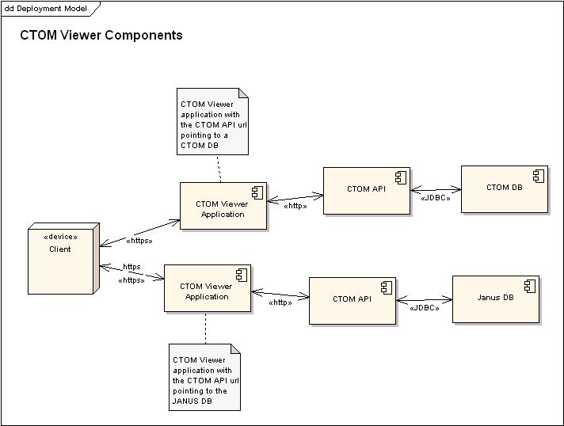

Assumptions
- Coded data descriptions will be hard coded into the CTOM Viewer application for the current release, since descriptions are not currently available in the CTOM database. CTMS 3.12 Data transfer specifications manual is used to define the code descriptions.
- CTOM API URL will be included in the war file. So changing the application data source between CTOM and Janus will require redeploying the application.

Dependencies
- Mapping from the CTOM model to the Janus database. This mapping is required for the CTOM Viewer application to use the CTOM API to access the Janus database.
- Common Security Module implementation of the security requirements for the CTOM Viewer application.

Issues

Third Party Tools
- Ant 1.6.5
- Hibernate 3.1
- Struts Framework Version 1.2.9.
- Spring framework version 1.2.7.
- Castor framework version 1.0.2.
- Junit version 3.8.1
- Log4j version 1.2.13

Implementation Contents

Server
The viewer application will use the CTOM API to retrieve data. An ant build script will be provided to build a war file for the application. The url for the CTOM API will be a parameter to the build file. Changing the application to point to a different database will required creating a new war file.

CTOM API hql (hibernate query language) will be used to retrieve summarized data using CTOM API’s hql interface. A sample hql query for returning summarized data:

Select ae.ctcCategoryCode,ae.ctcGradeCode, count(ae
from AdverseEvent ae
where ae in
(select ass
from Assessment ass
join ass.observationCollection as o
join o.activity as act
join act.studyParticipantAssignment as spa
join spa.studySite as ss
join ss.protocol as p
where ass.subtypeCode='ADVERSE_EVENT')
group by ae.ctcCategoryCode, ae.ctcGradeCode

Castor XML data binding framework will be used to generate XML from the data.

Error Handling
Log4J will be used for logging errors on the server. This can be configurred on the server to be redirected to a particular log. The main package of the application is gov.nih.nci.ctom. All log4j Loggers will be created under this package. All application exception conditions will be logged.

Client

JSP/HTML
The following jsp pages will be created as the first version of this application. The names are hyperlinked to the actual images of the pages included at the end of the document.
- Login
- Welcome
- Select Protocol Report.
- Protocol ->Participant Accrual Report.
- Protocol ->Participant Retention Report.
- Eligiblity Details
- Off Study Details
- Protocol ->Progress Report.
- Select Adverse Event Report.
- Adverse Event ->Detailed Report
- Adverse Event -> Summary by Grade.
- Adverse Event -> Summary by Attribution.
- Select Treatment/Response Report
- Best Response Report
- Off Study Adverse Events
- Select End Point Report
- Participant Survival
- Disease Progression
- Participant Data

Error Handling
Users will receive a message explaining all user errors on the screen they are currently working on.
Application errors will be logged and an error page will be presented to the user. Users can navigate back to the application from the error page.

Security Issues
Common Security Module CSM will be used to implement security along with the user-provisioning tool. The viewer application will use the CSM API to restrict access to the application. CSM API will be used for authentication at the ctom viewer level. Authorization will be delegated to the CTOM api which will be integrated with CSM API to secure access to the data. Please refer to the CSM implementation for CTOM document for details.

CTOM Viewer Screens

Login Screen
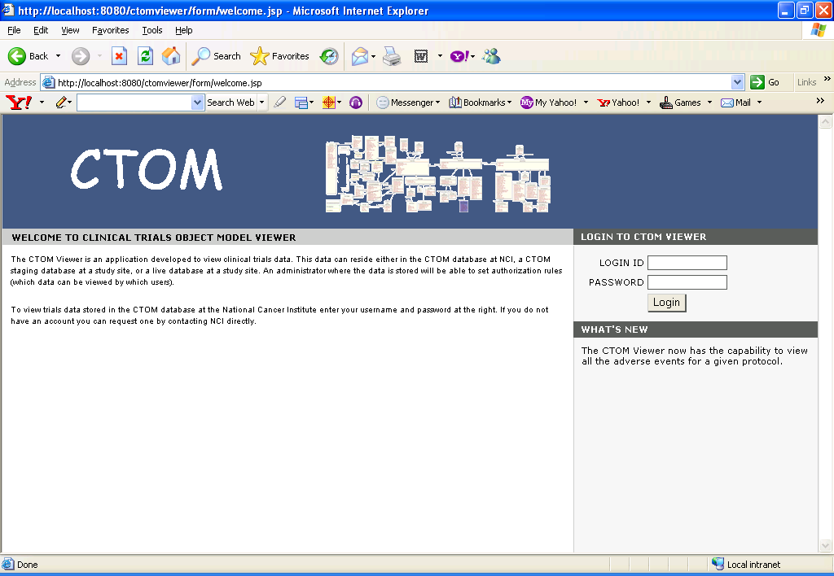

Welcome Screen
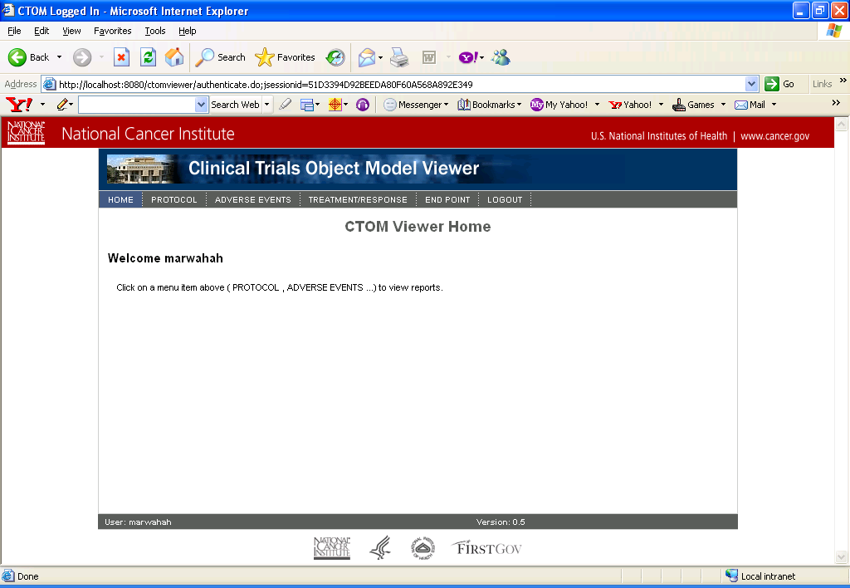

Select Protocol Report
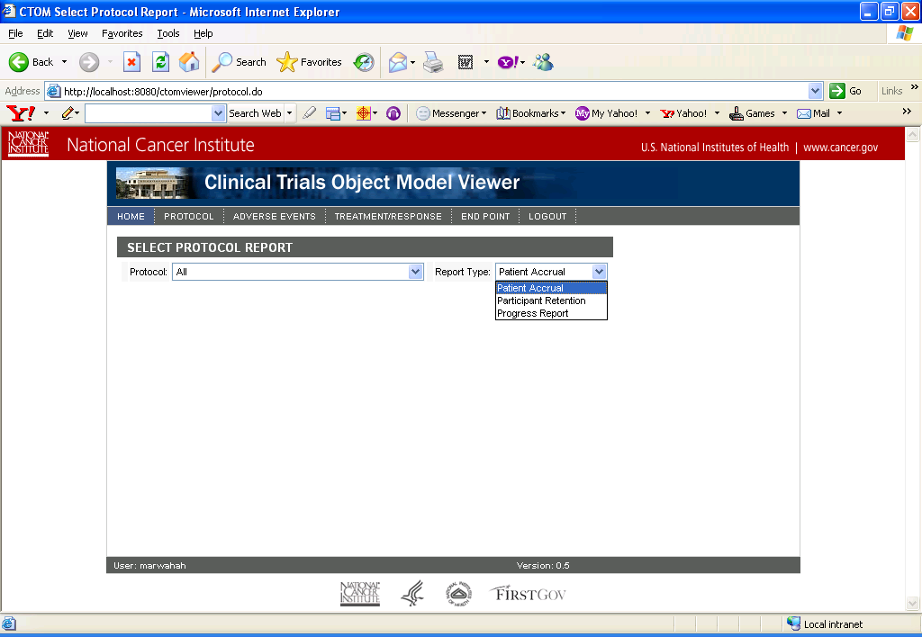

Participant Accrual
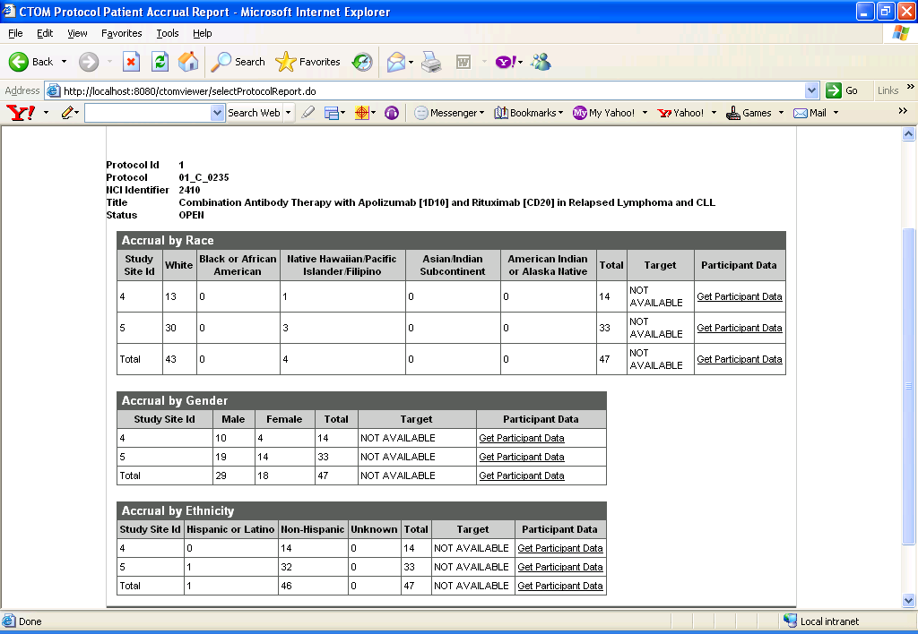

Participant Retention
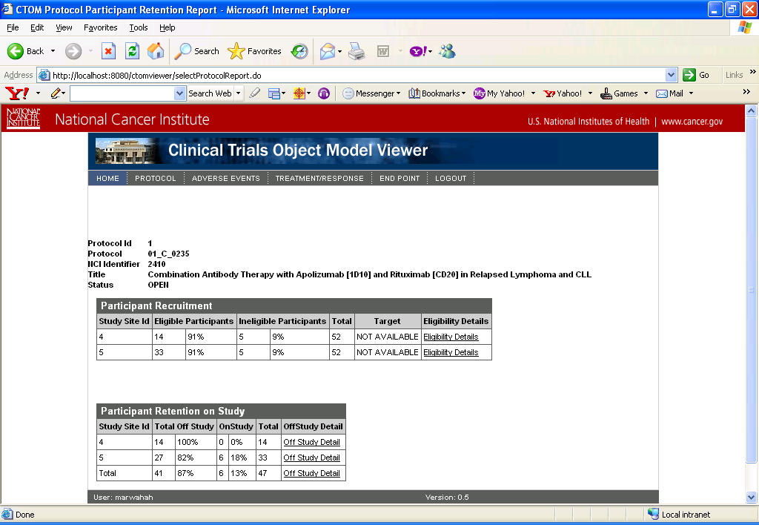

Eligibility Details
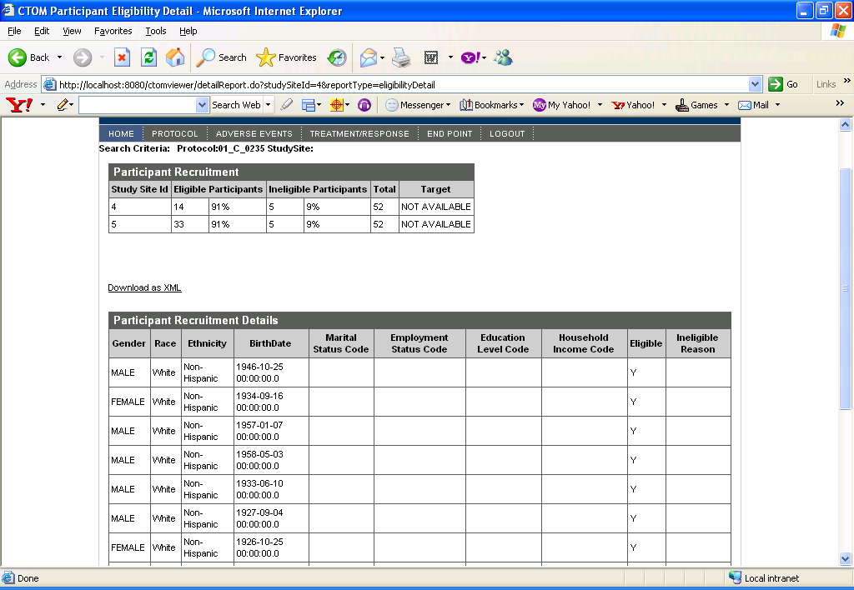

Off Study Details
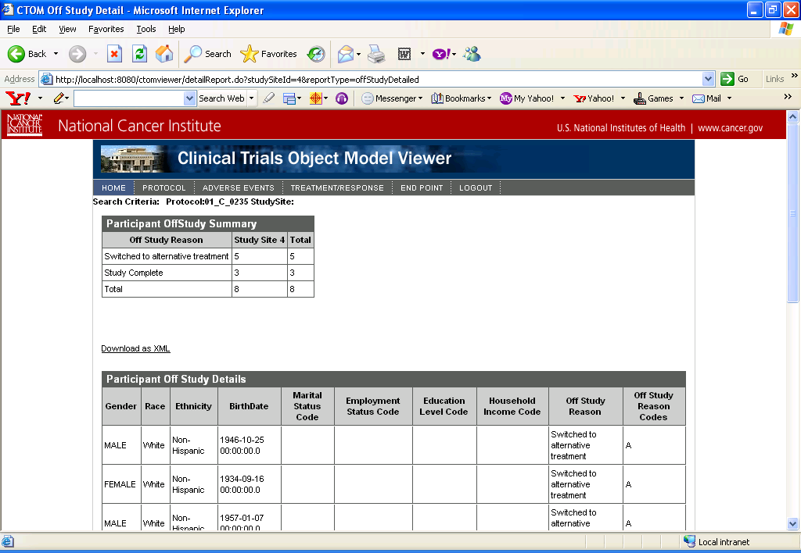

Protocol Progress Report
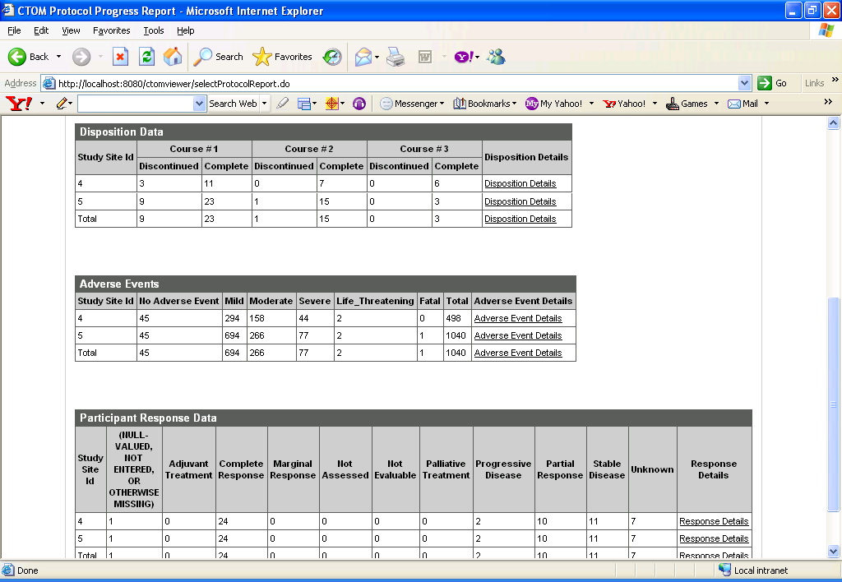

Disposition Details
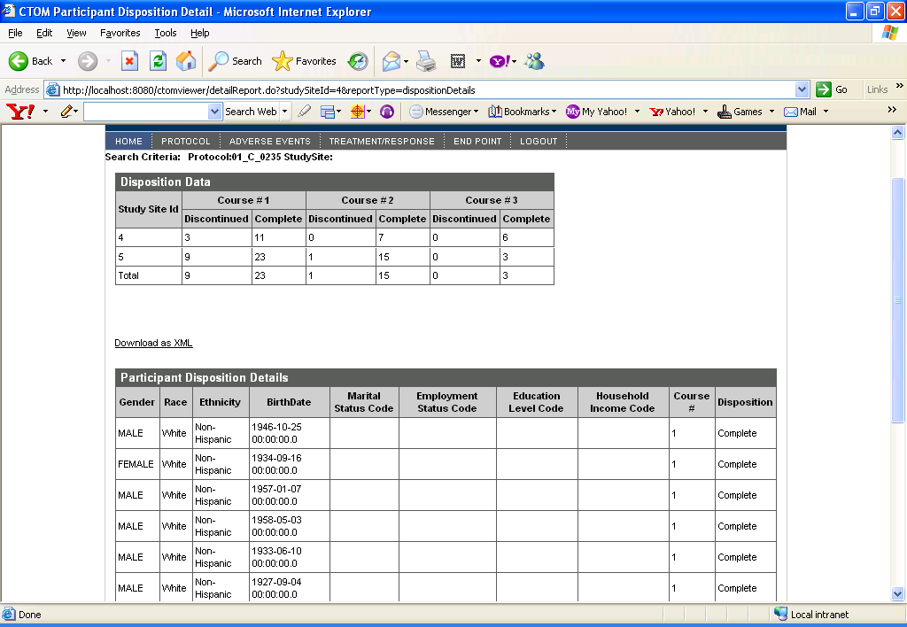

Participant Response Details
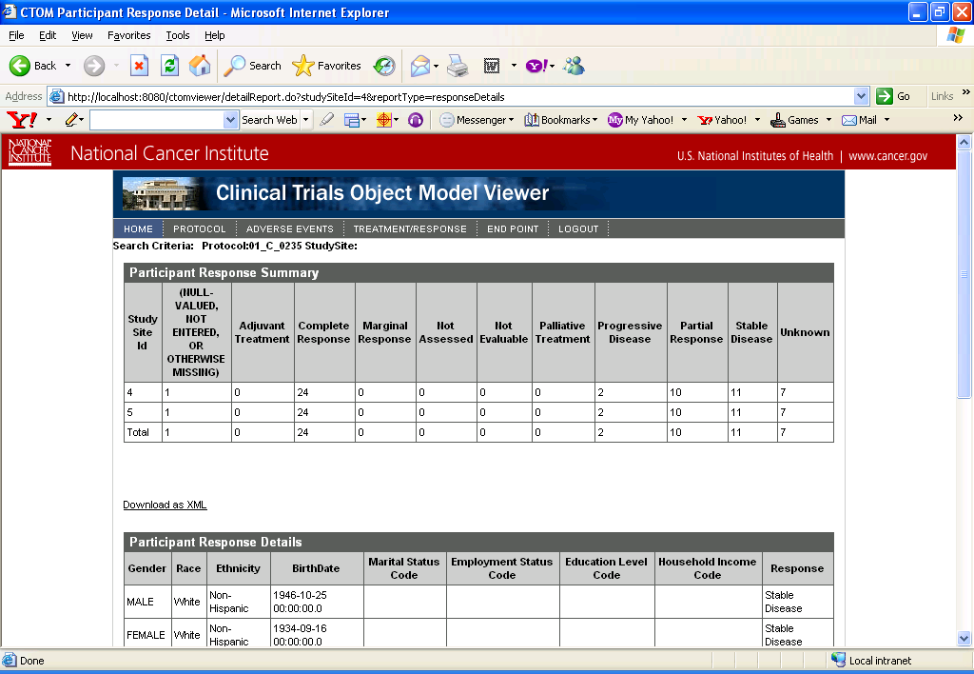

Select Adverse Event Report
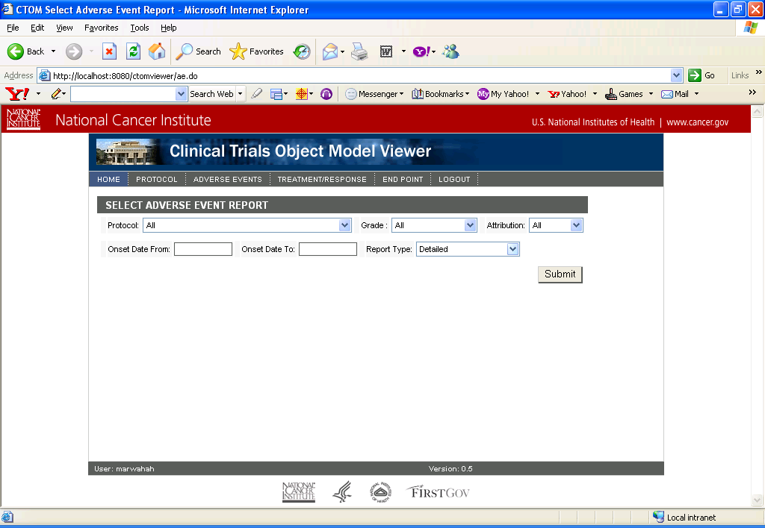

Adverse Event Detailed
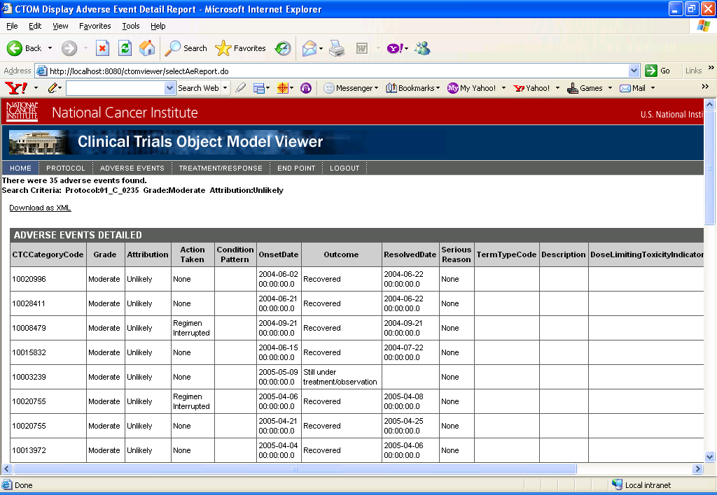

Adverse Events Summary by Grade

Select Treatment/Response Report

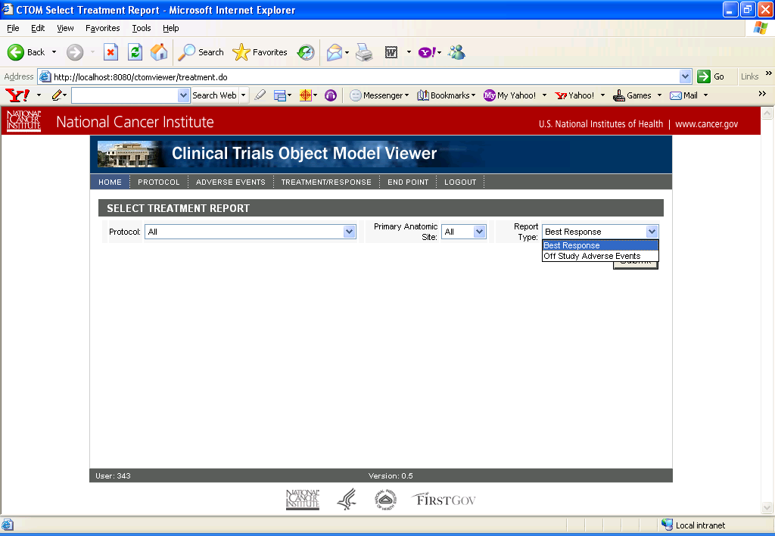

Best Response Report

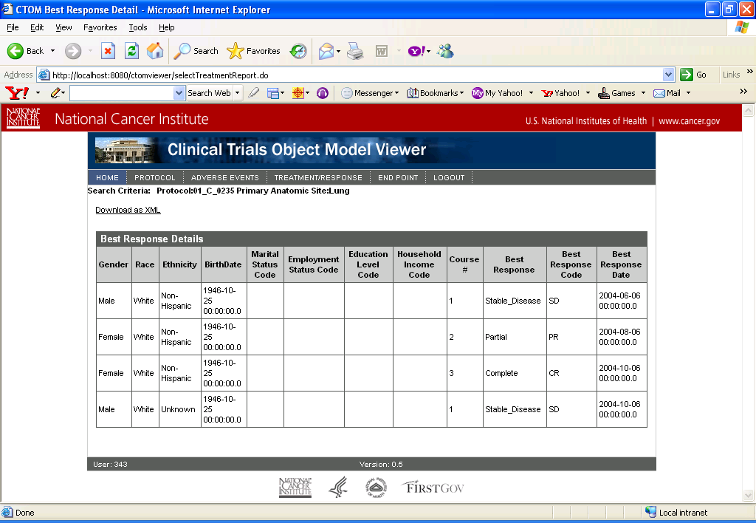

Off Study Adverse Events
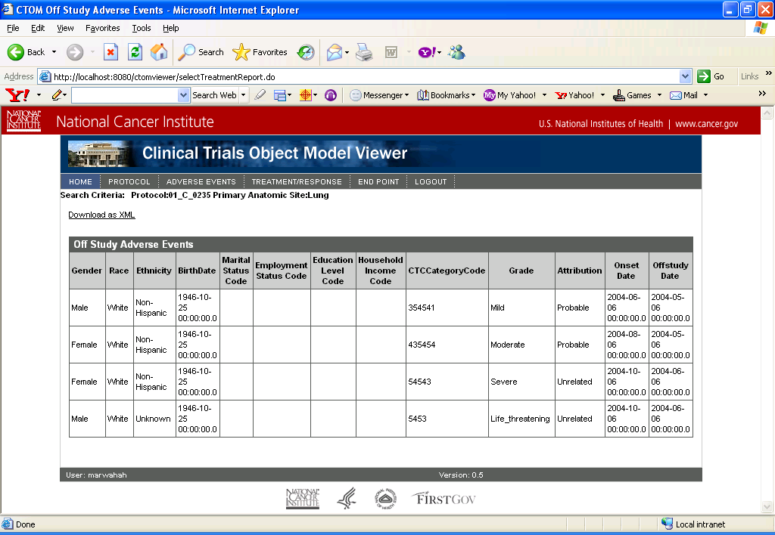

Select End Point Report
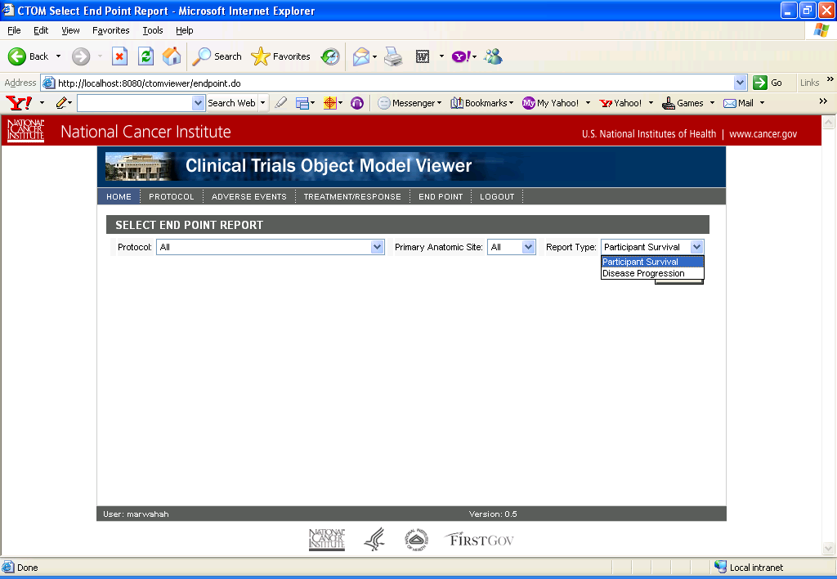

Patient Survival Report
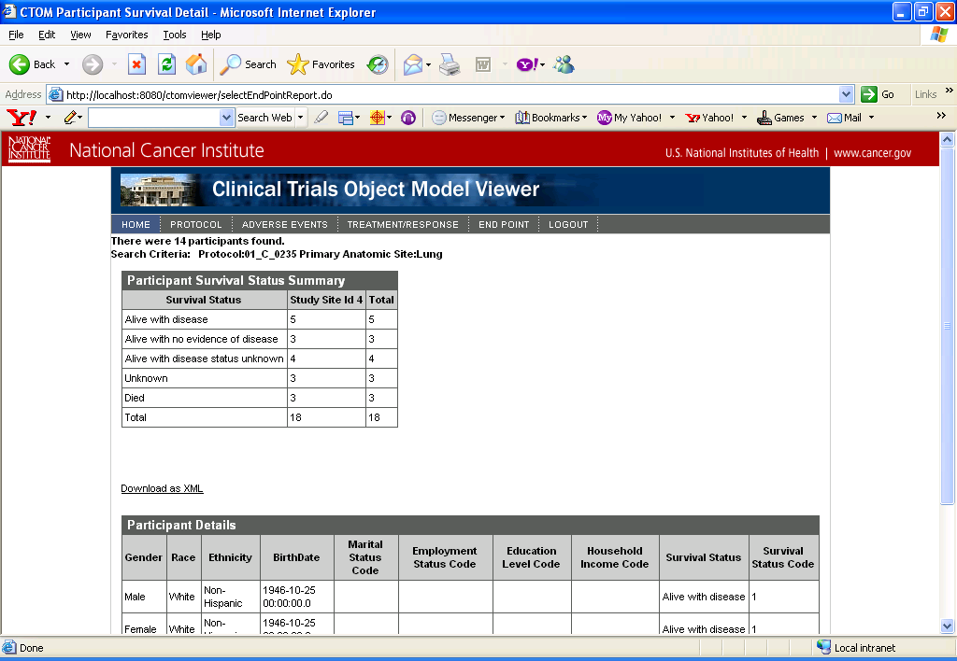

Disease Progression Report
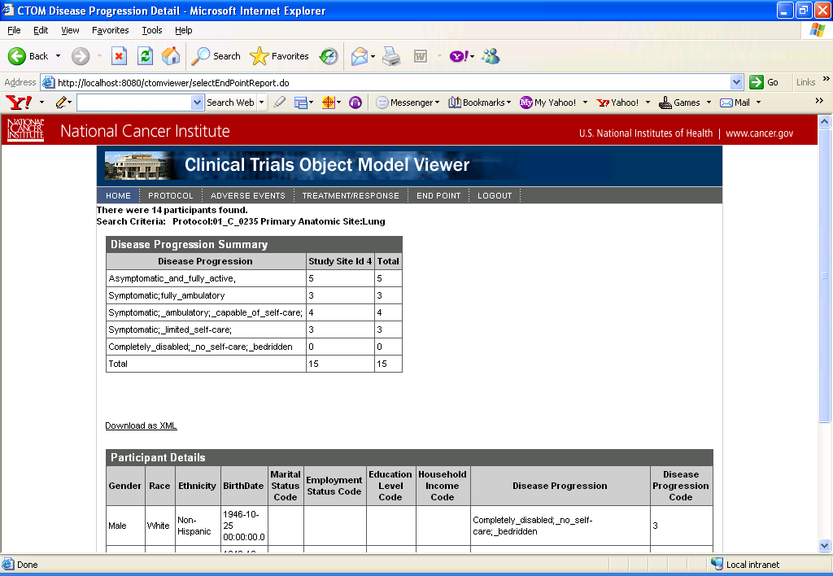

Participant Data

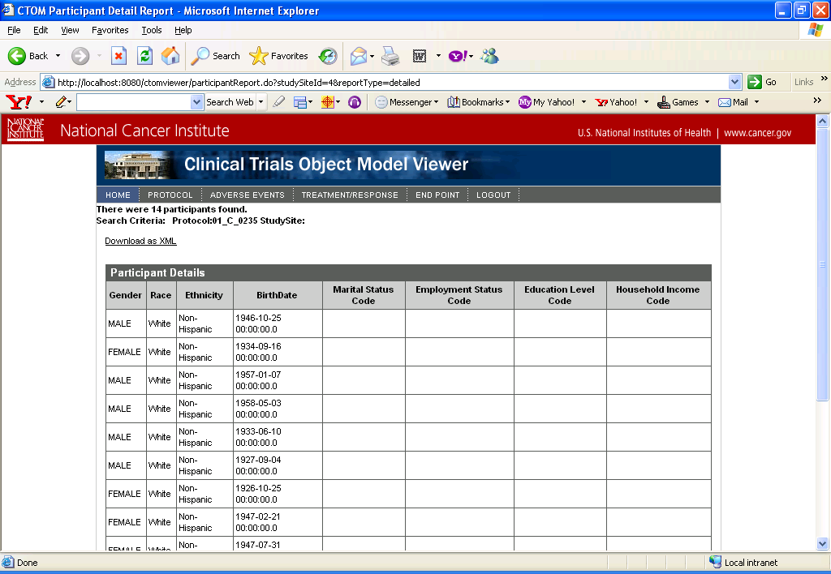

END OF DOCUMENT

