Louisiana State Epidemiological Workgroup Report for the Strategic Prevention Framework – State Incentive Grant



Prepared by
Louisiana State Epidemiological Workgroup

April 5, 2006

Contributors
This report was compiled and written by the following members of the State Epidemiological Workgroup as well as support staff listed below.

Mr. Chris Andrieu Louisiana Supreme Court
Dr. Gary Asmus University of Louisiana, Lafayette, Center for Child Development
Dr. Gary Balsamo DHH, Office of Public Health, Infectious Disease Epidemiologist
Mr. Jody Biscoe Northwestern State University, Louisiana Addiction Technology Transfer Center
Mr. Bill Blanchard DHH, Office for Addictive Disorders Prevention Services
Mr. Frank Broussard Department of Social Services, OCS
Mr. George Cazenavette Drug Enforcement Administration
Ms. Cathy Childers Attorney General’s Office
Dr. Yu-wen Chiu Louisiana State University Health Sciences Center School of Public Health
Ms. Karen Faulk Department of Social Services, OCS
Dr. Murelle Harrison Southern University Department of Psychology
Dr. James Heimdal Louisiana Tech University Dept. of Health & Exercise Sciences
Dr. Barbara Hunter Department of Social Services, ITT
Dr. Tai Istre Louisiana State University School of Social Work, OSSRD
Ms. Gloria Jones Office of Motor Vehicles
Mr. Jacques Kado DHH, Office for Addictive Disorders - I/T Technical Support Specialist
Dr. M.Mahmud Khan Tulane University School of Public Health & Tropical Medicine
Mr. Ronald Kinchen Office of Alcohol and Tobacco Control
Ms. Shirley Kirkconnell DHH, Office of Public Health, Injury Research & Prevention
Dr. Randall Lemoine DHH, Office of Mental Health
Mr. Dan Magri Department of Transportation and Development
Dr. Nancy Mathews Louisiana State University Campus Community Coalition for Change
Ms. Joan McGee Division Of Administration, Office of Electronic Services
Lt. Jim McGuane Louisiana State Police Technical Support
Ms. Beth McLain DHH, Office for Addictive Disorders Administration
Ms. Kay Watson DHH, Office for Addictive Disorders, Administration
Mr. Robert Mehrtens Louisiana Commission on Law Enforcement
Dr. Steve Nelson Louisiana State University Health Science Center School of Medicine
Ms. Karen Paterson Division of Administration, Office of Electronic Services
Captain Jerry Patrick Louisiana State Police Technical Support
Ms. Monique Preau Department of Education, Title IV
Ms. Felecia Johnson Department of Education, Title IV
Mr. Henry Richardson Drug Enforcement Administration
Ms. Patrice Rose DHH, Office of Public Health, Chronic Disease
Dr. Helmut Schneider Louisiana State University, ISDS Research Group for Highway Safety
Mr. Robert Starszak DHH, Office of Public Health, Vital Statistics
Dr. Katherine Theall Louisiana State University School of Public Health, Epidemiology
Mr. Louis Thompson Office of Alcohol and Tobacco Control
Dr. Catrice Tolbert Southern University Department of Psychology
Mr. Neal Underwood Division Of Administration, Office of Electronic Services
Ms. Nancy Wright Department of Social Services, OFS, Program Policy

Support Staff
Ms. Dortha Cummins SWCAPT
Ms. Jan DeVillier Governor’s Office, Executive Director
Ms. Dawn Diez Governor’s Office, Project Director SPF SIG
Mr. Sanford Hawkins DHH, Office for Addictive Disorders, Prevention Services
Ms. Linda McIntyre DHH, Office for Addictive Disorders, Prevention Systems Committee Liaison
SPF SIG

Table of Contents
1. Introduction 2
2. Impacts of Hurricanes Katrina and Rita 2
2.1. Population Redistribution 2
2.1.1. Parish Level Population Estimates 2
2.1.2. Demographics 2
2.2. Substance Abuse Prevention Following a Disaster 2
3. Substance Abuse Related Mortality Impacts 2
3.1. All Causes of Death 2
3.2. Causes of Death from Substance Abuse 2
4. Burden of Alcohol Use 2
4.1. State and Parish Long-Term Health Consequences 2
4.2. State and Parish Alcohol Consumption Patterns 2
4.3. State and Parish Immediate Health Consequences 2
4.3. College Alcohol Use 2
4.3.1. Louisiana State University Undergraduates’ Alcohol Use 2
5. Burden of Tobacco Use 2
5.1. State and Parish Long-Term Health Consequences 2
5.2. State and Parish Consumption Patterns 2
5.3. State and Parish Immediate Health Consequences 2
5.4. College Tobacco Use 2
5.4.1. Louisiana State University Undergraduates’ Cigarette Use 2
6. Burden of Other Drug Use 2
6.1. State and Parish Health & Social Consequences 2
6.2. State and Parish Consumption Patterns 2
6.3. State, Region, Parish Consumption Patterns by Demographics 2
6.4. College Other Drug Use 2
6.4.1. Louisiana State University Undergraduates’ Drug Use 2
7. Data Gaps and Implications 2
8. Problems of Greatest Impact and Hot Spots 2
9. Definitions Error! Bookmark not defined.
10. SEW Policy Statement 2
11. References 2

Introduction
The Strategic Prevention Framework State Incentive Grant (SPF-SIG) State Epidemiological Workgroup (SEW) is a group of epidemiologists and other professionals tasked with identifying and evaluating existing substance abuse related data sources and identifying needs for additional substance abuse related data sources. Membership is open to representatives from departments, agencies, universities, and other entities responsible for collecting, housing, analyzing, and reporting data related to the consumption and consequences of substance abuse, including underage drinking.

The primary purpose of the SEW is to support the efforts of the Strategic Prevention Framework State Incentive Grant (SPF-SIG) known as “The Governor’s Initiative to Build a Healthy Louisiana”. The SEW’s role is that of an advisory committee to the Prevention Systems Committee (PSC) and Drug Policy Board (DPB). The Drug Policy Board was established by legislation in 1990. The Drug Policy Board is “organizationally positioned and structurally empowered to elicit, motivate, and coordinate the best efforts and ideas of all organizations, agencies, entities, and individuals who volunteer or can be conscripted to make a contribution toward the goal of eradicating drug and alcohol abuse and its poisonous fruit”. (Acts 1990, No. 1029, §2, effective July 26, 1990.) In April 2005, the DPB approved the SEW and the PSC as formal advisory groups. Louisiana is one of twenty states that was awarded this grant. This process incorporates the SPF model that is endorsed and utilized by the Substance Abuse and Mental Health Services Administration’s (SAMHSA) Center for Substance Abuse Prevention (CSAP).

The SEW provides advice on issues related to the use of data in planning and evaluating substance abuse prevention activities. The grant is intended to fund the development of a total systems approach at state and community levels using data driven decisions and planning in developing an outcomes based method of funding prevention activities. The SEW report serves as a tool for substance abuse prevention planners at state and community levels.

Data included are related to risk and protective factors for consumption and consequences of substance abuse, including underage drinking, in the state of Louisiana. The goal of the workgroup is to identify and/or establish data that are capable of reflecting consumption and consequences of substance abuse, and risk or protective factors at state and community level. Data that are related to the entire life span (birth to death) are targeted. The SEW will attempt to close the gaps that exist in treatment and prevention data sources in Louisiana.

SEW members have introduced data sources from their respective disciplines that might be applied to the chosen data set. Several ad hoc committees and groups have been appointed to address specific needs:

- Law Enforcement Compliance Group
- Health Data Group
- University and Survey Group
- Data Systems Group
- Geographic Information Systems Group
- Prevention Program Data Resources Group
- Attendance, Discipline, and Truancy School Data Group
- Population Trends/Shifts
- Impacts of Disasters
- Substance Related Mortality
- Substance Related Crime
- Data Gaps Committee
- Data Definitions and Terms Committee
- SEW Policies Committee

SEW accomplishments to date:

- In April 2005, the SPF SIG SEW recommended and the Drug Policy Board adopted the following:

Through agreements both informal and formal, policies and procedures among its members and substance abuse-related Louisiana agencies and entities represented by the board, established a substance abuse prevention planning infrastructure to:

- harvest all archival census, crime, education, enforcement, health, and social service, etc. data related to substance abuse that is presently collected,
- summarize available archival data from 1995 to the present using common attributes (e.g., gender, race, age range, parish, etc,),
- house data within a system that allows agency staff and gives public access to data via the internet to use for planning,
- provide analytical tools that cross tabulate the data sets for up to ten years and report it using graphic images (e.g., bar, GIS, pie, and trend line)
- publish the link to the data system on an accessible website

- In August 2005, the SEW completed a review of consumption and consequences of substance abuse data. The data evaluated were from the following sources:

- State Epidemiological Data System set (SEDS)
- NIDA six state study – Bach Harrison 35
- Selected data from the Communities That Care/Caring Communities Youth Survey (CCYS)

- In January 2006, the following data sources were evaluated for inclusion into the SEW report to the Policy and Planning Committee:

- SEDS
- Bach Harrison 35
- CCYS
- College Alcohol Study, Louisiana State University results
- Mortality data from the Office of Public Health
- Motor Vehicle Crash and Fatality Data (FARS)
- Department of Education Population Shift Data

On August 28 and 29, 2005, Hurricane Katrina catastrophically affected the southeastern region of Louisiana. Katrina’s impact, as well as the impact of Hurricane Rita on September 24 in the southwest region of Louisiana severely limited the continued activity of the SEW. Many SEW members were associated with state agencies located in the affected areas. The major universities in the affected areas were impacted, limiting the assistance that could be provided to the workgroup. By necessity, all agencies of State government were forced to address the important issues brought about by the two storms and their after effects. These two events have required the SEW members to re-examine existing data collection and future data collection methods. At present, there is no consumption and consequence data available on the displaced population; however, we have been able to collect census data on the school population. The full impact of these two storms is yet to be determined.

Impacts of Hurricanes Katrina and Rita
The State of Louisiana has suffered unprecedented consequences from two hurricanes in 2005. On August 29, 2005, Hurricane Katrina made landfall in southeastern Louisiana resulting in widespread damage and causing the levee system to fail. Most of the New Orleans population evacuated prior to landfall, but the failure of the levee system resulted in the evacuation becoming a long-term displacement. On September 24, 2005, Hurricane Rita made landfall in southwest Louisiana. The storm caused severe damage in the southwest part of the state and caused the New Orleans levees to fail once again. The two storms caused in excess of $75 billion in damage and more than 1,400 deaths. The parish of Orleans was essentially depopulated following Katrina and the population has not yet returned to pre-Katrina levels and perhaps, never will.

Population Redistribution
This section of the report will provide data and analysis of current estimates of the Louisiana population. It is critical to the SEW and the SPF-SIG to have population estimates in order to complete the planning process. Without the hurricanes, previous data could be used directly to establish estimates and trends of consequence and burden. With the hurricanes and the resultant Diasporas, data from across the state must be carefully considered and re-evaluated for applicability.

Population estimates are typically based on decennial U.S. Census information gathered and analyzed by the United States Census Bureau. Annual estimates are created based on decennial census, births to US women, deaths of US residents, net international migration and net movement of US armed forces. None of this information can be used for the unprecedented movement of people due to the hurricanes. After careful consideration of various data sources, the Louisiana Department of Education’s (LDE) enrollment data was selected for use in determining ongoing dynamics of population redistribution within the state of Louisiana. LDE has been ranked number 1 three of the last four years in accountability. This is due, in part, to their excellent system for tracking enrollment in Louisiana’s public schools. LDE is gathering monthly enrollment from all school districts.

Previous years’ enrollment and population estimates are used to determine a standard ratio of public school students to total parish population. This ratio is then applied to the new enrollment data provided by LDE to generate new population estimates. The following maps are illustrative of the population redistribution.

Parish Level Population Estimates
The first map shows the initial Diaspora caused by hurricanes Rita and Katrina (change in population from 2004 to October 2005). Initially, the areas directly affected by the storms were almost completely de-populated. New Orleans was evacuated twice – once for each of the storms. The schools have been closed and residents were not even allowed into the city for weeks after the storms.

Figure 1 Pre to Post-Katrina Population Diaspora
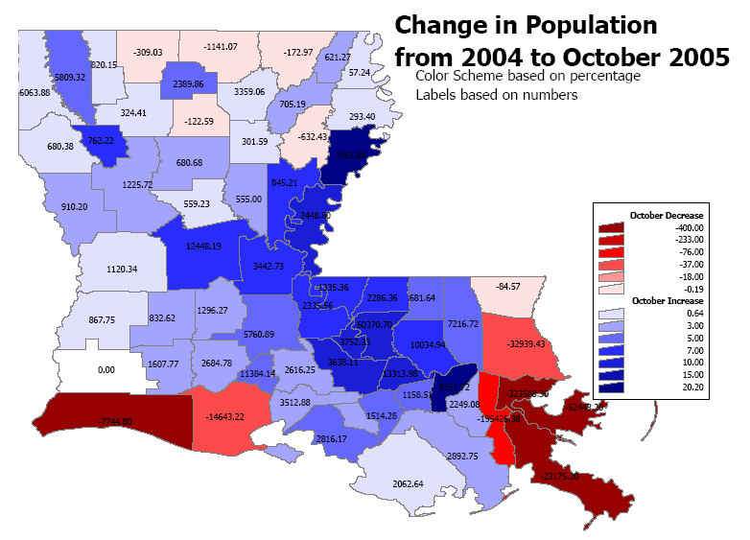
Data – LA Department of Education, Department of Health and Hospitals Bureau of Primary Care and Rural Health, US Census Bureau
Following the evacuations caused by the storms and the flooding, there has been some movement towards repopulating the affected areas. The second map (Population shift from October to December 2005) shows that most of the affected parishes have re-gained some population and the areas to which people had evacuated lost population. Since these maps are based on school enrollments, we can have a fair amount of confidence that we are seeing real population movement. Parents do not readily enroll or un-enroll their children in school unless they have truly moved or plan on moving.

Figure 2 Population Shift October to December 2005
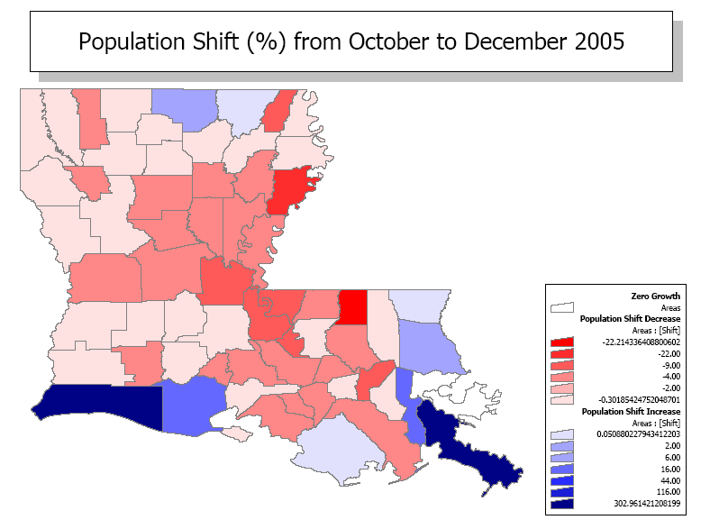
Data – LA Department of Education, Department of Health and Hospitals Bureau of Primary Care and Rural Health, US Census Bureau

While there was significant movement of people back to the affected areas, this does not represent a complete re-population. As the final map shows, all of the hurricane ravaged areas are still lacking significant numbers from their pre-storm populations.

Figure 3 Population Redistribution as of December 2005
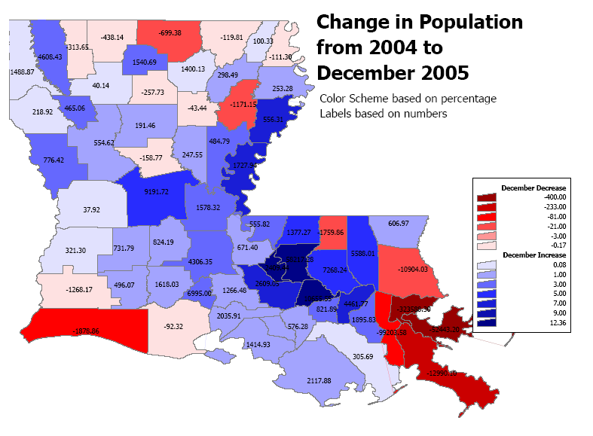
Data – LA Department of Education, Department of Health and Hospitals Bureau of Primary Care and Rural Health, US Census Bureau

Overall, population estimates indicate that there are nearly 500,000 fewer people residing in the state than there were prior to the hurricanes.

Table 2-1 Parish Level Population Estimates
PARISH | January 06 | December 05 | November 05 | October 05 | U.S. Census Estimate July 04
Acadia Parish | 60,146 | 60,738 | 60,738 | 61,804 | 59,168
Allen Parish | 26,072 | 26,108 | 26,126 | 26,209 | 25,407
Ascension Parish | 97,463 | 97,775 | 97,839 | 100,432 | 87,164
Assumption Parish | 23,475 | 23,766 | 23,819 | 24,703 | 23,234
Avoyelles Parish | 42,655 | 43,554 | 43,815 | 45,419 | 41,981
Beauregard Parish | 34,137 | 34,405 | 34,394 | 34,951 | 34,094
Bienville Parish | 15,396 | 15,389 | 15,339 | 15,673 | 15,361
Bossier Parish | 107,238 | 108,543 | 108,598 | 109,742 | 104,080
Caddo Parish | 254,125 | 253,593 | 254,662 | 258,179 | 251,506
Calcasieu Parish | 182,352 | 183,679 | 183,047 | 184,961 | 184,961
Caldwell Parish | 10,787 | 10,810 | 10,816 | 11,156 | 10,837
Cameron Parish | 7,851 | 7,798 | 7,568 | 1,936 | 9,681
Catahoula Parish | 11,143 | 11,119 | 11,174 | 11,480 | 10,627
Claiborne Parish | 16,067 | 16,085 | 16,055 | 16,214 | 16,471
Concordia Parish | 21,322 | 21,491 | 21,701 | 22,213 | 19,724
DeSoto Parish | 26,358 | 26,494 | 26,515 | 26,956 | 26,231
East Baton Rouge Parish | 448,500 | 453,946 | 457,489 | 458,333 | 412,633
East Carroll Parish | 8,736 | 8,849 | 8,871 | 9,017 | 8,954
East Feliciana Parish | 22,279 | 22,416 | 22,571 | 23,329 | 20,950
Evangeline Parish | 35,758 | 36,294 | 36,323 | 36,766 | 35,451
Franklin Parish | 19,553 | 19,637 | 19,727 | 20,176 | 20,812
Grant Parish | 18,921 | 18,983 | 19,004 | 19,702 | 19,139
Iberia Parish | 75,738 | 76,532 | 76,871 | 78,010 | 74,449
Iberville Parish | 34,859 | 35,158 | 35,229 | 36,188 | 32,497
Jackson Parish | 15,033 | 15,033 | 15,093 | 15,168 | 15,278
Jefferson Parish | 363,309 | 354,337 | 328,223 | 258,128 | 453,590
Jefferson Davis Parish | 31,488 | 31,753 | 32,012 | 32,865 | 31,235
Lafayette Parish | 200,933 | 203,457 | 204,229 | 207,863 | 195,707
Lafourche Parish | 92,061 | 92,622 | 93,251 | 95,214 | 92,157
LaSalle Parish | 14,316 | 14,410 | 14,316 | 14,718 | 14,161
Lincoln Parish | 43,600 | 43,993 | 44,253 | 44,844 | 42,382
Livingston Parish | 112,520 | 112,924 | 113,188 | 115,691 | 105,653
Madison Parish | 13,144 | 13,259 | 13,225 | 13,299 | 12,996
Morehouse Parish | 30,466 | 30,496 | 30,484 | 30,443 | 30,551
Natchitoches Parish | 39,346 | 39,251 | 39,307 | 39,922 | 38,741
Orleans Parish | 156,140 | 138,681 | 138,681 | 138,681 | 462,269
Ouachita Parish | 149,081 | 150,404 | 150,648 | 152,746 | 148,355
Plaquemines Parish | 17,309 | 15,984 | 14,671 | 5,794 | 28,969
Pointe Coupee Parish | 22,852 | 23,189 | 23,511 | 24,852 | 22,537
Rapides Parish | 136,217 | 137,179 | 137,499 | 140,435 | 128,013
Red River Parish | 9,981 | 10,085 | 10,065 | 10,382 | 9,606
Richland Parish | 20,696 | 20,816 | 20,906 | 21,223 | 20,485
Sabine Parish | 24,315 | 24,443 | 24,460 | 24,577 | 23,616
St. Bernard Parish | 6,899 | 13,111 | 13,111 | 13,111 | 65,554
St. Charles Parish | 51,830 | 52,137 | 52,205 | 52,492 | 50,073
St. Helena Parish | 11,609 | 8,539 | 8,508 | 10,978 | 10,309
St. James Parish | 21,747 | 21,981 | 21,975 | 22,317 | 21,146
St. John the Baptist Parish | 49,286 | 49,983 | 51,065 | 54,668 | 45,581
St. Landry Parish | 92,921 | 94,186 | 94,186 | 95,644 | 89,635
St. Martin Parish | 51,647 | 51,706 | 51,747 | 53,055 | 50,453
St. Mary Parish | 53,366 | 53,667 | 53,770 | 55,069 | 52,189
St. Tammany Parish | 205,461 | 202,536 | 198,668 | 180,513 | 213,553
Tangipahoa Parish | 109,423 | 110,359 | 110,547 | 111,982 | 105,158
Tensas Parish | 6,496 | 6,745 | 6,869 | 7,753 | 6,176
Terrebonne Parish | 107,501 | 108,796 | 109,000 | 108,740 | 106,523
Union Parish | 22,042 | 22,250 | 22,229 | 21,807 | 22,894
Vermilion Parish | 54,325 | 54,720 | 54,816 | 40,153 | 54,751
Vernon Parish | 49,119 | 49,550 | 49,719 | 50,632 | 49,545
Washington Parish | 42,449 | 42,341 | 41,901 | 41,701 | 44,161
Webster Parish | 40,510 | 40,869 | 41,432 | 42,001 | 41,254
West Baton Rouge Parish | 24,004 | 24,397 | 24,574 | 25,746 | 21,880
West Carroll Parish | 11,921 | 12,048 | 12,089 | 12,568 | 11,963
West Feliciana Parish | 15,397 | 15,652 | 15,890 | 16,431 | 15,108
Winn Parish | 16,219 | 16,277 | 16,306 | 16,765 | 16,151
STATE TOTAL | 4,137,915 | 4,137,331 | 4,116,925 | 4,054,522 | 4,515,770
Data – LA Department of Education, Department of Health and Hospitals Bureau of Primary Care and Rural Health, US Census Bureau

Demographics
In addition to estimating the total population effects within Louisiana parishes, it is also important to assess the demographics of the displaced population. Based on studies performed by the Center for Child Development of the University of Louisiana at Lafayette following the storms, there are several observations that can be made. Detailed data on evacuees was obtained from four school districts: Ascension, Caddo, East Baton Rouge, and Lafayette Parish school systems.

The demographics of the students that were displaced by the hurricanes are consistent with the demographics of the source parishes of Jefferson, Orleans, St. Bernard, Plaquemines, and Cameron. The following table shows the ethnic group demographics for the four Katrina-affected parishes.

Students in Orleans, Jefferson, St. Bernard, and Plaquemines School Districts (2004-05 SY)
Race | Number of Students | Percentage
Black | 91,106 | 70%
White | 29,326 | 22%
Hispanic | 5,879 | 4%
Asian | 4,027 | 3%
Native American | 583 | 0%
Total | 130,921
October 1, 2004 Louisiana Department of Education Student Information System

The enrollment data for all four of the parishes more closely matches the existing ethnic demographic than it does the source. For example, in Lafayette Parish school system the evacuee students were about 45% black and 41% white.

October 1, 2004 Louisiana Department of Education Student Information System
Race | Evacuees | Pre-Katrina Students
Black | 45.66% | 41.17%
White | 40.78% | 55.50%
(blank) | 7.53% | N/A
Hispanic | 2.81% | 1.68%
Asian | 2.84% | 1.36%
Native American | 0.08% | 0.29%

This same pattern was observed in the other school systems that were investigated, although there appears to be a distance effect. That is, the further from the affected parishes, the more likely that the evacuee demographics will be similar to the source parishes. While data is limited, the information from the Caddo School system provides some insight. The pre-Katrina demographics of the public school system indicated that there were 35% white students and 63% black students. The evacuee students in Caddo were 78% black and 18% white which is more closely aligned with the evacuated parish demographics and, in particular, is even closer to the Orleans parish demographics.

The data supports the observation that many of the highest poverty and ethnic groups were evacuated to areas further from the affected areas. It appears that those that could evacuate themselves headed toward family and friends closer to New Orleans, while those that were evacuated after the storms were sent out further.

This information seems to indicate that where data related to the SEW is being considered the most important information regarding the re-distribution of population will be two-fold. First, the closer to the epicenter of the affected areas, the more similar the evacuee population is to the pre-Katrina population demographically. This may imply that where consequence and consumption data are related to ethnic, gender, socio-economic or other demographic information, rates may simply be scaled to account for the new population levels. This assumption is independent of the effects of the disaster on substance abuse, which the following section addresses.

The second factor is the continuing movement of the affected population. While there was a large initial displacement of residents, there have been significant numbers returning to the area. The current (ca. January 2006) population in the affected areas is still significantly less than the pre-Katrina population. In order to insure that the proper resources are available in the proper areas at the proper time, ongoing population estimates will be required. The dynamics of the Louisiana population will require that the State be flexible and agile in responding to the changing needs and location of their citizens.

Substance Abuse Prevention Following a Disaster
In the wake of a disaster, concerns about substance use and abuse may seem minor in relation to the immediate devastation and the task of rebuilding. However, it is during times of extreme stress such as those following a disaster that substance use and abuse tends to increase. Focused disaster management activities are critical in dealing with disasters.

Disaster management activities can be viewed in three phases: preparedness, response, and recovery. Phase 1 encompasses all pre-disaster activities that lessen its effects and lay the groundwork for response and recovery. Phase 2 includes the first 3 weeks immediately following the disaster. Emergency assistance is provided during this phase. Phase 3, the Recovery Phase, runs from 2 weeks to several years after the disaster. This phase begins after basic needs are met and focus shifts to returning things to normal.

As part of the Recovery Phase, substance abuse prevention professionals must understand that survivors and disaster relief workers experience several different emotional phases following a disaster. The Alert Phase occurs when people actually realize that they can potentially be affected by a disaster. During the disaster impact and immediately following, people can experience the Heroic Phase and exert intense effort toward survival. Next, the Honeymoon Phase may last 1 week to 6 months immediately after a disaster. This phase involves a strong sense of companionship among the survivors and a renewed sense of community. During the period of 2 months to 2 years following a disaster the Disillusionment Phase can take over. Survivors can have feelings of anger, loss, and resentment. Hopelessness and depression can also surface. It is during this phase that the risk of substance abuse increases. Finally, the survivor accepts their role in recovery and takes on the responsibility to fulfill the role. This phase is called the Reconstruction Phase and can last several years.

The statistics that are available and the reports from professionals working in the field indicate that the extreme stress tied to disasters can lead to: misuse of alcohol and other drugs; increase in problems associated with substance abuse; breakdown of normal controls that prevent substance abuse and its related problems; increased difficulties for people in recovery; and increased initiation by children and youth or abuse the elderly. Substance abuse prevention professionals must remember “that all services that address mental health issues are potentially substance abuse prevention services, since they address the environmental factors that can give rise to increased alcohol and drug use and other maladaptive behaviors.” (Center for Substance Abuse Prevention [CSAP], 1997).

Substance Abuse Related Mortality Impacts

All Causes of Death
Several of the leading causes of death in Louisiana are at least partially caused by the abuse of alcohol, tobacco, or other drugs. Diseases of the heart (1st) are the leading cause of death in Louisiana, followed by malignant neoplasms (cancer) (2nd) and cerebrovascular disease (3rd), all of which are associated with smoking. Chronic lower respiratory disease (6th) is also frequently associated with smoking. Alcohol use is strongly associated with death due to accidents (4th).

Age Adjusted Mortality Rates* for the Thirteen Leading Causes of Death in Louisiana and the United States 2002
 |  | Louisiana |  | United States
Rank** | Cause of Death | Age-Adjusted Death Rate | Rank** | Age-Adjusted Death Rate
- | All Causes | 996.5 | - | 847.3
1 | Diseases of the Heart (I00-I09, I11, I13, I20-51) | 268.3 | 1 | 241.7
2 | Malignant Neoplasms (C00-C97) | 222 | 2 | 193.2
3 | Cerebrovascular Disease (I60-I69) | 62.5 | 3 | 56.4
4 | Accidents (V01-X59, Y85-Y86) | 47.6 | 5 | 37
5 | Diabetes Mellitus (E10-E14) | 42.1 | 6 | 25.4
6 | Chronic Lower Respiratory Disease (J40-J47) | 40.9 | 4 | 43.3
7 | Alzheimer's Disease (G30) | 27.8 | 8 | 20.4
8 | Nephritis, Nephrotic Syndrome, and Nephrosis (N00-N07, N17-N19, N25-N27) | 23.6 | 9 | 14.2
9 | Influenza and Pneumonia (J10-J18) | 23.4 | 7 | 22.8
10 | Septicemia (A40-A41) | 19.7 | 10 | 11.7
11 | Homicide (X85-Y09, Y87.1) | 13.4 | 14 | 6.1
12 | Suicide (X60-X84, Y87.0) | 11.3 | 11 | 10.9
13 | Chronic Liver Disease (K70, K73-K74) | 8.4 | 12 | 9.4
*Age-Adjusted Rate per 100,000, 2000 U.S. standard population
**Causes of death are ranked based on crude death rates
International Statistical Classification of Diseases (ICD) code definitions for each indicator are provided in parentheses.
Sources: Louisiana State Center for Health Statistics, National Center for Health Statistics (National Vital Statistics Reports - Deaths: Leading Causes for 2002), United States Census Bureau, http://wonder.cdc.gov/mortICD10J.html

Causes of Death from Substance Abuse
The chart below displays the eleven leading causes of substance related death in Louisiana. Ischemic cerebrovascular disease (1st), other cardiovascular diseases (2nd), lung cancer (3rd), and lung disease (4th) head the list and are associated with tobacco use. Alcohol consumption is often associated with homicide (5th), suicide (6th), traffic fatalities (alcohol related traffic fatalities (7th), cirrhosis (8th), and deaths due to other accidents (alcohol related accidents, 9th). The relationship of both cigarette related accidents or fires (10th) and illicit drug deaths (11th) to substance use are apparent.

From 1999 through 2003, cardiovascular disease death rates appear to consistently lie between 3.25 and 3.5 per thousand population. No significant increasing or decreasing trend is apparent. 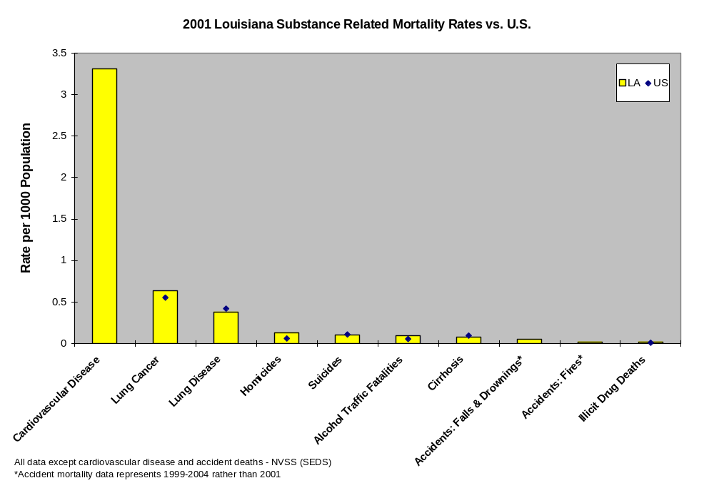

When leading causes of death by age group are observed, the importance of substance related mortality is apparent. From ages 15 until 24, the leading causes of death are unintentional injury (includes traffic fatalities), homicide, and suicide. All three are associated with substance use, particularly alcohol. From 25-34 years of age, unintentional injury and homicide are 1st and 2nd as the leading causes of mortality. In older age groups, chronic causes of death replace more proximal acute causes as the leading determinants of mortality. At age 35 and over, at least two substance related causes of mortality are ranked in the top three causes of death: heart disease (tobacco related), malignant neoplasms (some cancers are associated with tobacco use), and cerebrovascular disease (tobacco related) are common chronic causes of mortality.
Top Ten Leading Causes of Death in Louisiana by Age 2001
 | Age Groups
Rank | <1 | 1-4 | 5-9 | 10-14 | 15-17 | 18-21 | 22-24 | 25-34 | 35-44 | 45-54 | 55-64 | 65+ | All Ages
1 | Congenital  Anomalies  119 | Unintentional Injury  63 | Unintentional Injury  39 | Unintentional Injury  42 | Unintentional Injury  74 | Unintentional Injury  150 | Unintentional Injury  100 | Unintentional Injury  262 | Unintentional Injury  358 | Malignant  Neoplasms  963 | Malignant  Neoplasms  1,710 | Heart  Disease  8,846 | Heart  Disease  11,474
2 | Short  Gestation  117 | Homicide  14 | Malignant  Neoplasms  14 | Malignant  Neoplasms  8 | Homicide  24 | Homicide  82 | Homicide  53 | Homicide  162 | Malignant  Neoplasms  335 | Heart  Disease  836 | Heart  Disease  1,345 | Malignant  Neoplasms  6,360 | Malignant  Neoplasms  9,517
3 | SIDS  66 | Congenital  Anomalies  13 | Homicide  4 | Homicide  5 | Suicide  15 | Suicide  40 | Suicide  15 | HIV  84 | Heart  Disease  323 | Unintentional Injury  255 | Diabetes  Mellitus  306 | Cerebro-  vascular  2,145 | Cerebro-  vascular  2,638
4 | Maternal  Pregnancy  Comp.  42 | Malignant  Neoplasms  7 | Congenital  Anomalies  3 | Congenital  Anomalies  4 | Malignant  Neoplasms  13 | Malignant  Neoplasms  22 | Heart  Disease  12 | Suicide  84 | HIV  151 | Cerebro-  vascular  172 | Cerebro-  vascular  230 | Chronic Low.  Respiratory  Disease  1,478 | Unintentional Injury  2,029
5 | Respiratory  Distress  30 | Heart  Disease  4 | HIV  2 | Heart  Disease  4 | Heart  Disease  6 | Heart  Disease  12 | Malignant  Neoplasms  12 | Heart  Disease  76 | Suicide  105 | Diabetes  Mellitus  130 | Chronic Low.  Respiratory  Disease  191 | Diabetes  Mellitus  1,230 | Chronic Low.  Respiratory  Disease  1,763
6 | Unintentional Injury  22 | Anemias  2 | Benign  Neoplasms  1 | Influenza  & Pneumonia  3 | Congenital  Anomalies  4 | Congenital  Anomalies  6 | HIV  7 | Malignant  Neoplasms  73 | Homicide  101 | HIV  109 | Unintentional Injury  147 | Alzheimer's  Disease  943 | Diabetes  Mellitus  1,734
7 | Placenta  Cord  Membranes  18 | Benign  Neoplasms  2 | Heart  Disease  1 | Suicide  3 | Benign  Neoplasms  3 | Anemias  5 | Chronic Low.  Respiratory  Disease  5 | Diabetes  Mellitus  15 | Cerebro-  vascular  70 | Suicide  89 | Nephritis  125 | Influenza  & Pneumonia  819 | Nephritis  993
8 | Atelectasis  16 | HIV  2 | Meningitis  1 | Meningo-  coccal  Infection  2 | Cerebro-  vascular  2 | Benign  Neoplasms  3 | Congenital  Anomalies  3 | Septicemia  13 | Diabetes  Mellitus  49 | Liver  Disease  75 | Liver  Disease  77 | Nephritis  757 | Alzheimer's  Disease  957
9 | Intrauterine  Hypoxia  15 | Four Tied  1 |  | Three Tied  1 | Seven Tied  1 | Six Tied  2 | Anemias  2 | Influenza  & Pneumonia  12 | Liver  Disease  39 | Nephritis  64 | Septicemia  73 | Septicemia  579 | Influenza  & Pneumonia  941
10 | Circulatory  System  Disease  13 | Four Tied  1 |  | Three Tied 1 | Seven Tied  1 | Six Tied  2 | Eight Tied  1 | Two Tied  11 | Viral  Hepatitis  31 | Chronic Low.  Respiratory  Disease  62 | Influenza  & Pneumonia  52 | Unintentional Injury  517 | Septicemia  758

As stated above, more proximal causes of death, mortality consequences following substance use or abuse more closely in time, are more evident in younger age groups. Death rates from homicide are highest in 18-34 year olds. The highest number of homicides occurs in the 21-29 year old group. Suicide rates and rates of death from illicit drugs remain fairly constant from age 18 and up. The highest suicide and illicit drug death rates are seen in the 65 and older group and the highest number of suicides and illicit drug deaths is seen in the 35-54 year old group. Nevertheless, the proportion of deaths from these two causes in older age groups is reduced due to large numbers of deaths from chronic causes.
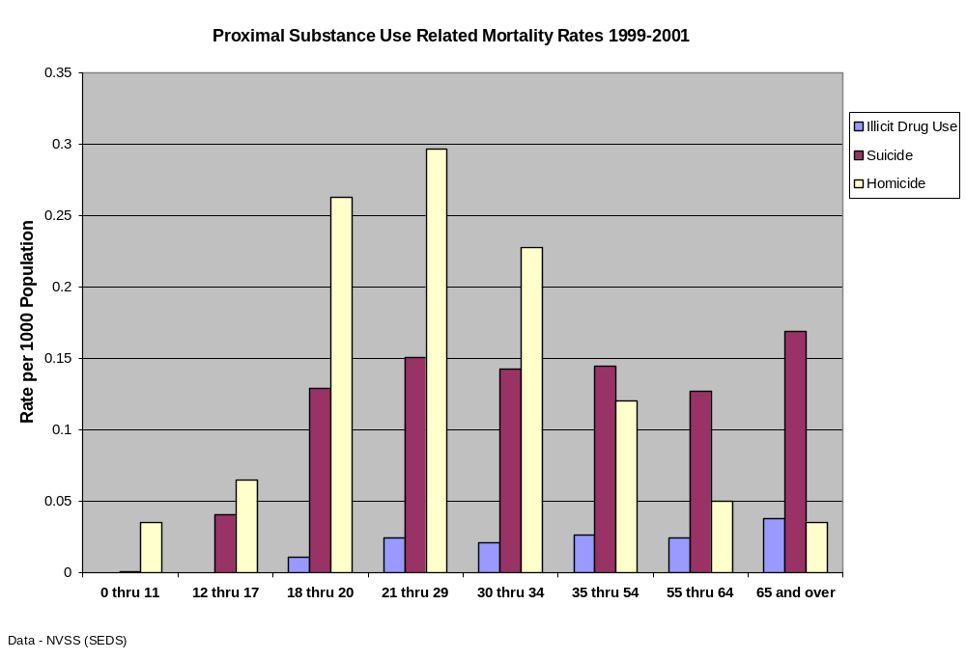

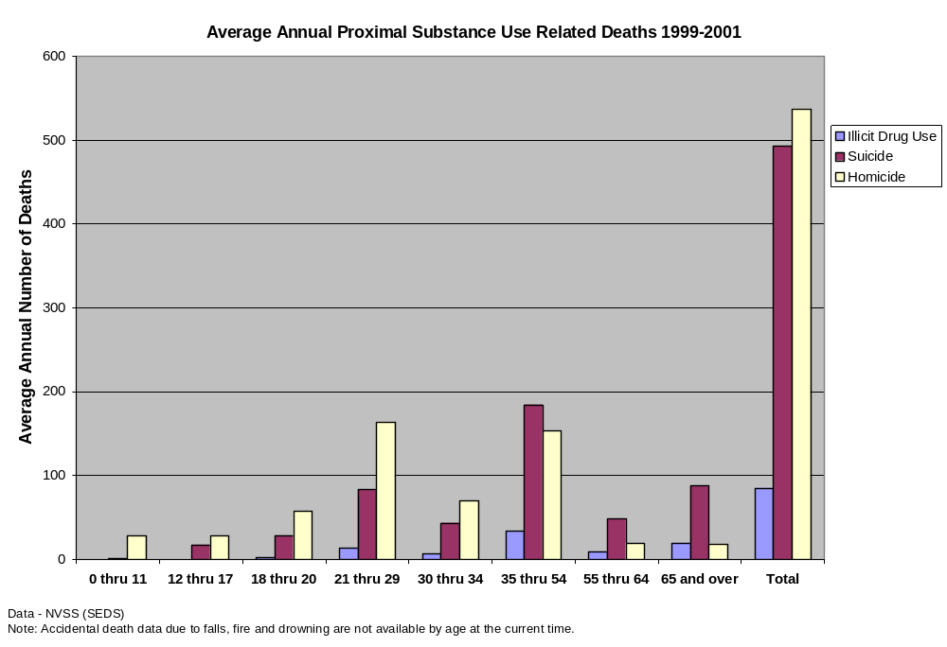

The following two charts illustrate the importance of death from ischemic cerebrovascular disease, other cardiovascular disease, lung cancer, and lung disease (all associated with tobacco use) in Louisiana residents.
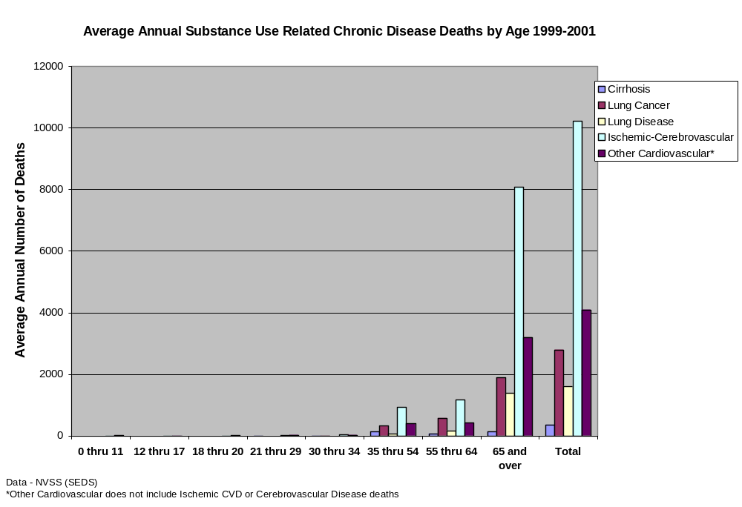
Years of Potential Life Lost
The years of potential life lost (YPLL) calculation emphasizes premature mortality by giving a larger computational weight to youthful deaths. YPLL before age 65 computes the burden of mortality from a particular cause responsible for life lost, assuming 65 years as a full life.₁₉ The causes of mortality responsible for the greatest burden of potential life lost are illustrated in the chart below. Unintentional injury, malignant neoplasms, heart disease, homicide, suicide, and
cerebrovascular diseases can all be related to substance use.

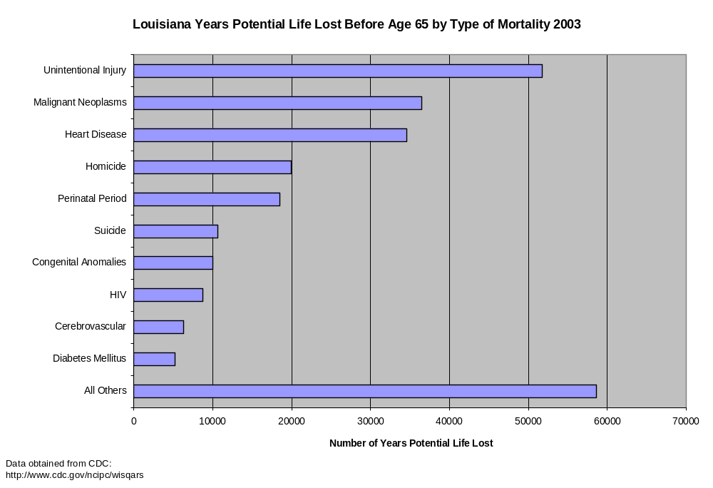
YPLL before age 85 computes the burden of mortality from a particular cause responsible for life lost, assuming 85 years as a full life. The causes of mortality responsible for the greatest burden of potential life lost are illustrated in the chart below. Malignant neoplasms, heart disease, unintentional injury, homicide, cerebrovascular diseases, chronic lower respiratory disease, and suicide can all be related to substance use.
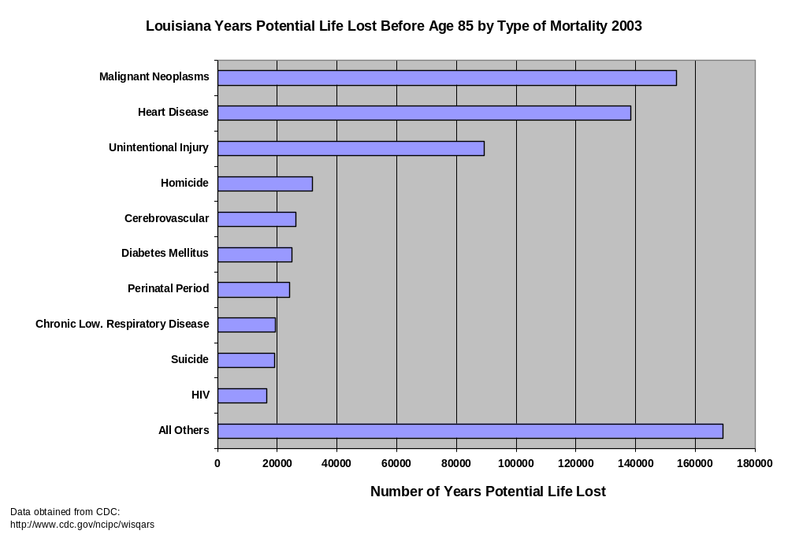
Top Ten Causes of Non-Fatal Injuries in the United States by Age 2002-2004
 | Age Groups
Rank | <1 | 1-4 | 5-9 | 10-14 | 15-24 | 25-34 | 35-44 | 45-54 | 55-64 | 65+ | All Ages
1 | Unintentional  Fall  375,016 | Unintentional  Fall  2,624,494 | Unintentional  Fall  2,023,255 | Unintentional  Fall  2,007,409 | Unintentional  Struck by/  Against  2,904,703 | Unintentional  Fall  2,220,340 | Unintentional  Fall  2,394,065 | Unintentional  Fall  2,215,221 | Unintentional  Fall  1,661,751 | Unintentional  Fall  5,311,690 | Unintentional  Fall  23,364,042
2 | Unintentional  Struck by/  Against  96,915 | Unintentional  Struck by/  Against  1,123,217 | Unintentional  Struck by/  Against  1,265,079 | Unintentional  Struck by/  Against  1,809,515 | Unintentional  MV-Occupant  2,732,539 | Unintentional  Overexertion  2,069,322 | Unintentional  Overexertion  1,958,897 | Unintentional  Overexertion  1,253,726 | Unintentional  Struck by/  Against  577,999 | Unintentional  Struck by/  Against  599,171 | Unintentional  Struck by/  Against  13,342,474
3 | Unintentional  Fire/Burn  35,872 | Unintentional  Other Bite/  Sting  406,675 | Unintentional  Cut/Pierce  376,334 | Unintentional  Overexertion  839,054 | Unintentional  Fall  2,529,728 | Unintentional  Struck by/  Against  2,016,926 | Unintentional  Struck by/  Against  1,778,739 | Unintentional  Struck by/  Against  1,169,563 | Unintentional  Overexertion  568,821 | Unintentional  MV-Occupant  567,125 | Unintentional  Overexertion  9,890,879
4 | Unintentional  Other Bite/  Sting  34,820 | Unintentional  Foreign Body  327,452 | Unintentional  Pedal Cyclist  333,450 | Unintentional  Cut/Pierce  483,113 | Unintentional  Overexertion  2,244,439 | Unintentional  MV-Occupant  1,851,821 | Unintentional  MV-Occupant  1,539,953 | Unintentional  MV-Occupant  1,047,402 | Unintentional  MV-Occupant  562,925 | Unintentional  Overexertion  492,622 | Unintentional  MV-Occupant  9,015,525
5 | Unintentional  Foreign Body  26,007 | Unintentional  Cut/Pierce  259,763 | Unintentional  Other Bite/  Sting  281,309 | Unintentional  Pedal Cyclist  423,400 | Unintentional  Cut/Pierce  1,484,060 | Unintentional  Cut/Pierce  1,343,914 | Unintentional  Cut/Pierce  1,183,345 | Unintentional  Cut/Pierce  843,068 | Unintentional  Cut/Pierce  450,265 | Unintentional  Cut/Pierce  354,785 | Unintentional  Cut/Pierce  6,799,166
6 | Unintentional  MV-Occupant  24,041 | Unintentional  Overexertion  218,633 | Unintentional  Overexertion  226,837 | Other Assault  Struck by/  Again  348,435 | Other Assault  Struck by/  Again  1,349,060 | Other Assault  Struck by/  Again  821,156 | Other Assault  Struck by/  Again  670,997 | Unintentional  Other Specified  384,295 | Unintentional  Other Bite/  Sting  191,683 | Unintentional  Other Bite/  Sting  221,679 | Other Assault  Struck by/  Again  3,832,577
7 | Unintentional  Poisoning  20,722 | Unintentional  Poisoning  188,891 | Unintentional  MV-Occupant  225,583 | Unintentional  Unknown/  Unspecified  342,162 | Unintentional  Other Bite/  Sting  485,493 | Unintentional  Other Bite/  Sting  436,417 | Unintentional  Other Specified  481,615 | Other Assault  Struck by/  Again  322,820 | Unintentional  Other Specified  148,086 | Unintentional  Poisoning  139,542 | Unintentional  Other Bite/  Sting  2,982,617
8 | Unintentional  Cut/Pierce  20,036 | Unintentional  Fire/Burn  178,733 | Unintentional  Foreign Body  161,284 | Unintentional  MV-Occupant  323,881 | Unintentional  Unknown/  Unspecified  480,987 | Unintentional  Other Specified  391,140 | Unintentional  Other Bite/  Sting  411,806 | Unintentional  Other Bite/  Sting  318,665 | Unintentional  Other  Transport  100,268 | Unintentional  Other  Transport  139,088 | Unintentional  Other Specified  2,141,911
9 | Unintentional  Inhalation/  Suffocation  19,737 | Unintentional  Unknown/  Unspecified  145,714 | Unintentional  Dog Bite  153,735 | Unintentional  Other  Transport  200,625 | Unintentional  Other Specified  417,563 | Unintentional  Other  Transport  300,228 | Unintentional  Poisoning  322,534 | Unintentional  Poisoning  253,775 | Unintentional  Poisoning  100,230 | Unintentional  Unknown/  Unspecified  134,572 | Unintentional  Unknown/  Unspecified  2,020,666
10 | Unintentional  Unknown/  Unspecified  18,385 | Unintentional  MV-Occupant  138,371 | Unintentional  Other  Transport  147,836 | Unintentional  Other Bite/  Sting  193,993 | Unintentional  Other  Transport  399,212 | Unintentional  Unknown/  Unspecified  287,495 | Unintentional  Foreign Body  263,707 | Unintentional  Other  Transport  189,180 | Other Assault  Struck by/  Again  89,118 | Unintentional  Other Specified  98,642 | Unintentional  Other  Transport  1,837,517

Burden of Alcohol Use
In the United States, alcohol is consumed more frequently than all other illicit drugs combined and is the drug most likely associated with injury or death.₁ Alcohol use in Louisiana cost the taxpayers approximately $2.989 billion in 1998. Many of these costs were connected to alcohol related deaths, such as direct costs for healthcare, medical consequences of alcohol consumption, ancillary services at motor vehicle crashes, fire deaths, and loss of future earnings from premature death due to alcohol use.₂ As stated previously, homicide, suicide, chronic disease (cirrhosis), and injuries (motor vehicle crashes (MVCs) and other alcohol related accidents), are substance use associated causes of death most frequently linked to alcohol use.

State and Parish Long-Term Health Consequences

Chronic Liver Disease Mortality
Death from alcohol-related chronic disease does not appear in the leading ten causes of death in Louisiana, but cirrhosis is eighth in the list of substance use related deaths. Alcohol-related chronic liver disease (AR-CLD), such as cirrhosis, is the single cause that accounts for the most deaths due to alcohol-related chronic diseases. St. Bernard Parish is characterized by the highest rate in the state. Orleans, Jefferson, and Caddo Parishes have the highest number of deaths due to AR-CLD. Cirrhosis is eighth in the list of Louisiana substance related causes of death. During the years 1999 to 2001, the rate of cirrhosis deaths in Louisiana was lower than the national rate. Levels have remained constant in a range from 0.07 to 0.09 deaths per thousand people in Louisiana from 1999 to 2004.

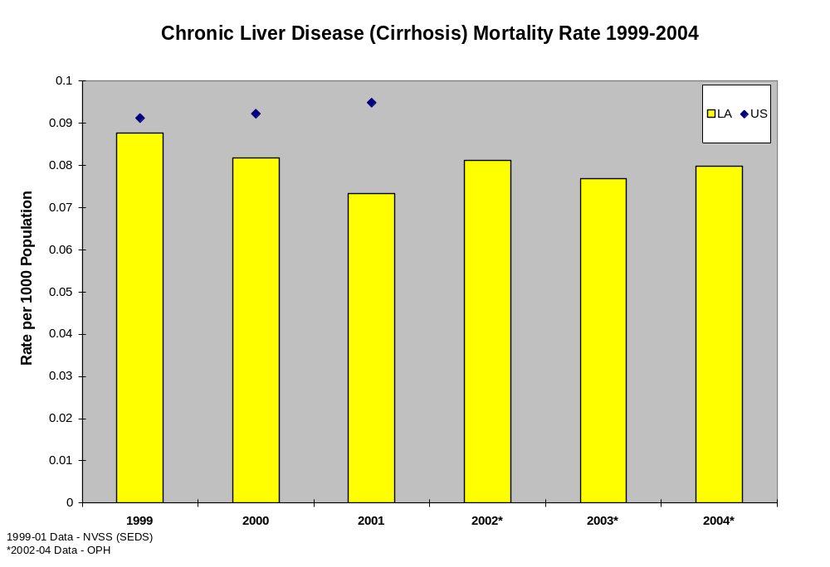

Average Annual Number of Cirrhosis Deaths by Age (1999-2001)
0
20
40
60
80
100
120
140
160
0 thru 11
12 thru 17
18 thru 20
21 thru 29
30 thru 34
35 thru 54
55 thru 64
65 and over
Data - NVSS (SEDS)
Number
From 1999 through 2001 in Louisiana, most cirrhosis deaths occurred in the 35-54 year age group. The second highest number of deaths occurred in the 65 and older group.
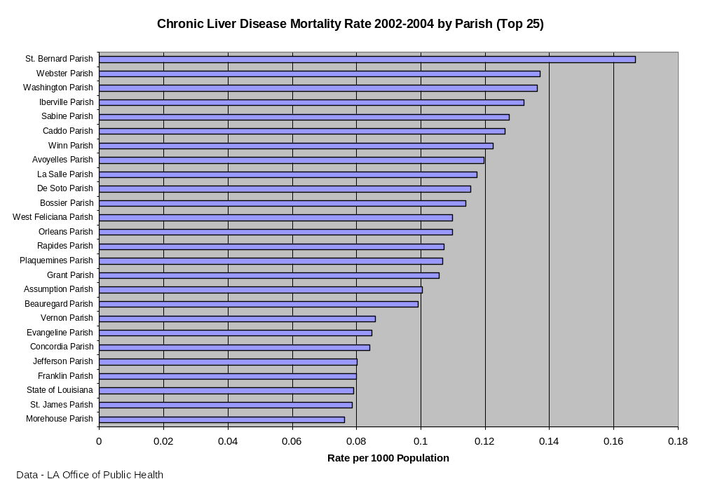

From 2002 through 2004, St. Bernard Parish exhibited the highest rate of chronic liver disease mortality in the state. Orleans, Jefferson, and Caddo Parishes had the next highest number of deaths due to chronic liver disease during the same period.
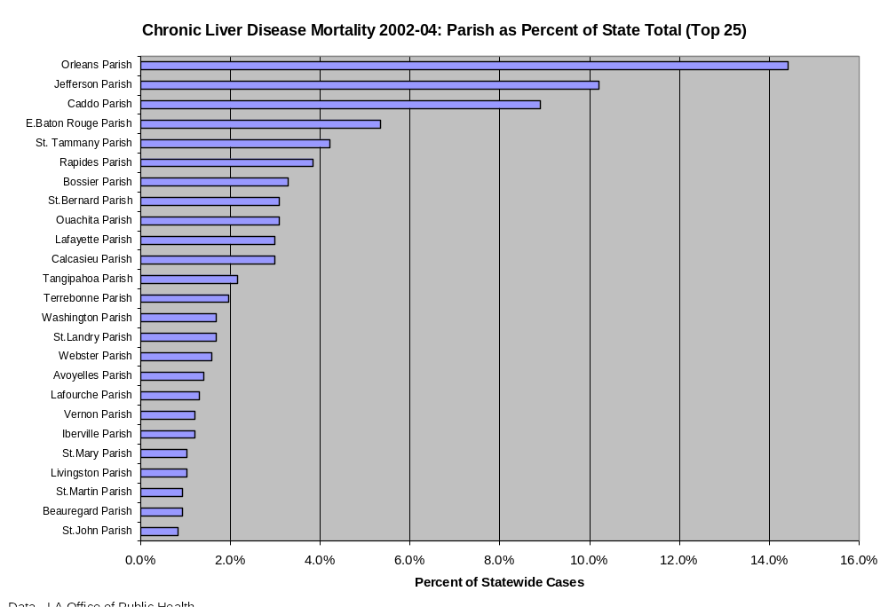
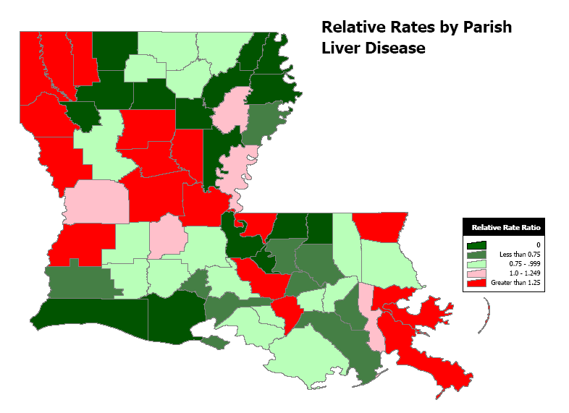
Data – LA Office of Public Health (2002-2004)

State and Parish Alcohol Consumption

Adult Current Drinking

The percentage of Louisiana residents 21 years of age and older that reported any use of alcohol within the past 30 days prior to completing CDC’s Behavioral Risk Factor Surveillance System (BRFSS) survey was higher than the national average (2001-2003). The highest percentages of respondents reporting alcohol use were in the 21 to 29 year old group. The lowest percentages were in the group 65 years of age and older.
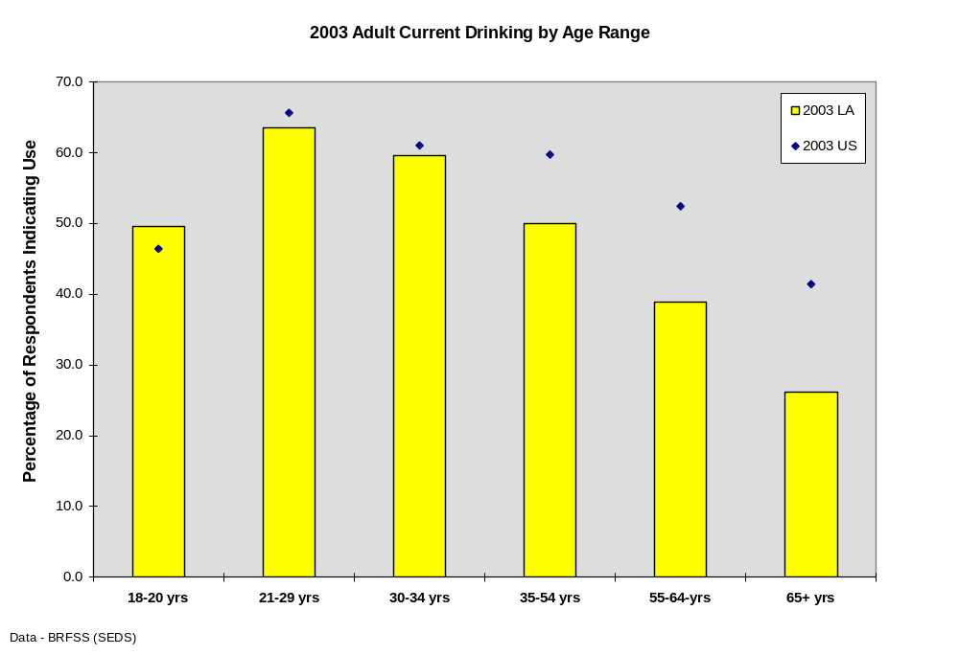

Respondents Classified as Dependent/Abusing Alcohol by Age 22

The National Survey on Drug Use and Health (NSDUH) provides annual data on drug use in the United States. The NSDUH is sponsored by the Substance Abuse and Mental Health Services Administration (SAMHSA), an agency of the U.S. Public Health Service and a division of the Department of Health and Human Services (DHHS). The survey provides yearly national and state level estimates of alcohol, tobacco, illicit drug, and non-medical prescription drug use. Other health-related questions also appear from year to year, including questions about mental health.¹⁴

In the 2002 NSDUH, the percentages of 12 to 17 year olds and respondents 26 and older were right at national levels. The percentage of respondents 17-25 classified as dependent/abusing alcohol was above national levels. Louisiana was slightly above the national average in the composite of all age groups.

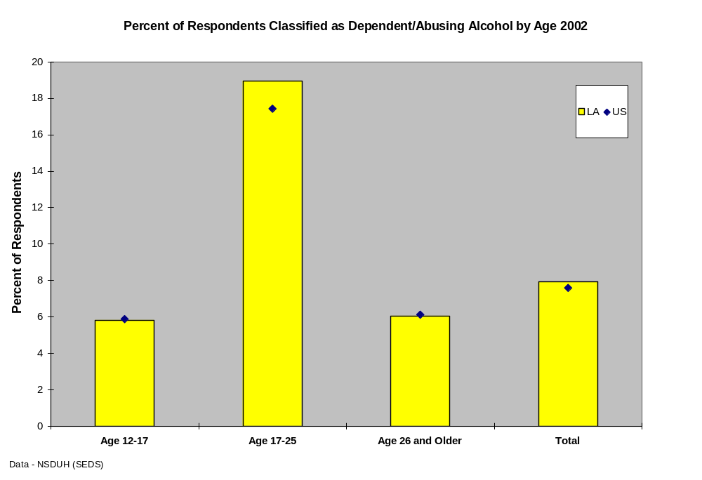
Adult Driving after Drinking

The percentages of adults reporting driving after drinking in the year prior to completion of the BRFSS (1999 and 2002) was above the national average in all age groups in the 1999 survey. In the 2002 survey, the percentages of adults reporting driving after drinking was well above the national average only in 18 to 29 years of age. The percentages were only slightly above national levels in the 30 to 54 year age group and were below the national average in respondents 55 years of age and older.
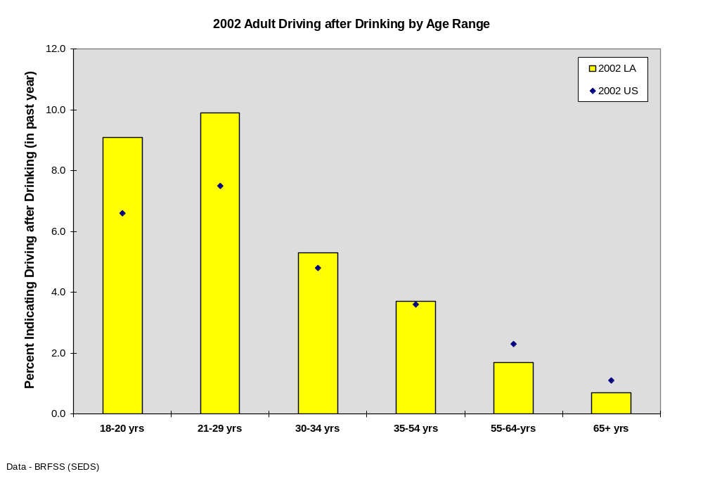

Adult Heavy Alcohol Use

In the BRFSS, heavy alcohol use was defined as having an average of two or more drinks per day for men or one or more drinks per day for women during the month preceding the interview.^{11, 12} In 2001 and 2002, the percentages of respondents indicating heavy usage was below the national average, except in the 2001 30-34 year old group. In 2003, the percentage of respondents indicating heavy alcohol use was above the national average in 30-54 year olds, and very near national levels in 21-29 year olds and 55-64 year olds. In 2003, 18-20 and 65 and older respondents indicated heavy alcohol use at percentages below the national average.
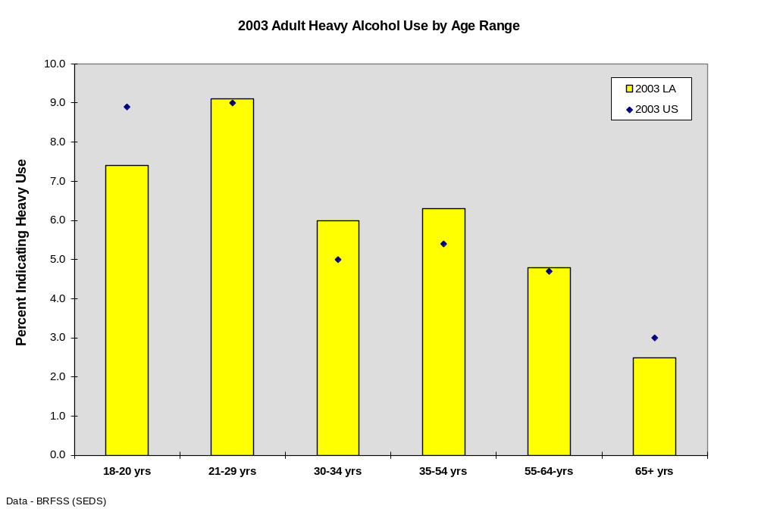

Binge Drinking

Binge drinking is defined by the BRFSS as having five or more drinks on one occasion during the month preceding completion of the survey.₁₁ The percentages of respondents indicating binge drinking behavior was fairly close to the national average (2001-2003). Binge drinking in the 65 year and older age group was above the national average while the three year mean of 2001 through 2003 percentages was slightly lower than the national average in the 18 to 20 year group.
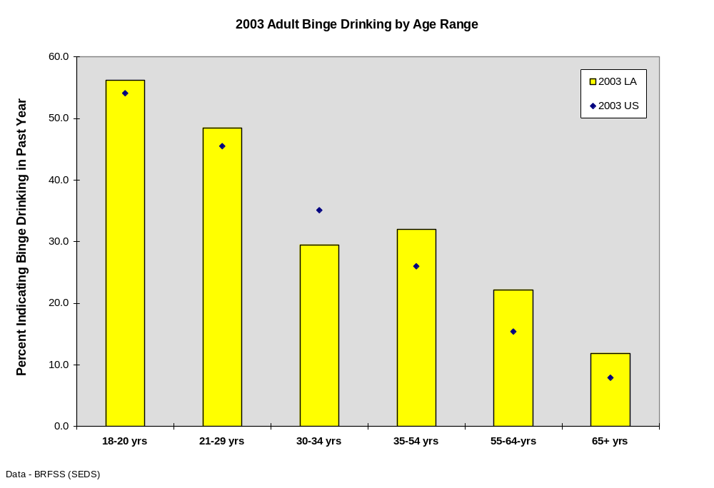

Youth 30-day Alcohol Use by Grade

The Louisiana Caring Communities Youth Survey (CCYS) is a survey of 6th, 8th, 10th, and 12th grade students designed to identify adolescent substance use, antisocial behavior, and the risk and protective factors that relate to these behaviors. The survey was conducted in the spring of 2001, the fall of 2002, and the fall of 2004. Thirty day use is a measure of the percentage of students who used the substance at least once in the 30 days prior to taking the survey and is considered a sensitive indication of the level of current use of the substance.¹³

No national comparisons are available for 6th graders. In 8th and 10th graders, the percentage of respondents indicating recent use was above the national average for all three years. In 12th graders, the percentages were higher than the national average in 2001, but in 2002 and 2003 were nearly identical to national averages.
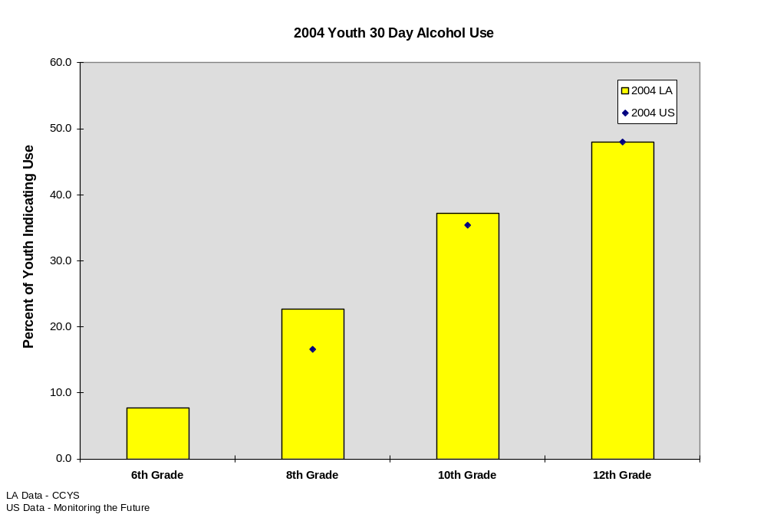

In the 2002 NSDUH, the percentages of 12 to 17 year olds and respondents 26 and older dependent /abusing alcohol were equivalent to national levels. The percentage of respondents 17-25 classified as dependent/abusing alcohol was above national levels. Louisiana was slightly above the national average in the composite of all age groups.

Table 4-2: 30 Day Youth Alcohol Use (2004 CCYS)
District | 0 Occasions | 1 or more occasions | Youth Percent Use Within Last 30 days
Zachary Community | 173 | 152 | 46.77%
St. Charles Parish | 888 | 667 | 42.89%
Cameron Parish | 204 | 151 | 42.54%
Avoyelles Parish | 704 | 498 | 41.43%
Terrebonne Parish | 1222 | 780 | 38.96%
Caldwell Parish | 81 | 48 | 37.21%
Allen Parish | 519 | 287 | 35.61%
Acadia Parish | 1057 | 578 | 35.35%
Plaquemines Parish | 672 | 353 | 34.44%
Jefferson Davis Parish | 800 | 418 | 34.32%
Beauregard Parish | 746 | 383 | 33.92%
Grant Parish | 448 | 227 | 33.63%
Ascension Parish | 2370 | 1191 | 33.45%
Iberville Parish | 519 | 260 | 33.38%
St. Martin Parish | 1001 | 496 | 33.13%
Evangeline Parish | 741 | 363 | 32.88%
Sabine Parish | 651 | 307 | 32.05%
West Carroll Parish | 139 | 65 | 31.86%
Assumption Parish | 659 | 308 | 31.85%
Iberia Parish | 2015 | 934 | 31.67%
St. Landry Parish | 1837 | 838 | 31.33%
Calcasieu Parish | 4640 | 2097 | 31.13%
Lafayette Parish | 3361 | 1502 | 30.89%
City of Bogalusa | 235 | 105 | 30.88%
Lafourche Parish | 1629 | 690 | 29.75%
Catahoula Parish | 182 | 77 | 29.73%
Livingston Parish | 3561 | 1475 | 29.29%
Louisiana Statewide | 70041 | 28838 | 29.16%
Webster Parish | 941 | 379 | 28.71%
East Baton Rouge Parish | 6486 | 2607 | 28.67%
Bienville Parish | 374 | 148 | 28.35%
Franklin Parish | 456 | 180 | 28.30%
Winn Parish | 401 | 155 | 27.88%
Union Parish | 421 | 159 | 27.41%
Claiborne Parish | 369 | 137 | 27.08%
Ouachita Parish | 2660 | 978 | 26.88%
Tangipahoa Parish | 2777 | 1021 | 26.88%
Natchitoches Parish | 755 | 274 | 26.63%
Caddo Parish | 1121 | 403 | 26.44%
St. James Parish | 408 | 146 | 26.35%
Washington Parish | 637 | 227 | 26.27%
Morehouse Parish | 614 | 216 | 26.02%
St. Mary Parish | 1496 | 522 | 25.87%
Bossier Parish | 2176 | 757 | 25.81%
West Baton Rouge Parish | 487 | 166 | 25.42%
Jefferson Parish | 5339 | 1757 | 24.76%
Red River Parish | 146 | 48 | 24.74%
West Feliciana Parish | 433 | 140 | 24.43%
Concordia Parish | 515 | 165 | 24.26%
East Carroll Parish | 242 | 76 | 23.90%
LaSalle Parish | 440 | 136 | 23.61%
Rapides Parish | 1917 | 586 | 23.41%
Vernon Parish | 975 | 296 | 23.29%
City of Baker | 335 | 101 | 23.17%
Richland Parish | 578 | 170 | 22.73%
Orleans Parish | 647 | 190 | 22.70%
Jackson Parish | 359 | 97 | 21.27%
Lincoln Parish | 752 | 187 | 19.91%
St. Bernard Parish | 629 | 129 | 17.02%
DeSoto Parish | 499 | 100 | 16.69%
City of Monroe | 933 | 180 | 16.17%
St. Helena Parish | 223 | 36 | 13.90%
Tensas Parish | 140 | 18 | 11.39%
Pointe Coupee Parish | 137 | 11 | 7.43%
Madison Parish | 71 | 3 | 4.05%

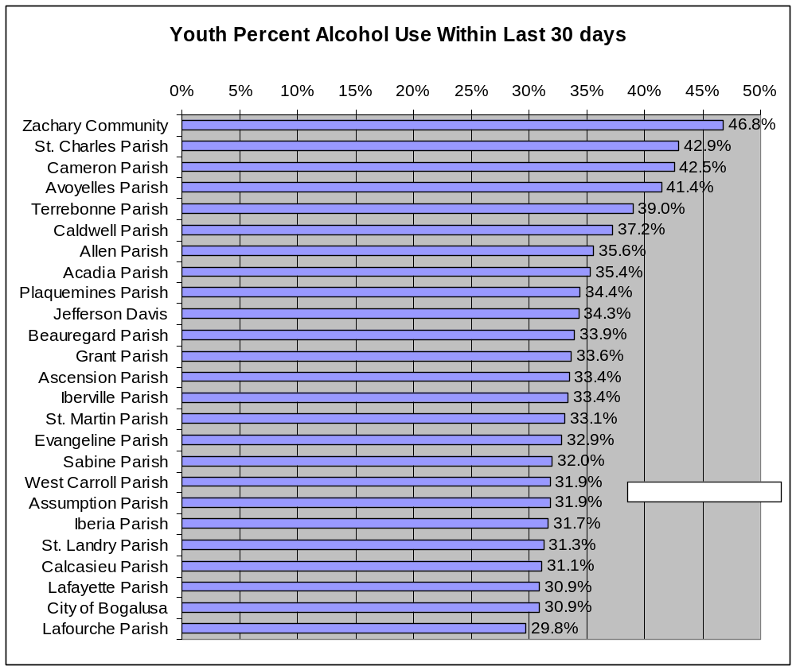

State and Parish Immediate Health Consequences
Alcohol is involved in approximately half of all homicides, suicides, and fatal traffic crashes in the United States.₃ The three leading causes of alcohol-related death in Louisiana are homicide, suicide, and alcohol-related traffic fatalities. In Louisiana, the death rates from homicide and motor vehicle traffic related accidents exceed the national rates.₄

From 1999 through 2001, Louisiana’s homicide rate remained nearly double the national rate. The Orleans Parish homicide rate is more than double that of any other parish in Louisiana. Caddo, St. John the Baptist, and East Baton Rouge Parishes all experience rates of homicide above the state average (parish statistics, 2002–2004).

From 1999 through 2001, death rates for suicide in Louisiana rested either right at, or slightly above the national rates. Evangeline and Avoyelles Parishes exhibit high rates of suicide. The highest percentage of suicides in Louisiana occurs in Jefferson, East Baton Rouge, and Orleans Parishes, three of the states most densely populated parishes (parish statistics, 2002–2004).

In the United States, the fourth and sixth leading causes of injury deaths are accidental falls and drowning (CDC, 2002). In Louisiana from 1999 through 2004, Accidental Falls, Accidental drowning and death due to fire/smoke/burns were among the leading causes of accidental deaths other than MV accidents. According to the Centers for Disease Control and Prevention (CDC), these three causes of accidental death are often associated with alcohol consumption.⁵

Homicide
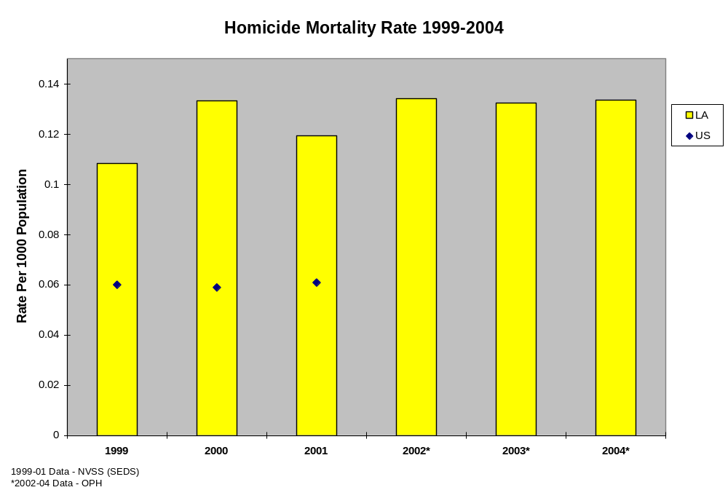
The highest number of homicides occurs in the 21-29 year old group and the 35-54 year old group.
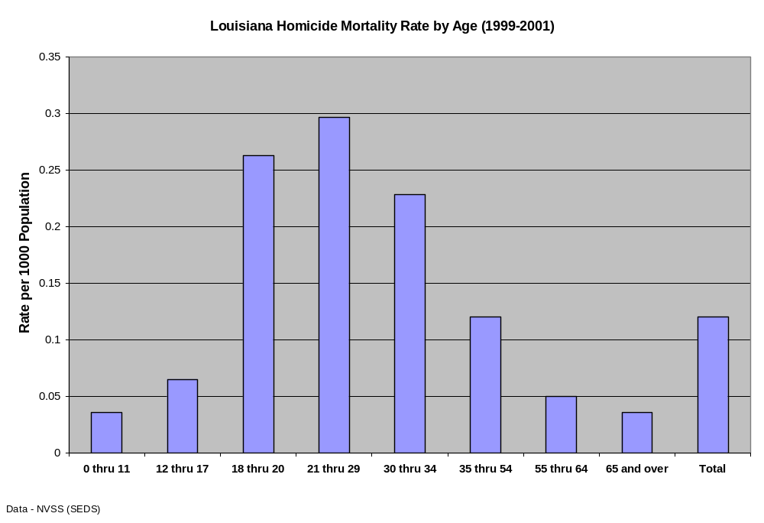
Death rates from homicide are highest in 18-34 year olds.
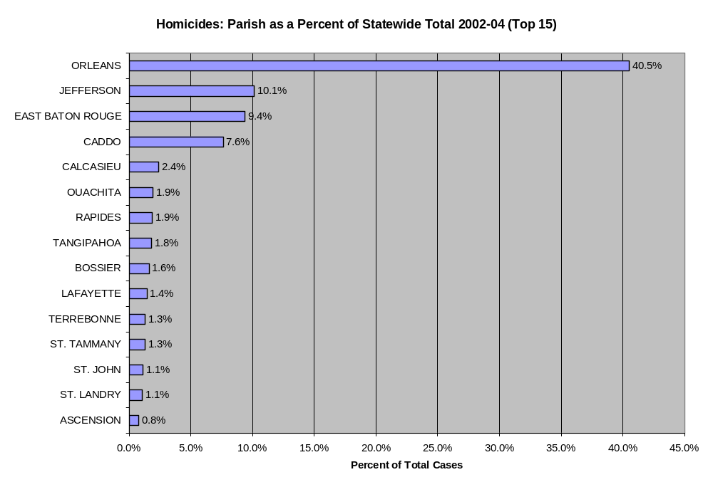
The highest percentages (number) of homicides occur in Orleans, Jefferson, East Baton Rouge, and Caddo Parishes. The number of homicides in Orleans Parish is more than double that of any other parish.
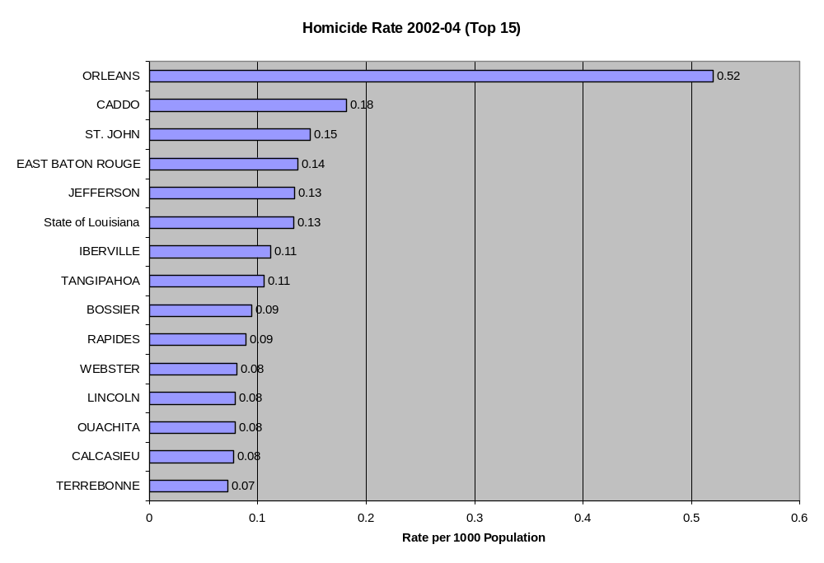
Caddo, St. John the Baptist, and East Baton Rouge Parishes all experience rates of homicide above the state average (parish statistics, 2002–2004).

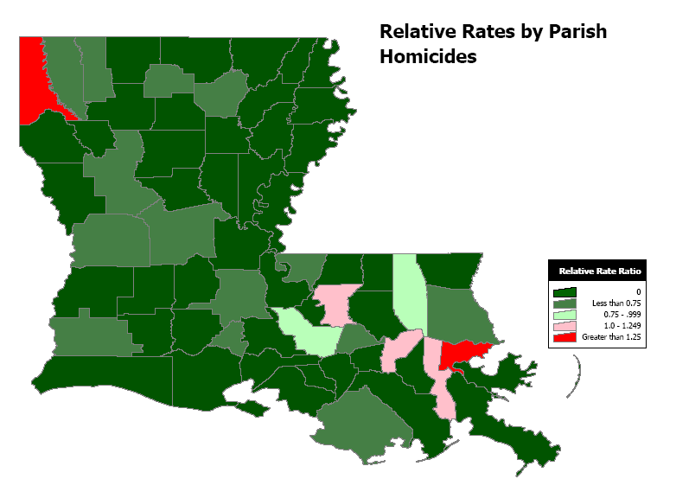
Data – LA Office of Public Health (2002-2004)

Suicide
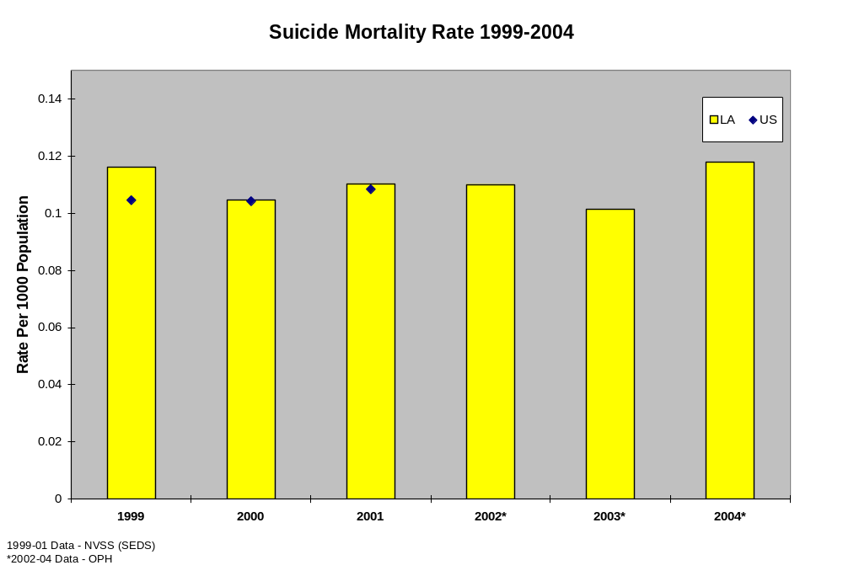

From 1999 through 2001, death rates for suicide in Louisiana were equivalent to or slightly above the national rates. In looking at suicides in Louisiana by age groups, the highest number of suicides is seen in the 35-54 year old group (averaging over 180 suicides a year), while the highest suicide rates are seen in the 65 and older group (16 for every 100,000 individuals in this age range).

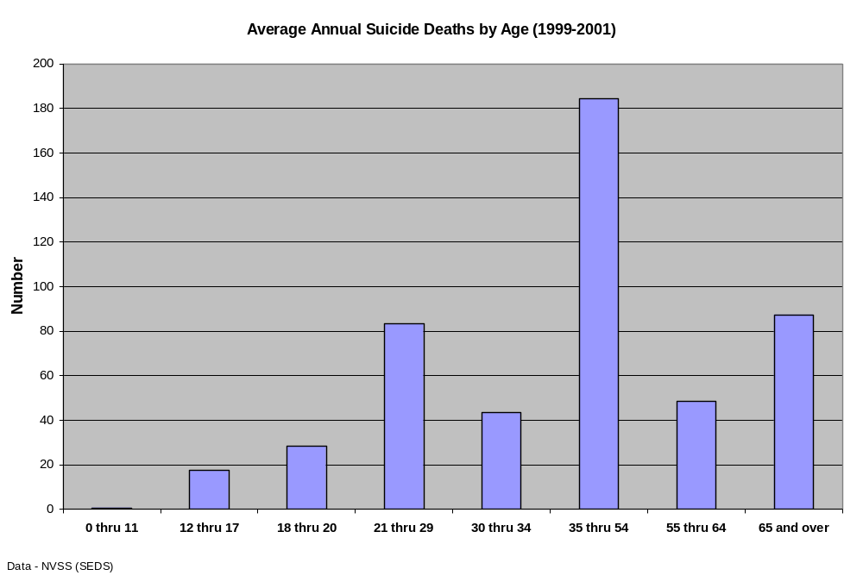

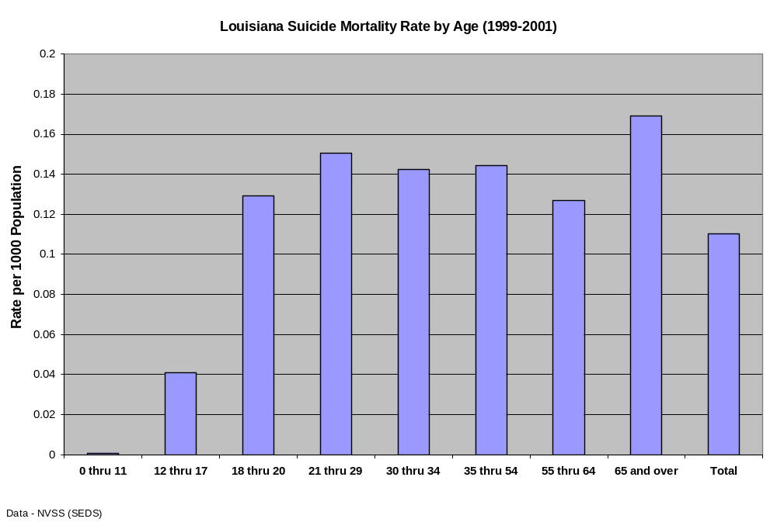
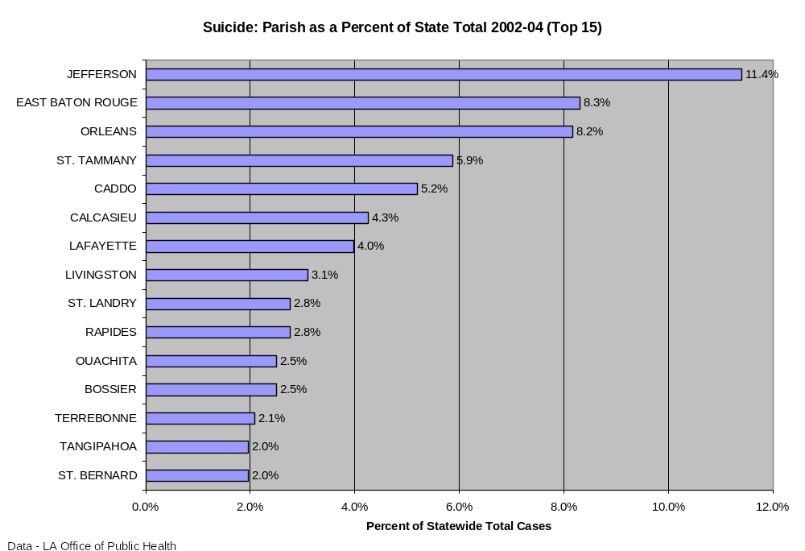
The highest percentage of suicides in Louisiana occurred in Jefferson, East Baton Rouge, and Orleans Parishes, three of the state’s most densely populated parishes (OPH statistics, 2002–2004).
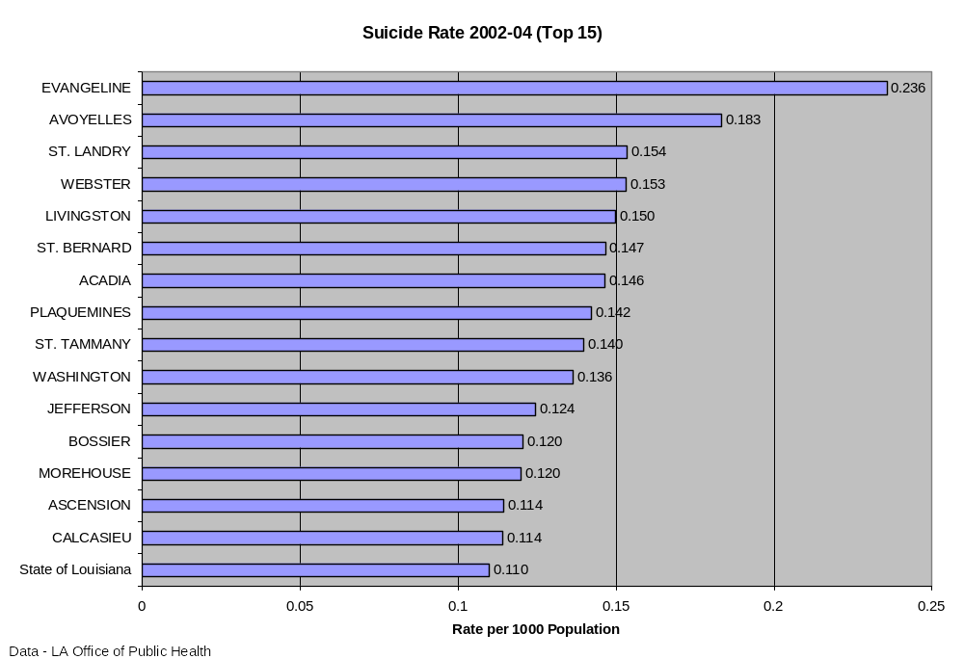
Evangeline and Avoyelles Parishes exhibited high rates of suicide. (OPH statistics, 2002-2004)
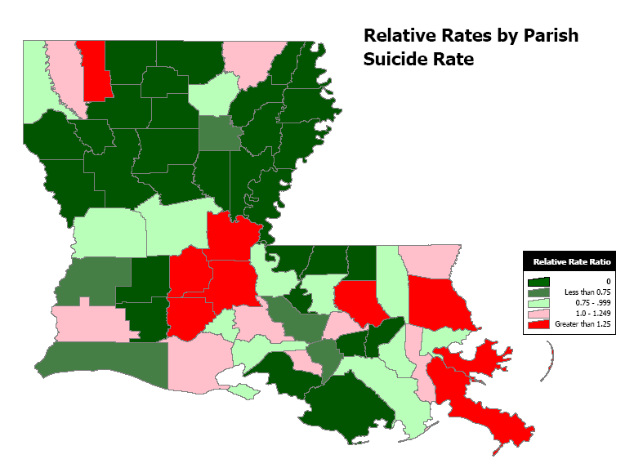
Data – LA Office of Public Health (2002-2004)

Accidental Death

In the United States, the fourth and sixth leading causes of injury deaths are accidental falls and drowning (CDC, 2002). In Louisiana from 1999 through 2004, the three leading causes of accidental deaths other than those caused by motor vehicle crashes were accidental falls, accidental drowning, and death due to fire, smoke, or burns. According to the Centers for Disease Control and Prevention (CDC), these three causes of accidental death are often associated with alcohol consumption.₅

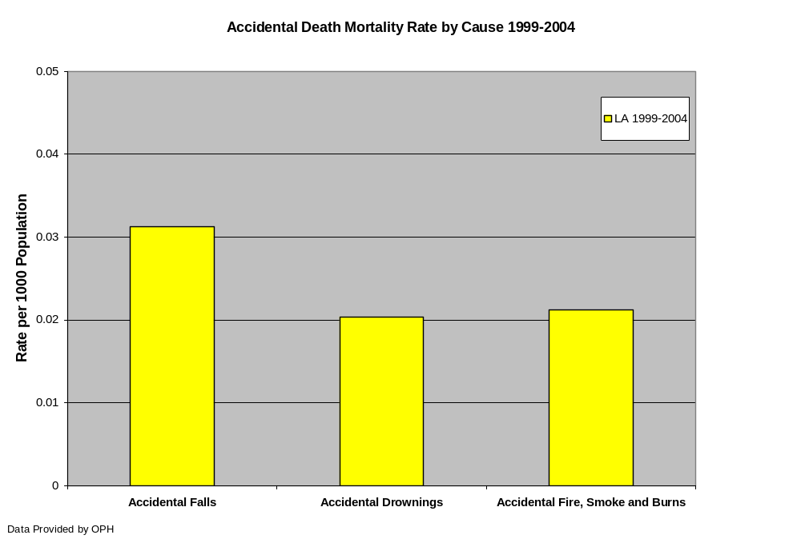
Alcohol-Related Traffic Fatalities

Alcohol-related traffic fatalities are the 7th leading cause of death related to substance use in Louisiana and one of the three leading causes of alcohol-related death. Almost half of all fatal motor vehicle crashes in Louisiana somehow involve alcohol. The percentage of fatal motor vehicle crashes in Louisiana during the years 1999 through 2003 was higher than the percentage nationwide. In Louisiana, the death rates from alcohol-related motor vehicle crashes also exceed the national rate.
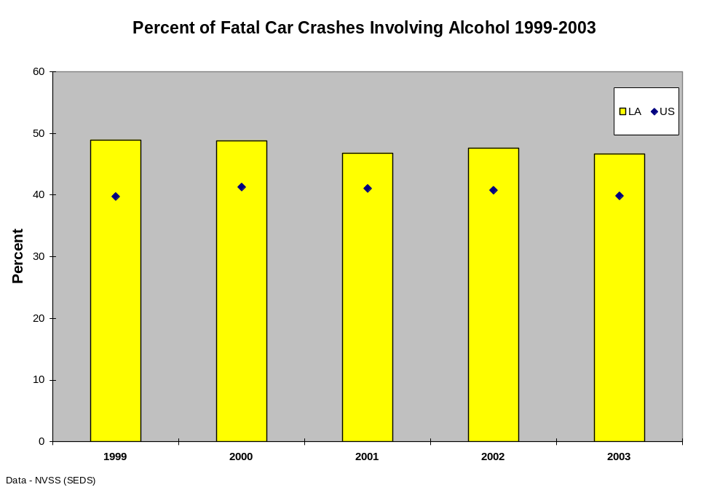
In 2003, the largest number of fatal alcohol-related motor vehicle crashes were reported from Jefferson Parish (n=25). East Baton Rouge (n=21), Orleans (n=20), Caddo (n=18), and Lafayette (n=16) Parishes also reported large numbers of these types of fatal crashes.

Motor vehicle Crash Injuries Involving Alcohol

In 2003, Orleans Parish experienced the largest number of injuries from alcohol-related motor vehicle crashes, with 651. Caddo and East Baton Rouge Parishes were next, each with over 300 alcohol-related crash injuries. Calcasieu, Lafayette, Jefferson, and St. Tammany Parishes reported between 200 and 300 such injuries in the same period.
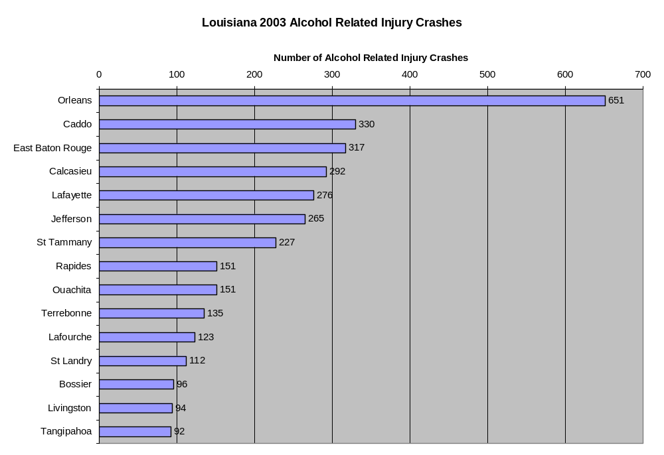
Data - LA Highway Safety Commission

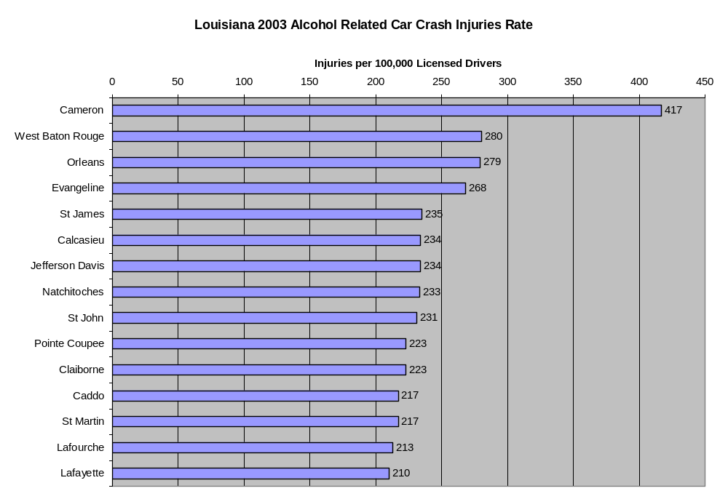
Data - LA Highway Safety Commission
The following map depicts the rates of alcohol related injuries by parish throughout the state. As is apparent, several parishes experience rates over 10% greater than the state rate.
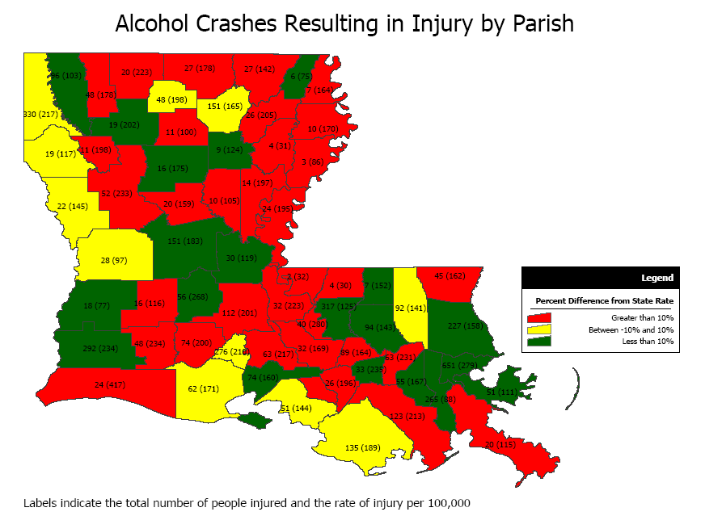
Data – LA Highway Safety Commission (2003)

Number of Fatal Alcohol-Related Motor vehicle Crashes
5
5
6
6
7
8
8
8
8
8
9
9
9
9
10
11
12
12
13
13
16
18
20
21
25
0
5
10
15
20
25
30
Union
Vermilion
Acadia
Iberville
St John
Bossier
Jefferson Davis
Rapides
Washington
Webster
Ascension
Lafourche
Natchitoches
Tangipahoa
Terrebonne
St Martin
Calcasieu
St Tammany
Ouachita
St Landry
Lafayette
Caddo
Orleans
East Baton Rouge
Jefferson
Data - LA Highway Safety Commission
The rate of alcohol-related traffic fatalities in 2003 was highest in Tensas Parish (fatalities per one hundred thousand licensed drivers).
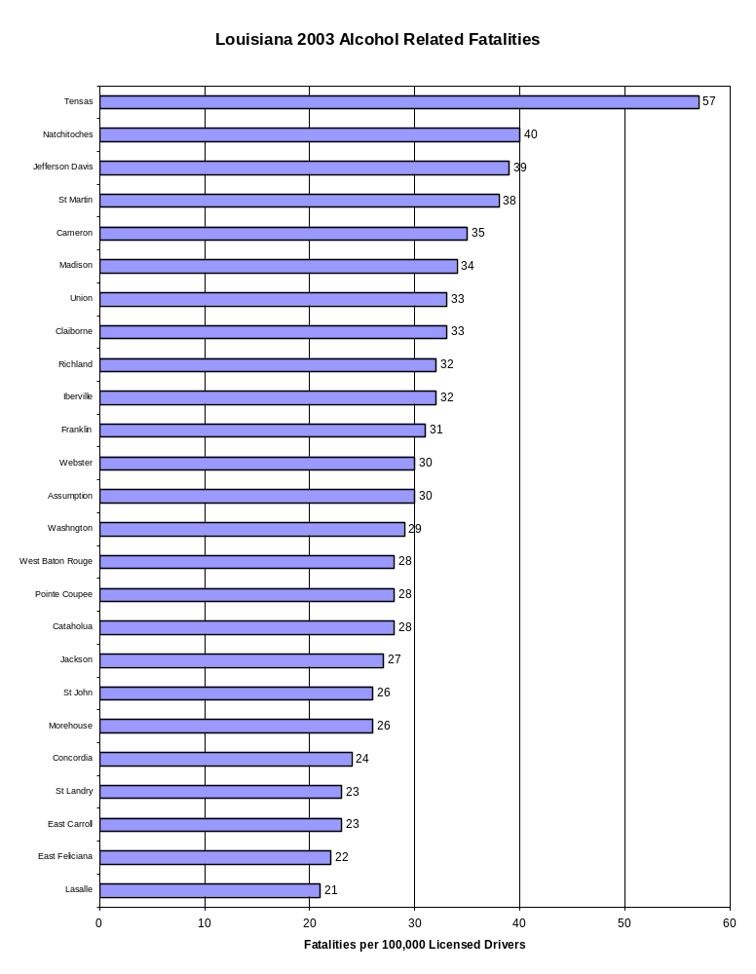
Data - LA Highway Safety Commission

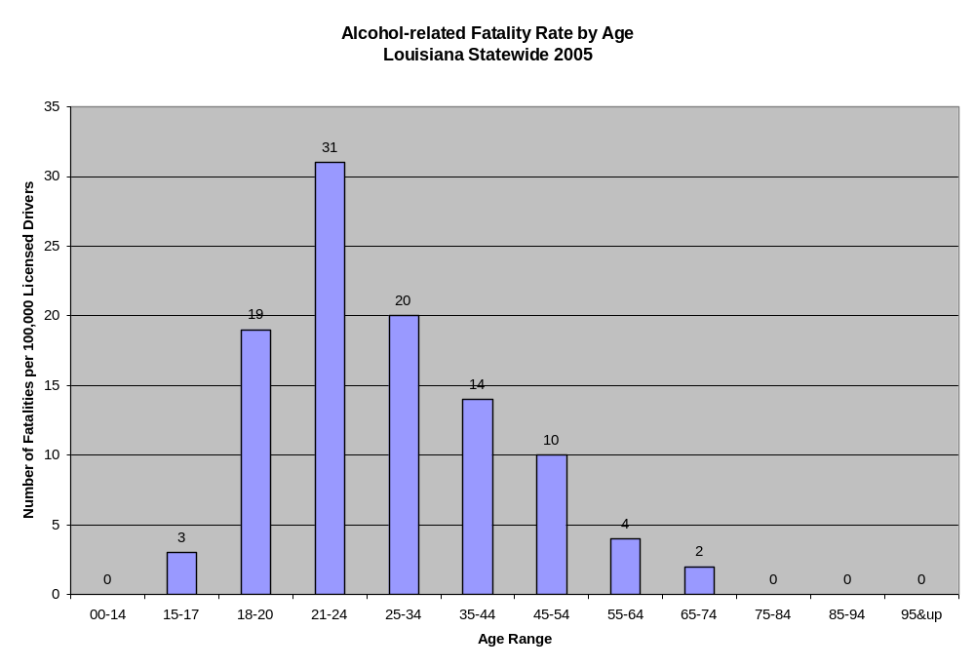
Data - LA Highway Safety Commission
Number of Fatalities
Alcohol-related Fatalities by Age
Louisiana Statewide 2005
0
2
30
70
99
78
56
14
4
0
0
0
0
20
40
60
80
100
120
00-14
15-17
18-20
21-24
25-34
35-44
45-54
55-64
65-74
75-84
85-94
95&up
Age Range
Data - LA Highway Safety Commission

The map shows that 34 Louisiana parishes report rates of fatal alcohol-related auto crashes more than 10% higher than the state rate (crashes per 100,000 licensed drivers).
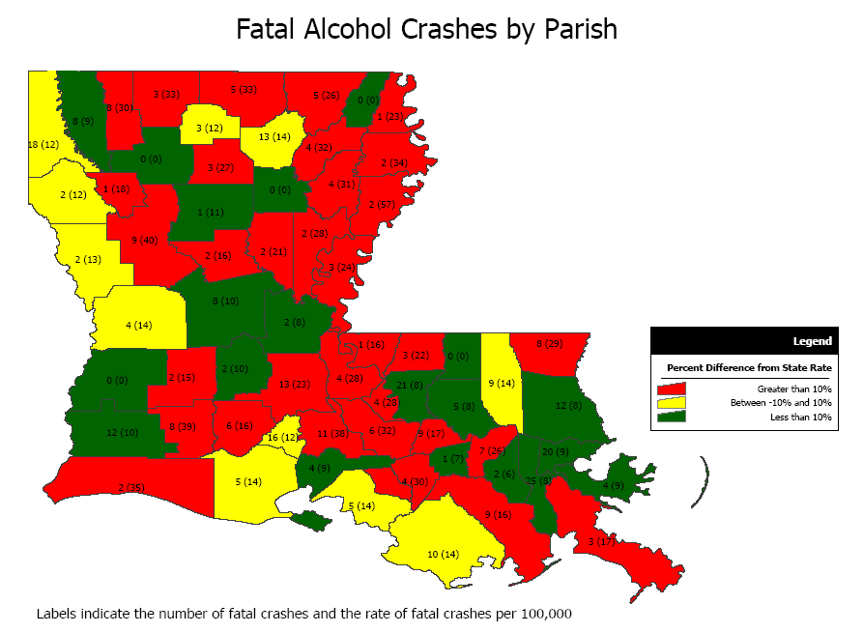
Data - LA Highway Safety Commission (2003)

Violent Crime

Both alcohol use and illicit drug use are related to violent crime. Alcohol is the drug most frequently associated with violence and is also associated with domestic violence, assault, and homicide. Alcohol is a key factor in up to 68 percent of manslaughters, 62 percent of assaults, 54 percent of murders/attempted murders, and 48 percent of robberies. Crack cocaine use is also a significant contributor to violence. Crack use exerts a negative impact on many inner-city neighborhoods.₆
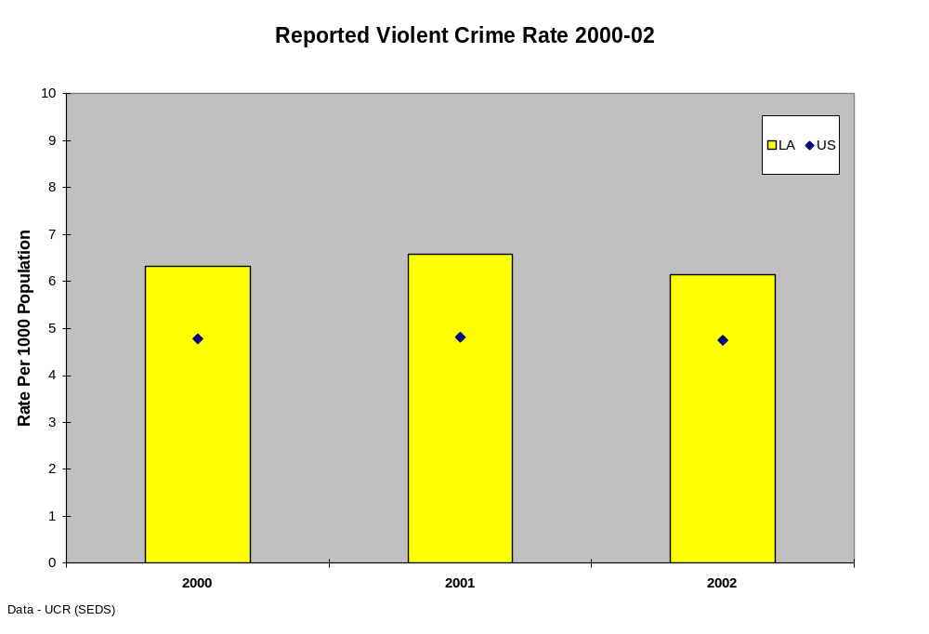
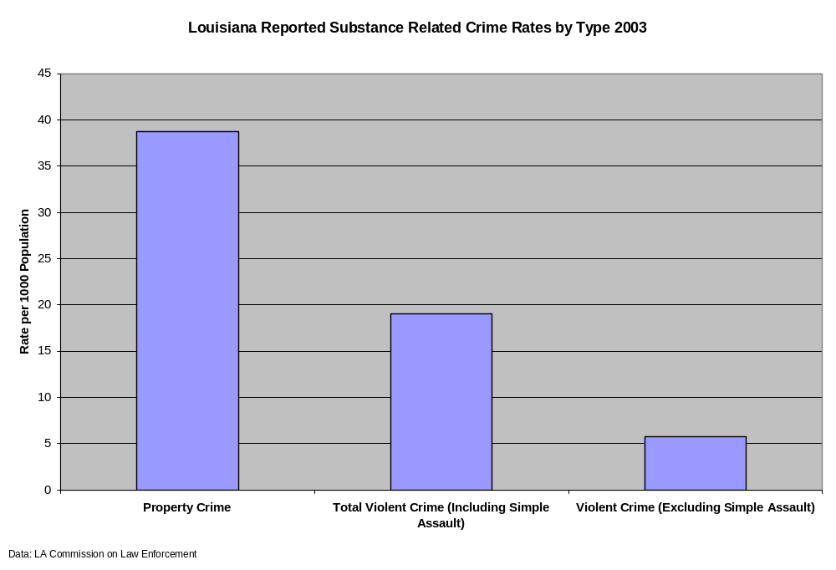
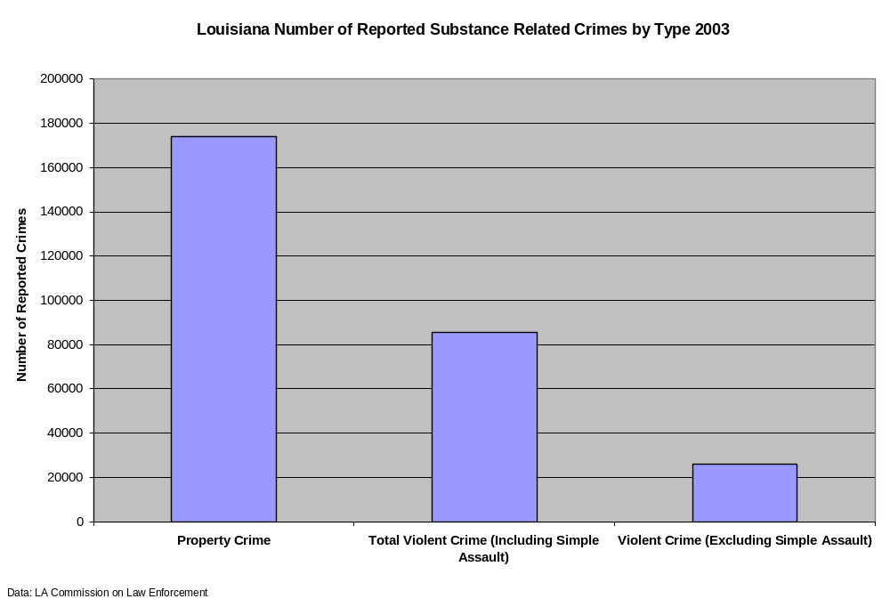
From 2000 through 2002, reports of violent crime in Louisiana exceeded the national average. Most violent crimes were reported in Orleans, East Baton Rouge, Jefferson, and Caddo Parishes. The highest rates of reported violent crimes were in St. James, Jefferson Davis, and Orleans Parishes. Sixteen other Louisiana parishes report rates higher than the state average.

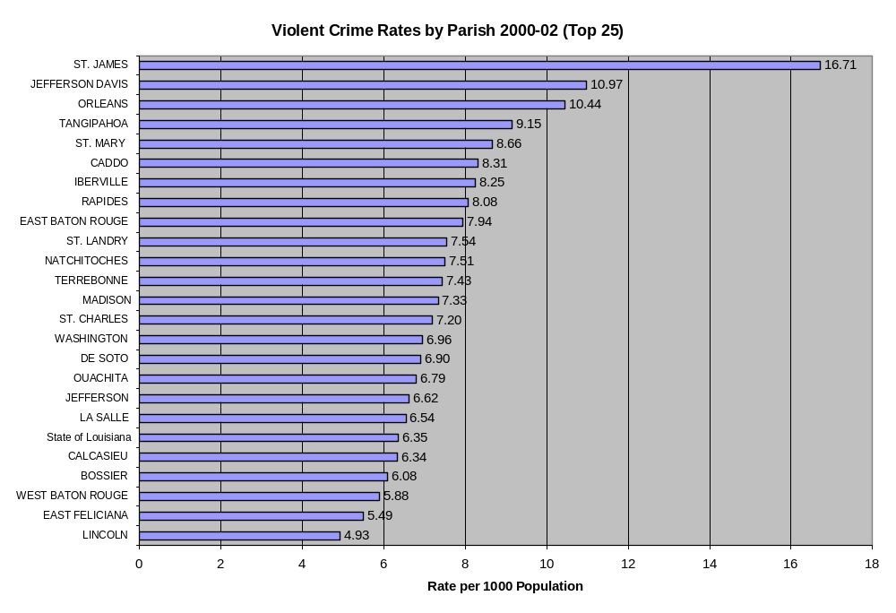
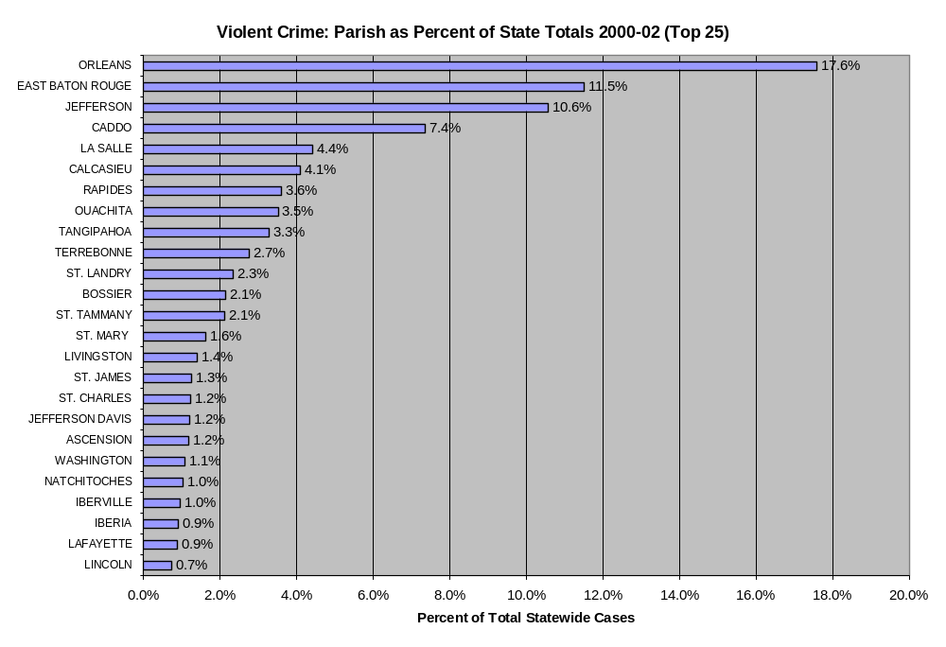
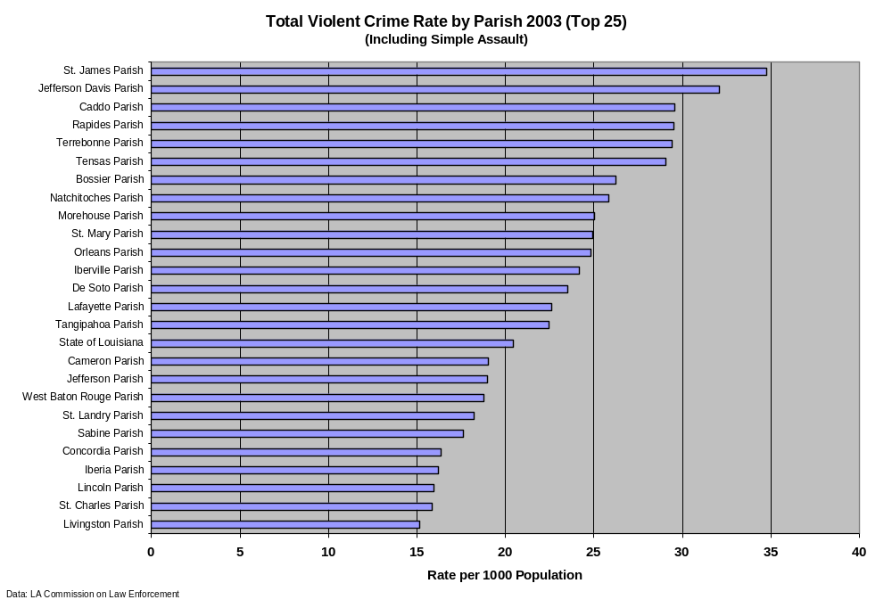
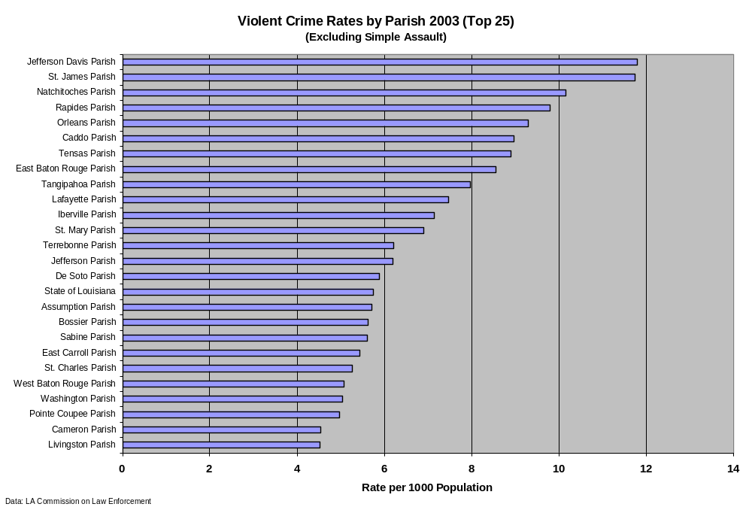
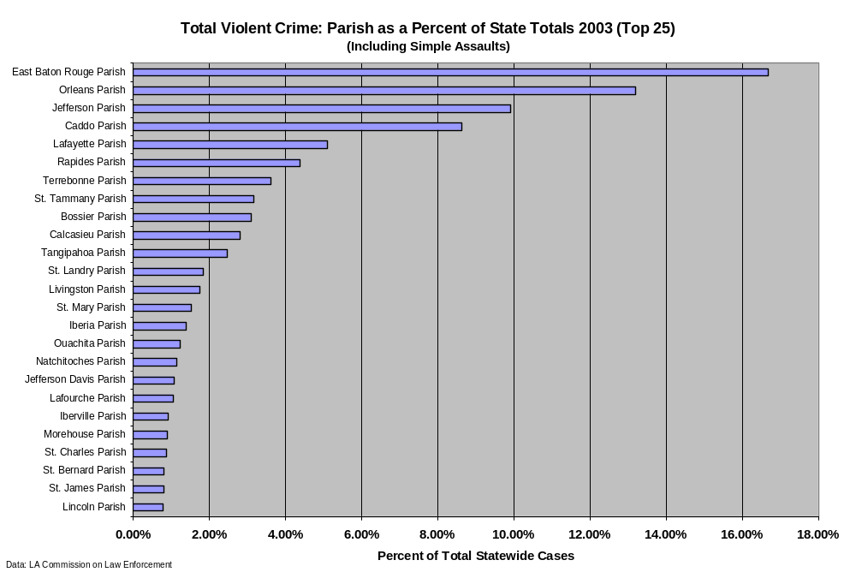
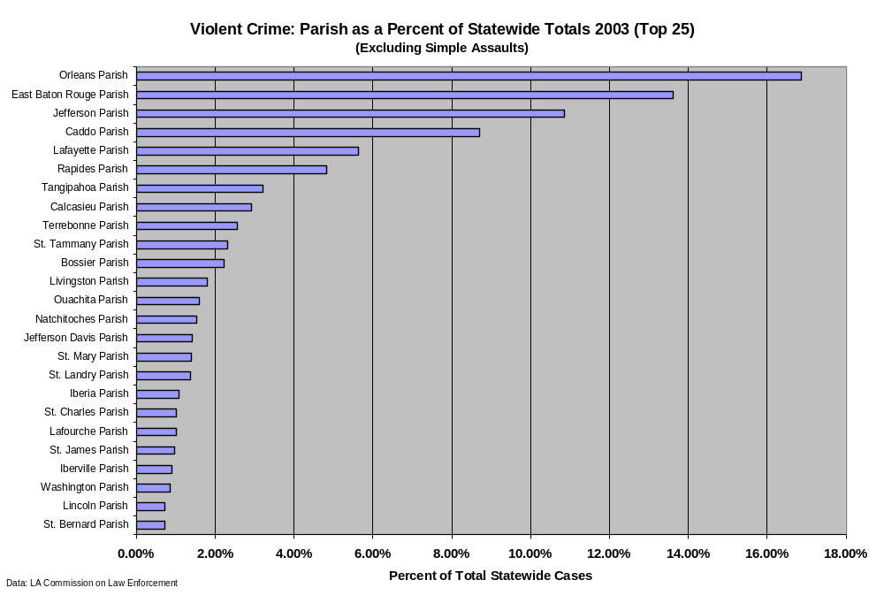

College Alcohol Use
Defining the College Alcohol Problem

The Harvard School of Public Health, based on its annual College Alcohol Study, reported that the 2003 mean binge drinking rate was 44.4% (±14.2%; range 13.2% to 83.1%) for undergraduates enrolled at institutions of higher education. Research from various studies has identified a range of serious “first-hand” consequences of excessive drinking by college students: deaths from vehicle crashes, accidents, overdoses, suicides, and homicides; battery and sexual assaults; physical injuries and psychological impairments; criminal offenses and legal records; academic failures and career problems; credit card debt and poor credit ratings, etc. The greater community is also subjected to “second-hand” social and economic consequences resulting from individuals’ excessive drinking: physical harm, property damage, devaluation of neighborhoods, community and university degradation, excessive involvement of emergency and public safety personnel, and increased legal costs – all unduly draining available community services and resources.

The Harvard School of Public Health also has reported: “Binge drinking rates vary among institutions and student subgroups. African American and Asian, female, and older students have lower rates of binge drinking than do White, male, and younger students. An increased presence of students from groups in which alcohol is less heavily consumed tends to moderate the level of binge drinking in high–binge drinking demographic subgroups. The higher the percentage of minority, female, and older (aged ≥ 22 years) students in a school, the lower the binge drinking rates for total students and high-risk subgroups. In addition, students who did not binge drink in high school are less likely to start binge drinking at colleges with larger enrollments of minority and older students, and students who were high school binge drinkers were less likely to continue drinking this way”.
(Source: Wechsler and Kuo, “Watering Down Drinks: The Moderating Effect of College Demographics on Alcohol Use of High-Risk Groups,” American Journal of Public Health, Nov 2003, 93.11.)

Based on those findings and others, epidemiologists should expect to find varying statistics for alcohol use/consequences by undergraduate students enrolled at different colleges within Louisiana and throughout the nation. Not only do student populations vary, but so do the cultural environments of the communities and regions in which they attend college. Further, surveys base their findings on differing definitions of “binge drinking” and other behaviors.

Louisiana State University Undergraduates’ Alcohol Use
Louisiana State University and Agricultural and Mechanical College is the state’s flagship institution of higher education with total student enrollment at approximately 30,000 students. Since 1993, Louisiana State University regularly has administered the College Alcohol Study administered by the Harvard School of Public Health as part of a grant requirement. As the only institution of higher education in the state that consistently has been able to assess undergraduate student substance use and consequences, the following charts provide data from a representative and random sample of undergraduate students enrolled at Louisiana State University in Baton Rouge. Response rates have ranged between 45% to 56%. The data presented is typical of results that might be found for undergraduate students enrolled in a primarily White, metropolitan, four-year institution of higher education. The Harvard School of Public Health has noted that the community’s cultural environment strongly influences students’ alcohol consumption rates, likely to vary both within the Louisiana and throughout the South. The presentation by Louisiana State University in Baton Rouge serves as one institutional example in Louisiana and should not be assumed to mirror any other institution.
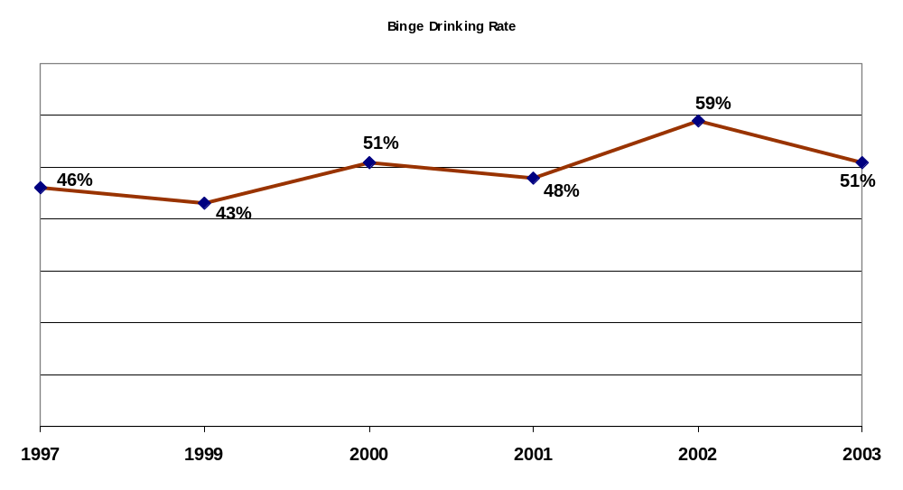
Source: 1997-2003 LSU Results, College Alcohol Study conducted by Harvard School of Public Health

The College Alcohol Study administered by the Harvard School of Public Health defines “binge drinking” for men as having five or more drinks in a row at least once in the prior two weeks, and for women as having four or more in a row. Though the combined binge drinking percentages for all students varied between 43% to 51% from 1997 to 2003 at Louisiana State University, none of the differences in the binge rate between survey years were statistically significant at the .05 level. The lowest overall rate occurred in 1999, the year after the campus experienced negative national attention about a fraternity student’s alcohol overdose.
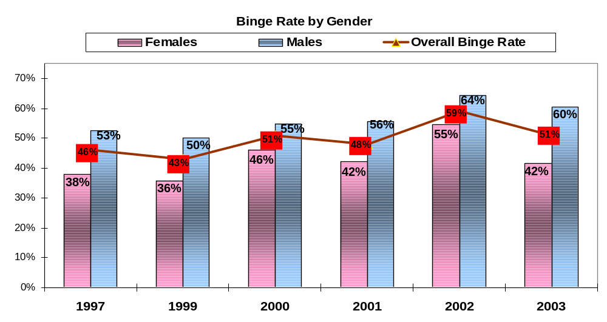
Source: 1997-2003 LSU Results, College Alcohol Study conducted by Harvard School of Public Health

The College Alcohol Study administered by the Harvard School of Public Health defines “binge drinking” for men as having five or more drinks in a row at least once in the prior two weeks, and for women as having four or more in a row. Results indicate that the binge drinking rate for men has ranged between 50% to 64% overall and for women between 36% to 55% overall, a gender difference of 9% to 18% depending on the year. The differences are explained in the next two graphs.
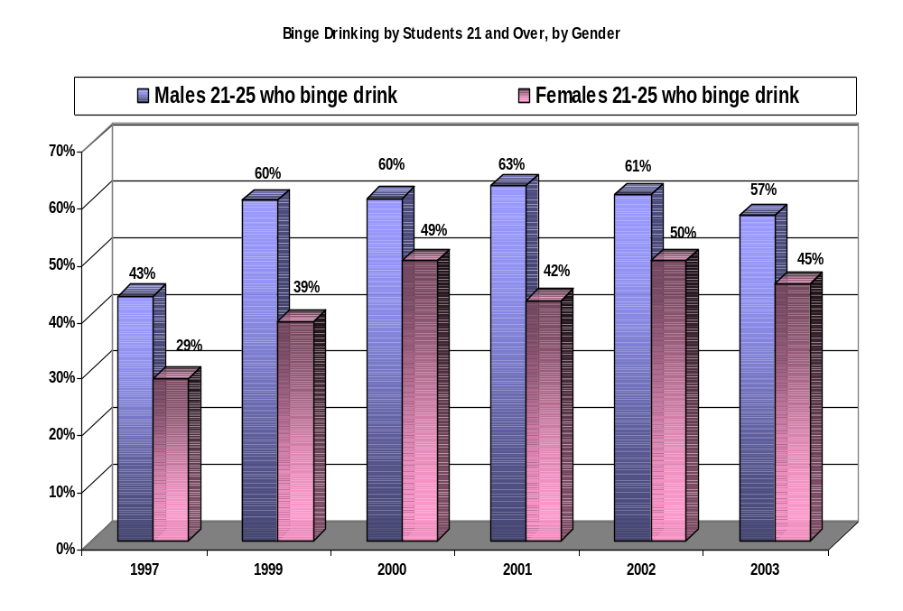
Source: 1997-2003 LSU Results, College Alcohol Study conducted by Harvard School of Public Health

The College Alcohol Study administered by the Harvard School of Public Health defines “binge drinking” for men as having five or more drinks in a row at least once in the prior two weeks, and for women as having four or more in a row. Results indicate that the binge rate for male students age 21+ has been fairly stable over time (hovering around 60% annually, except for 43% in 1997). For females age 21+, there was 30% increase from 1997 to 2000, when the variation between surveys stabilized somewhat (5% to 8% difference).
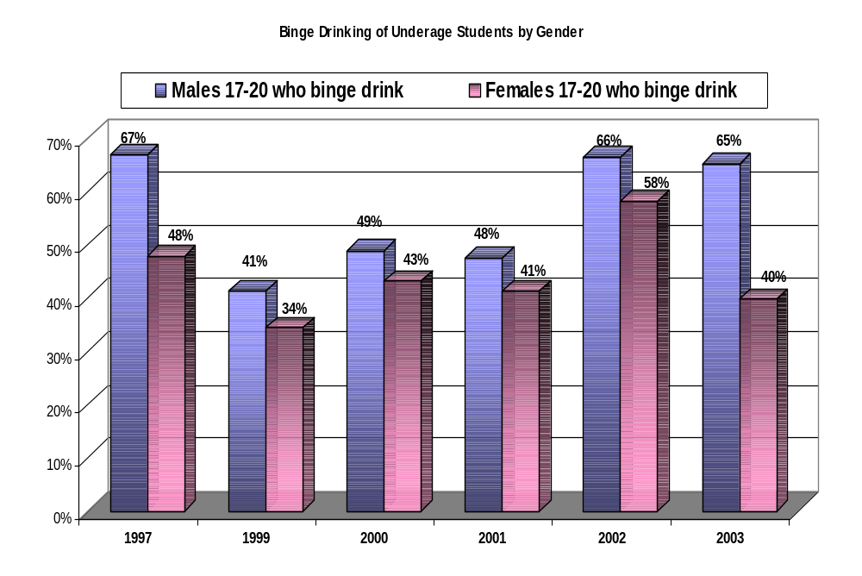
Source: 1997-2003 LSU Results, College Alcohol Study conducted by Harvard School of Public Health

The College Alcohol Study administered by the Harvard School of Public Health defines “binge drinking” for men as having five or more drinks in a row at least once in the prior two weeks, and for women as having four or more in a row. Results for students under age 21 indicate that there was only a 6-7% difference between males and females for 1999, 2000, and 2001 (ranging between 41% to 49% for males, 34% to 43% for females). For 2002 and 2003, underage male binge drinking increased greatly to ~66%, where it was in 1997 prior to the infamous fraternity student death. There is more variation for the underage female population (ranging from 34% to 58%, depending on the year), though females consistently binge drink less than males do, regardless of age.

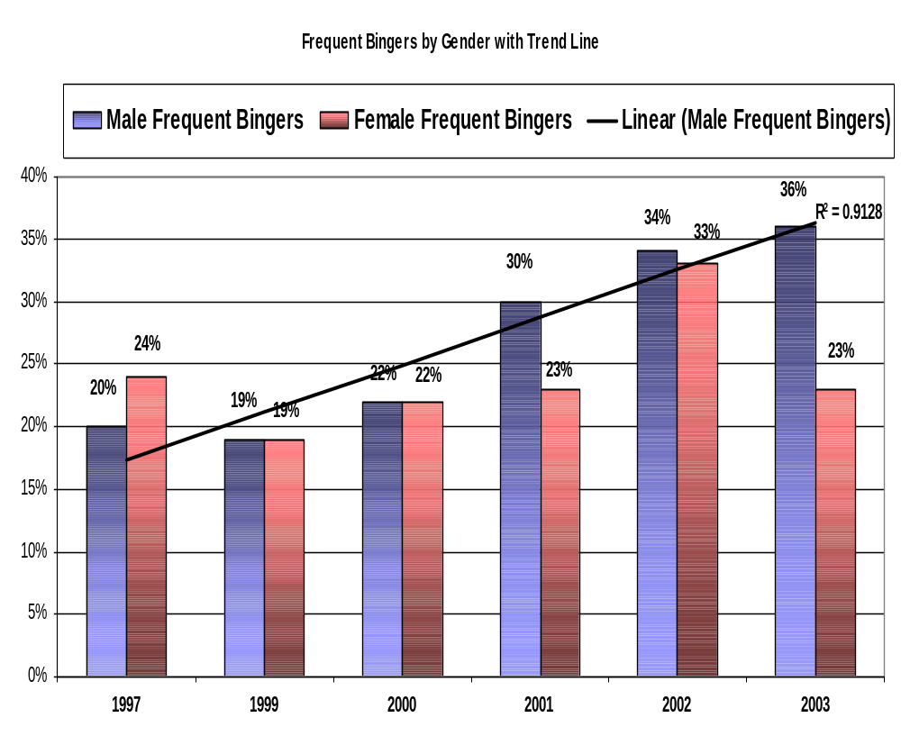
Source: 1997-2003 LSU Results, College Alcohol Study conducted by Harvard School of Public Health

The College Alcohol Study administered by the Harvard School of Public Health defines “frequent binge drinking” for men as having five or more drinks in a row at least once in the prior two weeks, and for women as having four or more in a row. “Frequent binge drinkers” drank in this manner three or more times in two weeks. Results indicate that, between 1997 and 2003, frequent binge drinking has increased steadily and significantly for undergraduate males. With the exception of 2002, there has been little variation in frequent binge drinking rates (~23%) for female undergraduate students.

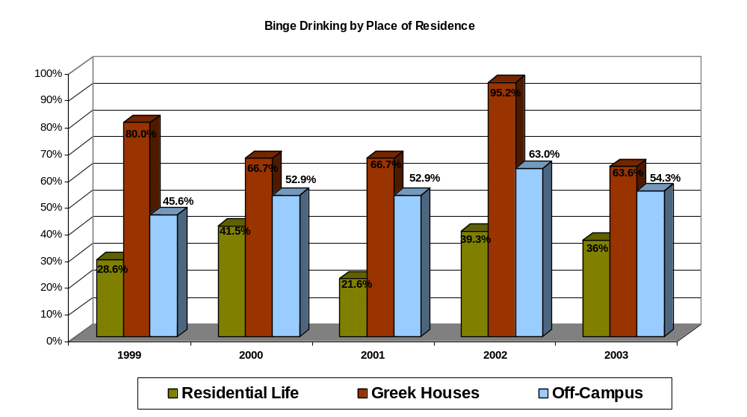
Source: 1997-2003 LSU Results, College Alcohol Study conducted by Harvard School of Public Health

The College Alcohol Study administered by the Harvard School of Public Health defines “frequent binge drinking” for men as having five or more drinks in a row at least once in the prior two weeks, and for women as having four or more in a row. This chart only demonstrates where binge drinkers reside, not where they consume alcohol. Results indicate that more binge drinkers reside in Greek houses (64%-95%, depending on the year), followed by students residing in off-campus houses or apartments (46% to 63%, depending on the year). The fewest binge drinkers reside in on-campus residence halls (22% to 42%, depending on the year) where many more freshmen choose to live and more environmental controls are in place.

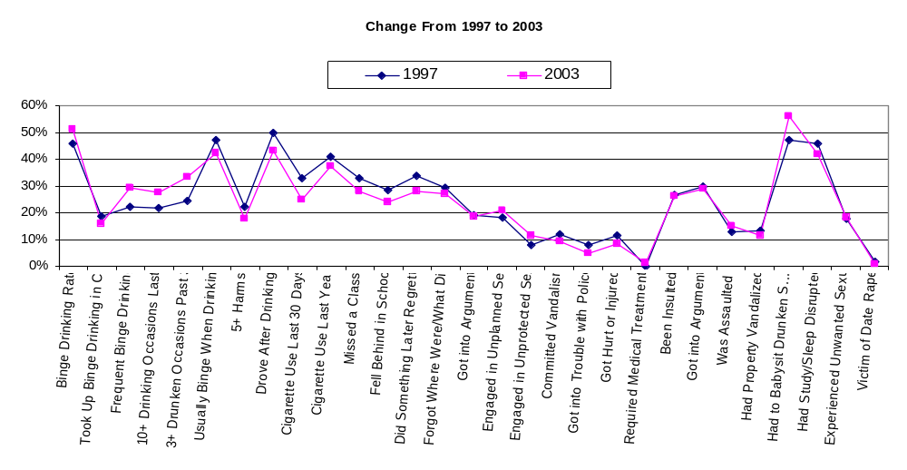
Source: 1997-2003 LSU Results, College Alcohol Study conducted by Harvard School of Public Health

The College Alcohol Study administered by the Harvard School of Public Health questions survey respondents about the negative consequences resulting from their alcohol consumption. This chart reveals that negative consequences over time have remained in the same relative position, though some minimal declines (red lines below blue lines) have been noted over the course of those years. The highest-range negative consequences experienced by 40% to 50% of respondents are: drove after drinking, engaged in binge drinking, usually binged when drinking, have had to “babysit” other drunken students, have had studying or sleep disturbed. Mid-range negative consequences experienced by 20% to 40% of respondents are: frequent binge drinking, 10+ drinking occasions in the last 30 days, was drunk 3+ times in the past month, experienced 5 or more problems (excluding hangover), missed a class, fell behind in school, did something later regretted, forget where I was or what I did, engaged in unplanned sex, have been insulted, and got into an argument. Lowest-range negative consequences experienced by 1%-20% are: took up binge drinking in college, engaged in unprotected sex, committed vandalism, got into trouble with police, got hurt or injured, required medical treatment, was assaulted, had property vandalized, experienced an unwanted sexual advance, and was a victim of date rape.

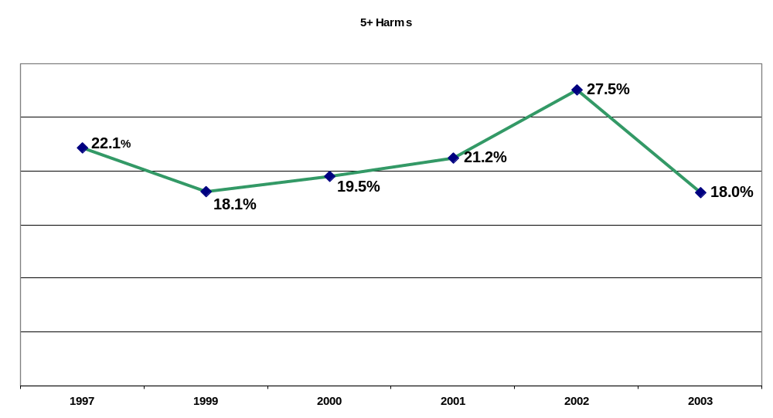
Source: 1997-2003 LSU Results, College Alcohol Study conducted by Harvard School of Public Health

The College Alcohol Study administered by the Harvard School of Public Health questions survey respondents about the negative consequences resulting from their alcohol consumption. This chart illustrates what percentage of respondents experienced five or more negative consequences resulting from their drinking. Results for this category hover around 20% of undergraduate respondents, with the exception of 2002 which was about 8% higher. [Note: The 2002 study revealed higher rates for nearly every negative consequence on the survey, compared with other years.]

Outcomes
- The following alcohol-related negative consequences to LSU undergraduate students declined 3-8% from 1997-2001 (College Alcohol Study):
  - driving after drinking (49.9-41.9%)
  - getting behind in school work (28.4-25.5%)
  - forgetting what one did while drinking (29.4-25.7%)
  - getting hurt or injured (11.7-8.4%)
  - damaging others’ property (12 – 8.2%)
  - getting in trouble with police ( 7.9-4.8%)
  - having studying or sleep interrupted by others (46-43.6%)

- Additional declines (3-8%) in alcohol-related consequences to LSU undergraduate students occurred between 1997-2003 (College Alcohol Study):
- had studying/sleep interrupted (46-41.6%)
- missing classes (33-27.8%)
- getting behind in schoolwork (28.4-24%)
- doing something later regretted (33.8-27.9%)
- using marijuana (18.3-14.6%) and cigarettes (32.7-24.9%) in last 30 days
- experiencing five or more of above problems (22.1-18.0%)

- What behaviors have not shown improvements?
  - binge drinking
  - frequent binge drinking among males
  - insulting others
  - arguments
  - fights and assaults
  - unplanned/unprotected sex under the influence
  - babysitting other intoxicated students

Burden of Tobacco Use

State and Parish Long-Term Health Consequences

Cardiovascular Disease Mortality

Death from cardiovascular disease is included in the category described as the leading cause of mortality in Louisiana (diseases of the heart) and is the leading cause of substance related mortality in the state. The use of tobacco is the number one preventable cause of cardiovascular disease.₉ The highest rates of cardiovascular disease mortality were found in Franklin, Jackson, Webster, Madison, and Catahoula Parishes during the years 2001-2003. Nineteen (19) other parishes were characterized by rates above the state average.

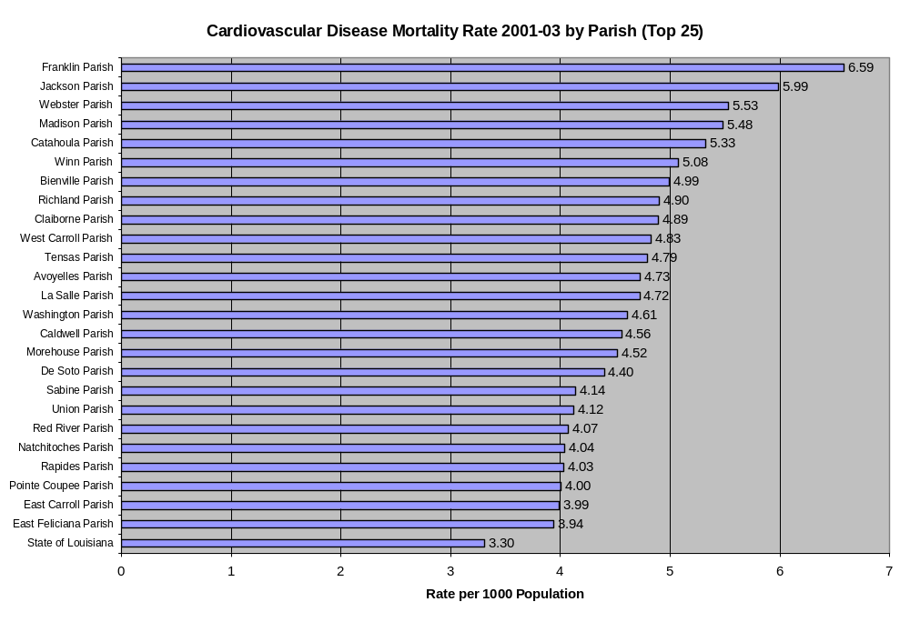
Ischemic Cerebrovascular Disease Mortality

The National Vital Statistics System (NVSS) is a cooperative effort between the National Center for Health Statistics (NCHS) and vital registration systems operated in the various jurisdictions legally responsible for the registration of vital events--births, deaths, marriages, divorces, and fetal deaths.¹⁶ In statistics provided by NVSS from the years 1999 through 2001, Louisiana’s rates of ischemic cerebrovascular disease were slightly lower than composite rates for the U.S. The category, ischemic cerebrovascular disease, includes heart attack and stroke.

Death from cerebrovascular disease alone is the third leading cause of mortality in Louisiana and is included in the category ischemic cerebrovascular disease, along with heart attacks. Smoking significantly elevates the risk of ischemic cerebrovascular disease.¹⁵ Death from ischemic cerebrovascular disease is also primarily a problem in Louisiana residents 65 and over, although a significant amount of death from cardiovascular disease also occurs in those aged 55-64.
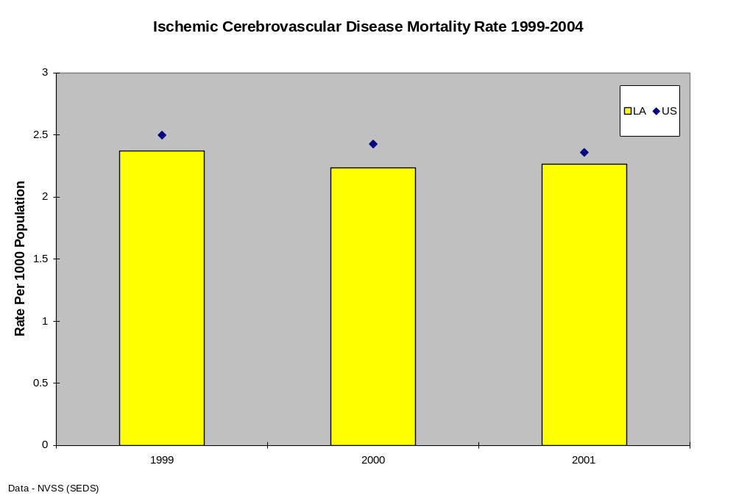
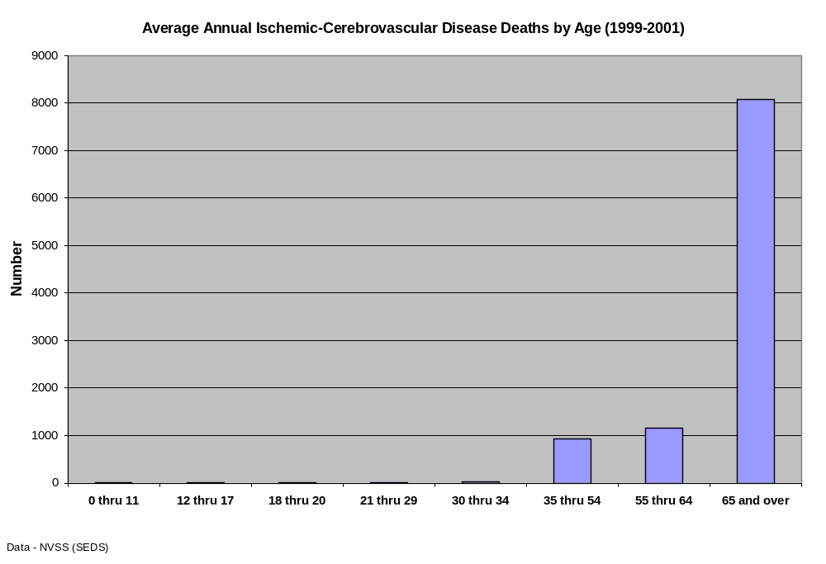
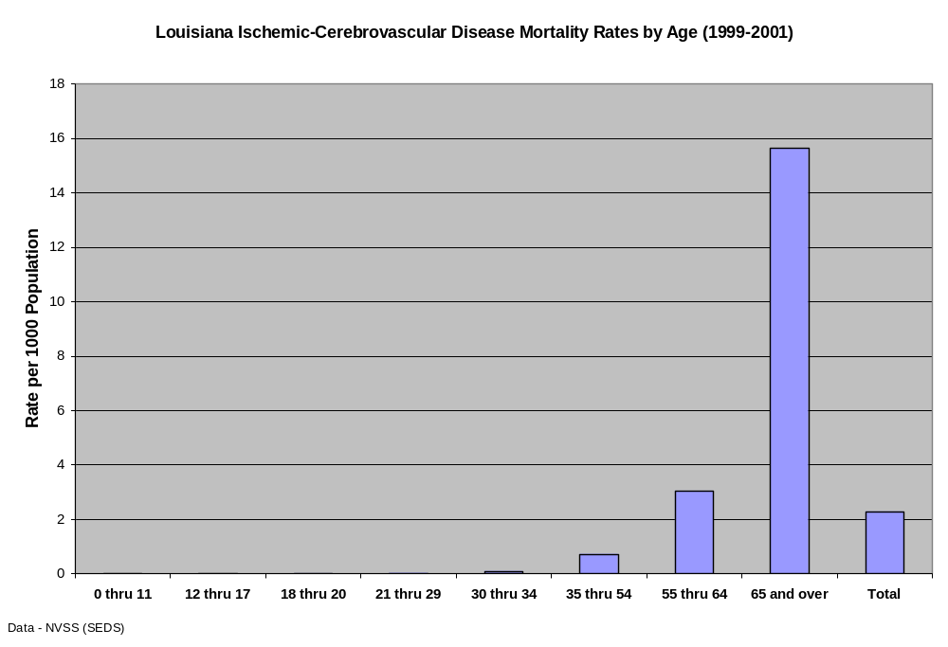

Lung Disease

Besides cardiovascular disease and lung cancer, cigarette smoking is also strongly associated with chronic lung disease.¹⁸ Death from lung diseases other than cancer is the fourth leading cause of substance related mortality in Louisiana. Chronic lower respiratory disease, a type of lung disease other than cancer, is the sixth leading cause of death in the state. According to statistics provided by NVSS from 1999 through 2001, rates of lung disease mortality in Louisiana were below national rates. Winn, Bienville, Grant, Franklin, and Union Parishes experienced the highest rates of lung disease mortality in the state. (OPH statistics, 2002-2004) The highest percentages of lung disease deaths in Louisiana occurred in Jefferson, Orleans, Caddo, East Baton Rouge, St. Tammany, and Ouachita Parishes. (OPH Statistics, 2002-2004)
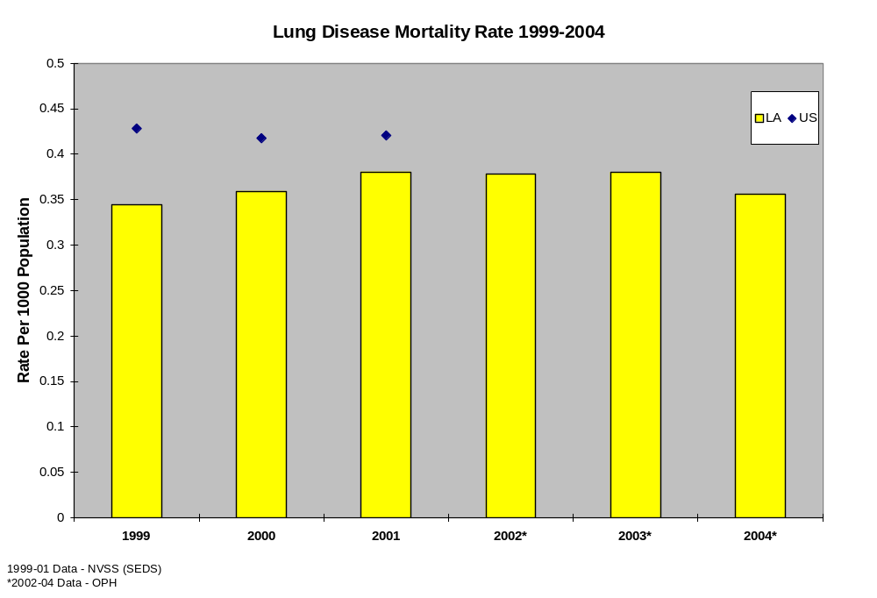
Winn, Bienville, Grant, Franklin, and Union Parishes experienced the highest rates of lung disease mortality in the state. (OPH statistics, 2002-2004)

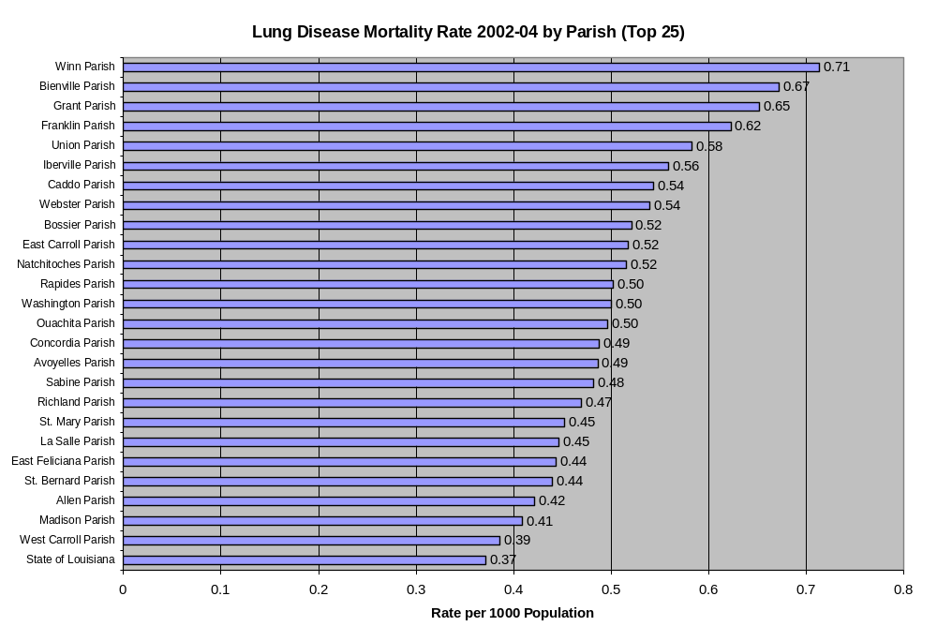
The highest percentages of lung disease deaths in Louisiana occurred in Jefferson, Orleans, Caddo, East Baton Rouge, St. Tammany, and Ouachita Parishes. (OPH Statistics, 2002-2004)

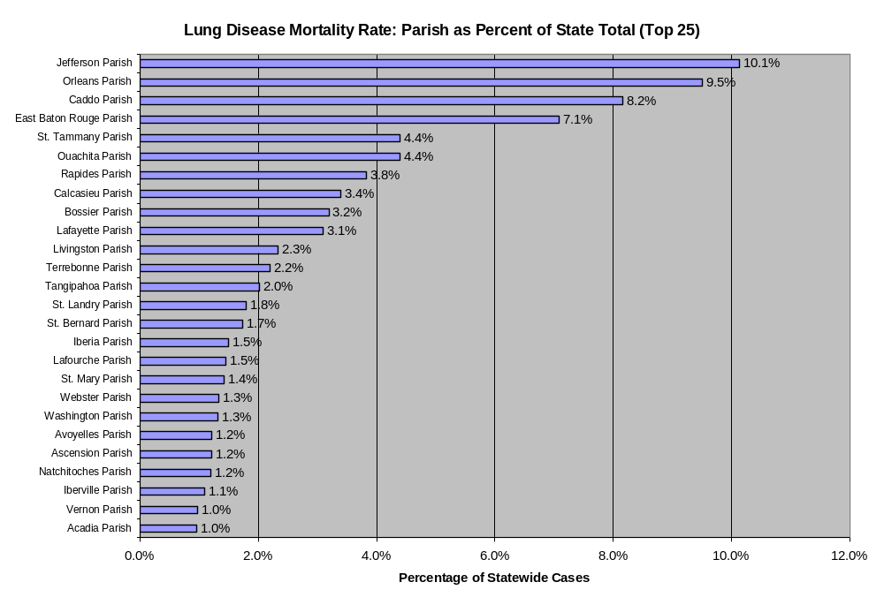

The following map displays the relative rate ratios of lung disease death in Louisiana parishes. The parishes experiencing the highest rates from 2002-2004 were in rural areas in north and central Louisiana. Bienville, Franklin, Grant, Union, and Winn Parishes were the Louisiana parishes with the highest rates of lung disease death.
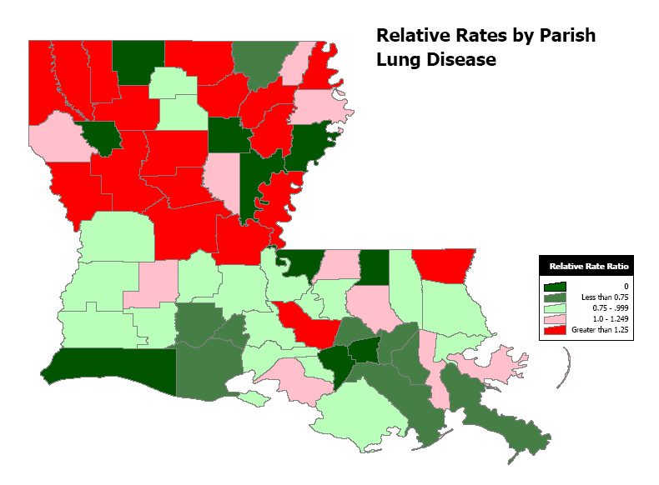
Data - LA Office of Public Health
Lung Cancer Mortality

Lung cancer deaths are the third most common cause of substance related death in Louisiana. There is direct and incontrovertible evidence for a dose related causal association between lung cancer and smoking. Evidence exists that exposure to second-hand smoke also is a significant risk factor for lung cancer. In statistics from 1999 through 2001 provided by NVSS, Louisiana’s mortality rates for lung cancer deaths have exceeded the national rates.

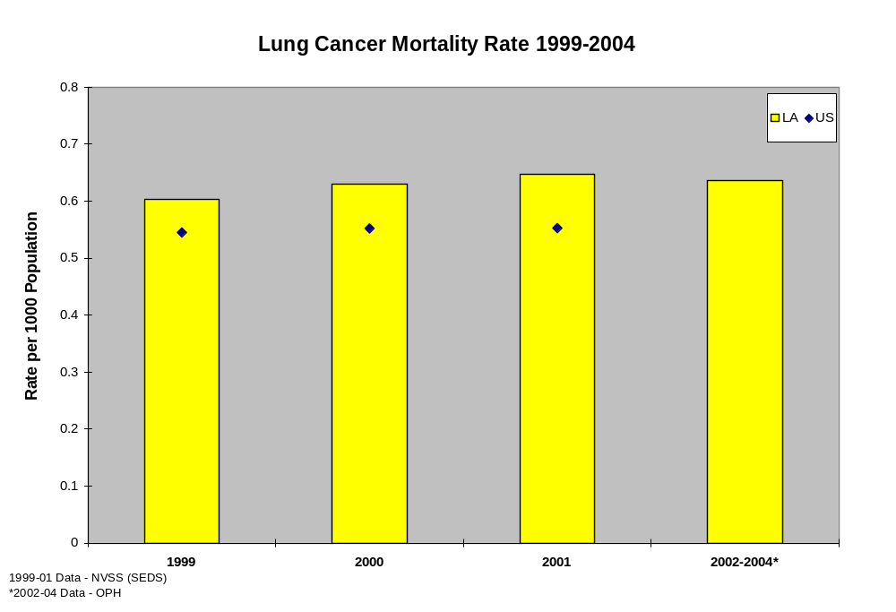

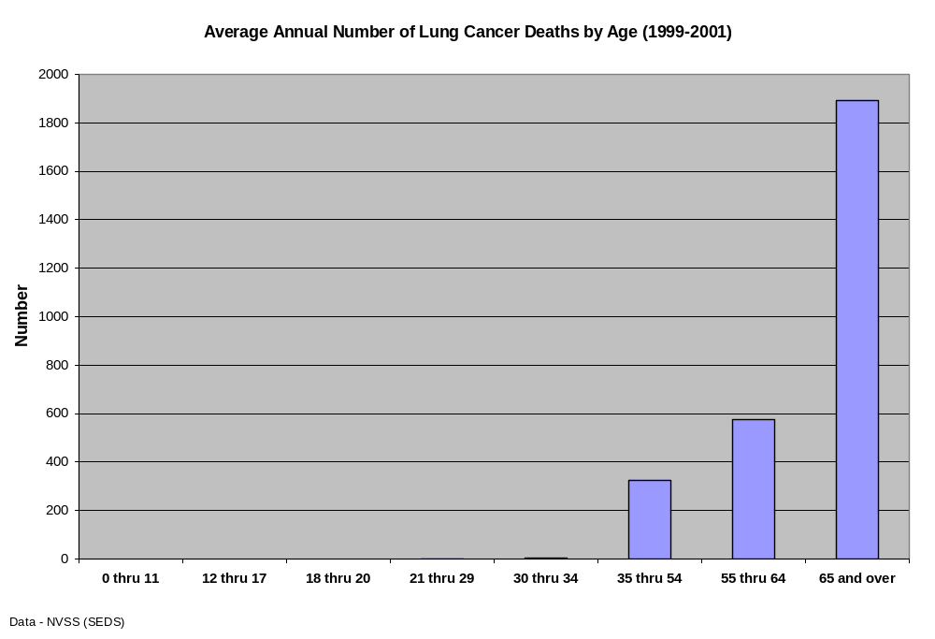
Mortality from lung cancer usually occurs in later years, the heaviest burden in those persons aged 65 and above. Significant numbers of death from lung cancer also occur in the 35-54 and 55-64 year age groups.

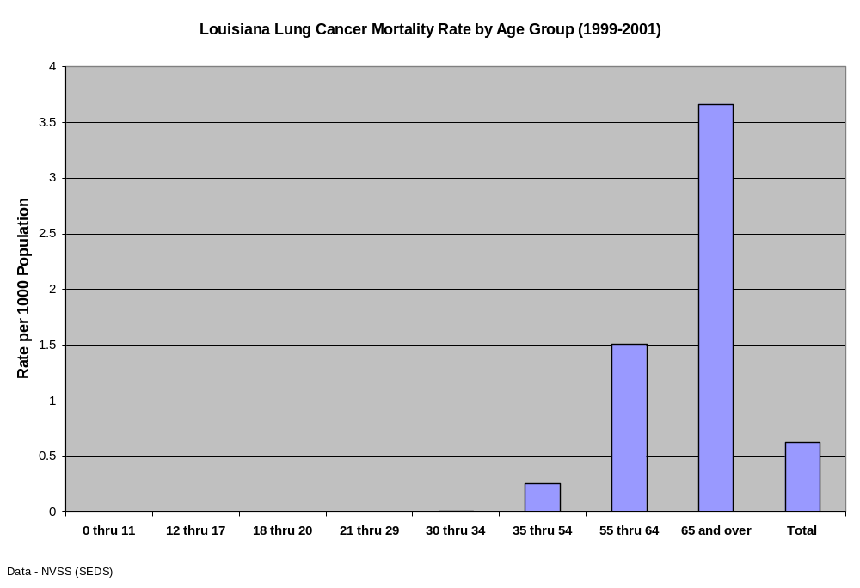
As would be expected, the highest mortality rate for lung cancer also occurs in the upper ages, the highest in the 65 and over group. Rates begin to rise significantly after age 35.

Cardiovascular Disease Mortality (excluding heart attack and stroke)

Cardiovascular diseases other than heart attack and stroke are the second leading substance related causes of death in Louisiana. During the years 1999-2001, Louisiana’s rates of non-heart attack, non-stroke related cardiovascular disease appeared to remain stable, no upward or downward trend was noted, but the state rate remained well above the national rate.

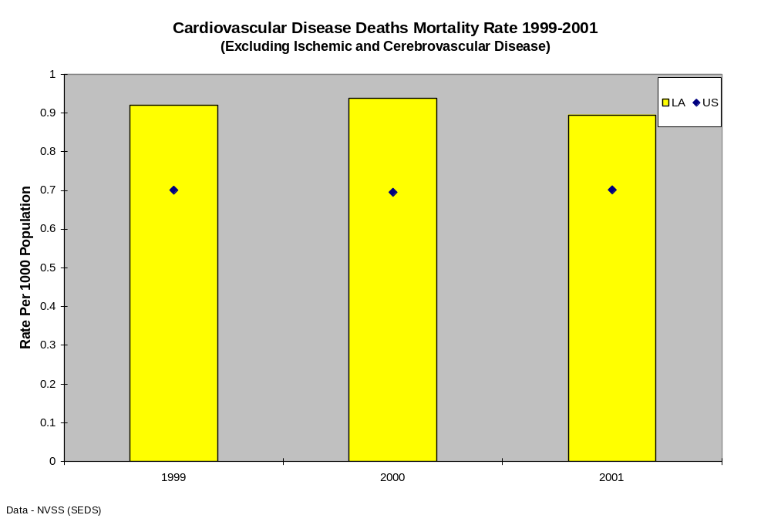
Death from cardiovascular disease other than ischemic and cerebrovascular disease (heart attack and stroke) is a problem primarily in Louisiana residents age 65 and over, although a significant amount of death from cardiovascular disease also occurs in those aged 55-64.

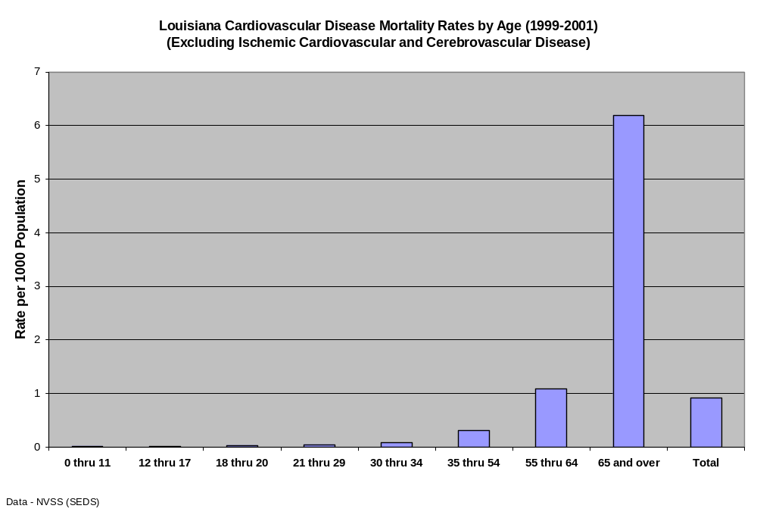

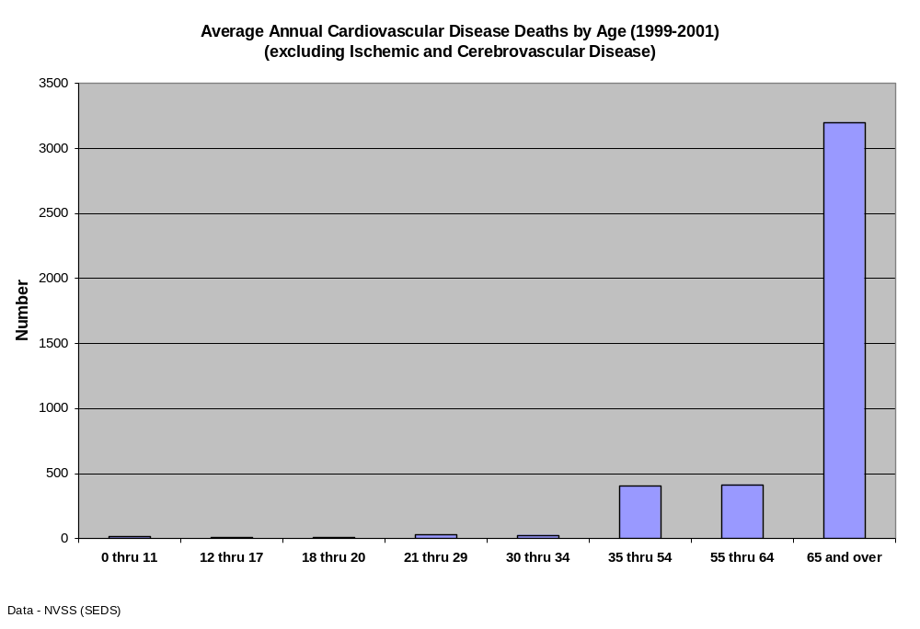

All Cardiovascular Disease
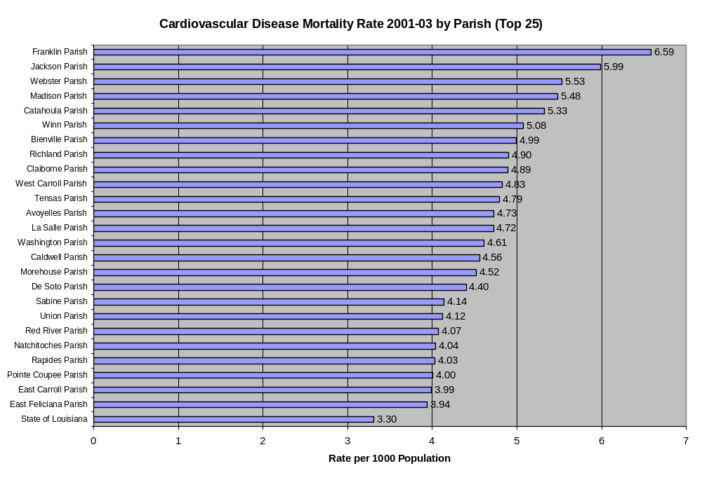
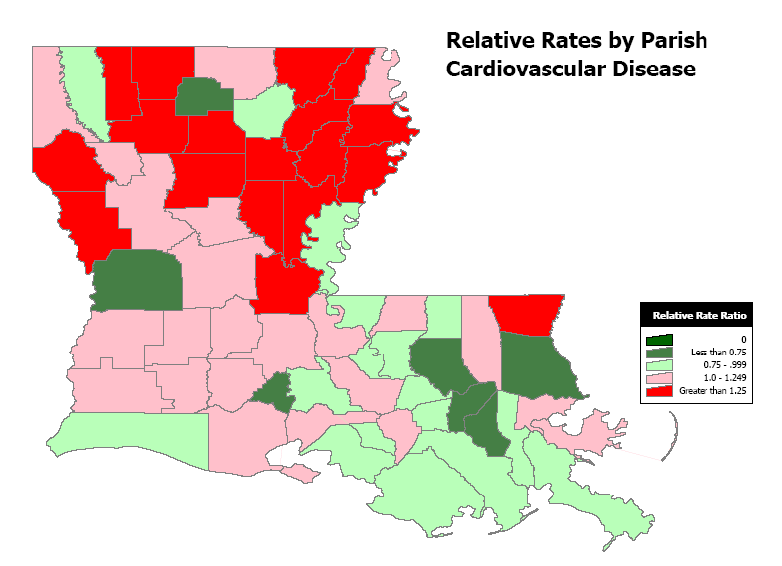
Data - LA Office of Public Health

State and Parish Consumption Patterns

Adult Current Cigarette Use

Respondents were classified as current smokers if they had smoked >100 cigarettes during their lifetimes and reported smoking every day or some days during the 12 months preceding the survey. The percentage of Orleans Parish respondents (30.1%) that indicated current use, was the highest percentage of any U.S. county._{11,12}

The percentage of Louisiana respondents indicating current use was above the national average in all age groups for 2001 through 2003, with the exception of 2001 18-20 year olds and 2002 55-64 year olds. The mean percentage for current use for the three years was above 15% in all age groups except the 65 year and older group.
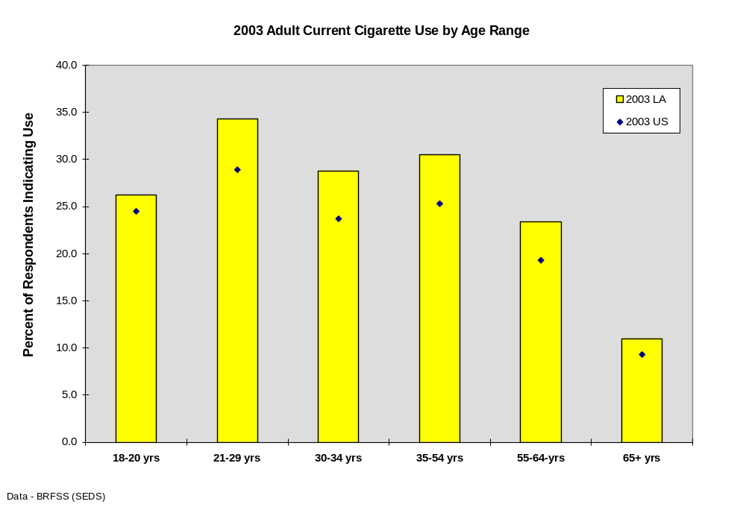

Adult Daily Cigarette Use

The percentages of Louisiana residents 18 years of age and older that indicated daily use of cigarettes were similar to the national average (2001-2003). The highest percentages of respondents reporting cigarette use were in the 21 to 29 year old group, although very high percentages were reported in the 18-20, 30-34, and 35-54 year old groups. The lowest percentages were in the group 65 years of age and older.
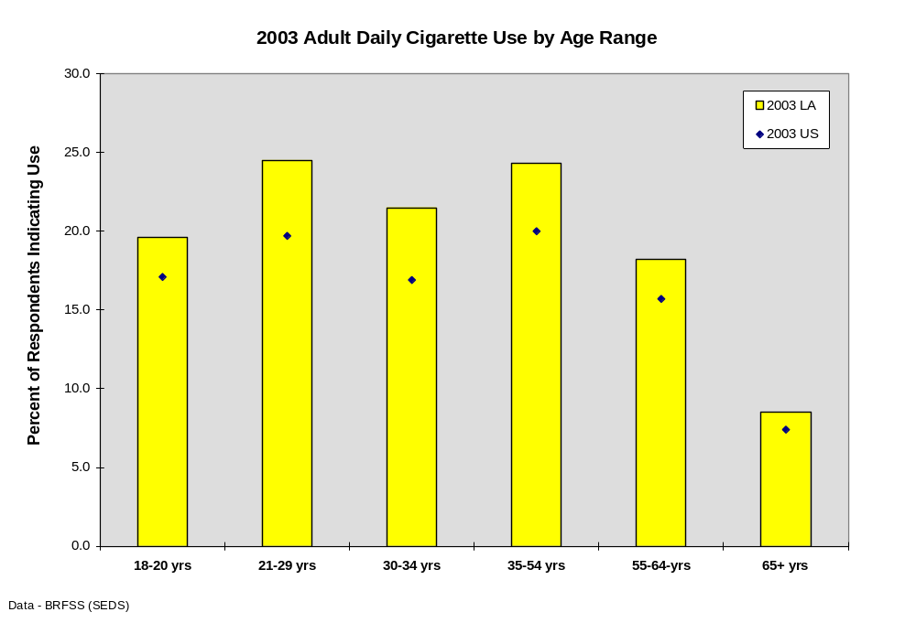

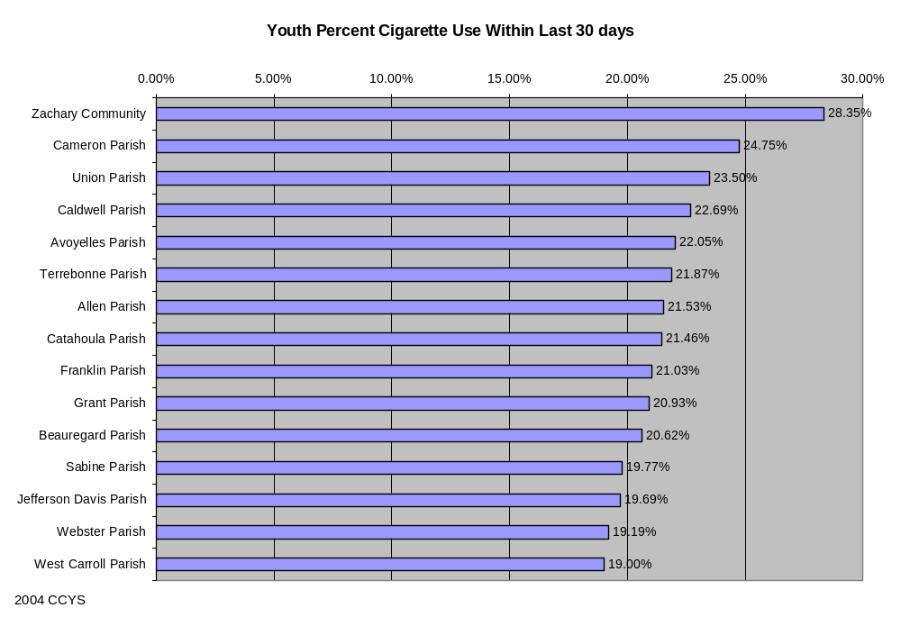
Table 5-3: Youth Tobacco Use Within the last 30 days
District | Not at all | 1 or more occasions | Percent Use Within Last 30 days
Zachary Community | 235 | 93 | 28.35%
Cameron Parish | 307 | 101 | 24.75%
Union Parish | 459 | 141 | 23.50%
Caldwell Parish | 92 | 27 | 22.69%
Avoyelles Parish | 944 | 267 | 22.05%
Terrebonne Parish | 1,590 | 445 | 21.87%
Allen Parish | 656 | 180 | 21.53%
Catahoula Parish | 194 | 53 | 21.46%
Franklin Parish | 507 | 135 | 21.03%
Grant Parish | 544 | 144 | 20.93%
Beauregard Parish | 920 | 239 | 20.62%
Sabine Parish | 771 | 190 | 19.77%
Jefferson Davis Parish | 999 | 245 | 19.69%
Webster Parish | 1,095 | 260 | 19.19%
West Carroll Parish | 162 | 38 | 19.00%
Iberia Parish | 2,375 | 542 | 18.58%
Bienville Parish | 427 | 97 | 18.51%
Iberville Parish | 657 | 149 | 18.49%
Lafourche Parish | 1,925 | 431 | 18.29%
St. Charles Parish | 1,294 | 288 | 18.20%
Natchitoches Parish | 854 | 188 | 18.04%
Calcasieu Parish | 5,526 | 1,199 | 17.83%
LaSalle Parish | 473 | 102 | 17.74%
Red River Parish | 183 | 39 | 17.57%
St. Martin Parish | 1,240 | 255 | 17.06%
Ouachita Parish | 3,006 | 617 | 17.03%
Plaquemines Parish | 863 | 177 | 17.02%
Richland Parish | 616 | 126 | 16.98%
Assumption Parish | 827 | 168 | 16.88%
Ascension Parish | 3,019 | 590 | 16.35%
St. Landry Parish | 2,323 | 453 | 16.32%
Livingston Parish | 4,258 | 827 | 16.26%
Louisiana Statewide | 83,463 | 16,042 | 16.12%
Washington Parish | 730 | 140 | 16.09%
Lafayette Parish | 4,114 | 778 | 15.90%
Evangeline Parish | 929 | 175 | 15.85%
City of Bogalusa | 284 | 53 | 15.73%
Acadia Parish | 1,378 | 255 | 15.62%
St. Mary Parish | 1,704 | 311 | 15.43%
Vernon Parish | 1,086 | 198 | 15.42%
Tangipahoa Parish | 3,312 | 590 | 15.12%
West Feliciana Parish | 491 | 86 | 14.90%
St. James Parish | 486 | 85 | 14.89%
Bossier Parish | 2,495 | 433 | 14.79%
Concordia Parish | 583 | 101 | 14.77%
Morehouse Parish | 702 | 120 | 14.60%
East Baton Rouge Parish | 7,748 | 1,322 | 14.58%
West Baton Rouge Parish | 574 | 96 | 14.33%
Jackson Parish | 409 | 65 | 13.71%
Claiborne Parish | 441 | 70 | 13.70%
City of Baker | 362 | 57 | 13.60%
Tensas Parish | 132 | 20 | 13.16%
Rapides Parish | 2,140 | 320 | 13.01%
Jefferson Parish | 6,086 | 907 | 12.97%
Caddo Parish | 1,332 | 192 | 12.60%
Winn Parish | 503 | 72 | 12.52%
Lincoln Parish | 828 | 116 | 12.29%
DeSoto Parish | 510 | 67 | 11.61%
St. Bernard Parish | 709 | 91 | 11.38%
East Carroll Parish | 306 | 31 | 9.20%
Orleans Parish | 777 | 70 | 8.26%
City of Monroe | 1,047 | 81 | 7.18%
St. Helena Parish | 242 | 14 | 5.47%
Pointe Coupee Parish | 154 | 5 | 3.14%
Madison Parish | 76 | 0 | 0.00%

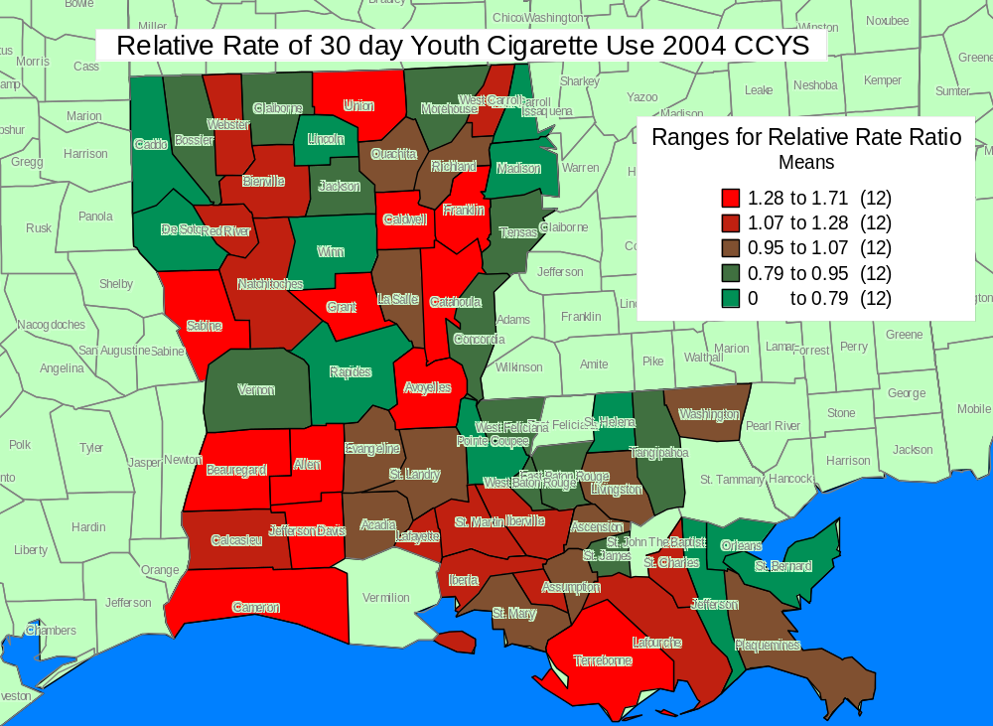

Youth 30-day Cigarette Use by Grade

Thirty day use is a measure of the percentage of students who used the substance at least once in the 30 days prior to taking the survey and is considered a sensitive indication of the level of current use of the substance.¹³

No national comparisons are available for 6th graders. A higher percentage of Louisiana 8th and 10th graders reported cigarette use than the national average in 2004. Percentages for Louisiana 12th graders, however, were slightly less than the national average and percentages of cigarette use consistently increased in all age groups from 6th to 12th grade.

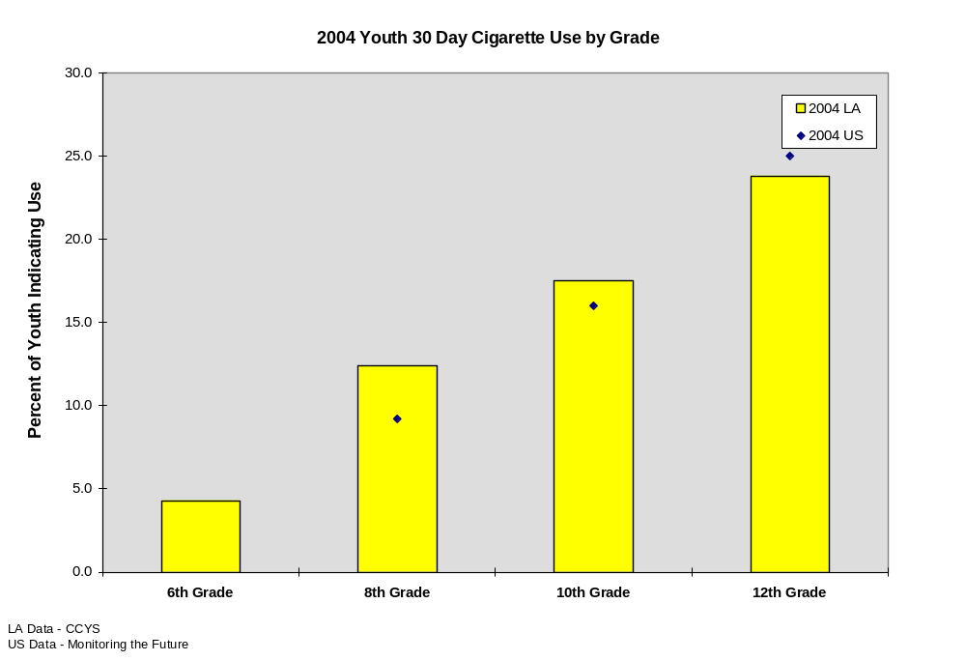
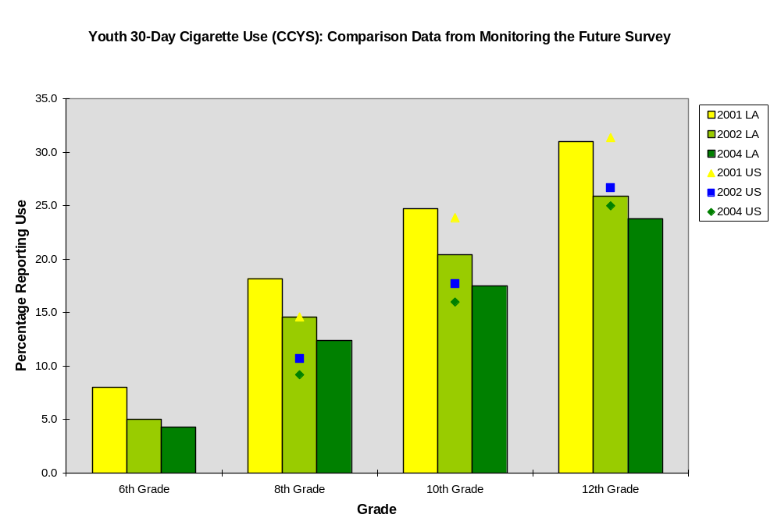
Adult Current Cigarette Use

The percentages of Louisiana residents 18 years of age and older that have smoked over 100 cigarettes in their lifetime and reported smoking some days in the twelve months prior to the survey, CDC’s Behavioral Risk Factor Surveillance System (BRFSS) survey, were similar to the national average (2001-2003). The highest percentages of respondents reporting cigarette use were in the 21 to 29 year old group, although very high percentages were reported in the 18-20, 30-34, and 35-54 year old groups. The lowest percentages were in the group 65 years of age and older.

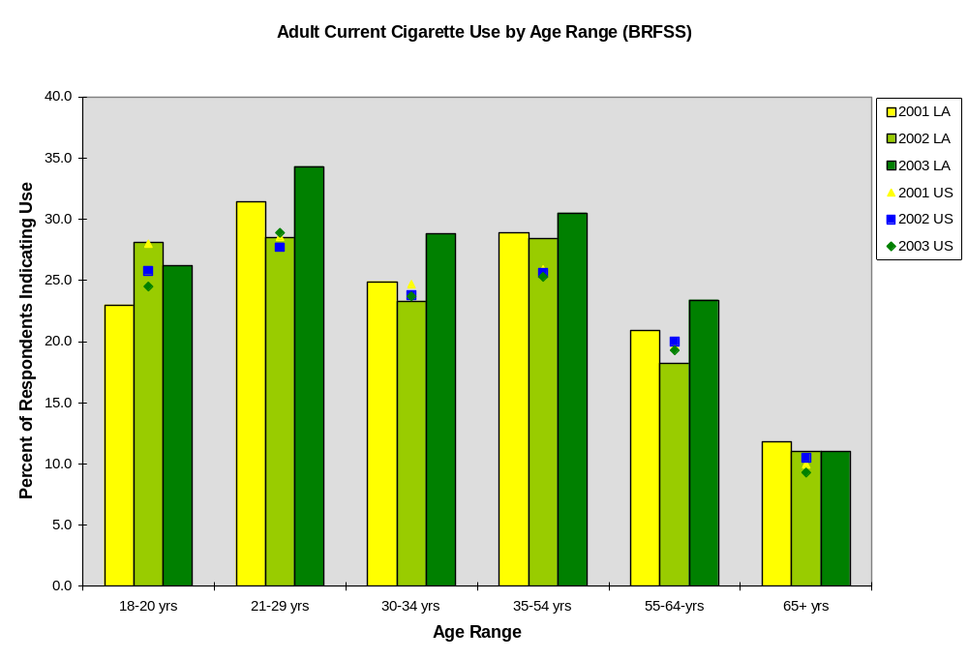
Respondents were classified as daily smokers if they reported smoking every day during the 12 months preceding the survey. The percentage of Orleans Parish respondents (30.1%) that indicated current use was the highest percentage of any U.S. county._{11,12}

The percentage of Louisiana respondents indicating daily use was above the national average in all age groups for 2001 through 2003, with the exception of 2001 18-20 year olds and 2002 55-64 year olds. The mean percentages for current use for the three years were above 15% in all age groups except the 65 year and older group.

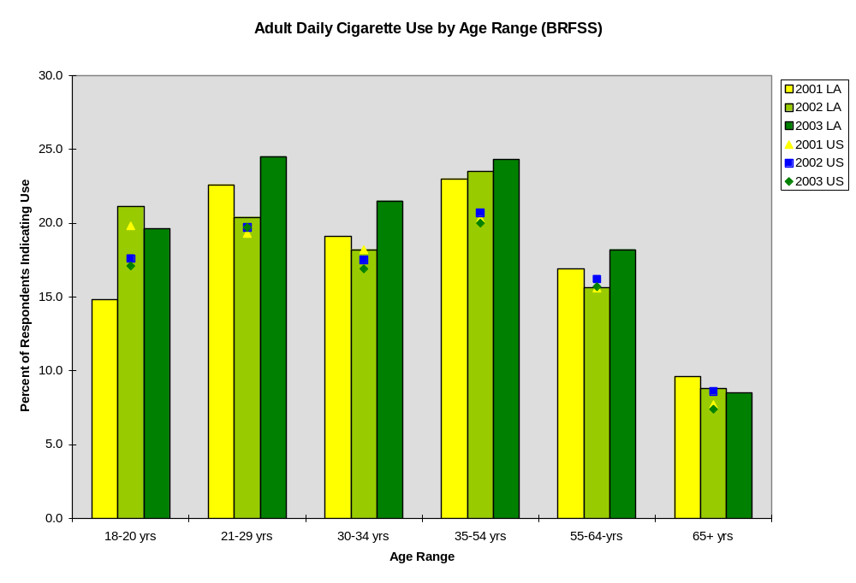

State and Parish Immediate Health Consequences

In the United States, the fourth and sixth leading causes of injury deaths are accidental falls and drowning (CDC, 2002). In Louisiana from 1999 through 2004, the three leading causes of accidental deaths other than those caused by motor vehicle crashes were accidental falls, accidental drownings, and death due to fire, smoke, or burns. According to the Centers for Disease Control and Prevention (CDC), these three causes of accidental death are often associated with alcohol consumption.₅
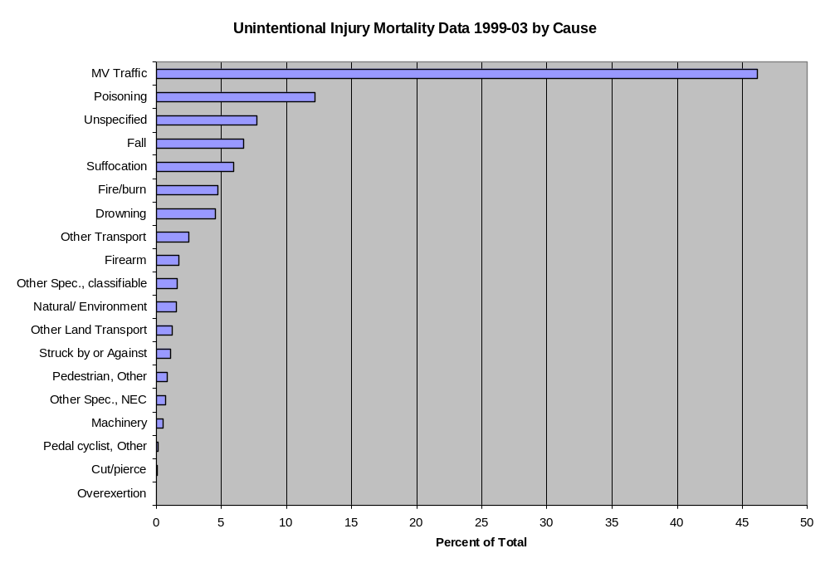

College Tobacco Use

Louisiana State University Undergraduates’ Cigarette Use
(Note: This data is specific to Louisiana State University undergraduate students. Please do not refer to this as LSU campus cigarette use as the term “campus” describes a circumscribed area of land with university buildings, not the student population of which 80% live off-campus.)

Since 1993, Louisiana State University has regularly conducted the College Alcohol Study administered by the Harvard School of Public Health as part of a grant requirement. As the only institution of higher education in the state that consistently has been able to assess undergraduate student substance use and consequences, the following charts provide data from a representative and random sample of undergraduate students enrolled at Louisiana State University in Baton Rouge. Response rates have ranged between 45% to 56%. The data presented is typical of results that might be found for undergraduate students enrolled in a primarily White, metropolitan, four-year institution of higher education. The Harvard School of Public Health has noted that the community’s cultural environment strongly influences students’ alcohol consumption rates, likely to vary both within the state of Louisiana and throughout the South. The presentation by Louisiana State University in Baton Rouge serves as one institutional example in Louisiana and should not be assumed to mirror any other institution.

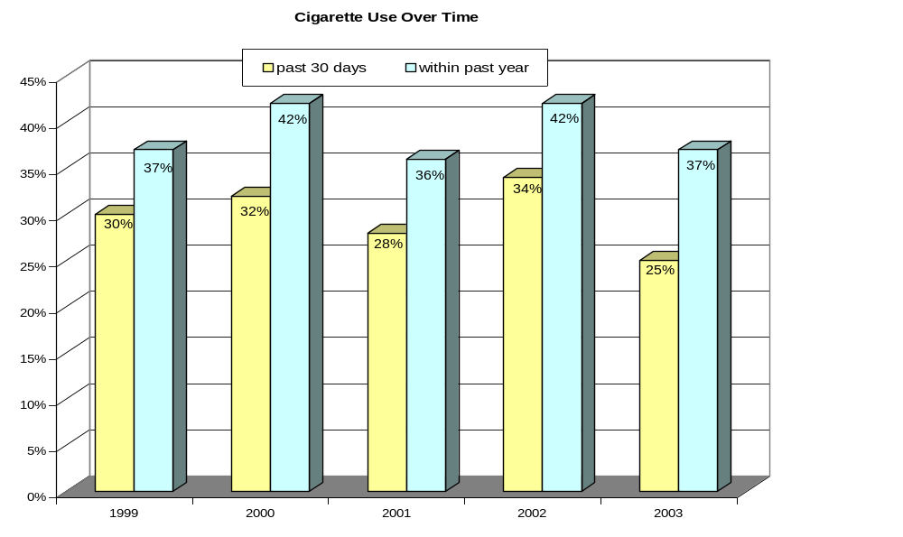
Source: 1999-2003 LSU Results, College Alcohol Study conducted by Harvard School of Public Health

Cigarette Use Over Time – LSU

The College Alcohol Study administered by the Harvard School of Public Health questions survey respondents about how often, if ever, they have used a variety of drugs, including cigarettes. This chart indicates students’ use of cigarettes in the past 30 days and in the past year over time. Results indicate that the overall cigarette use rate in the past 30 days has ranged between 25% to 34% and the overall cigarette use rate in the past year has ranged between 36% to 42%. Rates of use in the past year and in the past 30 days are at some of the highest levels in 2002, a year in which rates for nearly all other survey questions pertaining to students’ alcohol use and behavior were higher.

Cigarette Use in Past Year Over Time, by Gender – LSU
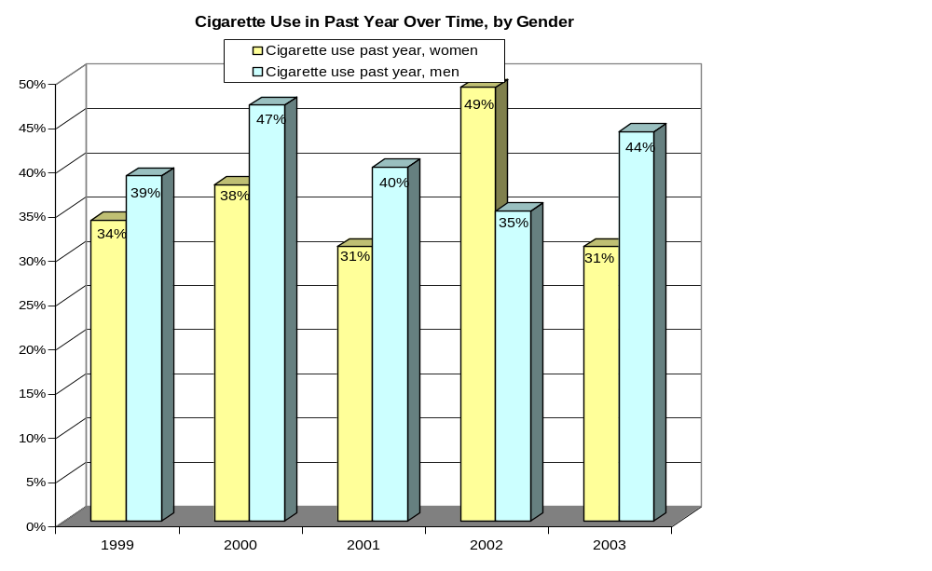
Source: 1999-2003 LSU Results, College Alcohol Study conducted by Harvard School of Public Health

The College Alcohol Study administered by the Harvard School of Public Health questions survey respondents about how often, if ever, they have used a variety of drugs, including cigarettes. Even when divided by gender, cigarette use in the past year for both males and females is similar to total students’ use in the past year. Results indicate that the past year use of cigarettes rates for males range between 35% to 47%. For females, past year cigarette use rates range between 31% to 49%. The yearly cigarette use rate by gender was highest for females in 2002 (49%) while it was lowest for males in that same year (35%). In all other years, males had higher use rates in the past year than females.
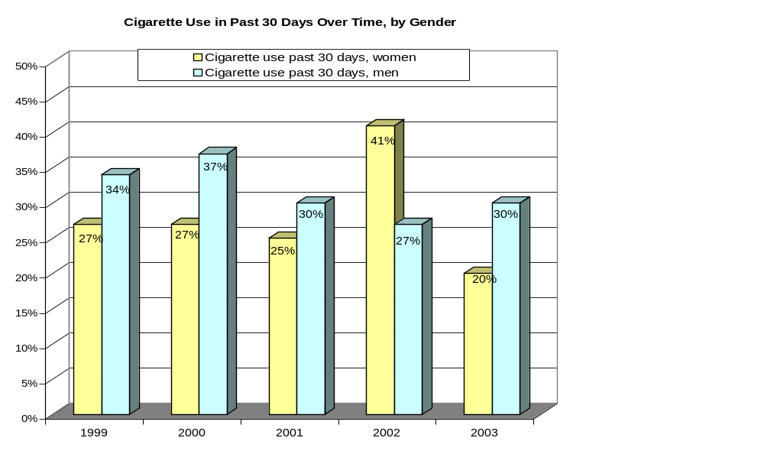 Source: 1999-2003 LSU Results, College Alcohol Study conducted by Harvard School of Public Health

Cigarette Use in Past 30 Days Over Time, by Gender – LSU
The College Alcohol Study administered by the Harvard School of Public Health questions survey respondents about how often, if ever, they have used a variety of drugs, including cigarettes. Cigarette use rates in the past 30 days for both males and females are lower than past year rates. Results indicate that the past 30 days use of cigarettes rates for males range between 27% to 37%. For females, past 30 days cigarette use rates range between 20% to 41%. The rate of cigarette use in the past 30 days by gender was highest for females in 2002 (41%) while it was lowest for males in that same year (27%). In all other years, males had higher use rates in the past 30 days than females.

Burden of Other Drug Use

State and Parish Health & Social Consequences
Drug related mortality (Illicit Drug Deaths)

From 1999 through 2001, the rates of death in Louisiana from the use of illicit drugs were higher than the national rates. The age group experiencing the most deaths from illicit drugs was in the 35-54 year old group. (NVSS) The Office of Public Health State Center for Health Statistics reports that from 1999 through 2004, the highest percentage of deaths related to drug use occurred in Orleans Parish. The rate in Orleans Parish was four times the rate in Jefferson Parish, the parish with the second highest percentage of drug deaths. The highest drug related mortality rates in Louisiana were reported in Orleans and St. Bernard Parishes.

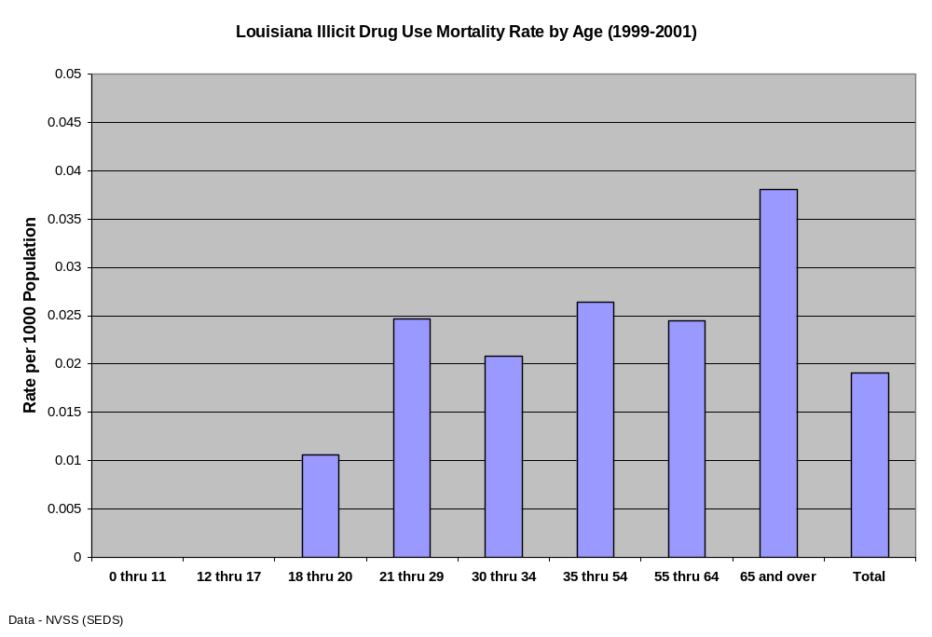
From 1999 through 2001 in Louisiana, the rates of death from the use of illicit drugs were higher than national rates. (NVSS) The composite rate from 1999-2004 (OPH statistics) is just over 0.02 deaths per 1000 population (2 deaths per 100,000).

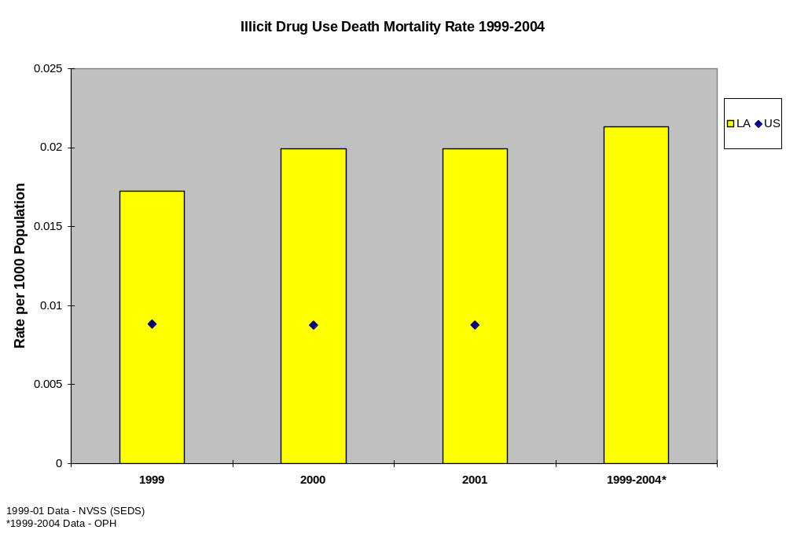

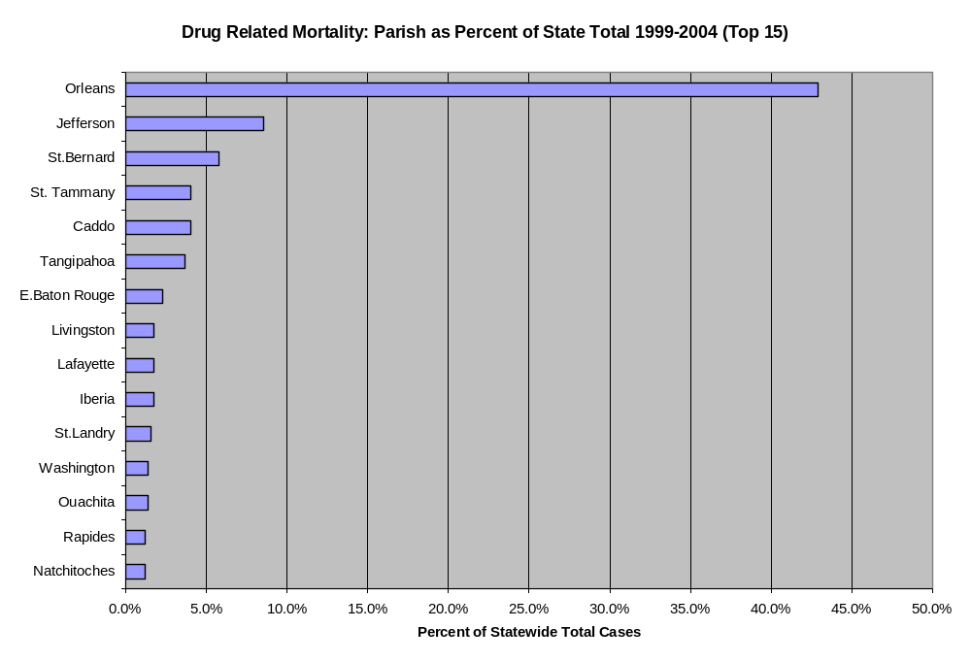
Data - LA Office of Public Health

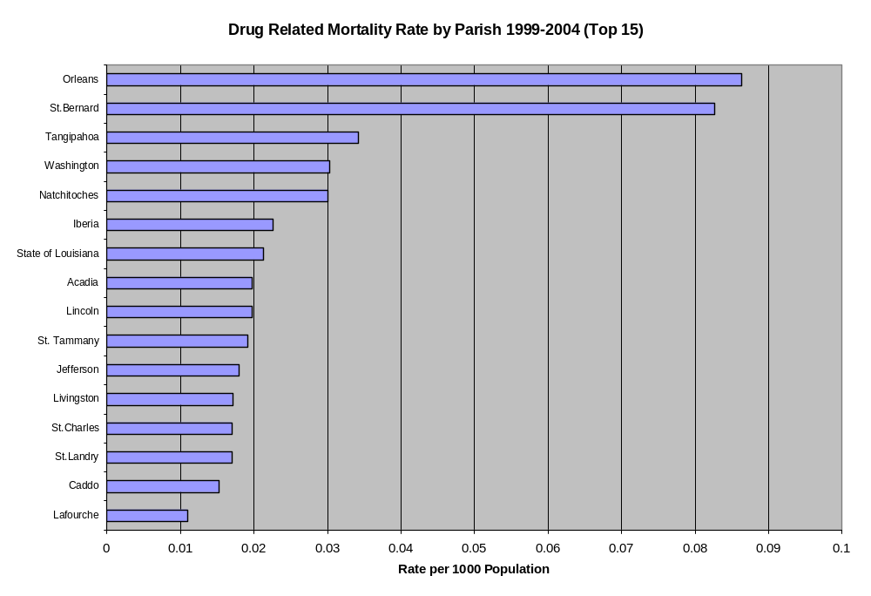
Data - LA Office of Public Health

The map below illustrates the relative rates of drug deaths in the state. Again, Orleans and St. Bernard Parishes experienced the highest rates.
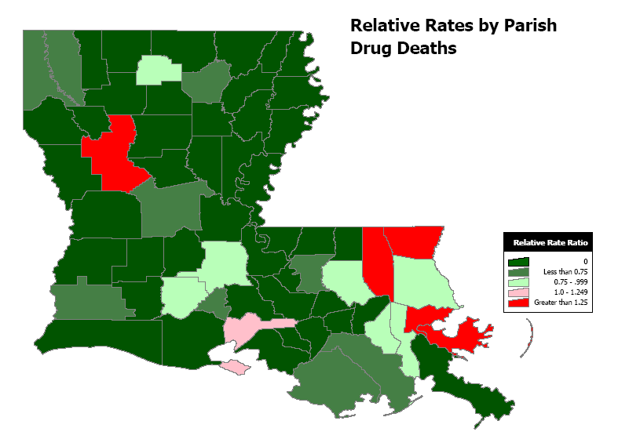
Data - LA Office of Public Health

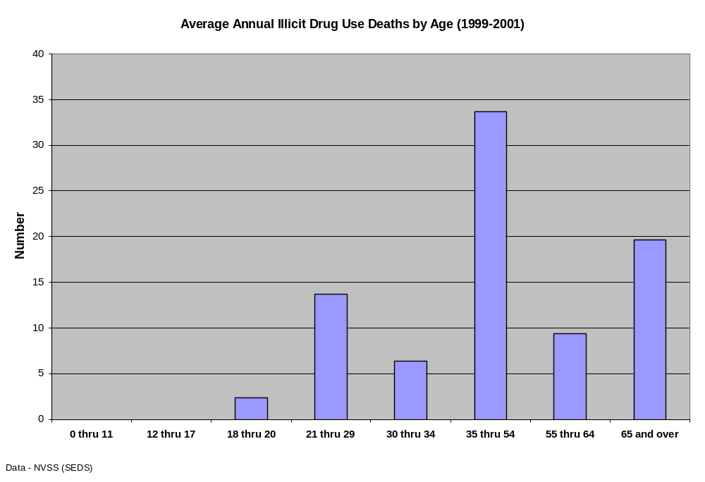
Property Crime
Property crimes are often committed to obtain money for the purchase of illicit drugs. Drug-related property crimes include burglary, larceny, and motor vehicle theft. Approximately 30% of burglaries can be attributed to drug use.₇ From 2000 through 2002, the rate of reported property crimes in Louisiana exceeded the national rate with most property crimes being reported in East Baton Rouge, Orleans, Jefferson, and Caddo Parishes. The highest rates were seen in East Baton Rouge, Caddo, Orleans, and Rapides Parishes. Nine other parishes also reported rates higher than the state average.

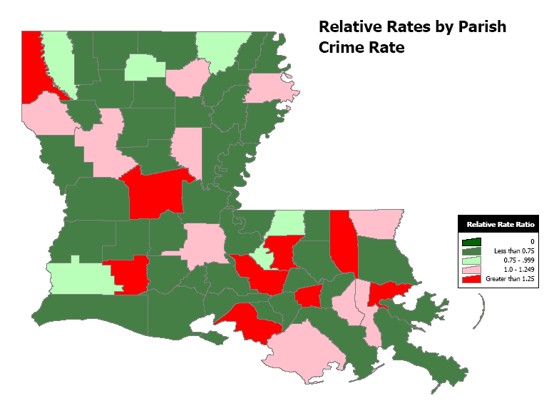

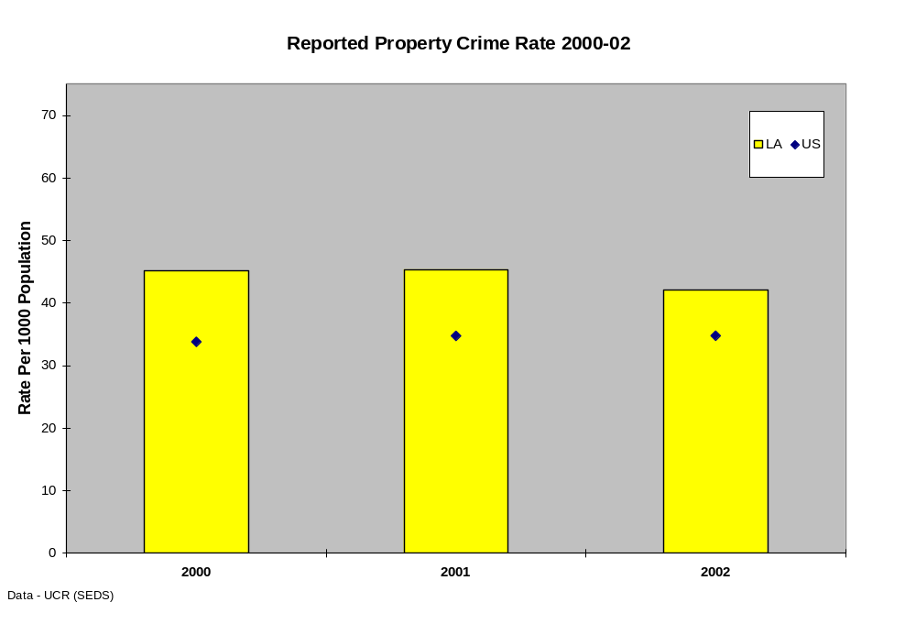
Most property crimes were reported in East Baton Rouge, Orleans, Jefferson, and Caddo Parishes. 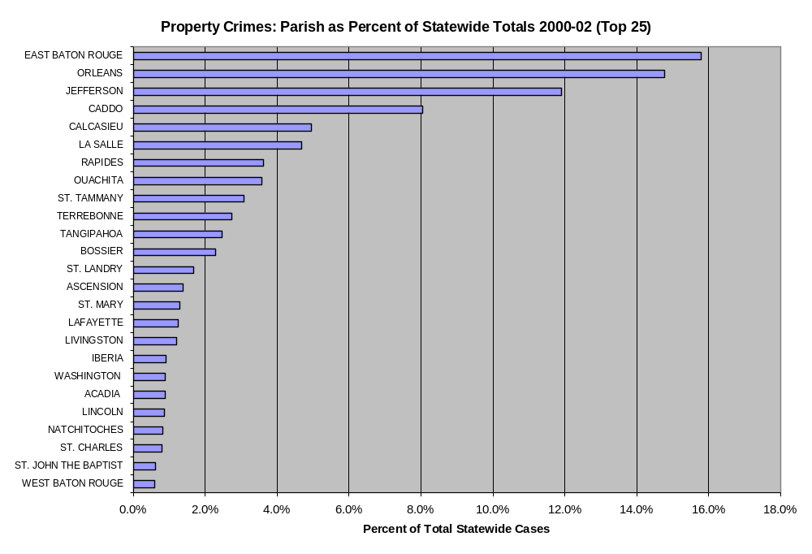
Data – LA Commission on Law Enforcement
The highest rates were seen in East Baton Rouge, Caddo, Orleans, and Rapides Parishes. Nine other parishes reported rates higher than the state average.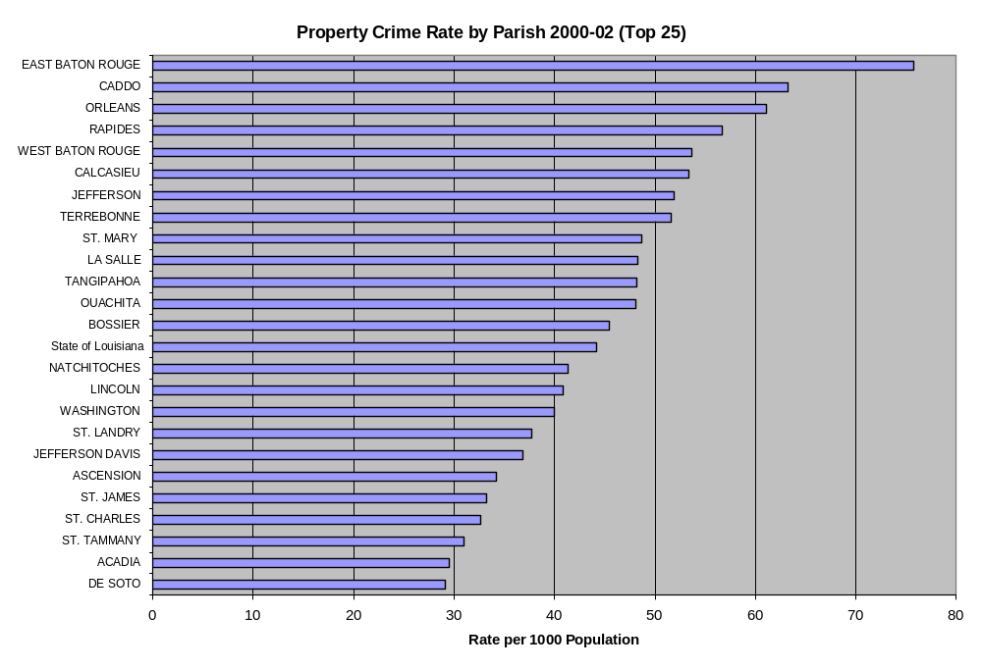
Data – LA Commission on Law Enforcement

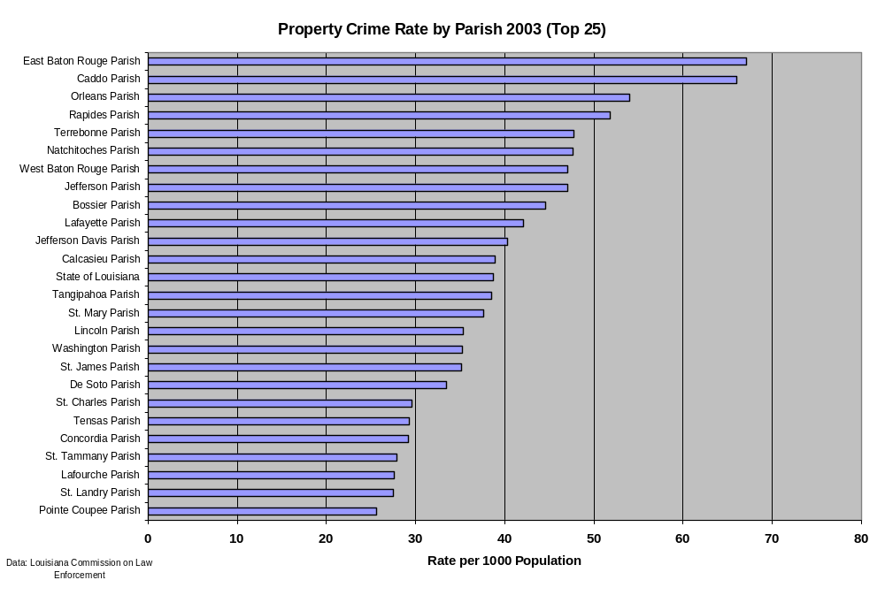

Data-Louisiana Commission on Law Enforcement
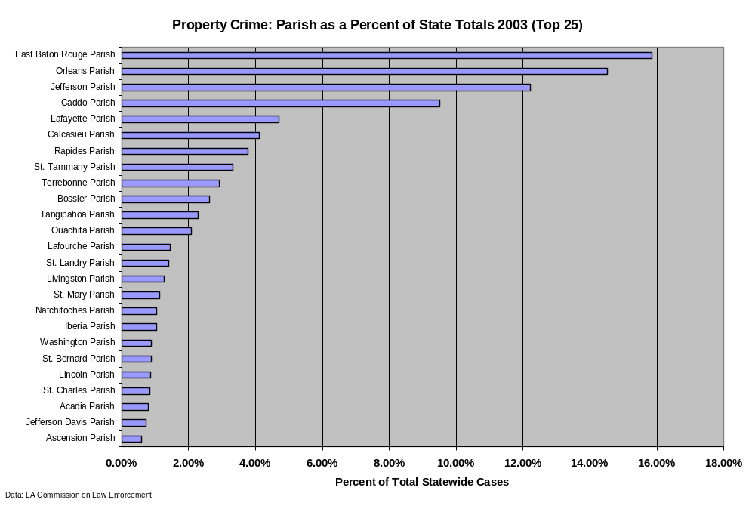
Data-Louisiana Commission on Law Enforcement

State and Parish Consumption Patterns
Drug Dependence/Abuse

The National Survey on Drug Use and Health (NSDUH) assesses the dependence on or abuse of a substance within 12 months prior to completion of the survey. Questions are used to classify persons as dependent or abusing specific substances, such as alcohol, prescriptions drugs, and/or illicit drugs based on criteria specified in the Diagnostic and Statistical Manual of Mental Disorders, 4th edition (DSM-IV) (American Psychiatric Association [APA], 1994). The questions on dependence inquire about health, emotional problems, attempts to reduce use, tolerance, withdrawal, participating in activities related to substance use, or using the substance in large quantities for long periods of time. The questions on abuse include questions concerning problems at work, home, and school; problems with family or friends; physical danger; and legal problems associated with substance use. Dependence is considered to be more severe than abuse.¹⁴

The greatest percentage of Louisiana respondents determined to be dependent or abusing illicit drugs were within the 17-25 year old age group. The second highest percentage of dependence or abuse was within the 12-17 year old group. However, the percentages reported in both these groups were lower than national percentages. Dependence or abuse percentages in the age 26 and older group were the lowest in comparison, but exceeded the national average. (2002 NSDUH)

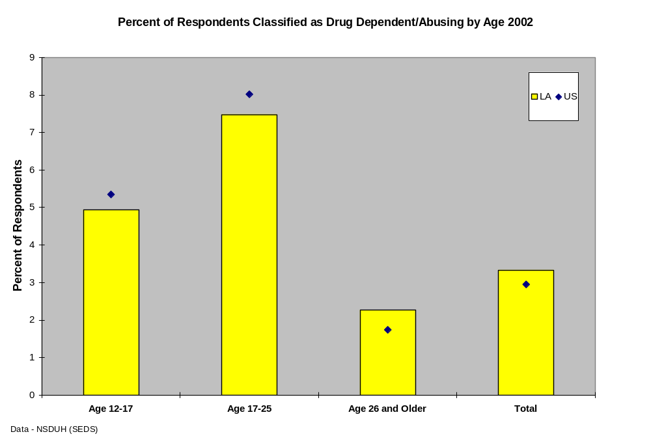

Admissions

Rates of admissions to public substance abuse treatment facilities and programs from 2003 to 2005 are illustrated in the chart below. During this period, approximately seven persons per one hundred thousand population per year were admitted to programs across the state. The number of admissions in East Baton Rouge Parish nearly doubled the admissions from any other parish. Orleans Parish also exhibited a high percentage of admissions. The highest rates of treatment admissions were reported from St. Mary, Rapides, Terrebonne, and East Baton Rouge Parishes.

Approximately 2/3 of treatment admissions were male. African Americans make up 32.5% of Louisiana’s population, but treatment admissions comprised a slightly higher proportion of African Americans than that of the general population.₈ Most of the admissions, however, were white. Most persons admitted were between 25 and 44 years of age, but a high number of admissions were also reported from the 18 to 24 year age group. An extremely high percentage of the admissions were unemployed.

The most common primary substances reported by treatment admissions were alcohol (1st), cocaine (2nd), and marijuana (3rd). If secondary substances were reported, the most common were alcohol (1st), marijuana (2nd), and cocaine (3rd).

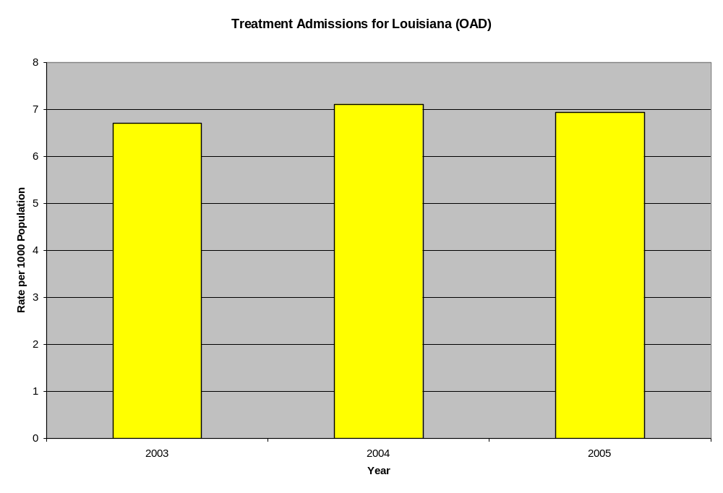

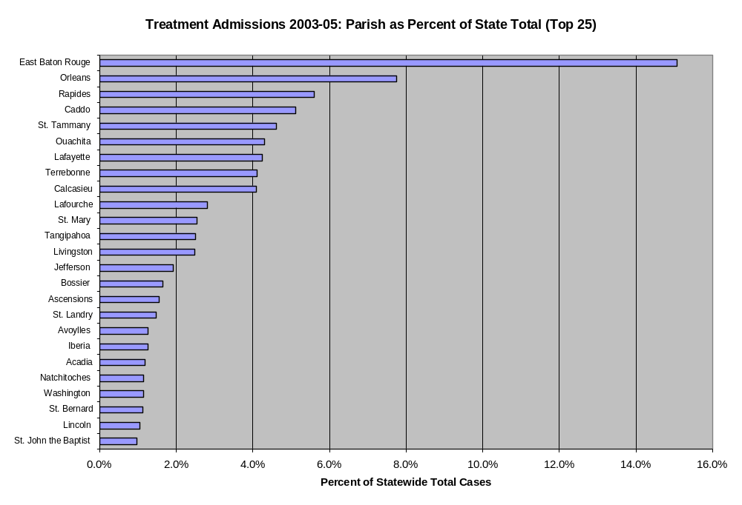
Data – LA Office of Addictive Disorders

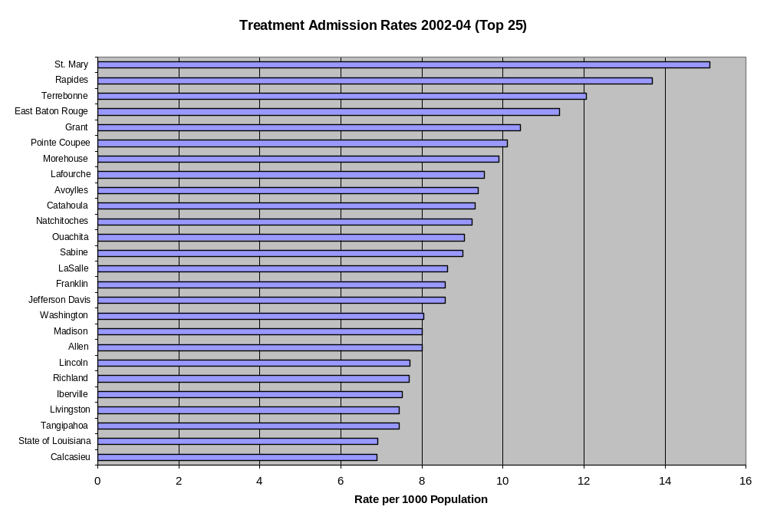
Data – LA Office of Addictive Disorders

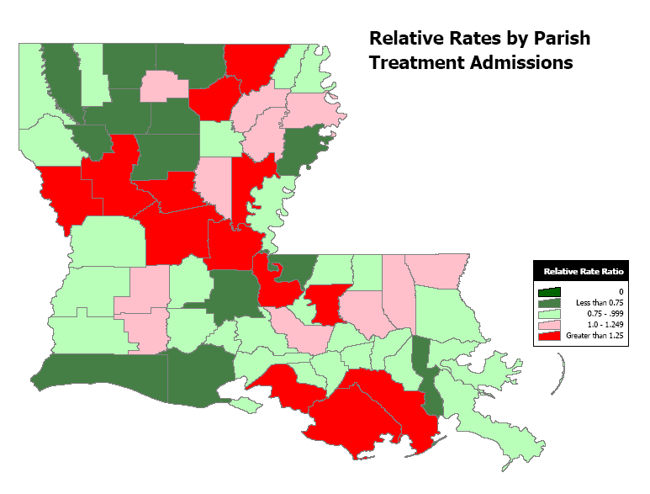

Data – LA Office of Addictive Disorders
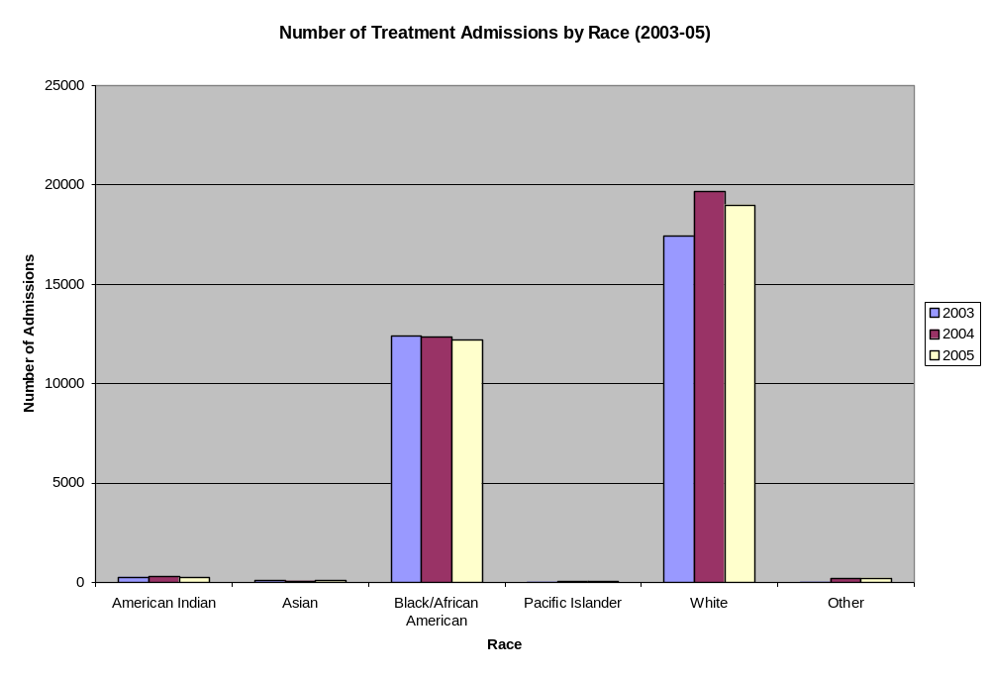
Data – LA Office of Addictive Disorders

African Americans make up 32.5% of Louisiana’s population, but treatment admission comprised a slightly higher proportion of African Americans than that of the general population.₈ Most persons admitted, however, were white.
. 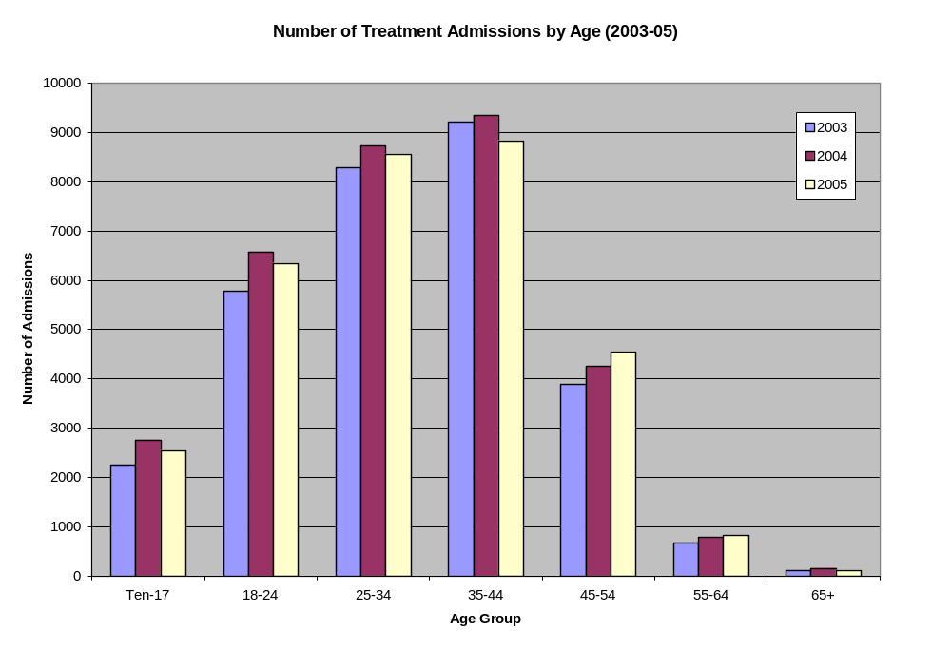
Data – LA Office of Addictive Disorders

Most persons admitted for treatment were between 25 and 44 years of age, but a high number of admissions were also reported from the 18 to 24 year age group.

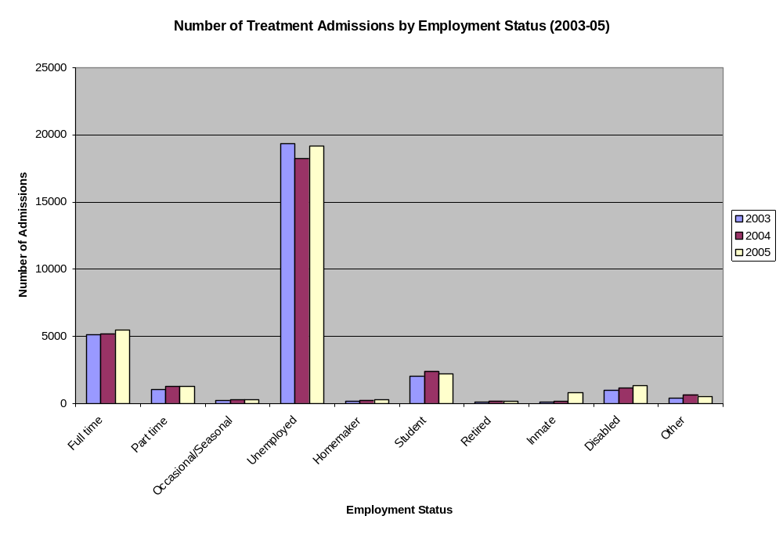
Data – LA Office of Addictive Disorders

An extremely high percentage of persons admitted were unemployed.
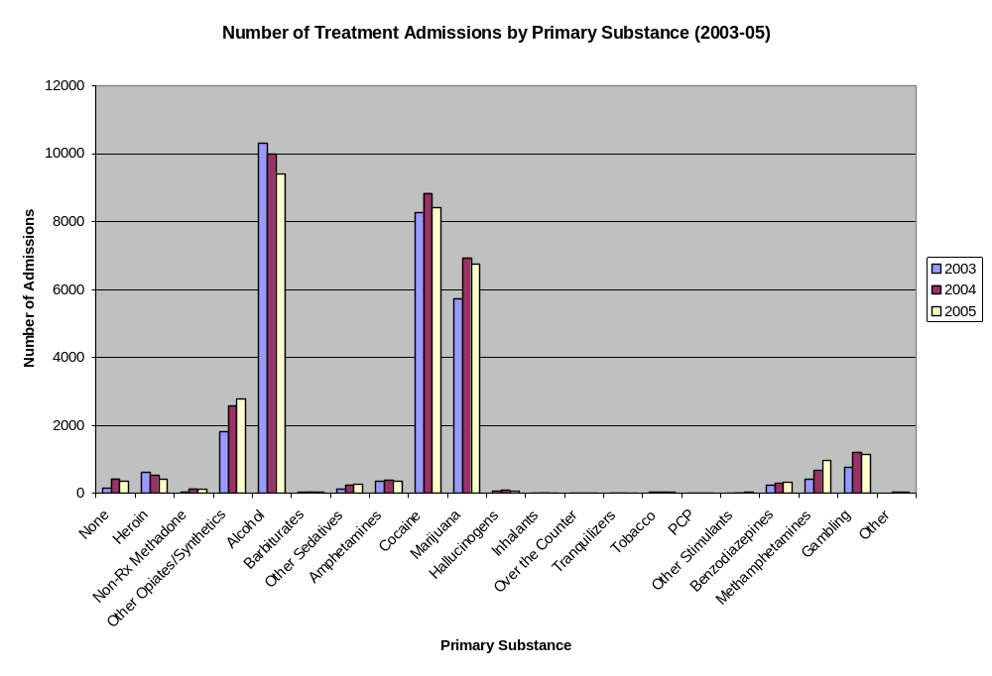
Data – LA Office of Addictive Disorders

The most common primary substances reported by treatment admissions were alcohol (1st), cocaine (2nd), and marijuana (3rd).

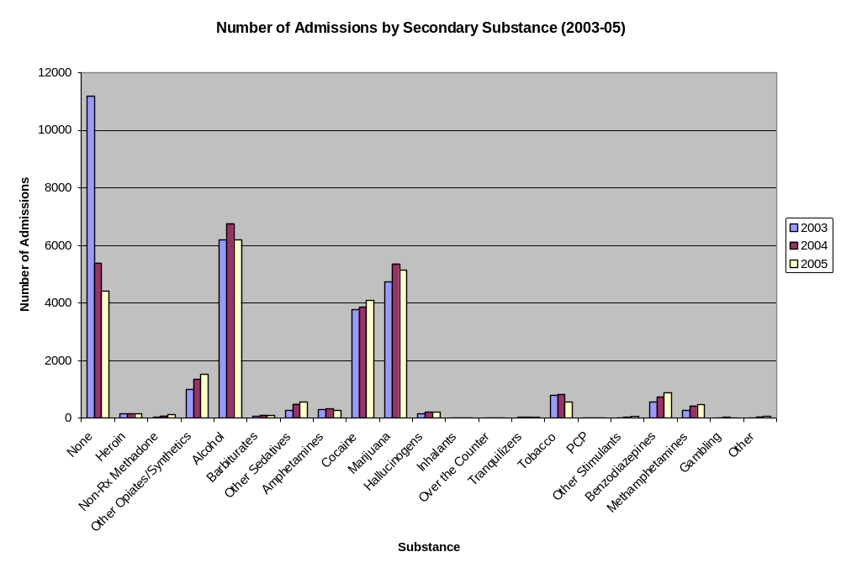
Data – LA Office of Addictive Disorders

If any secondary substances were reported, the most common were alcohol (1st), marijuana (2nd), and cocaine (3rd).
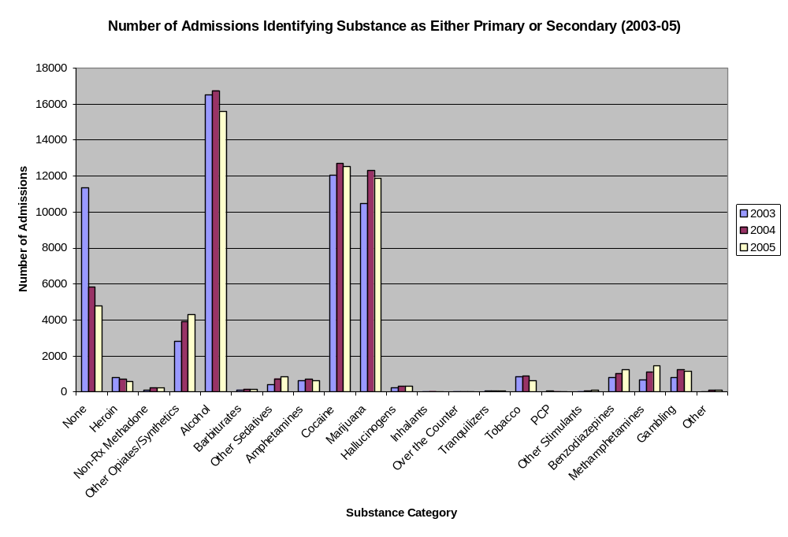
Data – LA Office of Addictive Disorders

Marijuana Use

The greatest percent of Louisiana respondents reporting current use of marijuana was within the 18-25 year old age group. The second highest percentage of current use was within the 12-17 year old group. The percentage reported in the 12-17 year group was below national percentages. The percentage in the 18-25 year group was above the national level. Current use percentage in the age 26 and older group was the lowest in comparison and was lower than the national average. Overall use of marijuana in all age groups was very near but slightly above the national level. (2002 NSDUH)
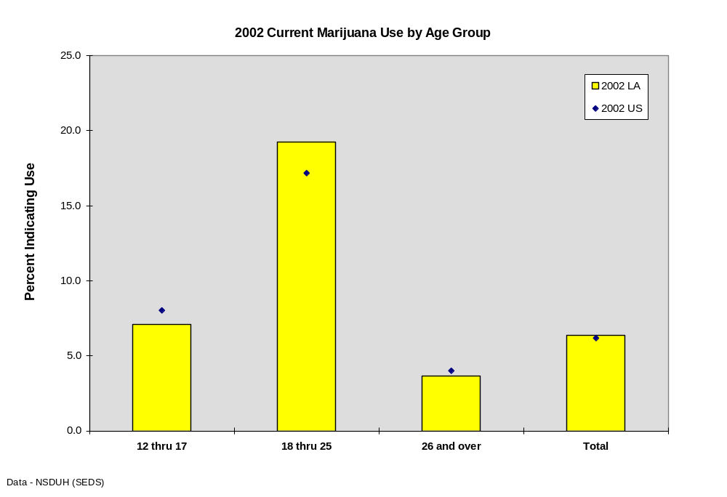

The same pattern of use by age was seen with other illicit drugs besides marijuana. The highest percentage of use was in the 18-25 year group. Louisiana’s percentages were higher than the national average in all categories.
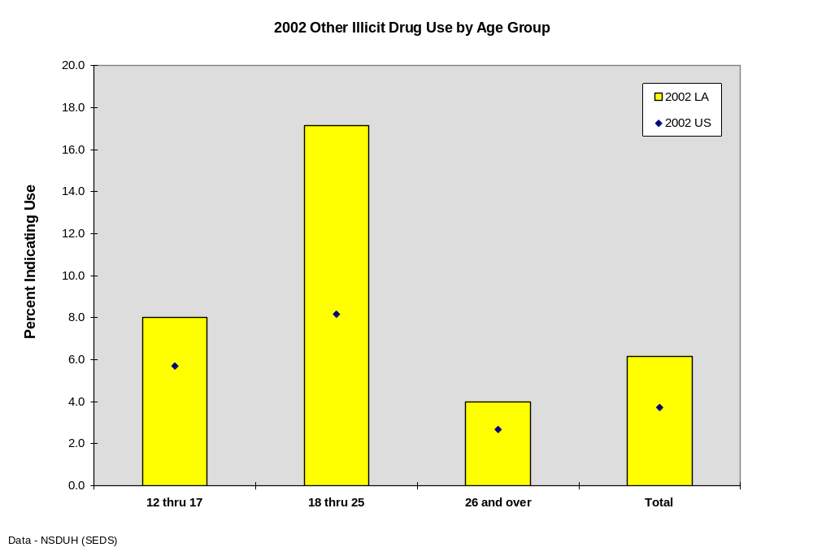

Youth 30-day Marijuana Use by Grade

Thirty day use is a measure of the percentage of students who used the substance at least once in the 30 days prior to taking the survey (CCYS) and is considered a sensitive indication of the level of current use of the substance.¹²

No national comparisons are available for 6th graders. Of the comparisons available, percentages of students that reported use of marijuana were lower in Louisiana than the national averages for 8th, 10th and 12th graders. Thirty day marijuana use consistently increased in Louisiana students from 6th to 12th grade.

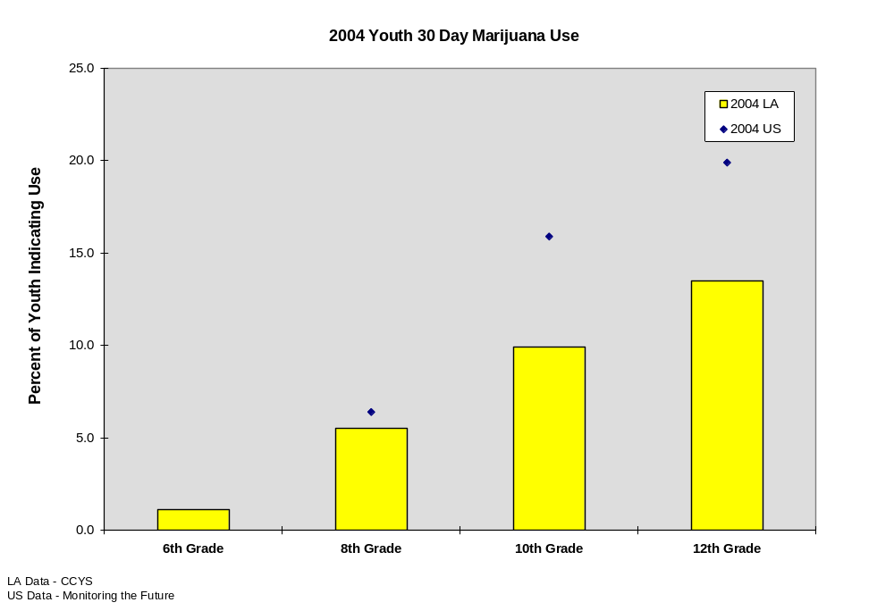

No national comparisons are available for 6th graders and no national comparisons exist for 12th graders in 2001. Of the comparisons available, percentages of students that reported use of marijuana were lower in Louisiana than the national average for 10th and 12th graders, and were lower for Louisiana students in 8th graders in 2002 and 2004. In 2001, the Louisiana percentages were higher than national levels for 8th graders. Thirty day marijuana use consistently increased in Louisiana students from 6th to 12th grade.
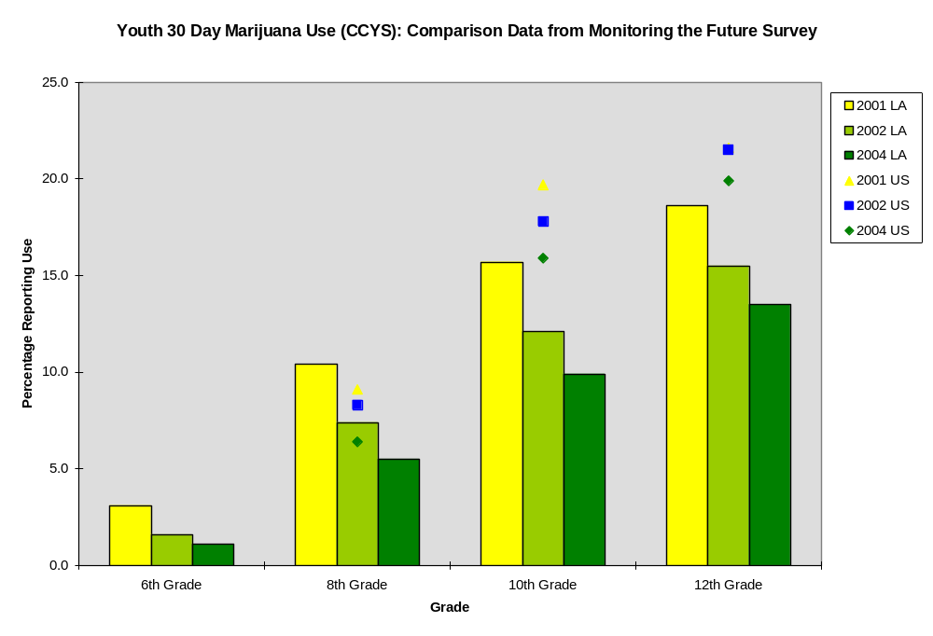

State, Region, Parish Consumption Patterns by Demographics
Table 6-4: Youth 30 day Marijuana Use (2004 CCYS)
District | 0 Occasions | 1 or more occasions | Percent Use Within Last 30 days
Caldwell Parish | 104 | 24 | 18.75%
Zachary Community | 266 | 51 | 16.09%
St. Charles Parish | 1302 | 246 | 15.89%
Terrebonne Parish | 1690 | 273 | 13.91%
City of Bogalusa | 296 | 45 | 13.20%
Franklin Parish | 534 | 81 | 13.17%
East Baton Rouge Parish | 7816 | 1166 | 12.98%
Iberville Parish | 664 | 98 | 12.86%
Plaquemines Parish | 888 | 131 | 12.86%
Lafourche Parish | 1994 | 285 | 12.51%
East Carroll Parish | 267 | 37 | 12.17%
St. Martin Parish | 1302 | 176 | 11.91%
Lafayette Parish | 4164 | 561 | 11.87%
Union Parish | 500 | 65 | 11.50%
Beauregard Parish | 984 | 127 | 11.43%
Grant Parish | 583 | 75 | 11.40%
Bienville Parish | 458 | 58 | 11.24%
Avoyelles Parish | 1050 | 128 | 10.87%
Allen Parish | 709 | 86 | 10.82%
Calcasieu Parish | 5935 | 718 | 10.79%
Orleans Parish | 737 | 88 | 10.67%
Jackson Parish | 397 | 47 | 10.59%
Ascension Parish | 3142 | 371 | 10.56%
Iberia Parish | 2597 | 301 | 10.39%
Louisiana Statewide | 87271 | 9917 | 10.20%
Claiborne Parish | 450 | 51 | 10.18%
Morehouse Parish | 736 | 83 | 10.13%
Jefferson Parish | 6283 | 704 | 10.08%
Livingston Parish | 4427 | 496 | 10.08%
City of Baker | 388 | 43 | 9.98%
Natchitoches Parish | 910 | 99 | 9.81%
Jefferson Davis Parish | 1071 | 115 | 9.70%
Webster Parish | 1168 | 124 | 9.60%
St. Landry Parish | 2348 | 249 | 9.59%
Caddo Parish | 1370 | 145 | 9.57%
Concordia Parish | 616 | 65 | 9.54%
Tangipahoa Parish | 3387 | 348 | 9.32%
St. Mary Parish | 1830 | 181 | 9.00%
Catahoula Parish | 234 | 23 | 8.95%
Ouachita Parish | 3259 | 320 | 8.94%
Tensas Parish | 144 | 14 | 8.86%
St. James Parish | 492 | 47 | 8.72%
Sabine Parish | 860 | 82 | 8.70%
Washington Parish | 774 | 73 | 8.62%
West Baton Rouge Parish | 583 | 54 | 8.48%
Bossier Parish | 2650 | 241 | 8.34%
Red River Parish | 177 | 16 | 8.29%
Richland Parish | 674 | 60 | 8.17%
Cameron Parish | 305 | 27 | 8.13%
Vernon Parish | 1161 | 102 | 8.08%
Evangeline Parish | 975 | 84 | 7.93%
Acadia Parish | 1455 | 121 | 7.68%
Lincoln Parish | 856 | 71 | 7.66%
LaSalle Parish | 534 | 43 | 7.45%
Rapides Parish | 2292 | 178 | 7.21%
City of Monroe | 1001 | 76 | 7.06%
West Carroll Parish | 189 | 14 | 6.90%
St. Bernard Parish | 694 | 50 | 6.72%
Winn Parish | 507 | 36 | 6.63%
West Feliciana Parish | 532 | 34 | 6.01%
Assumption Parish | 901 | 57 | 5.95%
DeSoto Parish | 546 | 34 | 5.86%
St. Helena Parish | 241 | 15 | 5.86%
Pointe Coupee Parish | 140 | 1 | 0.71%
Madison Parish | 72 | 0 | 0.00%

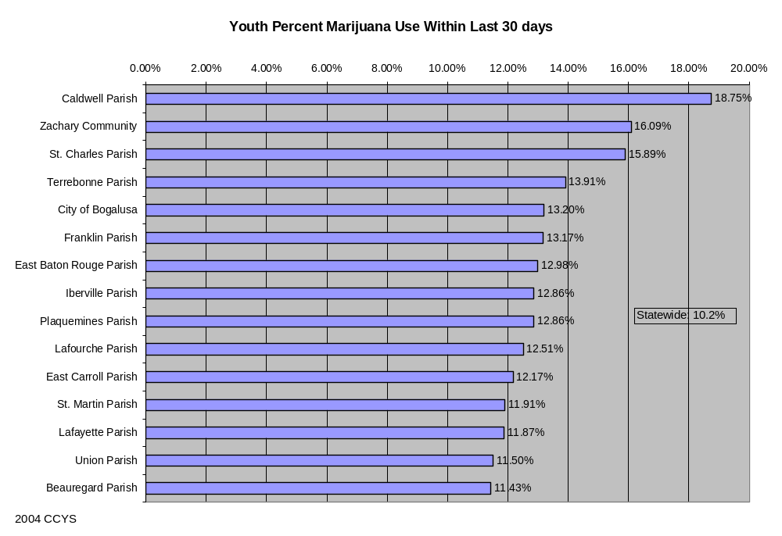

College Other Drug Use
- Tobacco use among U.S. college students in 1999: past year prevalence
- was 45.7%.
- Tobacco use among U.S. college students in 1999: 30-day prevalence was
- 32.9%; males 37.9%; females 29.7%.
- Marijuana use among U.S. college students in 2001: 30-day prevalence
- was 17%.
- Marijuana use among U.S. college students in 2001: past year prevalence
- was 30%.
- Ecstasy use among U.S. college students in 1999: past year prevalence
- was 4.7%.
- Opiod use among U.S. college students in 2001: past year prevalence was
- 7%.

Louisiana State University Undergraduates’ Drug Use
This data is specific to Louisiana State University undergraduate students. Please do not refer to this as LSU campus drug use as the term “campus” describes a circumscribed area of land with university buildings, not the student population of which 80% live off-campus.

Since 1993, Louisiana State University has regularly conducted the College Alcohol Study administered by the Harvard School of Public Health as a grant requirement. The only institution of higher education in the state that has consistently been able to assess undergraduate student substance use and consequences, the following charts provide data from a random and representative sample of undergraduate students enrolled at Louisiana State University in Baton Rouge. Response rates have ranged between 45% to 56%. The data presented is typical of results that might be found for undergraduate students enrolled in a primarily White, metropolitan, four-year institution of higher education. The Harvard School of Public Health has noted that the community’s cultural environment strongly influences students’ alcohol consumption rates, likely to vary both within the state of Louisiana and throughout the South. The presentation by Louisiana State University in Baton Rouge serves as one institutional example in Louisiana and should not be assumed to mirror any other institution.

Over the five-year period reported, the survey designers requested information about usage of the following drugs in addition to marijuana and cigarettes: (a) crack cocaine, (b) other forms of cocaine, (c) barbiturates (prescription-type sleeping pills like Seconal, Nembutal, downs or Yellow jackets), (d) amphetamines (methamphetamines, crystal meth, speed, uppers, ups), (e) tranquilizers (prescription-type drugs like Valium, Librium, Xanax, Ativan, Klonopin), (f) heroin, (g) other opiate-type prescription drugs (codeine, morphine, Demerol, Percodan, Percocet, Vicodin, Darvon, Darvocet), (h) LSD, (i) other psychedelics or hallucinogens like mushrooms, mescaline, or PCP, and (j) Ecstasy.
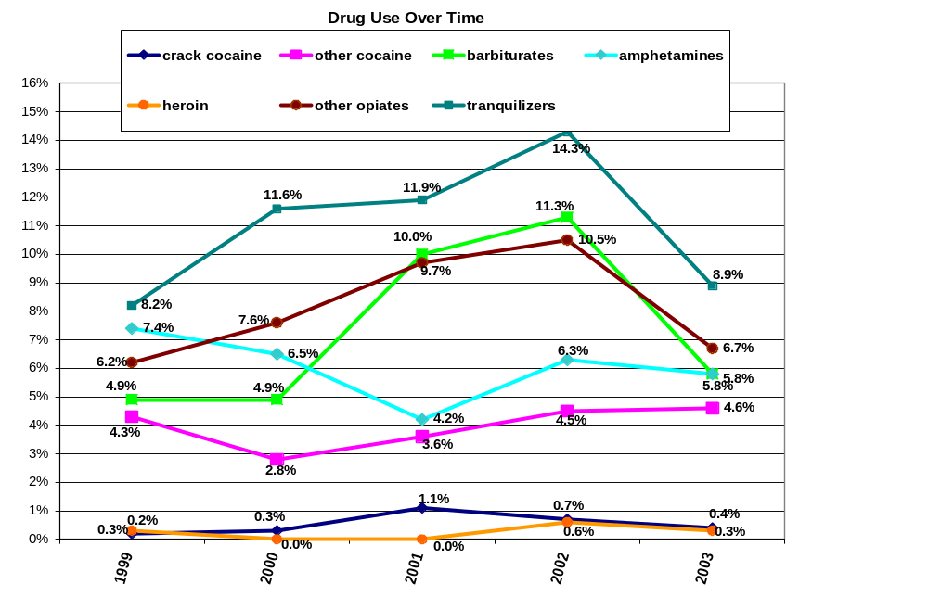
Source: 1999-2003 LSU Results, College Alcohol Study conducted by Harvard School of Public Health

Drug Use Over Time – LSU

The College Alcohol Study administered by the Harvard School of Public Health questions survey respondents about how often, if ever, they have used a variety of drugs, including marijuana (or hashish). This chart indicates students’ use of marijuana in the past 30 days and in the past year over time. Results indicate that the overall marijuana use rate in the past 30 days has ranged between 14% to 19% and the overall marijuana use rate in the past year has ranged between 21% to 31%. Rates of use in the past year and in the past 30 days are their highest levels in 2002, a year in which rates for nearly all other survey questions pertaining to students’ alcohol use and behavior were higher.

Psychedelic Drug Use Over Time - LSU

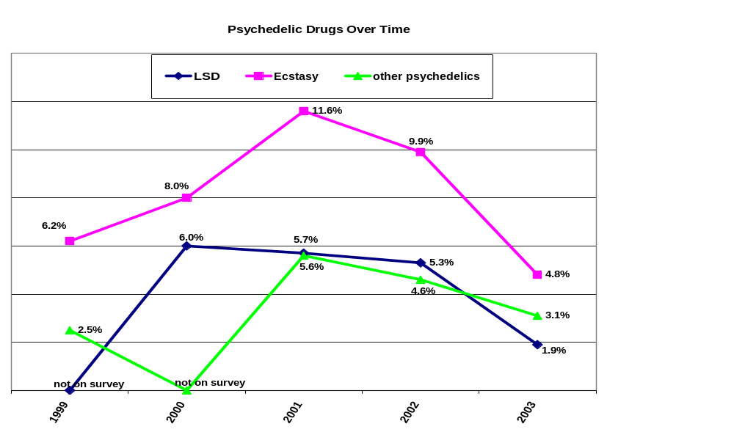
Source: 1999-2003 LSU Results, College Alcohol Study conducted by Harvard School of Public Health

The College Alcohol Study administered by the Harvard School of Public Health questions survey respondents about how often, if ever, they have used a variety of drugs, including Ecstasy, LSD, and other psychedelics. Of the psychedelic drugs, Ecstasy is used most by LSU undergraduates with ranges between 5% to 12%.

Data Gaps and Implications
Over the past year the State Epidemiologic Workgroup (SEW) has investigated several sources of consumption and consequence data from different agencies and organizations throughout the state and nation. This examination has resulted in discussions about the validity, precision, and plausibility of each of the data sets. Several SEW members have also scrutinized data sources from their own organizations and/or agencies and identified problems with accuracy, timeliness, sample number, etc. The end result of this scrutiny is that the SEW has identified a multitude of data gaps, or complete absences of data that in the opinion of the SEW, are worthy of working to develop in the future.

This encouragement and advocacy of new and/or improved data source development will be one of the primary roles of the SEW in the coming years. The consensus of the group is that the membership will continue to seek new sources individually and together as a group, and to work within the members’ respective agencies/organizations to accomplish the goals initially stated in the SPF SIG.

Examples of data sources and related challenges that are planned to be addressed are:

- State/parish drug-related emergency room reporting
  - No statewide system of emergency room reporting exists in Louisiana, although some hospitals report “complaint” information. No emergency room discharge or diagnostic reporting is required.
  - Emergency departments are often reluctant to release data due to proprietary concerns.
  - Reporting of emergency department diagnoses
    - Reporting of multiple diagnoses or subgroup diagnoses is also desirable.
  - Reporting of alcohol poisoning
- State/parish drug/alcohol related arrests (including those involving drugs and/or alcohol but without obvious possession of such substances).
  - Improvement of crime related data indicating possession or presence of alcohol and other non-controlled substances
  - Reporting of drug and alcohol related homicide data
  - Consistent collection of arrest data across all jurisdictions
  - Timely collection of arrest data in all jurisdictions
- State/parish drug related suicides (adults)
  - Data on alcohol and drug related suicides
  - Coroner reporting of substance related suicides
  - Toxicological analysis of all suicide victims
- Improvement of or creation of data sources dealing with alcohol or drug associated traffic accidents or other accidents
  - Uniform consistent drug and alcohol testing of all victims
  - More detailed reporting of non-traffic accidents (falls, industrial accidents, recreational accidents)
- State/campus college populations consumption/consequence data collection
- Age 18 and older consumption/consequence data
- Data reported in consistent age cohorts or individuals years across most indicators
  - Calculation of disability adjusted life years (DALYs) and/or years of potential life lost (YPLL) for mortality and morbidity data
- Parish level tobacco sales
  - Include data pertaining to citations given for sales to minors
- Parish level alcohol and tobacco sales
  - Include data pertaining to citations given for sales to minors
- Improved substance related data collection on risk questionnaires (HIV/AIDS, STDs, hepatitis C)
- Non-mortality accident data (injury data)
- Child Welfare Populations:
  - Limited and inconsistent methods of identifying and recording substance use/abuse in relation to validated complaints of child maltreatment.
  - No data fields available in data system for capturing information learned about substance abuse in families following a validated complaint of maltreatment when there is continued agency involvement with the family.
  - No data fields available for recording alcohol or other substance abuse by youth who are served in the foster care system.

The SEW will certainly not be restricted to consideration of the above data sources and data improvements. The SEW feels that the role of advocating adoption of new data sources and improvements to existing sources will be ever-changing as community needs and assets change through time.

It is intuitive that creation and improvement of these types of data sources involve cooperation of many different entities and require varying degrees of effort, some quite taxing to often scarce resources. The SEW intends to illustrate the importance of these data to the determination of the burden of substance abuse in Louisiana and to the proper allocation of assets. Some improvements will require cooperation of both government and private institutions and some will require allocation of funds through legislation. The primary stumbling blocks include lack of funding, manpower, and the will to carry out the task.

Problems of Greatest Impact and Hot Spots
Most of the following tables show the levels by parish for some of the most important indicators. Shaded rows in the tables indicate the parish rate is higher than the state’s.

Table 5 Alcohol Use - Binge
Age Range | Percent Reported Binge Drinking
College Age Binge | 32%
Adult Binge 25-34 | 22%
Adult Binge 35-44 | 20%
Adult Binge 45-54 | 12%
Adult Binge 55-64 | 8%
Adult Binge 65+ | 3%

Table 6 Alcohol Use - Drinking and Driving
Drinking and Driving | Percent Reporting Driving after Drinking
18-20 yrs | 9%
21-29 yrs | 10%
30-34 yrs | 5%
35-54 yrs | 4%
55-64-yrs | 2%
65+ yrs | 1%

Table 7 Youth Alcohol Use
 | 6th Grade
Parish | Percent Use within Last 30 days | 6th Grade Binge | 8th Grade Binge | 10th Grade Binge | 12th Grade Binge
Acadia Parish | 16.70% | 11.37% | 17.00% | 32.22% | 43.06%
Allen Parish | 14.93% | 13.97% | 25.20% | 28.33% | 46.30%
Ascension Parish | 8.53% | 5.88% | 18.04% | 33.79% | 42.44%
Assumption Parish | 16.60% | 13.68% | 12.39% | 25.53% | 34.88%
Avoyelles Parish | 17.39% | 11.00% | 20.65% | 33.90% | 44.15%
Beauregard Parish | 14.63% | 9.29% | 26.83% | 22.07% | 28.57%
Bienville Parish | 14.63% | 12.30% | 17.68% | 21.30% | 28.18%
Bossier Parish | 8.25% | 6.82% | 12.72% | 22.20% | 32.42%
Caddo Parish | 6.76% | 6.49% | 11.36% | 21.66% | 28.21%
Calcasieu Parish | 7.88% | 4.99% | 15.98% | 26.21% | 33.15%
Caldwell Parish | N/A | N/A | 30.08% | N/A | N/A
Cameron Parish | 13.10% | 8.08% | 31.53% | 31.43% | 48.72%
Catahoula Parish | 12.90% | 6.38% | 13.56% | 36.17% | 39.58%
Claiborne Parish | 18.25% | 10.77% | 15.44% | 20.33% | 27.97%
Concordia Parish | 10.61% | 8.71% | 11.97% | 25.88% | 60.00%
DeSoto Parish | 12.81% | 7.98% | 15.26% | 0.00% | 0.00%
East Baton Rouge Parish | 11.13% | 8.57% | 16.67% | 19.03% | 27.34%
East Carroll Parish | 14.89% | 13.89% | 15.15% | 14.67% | 21.74%
Evangeline Parish | 14.07% | 12.62% | 18.21% | 26.79% | 41.07%
Franklin Parish | 12.81% | 10.68% | 15.90% | 25.60% | 39.64%
Grant Parish | 7.30% | 5.32% | 17.89% | 28.57% | 39.23%
Iberia Parish | 11.70% | 8.03% | 19.93% | 27.00% | 34.08%
Iberville Parish | 11.27% | 7.31% | 26.75% | 30.57% | 27.04%
Jackson Parish | 5.60% | 3.76% | 15.97% | 13.95% | 21.28%
Jefferson Parish | 10.64% | 8.04% | 14.13% | 20.07% | 26.37%
Jefferson Davis Parish | 9.36% | 5.90% | 14.97% | 33.33% | 33.76%
Lafayette Parish | 9.79% | 8.76% | 15.40% | 32.36% | 40.33%
Lafourche Parish | 9.01% | 7.26% | 22.42% | 37.00% | 43.23%
LaSalle Parish | 5.88% | 4.65% | 11.54% | 33.63% | 25.33%
Lincoln Parish | 4.37% | 6.64% | 11.19% | 11.80% | 31.13%
Livingston Parish | 8.30% | 6.42% | 14.97% | 24.79% | 34.94%
Madison Parish | 4.29% | 4.00% | N/A | N/A | N/A
Morehouse Parish | 11.03% | 8.37% | 17.16% | 18.13% | 20.96%
Natchitoches Parish | 8.68% | 6.96% | 19.72% | 21.03% | 32.16%
Orleans Parish | 8.70% | 7.77% | 12.25% | 15.57% | 22.86%
Ouachita Parish | 8.12% | 5.97% | 15.21% | 21.03% | 28.31%
Plaquemines Parish | 11.93% | 4.96% | 22.13% | 28.86% | 38.86%
Pointe Coupee Parish | 7.48% | 8.44% | N/A | N/A | N/A
Rapides Parish | 7.83% | 4.94% | 12.49% | 26.33% | 28.76%
Red River Parish | 8.57% | 8.64% | 16.44% | N/A | 33.33%
Richland Parish | 11.83% | 8.70% | 10.82% | 26.79% | 32.29%
Sabine Parish | 7.76% | 10.00% | 21.18% | 30.38% | 33.02%
St. Bernard Parish | 9.21% | 7.36% | 15.16% | 100.00% | N/A
St. Charles Parish | 100.00% | 100.00% | 14.87% | 32.63% | 37.67%
St. Helena Parish | 5.33% | 5.26% | 7.27% | 14.58% | 7.69%
St. James Parish | 12.35% | 5.41% | 12.64% | 31.29% | 30.91%
St. Landry Parish | 14.54% | 10.37% | 14.53% | 24.25% | 30.18%
St. Martin Parish | 11.19% | 9.81% | 17.55% | 28.05% | 49.01%
St. Mary Parish | 7.50% | 9.03% | 11.24% | 20.19% | 30.95%
Tangipahoa Parish | 9.11% | 6.55% | 10.80% | 20.19% | 32.58%
Tensas Parish | 8.33% | 11.76% | 9.52% | 6.45% | 7.89%
Terrebonne Parish | 66.67% | 66.67% | 20.49% | 27.02% | 34.39%
Union Parish | 12.43% | 11.70% | 15.22% | 28.70% | 32.43%
Vernon Parish | 7.99% | 4.68% | 18.23% | 22.69% | 25.49%
Washington Parish | 8.02% | 7.45% | 13.54% | 17.70% | 33.99%
Webster Parish | 9.95% | 9.18% | 15.40% | 25.66% | 28.11%
West Baton Rouge | 10.58% | 7.58% | 19.50% | 16.67% | 50.00%
West Carroll Parish | 17.78% | 13.33% | 10.00% | 34.43% | 18.18%
West Feliciana | 8.15% | 7.65% | 15.24% | 17.89% | 30.56%
Winn Parish | 9.04% | 5.92% | 13.82% | 17.14% | 29.23%
City of Monroe | 6.36% | 5.68% | 9.46% | 13.83% | 20.29%
City of Bogalusa | 5.26% | 1.82% | 14.73% | 23.47% | 30.77%
City of Baker | 11.48% | 5.31% | 14.05% | 12.22% | 19.23%
Zachary Community | N/A | N/A | N/A | 34.51% | 34.34%
State | 0.100 | 0.077 | 0.250 | 0.247 | 0.330

Table 8 Alcohol Consequences
Rates are per 1000 population except where noted | -99 - Too Small to Count
 | Rate 00-02 | Rate 2002-04 | Rate 2002-04 | Rate 2003 (per 100K lic drivers) | Rate 2003 (per 100K lic drivers)
Parish of Residence | Violent Crime | Homicide | Suicide | Alcohol Related Crash Fatalities | Alcohol Related Crash Injuries
Acadia | 3.495 | -99.000 | 0.146 | 16.000 | 200.000
Allen | 3.345 | -99.000 | -99.000 | 15.000 | 116.000
Ascension | 4.173 | 0.055 | 0.114 | 17.000 | 164.000
Assumption | 3.421 | -99.000 | 0.072 | 30.000 | 196.000
Avoyelles | 3.413 | -99.000 | 0.183 | 8.000 | 119.000
Beauregard | 2.495 | -99.000 | 0.059 | 0.000 | 77.000
Bienville | 1.329 | -99.000 | -99.000 | 0.000 | 202.000
Bossier | 6.084 | 0.094 | 0.120 | 9.000 | 103.000
Caddo | 8.313 | 0.182 | 0.102 | 12.000 | 217.000
Calcasieu | 6.341 | 0.078 | 0.114 | 10.000 | 234.000
Caldwell | 2.174 | -99.000 | 0.031 | 0.000 | 124.000
Cameron | 3.042 | -99.000 | 0.034 | 35.000 | 417.000
Catahoula | 2.797 | -99.000 | -99.000 | 28.000 | 197.000
Claiborne | 2.617 | -99.000 | -99.000 | 33.000 | 223.000
Concordia | 4.614 | -99.000 | -99.000 | 24.000 | 195.000
DeSoto | 6.896 | -99.000 | -99.000 | 12.000 | 117.000
E.Baton Rouge | 7.943 | 0.137 | 0.100 | 8.000 | 125.000
E.Carroll | 3.390 | -99.000 | -99.000 | 23.000 | 164.000
E.Feliciana | 5.490 | -99.000 | -99.000 | 22.000 | 30.000
Evangeline | 1.564 | -99.000 | 0.236 | 10.000 | 268.000
Franklin | 3.447 | -99.000 | -99.000 | 31.000 | 31.000
Grant | 3.986 | -99.000 | -99.000 | 16.000 | 159.000
Iberia | 3.506 | -99.000 | 0.090 | 9.000 | 160.000
Iberville | 8.246 | 0.112 | 0.071 | 32.000 | 169.000
Jackson | 2.780 | -99.000 | -99.000 | 27.000 | 100.000
Jeff. Davis | 10.965 | -99.000 | -99.000 | 39.000 | 234.000
Jefferson | 6.618 | 0.134 | 0.124 | 8.000 | 88.000
Lafayette | 6.543 | 0.045 | 0.101 | 12.000 | 210.000
Lafourshe | 2.798 | -99.000 | 0.098 | 16.000 | 213.000
LaSalle | 1.475 | -99.000 | -99.000 | 21.000 | 105.000
Lincoln | 4.929 | 0.079 | -99.000 | 12.000 | 198.000
Livingston | 4.117 | -99.000 | 0.150 | 8.000 | 143.000
Madison | 7.334 | -99.000 | -99.000 | 34.000 | 170.000
Morehouse | 4.848 | -99.000 | 0.120 | 26.000 | 142.000
Natchitoches | 7.508 | 0.060 | -99.000 | 40.000 | 233.000
Orleans | 10.436 | 0.520 | 0.086 | 9.000 | 279.000
Ouachita | 6.786 | 0.079 | 0.083 | 14.000 | 165.000
Plaquemines | 2.376 | -99.000 | 0.142 | 17.000 | 115.000
Pt. Coupee | 4.105 | -99.000 | 0.089 | 28.000 | 223.000
Rapides | 8.078 | 0.089 | 0.107 | 10.000 | 183.000
Red River | 3.792 | -99.000 | -99.000 | 18.000 | 198.000
Richland | 1.294 | -99.000 | -99.000 | 32.000 | 205.000
Sabine | 4.138 | -99.000 | -99.000 | 13.000 | 145.000
St. Tammany | 3.061 | 0.037 | 0.140 | 8.000 | 158.000
St.Bernard | 1.965 | -99.000 | 0.147 | 9.000 | 111.000
St.Charles | 7.199 | -99.000 | 0.101 | 6.000 | 167.000
St.Helena | 3.920 | -99.000 | -99.000 | 0.000 | 152.000
St.James | 16.712 | -99.000 | -99.000 | 7.000 | 235.000
St.John | 2.243 | 0.148 | -99.000 | 26.000 | 231.000
St.Landry | 7.535 | 0.071 | 0.154 | 23.000 | 201.000
St.Martin | 2.845 | -99.000 | 0.113 | 38.000 | 217.000
St.Mary | 8.662 | -99.000 | -99.000 | 14.000 | 144.000
Tangipahoa | 9.149 | 0.106 | 0.093 | 14.000 | 141.000
Tensas | 4.411 | -99.000 | -99.000 | 57.000 | 86.000
Terrebonne | 7.427 | 0.072 | 0.097 | 14.000 | 189.000
Union | 3.051 | -99.000 | -99.000 | 33.000 | 178.000
Vermilion | 2.713 | -99.000 | 0.110 | 14.000 | 171.000
Vernon | 3.814 | 0.040 | 0.093 | 14.000 | 97.000
W.Baton Rouge | 5.884 | -99.000 | -99.000 | 28.000 | 280.000
W.Carroll | 2.542 | -99.000 | -99.000 | 0.000 | 75.000
W.Feliciana | 2.332 | 0.022 | -99.000 | 16.000 | 32.000
Washington | 6.957 | -99.000 | 0.136 | 29.000 | 162.000
Webster | 3.118 | 0.081 | 0.153 | 30.000 | 178.000
Winn | 2.440 | -99.000 | -99.000 | 11.000 | 175.000
STATE | 6.349 | 0.133 | 0.110 | 13.000 | 166.000

Table 9 Youth Drug Use
District | Percent Marijuana Use Within Last 30 days | Percent Inhalant Use in previous 30 days
Acadia Parish | 7.68% | 6.05%
Allen Parish | 10.82% | 10.79%
Ascension Parish | 10.56% | 8.31%
Assumption Parish | 5.95% | 5.59%
Avoyelles Parish | 10.87% | 9.65%
Beauregard Parish | 11.43% | 8.65%
Bienville Parish | 11.24% | 7.95%
Bossier Parish | 8.34% | 7.67%
Caddo Parish | 9.57% | 6.18%
Calcasieu Parish | 10.79% | 8.10%
Caldwell Parish | 18.75% | 25.20%
Cameron Parish | 8.13% | 8.12%
Catahoula Parish | 8.95% | 9.38%
City of Baker | 9.98% | 8.96%
City of Bogalusa | 13.20% | 7.64%
City of Monroe | 7.06% | 8.79%
Claiborne Parish | 10.18% | 8.74%
Concordia Parish | 9.54% | 9.59%
DeSoto Parish | 5.86% | 5.64%
East Baton Rouge Parish | 12.98% | 8.50%
East Carroll Parish | 12.17% | 7.30%
Evangeline Parish | 7.93% | 10.73%
Franklin Parish | 13.17% | 7.51%
Grant Parish | 11.40% | 7.58%
Iberia Parish | 10.39% | 5.98%
Iberville Parish | 12.86% | 8.05%
Jackson Parish | 10.59% | 9.66%
Jefferson Davis Parish | 9.70% | 8.32%
Jefferson Parish | 10.08% | 7.38%
Lafayette Parish | 11.87% | 7.48%
Lafourche Parish | 12.51% | 0.00%
LaSalle Parish | 7.45% | 5.53%
Lincoln Parish | 7.66% | 8.17%
Livingston Parish | 10.08% | 7.84%
Madison Parish | 0.00% | 6.88%
Morehouse Parish | 10.13% | 8.46%
Natchitoches Parish | 9.81% | 4.90%
Orleans Parish | 10.67% | 7.00%
Ouachita Parish | 8.94% | 7.65%
Plaquemines Parish | 12.86% | 6.84%
Pointe Coupee Parish | 0.71% | 6.65%
Rapides Parish | 7.21% | 10.95%
Red River Parish | 8.29% | 7.40%
Richland Parish | 8.17% | 5.12%
Sabine Parish | 8.70% | 8.91%
St. Bernard Parish | 6.72% | 6.98%
St. Charles Parish | 15.89% | 8.20%
St. Helena Parish | 5.86% | 6.95%
St. James Parish | 8.72% | 6.94%
St. Landry Parish | 9.59% | 5.06%
St. Martin Parish | 11.91% | 10.46%
St. Mary Parish | 9.00% | 8.45%
Tangipahoa Parish | 9.32% | 8.25%
Tensas Parish | 8.86% | 7.31%
Terrebonne Parish | 13.91% | 5.94%
Union Parish | 11.50% | 8.90%
Vernon Parish | 8.08% | 6.37%
Washington Parish | 8.62% | 5.85%
Webster Parish | 9.60% | 5.94%
West Baton Rouge | 8.48% | 7.45%
West Carroll Parish | 6.90% | 4.97%
West Feliciana | 6.01% | 7.57%
Winn Parish | 6.63% | 6.10%
Zachary Community | 16.09% | 7.60%
Louisiana Statewide | 0.102 | 0.078

Table 10 Drug Consequence
Rates are per 1000 population except where noted | -99 - Too Small to Count
 | Rate 1999-04 | Rate 00-02 | Rate 00-02
Parish of Residence | Drug Deaths | Property Crime | Violent Crime
Acadia | 0.020 | 29.495 | 3.495
Allen | -99.000 | 15.910 | 3.345
Ascension | -99.000 | 34.237 | 4.173
Assumption | -99.000 | 14.557 | 3.421
Avoyelles | -99.000 | 19.978 | 3.413
Beauregard | -99.000 | 18.589 | 2.495
Bienville | -99.000 | 7.225 | 1.329
Bossier | 0.010 | 45.404 | 6.084
Caddo | 0.015 | 63.262 | 8.313
Calcasieu | 0.005 | 53.343 | 6.341
Caldwell | 0.000 | 10.838 | 2.174
Cameron | 0.000 | 20.381 | 3.042
Catahoula | 0.000 | 15.398 | 2.797
Claiborne | 0.000 | 14.522 | 2.617
Concordia | 0.000 | 22.473 | 4.614
DeSoto | -99.000 | 29.146 | 6.896
E.Baton Rouge | 0.005 | 75.779 | 7.943
E.Carroll | -99.000 | 15.401 | 3.390
E.Feliciana | -99.000 | 11.106 | 5.490
Evangeline | 0.000 | 14.640 | 1.564
Franklin | 0.000 | 16.304 | 3.447
Grant | 0.000 | 19.434 | 3.986
Iberia | 0.023 | 24.706 | 3.506
Iberville | -99.000 | 28.702 | 8.246
Jackson | -99.000 | 15.071 | 2.780
Jeff. Davis | -99.000 | 36.843 | 10.965
Jefferson | 0.018 | 51.945 | 6.618
Lafayette | 0.009 | 27.207 | 6.543
Lafourshe | 0.011 | 7.635 | 2.798
LaSalle | -99.000 | 48.319 | 1.475
Lincoln | 0.020 | 40.851 | 4.929
Livingston | 0.017 | 25.055 | 4.117
Madison | 0.000 | 27.997 | 7.334
Morehouse | -99.000 | 26.464 | 4.848
Natchitoches | 0.030 | 41.359 | 7.508
Orleans | 0.086 | 61.060 | 10.436
Ouachita | 0.009 | 48.039 | 6.786
Plaquemines | -99.000 | 14.933 | 2.376
Pt. Coupee | -99.000 | 16.200 | 4.105
Rapides | 0.009 | 56.659 | 8.078
Red River | 0.000 | 19.344 | 3.792
Richland | -99.000 | 15.022 | 1.294
Sabine | -99.000 | 14.304 | 4.138
St. Tammany | 0.019 | 31.009 | 3.061
St.Bernard | 0.083 | 13.606 | 1.965
St.Charles | 0.017 | 32.648 | 7.199
St.Helena | 0.000 | 16.891 | 3.920
St.James | 0.000 | 33.235 | 16.712
St.John | -99.000 | 28.012 | 2.243
St.Landry | 0.017 | 37.767 | 7.535
St.Martin | -99.000 | 14.462 | 2.845
St.Mary | 0.000 | 48.645 | 8.662
Tangipahoa | 0.034 | 48.203 | 9.149
Tensas | 0.000 | 14.514 | 4.411
Terrebonne | 0.009 | 51.585 | 7.427
Union | -99.000 | 23.329 | 3.051
Vermilion | -99.000 | 16.509 | 2.713
Vernon | -99.000 | 20.256 | 3.814
W.Baton Rouge | -99.000 | 53.621 | 5.884
W.Carroll | -99.000 | 17.714 | 2.542
W.Feliciana | 0.000 | 13.750 | 2.332
Washington | 0.030 | 39.981 | 6.957
Webster | -99.000 | 16.607 | 3.118
Winn | -99.000 | 12.380 | 2.440
STATE | 0.021 | 44.179 | 6.349

Table 11 Youth Tobacco use
 | CCYS
District | Percent Use Within Last 30 days
Acadia Parish | 15.62%
Allen Parish | 21.53%
Ascension Parish | 16.35%
Assumption Parish | 16.88%
Avoyelles Parish | 22.05%
Beauregard Parish | 20.62%
Bienville Parish | 18.51%
Bossier Parish | 14.79%
Caddo Parish | 12.60%
Calcasieu Parish | 17.83%
Caldwell Parish | 22.69%
Cameron Parish | 24.75%
Catahoula Parish | 21.46%
City of Baker | 13.60%
City of Bogalusa | 15.73%
City of Monroe | 7.18%
Claiborne Parish | 13.70%
Concordia Parish | 14.77%
DeSoto Parish | 11.61%
East Baton Rouge Parish | 14.58%
East Carroll Parish | 9.20%
Evangeline Parish | 15.85%
Franklin Parish | 21.03%
Grant Parish | 20.93%
Iberia Parish | 18.58%
Iberville Parish | 18.49%
Jackson Parish | 13.71%
Jefferson Davis Parish | 19.69%
Jefferson Parish | 12.97%
Lafayette Parish | 15.90%
Lafourche Parish | 18.29%
LaSalle Parish | 17.74%
Lincoln Parish | 12.29%
Livingston Parish | 16.26%
Madison Parish | 0.00%
Morehouse Parish | 14.60%
Natchitoches Parish | 18.04%
Orleans Parish | 8.26%
Ouachita Parish | 17.03%
Plaquemines Parish | 17.02%
Pointe Coupee Parish | 3.14%
Rapides Parish | 13.01%
Red River Parish | 17.57%
Richland Parish | 16.98%
Sabine Parish | 19.77%
St. Bernard Parish | 11.38%
St. Charles Parish | 18.20%
St. Helena Parish | 5.47%
St. James Parish | 14.89%
St. Landry Parish | 16.32%
St. Martin Parish | 17.06%
St. Mary Parish | 15.43%
Tangipahoa Parish | 15.12%
Tensas Parish | 13.16%
Terrebonne Parish | 21.87%
Union Parish | 23.50%
Vernon Parish | 15.42%
Washington Parish | 16.09%
Webster Parish | 19.19%
West Baton Rouge | 14.33%
West Carroll Parish | 19.00%
West Feliciana | 14.90%
Winn Parish | 12.52%
Zachary Community | 28.35%
Louisiana Statewide | 0.161

Table 12 Tobacco Consequences
Rates are per 1000 population except where noted
 | Rate 2001-03 | Rate 2002-04
Parish of Residence | Cardiovascular Disease | Lung Cancer
Acadia | 3.674 | 0.783
Allen | 3.309 | 0.540
Ascension | 2.514 | 0.454
Assumption | 3.571 | 0.660
Avoyelles | 4.730 | 0.773
Beauregard | 3.722 | 0.624
Bienville | 4.994 | 0.846
Bossier | 2.579 | 0.560
Caddo | 3.708 | 0.691
Calcasieu | 3.491 | 0.690
Caldwell | 4.556 | 0.934
Cameron | 2.556 | 0.755
Catahoula | 5.327 | 0.905
Claiborne | 4.892 | 0.865
Concordia | 3.176 | 0.622
DeSoto | 4.399 | 0.744
E.Baton Rouge | 2.876 | 0.480
E.Carroll | 3.986 | 0.776
E.Feliciana | 3.941 | 0.713
Evangeline | 3.746 | 0.679
Franklin | 6.585 | 0.719
Grant | 3.727 | 0.758
Iberia | 3.449 | 0.752
Iberville | 3.873 | 0.539
Jackson | 5.986 | 0.916
Jeff. Davis | 3.724 | 0.824
Jefferson | 3.169 | 0.684
Lafayette | 2.336 | 0.532
Lafourshe | 2.963 | 0.543
LaSalle | 4.723 | 0.916
Lincoln | 2.428 | 0.451
Livingston | 2.353 | 0.535
Madison | 5.482 | 0.460
Morehouse | 4.518 | 0.785
Natchitoches | 4.039 | 0.481
Orleans | 3.312 | 0.631
Ouachita | 3.109 | 0.548
Plaquemines | 2.789 | 0.641
Pt. Coupee | 4.002 | 0.651
Rapides | 4.032 | 0.759
Red River | 4.070 | 0.695
Richland | 4.903 | 1.084
Sabine | 4.138 | 0.822
St. Tammany | 2.467 | 0.583
St.Bernard | 3.576 | 0.834
St.Charles | 2.421 | 0.552
St.Helena | 3.303 | 0.773
St.James | 3.217 | 0.472
St.John | 2.446 | 0.534
St.Landry | 3.830 | 0.760
St.Martin | 3.163 | 0.660
St.Mary | 3.253 | 0.592
Tangipahoa | 3.517 | 0.630
Tensas | 4.790 | 0.847
Terrebonne | 2.766 | 0.594
Union | 4.122 | 0.685
Vermilion | 3.919 | 0.631
Vernon | 2.214 | 0.456
W.Baton Rouge | 2.536 | 0.551
W.Carroll | 4.828 | 1.019
W.Feliciana | 2.481 | 0.484
Washington | 4.608 | 0.924
Webster | 5.534 | 0.935
Winn | 5.075 | 0.836
STATE | 3.304 | 0.636

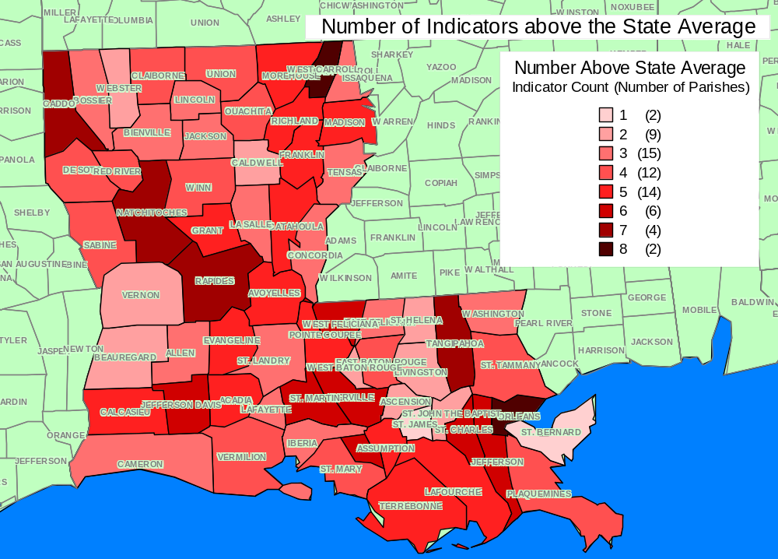

SEW Policy Statement
Governing Policy of the Louisiana State Epidemiological Workgroup
Strategic Prevention Framework State Incentive Grant
“The Governor’s Initiative to Build A Healthy Louisiana”
Unanimously Adopted on February 24, 2005
Amended and Unanimously Adopted on December 15, 2005

The following is an outline of membership, roles and responsibilities and procedures that are recommended to govern the Strategic Prevention Framework State Incentive Grant
State Epidemiological Workgroup (SEW).

Membership

- The SEW membership is open to representatives from departments, agencies, universities and other entities with responsibility for collecting, housing, analyzing and reporting data related to drug abuse, including underage drinking, and its consequences.
- The number of active, voting members shall not exceed forty.
- Membership will be determined by the SPF SIG SEW grant requirements and recommendations of the SPF SIG staff.

Members Roles and Responsibilities

- The SEW role is an advisory committee of the SPF SIG Grant advising the Prevention Systems Committee and Drug Policy Board. It shall advise on issues related to the use of data planning and evaluating drug abuse prevention activities.
- Members are responsible to attend all scheduled monthly meeting of the SEW or provide a substitute (proxy). The substitute shall have voting privileges.
- After more than two absences per year the committee will either dismiss or replace the member who has been absent.
- Members, at times, may volunteer or be assigned to subgroups of the SEW to complete time-limited tasks. Participation in these subgroups is essential to the work of SEW. Members may be required to complete these tasks via phone and email correspondence.
- The Chairperson of the SEW shall be the Epidemiological Workgroup Director.
- The Chairperson is responsible for creating the agenda, facilitating the meetings and communicating with the SPF SIG staff.
- Following the sixth meeting of the SEW a process will be recommended to appoint members of the SEW to rotate into the role of the SEW Chairperson.

Procedures

Agenda

- All agenda items shall be generated from recommendations of the SEW membership and the SPF SIG staff.
- The agenda shall be published at least seven workdays before the next scheduled SEW meeting.

Minutes

- Minutes will be taken of all SEW meetings. The minutes will be published to all members of the SEW via email within two weeks of the meeting.

Quorum

- A quorum will be established as 2/3 of the voting members being present.

Voting

- One vote shall be counted representing the membership from each office within the same department, agency, university or entity.
- All recommendations requiring a vote of the SEW will be submitted at least seven workdays prior to the next scheduled meeting of the SEW by the SPF SIG staff to the Chair of the SEW to be added to the agenda.
- In the event that a recommendation requires a vote before the next SEW meeting, the vote on the recommendation will be completed electronically. It will be submitted by email to the membership at least five workdays before the vote is to be completed.
- A proxy may make votes, by email or phone.
- The determination of a recommendation passing will be based on the following guidelines:
  - Governance of the Committee – a simple majority of those present at the SEW meeting for which the recommendation is scheduled for a vote.
  - Drug Policy Board and Prevention Systems Committee Recommendations – 2/3 of the voting members of the SEW.
  - Recommendations to Remove a Member – a simple majority of all SEW voting members.
- Within five workdays following passage of a recommendation to the Drug Policy Board, the Chairperson shall communication the disposition of the recommendation to the Drug Policy Board chair.

Unanimously Adopted December 15, 2005

SEW Chair recommended that formal voting requirements established in the first three months of the SEW’s existence be replaced by less formal reliance on majority votes of members present for the immediate future and that the SEW revisit the decision making process originally considered at a meeting within the next three months. Including that votes may be made by proxy and emergency votes required of the SEW membership before scheduled meetings can be made by email or phone.

References
1. U.S. Department of Health and Human Services. National Institute on Alcohol Abuse and Alcoholism. (2001, January 1). Alcoholism: Getting the Facts (NIH Publication No. 96–4153)[Brochure]. Washington, DC: U.S. Government Printing Office.

2. The National Institute of Alcoholism and Alcohol Abuse (NIAAA) in their
10th Report to Congress on Alcohol and Health (June 2000)

3. CDC. (2006) Measures of Alcohol Consumption and Alcohol–Related Health Effects from Excessive Consumption. http://www.cdc.gov/alcohol/factsheets/general_information.htm

4.OPH (2004) 2004 Louisiana Health Report Card. http://www.oph.dhh.state.la.us/recordsstatistics/statistics/page359e.html?page=557

5. CDC. (2006)Alcohol and Public Health. General Alcohol Information. http://www.cdc.gov/alcohol/factsheets/general_information.htm

6. National Clearinghouse for Alcohol and Drug Information. (1995). Making the Link: Violence, Alcohol & Other Drugs. www.health.org:80/govpubs/ml002/index.htm

7. Substance Abuse and Mental Health Services Administration (SAMHSA) (2006). SEDS. Indicator List. All Drug Indicators. http://www.epidcc.samhsa.gov/default.asp

8. U.S. Census Bureau. (2000 census). State and County Quick Facts. http://quickfacts.census.gov/qfd/states/22000.html

9. American Heart Association/American Stroke Association. (2006) Know the facts, get the stats. http://www.americanheart.org/downloadable/heart/1136904664099KnowFctSht2006.pdf

10. Naimi T, Brewer B, Mokdad A, Serdula M, Denny C, Marks J. (2003) Binge drinking among U.S. adults. JAMA;289:70–5.

11. CDC. (2005) MMWR. Surveillance for Certain Health Behaviors Among States and Selected Local Areas --- Behavioral Risk Factor Surveillance System, United States, 2003. 54(SS08);1-116

12. Substance Abuse and Mental Health Services Administration, Center for Substance Abuse Prevention. The State and Territorial Guide to Substance Abuse Prevention in Declared Disasters. DHHS Pub. No. (SMA) 97-3123; Rockville, MD: Center for Substance Abuse Prevention, 1997.

