
July 2 2007

Nurse director continues commitment to excellence
By Camille Sealy, Student Intern
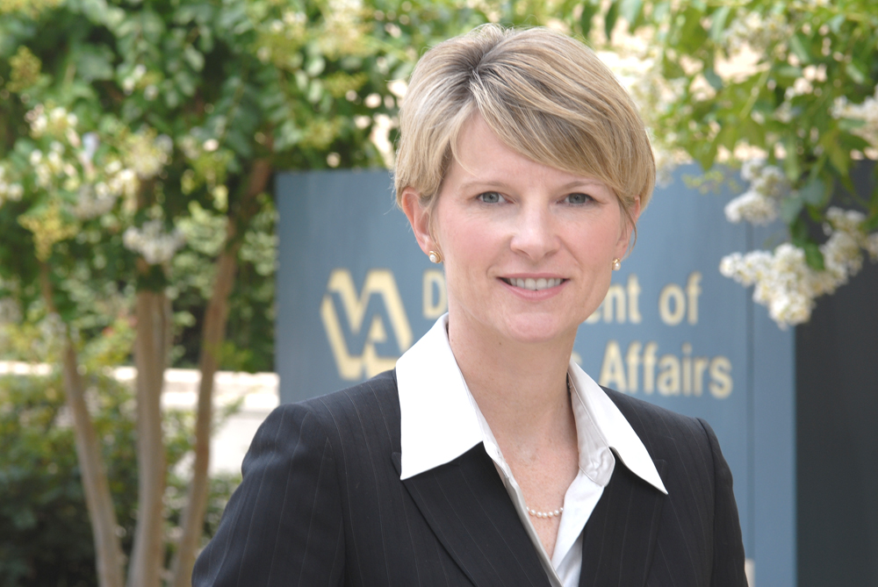

As one of 40 nurses selected worldwide to participate in the 25th annual Wharton Fellows Program in Management for Nurse Executives – a partnership between Johnson & Johnson Inc. and the Wharton School of Business at the University of Pennsylvania – Sandy Leake, MSN, RN demonstrates the drive, passion and sharpness, which have won her several noteworthy accolades and characterized her 14-year tenure at the Atlanta VA Medical Center.
Born in a small northwest town in Tennessee called Tiptonville, Leake’s journey toward a career at the VA was relatively linear. At a young age, Leake exhibited a sincere passion for both the life sciences and helping others. Thus, a career in nursing allowed her the dual privilege of learning applied science as well as effectively serving others. Upon completion of her associate’s degree, Leake obtained a BSN from the University of Memphis and a MSN from Vanderbilt.
See Leake on page 2

See Parking on page 2

News Briefs

The Accident Review Board is sponsoring a Slip, Trip and Falls Prevention Campaign. Our goal is to significantly reduce slip, trip and fall mishaps inside or outside the medical center. As part of the campaign, we are also sponsoring a “Best” slogan competition. Your task; simply be creative and submit a relevant, clear, and easily understood phrase, clause or slogan that can be used to heighten campaign awareness. The best slogan contest is available to VA employees. The winner will receive a $50.00 cash award. Submissions can be sent electronically via outlook or vista to Kenneth Miller, Joe Jenkins or Vernon Green. Submissions can also be mailed (Intra-Office) to mail stop 137 Safety, Room GC100, addressed to one of the individuals listed. All submissions must reach the Safety Office no later than Monday, July 16, 2007. The prize will be awarded July 27, 2007. Please consider participating in this very worthwhile endeavor.

The Federal Ballpark Estimate—a savings goal worksheet—is now available on the OPM web site. The Federal Ballpark Estimate allows users to automatically calculate estimates of future Civil Service Retirement System (CSRS) or Federal Employees Retirement System (FERS) retirement benefits and Thrift Savings Plan account balances. It will also let you know how well you are doing in meeting your savings goal. The Federal Ballpark Estimate was developed in partnership with the American Savings Education Council of the Employee Benefits Research Institute. The Federal Ballpark Estimate is at:
http://www.opm.gov/benefits/ballpark/menu.asp

Leave Donor program - The following employees have been approved for the leave donor program:
Pough, Michelle/ Primary Care
Sheldon, Dean/ Surgical & Perioperative

Defensive Driving Class-July 20, 2007 from 8 a.m. – 4 p.m. Pete Wheeler Auditorium. Any employee can take the class, but priority seating will be given to those who regularly drive a government vehicle. If you wish to attend, please contact Vernon Green, ext. 3435 via Outlook (preferred) or VISTA. Please include your name, extension number and whether you drive a government vehicle. Class is expected to last all day.

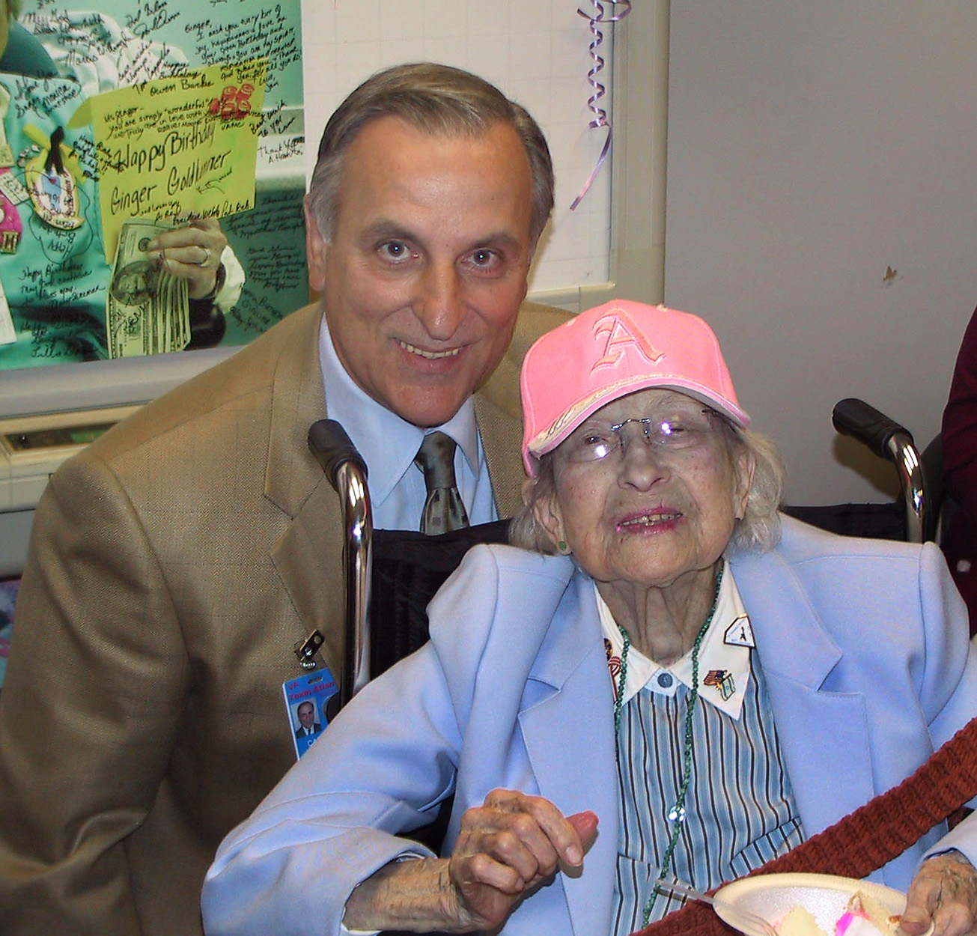
Sandy Leake, MSN, RN, associate director of nursing and patient care services.

Leake from page 1

She then began work at the Gainesville VA Medical Center. After three and half years she transferred to the Atlanta VA where she has served since 1993.
In an effort to expand her knowledge of business processes and financial strategies, Leake applied and was accepted to the prestigious Johnson & Johnson Nurse Executive Program at Wharton School of Business. Although the 3-week program takes place in June, the participants are required to complete readings and training modules during the preceding months.
Stated mildly, the executive program is undeniably rigorous. Leake explains the intensity of the program, “On average, we worked 14 hours a day, 6 days a week; 12-hour days were an exception!” Additionally, reading and group assignments were expected to be completed during the participant’s own time.
Leake was part of an international cohort of

hospital leaders including nurses from Australia, Brazil, Japan and Canada.
In addition to geographic diversity, the nurses were also representative of varied health systems. Leake states, “Some nurses came from small rural hospitals, others came from huge multi-level facilities like Mt. Sinai in Manhattan” with departmental operating budgets comparable to small hospital-wide budgets.
Leake further describes the program, “The fellowship is a network of educational opportunity. It concentrates on immersion in finance, strategy and leadership around the context of healthcare.”
When asked how the fellowship will contribute to her continued success at the Atlanta VA Medical Center, Leake responded, “I gain tremendous satisfaction from serving veterans; and this program sharpened my focus on financial aspects and strategies which will allow me to provide a stronger clinical management voice at the executive table.”

Lawrenceville nurse races to rescue victim from car accident
Burrell Whittaker stands outside his office.

Performing great deeds is nothing new for the men and women who work at the Atlanta VAMC. Burrell Whittaker, who works at the Lawrenceville outpatient clinic, is just the latest example.
Recently, while driving to work, Whittaker observed an accident involving a vehicle and motorcycle.

The driver of the vehicle struck the motorcyclist, knocking him off his bike and up in the air.
The motorcyclist ended up underneath Whittaker’s car. Whittaker, a Licensed Practical Nurse for ten years, immediately went into action and rushed out of his car and began administering first aid while calling 911.
Mr. Whittaker was able to stop a majority of the bleeding and stayed with the motorcyclist until Emergency Medical Services arrived. Thanks to the heroic acts of Whittaker, the cyclist survived the accident.
“I didn’t think about any danger. I just reacted and did what needed to be done,” Whittaker explained.
The native of Chicago served ten years in the Army as a Medical Paratrooper and earned the Expert Field Medical Badge.
The EFMB is issued to soldiers who attain a high degree of professional skill and proficiency as a combat field medic. “I contribute a lot of my experience to the military training I received,” Whittaker stated.
Mr. Whittaker resides in the Lawrenceville area with his wife of twenty years, Carmen, and his three sons.



