
F
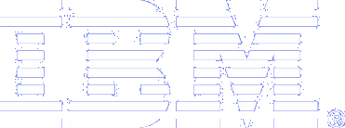

LAAS Benefits Analysis

Preliminary Findings
Update to LAAS Efficiency Benefits

June 2004

Table of Contents

Introduction - 3 -
Summary of Changes from February 2004 Preliminary Findings - 4 -
Stakeholder Validation - 6 -
Important Considerations for Interpreting Results - 9 -
Efficiency Benefits - 12 -
Summary of Efficiency Benefits - 12 -
Reduced Disruptions for Straight-in Precision Approaches - 25 -
Reduced Disruptions with LAAS Takeoff Guidance - 31 -
Benefits from LAAS-based Complex Procedures - 33 -
Benefits Due to Elimination of ILS Critical Areas - 36 -
Benefits for Closely Spaced Parallel Approaches - 40 -
Safety Benefits - 44 -
Societal Benefits - 45 -
Appendices - 46 -
Appendix A: Airports Included in this Study - 46 -
Appendix B: Order of Installation of LAAS Ground Facilities - 49 -
Appendix C: Derivation of Disruption Costs - 52 -
Appendix D: Sensitivity Analyses - 55 -
Appendix E: Derivation of the Single Airport Delay Model - 59 -
Appendix F: Navigation Capabilities Baseline - 64 -
Appendix G: Potential LAAS Sites Outside of the 120 Airports - 77 -
Appendix H: Aviation Facilities within 23nm of the 120 Airports - 78 -
Appendix I: LAAS Benefits Analysis Assumptions - 81 -
Appendix J: LAAS Efficiency Benefits by User Group - 83 -
Appendix K: Data Sources - 91 -
Appendix L: List of Acronyms - 92 -
Notes and References - 94 -

Introduction
The Federal Aviation Administration (FAA) is transforming the navigation infrastructure of the national airspace system (NAS), from a ground-based to a Global Positioning System (GPS)-based architecture. Part of this transformation entails the acquisition of augmentation systems to improve the accuracy, reliability, and integrity of the GPS signals. The Local Area Augmentation System (LAAS) is one of these systems, specifically designed to support aircraft operations in the terminal, approach, surface, and departure operational domains.

The FAA contracted with IBM Business Consulting Services to provide an independent analysis that estimates the benefits attributable to LAAS beyond those provided by existing and planned navigation services. These benefits are estimated over a 20 year period (2009-2028), at 120 selected airports, and for five distinct user groups; major and regional passenger airlines, cargo carriers, corporate jet operators, and general aviation (GA) operators in Alaska. This analysis serves as an update of previous studies as well as a more comprehensive and detailed evaluation of contributions that can be expected from LAAS. The analysis is based on independent research, and is supported by inputs solicited from both service providers and airline industry stakeholders, including validation of methodology, data, and output. The results of this analysis will be used to support the FAA, the airlines, and other stakeholders in their procurement and implementation decisions related to LAAS.

The first stage of the benefits analysis, completed in November 2003, involved the establishment of the navigation capabilities baseline against which all LAAS benefits would be measured. The second stage, completed in December 2003, entailed determining the incremental capabilities provided by LAAS, above and beyond this baseline. In February 2004, IBM delivered a Preliminary Findings report, which described a series of analyses conducted to estimate the monetized incremental benefits that can be expected from implementation of LAAS, relative to the baseline. The current document updates the preliminary findings related to efficiency benefits. Subsequent deliverables will update the safety and societal benefits results. A final report encompassing all of the benefits will be published in October 2004.

Structure of this Paper
This document provides an update to the preliminary findings for efficiency benefits. This update is based on feedback received from a wide variety of reviewers of the preliminary findings document, delivered February 25, 2004. Feedback consisted of written comments, as well as interviews and site visits with stakeholders in the FAA and the aviation industry.

The updated efficiency benefits sections of this paper describe in detail some of the principal capabilities of LAAS and give specific estimates of quantified benefits expected from the implementation of LAAS.

Summary of Changes from February 2004 Preliminary Findings

The following list highlights a number of important changes and refinements made to the LAAS efficiency benefits estimates since the Preliminary Findings were delivered on February 25, 2004.

- Reviews and Validation with Stakeholders
  - Incorporated, as fully as possible, comments received from reviewers of the February 2004 Preliminary Findings
  - Reviewed and validated the methodology and inputs with FAA and industry representatives, including:
    - Five airports and five airlines
      - MEM and FedEx
      - SEA and Alaska Airlines
        - also Horizon Airlines and Boeing
      - BDL and Southwest Airlines
      - EWR and Continental Airlines
      - ORD and United Airlines

- General
  - Included unscheduled IFR and VFR traffic in air traffic inputs to the Single Airport Delay Model
    - This change significantly affects the Take-off Guidance, Parallel Approach, and ILS Critical Area benefit estimates
  - Incorporated FAA’s 2004 Terminal Area Forecast traffic growth rates
  - Included an estimate of downstream effects of disruptions
  - Refined estimates of disruption costs
  - Included a listing of aviation facilities within 23nm of each of the 120 candidate LAAS airports

- Sensitivity Analyses Conducted to Evaluate Effects of Input Data Changes on Overall Benefits
  - Disruption cost
  - Minimum required avionics equipage
  - LAAS equipage timing

- Straight-in Approach Benefits
  - Limited runway use to appropriate aircraft types
  - Refined the runway usage estimates by assigning the majority of traffic to a primary runway
  - Included VFR traffic in the demand/capacity ratio calculation

- Take-off Guidance Benefits
  - Extended the upper bound of low visibility conditions up to 1600 RVR
  - Weighted the results by probability of occurrence of low visibility conditions
  - Refined the results by incorporating HUD equipage and assigning LAAS ½ credit for the benefits

- Complex Procedure Benefits
  - Refined the attribution of benefit to RNAV/RNP
  - Limited benefit accrual to arrival runways without an ILS
  - Limited most benefit accrual to the second half of the 20-year benefit period

- ILS Critical Area Benefits
  - Extended analysis of airborne benefit (reduced longitudinal spacing) to nine airports
  - Added taxi-in and taxi-out benefit estimate

- Parallel Approach Benefits
  - Extended the analysis to eleven candidate airports
  - Allocated ½ of the benefit to LAAS (½ of benefit given to required enabling technologies)

- Additional appendices included at the request of reviewers
  - NAS and User Baselines (from IBM November 2003 deliverable)
    - NAS baseline systems
    - System capabilities
    - User baseline

Stakeholder Validation

An important activity between the time of the delivery of the February 2004 Preliminary Findings and this update was the validation of both the methodology and specific key inputs with a wide range of service provider and industry stakeholders. Feedback was obtained from written comments provided by reviewers, from conference calls with principal stakeholder groups, and from site visits to five key airports and airlines. The purpose of these stakeholder validation meetings was to communicate IBM’s preliminary findings, to gain a better understanding of current and expected air traffic operations from a variety of viewpoints, and to explore how LAAS may provide additional benefit to such operations.

Data gathered during these visits was used to either validate or correct the methodology, the mathematical formulas, and specific critical inputs that IBM is currently using to quantify the incremental benefits of LAAS.

The IBM team wishes to thank the following organizations and individuals for providing their insights, constructive criticism, and valuable comments on our LAAS benefits analysis work. Appearance on this list is an indication that each individual was afforded an opportunity to comment on IBM’s benefits analysis approach; it does not imply agreement with IBM’s approach.

An asterisk (*) denotes a primary Point of Contact for each organization.

Airport and Airline Site Visits

Visit Date | Organization | Contact | Position
02-Feb-2004 | Federal Express | Cole, Ray | Aircraft Standards Engineer
02-Feb-2004 | Federal Express | Murdoch, Joel | *Manager, Strategic Projects
02-Feb-2004 | Federal Express | Vail, Steve | Senior Manager of Global Air Traffic
03-Feb-2004 | Shelby County Airport Authority | White, Walter | *Director of Operations and Public Safety
03-Feb-2004 | FAA | Wertz, Bill | *MEM ATCT Manager
05-May-2004 | Boeing | Ackland, John | *Senior Technical Fellow – Airplane Systems
05-May-2004 | Boeing | Alcabin, Monica | Principal Engineer
05-May-2004 | Boeing | Malsom, Don | Associate Director Business Development – Air Traffic Management
05-May-2004 | Boeing | Michael, Bob | Product Manager  Marketing & Business Strategy
05-May-2004 | Boeing | Siegmund, Paul | Program Manager, Regulatory Affairs
05-May-2004 | Boeing | Sipe, Alan | --
05-May-2004 | Boeing | Tuttle, Tim | Program Manager,  Product Development
05-May-2004 | FAA | Beckerdite, Ron | *SEA TRACON Facility Manager
05-May-2004 | Seattle Tacoma Airport | Kukillis, Rob | *SEA Operations Development Manager, Airfield
05-May-2004 | FAA | Vernon, Kathryn | *SEA ATCT Facility Manager
06-May-2004 | Alaska Airlines | Dalton, Sarah | * Director of Flight Operations
06-May-2004 | Horizon Airlines | Solmonson, Perry | *Manager Flight Operations Technical
17-May-2004 | BDL | Tebbetts, Rollin | BDL Ops Manager
17-May-2004 | FAA | Bellabona, Joseph | Regional SR Ops Research Spc/ANE 520.6
17-May-2004 | FAA | Fiske, Gary | *BDL Tower/TRACON
17-May-2004 | FAA | Guiod, Mark | BDL Air Traffic Manager
17-May-2004 | FAA | Hall, David L | Flight Standards – NE Region
19-May-2004 | FAA | Gross, Stu | EWR ATC
19-May-2004 | FAA | Jenny, Al | EWR ATC Manager
19-May-2004 | FAA | Sangs, Larry | EWR ATC
19-May-2004 | FAA | Wagner, Mike | *EWR ATC
20-May-2004 | FAA | Kalpaxis, Timon | NATCA N90
20-May-2004 | FAA | Moss, Patti | *N90 Airspace
20-May-2004 | NY,NJ Port Authority | Gatto, Ralph | *Senior Airport Engineer
03-Jun-2004 | City of Chicago, Dept of Aviation | Foggia, John | Consultant
03-Jun-2004 | City of Chicago, Dept of Aviation | Santos, Joe | *Executive Assistant
03-Jun-2004 | City of Chicago, Dept of Aviation | Bierbrodt, Jeffery | Consultant
08-Jun-2004 | United Airlines | Bass, Jim | Manager, Capacity Enhancement
08-Jun-2004 | United Airlines | Burns, Joe | Director, Flight Standards and Technology
08-Jun-2004 | United Airlines | Haynes, Brian | Manager, Flight Operations Technology
08-Jun-2004 | United Airlines | Holford, Tom | Manager, Navigation Upgrades
08-Jun-2004 | United Airlines | Stone, Rocky | *Manager, Flight Systems Technology
17-Jun-2004 | Continental Airlines | Vaughn, Bill | *Manager Advanced Navigation
21-Jun-2004 | Southwest Airlines | Crum, Greg | Vice President Flight Operations and Chief Pilot
21-Jun-2004 | Southwest Airlines | Edens, Dave | Chief Pilot
21-Jun-2004 | Southwest Airlines | Gleason, Brian | * Director, Flight Operations Technical
21-Jun-2004 | Southwest Airlines | Haynes, Rob | Regional Chief Pilot
21-Jun-2004 | Southwest Airlines | Humphrey, Stan D. | Pilot
21-Jun-2004 | Southwest Airlines | Johns, Frank | Air Traffic Coordinator
21-Jun-2004 | Southwest Airlines | Mills, Phil | Air Traffic Coordinator
21-Jun-2004 | Southwest Airlines | Stephens, Jon | Senior Financial Planning Analyst
21-Jun-2004 | Southwest Airlines | Ward, Edward T. | Manager, Navigation Data
21-Jun-2004 | Southwest Airlines | Wiecek, Kevin | Flight Operations Engineer

Federal Aviation Administration (FAA)
The following individuals from the FAA, listed in alphabetical order by organization, provided feedback to the February 2004 Preliminary Findings:

Organization | Contact | Position
FAA, AFS-430 | Jarvis, Ed | Flight Standards
FAA, AIR-130 | Abduselam, Hamza | Certification
FAA, AIR-130 | DeCleene, Bruce | Certification
FAA, ATO-R | MacNeill, Ken | AT Requirements
FAA, ATO-W | Peterson, Dave | OIT Team Lead
FAA, ATO-W | Bell, Hal | WAAS PT Lead
FAA, ATO-W/AMTI | Noto, John | WAAS Task Lead
FAA, ATO-W/ESC/ARINC | Packard, Richard | JPALS Liaison
FAA, ATO-W/ISI | Lay, Richard | LAAS System Engineer

MITRE/CAASD
The following individuals from MITRE/CAASD, listed in alphabetical order by last name, provided subject matter expertise, tools, data and valuable feedback to the February 2004 Preliminary Findings:

Organization | Contact | Position
MITRE/CAASD | Barrer, John | Lead Engineer
MITRE/CAASD | Markin, Kelly | Program Manager
MITRE/CAASD | Massimini, Vince | Senior Principal Engineer
MITRE/CAASD | Scales, Walt | Project Team Manager
MITRE/CAASD | Swedish, William | Principal Engineer

Preliminary Findings Conference Call with Major Airline Representatives, 15-April-2004
The following individuals, listed in alphabetical order by organization, participated in a discussion of the February 2004 Preliminary Findings:

Organization | Contact | Position
Alaska Airlines | Dalton, Sarah | Director of Flight Operations
American Trans Air | Enias, James | Technical Pilot
Boeing | Ackland, John | Senior Technical Fellow Airline System
Continental Airlines | Vaughn, Bill | Captain, Flight Technical
Delta Airlines | Speir, Ken | Fleet Technical Pilot
Federal Express | Murdock, Joel | Manager, Strategic Projects
Honeywell | Hoodspith, Mike | Manager, Satellite Landing Systems, Commercial Products, Asia, Latin America & Western U.S.
Horizon Airlines | Bush, Steve | Flight Ops Technical
JetBlue Airways | Somerville, Donald | Captain, GPS/RNAV Subject Matter Specialist
Northwest Airlines | Alexander, Frank | Chief Pilot Technical Programs
United Airlines | Stone, Rocky | Manager of Flight Systems Technology
United Parcel Service | Hilb, Bob | Manager of Advanced Flight Systems

GBAS FAA-Europe Coordination Meeting, April-27 to 29, 2004
The following participants provided a review of the IBM February 2004 Preliminary Findings:

Organization | Contact | Position
EUROCONTROL | Grand-Perret, Sylvie | *Expert – Navigation
SKYGUIDE | Berz, Gerhard | *System Engineer, Satellite Navigation
SOFREAVIA | De La Burgade, Olivier | Consulting Division, Project Manager

Important Considerations for Interpreting Results

This section describes several important points about the estimates of LAAS benefits in this study. The points presented below are described here to highlight their importance and to foster discussion of their treatment in this study. IBM welcomes discussion of these, and any other issues, that may impact the benefits estimates.

- Estimates of the cost of flight disruptions are central to this study. IBM has worked to ensure that the most credible and applicable estimates are used here, and has validated these estimates with industry stakeholders. However, there is substantial uncertainty inherent in any estimate of such complex events. Changes to these key cost inputs, particularly unforeseen systematic changes over time, could significantly alter these LAAS benefits estimates. The cost of disruptions is included in the sensitivity study in this update to the efficiency benefits.

- Estimates of traffic increases over the 20 year period are central to this study. While IBM has worked to ensure that the most credible and applicable estimates are used here, there is substantial uncertainty in any forecast covering such a long time period. As a consequence, this study shares the forecast risks identified in the FAA’s 2004 Terminal Area Forecast documentation. Changes to the forecasts, whether due to unforeseen economic events, world political events, or airline industry structural changes, could significantly alter the basis on which these LAAS benefits are founded.

- Flight disruptions of the kind studied here are not isolated events. In general, a single flight disruption may have an impact on other flight operations. This connection between disruptions can be accounted for either by formally modeling the network effects that link flight operations, or by adding a factor for “downstream” effects.
  - Network effects are not included in these preliminary findings. That is, the impact of a reduced rate of operations at one airport is viewed in these analyses as independent from the operations at other airports. In reality, a weather-related disruption at one airport, particularly an airline’s hub, can have substantial detrimental effects throughout that airline’s network.
  - In this update to the preliminary findings, downstream effects of a flight disruption are accounted for through a factor of 1.5 times the initial disruption. The specific value chosen for this factor has a substantial impact on total benefits. The estimate used here is based on published research and FAA guidance on the downstream effects of delays, the single most common form of disruption. The assumed factor of 1.5 is near the low end of the range of published downstream delay factors, which range from 1.0 to over 7, depending on the magnitude of the original delay and the time of day at which it occurs. Additionally, we recognize that a single factor may not apply to all user groups. Due to the relative importance of this factor, and the uncertainty surrounding its proper value, the final report will include downstream effects in the sensitivity analysis.

- Based on assumptions, like IOC dates, the ground facility installation schedule, avionics equipage rates, and minimum required avionics equipage, benefits accrual at each airport takes place over a subset of the full 20 year period. For this reason total numbers in this report cannot be divided by 20 to obtain average annual benefits.

- The pace of development and certification of procedures, both for LAAS and for other advanced systems in the Baseline (e.g., those with few currently existing procedures, like LPV) will be a key driver of benefits. At the beginning of this analysis, IBM and the FAA made the simplifying assumption that procedures would be available within four months of each system’s IOC. This assumption allows benefits to be calculated without the added complexity of considering procedure development schedules. However, this assumption also represents a real and potentially significant source of uncertainty in the benefits estimates in this study.

- Delay in the development and fielding of LAAS could cause significant changes to the benefit estimates. This is a particular concern with regard to LAAS Cat II/III capability, which is currently assumed, in this study, to be available beginning in 2013. Any delay to this start date without an associated extension of the end of the benefit study period is likely to have a significant negative impact on LAAS benefit estimates.

- The pace and extent of LAAS equipage among airlines will be a key driver for LAAS benefits. In this report, IBM has assumed a certain rate of equipage, based on feedback received from airline operations representatives. If the actual rate of equipage is either faster or slower than assumed, benefits due to LAAS may be significantly impacted. Similarly, if the extent of LAAS equipage differs substantially from that assumed, benefits due to LAAS may be significantly impacted. The rate of LAAS equipage is included in the sensitivity analysis in this update to the efficiency benefits.

- LAAS benefits may not accrue until a substantial proportion of the user base is equipped. The introduction of any new technology such as LAAS into a system as complex as the NAS may not yield benefits proportional to either the number of ground systems or avionics installed. Due to the difficulties of providing air traffic control services to aircraft equipped with a mix of capabilities, some benefits of LAAS may not be achieved until a large proportion of the aircraft serving a particular airport are LAAS-equipped. For example, the elimination of ILS critical areas may not be possible while a fraction of arriving aircraft still require protection of the ILS signal for precision approach in IMC. Other LAAS capabilities, such as support of low RNP procedures in the terminal area may not be as affected by this issue. The minimum level of LAAS equipage for benefit accrual is included in the sensitivity analysis in this update to the efficiency benefits.

- Current guidance from FAA suggests that LAAS approaches will use the ILS TERPS surfaces. While this may be necessary for the initial transition from ILS to LAAS-based approaches, it may also limit the benefit to be gained. Precision approaches using TERPS surfaces designed specifically for LAAS may result in lower approach minima than are currently permitted when ILS surfaces are used.

- Changes to the assumed rate of installation of LAAS ground facilities will have a substantial impact on estimated LAAS benefits. At the assumed 24 installations per year rate, all 120 airports in this study can have a LAAS installed within five years of IOC. If the actual rate of installation is reduced, then the onset of benefit accumulation will be delayed for many airports, with an associated reduction in overall benefits for the 20 year period.

- Benefits of LAAS-based complex approaches are constrained by the existence of other avionics and ground systems that provide similar capability. However, this does not take into account some advantages of LAAS that may prove operationally valuable, such as the ability of LAAS to improve the availability of actual navigation perfomance (in order to meet RNP) or the simplicity of using LAAS as a single system for terminal area navigation through precision approach and landing.

Efficiency Benefits

Summary of Efficiency Benefits

Table 1 shows the total 20 year discounted efficiency benefits estimated for all 120 airports. Tables A, B, and C show the best estimate, 5th and 95th percentiles, respectively. The percentiles are obtained through the sensitivity analysis which evaluates the impact on benefits of the variability in three key input parameters: cost of disruptions, pace of LAAS equipage, and minimum required equipage for benefit accrual. See Appendix D for details of the sensitivity analysis. Further tables in this paper report only the best estimate values.

Benefits are shown for both reduced direct operating costs and passenger time savings. These are reported separately here and in subsequent tables so that readers can easily distinguish the magnitude of benefits accruing to these two distinct stakeholder groups.

User decisions regarding WAAS avionics equipage are a key element in estimating LAAS benefits. In order to place bounds on this element for the preliminary findings, IBM agreed to state LAAS benefits for two extreme cases: no WAAS equipage by any users, and full WAAS equipage by all users. While neither of these two cases is likely to be realistic, together, they provide an upper and lower bound for LAAS benefits relative to WAAS equipage. Thus, in Table 1 and subsequent tables in this paper, benefits are shown for the two alternative cases of user equipage with WAAS: assuming no WAAS equipage by users (“0% WAAS”), and assuming full WAAS equipage by users (“100% WAAS”).

Table 1a: Discounted 20 year LAAS Efficiency Benefits – Best Estimate
 | Direct Operating Cost | Passenger Time Savings
LAAS Benefits  (Assuming 0% WAAS equipage) | $997,000,000 | $994,500,000
LAAS Benefits  (Assuming 100% WAAS equipage) | $680,200,000 | $663,800,000

Table 1b: Discounted 20 year LAAS Efficiency Benefits – 5th Percentile
 | Direct Operating Cost | Passenger Time Savings
LAAS Benefits  (Assuming 0% WAAS equipage) | $971,000,000 | $981,600,000
LAAS Benefits  (Assuming 100% WAAS equipage) | $649,600,000 | $643,000,000

Table 1c: Discounted 20 year LAAS Efficiency Benefits – 95th Percentile
 | Direct Operating Cost | Passenger Time Savings
LAAS Benefits  (Assuming 0% WAAS equipage) | $1,107,800,000 | $1,118,200,000
LAAS Benefits  (Assuming 100% WAAS equipage) | $765,200,000 | $754,500,000
Table 2 shows the total 20 year discounted efficiency benefits by user group. Table 2A lists direct operating cost benefits, and Table 2B lists passenger time savings. Further details of benefits by user group, listed by airport, are in Appendix J.

Benefits by User Group
Table 2a: Discounted 20 year LAAS Operating Cost Efficiency Benefits – by User Group
 | Major Passenger Airlines | Regional Passenger Airlines | Cargo Carriers | Corporate Jet GA Operators | Other GA Operators
LAAS Benefits  (Assuming 0% WAAS equipage) | $687,000,000 | $182,600,000 | $45,000,000 | $77,300,000 | $5,100,000
LAAS Benefits  (Assuming 100% WAAS equipage) | $481,800,000 | $116,200,000 | $29,600,000 | $51,800,000 | $700,000

Table 2b: Discounted 20 year LAAS Passenger Time Savings Efficiency Benefits – by User Group
 | Major Passenger Airlines | Regional Passenger Airlines | Cargo Carriers | Corporate Jet GA Operators | Other GA Operators
LAAS Benefits  (Assuming 0% WAAS equipage) | $612,900,000 | $365,400,000 | $0 | $14,500,000 | $1,700,000
LAAS Benefits  (Assuming 100% WAAS equipage) | $415,300,000 | $238,400,000 | $0 | $9,900,000 | $200,000

Benefits by Efficiency Benefit Categories and by Airport
The LAAS efficiency benefits estimated in this report are attributable to each of the five quantified efficiency benefit categories:
- Straight-in Approaches
- Takeoff Guidance
- Complex Procedures
- ILS Critical Area Elimination
- Parallel Approaches

The pie charts in Figure 1 show the proportion of benefit attributable to each of the five quantified efficiency benefit categories, for the best estimate, as summarized in Table 1A. Tables 3 and 4 list these benefits for each of the120 airports.

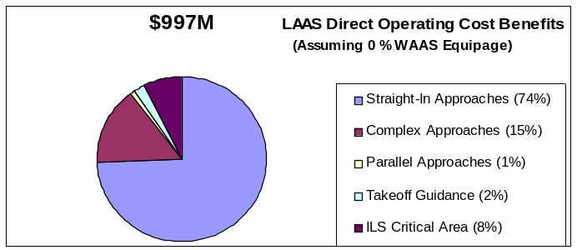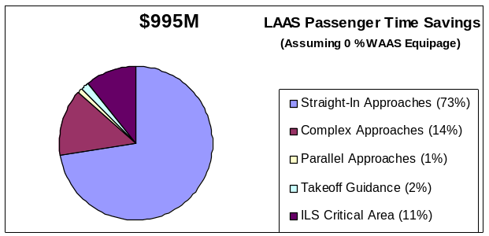

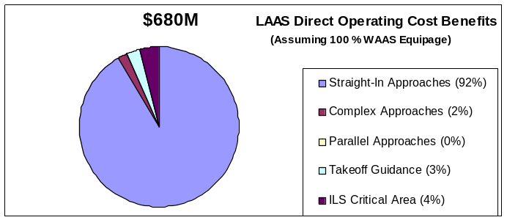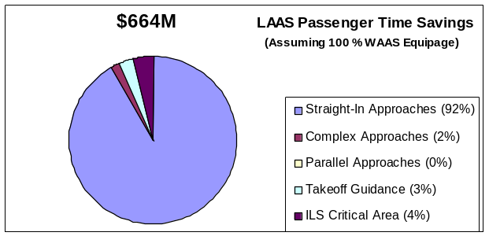

Figure 1. proportion of the Discounted 20 year LAAS Best Estimate Benefits Attributable to each of the Five Quantified Efficiency Benefit Categories

Estimated LAAS Benefits Assuming No User Equipage with WAAS

Tables 3A and 3B show the 20 year discounted efficiency benefits, by airport, for the scenario in which users do not equip with WAAS. These values provide the upper bound of estimated LAAS benefits relative to WAAS equipage by users. User operating cost benefits are shown in Table 3A, and passenger time savings are shown in Table 3B. Each airport’s rank in terms of total benefit is shown in the third column. In addition to total benefit at each airport, the contribution to the total from each separate efficiency benefit category is shown.

Table 3a: Discounted 20 year LAAS operating cost Benefits – 0% waas equipage scenario, by Airport
Airport | Total Benefit | Rank by Total Benefit | Straight-In Approach | Takeoff Guidance | Complex Approach | ILS Critical Area | Parallel Approach
ABQ | $1,915,000 | 87 | $1,824,000 | $91,000 | $0 | $0 | $0
ACK | $15,486,000 | 19 | $15,486,000 | $0 | $0 | $0 | $0
AFW | $188,000 | 114 | $188,000 | $0 | $0 | $0 | $0
ALB | $9,665,000 | 34 | $4,998,000 | $470,000 | $4,197,000 | $0 | $0
ANC | $9,342,000 | 36 | $9,342,000 | $0 | $0 | $0 | $0
ATL | $38,082,000 | 4 | $30,703,000 | $0 | $0 | $7,379,000 | $0
AUS | $5,116,000 | 58 | $5,116,000 | $0 | $0 | $0 | $0
AVL | $2,537,000 | 82 | $2,310,000 | $227,000 | $0 | $0 | $0
BDL | $15,778,000 | 18 | $6,325,000 | $0 | $9,453,000 | $0 | $0
BFI | $747,000 | 103 | $541,000 | $206,000 | $0 | $0 | $0
BGR | $1,153,000 | 95 | $1,153,000 | $0 | $0 | $0 | $0
BHM | $7,841,000 | 43 | $1,292,000 | $0 | $6,549,000 | $0 | $0
BNA | $3,069,000 | 74 | $3,069,000 | $0 | $0 | $0 | $0
BOI | $4,930,000 | 60 | $4,930,000 | $0 | $0 | $0 | $0
BOS | $13,169,000 | 22 | $13,169,000 | $0 | $0 | $0 | $0
BUF | $6,461,000 | 51 | $6,451,000 | $10,000 | $0 | $0 | $0
BUR | $39,750,000 | 2 | $6,476,000 | $127,000 | $33,147,000 | $0 | $0
BWI | $7,208,000 | 47 | $7,208,000 | $0 | $0 | $0 | $0
CAE | $2,068,000 | 86 | $2,068,000 | $0 | $0 | $0 | $0
CHA | $685,000 | 106 | $685,000 | $0 | $0 | $0 | $0
CHS | $4,906,000 | 61 | $4,906,000 | $0 | $0 | $0 | $0
CLE | $18,589,000 | 14 | $18,589,000 | $0 | $0 | $0 | $0
CLT | $17,696,000 | 15 | $17,696,000 | $0 | $0 | $0 | $0
CMH | $4,608,000 | 65 | $4,292,000 | $316,000 | $0 | $0 | $0
COS | $9,273,000 | 37 | $8,491,000 | $782,000 | $0 | $0 | $0
CVG | $37,931,000 | 5 | $10,603,000 | $0 | $0 | $27,328,000 | $0
DAB | $872,000 | 101 | $723,000 | $149,000 | $0 | $0 | $0
DAL | $4,408,000 | 68 | $3,532,000 | $876,000 | $0 | $0 | $0
DAY | $2,905,000 | 76 | $2,797,000 | $0 | $0 | $108,000 | $0
DCA | $30,834,000 | 6 | $4,169,000 | $0 | $26,665,000 | $0 | $0
DEN | $21,234,000 | 12 | $21,234,000 | $0 | $0 | $0 | $0
DFW | $53,557,000 | 1 | $23,874,000 | $0 | $0 | $29,683,000 | $0
DLH | $1,469,000 | 91 | $1,311,000 | $158,000 | $0 | $0 | $0
DSM | $3,004,000 | 75 | $3,004,000 | $0 | $0 | $0 | $0
DTW | $28,120,000 | 8 | $23,149,000 | $0 | $0 | $2,063,000 | $2,908,000
DVT | $8,000 | 120 | $8,000 | $0 | $0 | $0 | $0
ELP | $13,000 | 119 | $0 | $13,000 | $0 | $0 | $0
EUG | $3,886,000 | 70 | $3,368,000 | $518,000 | $0 | $0 | $0
EWR | $12,102,000 | 24 | $12,102,000 | $0 | $0 | $0 | $0
EYW | $99,000 | 117 | $99,000 | $0 | $0 | $0 | $0
FAI | $709,000 | 105 | $709,000 | $0 | $0 | $0 | $0
FAT | $408,000 | 109 | $408,000 | $0 | $0 | $0 | $0
FLL | $2,352,000 | 84 | $2,058,000 | $112,000 | $0 | $0 | $182,000
FWA | $2,581,000 | 81 | $2,562,000 | $19,000 | $0 | $0 | $0
FXE | $105,000 | 116 | $96,000 | $9,000 | $0 | $0 | $0
GEG | $7,226,000 | 46 | $7,226,000 | $0 | $0 | $0 | $0
GRR | $6,266,000 | 52 | $5,790,000 | $476,000 | $0 | $0 | $0
GSO | $11,775,000 | 26 | $11,775,000 | $0 | $0 | $0 | $0
GSP | $1,282,000 | 92 | $1,282,000 | $0 | $0 | $0 | $0
HNL | $4,525,000 | 67 | $46,000 | $0 | $4,479,000 | $0 | $0
HOU | $14,845,000 | 21 | $12,347,000 | $2,498,000 | $0 | $0 | $0
HPN | $7,740,000 | 44 | $4,804,000 | $2,730,000 | $0 | $206,000 | $0
HSV | $390,000 | 110 | $390,000 | $0 | $0 | $0 | $0
IAD | $9,237,000 | 38 | $9,237,000 | $0 | $0 | $0 | $0
IAH | $19,545,000 | 13 | $18,608,000 | $0 | $0 | $937,000 | $0
ICT | $5,343,000 | 56 | $5,343,000 | $0 | $0 | $0 | $0
ILN | $2,904,000 | 77 | $2,904,000 | $0 | $0 | $0 | $0
IND | $3,413,000 | 71 | $3,413,000 | $0 | $0 | $0 | $0
JAN | $732,000 | 104 | $732,000 | $0 | $0 | $0 | $0
JAX | $4,588,000 | 66 | $4,588,000 | $0 | $0 | $0 | $0
JFK | $17,459,000 | 16 | $17,234,000 | $0 | $0 | $0 | $225,000
JNU | $24,577,000 | 11 | $0 | $52,000 | $24,525,000 | $0 | $0
LAS | $344,000 | 112 | $342,000 | $2,000 | $0 | $0 | $0
LAX | $11,350,000 | 28 | $11,350,000 | $0 | $0 | $0 | $0
LCK | $122,000 | 115 | $122,000 | $0 | $0 | $0 | $0
LGA | $38,375,000 | 3 | $28,538,000 | $0 | $9,837,000 | $0 | $0
LGB | $6,197,000 | 53 | $3,142,000 | $792,000 | $0 | $0 | $2,263,000
LIT | $1,192,000 | 93 | $1,192,000 | $0 | $0 | $0 | $0
MCI | $5,814,000 | 55 | $5,814,000 | $0 | $0 | $0 | $0
MCO | $11,940,000 | 25 | $11,309,000 | $0 | $0 | $631,000 | $0
MDT | $1,030,000 | 98 | $872,000 | $158,000 | $0 | $0 | $0
MDW | $17,152,000 | 17 | $16,209,000 | $943,000 | $0 | $0 | $0
MEM | $9,686,000 | 33 | $7,287,000 | $0 | $0 | $264,000 | $2,135,000
MHT | $11,619,000 | 27 | $11,305,000 | $314,000 | $0 | $0 | $0
MIA | $2,840,000 | 78 | $2,840,000 | $0 | $0 | $0 | $0
MKE | $12,799,000 | 23 | $12,465,000 | $0 | $0 | $176,000 | $158,000
MMU | $235,000 | 113 | $105,000 | $130,000 | $0 | $0 | $0
MSP | $27,667,000 | 9 | $27,667,000 | $0 | $0 | $0 | $0
MSY | $8,376,000 | 41 | $8,376,000 | $0 | $0 | $0 | $0
OAK | $905,000 | 99 | $905,000 | $0 | $0 | $0 | $0
OKC | $8,381,000 | 40 | $8,326,000 | $55,000 | $0 | $0 | $0
OMA | $1,183,000 | 94 | $1,183,000 | $0 | $0 | $0 | $0
ONT | $6,665,000 | 50 | $6,665,000 | $0 | $0 | $0 | $0
ORD | $29,996,000 | 7 | $29,525,000 | $0 | $0 | $471,000 | $0
ORF | $5,926,000 | 54 | $5,347,000 | $474,000 | $0 | $105,000 | $0
PBI | $1,508,000 | 90 | $1,427,000 | $81,000 | $0 | $0 | $0
PDX | $4,134,000 | 69 | $4,086,000 | $0 | $0 | $0 | $48,000
PHL | $11,276,000 | 29 | $10,743,000 | $0 | $0 | $533,000 | $0
PHX | $1,625,000 | 89 | $1,033,000 | $592,000 | $0 | $0 | $0
PIE | $831,000 | 102 | $706,000 | $125,000 | $0 | $0 | $0
PIT | $10,200,000 | 32 | $10,200,000 | $0 | $0 | $0 | $0
PVD | $4,892,000 | 62 | $4,892,000 | $0 | $0 | $0 | $0
RDU | $15,145,000 | 20 | $15,078,000 | $1,000 | $0 | $0 | $66,000
RFD | $899,000 | 100 | $899,000 | $0 | $0 | $0 | $0
RIC | $7,425,000 | 45 | $7,389,000 | $0 | $0 | $36,000 | $0
RNO | $1,073,000 | 96 | $1,040,000 | $33,000 | $0 | $0 | $0
ROC | $5,081,000 | 59 | $2,344,000 | $4,000 | $0 | $2,733,000 | $0
RSW | $7,078,000 | 48 | $5,867,000 | $1,211,000 | $0 | $0 | $0
SAN | $27,315,000 | 10 | $0 | $0 | $27,315,000 | $0 | $0
SAT | $8,588,000 | 39 | $8,478,000 | $110,000 | $0 | $0 | $0
SDF | $439,000 | 108 | $439,000 | $0 | $0 | $0 | $0
SEA | $10,413,000 | 31 | $8,085,000 | $0 | $0 | $2,328,000 | $0
SFB | $366,000 | 111 | $314,000 | $52,000 | $0 | $0 | $0
SFO | $5,194,000 | 57 | $5,194,000 | $0 | $0 | $0 | $0
SHV | $1,818,000 | 88 | $1,818,000 | $0 | $0 | $0 | $0
SJC | $9,481,000 | 35 | $8,615,000 | $866,000 | $0 | $0 | $0
SLC | $4,771,000 | 63 | $3,328,000 | $0 | $0 | $0 | $1,443,000
SMF | $11,168,000 | 30 | $11,168,000 | $0 | $0 | $0 | $0
SNA | $2,379,000 | 83 | $1,027,000 | $1,352,000 | $0 | $0 | $0
STL | $6,931,000 | 49 | $6,929,000 | $2,000 | $0 | $0 | $0
SWF | $644,000 | 107 | $634,000 | $10,000 | $0 | $0 | $0
SYR | $2,123,000 | 85 | $2,122,000 | $1,000 | $0 | $0 | $0
TEB | $7,854,000 | 42 | $1,286,000 | $628,000 | $5,940,000 | $0 | $0
TLH | $4,666,000 | 64 | $4,265,000 | $401,000 | $0 | $0 | $0
TPA | $2,738,000 | 79 | $2,738,000 | $0 | $0 | $0 | $0
TRI | $1,068,000 | 97 | $1,068,000 | $0 | $0 | $0 | $0
TUL | $3,294,000 | 73 | $3,294,000 | $0 | $0 | $0 | $0
TUS | $57,000 | 118 | $53,000 | $4,000 | $0 | $0 | $0
TYS | $2,591,000 | 80 | $2,590,000 | $1,000 | $0 | $0 | $0
VNY | $3,411,000 | 72 | $3,263,000 | $148,000 | $0 | $0 | $0
Total | $996,976,000 |  | $742,131,000 | $18,329,000 | $152,107,000 | $74,981,000 | $9,428,000

Table 3b: Discounted 20 year LAAS Passenger Time savings – 0% waas equipage scenario, by Airport
Airport | Total Benefit | Rank by Total Benefit | Straight-In Approach | Takeoff Guidance | Complex Approach | ILS Critical Area | Parallel Approach
ABQ | $1,733,000 | 86 | $1,617,000 | $116,000 | $0 | $0 | $0
ACK | $26,581,000 | 9 | $26,581,000 | $0 | $0 | $0 | $0
AFW | $8,000 | 117 | $8,000 | $0 | $0 | $0 | $0
ALB | $11,323,000 | 27 | $5,843,000 | $571,000 | $4,909,000 | $0 | $0
ANC | $6,932,000 | 44 | $6,932,000 | $0 | $0 | $0 | $0
ATL | $40,616,000 | 3 | $28,351,000 | $0 | $0 | $12,265,000 | $0
AUS | $3,927,000 | 66 | $3,927,000 | $0 | $0 | $0 | $0
AVL | $2,996,000 | 71 | $2,824,000 | $172,000 | $0 | $0 | $0
BDL | $13,885,000 | 22 | $5,565,000 | $0 | $8,320,000 | $0 | $0
BFI | $167,000 | 110 | $124,000 | $43,000 | $0 | $0 | $0
BGR | $1,523,000 | 88 | $1,523,000 | $0 | $0 | $0 | $0
BHM | $6,197,000 | 51 | $1,025,000 | $0 | $5,172,000 | $0 | $0
BNA | $2,734,000 | 75 | $2,734,000 | $0 | $0 | $0 | $0
BOI | $5,145,000 | 58 | $5,145,000 | $0 | $0 | $0 | $0
BOS | $14,069,000 | 21 | $14,069,000 | $0 | $0 | $0 | $0
BUF | $6,523,000 | 45 | $6,510,000 | $13,000 | $0 | $0 | $0
BUR | $31,454,000 | 5 | $5,072,000 | $162,000 | $26,220,000 | $0 | $0
BWI | $6,407,000 | 47 | $6,407,000 | $0 | $0 | $0 | $0
CAE | $2,264,000 | 83 | $2,264,000 | $0 | $0 | $0 | $0
CHA | $649,000 | 99 | $649,000 | $0 | $0 | $0 | $0
CHS | $5,584,000 | 55 | $5,584,000 | $0 | $0 | $0 | $0
CLE | $21,209,000 | 13 | $21,209,000 | $0 | $0 | $0 | $0
CLT | $16,885,000 | 19 | $16,885,000 | $0 | $0 | $0 | $0
CMH | $4,543,000 | 62 | $4,225,000 | $318,000 | $0 | $0 | $0
COS | $8,635,000 | 35 | $7,698,000 | $937,000 | $0 | $0 | $0
CVG | $46,777,000 | 2 | $13,016,000 | $0 | $0 | $33,761,000 | $0
DAB | $601,000 | 103 | $513,000 | $88,000 | $0 | $0 | $0
DAL | $2,944,000 | 72 | $2,297,000 | $647,000 | $0 | $0 | $0
DAY | $2,774,000 | 74 | $2,666,000 | $0 | $0 | $108,000 | $0
DCA | $29,915,000 | 7 | $4,232,000 | $0 | $25,683,000 | $0 | $0
DEN | $20,503,000 | 14 | $20,503,000 | $0 | $0 | $0 | $0
DFW | $70,062,000 | 1 | $23,078,000 | $0 | $0 | $46,984,000 | $0
DLH | $1,267,000 | 90 | $1,175,000 | $92,000 | $0 | $0 | $0
DSM | $3,319,000 | 69 | $3,319,000 | $0 | $0 | $0 | $0
DTW | $30,025,000 | 6 | $23,161,000 | $0 | $0 | $3,415,000 | $3,449,000
DVT | $1,000 | 118 | $1,000 | $0 | $0 | $0 | $0
ELP | $12,000 | 116 | $0 | $12,000 | $0 | $0 | $0
EUG | $4,928,000 | 59 | $4,530,000 | $398,000 | $0 | $0 | $0
EWR | $11,047,000 | 28 | $11,047,000 | $0 | $0 | $0 | $0
EYW | $161,000 | 111 | $161,000 | $0 | $0 | $0 | $0
FAI | $533,000 | 104 | $533,000 | $0 | $0 | $0 | $0
FAT | $739,000 | 98 | $739,000 | $0 | $0 | $0 | $0
FLL | $2,392,000 | 80 | $2,063,000 | $147,000 | $0 | $0 | $182,000
FWA | $3,057,000 | 70 | $3,051,000 | $6,000 | $0 | $0 | $0
FXE | $19,000 | 115 | $17,000 | $2,000 | $0 | $0 | $0
GEG | $7,058,000 | 40 | $7,058,000 | $0 | $0 | $0 | $0
GRR | $6,426,000 | 46 | $6,096,000 | $330,000 | $0 | $0 | $0
GSO | $11,341,000 | 25 | $11,341,000 | $0 | $0 | $0 | $0
GSP | $1,653,000 | 87 | $1,653,000 | $0 | $0 | $0 | $0
HNL | $6,951,000 | 43 | $67,000 | $0 | $6,884,000 | $0 | $0
HOU | $12,275,000 | 24 | $9,532,000 | $2,743,000 | $0 | $0 | $0
HPN | $5,344,000 | 57 | $3,881,000 | $1,272,000 | $0 | $191,000 | $0
HSV | $356,000 | 105 | $356,000 | $0 | $0 | $0 | $0
IAD | $10,663,000 | 33 | $10,663,000 | $0 | $0 | $0 | $0
IAH | $19,096,000 | 15 | $17,972,000 | $0 | $0 | $1,124,000 | $0
ICT | $3,678,000 | 68 | $3,678,000 | $0 | $0 | $0 | $0
ILN | $0 | 119 | $0 | $0 | $0 | $0 | $0
IND | $2,336,000 | 81 | $2,336,000 | $0 | $0 | $0 | $0
JAN | $633,000 | 101 | $633,000 | $0 | $0 | $0 | $0
JAX | $3,969,000 | 65 | $3,969,000 | $0 | $0 | $0 | $0
JFK | $17,716,000 | 16 | $17,460,000 | $0 | $0 | $0 | $256,000
JNU | $26,198,000 | 11 | $0 | $54,000 | $26,144,000 | $0 | $0
LAS | $268,000 | 107 | $265,000 | $3,000 | $0 | $0 | $0
LAX | $10,770,000 | 31 | $10,770,000 | $0 | $0 | $0 | $0
LCK | $0 | 120 | $0 | $0 | $0 | $0 | $0
LGA | $39,060,000 | 4 | $29,049,000 | $0 | $10,011,000 | $0 | $0
LGB | $3,913,000 | 67 | $1,994,000 | $560,000 | $0 | $0 | $1,359,000
LIT | $817,000 | 97 | $817,000 | $0 | $0 | $0 | $0
MCI | $5,583,000 | 56 | $5,583,000 | $0 | $0 | $0 | $0
MCO | $12,591,000 | 23 | $11,630,000 | $0 | $0 | $961,000 | $0
MDT | $1,067,000 | 93 | $933,000 | $134,000 | $0 | $0 | $0
MDW | $16,446,000 | 20 | $14,865,000 | $1,581,000 | $0 | $0 | $0
MEM | $7,817,000 | 37 | $5,535,000 | $0 | $0 | $209,000 | $2,073,000
MHT | $10,740,000 | 32 | $10,360,000 | $380,000 | $0 | $0 | $0
MIA | $2,546,000 | 79 | $2,546,000 | $0 | $0 | $0 | $0
MKE | $16,891,000 | 18 | $16,550,000 | $0 | $0 | $230,000 | $111,000
MMU | $50,000 | 113 | $19,000 | $31,000 | $0 | $0 | $0
MSP | $26,432,000 | 10 | $26,432,000 | $0 | $0 | $0 | $0
MSY | $6,990,000 | 42 | $6,990,000 | $0 | $0 | $0 | $0
OAK | $638,000 | 100 | $638,000 | $0 | $0 | $0 | $0
OKC | $7,502,000 | 38 | $7,447,000 | $55,000 | $0 | $0 | $0
OMA | $940,000 | 95 | $940,000 | $0 | $0 | $0 | $0
ONT | $4,788,000 | 60 | $4,788,000 | $0 | $0 | $0 | $0
ORD | $28,731,000 | 8 | $27,957,000 | $0 | $0 | $774,000 | $0
ORF | $6,337,000 | 49 | $5,674,000 | $560,000 | $0 | $103,000 | $0
PBI | $1,211,000 | 92 | $1,154,000 | $57,000 | $0 | $0 | $0
PDX | $4,126,000 | 64 | $4,079,000 | $0 | $0 | $0 | $47,000
PHL | $10,813,000 | 30 | $10,021,000 | $0 | $0 | $792,000 | $0
PHX | $1,798,000 | 85 | $900,000 | $898,000 | $0 | $0 | $0
PIE | $259,000 | 108 | $217,000 | $42,000 | $0 | $0 | $0
PIT | $10,830,000 | 29 | $10,830,000 | $0 | $0 | $0 | $0
PVD | $6,155,000 | 52 | $6,155,000 | $0 | $0 | $0 | $0
RDU | $17,550,000 | 17 | $17,500,000 | $1,000 | $0 | $0 | $49,000
RFD | $146,000 | 112 | $146,000 | $0 | $0 | $0 | $0
RIC | $7,423,000 | 39 | $7,391,000 | $0 | $0 | $32,000 | $0
RNO | $861,000 | 96 | $823,000 | $38,000 | $0 | $0 | $0
ROC | $5,984,000 | 53 | $2,467,000 | $4,000 | $0 | $3,513,000 | $0
RSW | $6,999,000 | 41 | $5,403,000 | $1,596,000 | $0 | $0 | $0
SAN | $24,122,000 | 12 | $0 | $0 | $24,122,000 | $0 | $0
SAT | $5,915,000 | 54 | $5,811,000 | $104,000 | $0 | $0 | $0
SDF | $255,000 | 109 | $255,000 | $0 | $0 | $0 | $0
SEA | $11,330,000 | 26 | $8,318,000 | $0 | $0 | $3,012,000 | $0
SFB | $283,000 | 106 | $264,000 | $19,000 | $0 | $0 | $0
SFO | $4,582,000 | 61 | $4,582,000 | $0 | $0 | $0 | $0
SHV | $2,333,000 | 82 | $2,333,000 | $0 | $0 | $0 | $0
SJC | $7,984,000 | 36 | $6,783,000 | $1,201,000 | $0 | $0 | $0
SLC | $4,539,000 | 63 | $3,077,000 | $0 | $0 | $0 | $1,462,000
SMF | $9,494,000 | 34 | $9,494,000 | $0 | $0 | $0 | $0
SNA | $2,021,000 | 84 | $377,000 | $1,644,000 | $0 | $0 | $0
STL | $6,395,000 | 48 | $6,392,000 | $3,000 | $0 | $0 | $0
SWF | $942,000 | 94 | $937,000 | $5,000 | $0 | $0 | $0
SYR | $2,625,000 | 77 | $2,624,000 | $1,000 | $0 | $0 | $0
TEB | $1,464,000 | 89 | $234,000 | $151,000 | $1,079,000 | $0 | $0
TLH | $6,311,000 | 50 | $6,046,000 | $265,000 | $0 | $0 | $0
TPA | $2,588,000 | 78 | $2,588,000 | $0 | $0 | $0 | $0
TRI | $1,263,000 | 91 | $1,263,000 | $0 | $0 | $0 | $0
TUL | $2,844,000 | 73 | $2,844,000 | $0 | $0 | $0 | $0
TUS | $43,000 | 114 | $39,000 | $4,000 | $0 | $0 | $0
TYS | $2,726,000 | 76 | $2,725,000 | $1,000 | $0 | $0 | $0
VNY | $632,000 | 102 | $596,000 | $36,000 | $0 | $0 | $0
Total | $994,521,000 |  | $722,018,000 | $17,497,000 | $138,544,000 | $107,474,000 | $8,988,000

Estimated LAAS Benefits Assuming Full User Equipage with WAAS

Tables 4A and 4B show the 20 year discounted efficiency benefits, by airport, for the scenario in which users equip with WAAS. These values provide the lower bound of estimated LAAS benefits relative to WAAS equipage by users. User operating cost benefits are shown in Table 4A, and passenger time savings are shown in Table 4B. Each airport’s rank in terms of total benefit is shown in the third column. In addition to total benefit at each airport, the contribution to the total from each separate efficiency benefit category is shown.

Table 4a: Discounted 20 year LAAS operating cost Benefits – 100% waas equipage scenario, by Airport
Airport | Total Benefit | Rank by Total Benefit | Straight-In Approach | Takeoff Guidance | Complex Approach | ILS Critical Area | Parallel Approach
ABQ | $1,052,000 | 90 | $961,000 | $91,000 | $0 | $0 | $0
ACK | $10,645,000 | 20 | $10,645,000 | $0 | $0 | $0 | $0
AFW | $188,000 | 112 | $188,000 | $0 | $0 | $0 | $0
ALB | $6,969,000 | 31 | $4,998,000 | $470,000 | $1,501,000 | $0 | $0
ANC | $5,864,000 | 38 | $5,864,000 | $0 | $0 | $0 | $0
ATL | $33,189,000 | 1 | $30,703,000 | $0 | $0 | $2,486,000 | $0
AUS | $5,116,000 | 46 | $5,116,000 | $0 | $0 | $0 | $0
AVL | $2,537,000 | 70 | $2,310,000 | $227,000 | $0 | $0 | $0
BDL | $5,358,000 | 44 | $3,557,000 | $0 | $1,801,000 | $0 | $0
BFI | $747,000 | 98 | $541,000 | $206,000 | $0 | $0 | $0
BGR | $1,153,000 | 88 | $1,153,000 | $0 | $0 | $0 | $0
BHM | $1,710,000 | 76 | $1,292,000 | $0 | $418,000 | $0 | $0
BNA | $1,764,000 | 75 | $1,764,000 | $0 | $0 | $0 | $0
BOI | $3,441,000 | 59 | $3,441,000 | $0 | $0 | $0 | $0
BOS | $13,169,000 | 14 | $13,169,000 | $0 | $0 | $0 | $0
BUF | $6,084,000 | 37 | $6,074,000 | $10,000 | $0 | $0 | $0
BUR | $1,283,000 | 83 | $92,000 | $127,000 | $1,064,000 | $0 | $0
BWI | $7,208,000 | 30 | $7,208,000 | $0 | $0 | $0 | $0
CAE | $1,375,000 | 80 | $1,375,000 | $0 | $0 | $0 | $0
CHA | $651,000 | 100 | $651,000 | $0 | $0 | $0 | $0
CHS | $3,642,000 | 57 | $3,642,000 | $0 | $0 | $0 | $0
CLE | $6,086,000 | 36 | $6,086,000 | $0 | $0 | $0 | $0
CLT | $17,696,000 | 8 | $17,696,000 | $0 | $0 | $0 | $0
CMH | $4,608,000 | 49 | $4,292,000 | $316,000 | $0 | $0 | $0
COS | $8,379,000 | 27 | $7,597,000 | $782,000 | $0 | $0 | $0
CVG | $16,161,000 | 10 | $10,603,000 | $0 | $0 | $5,558,000 | $0
DAB | $598,000 | 101 | $449,000 | $149,000 | $0 | $0 | $0
DAL | $4,408,000 | 51 | $3,532,000 | $876,000 | $0 | $0 | $0
DAY | $1,798,000 | 74 | $1,724,000 | $0 | $0 | $74,000 | $0
DCA | $5,483,000 | 42 | $3,917,000 | $0 | $1,566,000 | $0 | $0
DEN | $21,234,000 | 6 | $21,234,000 | $0 | $0 | $0 | $0
DFW | $30,335,000 | 3 | $23,874,000 | $0 | $0 | $6,461,000 | $0
DLH | $1,397,000 | 79 | $1,239,000 | $158,000 | $0 | $0 | $0
DSM | $1,846,000 | 73 | $1,846,000 | $0 | $0 | $0 | $0
DTW | $15,308,000 | 11 | $13,226,000 | $0 | $0 | $2,063,000 | $19,000
DVT | $2,000 | 120 | $2,000 | $0 | $0 | $0 | $0
ELP | $13,000 | 118 | $0 | $13,000 | $0 | $0 | $0
EUG | $3,267,000 | 62 | $2,749,000 | $518,000 | $0 | $0 | $0
EWR | $12,102,000 | 16 | $12,102,000 | $0 | $0 | $0 | $0
EYW | $35,000 | 117 | $35,000 | $0 | $0 | $0 | $0
FAI | $486,000 | 103 | $486,000 | $0 | $0 | $0 | $0
FAT | $247,000 | 110 | $247,000 | $0 | $0 | $0 | $0
FLL | $1,348,000 | 81 | $1,229,000 | $112,000 | $0 | $0 | $7,000
FWA | $1,088,000 | 89 | $1,069,000 | $19,000 | $0 | $0 | $0
FXE | $57,000 | 116 | $48,000 | $9,000 | $0 | $0 | $0
GEG | $5,498,000 | 41 | $5,498,000 | $0 | $0 | $0 | $0
GRR | $4,425,000 | 50 | $3,949,000 | $476,000 | $0 | $0 | $0
GSO | $11,775,000 | 17 | $11,775,000 | $0 | $0 | $0 | $0
GSP | $1,282,000 | 84 | $1,282,000 | $0 | $0 | $0 | $0
HNL | $136,000 | 113 | $46,000 | $0 | $90,000 | $0 | $0
HOU | $14,257,000 | 13 | $11,759,000 | $2,498,000 | $0 | $0 | $0
HPN | $7,570,000 | 28 | $4,804,000 | $2,730,000 | $0 | $36,000 | $0
HSV | $390,000 | 106 | $390,000 | $0 | $0 | $0 | $0
IAD | $9,237,000 | 24 | $9,237,000 | $0 | $0 | $0 | $0
IAH | $19,545,000 | 7 | $18,608,000 | $0 | $0 | $937,000 | $0
ICT | $4,155,000 | 53 | $4,155,000 | $0 | $0 | $0 | $0
ILN | $2,904,000 | 65 | $2,904,000 | $0 | $0 | $0 | $0
IND | $3,413,000 | 60 | $3,413,000 | $0 | $0 | $0 | $0
JAN | $732,000 | 99 | $732,000 | $0 | $0 | $0 | $0
JAX | $3,835,000 | 55 | $3,835,000 | $0 | $0 | $0 | $0
JFK | $12,387,000 | 15 | $12,384,000 | $0 | $0 | $0 | $3,000
JNU | $799,000 | 97 | $0 | $52,000 | $747,000 | $0 | $0
LAS | $62,000 | 115 | $60,000 | $2,000 | $0 | $0 | $0
LAX | $11,350,000 | 18 | $11,350,000 | $0 | $0 | $0 | $0
LCK | $122,000 | 114 | $122,000 | $0 | $0 | $0 | $0
LGA | $30,600,000 | 2 | $28,538,000 | $0 | $2,062,000 | $0 | $0
LGB | $2,953,000 | 64 | $1,940,000 | $792,000 | $0 | $0 | $221,000
LIT | $803,000 | 96 | $803,000 | $0 | $0 | $0 | $0
MCI | $5,814,000 | 40 | $5,814,000 | $0 | $0 | $0 | $0
MCO | $6,756,000 | 33 | $6,125,000 | $0 | $0 | $631,000 | $0
MDT | $1,030,000 | 91 | $872,000 | $158,000 | $0 | $0 | $0
MDW | $16,989,000 | 9 | $16,046,000 | $943,000 | $0 | $0 | $0
MEM | $7,413,000 | 29 | $7,287,000 | $0 | $0 | $41,000 | $85,000
MHT | $9,484,000 | 22 | $9,170,000 | $314,000 | $0 | $0 | $0
MIA | $1,603,000 | 78 | $1,603,000 | $0 | $0 | $0 | $0
MKE | $5,367,000 | 43 | $5,177,000 | $0 | $0 | $176,000 | $14,000
MMU | $235,000 | 111 | $105,000 | $130,000 | $0 | $0 | $0
MSP | $27,667,000 | 5 | $27,667,000 | $0 | $0 | $0 | $0
MSY | $6,257,000 | 34 | $6,257,000 | $0 | $0 | $0 | $0
OAK | $807,000 | 95 | $807,000 | $0 | $0 | $0 | $0
OKC | $5,067,000 | 47 | $5,012,000 | $55,000 | $0 | $0 | $0
OMA | $1,183,000 | 86 | $1,183,000 | $0 | $0 | $0 | $0
ONT | $3,098,000 | 63 | $3,098,000 | $0 | $0 | $0 | $0
ORD | $29,996,000 | 4 | $29,525,000 | $0 | $0 | $471,000 | $0
ORF | $5,848,000 | 39 | $5,347,000 | $474,000 | $0 | $27,000 | $0
PBI | $1,018,000 | 92 | $937,000 | $81,000 | $0 | $0 | $0
PDX | $4,088,000 | 54 | $4,086,000 | $0 | $0 | $0 | $2,000
PHL | $10,845,000 | 19 | $10,312,000 | $0 | $0 | $533,000 | $0
PHX | $1,625,000 | 77 | $1,033,000 | $592,000 | $0 | $0 | $0
PIE | $483,000 | 104 | $358,000 | $125,000 | $0 | $0 | $0
PIT | $10,200,000 | 21 | $10,200,000 | $0 | $0 | $0 | $0
PVD | $3,690,000 | 56 | $3,690,000 | $0 | $0 | $0 | $0
RDU | $15,084,000 | 12 | $15,078,000 | $1,000 | $0 | $0 | $5,000
RFD | $304,000 | 109 | $304,000 | $0 | $0 | $0 | $0
RIC | $4,664,000 | 48 | $4,646,000 | $0 | $0 | $18,000 | $0
RNO | $497,000 | 102 | $464,000 | $33,000 | $0 | $0 | $0
ROC | $2,842,000 | 67 | $2,236,000 | $4,000 | $0 | $602,000 | $0
RSW | $6,093,000 | 35 | $4,882,000 | $1,211,000 | $0 | $0 | $0
SAN | $2,692,000 | 68 | $0 | $0 | $2,692,000 | $0 | $0
SAT | $8,588,000 | 25 | $8,478,000 | $110,000 | $0 | $0 | $0
SDF | $439,000 | 105 | $439,000 | $0 | $0 | $0 | $0
SEA | $9,416,000 | 23 | $8,085,000 | $0 | $0 | $1,331,000 | $0
SFB | $333,000 | 107 | $281,000 | $52,000 | $0 | $0 | $0
SFO | $5,194,000 | 45 | $5,194,000 | $0 | $0 | $0 | $0
SHV | $1,003,000 | 93 | $1,003,000 | $0 | $0 | $0 | $0
SJC | $4,361,000 | 52 | $3,495,000 | $866,000 | $0 | $0 | $0
SLC | $3,376,000 | 61 | $3,328,000 | $0 | $0 | $0 | $48,000
SMF | $8,382,000 | 26 | $8,382,000 | $0 | $0 | $0 | $0
SNA | $1,912,000 | 72 | $560,000 | $1,352,000 | $0 | $0 | $0
STL | $6,931,000 | 32 | $6,929,000 | $2,000 | $0 | $0 | $0
SWF | $330,000 | 108 | $320,000 | $10,000 | $0 | $0 | $0
SYR | $1,241,000 | 85 | $1,240,000 | $1,000 | $0 | $0 | $0
TEB | $2,099,000 | 71 | $1,178,000 | $628,000 | $293,000 | $0 | $0
TLH | $3,594,000 | 58 | $3,193,000 | $401,000 | $0 | $0 | $0
TPA | $1,168,000 | 87 | $1,168,000 | $0 | $0 | $0 | $0
TRI | $1,003,000 | 94 | $1,003,000 | $0 | $0 | $0 | $0
TUL | $2,856,000 | 66 | $2,856,000 | $0 | $0 | $0 | $0
TUS | $4,000 | 119 | $0 | $4,000 | $0 | $0 | $0
TYS | $2,591,000 | 69 | $2,590,000 | $1,000 | $0 | $0 | $0
VNY | $1,290,000 | 82 | $1,142,000 | $148,000 | $0 | $0 | $0
Total | $680,207,000 |  | $627,795,000 | $18,329,000 | $12,234,000 | $21,445,000 | $404,000
Table 4b: Discounted 20 year LAAS Passenger Time savings – 100% waas equipage scenario, by Airport
Airport | Total Benefit | Rank by Total Benefit | Straight-In Approach | Takeoff Guidance | Complex Approach | ILS Critical Area | Parallel Approach
ABQ | $962,000 | 89 | $846,000 | $116,000 | $0 | $0 | $0
ACK | $17,211,000 | 10 | $17,211,000 | $0 | $0 | $0 | $0
AFW | $8,000 | 116 | $8,000 | $0 | $0 | $0 | $0
ALB | $8,169,000 | 25 | $5,843,000 | $571,000 | $1,755,000 | $0 | $0
ANC | $4,425,000 | 48 | $4,425,000 | $0 | $0 | $0 | $0
ATL | $32,483,000 | 2 | $28,351,000 | $0 | $0 | $4,132,000 | $0
AUS | $3,927,000 | 56 | $3,927,000 | $0 | $0 | $0 | $0
AVL | $2,996,000 | 61 | $2,824,000 | $172,000 | $0 | $0 | $0
BDL | $4,715,000 | 43 | $3,130,000 | $0 | $1,585,000 | $0 | $0
BFI | $167,000 | 108 | $124,000 | $43,000 | $0 | $0 | $0
BGR | $1,523,000 | 75 | $1,523,000 | $0 | $0 | $0 | $0
BHM | $1,363,000 | 80 | $1,025,000 | $0 | $338,000 | $0 | $0
BNA | $1,488,000 | 77 | $1,488,000 | $0 | $0 | $0 | $0
BOI | $3,516,000 | 57 | $3,516,000 | $0 | $0 | $0 | $0
BOS | $14,069,000 | 14 | $14,069,000 | $0 | $0 | $0 | $0
BUF | $6,216,000 | 34 | $6,203,000 | $13,000 | $0 | $0 | $0
BUR | $1,031,000 | 88 | $26,000 | $162,000 | $843,000 | $0 | $0
BWI | $6,407,000 | 31 | $6,407,000 | $0 | $0 | $0 | $0
CAE | $1,497,000 | 76 | $1,497,000 | $0 | $0 | $0 | $0
CHA | $642,000 | 94 | $642,000 | $0 | $0 | $0 | $0
CHS | $4,146,000 | 51 | $4,146,000 | $0 | $0 | $0 | $0
CLE | $7,169,000 | 27 | $7,169,000 | $0 | $0 | $0 | $0
CLT | $16,885,000 | 11 | $16,885,000 | $0 | $0 | $0 | $0
CMH | $4,543,000 | 47 | $4,225,000 | $318,000 | $0 | $0 | $0
COS | $7,745,000 | 26 | $6,808,000 | $937,000 | $0 | $0 | $0
CVG | $19,652,000 | 7 | $13,016,000 | $0 | $0 | $6,636,000 | $0
DAB | $405,000 | 100 | $317,000 | $88,000 | $0 | $0 | $0
DAL | $2,944,000 | 62 | $2,297,000 | $647,000 | $0 | $0 | $0
DAY | $1,682,000 | 73 | $1,608,000 | $0 | $0 | $74,000 | $0
DCA | $5,316,000 | 39 | $3,810,000 | $0 | $1,506,000 | $0 | $0
DEN | $20,503,000 | 6 | $20,503,000 | $0 | $0 | $0 | $0
DFW | $33,321,000 | 1 | $23,078,000 | $0 | $0 | $10,243,000 | $0
DLH | $1,254,000 | 82 | $1,162,000 | $92,000 | $0 | $0 | $0
DSM | $1,835,000 | 69 | $1,835,000 | $0 | $0 | $0 | $0
DTW | $16,168,000 | 13 | $12,751,000 | $0 | $0 | $3,415,000 | $2,000
DVT | $0 | 118 | $0 | $0 | $0 | $0 | $0
ELP | $12,000 | 114 | $0 | $12,000 | $0 | $0 | $0
EUG | $3,981,000 | 54 | $3,583,000 | $398,000 | $0 | $0 | $0
EWR | $11,047,000 | 18 | $11,047,000 | $0 | $0 | $0 | $0
EYW | $51,000 | 110 | $51,000 | $0 | $0 | $0 | $0
FAI | $458,000 | 97 | $458,000 | $0 | $0 | $0 | $0
FAT | $435,000 | 98 | $435,000 | $0 | $0 | $0 | $0
FLL | $1,343,000 | 81 | $1,195,000 | $147,000 | $0 | $0 | $1,000
FWA | $1,095,000 | 86 | $1,089,000 | $6,000 | $0 | $0 | $0
FXE | $11,000 | 115 | $9,000 | $2,000 | $0 | $0 | $0
GEG | $5,123,000 | 42 | $5,123,000 | $0 | $0 | $0 | $0
GRR | $4,423,000 | 49 | $4,093,000 | $330,000 | $0 | $0 | $0
GSO | $11,341,000 | 17 | $11,341,000 | $0 | $0 | $0 | $0
GSP | $1,653,000 | 74 | $1,653,000 | $0 | $0 | $0 | $0
HNL | $220,000 | 107 | $67,000 | $0 | $153,000 | $0 | $0
HOU | $11,687,000 | 16 | $8,944,000 | $2,743,000 | $0 | $0 | $0
HPN | $5,187,000 | 40 | $3,881,000 | $1,272,000 | $0 | $34,000 | $0
HSV | $356,000 | 102 | $356,000 | $0 | $0 | $0 | $0
IAD | $10,663,000 | 21 | $10,663,000 | $0 | $0 | $0 | $0
IAH | $19,096,000 | 8 | $17,972,000 | $0 | $0 | $1,124,000 | $0
ICT | $2,794,000 | 63 | $2,794,000 | $0 | $0 | $0 | $0
ILN | $0 | 119 | $0 | $0 | $0 | $0 | $0
IND | $2,336,000 | 67 | $2,336,000 | $0 | $0 | $0 | $0
JAN | $633,000 | 95 | $633,000 | $0 | $0 | $0 | $0
JAX | $3,304,000 | 58 | $3,304,000 | $0 | $0 | $0 | $0
JFK | $11,697,000 | 15 | $11,697,000 | $0 | $0 | $0 | $0
JNU | $853,000 | 91 | $0 | $54,000 | $799,000 | $0 | $0
LAS | $50,000 | 111 | $47,000 | $3,000 | $0 | $0 | $0
LAX | $10,770,000 | 20 | $10,770,000 | $0 | $0 | $0 | $0
LCK | $0 | 120 | $0 | $0 | $0 | $0 | $0
LGA | $31,145,000 | 3 | $29,049,000 | $0 | $2,096,000 | $0 | $0
LGB | $1,823,000 | 71 | $1,236,000 | $560,000 | $0 | $0 | $27,000
LIT | $657,000 | 93 | $657,000 | $0 | $0 | $0 | $0
MCI | $5,583,000 | 37 | $5,583,000 | $0 | $0 | $0 | $0
MCO | $6,892,000 | 30 | $5,931,000 | $0 | $0 | $961,000 | $0
MDT | $1,067,000 | 87 | $933,000 | $134,000 | $0 | $0 | $0
MDW | $16,416,000 | 12 | $14,835,000 | $1,581,000 | $0 | $0 | $0
MEM | $5,578,000 | 38 | $5,535,000 | $0 | $0 | $33,000 | $10,000
MHT | $8,783,000 | 24 | $8,403,000 | $380,000 | $0 | $0 | $0
MIA | $1,423,000 | 79 | $1,423,000 | $0 | $0 | $0 | $0
MKE | $7,113,000 | 28 | $6,881,000 | $0 | $0 | $230,000 | $2,000
MMU | $50,000 | 112 | $19,000 | $31,000 | $0 | $0 | $0
MSP | $26,432,000 | 5 | $26,432,000 | $0 | $0 | $0 | $0
MSY | $5,173,000 | 41 | $5,173,000 | $0 | $0 | $0 | $0
OAK | $571,000 | 96 | $571,000 | $0 | $0 | $0 | $0
OKC | $4,305,000 | 50 | $4,250,000 | $55,000 | $0 | $0 | $0
OMA | $940,000 | 90 | $940,000 | $0 | $0 | $0 | $0
ONT | $2,263,000 | 68 | $2,263,000 | $0 | $0 | $0 | $0
ORD | $28,731,000 | 4 | $27,957,000 | $0 | $0 | $774,000 | $0
ORF | $6,260,000 | 33 | $5,674,000 | $560,000 | $0 | $26,000 | $0
PBI | $754,000 | 92 | $697,000 | $57,000 | $0 | $0 | $0
PDX | $4,079,000 | 53 | $4,079,000 | $0 | $0 | $0 | $0
PHL | $10,362,000 | 22 | $9,570,000 | $0 | $0 | $792,000 | $0
PHX | $1,798,000 | 72 | $900,000 | $898,000 | $0 | $0 | $0
PIE | $158,000 | 109 | $116,000 | $42,000 | $0 | $0 | $0
PIT | $10,830,000 | 19 | $10,830,000 | $0 | $0 | $0 | $0
PVD | $4,133,000 | 52 | $4,133,000 | $0 | $0 | $0 | $0
RDU | $17,502,000 | 9 | $17,500,000 | $1,000 | $0 | $0 | $1,000
RFD | $40,000 | 113 | $40,000 | $0 | $0 | $0 | $0
RIC | $4,661,000 | 44 | $4,645,000 | $0 | $0 | $16,000 | $0
RNO | $404,000 | 101 | $366,000 | $38,000 | $0 | $0 | $0
ROC | $3,139,000 | 59 | $2,366,000 | $4,000 | $0 | $769,000 | $0
RSW | $6,093,000 | 35 | $4,497,000 | $1,596,000 | $0 | $0 | $0
SAN | $2,381,000 | 65 | $0 | $0 | $2,381,000 | $0 | $0
SAT | $5,915,000 | 36 | $5,811,000 | $104,000 | $0 | $0 | $0
SDF | $255,000 | 105 | $255,000 | $0 | $0 | $0 | $0
SEA | $10,248,000 | 23 | $8,318,000 | $0 | $0 | $1,930,000 | $0
SFB | $277,000 | 104 | $258,000 | $19,000 | $0 | $0 | $0
SFO | $4,582,000 | 46 | $4,582,000 | $0 | $0 | $0 | $0
SHV | $1,164,000 | 84 | $1,164,000 | $0 | $0 | $0 | $0
SJC | $3,953,000 | 55 | $2,752,000 | $1,201,000 | $0 | $0 | $0
SLC | $3,083,000 | 60 | $3,077,000 | $0 | $0 | $0 | $6,000
SMF | $7,072,000 | 29 | $7,072,000 | $0 | $0 | $0 | $0
SNA | $1,833,000 | 70 | $189,000 | $1,644,000 | $0 | $0 | $0
STL | $6,395,000 | 32 | $6,392,000 | $3,000 | $0 | $0 | $0
SWF | $339,000 | 103 | $334,000 | $5,000 | $0 | $0 | $0
SYR | $1,427,000 | 78 | $1,426,000 | $1,000 | $0 | $0 | $0
TEB | $418,000 | 99 | $214,000 | $151,000 | $53,000 | $0 | $0
TLH | $4,589,000 | 45 | $4,324,000 | $265,000 | $0 | $0 | $0
TPA | $1,105,000 | 85 | $1,105,000 | $0 | $0 | $0 | $0
TRI | $1,223,000 | 83 | $1,223,000 | $0 | $0 | $0 | $0
TUL | $2,379,000 | 66 | $2,379,000 | $0 | $0 | $0 | $0
TUS | $4,000 | 117 | $0 | $4,000 | $0 | $0 | $0
TYS | $2,726,000 | 64 | $2,725,000 | $1,000 | $0 | $0 | $0
VNY | $245,000 | 106 | $209,000 | $36,000 | $0 | $0 | $0
Total | $663,773,000 |  | $603,529,000 | $17,497,000 | $11,509,000 | $31,189,000 | $49,000

Reduced Disruptions for Straight-in Precision Approaches

In the LAAS Navigation Capabilities Baseline, IBM identified a set of operational capabilities for which LAAS is expected to provide a benefit. Two of these operational capabilities are precision approaches down to Cat I minima and Cat II/III minima, respectively. The operational justification for the benefits arises from the expectation that 1) LAAS Cat I will reduce the landing minima at runways without Cat I service and 2) LAAS Cat II/III will reduce minima at runways without a corresponding ILS Cat II or III capability.

In instrument meteorological conditions (IMC), if a runway has no precision approach, instrument approaches must be conducted using non-precision approach (NPA) procedures. The minima for such procedures are typically a ceiling of 400 to 500 feet and 1 mile visibility (without approach lights). LAAS Cat I is expected to be able to support precision approaches down to a 200 foot Decision Height (DH) and 1/2 mile visibility (with approach lights). This lowering of minima can result in fewer 1) flight cancellations, 2) diversions to alternate airports, and 3) delays, all of which can occur when a pilot cannot see the runway at the decision height or the airport shuts down the runway due to visibility below minima for the available approaches. These types of disruptions can be very costly to the users, particularly the scheduled airlines, and can lead to major problems at the local airport as well as regionally or even nationally. Further, assuming that a LAAS Cat II capability is developed that meets the more stringent performance requirements for Cat II operations, it will be possible to achieve a ceiling/visibility reduction down to a 100 foot DH and 1200 foot runway visual range (RVR) (with lights and other supporting infrastructure). Similarly, further development is expected to result in LAAS achieving Cat III minima.

In this section, we describe the methodology that IBM used to calculate the monetary value of the benefit achieved for straight-in approaches from a reduction in disrupted flights. The methodology is based on analytical approaches used to derive similar benefits for the Microwave Landing System and for the European Geostationary Navigation Overlay Service (EGNOS). Note that although the methodology is being described for straight-in approaches, it was also used to calculate the benefits from complex approaches, assuming that these approaches result in further reductions in approach minima (e.g., by achieving separation from obstacles which currently limit straight-in approach minima) and they are approved for LAAS by the FAA.

Although the horizontal and vertical navigational accuracy achieved with LAAS is expected to be greater than that obtained with ILS, the FAA has decided to use the ILS Terminal Instrument Procedures (TERPS) criteria for initial LAAS approach implementations. This will result in the approach minima being the same for both ILS and LAAS. If the TERPS surfaces are later adjusted to take advantage of the improved accuracy of LAAS, either for the approach or the missed approach segments, the associated minima may be reduced below the minima for ILS. Consequently, for this analysis of straight-in approach benefits, LAAS was assumed to offer no improvement over existing ILS minima.

Derivation of the Mathematical Formula for Calculating Benefits

Preprocessing Step
The derivation of the mathematical formula begins with a preprocessing step to tailor the list of runways considered in the analysis to include only those that are appropriate candidates for LAAS benefits. There are a total of 704 runways at the 120 airports selected for this study. Runways that are not eligible candidates for possible improvement from LAAS Cat I or Cat II/III are discarded from consideration. These eliminated runways include the following:

- Runways not currently used, or planned to be used, for arrivals
- Runways that are less than 4200 feet in length, the shortest acceptable runway length for a precision approach
- For LAAS Cat I, all runways equipped with an ILS Cat I, II, or III, since as was mentioned above LAAS is not expected to offer any improvement in these circumstances
- For LAAS Cat II/III, all runways equipped with a Cat II or III ILS

In addition to the elimination of these runways from consideration, it is important to also remove any airport, along with its associated runways, if the demand for runway resources is sufficiently less than the IMC capacity of the airport.

There are several possible methods for calculating the demand/capacity ratio of any airport. IBM has selected the following approach for its simplicity and availability of relevant data:

- For each airport, determine the maximum sustainable arrival throughput during different weather conditions using Enhanced Traffic Management System (ETMS) traffic data and National Climatic Data Center (NCDC) weather data for CY2000. Since VFR flights are not captured in ETMS data, this method is not applicable to a few airports that have significant VFR traffic (e.g., ACK).
- Calculate the percent drop in observed throughput from VMC to IMC for each airport. A previous IBM analysis that calculated theoretical throughput change from VMC to IMC found that up to a 9% drop is expected based solely on required changes in longitudinal separations between arrivals. Thus, an observed drop of 10% or greater is likely to be associated with operational issues that LAAS may be able to address.
- If the airport’s throughput drops by less than 10% from VMC to IMC, then there is considered to be little that LAAS can provide as an incremental benefit from reduced straight-in disruptions. This airport and its associated runways are removed from consideration.

Mathematical Formulation of the Benefits Derived from Lower Approach Minima
To quantify the benefits that may be achieved by LAAS from the reduction in arrival disruptions due to lower approach minima, we need to derive two values:
- the number of disruptions avoidable with LAAS and
- the monetary savings obtained from each avoided disruption.

The product of these two values yields the benefit that can be expected from the lower minima achievable with LAAS over what is possible with the baseline systems (see Appendix F for a listing of baseline systems). In this report, it is assumed that the baseline consists of existing and planned technologies, and does not include those that might be justified, but are not currently included in the FAA’s plans (e.g., expanded installation of ILS at a variety of locations). The total benefit is obtained by summing this product over three dimensions:
- each year in the 20-year time horizon of this study,
- each runway that passed successfully through the preprocessing filter described above, and
- all user groups (i.e., major passenger airlines, major cargo airlines, regional airlines, corporate jet aircraft, and small GA aircraft in Alaska).

Expressed mathematically, this product and sum appear as follows:

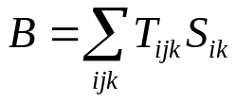

where B is the LAAS benefit for straight-in approaches, i is the year, j is the runway, k is the user group, is the total number of avoidable disruptions in year i at runway end j by user group k, and is the monetary operational savings obtained from each avoided disruption in year i by user group k.

It should be noted that this formula gives the total operational benefit for the various user groups, but does not include the benefit to the passengers. That benefit, based on the Passenger Time Savings (PTS) is calculated similarly except that is replaced with, the PTS from each avoided disruption in year i by user group k. PTS benefits are calculated for all user groups except cargo airlines.

Derivation of the Number of Disruptions Avoidable with LAAS

To derive the number of disruptions that can be avoided with LAAS we break the number down into its various components. This number can be expressed as follows:

where;

is the total number of avoidable disruptions in year i, on runway j, by user group k,
is the number of arrivals at this airport in year i by user group k,
is the probability that runway j will be used for arrivals of user group k,
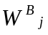is the probability that the weather at this airport is between the minima in ceiling and visibility for LAAS Cat X (where X is either I, II/III) and the Baseline navigation system on runway j,
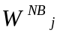is the probability that the weather at this airport is between the minima in ceiling and visibility for LAAS Cat X and the Next Best baseline navigation system on runway j,
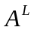 is the probability that LAAS Cat X is available,
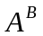 is the probability that the baseline system is available (next best baseline system is assumed to be 100% available),
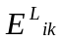is the probability that an aircraft in group k will be equipped and its pilots trained and certified on LAAS Cat X in year i,
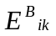is the probability that an aircraft in group k will be equipped and its pilots trained and certified on the baseline system in year i (Next Best baseline system is assumed to be 100% equipped), and
 is a factor to account for the ripple, or downstream, effects of each disruption.

As can be seen from this equation, the focus of the calculation is on individual runways rather than the entire airport. This is due to the runway-specific nature of some of the baseline technologies, and the fact that approach minima are runway-specific. Therefore, the benefits must be calculated at this level of detail and then aggregated to the airport level.

The annual number of arrivals () can be obtained in various ways. One way is to use the Official Airline Guide (OAG) to obtain the current demand for major passenger airlines and regional airlines and apply growth factors from the FAA’s Terminal Area Forecasts to derive the demand in future years. A similar method can be used to extrapolate from current to future years for major cargo airlines, corporate aircraft, and low-end general aviation aircraft in Alaska. Since some cargo carriers, and all air taxi and GA operators do not publish schedules in the OAG, the baseline year can be obtained from other sources (e.g., from cargo airlines themselves, ETMS data, DOT Transtat website).

Since the approach and landing capabilities are focused on individual runways, it is necessary to determine the number of these avoided disruptions that should be allocated to runway j. A logical way to approach this problem is to determine the probability that each runway is or will be used in instrument meteorological conditions () and to multiply this factor by the number of avoided disruptions for the entire airport. Although the Aviation System Performance Metrics (ASPM) database contains information on runway configuration use under various weather conditions, it is available for only 46 airports and, moreover, the frequency of use of the individual runways within each configuration is unknown. Therefore, runway usage for all 120 airports must be derived based on the available data, including wind direction, runway length and ILS placement. When possible, these derived runway usage estimates were validated against runway usage observations, (e.g., some individual Airport Capacity Enhancement Plans) and with airport operations representatives.

Recognizing that in most situations, airports favor one or two runways in IMC and therefore these runways account for a disproportional number of approaches, also takes into account the likelihood that an approaching aircraft will be routed to runway j as opposed to another alternative. When the wind is less than 10 knots making it possible for multiple runways to be used for approaches despite the wind direction, the principal runway(s) are assigned 70% of the traffic and the secondary runway(s) get 30%. These percentages are based on actual observations of runway use and were documented in previous FAA benefits studies. is modified to take account of the fact that not all aircraft for user group k may be capable of landing on runway j since, for example, the runway may not be long enough to accommodate a certain aircraft type.

To obtain the value for the probability of the weather being between two minima ( or ), IBM accessed the ceiling and visibility information for the 120 airports from the NCDC database for the years 1998 to 2001. Since the ceiling data is available in 100 foot increments, it was necessary to use an interpolation to derive the probability of weather for finer levels of gradation (e.g., 50 foot increments). The ceiling and visibility minima which are used for the baseline systems and LAAS are obtained from two sources: published instrument approaches whenever available and alternatively, the output from model runs conducted by the MITRE Corporation’s Center for Advanced Aviation System Development (CAASD) with its GPS Approach Minima Estimator (GAME) model. It should be mentioned here that the possibility exists that users may not be 100% equipped with the best baseline alternative system at each airport, and so the derivation of  must take this possibility into account by also considering the next best alternative.

Since the benefit of avoided disruptions from lower minima can be achieved only when LAAS is available and aircraft are equipped, it is necessary to include factors for the availability () and probability of being equipped ()in the equation. The availability and equipage of the best baseline system are also taken into consideration. The pace of expected avionics equipage was estimated through surveys and interviews conducted with representatives from the user communities, and resulted in a range of values used in the sensitivity analysis (See Appendix D for details of how the pace of equipage was incorporated into the sensitivity analysis).

Finally, a factor to account for the downstream effects of disruptions is applied to obtain the total number of avoided disruptions (see Important Considerations for Interpreting Results section for details of the downstream effect factor).

Derivation of Savings Obtained from Avoided Disruptions
To derive the savings that can be obtained from avoided disruptions in year i by user group k, we break the number down into its components. This number can be expressed as follows:



where;

 is the average cost of a disruption in the year 2004 to user group k and

 is the discount factor in year i relative to the year 2004,

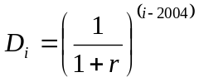

where r is the appropriate discount rate.

The average cost of a disruption to user group k () is calculated by taking the sum of the costs of a delay, cancellation, and diversion weighed by the frequency of their occurrence over a specified past period. For major and regional passenger airlines, disruption information was obtained from the Airline Service Quality Program (ASQP) database for the years 1998 through 2003. For cargo carriers, cancellations were set to zero based on airline representative input, and the ASQP disruption rates for major passenger airlines were applied for diversions and delays. For GA operators, cancellations were set to zero, and ASQP disruption rates for regional passenger airlines were applied for diversions and delays. An inflation factor, based on OMB guidance, was applied to derive the costs for 2004, the baseline year for this analysis.

The factoris multiplied by to ensure that the future saved cost of an avoided disruption is appropriately discounted, reflecting the reduction in present value the longer the benefit is deferred. We use a real discount rate of 7%, based on guidance from the OMB, as referenced above.

Example
To illustrate how the mathematical formula is applied to obtain the LAAS benefit, we selected Washington Reagan National airport (DCA). DCA has 6 runways (01/19, 15/33, 04/22). All 6 runways are used for approaches and only 01 is equipped with an ILS (Cat II). DCA runways 19, 04, 22, 15, and 33 have a variety of non-precision (e.g., VOR/DME and GPS) approaches with minimum decision heights ranging from 587 to 904 feet. An opportunity exists to reduce the ceiling and visibility minima on these runways with LAAS Cat I, if the users do not equip with WAAS.

To simplify this example, we will focus our attention on a single year (i = 2020), single runway (j = DCA 15), and single user group (k = corporate jet operators). Note that since DCA 15 is only 5204 feet long, it is not appropriate for all users, such as major passenger airlines and others who operate aircraft too large to land on this runway. Based on the methodology described above, we obtain the parameters in the Table 5. Note that the benefit for this year, runway end, and user group is obtained by simply multiplying the first 8 parameters. To obtain the Cat I benefit for the entire airport, we sum the discounted benefits for 20 years in our planning horizon, all runway ends, and all user groups.

Table 5. key parameter values for DCA 15 example
  # of DCA arrivals (Corporate jet Operators) |   % of time between LAAS and Baseline minima | Utilization of DCA runway 15  (Corporate jet Operators) | Availability of LAAS | LAAS equipage |   Cost of disruption (Corporate jet Operators) |   Discount factor for 2020 | Ripple Effect Factor | Direct Operating Cost Benefit  (Corporate jet Operators)
1,419 | .034 | .07 | .999 | 1.0 | $1,270 | .34 | 1.5 | $2,151

Results

Tables 6A and 6B, below show the total straight-in LAAS approach benefit estimated for the 120 airports studied. Table 6A shows these benefits for Cat I LAAS implementation, in terms of both reduced direct operating costs and passenger time savings, as well as for the two scenarios of user WAAS equipage. Table 6B shows these benefits for Cat II/III LAAS implementation.

Table 6a: Discounted 20 year LAAS Straight-in Benefits for Cat I
 | Direct Operating Cost | Passenger Time Savings
LAAS Benefits  (Assuming 0% WAAS equipage) | $118,300,000 | $122,300,000
LAAS Benefits  (Assuming 100% WAAS equipage) | $3,900,000 | $3,800,000

Table 6b: Discounted 20 year LAAS Straight-in Benefits for Cat II/III
 | Direct Operating Cost | Passenger Time Savings
LAAS Benefits  (Assuming 0% WAAS equipage) | $623,900,000 | $599,700,000
LAAS Benefits  (Assuming 100% WAAS equipage) | $623,900,000 | $599,700,000

Reduced Disruptions with LAAS Takeoff Guidance

A restricted ability to perform departure operations during low visibility conditions, although rare, can be highly disruptive to airport and airline operations. When low visibility conditions coincide with an airport’s departure bank, particularly early in the day, the impact can be significant. In some cases it can take more than a full day for an airline’s operations to recover from the disruption to their system that results from such an event.

Current rules governing takeoff under low visibility conditions permit operations in various RVR conditions depending on several factors, including runway markings, lighting, RVR measurement equipment, surface movement guidance and control plans, and aircrew training. Takeoff operations in very low visibility conditions may be conducted with the use of a takeoff guidance system, (e.g., Cat III ILS localizer for front-course guidance and a head up display (HUD)). It is expected that LAAS Cat II/III, as part of a takeoff guidance system, will also provide this level of guidance, potentially at far more runways than are currently served by Cat III localizers. Thus, LAAS and HUD equipped users benefit directly by continuing takeoff operations during these conditions, and all airport users benefit indirectly from the reduced time required for the airport to restore normal operations once these low visibility conditions end (due to a smaller backlog of aircraft waiting to depart).

Airports with a Cat III localizer will accrue benefit from this LAAS capability only if demand is sufficiently high to warrant the use of multiple departure runways under these conditions and if operational and safety considerations permit departures from multiple runways under these conditions. However, airports currently lacking Cat III localizers may benefit significantly from this LAAS capability, and this analysis is limited to such airports.

Within the 120 airports studied, 54 airports have a Cat III localizer. Of the remaining 66 airports, existing infrastructure supports takeoff operations at 500, 1000, and 1600 RVR at 23, 2, and 41 airports respectively. Users equipped with a LAAS-based takeoff guidance system may be able to benefit at these 66 airports.

Figure 2 shows the distribution of low visibility conditions during the day for these 66 airports. Although these conditions are observed at all times of day, the majority occur during the early morning, when the impact on an airline’s operation is greatest.
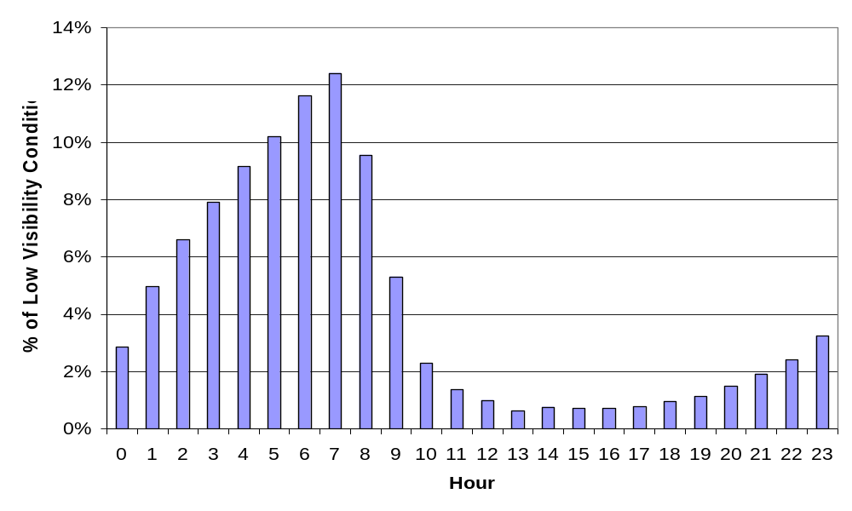
Figure 2. Time Distribution of Low Visibility Conditions among 66 Candidate Airports.

Methodology
In order to investigate the delay savings that may be achieved by using LAAS for takeoff guidance, we first determine the lowest takeoff minima supported by each airport, including the timing and duration of these conditions. We then combine that information with departure demand. Following that, we use an airport delay model to obtain an estimate of the expected delays both with and without LAAS-guided takeoffs. In this analysis, the impact of LAAS is modeled as the ability of the airport to maintain IMC departure rates, for aircraft equipped with both LAAS and HUD, while very low visibility conditions exist. The methodology consists of the following steps:

- Obtain the required data:
  - Airports without a Cat III localizer
  - The lowest takeoff minima supported by each airport
  - The number of hours per year that each airport experiences visibility conditions below these minima
  - The IMC and VMC departure capacity of each airport
  - The total departure traffic at each airport for a typical day
- Run IBM’s Single Airport Delay Model to calculate departure delay for two scenarios, accounting for the timing and duration of low visibility conditions:
  - Without LAAS: No departures during conditions with low visibility
  - With LAAS: Departures at IMC rates during low visibility conditions
- Calculate the average annual change in delay:
  - Take the difference between delays per flight in the two scenarios
  - Multiply this difference in delay per flight by the average daily traffic volume
  - Multiply this daily change in delay by the number of days with low visibility conditions
- Multiply by the percentages of LAAS and HUD avionics equipage and divide by 2 to get the portion attributable to LAAS
- Multiply by the downstream effect factor (see Important Considerations for Interpreting Results section, above)
- Multiply the minutes of delay by the cost of ground delay per minute for each user type

Limitations
Following takeoff, LAAS may be able to provide precision departure guidance, including procedural separation, on straight or curved departure paths, potentially allowing for a higher rate of departure operations under low visibility conditions than is possible with localizer guidance and radar vectoring. RNAV departure procedures, using existing avionics and ground systems, may also provide much of this benefit. Thus, the impact of this LAAS capability is difficult to evaluate.

Results
Table 7, below shows the total LAAS takeoff guidance benefit estimated for the 120 airports studied. The table shows these benefits for Cat II/III LAAS implementation, in terms of both reduced direct operating costs and passenger time savings, as well as for the two scenarios of user WAAS equipage.

Table 7: Discounted 20 year LAAS Takeoff Guidance Benefits for Cat II/III
 | Direct Operating Cost | Passenger Time Savings
LAAS Benefits  (Assuming 0% WAAS equipage) | $18,300,000 | $17,500,000
LAAS Benefits  (Assuming 100% WAAS equipage) | $18,300,000 | $17,500,000

Benefits from LAAS-based Complex Procedures

In addition to providing final approach guidance for straight-in approaches, LAAS is also capable of supporting complex area navigation (RNAV) procedures. However, a variety of other existing and planned avionics and ground systems may also support such procedures. RNAV procedures conducted without LAAS are reportedly capable of supporting complex operations down to near-Cat I approach minima, and if linked to an ILS final approach, down to the minima supported by the ILS. LAAS offers the possibility of conducting complex procedures down to Cat I or Cat II/III minima where no ILS is available, as well as the simplicity of using a single system for terminal area navigation through final approach and landing, potentially down to Cat III minima. Discussions with major airline representatives have shown that simplification of terminal area and landing procedures is a primary goal. Further, these airlines view GPS-based RNAV/RNP as the navigation solution down to near-Cat-I operations and LAAS-based RNAV/RNP as the desired transition from GPS to GLS down to Cat-III operations. Based on this input, we chose to evaluate LAAS-based complex approach benefits only in those cases where no ILS is present and only for weather conditions worse than those supported by baseline system approach minima.

LAAS may support complex operations either through use of the LAAS position-velocity-time signal (PVT) as an input to an on-board navigator, or through the direct broadcast of waypoints from the LAAS Ground Facility (LGF). In the former, LAAS may provide improved actual navigation performance (ANP) in the terminal area, and thus may support more stringent required navigation performance (RNP) procedures than other systems (e.g., un-augmented GPS). This benefit may not be limited to improved approach procedures, but may apply more generally to airspace management, with very low RNP routes supported by LAAS, and including highly precise vertical restrictions. Such routes have the potential to resolve existing airspace conflicts, both within a single airports operations (e.g., more precise separation of arrival and departure streams at SEA), and among closely situated airports (e.g., runway use conflicts between ORD and MDW, SEA and BFI, or JFK, LGA, EWR, and TEB). However, at this time, RNP levels have not been established for these procedures, and thus it is not possible to discern which requirements are beyond the capabilities of existing systems and which will require LAAS. Further, it is anticipated that the RNP will vary within the approach (and departure) environment, and thus the transition point in the procedures from a GPS-based RNAV/RNP to a LAAS-based RNAV/RNP is not clear. Until these RNP levels are established, the extent of LAAS-enabled RNAV benefits will remain unclear.

The appeal of direct broadcast of waypoints, or data uplink, is twofold. First, since the source of the procedure is local to the airport, uplink eliminates concerns about version control of procedures among different aircraft (that is, with an onboard database of procedures, and each operator potentially updating procedures at a different pace, there is a concern that two or more versions of a single procedure can be in use simultaneously). Second, uplink of procedures may reduce the burden placed on the onboard database for some aircraft. The costs of adding and certifying increased storage capacity can be significant. Further, as the number of procedures, including terminal area, en-route and high-altitude routes, continues to increase, operators may be forced to choose between the expense of database upgrades and the operational complexity of isolating certain aircraft to particular regions. Since the specific storage requirements for onboard versus uplinked procedures are not yet defined (i.e., even with uplink available, procedures may need to be stored in an onboard database for other purposes), this benefit of uplink is not clear.

In the absence of RNAV procedures, flight paths within the terminal area during IMC are controlled by vectoring, a process that involves a high level of air-to-ground communication and that can result in a broad range of paths flown by individual aircraft. Reducing both the communications workload and the variability in the time and distance flown in the terminal area are of great interest to controllers, pilots and airlines. RNAV/RNP procedures have the potential to significantly reduce the communications component of this overall workload. Since these procedures follow pre-set routes, the pilots can focus on flight operations to follow the routes and the controller can focus on surveillance. Further communications should only be necessary in the event that the aircraft diverges from the assigned route, or the controller determines that a deviation is necessary. One study of RNAV terminal procedure development at Philadelphia found that pilot-controller communications fell by over 60%, from 16 separate communications required for vectoring to just 6 with RNAV routes. The time and attention saved by eliminating these 10 communications can now be focused on flying, and monitoring, the RNAV route. While LAAS may contribute to the conduct of RNAV and RNP procedures, the ability of other systems in the baseline to provide similar services eliminates this as an incremental LAAS benefit.

Reductions in flight time variability could yield significant benefits in terms of direct operating cost saved, improved customer service and on-time performance, and through improved predictability of arrival times for the airlines’ gate operations. The value of predictability was described well by David Knorr et al; “Predictability measures the variation in the ATM system as experienced by the user. Commercial airlines may benefit as much from a reduction in the variance (or an improvement in the consistency) of flight/taxi times as they would from a reduction in average flight times. System predictability allows for improved scheduling and more efficient bank operations.” Other aviation industry stakeholders and researchers have also pointed out the high value of predictability to commercial airlines. Additionally, it is one of the goals in the FAA’s Flight Plan 2004-2008 to “achieve greater conformity between expected and actual flight times.” Potential benefits from reduced flight time variability are of particular importance at the nation’s busiest airports, due to the high volume of traffic handled, and to the related importance for airlines to carefully time their operations. Earlier work by IBM showed that flight time variability in the terminal area for arrivals to ORD 9L is as much as 13 minutes, depending on what vectoring path is assigned, and that a proposed RNP procedure for this runway could reduce this variability nearly to zero. However, as was the case for the benefits associated with communication workload, while LAAS may contribute to the conduct of such RNP procedures, the ability of other systems in the baseline to provide similar service eliminates this as an incremental LAAS benefit.

Estimated Complex Approach Benefit
As stated above, most terminal area complex operations can be accomplished with existing or planned avionics and ground systems, without the need for LAAS. Even complex procedures ending with a precision approach may be performed by transitioning to an existing ILS for the final approach and landing. In this section we explore the benefits available to LAAS at those runways that do not have an ILS and that did not receive any Cat II/III benefit in the Straight-In Approach section of this work, and had no, or limited, Cat I benefit due to relatively high estimated decision heights associated with LAAS. These runways include candidates such as JNU 8 and 26, as well as DCA 19, which for reasons of terrain or airspace restrictions cannot have an ILS installation.

Methodology
A key assumption in this methodology is the decision height achievable by LAAS complex approaches at these runways. Since MITRE’s GAME model provides estimates of decision heights for straight-in approaches, we can use its output strictly to inform us that these runways are obstacle constrained to relatively high decision heights. In this analysis we assume that there will be a learning curve for (or period of becoming comfortable with) advanced LAAS capabilities such as these complex procedures. Most newly introduced technologies do not achieve the full potential of their capabilities until users become familiar with, and comfortable with, those capabilities. Thus, we assume that during the early years that a LAAS is used at each airport, the decision height for a complex approach is no better than that associated with straight-in approaches. Then, beginning in 2018, lacking any better information, we simply assume that a complex terminal area path can be designed to support the full Cat I decision height (200 feet), and that Cat II/III minima are also achievable. Since it is not known whether a complex path can be constructed at each of these runways to achieve these minima, we recognize that this is an aggressive assumption. To address the uncertainty of achieving such minima, we plan to estimate the benefits using a sensitivity analysis that incorporates a measure of the likelihood of reducing the decision height from that given by GAME for a straight-in approach to the full Cat I or Cat II/III minima.

These assumed decision heights are then used as inputs to the method we have described in the section titled “Reduced Disruptions for Straight-in Precision Approaches”. As in that section, the number of reduced disruptions due to the improvement in approach minima are estimated. Other benefits often associated with complex procedures, such as reduced time or distance through the terminal airspace, appear to be attributable to RNAV or RNP procedures, and the role of LAAS in achieving these benefits is unclear.

Limitations
For some runways included in this complex benefit estimate, it may be possible to install an ILS. Installation of an ILS would change the baseline against which LAAS is evaluated, and that runway’s incremental LAAS-based complex approach benefit would be eliminated. Efforts to obtain data on ILS siting potential at NAS runways have not yet been fruitful.

The complete solution to the question of LAAS complex approaches involves significant complex technical issues beyond the scope of this study. This method assumes that the complex approach segment has allowed the aircraft to avoid controlling obstacles and intercept the final approach path at a point closer to the runway than current procedures. A preliminary evaluation of decision height improvements due to short finals, conducted by CAASD using the GAME tool, and based on GLS TERPS, indicated that few, if any, of the 120 airports would achieve any decision height benefit from such short finals. The impact of possible future changes in TERPS for LAAS approaches on achievable decision height for short final is unknown.

Results
Tables 8A and 8B, below show the total LAAS complex approach benefit estimated for the 120 airports studied. Table 8A shows these benefits for Cat I LAAS implementation, in terms of both reduced direct operating costs and passenger time savings, as well as for the two scenarios of user WAAS equipage. Table 8B shows these benefits for Cat II/III LAAS implementation.

Table 8a: Discounted 20 year LAAS Complex Approach Benefits for Cat I
 | Direct Operating Cost | Passenger Time Savings
LAAS Benefits  (Assuming 0% WAAS equipage) | $139,900,000 | $127,000,000
LAAS Benefits  (Assuming 100% WAAS equipage) | $0 | $0

Table 8b: Discounted 20 year LAAS Complex Approach Benefits for Cat II/III
 | Direct Operating Cost | Passenger Time Savings
LAAS Benefits  (Assuming 0% WAAS equipage) | $12,200,000 | $11,500,000
LAAS Benefits  (Assuming 100% WAAS equipage) | $12,200,000 | $11,500,000

Benefits Due to Elimination of ILS Critical Areas

Under certain weather conditions, the ILS signal must be protected by ensuring that aircraft or other obstacles do not enter areas on the airport surface where they may interfere with the ILS signal quality. These areas are called ILS critical areas, and are shown on taxiway diagrams, and are marked with appropriate signage on the airport surface. These critical areas require that aircraft taxiing into position for takeoff, or to cross the runway, must hold short at some distance from the runway. The critical area is protected when instrument approaches are being conducted with visibility less than or equal to 2 miles or ceilings are less than or equal to 800 feet. The figure below illustrates an ILS critical area on Cincinnati’s runway 18L.

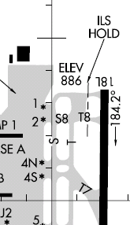
Figure 3. Example of an ILS Critical Area hold.

Protection of ILS critical areas may cause delays to both the arriving aircraft, and to aircraft taxiing on the airport surface. The impact that LAAS may have on each of these delays is explored in the sections below.

Arrival Delay due to Protection of ILS Critical Areas
When arrival and departure operations are being conducted during the same period on a single runway with an ILS critical area, the arriving aircraft must be spaced further apart longitudinally in order to allow for the time required for the departing aircraft to taxi through the critical area and onto the active runway. This results in a reduced rate of operations on that runway.

LAAS, when used for precision landing guidance in IMC, is expected to eliminate the need for ILS critical areas on the airport surface. With departing aircraft able to taxi closer to the runway, less time is required for their final taxi into position for takeoff, with a resulting reduction in required longitudinal spacing between sequential arrivals as well as between arrivals and departures. Thus, the elimination of ILS critical areas should allow a higher pace of operations on these runways where both arrival and departure operations are being conducted during reduced weather minimums.

The purpose of this section is to estimate the impact that ILS critical areas have on airport capacity and average arrival delays. Since LAAS can eliminate the need for ILS critical areas, increased arrival and departure capacity may be achieved through decreased arrival-departure and arrival-arrival spacing. Normally, a departing aircraft may begin its departure after an arrival aircraft is safely off the runway, but at a runway that is used for simultaneous departures and arrivals and that has an ILS critical area, spacing between arriving aircraft must be increased to allow a departing aircraft to taxi through the critical area and depart before the arriving aircraft may land.

The following is the methodology that was used in this analysis.

Methodology
- Identify ILS critical areas within the 120 studied airports.
- Identify which of the affected runways are used for both arrivals and departures during IMC.
- Calculate the estimated time in seconds to taxi through the critical area.
- Determine the minimum required aircraft time separation at the runway threshold, for two cases:
  - No critical area: Separation is dictated by wake vortex separation standards.
  - ILS critical area: Separation between affected arriving aircraft is increased by the time needed for the departing aircraft to taxi through the critical area.
- Convert the minimum aircraft time separation into a runway capacity per hour for each case.
- Use IBM’s Single Airport Delay Model to estimate the flight delays associated with each of these cases for a typical traffic volume day.
- Take the difference in delays between these two cases to get the one-day delay savings for ILS critical area elimination.
- Multiply by the percent of LAAS avionics equipage
- Multiply by the downstream effect factor (see Important Considerations for Interpreting Results section, above)
- Annualize the one-day delay savings and multiply by the cost of airborne delay for each user group in $/min.

Limitations
ILS Critical Areas were identified from airport taxiway diagrams. ILS Critical Areas that are not identified on the taxiways diagrams (e.g., ILS critical area between SEA 16R and 16L, identified by Alaska Airlines), and where runway operations include simultaneous IMC arrivals and departures, are not included and may provide additional potential benefits.

Example: Cincinnati Airport (CVG)
Typical runway configurations at CVG include departures on runway 27, and both departures and arrivals on either 18L/R or 36L/R, depending on wind conditions. CVG has an ILS critical area hold on every runway. Since runway 27 is dedicated to departures, we assume that most departures will be sent to this runway, with only those departures above and beyond the capacity of runway 27 being sent to the other runways. The OAG schedule data show that the IMC departure capacity of runway 27 is exceeded 11 of the 16 hours between 6 a.m. and 9 p.m. Thus, in IMC the demand that exceeds runways 27’s capacity, or approximately 160 departures per day must use either 18L/R or 36L/R, depending on wind direction. It is these aircraft that are subject to hold at the ILS critical areas, and which will thus require greater spacing between arrivals in order to execute their departure.

Applying the steps of the methodology outlined above, we find that CVG’s ILS critical areas require departing aircraft to taxi an additional 15 seconds (runways 18R and 36L) to 25 seconds (runways 18L and 36R) to perform a departure. This additional taxi time results in a ¾ mile increased separation between arrivals on runway 18R/36L, and 1¼ mile additional separation for 18L/36R. Next, we calculate the change in arrival capacity represented by these increased arrival separations, and use these capacities to estimate changes in airport delays. Finally, we calculate a net annual direct operating cost savings and passenger time savings due to reduced delays from ILS critical area elimination at CVG.

Results
Tables 9A and 9B, below show the total LAAS ILS critical area arrival delay benefit estimated for the 120 airports studied. Table 9A shows these benefits for Cat I LAAS implementation, in terms of both reduced direct operating costs and passenger time savings, as well as for the two scenarios of user WAAS equipage. Table 9B shows these benefits for Cat II/III LAAS implementation.

Table 9a: Discounted 20 year LAAS ILS Critical Area Arrival Delay Benefits for Cat I
 | Direct Operating Cost | Passenger Time Savings
LAAS Benefits  (Assuming 0% WAAS equipage) | $17,300,000 | $18,100,000
LAAS Benefits  (Assuming 100% WAAS equipage) | $2,800,000 | $3,000,000

Table 9b: Discounted 20 year LAAS ILS Critical Area Arrival Delay Benefits for Cat II/III
 | Direct Operating Cost | Passenger Time Savings
LAAS Benefits  (Assuming 0% WAAS equipage) | $2,400,000 | $2,600,000
LAAS Benefits  (Assuming 100% WAAS equipage) | $2,400,000 | $2,600,000

Taxi Time Delay due to Protection of ILS Critical Areas
The elimination of an ILS critical area may allow for a less impeded flow of arrival and departure ground operations across runways that currently have critical areas requiring a hold. The purpose of this section is to estimate the impact that ILS critical areas have on aircraft taxi operations.

Since multiple factors affect the pace of ground operations, it is necessary to attempt to isolate the contribution to taxi time delay that comes from protection of the ILS critical areas. Although the requirement to protect the critical area is limited to ceiling and visibility conditions below 800 feet or 2 miles, anecdotal evidence and stakeholder interviews suggest that critical areas are sometimes protected even in conditions outside of these limits. This practice complicates the process of isolating the operational impact of ILS critical area protection.

We proceed by collecting observed taxi times for each airport for weather conditions above and below the ceiling and visibility conditions of 800 feet or 2 miles. We then compare these observed times to the unimpeded, or expected, taxi times. For conditions at or below the 800 feet or 2 miles limits, the difference between these is simply the IMC taxi delay (observed time – expected time). However, there are taxi delays even in VMC, so we normalize our calculated IMC taxi delay by removing this VMC delay. The remaining IMC taxi delay should reflect conditions that are unique to the airport’s IMC operational conditions. Subtracting all of the VMC taxi delay in the normalization step may be excessive, as there may be more volume related taxi delays in VMC than IMC. However, taking this step suggests that our estimate is conservative. One final step, the subtraction of the normalized IMC delay averaged over all airports without an ILS critical area, should help to eliminate those delays attributable to weather and congestion, leaving delays due primarily to protection of ILS critical areas.

The following is the methodology that was employed in this analysis:

Methodology
- Identify ILS critical areas within the 120 studied airports
- Identify the actual and unimpeded (expected) taxi-in and taxi-out time from the ASPM database
- Calculate a normalized IMC taxi-in and taxi-out delay per flight that isolates the delay due to protection of ILS critical areas:
  - Obtain the raw IMC taxi time delay by subtracting the IMC unimpeded taxi time from IMC observed taxi time
  - Obtain the raw VMC taxi time delay by subtracting the VMC unimpeded taxi time from VMC observed taxi time
  - Obtain the normalized IMC taxi time delay by subtracting the raw VMC delay from raw IMC delay – this normalized IMC taxi delay represents delays in IMC, which may be due to both general operational slowdown in IMC and to protection of ILS critical areas
  - Further isolate the taxi delay specifically due to protection of critical areas by subtracting the average IMC taxi delay, normalized for VMC delay, observed at airports without critical areas
- Multiply this final normalized IMC taxi time delay, assumed to be due primarily to protection of ILS critical areas, by the cost of ground delay for each user group
- Adjust these delays for the percent of LAAS equipage
- Multiply the estimated per flight delay by total operations by user group
- Multiply by the downstream effect factor (see Important Considerations for Interpreting Results section, above)

Note that this methodology accounts for taxi delays associated with aircraft, but does not include restrictions on other types of airport surface traffic due to protection of ILS critical areas.

Results
Tables 10A and 10B, below show the total LAAS benefits from the reduction in taxi times made possible with the elimination of ILS critical areas. Table 10A shows these benefits for Cat I LAAS implementation, in terms of both reduced direct operating costs and passenger time savings, as well as for the two scenarios of user WAAS equipage. Table 10B shows these benefits for Cat II/III LAAS implementation.

Table 10a: Discounted 20 year LAAS ILS Critical Area Taxi-In and Taxi-Out Delay Benefits for Cat I
 | Direct Operating Cost | Passenger Time Savings
LAAS Benefits  (Assuming 0% WAAS equipage) | $46,600,000 | $73,000,000
LAAS Benefits  (Assuming 100% WAAS equipage) | $7,600,000 | $11,800,000

Table 10b: Discounted 20 year LAAS ILS Critical Area Taxi-In and Taxi-Out Delay Benefits for Cat II/III
 | Direct Operating Cost | Passenger Time Savings
LAAS Benefits  (Assuming 0% WAAS equipage) | $8,600,000 | $13,800,000
LAAS Benefits  (Assuming 100% WAAS equipage) | $8,600,000 | $13,800,000

Benefits for Closely Spaced Parallel Approaches

Three of the operational capabilities identified in the LAAS Navigation Capabilities Baseline are related to simultaneous independent parallel approaches. This section summarizes the current state of knowledge about the potential for using LAAS to support these types of approaches in IMC.

Operational Background
During VMC, the FAA allows aircraft to conduct simultaneous independent approaches on parallel runways separated by as little as 700 feet. as long as the pilots take over separation responsibility using “see and avoid” principles.

When weather deteriorates, maintaining visual separation is no longer possible and there are specific rules about the required separation between runways under which aircraft can conduct simultaneous independent parallel approaches. Currently, the minimum required separation is 4300 feet in IMC.

This separation is required to ensure adequate time to prevent a collision in the event that one of the aircraft on a parallel runway approach (the blundering aircraft) turns in the direction of the second aircraft (the evading aircraft). The separation distance is a function of the surveillance error, navigation system error, flight technical error, and the time required to detect the blunder, alert the evading aircraft, and conduct an evasive maneuver.

With improved surveillance, pilot and controller training, and special procedures, it is possible to conduct simultaneous independent parallel approaches down to as little as 3000 feet runway centerline separations. This entails the use of Precision Runway Monitors (PRM; a high update radar and high resolution display) which can cost more than $10M per unit. Currently, if the runway centerlines are separated between 2500 and 3000 feet, the approaches must be dependent with the aircraft positioned so as to have a minimum 1.5 nautical mile stagger on the parallel runways. For runways separated by less than 2500 feet, neither independent nor dependent approaches can be conducted in IMC due to the potential hazardous effects of wake vortices, and consequently one of the parallel runways is shut down for arrivals.

Evidence in Support of Potential LAAS Benefits
Given that the separation distances are based in part on navigation system errors, it seems logical to assume that it may be possible to achieve reductions in the required separations distances (i.e., below 4300 feet) with new navigation systems such as WAAS and LAAS.

In fact, a number of research efforts have been conducted on this issue as well as a host of other technical issues related to achieving increased airport capacity through a reduction in runway separations. These research efforts have included:
- Various studies by Sharon Houck et al. at Stanford University, showing the feasibility and potential benefits of WAAS or LAAS combined with tunnel-in-the-sky displays to reduce runway spacing while maintaining currently accepted safety levels.
- NASA’s Terminal Area Productivity Program which includes the Airborne Information for Lateral Spacing (AILS) and the Closely Spaced Parallel Approach (CSPA) Program. As part of this effort, NASA has been investigating ways to mitigate the effects of wake vortices on closely spaced parallel approaches.
- Investigations of parallel runway technical issues and air traffic control procedures conducted by RTCA SC-186, Working Group 1.
- Studies by Eurocontrol of the benefits of the Ground Based Augmentation System (GBAS), including studies specific to simultaneous independent operations.
- MIT Lincoln Lab analyses and tests of PRM and associated procedures.
- Analyses by MITRE/CAASD over the past 20 years supporting the FAA’s research, feasibility studies, and certification of various simultaneous independent parallel approach procedures (including most recently, the RNP Parallel Approach Transition or RPAT) as well as investigating reductions in wake turbulence constraints.

It is clear from these studies that the largest contributor to the required separation between parallel runways is surveillance error, flight technical error, and the distance needed to detect and resolve potential blunders. Although navigation system errors are not insignificant, their contribution to the required runway separation is minor (i.e., less than 20% of the 4300’ separation requirement) compared to other errors and required distances.

Without new technologies to reduce the size of the surveillance errors and flight technical errors as well as automated methods for detecting and resolving blunders, LAAS alone is likely to have a negligible impact on the reduction of lateral separations required for simultaneous independent parallel approaches. An estimate of the impact of LAAS in conjunction with other technologies will require a separate analysis that is outside of the scope of this project.

Nevertheless, the existing studies do indicate that LAAS can be combined with other technologies such as a tunnel-in-the-sky display or ADS-B and CDTI to enable those technologies to achieve performances that they would not be able to attain without LAAS. For example, Houck et al. illustrated that a tunnel-in-the-sky display in the cockpit combined with linear instrument approach corridors made possible with WAAS can result in reductions in the required separation between parallel runways from 4300 feet to 3100 feet. Clearly, with the greater horizontal and vertical accuracy of LAAS when compared to WAAS, it should be possible for LAAS to achieve and possibly surpass the reduction to 3100 feet estimated to be attainable with WAAS.

Although not explicitly tied to LAAS, the FAA’s Safe Flight 21 program indicates that ADS-B could provide PRM-like capability at a wider range of airports. Since the utility of ADS-B is linked to the accuracy of its inputs, utilizing the best available positioning information (i.e., LAAS, where available) will maximize ADS-B’s value. The FAA is also exploring the use of RPAT (an ILS approach path on one track combined with an RNP approach procedure and a visual side step maneuver on the parallel track) for use with closely spaced parallel runways. The possibility of using LAAS to increase the usability of RPAT procedures appears to hold some promise, but is a research topic outside of the scope of this benefits analysis.

In the following analysis, we estimated the potential improvement that may be achieved when LAAS is combined with improved cockpit displays for both the 0% and 100% WAAS user equipage scenarios. For the 100% WAAS equipage case the incremental accuracy of LAAS over WAAS is not expected to produce an appreciable difference in the required runway centerline separation requirement for simultaneous independent parallel approaches, and LAAS accrues benefits for the years prior to WAAS Cat I capability in 2015.

There are 12 airports among the 120 candidate airports in the LAAS benefits analysis that would be affected if the required separation for simultaneous independent parallel approaches were reduced from 4300 feet to 3100 feet. They include:
- Tampa (TPA)
- Ft. Lauderdale (FLL)
- Detroit (DTW)
- Salt Lake City (SLC)
- Milwaukee (MKE)
- Jackson (JAN)
- Raleigh-Durham (RDU)
- Minneapolis-St. Paul (MSP)
- Memphis (MEM)
- Long Beach (LGB)
- Portland (PDX)
- New York – Kennedy (JFK)

Minneapolis-St. Paul already has a PRM and thus is unlikely to benefit from a combination of LAAS and other technologies and therefore it was excluded from the analysis. Ft. Lauderdale, Salt Lake City, Memphis, and John F. Kennedy, are listed in the Aviation Capacity Enhancement (ACE) Plan as sites recommended for a PRM. It is possible that these airports may be too far along the procurement path to have LAAS make a difference. However, since delays in implementation may still occur, we decided to include these airports in the analysis. The remaining airports (Tampa, Detroit, General Mitchell, Jackson, Raleigh-Durham, Long Beach, and Portland) are not in the list of sites recommended for a PRM, and may be candidates for a capacity improvement with LAAS.

Using capacities from the FAA benchmark report and FAA’s ASD organization, we estimated the impact that bad weather has on these airports and the magnitude of the potential arrival capacity gains that may be achieved if the capacity from the parallel runways at these airports is partly or wholly regained with LAAS and associated technologies. Table 11 contains a list of the 11 airports that were part of this analysis and their capacities. Note that the reduction in capacity at these airports ranges from 14% at Detroit to a high of 67% at Long Beach. A reduction of over 50% is probably caused by the closing of one of the two parallel runways whereas a more limited reduction in capacity (e.g., 32% at MEM) is likely to indicate the use of dependent parallel approaches at the airport when the weather deteriorates. Capacities for JAN were unavailable, and values from RDU were substituted based on similarities in the runway layouts and centerline separations.

Table 11. Capacities of Airports with Parallel Runways Between 3100 and 4300 ft. Separations Between Centerlines (Excluding MSP)

Airport ID | Airport Name | Optimum Hourly Arrival Capacity | Reduced Hourly Arrival Capacity | % Arrival Capacity Reduction
TPA | Tampa | 71 | 50 | 30
FLL | Ft. Lauderdale | 65 | 27 | 58
DTW | Detroit | 84 | 72 | 14
SLC | Salt Lake City | 90 | 40 | 56
MKE | General Mitchell | 72 | 34 | 53
JAN | Jackson | 60 | 40 | 33
RDU | Raleigh-Durham | 60 | 40 | 33
MEM | Memphis | 88 | 60 | 32
LGB | Long Beach | 70 | 23 | 67
PDX | Portland | 60 | 38 | 37
JFK | John F. Kennedy | 74 | 48 | 35

Methodology
In order to describe the methodology employed in this analysis, we will step through an example involving JFK. To determine the impact that a capacity reduction of the size shown in this table can have on congestion and delays, we applied the IBM Single Airport Delay Model to the demand and capacity data. The arrivals for a representative traffic day were compared to the optimum and reduced capacities at JFK. This analysis focused on Cat I operations, although there is no restriction preventing Cat II/III simultaneous parallel operations on runways separated by 3400 feet. Since reduced capacity conditions occur approximately 7.5% of the time at JFK, or on average about 1.75 hours per day, we applied a moving window of reduced delay to the model, effectively creating different scenarios representing many possible combinations of 1.75 hour windows during the course of a day. For each of these scenarios, we calculated the average daily delay and then averaged these average delays across the scenarios. This model result (0.03 minutes per flight) was compared to the delays obtained with JFK at optimum capacity (0.0 minutes per flight). The difference in delays, 0.03 minutes per flight, represents the potential improvement that can be achieved with LAAS.

Multiplying this value by the number of flights by user group yields the delay minutes by user group. Then, multiplying by the cost of a minute of delay, yields the total cost savings that might be achieved at JFK. Finally, recognizing the fact that LAAS will need to be combined with other technologies to achieve this benefit, we applied a factor of ½ to the result. As with the other benefits estimated in this report, we also applied a downstream effect factor for disruptions of 1.5. Over the 20 year benefits period, the total direct operating cost savings at JFK is estimated to be $225,000.

Results
Table 12 shows the LAAS closely spaced parallel approach benefit for Cat I LAAS implementation, in terms of both reduced direct operating costs and passenger time savings, as well as for the two scenarios of user WAAS equipage.

Table 12: Discounted 20 year LAAS Closely Spaced Parallel Approach Benefits for Cat I
 | Direct Operating Cost | Passenger Time Savings
LAAS Benefits  (Assuming 0% WAAS equipage) | $9,400,000 | $9,000,000
LAAS Benefits  (Assuming 100% WAAS equipage) | $400,000 | $0

Summary
As indicated above, LAAS without advanced cockpit technologies or LAAS in the presence of a 100% WAAS equipage scenario is unlikely to lead to a significant reduction in runway separation distances required to conduct simultaneous independent parallel approaches. However, evidence from previous studies seems to support the conclusion that LAAS, when combined with other advanced avionics, may be able to reduce these distances and result in sizable quantifiable benefits in the 0% WAAS equipage scenario. This comes about from the combination of improved navigation system accuracy and reduction in the flight technical error. LAAS may also enable more accurate position reporting when used in concert with ADS-B, thus reducing the surveillance error. This may lead to additional reductions in the required separation distances between runway centerlines.

Safety Benefits

Safety benefits were developed and reported in the February 2004 Preliminary Benefits document. These benefits are undergoing a substantial revision and refinement to reflect comments received. The next version of the safety benefits analysis is to be delivered August 31, 2004, and the safety benefits section will be updated at that time.

Societal Benefits

Societal benefits were developed and reported in the February 2004 Preliminary Benefits document. These benefits are undergoing revision and refinement to reflect comments received. The next version of the societal benefits analysis is to be delivered August 31, 2004, and the societal benefits section will be updated at that time.

Appendices

Appendix A: Airports Included in this Study

Airports were selected for this study through an objective process that included the following selection criteria:
- High traffic airports associated with likely LAAS users:
  - Major passenger airlines (More than 20,000 operations over a three year period)
  - Regional passenger airlines (Regional Airline Association – Top 50 airports)
  - Cargo carriers
  - Corporate operators (National Business Aviation Association – Top 10 airports)
- LAAS Low Rate Initial Production (LRIP) sites
- FAA Operational Evolution Plan (OEP) airports
- Current Cat II/III ILS airports
- Qualifier Cat II/III ILS airports

Based on these criteria 120 airports throughout the NAS were selected for this study, as shown in the following table and map.

ABQ | ALBUQUERQUE INTL SUNPORT, NEW MEXICO | FAI | FAIRBANKS INTL, ALASKA | OKC | WILL ROGERS WORLD, OKLAHOMA
ACK | NANTUCKET MEMORIAL, MASSACHUSETTS | FAT | FRESNO YOSEMITE INTERNATIONAL, CALIFORNIA | OMA | EPPLEY AIRFIELD, NEBRASKA
AFW | FORT WORTH ALLIANCE, TEXAS | FLL | FORT LAUDERDALE/HOLLYWOOD INTL, FLORIDA | ONT | ONTARIO INTL, CALIFORNIA
ALB | ALBANY INTL, NEW YORK | FWA | FORT WAYNE INTERNATIONAL, INDIANA | ORD | CHICAGO O'HARE INTL, ILLINOIS
ANC | TED STEVENS ANCHORAGE INTL, ALASKA | FXE | FORT LAUDERDALE EXECUTIVE, FLORIDA | ORF | NORFOLK INTL, VIRGINIA
ATL | THE WILLIAM B HARTSFIELD ATLANTA INTL, GEORGIA | GEG | SPOKANE INTL, WASHINGTON | PBI | PALM BEACH INTL, FLORIDA
AUS | AUSTIN-BERGSTROM INTL, TEXAS | GRR | GERALD R. FORD INTERNATIONAL, MICHIGAN | PDX | PORTLAND INTL, OREGON
AVL | ASHEVILLE REGIONAL, NORTH CAROLINA | GSO | PIEDMONT TRIAD INTERNATIONAL, NORTH CAROLINA | PHL | PHILADELPHIA INTL, PENNSYLVANIA
BDL | BRADLEY INTL, CONNECTICUT | GSP | GREENVILLE-SPARTANBURG INTL, SOUTH CAROLINA | PHX | PHOENIX SKY HARBOR INTL, ARIZONA
BFI | BOEING FIELD/KING COUNTY INTL, WASHINGTON | HNL | HONOLULU INTL, HAWAII | PIE | ST PETERSBURG-CLEARWATER INTL, FLORIDA
BGR | BANGOR INTL, MAINE | HOU | WILLIAM P HOBBY, TEXAS | PIT | PITTSBURGH INTERNATIONAL, PENNSYLVANIA
BHM | BIRMINGHAM INTL, ALABAMA | HPN | WESTCHESTER COUNTY, NEW YORK | PVD | THEODORE FRANCIS GREEN STATE, RHODE ISLAND
BNA | NASHVILLE INTL, TENNESSEE | HSV | HUNTSVILLE INTL-CARL T JONES FIELD, ALABAMA | RDU | RALEIGH-DURHAM INTL, NORTH CAROLINA
BOI | BOISE AIR TERMINAL/GOWEN FLD, IDAHO | IAD | WASHINGTON DULLES INTERNATIONAL, DIST. OF COLUMBIA | RFD | GREATER ROCKFORD, ILLINOIS
BOS | GENERAL EDWARD LAWRENCE LOGAN INTL, MASSACHUSETTS | IAH | GEORGE BUSH INTERCONTINENTAL ARPT/HOUSTON, TEXAS | RIC | RICHMOND INTERNATIONAL, VIRGINIA
BUF | BUFFALO NIAGARA INTL, NEW YORK | ICT | WICHITA MID-CONTINENT, KANSAS | RNO | RENO/TAHOE INTERNATIONAL, NEVADA
BUR | BURBANK-GLENDALE-PASADENA, CALIFORNIA | ILN | AIRBORNE AIRPARK, OHIO | ROC | GREATER ROCHESTER INTERNATIONAL, NEW YORK
BWI | BALTIMORE-WASHINGTON INTL, MARYLAND | IND | INDIANAPOLIS INTL, INDIANA | RSW | SOUTHWEST FLORIDA INTL, FLORIDA
CAE | COLUMBIA METROPOLITAN, SOUTH CAROLINA | JAN | JACKSON INTERNATIONAL, MISSISSIPPI | SAN | SAN DIEGO INTL-LINDBERGH FLD, CALIFORNIA
CHA | LOVELL FIELD, TENNESSEE | JAX | JACKSONVILLE INTL, FLORIDA | SAT | SAN ANTONIO INTL, TEXAS
CHS | CHARLESTON AFB/INTL, SOUTH CAROLINA | JFK | JOHN F KENNEDY INTL, NEW YORK | SDF | LOUISVILLE INTL-STANDIFORD FIELD, KENTUCKY
CLE | CLEVELAND-HOPKINS INTL, OHIO | JNU | JUNEAU INTL, ALASKA | SEA | SEATTLE-TACOMA INTL, WASHINGTON
CLT | CHARLOTTE/DOUGLAS INTL, NORTH CAROLINA | LAS | MC CARRAN INTL, NEVADA | SFB | ORLANDO SANFORD, FLORIDA
CMH | PORT COLUMBUS INTL, OHIO | LAX | LOS ANGELES INTL, CALIFORNIA | SFO | SAN FRANCISCO INTERNATIONAL, CALIFORNIA
COS | CITY OF COLORADO SPRINGS MUNI, COLORADO | LCK | RICKENBACKER INTERNATIONAL, OHIO | SHV | SHREVEPORT REGIONAL, LOUISIANA
CVG | CINCINNATI/NORTHERN KENTUCKY INTERNATIONAL, KENTUCKY | LGA | LA GUARDIA, NEW YORK | SJC | NORMAN Y. MINETA SAN JOSE INTERNATIONAL, CALIFORNIA
DAB | DAYTONA BEACH INTL, FLORIDA | LGB | LONG BEACH /DAUGHERTY FIELD/, CALIFORNIA | SLC | SALT LAKE CITY INTL, UTAH
DAL | DALLAS LOVE FIELD, TEXAS | LIT | ADAMS FIELD, ARKANSAS | SMF | SACRAMENTO INTERNATIONAL, CALIFORNIA
DAY | JAMES M COX DAYTON INTL, OHIO | MCI | KANSAS CITY INTL, MISSOURI | SNA | JOHN WAYNE AIRPORT-ORANGE COUNTY, CALIFORNIA
DCA | RONALD REAGAN WASHINGTON NATIONAL, DIST. OF COLUMBIA | MCO | ORLANDO INTL, FLORIDA | STL | LAMBERT-ST LOUIS INTL, MISSOURI
DEN | DENVER INTL, COLORADO | MDT | HARRISBURG INTERNATIONAL, PENNSYLVANIA | SWF | STEWART INT'L, NEW YORK
DFW | DALLAS/FORT WORTH INTERNATIONAL, TEXAS | MDW | CHICAGO MIDWAY, ILLINOIS | SYR | SYRACUSE HANCOCK INTL, NEW YORK
DLH | DULUTH INTL, MINNESOTA | MEM | MEMPHIS INTL, TENNESSEE | TEB | TETERBORO, NEW JERSEY
DSM | DES MOINES INTL, IOWA | MHT | MANCHESTER, NEW HAMPSHIRE | TLH | TALLAHASSEE REGIONAL, FLORIDA
DTW | DETROIT METROPOLITAN WAYNE COUNTY, MICHIGAN | MIA | MIAMI INTL, FLORIDA | TPA | TAMPA INTL, FLORIDA
DVT | PHOENIX DEER VALLEY, ARIZONA | MKE | GENERAL MITCHELL INTERNATIONAL, WISCONSIN | TRI | TRI-CITIES RGNL TN/VA, TENNESSEE
ELP | EL PASO INTL, TEXAS | MMU | MORRISTOWN MUNI, NEW JERSEY | TUL | TULSA INTL, OKLAHOMA
EUG | MAHLON SWEET FIELD, OREGON | MSP | MINNEAPOLIS-ST PAUL INTL/WOLD-CHAMBERLAIN/, MINNESOTA | TUS | TUCSON INTL, ARIZONA
EWR | NEWARK INTL, NEW JERSEY | MSY | LOUIS ARMSTRONG NEW ORLEANS INTL, LOUISIANA | TYS | MC GHEE TYSON, TENNESSEE
EYW | KEY WEST INTL, FLORIDA | OAK | METROPOLITAN OAKLAND INTL, CALIFORNIA | VNY | VAN NUYS, CALIFORNIA

Map of Airports Included in this Study
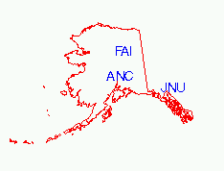

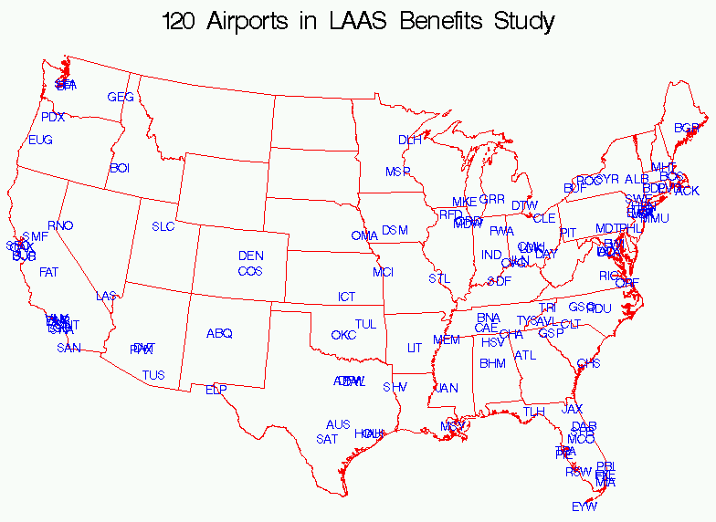

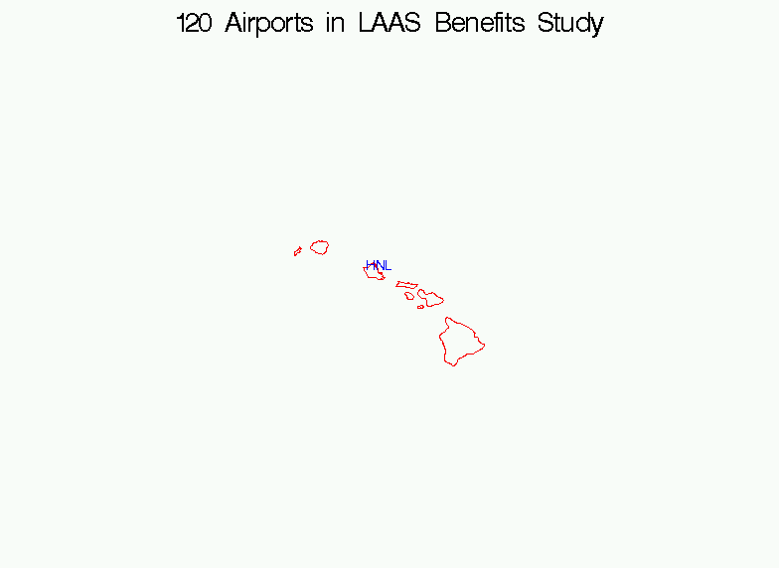

Appendix B: Order of Installation of LAAS Ground Facilities

The order in which LAAS ground facilities are installed is an important factor in the estimation of LAAS benefits. For this study, airport installations are assumed to take place at a pace of 24 per year, and in order of greatest to least benefit; that is, the first installations will be at airports with the highest benefit. A rank ordered list of airports is constructed by calculating the full 20-year discounted benefit, assuming LAAS is installed at all airports at IOC (June 2009 for Cat I; June 2013 for Cat II/III). A separate rank ordering is obtained depending on whether user equipage of WAAS is assumed to be 0% or 100%, since this assumption changes the benefits at many airports, and thus, potentially changes the order among airports. The following table shows the assumed date of installation at each of the 120 airports studied.

Airport | 0% WAAS |  | 100% WAAS |  | Airport | 0% WAAS |  | 100% WAAS
Airport | Cat I | Cat II/III | Cat I | Cat II/III | Airport | Cat I | Cat II/III | Cat I | Cat II/III
ABQ | Aug-2011 | Aug-2017 | Mar-2011 | Aug-2017 | JFK | Apr-2010 | Dec-2013 | Mar-2012 | Dec-2013
ACK | May-2010 | Mar-2014 | Feb-2010 | Mar-2014 | JNU | Jun-2009 | Nov-2017 | Jun-2009 | Nov-2017
AFW | . | May-2018 | . | May-2018 | LAS | Oct-2012 | July-2018 | Jan-2012 | July-2018
ALB | Sep-2010 | Sep-2014 | . | Sep-2014 | LAX | . | Feb-2014 | . | Feb-2014
ANC | Jun-2010 | Feb-2015 | Nov-2009 | Feb-2015 | LCK | . | Jun-2018 | . | Jun-2018
ATL | Feb-2010 | Jun-2013 | Oct-2009 | Jun-2013 | LGA | Jan-2010 | Jun-2013 | . | Jun-2013
AUS | . | Apr-2015 | . | Apr-2015 | LGB | July-2010 | Feb-2016 | Jan-2010 | Feb-2016
AVL | . | Sep-2016 | . | Sep-2016 | LIT | Feb-2012 | Nov-2017 | Feb-2011 | Nov-2017
BDL | Dec-2009 | Mar-2015 | . | Mar-2015 | MCI | . | Dec-2014 | . | Dec-2014
BFI | . | Oct-2017 | . | Oct-2017 | MCO | Apr-2010 | Oct-2014 | Jan-2010 | Oct-2014
BGR | . | Jun-2017 | . | Jun-2017 | MDT | . | July-2017 | . | July-2017
BHM | Feb-2010 | Jan-2017 | . | Jan-2017 | MDW | Nov-2012 | Oct-2013 | Sep-2011 | Oct-2013
BNA | Mar-2011 | Dec-2016 | . | Dec-2016 | MEM | July-2009 | Aug-2014 | July-2009 | Aug-2014
BOI | Jan-2011 | Nov-2015 | . | Nov-2015 | MHT | Oct-2010 | Apr-2014 | May-2010 | Apr-2014
BOS | . | Dec-2013 | . | Dec-2013 | MIA | Mar-2011 | Jan-2017 | Nov-2010 | Jan-2017
BUF | Mar-2012 | Nov-2014 | Dec-2011 | Nov-2014 | MKE | Jan-2010 | Apr-2015 | Dec-2009 | Apr-2015
BUR | Sep-2009 | Mar-2017 | . | Mar-2017 | MMU | . | Apr-2018 | . | Apr-2018
BWI | . | Aug-2014 | . | Aug-2014 | MSP | . | July-2013 | . | July-2013
CAE | Oct-2011 | Feb-2017 | Aug-2011 | Feb-2017 | MSY | Oct-2010 | Nov-2014 | Mar-2010 | Nov-2014
CHA | May-2013 | Nov-2017 | Mar-2012 | Nov-2017 | OAK | Dec-2012 | Oct-2017 | Oct-2012 | Oct-2017
CHS | Feb-2011 | Oct-2015 | Jun-2010 | Oct-2015 | OKC | July-2010 | May-2015 | Feb-2010 | May-2015
CLE | Dec-2009 | Jan-2015 | Dec-2009 | Jan-2015 | OMA | . | May-2017 | . | May-2017
CLT | . | Sep-2013 | . | Sep-2013 | ONT | Jun-2010 | Jan-2016 | May-2010 | Jan-2016
CMH | . | May-2015 | . | May-2015 | ORD | July-2009 | July-2013 | July-2009 | July-2013
COS | Aug-2011 | Jun-2014 | Jun-2011 | Jun-2014 | ORF | Jan-2013 | Dec-2014 | July-2011 | Dec-2014
CVG | Oct-2009 | Jan-2014 | Sep-2009 | Jan-2014 | PBI | Dec-2011 | Aug-2017 | Aug-2011 | Aug-2017
DAB | Sep-2012 | Dec-2017 | July-2011 | Dec-2017 | PDX | Apr-2013 | Aug-2015 | Sep-2012 | Aug-2015
DAL | . | Jun-2015 | . | Jun-2015 | PHL | Feb-2012 | Mar-2014 | . | Mar-2014
DAY | May-2011 | Dec-2016 | Oct-2010 | Dec-2016 | PHX | Aug-2009 | Nov-2016 | Aug-2009 | Nov-2016
DCA | Oct-2009 | Jan-2015 | Jan-2012 | Jan-2015 | PIE | Mar-2012 | Dec-2017 | Sep-2011 | Dec-2017
DEN | . | Aug-2013 | . | Aug-2013 | PIT | . | Apr-2014 | . | Apr-2014
DFW | Sep-2009 | Aug-2013 | Sep-2009 | Aug-2013 | PVD | Apr-2011 | Sep-2015 | Nov-2010 | Sep-2015
DLH | Jan-2013 | Feb-2017 | Dec-2011 | Feb-2017 | RDU | Feb-2013 | Nov-2013 | Nov-2011 | Nov-2013
DSM | May-2011 | Nov-2016 | Aug-2010 | Nov-2016 | RFD | Nov-2011 | Apr-2018 | Jun-2011 | Apr-2018
DTW | Nov-2009 | Oct-2013 | May-2011 | Oct-2013 | RIC | Aug-2010 | Jun-2015 | Mar-2010 | Jun-2015
DVT | Jun-2013 | Sep-2018 | . | Sep-2018 | RNO | Dec-2011 | Jan-2018 | May-2011 | Jan-2018
ELP | . | Aug-2018 | . | Aug-2018 | ROC | Sep-2010 | Sep-2016 | Nov-2009 | Sep-2016
EUG | Oct-2011 | Dec-2015 | Jan-2011 | Dec-2015 | RSW | July-2011 | Oct-2014 | Aug-2010 | Oct-2014
EWR | . | Jan-2014 | . | Jan-2014 | SAN | Nov-2009 | Mar-2016 | . | Mar-2016
EYW | Feb-2013 | Aug-2018 | Sep-2012 | Aug-2018 | SAT | . | Jun-2014 | . | Jun-2014
FAI | Oct-2012 | Jan-2018 | . | Jan-2018 | SDF | . | Feb-2018 | . | Feb-2018
FAT | Dec-2012 | May-2018 | . | May-2018 | SEA | Aug-2009 | May-2014 | Aug-2009 | May-2014
FLL | Jun-2011 | Mar-2017 | Dec-2010 | Mar-2017 | SFB | May-2013 | Mar-2018 | Feb-2012 | Mar-2018
FWA | Jan-2011 | July-2017 | . | July-2017 | SFO | . | Mar-2015 | . | Mar-2015
FXE | Apr-2013 | July-2018 | Feb-2012 | July-2018 | SHV | Sep-2011 | Sep-2017 | Feb-2011 | Sep-2017
GEG | Dec-2010 | Feb-2015 | July-2010 | Feb-2015 | SJC | Mar-2010 | Aug-2015 | Oct-2009 | Aug-2015
GRR | Nov-2010 | July-2015 | Apr-2010 | July-2015 | SLC | Feb-2011 | Dec-2015 | Sep-2010 | Dec-2015
GSO | . | Feb-2014 | . | Feb-2014 | SMF | Aug-2010 | July-2014 | Apr-2010 | July-2014
GSP | . | Apr-2017 | . | Apr-2017 | SNA | Jan-2012 | Oct-2016 | Nov-2011 | Oct-2016
HNL | May-2010 | Jun-2018 | . | Jun-2018 | STL | . | Sep-2014 | . | Sep-2014
HOU | Nov-2011 | Nov-2013 | Apr-2011 | Nov-2013 | SWF | Sep-2012 | Mar-2018 | Oct-2011 | Mar-2018
HPN | Nov-2012 | July-2014 | Jan-2011 | July-2014 | SYR | July-2011 | May-2017 | July-2010 | May-2017
HSV | . | Feb-2018 | . | Feb-2018 | TEB | Mar-2010 | Oct-2016 | Mar-2011 | Oct-2016
IAD | . | May-2014 | . | May-2014 | TLH | Jun-2011 | Oct-2015 | Apr-2011 | Oct-2015
IAH | Jun-2009 | Sep-2013 | Jun-2009 | Sep-2013 | TPA | Dec-2010 | Jun-2017 | Sep-2010 | Jun-2017
ICT | Apr-2011 | July-2015 | Dec-2010 | July-2015 | TRI | Mar-2013 | Sep-2017 | . | Sep-2017
ILN | . | Jan-2016 | . | Jan-2016 | TUL | Jan-2012 | Feb-2016 | Oct-2010 | Feb-2016
IND | . | Nov-2015 | . | Nov-2015 | TUS | Mar-2013 | Sep-2018 | . | Sep-2018
JAN | . | Nov-2017 | . | Nov-2017 | TYS | . | Mar-2016 | . | Mar-2016
JAX | Sep-2011 | Sep-2015 | Jun-2010 | Sep-2015 | VNY | Nov-2010 | Apr-2017 | Oct-2011 | Apr-2017

Appendix C: Derivation of Disruption Costs

Disruptions occur when there is an interruption to a planned or optimum flight schedule, and are categorized as delays, cancellations, and diversions. These disruptions have costs for both aircraft operators (Direct Operating Cost; DOC) and passengers (Passenger Time Savings; PTS). Both DOC and PTS costs are assessed and reported by user type: Major passenger airlines, Regional airlines, Cargo carriers, Corporate jet operators, and General Aviation (GA).

Direct Operating Costs
A weighted average delay cost was computed for direct operating cost of Major, Regional, Cargo, Corporate, and other GA assuming two-thirds of delays are ground delays and one-third occur in the air. FAA APO data sources were used to obtain the recommended values. Corporate jet DOC costs were provided by the FAA’s Office of Investment Analysis and Operations Research (ASD) including cost of crew, fuel and maintenance.

Cancellation costs were configured assuming a typical mid size aircraft for Majors (i.e., MD80) and for Regional carriers (i.e., F100). Based on inputs from airline representatives, it was assumed that Cargo operators do not cancel flights, so no cost was needed for this user group. It was also assumed that since general aviation flights are not scheduled, corporate jet operators and other GA operators do not incur cancellations.

Diversion costs were derived from the Issue Paper analyzing “Schedule Disruptions” from the FAA’s Office of Aviation Policy and Plans (APO). The estimated average hourly costs of the aircraft for diverted flights were obtained for Majors and Regional carriers. It was further assumed that an average diversion time is approximately two hours, and the per hour costs were multiplied for total diversion cost per flight. The draft APO report used in this study (version 2) can be found at http://apo.faa.gov/arcc/Research.htm for more information.

The average unit costs of disruptions used for DOC values are summarized in Table C1.

Table C1: Average DOC Disruption Costs (2004 dollars)
Type of Disruption | Majors | Regional | Cargo | Corporate (NBAA) | General Aviation
Delay (per minute)* | $35.08 | $21.43 | $69.95 | $20.80 | $6.35
Cancellation | $6,820 | $2,132 | $0 | $0 | $0
Diversion** | $8,047 | $4,412 | $9,845 | $2,496 | $2,202
* Weighted Average direct operating cost
**Assume Average duration of a diversion is 2 hours

Passenger Time Savings
To monetize passenger benefits, the following PTS economic values were used, listed below by user type.

Table C2: Breakdown of PTS (dollars/hr)
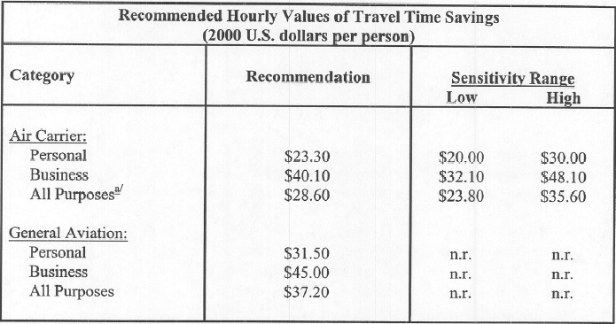

The Air Carrier’s All Purposes recommended values in Table C2 were used for Major and Regional users. Air Carrier Business category was used for all corporate jet travelers. General Aviation All Purposes was applied to all GA operations.

Aircraft capacity and utilization factors identified in Table C3 were applied to Passenger Time Savings to obtain total PTS per flight.

Table C3: Aircraft Capacity and Utilization Factors
Factor  User Type | Aircraft Seating Capacity | Passenger Load Factor
Major Carrier | 157 | 72%
Regional | 100 | 62%
Corporate | 10 | 50%
General Aviation | 6 | 60%

Results Summary:
A weighted average cost of a disruption was calculated using the observed occurrence of the three categories of disruption types. Observed disruptions for major and regional airlines were analyzed based on scheduled arrivals from Airline Service Quality Performance (ASQP) database. The proportion of each disruption type was then used to determine cargo, corporate, and GA disruptions.

Table C4 provides weighted average disruption DOC and PTS costs by user type. Costs were computed using FAA-APO recommended values.

Table C4: Average Disruption Costs by Carrier
User Type | Direct Operating Cost | Passenger Time Savings | Total Cost
Major Carrier | $3,359 | $2,765 | $6,124
Regional | $1,082 | $2,262 | $3,344
Cargo | $2,246 | $0 | $2,246
Corporate | $1,270 | $232 | $1,502
General Aviation | $412 | $138 | $551

Data Sources:

- The DOT’s Airline Service Quality Performance database was used for Scheduled Arrivals and Disruption data from January 1998 to July 2003. Outliers, such as the time period after September 11 and time periods associated with airline strikes were removed from the data.

- FAA APO data sources were used to obtain the recommended values. Updated Departmental Guidance to FAA Office of Aviation Policy and Plan, "Economic Values for Evaluation of FAA Investment and Regulatory Programs", FAA-APO-98-8:
  - Section 1- Treatment of Values of Passenger Time in Economic Analysis (U.S. Department of Transportation, FAA-APO-03-1, March 2003)
  - Section 3- Aircraft Utilization and Capacity Factors (2002 Passenger Air Carrier Capacity and Utilization Factors),Chapter Draft
  - Section 4- Majors and Regional direct operating cost (2002 Aircraft Operating Costs), Chapter Draft

- Inflation Factors Source: Dept. of Commerce, Bureau of Economic Analysis, GDP Price Indexes. OMB's GDP Price Index Guidelines were applied for projection to 2004 dollars.

Appendix D: Sensitivity Analyses

There is considerable uncertainty surrounding the proper values of several input parameters used in this benefits estimate. A sensitivity analysis was conducted to determine the impact of this uncertainty on the estimated benefits. This update to the LAAS efficiency benefits includes sensitivity analysis on three parameters:
- the cost of a disruption,
- the rate at which LAAS avionics equipage occurs, and
- the minimum avionics equipage level required for benefit accrual.

These three parameters were selected due to both the uncertainty of their values, and their central importance in building the benefits estimates. Based on research of historical precedents, published estimates, and interviews with airline and other industry stakeholders, there is a wide range of opinion regarding the correct value to assign to the cost of a flight disruption, the likely pace at which users will install new technology avionics, and the fraction of users that must be equipped before concerns about mixed-equipage operations are overcome. From this research, we have developed a range of expected values for each of these parameters, including a central, or most likely value, as well as upper and lower bounds. In each case, the central value was first developed from research, and then validated with airline representatives, with the upper and lower bounds also emerging from these stakeholder discussions.

The risk modeling approach selected for this analysis varies the parameter values between these upper and lower bounds in order to explore the extent to which the uncertainty in the parameter values may affect the benefits. This risk analysis was conducted using @RISK, a commercial software tool, which employs Monte Carlo simulation to explore a large number of possible values of the uncertain parameters.

The sensitivity analysis was conducted in two steps. The first analysis varied parameter values of both direct operating costs and passenger time costs for the five user groups (major airlines, regional airlines, cargo carriers, corporate jets, and general aviation). A triangular distribution was applied, representing low, most likely and high values of these costs. The tables below show the cost value ranges applied:

Table D1: Direct Operating Costs Ranges
User Type | Low Estimate | Best or Most Likely Estimate | High Estimate
Major Carrier | $2,330 | $3,359 | $5,278
Regional | $949 | $1,082 | $1,340
Cargo | $1,987 | $2,246 | $2,570
Corporate | $797 | $1,270 | $1,872
General Aviation | $352 | $412 | $491

Table D2: Ground and Airborne Delay Unit Costs Ranges
User Type | Low Estimate | Best Estimate | High Estimate
 | Ground / Airborne | Ground / Airborne | Ground / Airborne
Major Carrier | $27.63 / $39.47 | $30.70 / $43.85 | $33.77 / $48.24
Regional | $16.88 / $24.11 | $18.75 / $26.79 | $20.63 / $29.47
Cargo | $55.09 / $78.70 | $61.21 / $87.44 | $67.33 / $96.18
Corporate | $14.04 / $28.08 | $15.60 / $31.20 | $17.16 / $34.32
General Aviation | $5.00 / $7.15 | $5.55 / $7.94 | $6.11 / $8.73

Table D3: Passenger Time Savings Costs Ranges
User Type | Low Estimate | Best Estimate | High Estimate
Major Carrier | $2,121 | $2,765 | $3,722
Regional | $1,062 | $2,262 | $4,368
Cargo | $0 | $0 | $0
Corporate | $46 | $232 | $613
General Aviation | $67 | $138 | $256

In the second analysis, another distribution was applied based on low, medium, and high values of the time to equip and the minimum required equipage. These values are consistent with recommendations received through interviews with airline and air traffic control representatives:

- 5 years to equip with 0% critical mass,
- 6 years for fleet to equip with 80% critical mass and
- 8 years equipage rate with 100% critical mass, respectively.

Conducting the sensitivity analysis using these bounds produces risk-adjusted benefits for both direct operating cost and passenger time savings, for the two WAAS user equipage scenarios. Figures D1 through D4 show the range of estimated LAAS benefits, highlighting the 5th and 95th percentiles. Figures D1 and D2 show these results for direct operating costs and the 0% and 100% WAAS user equipage scenarios, respectively. Figures D3 and D4 show these results for passenger time savings and the 0% and 100% WAAS user equipage scenarios, respectively.

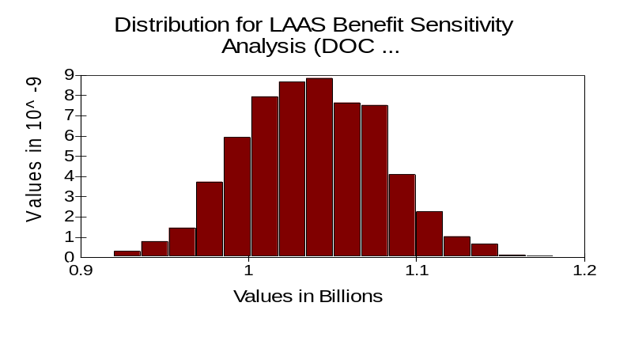
Figure D1: LAAS Direct Operating Cost Benefits (assuming 0% WAAS equipage)

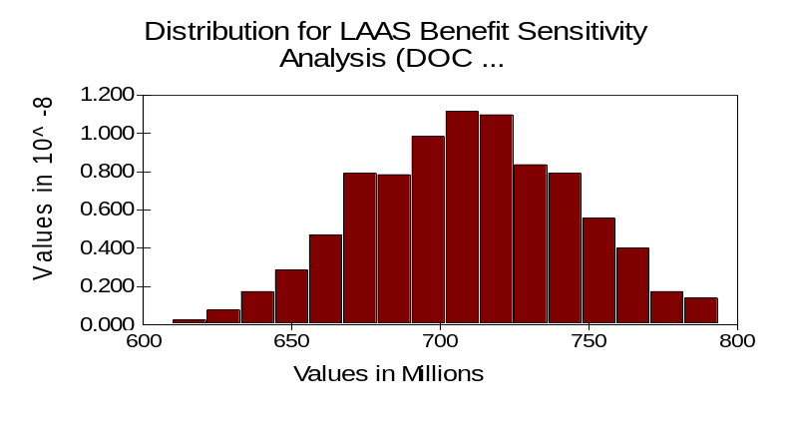
Figure D2: LAAS Direct Operating Cost Benefits (assuming 100% WAAS equipage)

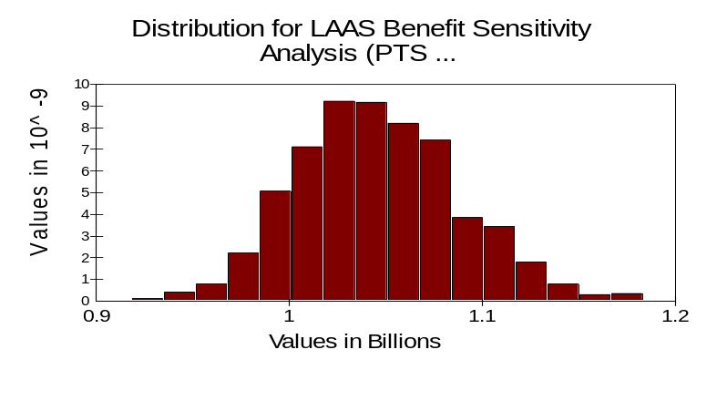
Figure D3: LAAS Passenger Time Savings (assuming 0% WAAS equipage)

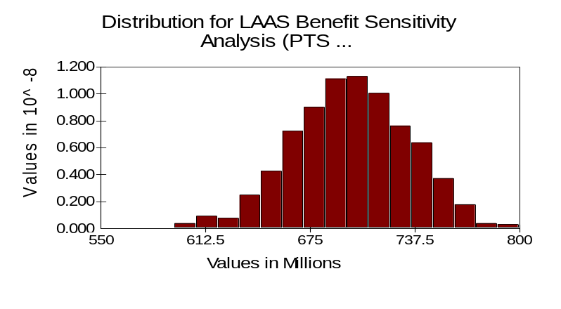
Figure D4: LAAS Passenger Time Savings (assuming 100% WAAS equipage)

Another output of the sensitivity analysis is an estimate of the relative influence that the uncertain parameters have on the benefits. In this case, the disruption cost parameter was shown to have about 50% more influence than the time to equip and critical mass parameters for the case of 0% WAAS equipage by users, and roughly equal influence with the time to equip and critical mass parameters for the case of 100% WAAS equipage by users.

Appendix E: Derivation of the Single Airport Delay Model

The Single Airport Delay Model is a deterministic model that can be used to estimate delays at a single airport when demand exceeds capacity. Since the model is deterministic, it does not take into account all of the delays that may occur due to the randomness of operations at a capacity constrained resource. Nevertheless, it offers a very reasonable approximation to those delays.

Basic Methodology and Illustrative Example

The model is based on a methodology described on pp. 339-343 of Robert Horonjeff’s and Francis McKelvey’s “Planning and Design of Airports” (4th edition, 1994). The idea behind the model is fairly straightforward. Any demand that cannot be satisfied by the available capacity during a particular period rolls over into the next period and contributes to delay. If the capacity during that period is sufficient to handle the rollover demand plus the new demand arriving in that period, there is no additional delay. However, if the demand exceeds the capacity, a rollover into the next period occurs once again and the delay accumulates. The spreadsheet model calculates the average delay and a number of other metrics that summarize the performance of the airport.

To understand how the model calculates delay, we use a simple example. Figure E1 illustrates the overall problem. A given airport has insufficient capacity to handle the demand. This demand can be in the form of arrivals, departures, or both, and the capacity can be for a single runway or multiple runways at the airport. The unit of time is a quarter hour, but can just as well be any other value. Note in this example that in the second quarter hour, the demand of 5 flights exceeds the capacity of 4 flights per 15 minute period.

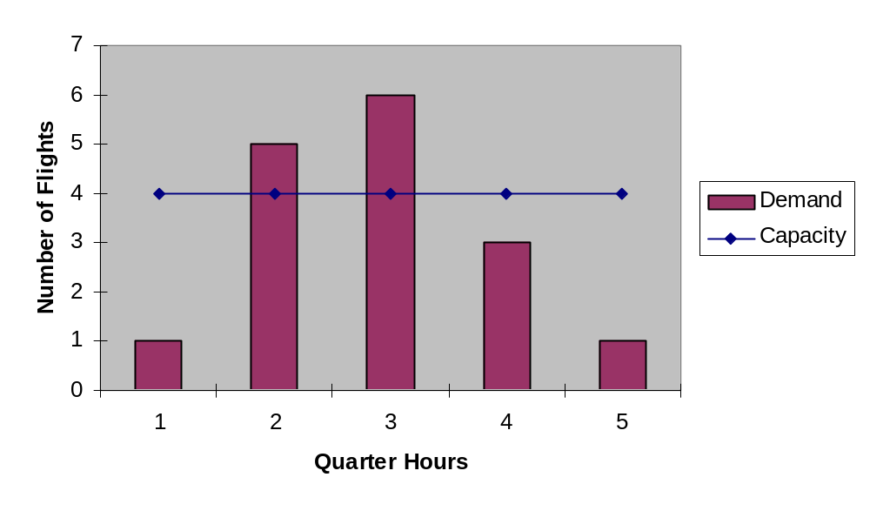
Figure E1. Illustrative Example of Demand and Capacity versus Time at an Airport

Figure E2 shows another way of representing this same data. In this graph, the demand and capacity are depicted as cumulative functions over the specified time period. Note that the cumulative capacity curve begins at the point in time when the demand rate starts to exceed the service rate or capacity (end of the first time period). For any point in time after that on the horizontal axis (until the two curves intersect once again), the vertical distance between the two curves represents the total queue at that point in time. Similarly, for any flight on the vertical axis, the horizontal distance between the two curves corresponds to the total delay experienced by that flight. The area between the two curves is the total delay for all the flights in this five quarter hour period.

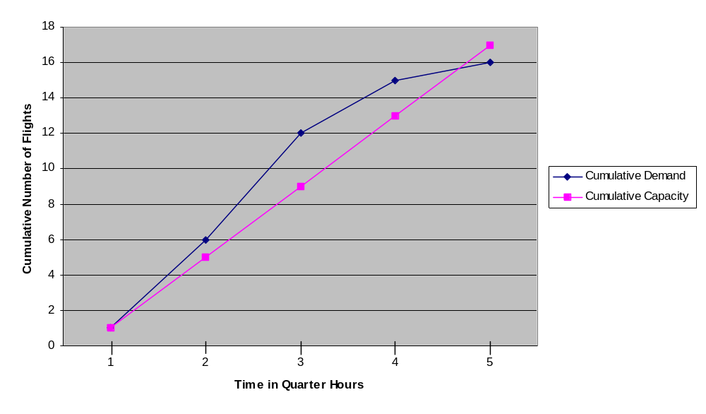
Figure E2. Cumulative Demand and Capacity Versus Time

In order to simplify Figure E2, we compute the difference between the cumulative demand and cumulative capacity and plot the result as a function of time over the period of interest when the demand exceeds the capacity. This effectively transforms Figure E2 into another graph (see Figure E3) with the y-value representing the total queue at any point in time. Note that in addition to obtaining the queue length, we can also derive a number of other performance measurements from this graph. For example, the maximum queue length can be easily seen to be 3.
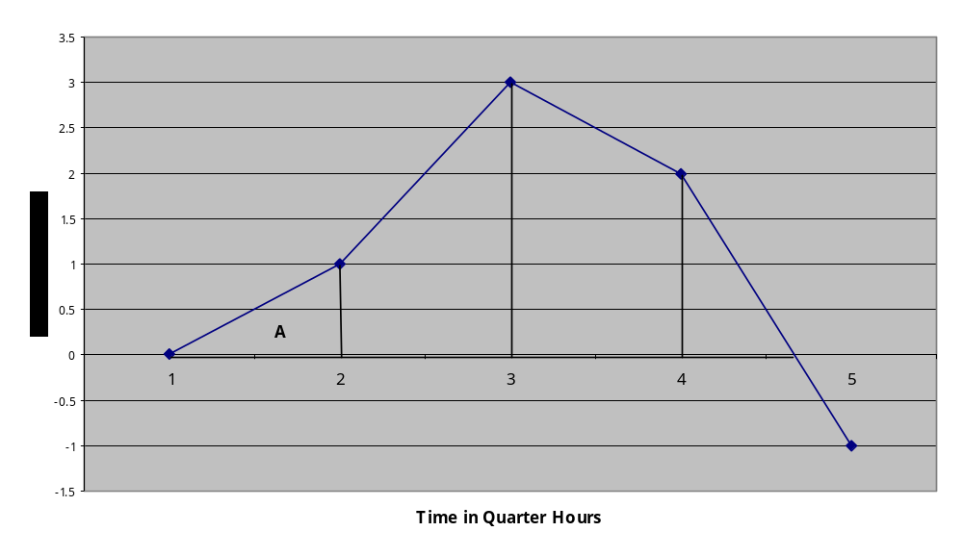
Figure E3. Difference Between Cumulative Demand and Cumulative Capacity as a Function of Time

Service time is the reciprocal of the capacity. For this particular example, the capacity is 16 aircraft/60 minutes, which gives a service time of 3.75 minutes per aircraft. Therefore the value for the longest delayed aircraft can be obtained by multiplying the maximum queue length by 3.75 minutes, thus obtaining 3 x 3.75 minutes = 11.25 minutes. The delay for all aircraft during any 15 minute period can be derived by calculating the area of the curve for that 15 minute period. This amounts to calculating the area of one of the triangles or trapezoids labeled A, B, C, or D. For example, the delay during the first 15 minute period is simply the area of triangle A - ½ x base x height or ½ x 15 minutes x 1 = 7.5 minutes. Note that the calculation of the area of D is a little more complex since the function does not intersect the x-axis at a convenient break point (multiple of the quarter hour time interval). Therefore, it is necessary to determine the exact point of intersection before the calculation can be performed.

Once the areas under the curve are determined for each quarter hour period, the total delay for all aircraft during the entire period can be obtained by summing the areas of all these triangles and trapezoids. In this example, this area turns out to be 85 minutes. The average delay per aircraft is then simply the total delay divided by the number of aircraft or 85 minutes/16 aircraft = 5.3 minutes/aircraft.

Inputs and Outputs in the Model

Model Input: Estimated Total Traffic

The total traffic demand at an airport, a key input to the Single Airport Delay Model, is estimated for each fifteen minute time period for a typical day by using the scheduled volume and factoring in an estimate of unscheduled traffic. We build up total traffic from three elements; 1) scheduled, 2) unscheduled IFR, and 3) VFR traffic. To address these three elements, three data sources from FAA-APO were used for this analysis: Flight Schedule Data System (FSDS), Enhanced Traffic Management System Counts (ETMSC), and OPSNET.

Scheduled volume was obtained from the FSDS database, using April 30, 2003 as a representative traffic volume day. This date was selected because the arrival count for that date had the median volume, nationwide, of the 2003 calendar year. Scheduled traffic is allotted to 15 minute periods throughout the day. To add unscheduled volume, ETMSC data, which include both scheduled and unscheduled IFR traffic, was obtained. We selected data for four Wednesdays within the same month, April 9, 16, 23 and 30, 2003 to obtain a representative sampling of the variability of this unscheduled traffic. An average ETMSC count of arrivals and departures for these four days was calculated and the number of flights above and beyond the scheduled traffic was then added to the original FSDS-based daily volume. These flights were added randomly to 15 minute periods over the 24 hours of the day. VFR traffic was added through a similar process. Flight counts were obtained from OPSNET, which includes both IFR and VFR flights. OPSNET flight counts above and beyond the average ETMSC traffic represent an estimate of VFR traffic, and were added to the scheduled and unscheduled traffic. Since these VFR flights typically occur during daylight hours, this volume was added randomly between 6am and 10pm to complete our total traffic estimate.

Example:
To illustrate the method of building the total traffic, the following chart shows simulated numbers of arrivals reported by each database, for an imaginary example airport, ABC, on April 30th, 2003.

Airport | FSDS Arrivals | ETMSC Arrivals | OPSNET Arrivals
ABC | 200 | 224 | 240

The 200 scheduled FSDS arrivals are allotted to their proper quarter-hour periods. ETMSC reports 24 additional arrivals beyond those in FSDS. We use a random number generator to assign these 24 flights to quarter-hour time slots, adding these to the FSDS arrivals already in those quarter-hours. NOTE: The random number generator allows for replacement, so any quarter-hour throughout the day can have any number of these 24 flights added to it.

The random assignment process is repeated for the additional 16 OPSNET arrivals above and beyond those recorded in the ETMSC database. These sixteen flights will be added at random to the new volume calculated from the FSDS + ETMSC data. The end result is an estimate of the total traffic encountered at an airport, and it is used as an input to IBM’s Single Airport Delay Model to simulate the actual flights that arrive and depart at each airport on that day.

The chart below illustrates how these arrivals might be assigned to quarter-hour periods to build a total number of arrivals for each period. Only part of a complete 24 hour day is shown for this example.
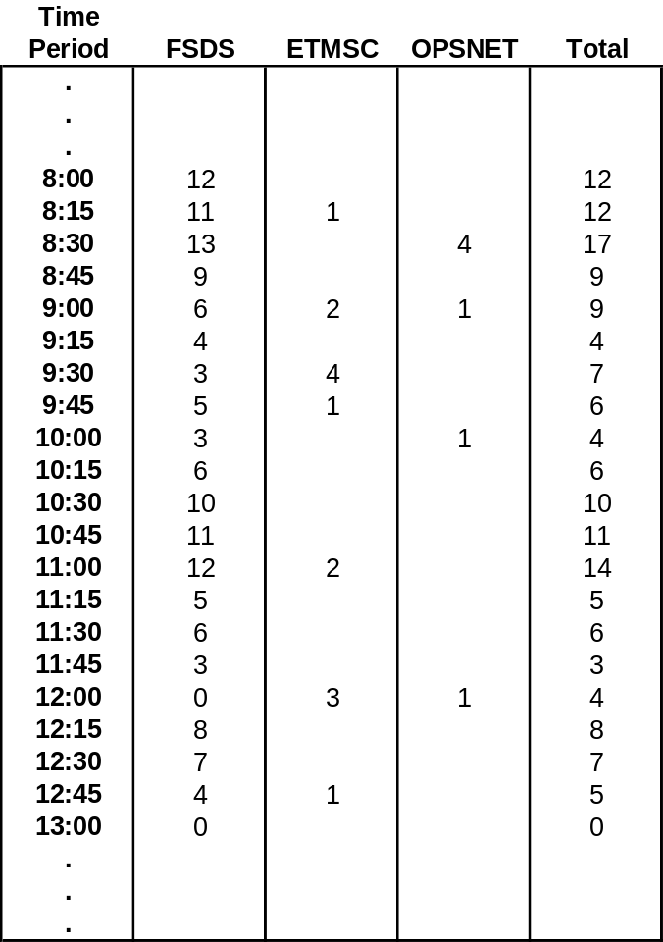

Continuing the example from the previous sections, Table E1 shows the values derived by the model for this illustrative example, including all of the critical system performance parameters.

Table E1. Single Airport Delay Model Inputs and Results for Illustrative Example
Quarter Hour | Demand (D) | Capacity (C) | D - C | # of Aircraft in Queue | Delays/Quarter Hour | Dem>Cap? | A/C in Queue?
0:15 | 1 | 4 | -3 | 0 |  | 0 | 0
0:30 | 5 | 4 | 1 | 1 | 7.5 | 1 | 1
0:45 | 6 | 4 | 2 | 3 | 30.0 | 1 | 1
1:00 | 3 | 4 | -1 | 2 | 37.5 | 0 | 1
1:15 | 1 | 4 | -3 | 0 | 10.0 | 0 | 0
 | 16
Total delay = |  |  | 85.0 | minutes | or | 1.4 | hours
Average delay per aircraft = |  |  | 5.3 | min/aircraft
Largest number of aircraft delayed = |  |  | 3 | aircraft
Delay time for longest-delayed aircraft = |  |  | 11.3 | minutes
# of quarter hours when demand>cap = |  |  | 2 |  | or | 40% | of the time
# of quarter hours when ac in queue = |  |  | 3 |  | or | 60% | of the time

The inputs to the model are the demand and the capacity. Demand at each airport was estimated as described above, using the scheduled volume and factoring in an estimate of unscheduled traffic. Airport capacity data was provided by FAA ASD-430.

The model simply calculates the difference between the demand and capacity during each period. The “#of Aircraft in Queue” column contains the queue lengths (shown as y-axis values (Aircraft In Queue) in Figure E3). They are obtained by calculating the difference between the overall demand (flights left over from the previous period plus those arriving in this period) and the capacity. Negative values are set equal to zero since we cannot have a negative queue length.

The “Delays/Quarter Hour” are obtained by calculating the areas of the triangles and trapezoids as described earlier (in reference to Figure E3). The last two columns are simply set to 1 when the fourth and fifth columns, respectively, are greater than 0.

The highlighted metrics at the bottom of the table summarize the results of the computations. The methods for deriving the first four values were described previously. The last two metrics are obtained by taking the sum of the last two columns and dividing by the total number of quarter hour periods to obtain the “# of quarter hours when demand exceeds capacity” and the “# of quarter hours when aircraft are in queue”, respectively.

Summary
In summary, it is important to note that the Single Airport Delay Model is extremely simple to use and can be easily adapted to determine delays associated with any demand and capacity imbalance. It is not restricted to aircraft and airports, but in fact can be used for a wide variety of applications. In particular, it has already proven to be useful in determining delays that may occur from the introduction of new security screening equipment and procedures at airline cargo facilities.

Appendix F: Navigation Capabilities Baseline

LAAS benefits are estimated relative to a baseline of existing and planned systems. This baseline was defined in the Navigation Capabilities Baseline delivered November 2003. The following three tables, excerpted from the earlier deliverable, contain the key elements of the baseline:

- NAS Baseline – the existing and planned ground and space-based infrastructure
- System Capabilities – those capabilities associated with existing and planned systems
- User Baseline – estimates of avionics equipage levels for the relevant systems

Table F1: NAS Baseline

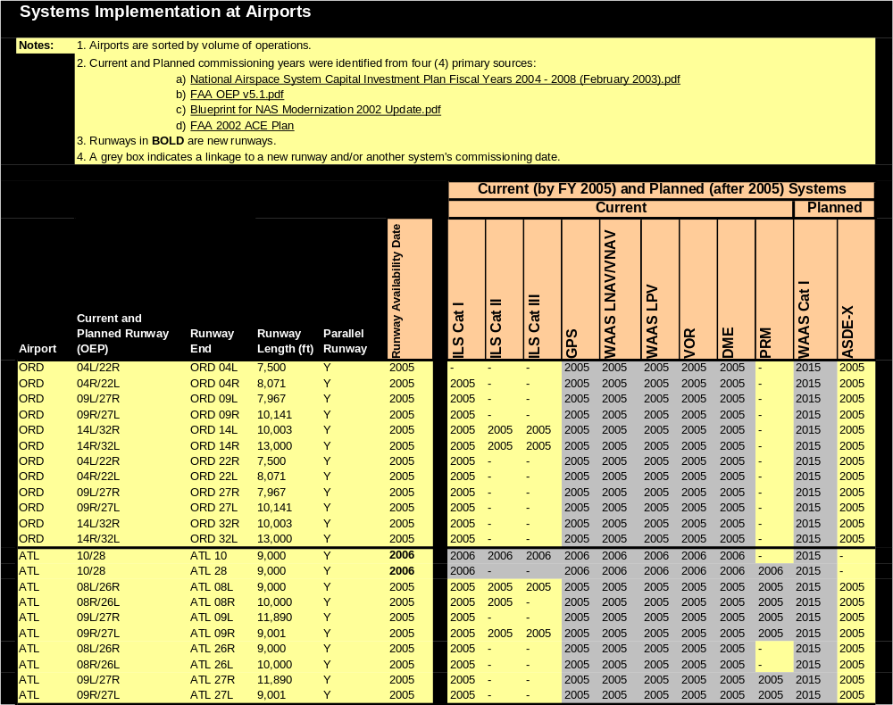
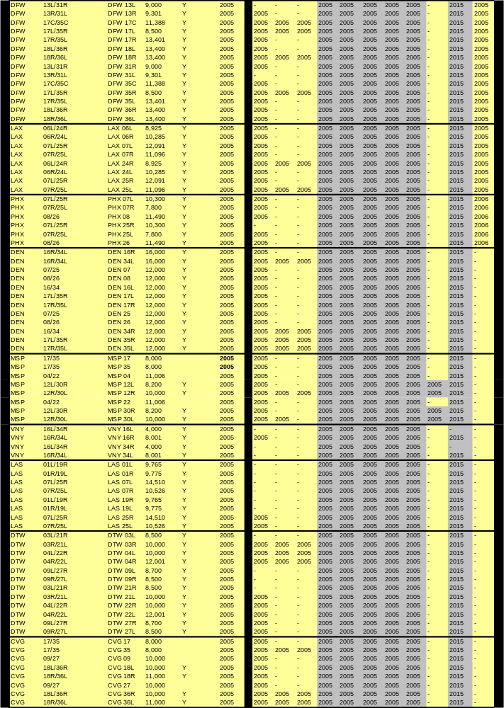
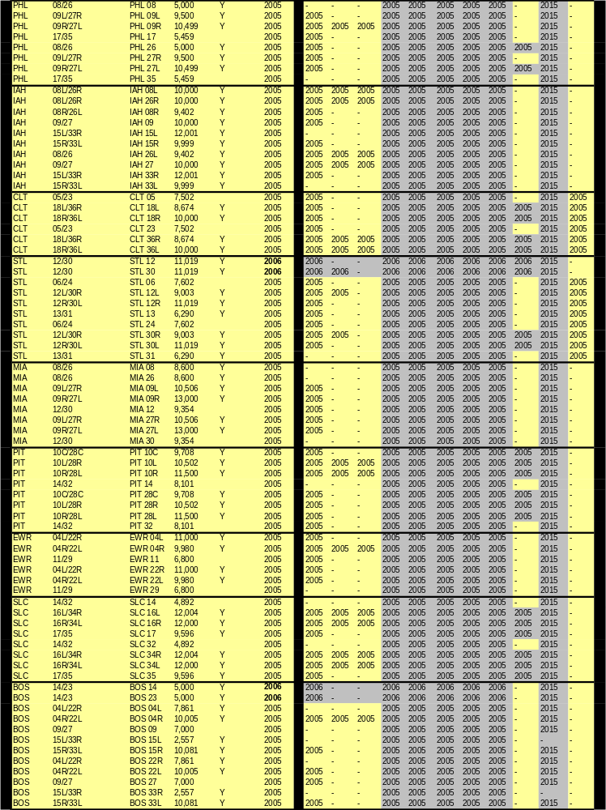
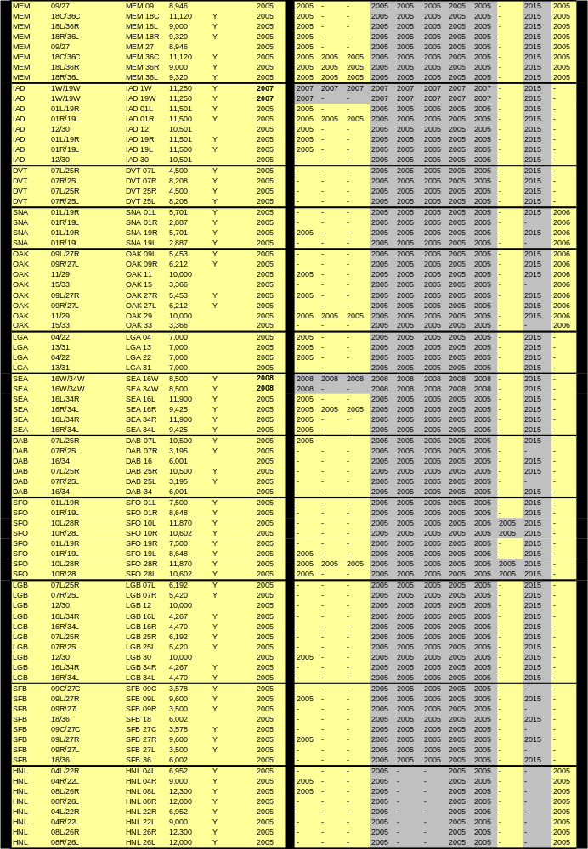
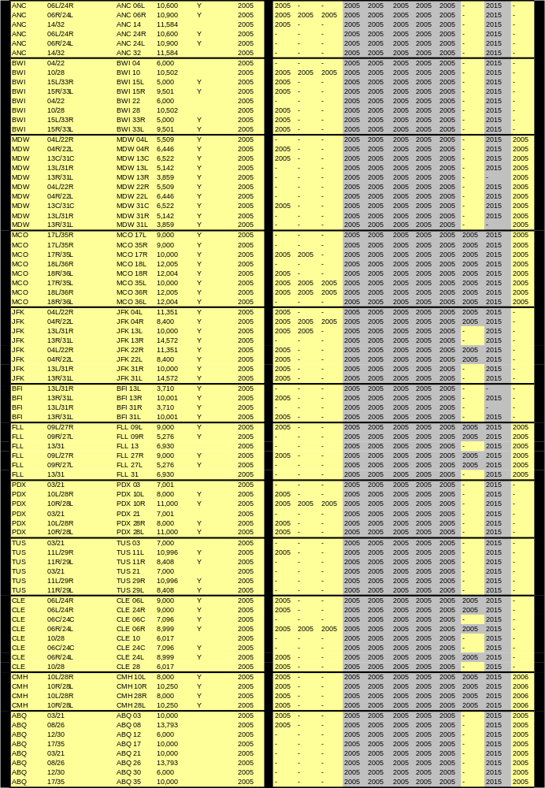
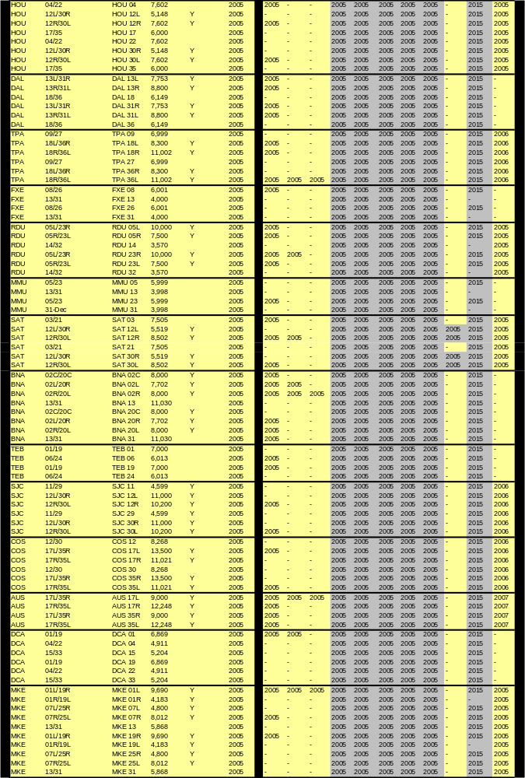
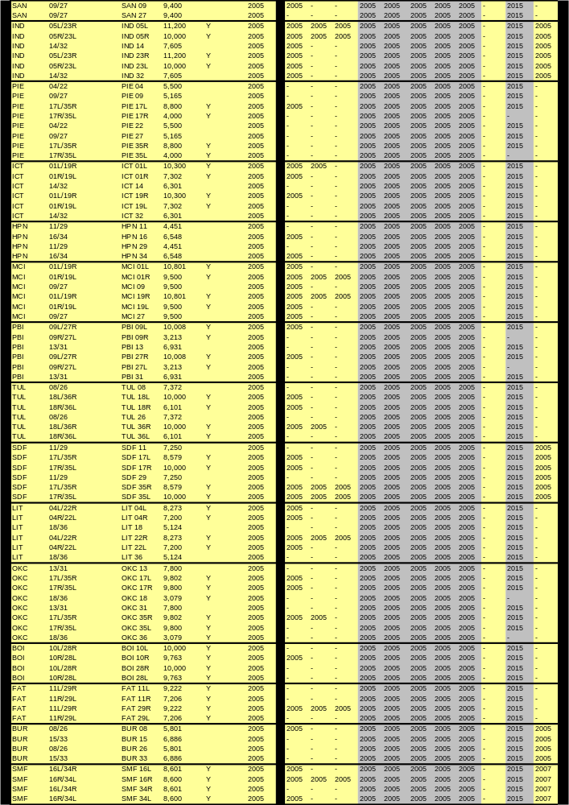
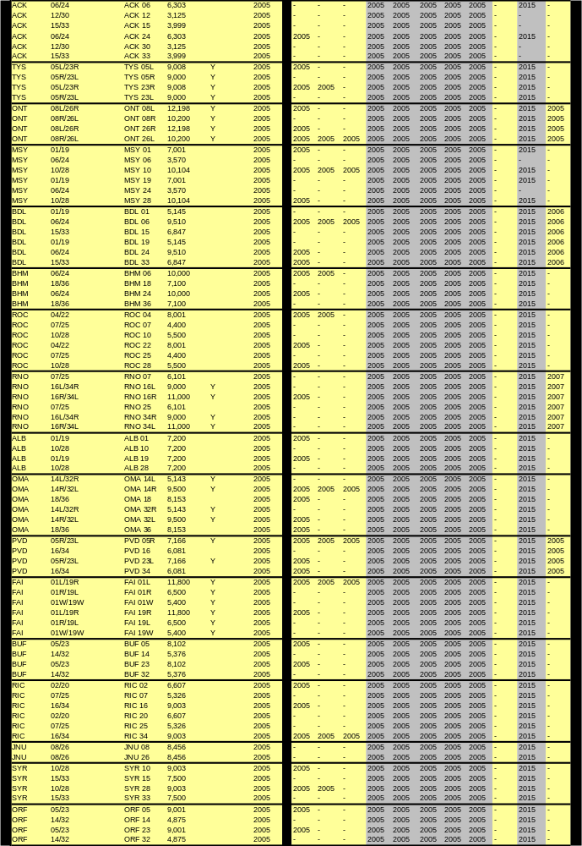
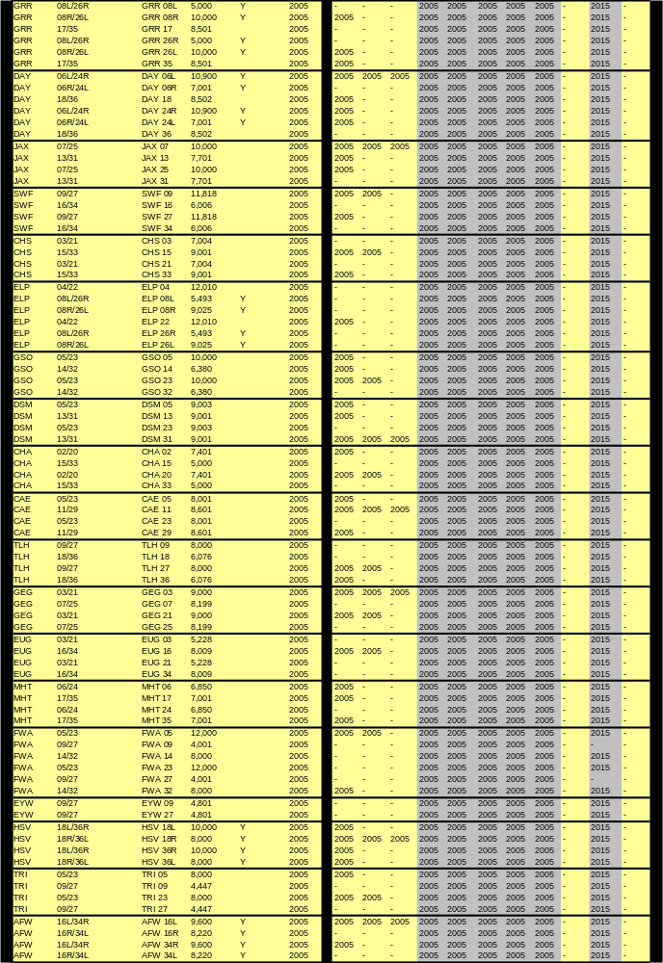
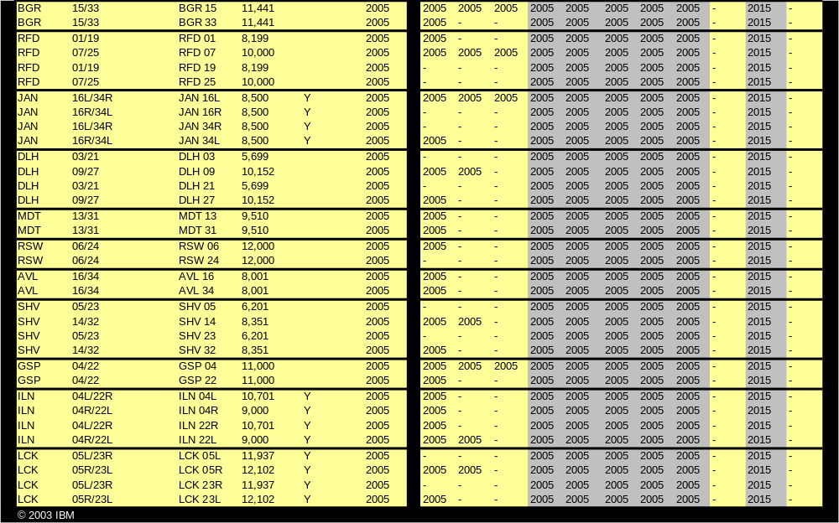
Table F2: System Capabilities

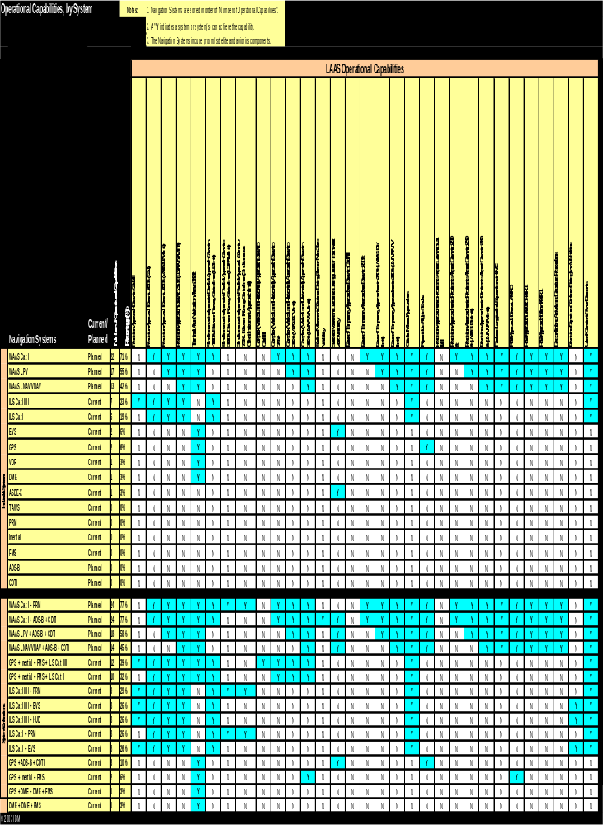
Table F3: User Baseline

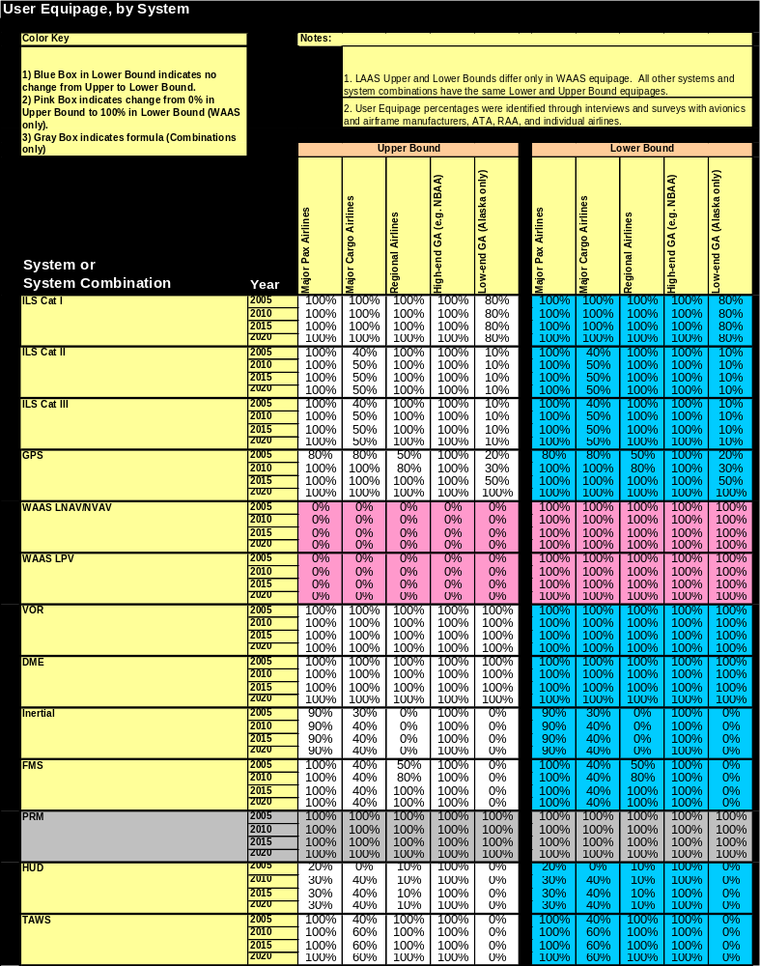
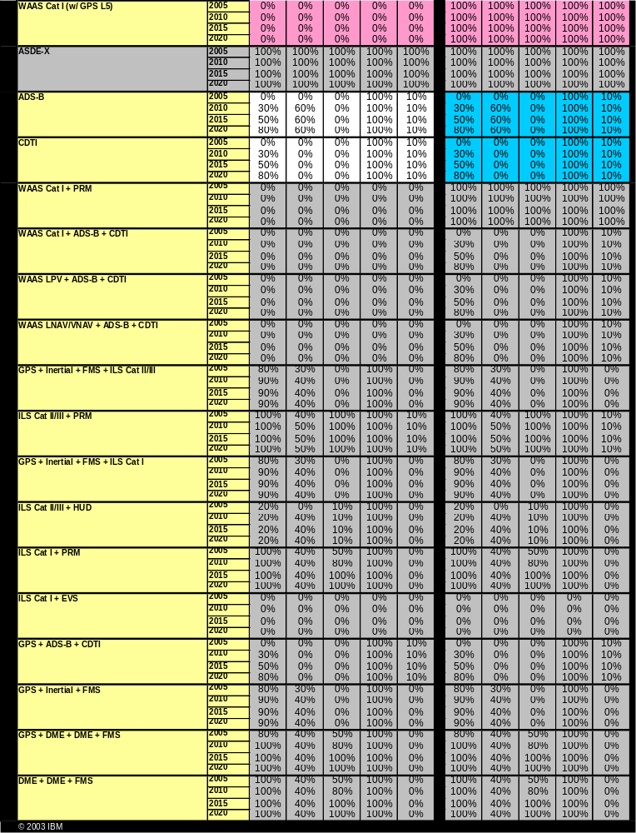

Appendix G: Potential LAAS Sites Outside of the 120 Airports

The following airports, listed in alphabetical order, have been identified by airline stakeholders as potential LAAS candidate airports outside the IBM 120 Airports.

Airport Code | Location | 2003 Scheduled Arrivals
ASE | Aspen, CO | 4,162
EAT | Wenatchee, WA | 2,334
EGE | Eagle County, CO | 2,257
GUC | Gunnison County, CO | 1,387
ISP | Long Island, NY | 16,243
JAC | Jackson Hole, WY | 4,979
PUW | Pullman, WA | 1,744
SIT | Sitka, AL | 1,647
SUN | Sun Valley, ID | 4,333
YAK | Yakutat, AL | 1,196

Limitations
Lack of operational data precludes analyzing these airports at the same level of detail as was performed for the IBM 120 Airports.
Analysis of airports outside of the original list of 120 is currently out of scope for this study.

Appendix H: Aviation Facilities within 23nm of the 120 Airports

The LAAS Concept of Operations (CONOPS), dated August 5, 2002, states the LAAS service coverage volume extends out to 23nm radially from the LAAS Ground Facility VDB [Very High Frequency (VHF) Data Broadcast (VDB)].

IBM identified the aviation facilities (e.g., other airports, seaplane bases, gliderports, and heliports) within 23nm of each of the IBM 120 Airports from entries in the NFDC database. Table H1 lists the results of this investigation, which identified: 1) 6,453 total aviation facilities within 23nm of all 120 airports, and 2) 428 total aviation facilities within 23nm of the 6 LRIP Airports.

This table shows the scope of potential beneficiaries of the LAAS signal if LAAS were installed at each of the 120 airports. No claim of benefits is made for this potential capability, as the evaluation and certification of LAAS service to proximate facilities has yet to be determined by the FAA.

Table H1: Number of aviation facilities within 23nm of each of the 120 Airports.
The LAAS LRIP sites are shown in bold.
Airport Code | # of Proximate Airports | Airport Code | # of Proximate Airports | Airport Code | # of Proximate Airports | Airport Code |  | # of Proximate Airports | Airport Code |  | # of Proximate Airports |  | Airport Code | # of Proximate Airports
ABQ | 13 | CHS | 10 | FAI | 13 | JFK | 86 |  | OKC | 57 |  | SDF |  | 31
ACK | 4 | CLE | 62 | FAT | 26 | JNU | 6 |  | OMA | 35 |  | SEA |  | 85
AFW | 124 | CLT | 31 | FLL | 52 | LAS | 22 |  | ONT | 53 |  | SFB |  | 56
ALB | 42 | CMH | 71 | FWA | 57 | LAX | 152 |  | ORD | 93 |  | SFO |  | 26
ANC | 24 | COS | 23 | FXE | 41 | LCK | 50 |  | ORF | 34 |  | SHV |  | 28
ATL | 75 | CVG | 39 | GEG | 32 | LGA | 104 |  | PBI | 38 |  | SJC |  | 18
AUS | 31 | DAB | 23 | GRR | 34 | LGB | 161 |  | PDX | 99 |  | SLC |  | 28
AVL | 11 | DAL | 116 | GSO | 30 | LIT | 35 |  | PHL | 148 |  | SMF |  | 37
BDL | 75 | DAY | 57 | GSP | 23 | MCI | 68 |  | PHX | 78 |  | SNA |  | 81
BFI | 75 | DCA | 71 | HNL | 13 | MCO | 64 |  | PIE | 35 |  | STL |  | 66
BGR | 12 | DEN | 73 | HOU | 160 | MDT | 77 |  | PIT | 68 |  | SWF |  | 45
BHM | 23 | DFW | 139 | HPN | 68 | MDW | 77 |  | PVD | 49 |  | SYR |  | 34
BNA | 29 | DLH | 13 | HSV | 21 | MEM | 38 |  | RDU | 21 |  | TEB |  | 114
BOI | 18 | DSM | 25 | IAD | 73 | MHT | 65 |  | RFD | 83 |  | TLH |  | 11
BOS | 75 | DTW | 46 | IAH | 128 | MIA | 57 |  | RIC | 35 |  | TPA |  | 42
BUF | 44 | DVT | 73 | ICT | 55 | MKE | 43 |  | RNO | 22 |  | TRI |  | 17
BUR | 138 | ELP | 9 | ILN | 42 | MMU | 149 |  | ROC | 40 |  | TUL |  | 50
BWI | 70 | EUG | 27 | IND | 94 | MSP | 72 |  | RSW | 39 |  | TUS |  | 17
CAE | 21 | EWR | 141 | JAN | 25 | MSY | 40 |  | SAN | 20 |  | TYS |  | 34
CHA | 18 | EYW | 6 | JAX | 28 | OAK | 32 |  | SAT | 59 |  | VNY |  | 137

There is a wide variety of facilities included in the list above. To give a sample of these facilities, Table H2 details the 84 aviation facilities within 23nm of SEA.

Table H2: Aviation facilities within 23nm of SEA
Locid | Airport Name | City | State
02WA | CAWLEYS SOUTH PRAIRIE | SOUTH PRAIRIE | WA
08WA | MANCHESTER LABORATORY | MANCHESTER | WA
0S8 | PORT ORCHARD | PORT ORCHARD | WA
0W0 | SEATTLE SEAPLANES | SEATTLE | WA
0WA6 | STEVENS MEMORIAL HOSPITAL | EDMONDS | WA
0WA8 | CHILDRENS HOSPITAL EMERGENCY | SEATTLE | WA
1S0 | PIERCE COUNTY - THUN FIELD | PUYALLUP | WA
1WA1 | WEBER POINT | REDMOND | WA
1WA6 | FALL CITY | FALL CITY | WA
1WA8 | MADIGAN HOSPITAL | FORT LEWIS | WA
23WA | BCAG - FREDERICKSON | PUYALLUP | WA
29WA | CROSSINGS | TACOMA | WA
2S1 | VASHON MUNI | VASHON | WA
2WA2 | QUARTERMASTER HARBOR | DOCKTON | WA
2WA4 | MOSS FIELD | GRAHAM | WA
31WA | MARY BRIDGE | TACOMA | WA
3B8 | SHADY ACRES | SPANAWAY | WA
3WA6 | BOEING KENT | KENT | WA
3WA7 | KENT BENAROYA | KENT | WA
43WA | WILSON | WOODINVILLE | WA
47WA | FITZ PAD 1 | WOODINVILLE | WA
51WA | EVERGREEN SKY RANCH | BLACK DIAMOND | WA
54WA | TUKWILA OPERATIONS CENTER | TUKWILA | WA
60WA | J. J. H. | AUBURN | WA
64WA | TAYMAR | BELLEVUE | WA
71WA | I-90/BELLEVUE BUSI PK BOEING COMP SVCS H | BELLEVUE | WA
7WA8 | GOOD SAMARITAN HOSP | PUYALLUP | WA
81WA | JOBE SKIS PLANT 1 | REDMOND | WA
83Q | PORT OF POULSBO MARINA MOORAGE | POULSBO | WA
88WA | PERSONAL 500 SALES CO. | SUMNER | WA
8WA2 | BOEING RENTON RAMP SITE NR 2 | RENTON | WA
8WA3 | VALLEY MEDICAL CENTER | RENTON | WA
8WA8 | SNOQUALMIE VALLEY HOSPITAL EMERGENCY ROOM | KING COUNTY | WA
8WA9 | BROADCAST HOUSE HELISTOP | SEATTLE | WA
92WA | CONNER | ISSAQUAH | WA
95WA | BLACK DIAMOND | BLACK DIAMOND | WA
9WA0 | BOEING PLANT 2 | SEATTLE | WA
9WA6 | PUGET SOUND PLAZA | SEATTLE | WA
9WA9 | NAVAL SUBMARINE BASE BANGOR | SILVERDALE | WA
BFI | BOEING FIELD/KING COUNTY INTL | SEATTLE | WA
PWT | BREMERTON NATIONAL | BREMERTON | WA
RNT | RENTON MUNI | RENTON | WA
S36 | CREST AIRPARK | KENT | WA
S37 | CLOVER PARK TECHNICAL COLLEGE | TACOMA | WA
S42 | APEX AIRPARK | SILVERDALE | WA
S44 | SPANAWAY | SPANAWAY | WA
S50 | AUBURN MUNI | AUBURN | WA
S60 | KENMORE AIR HARBOR INC | KENMORE | WA
TCM | MCCHORD AFB | TACOMA | WA
TIW | TACOMA NARROWS | TACOMA | WA
W36 | WILL ROGERS WILEY POST MEML | RENTON | WA
W37 | AMERICAN LAKE | TACOMA | WA
W55 | KENMORE AIR HARBOR | SEATTLE | WA
WA06 | DON JOHNSON HOME | AUBURN | WA
WA11 | BOEING MILITARY AIRPLANES | TUKWILA | WA
WA19 | BERKLEY STRUCTURES | REDMOND | WA
WA28 | TOM MATSON | AUBURN | WA
WA53 | HARBORVIEW MEDICAL CENTER | SEATTLE | WA
WA54 | 1001 FOURTH AVENUE PLAZA | SEATTLE | WA
WA55 | ELLIOTT PARK | SEATTLE | WA
WA69 | WAX ORCHARDS | VASHON | WA
WA75 | FLYING 'O' RANCH | COVINGTON | WA
WA77 | ENUMCLAW | ENUMCLAW | WA
WA84 | AUBURN ACADEMY | AUBURN | WA
WA85 | WEYERHAEUSER | AUBURN | WA
WA86 | BOEING - AUBURN COMPLEX | AUBURN | WA
WA92 | MC NEIL ISLAND EMERGENCY PAD | STEILACOOM | WA
WA94 | WASHINGTON AIR MUSEUM | BLACK DIAMOND | WA
WA96 | LEISURELAND AIRPARK | BREMERTON | WA
WN01 | SEATTLE PRIVATE NUMBER ONE | SEATTLE | WA
WN13 | VAUGHAN RANCH AIRFIELD | PORT ORCHARD | WA
WN16 | KOMO TV | SEATTLE | WA
WN19 | GIG HARBOR | GIG HARBOR | WA
WN22 | LAKE UNION | SEATTLE | WA
WN42 | FLYING H RANCH | BUCKLEY | WA
WN50 | ST JOSEPH HOSPITAL | TACOMA | WA
WN62 | AUBURN FIRE DEPARTMENT | AUBURN | WA
WN71 | EVANS | BELLEVUE | WA
WN76 | BERGSETH FIELD | ENUMCLAW | WA
WN79 | HALEY | WINSLOW | WA
WN83 | TELEPHONE UTILITIES/TIW/ | GIG HARBOR | WA
WN87 | BRYAN | ENUMCLAW | WA
WN91 | EVANS | REDMOND | WA
WN93 | PARK 90 | SEATTLE | WA
WN96 | MISTY ISLE FARMS | VASHON ISLAND | WA

Limitations
Investigation has shown that some double-counting of proximate facilities exists within the 120 airport list. For example, the list of proximate facilities for SEA includes BFI, and visa versa.

Final evaluation and certification of service provided to proximate facilities, if any, is to be determined by the FAA.

Appendix I: LAAS Benefits Analysis Assumptions

This following list of assumptions was developed, prior to the start of this analysis, through a series of meetings between IBM and the FAA. Several of these assumptions have been modified or updated as a result of new guidance from the FAA (e.g., #3, 4, 6, 13).

One key assumption, regarding airline WAAS equipage (#20), was designed to be modified through airline stakeholder feedback and the development of airline benefit estimates. For these preliminary findings, the impact of this assumption is bounded, as shown in the LAAS benefit tables, by estimating LAAS benefits for two cases:
- assuming no WAAS equipage by users (“0% WAAS”), and
- assuming full WAAS equipage by users (“100% WAAS”).

No. | Assumption
1 | LAAS will accrue benefit only when and where it provides capabilities above and beyond those provided by other systems.
2 | Where LAAS provides capabilities above and beyond those provided by other systems, it may reduce flight disruptions, including:  – Diversions  – Cancellations  – Delays (Ground Delay Program and circular holding delays)
3 | LAAS Cat-I Initial Operational Capability (IOC) at end of FY06 (changed to FY09; 2/26/04)
4 | LAAS Cat-II/III IOC in FY10 (changed to FY13; 2/26/04)
5 | LAAS may be installed at a maximum rate of 2 per month (24/yr), with a cap equal to the number of FAA LAAS airports to be studied
6 | LAAS approach procedures, including complex procedures, will be available at commissioning of each site, for all weather conditions. (changed to 4 months after commissioning; 2/26/04)
7 | LAAS training will keep pace with LAAS procedure development and publication.
8 | Appropriate infrastructure will exist at LAAS candidate runways at the time of LAAS installation
9 | There may be some decommissioning of ground-based navaids (consistent with the Navigation and Landing Transition Strategy)
10 | LAAS provides no operational improvement during weather conditions that would be likely to close the airport.
11 | LAAS, coupled with other technologies, may provide operational improvement in extremely low visibility conditions.
12 | WAAS LNAV/VNAV and LPV approach procedures, including complex procedures, will be available at or before LAAS commissioning at each site.
13 | WAAS Cat-I requires GPS L5 and modifications to the current architecture, and may not be achieved during the time period under study (2005 – 2024) (changed to 2009 – 20023; 2/26/04).
14 | GPS L5 frequency will become operationally available after 2015
15 | Detailed study of quantitative DoD benefits are beyond the scope of this benefits analysis.
16 | Assume LAAS can be sited at every airport. If all runway ends at the airport are within 5 nm* of each other, assume that one (1) LAAS will cover every runway end. Otherwise, assume that two (2) LAAS are required. (*Note: This distance will be verified with LAAS SME input)
17 | If any navigation system performance assumptions stated herein (SOW) cannot be achieved at a specific location, then the actual performance parameters will be used.
18a | RNAV and RNP operations (approaches) intercept a straight-in approach at or above 500’ HAT.  The straight-in approach can be supported by ILS, LAAS, or WAAS, to the appropriate operating minima.  RNAV and RNP departures and missed approaches have a straight-ahead segment to at least 400’ HAT.  Typical required performance (above 500’ HAT on approach, above 400’ HAT on missed approach or departure) is RNP-0.1.
18b | GPS/INS, GPS/WAAS and GPS/LAAS all provide an RNP-0.1 capability, with potentially different levels of service availability
18c | Cat I: The Cat I LAAS should obtain the benefits accruing from:  1) the reduction in weather minima below those supported by other systems  2) greater availability, where demonstrated.
18d | Cat I: LAAS performance would generally achieve Cat I GLS with [0.99999] availability
19a | Cat II/III: The Cat II/III LAAS should obtain the benefits accruing from:  1) the reduction in weather minima below those supported by other systems  2) greater availability, where demonstrated.
19b | The benefits analysis does not include any decommissioning of Cat II/III ILS facilities
20 | The initial airline equipage assumption is that all users equip with GPS/WAAS LPV as the baseline.  The final airline equipage assumption will be based on the airline benefit assessment.
21 | For efficiency analyses, expected LAAS user groups include: High-end GA (corporate turbine; helicopters), and commercial (airline and air-taxi) operators. Low-end (recreational) GA operators are not among the expected users of LAAS and will not be addressed in this efficiency analysis
22 | Navigation capabilities baseline will include:  NAS Baseline User Baseline  Current Systems  ILS X X_____________________________  WAAS-LPV X X_____________________________  VOR X X_____________________________  DME X X_____________________________  GPS X X_____________________________  Loran X X_____________________________  NDB X X_____________________________  INS X_____________________________  FMS X_____________________________  PRM X _____________________________  Multilateration X _____________________________  TAWS X_____________________________  HUD X_____________________________
23 | Navigation capabilities baseline will include:  NAS Baseline User Baseline  Planned Systems  WAAS-GLS X X_____________________________  GPS L5 X X_____________________________  GPS – III X X_____________________________  ASDE-X X _____________________________.  ADS-B X X_____________________________  CDTI X_____________________________
24 | LAAS improves safety by providing vertical guidance
25 | LAAS may be a source of positioning information for surface navigation systems
26 | For safety analyses covering operations in Alaska, low-end GA users, in addition to high-end GA and commercial users, will be considered.

Appendix J: LAAS Efficiency Benefits by User Group
Table J1: Discounted 20 year LAAS operating cost Benefits – 0% waas equipage scenario, by Airport
Airport | Total Benefit | Rank by Total Benefit | Major Passenger Airlines | Regional Passenger Airlines | Cargo Carriers | Corporate Jet GA Operators | Other GA Operators
ABQ | $1,916,000 | 87 | $1,531,000 | $195,000 | $119,000 | $71,000 | $0
ACK | $15,486,000 | 19 | $0 | $12,476,000 | $272,000 | $2,738,000 | $0
AFW | $189,000 | 114 | $0 | $0 | $145,000 | $44,000 | $0
ALB | $9,666,000 | 34 | $5,591,000 | $3,082,000 | $470,000 | $523,000 | $0
ANC | $9,343,000 | 36 | $4,218,000 | $1,461,000 | $2,311,000 | $305,000 | $1,048,000
ATL | $38,083,000 | 4 | $33,403,000 | $3,875,000 | $592,000 | $213,000 | $0
AUS | $5,116,000 | 58 | $4,486,000 | $62,000 | $0 | $568,000 | $0
AVL | $2,537,000 | 82 | $784,000 | $1,049,000 | $1,000 | $703,000 | $0
BDL | $15,778,000 | 18 | $11,278,000 | $2,071,000 | $944,000 | $1,485,000 | $0
BFI | $748,000 | 103 | $0 | $24,000 | $129,000 | $595,000 | $0
BGR | $1,153,000 | 95 | $0 | $693,000 | $61,000 | $399,000 | $0
BHM | $7,841,000 | 43 | $5,243,000 | $757,000 | $204,000 | $1,637,000 | $0
BNA | $3,069,000 | 74 | $2,421,000 | $336,000 | $97,000 | $215,000 | $0
BOI | $4,930,000 | 60 | $2,924,000 | $1,266,000 | $247,000 | $493,000 | $0
BOS | $13,168,000 | 22 | $9,658,000 | $2,892,000 | $222,000 | $396,000 | $0
BUF | $6,462,000 | 51 | $4,251,000 | $1,387,000 | $169,000 | $655,000 | $0
BUR | $39,748,000 | 2 | $37,131,000 | $222,000 | $530,000 | $1,865,000 | $0
BWI | $7,207,000 | 47 | $6,186,000 | $606,000 | $154,000 | $261,000 | $0
CAE | $2,069,000 | 86 | $623,000 | $816,000 | $379,000 | $251,000 | $0
CHA | $686,000 | 106 | $97,000 | $247,000 | $46,000 | $296,000 | $0
CHS | $4,906,000 | 61 | $2,421,000 | $1,657,000 | $135,000 | $693,000 | $0
CLE | $18,588,000 | 14 | $11,789,000 | $5,435,000 | $584,000 | $780,000 | $0
CLT | $17,695,000 | 15 | $14,692,000 | $2,251,000 | $288,000 | $464,000 | $0
CMH | $4,608,000 | 65 | $2,769,000 | $949,000 | $0 | $890,000 | $0
COS | $9,272,000 | 37 | $6,908,000 | $1,123,000 | $258,000 | $983,000 | $0
CVG | $37,930,000 | 5 | $17,373,000 | $16,736,000 | $3,430,000 | $391,000 | $0
DAB | $872,000 | 101 | $390,000 | $84,000 | $0 | $398,000 | $0
DAL | $4,409,000 | 68 | $2,553,000 | $115,000 | $48,000 | $1,693,000 | $0
DAY | $2,905,000 | 76 | $1,322,000 | $774,000 | $514,000 | $295,000 | $0
DCA | $30,834,000 | 6 | $27,088,000 | $3,633,000 | $0 | $113,000 | $0
DEN | $21,233,000 | 12 | $17,882,000 | $2,753,000 | $443,000 | $155,000 | $0
DFW | $53,558,000 | 1 | $42,408,000 | $9,213,000 | $1,841,000 | $96,000 | $0
DLH | $1,469,000 | 91 | $404,000 | $381,000 | $49,000 | $635,000 | $0
DSM | $3,004,000 | 75 | $1,062,000 | $1,133,000 | $387,000 | $422,000 | $0
DTW | $28,120,000 | 8 | $23,566,000 | $3,924,000 | $336,000 | $294,000 | $0
DVT | $8,000 | 120 | $0 | $0 | $0 | $8,000 | $0
ELP | $12,000 | 119 | $6,000 | $0 | $2,000 | $4,000 | $0
EUG | $3,887,000 | 70 | $1,012,000 | $1,891,000 | $469,000 | $515,000 | $0
EWR | $12,102,000 | 24 | $9,911,000 | $1,363,000 | $621,000 | $207,000 | $0
EYW | $99,000 | 117 | $0 | $75,000 | $0 | $24,000 | $0
FAI | $709,000 | 105 | $266,000 | $103,000 | $45,000 | $3,000 | $292,000
FAT | $408,000 | 109 | $16,000 | $345,000 | $19,000 | $28,000 | $0
FLL | $2,351,000 | 84 | $1,762,000 | $380,000 | $67,000 | $142,000 | $0
FWA | $2,581,000 | 81 | $92,000 | $1,392,000 | $704,000 | $393,000 | $0
FXE | $105,000 | 116 | $0 | $0 | $0 | $105,000 | $0
GEG | $7,226,000 | 46 | $4,273,000 | $1,675,000 | $1,063,000 | $215,000 | $0
GRR | $6,265,000 | 52 | $2,204,000 | $2,050,000 | $682,000 | $1,329,000 | $0
GSO | $11,775,000 | 26 | $7,100,000 | $2,524,000 | $943,000 | $1,208,000 | $0
GSP | $1,283,000 | 92 | $497,000 | $583,000 | $60,000 | $143,000 | $0
HNL | $4,523,000 | 67 | $1,528,000 | $2,721,000 | $249,000 | $25,000 | $0
HOU | $14,845,000 | 21 | $10,625,000 | $752,000 | $1,000 | $3,467,000 | $0
HPN | $7,740,000 | 44 | $1,293,000 | $1,489,000 | $0 | $4,958,000 | $0
HSV | $391,000 | 110 | $210,000 | $83,000 | $45,000 | $53,000 | $0
IAD | $9,237,000 | 38 | $5,301,000 | $2,936,000 | $117,000 | $883,000 | $0
IAH | $19,545,000 | 13 | $16,474,000 | $2,555,000 | $215,000 | $301,000 | $0
ICT | $5,342,000 | 56 | $1,940,000 | $805,000 | $422,000 | $2,175,000 | $0
ILN | $2,904,000 | 77 | $0 | $0 | $2,904,000 | $0 | $0
IND | $3,413,000 | 71 | $1,728,000 | $403,000 | $894,000 | $388,000 | $0
JAN | $732,000 | 104 | $431,000 | $122,000 | $45,000 | $134,000 | $0
JAX | $4,588,000 | 66 | $3,481,000 | $491,000 | $198,000 | $418,000 | $0
JFK | $17,460,000 | 16 | $12,146,000 | $3,632,000 | $1,450,000 | $232,000 | $0
JNU | $24,577,000 | 11 | $10,528,000 | $7,701,000 | $1,719,000 | $875,000 | $3,754,000
LAS | $344,000 | 112 | $318,000 | $0 | $0 | $26,000 | $0
LAX | $11,351,000 | 28 | $9,449,000 | $1,414,000 | $287,000 | $201,000 | $0
LCK | $122,000 | 115 | $0 | $0 | $122,000 | $0 | $0
LGA | $38,375,000 | 3 | $31,151,000 | $6,341,000 | $0 | $883,000 | $0
LGB | $6,197,000 | 53 | $3,283,000 | $106,000 | $579,000 | $2,229,000 | $0
LIT | $1,191,000 | 93 | $445,000 | $169,000 | $48,000 | $529,000 | $0
MCI | $5,813,000 | 55 | $4,616,000 | $843,000 | $240,000 | $114,000 | $0
MCO | $11,939,000 | 25 | $8,857,000 | $2,369,000 | $491,000 | $222,000 | $0
MDT | $1,031,000 | 98 | $496,000 | $285,000 | $124,000 | $126,000 | $0
MDW | $17,152,000 | 17 | $15,402,000 | $1,408,000 | $30,000 | $312,000 | $0
MEM | $9,687,000 | 33 | $5,417,000 | $1,214,000 | $2,305,000 | $751,000 | $0
MHT | $11,619,000 | 27 | $8,825,000 | $1,554,000 | $931,000 | $309,000 | $0
MIA | $2,839,000 | 78 | $2,132,000 | $369,000 | $235,000 | $103,000 | $0
MKE | $12,798,000 | 23 | $4,652,000 | $6,156,000 | $1,021,000 | $969,000 | $0
MMU | $235,000 | 113 | $0 | $0 | $0 | $235,000 | $0
MSP | $27,666,000 | 9 | $23,929,000 | $3,207,000 | $372,000 | $158,000 | $0
MSY | $8,376,000 | 41 | $7,391,000 | $405,000 | $248,000 | $332,000 | $0
OAK | $904,000 | 99 | $666,000 | $31,000 | $74,000 | $133,000 | $0
OKC | $8,381,000 | 40 | $5,645,000 | $1,269,000 | $495,000 | $972,000 | $0
OMA | $1,184,000 | 94 | $733,000 | $145,000 | $119,000 | $187,000 | $0
ONT | $6,666,000 | 50 | $5,118,000 | $267,000 | $1,188,000 | $93,000 | $0
ORD | $29,996,000 | 7 | $25,972,000 | $3,356,000 | $433,000 | $235,000 | $0
ORF | $5,927,000 | 54 | $3,744,000 | $1,422,000 | $266,000 | $495,000 | $0
PBI | $1,509,000 | 90 | $828,000 | $203,000 | $31,000 | $447,000 | $0
PDX | $4,135,000 | 69 | $2,971,000 | $782,000 | $203,000 | $179,000 | $0
PHL | $11,277,000 | 29 | $8,311,000 | $1,697,000 | $444,000 | $825,000 | $0
PHX | $1,625,000 | 89 | $1,454,000 | $68,000 | $50,000 | $53,000 | $0
PIE | $831,000 | 102 | $162,000 | $0 | $66,000 | $603,000 | $0
PIT | $10,200,000 | 32 | $7,620,000 | $2,158,000 | $165,000 | $257,000 | $0
PVD | $4,890,000 | 62 | $2,283,000 | $1,997,000 | $62,000 | $548,000 | $0
RDU | $15,144,000 | 20 | $8,379,000 | $4,962,000 | $350,000 | $1,453,000 | $0
RFD | $899,000 | 100 | $0 | $47,000 | $589,000 | $263,000 | $0
RIC | $7,424,000 | 45 | $4,479,000 | $1,728,000 | $518,000 | $699,000 | $0
RNO | $1,071,000 | 96 | $887,000 | $45,000 | $46,000 | $93,000 | $0
ROC | $5,082,000 | 59 | $2,269,000 | $1,708,000 | $609,000 | $496,000 | $0
RSW | $7,079,000 | 48 | $5,450,000 | $791,000 | $80,000 | $758,000 | $0
SAN | $27,315,000 | 10 | $23,370,000 | $2,227,000 | $463,000 | $1,255,000 | $0
SAT | $8,588,000 | 39 | $6,580,000 | $77,000 | $367,000 | $1,564,000 | $0
SDF | $439,000 | 108 | $196,000 | $42,000 | $169,000 | $32,000 | $0
SEA | $10,413,000 | 31 | $7,692,000 | $2,188,000 | $473,000 | $60,000 | $0
SFB | $367,000 | 111 | $0 | $112,000 | $0 | $255,000 | $0
SFO | $5,194,000 | 57 | $4,632,000 | $355,000 | $58,000 | $149,000 | $0
SHV | $1,819,000 | 88 | $224,000 | $993,000 | $206,000 | $396,000 | $0
SJC | $9,480,000 | 35 | $8,470,000 | $133,000 | $252,000 | $625,000 | $0
SLC | $4,771,000 | 63 | $3,751,000 | $441,000 | $163,000 | $416,000 | $0
SMF | $11,168,000 | 30 | $9,547,000 | $757,000 | $580,000 | $284,000 | $0
SNA | $2,378,000 | 83 | $853,000 | $124,000 | $25,000 | $1,376,000 | $0
STL | $6,932,000 | 49 | $5,964,000 | $692,000 | $65,000 | $211,000 | $0
SWF | $645,000 | 107 | $74,000 | $410,000 | $24,000 | $137,000 | $0
SYR | $2,122,000 | 85 | $965,000 | $864,000 | $155,000 | $138,000 | $0
TEB | $7,854,000 | 42 | $0 | $0 | $39,000 | $7,815,000 | $0
TLH | $4,664,000 | 64 | $712,000 | $2,653,000 | $360,000 | $939,000 | $0
TPA | $2,738,000 | 79 | $2,235,000 | $346,000 | $23,000 | $134,000 | $0
TRI | $1,068,000 | 97 | $139,000 | $517,000 | $33,000 | $379,000 | $0
TUL | $3,293,000 | 73 | $1,861,000 | $564,000 | $142,000 | $726,000 | $0
TUS | $56,000 | 118 | $47,000 | $0 | $0 | $9,000 | $0
TYS | $2,592,000 | 80 | $1,067,000 | $843,000 | $218,000 | $464,000 | $0
VNY | $3,410,000 | 72 | $0 | $0 | $0 | $3,410,000 | $0
Total | $996,971,000 |  | $686,989,000 | $182,603,000 | $44,975,000 | $77,310,000 | $5,094,000
Table J2: Discounted 20 year LAAS Passenger Time Savings – 0% waas equipage scenario, by Airport
Airport | Total Benefit | Rank by Total Benefit | Major Passenger Airlines | Regional Passenger Airlines | Cargo Carriers | Corporate Jet GA Operators | Other GA Operators
ABQ | $1,734,000 | 86 | $1,316,000 | $404,000 | $0 | $14,000 | $0
ACK | $26,581,000 | 9 | $0 | $26,081,000 | $0 | $500,000 | $0
AFW | $8,000 | 117 | $0 | $0 | $0 | $8,000 | $0
ALB | $11,324,000 | 27 | $4,825,000 | $6,399,000 | $0 | $100,000 | $0
ANC | $6,932,000 | 44 | $3,472,000 | $3,053,000 | $0 | $56,000 | $351,000
ATL | $40,617,000 | 3 | $33,056,000 | $7,519,000 | $0 | $42,000 | $0
AUS | $3,926,000 | 66 | $3,692,000 | $130,000 | $0 | $104,000 | $0
AVL | $2,997,000 | 71 | $686,000 | $2,174,000 | $0 | $137,000 | $0
BDL | $13,884,000 | 22 | $9,284,000 | $4,329,000 | $0 | $271,000 | $0
BFI | $167,000 | 110 | $0 | $49,000 | $0 | $118,000 | $0
BGR | $1,523,000 | 88 | $0 | $1,450,000 | $0 | $73,000 | $0
BHM | $6,197,000 | 51 | $4,316,000 | $1,582,000 | $0 | $299,000 | $0
BNA | $2,734,000 | 75 | $1,993,000 | $702,000 | $0 | $39,000 | $0
BOI | $5,145,000 | 58 | $2,407,000 | $2,648,000 | $0 | $90,000 | $0
BOS | $14,069,000 | 21 | $7,950,000 | $6,047,000 | $0 | $72,000 | $0
BUF | $6,523,000 | 45 | $3,505,000 | $2,898,000 | $0 | $120,000 | $0
BUR | $31,454,000 | 5 | $30,646,000 | $465,000 | $0 | $343,000 | $0
BWI | $6,408,000 | 47 | $5,092,000 | $1,268,000 | $0 | $48,000 | $0
CAE | $2,264,000 | 83 | $513,000 | $1,705,000 | $0 | $46,000 | $0
CHA | $649,000 | 99 | $80,000 | $515,000 | $0 | $54,000 | $0
CHS | $5,584,000 | 55 | $1,992,000 | $3,465,000 | $0 | $127,000 | $0
CLE | $21,208,000 | 13 | $9,704,000 | $11,362,000 | $0 | $142,000 | $0
CLT | $16,885,000 | 19 | $12,094,000 | $4,706,000 | $0 | $85,000 | $0
CMH | $4,543,000 | 62 | $2,404,000 | $1,968,000 | $0 | $171,000 | $0
COS | $8,634,000 | 35 | $6,119,000 | $2,323,000 | $0 | $192,000 | $0
CVG | $46,777,000 | 2 | $21,620,000 | $25,090,000 | $0 | $67,000 | $0
DAB | $602,000 | 103 | $350,000 | $173,000 | $0 | $79,000 | $0
DAL | $2,944,000 | 72 | $2,366,000 | $236,000 | $0 | $342,000 | $0
DAY | $2,775,000 | 74 | $1,118,000 | $1,602,000 | $0 | $55,000 | $0
DCA | $29,915,000 | 7 | $22,298,000 | $7,596,000 | $0 | $21,000 | $0
DEN | $20,503,000 | 14 | $14,720,000 | $5,755,000 | $0 | $28,000 | $0
DFW | $70,062,000 | 1 | $54,268,000 | $15,774,000 | $0 | $20,000 | $0
DLH | $1,266,000 | 90 | $355,000 | $789,000 | $0 | $122,000 | $0
DSM | $3,319,000 | 69 | $874,000 | $2,368,000 | $0 | $77,000 | $0
DTW | $30,025,000 | 6 | $21,991,000 | $7,986,000 | $0 | $48,000 | $0
DVT | $1,000 | 118 | $0 | $0 | $0 | $1,000 | $0
ELP | $12,000 | 116 | $11,000 | $0 | $0 | $1,000 | $0
EUG | $4,930,000 | 59 | $930,000 | $3,896,000 | $0 | $104,000 | $0
EWR | $11,046,000 | 28 | $8,158,000 | $2,850,000 | $0 | $38,000 | $0
EYW | $161,000 | 111 | $0 | $157,000 | $0 | $4,000 | $0
FAI | $534,000 | 104 | $219,000 | $216,000 | $0 | $1,000 | $98,000
FAT | $739,000 | 98 | $13,000 | $721,000 | $0 | $5,000 | $0
FLL | $2,392,000 | 80 | $1,577,000 | $790,000 | $0 | $25,000 | $0
FWA | $3,057,000 | 70 | $76,000 | $2,909,000 | $0 | $72,000 | $0
FXE | $20,000 | 115 | $0 | $0 | $0 | $20,000 | $0
GEG | $7,058,000 | 40 | $3,517,000 | $3,502,000 | $0 | $39,000 | $0
GRR | $6,426,000 | 46 | $1,915,000 | $4,256,000 | $0 | $255,000 | $0
GSO | $11,342,000 | 25 | $5,845,000 | $5,276,000 | $0 | $221,000 | $0
GSP | $1,653,000 | 87 | $409,000 | $1,218,000 | $0 | $26,000 | $0
HNL | $6,952,000 | 43 | $1,258,000 | $5,689,000 | $0 | $5,000 | $0
HOU | $12,275,000 | 24 | $10,029,000 | $1,550,000 | $0 | $696,000 | $0
HPN | $5,344,000 | 57 | $1,320,000 | $2,980,000 | $0 | $1,044,000 | $0
HSV | $357,000 | 105 | $173,000 | $174,000 | $0 | $10,000 | $0
IAD | $10,663,000 | 33 | $4,364,000 | $6,138,000 | $0 | $161,000 | $0
IAH | $19,096,000 | 15 | $13,884,000 | $5,158,000 | $0 | $54,000 | $0
ICT | $3,677,000 | 68 | $1,597,000 | $1,683,000 | $0 | $397,000 | $0
ILN | $0 | 119 | $0 | $0 | $0 | $0 | $0
IND | $2,336,000 | 81 | $1,423,000 | $842,000 | $0 | $71,000 | $0
JAN | $632,000 | 101 | $354,000 | $254,000 | $0 | $24,000 | $0
JAX | $3,968,000 | 65 | $2,865,000 | $1,027,000 | $0 | $76,000 | $0
JFK | $17,715,000 | 16 | $10,082,000 | $7,592,000 | $0 | $41,000 | $0
JNU | $26,198,000 | 11 | $8,686,000 | $16,094,000 | $0 | $160,000 | $1,258,000
LAS | $268,000 | 107 | $263,000 | $0 | $0 | $5,000 | $0
LAX | $10,771,000 | 31 | $7,778,000 | $2,956,000 | $0 | $37,000 | $0
LCK | $0 | 120 | $0 | $0 | $0 | $0 | $0
LGA | $39,060,000 | 4 | $25,642,000 | $13,257,000 | $0 | $161,000 | $0
LGB | $3,913,000 | 67 | $3,350,000 | $217,000 | $0 | $346,000 | $0
LIT | $817,000 | 97 | $367,000 | $353,000 | $0 | $97,000 | $0
MCI | $5,584,000 | 56 | $3,800,000 | $1,763,000 | $0 | $21,000 | $0
MCO | $12,591,000 | 23 | $7,675,000 | $4,875,000 | $0 | $41,000 | $0
MDT | $1,068,000 | 93 | $457,000 | $585,000 | $0 | $26,000 | $0
MDW | $16,446,000 | 20 | $13,470,000 | $2,917,000 | $0 | $59,000 | $0
MEM | $7,817,000 | 37 | $5,195,000 | $2,515,000 | $0 | $107,000 | $0
MHT | $10,741,000 | 32 | $7,445,000 | $3,238,000 | $0 | $58,000 | $0
MIA | $2,546,000 | 79 | $1,755,000 | $772,000 | $0 | $19,000 | $0
MKE | $16,891,000 | 18 | $3,900,000 | $12,818,000 | $0 | $173,000 | $0
MMU | $50,000 | 113 | $0 | $0 | $0 | $50,000 | $0
MSP | $26,432,000 | 10 | $19,698,000 | $6,705,000 | $0 | $29,000 | $0
MSY | $6,991,000 | 42 | $6,084,000 | $846,000 | $0 | $61,000 | $0
OAK | $637,000 | 100 | $548,000 | $65,000 | $0 | $24,000 | $0
OKC | $7,502,000 | 38 | $4,671,000 | $2,652,000 | $0 | $179,000 | $0
OMA | $939,000 | 95 | $603,000 | $302,000 | $0 | $34,000 | $0
ONT | $4,789,000 | 60 | $4,213,000 | $559,000 | $0 | $17,000 | $0
ORD | $28,731,000 | 8 | $21,717,000 | $6,971,000 | $0 | $43,000 | $0
ORF | $6,337,000 | 49 | $3,335,000 | $2,906,000 | $0 | $96,000 | $0
PBI | $1,212,000 | 92 | $703,000 | $424,000 | $0 | $85,000 | $0
PDX | $4,127,000 | 64 | $2,461,000 | $1,634,000 | $0 | $32,000 | $0
PHL | $10,813,000 | 30 | $7,169,000 | $3,492,000 | $0 | $152,000 | $0
PHX | $1,798,000 | 85 | $1,654,000 | $132,000 | $0 | $12,000 | $0
PIE | $258,000 | 108 | $142,000 | $0 | $0 | $116,000 | $0
PIT | $10,831,000 | 29 | $6,273,000 | $4,511,000 | $0 | $47,000 | $0
PVD | $6,154,000 | 52 | $1,879,000 | $4,175,000 | $0 | $100,000 | $0
RDU | $17,550,000 | 17 | $6,912,000 | $10,374,000 | $0 | $264,000 | $0
RFD | $146,000 | 112 | $0 | $98,000 | $0 | $48,000 | $0
RIC | $7,422,000 | 39 | $3,693,000 | $3,602,000 | $0 | $127,000 | $0
RNO | $862,000 | 96 | $749,000 | $95,000 | $0 | $18,000 | $0
ROC | $5,984,000 | 53 | $2,849,000 | $3,033,000 | $0 | $102,000 | $0
RSW | $6,999,000 | 41 | $5,230,000 | $1,613,000 | $0 | $156,000 | $0
SAN | $24,121,000 | 12 | $19,237,000 | $4,655,000 | $0 | $229,000 | $0
SAT | $5,915,000 | 54 | $5,466,000 | $161,000 | $0 | $288,000 | $0
SDF | $255,000 | 109 | $161,000 | $88,000 | $0 | $6,000 | $0
SEA | $11,332,000 | 26 | $7,265,000 | $4,056,000 | $0 | $11,000 | $0
SFB | $282,000 | 106 | $0 | $233,000 | $0 | $49,000 | $0
SFO | $4,583,000 | 61 | $3,813,000 | $743,000 | $0 | $27,000 | $0
SHV | $2,334,000 | 82 | $185,000 | $2,077,000 | $0 | $72,000 | $0
SJC | $7,984,000 | 36 | $7,587,000 | $275,000 | $0 | $122,000 | $0
SLC | $4,540,000 | 63 | $3,559,000 | $922,000 | $0 | $59,000 | $0
SMF | $9,494,000 | 34 | $7,859,000 | $1,583,000 | $0 | $52,000 | $0
SNA | $2,022,000 | 84 | $1,498,000 | $247,000 | $0 | $277,000 | $0
STL | $6,395,000 | 48 | $4,910,000 | $1,446,000 | $0 | $39,000 | $0
SWF | $943,000 | 94 | $62,000 | $856,000 | $0 | $25,000 | $0
SYR | $2,625,000 | 77 | $795,000 | $1,805,000 | $0 | $25,000 | $0
TEB | $1,464,000 | 89 | $0 | $0 | $0 | $1,464,000 | $0
TLH | $6,310,000 | 50 | $626,000 | $5,501,000 | $0 | $183,000 | $0
TPA | $2,589,000 | 78 | $1,840,000 | $724,000 | $0 | $25,000 | $0
TRI | $1,263,000 | 91 | $114,000 | $1,080,000 | $0 | $69,000 | $0
TUL | $2,844,000 | 73 | $1,532,000 | $1,179,000 | $0 | $133,000 | $0
TUS | $42,000 | 114 | $40,000 | $0 | $0 | $2,000 | $0
TYS | $2,726,000 | 76 | $879,000 | $1,762,000 | $0 | $85,000 | $0
VNY | $632,000 | 102 | $0 | $0 | $0 | $632,000 | $0
Total | $994,534,000 |  | $612,919,000 | $365,431,000 | $0 | $14,477,000 | $1,707,000

Table J3: Discounted 20 year LAAS operating cost Benefits – 100% waas equipage scenario, by Airport
Airport | Total Benefit | Rank by Total Benefit | Major Passenger Airlines | Regional Passenger Airlines | Cargo Carriers | Corporate Jet GA Operators | Other GA Operators
ABQ | $1,053,000 | 90 | $831,000 | $104,000 | $77,000 | $41,000 | $0
ACK | $10,644,000 | 20 | $0 | $8,020,000 | $197,000 | $2,427,000 | $0
AFW | $189,000 | 112 | $0 | $0 | $145,000 | $44,000 | $0
ALB | $6,969,000 | 31 | $4,021,000 | $2,202,000 | $355,000 | $391,000 | $0
ANC | $5,865,000 | 38 | $2,728,000 | $946,000 | $1,495,000 | $196,000 | $500,000
ATL | $33,189,000 | 1 | $29,447,000 | $3,125,000 | $437,000 | $180,000 | $0
AUS | $5,116,000 | 46 | $4,486,000 | $62,000 | $0 | $568,000 | $0
AVL | $2,537,000 | 70 | $784,000 | $1,049,000 | $1,000 | $703,000 | $0
BDL | $5,358,000 | 44 | $3,830,000 | $703,000 | $321,000 | $504,000 | $0
BFI | $748,000 | 98 | $0 | $24,000 | $129,000 | $595,000 | $0
BGR | $1,153,000 | 88 | $0 | $693,000 | $61,000 | $399,000 | $0
BHM | $1,710,000 | 76 | $1,156,000 | $166,000 | $33,000 | $355,000 | $0
BNA | $1,764,000 | 75 | $1,460,000 | $125,000 | $41,000 | $138,000 | $0
BOI | $3,441,000 | 59 | $2,091,000 | $827,000 | $167,000 | $356,000 | $0
BOS | $13,168,000 | 14 | $9,658,000 | $2,892,000 | $222,000 | $396,000 | $0
BUF | $6,085,000 | 37 | $4,251,000 | $1,262,000 | $169,000 | $403,000 | $0
BUR | $1,282,000 | 84 | $1,086,000 | $11,000 | $19,000 | $166,000 | $0
BWI | $7,207,000 | 30 | $6,186,000 | $606,000 | $154,000 | $261,000 | $0
CAE | $1,375,000 | 80 | $419,000 | $536,000 | $251,000 | $169,000 | $0
CHA | $652,000 | 100 | $97,000 | $247,000 | $46,000 | $262,000 | $0
CHS | $3,641,000 | 57 | $1,797,000 | $1,230,000 | $101,000 | $513,000 | $0
CLE | $6,086,000 | 36 | $3,617,000 | $1,979,000 | $192,000 | $298,000 | $0
CLT | $17,695,000 | 8 | $14,692,000 | $2,251,000 | $288,000 | $464,000 | $0
CMH | $4,608,000 | 49 | $2,769,000 | $949,000 | $0 | $890,000 | $0
COS | $8,378,000 | 27 | $6,277,000 | $952,000 | $238,000 | $911,000 | $0
CVG | $16,160,000 | 10 | $8,461,000 | $6,414,000 | $1,124,000 | $161,000 | $0
DAB | $599,000 | 101 | $252,000 | $54,000 | $0 | $293,000 | $0
DAL | $4,409,000 | 51 | $2,553,000 | $115,000 | $48,000 | $1,693,000 | $0
DAY | $1,797,000 | 74 | $845,000 | $450,000 | $312,000 | $190,000 | $0
DCA | $5,483,000 | 42 | $4,814,000 | $645,000 | $0 | $24,000 | $0
DEN | $21,233,000 | 6 | $17,882,000 | $2,753,000 | $443,000 | $155,000 | $0
DFW | $30,334,000 | 3 | $25,189,000 | $4,355,000 | $741,000 | $49,000 | $0
DLH | $1,397,000 | 79 | $404,000 | $381,000 | $49,000 | $563,000 | $0
DSM | $1,846,000 | 73 | $758,000 | $552,000 | $221,000 | $315,000 | $0
DTW | $15,308,000 | 11 | $12,937,000 | $2,034,000 | $201,000 | $136,000 | $0
DVT | $2,000 | 120 | $0 | $0 | $0 | $2,000 | $0
ELP | $12,000 | 118 | $6,000 | $0 | $2,000 | $4,000 | $0
EUG | $3,268,000 | 62 | $900,000 | $1,485,000 | $401,000 | $482,000 | $0
EWR | $12,102,000 | 16 | $9,911,000 | $1,363,000 | $621,000 | $207,000 | $0
EYW | $35,000 | 117 | $0 | $24,000 | $0 | $11,000 | $0
FAI | $486,000 | 103 | $266,000 | $103,000 | $45,000 | $3,000 | $69,000
FAT | $246,000 | 110 | $9,000 | $203,000 | $18,000 | $16,000 | $0
FLL | $1,348,000 | 81 | $1,031,000 | $199,000 | $41,000 | $77,000 | $0
FWA | $1,088,000 | 89 | $52,000 | $482,000 | $303,000 | $251,000 | $0
FXE | $57,000 | 116 | $0 | $0 | $0 | $57,000 | $0
GEG | $5,497,000 | 41 | $3,523,000 | $1,047,000 | $743,000 | $184,000 | $0
GRR | $4,424,000 | 50 | $1,636,000 | $1,347,000 | $470,000 | $971,000 | $0
GSO | $11,775,000 | 17 | $7,100,000 | $2,524,000 | $943,000 | $1,208,000 | $0
GSP | $1,283,000 | 83 | $497,000 | $583,000 | $60,000 | $143,000 | $0
HNL | $136,000 | 113 | $50,000 | $86,000 | $0 | $0 | $0
HOU | $14,257,000 | 13 | $10,625,000 | $500,000 | $1,000 | $3,131,000 | $0
HPN | $7,570,000 | 28 | $1,268,000 | $1,430,000 | $0 | $4,872,000 | $0
HSV | $391,000 | 106 | $210,000 | $83,000 | $45,000 | $53,000 | $0
IAD | $9,237,000 | 24 | $5,301,000 | $2,936,000 | $117,000 | $883,000 | $0
IAH | $19,545,000 | 7 | $16,474,000 | $2,555,000 | $215,000 | $301,000 | $0
ICT | $4,156,000 | 53 | $1,525,000 | $585,000 | $314,000 | $1,732,000 | $0
ILN | $2,904,000 | 65 | $0 | $0 | $2,904,000 | $0 | $0
IND | $3,413,000 | 60 | $1,728,000 | $403,000 | $894,000 | $388,000 | $0
JAN | $732,000 | 99 | $431,000 | $122,000 | $45,000 | $134,000 | $0
JAX | $3,836,000 | 55 | $2,931,000 | $396,000 | $156,000 | $353,000 | $0
JFK | $12,388,000 | 15 | $9,489,000 | $1,843,000 | $872,000 | $184,000 | $0
JNU | $798,000 | 97 | $342,000 | $245,000 | $64,000 | $33,000 | $114,000
LAS | $62,000 | 115 | $58,000 | $0 | $0 | $4,000 | $0
LAX | $11,351,000 | 18 | $9,449,000 | $1,414,000 | $287,000 | $201,000 | $0
LCK | $122,000 | 114 | $0 | $0 | $122,000 | $0 | $0
LGA | $30,600,000 | 2 | $24,838,000 | $5,056,000 | $0 | $706,000 | $0
LGB | $2,952,000 | 64 | $1,548,000 | $61,000 | $419,000 | $924,000 | $0
LIT | $803,000 | 96 | $445,000 | $121,000 | $26,000 | $211,000 | $0
MCI | $5,813,000 | 40 | $4,616,000 | $843,000 | $240,000 | $114,000 | $0
MCO | $6,755,000 | 33 | $5,317,000 | $1,044,000 | $258,000 | $136,000 | $0
MDT | $1,031,000 | 91 | $496,000 | $285,000 | $124,000 | $126,000 | $0
MDW | $16,989,000 | 9 | $15,402,000 | $1,408,000 | $30,000 | $149,000 | $0
MEM | $7,414,000 | 29 | $3,714,000 | $1,176,000 | $2,191,000 | $333,000 | $0
MHT | $9,483,000 | 22 | $7,193,000 | $1,265,000 | $770,000 | $255,000 | $0
MIA | $1,603,000 | 78 | $1,220,000 | $196,000 | $131,000 | $56,000 | $0
MKE | $5,366,000 | 43 | $1,924,000 | $2,618,000 | $439,000 | $385,000 | $0
MMU | $235,000 | 111 | $0 | $0 | $0 | $235,000 | $0
MSP | $27,666,000 | 5 | $23,929,000 | $3,207,000 | $372,000 | $158,000 | $0
MSY | $6,257,000 | 34 | $5,583,000 | $254,000 | $164,000 | $256,000 | $0
OAK | $807,000 | 95 | $666,000 | $6,000 | $74,000 | $61,000 | $0
OKC | $5,067,000 | 47 | $3,580,000 | $581,000 | $260,000 | $646,000 | $0
OMA | $1,184,000 | 86 | $733,000 | $145,000 | $119,000 | $187,000 | $0
ONT | $3,098,000 | 63 | $2,533,000 | $81,000 | $436,000 | $48,000 | $0
ORD | $29,996,000 | 4 | $25,972,000 | $3,356,000 | $433,000 | $235,000 | $0
ORF | $5,848,000 | 39 | $3,707,000 | $1,395,000 | $259,000 | $487,000 | $0
PBI | $1,018,000 | 92 | $571,000 | $95,000 | $13,000 | $339,000 | $0
PDX | $4,089,000 | 54 | $2,934,000 | $782,000 | $203,000 | $170,000 | $0
PHL | $10,844,000 | 19 | $8,311,000 | $1,501,000 | $444,000 | $588,000 | $0
PHX | $1,625,000 | 77 | $1,454,000 | $68,000 | $50,000 | $53,000 | $0
PIE | $484,000 | 104 | $97,000 | $0 | $45,000 | $342,000 | $0
PIT | $10,200,000 | 21 | $7,620,000 | $2,158,000 | $165,000 | $257,000 | $0
PVD | $3,690,000 | 56 | $2,283,000 | $1,053,000 | $62,000 | $292,000 | $0
RDU | $15,084,000 | 12 | $8,342,000 | $4,962,000 | $350,000 | $1,430,000 | $0
RFD | $305,000 | 109 | $0 | $10,000 | $187,000 | $108,000 | $0
RIC | $4,664,000 | 48 | $2,823,000 | $1,081,000 | $321,000 | $439,000 | $0
RNO | $496,000 | 102 | $408,000 | $20,000 | $22,000 | $46,000 | $0
ROC | $2,843,000 | 67 | $1,439,000 | $864,000 | $265,000 | $275,000 | $0
RSW | $6,093,000 | 35 | $4,671,000 | $670,000 | $70,000 | $682,000 | $0
SAN | $2,692,000 | 68 | $2,306,000 | $220,000 | $45,000 | $121,000 | $0
SAT | $8,588,000 | 25 | $6,580,000 | $77,000 | $367,000 | $1,564,000 | $0
SDF | $439,000 | 105 | $196,000 | $42,000 | $169,000 | $32,000 | $0
SEA | $9,416,000 | 23 | $7,073,000 | $1,901,000 | $390,000 | $52,000 | $0
SFB | $334,000 | 107 | $0 | $112,000 | $0 | $222,000 | $0
SFO | $5,194,000 | 45 | $4,632,000 | $355,000 | $58,000 | $149,000 | $0
SHV | $1,004,000 | 93 | $224,000 | $453,000 | $145,000 | $182,000 | $0
SJC | $4,360,000 | 52 | $3,855,000 | $48,000 | $131,000 | $326,000 | $0
SLC | $3,376,000 | 61 | $2,588,000 | $441,000 | $163,000 | $184,000 | $0
SMF | $8,383,000 | 26 | $7,245,000 | $512,000 | $409,000 | $217,000 | $0
SNA | $1,911,000 | 72 | $853,000 | $70,000 | $25,000 | $963,000 | $0
STL | $6,932,000 | 32 | $5,964,000 | $692,000 | $65,000 | $211,000 | $0
SWF | $330,000 | 108 | $74,000 | $124,000 | $24,000 | $108,000 | $0
SYR | $1,240,000 | 85 | $637,000 | $423,000 | $87,000 | $93,000 | $0
TEB | $2,099,000 | 71 | $0 | $0 | $9,000 | $2,090,000 | $0
TLH | $3,594,000 | 58 | $617,000 | $1,878,000 | $286,000 | $813,000 | $0
TPA | $1,168,000 | 87 | $954,000 | $148,000 | $10,000 | $56,000 | $0
TRI | $1,004,000 | 94 | $139,000 | $502,000 | $33,000 | $330,000 | $0
TUL | $2,855,000 | 66 | $1,861,000 | $359,000 | $109,000 | $526,000 | $0
TUS | $4,000 | 119 | $2,000 | $0 | $0 | $2,000 | $0
TYS | $2,592,000 | 69 | $1,067,000 | $843,000 | $218,000 | $464,000 | $0
VNY | $1,289,000 | 82 | $0 | $0 | $0 | $1,289,000 | $0
Total | $680,206,000 |  | $481,826,000 | $116,234,000 | $29,646,000 | $51,817,000 | $683,000

Table J4: Discounted 20 year LAAS Passenger Time Savings – 100% waas equipage scenario, by Airport
Airport | Total Benefit | Rank by Total Benefit | Major Passenger Airlines | Regional Passenger Airlines | Cargo Carriers | Corporate Jet GA Operators | Other GA Operators
ABQ | $962,000 | 89 | $740,000 | $214,000 | $0 | $8,000 | $0
ACK | $17,210,000 | 10 | $0 | $16,767,000 | $0 | $443,000 | $0
AFW | $8,000 | 116 | $0 | $0 | $0 | $8,000 | $0
ALB | $8,169,000 | 25 | $3,532,000 | $4,561,000 | $0 | $76,000 | $0
ANC | $4,426,000 | 48 | $2,245,000 | $1,977,000 | $0 | $36,000 | $168,000
ATL | $32,484,000 | 2 | $26,113,000 | $6,337,000 | $0 | $34,000 | $0
AUS | $3,926,000 | 56 | $3,692,000 | $130,000 | $0 | $104,000 | $0
AVL | $2,997,000 | 61 | $686,000 | $2,174,000 | $0 | $137,000 | $0
BDL | $4,715,000 | 43 | $3,153,000 | $1,470,000 | $0 | $92,000 | $0
BFI | $167,000 | 108 | $0 | $49,000 | $0 | $118,000 | $0
BGR | $1,523,000 | 75 | $0 | $1,450,000 | $0 | $73,000 | $0
BHM | $1,364,000 | 80 | $952,000 | $347,000 | $0 | $65,000 | $0
BNA | $1,489,000 | 77 | $1,202,000 | $262,000 | $0 | $25,000 | $0
BOI | $3,516,000 | 57 | $1,722,000 | $1,729,000 | $0 | $65,000 | $0
BOS | $14,069,000 | 14 | $7,950,000 | $6,047,000 | $0 | $72,000 | $0
BUF | $6,216,000 | 34 | $3,505,000 | $2,637,000 | $0 | $74,000 | $0
BUR | $1,030,000 | 88 | $975,000 | $23,000 | $0 | $32,000 | $0
BWI | $6,408,000 | 31 | $5,092,000 | $1,268,000 | $0 | $48,000 | $0
CAE | $1,498,000 | 76 | $345,000 | $1,122,000 | $0 | $31,000 | $0
CHA | $643,000 | 94 | $80,000 | $515,000 | $0 | $48,000 | $0
CHS | $4,145,000 | 51 | $1,479,000 | $2,572,000 | $0 | $94,000 | $0
CLE | $7,169,000 | 27 | $2,977,000 | $4,137,000 | $0 | $55,000 | $0
CLT | $16,885,000 | 11 | $12,094,000 | $4,706,000 | $0 | $85,000 | $0
CMH | $4,543,000 | 47 | $2,404,000 | $1,968,000 | $0 | $171,000 | $0
COS | $7,745,000 | 26 | $5,599,000 | $1,967,000 | $0 | $179,000 | $0
CVG | $19,652,000 | 7 | $8,342,000 | $11,282,000 | $0 | $28,000 | $0
DAB | $406,000 | 100 | $236,000 | $110,000 | $0 | $60,000 | $0
DAL | $2,944,000 | 62 | $2,366,000 | $236,000 | $0 | $342,000 | $0
DAY | $1,681,000 | 73 | $716,000 | $930,000 | $0 | $35,000 | $0
DCA | $5,315,000 | 39 | $3,963,000 | $1,348,000 | $0 | $4,000 | $0
DEN | $20,503,000 | 6 | $14,720,000 | $5,755,000 | $0 | $28,000 | $0
DFW | $33,321,000 | 1 | $24,962,000 | $8,349,000 | $0 | $10,000 | $0
DLH | $1,253,000 | 82 | $355,000 | $789,000 | $0 | $109,000 | $0
DSM | $1,836,000 | 69 | $624,000 | $1,154,000 | $0 | $58,000 | $0
DTW | $16,168,000 | 13 | $12,108,000 | $4,035,000 | $0 | $25,000 | $0
DVT | $0 | 118 | $0 | $0 | $0 | $0 | $0
ELP | $12,000 | 114 | $11,000 | $0 | $0 | $1,000 | $0
EUG | $3,982,000 | 54 | $837,000 | $3,047,000 | $0 | $98,000 | $0
EWR | $11,046,000 | 18 | $8,158,000 | $2,850,000 | $0 | $38,000 | $0
EYW | $52,000 | 110 | $0 | $50,000 | $0 | $2,000 | $0
FAI | $459,000 | 97 | $219,000 | $216,000 | $0 | $1,000 | $23,000
FAT | $436,000 | 98 | $8,000 | $425,000 | $0 | $3,000 | $0
FLL | $1,342,000 | 81 | $916,000 | $411,000 | $0 | $15,000 | $0
FWA | $1,095,000 | 86 | $43,000 | $1,006,000 | $0 | $46,000 | $0
FXE | $11,000 | 115 | $0 | $0 | $0 | $11,000 | $0
GEG | $5,123,000 | 42 | $2,900,000 | $2,189,000 | $0 | $34,000 | $0
GRR | $4,423,000 | 49 | $1,447,000 | $2,787,000 | $0 | $189,000 | $0
GSO | $11,342,000 | 17 | $5,845,000 | $5,276,000 | $0 | $221,000 | $0
GSP | $1,653,000 | 74 | $409,000 | $1,218,000 | $0 | $26,000 | $0
HNL | $221,000 | 107 | $41,000 | $180,000 | $0 | $0 | $0
HOU | $11,686,000 | 16 | $10,029,000 | $1,023,000 | $0 | $634,000 | $0
HPN | $5,187,000 | 40 | $1,275,000 | $2,888,000 | $0 | $1,024,000 | $0
HSV | $357,000 | 102 | $173,000 | $174,000 | $0 | $10,000 | $0
IAD | $10,663,000 | 21 | $4,364,000 | $6,138,000 | $0 | $161,000 | $0
IAH | $19,096,000 | 8 | $13,884,000 | $5,158,000 | $0 | $54,000 | $0
ICT | $2,794,000 | 63 | $1,256,000 | $1,222,000 | $0 | $316,000 | $0
ILN | $0 | 119 | $0 | $0 | $0 | $0 | $0
IND | $2,336,000 | 67 | $1,423,000 | $842,000 | $0 | $71,000 | $0
JAN | $632,000 | 95 | $354,000 | $254,000 | $0 | $24,000 | $0
JAX | $3,304,000 | 58 | $2,412,000 | $827,000 | $0 | $65,000 | $0
JFK | $11,697,000 | 15 | $7,811,000 | $3,853,000 | $0 | $33,000 | $0
JNU | $853,000 | 91 | $301,000 | $507,000 | $0 | $7,000 | $38,000
LAS | $50,000 | 111 | $49,000 | $0 | $0 | $1,000 | $0
LAX | $10,771,000 | 20 | $7,778,000 | $2,956,000 | $0 | $37,000 | $0
LCK | $0 | 120 | $0 | $0 | $0 | $0 | $0
LGA | $31,144,000 | 3 | $20,445,000 | $10,570,000 | $0 | $129,000 | $0
LGB | $1,822,000 | 71 | $1,524,000 | $124,000 | $0 | $174,000 | $0
LIT | $657,000 | 93 | $367,000 | $252,000 | $0 | $38,000 | $0
MCI | $5,584,000 | 37 | $3,800,000 | $1,763,000 | $0 | $21,000 | $0
MCO | $6,893,000 | 30 | $4,761,000 | $2,106,000 | $0 | $26,000 | $0
MDT | $1,068,000 | 87 | $457,000 | $585,000 | $0 | $26,000 | $0
MDW | $16,416,000 | 12 | $13,470,000 | $2,917,000 | $0 | $29,000 | $0
MEM | $5,578,000 | 38 | $3,068,000 | $2,454,000 | $0 | $56,000 | $0
MHT | $8,783,000 | 24 | $6,102,000 | $2,633,000 | $0 | $48,000 | $0
MIA | $1,423,000 | 79 | $1,004,000 | $409,000 | $0 | $10,000 | $0
MKE | $7,112,000 | 28 | $1,620,000 | $5,422,000 | $0 | $70,000 | $0
MMU | $50,000 | 112 | $0 | $0 | $0 | $50,000 | $0
MSP | $26,432,000 | 5 | $19,698,000 | $6,705,000 | $0 | $29,000 | $0
MSY | $5,174,000 | 41 | $4,596,000 | $531,000 | $0 | $47,000 | $0
OAK | $571,000 | 96 | $548,000 | $12,000 | $0 | $11,000 | $0
OKC | $4,305,000 | 50 | $2,972,000 | $1,214,000 | $0 | $119,000 | $0
OMA | $939,000 | 90 | $603,000 | $302,000 | $0 | $34,000 | $0
ONT | $2,264,000 | 68 | $2,085,000 | $170,000 | $0 | $9,000 | $0
ORD | $28,731,000 | 4 | $21,717,000 | $6,971,000 | $0 | $43,000 | $0
ORF | $6,261,000 | 33 | $3,289,000 | $2,877,000 | $0 | $95,000 | $0
PBI | $754,000 | 92 | $492,000 | $197,000 | $0 | $65,000 | $0
PDX | $4,080,000 | 53 | $2,415,000 | $1,634,000 | $0 | $31,000 | $0
PHL | $10,361,000 | 22 | $7,169,000 | $3,083,000 | $0 | $109,000 | $0
PHX | $1,798,000 | 72 | $1,654,000 | $132,000 | $0 | $12,000 | $0
PIE | $157,000 | 109 | $89,000 | $0 | $0 | $68,000 | $0
PIT | $10,831,000 | 19 | $6,273,000 | $4,511,000 | $0 | $47,000 | $0
PVD | $4,133,000 | 52 | $1,879,000 | $2,201,000 | $0 | $53,000 | $0
RDU | $17,502,000 | 9 | $6,867,000 | $10,374,000 | $0 | $261,000 | $0
RFD | $40,000 | 113 | $0 | $20,000 | $0 | $20,000 | $0
RIC | $4,661,000 | 44 | $2,327,000 | $2,254,000 | $0 | $80,000 | $0
RNO | $404,000 | 101 | $354,000 | $41,000 | $0 | $9,000 | $0
ROC | $3,140,000 | 59 | $1,400,000 | $1,687,000 | $0 | $53,000 | $0
RSW | $6,091,000 | 35 | $4,588,000 | $1,361,000 | $0 | $142,000 | $0
SAN | $2,381,000 | 65 | $1,898,000 | $461,000 | $0 | $22,000 | $0
SAT | $5,915,000 | 36 | $5,466,000 | $161,000 | $0 | $288,000 | $0
SDF | $255,000 | 105 | $161,000 | $88,000 | $0 | $6,000 | $0
SEA | $10,249,000 | 23 | $6,502,000 | $3,737,000 | $0 | $10,000 | $0
SFB | $276,000 | 104 | $0 | $233,000 | $0 | $43,000 | $0
SFO | $4,583,000 | 46 | $3,813,000 | $743,000 | $0 | $27,000 | $0
SHV | $1,165,000 | 84 | $185,000 | $947,000 | $0 | $33,000 | $0
SJC | $3,952,000 | 55 | $3,788,000 | $96,000 | $0 | $68,000 | $0
SLC | $3,083,000 | 60 | $2,130,000 | $922,000 | $0 | $31,000 | $0
SMF | $7,072,000 | 29 | $5,963,000 | $1,069,000 | $0 | $40,000 | $0
SNA | $1,834,000 | 70 | $1,498,000 | $134,000 | $0 | $202,000 | $0
STL | $6,395,000 | 32 | $4,910,000 | $1,446,000 | $0 | $39,000 | $0
SWF | $340,000 | 103 | $62,000 | $258,000 | $0 | $20,000 | $0
SYR | $1,427,000 | 78 | $525,000 | $885,000 | $0 | $17,000 | $0
TEB | $418,000 | 99 | $0 | $0 | $0 | $418,000 | $0
TLH | $4,588,000 | 45 | $548,000 | $3,880,000 | $0 | $160,000 | $0
TPA | $1,104,000 | 85 | $785,000 | $309,000 | $0 | $10,000 | $0
TRI | $1,223,000 | 83 | $114,000 | $1,049,000 | $0 | $60,000 | $0
TUL | $2,379,000 | 66 | $1,532,000 | $751,000 | $0 | $96,000 | $0
TUS | $3,000 | 117 | $3,000 | $0 | $0 | $0 | $0
TYS | $2,726,000 | 64 | $879,000 | $1,762,000 | $0 | $85,000 | $0
VNY | $244,000 | 106 | $0 | $0 | $0 | $244,000 | $0
Total | $663,780,000 |  | $415,267,000 | $238,357,000 | $0 | $9,927,000 | $229,000

Appendix K: Data Sources

Air traffic data
- Growth rates: Terminal Area Forecast (TAF)
- Scheduled traffic: Official Airline Guide (OAG) and Flight Schedule Data System (FSDS)
- Unscheduled IFR traffic: Enhanced Traffic Management System (ETMS)
- VFR traffic: FAA Operations Network (OPSNET) data
- Cargo traffic: DOT TranStats Schedule T-3 data; Cargo airlines

Weather data
- National Climatic Data Center (NCDC) surface weather observations

Flight data
- Airline Service Quality Performance (ASQP) database
- Aviation System Performance Metrics (ASPM) database

Airport data
- National Flight Data Center
- DOT/FAA U.S. Terminal Procedures
- FAA Airport Capacity Benchmark Report
- FAA Operational Evolution Plan
- FAA Airport Capacity Enhancement reports
- FAA ASD-430 Airport capacity and configuration data
- FAA National Airspace System Capital Investment Plan Fiscal Years 2004 – 2008
- FAA Blueprint for NAS Modernization

Safety data
- National Transportation Safety Board (NTSB) accident and incident investigation database
- National Airspace Incidents Monitoring System (NAIMS)
- NASA’s Aviation Safety Reporting System (ASRS)

Appendix L: List of Acronyms

ACE Aviation Capacity Enhancement
ADS-B Automatic Dependent Surveillance – Broadcast
AILS Airborne Information for Lateral Spacing
AIP Airport Improvement Program
ANP Actual Navigation Performance
APO Office of Aviation Policy and Plans
ASDE-X Airport Surface Detection Equipment – neXt generation
ASPM Aviation System Performance Metrics
ASQP Airline Service Quality Program
ATC Air Traffic Control
ATM Air Traffic Management
CAASD Center for Advanced Aviation System Development
CDTI Cockpit Display of Traffic Information
CFIT Controlled Flight Into Terrain
CNS Communication Navigation Surveillance
CONOPS Concept of Operations
CONUS Continental United States
DH Decision Height
DME Distance Measuring Equipment
DOC Direct Operating Cost
EGNOS European Geostationary Navigation Overlay Service
ETMS Enhanced Traffic Management System
EVS Enhanced Vision System
FAA Federal Aviation Administration
FMS Flight Management System
GA General Aviation
GAME GPS Approach Model Estimator
GAO General Accounting Office
GBAS Ground Based Augmentation System
GDP Gross Domestic Product
GLS GNSS Landing System
GNSS Global Navigation Satellite System
GPS Global Positioning System
GPS-III Next-generation GPS
GS Glide Slope
HUD Head-Up Display
ICAO International Civil Aviation Organization
IFR Instrument Flight Rules
ILS Instrument Landing System
IMC Instrument Meteorological Conditions
IRU Inertial Reference Unit
LAAS Local Area Augmentation System
LGF LAAS Ground Facility
LNAV Lateral Navigation
LOC Localizer
LPV Lateral Precision with Vertical Guidance
MMR Multi-Mode Receiver
MSAS MTSAT Space Augmentation System
MTSAT Multi-functional Transport Satellite
MVMC Marginal VMC
NAS National Airspace System
NASA National Aeronautics and Space Administration
NCDC National Climatic Data Center
NDB Non-Directional Beacon
NFDC National Flight Data Center
NPA Non-Precision Approach
NTSB National Transportation Safety Board
OAG Official Airline Guide
OMB Office of Management and Budget
O&M Operations and Maintenance
PFC Passenger Facility Charge
PRM Precision Runway Monitor
PTS Passenger Time Savings
PVT Position, Velocity, Time
RNAV Area Navigation
RNP Required Navigation Performance
RPM Revenue Passenger Mile
RTM Revenue Ton Mile
RVR Runway Visual Range
SARPS Standards and Recommended Practices
SBAS Space Based Augmentation System
SOIT Satellite Operational Integration Team
SPSS Statistical Package for the Social Sciences
TAWS Terrain Awareness and Warning System
TERPS Terminal Instrument Procedures
VDB VHF Data Broadcast
VFR Visual Flight Rules
VHF Very High Frequency
VMC Visual Meteorological Conditions
VOR VHF Omni-directional Range
WAAS Wide Area Augmentation System
WAAS-GLS WAAS GNSS (Global Navigation Satellite System) Landing System
WAAS-LPV WAAS procedures with vertical guidance

Notes and References

See Appendix A for the selection criteria, as well as a listing and map of these 120 airports.
Rovinsky, Dr. Robert. (1999, September 25). Satellite Navigation Investment Analysis Report. Federal Aviation Administration, 1-129. Retrieved May 18, 2004 from World Wide Web: http://www.faa.gov/asd/satnav/fullyrelease.pdf
Gustafson, David M., Smith, Alexander E., Cassell, Rick. (October 1998). Cost Benefit Analysis of the Combined WAAS/LAAS System. AIAA Digital Avionics Systems Conference, 1-8. Retrieved May 18, 2004 from World Wide Web: http://www.aviationtoday.com/reports/costbenefit.pdf
Prabhakar, Anand S. (1996). Economic Analysis of Local Area Augmentation System and Alternative Architectures (Rep. No. A560803). Massachusetts: Transportation Systems Center.
No Author. (1997). Local Area Augmentation System Cost Savings Potential. Washington, DC: Air Transport Association.
LAAS Benefits Analysis - Executive Summary of the Navigation Capabilities Baseline, IBM Corporation, November 2003.
LAAS Benefits Analysis - Executive Summary of the LAAS Incremental Capabilities, IBM Corporation, December 15, 2003.
No Author. (2004, March). FAA Aerospace Forecast 2004-2015. Federal Aviation Administration, Chapter 1. http://www.api.faa.gov/foreca03/start.htm
Beatty, R., Hsu, R., Berry, L, and Rome, J. (Dec. 1998) Preliminary Evaluation of Flight Delay Propagation Through an Airline Schedule; 2nd USA/Europe Air Traffic Management R&D Seminar. Rome, J, Rose, S, Lee, R, Cistone, J, Bell, G., Leber, W. (undated) Ripple Delay and Its Mitigation. No Author, Nov 2003, Investment Analysis Benefit Guidelines: Quantifying Benefits from Projected Reductions in National Airspace System Equipment Outages; FAA ASD-430; Appendix A, p. A-3. Welch, Andrews and Robinson, Aug 2001, Assessing Delay Benefits of the Final Approach Spacing Tool, MIT Lincoln Labs, and NASA Ames Research Center, presented at the AAIA Guidance, Navigation and Control Conference, Aug 2001.
No Author. (1992, October 29). Guidelines and Discount Rates for Benefit-Cost Analysis of Federal Programs. Office of Management and Budget
See Appendix J for a listing of LAAS Benefits by User Group and by Airport.
See Appendix F.
Hawkins, Joseph A. (1983, September). Establishment and Discontinuance Criteria for Precision Landing Systems. US Department of Transportation and The Federal Aviation Administration, 1-102. Retrieved May 18, 2004 from the World Wide Web: http://api.hq.faa.gov/precision%20landing%20systems/Precision%20Landing%20Systems.pdf
Haro, Pablo; Mateo, Mariluz de; Andrada, Luis. (1998, October 7). Methodology and Quantification of Several EGNOS Operational Benefits. Ministry of Public Works and the Economy, 1-6. Retrieved May 18, 2004 from the World Wide Web: http://www.mfom.es/aviacioncivil/programas/egnos_html/cba.doc
See for example: a) Pervan, Boris; Lawrence, David; Gromov, Konstantin. (1998, March 19). Flight Test Evaluation of a Prototype Local Area Augmentation System Architecture. Department of Aeronautics and Astronautics, 1-9. Retrieved May 18, 2004 from the World Wide Web: http://waas.stanford.edu/~wwu/papers/gps/PDF/flight_eval_laas_bsp97.pdf b) Hammer, Jonathan. (2000). Case Study of Paired Approach Procedure to Closely Spaced Parallel Runways. The MITRE Corporation, 223-252. Retrieved May 18, 2004 from the World Wide Web: http://www.mitre.org/work/best_papers/best_papers_00/hammer_casestudy/hammer_casestudy.pdf
http://www.transtats.bts.gov/
http://www.faa.gov/ats/asc/capacity.html
Hawkins, Joseph A. (1983). Establishment and Discontinuance Criteria for Precision Landing Systems (Rep. No. FAA-APO-83-10). Washington, DC: Federal Aviation Administration.
Prabhakar, Anand S. (1996). Economic Analysis of Local Area Augmentation System and Alternative Architectures (Rep. No. A560803). Massachusetts: Transportation Systems Center.
NCDC data provided by ASD-400.
Details of the derivation of disruption costs are in Appendix C.
The period from 9/11/01 through 12/31/01 was omitted.
No Author. (1992, October 29). Guidelines and Discount Rates for Benefit-Cost Analysis of Federal Programs. Office of Management and Budget. Retrieved May 18, 2004 from the World Wide Web: http://www.whitehouse.gov/omb/circulars/a094/a094.html#7
For a discussion of the impact of severe weather on airline operations, see for example, Zalman, Shavell A. (2000, April 15). The Effects of Schedule Disruptions on the Economics of Airline Operations. The MITRE Corporation, 1-11. Retrieved May 18, 2004 from the World Wide Web: http://www.mitre.org/work/tech_papers/tech_papers_00/shavell_effects/shavell_effects.pdf
For details see FAA Advisory Circulars 120-29A, 120-28D; FAA Order 8400.10
See Appendix E for a description of how total demand is estimate.
Capacity data was made available to IBM by the FAA’s ASD-400
See Appendix E for a description of how a “typical” day’s traffic is estimated
See Appendix E for a description of the Single Airport Delay Model.
See Appendix C.
Becher, T.; Formosa, J. (2000, June 16). RNAV Near-Term Terminal Procedures Development. Center for Advanced Aviation System Development, 1-11. Retrieved May 19, 2004 from the World Wide Web: http://www.mitrecaasd.org/library/presentations/becher.pdf
Hoitomt, Debra; Dareing, Stephen; Tang, Baoxing. (No Date Given). Traffic Management and Airline Operations. United Airlines Research Center, 1-3. Retrieved May 19, 2004 from the World Wide Web: http://icat-server.mit.edu/~fcarr/ACC2002/Abstracts/UAL_Hoitomt.pdf
Knorr, David. (2000, June 16). The Operational Assessment of Free Flight Phase 1 ATM Capabilities. Free Flight Phase 1 Program Office, 1-9. Retrieved May 19, 2004 from the World Wide Web: http://www.mitrecaasd.org/library/presentations/blucher.pdf
See for example: a) Testimony before the Aviation Subcommittee of the House Committee on Transportation and Infrastructure, (1999, October 14). http://www.house.gov/transportation/aviation/hearing/10-14-99/chew.html b) No Author. (1998, November 18). All-Airline Meeting. CNS/ATM Focused Team (C/AFT), 1-24. Retrieved May 19, 2004 from the World Wide Web: http://www.boeing.com/commercial/caft/reference/meetings/98_11_18/01_atspfg.pdf c) Pepper, Joshua W.; Mills, Kristine R.; Wojcik, Leonard A. (2003, June 27). Predictability and Uncertainty in Air Traffic Flow Management. Center for Advanced Aviation System Development (CAASD), 1-10. Retrieved May 19, 2004 from the World Wide Web: http://www.mitrecaasd.org/library/presentations/atm2003/atm2003_paper45.pdf d) this benefit has also been strongly substantiated in IBM’s interviews with airline stakeholders.
No Author. (2003, September 11). FAA Flight Plan 2004-2008. Federal Aviation Administration, 31. Retrieved May 19, 2004 from World Wide Web: http://www.faa.gov/apo/strategicplan/FAA_Flight_Plan.pdf
(25 Feb, 2004) IBM LAAS Benefits Analysis – Preliminary Findings.
No Author. (No Date Given). Section 6. Holding Aircraft. Federal Aviation Administration. Retrieved May 19, 2004 from the World Wide Web: http://www.faa.gov/ATPUBS/ATC/Chp4/atc0406.html
Interview with a major carrier produced the estimate of 2 minutes to taxi 1500 ft
No Author. (No Date Given). Section 3. Wake Turbulence. Federal Aviation Administration. Retrieved May 19, 2004 from the World Wide Web: http://www2.faa.gov/ATpubs/AIM/Chap7/aim0703.html
Odoni, Amedeo R., Rousseau, Jean-Marc, and Wilson, Nigel (1994). Models in Urban and Air Transportation. Amsterdam: Elsevier Science Publishers.
See Appendix E for a description of how a “typical” day’s traffic is estimated.
See Appendix C.
Estimated to be 30 departures per hour, based on theoretical models and comparison to similar runways at other airports.
Discounted 20 year benefit for the scenario in which all users equip with WAAS is $2.5M for Airline Direct Operating Costs and $2.8M for Passenger Value of Time.
Egan, Paul. (2001, February 27). New radar would speed airport traffic. The Detroit News. Retrieved May 19, 2004 from the World Wide Web: http://www.detnews.com/2001/metro/0102/27/d01-193153.htm
Houck, Sharon; Barrows, Andrew; Parkinson, Bradford; Enge, Per; Powell, J. David. (1999). Flight Testing WAAS for Use in Closely Spaced Parallel Approaches. Department of Aeronautics and Astronautics, Stanford University, 1-12. Retrieved May 19, 2004 from the World Wide Web: http://waas.stanford.edu/~wwu/papers/gps/PDF/sharonparallel.pdf
Houck, Sharon; Powell, J. David. (2001). Assessment of the Probability of a Midair Collision during an Ultra Closely Spaced Parallel Approach. Department of Aeronautics and Astronautics, Stanford University, 1-11. Retrieved May 19, 2004 from the World Wide Web: http://waas.stanford.edu/~wwu/sharon/briefs/gncpaper01.pdf
Houck, Sharon. (2001, April). Multi Aircraft Dynamics, Navigation and Operation. The Department of Aeronautics and Astronautics and the Committee on Graduate Studies of Stanford University, 1-141. Retrieved May 19, 2004 from the World Wide Web: http://waas.stanford.edu/~wwu/sharon/briefs/sharonthesis01.pdf
Ashford, Rose. (1998, December 24). Closely Spaced Parallel Approaches. NASA Ames Research Center. Retrieved May 19, 2004 from the World Wide Web: http://www.asc.nasa.gov/tap/cspa/cspa.html
Elliott Dawn M. and Perry R. Brad. (2000, August14-17). NASA Research for Instrument Approaches to Closely Spaced Parallel Runways. NASA, 1-8. Retrieved June 2, 2004 from the World Wide Web: http://techreports.larc.nasa.gov/ltrs/PDF/2000/aiaa/NASA-aiaa-2000-4358.pdf
Ashford, Rose. (2002, September 11). Closely-Spaced Parallel Approaches. NASA, 1-21. Retrieved May 19, 2004 from the World Wide Web: http://human-factors.arc.nasa.gov/ihi/personnel/ashford/CSPA20D.pdf
Eurocontrol. (2003, May 2). GBAS Roadmap. EUROCONTROL, 1-6. Retrieved May 19, 2004 from the World Wide Web: http://www.eurocontrol.fr/projects/sbas/Library/gwg7/GWG-7_IP1_GNSS.4WP.yy2_v1.0.pdf
Eurocontrol, “Benefit Estimation of GBAS for Simultaneous Independent Operations for Closely Spaced Parallel Runways in ECAC”
Eurocontrol, Executive Summaries of ECAC Precision Approach and Landing Task Force (EPAL) Activities in Close Relation to GBAS, Joint EPAL/GWG meeting, February 3, 2004.
Shank, E. M.; Hollister, K. M. (1994). Precision Runway Monitor. Lincoln Laboratory Journal, Vol. 7, No. 2.
Haines, Dr. A. L.; Swedish, W. J. (1981). Requirements for Independent and Dependent Parallel Instrument Approaches at Reduced Runway Spacing (Rep. No. MTR-81W15). Virginia: The MITRE Corporation.
Bone, R.; Olmos, O.; Mundra, A. (2001). Paired Approach: A Closely Spaced Parallel Runway Approach Concept (Rep. No. MP-01W0000046). Virginia: The MITRE Corporation.
Higgins, M. K. (1994). Evidence for Parallel Approach Blunders in the National Airspace System Incident Monitoring System (NAIMS). (Rep. No. MP-94W000076). Virginia: The MITRE Corporation.
Monaco, Nadine. (2003, September). New Performance-based Navigation Standards Encourage Increased Flexibility and Safety in the Skies. Federal Aviation Administration. Retrieved June 2, 2004 from the World Wide Web: http://www.mitre.org/news/digest/aviation/09_03/a_nrp.html
Mundra, Anand, D., Cooper, Wayne W., Levy, Benjamin S., Lunsford, Clark R., Smith, Arthur P., Tittsworth, Jeffrey A. and Lang, Steven. (2003, June 23-27). A Phased Approach to Increase Airport Capacity Through Safe Reduction of Existing Wake Turbulence Constraints. The MITRE Corporation. Retrieved June 2, 2004 from the World Wide Web: http://atm2003.eurocontrol.fr/slides/airport/6_85_Cooper.ppt
Houck, Sharon; Barrows, Andrew; Parkinson, Bradford; Enge, Per; Powell, J. David. (1999). Flight Testing WAAS for Use in Closely Spaced Parallel Approaches. Department of Aeronautics and Astronautics, Stanford University, 1-12. Retrieved May 19, 2004 from the World Wide Web: http://waas.stanford.edu/~wwu/papers/gps/PDF/sharonparallel.pdf
Salvano, D. (2003, August 12). ADS-B within the Safe Flight 21 Program. Federal Aviation Administration. Retrieved June 2, 2004 from the World Wide Web: http://www.faa.gov/And/AND500/docmgr/docs/T0276.ppt
No Author. (No Date Given). 2002 Aviation Capacity Enhancement Plan. Federal Aviation Administration. Retrieved June 2, 2004 from the World Wide Web: http://www.faa.gov/ats/asc/02ACE.html
FAA (2001) Airport Capacity Benchmark Report 2001
For a description of this model, please see Appendix E.
See Appendix E for a description of how a representative traffic day was estimated
See Appendix I, assumptions 3 and 4.
No Author. (2004, May 19). Section 4: Aircraft Operating Costs. Federal Aviation Administration. Retrieved May 19, 2004 from the World Wide Web: http://apo.faa.gov/arcc/Chapters/031223%20Sec%204%20-%20Operating%20costs.doc
Treatment of Values of Passenger Time in Economic Analysis, U.S. Department of Transportation, FAA-APO-03-1, March 2003.
No Author. (2004, May 19). Section 3: Aircraft Capacity and Utilization Factors. Federal Aviation Administration. Retrieved May 19, 2004 from the World Wide Web: http://apo.faa.gov/arcc/Chapters/031223%20Sec%203%20-%20Capacity%20and%20utilization.doc
see for example: Press, Flannery, Teukolsky, Vetterling, Numerical Recipes, Cambridge Univ. Press, 1986; or, http://www.ualberta.ca/~cdeutsch/images/Lec04-MonteCarlo.pdf.; or, Rubinstein, Simulation and the Monte Carlo Method, Wiley Interscience, 1981.
With replacement, the sampling may result in random numbers being selected more than once within the same trial. In other words, randomly selecting a particular quarter hour to add a flight to does not eliminate that quarter hour from being selected again. Thus, more than one flight may be added to any one quarter hour interval. See, for example: http://www.nysscpa.org/cpajournal/2002/0402/dept/d045802.htm.
Satellite Operational Implementation Team. (2002, August 5). LAAS Concept of Operations; “Each LAAS ground facility has a very high frequency data broadcast (VDB) coverage volume that extends from surface line of sight to 10,000ft above ground level (AGL) at a radial distance out to 23 nm from the VDB antenna site.”
National Flight Data Center, FAA ATA-110; http://www.faa.gov/ats/ata/ata100/110/index.html

