DROUGHT MONITORING TASK FORCE
Drought Status Report
April 22, 2008

Statewide precipitation for the previous water year (October 1, 2006 through September 30, 2007) was below normal (81% of normal). Statewide precipitation for the period from October 1, 2006 until April 18, 2008 was below normal (78% of normal). Statewide precipitation for the period from March 1, 2008 through April 18, 2008 is in the normal range (90% of normal). Precipitation greater than 85% of normal is considered to be in the normal range. The relatively wet period from February 1 until April 18 has had very little effect on accumulated precipitation deficits across the Commonwealth. The following drought evaluation regions are currently below normal for the period beginning October 1, 2006; Big Sandy (73%), New River (76%), Roanoke (76%), Upper James (80%), Middle James (80%), Shenandoah (81%), Northern Virginia (78%), Northern Piedmont (75%), Chowan (84%), Northern Coastal Plain (78%), and York-James (81%). Cumulative precipitation deficits across the Commonwealth remained relatively constant in most drought evaluation regions since the last report. All drought evaluation regions now have accumulated precipitation deficits that represent below normal conditions except Southeast Virginia (86%) and the Eastern Shore (91%). Appendix A contains precipitation tables for periods dating to October 1, 2006. The rainfall event of April 20 and 21 will likely reduce accumulated precipitation deficits in the eastern half of the Commonwealth but should be viewed as short-term improvement and will not end the current drought. The long-range monthly climatologic outlook calls for equal chances of below normal, normal and above normal precipitation and temperatures for the Commonwealth through May of 2008. The long-range seasonal outlook calls for equal chances of below normal, normal and above normal precipitation and temperatures for the Commonwealth through July 2008.

The latest NOAA drought monitor indicates the occurrence of drought conditions throughout the majority of the Commonwealth and is included as Appendix B. Appendix C contains information from the national drought monitor with only Virginia displayed. Drought conditions have remained stable over the Commonwealth during the last month. The NOAA seasonal drought outlook through July 2008 indicates that drought conditions may improve in the majority of the Commonwealth with the potential for improvement greater in the early portion of this time period. The seasonal drought outlook is included as Appendix D.

Seven day average streamflows for April 20 are below normal (10th to 24th percentiles) in the majority of the Commonwealth. Streamflows in the middle Peninsula and upper Roanoke River basin are indicative of moderate hydrologic drought (6th to 9th percentiles). The rainfall event of April 20 and 21 will likely return stream flows to the normal range of flows, at least for the short term. While drought monitoring ground water levels data is scarce, ground water levels are generally in the lower range of expected water levels in areas east of Route 95 and are generally lower than normal in the area west of Route 95. Three dedicated drought monitoring wells are at levels indicative of normal ground water levels, seven are at levels indicative of moderate hydrologic drought (10th to 24th percentiles) and nine are at levels indicative of severe hydrologic drought (< 10th percentile). Ground water levels in 10 of 19 dedicated monitoring wells have shown increases in water levels in the last month indicating a short period of ground water recharge. While this period of ground water recharge is beneficial all indications are that ground water recharge will be below normal prior to the onset of the 2008 growing season. Levels of most large reservoirs have continued to rebound over the last month and are now full. There are two significant reservoirs that remain unusually low, Carvins Cove and Spring Hollow.

While the Virginia Department of Health has not reported any impacts to public water supplies that have compromised their ability to provide the needs of their customers’ 31systems remain on voluntary water conservation requirements and 4 systems remain on mandatory water conservation requirements. Appendix E contains a table of waterworks that includes systems that have initiated water conservation requirements.

The Department of Forestry reports that wildfire conditions have generally seen modest improvements over the last month as the normal spring green-up helps to bring an end to the spring wildfire season. Several recent frontal passages, with generally light precipitation, have kept fuel moistures high in the short term and have helped to eliminate the threat of widespread wildfire activity. The higher elevations of western and southwestern Virginia have accounted for most of the significant wildfire activity over the last few weeks. Since January 1st, The VDOF responded to more than 850 wildfires which have burned more than 20,000 acres, as well as damaging or destroying 13 homes and 37 other structures. On a positive note, the VDOF has saved or protected 442 homes and 316 other structures during this same period. These numbers are all well above 5 and 10 year averages for the period. Virginia’s spring fire season will likely end by the first week of May. The next real threat for significant wildfire development will return later this fall.

The Department of Game and Inland Fisheries reports all boating access facilities are accessible and operating to support the beginning of the spring fishing season. Reservoirs are expected to be at normal levels for both recreation and the spring fish spawning period. Trout stocking is on schedule in the western part of the state, however the average size and the total number of fish is down due to the drought and reduced production during 2007. While river and stream flows increase to near normal levels during rainfall events, flows rapidly decrease due to depressed ground water levels. As the spring growing season begins significant precipitation events will be necessary to maintain stream flows and recreational opportunities. Periodic spring rains are necessary to recharge seasonal pools and wetlands that amphibians require for reproduction. Climate change, habitat fragmentation and recent drought have contributed to significant declines in many species of frogs and salamanders.

While the intensity of drought impacts has remained stable during the last month it is probable that drought impacts will intensify as the growing season progresses. Current moisture deficits will likely result in significant drought impacts across all socio-economic sectors during the 2008 growing season without significant additional precipitation during the summer of 2008. The significant rainfall event of April 20 and 21 will likely forestall the intensification of drought conditions, at least in the eastern half of the Commonwealth, for a period of several weeks.

Reports from the Climatology Office of the University of Virginia, the National Weather Service, the Virginia Department of Agriculture and Consumer Services, the Virginia Department of Environmental Quality, and the United States Geological Survey follow.

Report of the Climatology Office of the University of Virginia

Favorable upper-air circulation has continued to steer winter storm activity toward the Commonwealth over the past month and has led to precipitation in the normal to above normal range for most regions. The rainfall event of April 20 and 21 resulted in significant gains, especially in eastern portions of Virginia. Beyond this, short-range outlooks indicate little opportunity for rain for the remainder of April. The longer-range outlooks (for May and May–July) give little useful guidance at this point.

The critical period for moisture deficit reduction has now past and, unfortunately, most of Virginia has received significantly less than normal precipitation during this period. The current onset of the growing season begins the time of year when, even with normal rainfall, moisture loss from evaporation and plant uptake result in a net loss of water. In addition, the primary mechanism for rainfall will usually shift from widespread winter storms and frontal passages, to more scattered thunderstorm activity.

These factors combine to make it unlikely that any significant amount of moisture will penetrate past the topsoil before it is lost back to the atmosphere. Of note is the Atlantic hurricane season forecast recently issued by the team at Colorado State University. This forecast calls for a higher than average amount of tropical storm/hurricane activity and an increased likelihood that storms will cross the U.S. coastline. Given the long-term precipitation deficits across the Commonwealth, such tropical activity may bring some relief, albeit with its own set of risks.

Report of the National Weather Service

Substantial rainfall early in April improved moisture conditions to some extent, but little widespread rain occurred between April 6 and 18. The rainfall event of April 20 and 21 resulted in a broad area of significant precipitation that corresponded very closely with the area of severe drought in central Virginia. In this area, centered along Interstate 95, there are reports of more than five inches of precipitation in some locations with broad areas that received more than one inch of rainfall. This event should provide significant short term relief to the portion of Virginia that was experiencing the most severe drought impacts. The next opportunity for significant precipitation appears to be late on April 25 through April 26.

Virginia Department of Agriculture and Consumer Services
Status of Agricultural Drought

According to the USDA Crop Weather Report released on April 14, 2008, 86% of topsoil moisture was adequate or better during the previous week. The low temperatures hindered small grain progress and delayed corn planting in parts of the state. However, recent scattered showers have helped to improve hay and pasture crop conditions. Most crops are reported as being in fair to good condition throughout the state.

Disaster Designations
Due to the extreme agricultural drought, 93 Virginia counties and 34 independent cities received a Secretarial disaster designation in 2007 as a primary natural disaster area. York and Arlington counties and the independent cities of Alexandria, Bristol, Falls Church, Poquoson, and Norton were named contiguous disaster areas.

Waivers for Hauling of Emergency Supplies Extended
At the request of the Virginia Department of Agriculture and Consumer Services (VDACS), the Virginia Department of Emergency Management (VDEM) authorized motor carrier exemptions to hours worked, and the Virginia Departments of Transportation and Motor Vehicles granted temporary waivers of registration and license requirements along with normal weight and width restrictions for carriers transporting emergency supplies of hay or animal feed. The exemptions, which became effective at 6 a.m. August 11, 2007, have been extended through 6 a.m., June 15, 2008. The exemptions apply to the entire state since every Virginia locality has received either a primary or contiguous drought disaster designation from the United States Department of Agriculture.

Virginia Department of Environmental Quality
Condition of Major Reservoirs

Most major reservoirs have fully recharged and will be entering the low flow – high use season in good condition. Inflows, which normally peak in March and April, remain at very low levels for this time of year.

Kerr Reservoir is at 304.5 feet, 3.5 feet above guide curve. April rains have brought the reservoir to a level that is high enough to release extra water to augment flow in the lower Roanoke River to enhance the spawning of anadromous fish. By conserving water all last year the Corps has arrived at this point in time with enough water for spawning and enough water to start the all important summer season in excellent shape, when water is needed for multiple uses.

The other large Corps of Engineers Lake, Lake Philpott, still is two feet below the guide curve. SEPA is only making half of the normal release for hydropower in order to bring that lake back up to a more normal level. This is not a problem at this time of year, because the temperatures are still cool and water quality downstream is in good condition. The lake rose 3.5 feet in the last month.

Smith Mountain Lake is full. AEP and DGIF have initiated releases to accommodate the striped bass spawn in the Staunton River. Striper releases will continue for the next 4 to 6 weeks. It remains to be seen if the lake will still be full at the end of the striper release, because inflows are still marginal and striper releases require more water than the normal minimum release of 650 cfs.

The rainfall event of April 20 and 21 has resulted in the complete filling of Lake Anna.

Two large water supply reservoirs for the Western Virginia Water Authority that serve the Roanoke area remain a cause for concern. Carvins Cove Reservoir, the more important reservoir is at only 69% of capacity, up 10% from last month. Spring Hollow Reservoir is at 82% of capacity, up 13%. Both of these reservoirs have extremely small drainage areas. Spring Hollow Reservoir relies on a pump station on the Roanoke River for refill. That pump station is subject to minimum instream flowby protection and frequent precipitation events will be necessary to assure that stream flows are at levels that will accommodate pumping.

United States Geological Survey
Streamflow and Ground Water Levels

Streamflow throughout Virginia has remained in the normal to below normal ranges of flow except in southwest Virginia (New and Tennessee River basins), the Valley and Ridge Physiographic Province, and in portions of the Rappahannock and York River Basins where streamflow has fallen to the well below normal range. Conditions in the Shenandoah, Big Sandy, and western portion of the James River Basins are considerably better than the rest of the State. The rainfall event of April 20 and 21 has resulted in significantly increased stream flows in the eastern portion of the Commonwealth with the potential for minor flooding in some areas. This event will likely cause streamflows to remain near normal for the short term, however, expect rapid declines to well below normal within two weeks if additional precipitation does not arrive.

Ground-water levels are mixed with some levels in the normal range and others well below normal. Some recharge has occurred from the recent precipitation and additional minimal recharge is anticipated from precipitation on April 20 and 21. We are approaching the time of year where maximum ground water levels are observed.

Streamflow conditions based on daily values for April 20 are presented in Appendix F. Area summaries of 7-day average streamflows from the USGS drought watch web page show similar flow conditions and are presented in Appendix G. Current conditions are generally higher than depicted by seven day average stream flows as flows continue to increase due to the significant precipitation event of April 20 and 21. Ground water levels based on conditions on April 20 are presented in Appendix H.

APPENDIX A

Precipitation departures by Drought Evaluation Region.

 | PRELIMINARY PRECIPITATION SUMMARY |  |  |  | Prepared:
 |  |  |  |  | 04/21/08
 | DROUGHT |  | Apr 1, 2008 | - Apr 18, 2008
 | REGION | OBSERVED | NORMAL | DEPARTURE | % OF NORM.
1 | Big Sandy | 2.51 | 2.26 | 0.26 | 111%
2 | New River | 2.09 | 2.13 | -0.04 | 98%
3 | Roanoke | 2.48 | 2.28 | 0.20 | 109%
4 | Upper James | 1.85 | 2.04 | -0.19 | 91%
5 | Middle James | 2.28 | 2.00 | 0.28 | 114%
6 | Shenandoah | 1.58 | 1.75 | -0.17 | 90%
7 | Northern Virginia | 1.65 | 1.98 | -0.33 | 83%
8 | Northern Piedmont | 1.82 | 1.97 | -0.15 | 92%
9 | Chowan | 2.46 | 2.06 | 0.40 | 120%
10 | Northern Coastal Plain | 2.10 | 1.85 | 0.25 | 113%
11 | York-James | 2.43 | 1.98 | 0.45 | 123%
12 | Southeast Virginia | 2.25 | 1.95 | 0.30 | 115%
13 | Eastern Shore | 2.50 | 1.75 | 0.75 | 143%
 | Statewide | 2.17 | 2.05 | 0.12 | 106%
 | DROUGHT |  | Mar 1, 2008 | - Apr 18, 2008
 | REGION | OBSERVED | NORMAL | DEPARTURE | % OF NORM.
1 | Big Sandy | 6.28 | 6.51 | -0.22 | 97%
2 | New River | 4.29 | 5.80 | -1.51 | 74%
3 | Roanoke | 5.24 | 6.55 | -1.31 | 80%
4 | Upper James | 4.37 | 5.83 | -1.46 | 75%
5 | Middle James | 5.71 | 6.06 | -0.36 | 94%
6 | Shenandoah | 4.46 | 4.95 | -0.49 | 90%
7 | Northern Virginia | 5.39 | 5.64 | -0.25 | 96%
8 | Northern Piedmont | 5.02 | 5.78 | -0.76 | 87%
9 | Chowan | 6.49 | 6.43 | 0.07 | 101%
10 | Northern Coastal Plain | 5.82 | 6.13 | -0.32 | 95%
11 | York-James | 8.37 | 6.67 | 1.70 | 125%
12 | Southeast Virginia | 6.76 | 6.15 | 0.61 | 110%
13 | Eastern Shore | 5.32 | 6.06 | -0.75 | 88%
 | Statewide | 5.49 | 6.09 | -0.60 | 90%

 | DROUGHT |  | Feb 1, 2008 | - Apr 18, 2008
 | REGION | OBSERVED | NORMAL | DEPARTURE | % OF NORM.
1 | Big Sandy | 8.76 | 10.09 | -1.32 | 87%
2 | New River | 6.04 | 8.73 | -2.69 | 69%
3 | Roanoke | 7.45 | 9.86 | -2.41 | 76%
4 | Upper James | 6.26 | 8.68 | -2.42 | 72%
5 | Middle James | 8.31 | 9.18 | -0.87 | 90%
6 | Shenandoah | 6.40 | 7.36 | -0.96 | 87%
7 | Northern Virginia | 8.05 | 8.31 | -0.26 | 97%
8 | Northern Piedmont | 7.43 | 8.75 | -1.33 | 85%
9 | Chowan | 9.26 | 9.60 | -0.34 | 96%
10 | Northern Coastal Plain | 8.32 | 9.27 | -0.95 | 90%
11 | York-James | 12.06 | 10.20 | 1.86 | 118%
12 | Southeast Virginia | 10.38 | 9.65 | 0.73 | 108%
13 | Eastern Shore | 8.50 | 9.25 | -0.75 | 92%
 | Statewide | 7.91 | 9.22 | -1.31 | 86%
 | DROUGHT |  | Jan 1, 2008 | - Apr 18, 2008
 | REGION | OBSERVED | NORMAL | DEPARTURE | % OF NORM.
1 | Big Sandy | 11.03 | 13.82 | -2.79 | 80%
2 | New River | 7.28 | 11.94 | -4.66 | 61%
3 | Roanoke | 8.34 | 13.78 | -5.44 | 61%
4 | Upper James | 7.53 | 11.96 | -4.43 | 63%
5 | Middle James | 9.28 | 12.84 | -3.56 | 72%
6 | Shenandoah | 7.39 | 10.21 | -2.82 | 72%
7 | Northern Virginia | 9.43 | 11.59 | -2.16 | 81%
8 | Northern Piedmont | 10.32 | 12.27 | -1.96 | 84%
9 | Chowan | 10.44 | 13.71 | -3.26 | 76%
10 | Northern Coastal Plain | 9.54 | 13.02 | -3.49 | 73%
11 | York-James | 13.47 | 14.34 | -0.87 | 94%
12 | Southeast Virginia | 11.89 | 13.81 | -1.92 | 86%
13 | Eastern Shore | 10.31 | 12.81 | -2.51 | 80%
 | Statewide | 9.28 | 12.86 | -3.58 | 72%

 | DROUGHT |  | Dec 1, 2007 | - Apr 18, 2008
 | REGION | OBSERVED | NORMAL | DEPARTURE | % OF NORM.
1 | Big Sandy | 13.94 | 17.46 | -3.52 | 80%
2 | New River | 9.73 | 14.65 | -4.92 | 66%
3 | Roanoke | 11.56 | 17.03 | -5.47 | 68%
4 | Upper James | 10.49 | 14.91 | -4.42 | 70%
5 | Middle James | 11.96 | 16.01 | -4.05 | 75%
6 | Shenandoah | 10.34 | 12.80 | -2.47 | 81%
7 | Northern Virginia | 12.47 | 14.69 | -2.22 | 85%
8 | Northern Piedmont | 13.22 | 15.55 | -2.33 | 85%
9 | Chowan | 14.58 | 16.73 | -2.14 | 87%
10 | Northern Coastal Plain | 12.28 | 16.30 | -4.02 | 75%
11 | York-James | 17.58 | 17.73 | -0.15 | 99%
12 | Southeast Virginia | 15.55 | 16.99 | -1.44 | 92%
13 | Eastern Shore | 14.88 | 16.05 | -1.18 | 93%
 | Statewide | 12.35 | 15.98 | -3.63 | 77%
 | DROUGHT |  | Nov 1, 2007 | - Apr 18, 2008
 | REGION | OBSERVED | NORMAL | DEPARTURE | % OF NORM.
1 | Big Sandy | 15.64 | 20.74 | -5.10 | 75%
2 | New River | 10.18 | 17.68 | -7.50 | 58%
3 | Roanoke | 12.04 | 20.39 | -8.35 | 59%
4 | Upper James | 10.90 | 18.27 | -7.37 | 60%
5 | Middle James | 12.48 | 19.52 | -7.05 | 64%
6 | Shenandoah | 11.44 | 15.85 | -4.41 | 72%
7 | Northern Virginia | 14.05 | 18.10 | -4.05 | 78%
8 | Northern Piedmont | 14.09 | 19.35 | -5.26 | 73%
9 | Chowan | 15.03 | 19.84 | -4.80 | 76%
10 | Northern Coastal Plain | 13.39 | 19.44 | -6.05 | 69%
11 | York-James | 18.40 | 21.10 | -2.70 | 87%
12 | Southeast Virginia | 16.11 | 20.06 | -3.95 | 80%
13 | Eastern Shore | 15.72 | 18.99 | -3.28 | 83%
 | Statewide | 13.15 | 19.21 | -6.06 | 68%

 | DROUGHT |  | Oct 1, 2007 | - Apr 18, 2008
 | REGION | OBSERVED | NORMAL | DEPARTURE | % OF NORM.
1 | Big Sandy | 17.60 | 23.62 | -6.02 | 75%
2 | New River | 13.89 | 20.85 | -6.96 | 67%
3 | Roanoke | 15.66 | 24.10 | -8.44 | 65%
4 | Upper James | 13.27 | 21.52 | -8.25 | 62%
5 | Middle James | 16.10 | 23.36 | -7.26 | 69%
6 | Shenandoah | 13.65 | 19.04 | -5.39 | 72%
7 | Northern Virginia | 17.29 | 21.58 | -4.29 | 80%
8 | Northern Piedmont | 17.10 | 23.34 | -6.25 | 73%
9 | Chowan | 18.13 | 23.42 | -5.29 | 77%
10 | Northern Coastal Plain | 18.77 | 22.95 | -4.19 | 82%
11 | York-James | 22.24 | 24.63 | -2.39 | 90%
12 | Southeast Virginia | 21.38 | 23.72 | -2.34 | 90%
13 | Eastern Shore | 19.08 | 22.20 | -3.12 | 86%
 | Statewide | 16.46 | 22.71 | -6.25 | 72%
 | DROUGHT |  | Sep 1, 2007 | - Apr 18, 2008
 | REGION | OBSERVED | NORMAL | DEPARTURE | % OF NORM.
1 | Big Sandy | 18.85 | 27.08 | -8.23 | 70%
2 | New River | 15.53 | 24.26 | -8.73 | 64%
3 | Roanoke | 17.74 | 28.33 | -10.59 | 63%
4 | Upper James | 15.52 | 25.02 | -9.50 | 62%
5 | Middle James | 16.91 | 27.49 | -10.58 | 62%
6 | Shenandoah | 15.60 | 22.71 | -7.12 | 69%
7 | Northern Virginia | 18.46 | 25.65 | -7.19 | 72%
8 | Northern Piedmont | 18.09 | 27.62 | -9.54 | 65%
9 | Chowan | 19.09 | 27.85 | -8.75 | 69%
10 | Northern Coastal Plain | 20.01 | 27.04 | -7.04 | 74%
11 | York-James | 24.14 | 29.53 | -5.39 | 82%
12 | Southeast Virginia | 22.11 | 28.15 | -6.04 | 79%
13 | Eastern Shore | 20.64 | 25.81 | -5.17 | 80%
 | Statewide | 17.88 | 26.71 | -8.83 | 67%

 | DROUGHT |  | Aug 1, 2007 | - Apr 18, 2008
 | REGION | OBSERVED | NORMAL | DEPARTURE | % OF NORM.
1 | Big Sandy | 20.03 | 30.91 | -10.87 | 65%
2 | New River | 16.72 | 27.57 | -10.85 | 61%
3 | Roanoke | 18.57 | 32.05 | -13.48 | 58%
4 | Upper James | 16.97 | 28.35 | -11.38 | 60%
5 | Middle James | 19.63 | 31.31 | -11.68 | 63%
6 | Shenandoah | 18.37 | 26.04 | -7.67 | 71%
7 | Northern Virginia | 20.32 | 29.50 | -9.18 | 69%
8 | Northern Piedmont | 20.47 | 31.44 | -10.98 | 65%
9 | Chowan | 21.10 | 32.16 | -11.06 | 66%
10 | Northern Coastal Plain | 21.46 | 30.90 | -9.45 | 69%
11 | York-James | 26.47 | 34.40 | -7.94 | 77%
12 | Southeast Virginia | 25.59 | 33.27 | -7.68 | 77%
13 | Eastern Shore | 23.14 | 29.68 | -6.55 | 78%
 | Statewide | 19.75 | 30.54 | -10.79 | 65%
 | DROUGHT |  | Jul 1, 2007 | - Apr 18, 2008
 | REGION | OBSERVED | NORMAL | DEPARTURE | % OF NORM.
1 | Big Sandy | 24.52 | 35.39 | -10.86 | 69%
2 | New River | 19.65 | 31.36 | -11.71 | 63%
3 | Roanoke | 21.84 | 36.44 | -14.60 | 60%
4 | Upper James | 19.31 | 32.39 | -13.08 | 60%
5 | Middle James | 21.99 | 35.72 | -13.74 | 62%
6 | Shenandoah | 20.37 | 29.80 | -9.44 | 68%
7 | Northern Virginia | 22.79 | 33.27 | -10.48 | 68%
8 | Northern Piedmont | 22.00 | 35.84 | -13.84 | 61%
9 | Chowan | 24.16 | 36.67 | -12.51 | 66%
10 | Northern Coastal Plain | 22.88 | 35.35 | -12.48 | 65%
11 | York-James | 29.91 | 39.50 | -9.59 | 76%
12 | Southeast Virginia | 28.90 | 38.34 | -9.44 | 75%
13 | Eastern Shore | 25.22 | 33.68 | -8.46 | 75%
 | Statewide | 22.48 | 34.88 | -12.40 | 64%

 | DROUGHT |  | Jun 1, 2007 | - Apr 18, 2008
 | REGION | OBSERVED | NORMAL | DEPARTURE | % OF NORM.
1 | Big Sandy | 27.27 | 39.53 | -12.26 | 69%
2 | New River | 22.69 | 35.21 | -12.52 | 64%
3 | Roanoke | 24.77 | 40.33 | -15.56 | 61%
4 | Upper James | 23.06 | 36.10 | -13.04 | 64%
5 | Middle James | 25.34 | 39.23 | -13.89 | 65%
6 | Shenandoah | 23.64 | 33.51 | -9.87 | 71%
7 | Northern Virginia | 24.73 | 37.13 | -12.40 | 67%
8 | Northern Piedmont | 24.15 | 39.85 | -15.70 | 61%
9 | Chowan | 26.37 | 40.32 | -13.94 | 65%
10 | Northern Coastal Plain | 24.73 | 38.91 | -14.19 | 64%
11 | York-James | 32.10 | 42.91 | -10.82 | 75%
12 | Southeast Virginia | 32.12 | 41.95 | -9.83 | 77%
13 | Eastern Shore | 30.48 | 36.66 | -6.18 | 83%
 | Statewide | 25.34 | 38.67 | -13.33 | 66%
 | DROUGHT |  | May 1, 2007 | - Apr 18, 2008
 | REGION | OBSERVED | NORMAL | DEPARTURE | % OF NORM.
1 | Big Sandy | 29.01 | 44.35 | -15.33 | 65%
2 | New River | 24.47 | 39.42 | -14.95 | 62%
3 | Roanoke | 26.74 | 44.66 | -17.92 | 60%
4 | Upper James | 25.08 | 40.38 | -15.30 | 62%
5 | Middle James | 27.80 | 43.47 | -15.67 | 64%
6 | Shenandoah | 25.83 | 37.35 | -11.52 | 69%
7 | Northern Virginia | 25.99 | 41.47 | -15.48 | 63%
8 | Northern Piedmont | 26.24 | 44.07 | -17.83 | 60%
9 | Chowan | 29.26 | 44.41 | -15.15 | 66%
10 | Northern Coastal Plain | 25.97 | 43.07 | -17.10 | 60%
11 | York-James | 33.65 | 47.18 | -13.53 | 71%
12 | Southeast Virginia | 34.08 | 45.81 | -11.73 | 74%
13 | Eastern Shore | 32.22 | 40.18 | -7.96 | 80%
 | Statewide | 27.37 | 42.93 | -15.56 | 64%

 | DROUGHT |  | Apr 1, 2007 | - Apr 18, 2008
 | REGION | OBSERVED | NORMAL | DEPARTURE | % OF NORM.
1 | Big Sandy | 33.48 | 48.11 | -14.62 | 70%
2 | New River | 27.58 | 42.97 | -15.39 | 64%
3 | Roanoke | 29.95 | 48.46 | -18.51 | 62%
4 | Upper James | 28.58 | 43.78 | -15.20 | 65%
5 | Middle James | 31.04 | 46.81 | -15.78 | 66%
6 | Shenandoah | 29.41 | 40.27 | -10.86 | 73%
7 | Northern Virginia | 29.72 | 44.77 | -15.05 | 66%
8 | Northern Piedmont | 29.33 | 47.36 | -18.03 | 62%
9 | Chowan | 33.69 | 47.84 | -14.14 | 70%
10 | Northern Coastal Plain | 29.68 | 46.16 | -16.48 | 64%
11 | York-James | 37.69 | 50.48 | -12.79 | 75%
12 | Southeast Virginia | 38.60 | 49.06 | -10.46 | 79%
13 | Eastern Shore | 36.77 | 43.10 | -6.33 | 85%
 | Statewide | 31.01 | 46.35 | -15.34 | 67%
 | DROUGHT |  | Mar 1, 2007 | - Apr 18, 2008
 | REGION | OBSERVED | NORMAL | DEPARTURE | % OF NORM.
1 | Big Sandy | 36.62 | 52.36 | -15.74 | 70%
2 | New River | 31.62 | 46.64 | -15.02 | 68%
3 | Roanoke | 33.64 | 52.73 | -19.09 | 64%
4 | Upper James | 32.22 | 47.57 | -15.35 | 68%
5 | Middle James | 34.09 | 50.87 | -16.79 | 67%
6 | Shenandoah | 32.29 | 43.47 | -11.19 | 74%
7 | Northern Virginia | 32.87 | 48.43 | -15.56 | 68%
8 | Northern Piedmont | 31.76 | 51.17 | -19.41 | 62%
9 | Chowan | 36.26 | 52.21 | -15.95 | 69%
10 | Northern Coastal Plain | 32.49 | 50.44 | -17.95 | 64%
11 | York-James | 39.41 | 55.17 | -15.76 | 71%
12 | Southeast Virginia | 40.54 | 53.26 | -12.72 | 76%
13 | Eastern Shore | 38.55 | 47.41 | -8.86 | 81%
 | Statewide | 34.08 | 50.39 | -16.31 | 68%

 | DROUGHT |  | Feb 1, 2007 | - Apr 18, 2008
 | REGION | OBSERVED | NORMAL | DEPARTURE | % OF NORM.
1 | Big Sandy | 38.02 | 55.94 | -17.92 | 68%
2 | New River | 33.27 | 49.57 | -16.30 | 67%
3 | Roanoke | 35.69 | 56.04 | -20.35 | 64%
4 | Upper James | 34.67 | 50.42 | -15.75 | 69%
5 | Middle James | 36.06 | 53.99 | -17.94 | 67%
6 | Shenandoah | 34.34 | 45.88 | -11.54 | 75%
7 | Northern Virginia | 35.71 | 51.10 | -15.39 | 70%
8 | Northern Piedmont | 34.21 | 54.14 | -19.94 | 63%
9 | Chowan | 38.43 | 55.38 | -16.95 | 69%
10 | Northern Coastal Plain | 35.00 | 53.58 | -18.59 | 65%
11 | York-James | 41.16 | 58.70 | -17.55 | 70%
12 | Southeast Virginia | 42.81 | 56.76 | -13.95 | 75%
13 | Eastern Shore | 41.34 | 50.60 | -9.27 | 82%
 | Statewide | 36.17 | 53.52 | -17.35 | 68%
 | DROUGHT |  | Jan 1, 2007 | - Apr 18, 2008
 | REGION | OBSERVED | NORMAL | DEPARTURE | % OF NORM.
1 | Big Sandy | 41.20 | 59.67 | -18.47 | 69%
2 | New River | 36.23 | 52.78 | -16.55 | 69%
3 | Roanoke | 39.57 | 59.96 | -20.39 | 66%
4 | Upper James | 37.68 | 53.70 | -16.02 | 70%
5 | Middle James | 39.63 | 57.65 | -18.02 | 69%
6 | Shenandoah | 35.90 | 48.73 | -12.83 | 74%
7 | Northern Virginia | 37.96 | 54.38 | -16.42 | 70%
8 | Northern Piedmont | 36.72 | 57.66 | -20.94 | 64%
9 | Chowan | 40.95 | 59.49 | -18.54 | 69%
10 | Northern Coastal Plain | 39.24 | 57.33 | -18.10 | 68%
11 | York-James | 43.77 | 62.84 | -19.08 | 70%
12 | Southeast Virginia | 45.98 | 60.92 | -14.94 | 75%
13 | Eastern Shore | 43.51 | 54.16 | -10.66 | 80%
 | Statewide | 39.23 | 57.16 | -17.93 | 69%

 | DROUGHT |  | Dec 1, 2006 | - Apr 18, 2008
 | REGION | OBSERVED | NORMAL | DEPARTURE | % OF NORM.
1 | Big Sandy | 43.19 | 63.31 | -20.11 | 68%
2 | New River | 38.02 | 55.49 | -17.47 | 69%
3 | Roanoke | 41.75 | 63.21 | -21.46 | 66%
4 | Upper James | 39.67 | 56.65 | -16.98 | 70%
5 | Middle James | 41.22 | 60.82 | -19.61 | 68%
6 | Shenandoah | 37.02 | 51.32 | -14.30 | 72%
7 | Northern Virginia | 39.62 | 57.48 | -17.86 | 69%
8 | Northern Piedmont | 38.48 | 60.94 | -22.47 | 63%
9 | Chowan | 43.12 | 62.51 | -19.39 | 69%
10 | Northern Coastal Plain | 40.94 | 60.61 | -19.67 | 68%
11 | York-James | 45.59 | 66.23 | -20.65 | 69%
12 | Southeast Virginia | 48.43 | 64.10 | -15.67 | 76%
13 | Eastern Shore | 46.26 | 57.40 | -11.15 | 81%
 | Statewide | 41.08 | 60.28 | -19.20 | 68%
 | DROUGHT |  | Nov 1, 2006 | - Apr 18, 2008
 | REGION | OBSERVED | NORMAL | DEPARTURE | % OF NORM.
1 | Big Sandy | 45.95 | 66.59 | -20.64 | 69%
2 | New River | 41.97 | 58.52 | -16.55 | 72%
3 | Roanoke | 47.14 | 66.57 | -19.43 | 71%
4 | Upper James | 43.45 | 60.01 | -16.56 | 72%
5 | Middle James | 46.95 | 64.33 | -17.38 | 73%
6 | Shenandoah | 41.17 | 54.37 | -13.20 | 76%
7 | Northern Virginia | 45.41 | 60.89 | -15.48 | 75%
8 | Northern Piedmont | 44.78 | 64.74 | -19.96 | 69%
9 | Chowan | 50.49 | 65.62 | -15.13 | 77%
10 | Northern Coastal Plain | 46.24 | 63.75 | -17.51 | 73%
11 | York-James | 51.25 | 69.60 | -18.35 | 74%
12 | Southeast Virginia | 56.05 | 67.17 | -11.12 | 83%
13 | Eastern Shore | 51.13 | 60.34 | -9.21 | 85%
 | Statewide | 46.24 | 63.51 | -17.27 | 73%

 | DROUGHT |  | Oct 1, 2006 | - Apr 18, 2008
 | REGION | OBSERVED | NORMAL | DEPARTURE | % OF NORM.
1 | Big Sandy | 50.92 | 69.47 | -18.55 | 73%
2 | New River | 46.96 | 61.69 | -14.73 | 76%
3 | Roanoke | 53.18 | 70.28 | -17.10 | 76%
4 | Upper James | 50.38 | 63.26 | -12.88 | 80%
5 | Middle James | 54.64 | 68.17 | -13.53 | 80%
6 | Shenandoah | 46.41 | 57.56 | -11.15 | 81%
7 | Northern Virginia | 50.20 | 64.37 | -14.17 | 78%
8 | Northern Piedmont | 51.31 | 68.73 | -17.42 | 75%
9 | Chowan | 58.19 | 69.20 | -11.00 | 84%
10 | Northern Coastal Plain | 52.32 | 67.26 | -14.94 | 78%
11 | York-James | 59.25 | 73.13 | -13.88 | 81%
12 | Southeast Virginia | 61.11 | 70.83 | -9.72 | 86%
13 | Eastern Shore | 58.07 | 63.55 | -5.49 | 91%
 | Statewide | 52.48 | 67.01 | -14.53 | 78%

APPENDIX B

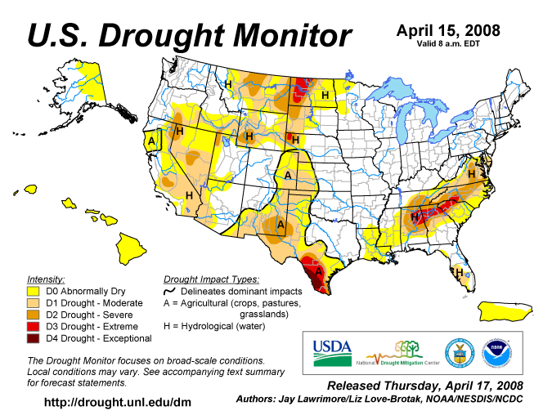

APPENDIX C

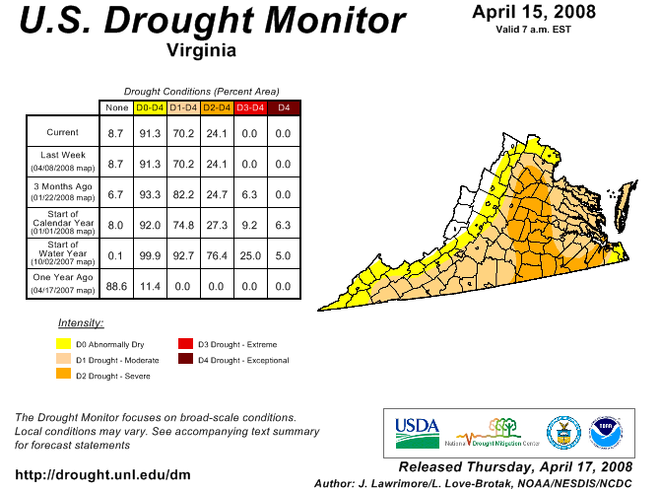
APPENDIX D

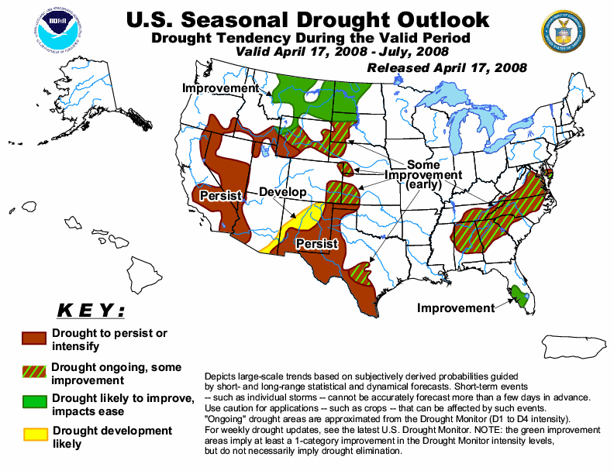

APPENDIX E
Condition of Public Water Supplies
April 18, 2008

ODW Drought Situation Report |  |  |  | Restriction totals
Date: | 4/18/08 |  | Mandatory | 4
 |  |  | Voluntary | 31
 |  |  | Total | 35
 |  |  | N-None | B-Better
 |  |  | M-Mandatory | S-Stable/Same
 |  |  | V-Voluntary | W-Worse
PWSID | Waterworks | Source Name | Restrictions | Situation | Population Served
1105400 | Lee County PSA | KVS Quarry | N | B 04/14/08: Water level in quarry is rising; currently at 132 inches below catwalk . Level was 163 inches below catwalk on 03/18/08. | 2,500
1169725 | Town of Nickelsville | Wells | V | B 04/16/08: Well production had dropped and voluntary conservation notice issued 8/31/07. Well production steady now. Well #1 pump was replaced and is now pumping at capacity. Well #3 drops to ~ 8 - 10 gpm (safe yield = 13 gpm). Well #6 starts out at ~15 gpm and then after about 3 - 4 hours will drop to ~5 - 8 gpm (safe yield=21 gpm). Well #4 & 5 no drop in output. Repairing leaks, but accountability is satisfactory. Have added two new wells: (1) Park well (the emergency well) is no longer being used. (2) New Tank well is now being used (safe yield = 28 gpm). | 900
1195050 | Town of Appalachia | reservoir | M | B 04/14/08: down 4" from overflow. 98 MG left, 215 days ± 10 left. Not pumping from Powell River anymore. | 3,280
2003250 | Albemarle County / Crozet | Beaver Creek Reservoir | V | S - Beaver Creek Reservoir is full. Drought Watch still in effect since 1/2/08 | 5,768
2003600 | Charlottesville/Albemarle County | Sugar Hollow and Ragged Mountain Reservoirs (Observatory WTP) | V | B - Sugar Hollow reservoir is full. Ragged Mountain reservoir is full. Drought Watch still in effect since 1/2/08 | 40,743
2003675 | Albemarle County / Scottsville | Totier Creek Reservoir | V | S - Totier Creek reservoir is full. Drought Watch still in effect since 1/2/08 | 700
2003725 | Charlottesville/Albemarle County | South Fork Rivanna (South Rivanna WTP) | V | S - South Fork Rivanna reservoir is full. Drought Watch still in effect since 1/2/08 | 54,200
2023720 | Town of Troutville | Five Drilled Wells | N | S - Town reported the pumping rate of their No. 3 well dropped from 123 gpm to 40 gpm. The pumping rates of the other four wells are the same. | 500
2023730 | Dal-Nita Hills | Drilled Well | V | S - Well yield has dropped to 4 to 5 gpm. Owner is hauling water, as needed, to keep storage tank full. Letter provided to the customers advising them of the situation. | 100
2043125 | Berryville, Town of | Shenandoah River | V | S - Voluntary conservation requested on 11 December 2007. | 2,965
2065250 | Fluvanna Correctional Center for Women | Mechunk Creek and on-site Raw Water Reservoir | V | S - Reservoir is 3 feet below full (~35 MG stored). Moderate Drought Condition continues. | 1,650
2171750 | Town of Strasburg | North Fork Shenandoah River | V | S - Voluntary conservation has been requested. Stream flow approx 487 cfs on 17 April 2008 | 4,500
2560100 | Town of Clifton Forge | Smith Creek | V | S - Voluntary conservation has been requested. | 4,679
2660345 | City of Harrisonburg | North River, Dry River/Switzer Reservoir (Rawley Springs) | V | S - Voluntary conservation has been requested. This has not been implemented as a result of limited low source water quantity, but rather at the request of the Governor's letter requesting conservation. | 44,500
3053280 | DCWA Central (Dinwiddie County) | Appomattox River Water Authority (ARWA) | N | S - Lifted restrictions on 12/27/07. | 6,800
3081550 | GCWSA - Jarratt | Nottoway River | N | S - Waterworks production rate still reduced due to lower demand; river level lower than April 2007 but sufficient to allow plant operation at 2.0 mgd | 7,190
3093120 | Isle of Wight County | Suffolk | V | B - follows Suffolk's lead on conservation. | 1,284
3095490 | JCSA Central | wells | N | S - No restrictions at this time. 4/16 (lifted late fall) | 44,760
3149700 | Puddledock Road (Prince George County) | ARWA | N | S - Lifted restrictions on 12/28/07. | 6,525
3550050 | Chesapeake - Western Branch system | City of Portsmouth | V | S -This portion of the city is consecutive to (receives water from) the city of Portsmouth. City Council voted to go to voluntary conservation city-wide - it took effect on 24 Oct 2007. Still following Portsmouth's lead on conservation. | 36,407
3550051 | Chesapeake | Northwest River, City of Norfolk Raw Water (Lake Gaston) | V | S - City Council voted to go to voluntary conservation city-wide - took effect on 24 Oct 2007. Chlorides are used as an indicator of drought, the higher the levels the more concentrated the contaminant in a lesser amount of surface water. The chlorides have been average since the recent rains. City is still encouraging voluntary conservation measures. | 101,175
3550052 | Chesapeake - South Norfolk system | City of Norfolk | V | S - 4/17/08-This portion of the city is consecutive to (receives water from) the city of Norfolk. City Council voted to go to voluntary conservation city-wide - it took effect on 24 Oct 2007. Still following Norfolk's lead on conservation. | 38,608
3570150 | Colonial Heights | ARWA | N | S - Lifted restrictions on 12/1/07. | 17,286
3595250 | Emporia | Meherrin River | N | S - Water is going over the dam. | 5,600
3670800 | Virginia-American Water Company (Hopewell) | Appomattox & James Rivers | N | S - Intake levels at mid-range and no current issues with increased salinity in raw water | 25000 - Primary / 42463 Total including Consecutive System (Ft. Lee)
3700500 | Newport News | Chickahomony River, Skiffs Creek, Diascand, Little Creek, Harwoods Mill, Lee Hall | N | B - reservoir levels are rising (4-16-08 at 99% full, up from 92). May not go higher. Likes to have some free board so that the water pumped into the reservoirs doesn't slosh over with the wind | 406,000
3710100 | Norfolk | Lake Prince, Lake Burnt Mills, Western Branch reservoir, Nottoway River, Blackwater River, 4 western wells; Little Creek reservoir, Lakes Smith, Lawson, Whitehurst, and Wright. Lake Gaston. | V | S - As of 04/14, reservoirs at 91.0% (down from 91.9% on 03/10). Historic reservoir capacity is 95.7%. Avg. pumping: Lake Gaston = 46.34 MGD; Blackwater River = 0 MGD; Nottoway River = 0 MGD; Deep wells = 0.44 MGD; Spillway elev.: Western Branch -2.1 ft; Lake Prince 0.2 ft; Burnt Mils -3.8 ft; Lake Wright 0.3 ft; Lake Smith 0.4 ft; Blackwater River 10.5 ft; Nottoway River 13.3 ft. Called for voluntary conservation 11/1/07. | 261,250 - Primary / 755,617 - Total including consecutive systems (Va Beach + military bases).
3730750 | Petersburg | ARWA | N | S - Lifted restrictions on 1/8/08. | 39,386
3740600 | Portsmouth | Lakes Cohoon, Meade, Kilby, and Speights Run | V | S - As of 04/11, reservoirs at 100% (same as on 03/14). Median reservoir capacity is 100%, average capacity is 99% (period of 1969-2006). Both emergency wells are OFF. Estimated 266 days of reservoir storage remaining at current pumpage and no rainfall, down from 269 days on 03/14. Called for voluntary conservation on 10/10/07. | 100,400 - Primary / 120,400 Total including consecutive systems (military bases)
3800805 | Suffolk | Lone Star Lakes, Cumps Mill Pond | V | B - Will follow Portsmouth's lead and the region as far as conservation. As of 4/17/08-Reservoir levels look good. Southern Lakes at 55% capacity, for the Northern Lakes at 100% and Crumps Mill Pond at 81% The Southern Lakes are for emergency use only. Still purchasing water from Portsmouth per their contract, no drought measure taken to date. | 62,562
3810900 | Virginia Beach | Norfolk | V | S - obtains water from Norfolk. Called for voluntary conservation on 9/19/07. | 423,743
4041035 | APPOMATTOX RIVER WATER AUTHORITY | Surface water; Lake Chesdin | N | Wholesaler to Chesterfield County, Prince George County, Dinwiddie County; Cities of Petersburg and Colonial Heights. Water level is normal. | 200,000
4041845 | CHESTERFIELD CO CENTRAL WATER SYSTEM | Surface water; Swift Creek reservoir; purchases finished water | N | Purchases water from the City of Richmond and the Appomattox River Water Authority. | 263,000
4057800 | TAPPAHANNOCK, TOWN OF | Groundwater wells | N |  | 2,100
4073311 | GLOUCESTER CO WATER TREATMENT PLT | Surface water, Beaverdam reservoir; 2 deep groundwater wells | N | Reservoir at 100%. | 8,870
4075283 | EASTERN GOOCHLAND CENTRAL WATER SYSTEM | Purchased surface water | N | purchases water from Henrico County | 2,500
4075735 | JAMES RIVER CORRECTIONAL CTR | Surface water; James River | N |  | 9,300
4085398 | HANOVER SUBURBAN WATER SYSTEM | Surface water; North Anna River; some groundwater wells; purchases finished water | N |  | 71,000
4085770 | SPRING MEADOWS-MEADOW GATE | Groundwater wells | N |  | 2,300
4087125 | HENRICO COUNTY WATER SYSTEM | Surface water; James River | N | Similar to City of Richmond | 289,000
4101900 | WEST POINT, TOWN OF | Groundwater wells | N |  | 3,000
4127110 | DELMARVA PROPERTIES | Groundwater wells | V | New Kent Co. encourages conservation. Still in place. | 7,700
4145675 | POWHATAN COURTHOUSE | Groundwater wells | N |  | 2,600
4193280 | COLONIAL BEACH, TOWN OF | Groundwater wells | N |  | 3,300
4760100 | RICHMOND, CITY OF | Surface water; James River | N | Drop in water levels in the James River but still fairly normal; under James River Regional Flow Management Plan; counties of Henrico, Chesterfield, Goochland, and Hanover counties purchases water from the City. | 197,000
5515050 | City of Bedford | Stoney Creek Reservoir and Wells 1 to 5 | N | S - overflowing | 6,946
5143210 | Town of Gretna | Georges Creek Res | N | B - Town is moving forward on new supplemental source development | 2,500
5029085 | Buckingham County | Troublesome Creek Reservoir | N | B | 5,751
5037300 | Town of Keysville | Keysville Reservoir | N | B | 800
5083550 | Town of Halifax | Bannister River Reservoir | N | B | 1,389
5780600 | Town of South Boston | Dan River | N | B | 9,726
5141640 | Town of Stuart | South Mayo River | N | B | 1,500
5147170 | Town of Farmville | Appomattox River | N | B | 7,011
5011050 | Town of Appomattox | Wells | V | S - The Town has noted a significant water level drop in many of their wells. The town is actively looking for additional water sources. | 1,708
5031150 | Campbell County Central System | Big Otter River | N | B - no impact for the drought, can be removed from the list. | 20,000
5025450 | Town of Lawrenceville | Great Creek (with upstream reservoir) | N | B - no impact from the drought, can be removed from the list. | 4,806
5135160 | Town of Crewe | Crystal Lake | N | B - overflowing | 3,500
5111450 | Town of Kenbridge | Flat Rock Creek and Offstream Reservoir | N | S - good levels, plenty of rain | 1,400
5067785 | Ridgscrest | Wells | N | B | 52
5067265 | Hales Point | Wells | V | B | 46
5067937 | Stripers Landing | Wells | N | B | 125
5680200 | City of Lynchburg | Pedlar Reservoir | N | Overflowing spillway | 76,000
6047070 | Emerald Hill Elementary School | Groundwater | N | S - Well EHS-3 is onstream at a reliable production rate of 12 gpm. Well 1 has been reworked for improved production. Water hauling is no longer needed. | 977
6047500 | Town of Culpeper | Lake Pelham | N | S - On Tuesday, April 15, 2008, the main reservoir, Lake Pelham, was reported to be at the overflow | 14,200
6059501 | Fairfax County Water Authority | Potomac River and Occoquan Reservoir | V | B - 3/17/08 Fairfax Water has reduced withdrawals to about 75 MGD from Potomac River, limited by half of Corbalis WTP out of service (scheduled outages for construction of tie-ins), with the balance taken from Occoquan Reservoir. Potomac River flows have increased due to recent rains. Occoquan Reservoir is 100% full. Metro Washington area-wide voluntary conservation went into effect 10/3/07. | 823,216
6061200 | Marshall | Groundwater | M | S - Four loads of water were hauled in March. Water ditribution system repairs and line replacements are being done. | 2,134
6061600 | Town of Warrenton | Reservoir on Cedar Run and groundwater | N | S - On Tuesday, 4/15, Warrenton Reservoir surface elevation is at 445.4 feet which is the full level. Airlie Reservoir is down about 2 feet below full. | 11,160
6107150 | Town of Hamilton | Groundwater | M | S - 4/17/08 Water levels in wells improving. Several problems with well controls. Town Council voted to maintain Mandatory water use restrictions until new Well 14 is placed in service. | 2,000
6107200 | Town of Hillsboro | Spring/Well | N | B - 4/17/08 Increased flow from spring has been adequate to meet current demand. A leak survey revealed 10 potential leaks in the distribution system. | 58
6107221 | LCSA Lenah Farms | Groundwater | V | S | 810
6107350 | Loudoun County Sanitation Authority | Purchase treated surface water from FCWA (Potomac River) and City of Fairfax (Goose Creek Reservoir) | V | S - 4/17/08 Voluntary conservation in place beginning 3/11/08. | 167,904
6107400 | Town of Lovettsville | Groundwater | V | S - 4/17/08 Voluntary water use restrictions remain in place; however there is no problem with water supply. | 1,280
6107450 | Town of Middleburg | Groundwater | V | B - 4/17/08 - Voluntary water use restrictions replace mandatory water use restrictions on 4/10/08. | 590
6107600 | Town of Purcellville | Hirst Reservoir and groundwater | V | B -- 4/17/08 Reservoir is full. Mandatory water conservation replaced with voluntary water conservation, 4/2/08. | 6,300
6107650 | Town of Round Hill | Groundwater | V | B - 4/17/08 - Voluntary water use restrictions replace mandatory water use restrictions on 4/1/08. | 3,156
6113200 | Town of Madison | White Oak Run | N | S -- Stream flow remains adequate to meet normal demands. | 778
6137300 | Rapidan Service Authority - Rt. 15 | Purchase treated surface water from Town of Orange (Rapidan River) | N | S - 4/15/08 - Town of Orange raw water availability is well above minimum. | 273
6137400 | Town of Gordonsville | Purchase treated surface water from RSA and Town of Orange | N | S--No water use restrictions are in place. | 1,800
6137500 | Town of Orange | Rapidan River | V | S - 4/15/08 - Fourteen day running average of Rapidan River flow is 536 cfs (withdrawal restrictions are imposed below 44 cfs) Offstream raw water reservoir is full. | 4,500
6137999 | Rapidan Service Authority - Wilderness and Lake of the Woods | Rapidan River | N | Rapidan River flow has been steady at an adequate level. | 11,331
6153260 | Woodbridge Mobile Home Park | Groundwater | M | S -- 4/17/08 Waterworks continues to have episodes of low pressure due to inadequate sources and leaks in the distribution system. This problem is indirectly related to drought as source problems existed previously. | 320
6600100 | City of Fairfax | Goose Creek Reservoir | N | B -- 4/17/08 Adequate flows coming down Goose Creek. Pumping into Beaver Dam Reservoir at approx 4.5 MGD, which has risen about ten feet due to pumping plus recent rains. Reservoir is still about 13 feet below full, or approximately 65% full. Lifted voluntary water use restrictions on 4/7/08. | 45,000
6685100 | City of Manassas | Lake Manassas | N | B -- 4/17/08 Lake Manassas is full. | 37,000
6179100 and 6179775 | Stafford County | Smith Lake and Abel Lake | V | B -- Both lakes are full. Mandatory restrictions went into effect 9/17/07, were increased 10/8/07, and were reduced 2/19/08. Mandatory restrictions lifted 3/18/08. | 53,086
Notes of interest:
(1) Metropolitan Washington Council of Governments lifted the drought Watch, returning to Normal status, lifting a region-wide voluntary conservation advisory, on 4/1/08, covering DC, Maryland, and Northern Virginia.
(2) Interstate Commission on the Potomac River Basin (ICPRB) gathers meterological, drought, and water supply data from all of the major water suppliers in the Metro Washington area and determines the need for upstream reservoir releases, if any, to augment the flow in the Potomac River for water supply withdrawal. ICPRB has predicted that likelihood of releases from upstream reservoirs is slightly below normal.

APPENDIX F

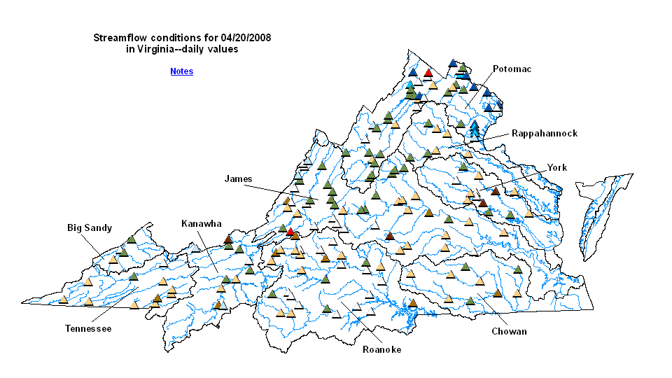
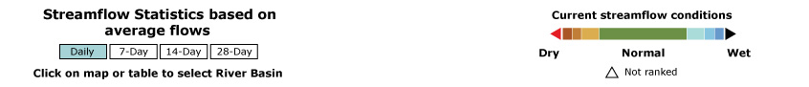

APPENDIX G
Drought Watch -- USGS State Information on Drought
Map of below normal 7-day average streamflow

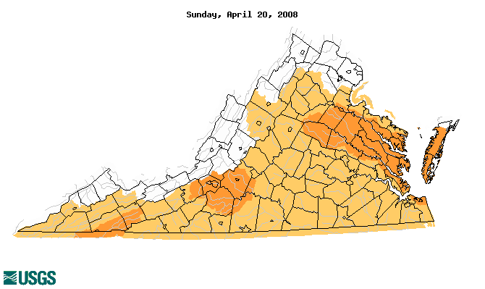
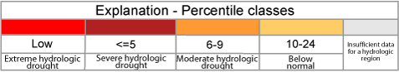

APPENDIX H
Virginia Climate Response Network
April 20, 2008



