Atlantic Stratocumulus Transition Experiment

and

Marine Aerosol and Gas Exchange

June 1992

Experiment Summary

Part I - Mission Summaries

Robert T. Bluth
Bruce A. Albrecht

June 1993
Pennsylvania State University
Department of Meteorology
University Park, PA 16802

ACKNOWLEDGEMENTS

Much of the information summarized in this report was kindly supplied by the dedicated scientist, students, and staff who participated in ASTEX, MAGE, and SOFIA. We greatly appreciate their contributions. Special thanks are given to Drs. Kevin Kloesel, Don Wylie, Chris Bretherton and Phil Durkee. Kevin prepared the synoptic summaries used in this report and Don Wylie prepared the satellite images. Chris supplied the ECMWF surface analyses, isentropic back-trajectories, and the soundings shown in the report. These contributions were critical to the production of the document. The images on the covers are radiances from a cloud deck observed during the experiment from the NASA ER-2 and were kindly provided by Dr. Michael King. We greatly appreciate the efforts of Terry Faber, Michael Jensen, Benjamin Moyer and William Syrett for their efforts with the preparation of this document. A special thanks goes to Peggy Zentner for coordinating the final production and tolerating our idiosyncracies. The production of this report was funded by ONR Grant N00014-91-1992.
TABLE OF CONTENTS

ACKNOWLEDGMENTS i
INTRODUCTION 1
MISSION SUMMARY - 1 JUNE 3
MISSION SUMMARY - 2 JUNE 13
MISSION SUMMARY - 3 JUNE 23
MISSION SUMMARY - 4 JUNE 31
MISSION SUMMARY - 5 JUNE 43
MISSION SUMMARY - 6 JUNE 53
MISSION SUMMARY - 7 JUNE 61
MISSION SUMMARY - 8 JUNE 69
MISSION SUMMARY - 9 JUNE 79
MISSION SUMMARY - 10 JUNE 91
MISSION SUMMARY - 11 JUNE 103
MISSION SUMMARY - 12 JUNE 113
MISSION SUMMARY - 13 JUNE 125
MISSION SUMMARY - 14 JUNE 137
MISSION SUMMARY - 15 JUNE 147
MISSION SUMMARY - 16 JUNE 159
MISSION SUMMARY - 17 JUNE 171
MISSION SUMMARY - 18 JUNE 183
MISSION SUMMARY - 19 JUNE 193
MISSION SUMMARY - 20 JUNE 205
MISSION SUMMARY - 21 JUNE 217
MISSION SUMMARY - 22 JUNE 227
MISSION SUMMARY - 23 JUNE 239
MISSION SUMMARY - 24 JUNE 251
MISSION SUMMARY - 25 JUNE 261
MISSION SUMMARY - 26 JUNE 271
MISSION SUMMARY - 27 JUNE 279

I. Introduction

The representation of boundary layer clouds (stratocumulus and trace cumulus) in large-scale and mesoscale models continues to be an unresolved problem. These clouds have a pronounced effect on the earth's radiation budget and on visibility in the longer layers of the atmosphere. Their representation in models is complicated by the fact that they are frequently less than 500 m thick and are intimately connected to the boundary layer turbulence. Thus in large-scale or mesoscale models their effects must be parameterized or represented as functions of the resolvable fields.

The development of parameterizations requires an understanding of the processes that generate, maintain, and dissipate boundary layer clouds. This development is currently impeded by a lack of understanding of the transition from stratocumulus clouds to trade cumulus clouds and the factors that control cloud type and amount in the boundary layer.
The Atlantic Stratocumulus Transition Experiment (ASTEX) was designed to address key issues related to stratocumulus to trade-cumulus transition and cloud mode selection. ASTEX involved intensive measurements from several platforms operating from 1-28 June 1992 in the area of the Azores and Madeira Islands as shown on the map. The purpose was to study how the transition and mode selection are affected by 1) cloud-top entrainment instability, 2) diurnal decoupling and clearing due to solar absorption, 3) patchy drizzle and a transition to horizontally inhomogeneous clouds through decoupling, 4) mesoscale variability in cloud thickness and associated mesoscale circulations, and 5) episodic strong subsidence lowering the inversion below the LCL. Detailed descriptions of the scientific goals of ASTEX are in the FIRE Phase II: Research Plan (1989) and in the ASTEX Operations Plan (1992).

From a broader perspective ASTEX was designed to provide improved dynamical, radiative, and microphysical models and an improved understanding of the impact of aerosols, cloud microphysics, and chemistry on large-scale cloud properties. ASTEX is part of the
First ISCCP Regional Experiment (FIRE), which receives broad multiagency support. Scientists from the United Kingdom, France, Germany, Portugal, Netherlands and Spain participated in ASTEX and two related experiments -- the International Global Atmospheric Chemistry Program's MAGE (Marine Aerosol and Gas Exchange: Atmospheric Chemistry and Climate) and a French experiment SOFIA (Surface of the Ocean Fluxes and Interactions with the Atmosphere).

II. Platforms

The goals of ASTEX were pursued by combining measurements from aircraft, satellites, ships and islands. A detailed description of the platforms and the instrumentation on each are described in the ASTEX Operations Plan (1993). Surface based measurements were made from the islands of Santa Maria (in the Azores) and Porto Santo (near Madeira) and four research vessels -- NOAA's Oceanus and Malcolm Baldrige, the German ship Valdivia and the French ship Le Suroit. Instrumentation at these surface sites provided a
wide range of observations including surface and upper-air temperature, moisture, and winds;
surface radiation; remotely sensed atmospheric and cloud parameters; and atmospheric chemistry and aerosols. Summaries of the instrumentation at these sites and the parameters they measured are described in the ASTEX Operations Plan (1992) and in field reports produced by various research groups participating in the experiment. Summaries of the times when various instruments were operating during the experiment are presented in appendices given in Part II of this document. Plots of ship positions and information on two Lagrangian experiments are also included in these appendices.

Radiosonde launches were made every three hours from the islands of Santa Maria and Porto Santo and the research vessels Valdivia, and Malcolm Baldrige during their operations in the area. Soundings were also made from the Le Suroit and the Oceanus. A majority of
the soundings were coded and subsequently transferred to the Global Telecommunications System (GTS) so that they could be assimilated into ECMWF and NMC analyses.

Four major aircraft -- the UK C-130, NCAR Electra, NASA ER-2, and University of Washington C-131 -- were dedicated to ASTEX activities. In addition, the French Fokker F-27 aircraft flew a number of missions in support of SOFIA that contributed directly to the objectives of ASTEX. A P-3 operated by NRL made measurements during the first part of the experiment. Most of the aircraft operated from Santa Maria. The ER-2 and P-3 operated from Lajes on the island of Terceira. Flight paths for the major ASTEX aircraft are included in Appendices H-L. Further details on the instrumentation and operations of each aircraft are described in various field reports that have been generated by individual research groups.

III. Mission Summaries

Part I of this report includes mission summaries for each day. These summaries are intended to provide an overview of the operations and synoptic conditions on each day of the experiment. The format for each of the summaries is similar and most of the information is self explanatory. The summary map shows approximate positions of ships and aircraft for each day. The satellite images are infrared images from METEOSAT. The maps of surface pressure and winds are for the 1200Z ECMWF analyses. Forecast trajectories (at one-hour
increments) are also shown on these maps. Isentropic back-trajectories, which were calculated 2by Dr. Chris Bretherton, are included for some of the days. The 0000Z surface pressure
and 850 mb height fields are analysis from the United Kingdom Meteorological Office model. A summary of the soundings that were made and those placed on the GTS are given in the mission summaries. The soundings were generally launched 1-2 hours before the synoptic times listed in this summary. Details on radiosonde launch times are given in the appendices. Plots of some of the soundings (based on significant level data) are given for each day.
These soundings are intended to give some general definition of the boundary layer structure observed at each site. The general activity chart indicates times of operations for the various platforms by the symbol "->". The numbers on this chars are minutes during a given hour. The synoptic summaries, which were prepared by Dr. Kevin Kloesel during the field experiment, and brief flight reports from the individual aircraft are provided.
Date: 1 JUNE Julian Day: 153 Experiment Day: 01

Mission Scientist: Dr. Bruce Albrecht

Mission Objective: Measure the microphysical and radiative properties of stratocumulus and their relation to CCN concentrations below cloud base.

Mission Description: Multiple Aircraft Temporally Separated missions involving C-130 and F-27. Le Suroit over flight.

Synoptic Situation: Pressure was building over most of the Atlantic and a light to moderate northerly airflow was effecting the area to the north and east of the Azores.




GENERAL, A.M. WEATHER: 1 June 92 - 12 GMT surface high position near 43N, 38W with a 1028mb closed contour. Estimated maximum surface sea level pressure near 1030mb. At this time, the 1012mb low centered off the coast of Portugal yesterday has moved onshore and deepened to 1010mb. A weak stationary frontal boundary continues to weaken near the center of the ASTEX triangle. The surface low is embedded in a 500mb trough which extends S-SE from the coast of Portugal through the eastern portion of the ASTEX area. A cut
off low appears to have formed on the southern extent of this 500mb trough and deep convection (thunderstorms) appears to be occurring in a region of weak cold advection at 500mb just off the African coast, southeast of the Canary Islands. Cloud base height at Santa Maria is approximately 1.4km. A large area of scattered (4/8) stratocumulus clouds are evident in the ASTEX triangle with tops estimated
at 1.6km. A more solid (6/8) area of stratocu extends from the western portion of the triangle westward approximately 300km. This broken area appears similar to the mesoscale cellular region observed yesterday. This area continues to move southeastward in response to the southeastward movement of the surface high. A second broad region of stratocu (5/8) is present about 300 km north of the ASTEX region and continues to drift SSE at 15 knots.

NASA ER-2: At Lajes.

MRF C-130: A relatively successful flight was flown, the flight being split into four consecutive sections. All instruments worked for the entire flight with the exception of the ozone sampler which failed at 12:50Z.

On take off a transit was flown at FL150 to a position north east of Ponta Delgada. The cloud cover was 7/8 Sc with clear air above. There was visual evidence of cumulus intrusion into the cloud deck below. Some turrets were penetrating the main deck and the reflectance of the cloud sheet was quite varied. The microwave radiometer also showed a lot of variability in the total water column below the aircraft. A profile from FL150 to 50ft was flown terminating at a position 38.18N 25.71W. The main cloud top was at approx 6300ft with a very indistinct base at around 1000ft.

The cloud droplet effective radius was relatively constant throughout the cloud depth varying from a maximum of 12,um at cloud top to 8pm at cloud base. The lack of variation of effective radius with height being indicative of cumuloform cloud. FSSP droplet concentrations were low at around 15 to 20/cc indicating a maritime airmass, later CCN and PCASP aerosol measurements confirmed this. The 2D Cloud probe indicated drizzle in the cloud deck with droplets of 400, um to 800pm diameter with concentrations of around 1000/liter. A stack was flown with two runs below cloud, three in cloud and one above cloud. Saw tooth profiles were then flown heading back to Santa Maria.
An attempt was made to overfly the Santa Maria field site at two levels 3500ft and 4500ft. The cloud over the field site had become very broken and non uniform. Due to air traffic restrictions, the runs could not be performed satisfactorily. A climb to FL100 followed as we transitted towards the French ship Le Suroit.

A profile was flown from FL100 to 50ft ending in the vicinity of Le Suroit (36,02.3N, 23,50.9W). The cloud consisted of 4/8 small cumulus, tops approx 3000ft. A distinct haze layer was observed at 6000ft where the PCASP aerosol concentration peaked at 1000/cc. A stack was then flown just upwind of Le Suroit displaced to the West. Runs were flown at 200ft, 1000ft, 1500ft, 2000ft, 3000ft and 4500ft in the broken cloud layer. This stack should be interesting to compare with the data from the earlier flight of the Fokker 27 which overflew Le Suroit during a Landsat overpass when there was complete cloud cover. Finally a run at 200ft was flown at a distance of 10nm downwind of Le Suroit. A profile was flown from 50ft to FL240 in the broken cloud field, the haze layer being observed once again. The airmass dried out rapidly at 11000ft. At FL240, a box pattern was flown for the computation of pitch and roll offsets.

From a high level a long narrow sheet of low clouds was observed which had a distinct edge with the broken cloud field around Le Suroit. A profile from FL120 was flown penetrating this cloud sheet and a stack was flown across wind below, in and above the cloud layer. The tops were approx 4300ft with an indistinct base at 2000ft. Drizzle was observed with drops of 500um, the cloud droplet effective radius was varied from 12u near cloud top to 7pm near cloud base. There were some heavy showers beneath the cloud sheet and evidence of cumulus intrusion. The CCN measurements beneath this sheet showed lower concentrations than those observed at the same level in the broken cloud. A run was then flown above the cloud across the transition from solid to broken cloud with a shallow profile in the broken cloud and another run below the cloud level from the broken cloud to the solid cloud. Finally two shallow saw tooth profiles were flown on final approach to Santa Maria.
Take Off: 10:55:57 GMT Landing: 19:00:00 GMT.

All instruments were fully functional with the exception of the ozone sampler which ceased working at 1250Z.

UW C-131A: At Lajes to-pick up equipment for shipment to Santa Maria.

NCAR ELECTRA: Down

ARAT F-27: Measurement of cloud radiative properties; remote sensing with LIDAR; and LANDSAT overpass. LIDAR flight pattern during the LANDSAT overpass was four axes 60nm and 60nm long at 15,000ft between 10:57 and 12:12 GMT. The pattern was centered at 36.00W and 23.40W. Observations of stratocumulus were made with cloud tops at 1.6km.

FMO Merlin IV: Arrived at Santa Maria with an engine problem. Needs a new engine before flight operations can commence.

Date: 2 JUNE Julian Day: 154 Experiment Day: 02

Mission Scientist: Dr. Doug Johnson

Mission Objective: Coordinated radiation mission to make radiation and microstructure measurements. Diurnal variation of the microphysical and turbulence characteristics of stratocumulus.

Mission Description: Multi-aircraft vertically separated and diurnal mission.

Synoptic Situation: Pressure was building over most of the Atlantic and a light
to moderate north to northeasterly airflow was affecting the ASTEX Triangle. Broken to overcast stratocumulus in the northeast region of ASTEX triangle.



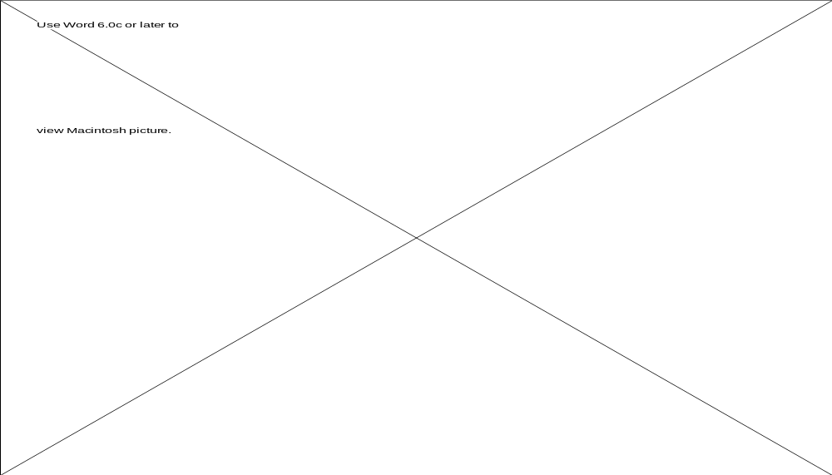



GENERAL, A.M. WEATHER: 2 June 1992 - 12 GMT surface high position near 39N, 33W with a 1032mb closed contour. Estimated maximum surface sea level pressure near 1033mb. The weak stationary frontal boundary from the previous two days is no longer evident. The surface high continues to strengthen and move southeastward toward the Central Islands of the Azores. A diffluent zone in the surface wind field is evident across the ASTEX region. Winds are from the
northeast at 15knots across the northern and western portions of the triangle and north-northwest at 10-15knots across the southeast portion of the triangle near Porto Santo. Three large patchy regions of stratocumulus are evident. The ASTEX triangle is 3/8 covered with scattered large patches of broken stratocu. An extensive area of stratocu (6/8 covered) extends westward from the triangle (25W) to near 35W. A third area (7/8 covered) is located to the east and northeast of Santa Maria and extends some l000km upstream. The surface high continues to strengthen and drift eastward in response to the strong ridging taking place at upper levels. All-three stratocumulus areas described above lie between a strong SW-NE oriented 500mb ridge axis (approx l000km NW of Azores) and a
downstream trough axis that extends from Western Europe southwestward to the western coast of Africa. A "clear" wake is also evident south-southwest of Sao Miguel which extends to just west of Santa Maria.

NASA ER-2: First research flight aimed at coordinating the ER-2 aircraft with the University of Washington C-131A along a 155 km flight track. Two flight legs
were flown (A-B and returning B-A). The ER-2 was at point A (35 deg 35' N, 23 deg 00ÕW) heading north at 1000 GMT when the NOAA-12 satellite overflew the area. The satellite was in a descending orbit whereas the ER-2 was going in an ascending orientation. Part of the flight track was cloud covered and part was clear sky or thin cloud cover. Takeoff 0905 GMT Landing 1135 GMT.

INSTRUMENT PERFORMANCE

MAS Instrument worked properly, with some saturation at
0.875 um, much saturation at 3.73 um, and clipping at 0.66 and 8.56 um. Data quality exceptionally good, with good detail on the reflectance variations of the stratocumulus clouds.
CLS Slightly out of alignment, enabling cloud top altitude to be determined, but insufficient signal strength to permit depolarization or aerosol characteristics to be determined.
EOC Instrument worked, but gain levels are such that there is some saturation at all six charnels, with the red charnels (0.68 um) saturated much of the mission. The green charnels (0.53 um) are saturated on bright cloud tops,
and there is occasional saturation on the blue (0.46 um) charnels. The
focus has a resolution of about 50 m.
RADIOMETERS Data system failed, thus no data recorded.
MRF C-130: A very successful flight was carried out to investigate diurnal changes in stratocumulus after sunset. During the day, the cloud cover over Santa Maria was patchy and by take-off time skies were clear over the island. While flying southeastward this very broken stratocumulus was observed not far from the island, but by the time the operating area was reached, there were some large areas of almost solid cloud. The cloud layer appeared to be very thin and there were various sizes of cumulus poking through the layer.

The initial profile showed two inversions, with the stratocumulus below the lower inversion. Beneath the upper inversion, at about 8500ft was a haze layer, in which the PCASP concentrations were about 900 cm⁻³. The stratocumulus top was very uneven and lay at about 4300ft. The layer was about 500 ft thick and many cumuli were observed below, some of which were poking into the stratocumulus. Droplet concentrations in the stratocumulus cloud were about 250 cm⁻³ and the effective radius at cloud top was 6 gm. No drizzle was observed in the profile. The boundary layer was found to be decoupled at about 2000ft and the base of all of the cumulus coincided with this level.

Six vertical stacks were carried out, moving downwind between each and trying to follow the same parcel of air. Seven minute runs were made at 6 levels, two in the surface layer, one at the level of decoupling, one in the subcloud layer, one in cloud and one above cloud. In the first stack, there was daylight so the lowest run level was 100ft. At the end of this run and the run above cloud, two orbits with 30 deg banks were made for the MARSS radiometer. The stacks were each separated by a vertical profile from above the inversion to 550ft, which was the lowest permitted altitude after dark.

The surface layer was found to be very well mixed during the first two stacks, with aerosol concentrations of 500-600 cm⁻³ and higher total water content in theta-e than in the subcloud layer. Variations in these two parameters seemed less in the subcloud layer, except where cumulus clouds brought the surface layer characteristics into the subcloud layer. The stratocumulus layer filled in through the flight, although the droplet concentration and maximum effective radius stayed constant. In the last three stacks, the vertical profiles showed increasing variations in the surface and subcloud layers. The inversion height also varied horizontally in these later stacks, so that the straight and level runs above the cloud occasionally went through the inversion and into the cloud top. The overall height of the inversion increased with time. The last three profiles showed
that the boundary layer was recoupling, with theta-e and total water content becoming constant throughout the layer and the temperature profile adiabatic. The cloud appeared to be filling vertically from the level that the cumulus clouds had been previously. On the transit home, the radiation instruments indicated that the cloud layer was much more uniform than at the start of the flight. Take Off: 18:29.55 GMT Landing: 02:47:25 GMT

UW C-131A: Coordinated radiation mission with ER-2 and Convair. C-131A to make low level radiation measurements above cloud top and measure cloud microstructure. Fly straight legs in and on top of stratocumulus cloud layer and pre-destined points in "wild-dogging" rad experiment sanctioned by M. King.

Flew southeast of SMA to encounter region of widespread stratocumulus. Performed rad maneuver for Tsay enroute. The top of broken to overcast stratocumulus layer between 5 and 6 kft ASL with regions of embedded cumulus clouds with modest overshooting (visually brighter) tops less than 200 feet above
general tops. The maximum liquid water content was about 0.8 9 kg-1, near tops of cumulus clouds embedded within the stratocumulus. There were extensive regions
in the stratocumulus with Iwc >0.3 9 kg⁻¹. Bases of the cumulus clouds were about 2.2 kft, and bases of the stratocumulus about 3.7 kft ASL with thinner and thicker regions. Occasional regions of drizzle drops encountered. The average droplet concentrations were about 150 cm⁻¹ with no anomalous spikes that might originate with ship plumes. Flight legs oriented SW-NE flown 50-100 ft above stratocumulus clouds, in upper 150 feet, in the middle, below cloud base and within 100 feet of the surface. Punched a few cumulus fractus to cumulus mediocris clouds on the return leg to SMA.

NCAR ELECTRA: Arrived Lajes.

ARAT F-27: Measurement of cloud radiative properties, remote sensing with LIDAR, and coordination with ER-2 and C-131 with NOAA-12. Flight involved two orthogonal axes 60nm long at 1 5,000.00ft centered at 35.40N 23.00W.

FMO Merlin IV: Not operational
Date: 3 JUNE Julian Day: 155 Experiment Day: 03

Mission Scientist: Dr. Bruce Albrecht

Mission Objective: Down Day

Mission Description:

Synoptic Situation: Pressure was building over most of the Atlantic and a light to moderate north to northeasterly flow was affecting the ASTEX Triangle. Broken to overcast stratocumulus in the northeast region of ASTEX triangle.









GENERAL, A.M. WEATHER: 3 June 92 - 12 GMT surface high position near 38N, 29W with a 1032mb closed contour. Estimated maximum surface sea level pressure near 1033mb. The surface high has built into the Central Islands of the Azores. A diffluent zone in the surface wind field evident yesterday across the ASTEX region has moved southeast of the region. Winds across the triangle are
from the north-northeast at 10-15kts across the northern portion of the triangle and northeast at 15kts across the southern half of the triangle. An upper level 500mb low has moved southeastward to a position near 44N and 12W. The axis of the 500mb trough extends southwestward from this position to just east of Porto
Santo. The 500mb ridge axis remains over the Central Islands. A large region of mostly solid (7/8) stratocumulus clouds exist in a region from just east of the
center of the surface high eastward across the northern 1/3 of the triangle. There is a transition flow from these more solid clouds in the northern part of the triangle to more scattered and broken (3/8-5/8) patches of stratocumulus occurs along 34N. These more solid clouds built in overnight (typical diurnal cycle) and have remained through midday with very little breakup. South of the transition zone, however, the diurnal daytime evaporation appears to be more evident. An upper
frontal boundary also appears to be present along the northern periphery of the high along 25W. Cirrus clouds (3/8) associated with this system are being observed at Lajes. These cirrus are evaporating downstream (east) of Lajes.

NASA ER-2: Down

MRF C-130: Down

UW C-131A: Down

NCAR ELECTRA: Arrived Santa Maria.

ARAT F-27: Static pressure and angle of attack calibrations. Flights involved square flight pattern close to Santa Maria.

FMO Merlin IV: Not operational
Date: 4 JUNE Julian Day: 156 Experiment Day: 04

Mission Scientist: Dr. Bruce Albrecht

Mission Objective: Simultaneously sample the microphysical properties of stratocumulus, and turbulence structure of the boundary layer in three different locations, in order to investigate the spatial variability of the cloud.

Mission Description: Multi-aircraft horizontally separated.

Synoptic Situation: A high pressure system was situated to the northwest of the Azores and nearly all of the triangle was effected by a northeasterly wind.




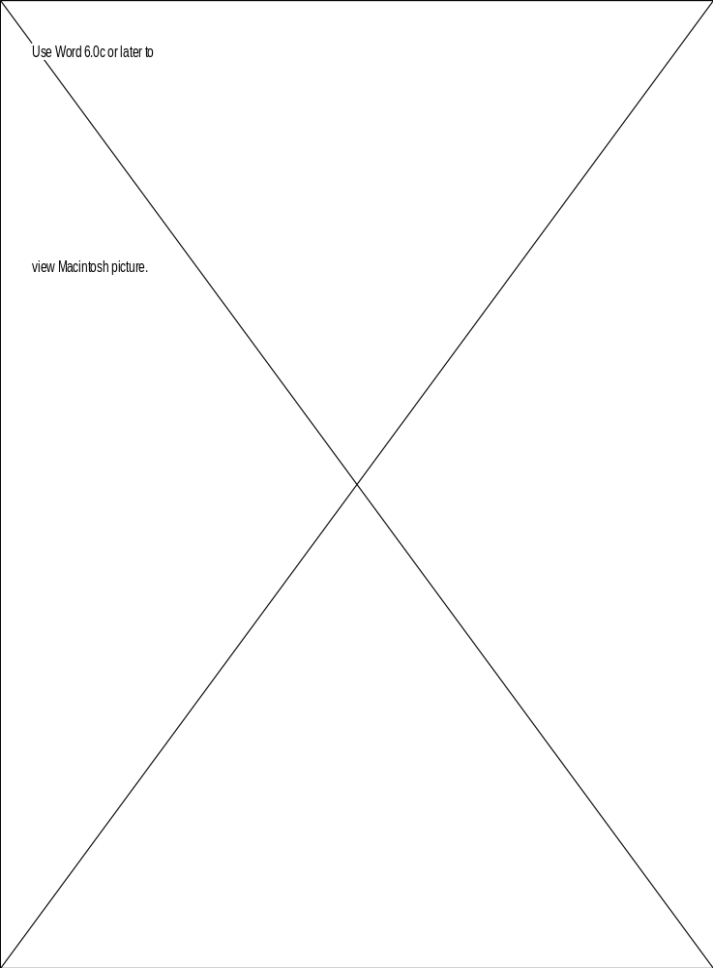

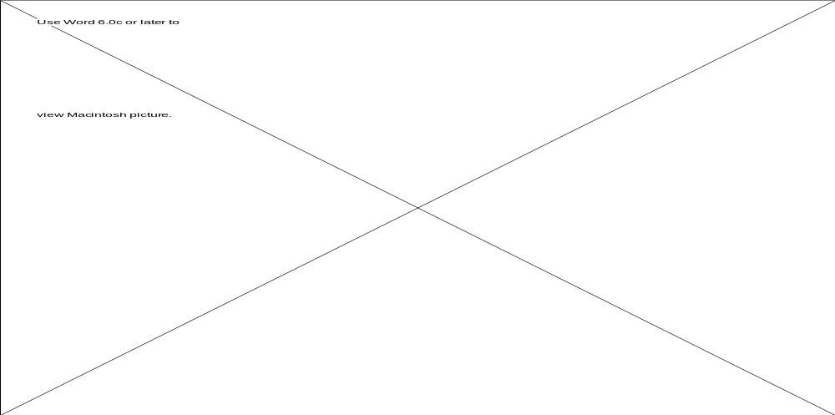



GENERAL, A.M. WEATHER: 4 June 92 - 12 GMT surface high position near 35N, 30W with a 1032mb closed contour. Estimated maximum surface sea level pressure is near 1033mb. The surface high is nearly stationary over the Central Islands of the Azores. Winds across the far northern portion of the triangle (near
Santa Maria) are northwest at 5-10kts. Winds across the remainder of the triangle
are from the north-northeast at 10-15kts across the northern portion of the triangle and northeast at 15kts across the southern half of the triangle. The axis of the 500mb trough extends from the UK southwestward to just east of
Porto Santo. The 500mb ridge axis, however, is showing signs of shifting slightly westward from its morning position over the Central Islands. A large region of mostly broken to solid ( 6/8) stratocumulus clouds existe in a region from just east of the center of the surface high and extends eastward across the northern 1/3 of the triangle. A transition from these more solid clouds in the northern part of the triangle to more scattered and broken (3/8-5/8) patches of stratocumulus occurs along a line from 35N, 25W northeastward to near 35N, 20W. Cirrus clouds (3/8) and some altocumulus clouds associated with the upper level trough are being observed north and northeast of the project area.

NASA ER-2: Research flight aimed at coordinating the ER-2 aircraft with the UK C-
130 and NCAR Electra along a cloud transition. Four 325 km flight legs were flown (A-C, C-A, A-C and returning C-A) across the transition, followed by a
couple of other legs (one in a cloudy region and the other in a much clearer region). On returning from the coordinated region, a 526 km westward flight track was flown that overlapped a region containing a ship track feature from the 9:15 NOAA-12 overpass. The pilot reported that the A-C flight leg crossed 5 roll clouds some 10 (?)nm wide and 300 nm long perpendicular to this flight leg, that were thicker at the beginning of the flights and thinner on this forth flight. He was
unable to see any shiptrack signatures in the clouds, though he was briefed on what to look for. (Shuttle photographs as well as NOAA AVHRR imagery). Takeoff 1130 GMT Landing 1700 GMT.

INSTRUMENT PERFORMANCE

MAS Instrument performed properly, with some saturation at 0.875 um, much saturation at 3.73 um, and clipping at 8.56 um. Data quality exceptionally good, with good detail on the reflectance variations of the stratocumulus clouds.

CLS Slightly out of alignment, but more signal strength after boosting the laser strength from the previous mission. Cloud top altitude easily determined, however.

EOC Instrument worked, but gain levels are such that there is some saturation at all six charnels, with the red charnels (0.68 um) saturated much of the mission. The green charnels (0.53 um) are saturated on bright cloud tops, and there is occasional saturation on the blue (0.46 um) charnels. The
focus has a resolution of about 50 m.

RADIOMETERS Data system and instruments worked, except that the narrow field of view radiometer had only the 3.7 um charnel.

MRF C-130: A successful flight was carried out in collaboration with the Electra to look at the transition between two cloud regimes. A mufti aircraft horizontally separated mission was planned to look at the cloud regimes on either side of a feature visible on the morning satellite pictures. A sharp edge to a cloud sheet
was seen lying N.E. to S.W. with fairly thick cloud to the N.W. of it and more broken clouds with a banded structure to the S.E. of it. It was decided that the C-130 and Electra should work on either side of this edge and swap positions in the second half of the sortie. The ER-2 would do a mapping mission over the area at 60,000ft and the F-27 at 15,000ft.

On the transit out to the area the C-130 and the Electra met up shortly after take off and carried out a wing tip to wing tip intercomparison in a profile from 6,000ft to 19,000ft and then a short straight and level leg at this height. The
C-130 then broke formation and profiled clown to point A to carry out a stack perpendicular to the wind in the airmass to the N.W. of the edge. The Electra then flew on over the edge to point C in the broken cloud region.

Points A, B and C were identified as: Point A 35N 22.5W; Point B 34.5N 21.5W; Point C 33.6N 20.4W. The profile to point A showed the cloud top to be at around 3,700ft and the cloud base 2,900ft. The boundary layer was well decoupled and relatively large amounts of scud and small cumulus clouds were observed under the main base of the stratocumulus. Several of the cumulus clouds were penetrating the base of the stratocumulus and their effects were clearly seen in the top of the stratocumulus i.e. there were local changes in
reflectivity and the top of the stratocumulus was bumpy where the cumulus clouds poked through.

A stack consisting of 7 legs was flown at the following heights: (a) 100ft; (b) 1,000ft near the top of the surface layer; (c) 2,500ft near the base of the cumulus clouds; (4) 3,000ft under Sc base but through cumulus clouds; (c) 3,600ft very close to Sc base in cloud; (f) 3,800ft very close to Sc top in cloud; and (g) 4,600ft above cloud top in clear air. At the end of the stack a series of saw tooth profiles were flown towards the edge of the cloud sheet to position B that the Electra had earlier identified. The cloud edge was very sharp and extended from one horizon to the other. On the other side of the edge the skies were clear although cloud could be seen not too far away to the south east. A second stack perpendicular to the wind was set up here and legs at very similar levels to that shown at A were carried out. The wind direction was almost along the direction of orientation of the edge and the legs were perpendicular to it. A second layer of cloud was found to the S.E. of it and it had almost exactly the same thickness and altitude to that on the N.W. side. The main difference was that cumulus activity below the sheet to the N.W. was much more active.

The clear gap between the sheets had much different turbulence characteristics to that seen in the cloudy areas and in some places small Cu was forming.

During the stack at B the Electra flew a leg under the cloud back across the edge. It had been planned to fly over the cloud top but this proved impractical as their lidar had jammed in the upward looking direction. They then carried out a small stack at air position A.

At the end of the stack at B a series of saw tooth profiles in the vertical were carried out to air position C. The clouds to the S.E. of the edge became very broken until the stratocumulus completely dispersed and only small cumulus clouds were left. These had a very similar appearance to trace wind cumulus and
the profiles showed their vertical extent was limited by the strong inversion above them. The total water contents in the boundary layer were much higher here than they were at point A. A stack perpendicular to the wind was carried out at the following heights: (a) 100ft; (b) 1,300ft near the base of cumulus clouds; (c) 2,200ft through cumulus clouds; (d) 3,000ft through cumulus clouds; (e) 3,300ft through cumulus clouds; (f) 3,700ft through occasional cumulus tops; and (9) 6,100ft above cloud top in clear air

The sortie was completed with vertical sawtooth profiles back towards point A. The edge was no longer visible and the cloud near point A was very broken. It looked as though large diurnal variation had taken place.
Take Off: 09:26.30 GMT Landing: 18:55:35 GMT.

All instruments were fully functional except CCN counter as the alleviator bladder burst early in the flight.

UW C-131A: Intercepted ship plumes and measure cloud microstructure in the vicinity of ship plumes. Three tentative plumes identified on AVHRR morning pass amid Sc.

Flew south along 26W to intercept potential ship plumes. Dipped into Sc tops south of SMA for about 10 min to establish cloud microstructure prior to
intercepting plumes. Top of broken to overcast stratocumulus layer between 4 and 5 kft ASL with isolated patches of embedded towering cumulus clouds with
modest overshooting (visually brighter) tops less than 300 feet above general tops. Descended for possible visual sighting of plume as calculated intercept point
approached. Flight level adjusted to in-cloud penetrations as "suspicious" line of E-W oriented cumulus merging with stratocumulus spotted by FM. Climb made to cloud base to check droplet concentrations. Momentary spike to > 300 cm⁻³ well above background droplet concentrations in first cloud sampled (but at south termination point of the E-W line). Thereafter, under flight direction of Tsay, this possible plume intercept abandoned to search for a ship that might have caused this possible plume intercept. Two ships, 40 and 60 nm from present location
spotted. First to E and in out-of-bounds region dictated by on-going Fokker/ C-130/Electra experiment. Ship to W became subject to study with several low level passes downwind of stack (plume almost invisible). No cloud street or other sign of a ship plume in the clouds was visible in the vicinity of this ship. Thereafter ascended to cloud base about 2 nm downwind with cloud penetrations perpendicular to the possible ship plume. This maneuver was carried out at 5, 10 and about 20 nm downwind with no indications of a plume intercept. Droplet concentrations in a noticeably hazy environment were exceptionally high, averaging 350-400 in active cloud regions. No drizzle drops were observed. Clouds
gradually thinned during the flight. The plume of a second ship was sampled under largely clear skies enroute to SMA.

NCAR ELECTRA: The basic pattern for this flight was a multi-aircraft horizontally separative (MHS) mission in collaboration with the C-130. Initially, the two aircraft carried out an inter-comparison, starting soon after takeoff and flying in formation form about 5,000' to about 19,000'. The C-130 then descended to carry out a flight pattern in a cloudy region centered at 35^{O}00'N and 22 ^{O} 30'W. The Electra continued SE and carried out E-W flight legs centered at about 33 ^{O} 36.2'N and
20 ^{O} 21.1'W. This area was initially mostly clear, but it appeared to cloud up during the pattern. Levels were flown at 100', 600', 2000', 3500' (cloud base?), 4700',
at cloud top (4900'-5200'), then 5600'. The Electra then traversed to point "A" (the initial C-130 position, advected downward) and flew E-W patterns at 100', 2500', 4000' (above low clouds, below high clouds), 4500' (in cloud), 4500'-
4600') (at cloud top) and 5000'. The Electra then ferried back at 5000' (with maneuvers near SMA). During the course of the flight, cloud cover seemed to increase. Two layers of clouds were typical, with penetration through the top occasionally noted.

ARAT F-27: Measure transition stratocumulus to cumulus with LIDAR coupled with C-130, C-131, Electra, ER-2 and NOAA 12 overpass. Flight pattern from Santa Maria to 34.30N 21.15W at 15,000ft.

FMO Merlin IV: Not operational.

Date: 5 JUNE Julian Day: 157 Experiment Day: 05

Mission Scientist: Dr. Bruce Albrecht

Mission Objective: Intercomparison between the C-130 and the Electra in a transition region. Followed by measurements in a stratocumulus layer and adjacent clear air.

Mission Description: Multi-aircraft vertically separated.

Synoptic Situation: A high pressure system was situated to the south west of the Azores and nearly all of the triangle was effected by a northeasterly wind. A weak warm front passed clown the eastern edge of the ASTEX triangle during the day.






GENERAL, A.M. WEATHER: 5 June 92 - 12 GMT surface high position near 37N, 32W with a 1032mb closed contour. Estimated maximum, surface sea level pressure is near 1033mb. The surface high is gradually drifting westward in response to an eastward moving 992mb low near 63N, 38W. A surface frontal system extends from this low southwestward to near 41N, 51W. Pressures in the Central Islands of the Azores have dropped from 1032 to 1028 in the lest six hours. In addition, a rapidly developing surface low is located near 45N, 10W. A secondary low appears to be developing near 41 N, 17W. A cold front extends from this secondary low southwestward across the northern portion of the triangle to near 35N, 27W, the front exists from this point northward to 42N, 30W as a warm front. A nearly solid stratus cloud deck extends to the north and west of this boundary for nearly l000km. Fog and drizzle are also being observed in this
region. Winds across the far northern portion of the triangle (near Santa Maria) are
northerly at 10-15kts. Island wakes are evident from Sao Miguel and Santa Maria in satellite imagery (third straight day) which extend into the far northern areas of the project region. Winds across the remainder of the triangle are from the north-northeast at 15- 20kts across the northern portion of the triangle and northeast at 20kts across the southern half of the triangle. The axis of the 500mb trough extends from the UK southwestward to the far eastern portion of the triangle near Porto Santo. The 500mb ridge axis, has shifted westward and its shape has flattened in response to the approaching short wave along the northwest periphery of the high. A transition from these more solid clouds behind the front to more scattered (2/8-3/8) patches of stratocumulus occurs along a line from 34N, 25W northeastward to near 36N, 22W.

NASA ER-2: Flight track aimed at overflying the ground sites at Santa Maria and Porto Santo, followed by a track southwest to 31 deg N, 23 deg 07'W, whereby the ER-2 aligned with the orbital ground track of the NOAA-11 satellite for a 589 km flight track. The ER-2 was at point D (36 deg N, 24 deg W) heading along the ascending orbit of NOAA-11 at the time of the overpass (1635 GMT). Most of the flight consisted of broken clouds and overcast conditions, with some clear sky over Porto Santo. Over the Maderia Islands themselves, some cumulus clouds were observed, although the surrounding ocean was cloud free. Flight Data Takeoff 1258 GMT Landing 1728 GMT.

INSTRUMENT PERFORMANCE

MAS Instrument failed to stars recording from the very beginning of the flight.

CLS The lidar is now properly aligned, and worked well throughout flight. The terrain of Madeira showed up well, surrounded by orographic clouds.

EOC Instrument worked, but gain levels are such that there is some saturation at all six charnels, with the red charnels (0.68 um) saturated much of the mission. The green charnels (0.53 um) are saturated on bright cloud tops, and there is occasional saturation on the blue (0.46 um) channels. The
focus has a resolution of about 50 m.

RADIOMETERS Data system and instruments worked well, except that there are no upward looking broadband solar radiometer measurements. The narrow field of view radiometer had both the 3.7 and 10.5 um channels. Data quality looks good.

MRF C-130: A relatively successful intercomparison flight was carried out in collaboration with the Electra followed by a single aircraft mission to study the transition between a solid sheet of stratocumulus with cumulus penetration and a totally clear region alongside.

Initially an attempt was made to track the constant level balloons released by the Oceanus at 11Z. This proved to be very easy and the balloons were tracked by the C130 for a large portion of the flight with the aircraft in any orientation with the balloon and at distances up to 100nm.Two L patterns were flown with the Electra for the intercomparison of turbulence data and basic met parameters. The C130 profiled from FL100 to 50ft in the vicinity of point A (36N 24W) and on the basis of this profile two L patterns were flown one at 500ft and one at 6000ft orientated along and across wind. The 'L' pattern at 500ft was below 7/8 Sc with some large Cu poking into the main cloud deck. On the first leg some drizzle was flown through which should he useful for cloud physics instrument intercomparisons. Drizzle was also observed on the second leg below cloud. Both aircraft spiralled up to 6000ft in clear air and then carried out a
second L pattern back to point A. Towards the end of the second above cloud leg some small wisps of altocumulus were observed 500ft above the flight level.

After the intercomparison the C130 climbed to FL200 to survey the area and carry out some MCR SW calibrations. There was observed some large areas of solid cloud surrounded by regions of very thin and low reflectivity cloud. A profile was flown from FL200 to 50ft into one of the bright solid cloud sheets. The solid sheet showed extensive convective structure with some larger Cu cells penetrating the tops of the main sheet. The main cloud top was at 4800ft,
re = 12um and FSSP conc of 100/cc. The cloud sheet was multileveled in nature with large amounts of scud below 2700ft. Some of the Cu below the main deck was penetrating into the main cloud sheet. Runs were then flown at the following levels: 100ft - low level turbulence run; 750ft - just below cumulus cloud base; 2400ft - in main cloud base; 4500ft - above all cloud; and 3300ft - in cloud tops.

A climb was then made to FL070 and a profile made into an adjoining clear sky area. Very little cloud was observed in this air mass with the exception of some very shallow (100ft) wisps of cumulus. A low level turbulence leg was then flown at 100ft in the clear air. Unfortunately due to deteriorating weather at Santa
Maria the sortie had to be curtailed at this point and two saw tooth profiles were flown on the return transit. Take off: 11:27:54 GMT Landing: 17:33:42 GMT.

UW C- 131 A: Down

NCAR ELECTRA: The mission began with two "L" patterns in formation with the C-130. The first was flown at 500ft with the second at 6,000ft which was below the haze layer and the highest wisps of stratus (7,000ft). These legs comprised the boundary layer pattern of the intercomparision mission. The two aircraft then separated with the Electra repeating the pattern at 1,000ft (cumulus cloud base, 2,000ft (near the level of a stratus deck and above some penetrating cumulus), 3,500ft (in middle of the upper cumulus/status deck). Return to base because poor weather prevented a LIDAR run.
Weather was characterized by horizontal inhomogeneity. There were two layers of stratus patches (each of variable altitude and depth) and patches of cumulus of variable depth but nearly uniform base. The stratus layers were trapped by many (?) inversions. The cumulus frequently penetrated the stratus decks. The day appeared to be a case of transition from a decoupled, sub-tropical stratus to deep trace cumulus with significant mesoscale structure.

F-27: Flux surface mapping; turbulence in the boundary layer; comparison with Le Suroit; and lagrangian with balloons. Observations centered around Le Suroit (36.40.7N 25.00.25W). Two LIDAR legs were flown at FL 120 (W and N). Two turbulent mapping surfaces at 150' and 600' with three axes N-S two axes E-W.

FMO Merlin IV: Not operational
Date: 6 JUNE Julian Day: 158 Experiment Day: 06

Mission Scientist: Dr. Bruce Albrecht

Mission Objective: Down day

Mission Description:

Synoptic Situation: A high pressure system was situated to the southwest of the Azores and nearly all of the triangle was effected by a northeasterly flow.







GENERAL, A.M. WEATHER: 6 June 92 - 12 GMT surface high position near 35N, 35W with a 1032mb closed contour. Estimated maximum surface sea level pressure is near 1033mb. The surface high is gradually drifting westward in response to an eastward moving 993mb low near 62N, 37W. A strong cold front extends from this low southwestward to near 41 N, 40W. A surface low is also located near 38N, 12W. A weak cold front extends from this low southwestward to near Porto Santo and westward across the middle of the triangle to near 33N, 28W, the front exists from this point northward through the Central Islands as a warm front. A nearly solid stratus cloud deck extends to the north and west of this boundary for nearly 800km. Fog and drizzle are also being observed in this region. In addition, the Central Islands are experiencing rain showers and drizzle associated with the warm front. Winds across the far northern portion of the triangle (near Santa Maria) are north to northeast at 15-20kts. Winds across the remainder of the triangle are from the northeast at 15-20kts. The axis of the 500mb trough remains from the UK southwestward to the far eastern portion of the triangle near Porto Santo. The 500mb ridge axis to the west of the Azores continues to break clown in response to the approaching 500mb trough upstream.
Scattered (1/8-3/8) patches of stratocumulus exist south of a line from near Porto Santo southwestward to near 32N, 25W.

NASA ER-2: Down

MRF C-130: Down

UW C-131A: Down

NCAR ELECTRA: Down

ARAT F-27: Down

FMO Merlin IV: Not operational
Date: 7 JUNE Julian Day: 159 Experiment Day: 07

Mission Scientist: Dr. Bruce Albrecht

Mission Objective: Down day

Mission Description:

Synoptic Situation:

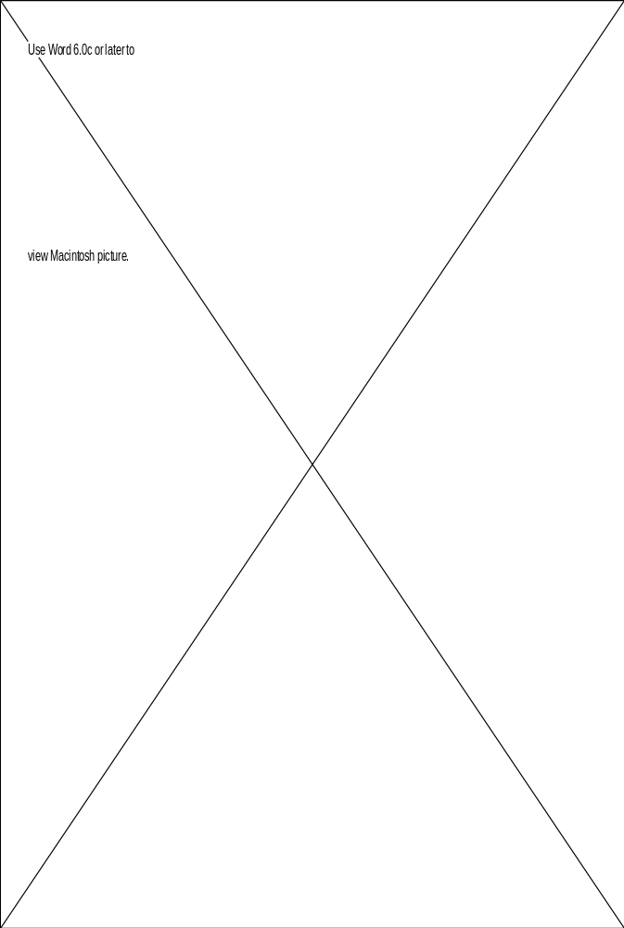

GENERAL, A.M. WEATHER: 7 June 92 - 12 GMT surface high position near 38N, 40W with a 1028mb closed contour. Estimated maximum surface sea level pressure is near 1032mb. The surface high is gradually drifting northwestward in response to a northeastward moving 996mb low near 63N, 36W. An occluded front extends from this low southeastward to near 50N, 20W. From this point a cold front extends southwestward to near San Miguel in the Eastern Azores. A warm front extends southward from 50N, 20W into the northwestern portion of
the ASTEX region. A strong surface high (1039mb) is located behind the cold front (centered near 45N, 45W). A 7C dew point drop in four hours was observed as the cold front crossed Terciera this morning. The region between the cold and warm fronts is nearly clear; however, some drizzle exists along both the cold and warm frontal boundaries. To the east of the warm front, and across the ASTEX
region, scattered patchy (3/8) stratus and stratocumulus clouds exist. The surface low, which was located yesterday near 38N, 12W, has moved northeastward to near 45N, 5W. Winds across the ASTEX region are north to northeast at 15kts. Winds north of the front are northerly at 15-20kts with occasional gusts to near 30kts.

NASA ER-2: Down

MRF C-130: Down

UVV C-131A: Down

NCAR ELECTRA: Down

ARAT F-27: Down

FMO Merlin IV: Not operational

