A Final Report of the

Vegetation Survey and Map Project for

St. Vincent National Wildlife Refuge, Apalachicola, Florida

A USFWS-USGS Research Partnership Program Project

submitted by

Susan L. Grace

U.S. Geological Survey

National Wetlands Research Center

700 Cajundome Blvd.

Lafayette, LA

70506

phone: 337-266-8618

e-mail: sue_grace@usgs.gov

April 2000

Contents
Initial Project Description 4

Brief Project Summary 4

Background 5
Climate 5
Geology 6
Soils 7
Hydrology 14
Natural Disturbances 15
Hurricanes 15
Wildfires and Prescribed Fires 16

Methods 18
Earlier Vegetation Surveys 18
Field Survey Procedures 1997 19
Mapping Procedures 19

Results 20
Plant Database 20
Species at Risk 20
Invasive Species 21
Vegetation Map 23
Vegetation Class Descriptions 24
Pine Flatwoods 24
Pine-Cabbage Palm Flatwoods 28
Cabbage Palm Hammock 31
Scrub 34
Sand Pine-Scrub 37
Live Oak Hammock 40
Hardwood Hammock 43
Coastal Grassland 46
Palustrine Marsh 49
Palustrine Shrub 53
Palustrine Open Water 56
Estuarine Marsh 59
Estuarine Shrub 62
Estuarine Open Water 64
Beach Dunes 67

Other Cover Classes 70
Intertidal Zone 70
Oyster Reef 70
Intertidal Flats 70
Developed 71
Managed Marsh 72
Managed Open Water 73

Summary 73

Research Needs 74

Acknowledgments 74

Literature Cited 76

Appendix 78

Initial Project Description

In an effort to understand the plant community structure of St. Vincent Island, the US Fish and Wildlife Service (USFWS) conducted a vegetation survey of the island in 1969. At that time, 17 plant communities were identified and mapped using colored pencils and hand-drawn delineations of vegetation boundaries. This map was in desperate need of updating using current knowledge of plant community classifications and technologies. The objectives of this research were to resurvey the plant communities on the refuge and to create a digitized vegetation map to be used as a tool for management decisions for USFWS staff. This map, developed as a GIS layer, would provide needed information used in the management of wildlife, fire, hydrology, and recreation areas for which the refuge currently is responsible.

Refuge employees were responsible for information associated with the 1969 vegetation survey, current road maps of St. Vincent NWR, and site visit consultations. An estimated 5-15 person days of refuge employee time was required to conduct these activities. U.S. Geological Survey, Biological Resources Division (USGS-BRD) personnel and associates were responsible for photo interpretation and digitizing of photography, a new vegetation survey, and delineations of vegetation boundaries. Discussions with researchers from the National Wetlands Research Center (NWRC) in Lafayette, Louisiana, indicated that the direct costs could be minimized by the fact that employee time would be donated by each agency. USGS-BRD would contribute partial funding towards the vegetation survey and photo interpretation (supervised by Dr. Sue Grace, NWRC). Total estimated costs for this project included the cost of updating the aerial photography and a student intern to help digitize information from the photography. Project completion: December 1999.

Brief Project Summary

In July 1997, Thom Lewis, biologist at St. Vincent National Wildlife Refuge (NWR) identified a research need to have the vegetation of the refuge surveyed and mapped for management purposes. USGS staff made an initial refuge visit in October 1997 where ideas and issues were discussed among collaborative staff to help define a study to meet the research needs requested by the refuge. In the fall 1997, a proposal for the Research Partnership Program was successfully funded to support the identified projects and further support was provided from the USFWS Ecological Services Office, Panama City, FL.

Information regarding aerial photography acquisition, earlier plant surveys and vegetation maps, soil maps, and ecological literature was obtained during the fall 1997. Also at this time correspondence was established between collaborators and Anne Johnson of the Florida Natural Areas Inventory (FNAI) with a site visit in October 1997.

Field surveys were conducted during the next two summers (FY 1998-99) to define and refine plant communities used in the vegetation map. A draft vegetation map was completed by the end of summer 1998, then ground-truthed, georeferenced, and refined in summer 1999. In addition to definition of plant community boundaries, a description of each plant community was made and dominant plant species listed for each plant community type. Plant community descriptions were made and cross referenced to earlier vegetation descriptions of the refuge and compared to the natural community descriptions for Florida published by FNAI (1990).

Products from this project included an updated list of plant species for the refuge, a plant database describing plant species on the refuge, a description of plant communities, and a final map of the vegetation types of the refuge both in digital and hard copy. This project is an excellent working example of interagency cooperation between USFWS and USGS. The help of the USFWS staff made this project possible by providing transportation to and from the refuge, housing, fuel and transportation while on the refuge and in sharing their knowledge, providing historical data and information of the refuge itself.

Background

St. Vincent National Wildlife Refuge (NWR) is made up of three land units: (1) St. Vincent Island - a 12,35-acre island located in a chain of barrier islands within Apalachicola Bay; (2) the mainland unit, an 86-acre pine forest and tidal marsh located on the adjacent mainland across from St. Vincent Island; (3) Pig Island, a small 46 acre island located to the east of St. Joseph Peninsula within St. Joseph Bay. Both the St. Vincent Island and mainland unit boundaries are within Franklin County. Pig Island is located in Gulf County.

Climate

The climate of the Apalachicola area is affected by the adjacent Gulf of Mexico and is characterized as a moderate climate with long, warm growing seasons and mild winters (Sasser et al. 1994). Average summer temperatures for June, July, and August hover around 80⁰F while winter temperatures for December, January, and February fall to 55⁰F. The last freeze date for spring is February 2, and the first freeze date in fall is December 21 giving a 322 day potential growing season for the area. Precipitation in the Apalachicola area follows two rain periods. The summer rainy season from June through September contributes an average of 30 inches of rain a year while the winter rainy season (December through April) contributes an average of 16 inches per year with May, October, and November being generally drier months. Total average precipitation is about 56 inches per year.

Summer at St. Vincent NWR is characterized by afternoon thunderstorms caused by the moist, unstable air produced from the surrounding Gulf of Mexico waters. Thunderstorms are generally intense and occur over a short period of time during 2-4 days each week. In general, these thunderstorms produce little significant rainfall but occasionally can produce 2 to 3 inches of rain in less than 2 hours. The greatest amount of precipitation recorded for the Apalachicola region was 11.7 inches in September 1932. Humidity is high in this area as a result of the adjacent Gulf of Mexico waters. The humidity will fall to 60% to 70% during mid-afternoons of summer and recover to 85% during the night until dawn.

The prevailing winds are from the north in the winter and south in the summer with an average windspeed ranging from 6.5 to 7.9 mph. A record windspeed of 85 miles per hour was recorded during Hurricane Kate, November 1985.

Geology

The underlying geologic formation described for the Apalachicola region includes Miocene, Pliocene, and Holocene descriptions although older geologic formations certainly underlie these formations (Stapor 1973, Sasser et al. 1994). The Miocene formations are found approximately 300-450 feet below mean sea level and include the St. Mark's Formation (early Miocene in age - 26 million years ago) and the Bruce Creek Limestone Formation (early to mid Miocene in age). Both formations are mostly composed of limestone with some thin beds of sand and clay present. The Intracoastal Formation (late Miocene to early Pliocene in age - 13 million years ago), overlies the St. Mark's Formation and Bruce Creek Limestone Formations and occurs up to 175 feet below mean sea level in the vicinity of St. Vincent Island. Pliocene formations that occur in this area and below the island includes the Alum Bluff Group (late Pliocene in age - 2 million years ago), which is composed of unconsolidated sandy, shelly limestone in a clay matrix and sandy shell beds. More recent Pleistocene and Holocene deposits of undifferentiated surface sediments (alluvium and marine terrace deposits), overlie the Alum Bluff deposits and are less than 11,000 years old. These Holocene deposits make up the surface geologic layers of St. Vincent Island and surrounding area. The earliest radiocarbon dates from Holocene deposits of the barrier islands are approximately 4,400 years old (Schnable 1966).

There has been significant study and interpretation of the geologic history of St. Vincent Island and the geologic formation of the barrier islands of Apalachicola Bay (Stapor 1973, Stapor and Tanner 1977, Donohue et al. 1990). Stapor (1973) suggested that St. Vincent Island was formed from a series of sand ridges that were deposited from the northwest end of the island (the oldest ridges) to the southeast end of the island (youngest sand ridges). The oldest sand ridges on the island have been carbon dated to being between 3,500 and 6,500 years old. Following the initial shoal development on the northwest portion of the island a series of four east-west oriented sand ridges, less than 2 miles each, formed to the south of the shoal. Stapor also suggests a possible sea-level rise approximately 2,000 to 3,000 years ago which drowned the older ridges and created Big Bayou. Following this increase in sea level, the sand ridge deposition forming St. Vincent Island changed the orientation to a more southeast-northwest one. Also following this sea-level rise St. George shoal developed, beaches of Cape St. George Island formed and Pig Island formed as the beginning of Cape San Blas shoal developed. These newly developed islands continued to grow from sand ridge depositions 1,000 to 2,000 years ago. The formation of the deep and narrow West Pass Channel between St. Vincent Island and Cape St. George Island led to the formation of the youngest sand ridges on the island which were deposited 400-500 years ago. As a result of the deep West Pass channel formation, the youngest deposited sand ridges have been deposited at more northeast-southwest orientation, almost perpendicular to the orientation of the older sand ridges on the island. Donohue et al. (1990) suggests that the youngest sand ridges on the southeast portion of the island are currently undergoing erosional processes because of less sand availability for deposition.

Soils

There are 16 soil types mapped for St. Vincent NWR, with some overlap among the refuge units (Table 1): 14 soil types mapped for St. Vincent Island, 3 soils mapped for the mainland unit and 6 mapped for Pig Island. The following is a description of each soil type and a general description of its mapped location on the refuge. All descriptions are summarized from the soils surveys conducted in Franklin and Gulf Counties (Sasser et al. 1994).

Table 1. List of soils and location on St. Vincent NWR. SVI= St. Vincent Island, MU=mainland unit, PI=Pig Island.

Soil Type | SVI | MU | PI
Beaches | X
Bohicket-Tisonia complex | X
Corolla sand | X |  | X
Corolla-Duckston complex |  |  | X
Dirego-Bayvi complex | X |  | X
Duckston sand | X | X
Duckston-Bohicket-Corolla complex | X
Duckston-Rutledge-Corolla complex | X
Kershaw sand | X
Kureb-Corolla complex |  |  | X
Leon sand |  | X
Lynn Haven sand |  | X
Mandarin fine sand | X
Maurepas muck | X
Newhan-Corolla complex | X
Ortega fine sand | X
Resota fine sand | X
Rutledge loamy fine sand | X

Beach soils

Beaches are deposits of loose, fine sand and shell fragments within the high tide mark. These fragments and sand are susceptible to movement by wind and tide. This soil type is of low fertility and low organic content. This soil type occurs in a small portion of St. Vincent Island and is restricted to the narrow strip of beach along the southern and eastern portions of St. Vincent Island from Indian Pass Point to West Pass Point and along most of the eastern portion of St. Vincent Island up to Mallard Slough. There is a small area of beach at St. Vincent Point on the island.

Bohicket and Tisonia soils

These soils are very poorly drained soils of nearly level (<1% slope) tidal and estuarine marshes. Bohicket soil has approximately 23 inches of gray silty clay in its surface layer to 80 inches of black silty clay. Tisonia soil profile has 4 inches of mucky peat in the surface layer, over 22 inches of brown muck below the surface layer, 44 inches of gray clay, and below this to a depth of 80 inches of sand and sandy clay loam. The water table of this soil complex occurs at or above the surface throughout the year and under tidal influence. The organic content of Bohicket soil is low to moderate (5-25%) whereas Tisonia soil has a high organic content (40-65%). Both soil types exhibit high salinities and fertility. This soil type occurs abundantly in the tidal marshes on the eastern portion of St. Vincent Island including Big Bayou, Mallard Slough, Sheepshead Bayou, and the marshes of the northwest portion of the island.

Corolla sand

This soil type is a somewhat poorly drained soil of nearly level to gently sloping terrain (<3% slope). It occurs on salt flats, small sand dunes and in swales of large dunes. The surface layer is composed of 6 inches of light gray sand and below the surface to 80 inches is more light gray sand. This soil type has a seasonally high water table at a depth of 18 to 36 inches for 3 to 6 months per year. Flooding can occur during coastal storms and hurricanes. This soil type has a low organic content (0.5%) and low fertility. This soil type is moderately abundant on St. Vincent Island. It occurs scattered throughout the island on some interior dunes and makes up the predominant soil type of the high dunes along the southern portion of the island. There is a small portion of this soil type found in association with the cabbage palm islands of the northwestern portion of the island at the mouth of Big Bayou. It also makes up the sand dunes along the southwestern portion of Pig Island.

Corolla-Duckston complex

The soils of this complex range from very poorly drained to moderately drained soils of nearly level to strongly sloping terrain. They occur on low dune-like ridges along the coast, low ridges and rises in flatwoods, and floodplains. See earlier descriptions for Corolla sand and Duckston sand for soil profile characterizations. This soil complex makes up the sandy dune areas of Pig Island, primarily located on the eastern portion of the island.

Dirego and Bayvi soils

These are very poorly drained soils of nearly level (<1% slope) tidal and estuarine marshes. Generally this soil complex is made up of 50% Dirego and 40% Bayvi soils. The surface soil of Dirego soil is brown muck to 35 inches with a subsurface sand to 72 inches. The surface soil of Bayvi soil is mucky sand to 8 inches and a subsurface layer of sand to 80 inches. Both soil types have a water table at or above the surface throughout the year and are tidally influenced. Dirego soils have a high organic content (25-60%) whereas the Bayvi soil has a moderate organic content (8-20%). Both soil types are of low fertility and have high salinities. This soil type has a low occurrence on St. Vincent Island and is found in the marshes to the north of Big Bayou, in the northwest portion of St. Vincent Island. It also makes up the soils of the marshes of the southern portion of Pig Island.

Duckston sand

This is a poorly drained soil on nearly level (0-2% slopes) terrain. It occurs on level flats adjacent to coastal dunes and marshes in low swales between dunes. The soil surface layer consists of gray sand 4 inches thick, and below the surface layer to 80 inches is more gray and white sand. There is a high water table in this soil type to a depth of 12 inches throughout the year. The water table may fluctuate with tides. This soil type can flood during storm events. There is a low organic content (3%) and this soil has low fertility. This soil type occurs in moderate abundance on St. Vincent Island. It is found in association with pine-cabbage palm flatwoods and swales of the southern portion of the island. On the southeast end of the island it occurs in pine-cabbage palm flatwoods adjacent to wetlands associated with Oyster Pond and pine-cabbage palm flatwoods associated with the high dunes along the coast of West Pass point. There is one narrow strip of this soil type associated with a pine-palmetto flatwoods area in the interior of the island between Shell Road and G Road near Road 6. There is also a small narrow strip of this soil type associated with pine-palmetto flatwoods north of the scrub oak dune that runs along Road A between Road 1 and Road 2. In addition, there is a small portion of this soil type associated with the swales adjacent to the high dunes that run along the southern coast of the island between Road 3 and Road 4. This soil type can also be found in the pine-cabbage palm flatwoods and swales in the northwest portion of the island on the western end of Road J along Dry Bar. This soil type occurs abundantly in the mainland unit. It is found in association with the pine flatwoods forest community of this unit and makes up about 50-60% of the unit.

Duckston-Bohicket-Corolla complex

This complex is made up of very poorly to somewhat poorly drained soils of nearly level terrain (0-2% slopes). This complex of soils occurs on low ridges, flats and in narrow, elongated tidal marshes on barrier islands. This complex is made up of 50% Duckston, 25% Bohicket and 15% Corolla soils. Duckston occurs on very low ridges, on nearly level flats, and in swales; Bohicket occurs in narrow, elongated marshes between low dune ridges and Corolla soil occurs on low dune ridges. See previous descriptions for characteristics of individual soil types. This soil complex has moderate to high occurrence on St. Vincent Island. It occurs predominately on the northern portion and a small amount in the southeastern corner of the island. It is most closely associated with the hardwood hammock communities of the island north of Road G. In addition it is associated with the pine flatwoods forests on Dry Bar along Road I and Road J. This soil complex is also associated with the hardwood hammock communities, southeast of St. Vincent Creek Outlet.

Duckston-Rutledge-Corolla complex

This complex is made up of very poorly drained to somewhat poorly drained soils of nearly level terrain (0-2% slopes). This complex occurs on low ridges, flats and swales of barrier islands. This complex is made up of 50% Duckston, 25% Rutledge and 25% Corolla soils. Rutledge soils occur in low swales, Duckston in flats and Corolla in low ridges. See previous descriptions for characteristics of individual soil types. The majority (>60%) of St. Vincent Island is made up of this soil complex. It occurs predominantly in the southern and middle of the island with no occurrence of this soil complex in the oldest part of the island in the northwest corner (north of Mallard Slough). This complex is closely associated with the pine flatwoods forest communities that are the dominant vegetation class of the island.

Kershaw sand

This is an excessively drained soil of sloping to strongly sloping (5-12%) terrain. It occurs on side slopes and tops of high sandy ridges. The surface layer is composed of 5 inches of gray sand with brown fine sand below to a depth of 80 inches. There is no water table within 80 inches of the soil surface. This soil has a low organic content (<1%) and low fertility. This soil type has a low occurrence on St. Vincent Island and occurs on two sand ridges on the southeast corner of the island. It occurs in association with live oak hammocks.

Kureb-Corolla complex

This soil complex is made up of excessively to moderately drained soils that are found in nearly level to strongly sloping terrain. These soils are found in sand dune ridges along the coast and in low rises in flatwoods. The profile for both soils consists of sandy soil to 80 inches. Soils in this complex may have a seasonal high water table between 18 and 60 inches from 1 to 6 months per year, with no seasonal water table the rest of the year. This soil complex is found in the sand dunes along the western portion of Pig Island.

Leon sand

This soil type is a poorly drained soil of nearly level terrain (0-2% slope). It occurs in broad flatwoods and on small inclines or low ridges in titi bogs. The surface layer is 8 inches of dark gray sand with brown gray to brown sand below to 80 inches. This soil type has a seasonally high water table at a depth of 6-12 inches 1 to 4 months per year. The soil has low to moderate levels of organic matter (0.5-4%) and has low fertility. This soil type is moderately abundant on the mainland unit. It occurs along the northern edge of the unit, in association with the pine flatwoods community of the unit.

Lynn Haven sand

This soil type is a poorly drained soil of nearly level terrain (0-2% slopes). This soil type is found in broad, depressional areas of flatwoods. The soil profile consists of a surface layer composed of 8 inches black sand with 14 inches below of dark gray sand. The subsoil to 80 inches is gray and brown sand. This soil type has a seasonal (late winter and early spring) high water table within a depth of 12 inches of the surface 4 to 6 months per year and a depth of 30 inches the rest of the year. The organic content of the soil is moderate (0.2-4%) with low fertility. This soil type occurs in low abundance only on the mainland unit. It is primarily located along the east end of the unit and along a small north-south section through the middle of the unit.

Mandarin fine sand

This soil type is somewhat poorly drained in nearly level soil (0-3% slopes) of low coastal ridges and small inclines in flatwoods. The surface of this soil type has 4 inches of gray fine sand and below this layer to 80 inches is more fine sand. There is a seasonally high water table present in this soil at a depth of 18 to 36 inches for 3 to 6 months per year. This soil has low organic content (<3%) and low fertility. This soil type has a low occurrence on St. Vincent Island. There are two locations in the interior of the island where this soil type is found. It occurs in two interior sand ridges that run along the southern half of the island in association with scrub oak plant communities.

Maurepas muck

This is a poorly drained, organic soil of nearly level (<1% slope) brackish marshes and swamps. The surface layer consists of 6 inches of brown muck, and below that to a depth of 80 inches is brown muck. There is a high water table in this soil that is 6 to 12 inches above the surface throughout the year. The water table is tidally influenced. The organic content and the fertility is high in this soil type. This soil type occurs in moderate to high abundance on St. Vincent Island. It is located in the southeastern portion of the island. This soil type is closely associated with the fresh and brackish marshes adjacent to the lakes and large ponds in the southeastern end of the island.

Newhan-Corolla complex

This soil complex is made up of excessively to somewhat poorly drained soils of gently undulating to steep terrain (5-15% up to 30% slope). This complex occurs in coastal dunes and swales. The Newhan soils occur in high dunes and the Corolla soils are soils of low dunes and swales. The Newhan soil surface has 1 inch of gray sand and has gray and white sands below to 80 inches. The surface layer of the Corolla sand is made up of 3 inches of dark gray sand with more gray sand below to 80 inches. Newhan soils do not have a water table within 80 inches of the surface whereas the Corolla soil has a seasonal water table at a depth of 18 to 36 inches 2 to 6 months per year (36 inches below surface the rest of year). Both soils have low organic content (0.5%) and low fertility. This soil type is in moderate abundance on St. Vincent Island and is found in two locations on the island. It is found along the tip of Indian Pass Point along the southwestern corner and also occurs around West Pass Point along the southeastern portion of the island. This soil type occurs in association with the high sand dunes of the island.

Ortega fine sand

This soil type is moderately well-drained and in nearly level to gentle sloping terrain (0-5% slopes). It occurs on side slopes or in concave areas of sandy uplands. The surface layer consists of 5 inches of grayish brown fine sand and below this to 80 inches is more fine sand. This soil type has a seasonally high water table located at a depth of 60 to 72 inches for 6 months per year. The organic content of this soil is low (1-2%) and has low fertility. This soil type has a low occurrence on St. Vincent Island and is restricted to a small portion of the southeastern end of the island associated with live oak sand ridges.

Resota fine sand

This soil type is a moderately well-drained soil of nearly level or gently sloping (0-5% slopes) terrain. It occurs in coastal ridges and remnant sand dunes. The soil profile consists of a surface of 3 inches of fine sand with more fine sand to 80 inches below. There is a seasonally high water table at a depth of 40 to 60 inches 6 months per year. This soil type has low organic content (<1%) and has low fertility. The majority of interior sand ridges that run northwest-southeast across St. Vincent Island are made up of Resota fine sand, giving this soil type a moderate to high occurrence on the island. These sand ridges are mainly in the southwestern and south central portions of the island and are associated with the scrub oak communities of the interior of the island.

Rutledge loamy fine sand

This is a very poorly drained soil of nearly level terrain and depressions (<2% slope). The surface layer is composed of 5 inches of black loamy fine sand with fine gray sand below the surface to 80 inches. There is a seasonally high water table present in this soil type at a depth of 24 inches for 3 to 6 months per year. This soil type has a high organic content in the surface layer and low throughout the rest of the profile. This soil type also has a moderate level of fertility. It has low to moderate occurrence on St. Vincent Island. It is found primarily on the southern half of the island adjacent to the large ponds and lakes of the southeastern section of the island. This soil type occurs in association with shrub thickets upstream from wetlands adjacent to lakes 1, 4, and 5, Oyster Pond, and the sawgrass wetland south of Road B between Road 3 and Road 4. It also occurs in a narrow strip just south of Mallard Slough and is associated with a sawgrass marsh.

Hydrology

The patterns of water movement, both at the surface and below, play a significant role in the present day vegetation patterns observed on St. Vincent NWR. Of the three units that make up the refuge, only surface water flow movement on St. Vincent Island has been investigated. In a recent study, Davis and Mokray (1999) documented sites where natural flow of surface water of St. Vincent Island had been altered by road construction and other modifications to determine how to restore natural surface water flow patterns on the island. They observed water flow patterns at 261 sites and determined that 250 sites exhibited channel flow (surface flow from uplands to creek channels) and 11 sites demonstrated sheet flow (large flat areas several hundred feet across through which water flows in a large mass). All surface water flow on the island results as run-off from rain events or occurs as baseflow from seepage of the ground water table (estimated to be five ft above mean sea level; Davis and Mokray 1999). The ground water table recharges rapidly on the island because of the high sand content of the soil that allows water to permeate down to the ground water table quickly.

Results of the recent hydrology study on St. Vincent Island suggest that human alterations such as roads have created impediments to natural surface water flow. Roads and other constructed features act as dams to creeks, reduce flow to wetlands creating deeper water wetlands, reduce salinity flows to salt marshes, provide a means of allowing nearby creeks to overflow into one another during high water events, and manipulate water movement with ditching. Not only have these activities altered the natural surface water flow patterns, but they have also significantly altered vegetation patterns as well. The most obvious vegetation response to surface water flow changes can be seen along roads where saltwater has been restricted to flow into creeks and marshes on one side of the road. As a result, one side of the road shows a converted saltwater marsh to freshwater marsh, and on the other side the natural salt marsh is present. Roads have also created deeper water wetlands on portions of the island, damming small creeks and channels. As a result, more deeper-water plant species such as cattails, red maple, and cypress trees have begun to invade willow thickets, bayheads and titi swamps along the small creeks and channels. Having deeper-water wetlands also affects the potential for a wetland to burn in dry periods. Many of these wetland communities that are being converted (e.g., titi swamps and bayheads), will not burn in dry periods perpetuating less fire-tolerant species and greater abundance of deeper water wetland species. In addition, water flow patterns on the island are manipulated by water control structures constructed between lakes on the southeastern portion of the island. These control devices have been established to control water levels. They are currently used to manage plant species, primarily cattails, and have a significant impact on the composition of other wetland species present. Further, the construction area of water control structures house several invasive species as a result of soil disturbance. Further construction of culverts and other water flow control structures should consider the possibility of increasing introductions of invasive species Minimum soil disturbance should be maintained in the construction of these modifications.

Natural Disturbances

The vegetation of St. Vincent NWR is subject to both large and small scale disturbances that have influenced and continue to influence the structure and abundance of plant species present on the refuge. Below is a discussion of the two large scale disturbances that have significant effects on the vegetation of St. Vincent NWR.

Hurricanes

One of the most significant large scale disturbances to the refuge vegetation is hurricanes. Although the refuge is situated in an area along the northern Gulf of Mexico that is considered to have a relatively low frequency of hurricanes (Doyle and Krauss 1999), there have been at least 60 tropical storm tracks through the general vicinity of the refuge in the past 100 years. Of these storms, there have been 19 storms with hurricane force winds over 70 mph and two storms with winds greater than 100 mph (Table 2). These storms play a strong role in the dynamic vegetation patterns of the refuge over time. Sand is blown about from the high winds of the storm and either covers up existing vegetation or creates new sand dunes that allow a site for plants to colonize. As a result, plant populations fluctuate in size and presence over time. In addition to the impact of hurricanes on population loss or gain, hurricanes also affect tree growth. Doyle and Krauss (1999) found changes in diameter growth as a response to Hurricanes Elana and Kate in 1985. Trees impacted by the hurricane produced less girdle growth and more foliage growth as a response. Doyle and Krauss (1999) also suggests the hurricane of 1894 may have reduced forest density significantly as evidenced by increased growth of neighboring trees resulting in a much thinner stand of trees. In addition to affecting tree growth and forest structure, hurricanes and strong wind and flood events can act as mechanisms for new introductions of native and invasive plant species on the refuge.

Table 2. Tropical storms with hurricane force winds (70 mph) for the general vicinity of St. Vincent NWR.

Year of Hurricane | Maximum  Windspeed  (mph)
1886 | 96
1886 | 83
1893 | 81
1894 | 109
1896 | 75
1899 | 80
1903 | 79
1915 | 92
1926 | 73
1929 | 79
1936 | 83
1939 | 74
1941 | 83
1966 | 95
1972 | 80
1985 | 113
1985 | 97
1995 | 79
1998 | 74

Wildfires and Prescribed Fires

A second large-scale disturbance that strongly influences the vegetation of St. Vincent NWR is wildfires. Florida, in general, is prone to wildfires because it is located in a climate that has the highest frequency of lightning activity. As such, many of the native plant communities are made up of plant species that are fire-tolerant and benefit from fire by either resprouting or producing flowers and seeds following fire. Although there is an active wildfire suppression program on St. Vincent NWR and throughout the United States in all land management agencies, there is a growing awareness of the importance of wildfires on the landscape ecologically. In the last decade there have been 24 wildfires that burned across 2,302 acres of the refuge (Table 3). We realize that fire is a critical process in many communities and ecosystems in fire prone areas. As a result, we are increasing our fire management programs to include prescribed fires that try to mimic wildfire effects under more controlled conditions. St. Vincent NWR has a fire management program that includes prescribed fires. In the last decade over 113 prescribed burns have been conducted to successfully burn 36,415 acres of the refuge (Table 3).

Fire is an important ecological process that determines the structure and composition of natural plant communities of St. Vincent NWR. Historically, wildfires occurred frequently on the landscape and were caused by lightning strikes that ignited fuels to burn across the landscape. The majority of refuge lands are dominated by slash pine forests which is one of the forest types in the southeastern U.S. that was naturally maintained by frequent low-intensity fires. Many of the plant species of the pine forests of St. Vincent NWR are considered fire tolerant or fire-adapted by having characteristics that allow the plant to regenerate either vegetatively or reproductively following fire and is not killed by fire. In the presence of frequent burning, the structure of these forests develop into an open pine stand with little to no midstory trees or shrubs present and a rich diverse layer of grasses and herbs in the understory. The vegetation structure of these forests are also influenced strongly by the season of burn. Robbins and Myers (1990) have shown that frequent late spring and early summer fires (growing season burns) will reduce woody shrub and tree invasion into the forest. Further, less fire-tolerant, invasive plant species such as Chinese tallow (Sapium sebiferum) may be eliminated with frequent growing season burns (Grace 1998). On the other hand, in the absence of fire (e.g., active fire suppression programs), heavier fuels such as shrubs and small trees begin to invade forest stands and can have a significant shading impact on native herbaceous vegetation in the understory in as little as 3 years, thus significantly reducing native plant diversity in a forest stand. As heavy fuels build up in fire suppressed areas, the potential for higher intensity fire behavior can be expected.

Not all plant communities on St. Vincent NWR should be subjected to frequent burning however. Natural plant communities other than slash pine forests such as scrub oak dunes, sand pine-scrub oak, scrub-shrub, live oak hammocks, cabbage palm hammocks, and maritime forests probably had less exposure to frequent fire because of the fuel structure in these communities and probably only burned in extremely dry conditions. As such, many of the plant species in these communities are not fire tolerant and are killed back after each fire. A fire management program for the refuge should consider the timing and season of burning in the fire regime.

Table 3. Numbers of prescribed fire and wildfires from 1985-99 and their acreages for St. Vincent NWR.

Year | Number of  Prescribed  Fire | Acreage of Prescribed Fire | Number of Wildfires | Acreage of wildfires  (acres)
1985 | 5 | 540 | 1 | 0.1
1986 | 4 | 4960 | 0 | 0
1987 | 6 | 843.4 | 1 | 0.3
1988 | 6 | 1604.7 | 0 | 0
1989 | 13 | 2246.8 | 1 | 33
1990 | 9 | 1635 | 3 | 97
1991 | 10 | 2336 | 2 | 201
1992 | 8 | 2125 | 1 | 1100
1993 | 16 | 5861 | 7 | 1452
1994 | 9 | 2671 | 0 | 0
1995 | 4 | 776 | 1 | 38
1996 | 12 | 5045 | 0 | 0
1997 | 1 | 151 | 1 | 86
1998 | 10 | 5620 | 6 | 285
1999 | 2 | 1278 | 4 | 160
Total | 115 | 37692.9 | 28 | 3452.4

Methods

Earlier Vegetation Surveys

St. Vincent Island is an attractive place for botanical surveys due to its extensive diversity of native plants and plant communities. McAtee (1913) published the first plant list for St. Vincent Island. There was little plant inventory work following this survey for the next several decades. Thompson (1970) conducted an extensive survey of vegetation cover classes for St. Vincent Island and expanded the plant list generated by McAtee (1913). Thompson listed 301 plant species that occurred on St. Vincent Island. At this time, Thompson also completed a plant community survey of Pig Island but did not submit a plant species list. These surveys conducted by Thompson offered a baseline data for general vegetation patterns for management operations of the refuge. The results of Thompson's work is compared to current vegetation patterns on the refuge in the Results section below. Thompson's existing plant species list was expanded and 2 years on the barrier islands of the Apalachicola National Estuarine Research Reserve including St. Vincent Island. Results of this study showed 632 plant species listed for St. Vincent Island (Anderson 1986, 1987, 1988). Additional research of plant inventories and vegetation surveys have been conducted by FNAI in 1987 and are ongoing. These studies will inventory and monitor plant species at risk on the refuge, specifically on St. Vincent Island (Table 4).

Field Survey Procedures 1997

The goal of the current study was to update vegetation data and produce a digitized vegetation map. For the vegetation portion of this study, the information gathering phase involved obtaining information regarding previously published vegetation data. Information obtained included published literature, maps, interim and final reports, and correspondence and personal communications with previous surveyors. The field phase of this project included an initial site visit for reconnaissance, specimen collections, and initial descriptions of plant communities. Additional site visits were conducted throughout the 2-year period to continue to fine tune plant community descriptions and inventory plant species. The product development phase of this research included compiling all data resulting from plant inventories and developing a plant database using Microsoft Access software.

Mapping Procedures

The mapping process consists of aerial photography acquisition, data preparation, photo interpretation, and mapping. Procedures and techniques used in the mapping process for this project were derived from, and are in accordance with, nationally accepted standards and conventions for map accuracy and habitat mapping. A photo search was conducted to determine the availability of existing aerial photography. Color infrared photography flown by NASA-Ames Research Center in December 1992 at a scale of 1:32,500 was acquired for this project. This data fulfilled the requirements necessary for landcover vegetation mapping; namely, full stereo coverage, flown during leaf-off/winter time of year, good quality, clarity and color, cloud-free coverage, and acceptable scale for achieving level of detail desired for final map. In preparation for photo interpretation, soil surveys, topographic maps, and other collateral information was compiled and analyzed. A landcover classification system was developed for the purpose of categorizing and mapping the vegetation communities in accordance with project goals. Field surveys were conducted to record ground-truthed data such as habitat structure, vegetation type and/or class, and to correlate photographic signatures for photo interpretation. The photography was interpreted by using a stereoscope, and the vegetation classes were delineated by hand with technical pen and ink. The data were mapped by using a Zoom Transfer Scope. The cartographic transformation phase, as this stage of the process is known, consists of transferring the information from the aerial photograph to base maps, in this case, USGS 1:24,000 scale quadrangles. Field verification surveys as well as quality control checks were conducted before final map production. The maps were digitized and the data was edited, compiled, and stored in ArcInfo format.

Results

Plant Database

The plant surveys of St. Vincent NWR during 1997 revealed eight new plant species not previously reported for the refuge. These results compiled with previous reports of plant surveys increase the total number of plant species reported for the refuge to be 596 species. The great number of plant species reported for the refuge reflects the vast diversity of habitats included within the refuge boundaries. To manage these data efficiently and effectively for current and future managers of the refuge, a plant database was developed. This database includes the following fields: common name, genus, species, variety or subspecies (if present), author citation, plant family, flowering characteristics, flowering date, life history (annual, biennial or perennial), habit (herbaceous or woody), life form (herb, shrub, tree, vine), origin (native or non-native), habitat, Florida status (common, frequent, occasional, rare), wetland status (obligate wetland, facultative wetland, facultative upland, obligate upland), species at risk (whether it is monitored by FNAI as a rare plant), and global rank (as defined by FNAI) for all plant species on the refuge. The software used to develop this database allows for the user to sort by any field given above, so refuge managers can access any part of the database needed to generate lists of plants that are of interest.

Species at Risk

There are five known species at risk for St. Vincent NWR; corkwood (Leitneria floridana), Gulf Coast lupine (Lupinus westianus var. westianus), Florida beargrass (Nolina atopocarpa), West's flax (Linum westii), and Drummond's yelloweyed grass (Xyris drummondii) (Table 4). The Florida Natural Areas Inventory Program considers the two most imperiled species on the refuge are the West's flax and the Gulf Coast lupine which both have global ranks of G2 (imperiled globally). Of these species, Linum westii is considered listed endangered by the Florida Department of Agriculture and Consumer Services (FDACS). All other species with the exception of Xyris drummondii are listed as threatened species by the FDACS. There are no federally listed plant species for the refuge currently.

Table 4. Species at risk listed for St. Vincent Island, both species and common names are given as well as global rank, Florida status, and federal status. Global and state ranks; G2=imperiled globally, G3=very rare and local throughout range, S2=imperiled in Florida, S3= very rare and local throughout range. Florida status ranks; LT=listed threatened, LE= listed endangered, NL=not listed. There are no species listed that are at risk federally.

Species | Common Name | Global Rank | Florida  Status
Leitneria floridana | corkwood | G3S3 | LT
Linum westii | West's flax | G2S2 | LE
Lupinus westianus var. westianus | Gulfcoast lupine | G2S2 | LT
Nolina atopocarpa | Florida beargrass | G3S3 | LT
Xyris drummondii | Drummond's yellow-eyed grass | G3S3 | NL

Invasive Species

There are 35 plant species listed for the refuge that are considered invasive species to Florida (Wunderlin 1997). The invasive species of the refuge represent 16 different plant families with grasses the largest family represented by 10 species (Table 5). Most of the invasive species introductions have occurred in human-altered sites within the refuge, specifically on roadsides, water control structures and open water canals. Some invasive species are introduced from high water floodings into natural communities but there is little evidence of wide establishment by this means of introduction. Current control management practices for each species can be found on the internet at: http://aquat1.ifas.ufl.edu/welcome.html (Center for Invasive and Aquatic Species).

Table 5. A list of invasive plant species and their plant families on St. Vincent NWR.

Species | Common Name | Family
Alternanthera philoxeroides | alligatorweed | Amaranthaceae
Carya illinoinensis | pecan | Juglandaceae
Carya ovata | shagbark hickory | Juglandaceae
Chenopodium ambrosioides | Mexican tea | Chenopodiaceae
Cynodon dactylon | bermudagrass | Poaceae
Cyperus esculentus | chufa flatsedge | Cyperaceae
Cyperus lanceolatus | epiphytic flatsedge | Cyperaceae
Echinochloa crusgalli | barnyardgrass | Poaceae
Eleusine indica | Indian goosegrass | Poaceae
Eragrostis atrovirens | thalia lovegrass | Poaceae
Heliotropium curassavicum | seaside heliotrope | Boraginaceae
Heliotropium indicum | Indian heliotrope | Boraginaceae
Hyptis mutabilis | tropical bushmint | Lamiaceae
Kummerowia striata | Japanese clover | Fabaceae
Leonotis nepetifolia | lion's ear | Lamiaceae
Limnophila sessiliflora | Asian marshweed | Scrophulariaceae
Lycopersicon esculentum | garden tomato | Solanaceae
Lygodium japonicum | Japanese climbing fern | Schizaeaceae
Medicago lupulina | black medick | Fabaceae
Mollugo verticillata | green carpetweed | Molluginaceae
Panicum repens | torpedograss | Poaceae
Paspalum notatum | bahiagrass | Poaceae
Paspalum urvillei | vaseygrass | Poaceae
Phyllostachys aurea | golden bamboo | Poaceae
Polygonum lapathifolium | pale smartweed | Polygonaceae
Rumex chrysocarpus | amamastla | Polygonaceae
Rumex paraguayensis | Paraguayan dock | Polygonaceae
Sapium sebiferum | Chinese tallow | Euphorbiaceae
Sesbania punicea | rattlebox | Fabaceae
Setaria viridis | green foxtail | Poaceae
Sonchus asper | spiny sowthistle | Asteraceae
Sonchus oleraceus | common sowthistle | Asteraceae
Sporobolus indicus var. indicus | smutgrass | Poaceae
Wisteria sinensis | Chinese wisteria | Fabaceae
Xyris jupicai | Richard's yellow-eyed grass | Xyridaceae

Vegetation Map

The diversity of vegetation on St. Vincent NWR has been described in 21 cover classes that, for the most part, reflect the major vegetation patterns of the refuge. The following describes the synonyms, extent, topography, soils, appearance, ecology, and associated plant species for each vegetation class. A cross reference of the vegetation classes defined in this study compared to the natural plant community descriptions for Florida (FNAI 1990) and previous studies are given in Table 6.

Table 6. A cross comparison of vegetation classes and natural plant communities as defined by the 1999 vegetation map of St. Vincent NWR, FNAI (1998), and Thompson (1968).

1999 Vegetation/Cover Classes | FNAI (1998) | Thompson (1968)
Pine flatwoods | Mesic flatwoods | Slash pine-mixed understory  Slash pine-saw palmetto-Ilex
Pine-cabbage palm flatwoods | Wet flatwoods | Slash pine-cabbage palm hammock
Cabbage palm hammock | Maritime hammock | Cabbage palm
Scrub | Scrub | Scrub oak dunes
Sand pine-scrub | Scrub | Sand pine-scrub oak
Live oak hammock | Xeric hammock | Mixed live oak-scrub oak  Live oak dunes  Live oak-grass dune
Hardwood hammock | Maritime hammock | Hardwood hammock
Coastal grassland | Coastal grassland | Slash pine-grass
Palustrine marsh | Swale | Sawgrass-emergent marsh  Cattail
Palustrine shrub | Baygall, swale | Not identified
Palustrine open water | Coastal dune lakes | Freshwater pond
Estuarine marsh | Estuarine tidal marsh | Tidal marsh
Estuarine shrub | Estuarine tidal marsh | Not identified
Estuarine open water | Coastal dune lakes | Saltwater pond
Beach dunes | Beach dunes | Beach
Intertidal zone | Uncolsolidated substrate | Beach
Oyster reefs | Mollusk reefs | Not identified
Intertidal flats | Unconsolidated substrate | Not identified
Developed | Not identified | Not identified
Managed marsh | Not identified | Not identified
Managed open water | Not identified | Not identified

Vegetation Class Descriptions

Pine Flatwoods

Synonyms: Mesic slash pine flatwoods, mesic flatwoods, slash pine-mixed understory, slash pine-saw palmetto-Ilex, Pinus elliottii var. elliottii / Ilex glabra woodland, Pinus elliottii var. elliottii / (Sabal palmetto) / Serenoa repens-Ilex glabra woodland.

Extent on Refuge: Total acres = 4279.8 acres. Occurs on St. Vincent Island, Mainland Unit and Pig Island. This vegetation type is the most abundant vegetation type on the refuge. It makes up most of the forested vegetation of St. Vincent Island where it occurs in low ridges between sand dunes. On the mainland unit it makes up the majority of vegetation on the northern portion of the unit. Pine flatwoods also make up the interior forests of Pig Island.

Topographic Position: Low and nearly level terrain.

Soils: Mapped soil units associated with this vegetation type include Duckston, Duckston-Rutledge-Corolla Complex, Leon Sand, and Lynn Haven Sand. These soils are poorly drained soils on nearly level terrain and are composed of fine sands to a depth of more that 80 inches. The soils are of low fertility, low organic matter and moderate acidity.

Hydrology: Mesic sites that are seasonally flooded up to 6 months per year. In dry periods the water table can fall below 24 inches from the soil surface.

Appearance: In relatively natural conditions and under frequent fire regimes (once every 3 to 5 years) this vegetation type is characterized by an open to closed canopy of pine trees with little to no midstory, or an understory of either continuous saw palmetto or a rich grass and herb groundcover layer. In more fire suppressed sites, this vegetation type will have a dense hardwood component, including significant height growth of palmetto in the midstory and understory and a loss of native herbs and grasses in the groundcover (Figure 1).

Ecology: Frequent, light intensity, surface fires are essential to preserving and restoring this vegetation type. Frequent fire promotes the dominance of native groundcover plants such as herbs and grasses and decreases encroachment of woody vegetation into the midstory. In the absence of fire, open pine flatwoods are quickly invaded by hardwoods and shrubs that shade out and out compete native species in the understory. Further, the increased presence of hardwoods and shrubs in the midstory changes the behavior and intensity of fires as they burn through the stand. Increased woody vegetation in the midstory results in greater amounts of vertical fuels present and can lead to torching and crowning up into the canopy, creating more intense fire behavior, less ability for control and a higher potential for catastrophic fires.

There is little controversy that Florida is the thunderstorm capital of the world and that frequent fires played a significant role in the structure of plant communities on the landscape historically. Pine flatwoods and other pine forests of North Florida are extremely vulnerable to ignition during lightning activities and once ignited have the potential to spread fire across the landscape due to the light fuels present on the ground (i.e., pine needle litter, grassy understory, etc). While there is little dispute that most lightning activities occur during the summer months, there is still considerable debate about what season to use prescribed fire in the management of these ecosystems. This is a difficult issue since conditions during the summer or growing season are drier and can lead to more intense fire behavior with potential control problems than conditions during the dormant or winter months. The most common practice used today in this vegetation type is to introduce prescribed fire under cooler more controllable conditions initially to reduce fuel hazards and then over time introduce growing season burns for restoration. Growing season burns have several beneficial effects in the flatwoods. First, growing season burns have a greater impact on reducing woody vegetation than dormant season burns (Robbins and Myers 1990). Second, many native grasses and herbs in the understory flower and produce seeds (therefore increasing in numbers) only following a growing season burn. This is especially important for rare plants and plants of concern like wiregrass (Aristida spp.), toothache grass (Ctenium spp.), pitcher plants (Sarracenia spp.) and orchids (Calapogon spp., Pogonia spp.) for example.

Vegetation:

Overstory: The overstory is made up of mostly slash pine (Pinus elliotii) trees, but may include a few scattered trees of sweetgum (Liquidambar styraciflua), cabbage palm (Sabal palmetto), Virginia live oak (Quercus virginiana) and other oaks (Quercus spp.).

Midstory: Frequently burned sites have very few species present; however, less frequently burned sites may include regenerating overstory species as well as red maple (Acer rubrum), common persimmon (Diospyros virginiana), fetterbush (Lyonia lucida), sweetbay (Magnolia virginiana), wax myrtle (Myrica cerifera), red bay (Persea borbonia var. borbonia), dwarf live oak (Quercus minima), myrtle oak (Q. myrtifolia), water oak (Q. nigra), and farkleberry (Vaccinium arboreum).

Understory: The understory includes regenerating overstory and midstory species as well as huckleberrys (Gaylussacia dumosa, G. frondosa, G. mosieri), St. John's-wort (Hypericum spp.), gallberry (Ilex glabra) other hollies (Ilex spp.), winged sumac (Rhus copallinum), dewberry species (Rubus spp.), greenbrier species (Smilax spp.), eastern poison ivy (Toxicodendron radicans), Darrow's blueberry (Vaccinium darrowii), and shiny blueberry (V. myrsinites).

Groundcover: The groundcover of this vegetation type is very diverse and may include species of foxgloves (Agalinis spp.), bluestems (Andropogon spp.), threeawns (Aristida spp.), asters (Aster spp.), hairsedges (Bulbostylis spp.), vanillaleaf (Carphephorus odoratissimus), spadeleaf (Centella asiatica), spurred butterfly pea (Centrosema virginianum), thistles (Cirsium spp.), pigeonwings (Clitoria spp.), tickseeds (Coreopsis spp.), flatsedges (Cyperus spp.), witchgrasses (Dichanthelium spp.), crabgrasses (Digitaria spp.), buttonweeds (Diodia spp.), sundews (Drosera spp.), elephantsfoots (Elephantopus spp.), lovegrasses (Eragrostis spp.), fleabanes (Erigeron spp.), pipeworts (Eriocaulon spp.), eryngoes (Eryngium spp.), thoroughworts (Eupatorium spp.), fingergrasses (Eustachys spp.), umbrellasedges (Fuirena spp.), everlastings (Gnaphalium spp.), hedgehyssops (Gratiola spp.), mille grains and bluets (Hedyotis spp.), frostweeds (Helianthemum spp.), St John's-worts (Hypericum spp.), yellow stargrasses (Hypoxis spp.), rushes (Juncus spp.), Carolina redroot (Lachnanthes caroliana), pinweeds (Lechea spp.), lespedezas (Lespedeza spp.), flaxes (Linum spp.), lobelias (Lobelia spp.), goldencrest (Lophiola aurea), primrosewillows (Ludwigia spp.), hornpods (Mitreola spp.), beebalms (Monarda spp.), muhlies (Muhlenbergia spp.), gromwell (Onosmodium virginianum), devilwoods (Osmanthus spp.), royal ferns (Osmunda spp.), panicgrasses (Panicum spp.), nailworts (Paronychia spp.), crowngrasses (Paspalum spp.), butterworts (Pinguicula spp.), camphorweeds (Pluchea spp.), pogonias (Pogonia spp.), milkworts (Polygala spp.), jointweeds (Polygonella spp.), mermaidweeds (Proserpinaca spp.), bracken ferns (Pteridium spp.), bishopsweed (Ptilimnium capillaceum), meadowbeauties (Rhexia spp.), snoutbeans (Rhynchosia spp.), beaksedges (Rhynchospora spp.), rosegentians (Sabatia spp.), plumegrasses (Saccharum spp.), bluestems (Schizachyrium spp.), nutrushes (Scleria spp.), blueeyed grasses (Sisyrinchium spp.), goldenrods (Solidago spp.), indiangrasses (Sorghastrum spp.), ladiestresses (Spiranthes spp.), dropseeds (Sporobolus spp.), queens delights (Stillingia spp.), bluecurls (Trichostema spp.), bladderworts (Utricularia spp.), cowpeas (Vigna spp.), violets (Viola spp.), chainferns (Woodwardia spp.), and yelloweyed grasses (Xyris spp.).

Figure 1. Appearance of frequently burned pine flatwoods vegetation class.
Pine-Cabbage Palm Flatwoods

Synonyms: Wet slash pine-cabbage palm flatwoods, low flatwoods, pocosin, cabbage palm/pine savanna, hydric flatwoods, wet flatwoods, slash pine-cabbage palm flatwoods, Pinus elliottii var. elliottii / (Sabal Palmetto) / Serenoa repens - Ilex glabra woodland.

Extent on Refuge: Total acres = 426.2 acres. Occurs on St. Vincent Island. On the island, it is found along pond margins of the southeastern portion of the island and as small islands of woodlands scattered in estuarine marshes of the northeastern portion of the island.

Topography: Low flatlands, lower in slope than pine flatwoods.

Soils: Similar to pine flatwoods, Duckston, Duckston-Rutledge-Corolla Complex, Duckston-Bohicket-Corolla Complex, Leon Sand, and Lynn Haven soils. These soils are poorly drained soils on nearly level terrain and composed of fine sands to a depth of more that 80 inches. The soils are of low fertility and low organic matter and are slightly acidic.

Hydrology: Mesic to hydric sites that are seasonally flooded with standing water for one or more months per year.

Appearance: This vegetation type is characterized by the relatively open canopy of mixed pine and cabbage palm trees with either a dense thicket of hardwood shrubs and small trees in the midstory and understory with a sparse groundcover or a sparse midstory with a dense groundcover of hydrophytic herbs and small shrubs (Figure 2).

Ecology: Pine-cabbage palm flatwoods occur in low lying areas that can have standing water for at least one month per year. As a result, hydrology is an important component of this vegetation type. Plant species that occur in these flatwoods are wetland associated. They either require or can live in saturated conditions for a part of the life cycle. Alterations to the local hydrology can alter the composition and structure of this vegetation type. In general more water allowed in this vegetation type will promote the growth of deeper water species such as cypress, sourgum, and bay. The removal of water from a site will promote more upland species such as pines and oaks. Recovery from hydrologic alterations in this vegetation type is slow and may lead to the introduction of invasive species in more disturbed sites (FNAI 1990).

Although pine-cabbage palm flatwoods are found in wetland habitats, periodic fires can burn across a site under drier conditions. Natural fires are estimated to occur once every 3 to 10 years (FNAI 1990). Like slash pine flatwoods, fires probably occurred in the summer during active thunderstorm activity and when the water table fell below the soil surface. Ignition probably occurs where more pine trees are found, and fire spreads into areas of pine-cabbage palm mixed flatwoods, although it is possible for ignition to actually occur in pine-cabbage palm flatwoods. Depending on fuel conditions, catastrophic fires can occur in this vegetation type. Areas with a long absence of fire (i.e., more than 25 years) and a thick midstory of shrubs, vines, and small hardwood trees can develop to create a vertical wall of fuel that when covered with dead pine needles and cabbage palm fronds from the canopy will ignite and cause extreme fire behavior (e.g., torching and crowning). More frequently burned areas will have a reduced midstory of shrubs and woody growth, producing a low creeping surface fire. Management of this vegetation type with fire is similar to pine flatwoods. Fuel reduction burns occur in the winter or dormant season, but over time, growing season burns may be introduced at a site as well.

Vegetation:

Overstory: The overstory is dominated by slash pine (Pinus elliottii) and cabbage palm (Sabal palmetto) trees. Other trees in the canopy may include red cedars (Juniperus virginiana) and live oaks (Quercus virginiana) .

Midstory: The midstory is made up of regenerating overstory species as well as seacoast marshelder (Iva imbricata), wax myrtle (Myrica cerifera), and oak species (Quercus spp.).

Understory: The understory includes regenerating midstory and overstory species as well as St. John's-worts (Hypericum spp.), hollies (Ilex spp.), winged sumac (Rhus copallinum), dewberries (Rubus spp.), greenbriers (Smilax spp.), eastern poison ivy (Toxicodendron radicans), blueberries (Vaccinium spp.), and grapes and muscadines (Vitis spp.).

Groundcover: The groundcover is sparse but may include scattered stems of sedges (Carex spp.), ticktrefoils (Desmodium spp.), witchgrasses (Dichanthelium spp.), thoroughworts (Eupatorium spp.), morningglories (Ipomoea spp.), rushes (Juncus spp.), primrosewillows (Ludwigia spp.), panicgrasses (Panicum spp.), golden polypody (Phlebodium aureum), camphorweeds (Pluchea spp.), and chickweeds (Stellaria spp.).

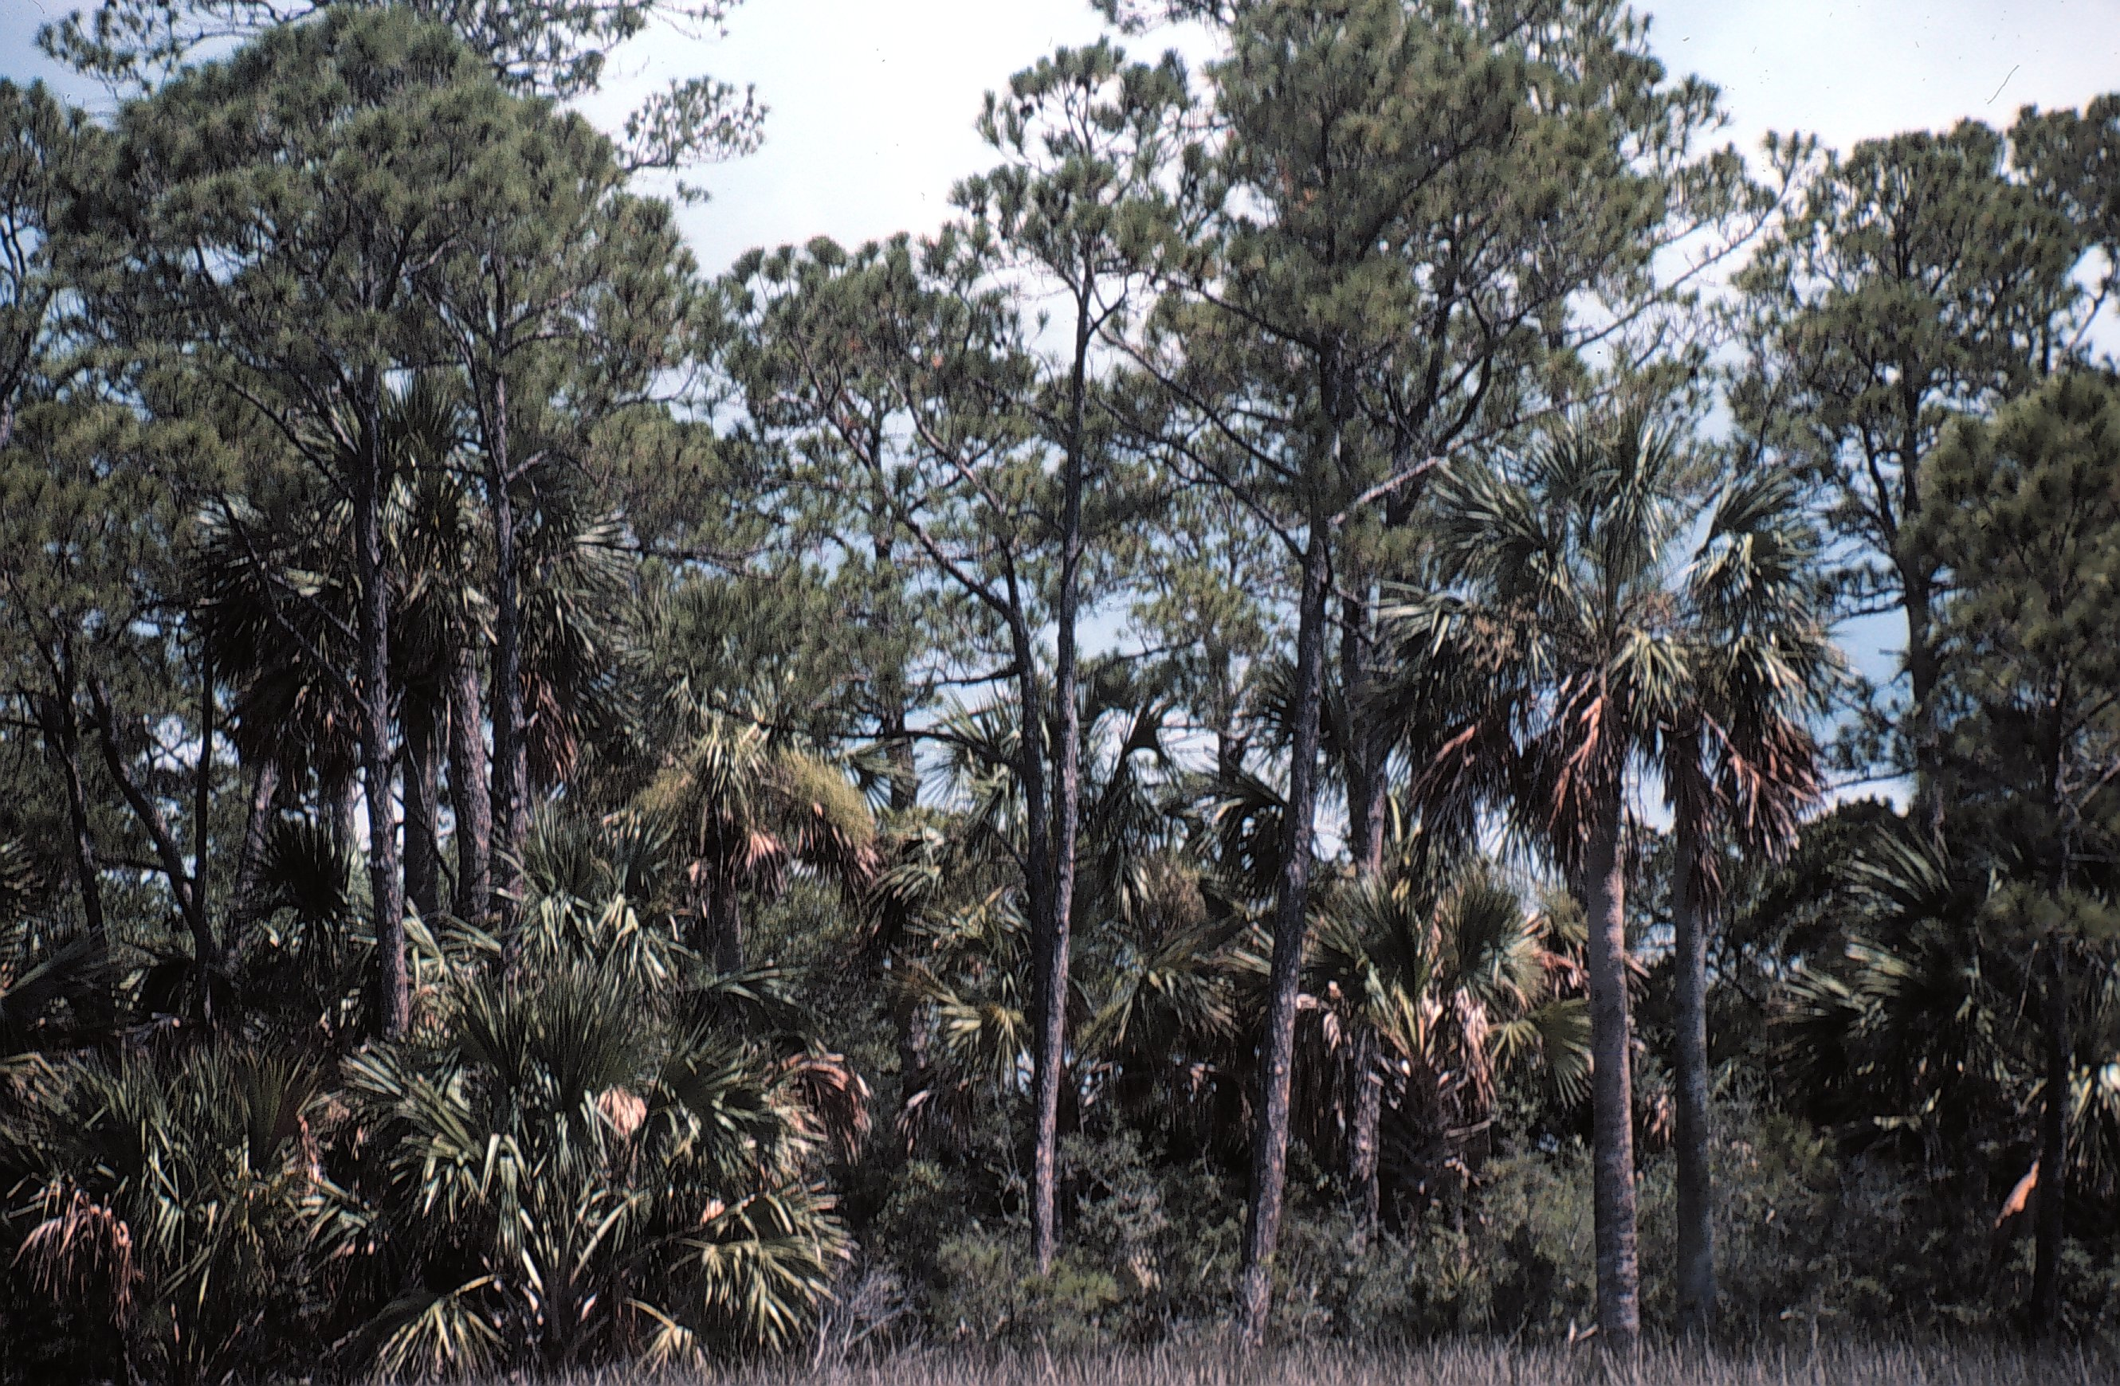

Figure 2. Appearance of pine-cabbage palm flatwoods vegetation class.
Cabbage Palm Hammock

Synonyms: Maritime hammock, coastal hammock, maritime forest, tropical hammock, Sabal palmetto seasonally flooded woodland, Sabal Palmetto woodland, Quercus virginiana - Sabal palmetto- Persea borbonia / Serenoa repens - Ilex vomitoria.

Extent on Refuge: Total acres = 106.5 acres. Occurs on St. Vincent Island. On the island, it is found in two locations. It occurs adjacent to managed marshes and ponds of the southeastern portion of the island as well as a small line of cabbage palm hammock along the eastern shore.

Topography: Low areas of shorelines, lakes, and pond margins.

Soils: This vegetation type occurs in association with Corolla sands and the Duckston-Bohicket-Corolla soil complex. These soils are very poorly drained soils of flat terrain. The soils are made up of sand to a depth of over 80 inches with little organic content, low fertility and moderate acidity. These soils may be tidally influenced.

Hydrology: Mesic to hydric sites with seasonally high water table present within 12 to 36 inches of soil surface 3 to 6 months per year.

Appearance: Cabbage palm hammocks are characterized as narrow bands of hardwood forests along shorelines and edges of lakes and ponds. On the refuge, this vegetation type is characterized as canopy of palm trees, with a few scattered live oak trees. There is little to no midstory or understory and a sparse groundcover (Figure 3).

Ecology: Cabbage palm hammocks occur along coastlines and marsh edges where saltwater flooding, salt spray, and strong winds affect the vegetation. As a result the plant species that occur in this vegetation are adapted to these harsh conditions. In general, this vegetation type is fairly resistant to fire. There is little to no midstory or understory and little groundcover. Fuels in this vegetation type are poor for spreading a fire and include dead palm fronds that hang from the canopy, dried up sea wrack, and overwash debris materials such as driftwood. Natural fires probably occurred once every 26 to 100 years (FNAI 1990). Fires that do burn across this vegetation type probably ignite in adjacent pine stands and under extreme drought conditions can be catastrophic (i.e., all vegetation consumed).

Vegetation:

Overstory: The overstory is dominated by cabbage palm (Sabal palmetto) trees.

Midstory: The midstory is composed of juvenile overstory species and scattered red cedars (Juniperus virginiana), hollies (Ilex spp.), and hackberry (Celtis laevigata) trees.

Understory: The understory is fairly sparse, but scattered regenerating overstory and midstory species may be present as well as coralbean (Erythrina herbacea), Virginia creeper (Parthenocissus quinquefolia), and yuccas (Yucca spp.).

Groundcover: The groundcover is very sparse and may include woodoats (Chasmanthium spp.), bedstraws (Galium spp.), basketgrasses (Oplismenus spp.), and blacksnakeroots (Sanicula spp.).

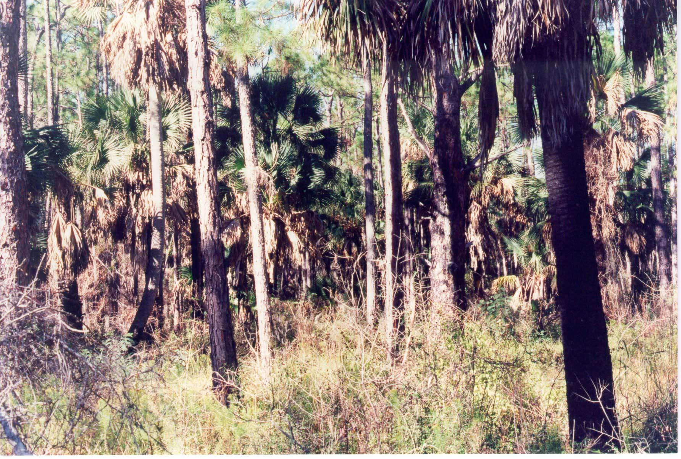
Figure 3. Appearance of cabbage palm hammock vegetation class.
Scrub

Synonyms: Sand pine scrub, Florida scrub, sand scrub, rosemary scrub, oak scrub, scrub oak, Pinus clausa / Quercus myrtifolia - Quercus geminata - Quercus chapmanii woodland, Ceratiola ericoides shrubland, and Ceratiola ericoides - Quercus geminata - Serenoa repens/ Cladonia spp. - Cladina spp. shrubland.

Extent on Refuge: Total acres = 1557.9 acres. Occurs on St. Vincent Island and Pig Island. This vegetation type is common on St. Vincent Island. Here, it occurs associated with sand dunes that run northwest-southeast along the interior of the island. On Pig Island, a mixture of scrub and sand pine-scrub can be found along the northern portion of the island. This mixed vegetation type occurs on high sand dunes that run northwest-southeast on Pig Island.

Topography: Older sand dunes and along slopes of high sand ridges. Strongly sloping to nearly level terrain.

Soils: This vegetation type is associated with Mandarin-Resota, Corolla-Duckston, and Kershaw-Ortega fine sands. These soils are excessively drained to moderately drained soils. They are made up of fine gray to white sands. These soils have low fertility and low organic matter content.

Hydrology: Xeric conditions, there is no water table within 80 inches of the soil surface.

Appearance: This vegetation type is considered both a woodland and a shrubland, depending on the fire history of the site. In a more mature stand that has had no recent fire in the past 25 or more years, this vegetation type takes on more of a woodland aspect as the scrub oaks and sand pine enter into the canopy. At this stage of succession a scrub community will have a closed to open canopy of sand pine and sand live oak trees, with dense clumps or thickets of scrub oaks and other hardwood shrubs in the midstory and understory. The groundcover is generally sparse and dominated by lichens and few herbs. With more frequent fire, this vegetation type is considered more of a shrubland. Florida rosemary (Ceratiola ericoides) and false rosemary (Conradina canescens) will dominate the canopy which may only be several feet high. The groundcover remains sparse in frequently burned sites (Figure 4).

Ecology: Scrub is associated with very dry, xeric conditions. As such, the plant species that occur on this vegetation type are adapted to living with little water availability. To live in this environment, plants have evolved adaptations to conserve water similar to plants of the desert.

Fire is an important ecological process for scrub vegetation. Frequent surface fires are not prevalent in this system, so fires are catastrophic (i.e., consuming and killing most vegetation). Natural fire frequencies for this vegetation type are estimated to be once every 20 to 80 years or more. Plant species growing in scrub exhibit adaptations to catastrophic fires. Serotinous species such as sand pine, for example, will open their cones and release seeds only under high heat conditions. Other plants have underground root systems that allow the plant to resprout immediately following fire. Fire begins a regeneration process in this vegetation type, similar to western forest ecosystems.

Vegetation:

Overstory: There is no overstory species in this vegetation type, though an occasional slash pine (Pinus elliottii) tree may be present

Midstory: Depending on fire history, the midstory may be a well developed tall shrubland in less frequently burned sites and may include Florida rosemary (Ceratiola ericoides), rusty staggerbush (Lyonia ferruginea), scrub oak species (Quercus myrtifolia, Q. geminata, Q. Chapmanii), and saw palmetto (Serenoa repens). More frequently burned sites will not have a well developed shrub layer.

Understory: The understory will include regenerating midstory species and may also include false rosemary (Conradina canescens), earleaf greenbrier (Smilax auriculata), Darrow's blueberry (Vaccinium darrowii), Shiny blueberry (V. myrsinites) and yuccas (Yucca spp.)

Groundcover: The groundcover is mostly open sands and lichens (Cladonia spp.), but may also include scattered stems of threeawns (Aristida spp.), hairsedges (Bulbostylis spp.), tread-softly (Cnidoscolus stimulosus), milkpeas (Galactia spp.), gayfeathers (Liatris spp.), toadflaxes (Linaria spp.), lupines (Lupinus spp.), Florida beargrass (Nolina atopocarpa), pricklypear cacti (Opuntia spp.), jointweeds (Polygonella spp.), snoutbeans (Rhynchosia spp.), beaksedges (Rhynchospora spp.), nutrushes (Scleria spp.), gum bully (Sideroxylon lanuginosum), sandgrasses (Triplasis spp.), and Carolina yelloweyed grass (Xyris caroliniana).

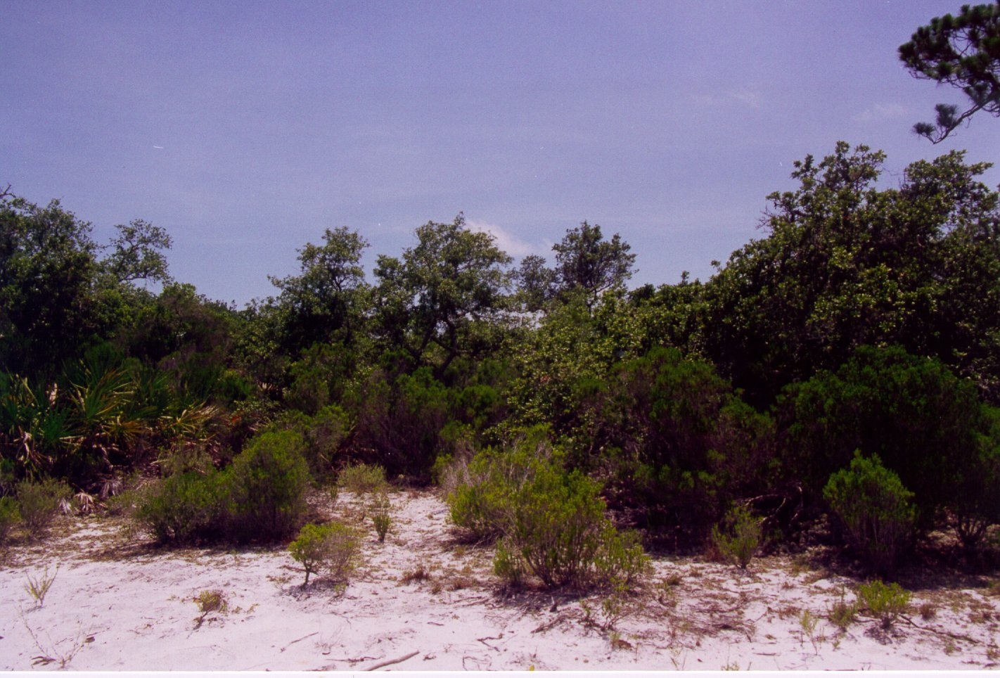
Figure 4. Appearance of scrub vegetation class.
Sand Pine-Scrub

Synonyms: Scrub, Florida scrub, sand scrub, rosemary scrub, oak scrub, scrub oak, Pinus clausa / Quercus myrtifolia - Quercus geminata - Quercus chapmanii woodland, Ceratiola ericoides shrubland, Ceratiola ericoides - Quercus geminata - Serenoa repens/ Cladonia spp. - Cladina spp. shrubland.

Extent on Refuge: Total acres = 13.5 acres. Occurs on St. Vincent Island and Pig Island. This vegetation type is fairly limited on St. Vincent Island and currently occurs in one small area in the northwestern portion of the island along Road D between Road 2 and Road 3. On Pig Island, this vegetation type occurs in a dense stand on the northern tip of the island and extends along both the eastern and western sides of the island. Sand pine-scrub is a mixed vegetation type of Pig Island. The acreage estimated includes only pure sand pine dominated portions of the islands.

Topography: Older sand dunes and along slopes of high sand ridges. Strongly sloping to nearly level terrain.

Soils: This vegetation type is associated with Mandarin-Resota, Corolla-Duckston, and Kershaw-Ortega fine sands. These soils are excessively drained to moderately drained soils. They are made up of fine gray to white sands. These soils have low fertility and low organic matter content.

Hydrology: Xeric conditions, there is no water table within 80 inches of the soil surface.

Appearance: This vegetation type is considered both a woodland and a shrubland, depending on the fire history of the site. In a more mature stand that has had no recent fire in the past 30 or more years, this vegetation type takes on more of a woodland aspect as the scrub oaks and sand pine enter into the canopy. At this stage of succession a scrub community will have a closed to open canopy of sand live oak trees, with dense clumps or thickets of scrub oaks and other hardwood shrubs in the midstory and understory. The groundcover is generally sparse and dominated by lichens and few herbs. In more recently burned sites where there is no canopy layer of scrub oak trees, this vegetation type appears as a shrubland. At this stage, dense thickets of younger scrub oaks and scrub shrubs dominate the midstory and understory layers with little groundcover except lichens and a few scattered herbs (Figure 5).

Ecology: The ecology of sand pine-scrub is similar to scrub vegetation, the difference from scrub is the dominance of sand pine in this vegetation type. Sand pine-scrub is associated with very dry, xeric conditions. As such, the plant species that occur on this vegetation type are adapted to living with little water availability. To live in this environment, plants have evolved adaptations to conserve water similar to plants of the desert.

Fire is an important ecological process of sand pine-scrub vegetation. Because frequent surface fires are not prevalent in this system, fires are catastrophic (i.e., consuming and killing most vegetation). Natural fire frequencies for this vegetation type are estimated to be once every 20 to 80 years or more. Plant species growing in scrub exhibit adaptations to catastrophic fires. Serotinous species such as sand pine, for example, will open their cones and release seeds only under high heat conditions. Other plants have underground root systems that allow the plant to resprout immediately following fire. Fire begins a regeneration process in this vegetation type, similar to western forest ecosystems.

Vegetation:

Overstory: The overstory in this vegetation type is dominated by sand pine (Pinus clausa); however, an occasional slash pine (Pinus elliottii) may also occur in the overstory.

Midstory: The midstory is similar to scrub vegetation and varies with fire history. Less frequently burned sites may include Florida rosemary (Ceratiola ericoides), rusty staggerbush (Lyonia ferruginea), scrub oak species (Quercus myrtifolia, Q. geminata, Q. Chapmanii), and saw palmetto (Serenoa repens). More frequently burned sites will not have a well developed shrub layer.

Understory: The understory is also similar to scrub vegetation and will include regenerating midstory species and may also include false rosemary (Conradina canescens), saw greenbrier (Smilax auriculata), Darrow's blueberry (Vaccinium darrowii), Shiny blueberry (V. myrsinites), and yuccas (Yucca spp.)

Groundcover: The groundcover is also similar to scrub vegetation and is made up of mostly open sands and lichens (Cladonia spp.), but it may also include scattered stems of threeawns (Aristida spp.), hairsedges (Bulbostylis spp.), tread-softly (Cnidoscolus stimulosus), milkpeas (Galactia spp.), gayfeathers (Liatris spp.), toadflaxes (Linaria spp.), lupines (Lupinus spp.), Florida beargrass (Nolina atopocarpa), pricklypear cacti (Opuntia spp.), jointweeds (Polygonella spp.), snoutbeans (Rhynchosia spp.), beaksedges (Rhynchospora spp.), nutrushes (Scleria spp.), gum bully (Sideroxylon lanuginosum), sandgrass (Triplasis spp.), and Carolina yelloweyed grass (Xyris caroliniana).

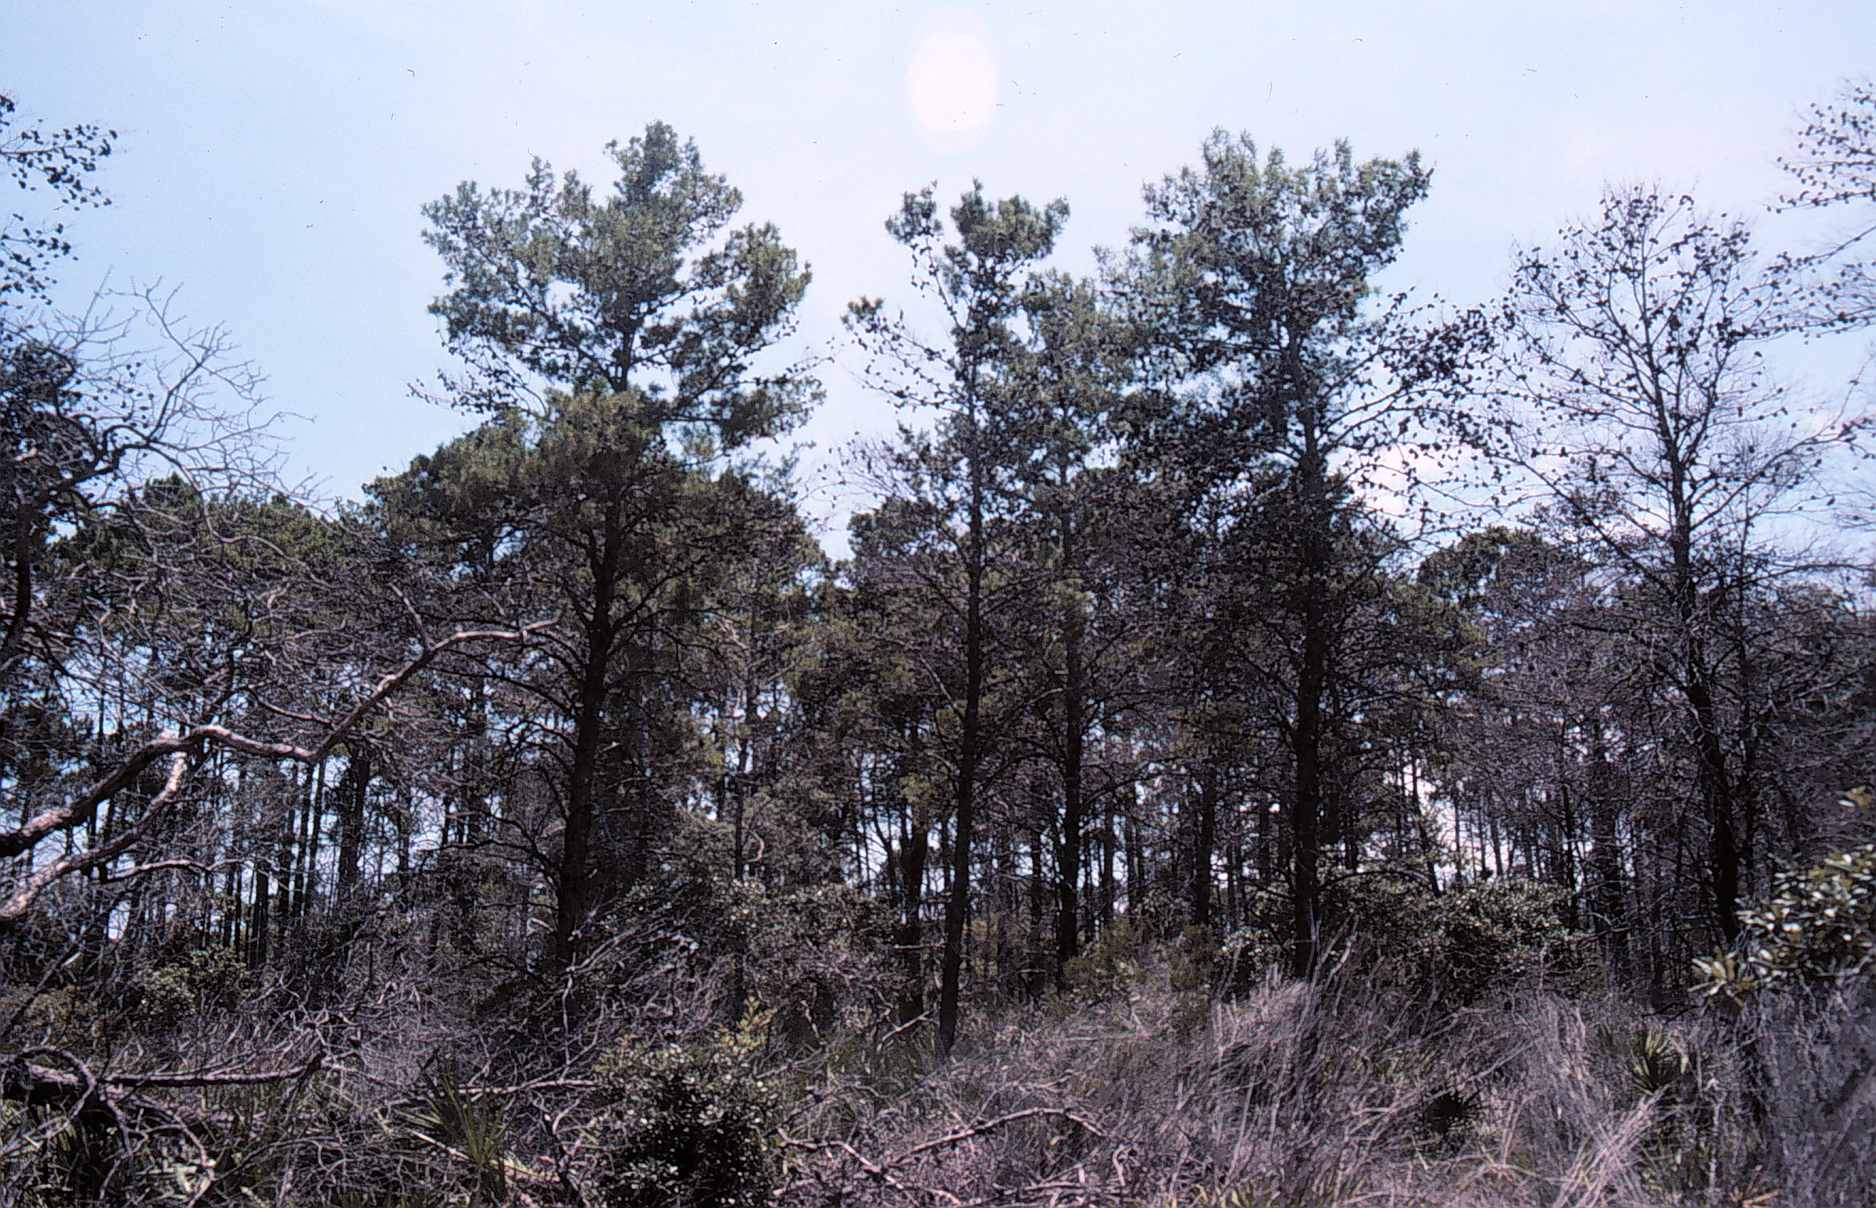
Figure 5. Appearance of sand pine- scrub vegetation class.
Live Oak Hammock

Synonyms: Xeric hammock, xeric forest, sand hammock, live oak forest, oak woodland, oak hammock, live oak, mixed live oak-scrub oak, live oak dunes, live oak-grass dunes, Quercus geminata - (Quercus virginiana) / Serenoa repens - Lyonia fruticosa forest, Quercus virginiana / Ilex vomitoria / Oplismenus setarius forest, Quercus virginiana / Serenoa repens forest, Quercus virginiana / vaccinium arboreum - Ilex vomitoria forest.

Extent on Refuge: Total acres = 420.9 acres. Occurs on St. Vincent Island and the Mainland unit. On St. Vincent Island, this vegetation type is found along the sand ridges of the southeastern portion of the island. There are small patches of live oak hammocks along the northeastern portion of the island as well. On the mainland unit, there is a small live oak hammock on the northern portion of the unit.

Topography: Older sand dunes and along slopes of high sand ridges. Strongly sloping to nearly level terrain.

Soils: This vegetation type is most strongly associated with Kershaw-Ortega sands, but it can occur where other excessively drained soils such as Mandarin-Resota, Corolla-Duckston are found on the refuge. These soils are made up of fine sands to a depth of over 80 inches below the soil surface. They make up the older sand dunes and higher sand ridges that occur on the refuge. These soils are of low fertility and low organic content.

Hydrology: Xeric conditions, no water table present within 80 inches of the soil surface.

Appearance: In more mature forests, this vegetation type appears as an open or closed canopy forest with tall live oak trees. At this stage of succession, there is little to no midstory and an understory of palmettos below with a sparse groundcover of herbs or grasses. This vegetation type, as it succeeds from a scrub oak shrubland to a live oak forest (see ecology section below) may appear as a scrubby dense low canopy forest of scrub oaks and live oak trees with a dense shrubby midstory and understory of hardwoods with little to no groundcover present (Figure 6).

Ecology: Live oak hammocks are associated with dry, xeric conditions. This vegetation type has been considered to be a late successional stage of scrub vegetation and develops in the absence of fire for more than 30 years (FNAI 1990). In general, this vegetation type is resistant to fire. The natural fire frequency of this vegetation type is estimated to be once every 30 or more years. The dominance of live oak trees and other hardwoods in the canopy and midstory of the hammock produce poor fuel conditions due to the incombustible oak leaf litter. However, under drought conditions, the palmetto understory may promote the spread of fire throughout a site. In general, fires that do burn across this vegetation type will be catastrophic, consuming and killing most vegetation within the hammock.

Vegetation:

Overstory: The dominant overstory species is live oak (Quercus virginiana)

Midstory: The midstory is sparse and includes regenerating live oaks as well as American beautyberry (Callicarpa americana), common persimmon (Diospyros virginiana), hollies (Ilex spp.), southern magnolia (Magnolia grandiflora), and other oaks (Quercus spp.).

Understory: The understory may include regenerating midstory species and false rosemary (Conradina canescens), saw palmetto (Serenoa repens), and blueberries (Vaccinium spp.).

Groundcover: There is a sparse groundcover that may include species of bluestems (Andropogon spp.), threeawns (Aristida spp.), hairsedges (Bulbostylis spp.), butterfly peas (Centrosema spp.), partridgepeas (Chamaecrista spp.), bush goldenrod (Chrysoma pauciflosculosa), goldenasters (Chrysopsis spp.), pigeonwings (Clitoria spp.), tread-softly (Cnidosculus stimulosus), dayflowers (Commelina spp.), flatsedges (Cyperus spp.), ticktrefoil (Desmodium spp.), witchgrasses (Dichanthelium spp.), crabgrasses (Digitaria spp.), Elephantsfoots (Elephantopus spp.), lovegrasses (Eragrostis spp.), thoroughworts (Eupatorium spp.), flattop goldenrod (Euthamia graminifolia), cottonweed (Froelichia floridana), milkpeas (Galactia spp.), bedstraws (Galium spp.), beeblossoms (Gaura spp.), everlastings (Gnaphalium spp.), frostweeds (Helianthemum spp.), St John's-worts (Hypericum spp.), pinweeds (Lechea spp.), lespedezas (Lespedeza spp.), toadflaxes (Linaria spp.), lupines (Lupinus spp.), prickly pear cacti (Opuntia spp.), nailworts (Paronychia spp.), crowngrasses (Paspalum spp.), groundcherries (Physalis spp.), resurrection fern (Pleopeltis polypodioides), jointweeds (Polygonella spp.), beaksedges (Rhynchospora spp.), bluestems (Schizachyrium spp.), nutrushes (Scleria spp.), gum bully (Sideroxylon lanuginosum), goldenrods (Solidago spp.), indiangrasses (Sorghastrum spp.), bluecurls (Trichostema spp.), sandgrasses (Triplasis spp.), and Carolina yelloweyed grass (Xyris caroliniana).

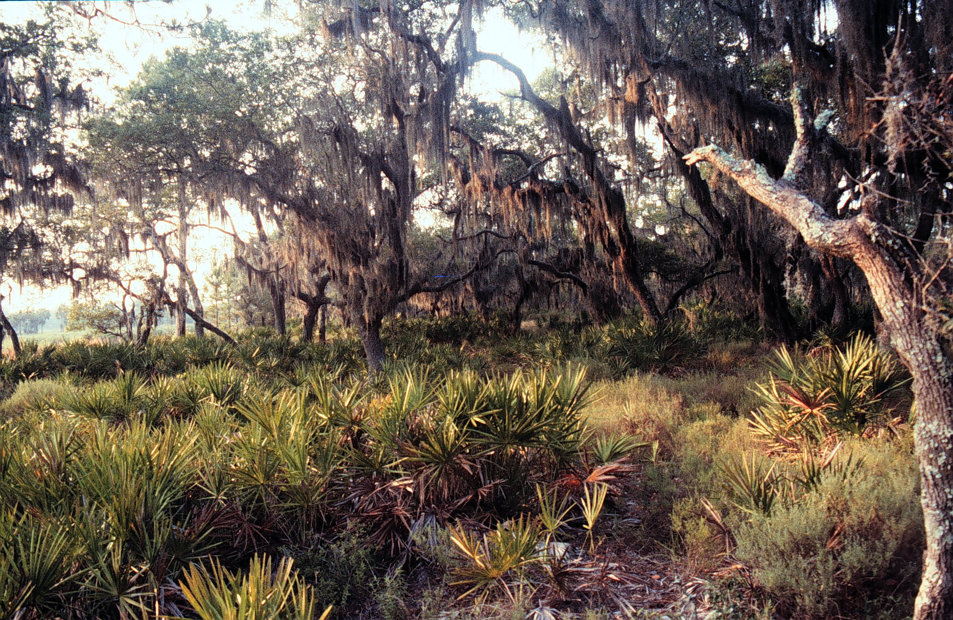
Figure 6. Appearance of live oak hammock vegetation class.
Hardwood Hammock

Synonyms: Maritime hammock, coastal hammock, maritime forest, tropical hammock, Quercus virginiana-Sabal palmetto - Juniperus virginiana var. silicicola / Persea borbonia, Quercus virginiana - Sabal palmetto - Persea borbonia / Serenoa repens - Ilex vomitoria.

Extent on Refuge: Total acres = 166.9 acres. Occurs on St. Vincent Island. This vegetation type is found along the northern portion of the island and along the eastern edge of the island. It forms forests adjacent to the shoreline.

Topography: Lower slopes, nearly level terrain.

Soils: This vegetation type is associated with the Duckston-Bohicket-Corolla soil complex. These soils are very poorly drained soils that occur on low ridges, flats and in narrow strips along coastlines. Other soils of the flatwoods such as the Leon and Lynn Haven sands may also support hardwood hammocks.

Hydrology: Mesic sites that are seasonally flooded up to 6 months per year. In dry periods the water table can fall below 24 inches from the soil surface.

Appearance: This vegetation type is characterized as a closed canopy forest of mixed hardwood tree species, a well developed midstory and understory of mixed hardwoods, some palmetto and a sparse groundcover of herbs and grasses (Figure 7).

Ecology: Hardwood hammocks are restricted to narrow bands along shorelines. As a result, the plants of this vegetation type are exposed to episodic saltwater flooding, and strong winds during storm events. In addition, this vegetation type occurs in low lying areas where standing water can occur for long periods of time throughout the year. Alterations to local hydrology could significantly affect the composition and structure of this vegetation type. Allowing more water to this site may promote deeper water species such as red bay and sourgum. Restricting water from this site may promote more oaks and other hardwoods to replace the cabbage palm and pines over time.

Hardwood hammocks are fairly resistant to fire. The fuels are poor because of the incombustible nature of the oak and hardwood litter that can not carry a fire well. Natural fire frequencies for this vegetation type are estimated to be once every 26 to 100 years (FNAI 1990). Ignition probably occurs in adjacent pine flatwoods and burns up to the boundary of this vegetation type. Under extreme drought conditions fires that burn through hardwood hammocks are catastrophic, consuming and killing most vegetation.

Vegetation:

Overstory: The overstory is composed of a mixture of slash pine (Pinus elliottii), live oak (Quercus virginiana), and cabbage palm (Sabal palmetto) trees in equal occurrence. Other species that may be present in the canopy can include red cedar (Juniperus virginiana) and southern magnolia (Magnolia grandiflora).

Midstory: Depending on the maturity of the stand the midstory can include species of the canopy as well as American beautyberry (Callicarpa americana), hackberry (Celtis laevigata), hollies (Ilex spp.), wax myrtle (Myrica cerifera), and Hercule's-club (Zanthoxylum clava-herculis).

Understory: The understory can include regenerating midstory species as well as Virginia creeper (Parthenocissus quinquefolia), saw palmetto (Serenoa repens), greenbriers (Smilax spp.), and yuccas (Yucca spp.).

Groundcover: The groundcover is very sparse in this vegetation type and may include woodoats (Chasmanthium spp.), coralbeans (Erythrina herbacea), bedstraws (Galium spp.), basketgrasses (Oplismenus spp.), woodsorrels (Oxalis spp.), golden polypody (Phlebodium aureum), resurrection fern (Pleopeltis polypodioides), and blacksnakeroots (Sanicula spp.).

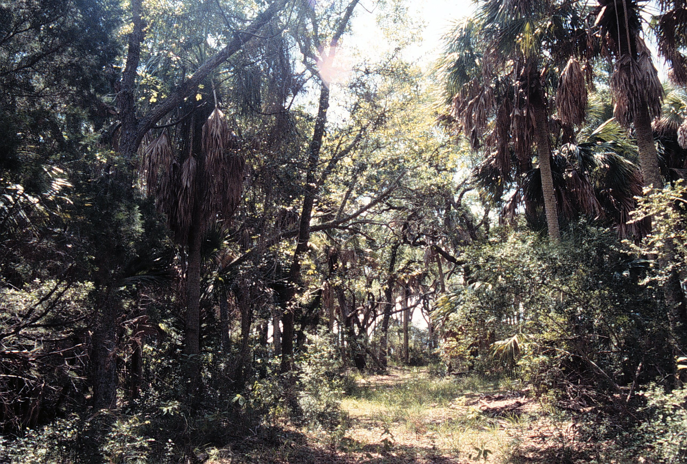
Figure 7. Appearance of hardwood hammock vegetation class.
Coastal Grassland

Synonyms: Coastal savanna, salt flat, overwash plain, slash pine-grass, Uniola paniculata - Schizachyricum maritimum - Hydrocotyle bonariensis herbaceous vegetation.

Extent on Refuge: Total acres = 43.9 acres. Occurs on St. Vincent Island. This vegetation type is found along the southeastern tip of the island. It makes up a narrow strip of grasslands adjacent to the beach dune vegetation along the shoreline.

Topography: On nearly level terrain associated with inland side of fore dunes and high sand ridges along coastline.

Soils: This vegetation type is associated with excessively to somewhat poorly drained soils of the sand dunes adjacent to the coastline such as the Newhan-Corolla complex, and Kureb-Corolla complex. These are sandy soils to a depth of more than 80 inches.

Hydrology: Mesic to hydric conditions, this vegetation type may be exposed to extreme, high-water salt pulses during storm events along the coast and may exhibit flooding from 1 to 6 months per year.

Appearance: This vegetation type is characterized as a treeless open flat land with a sparse to dense groundcover of grasses, prostrate vines, and herbaceous species that are exposed to beach and coastline conditions. On more established sites, a small cluster of pine trees or shrubs may occur (Figure 8).

Ecology: Coastal grasslands are found in low, flat areas behind the foredunes along the coast. This vegetation type occurs in an area subject to episodic saltwater flooding, strong winds, and overwash deposition during storm events. As a result most of the plant species found in this vegetation type are adapted to high salinity pulses and windy conditions. Most of the plant species that occur in this vegetation type are also species of the beach vegetation. Frequent fires may play an important role in this vegetation type by reducing the woody growth and maintaining a grass-dominated groundcover. While fires probably ignite in adjacent pine flatwoods the fine fuels of this vegetation type promote the spread of fire. Natural fires probably occurred in this vegetation type once every 3 to 5 years.

Vegetation:

Overstory: This vegetation type is considered a grassland. There are no dominant overstory species, though an occasional slash pine (Pinus elliottii) may occur.

Midstory: As a grassland, there are no dominant midstory species. Scattered shrubs such as saltwater falsewillow (Baccharis angustifolia), marshelder (Iva spp.), red cedar (Juniperus virginiana) and wax myrtle (Myrica cerifera), may occur.

Understory: There are no dominant understory species in this grassland vegetation type; however, scattered juveniles of midstory shrubs may be present.

Groundcover: The groundcover in this vegetation type is made up of salt tolerant and maritime species and may include asters (Aster spp.), bushy seaside oxeye (Borrichia frutescens), sandburs (Cenchrus spp.), crotons (Croton spp.), buttonweeds (Diodia spp.), lovegrasses (Eragrostis spp.), sunflowers (Helianthus spp.), marshpennyworts (Hydrocotyle spp.), morningglories (Ipomoea spp.), muhlies (Muhlenbergia spp.), eveningprimroses (Oenothera spp.), prickly pear cacti (Opuntia spp.), panicgrasses (Panicum spp.), crowngrasses (Paspalum spp.), fogfruits (Phyla spp.), groundcherries (Physalis spp.), saltworts (Salsola spp.), bluestems (Schizachyrium spp.), goldenrods (Solidago spp.), cordgrasses (Spartina spp.), and seaoats (Uniola spp.), cowpeas (Vigna spp.).

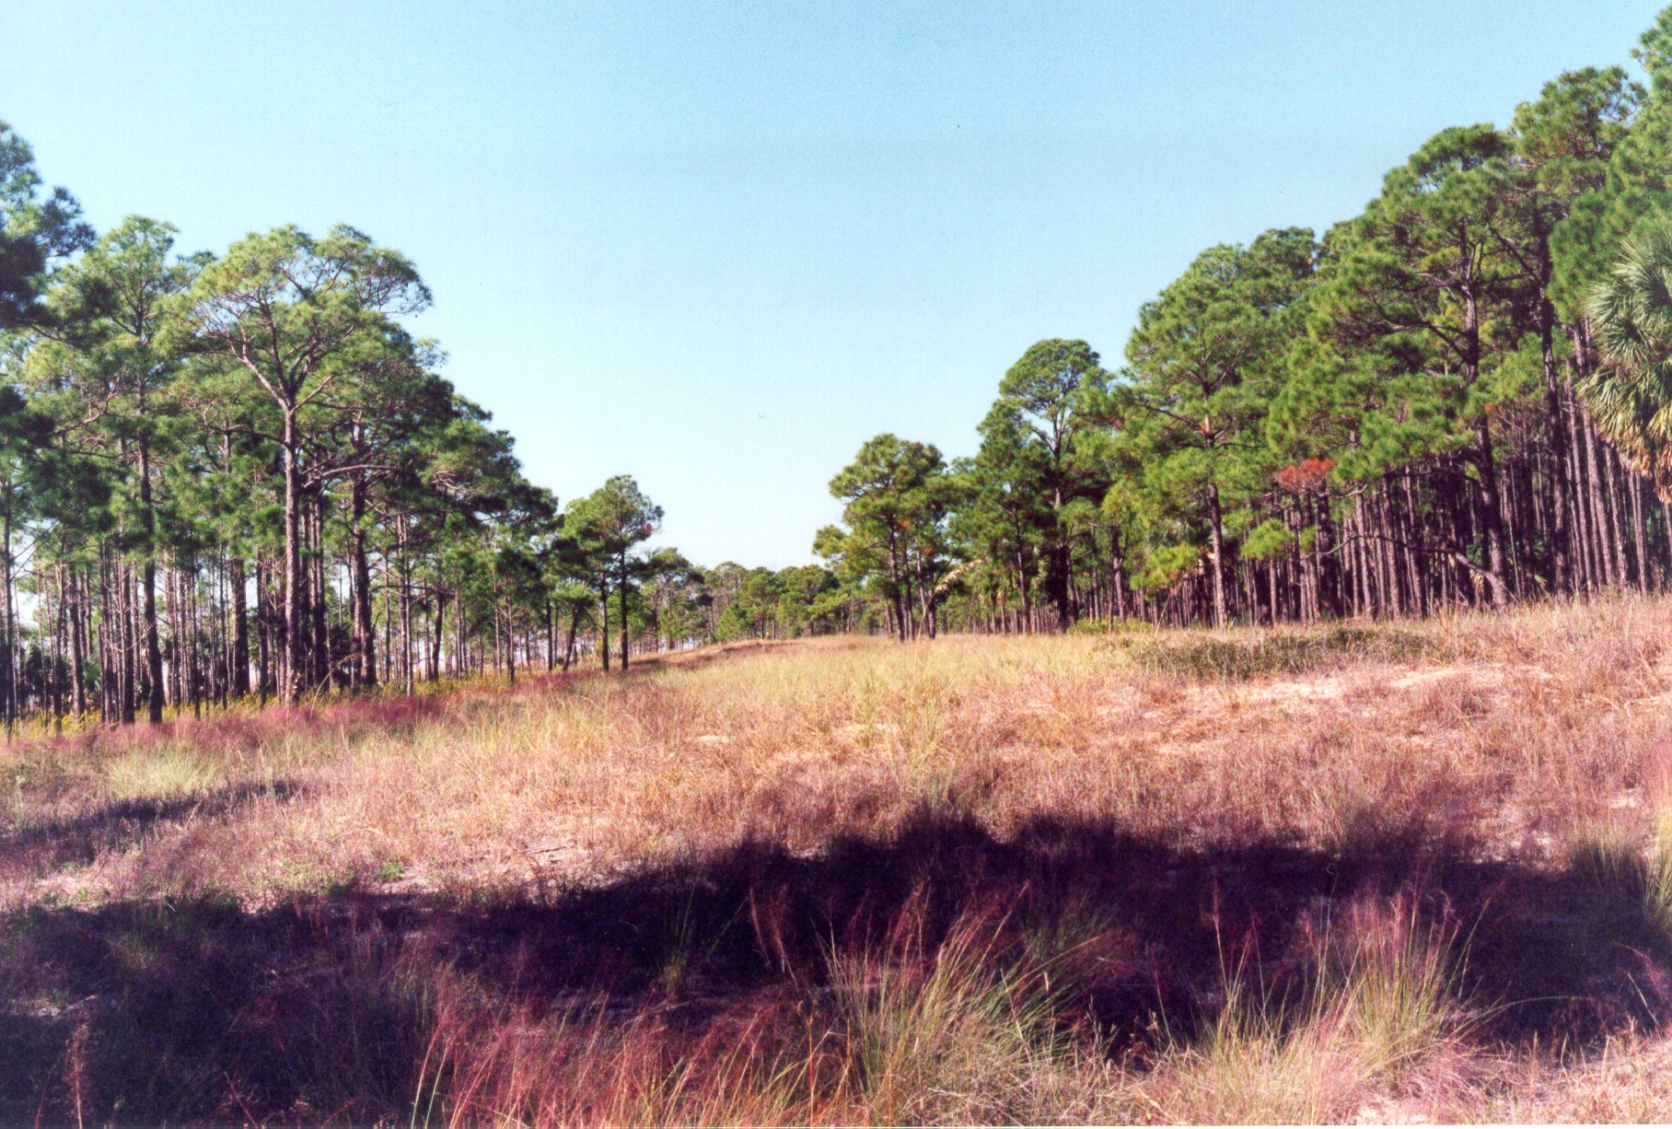
Figure 8. Appearance of coastal grassland vegetation class.
Palustrine Marsh

Synonyms: Swale, sawgrass-emergent marsh, cattail, freshwater marsh, slough, Cladium mariscoides Herbaceous Vegetation, Cladium mariscoides - Eleocharis equisetoides Herbaceous Vegetation.

Extent on Refuge: Total acres = 668.4 acres. Occurs on St. Vincent Island. This vegetation type occurs mostly in narrow strips in the swales between dunes and pine flatwoods of the interior of the island. This vegetation type makes up the headwaters of the ponds and lakes of the island.

Topography: Low nearly level terrain.

Soils: The soils associated with this vegetation type include Maurepas muck, and Rutledge loamy fine sand. These soils are poorly drained soils of brackish marshes and swamps. There is generally a mucky or loamy sand within the top 8 inches of the soil surface and sands below to a depth of 80 inches or more. These soils are fertile and contain a large amount of organic matter.

Hydrology: Mesic to hydric conditions, a high water table can be at or above the soil surface for 3 to 6 months per year.

Appearance: This vegetation type is characterized as an open, treeless grassland that has standing water in it a good portion of the year of following precipitation events. The vegetation is composed mainly of herbaceous species of emergent wetland species that form a continuous groundcover. Where vegetation includes woody shrubs and small trees the vegetation type is considered a palustrine shrub class (Figure 9).

Ecology: Palustrine marsh is a hydrologically driven ecosystem. The water table of this vegetation type is above the soil surface for most of the year. At times of the year in drier periods when the water levels are not maintained by ground water tables, levels are maintained by surface water run-off during precipitation events. As a result of the continued presence of water at or above the soil surface, the plant species associated with this vegetation type are obligate wetland species requiring flooded conditions throughout most or all of its life cycle. Alterations to the local hydrology would significantly impact the species composition and structure of this vegetation type. Increased water levels may promote more deeper-water-tolerant species such as cattails, cypress, red maple, bays, sourgum and others. Decreased water levels may promote a transition to palustrine shrub vegetation of dense shrubs, increased hardwoods and willow trees. In addition, alterations to local hydrology may allow invasive species to colonize an area, under conditions of either increased or decreased water to a site. Chinese tallow, cogongrass, and cattails for example, can be extremely aggressive in response to changes in hydrology.

Fire may play an important ecological role in palustrine marshes. Periodic surface and ground fires are common in this vegetation type. Natural fire frequencies for this vegetation type are estimated to be once every 1 to 3 years (FNAI 1990). Frequent fires in this ecosystem reduce the invasion of shrubs and woody growth into a site and promote the presence of a grass dominated ecosystem. In frequently burned sites where soils are saturated, surface fires will ignite and the fine fuels of grass and dead grass litter will promote fire spread. Under drier conditions when soils are not saturated, a ground fire can occur where the organic peat layer ignites and can continue to burn underground for long periods of time. The results of peat fires in marshes can reduce several in of organic peat accumulations.

Vegetation:

Overstory: Few overstory species are present in this vegetation type but may include red maple (Acer rubrum), Carolina willow (Salix caroliniana), or baldcypress (Taxodium distichum).

Midstory: There are few midstory species present in this vegetation type but may include regenerating overstory species as well as common buttonbush (Cephalanthus occidentalis), corkwood (Leitneria floridana), sweetbay (Magnolia virginiana), wax myrtle (Myrica cerifera), swamp bay (Persea palustris), Carolina willow (Salix caroliniana), and sourgum (Nyssa spp.).

Understory: The understory can include midstory species as well as amaranths (Amaranthus spp.), rosemallows (Hibiscus spp.), dewberries (Rubus spp.), elderberries (Sambucus spp.), and greenbriers (Smilax spp.).

Groundcover: The groundcover is dominated by Jamaica swamp sawgrass (Cladium jamaicense), other species may include foxgloves (Agalinis spp.), redstems (Ammannia spp.), milkweeds (Asclepias spp.), asters (Aster spp.), waterhyssop (Bacopa spp.), screwstems (Bartonia spp.), false nettles (Boehmeria spp.), waterstarworts (Callitriche spp.), grasspinks (Calopogon spp.), Bandana-of-the-Everglades (Canna flaccida), sedges (Carex spp.), dodders (Cuscuta spp.), flatsedges (Cyperus spp.), witchgrasses (Dichanthelium spp.), buttonweeds (Diodia spp.), barnyardgrasses (Echinochloa spp.), spickerushes (Eleocharis spp.), thoroughworts (Eupatorium spp.), flattop goldenrod (Euthamia graminifolia), bedstraws (Galium spp.), umbrellasedges (Fuirena spp.), mille grains and bluets (Hedyotis spp.), mudplantains (Heteranthera spp.), marshpennyworts (Hydrocotyle spp.), bushmints (Hyptis spp.), jewelweeds (Impatiens spp.), irises (Iris spp.), rushes (Juncus spp.), Carolina redroot (Lachnanthes caroliana), sprangletops (Leptochloa spp.), primrosewillows (Ludwigia spp.), watergrasses (Luziola spp.), hempvines (Mikania spp.), muhlies (Muhlenbergia spp.), goldenclub (Orontium aquaticum), devilwoods (Osmanthus spp.), cinammon fern (Osmunda cinnamomea), panicgrasses (Panicum spp.), crowngrasses (Paspalum spp.), arrow arums (Peltandra spp.), common reeds (Phragmites spp.), camphorweeds (Pluchea spp.), knotweeds (Polygonum spp.), rustweed (Polypremum procumbens), pickerelweeds (Pontederia spp.), mermaidweeds (Proserpinaca spp.), mock bishopsweed (Ptilimnium capillaceum), meadowbeauties (Rhexia spp.), docks (Rumex spp.), rosegentians (Sabatia spp.), plumegrasses (Saccharum spp.), arrowhead (Sagittaria spp.), lizard's tail (Saururus cernuus), bulrushes (Scirpus spp.), foxtails (Setaria spp.), cordgrass (Spartina spp.), wood sages (Teucrium spp.), fireflag (Thalia geniculata), cattails (Typha spp.), bladderworts (Utricularia spp.), vervains (Verbena spp.), vetches (Vicia spp.), chainferns (Woodwardia spp.), yelloweyed grasses (Xyris spp.), and wild rice (Zizania aquatica).

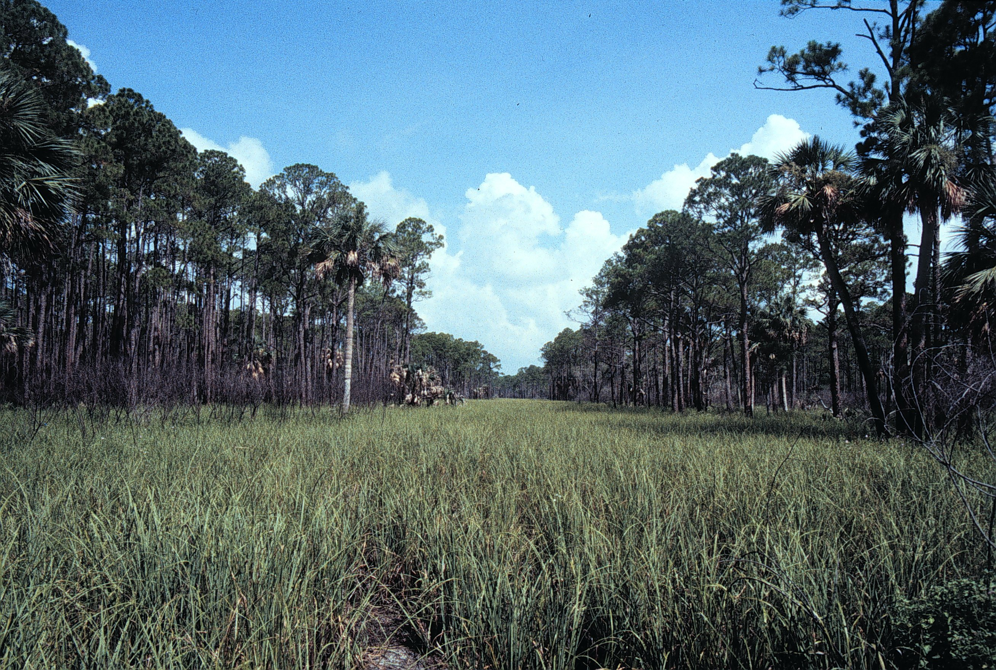
Figure 9. Appearance of palustrine marsh vegetation class.
Palustrine Shrub

Synonyms: Baygall, swales, Salix caroliniana shrubland, Salix caroliniana woodland, Cyrilla racemiflora-Persea palustris-Magnolia virginiana shrubland.

Extent on Refuge: Total acres = 106.5 acres. Occurs on St. Vincent Island. This vegetation type is found along the margins of freshwater and managed open water areas of the interior and southern portions of the island.

Topography: Low, nearly level terrain.

Soils: The soils associated with this vegetation type are similar to the soils of palustrine marshes and include Maurepas muck, and Rutledge loamy fine sand. These soils are poorly drained soils of brackish marshes and swamps. There is generally a mucky or loamy sand within the top 8 inches of the soil surface and sands below to a depth of 80 inches or more. These soils are fertile and contain a large amount of organic matter.

Hydrology: Mesic to hydric conditions, a high water table can be at or above the soil surface for 3 to 6 months per year.

Appearance: This vegetation type is characterized as a shrubland or woodland in more mature stages. It is considered a low closed canopy of mixed wetland shrub and tree species such as willow, wax myrtle, red maple, and bay trees. A dense midstory and understory of wetland shrub and tree species is present, and a sparse groundcover of aquatic herbs may occur (Figure 10).

Ecology: Palustrine shrub is ecologically similar to palustrine marsh. This is a water dependent ecosystem where the vegetation is composed of wetland-dependent species. The water table of this vegetation type is above the soil surface for most of the year. At times of the year in drier periods when the water levels are not maintained by ground water tables, levels are maintained by surface water run-off during precipitation events. As a result of the continued presence of water at or above the soil surface, the plant species associated with this vegetation type are obligate wetland species requiring flooded conditions throughout most or all of its life cycle. Alterations to the local hydrology would significantly impact the species composition and structure of this vegetation type. Increased water levels may promote more deeper-water-tolerant species such as cattails, cypress, red maple, bays, sourgum, and others. Decreased water levels may promote a transition to more mesic or flatwoods species (e.g., sweetbay, slash pine, and palmetto). In addition, alterations to local hydrology may allow invasive species to colonize an area under conditions of either increased or decreased water to a site.

Fire may influence the abundance, composition, and structure of palustrine shrub vegetation. In the absence of fire, palustrine marsh develops increased shrubs and woody growth into the midstory and develops into a palustrine shrub vegetation type. This vegetation type is more resistant to frequent fires than palustrine marshes. The fuels are poor in this vegetation and mostly made up of incombustible materials. Natural fire frequencies probably occur in this vegetation type once every 5 to 10 years. Under drier conditions, fires can carry across this vegetation type, consume and kill all vegetation present. Like many wetland forest species, however, resprouting will occur immediately following fires. Although fire is currently used as a management tool to reduce woody growth in palustrine shrub vegetation, it is unclear what the impact of different seasons of burn will have on reducing woody growth.

Vegetation:

Overstory: The overstory may include red maple (Acer rubrum), sweetbay (Magnolia virginiana), sourgums (Nyssa spp.) red bay (Persea borbonia var. borbonia), Carolina willow (Salix caroliniana), baldcypress (Taxodium distichum).

Midstory: The midstory can be a thicket of tall shrubs and can include red maple (Acer rubrum), buttonbush (Cephalanthus occidentalis), buckwheat tree (Cliftonia monophylla), titi (Cyrilla racemiflora), huckleberries (Gaylussacia spp.), hollies (Ilex spp.) corkwood (Leitneria floridana), sweetbay (Magnolia virginiana), wax myrtle (Myrica cerifera), red bay (Persea borbonia var. borbonia), swamp bay (P. palustris), sourgum ( Nyssa spp.), and Carolina willow (Salix caroliniana).

Understory: In addition to midstory species, the understory can include peppervine (Ampelopsis arborea), St. John's-worts (Hypericum spp.), and dewberries (Rubus spp.).

Groundcover: There are few groundcover species present in this vegetation type, but they may include any groundcover species that occur in palustrine marsh.

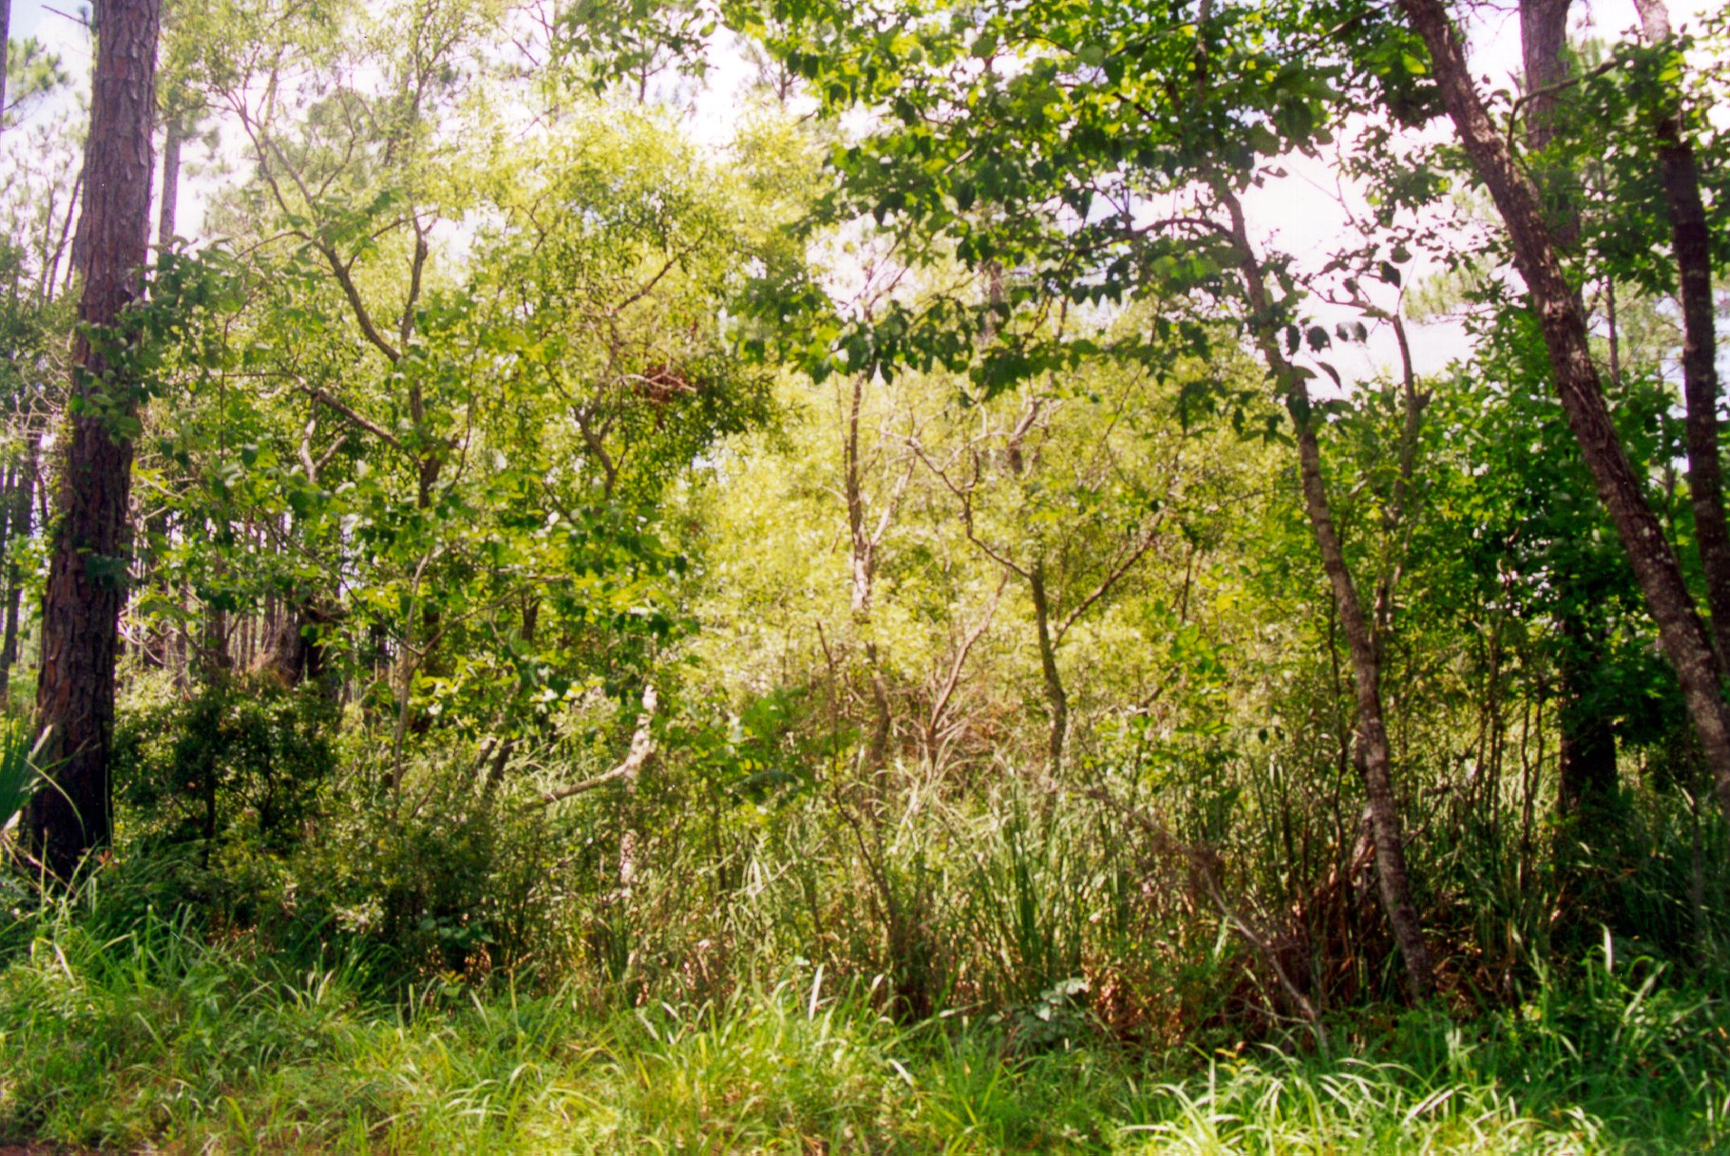
Figure 10. Appearance of palustrine shrub vegetation class.
Palustrine Open Water

Synonyms: Coastal dune lake, freshwater pond, Ceratophyllum demersum herbaceous vegetation Najas guadalupensis - Ceratophyllum demersum - Utricularia inflata herbaceous vegetation.

Extent on Refuge: Total acres = 5.5 acres. A description of this vegetation type is given to describe a management goal for palustrine open water sites if needed.

Topography: Low, nearly level terrain.

Soils: The soils of this vegetation type are similar to the soils of palustrine marsh and shrub vegetation types and include Maurepas muck, and Rutledge loamy fine sand. These soils are poorly drained soils of brackish marshes and swamps. There is generally a mucky or loamy sand within the top 8 inches of the soil surface and sands below to a depth of 80 inches or more. These soils are fertile and contain a large amount of organic matter.

Hydrology: Hydric, permanent deep to shallow standing water throughout the year.

Appearance: The vegetation that makes up this cover class includes herbaceous submergent and emergent wetland species that are confined to the boundaries of the pond or lake. The vegetation of shorelines and margins of palustrine open water is considered separately as either palustrine marsh or shrub for this study (Figure 11).

Ecology: This is a water-dependent system. Water levels are permanently maintained in open water ponds and lakes by the ground water table being above the soil surface for most of the year. Water levels are also maintained by surface water run-off into the open water sites. Small palustrine ponds may dry out for a portion of the year. The plants associated with this vegetation type are obligate wetland species and provide the basis of the food chain for the fish and wildlife (e.g. migratory birds) that live in and around open water ponds and lakes. Most of the vegetation consists of submergent vegetation that grows below the water surface for most of its life cycle except during flowering. Alterations to the hydrologic regime could impact the abundance and composition of species in open water areas. Increased water levels may promote only deeper-water-tolerant plant species and lower plant species diversity. Decreased water levels may promote more shallow water species such as cattails and other palustrine marsh and shrub species. Alterations in water levels may also promote the introduction of invasive species such as Salvinia spp. and others.

This vegetation type is resistant to fire for the most part. The vegetation is vulnerable to fire under drought conditions, or during times when small open ponds dry up. Fires will generally ignite in adjacent vegetation types and burn into the organic peat layers of the ponds as they dry out. In the absence of precipitation events or a recovery of water levels, ground peat fires may occur at the surface or underground peat layers for a long period of time.

Vegetation:

Overstory: none, an occasional baldcypress (Taxodium distichum) tree or sourgum (Nyssa spp.) may occur in standing water along the edge of the open water.

Midstory: Few midstory species are present except small trees and tall shrubs that may grow along the edge in shallow water. These species may include red maple (Acer rubrum), rosemallows (Hibiscus spp.), wax myrtle (Myrica cerifera), and Carolina willow (Salix caroliniana).

Understory: In addition to juvenile midstory species present in the understory amaranth (Amaranthus spp.), and St. John's-worts (Hypericum spp.) may occur.

Groundcover: Plants growing on the edge in shallow water or in the deeper open water may include; joyweeds (Alternanthera spp.), coontail (Ceratophyllum demersum), bittercresses (Cardamine spp.), Jamaica swamp sawgrass (Cladium jamaicense), flatsedges (Cyperus spp.), spikerushes (Eleocharis spp.), marshpennyworts (Hydrocotyle spp.), St. John's-worts (Hypericum spp.), rushes (Juncus spp.), duckweeds (Lemna spp.), sprangletops (Leptochloa spp.), frog's-bit (Limnobium spongia), marshweeds (Limnophila spp.), halfchaff sedges (Lipocarpha spp.), primrosewillows (Ludwigia spp.), watergrasses (Luziola spp.), waternymphs (Najas spp.), lotus (Nelumbo spp.), pondlilies (Nuphar spp.), waterlilies (Nymphaea spp.), goldenclub (Orontium aquaticum), royal fern (Osmunda regalis), knotweeds (Polygonum spp.), rustweed (Polypremum procumbens), pondweeds (Potamogeton spp.), mermaidweeds (Proserpinaca spp.), beaksedges (Rhynchospora spp.), docks (Rumex spp.), pimpernels (Samolus spp.), arrowheads (Sagittaria spp.), bulrushes (Scirpus spp.), duckweeds (Spirodela spp.), fireflag (Thalia geniculata), cattails (Typha spp.), bladderworts (Utricularia spp.), vetches (Vicia spp.), chainferns (Woodwardia spp.) yelloweyed grasses (Xyris spp.), and wild rice (Zizania aquatica).

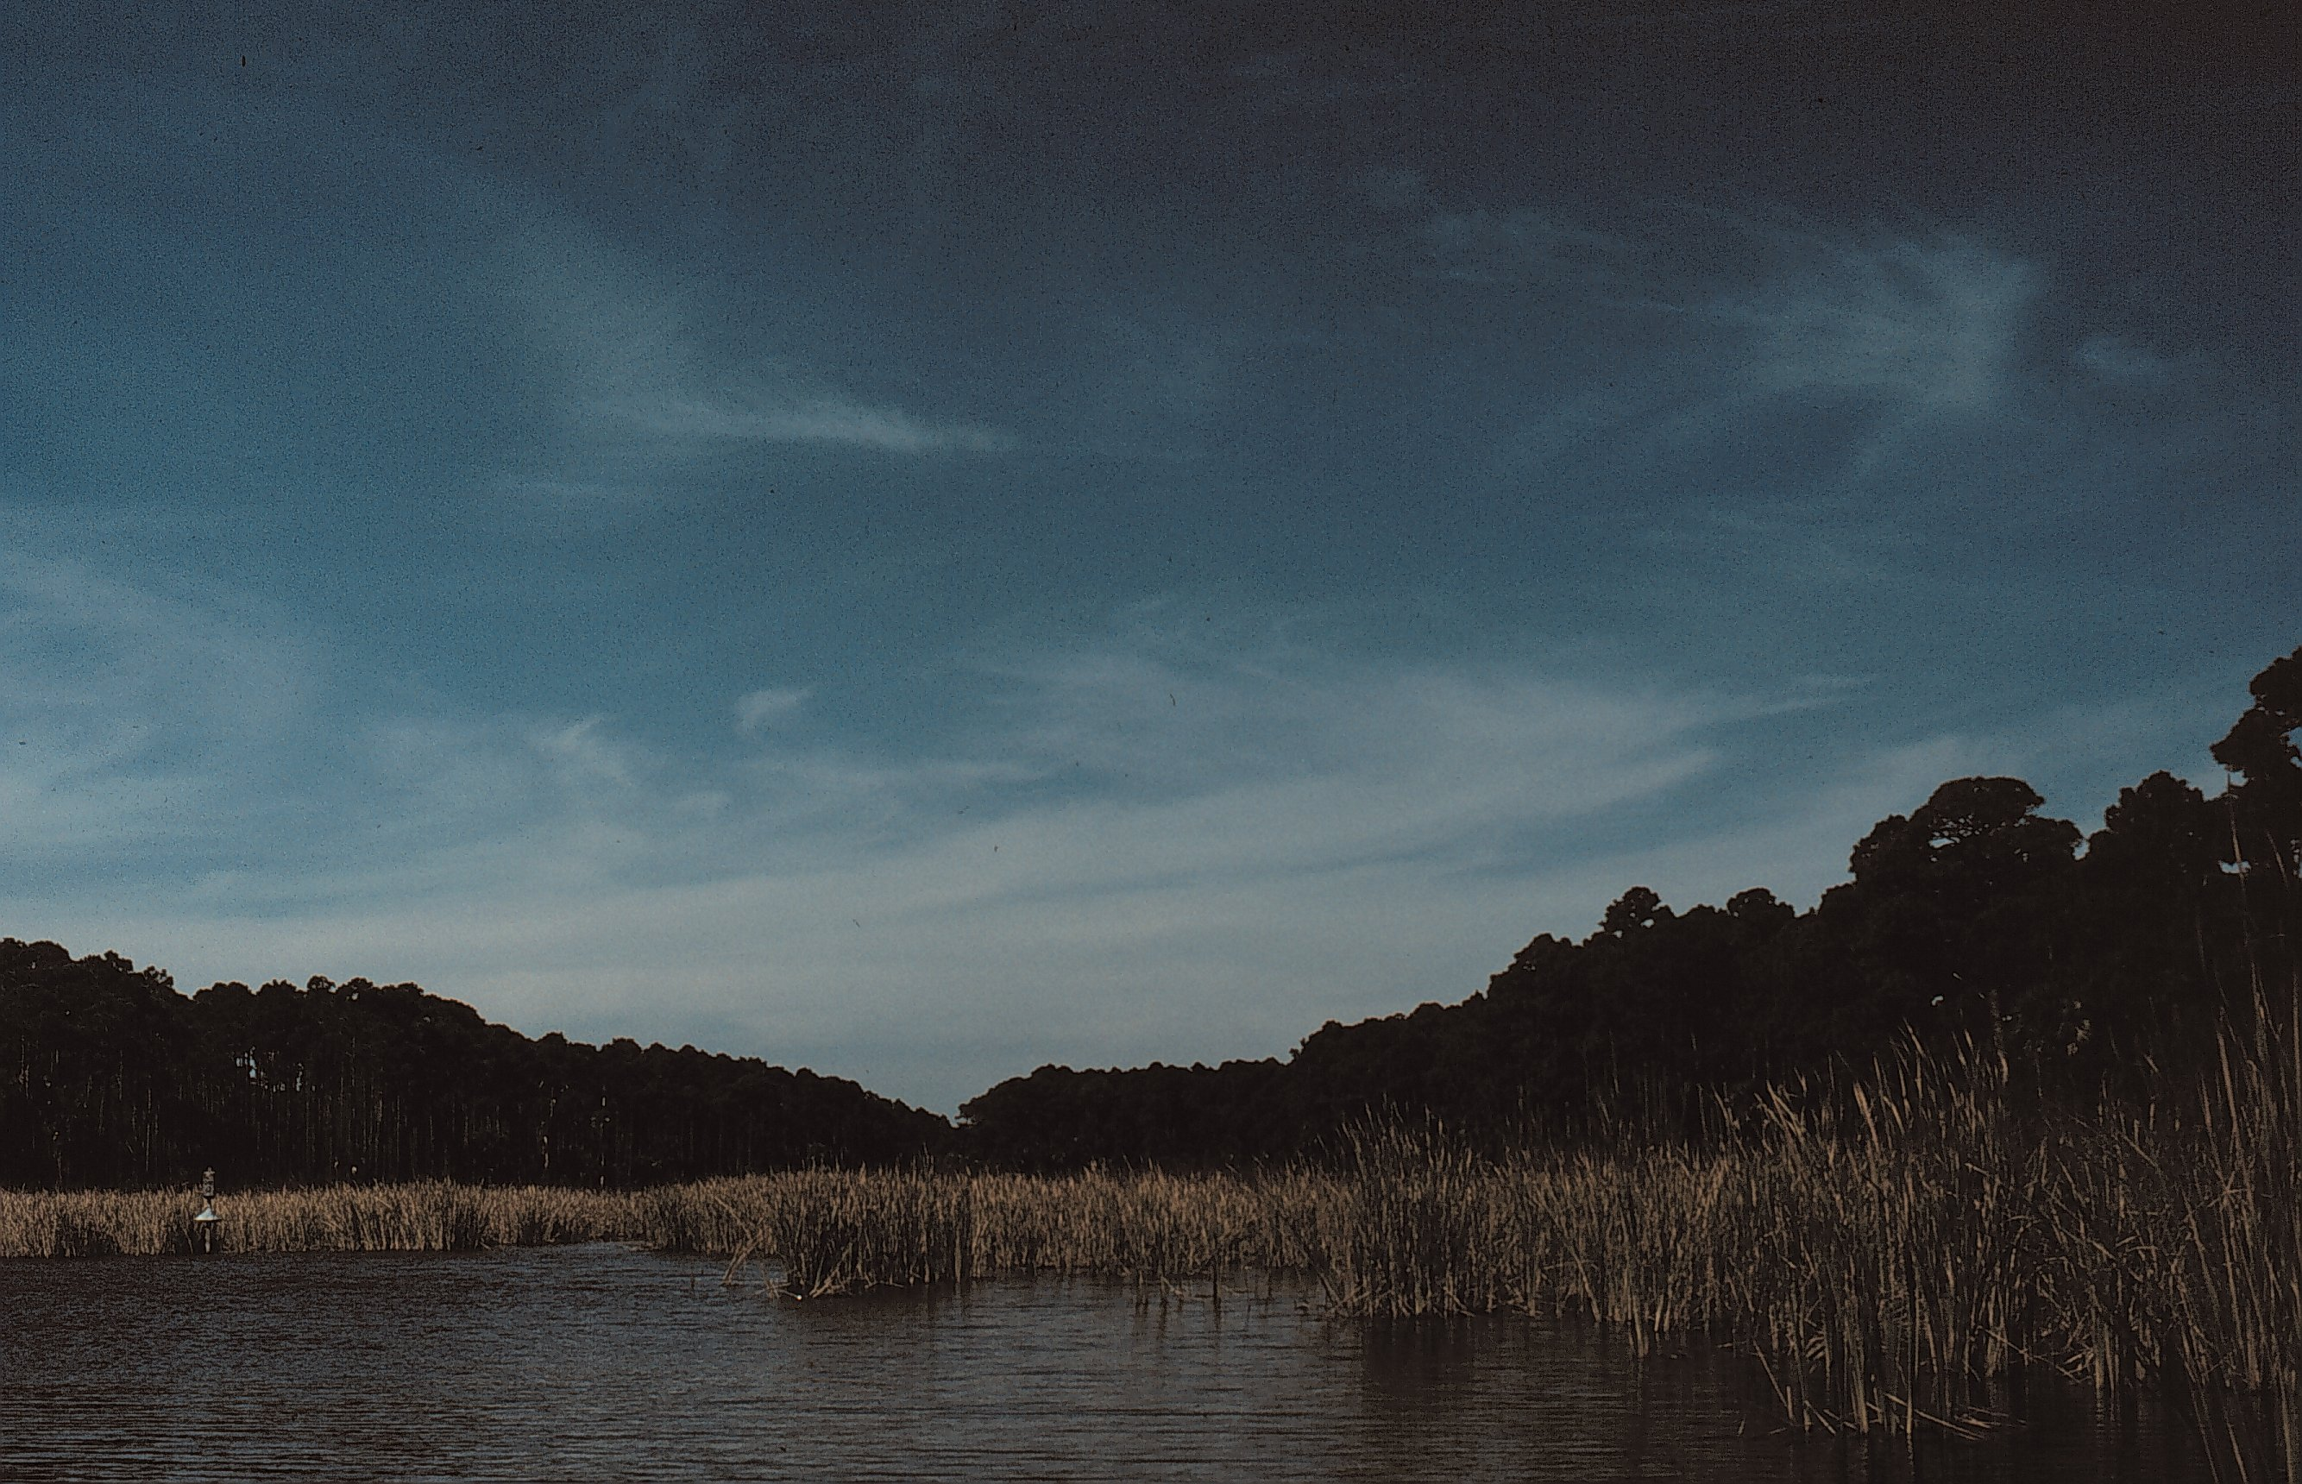
Figure 11. Appearance of palustrine open water.
Estuarine Marsh

Synonyms: Saltwater marsh, coastal dune lake, estuarine tidal marsh, tidal marsh, brackish marsh, coastal marsh, Spartina patens - Juncus roemerianus tidal herbaceous vegetation, Juncus roemerianus high marsh vegetation, Juncus roemerianus low marsh vegetation, Distichlis spicata - Spartina spp. tidal herbaceous vegetation, Spartina bakeri - Spartina patens herbaceous vegetation.

Extent on Refuge: Total acres = 2782.4 acres. Occurs on St. Vincent Island, Pig Island, and the Mainland Unit. This vegetation type is found mostly along the northeastern portion of St. Vincent Island and in Mallard Slough marsh and Sheepshead Bayou marsh. It makes up almost one third of the vegetation on St. Vincent Island. On Pig Island, estuarine marsh forms a narrow strip of marsh completely around the outer edge of the island. The largest area of estuarine marsh on Pig Island is found in the southern portion of the island. It makes up to one third of the vegetation of this island. On the mainland unit, estuarine marsh makes up the vegetation of the southern half of the unit and extends into St. Vincent Sound.

Topography: Low, nearly level terrain at or below sea level.

Soils: The soils of this vegetation type include Bohicket, Tisonia, Dirego, and Bayvi soils. These soils are very poorly drained soils that are made up of muck in the top surface layers with a clay or sandy component deeper in the profile. These are generally fertile, highly saline soils with a high organic content.

Hydrology: Estaurine marsh is subject to hydric conditions, flooded once or more daily in low marsh situations to periodic flooding during storm events and extremely high tides in high marsh situations.

Appearance: This vegetation type appears as a continuous layer of salt-tolerant, herbaceous species with little to no shrubs or trees. This vegetation class will appear as large expanses of grasses, rushes, and sedges along coastlines (Figure 12).

Ecology: Estuarine marshes are, by definition, exposed to tidal influence at least one time per day. Tides flush nutrients into and out of marshes that act as buffers between the harsh shoreline environments and the more upland forests and freshwater marsh environments. Primary productivity is the highest in this ecosystem. Plants of estuarine marshes are able to survive both saline and flooding conditions. Most plants of this vegetation type are considered obligate wetland species where flooded conditions or saturated soils are required for all or part of the life cycle. Alterations of the hydrology to this vegetation type could impact the composition of species present. Increased fresh water into a site could convert the site to more palustrine systems.

The natural fire frequency and importance of natural fire to this vegetation type are not well understood. Current management practices of estuarine marshes use fire as a tool to produce young plant shoots as a food source for migrating waterfowl and shorebirds. Fire will also reduce woody growth into open salt marshes and maintain a grass and herb groundcover. Fire is promoted in areas as frequent as once every year to once every 3 years.

Vegetation:

Overstory: This vegetation type is considered a grassland, with few overstory species present. Cabbage palm (Sabal palmetto) trees may occur infrequently throughout a site.

Midstory: The midstory is sparse in this vegetation type but may include falsewillows (Baccharis spp.), marshelder (Iva spp.), wax myrtle (Myrica cerifera), which make up the majority of tall shrubs if present.

Understory: In addition to occasional midstory species, the understory may include amaranths (Amaranthus spp.), saltbushes (Atriplex spp.), rosemallows (Hibiscus spp.), saltmarsh mallows (Kostelezkya spp.), and common reeds (Phragmites spp.).

Groundcover: The groundcover may include foxgloves (Agalinis spp.), milkweeds (Asclepias spp.), asters (Aster spp.), herb-of-grace (Bacopa monnieri), saltwort (Batis maritima), seaside oxeyes (Borrichia spp.), sedges (Carex spp.), Jamaica swamp sawgrass (Cladium jamaicense), swallowworts (Cynanchum spp.), flatsedges (Cyperus spp.), saltgrasses (Distichlis spp.), spikerushes (Eleocharis spp.), morningglories (Ipomoea spp.), rushes (Juncus spp.), sealavenders (Limonium spp.), christmasberry (Lycium carolinianum), shoregrass (Monanthochloe littoralis), camphorweeds (Pluchea spp.), pondweesd (Potamogeton spp.), mock bishopsweed (Ptilimnium capillaceum), rosegentians (Sabatia spp.), glassworts (Salicornia spp.), bulrushes (Scirpus spp.), rattlebox (Sesbania punicea), seapurslanes (Sesuvium spp.), cordgrasses (Spartina spp.), dropseeds (Sporobolus spp.), seepweeds (Suaeda spp.), arrowgrass (Triglochin striata), cattails (Typha spp.), vetches (Vicia spp.), cowpeas (Vigna spp.), and horned pondweed (Zannichellia palustris).

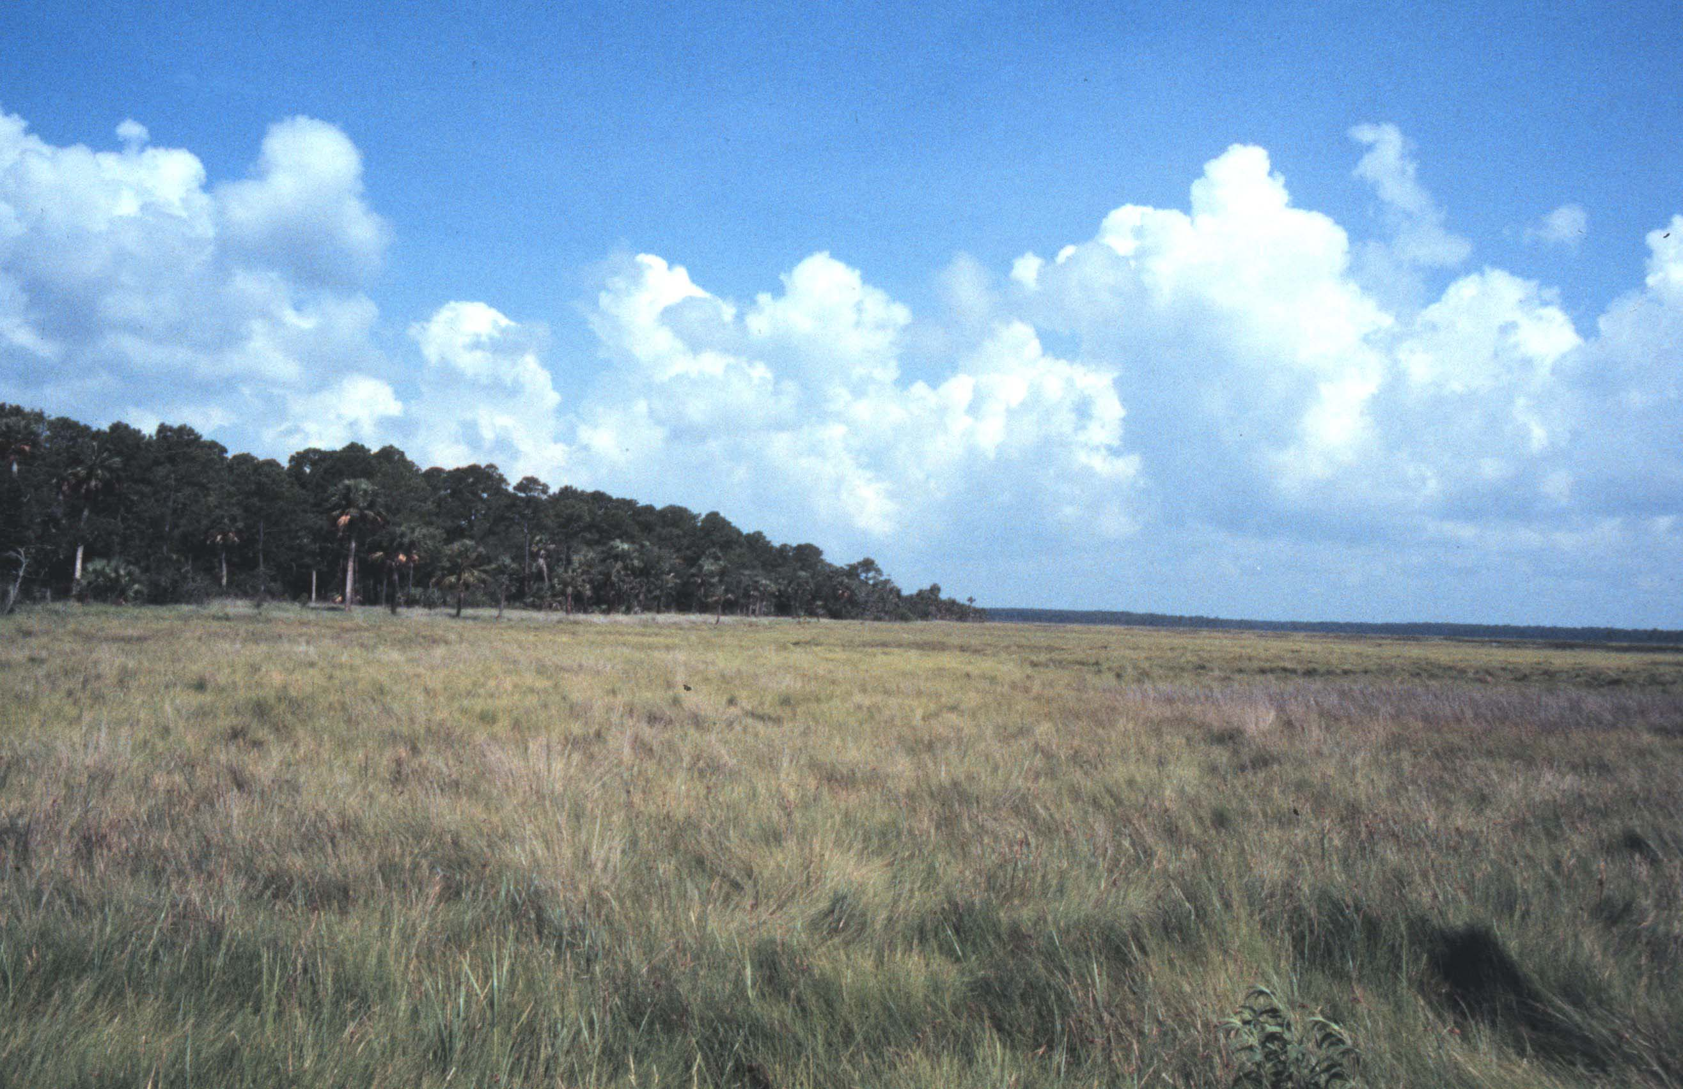
Figure 12. Appearance of estaurine marsh vegetation class.
Estuarine Shrub

Synonyms: Estuarine tidal marsh, Baccharis halimifolia - Iva frutescens shrubland, Baccharis halimifolia - Iva frutescens / Panicum virgatum shrubland, Iva frutescens / Spartina spartinae shrubland, Iva frutescens shrubland, Myrica cerifera - Baccharis halimifolia / Spartina spartinae shrubland.

Extent on Refuge: Total acres = 1.5 acres. Occurs on St. Vincent Island, Pig Island, and the Mainland Unit. On St. Vincent Island, this vegetation type is found in small areas along edges of estuarine marshes on the northern portion of the island. On Pig Island, this vegetation type occurs in small patches in the interior of the marsh along the southern tip of the island. On the mainland unit, a small patch of this vegetation type is found in the estuarine marsh on the southern end of the unit.

Topography: Low, nearly level terrain, at or below sea level. This vegetation type is slightly higher in elevation than estuarine marsh.

Soils: The soils of this vegetation type are similar to estuarine marsh soils and include Bohicket, Tisonia, Dirego and Bayvi soils. These soils are very poorly drained soils that are made up of muck in the top surface layers with a clay or sandy component deeper in the profile. These are generally fertile, highly saline soils with a high organic content.

Hydrology: Mesic to hydric conditions, flooded once or more daily in low marsh situations to periodic flooding during storm events and extremely high tides in high marsh situations.

Appearance: This vegetation type is characterized as a shrubland. The canopy is dominated by salt-tolerant wetland species such as marsh elder, groundsel tree, and wax myrtle which make a thick shrub layer. The midstory and understory of this vegetation type can be thickets of shrub species as well. Herbaceous estuarine marsh species makeup the groundcover if present (Figure not available).

Ecology: Estuarine shrub vegetation is similar in ecology to estuarine marsh vegetation. This vegetation type is considered a more mature area of estuarine marsh where thickets of salt-tolerant shrubs have invaded higher elevation areas that may not be exposed to tidal influence. The dominant shrubs of this vegetation type are not necessarily obligate wetland species but may tolerate periodic flooding events. Alterations of the hydrology to this vegetation type could impact the composition of species present. Increased fresh water into a site could convert the site to more palustrine systems.

The natural fire frequency and importance of natural fire to this vegetation type are not well understood. Current management practices of estuarine shrub vegetation use fire as a tool to reduce woody growth to develop more open salt marshes and maintain a grass and herb groundcover. Fire is promoted in areas as frequently as annually to once every 3 years.

Vegetation:

Overstory: similar to estuarine marsh with cabbage palm (Sabal palmetto) occurring occasionally.

Midstory: The midstory is more prominent in this vegetation type and is made up of a thicket of shrubs including saltwater falsewillows (Baccharis spp.), marshelders (Iva spp.), and wax myrtle (Myrica cerifera).

Understory: The understory is similar to estuarine marsh species and includes amaranths (Amaranthus spp.), saltbushes (Atriplex spp.), rosemallows (Hibiscus spp.), saltmarsh mallows (Kostelezkya spp.), and common reeds (Phragmites spp.).

Groundcover: The groundcover is similar to estuarine marsh and includes foxgloves (Agalinis spp.), milkweeds (Asclepias spp.), asters (Aster spp.), herb-of-grace (Bacopa monnieri), saltwort (Batis maritima), seaside oxeyes (Borrichia spp.), sedges (Carex spp.), Jamaica swamp sawgrass (Cladium jamaicense), swallowworts (Cynanchum spp.), flatsedges (Cyperus spp.), saltgrasses (Distichlis spp.), spikerushes (Eleocharis spp.), morningglories (Ipomoea spp.), rushes (Juncus spp.), sealavenders (Limonium spp.), christmasberry (Lycium carolinianum), shoregrass (Monanthochloe littoralis), camphorweeds (Pluchea spp.), pondweeds (Potamogeton spp.), mock bishopsweed (Ptilimnium capillaceum), rosegentians (Sabatia spp.), glassworts (Salicornia spp.), bulrushes (Scirpus spp.), rattlebox (Sesbania punicea), seapurslanes (Sesuvium spp.), cordgrasses (Spartina spp.), dropseeds (Sporobulus spp.), seepweeds (Suaeda spp.), arrowgrass (Triglochin striata), cattails (Typha spp.), vetches (Vicia spp.), cowpeas (Vigna spp.), and horned pondweed (Zannichellia palustris).

Estuarine Open Water

Synonyms: Coastal dune lakes, saltwater ponds, lagoons, Ruppia, maritima herbaceous vegetation, Potamogeton pectinatus - Ruppia maritima herbaceous vegetation, Potamogeton perfoliatus - Zannichellia palustris herbaceous vegetation.

Extent on Refuge: Total acres = 854.2 acres. This cover type occurs on St. Vincent Island and occurs as small saline ponds scattered in estuarine marsh vegetation of the northern portion of the island of Mallard Slough marsh and Sheepshead Bayou marsh.

Topography: Low, nearly level terrain at or below sea level.

Soils: The soils of this vegetation type are similar to the soils of estuarine marshes and shrub vegetation types and include Bohicket, Tisonia, Dirego, and Bayvi soils. These soils are very poorly drained soils that are made up of muck in the top surface layers with a clay or sandy component deeper in the profile. These are generally fertile, highly saline soils with a high organic content.

Hydrology: Estaurine open water occurs under hydric conditions with standing water present at high tide. Fluctuations in water levels are dependent on tidal influence and flooding with storm events.

Appearance: The plants of this cover class are predominately submersed and emergent vegetation confined to the boundaries of the estuarine open water. The vegetation is herbaceous and mostly submergent in deeper-water areas and emergent vegetation restricted to the margins and edges of the ponds and lakes (Figure 14).

Ecology: Estuarine open water systems can be tidally influenced or over time can be isolated into saltwater ponds and lakes that are periodically overwashed with salt water. Salinity in this open water system can vary greatly depending on precipitation and storm events. Estuarine open water systems are important as breeding grounds for organisms and stopovers for migratory birds feeding on plants within them. The plant species that are associated with this vegetation type are submergent, salt tolerant wetland species that are found below the water surface most of the life cycle and above the surface during flowering.

This vegetation type is resistant to fire for the most part. The vegetation is vulnerable to fire under drought conditions or during times when small open saltwater ponds dry up. Fires will generally ignite in adjacent vegetation types and burn into the organic peat layers of the ponds as they dry out. In the absence of precipitation events or a recovery of water levels, ground peat fires may occur at the surface or underground peat layers for a long period of time.

Vegetation:

Overstory: This vegetation type is similar to estuarine marsh with cabbage palm (Sabal palmetto) occurring occasionally.

Midstory: Similar to estuarine shrub vegetation, the midstory along the edge of open water may include saltwater falsewillows (Baccharis spp.), marshelders (Iva spp.), and wax myrtles (Myrica cerifera).

Understory: The understory species that occur on the edge of open water are similar to estuarine marsh species and may include amaranths (Amaranthus spp.), saltbushes (Atriplex spp.), rosemallows (Hibiscus spp.), saltmarsh mallows (Kostelezkya spp.), and common reeds (Phragmites spp.).

Groundcover: The groundcover in this vegetation type will include submergent saltwater species such as widgeongrasses (Ruppia spp.), and saltwater eel grasses (Zostera spp.). Emergent groundcover species in shallow water along the margin of open water may include any species of estuarine marsh.

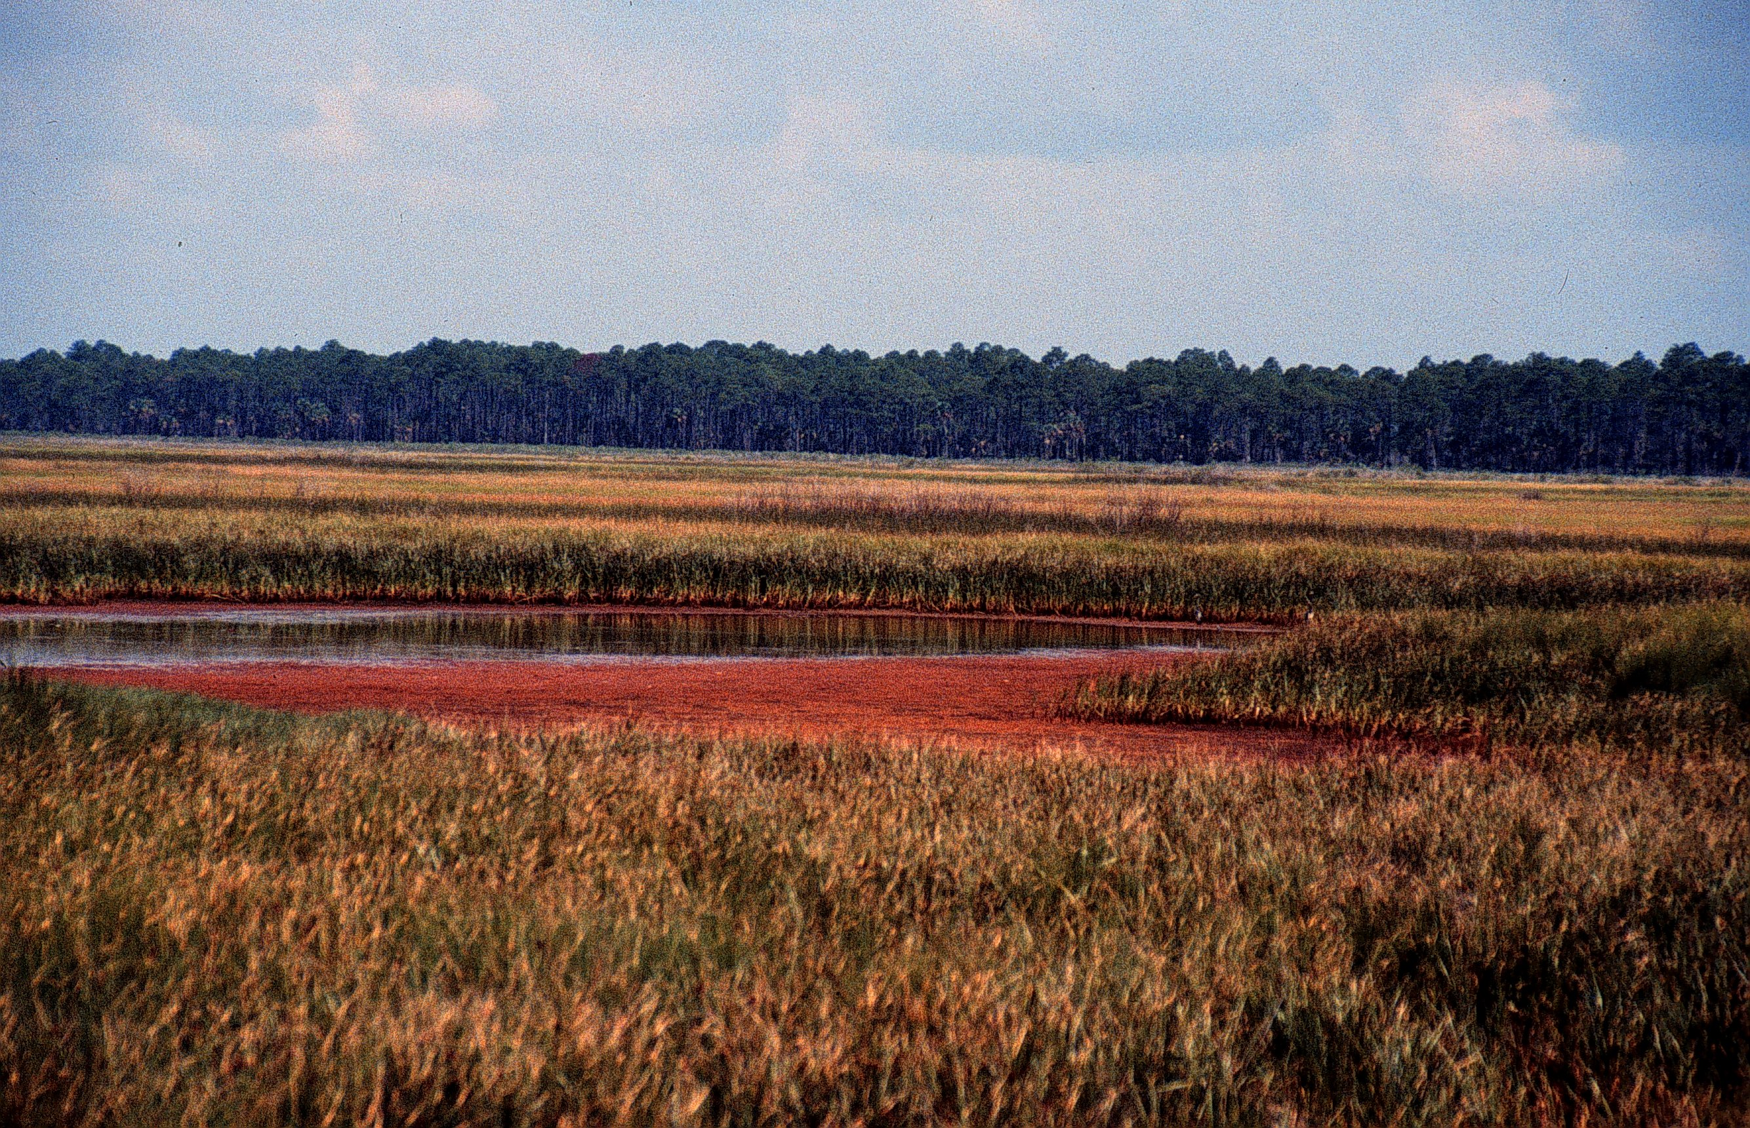
Figure 13. Appearance of estaurine open water.
Beach Dunes

Synonyms: Beach

Extent on Refuge: Total acres = 219.2 acres. Occurs on St. Vincent Island. This vegetation type is found along the foredunes of high wave active areas of the southern and eastern shorelines of the island.

Topography: Sand ridge tops and side slopes of sand ridges along coastline.

Soils: The soil map unit that makes up the beach dunes on the refuge is the Newhan-Corolla complex. This soil is excessively drained soil made up of gray and white sands to a depth over 80 inches.

Hydrology: Excessively drained deep sands, there is no water table within 80 inches.

Appearance: The vegetation of the beach dunes is sparse with no overstory or midstory components and either a sparse to dense understory vegetation layer (Figure 15).

Ecology: Beach dune vegetation occurs on the foredune or first dune parallel to the shore. This is a harsh and dynamic environment for plants and animals to live in. Organisms living in this environment are subjected to high energy wave actions, heavy winds, saltwater flooding, and constant sand deposition. As a result most plant species in this vegetation type have specialized adaptations for procumbent growth (i.e., spreading growth close to the ground), water conservation, salt tolerance, and flood tolerance. There are few species that can survive and establish over long periods of time in this dynamic environment. There is continual movement of sand and deposition. During storm events, foredunes can be destroyed or created in one event. The vegetation is generally sparse on younger foredunes and more abundant on back dunes and older sand dunes.

Fire does not play a significant role in the structure or composition of this vegetation type. Fires will occasionally burn into beach vegetation but due to its sparse nature will not spread over large areas.

Vegetation:

Overstory: Very few species occur in the overstory, but they may include red cedar (Juniperus virginiana), slash pine (Pinus elliottii), or cabbage palm (Sabal palmetto).

Midstory: The midstory is not prominent in this vegetation type and may include isolated individuals of saltwater falsewillows (Baccharis spp.), marshelders (Iva spp.), and regenerating overstory species.

Understory: The understory may include species such as saltbushes (Atriplex spp.), and juveniles of midstory species.

Groundcover: The groundcover is mostly barren and may include dense areas with sandburs (Cenchrus spp.), buttonweeds (Diodia spp.), lovegrasses (Eragrostis spp.), mille grains and bluets (Hedyotis spp.), sunflowers (Helianthus spp.), marshpennyworts (Hydrocotyle spp.), morningglories (Ipomoea spp.), lupines (Lupinus spp.), eveningprimroses (Oenothera spp.), pricklypear cacti (Opuntia spp.), panicgrasses (Panicum spp.), nailworts (Paronychia spp.), crowngrasses (Paspalum spp.), fogfruits (Phyla spp.), groundcherries (Physalis spp.), spurges (Poinsettia spp.), docks (Rumex spp.), saltworts (Salsola spp.), bluestem grass (Schizachyrium spp.), seaoats (Uniola spp.), and yuccas (Yucca spp.).

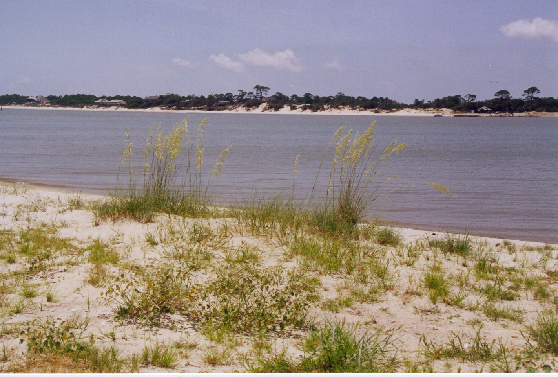
Figure 14. Appearance of beach dune vegetation class.
Other Cover Classes

Intertidal Zone

Synonyms: Unconsolidated shoreline, unconsolidated substrate, beach, tidal flat.

Extent on Refuge: Total acres = 263.1 acres. Occurs on St. Vincent Island. This cover type is found between the high and low tide marks of the high wave energy areas of the southern and eastern portions of the island. A small amount of intertidal zone can also be found along the northwestern tip of the island.

Soils: This cover class is associated with beach soil as defined by the Franklin County soil survey map. As defined, beach as a soil unit includes deposits of loose fine sand and shell fragments below the high tide mark.

Topography: Along slopes of shorelines between low and high tide marks.

Hydrology: Flooded with tides.

Oyster Reef

Synonyms: Mollusk reefs, oyster bed.

Extent on Refuge: Total acres = 36.9 acres. Occurs along the shores of St. Vincent Island and the Mainland Unit. This cover type is found exposed at low tide and makes extensions of land along the northeastern tip of the island forming St. Vincent Point and along the northern portion of the island forming Pickalene Bar. A small oyster reef is found on the southeastern portion of the mainland unit.

Soils: No soils have been mapped for this class because the area is made up of shells and shell fragments from oysters.

Topography: At or below sea level.

Hydrology: Portions of oyster reefs may be completely flooded during high tides.

Intertidal Flats

Synonyms: Unconsolidated substrate, saltflats, mudflats, tidal flats.

Extent on Refuge: Total acres = 5.5 acres. Occurs on St. Vincent Island and Pig Island. On St. Vincent Island, this cover type is found in small isolated patches of estuarine marshes of the northeastern portion and along the northern shore of the western end of the island. On Pig Island, this cover type is found in the southwestern portion of the island as a small patch within the estuarine marsh.

Soils: This cover class is associated with beach soil as defined by the Franklin County soil survey map (Sasser et al. 1994). As defined, beach soils include deposits of loose fine sand and shell fragments below the high tide mark.

Topography: Along slopes of shorelines between low and high tide marks.

Hydrology: Flooded with tides.

Developed

Synonyms: Urban, disturbed sites.

Extent on refuge: Total acres identified on map =14.1 acres. There are significant areas of disturbance to native soils throughout the refuge including an extensive road system, home sites, clearings for soil borrow pits, bridges, water control structures, fenced impoundments, boat landing sites, and others. Where there is significant disturbance to native soil (i.e., turning over of the topsoil) there will be an opportunity for invasive species to establish on the refuge. Most of the invasive species (see Table 5) on the refuge are limited to disturbed and developed areas.

Topography: Variable.

Soils: Soils are variable depending on the original soil map unit developed.

Hydrology: Variable, but see hydrology report to refuge by Davis and Mokray 1999.

Vegetation:

Overstory: Overstory trees of disturbed sites may include mulberries (Morus spp.), sweet acacias (Acacia spp.), and Chinese tallows (Sapium sebiferum).

Midstory: In addition to overstory tree species, the midstory of disturbed sites may include saltwater falsewillows (Baccharis spp.), hickories (Carya spp.), oaks (Quercus spp.), and Hercule's club (Zanthoxylum clava-herculis).

Understory: The understory of disturbed sites may include regenerating species of the overstory and midstory as well as peppervine (Ampelopsis arborea), Virginia creeper (Parthenocissus quinquefolia), common reeds (Phragmites spp.), dewberries (Rubus spp.), elderberries (Sambucus spp.), sensitive plants (Senna spp.), rattlebox (Sesbania punicea), eastern poison ivy (Toxicodendron radicans), and Chinese wisteria (Wisteria sinensis).

Groundcover: The groundcover species that occupy a disturbed site vary depending on the initial vegetation type disturbed and can include any of the following threeseed mercuries (Acalypha spp.), foxgloves (Agalinis spp.), amaranths (Amaranthus spp.), ragweeds (Ambrosia spp.), bluestems (Andropogon spp.), threeawns (Aristida spp.), carpetgrasses (Axonopus spp.), bittercresses (Cardamine spp.), sedges (Carex spp.), sandburs (Cenchrus spp.), partridgepeas (Chamaecrista spp.), sandmats (Chamaesyce spp.), goosefoots (Chenopodium spp.), thistles (Cirsium spp.), dayflowers (Commelina spp.), horseweeds (Conyza spp.), tickseeds (Coreopsis spp.), rabbitbells (Crotalaria spp.), crotons (Croton spp.), bermudagrass (Cynodon dactylon), flatsedges (Cyperus spp.), American wild carrot (Daucus pusillus), tansymustards (Descurainia spp.), witchgrasses (Dichanthelium spp.), crabgrasses (Digitaria spp.), buttonweeds (Diodia spp.), barnyardgrasses (Echinochloa spp.), false daisy (Eclipta prostrata), goosegrass (Eleusine indica), lovegrasses (Eragrostis spp.), fireweed (Erechtites hieracifolia), fleabanes (Erigeron spp.), eryngoes (Eryngium spp.), thoroughworts (Eupatorium spp.), fingergrasses (Eustachys spp.), flattop goldenrod (Euthamia graminifolia), fimbries (Fimbristylis spp.), bedstraws (Galium spp.), beeblossoms (Gaura spp.), Carolinacranesbill (Geranium carolinianum), everlastings (Gnaphalium spp.), mille grains and bluets (Hedyotis spp.), heliotropes (Heliotropium spp.), camphorweed (Heterotheca spp.), St. John's-worts (Hypericum spp.), morningglories (Ipomoea spp.), dwarfdandelions (Krigia spp.), japanese clover (Kummerowia striata), wild lettuces (Lactuca spp.), lion's ear (Leonotis neptifolia), pepperweeds (Lepidium spp.), sprangletops (Leptochloa spp.), toadflaxes (Linaria spp.), watergrasses (Luziola spp.), christmasberry (Lycium carolinianum), garden tomato (Lycopersicon esculentum), Japanese climbing fern (Lygodium japonicum), black medick (Medicago lupulina), Carolina bristlemallow (Modiola caroliniana), carpetweeds (Mollugo spp.), beebalms (Monarda spp.), tropical puff (Neptunia pubescens), eveningprimroses (Oenothera spp.), prickly pear cacti (Opuntia spp.), woodsorrels (Oxalis spp.), panicgrasses (Panicum spp.), crowngrasses (Paspalum spp.), golden bamboo (Phyllostachys aurea), pokeweeds (Phytolacca spp.), plantains (Plantago spp.), fire-on-the-mountain (Poinsettia cyathophora), knotweeds (Polygonum spp.), rustweed (Polypremum procumbens), meadowbeauties (Rhexia spp.), beaksedges (Rhynchospora spp.), docks (Rumex spp.), soapberries (Sapindus spp.), bluestems (Schizachyrium spp.), licoriceweed (Scoparia dulcis), foxtails (Setaria spp.), fanpetals (Sida spp.), catchflies (Silene spp.), sowthistles (Sonchus spp.), scaleseeds (Spermolepis spp.), wedgescales (Sphenopholis spp.), dropseeds (Sporobolus spp.), tridens (Tridens spp.), sandgrasses (Triplasis spp.), vervains (Verbena spp.), crownbeards (Verbesina sp.), and fescue (Vulpia spp.).

Managed Marsh

The vegetation of this class will reflect the vegetation types as defined by management and restoration activities.

Extent on refuge: Total acres currently identified on map is 762.6 acres. There are currently five water control structures on St. Vincent Island. These allow the control of salt water into and out of designated lakes, ponds, and wetlands. The areas controlled are in the southeastern portion of the island and include Oyster Pond and Lakes 1-5. The marshes surrounding these open water sites have been impacted by the flooding regimes and saltwater exchange allowed in these areas. Most recently, a significant amount of cattail (Typha spp.) was reduced by humans as a result of flood management projects.

Managed Open Water

The vegetation of this class will reflect the vegetation types as defined by management and restoration activities.

Extent on refuge: Total acres currently identified on map is 167.6 acres. There are currently five water control structures on St. Vincent Island. These allow the control of salt water into and out of designated lakes, ponds, and wetlands. The areas controlled are in the southeastern portion of the island and include Oyster Pond and Lakes 1-5. The vegetation, predominately submersed vegetation, will be impacted as flooding regimes and salinities change with management activities.

Summary

This project has resulted in a current description of the vegetation cover types for St. Vincent NWR. We have produced a base vegetation map that can continue to be used with GIS software to build layers of information for management purposes. As a result of this project, we have defined 21 cover types; 15 are composed of natural vegetation, 3 are defined based on mineral components, and 3 are associated with human activities. We have also described the ecology and flora for each vegetation class and produced a database that can be used for plant identification and other purposes. Nearly 600 plant species descriptions were defined in the plant database which included not only traditional taxonomic information, but also ecological information, native or non-native status, wetland status, and rare plant status. In addition, this final report has described the overall ecology of the refuge in terms of climate, geological history, and soils to give a broader perspective of the refuge as a whole.

The natural vegetation of St. Vincent NWR makes up the ecological building blocks for the ecosystems and organisms that utilize the refuge. It makes up the habitat, fuels and food base for resident organisms such as wildlife and migratory birds. Understanding the structure and composition of the natural vegetation patterns is the first step to understanding the ecology of the refuge. It is hoped that the information provided in this study will give managers of the refuge now, and in the future, an information resource that will help them make sound management decisions.

Research Needs

As with many research projects, as one question begins to be answered many more are revealed. Below are some examples of additional plant ecology research projects and products that might help with management issues in the future.

- Develop a more refined ecological map of plant communities.
- Develop a fuels map of the refuge, reflecting condition of fuels and successional trends.
- Conduct an analysis of the effectiveness and efficiency of the fire management program in terms of success / failures of management objectives.
- Conduct an extensive invasive species survey.
- Conduct an analysis of the vegetation change in response to water management programs.
- Conduct a rare plant survey.
- Develop studies of fire effects on native vegetation such as wiregrass.
- Conduct habitat quality studies for migrating waterfowl and shorebirds.
- Develop a vegetation monitoring program to evaluate management practices.
- Conduct fire effect studies on vegetation used by secretive marsh birds and neotropical migrants.
- Develop historical vegetation maps and investigate changes in vegetation over time.
- Conduct an analysis of large scale disturbances (e.g., hurricanes, wildfires) on vegetation structure.
- Establish long term demographic studies of forest structure.
- Conduct an investigation of fire history and estimate natural fire frequency for community types on the refuge.

Acknowledgments

We are grateful to Thom Lewis, biologist, St. Vincent NWR, whose interest, insights, experience and support made this research possible. We thank the management staff of St. Vincent NWR, Terry Peacock, Don Kosin and Randy Cordray for their support and interest in this study. In addition, we thank Charlotte Chumney, Robert and Tommy Gay, Dale Shiver, and other members of the refuge staff for their help with logistics. They were always willing to provide logistic support with transportation in and around the refuge, and help provide comfortable accommodations for us on the refuge. This research would not be possible without the help of Brandy Wainwright and Tamara Kley of the Johnson Control World Services. Their tireless effort in helping with field data collection and data entry made this research project a success. We also thank Sharon King of the Johnson Control World Services for her assistance in plant identification and specimen collections and preparations. Vegetation map provided by Arturo Calix of the USGS-BRD, National Wetlands Research Center. Ann Johnson of the Florida Natural Areas Inventory program, provided technical advice and information regarding plant taxonomy, identification and vegetation classification. This research was funded by the USFWS and USGS-BRD under the Research Partnership Proposal Program and additional support was provided by the USFWS Ecological Services, Panama City, FL.

Literature Cited

Anderson, L. 1986. Noteworthy plants from Florida. II. Sida 11(4): 379-384.

Anderson, L. 1987. Boltonia apalachicolensis (Asteraceae): a new species from Florida. Systematic Botany 12: 133-138.

Anderson, L. 1988. Noteworthy plants from north Florida. III. Sida 13(1): 93-100.

Davis, H., and M. Mokray. 1999. Assessment of the impact of road construction and other modifications on surface water flow at St. Vincent National Wildlife Refuge, Franklin County, Florida. USGS Final Report to USFWS, Apalachicola, FL.

Donohue, J.F., S. Demirpolat, and W. F. Tanner. 1990. Recent shoreline changes, Northeastern Gulf of Mexico. Pages 51-66 in W. F. Tanner, editor. Coastal Sediments and Processes, Proceedings of the Ninth Symposium on Coastal Sedimentology, Geology Department, Florida State University, Tallahassee, FL.

Doyle, T., and K. Krauss. 1999. The sands and sambars of St. Vincent Island. Florida Wildlife 53(4): 22-25.

Florida Natural Areas Inventory. 1990. Guide to the natural communities of Florida. Florida Natural Areas Inventory, Tallahassee, FL. 111 pp.

Grace, J.B. 1998. Can prescribed fire save the endangered coastal prairie ecosystem from Chinese tallow invasion? Endangered Species Update 15:70-76.

McAtee, W. L. 1913. A list of plants collected on St. Vincent Island, Florida. Proceedings of the Biological Society of Washington 26:39-52.

Robbins, L.E., and R. L. Myers. 1990. Seasonal effects of prescribed burning in Florida: a review. Tall Timbers Research Station Miscellaneous Publication No. 8, Tallahassee, FL.

Sasser, L.D., K.L. Monroe, and J.N. Schuster. 1994. Soil surve y of Franklin County, Florida. US Department of Agriculture, Soil Conservation Service, University of Florida and Florida Department of Agriculture and Consumer Services, Gainesville. 192 pp.

Schnable, J. 1966. The evolution and development of part of the northwest Florida coast. PhD Dissertation, Florida State University, Tallahassee. 231 pp.

Stapor, F. 1973. Coastal sand budgets and Holocene beach ridge plain development, northwest Florida. PhD Dissertation, Florida State University, Tallahassee. 221 pp.

Stapor, F. W., and W. F. Tanner. 1977. Late Holocene mean sea level data from St. Vincent Island and the shape of the late Holocene mean sea level curve. Pages 35-68 in W. F. Tanner, editor, Coastal Sedimentology, Proceedings of the Third Symposium on Coastal Sedimentology, Geology Department, Florida State University, Tallahassee, FL.

Thompson, D. 1970. Vegetative cover types of St. Vincent Island Refuge. Unpublished report to St. Vincent National Wildlife Refuge, Apalachicola, FL. 11 pp.

Wunderlin, R. P. 1997. Guide to the vascular plants of Florida. University Press of Florida, Gainesville, FL. 806 pp.

Appendix

Appendix A. Database of plant species of St. Vincent NWR

A hard copy of the database has been submitted with this final report. In addition, a digital copy of the database has been submitted with this report.

Appendix B. Digital copy of vegetation map of St. Vincent NWR.

A digital image burned onto a CD has been submitted with this final report.

Appendix C. Digital copy of the final report.

An electronic copy of the final report is submitted with this report.

