Summary of the Structural Analysis and Design of the NOvA Detector
March 17, 2006
Ang Lee (FNAL)
Victor Guarino (ANL)
Jim Grudzinski (ANL)

- Introduction
The NOvA detector is a unique structure that is constructed completely from alternating layers of vertical and horizontal PVC extrusions that are connected together only by an adhesive between layers. The current design envisions 31 planes of PVC extrusions (a block) being assembled and adhered together in the horizontal position on block raiser and then rotated into the vertical position.

Critical to the success of this design is the strength of the PVC and the adhesive joint between extrusions. The PVC must not only act as the main structural element of the detector but it also is required to provide a high level of reflectivity so that there is sufficient light output from the detector. As a result the reflectivity requirement on the PVC a commercial PVC mixture that is commonly available most likely will not work for the experiment. Therefore, the structural analysis on the detector has progressed without a complete knowledge of the type of PVC that would be used. Certain assumptions have been used on the acceptable level of stress that would minimize creep affects and the modulus of elasticity that should be used over the life of the experiment.

The adhesive that is used between layers is also critical to the structural integrity of the structure. The adhesive will have to be applied over large surfaces so ES&H concerns have dominated the criteria for selecting the adhesive to date. The adhesive must have a work life of approximately 20 minutes to allow extrusions to be placed during assembly, but cure rather quickly so that sufficient strength in a 24 hour period so that the block can be rotated into the vertical position.

Throughout the analysis a safety factor of 5 on the maximum stress and buckling has been the goal of the design. It is felt that a safety factor of 5 is needed in a unique structure such as NOvA that is constructed completely from PVC extrusions bonded together.

This paper will summarize the work that has been done on the PVC material properties, adhesive between the extrusions, and structural analysis of the PVC extrusions and assembled NOvA structure.

This paper will be divided into the following sections.
- PVC material properties
- Adhesive
- Analysis of individual PVC extrusions
- Detailed Description of FEA model of Assembled Planes
- Methods for modeling adhesive joints
- Buckling analysis of assembled PVC planes
- Stress/deflection analysis of assembled PVC planes.
- Adhesive Stresses
- Conclusions/recommendations.

- PVC Material Properties
2.1 Baseline PVC Material

The PVC extrusions form the main structural element of the NOvA detector. As discussed above the PVC material must meet not only mechanical requirements for strength, creep, impact strength, but also requirements for reflectivity. Research on reflectivity currently indicates that relatively high concentrations of TiO₂, (>15%) are needed. This amount greatly exceeds that used in commonly available PVC pipe resins or other commonly used building materials. Similarly we have to restrict certain common additives such as acrylic impact modifiers and UV absorbers which absorb light in the spectrum we are concerned with (blue). One consequence of developing a unique PVC mixture is that mechanical properties, particularly creep, are not well known. This is in contrast with a standard PVC pipe compounds which are developed to an industry standard with known minimum properties.

The current baseline PVC mixture is the so called PET B mixture. This mixture is shown in table 1 (listed both as total percentage and the plastic industry standard representation of parts per hundred, phr ). Various polymer additives are added to the base PVC polymer to alter mechanical properties as well improve the processing. The PET-B compound was arrived at in an attempt to make an extrudable PVC containing 15% TiO2 with minimal other additives. based on existing data, it has shown the highest reflectivity of various trails. R+D is continuing for the PVC composition to confirm and further improve the mechanical and reflectivity properties.

PVC Resin | 100 phr | 78.6%
TiO2 uncoated Rutile, size <0.2 micron | 18 phr | 14.9%
Internal and External Lubricants | 1 phr | 3.9%
Organo-Tin Stabilizers | 2.3 phr | 1.8%
Table 1. Composition of PET-B PVC compound.

2.2 Mechanical properties

As the structural analysis must progress in parallel to the PVC R&D effort, the material specifications is iteration between required minimum and achievable properties. Table 2 lists the current desired minimum mechanical properties. These have been arrived at by combination of considering values used in the PVC pipe industry, the particular measured values of the PET-B material, and the results of FEA analysis of the structure. Similarly, a maximum tensile design stress of 1000 psi was based on PVC pipe industry references. Each of these values has different levels of significance to the design. Similarly the uncertainty of the current measured values as well as the application of these values in design varies for each. The current state of each of these properties is discussed individually below.

Material Property | Value | Test Method
Modulus of Elasticity | 450,000 psi | ASTM D638
0.2 % Offset Yield | 4000 psi | ASTM D638
Ultimate tensile Stress | 5500 psi | ASTM D638
Notched Izod Impact Test | 1 ft-lb/in | ASTM D256
Creep Modulus | 360,000 psi after 20 years | ASTM D2990
Table 2. Desired minimum mechanical properties for the NOVA PVC compound.

2.2.1 Modulus of Elasticity (E)

While the value of E drives the deformation and stress distributions of the structure, the more significant concern is the effect on buckling stability. The safety factor of buckling as discussed below is not excessive. A reduction in the stiffness would further reduce this value. The analysis is linear and uses a value of 360,000 psi. The PET-B material has been measured at 470,000 psi. It is important to say two things about this value. The first is that this is the instantaneous E measured in a short time tensile test. As will be discussed in section 2.2.2, PVC is viscoelastic which implies the E is a funtion of time. Secondly, PVC does not have a well defined elastic yield point. Figure 1 shows a representative plot from 10 PET-B tensile test samples. The value of E is the slope of the stress/strain curve where the curve remains linear. Again noting that the design stresses are limited to 1000psi, it is important to note that this linear region persists up to 2000 psi.

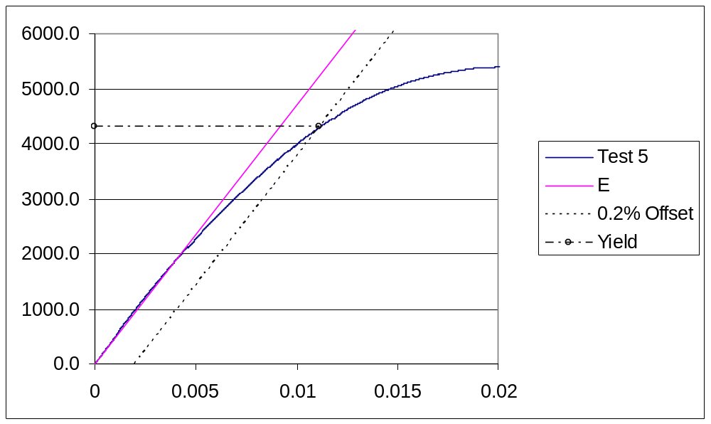
Figure 1. Representative stress strain diagram for PET-B tensile specimen.

2.2.2 Creep Modulus
As mentioned above, PVC is viscoelastic which implies that the material will flow over time. This can manifest itself as stress relaxation in constant strain or creep under constant load. We are more concerned with creep since we are in a constant load situation. The deformation over time lends itself to an apparent creep modulus where it can be thought of as a reduced stiffness over time.

There are three possible problems related to creep. 1. The material initial loaded and stable deforms until it ruptures (creep rupture). 2. Creep initiates crazing. 3. The deflections lead to an instability such as buckling (reduced effective stiffness).

All of these problems are functions of stress. This is the driving force behind a relatively low design stress (1000 psi ) as compared to the yield stress such as 4500 psi. Similarly, as mentioned above, the value of E used in the FEA has been 360,000 psi which is considerably lower than the measured values. This value is used a lower bound to see the effect of a reduction of the initial modulus in time. This leads to the current requirement that the E after 20 years is greater or equal to 360,000 psi.

The creep modulus is not yet measured for PET-B and it is not clear that the value of 360,000psi is achievable. Tests are under way to measure this. The difficulty of course is in predicting a value 20 years from now based on short term tests. The standard procedure for extrapolating such information is by exploiting the time-temperature relation ships for PVC. We are currently planning and performing accelerated creep and stress relaxation tests at various temperatures in an attempt to determine this value. At the same time we have long term creep tests in progress that will be used as a validation of the predictions. see figure 2. Similar tests were run for 1.5 years on Extrutech PVC samples and the results are descirbed in NOvA note 49. We are also considering employing expert consultants in this area to assist in the development of the test and interpretation of the data.

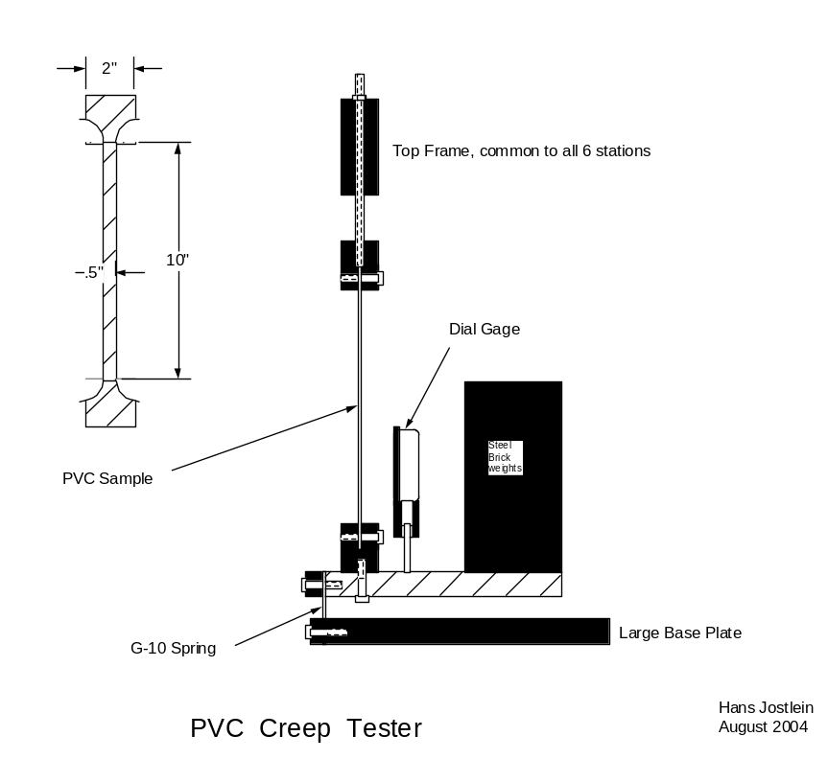

Figure 2. Long term creep apparatus.

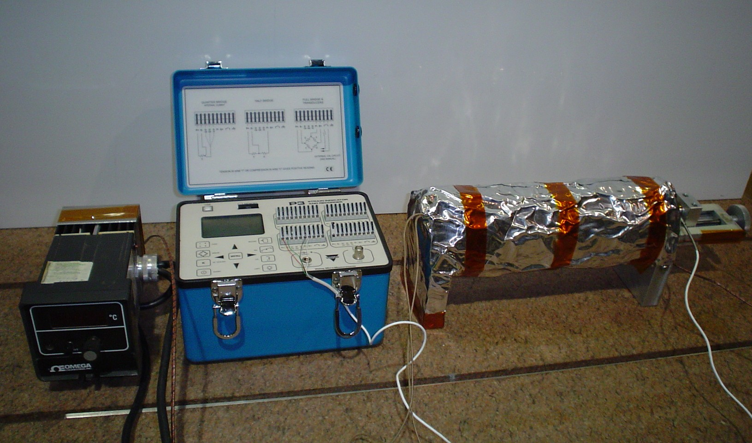

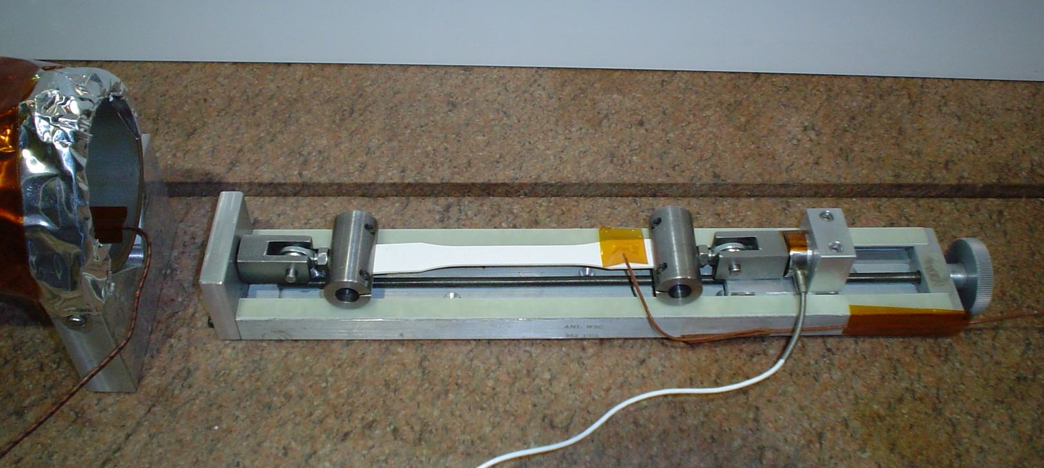
Figure 3. Apparatus for accelerated stress relaxation test at elevated temperature.

2.2.3 Ultimate and Yield stresses

These values are normally important in designs such as from steel where the safety factor is based on these values. For plastic design as mentioned above, creep dominates the design stress. The yield stress and ultimate become less meaningful. Referring to figure 1, the 0.2 % offset yield point is shown. This method is used since a well defined yield point does not exist for PVC.

2.2.4 Impact strength

Polymers can behave in a brittle manner depending on the strain rate and temperature. The NOvA detector does is not exposed to see dynamic, impact, or alternating loads by design. Impact loads are possible from accidental contact such as tool dropping. There is no guidance from industry for an impact design criteria and at this point we have not determined one. Aside from impact, the impact strength tells you something about the fracture characteristics. In a qualitative sense, we desire a material that behaves in a ductile manner and has sufficient fracture toughness.

There are several ways of measuring impact toughness the most common being Izod impact test and drop weight tests. These are simple and quick but only allow relative comparisons. Fracture mechanic tests are available that measure true material properties but these are expensive.

We have included the Izod impact value in table 2 that matches that defined fro PVC pipe. PVC's can take on a value of 1-15 ft-lb/in and so this value is relatively low. We are investigating getting fracture mechanics type tests done on PET-B to help quantify the fracture toughness. the desire is to then relate this to an Izod impact or similar test value to allow comparison between compounds as well as QC measurement.

2.3 Resistance to Liquid Sinctillator
The PVC structure will also be exposed to the liquid scintillator. It is essential that the liquid does not degrade the mechanical properties. Historical tests for the MINOS collaboration that looked to see degradation of liquid scintillator housed in PVC found no evidence. This is a good indication that PVC is not attacked by the liquid scintillator. Nonetheless we are performing tests to confirm this. Preliminary tests of samples exposed between 1 and 30 days to the liquid scintillator reveal no significant material loss. This test has systematic difficulties and so in itself is not conclusive. Similarly, PET-B specimens are currently soaking in liquid scintillator with the plan to perform mechanical tests at various time periods. In particular, impact and tensile properties will be investigated. There is also plans to duplicate the accelerated creep tests while exposed to liquid to see if differences are observed.

- Adhesive Strength
The selection of an adhesive has been dominated by concern about vapor and volatiles as large plane of PVC extrusions 53ft square are bonded together. As a result of these concerns epoxies have been focused on as the adhesive of choice, however, recent concerns about the bond strength of epoxies has led recently to a re-examination of solvent adhseives.

Several adhesives are being considered for the NoVA structure and standard ASTM tests (shear/peel/cleavage) have been performed in order to understand their relative strengths. The initial tests were conducted using specially fabricated fixtures for insuring a consistent glue line thickness and consistency between test samples. The fixtures are shown in the figures below.

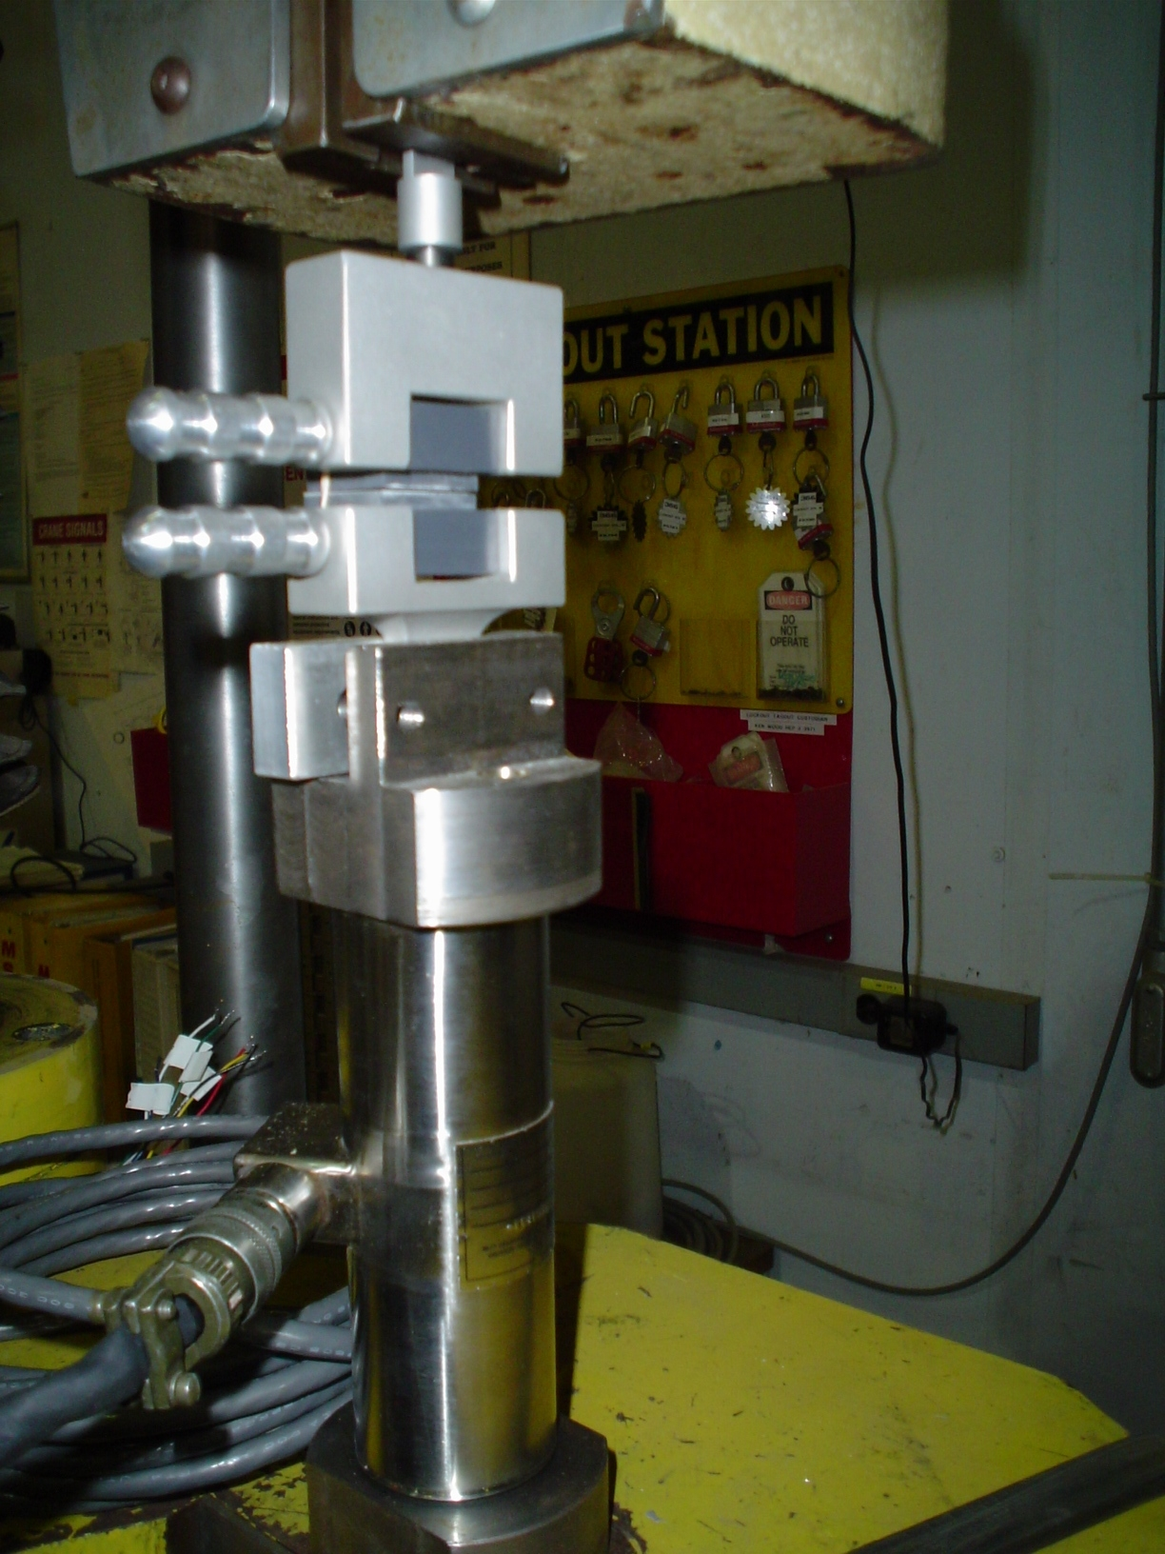
Cleavage Sample in Test Fixture

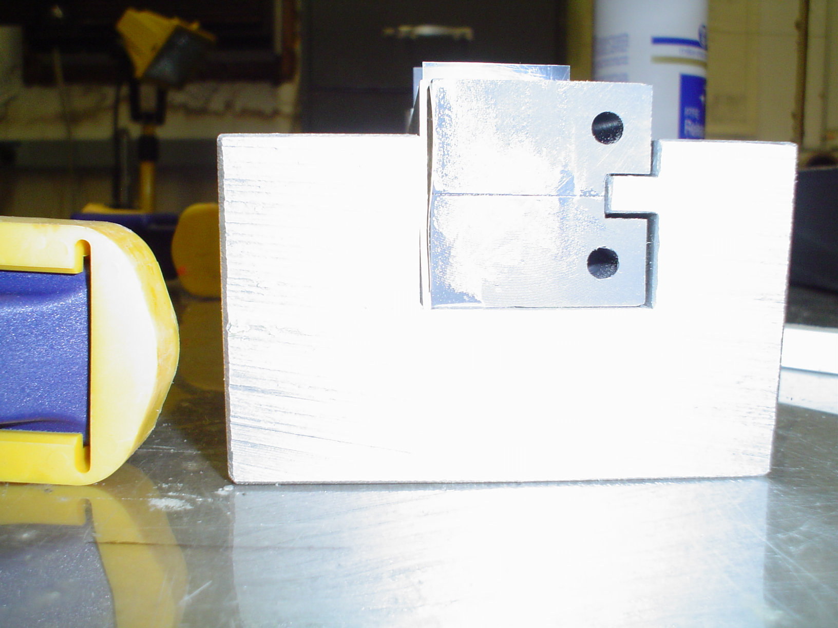
Cleavage Test Sample in Fixture for Gluing

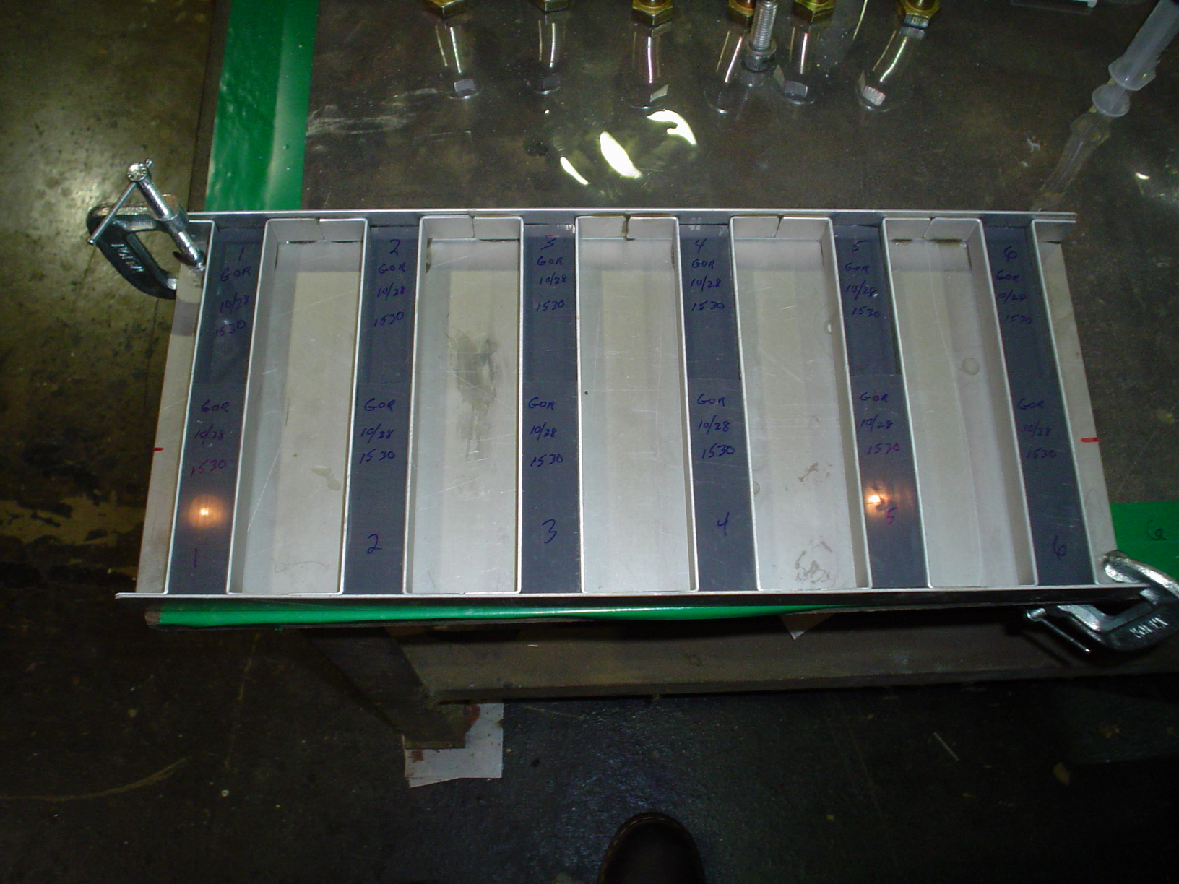
Double Shear Test Samples in Gluing Fixture

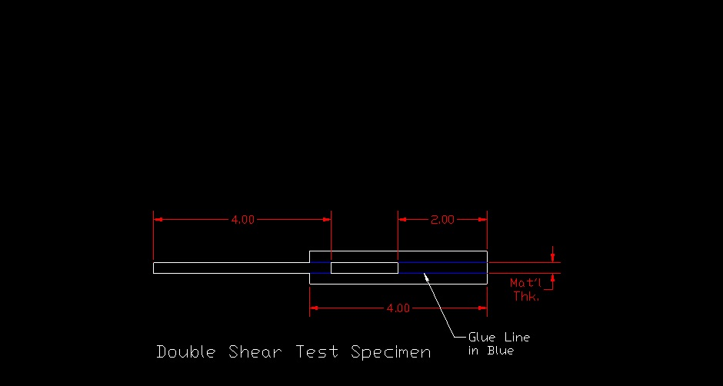

Dimensions of Double Shear Test Specimen

The cleavage and peel test specimen are mainly used for a relative comparison between adhesives. The double shear test though can be directly related to the strength of the bond joint. The initial specimens were fabricated using ¼” thick material and the dimensions shown in the Figure above. The results are shown in the chart below:
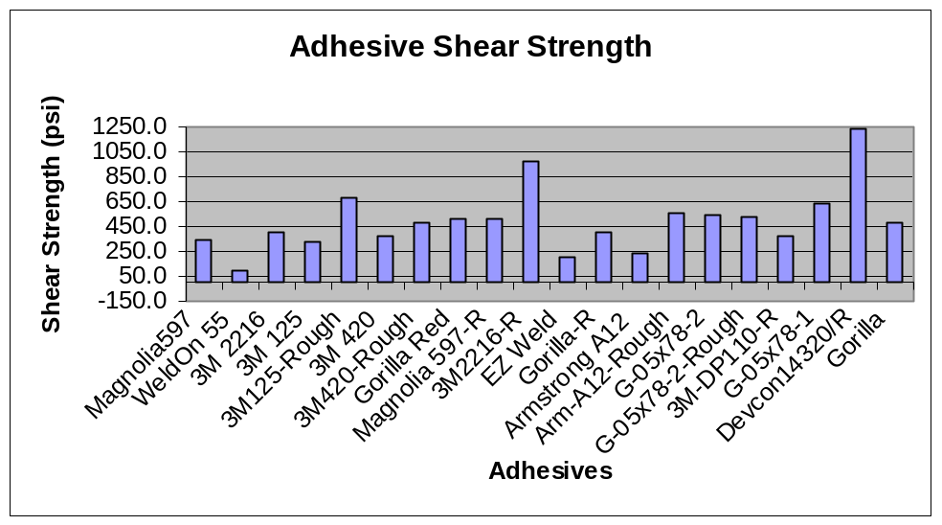

The R designation indicates adhesives that had the mating surfaces roughened using a 60 grit emery paper.

Two adhesives have achieve the shear strength that is needed. The first is 3M 2216 epoxy with the surface roughed up. There is considerable experience with this epoxy within the collaboration because this is the same epoxy that was used during Minos to glue modules (~8m x 1m) together. The ES&H concerns of this epoxy are well understood and it is believed that it is possible to provide the needed ventilation. 3M 2216 is currently the baseline adhesive for the detector. In addition, Devcon Plastic welder has significantly higher shear strength and ductility than 2216, however, there are many concerns about the volatiles that are emitted by this adhesive. The Devcon product is used in industry to bond large surfaces together and the collaboration is currently investigating the ways in which industrial manufacturers have alleviated the ES&H hazards of this product.

Once concern with using 2216 and any other epoxy is that they display significant brittleness. Several test specimens were destroyed after being dropped and the epoxy bond shattering.

- Analysis of Individual PVC extrusions
The structural analysis of the NOvA structure began with an examination of individual PVC extrusions. The pressure at the bottom of the vertical extrusions is 19psi due to the 53ft head of the liquid scintillator. The horizontal extrusions are not subjected to this pressure because they are supported individually by adjacent vertical extrusions and there is no accumulation of weight from the extrusions above.

The geometry of the extrusions and cells has been optimized to minimize the stress within extrusion to approximately 600psi when subjected to the maximum 19psi hydrostatic pressure. The 600 psi stress was chosen based on initial understanding of the PVC creep as described above. Figure 4 shows the basic geometry of the extrusion. The current baseline geometry for the extrusion is to have a 3mm thick outer wall and a 2mm thick inner web for the horizontal modules and a 4.5mm thick outer wall and 3.0mm thick inner web for the vertical extrusions. The difference is wall thickness between vertical and horizontal extrusions is done to minimize adhesive stresses as described below. The scallops shown are needed in order to reduce the stress concentrations in the corner of the cell. Figure 5 below shows the stress distribution within the PVC extrusion under the 19psi internal pressure and Figure 6 shows the expected deflection.

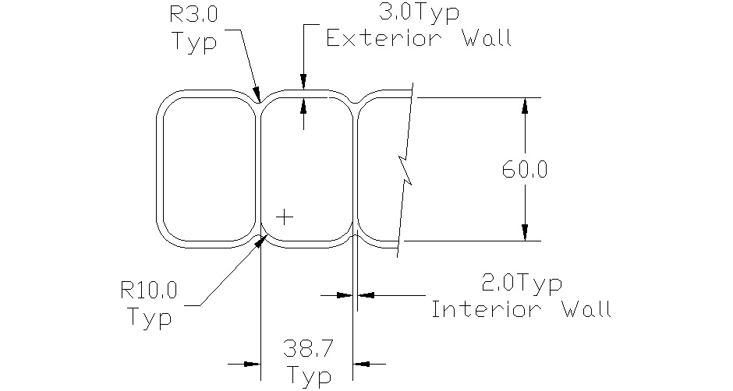
Figure 4
Geometry of Horizontal Extrusion

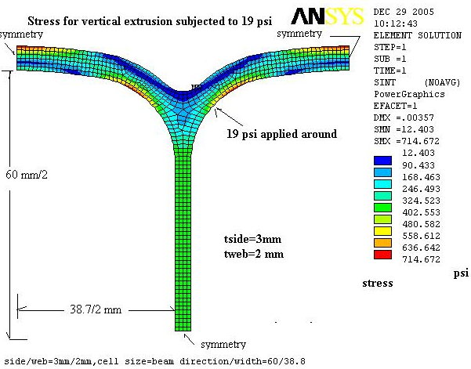

Fig 5
Stress of Vertical extrusion subjected to 19 psi for wall thickness=3/2 mm

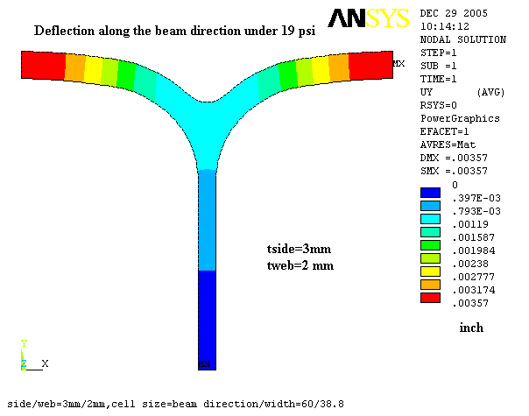

Fig 6
Deflection of Vertical extrusion subjected to 19 psi for wall thickness=3/2 mm

For details of the analysis see Nova Note 0079.

- Modeling & Calculation Details of Adhesive Joints
Optimizing the geometry of the PVC extrusion to withstand the 19psi hydrostatic pressure within the detector is a fairly straightforward analysis. However, once these extrusions are bonded together to form a monolithic structure the challenge of the structural analysis is significantly magnified. The buckling/stress/deflection analyses of the assembled detector that are described in the sections below depend on how the adhesive bond is modeled.

The analysis an adhesive bonded joint is considered to be one of the most challenging tasks. The difficulty is not only on the complex stress state within the adhesive but also due to the complicated geometry being modeled as well as the limitation of computational capacity. Several methods including the average stress method, the maximum stress method and fracture mechanics method has been discussed in great details in reference (1). For the case of a nominal thickness of the adhesive in the PVC structure being around 10 mils (0.25 mm), to model it with 3-D element combined with a large scintillator structure will result in a FEA model of formidable size.

As an alternative, two widely used approaches are considered in this study. One is to extract the nodal force by assuming the interface between the vertical and horizontal plane will move together with a connected node __ merged node. The second approach is to model the adhesive layer as three spring elements as suggested by Tahmasebi ⁽²⁾ and Zhu & Keyward ⁽³⁾ : Two springs are accounted for the in-plane shear stiffness of adhesive and one is for the normal stiffness of adhesive. This can be accomplished by using a spring element (#14) in ANSYS.

The nodal force, in both methods is extracted and divided by its element area to calculate the average shear and normal stress around that location. Finally, by using a Mohr’s circle, a maximum shear stress (principle shear stress) can be obtained as
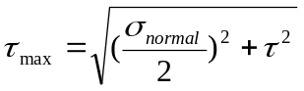
and compared with the average stress data taken from a test coupon with the same geometry and material. It is a similar approach as that described by in reference 1.

As described in detail in Reference 1, the stresses that develop in an adhesive joint is dependent upon the geometry of the joint itself. Standard ASTM tests of double shear peel strength, and cleavage can only provide information on the comparative strength of different adhesive. Physical tests that most closely mimic the actual adhesive joint in service can provide the best correlation with structural analysis and estimate expected performance. Therefore, in order to correlate the stresses determined in the structural analysis to the actual strength of the various adhesives being considered a double shear test was performed using 3mm thick PVC and an adhesive area of 0.776” square which mimics the area modeled in the FEA model.

- Detailed description of FEA model of Assembled Planes
Several finite element models have been developed to understand the PVC structure. An initial FEA model was a simple 2-D model to calculate the stress due to 19 psi hydrostatic pressure for the vertical extrusion as shown in section 4 above. Subsequently, a more complex model has been developed to understand the structure as whole assembly in terms of the stress and its stability. The structure has 15 x 15 m cross section with 1674 layers PVC extrusion as described above. The vertical and horizontal extrusions are alternated by 90 degree. For such geometry, the best approach is to use the shell element (STIF 63 in ANSYS) to efficiently model the structure. It has similar characteristic of the beam element. To reduce the size of the problem and to accommodate the computer limitations as well as the computational time, only a “slice of the structure” in the mid of the structure is modeled with a symmetry boundary condition imposed on the both side to reflect other portion of the structure. The mesh size of shell element is around 0.5”~0.7” for the structure with its full height being ~600”. The model is approximately 260,000 nodes (6 degree of freedom_DOF per node) with total 1.5 million DOF for a 31 planes block without counting the spring elements used for the adhesive layers. The boundary condition is considered to be a free for the top and fixed for the bottom as a worst case. The hydrostatic load of 19 psi is applied linearly along the vertical extrusion and zero pressure for the horizontal extrusion. The density of PVC has been modified to reflect the weight of the liquid. This baseline model as well as its boundary condition has been modified many times to study the structure implications under the different scenarios as described more details in the references.

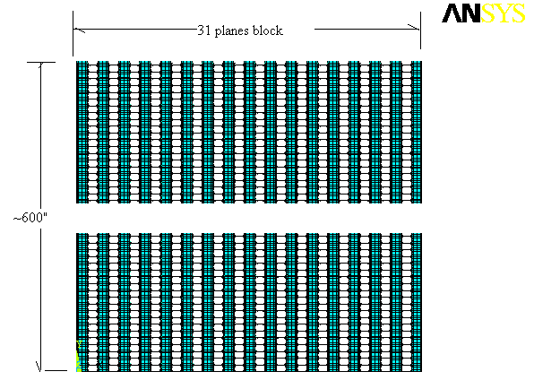

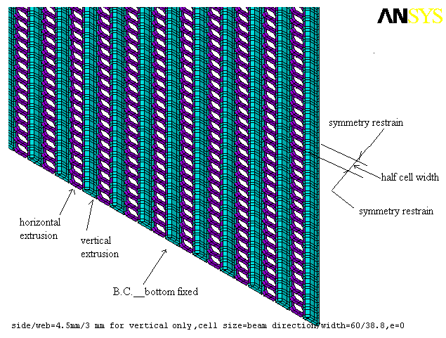
Fig 7 A FEA model with the shell element

- Buckling Analysis of Assembled PVC extrusions
A buckling analysis was done on the 31 plane block for four different conditions: the block empty and unguided at the top; the block empty and guided at the top; the block filled and unguided at the top; the block filled and guided at the top.

Buckling SF for a 31 planes

Case | Filled  Top free  bottom fixed | Unfilled  Top free  Bottom fixed | Filled  Top guided  Bottom fixed | Unfilled  Top guided  Bottom fixed
SF | 5 | 20 | 6.17 | 24.6

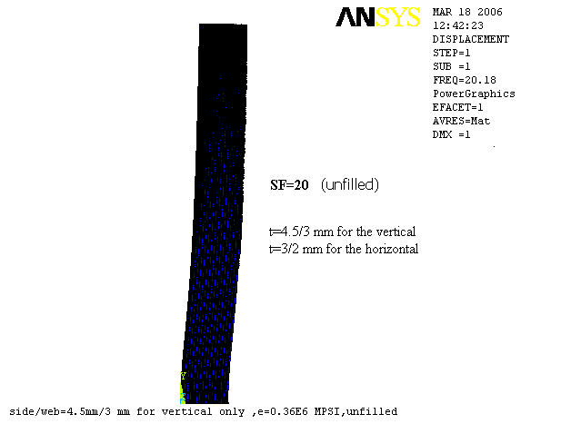

Figure 3a - Top free and bottom fixed __unfilled

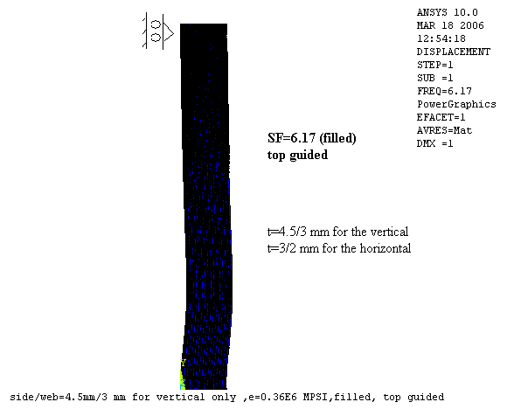

Figure 3b - Top guided and bottom fixed __ filled

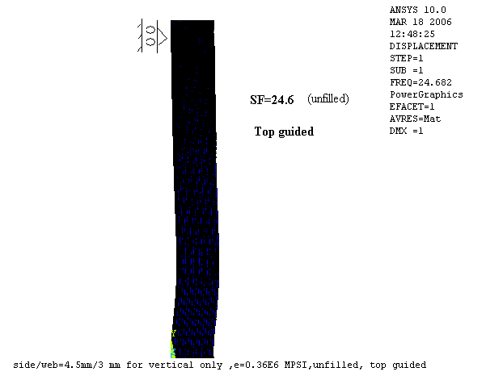
Figure 3c - Top guided and bottom fixed __ unfilled

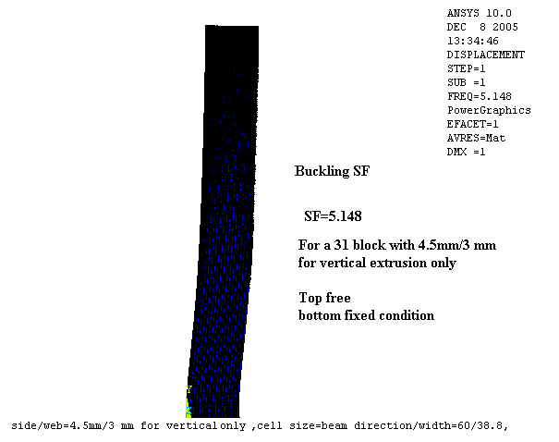
Fig 3d - Buckling SF for 31 block with 4.5mm/3mm for vertical extrusion only

- Stress/Deflection Analysis of Assembled PVC Extrusions.
The stresses and deflections of the planes once they are assembled together were examined. A series of analysis were done over the last year which showed that as the number of planes increased the swelling at the bottom of the detector, due to the internal pressure, increased which in turn increased the stresses in the PVC. In order to keep the stresses to within a range that it was felt was acceptable for creep the number of planes within a block was restricted to 31. The stresses in the PVC could be further reduced by reducing the number of planes within a block, however, below 31 planes the buckling stability falls below the target safety factor of 5.

The figures below show the stresses and deflections within a 31 plane block

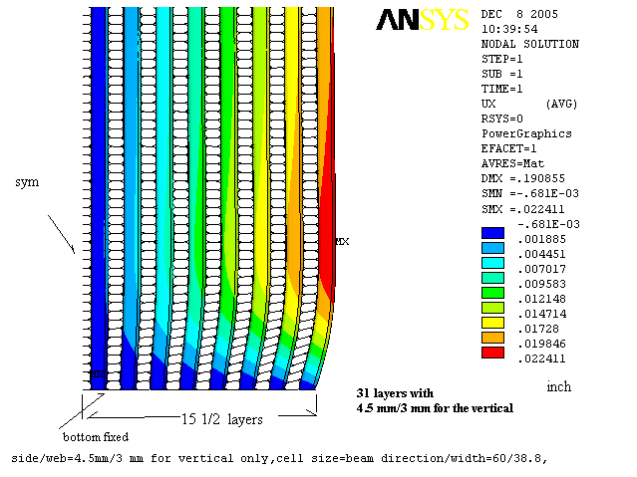

Fig 10 Deflection along the beam direction (4.5mm/3mm for vertical only)

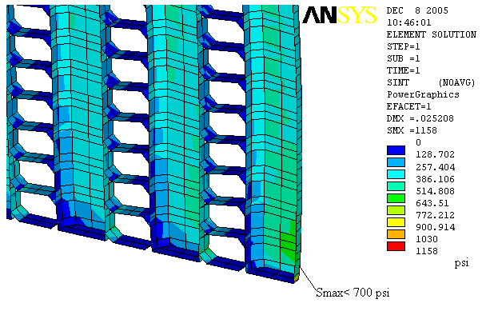

Fig 11 Stress near the bottom (4.5mm/3mm for vertical only)

- Adhesive Stresses
The adhesive stresses were also examined in order to understand the strength requirement for the adhesive. The initial analysis examined 32 planes filled with scintillator. Figures 12 and 13 below show the distribution of the adhesive stresses from the bottom to the top of the detector and Figure 14 shows the location of the shear stresses in the FEA model. The maximum adhesive shear stresses occur at the bottom of the detector and are approximately 165psi but then taper off to approximately 140psi throughout the remainder of the plane.

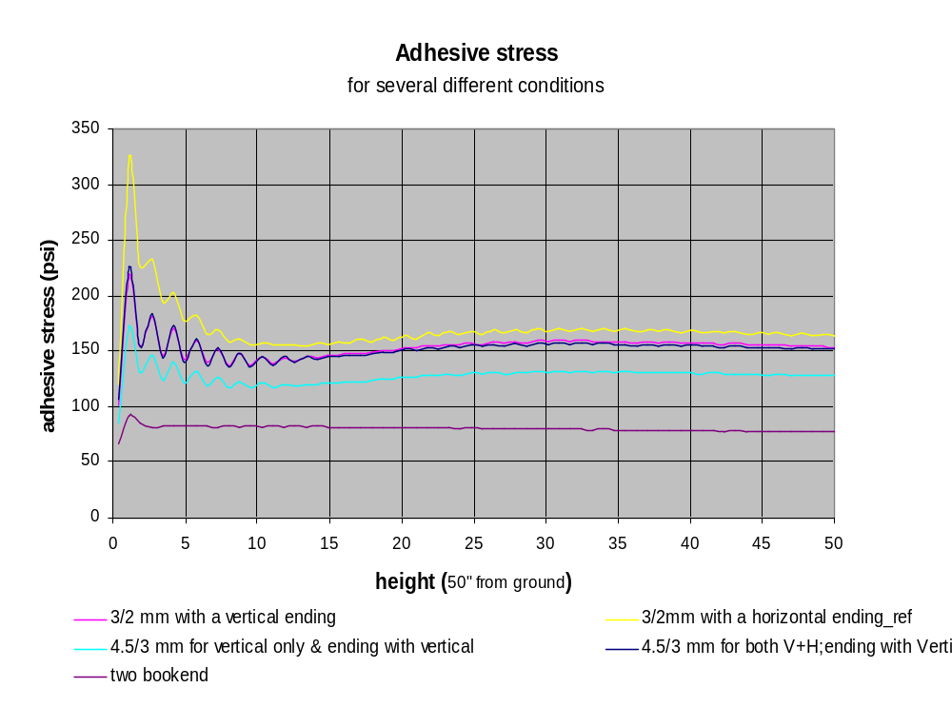
Fig 12 Adhesive stress for several conditions

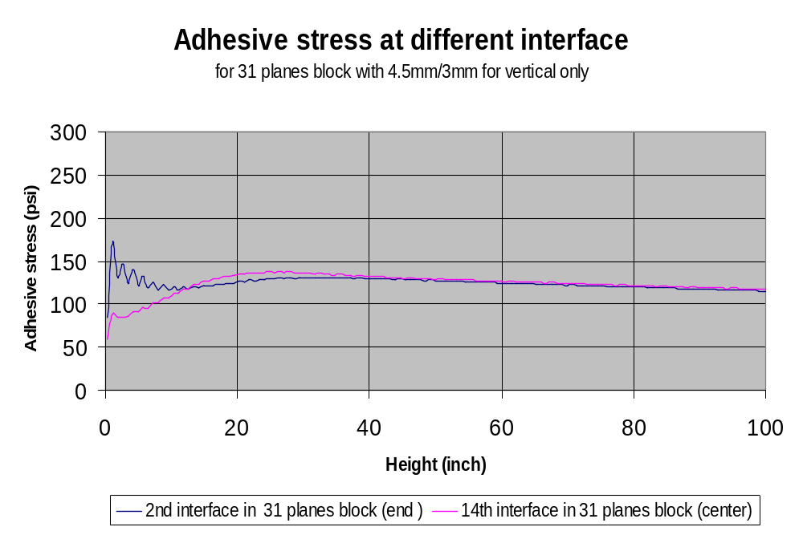

Fig 13 Shear stress at different interface for 31 planes block with
(4.5 mm/3mm for vertical only)

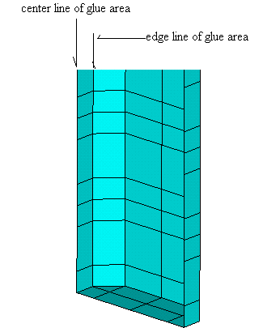

Figure 14
Location of Shear Stresses shown in Figure 12-13

An examination of the adhesive stresses has shown that there are three components contributing to them. The first component is very small and is due to the weight of the horizontal extrusions being transferred to the horizontal extrusions. The second component is due to the stress from the PVC deformation due to swelling. The third component is due to the differential strain between the vertical and horizontal extrusions from the weight of the extrusions and scintillator.

Since the maximum adhesive stresses occur at the bottom of the detector an analysis was performed to simulate failure of the adhesive on the bottom two horizontal extrusions. In the case where the bottom two horizontal extrusions have no adhesion to the vertical extrusions the buckling safety factor drops to approximately 1.5 from 5.1 when there is a full bond. If only the very bottom horizontal extrusion is not bonded the buckling safety factor drops to 4.0. The PVC stresses increase slightly too approximately 900psi and the adhesive stresses throughout the detector remain virtually unchanged. See DocDB-400 for additional details.

- Recommendations/Conclusions
The following conclusions and recommendations have been drawn from the work that has been done so far.

PVC Stress
The final PVC composition must be selected and extensive testing done in order to determine the creep modulus that can be used in buckling calculations and to determine an acceptable level of stress for the design. The PVC stress in the loading conditions examined so far is no greater than 700 psi which was the target of the design based on an initial survey of the literature on PVC. However, further testing is needed to show that this is adequate and if creep will be a long term problem for the experiment.

Adhesive Stresses and Bonding
The current calculations show average adhesive stresses at the bottom of the detector in the range of 125-165psi. To achieve a safety factor of 5.0 adhesive bond strength of approximately 750psi is needed. So far testing has shown found only one adhesive that meets this criterion, 3M 2216. The required strength was achieved using 3M 2216 by roughing up the surface of the PVC. Also, all of the calculations to date have been based on 100% adhesive coverage of the PVC surface and further calculations and testing is needed to understand the maximum stresses that occur if less than 100% coverage is achieved. Finally, the 3M epoxy has shown problems with brittleness, test samples that were inadvertently dropped broke on impact. It is unclear what the brittleness of the epoxy will mean for the long term strength of the detector but this must be evaluated. A more promising adhesive has been found, Devcon Plastic Welder, but this adhesive poses a number of ES&H risks that need to be addressed in the near future in order to determine whether it is practical to use.

Reference:
- Engineered Materials Handbook – Adhesives and Sealants Volume 3, ASM International
- F Tahmsebi, PhD, “Finite Element Modeling of an Adhesive in a Bonded joint”, FEMCI, NASA Goddard Space Flight Center, July,1999
- Y Zhu & K Kedward, “ Method of Analysis and Failure Predictions for Adhesively Bonded Joints of Uniform and Variable Bond line thickness”, DOT/FAA/AR-05/12, Final Report, May, 2005

