ENERGY CONVERSION DEVICES, INC.

QUARTERLY TECHNICAL STATUS REPORT

September 15 2004 - December 15 2004

Subcontract Title: Development of Optically Enhanced Back Reflectors and Improved Deposition Processes for Amorphous Silicon-Based Photovoltaic Technologies
Subcontract Number: ZDJ-2-30630-22
Technical Monitor: Bolko von Roedern
Contributors: Scott J. Jones (Principal Investigator), Joe Doehler, Masat Izu, Tongyu Liu, David Tsu, Jeff Steele and Rey Capangpangan

Program Goals

In this program, we plan to improve the module efficiencies through development of a new optically enhanced Al/ZnO back reflector and improved i-layer deposition process. In the case of the back reflector development, a multi-layered thin film structure consisting of films with contrasting indices of refraction placed between the Al and ZnO layers of the back reflector will be developed. These new types of back reflectors will be tested in amorphous silicon based single junction and multi-junction devices. The differences in n of the different layers of the multi-layered back reflector and electrical conduction through the multi-layered structure will be optimized to obtain the highest reflection values, highest currents and best cell performance. The ultimate goal is to achieve the high currents and cell efficiencies typically obtained with the Ag/ZnO back reflector with a new optically enhanced back reflector that can be used in the solar module products. For the multi-layered structure, focus will be on preparing the layers using sputtering techniques so that this technology might be quickly applied to ECD’s present back reflector fabrication process that uses sputtering techniques.
In the case of the i-layer, the focus will be on preparing microcrystalline silicon based intrinsic layers for low cost, high stable efficiency solar cells through the use of microwave plasmas. In these studies, the effects of such deposition conditions as ion bombardment, substrate temperature and etchant gases on the grain size and film transparency will be studied and correlated with cell performance.
Achievement of the goals of this program and application of these advancements to ECD’s joint venture company’s production lines would lead to an immediate improvement in module efficiencies. These advances along with ECD’s participation in the NREL a-Si teams with other development programs will contribute to the ultimate goal of achieving stable efficiencies of 15% using a low-cost, scalable, manufacturable techniques and inexpensive substrates.

This Quarter’s Results
We are currently working on Al/Multi-layer (ML)/ZnO structure where ML is ZnO/ZnOSi/Si/ZnOSi where the ZnOSi is the low index of refraction layer and Si is the high index of refraction layer. In our last report, we showed the increased solar cell performance obtained when the ML structure was added to back reflectors using flat specular back reflector surfaces. This month, we have further optimized the multi-layer structure to increase the performance of the non-textured back reflector with the increases in red light (λ>630nm) performance with the improvements in P_{max} for single-junction a-SiGe cells shown in Table I. Focusing on the data beyond λ=630nm was done because the back reflector properties affect the solar cell performance only in this wavelength region. With i-layers having similar thicknesses, use of the new multi-layer deposition conditions has led to red light P_{max} values of 2.8 mW/cm² as compared with 2.2 mW/cm2 values for the cells with Al/ZnO back reflectors having no ML structure.

Table I. IV data for a-SiGe cells made with Al(specular)/ML/ZnO back reflectors.
IV data taken using 630nm filter.
Date | Voc  (V) | Jsc (mA/cm²) | FF | Rs  (ohm cm) | Pmax  (mW/cm²)
Al/ZnO | 0.564 | 7.05 | 0.563 | 17.8 | 2.24
Al/ML/ZnO  9/04 | 0.561 | 8.28 | 0.556 | 17.9 | 2.58
Al/ML/ZnO  12/04 | 0.576 | 8.75 | 0.558 | 15.6 | 2.81

To demonstrate the correlation of increased reflection with improved solar cell performance, we have made Al/ML/ZnO structures with ML made with different recipes. Again to eliminate the possibility of different degrees of texturing affecting the reflectance, the Al layers were deposited at room temperature leading to a surface that is close to specular. The data in Figure 1 demonstrates that for the Al(specular)/ML/ZnO structures made under conditions A, the reflectance values in the red portion of the light spectrum (600-1000nm) are close to those obtained with the Al/MgF₂/Si/MgF₂ optical stacks that we have previously shown are similar to Ag/ZnO back reflectors. The Al(specular)/ML/ZnO structure (Recipe B) was made under different Si deposition conditions which led to lower reflectance values in the 600-1000nm region.
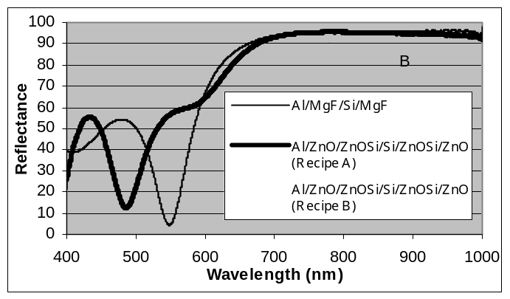
Figure 1. Reflectance data for different type of back reflectors.

Quantum Efficiency Data for cells made with the Al(specular)/ML/ZnO back reflectors with recipes A and B are shown in Figure 2. The reader is reminded that these back reflectors do not have textured surfaces so the currents are lower than typically observed for high efficiency a-SiGe cells. In the figure, one can see that the Recipe A conditions which leads to higher reflectivity values in the 600-1000 nm range also leads to increased red response for the solar cells with the integrated quantum efficiency beyond 600nm leading to an 8.75 mA/cm² red current for cells with the Recipe A back reflector while the cell with Recipe B conditions has a red current of 7.10 mA/cm².
In Table II, the solar cell properties for devices made with the Recipe A and B back reflectors (Al/ML/ZnO) are compared with those for a solar cell with an Al(specular)/ZnO. Other than J_{sc}, the properties were obtained by IV measurements using AM1.5 light filtered with a 630nm cuton filter. J_{sc} values were obtained through integration of quantum efficiency data greater than λ=630nm. The data for the cell made with the Al(specular)/ZnO back reflector are similar to those for the device with the Al(specular)/ML/ZnO structure made with Recipe B which had the lower reflectivity properties. In contrast, the cell with the Al(specular)/ML/ZnO structure made under Recipe A having the better reflectivity values has better overall solar cell performance due to higher solar cell currents. These results demonstrate the potential advantages of using the Al(specular)/ML/ZnO back reflector structure with the proper recipes and layer thicknesses to improve solar cell performance.

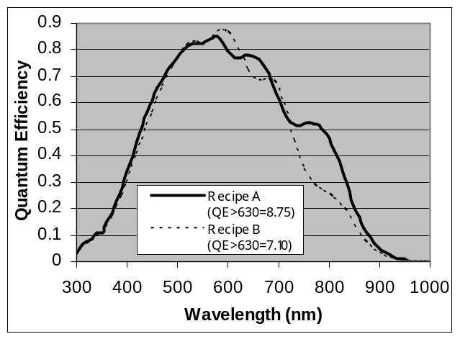
Figure 2. Quantum Efficiency data for a-SiGe cells made with Al(specular)/ZnO/ZnOSi/Si/ZnOSi/ZnO back reflectors with Recipes A and B.

Table II.
IV data for a-SiGe cells with specular back reflectors.IV data taken using 630nm filter.
Back Reflector | Voc  (V) | Jsc  (mA/cm²) | FF | Rs  (Ω cm²) | Pmax  (mW/cm²)
Al/ML/ZnO (Recipe A) | 0.576 | 8.75 | 0.558 | 15.6 | 2.81
Al/ML/ZnO (Recipe B) | 0.572 | 7.10 | 0.562 | 18.0 | 2.28

To achieve high efficiency performance, it is well known that the back reflector structure must have a textured scattering interface/surface to achieve enhanced cell currents through increased light passes through the intrinsic layers. Addition of the ZnOSi/Si/ZnOSi structure alone will not lead to high performance cells and thus the high reflective properties with this new optically enhanced multi-layer back reflector must be achieved along with a textured back reflector surface to achieve high solar cell efficiencies.
In contrast to the solar cell with specular surface back reflectors, smaller improvements in bottom cell performance have been achieved thus far in the program with the Al/ML/ZnO back reflector structure. Table III compares IV data for a-SiGe cells with Al/ZnO and Al/ML/ZnO textured back reflectors. These back reflectors have been textured by increasing the top ZnO thickness. Again the IV measurements were made using AM1.5 light filtered using a 630nm cuton filter. Theses cells were chosen because they have the best overall performance for the type of back reflector used. The cell with the Al/ZnO back reflector has lower V_{oc} and FF likely due to slightly higher Ge contents in the intrinsic layer. Thus there may be an improvement in the J_{sc} with the Al/ML/ZnO back reflector however it is masked by lower Ge contents in the intrinsic layer of the solar cell. However, the overall P_{max} value is higher for the Al/ML/ZnO back reflector showing there is some improvement with this new type of back reflector structure.
Considering the data for the specular back reflectors (See Table I), higher improvements might be expected for the cells with the Al/ML/ZnO back reflectors that are textured. However, we have started making these textured back reflectors and further optimization should lead to more significant increases with the use of the ML structure.

Table III.
IV data for a-SiGe cells with textured back reflectors.IV data taken using 630nm filter.
Back Reflector | Voc  (V) | Jsc  (mA/cm²) | FF | Rs  (Ω cm²) | Pmax  (mW/cm²)
Al/ZnO | 0.593 | 10.5 | 0.556 | 14.3 | 3.43
Al/ML/ZnO  Recipe A | 0.605 | 10.4 | 0.585 | 12.5 | 3.66

There are a few potential reasons why the improvement in device performance is not as large when the back reflector is textured. To create a textured back reflector, both the use of a thick top ZnO as well as use of high substrate temperatures during Al growth to texture the Al surface prior to ZnO growth have been used. In these studies, it was thought that minimizing the surface roughness at the interfaces of the ZnOSi/Si/ZnOSi optical stack might be important to achieve high reflectivity. Thus, thick ZnO have initially been used to achieve the textured scattering surface for the back reflector. Texturing the Al surface with high temperature growth will likely lead to a different type of textured surface which might not affect the reflectivity of the multi-layer stack and lead to higher performance module.
With the addition of the textured surface (either with the thick ZnO or the textured Al), layer thicknesses in the multi-layer stack might need to be re-optimized to achieve high solar cell efficiencies. Little of this work has yet to be done in these studies.
Also a different scattering scheme which does not involve the formation of rough interfaces might need to be developed to achieve high efficiency solar cells with the Al/ML/ZnO back reflector. Adding a porous TCO layer or altering the present layers to have low density regions or voids that would act as scattering sources might need to be done. The low density regions/voids would have to have sizes on the order of 600-1000nm. Developing materials with these size scatterers that would be conductive enough to achieve low solar cell series resistances and maintain these properties during all of the solar cell fabrication steps might be a difficult task. Thus focus in future studies will be on the testing of textured Al surfaces and re-optimization of the Al/ML/ZnO stacks.

