  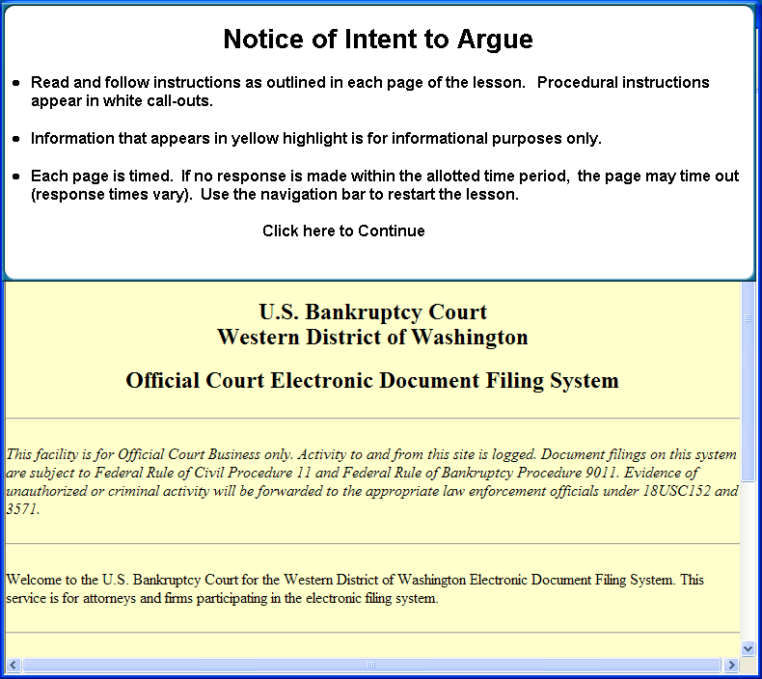
  Slide 1
  Read and follow instructions as outlined in each page of the lesson. Procedural instructions appear in white call-outs. Information that appears in the header is for informational purposes only. Each page is timed. If no response is made within the allotted time period, the page may time out (response times vary). Use the navigation bar to restart the lesson
  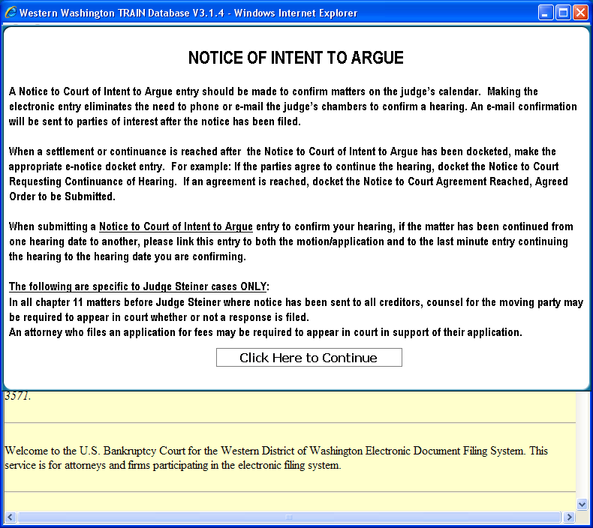
  Slide 2.
  NOTICE OF INTENT TO ARGUE. A Notice to Court of Intent to Argue entry should be made to confirm matters on the judge’s calendar. Making the electronic entry eliminates the need to phone or e-mail the judge’s chambers to confirm a hearing. An e-mail confirmation will be sent to parties of interest after the notice has been filed. When a settlement or continuance is reached after the Notice to Court of Intent to Argue has been docketed, make the appropriate e-notice docket entry. For example: If the parties agree to continue the hearing, docket the Notice to Court Requesting Continuance of Hearing.
  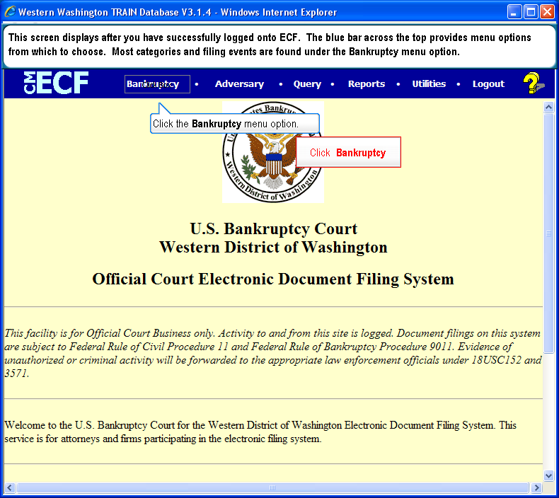
  Slide 3
  Text Captions: Click Bankruptcy
  This screen displays after you have successfully logged onto ECF. The blue bar across the top provides menu options from which to choose. Most categories and filing events are found under the Bankruptcy menu option.
  Click the Bankruptcy menu option.
  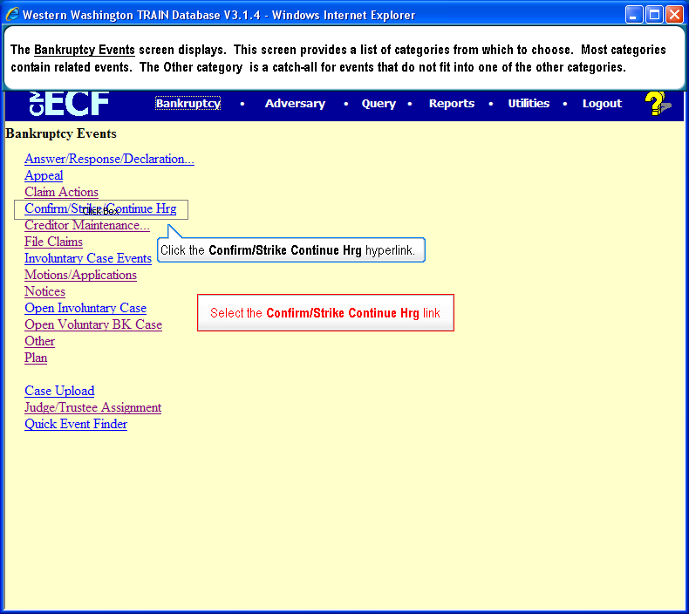
  Slide 4
  Text Captions: Select the Confirm/Strike Continue Hrg link
  The Bankruptcy Events screen displays. This screen provides a list of categories from which to choose. Most categories contain related events. The Other category is a catch-all for events that do not fit into one of the other categories.
  Click the Confirm/Strike Continue Hrg hyperlink.

  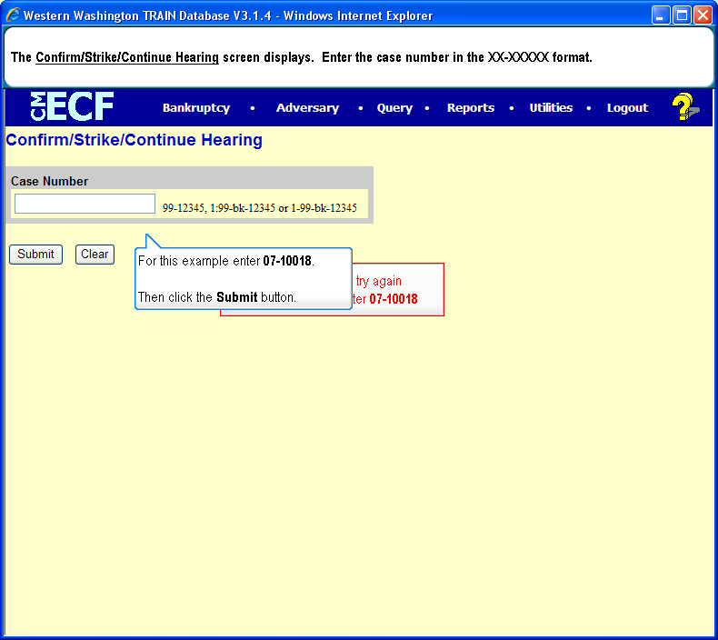
  Slide 5
  For this example enter 07-10018
  The Confirm/Strike/Continue Hearing screen displays. Enter the case number in the XX-XXXXX format.
  For this example enter 07-10018.
  Then click the Submit button.
  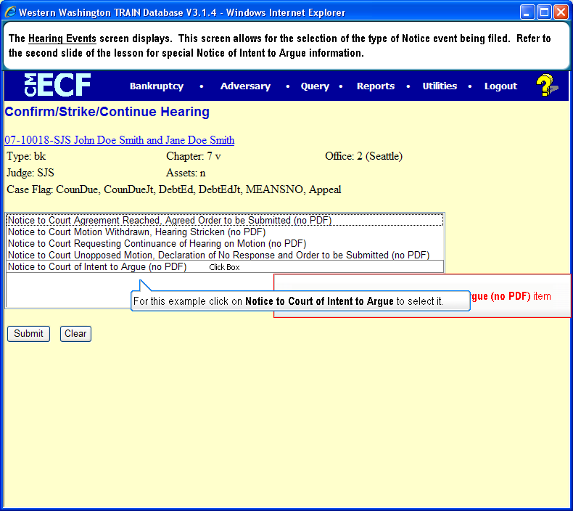
  Slide 6
  Text Captions: Select the Notice to Court of Intent to Argue (no PDF) item
  The Hearing Events screen displays. This screen allows for the selection of the type of Notice event being filed. Refer to the second slide of the lesson for special Notice of Intent to Argue information.
  For this example click on Notice to Court of Intent to Argue to select it.
  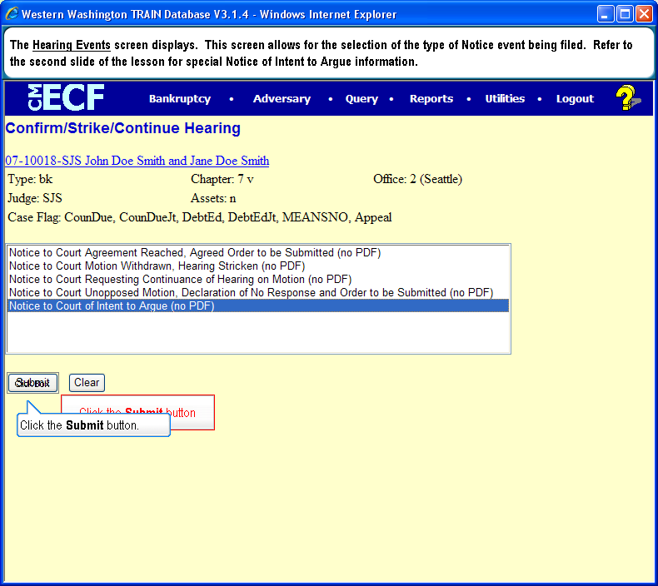
  Slide 7
  Text Captions: Click the Submit button
  The Hearing Events screen displays. This screen allows for the selection of the type of Notice event being filed. Refer to the second slide of the lesson for special Notice of Intent to Argue information.
  Click the Submit button.
  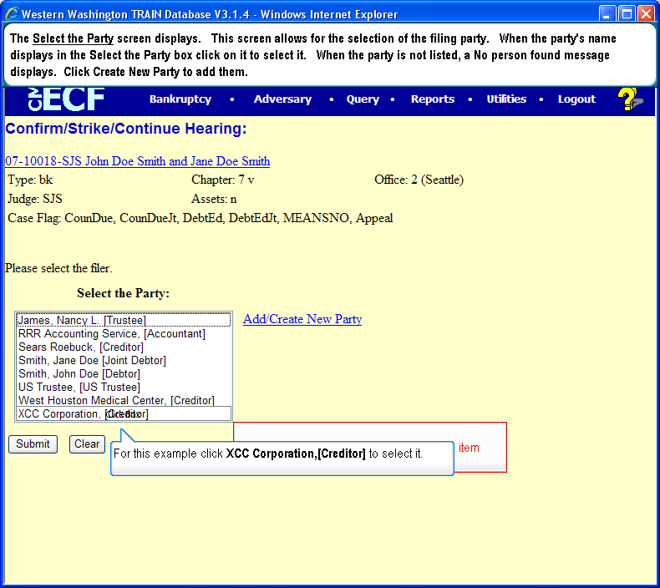
  Slide 8
  Text Captions: Select the XCC Corporation, [Creditor] item
  The Select the Party screen displays. This screen allows for the selection of the filing party. When the party's name displays in the Select the Party box click on it to select it. When the party is not listed, a No person found message displays. Click Create New Party to add them.
  For this example click XCC Corporation,[Creditor] to select it.

  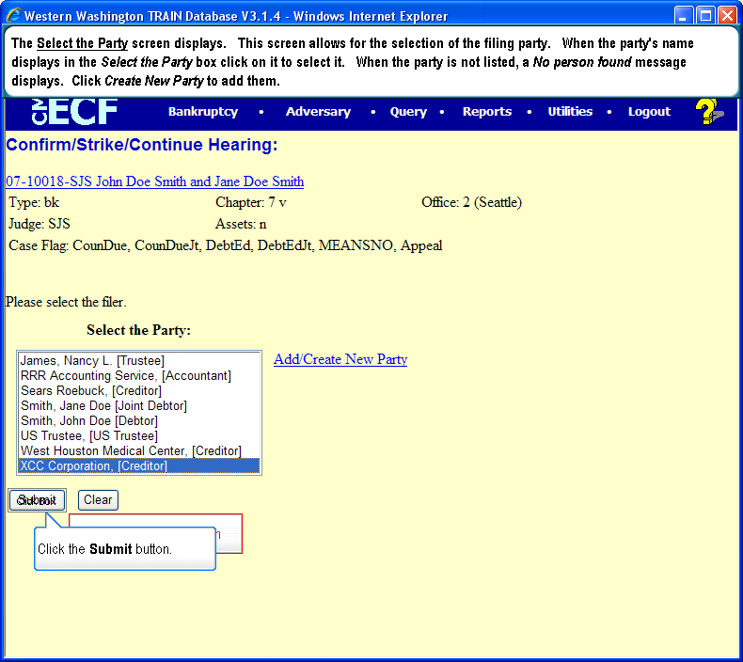
  Slide 9
  Text Captions: Click the Submit button
  The Select the Party screen displays. This screen allows for the selection of the filing party. When the party's name displays in the Select the Party box click on it to select it. When the party is not listed, a No person found message displays. Click Create New Party to add them.
  Click the Submit button.
  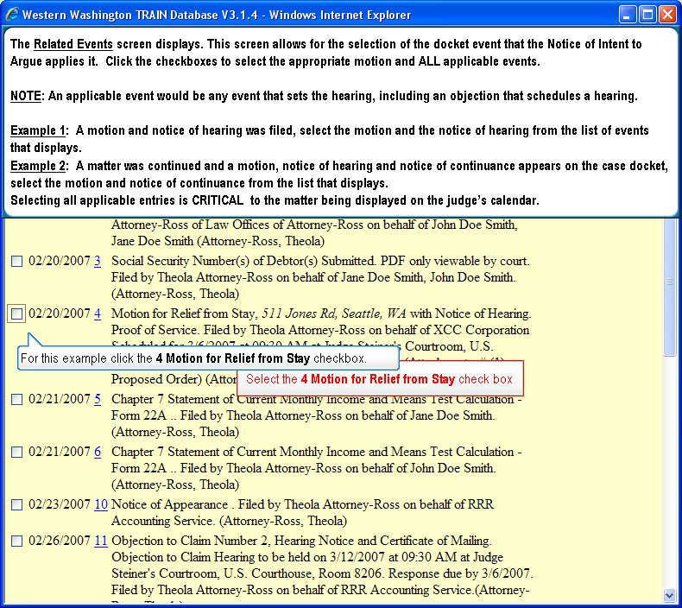
  Slide 10.
  Select the 4 Motion for Relief from Stay check box. The Related Events screen displays. This screen allows for the selection of the docket event that the Notice of Intent to Argue applies it. Click the checkboxes to select the appropriate motion and ALL applicable events. NOTE: An applicable event would be any event that sets the hearing, including an objection that schedules a hearing. Example 1: A motion and notice of hearing was filed, select the motion and the notice of hearing from the list of events that displays. Example 2: A matter was continued and a motion, notice of hearing and notice of continuance appears on the case docket, select the motion and notice of continuance from the list that displays. Selecting all applicable entries is CRITICAL to the matter being displayed on the judge’s calendar. For this example click the 4 Motion for Relief from Stay checkbox.
  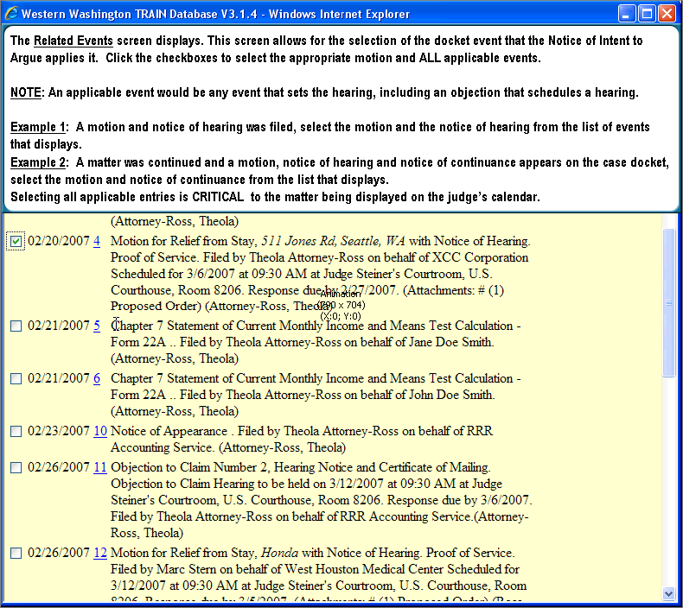
  Slide 11
  Text Captions: The Related Events screen displays. This screen allows for the selection of the docket event that the Notice of Intent to Argue applies it. Click the checkboxes to select the appropriate motion and ALL applicable events. NOTE: An applicable event would be any event that sets the hearing, including an objection that schedules a hearing. Example 1: A motion and notice of hearing was filed, select the motion and the notice of hearing from the list of events that displays. Example 2: A matter was continued and a motion, notice of hearing and notice of continuance appears on the case docket, select the motion and notice of continuance from the list that displays. Selecting all applicable entries is CRITICAL to the matter being displayed on the judge’s calendar.
  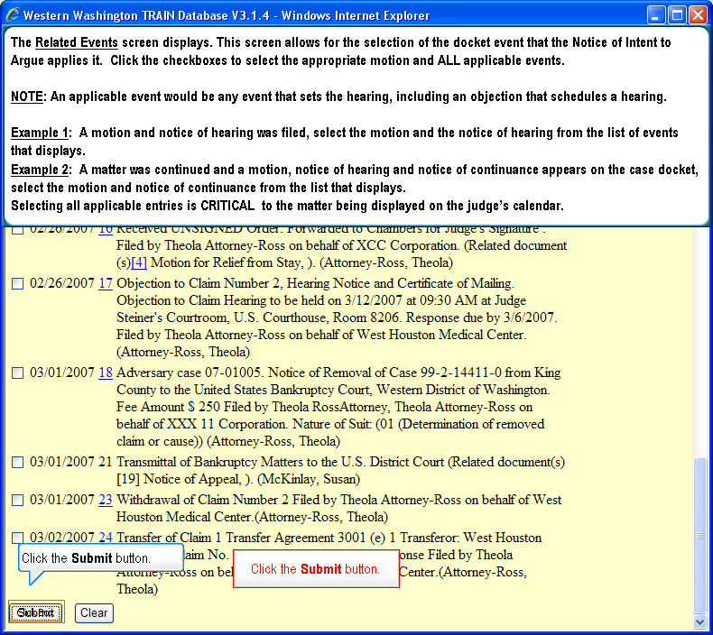
  Slide 12
  Text Captions: Click the Submit button. The Related Events screen displays. This screen allows for the selection of the docket event that the Notice of Intent to Argue applies it. Click the checkboxes to select the appropriate motion and ALL applicable events. NOTE: An applicable event would be any event that sets the hearing, including an objection that schedules a hearing. Example 1: A motion and notice of hearing was filed, select the motion and the notice of hearing from the list of events that displays. Example 2: A matter was continued and a motion, notice of hearing and notice of continuance appears on the case docket, select the motion and notice of continuance from the list that displays. Selecting all applicable entries is CRITICAL to the matter being displayed on the judge’s calendar.

  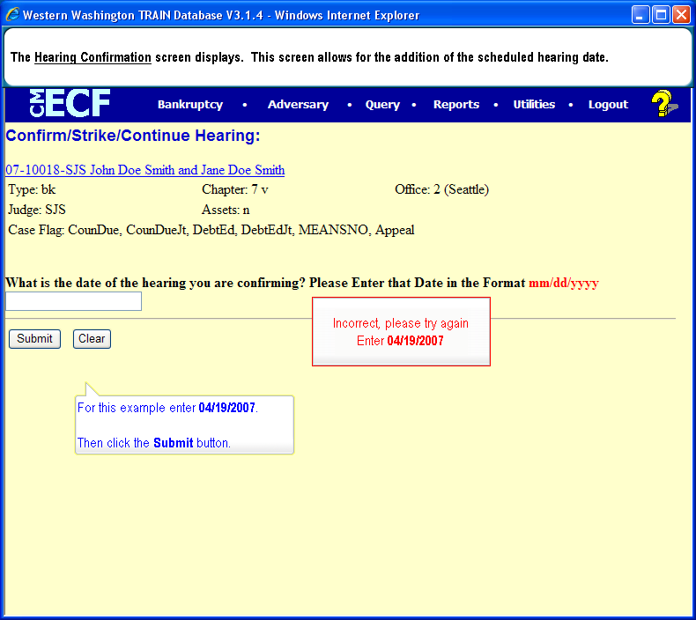
  Slide 13
  Enter 04/19/2007
  The Hearing Confirmation screen displays. This screen allows for the addition of the scheduled hearing date.
  For this example enter 04/19/2007.
  Then click the Submit button.
  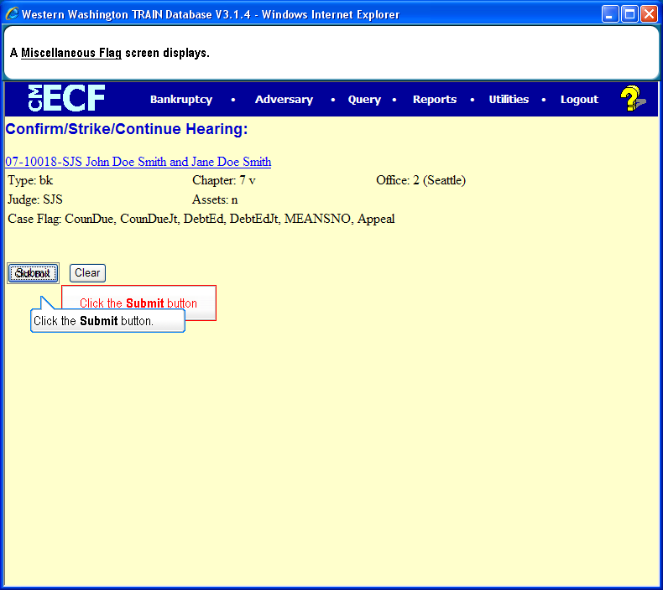
  Slide 14
  Text Captions: Click the Submit button
  A Miscellaneous Flag screen displays.
  Click the Submit button.
  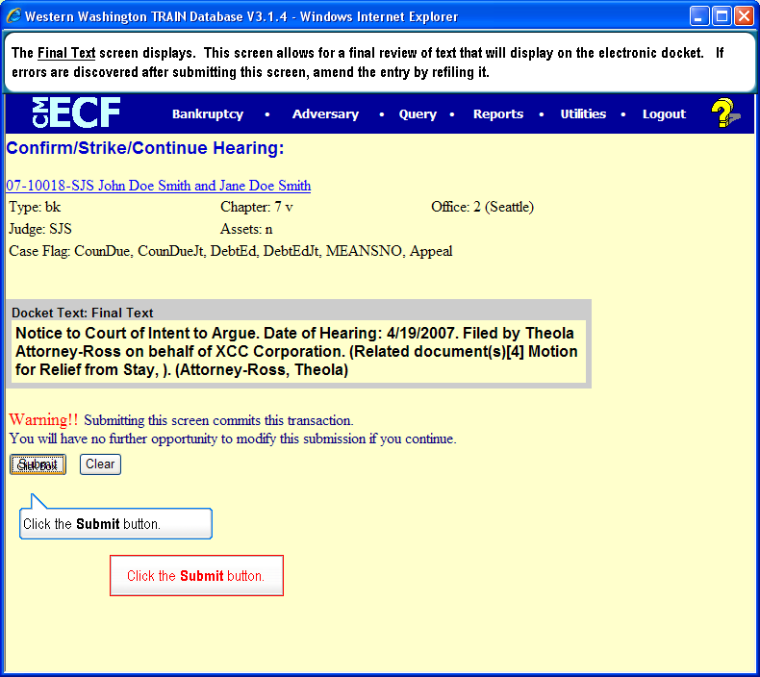
  Slide 15
  Text Captions: Click the Submit button.
  Click the Submit button.
  The Final Text screen displays. This screen allows for a final review of text that will display on the electronic docket. If errors are discovered after submitting this screen, amend the entry by re-filing it.
  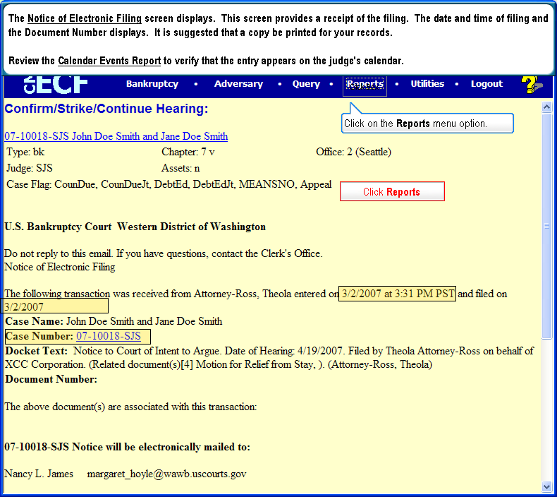
  Slide 16
  Text Captions: Click Reports
  Click on the Reports menu option.
  The Notice of Electronic Filing screen displays. This screen provides a receipt of the filing. The date and time of filing and the Document Number displays. It is suggested that a copy be printed for your records.
  Review the Calendar Events Report to verify that the entry appears on the judge's calendar.

  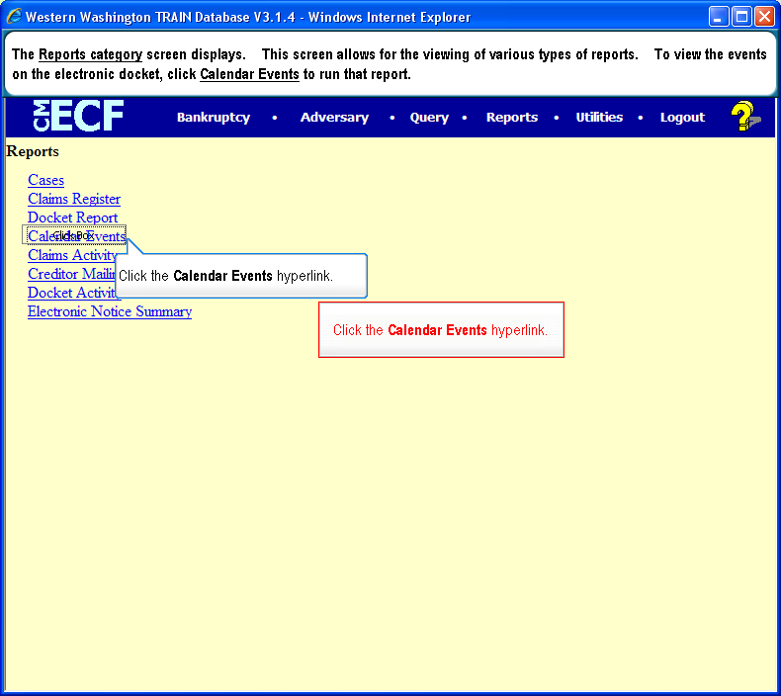
  Slide 17
  Text Captions: The Reports category screen displays. This screen allows for the viewing of various types of reports. To view the events on the electronic docket, click Calendar Events to run that report.
  Click the Calendar Events hyperlink.
  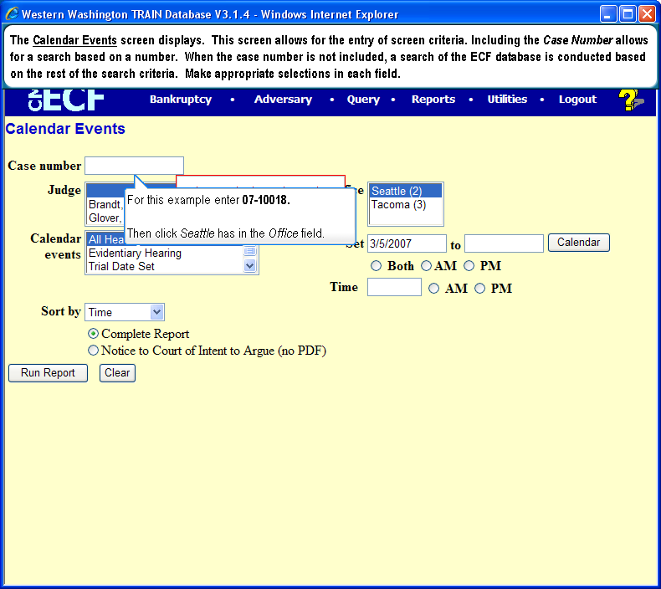
  Slide 18
  Enter 07-10018
  The Calendar Events screen displays. This screen allows for the entry of screen criteria. Including the Case Number allows for a search based on a number. When the case number is not included, a search of the ECF database is conducted based on the rest of the search criteria. Make appropriate selections in each field.
  For this example enter 07-10018.
  Then click Seattle has in the Office field.
  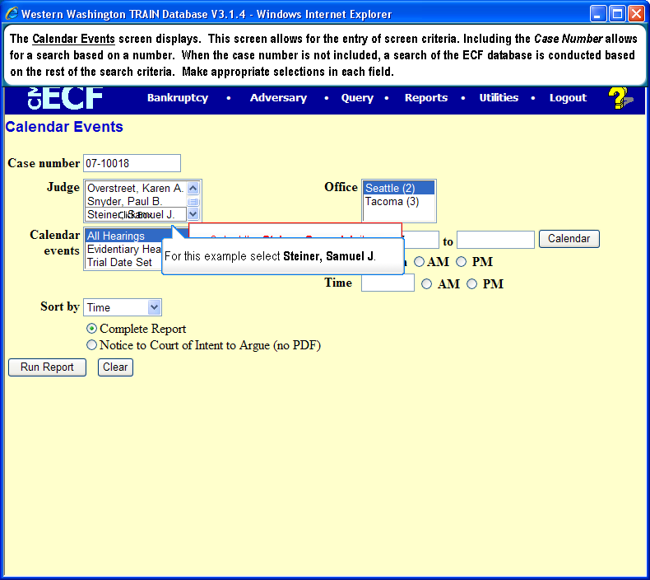
  Slide 19
  Text Captions: Select the Steiner, Samuel J. item
  The Calendar Events screen displays. This screen allows for the entry of screen criteria. Including the Case Number allows for a search based on a number. When the case number is not included, a search of the ECF database is conducted based on the rest of the search criteria. Make appropriate selections in each field.
  For this example select Steiner, Samuel J.
  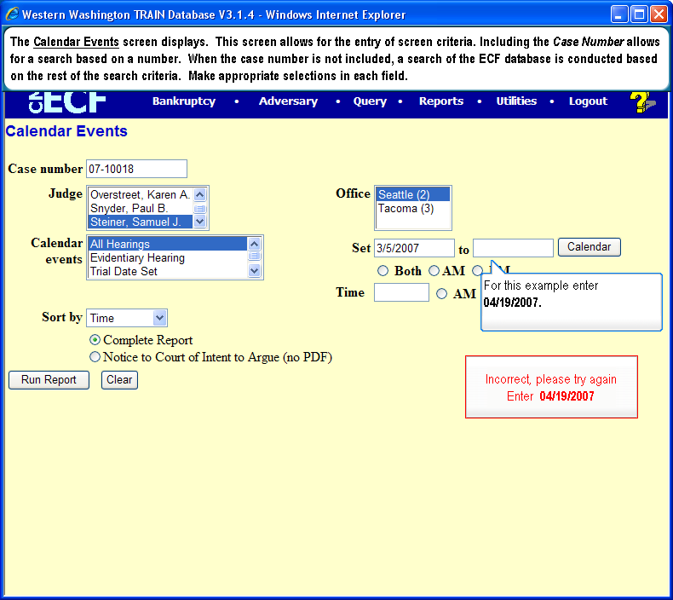
  Slide 20
  Enter 04/19/2007
  The Calendar Events screen displays. This screen allows for the entry of screen criteria. Including the Case Number allows for a search based on a number. When the case number is not included, a search of the ECF database is conducted based on the rest of the search criteria. Make appropriate selections in each field.
  For this example enter 04/19/2007.
  Then click Both at AM PM.

  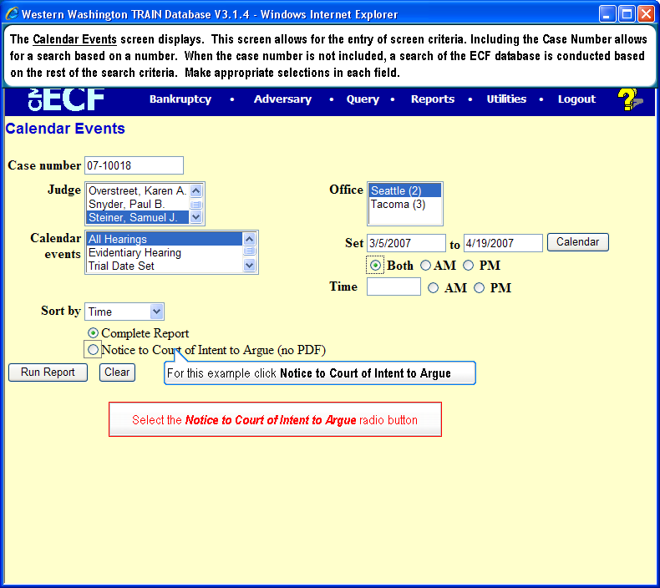
  Slide 21
  Text Captions: Select the Notice to Court of Intent to Argue radio button
  The Calendar Events screen displays. This screen allows for the entry of screen criteria. Including the Case Number allows for a search based on a number. When the case number is not included, a search of the ECF database is conducted based on the rest of the search criteria. Make appropriate selections in each field.
  For this example click Notice to Court of Intent to Argue
  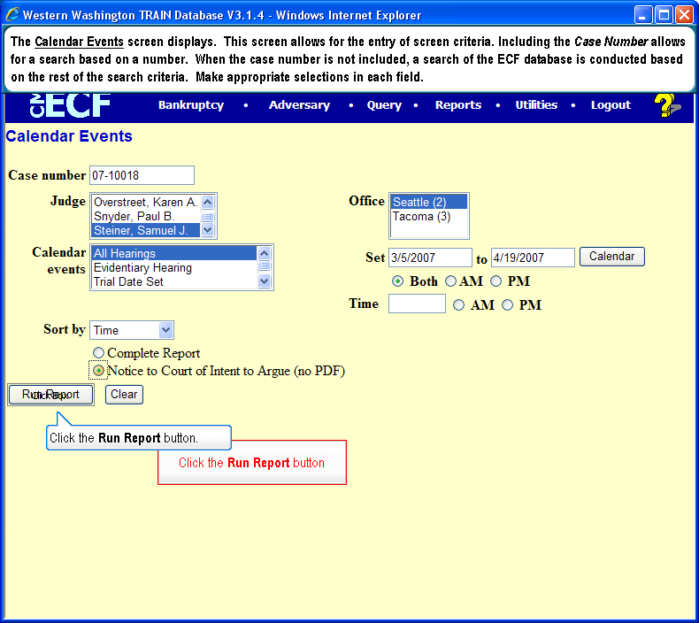
  Slide 22
  Text Captions: Click the Run Report button
  The Calendar Events screen displays. This screen allows for the entry of screen criteria. Including the Case Number allows for a search based on a number. When the case number is not included, a search of the ECF database is conducted based on the rest of the search criteria. Make appropriate selections in each field.
  Click the Run Report button.
  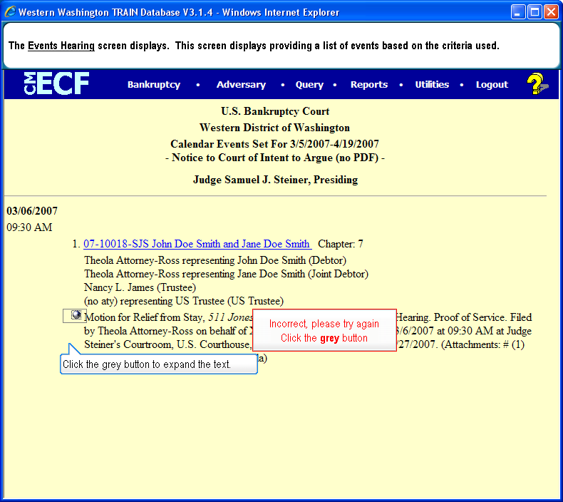
  Slide 23
  Click the grey button
  The Events Hearing screen displays. This screen displays providing a list of events based on the criteria used.
  Click the grey button to expand the text.
  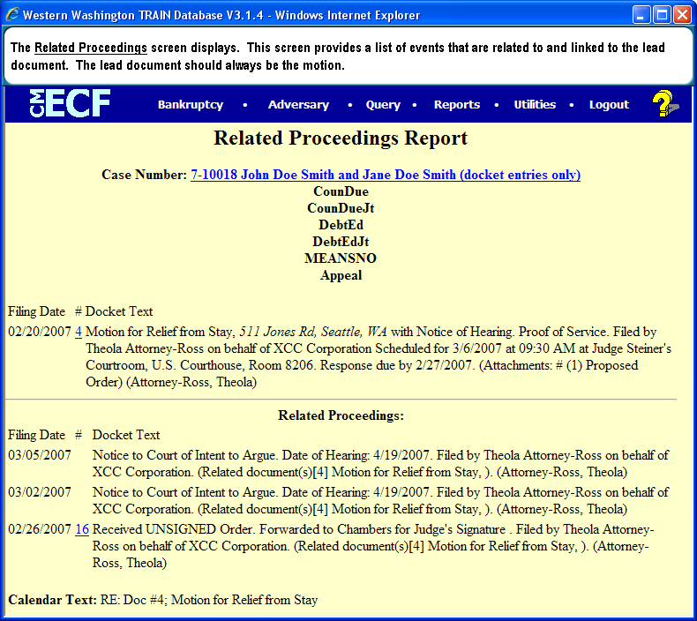
  Slide 24
  Text Captions: The Related Proceedings screen displays. This screen provides a list of events that are related to and linked to the lead document. The lead document should always be the motion.

