Testimony of G.A. (Art) Barnaby, Jr.
Professor of Agricultural Economics
Research and Extension
Kansas State University
Manhattan, Kansas 66506

Before the Subcommittee on General Farm Commodities and Risk Management

U.S. House of Representatives

June 7, 2007

Mr. Chairman Etheridge, Ranking Member Moran and Members of the General Farm Commodities and Risk Management Subcommittee of the House Committee on Agriculture; I appreciate the opportunity to appear before this hearing on an overview of the Federal Crop Insurance System. My name is Art Barnaby, with Research and Extension, Kansas State University.

Crop insurance has become an integral part of many farmers risk management plans. In the mid-1980’s, Dr. Bill Tierney and myself developed a series of workshops to teach farmers how to combine crop insurance with marketing tools to manage revenue risk. In the process, it became apparent the standard multi-peril crop insurance contract offered through the Risk Management Agency (RMA) did not meet the real need of farmers who were preharvest pricing grain because multi-peril crop insurance replaced bushels not at current market value but at a forecasted price. For example, the 1988 drought caused both crop losses and an increase in market prices that far exceeded the price forecasted by RMA. A similar result occurred with the 2006 corn and grain sorghum harvest price increase above RMA’s forecasted price. APH insured corn farmers were paid $2 while Revenue Assurance with the Harvest Price Option (RA-HPO) insured farmers were paid $3.56 per lost bushel. Any farmer who forward contracted corn but was not able to make delivery were required to purchase those lost bushels at current market value of $3.56 plus basis to meet the requirements of their forward contract.

After the large price increase combined with a short crop in 1988, working with a private company we developed a multi-peril insurance contract that increased coverage when grain prices increased and replaced any loss production at current market value, not at a forecasted price at planting time. This was a private endorsement on the multi-peril crop insurance contact titled Market Value Protection (MVP). The MVP endorsement converted the multi-peril crop insurance contract from a bushel payment trigger contract to a replacement guarantee. Initially, that was done to offset the loss of deficiency payments that occurred when markets prices were higher and farmers had no yield to sell due to drought or other weather perils but after the 1996 Farm Bill, it was used primarily as a method to guarantee performance on forward contracts or hedges.

The MVP replacement contract was the first crop insurance contract to include price risk and was released in 1990. This concept of inventory replacement at current market value is not a new one as many homeowners’ policies also contain provisions to replace their insured house at current construction cost rather than a fixed dollar amount.

The MVP replacement coverage was included in the Crop Revenue Coverage (CRC) contract introduced in 1996. Working with a private company I helped to develop the CRC contract. CRC was submitted to RMA for reinsurance and made available to all insurance companies. The CRC contract combined both the revenue guarantee and the replacement guarantee in a single contract.

Income Protection (IP) was released the following year as was Revenue Assurance (RA). These contracts guaranteed revenue but did not include replacement value protection. In 2000, Revenue Assurance added the Harvest Price Option (RA-HPO), which is the bushel replacement portion of the contract and it is nearly identical to the CRC contract.

Because of the availability of CRC and RA-HPO, it is possible for farmers to forward contract bushels up to 3 years before harvest and remain in a fully hedged position. Farmers will either have the bushels at harvest time in those future years or they will receive enough insurance dollars to replace the lost inventory that is necessary to offset the marketing plan. Some academics will argue that it does not pay to market and I will not enter into that debate. But one thing is absolutely certain, farmers have no choice once they plant the crop, they will have to sell the crop because farmers simply can’t store the crop forever. Because farmers must sell the crop at some point, then the alternative becomes either create an organized plan for selling the crop, recognizing that price forecasting is less than a perfect science, or if one truly believes marketing is random then just get up in the morning and flip coins on the decision to sell or not to sell
.
I personally believe that an organized marketing strategy will out perform flipping coins. I also recognize that selling production ahead of harvest does carry additional risk but with the advent of replacement coverage crop insurance through CRC and RA-HPO this risk is greatly reduced. The major benefit of the replacement crop insurance contracts is not that farmers expect to collect claims exceeding their premiums paid but the fact that CRC/RA-HPO increases the length of the marketing window. In fact, under today’s conditions farmers can price grain up to 3 years ahead of harvest to roughly 9 months after harvest, combined with replacement coverage insurance and storage, and still remain in a fully hedged position. At harvest time, replacement insured farmers will either have the bushels to deliver or they will receive enough indemnity dollars to replace those bushels at current market value.

Congress should be concerned about unintended consequences, because many farmers are making marketing decisions now for the 2007 crop based on some of the best corn and grain sorghum prices that have been offered in years. Many farmers are even selling their 2008 crop. Most of these forward marketing decisions are based on the assumption CRC/RA-HPO will still be available. This is why it is so important that Congress consider all of these unintended consequences if a major policy change is made.

Even the critics of the crop insurance program have not argued the program has not worked as planned by Congress. In Table 1, it is readily apparent that the growth of the crop insurance program has continued over the past 15 years. The combined farmer paid premium and premium subsidy has increased from $759 million to $4.6 billion over this period of time. During this period of time, there have been many reforms of the crop insurance program that primarily focused on increasing participation and encouraging farmers to purchase higher coverage levels. Clearly, an increased number of farmers did purchase insurance in 2006 versus farmers in 1992. Apparently, Congress has recognized this too in the most recently passed disaster bill that does not provide benefits on insurable crops to uninsured farmers on that particular crop. In the past, farmers growing insurable crops were also allowed to collect disaster payments but that will not be the case for the most recently passed law.

There are two special cases where crop insurance may not provide the level of protection farmers’ desire. The first case is shallow losses. As any insured farmers will tell you, crop insurance works extremely well if one has a total loss but if a farmer raises half of a crop that leaves one with all of the harvest expenses and greatly reduces production to sell. Because of the “large” deductibles in the crop insurance contracts a half of a crop leaves insured farmers with a much greater financial loss than if they had a total crop failure. The other issue is the case of multiple year losses where the APH declines and premium rates increase exponentially. For some growers with a declining APH the new Group Risk Income Protection (GRIP) or the Group Risk Plan (GRP) contracts maybe the best alternative in selected counties under conditions of a multi-year loss. However, those issues will be left for future discussions.

If crop insurance has worked as intended by Congress; then why are we having the current debate? One current argument being made is the crop insurance program has worked but it is “extremely” expensive. As one can see in table 1, as participation increases, the cost of premium subsidies also increases proportionally, therefore the more farmers that are insured, the higher the cost is for USDA. If we were still dealing with 1992 participation the government cost would be lower but Congress wanted higher participation and that is exactly what happened. Therefore, if Congress wants to reduce the USDA cost of the program then simply reduce participation, which may have unintended consequences.

The other fundamental question being raised; crop insurance is “too expensive” but compared to what? In order to try to answer that question, the USDA data in table 1 was converted to a format similar to private property/casualty insurance. First step in the analysis was to calculate the total premium costs that includes the A&O, the underwriting gains/losses by the insurance companies, the premium subsidy and the farmer paid premium to reach a total premium cost. One point that is often overlooked is “underwriting gain” as defined by the government is not underwriting gain as defined by property/casualty insurance. Because RMA uses an incorrect term, many analysts have made an error in their arguments by assuming underwriting gain has the same definition as it does in the private sector. Under private property/casualty insurance all of the company expenses and indemnity payments are paid before there is an underwriting gain/loss. Clearly some of those dollars USDA is reporting as “underwriting gains” to the companies are being used to cover some of the companies’ operating expenses.

If multi-peril was a private insurance contract the companies source of revenue is the unsubsidized premium paid by the consumer for their auto policy, homeowner’s policy, or crop hail policy. Out of each dollar of premium collected insurance companies must pay their claims, loss adjustment expenses, insurance agent commissions, operating expenses of the company, etc. However, because of GAP accounting procedures for the insurance industry it becomes quite complex to compare federally subsidized crop insurance with other common lines of private property/casualty insurance. In addition most private property/casualty insurance companies, investment income is a significant source of revenue simply because premiums are paid at the start of coverage unlike crop insurance where companies are actually paying losses before they collect premiums. Crop insurance premiums are collected at harvest time, not at the start of the coverage period.

Once total premiums were calculated, which is all dollars paid in; the analysis then lists the total dollars paid in indemnity payments. The analysis then calculated the percent of the total premium that was paid in indemnity payments.

Percent of premium paid is a hard number that is not subject to accounting gimmicks or other manipulation and therefore, the one number that is the most relevant for comparison. Over this 15 year period, the weighted average percent of premium paid in claims was 66 percent. That means out of every dollar received in total premiums, 66 cents was paid out in claims and the remaining dollars would be used to cover agent commissions, loss adjustment expenses, legal litigation and all of the other operating costs of the insurance company.

The 66 percent of premium paid in indemnity payment is overly optimistic and a simple average of the percentage paid, that weights the risk of loss equal in each year, is probably closer to the long-run average, which was 74.1 percent of each dollar paid in premiums to cover claims. The reason is the most recent 5 years of experience has been exceptionally good in the crop insurance industry and because the sales volumes are significantly higher in the most recent 5 years that good experience overrides some of the earlier years that generated sizeable losses. Assuming RMA’s premium rate is correct companies will have future large scale losses that will make the average closer to the 74.1 percent figure.

If one somehow believes weather has significantly changed so that companies will not have those severe future losses then RMA has set the premium rates too high and they should be cut. Most observers are willing to concede the past loss ratio experience is basically actuarially sound at the national level and the recent run of good luck is likely to be offset in future years bringing the loss experience back in to line. In fact, over the last 4 years effectively RMA has also generated about $1 billion in “underwriting gain” that they retained. However, I don’t expect that to continue either.

The other thing that is really striking is the amount of variability in the percent of premiums paid in claims ranging from a high of 181 percent to a low of 39 percent of premium paid in claims. While the average is closer to 70 to 75 percent, there is a lot of extreme variability annually. It is this annual variation in percent of premium paid in claims that makes crop insurance a particularly difficult risk to insure privately. Because these crop risks contain a significant amount of systemic risk is the reason the crop insurance loss ratios are either really high or really low. Unlike other lines of property/casualty insurance where losses are largely independent of each other, these losses are highly correlated. In other words, when a farmer has a drought all farmers in the county/state have a drought and the result is a catastrophic risk that is difficult to insure privately.

As demonstrated the expected premium paid in claims over the long-run is likely to be in the 70 to 75 percent range, leaving 25 to 30 percent for operating the insurance companies. The remaining question; is that a reasonable margin? A comparison analysis was made of the performance of reinsured crop insurance versus other lines of common private property/casualty insurance. Table 2 contains historical losses for personal automobiles. Notice the dollar amounts are much larger than the $5 to $6 billion in reinsured crop insurance, approaching nearly $160 billion dollars in premiums. A net premium was calculated that deducted dividends paid back to policy holders from premium dollars paid in by policy holders to allow for comparison with reinsured crop insurance.

The property/casualty industry statistics on claims unfortunately are not as clean as one would hope. In their reported losses property/casualty companies also include the Loss Adjustment Expense (LAE). By utilizing data published in AM Best, an annual report from State Farm automobile insurance company and the Insurance Information Institute, it was documented the percent of these total losses attributed to LAE range from a low of about 15 percent to a high of 18 percent of the combined LAE and auto claims. Therefore, the indemnity only payments were estimated as a range based on the estimated amount of dollars that would have been paid in LAE. Depending on how low or how high the LAE is the percentage of each dollar premium paid in claims ranges from about 62 percent to about 65 percent. The remaining amount of the premium dollar is then used to pay for all of the expenses of the insurance company and after the expenses are deducted the company generates an underwriting loss or gain. The private property/casualty companies then add their investment income to reach a bottom line.

A similar analysis was done for homeowner’s policies where the expected payout ranged from about 60 percent to about 63 percent of the total premium paid in indemnity payments (table 3). Private crop hail insurance had an expected payout that ranged from about 63 percent to about 72 percent of the total premium paid in indemnity payments (table 4).

When comparing the percent of each premium dollar paid in claims between reinsured crop insurance versus auto insurance, homeowners insurance, etc, crop insurance is paying out anywhere from 5 to 10 percent more of each premium dollar in claims then are other private lines of insurance. That leaves crop insurance companies with a smaller margin to operate than the typical private property/casualty company. Any reasonable objective view would have to conclude the private crop insurance companies selling reinsured crop insurance are as at least as efficient as private sector property/ casualty insurance companies, which are market driven. In fact, there are few barriers to entry to the insurance industry other than the company must provide evidence they have the financial means to pay claims on the insurance coverage that they write. It is a very competitive market and one would have to conclude these margins are necessary for a viable private property/casualty insurance industry.

The data clearly suggests the crop insurance companies are operating with a smaller margin than the typical private property/casualty company. This would suggest there are limits on how large Congress can cut the A&O or increase the retention of “underwriting gain” (quota share) by RMA and still have a viable private crop insurance industry to deliver reinsured crop insurance contracts. This data suggests crop insurance providers are already more efficient then the typical private property/casualty company so how much increased efficiency is possible is really an unknown. If Congress further reduces these margins, then these companies will have to find ways to be even more efficient or exit the industry. This data also does not answer the question, could USDA sell, service, and deliver crop insurance cheaper through government employees then through the private sector. There have been USDA studies completed several years ago that concluded sales through government employees would be more expensive, but there is no current data, only “common sense”.

As demonstrated the percent of premium that remains, after all claims are paid, to pay all of the operating expenses of the crop insurance company are less than for the typical private property/casualty company. Therefore, the other question is “are the costs lower for a crop insurance company versus a private property/casualty insurance company?” On the surface, one would certainly think the opposite would be true. For example, insuring an automobile is a fairly simple process and there are several major private property/casualty insurance companies who operate with only a web site and 800 numbers and don’t even employ agents. By contrast, crop insurance agents have a much larger paper volume than is required to write a crop insurance policy. This is primarily due to the extensive recordkeeping for proven yield purposes as those records must be maintained and updated by unit (often by crop field) over a period of years. Many insurance agents provide some of the recordkeeping help as a service to their clients.

Another source of cost to the insurance company beyond agent commissions is the Lost Adjustment Expense (LAE). It is difficult to find statistics that would allow for a direct comparison to give some indication of the LAE for crop insurance companies versus private property/casualty companies. As one thinks about the LAE for settling crop losses, particularly in the Great Plains, farms cover very large geographic areas that involve a significant amount of travel time as well as travel expense operating a vehicle for the loss adjuster to inspect the various fields for claim purposes.

As a proxy for the LAE cost, the percent of claims per policies (car or house) sold was compared with the percent of reinsured crop insurance polices with claims. The RMA web site reports the number of policies with premium and also reports the policies with indemnity payments. The percent of policies with paid claims’ 15 year average was 23.4 percent and was a little higher during the most recent 5 years at 29.34 percent.

In addition, there are a significant number of claims filed on crop insurance policies because farmers think they might have a loss. This requires the insurance company to pay loss adjusters to go through the process of settling the claim and checking to see if in fact there is an indemnity due. In a significant number of cases after working the claim the loss adjuster simply discovers the amount of loss does not exceed the deductible and therefore there is no indemnity payment due to the farmer. The policy is then released but the fact that this claim was processed and LAE incurred is never reported to RMA. Only claims that result in indemnity payments are reported to RMA and using only RMA data severely underreports the number of claims that are actually worked, all of which generate LAE costs for the insurance company.

Within the industry the percent of claims filed resulting in no indemnity payments has a very wide range, from 25 to 40 percent of the total claims filed. In the KSU estimate it was assumed 30 percent of claims filed resulted in no indemnity payment and therefore, was not reported to RMA. A 15 year average estimate for total claims processed is approximately 30 to 38 percent of the policies had claims worked that included both policies that had indemnity payments due as well as those that did not have losses exceeding deductible and were released without indemnity payments. When comparing the amount of claims that are worked under a crop insurance policy versus typical private property/casualty insurance policies such as auto, private crop hail, and homeowners, it is clearly significantly higher (table 5). With approximately 1/3 of the crop insurance policies having claims paid compared to less than 6 to 7 percent of the policies having claims on homeowners and a smaller percentage of auto policies with claims. The crop insurance claim rate per policy was more than double that of private crop hail.

Looking at the big difference in frequency of claims for crop insurance versus other lines of property/casualty would suggests the LAE would certainly be as expensive as auto, homeowners and private crop hail policies. However, the cost of loss adjusting expenses for homeowners and private auto insurance, in many cases, will exceed 10 percent of the gross premium. By this measure, one could only conclude the crop insurance companies have become very efficient at managing and settling their claims.

Summary. Based on this data, it is reasonable to conclude the operating margins in crop insurance are less than they are for a typical property/casualty insurance company and would certainly suggest the companies are at least as efficient at delivering crop insurance as other lines of insurance. Given the very “high” frequency of claim on a crop insurance policy, as well as the recordkeeping for selling a crop insurance policy there is no reason to believe the administrative burden is less for crop insurance then it is for other lines of insurance, in fact, the administrative burden is probably larger. Finally, the crop insurance program has performed basically at the level that Congress intended as participation during the past 15 years has increased from less than $800 million premium volume to over $4.5 billion. As more farmers continue to buy crop insurance and to buy higher levels of crop insurance coverage, the result has been higher aggregate premiums paid by both the government and farmers. If the government wants to reduce its contributions that will likely reduce participation in the crop insurance program.

Finally, one needs to remember many farmers have tied their marketing risk management plans to crop insurance not only for this year but in some cases they have already obligated themselves on 2008 and perhaps even 2009 crop sales. If major changes are made in the crop insurance program there may be some unintended consequences occur before farmers are able to unwind their forward marketing hedge position that is only a hedge as long as there are bushels or crop insurance dollars to offset that hedge.

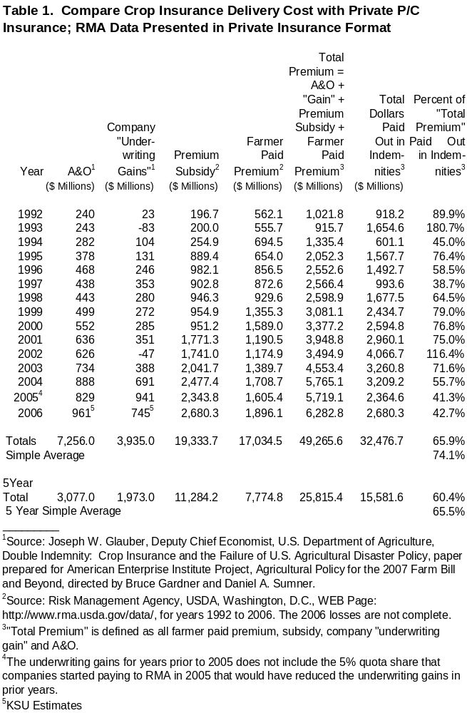

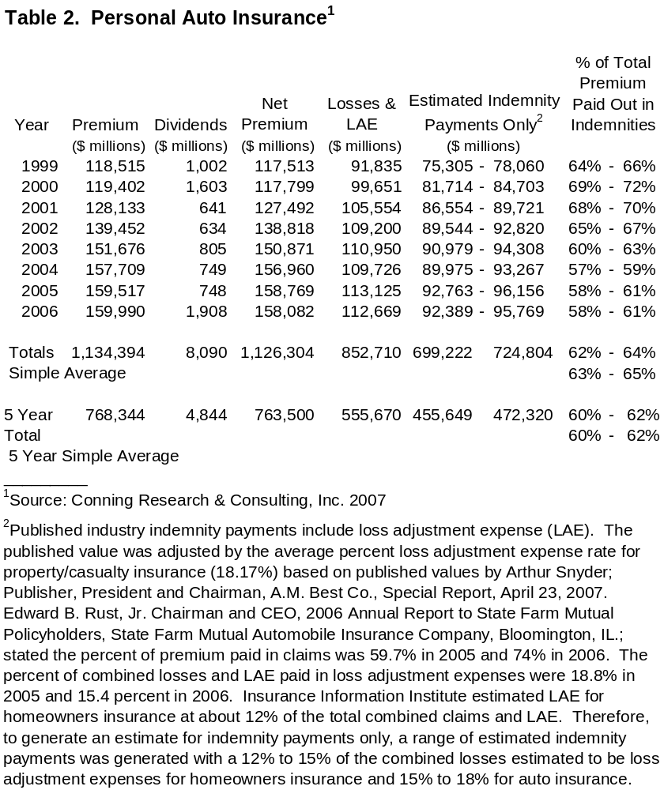

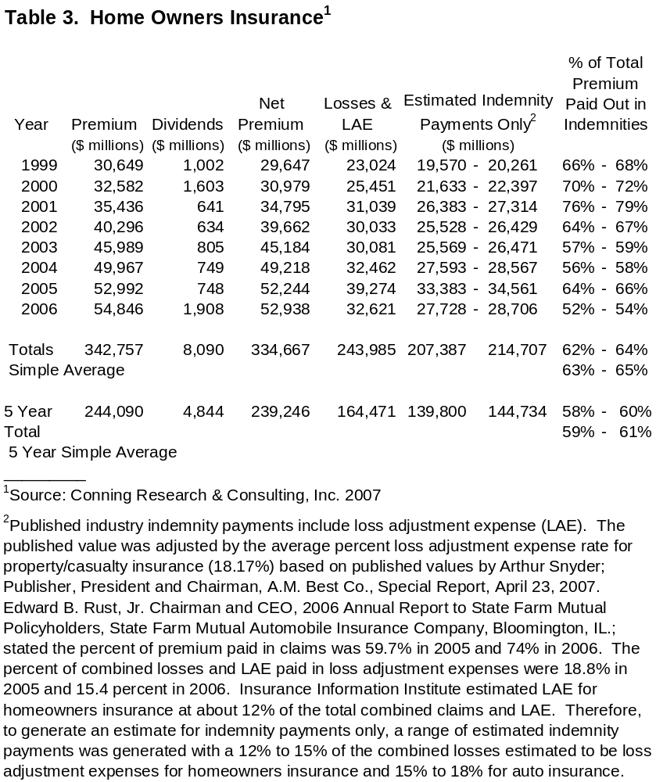

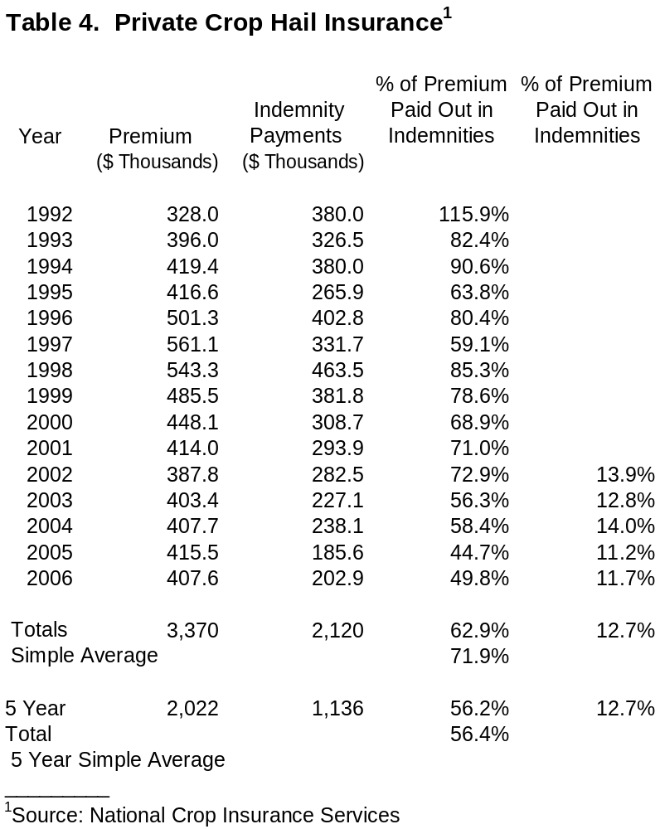

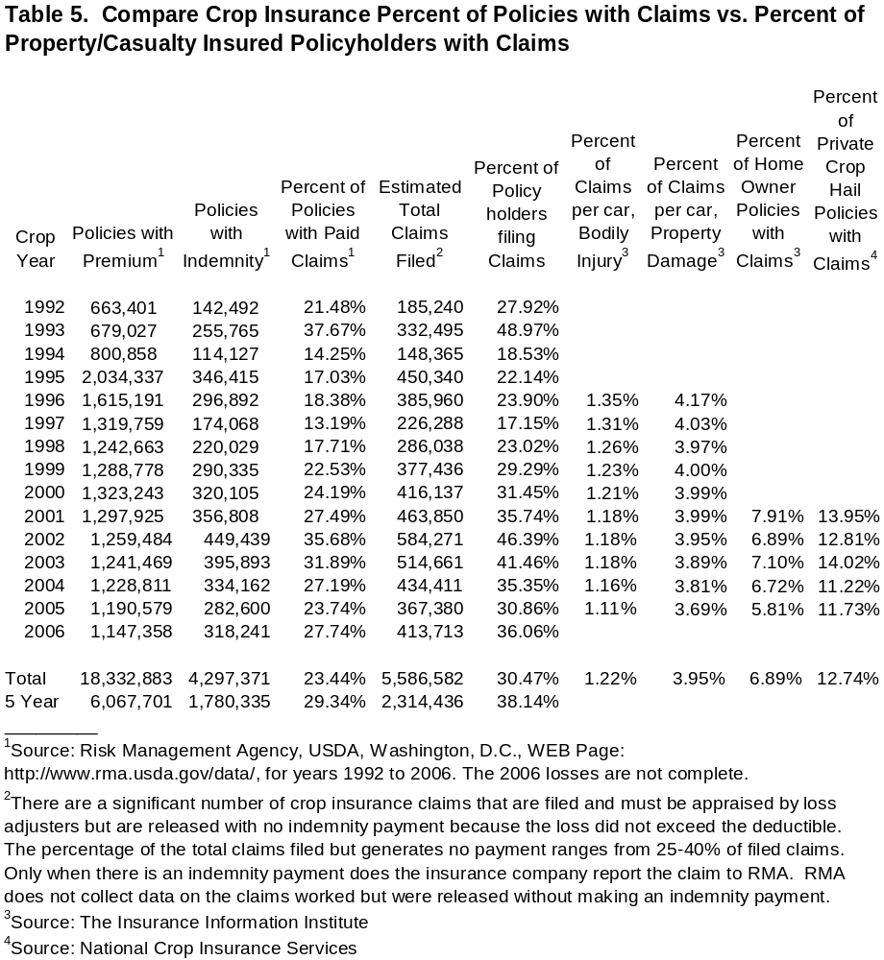
G. A. (Art) Barnaby, Jr.

124 North Dartmouth
Manhattan, Kansas 66503

PERSONAL DATA:

Home Phone: (785) 776-9232

Office Phone: (785) 532-1515

Fax Number: (785) 532-6925

Cell Phone Number: (785) 564-1947

Citizenship: USA

Military: Active duty with United States Navy -- 1967-1971

PRESENT RANK: Professor (July 1, 1990)

PRESENT POSITION: Agricultural Economist, Department of Agricultural Economics, Research and Extension, Kansas State University, Manhattan, Kansas 66506

AREAS OF CONCENTRATION: Crop Insurance, Risk, Farm Management, Production and Resource Economics

EDUCATION:

Ph.D. Texas A&M University 1981; Major in Agricultural Economics
Major Professor - Dr. Robert Whitson

M.S. New Mexico State University 1976; Major in Animal Science; Minor in Agricultural
Economics

Major Professor - Dr. G. S. Smith

B.S. Fort Hays Kansas State College 1973; Major in Animal Science

ACADEMIC RANK:

Professor, Extension Agricultural Economist, Department of Agricultural Economics, Kansas State University, July 1990 - Present

Associate Professor, Extension Agricultural Economist, Department of Agricultural Economics, Kansas State University, 1984 - July 1, 1990

Assistant Professor, Extension Agricultural Economist, Department of Agricultural Economics, Kansas State University, 1979 - 1984

AWARDS:

Dr. Barnaby was the winner of the American Agricultural Economics Association’s 2001 Individual Distinguished Extension Program Award for his grower education on combining revenue insurance with marketing tools to manage risk. This is generally accepted as the top award for extension and his risk management approach has been widely adopted by growers, marketing consultants, insurance agents and other extensions services.

Dr. Barnaby also cooperated with Professors Dean Baldwin, Ohio State University and Robert Wisner, Iowa State University on a series of risk management educational programs in the Corn Belt. This educational program was awarded the American Agricultural Economics Association’s 2000 Group Distinguished Extension Program Award.

National Association of Wheat Growers, Excellence in Extension Award, 1990.

American Agricultural Economics Association, Distinguished Individual Extension Program Award, 1991.

MAST Team Award, 2003.

Western Agricultural Economics Association Outstanding Extension Project Award, 2004

PUBLISHED BOOKS:

Edwards, William and G. A. Barnaby, Jr., Managing Risk Through Crop Insurance, John Deere Publishing, East Moline, IL, 2000.

Barnaby, G. A., ACrop Revenue Coverage Insurance Provides Additional Risk Management Grain Sorghum Alternatives,@ Sorghum: Origin, History, Technology, and Production, Chapter, National Grain Sorghum Producers, Abernathy, TX, October 1997.

SELECTED PUBLICATIONS AND PAPERS:

Barnaby, G. A., and Jeffery R. Williams, Testimony Before the Nationwide Hearings on Crop Insurance Scheduled by the Commission for the Improvement of the Federal Crop Insurance Program, Testimony presented to the Commission for the Improvement of the Federal Crop Insurance Program, Salina, Kansas, March 14, 1989.

Harper, Jayson, Jeffery R. Williams, and G. Art Barnaby, Selecting Risk Efficient Crop Insurance Alternatives for Northeast Kansas Corn/Soybean Farms, Selected paper WAEA meetings, Coeur d'Alene, Idaho, July 9-12, 1989.

Williams, Jeffery R., Richard V. Llewelyn, and G. A. Barnaby, "Risk Analysis Tillage Alternatives with Government Programs,@ American Journal of Agricultural Economics, 72(1990):172-181.

Williams, Jeffery R., Jason K. Harper, and G. Art Barnaby, "Government Program Impacts on the Selection of Crop Insurance in Northeastern Kansas," North Central Journal of Agricultural Economics, 12(1990):207-221.

Barnaby, G. A. and Jerry Skees, "Public Policy for Catastrophic Yield Risk: An Alternative Crop Insurance Program,@ Choices, Second Quarter 1990: 7-9.

Carriker, G.L., J.R. Williams, G.A. Barnaby, Jr., and J.R. Black. "Reduction of Yield and Income Risk Under Alternative Crop Insurance and Disaster Assistance Plans.@ Selected paper presented at the 1991 SAEA meetings, Fort Worth, TX, February 1991. Abstract in Southern Journal of Agricultural Economics, 23(1991):258.

Williams, J.R., G.L. Carriker, G.A. Barnaby, Jr., J.K. Harper, and J.R. Black. "Area Measured Crop Insurance and Disaster Aid for Wheat and Grain Sorghum." Selected paper presented at the 1991 AAEA meetings, Manhattan, Kansas, August 1991. Abstract in American Journal of Agricultural Economics, 73(1991).

Carriker, G.L., J.R. Williams, and G.A. Barnaby, Jr., and J.R. Black. "Comparative Performance of Individual and Area Measured Crop Insurance Programs." Selected paper presented at the 1991 WAEA meetings, Portland, OR, July 1991. Abstract in Western Journal of Agricultural Economics, 16(1991).

Carriker, G.L., J.R. Williams, G.A. Barnaby, and J.R. Black, "Yield and Income Risk Reduction Under Alternative Crop Insurance and Disaster Assistance Plans,@ Western Journal of Agricultural Economics, 16(1991):238-50.

Williams, Jeffery R., Gordon L. Carriker, G. Art Barnaby, and Jayson K. Harper, "Crop Insurance and Disaster Assistance Designs for Wheat and Grain Sorghum,@ American Journal of Agricultural Economics, 75(1993): 435-447.

Barnaby, G. A., Risk Assessed Marketing Applied to Wheat, Department of Agricultural Economics, Cooperative Extension Service, Kansas State University, Manhattan, Kansas 66506. Selected paper presented to the National Wheat Growers, Winter Meeting 1994, New Orleans, Louisiana, January 19, 1994.

Barnaby, G. A., Using Private Markets to Achieve Revenue Insurance, Department of Agricultural Economics, Cooperative Extension Service, Kansas State University, Manhattan, Kansas 66506. Selected paper presented to the AAEA Risk Management Preconference, San Diego, CA, August 6, 1994.

Edwards, William and G. A. Barnaby, DTN - Lesson VIII. Crop Insurance Alternatives, Iowa State University, Ames, IA and Kansas State University, Manhattan, KS, August 15, 1997.

Barnaby, G. A., Crop Revenue Coverage Insurance Provides Additional Risk Management Alternatives for Corn Growers, Department of Agricultural Economics, Cooperative Extension Service, Kansas State University, Manhattan, KS 66506. Presented to the First Farm Journal Forum, Washington, D.C., November 13-14, 1997.

Flaskerud, George, Bruce Babcock and G. A. Barnaby, DTN Lesson XII. Alternative Yield and Price Risk Management Tools for Wheat, North Dakota State University, Fargo, ND, Iowa State University, Ames, IA and Kansas State University, Manhattan, KS, November 1997, 1998.

Edwards, William and G. A. Barnaby, DTN - Lesson IX. Crop Insurance Alternatives, Iowa State University, Ames, IA and Kansas State University, Manhattan, KS, September 1998.

Barnaby, G.A., Risk Assessed Marketing (RAM), An Extension Education Program on Managing Price and Yield Risk, Department of Agricultural Economics, K-State Research & Extension, Kansas State University, Manhattan, KS 66506. Presented to the American Agricultural Economics Association Pre-Conference Workshop, Salt Lake City, UT, August 1, 1998.

Barnaby, G.A., Current New Crop Prices and Crop Insurance Participation, Department of Agricultural Economics, K-State Research & Extension, Kansas State University, Manhattan, KS 66506. Presented to Secretary Dan Glickman=s Working Group, Washington, DC, August 24, 1998.

Barnaby, G.A., Risk Assessed Marketing (RAM), An Extension Education Program on Managing Price and Yield Risk, Department of Agricultural Economics, K-State Research & Extension, Kansas State University, Manhattan, KS 66506. Presented to the American Agricultural Economics Association Pre-Conference Workshop, Salt Lake City, UT, August 1, 1998.

Barnaby, G.A., Risk Management Includes More Than MPCI Crop Insurance, Department of Agricultural Economics, K-State Research & Extension, Kansas State University, Manhattan, KS 66506. Presented to National Governors= Association Agriculture Summit, Ames, IA, August 26, 1999.

Barnaby, G.A., Managing Financial Risk With Crop Insurance Marketing Tools, Department of Agricultural Economics, K-State Research & Extension, Kansas State University, Manhattan, KS 66506. Presented to American Bankers Association 1999 National Ag. Bankers Conference, Colorado Springs, CO, November 2, 1999.

Pendell, Dustin L., William R. Perry, Jeffery R. Williams, G. Art Barnaby, and Bradley Lubben, Mathematical Formulas for Calculating Net Returns From Participation in Government Programs, CRP, and Crop Insurance Alternatives, Staff Paper, Kansas Agricultural Experiment Station, Contribution No. 04-036-D, Kansas State University, Manhattan, Kansas, No. 04-02, August 2003.

Barnaby, G.A., Compare Livestock Risk Protection (LRP) Contract with Chicago Mercantile Exchange (CME) Put Option Premiums for Similar Coverage, Department of Agricultural Economics, K-State Research & Extension, Kansas State University, Manhattan, KS 66506, October 31, 2003.

Barnaby, G.A., Farm Journal Grain Marketing Guide , Department of Agricultural Economics, K-State Research & Extension, Kansas State University, Manhattan, KS 66506, March 1, 2004.

Barnaby, G.A., Testimony on Disaster Aid Alternatives, Testimony presented to the Subcommittee on General Farm Commodities and Risk Management, U.S. House of Representatives, Committee on Agriculture, Washington, DC, April 26, 2006.
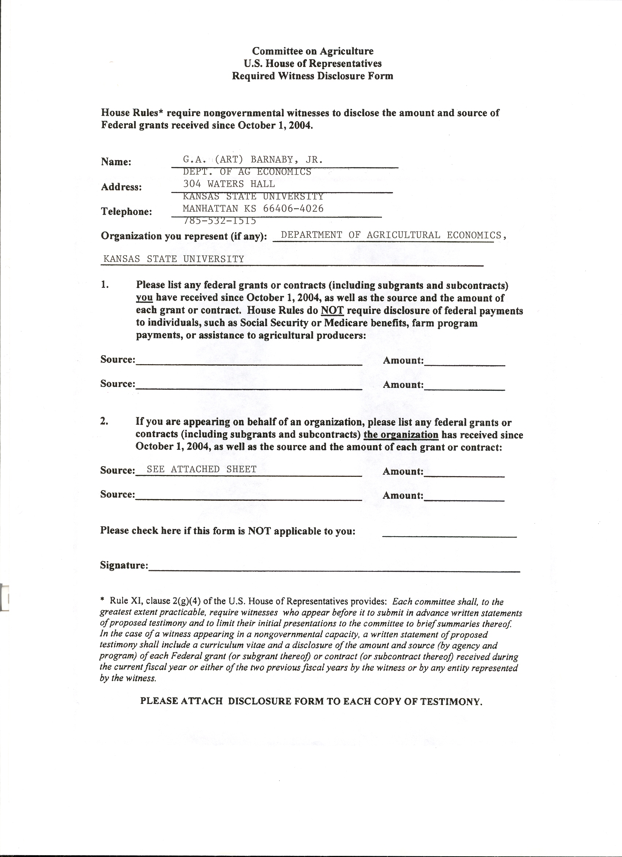
Federal Grants or Contracts (including subgrants and subcontracts) the organization has received since October 1, 2004:

Improving Farm Competitiveness: Explaining and Forecasting Farm Profitability
USDA (Through: USDA) - 11/15/2002 - 11/14/2005 $82,000.00

Kansas Urban Water Quality Restoration and Protection Initiative; & Part 2 (Year 2) (proposal = Planning Process Technical Assistance, Education and Outreach)
EPA (Through: KS Dept. Of Health & Environment) - 01/01/2000 - 06/30/2007 $250,214.00

USDA Agricultural Marketing Resource Center
USDA (Through: Iowa State University) - 09/27/2001 - 09/30/2006 $245,275.00

Information Technology and E-Commerce: Implications for Small Business Development in Rural Areas
USDA - 09/15/2003 - 09/14/2006 $90,730.00

Market Risk Analysis for Organic Grain Farmers in the Great Plains
USDA (Through: USDA) - 09/30/2003 - 09/29/2006 $158,726.00

The Potential Impact of Bovine Spongiform Encephalopathy (BSE) on Demand for Beef in the United
States - USDA (Through: USDA) - 09/25/2003 - 12/31/2004 $15,000.00

Integrating Economic and Biophysical Models to Assess the Impacts of Water Quality Trading
EPA (Through: EPA) - 01/01/2005 - 12/31/2006 $376,165.00

Improving Agriculture Students= Understanding of Global Production Systems through Distance Learning
USDA (Through: USDA) - 09/01/2004 - 08/31/2006 $273,457.00

Cost Production Studies for Corn and Wheat Grown in Kansas
USDA (Through: University of California) - 01/01/2004 - 01/31/2005 $17,638.00

Value Added Producer - Rainbow Organic Farms (Through: Rainbow Organic Farms)
03/19/2004 - 03/18/2005 $50,000.00

Provision of Services to the Kansas Ag Innovation Center
USDA (Through: Kansas Department of Commerce and Housing)
- 01/01/2004 - 12/31/2004 $729,000.00

Development of a Research-Based Risk Assessment and Management Tool for Cattle Feeders
USDA (Through: North Carolina State University) - 09/01/2004 - 08/31/2006 $206,376.00

Combining Livestock Risk Protection Insurance with Private Market Tools for Effective Cow-Calf Risk Management Plan
USDA (Through: USDA) - 10/01/2004 - 09/30/2005 $149,962.00

The Value of the AU.S.A.@ Label on Retail Agricultural Products in Japan
USDA (Through: USDA) - 09/01/2005 - 08/31/2007 $334,473.00

Meeting National Needs for Scholars Trained in Economics of Food Marketing and Biosecurity
USDA (Through: USDA) - 09/01/2005 - 08/31/2008 $276,000.00

Minority Fellows in the Economics of Food Safety and Biosecurity
USDA (Through: USDA) - 09/01/2005 - 08/31/2007 $128,000.00

Pollution Trading
EPA (Through: Kansas Department of Health & Environment)
10/11/2005 - 06/30/2010 $142,850.00

Value of Animal Traceability Systems in Managing Contagious Animal Diseases
USDA (Through: USDA) - 09/20/2005 - 09/30/2007 $151,791.00

Big Hill Creek/Big Hill Lake WRAPS Development
EPA (Through: Kansas Department of Health & Environment) $31,041.00

Elk City Lake WRAPS Development - Amend 102
EPA (Through: Kansas Department of Health & Environment) $31,041.00

Upper Verdigris/Toronto Lake WRAPS Development - Amend 103
EPA (Through: Kansas Department of Health & Environment) $31,041.00

Tuttle Creek Lake Watershed WRAPS Development
EPA (Through: Kansas Department of Health & Environment) $42,600.00

Milford Lake Watershed WRAPS Development
EPA (Through: Kansas Department of Health & Environment) $42,600.00

Meeting National Needs for Scholars in the Economics and Management of Water
Resources and the Environment
USDA (Through: USDA) – 11/15/2006 – 11/14/2011 $252,000.00

Upper Arkansas Basin WRAPS Development
EPA (Through: Kansas Department of Health & Environment) –
12/1/2006 – 06/30/2011 $48,000.00

Verdigris River WRAPS Support - Amend 108
EPA (Through: Kansas Department of Health & Environment) –
11/01/2006 – 8/31/2011 $49,850.00

Agricultural Marketing Center
USDA (Through: USDA) – 04/01/2007 – 09/25/2008 $361,350.00

Economic Analysis of Supply Chains
USDA (Through: Rainbow Organic Farms) – 05/01/2006 – 09/30/2006 $9,516.00

Water Allocation Risk Analysis Tool
USDA (Through: USDA) – 10/01/2006 – 09/30/2008 $698,952.00

Cattle Risk Management in Kansas for Today’s and Tomorrow’s Producers
USDA (Through: USDA) – 08/30/2006 – 09/30/2007 $147,349.00

Advanced Risk Management WEB Based Education on Livestock and Other Under-

Served Commodities via AgManager.Info
USDA (Through: USDA) – 08/30/2006 – 09/30/2007 $10,000.00

Agricultural Marketing Resource Center (#412-30-39)
USDA (Through: USDA) – 10/01/2006 – 09/21/2007 $315,725.00

Agricultural Marketing Resource Center (#412-30-54)
USDA (Through: USDA) – 10/20/2006 – 10/19/2007 $119,960.00

Global Awareness of the International Dimensions of Agriculture
USDA (Through: USDA) – 04/01/2006 – 08/31/2008 $99,917.00

Evaluation of Policy Options Aimed at Achieving a Reduction in Groundwater
Consumption in Western Kansas
USDA (Through: USDA) – 09/01/2006 – 08/31/2009 $83,500.00

Prepared by G.A. (Art) Barnaby, Jr., Ph.D., Professor, Department of Agricultural Economics, K-State Research and Extension, Kansas State University, Manhattan, KS 66506, June 4, 2007, Phone 785-532-1515, e-mail – barnaby@ksu.edu.

