Slide 1 | 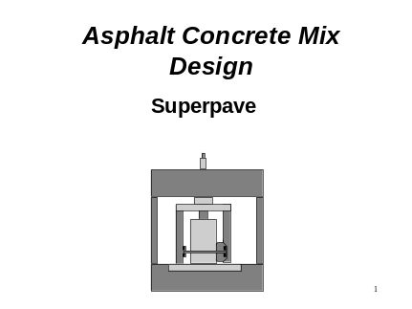 | This block of instruction will cover the Superpave procedures.  At the conclusion of this block the student will have a general understanding of:  The principal procedures involved in the Superpave mix design.  The relationship between these procedures and paving specifications.  This material is covered in detail in Chapter 4 “Hot Mix Asphalt Mixture Design Methodology” of the recommended textbook.
Slide 2 | 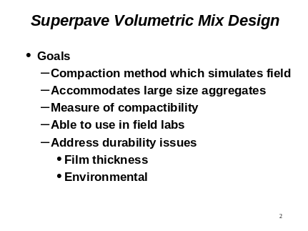 | The goals of the first new mix design procedure for HMA pavements in over 50 years were to have a procedure that would simulate the real world. In the past we may have “allowed the mold to design road”. The Marshall and Hveem procedures used 4 inch (100 mm) molds with Superpave using 150 mm molds to use larger aggregates.  By monitoring compaction throughout the process, may provide a measure of how the mix will compact during construction.  It was also desired to have equipment that could be used to for field quality control purposes.
Slide 3 | 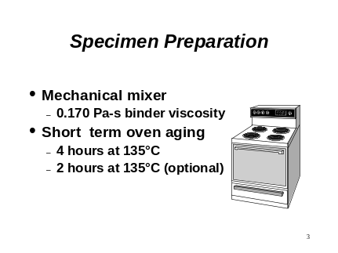 | The asphalt and aggregates are mixed in a mechanical mixer. Many years of experience have shown that it is necessary to have a binder with a minimum fluidity when mixing. After the binder and aggregate are mixed the mixture is oven aged for a period of either 4 hrs or 2 hrs. The 4 hour aging is used when the mix has more than 2% water absorption. The short term oven aging is included to simulate the aging that occurs in the manufacture and laydown of the HMA.
Slide 4 | 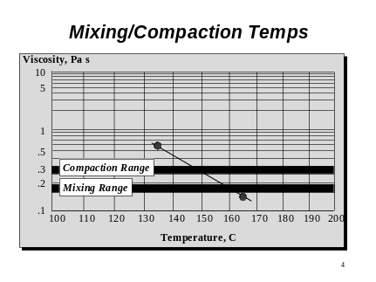 | To establish mixing and compaction temperatures it is necessary to develop a temperature viscosity chart. This can be done by determining the viscosity at two different temperatures - generally 135 and 165 C. These two viscosities are then plotted on the graph above and a straight line is drawn between the two points.  The desired viscosity range for mixing is between 0.15 and 0.19 Pa-s and 0.25 and 0.31 Pa-s for compaction. Appropriate mixing and compaction temperatures are selected as the temperature where these viscosity requirements are met. This information can be obtained from the suppliers. In many DOTs this information is developed during the mix design process.  If using modified binders - it is recommended that to contact the supplier to determine the mixing and compaction temperatures.
Slide 5 | 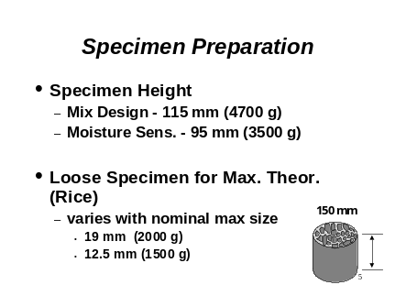 | Two different heights are used for specimens in Superpave. Superpave also recommends that two specimens be mixed for use in determine the maximum theoretical specific gravity of the mixture.
Slide 6 | 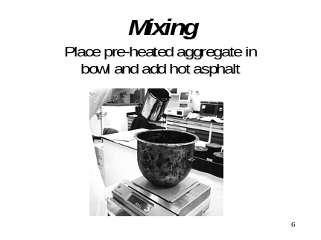 | Pour the heated binder into a bowl with the heated aggregate. Typically the temperature for this is about 275 to 325 C.
Slide 7 | 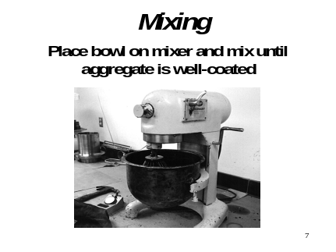 | The mixture is typically mixed in a mechanical mixer. The mix should be observed to insure that the aggregate and asphalt are thoroughly mixed.
Slide 8 | 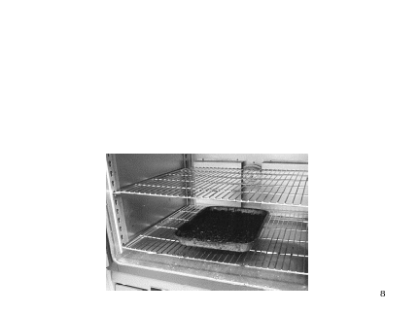 | The mix is subjected to short term oven aging (STOA) in flat pans. The recommended rate is 21 kg per sq. meter; research has shown that 50 kg per sq. meter is also OK. The dividing line for absorption is 2% water absorption.
Slide 9 | 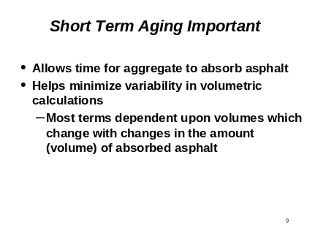 | The short term aging is used to simulate what is happening in the hot mix plant during the mixing, storage and placement operations.
Slide 10 | 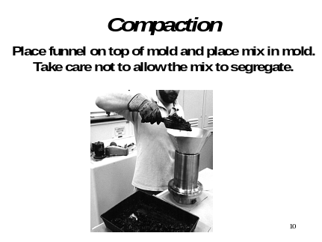 | Charging the mold should be done in one mass operation. The mix is not to be rodded. A scoop or gyroloader are all acceptable. The process should be done quickly to avoid loss heat loss. Care should also be taken to ensure that the fine and coarse fractions of the mix are not separated.
Slide 11 | 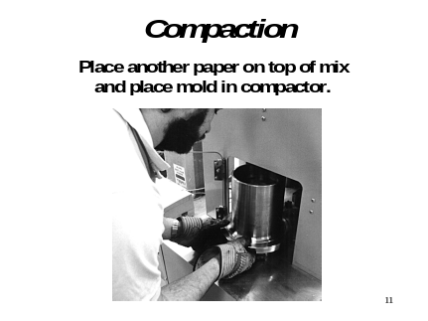 | The filled mold is placed in the compactor. Push button to start.
Slide 12 | 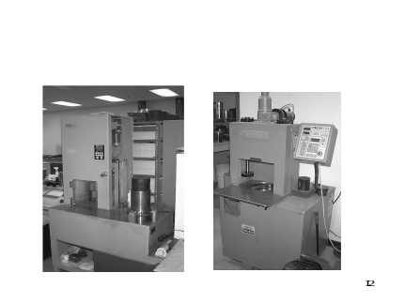 | These are typical full-size compactors. There are now seven (June 98) different compactors on the market. They all obtain comparable results.
Slide 13 | 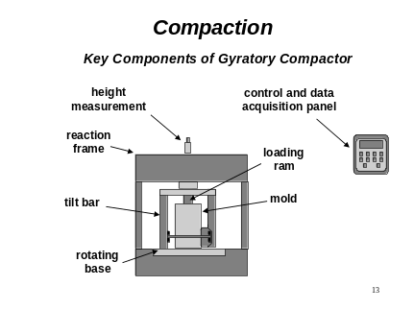 | These are the components of the machine.
Slide 14 | 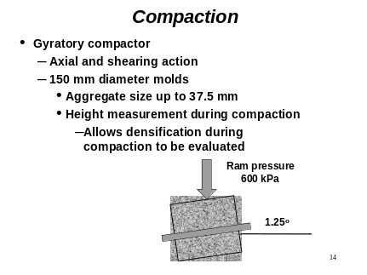 | The compactor puts 600 kPa of pressure on the specimen and operates at 30 rpm.
Slide 15 | 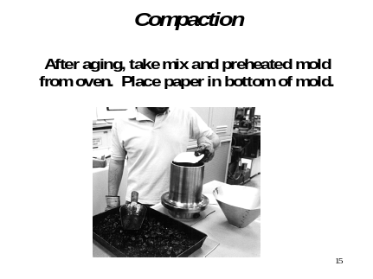 | The mold is made ready by first placing a paper disk in the bottom.
Slide 16 | 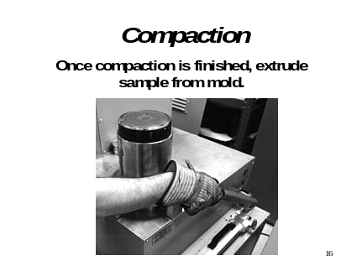 | After compaction is complete the specimen is extruded from the mold and allowed to cool for 3 to 5 minutes.
Slide 17 | 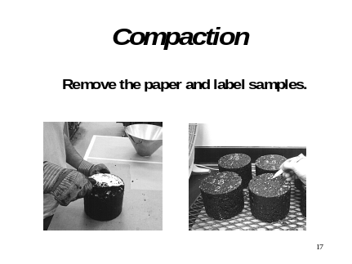 | The paper disk is removed from the specimen. The specimens are marked for tracking purposes. After cooling and marking the specimens are tested to determine their bulk specific gravity.
Slide 18 | 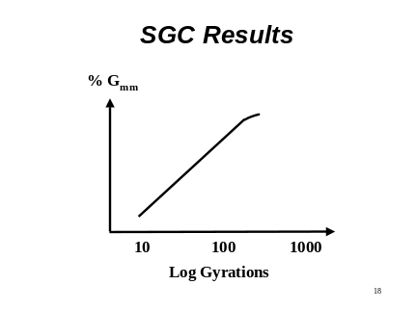 | Using the measured bulk specific gravity of the final specimen and the recorded change in height during compaction, the change in density (%Gmm) with number of gyrations can be calculated. It is typically plotted on a semi-log scale. A smooth sided cylinder is assumed initially and then later corrected based on the measured value for specific gravity.
Slide 19 | 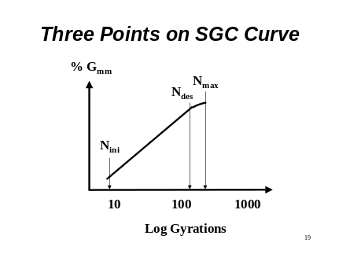 | There are three critical points on the SGC compactor curve that are evaluated in Superpave. Ninital is of importance because it is desirable not to have mixes that compact too easily. Nmaximum is of importance to prevent having mixes that continue to compact under traffic loading.
Slide 20 | 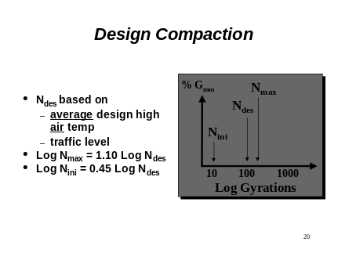 | The level of Ndesign is based on the climate and traffic levels.
Slide 21 | 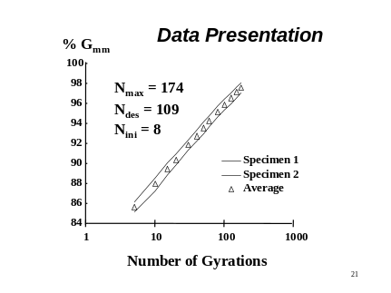 | Because the SGC compaction process is very repeatable, two specimens are used at each blend or binder content being evaluated.
Slide 22 |  | Once the compaction is completed it is necessary to conduct an analysis of the test data to determine the optimum asphalt content.
Slide 23 | 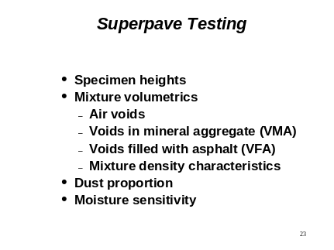 | This data is available or must be calculated to complete the development of the Superpave mix design.
Slide 24 | 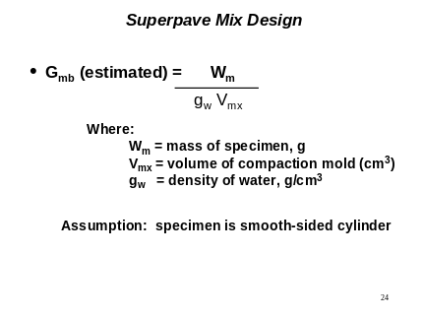 | If the mass of the specimen is known and the volume at each point in the compaction process is known then it is possible to calculate the bulk specific gravity of the specimens at each point on the gyration curve.
Slide 25 | 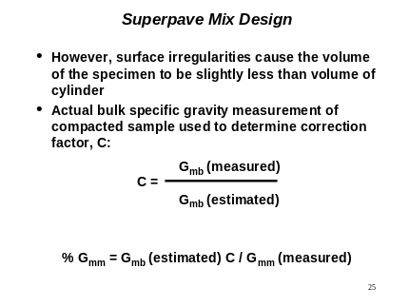 | It is necessary to determine a correction factor for each specimen and apply that to the calculated (estimated) values.
Slide 26 | 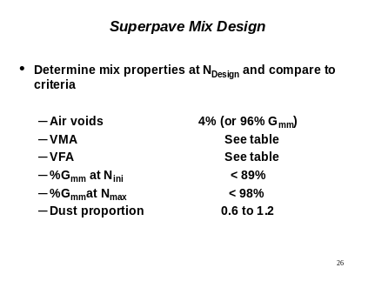 | These properties are determined and compared to the specification criteria.
Slide 27 | 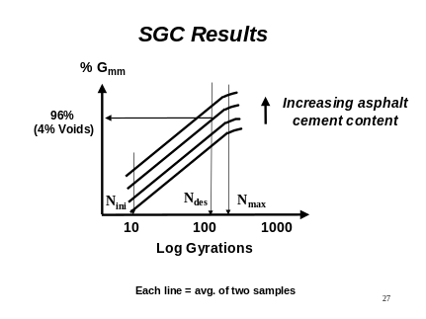 | In the development of a Superpave mix design the binder contend is varied. The binder content is selected at 96% of the maximum specific gravity. At this binder content each of the other criteria is checked.
Slide 28 | 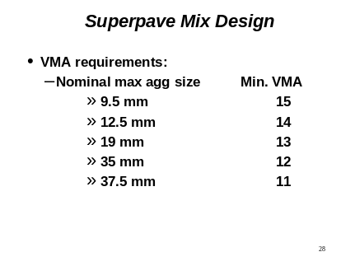 | The VMA is calculated and checked against the requirement for that gradation.
Slide 29 | 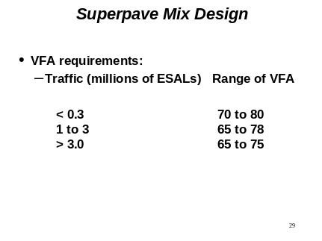 | The VFA is calculated and checked against the criteria for the traffic level.
Slide 30 | 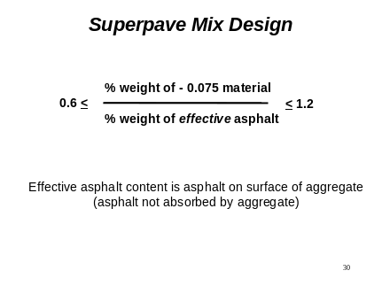 | The FHWA Technical Advisory 5040.27 recommends that the dust level in the mix be controlled. If the dust level is too high the mix will be brittle, if it is too low the mix will have insufficient stability.
Slide 31 | 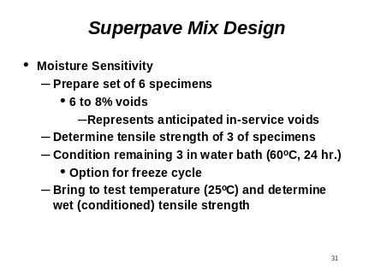 | The mix must also be checked to insure that it is not susceptible to moisture damage.
Slide 32 | 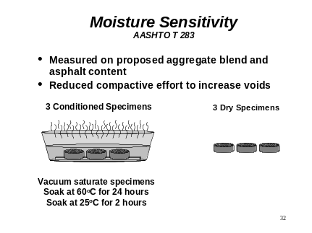 | The procedure is detailed in AASHTO T283.
Slide 33 | 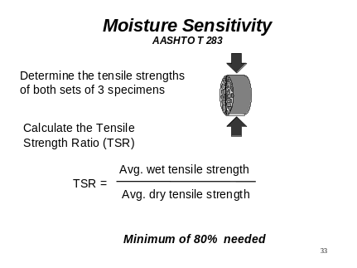 | The tensile strength of the mix is determined both before and after conditioning.
Slide 34 | 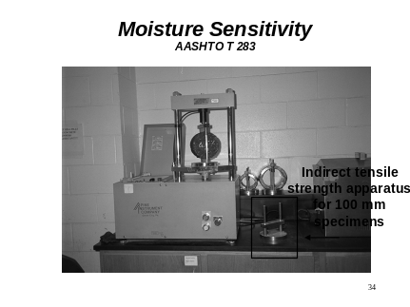 | Many laboratories use the same load frame which used to be used for Marshall stability (Note the Marshall stability breaking heads in the background). The indirect tensile test uses the same specimen orientation but the breaking head has been modified to induce a more theoretically correct application of the load. Note the narrow loading strip.
Slide 35 | 
Slide 36 | 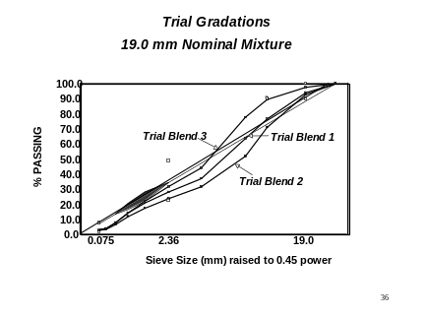 | Typically more that one gradation is evaluated in the mix design process. Remember the goal is to develop and economical mix that meets the specification requirements.
Slide 37 | 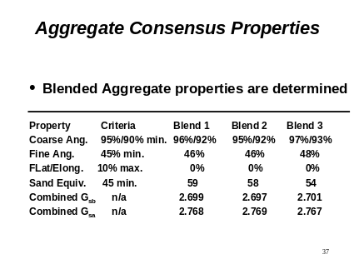 | The aggregate blends are checked to insure that the aggregate requirements are meet which varies with the traffic levels. For example with a mix with ESALs of greater than 3,000,000 will meet the requirements as shown.
Slide 38 | 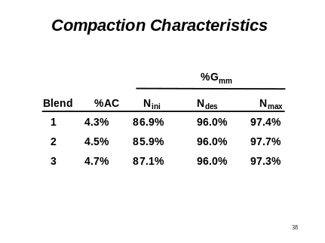 | Then the design binder content is determined for each of the gradations. In this example it can be noted that the mixes meet all of the Superpave compaction criteria.
Slide 39 | 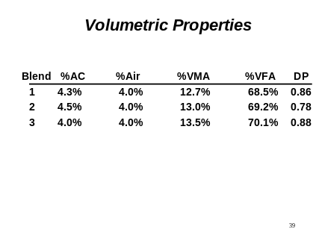 | These were 19 mm mixes. Mix 1 did not meet the VMA criteria which was 13%. Mix 2 was border line on the VMA requirement. HMA mixes will generally have a slightly lower VMA in the field than they have in the laboratory. Therefore, Mix 2 would not be chosen. Mix 3 would be selected. It meets all the criteria and has the lowest AC content thus making it the most economical mixes if the aggregates are roughly the same in all three blends.
Slide 40 | 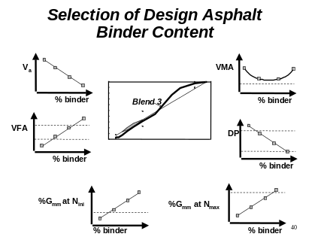 | The final results for blend 2 are plotted.
Slide 41 | 

