TESTIMONY

before

SUBCOMMITTEE - WATER and POWER

SENATE COMMITTEE
ENERGY and NATURAL RESOURCES

JACKSON GULCH REHABILITATION BILL S.1477

by

GARY KENNEDY, SUPERINTENDENT
MANCOS WATER CONSERVANCY DISTRICT

JULY 26, 2007

COMMITTEE CHAIRMAN AND MEMBERS:

I am before you representing the board of directors and residents of the Mancos Water Conservancy District. I am Gary Kennedy, Superintendent of the District for the last 18 years. I would like to thank you for holding this hearing in order that I can provide information on Jackson Gulch Rehabilitation Act of 2007 (S.1477).

HISTORY

First I would like to provide a brief history of the project. The ranchers living in the Mancos valley during the dust bowl of the 1930’s also experienced a devastating drought. This brought about discussion and a study—the end result of this was the construction of Jackson Gulch Reservoir (an off-river dam) providing storage of 10,000 acre feet of water storage. 2.6 miles of feeder canal (Inlet Canal) snakes along the steep West Mancos River Canyon, across a narrow mesa and dumps water from the West Mancos River into Jackson Gulch. Storage water is returned back to the river via 2.2 miles of return flow canal (Outlet Canal).
The Mancos Project was authorized in 1940; construction began in 1941. The CCC’s began construction. During WWII, their camp became the home of many conscientious objectors. In 1947, the Venel Company was awarded the contract for the dam which was completed in 1954.
Construction was continually plagued by interruptions caused by earth slides, rock falls, and adverse weather. Construction roads along the Inlet Canal were constantly being reinforced and rebuilt. In 1958 the Bureau of Reclamation elected to discontinue rebuilding the roads. Natural erosion over the years has narrowed many places to barely walking trail width.
Immense boulders have rolled right through portions of the canal. Mudslides have filled the canal requiring lengthy shut-downs for repairs. This could occur at anytime along the canal today. Fortunately with Reclamation’s assistance, the majority of the concrete flumes are protected from small rock fall and mudslides by concrete lids. However, the earthen sections are still vulnerable to slides that which fill sections and/or take the canal into the canyon with them. We have experienced the loss of 700 feet of canal in the last 10 years. Boulders the size of cars hitting canal walls has created the need for emergency repairs.

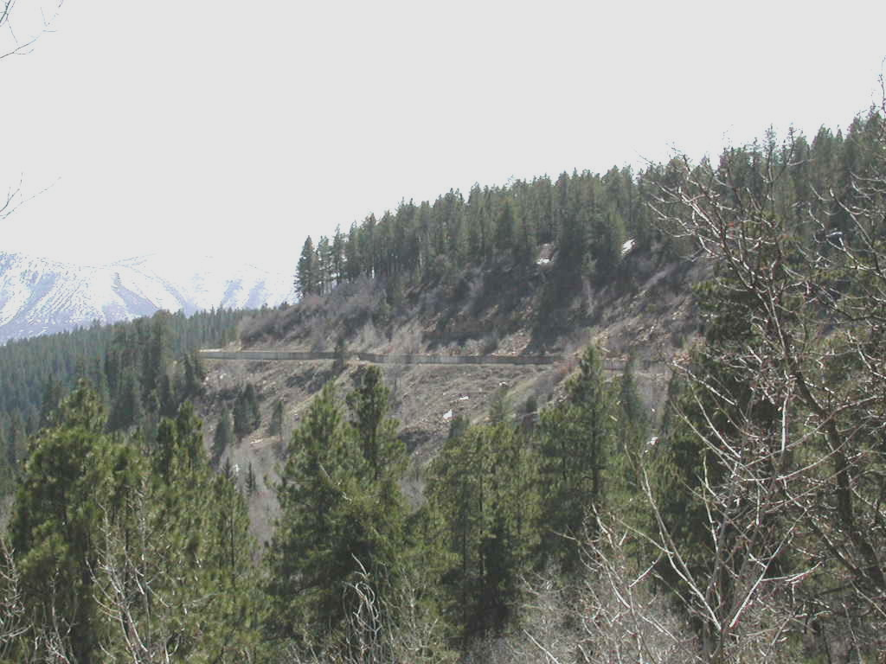
O&M (Operations and Maintenance)

The District assumed operations and maintenance of the project in 1963 and has continued to the satisfaction of the Bureau of Reclamation to date.

In the last 20 years, we have financed and overseen major upgrades to the project such as:

Construction of a permanent diversion dam on the West Mancos River.
Installation of a Hydroelectric Power Plant (increased revenue).
Installation of automated Measuring Devices and Structures (conservation).
Purchase of Canal Easement.
Safety Measures (fences, protective covers on the canal, 200 feet of pipe for safety).
New Equipment for O&M.
500 feet of pipe for Canal Repair.
400 feet of Penstock Pipe Upgrade.
New bridges at canal crossings.

The total amount of money spent during these years for these upgrades is over $850,000.

IMPORTANCE of the MANCOS PROJECT and JACKSON GULCH RESERVOIR

Many valley residents depend on the agricultural land for their livelihood. The town of Mancos and the Mancos Rural Water Company utilize the water stored in the reservoir to supply domestic water to residents. The water provided to over 550,000 annual visitors (742,080 in 1992) to Mesa Verde National Park is supplied by the reservoir.
In 1998, we experienced loss of a section of canal due to a landslide. The emergency repair was exceedingly expensive. In 2002, drought conditions resulted in sacrifice of irrigation water by agricultural producers in order that domestic water could be provided with drastic conservation measures. It is hard to imagine what would have happened had the reservoir not been in place to supply the domestic water. Our agricultural producers are just now recovering from that summer.
It is plainly evident that loss of the reservoir is unacceptable. It is also evident that the District does not and cannot sustain or generate the revenue required to continue emergency management.
Since the loss of the reservoir is not an option and emergency management is cost prohibitive, two options remain--either to rebuild the structures or to rehabilitate the structures. The Board requested a feasibility study from the Bureau of Reclamation for the cost to replace the structures and/or to rehabilitate the structures. The study was completed in 2000. Cost to rebuild was so excessive that rehabilitation was chosen. Projected cost at that time was 5.6 million. A formal engineer study came back with a cost of 6.2 million for total rehabilitation.

CONSEQUENCES OF CANAL FAILURE

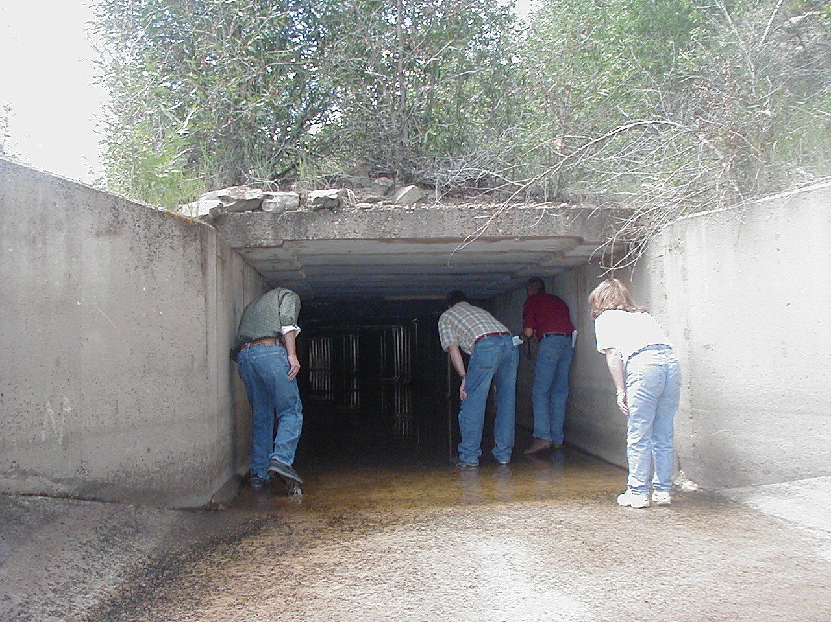
The canals were built in 1947 and 1948. The canals had a flow capacity of 258 c.f.s. They are concrete box flumes in some sections and earthen in others. Natural occurrences and emergency repairs have forced a reduction in our flow capacity. Current capacity is 160 c.f.s.

The earthen canal sections have been plagued with land/mud slides since the start of construction. As stated previously, we’ve lost 700 feet of earthen canal in the last 10 years. Repairs to canal sections cost well over $170,000 requiring loans from the State of Colorado. The failure of the canal area happened after extremely dry summers when the water in the reservoir was lower than normal. In fact, it had been drawn down to historic levels – 18% - equal to 2 years of domestic water supplies.
The concrete box flume was designed and constructed before the use of rubber water stops for construction joints. Over 50% of the construction joints have experienced serious deterioration causing reduced structural integrity. The seepage from deteriorating concrete walls not only reduces the structural integrity, it also contributes to slope instability and failure.
One other hazard to the concrete flumes is rock fall. There is 1,400 feet of the flume that is exposed to high-moderate rock falls. The right rock in the wrong place would destroy a section of the canal causing a large financial hardship due to the manner in which the repair would have to be made (helicopter in most cases). It would also most likely happen during inflow to the reservoir restricting water to the reservoir for an extended amount of time. Depending on the seasonal precipitation, it could take us more than one season to recover and would possibly cause great strain on water availability for domestic and agriculture.
Access is a huge problem to approximately 1,000 feet of concrete flume. The construction road was not rebuilt after it failed in 1958. Rebuilding the road is much more financially responsible than making repairs by helicopter.

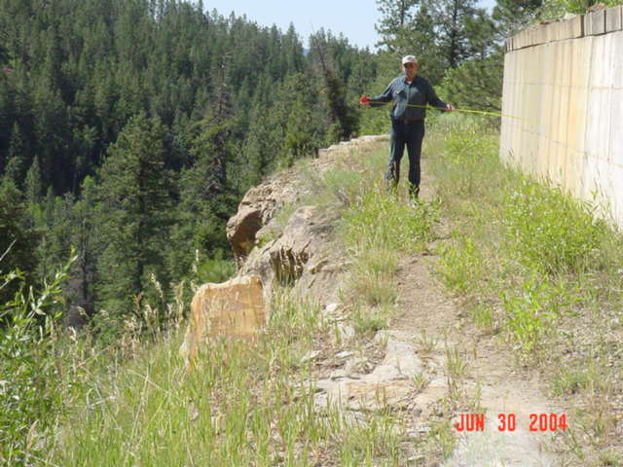
The operation facilities were constructed in 1941-42 as temporary facilities. Partly due to the era and partly due to their temporary status, they were constructed using unconventional building methods. Therefore, these buildings do not conform to uniform building codes and do not comply with federal regulations. The District’s Superintendent is required to live on-site by contract with Bureau of Reclamation. Following 9/11 this is even more important for the safety and security of the project itself.

PREVIOUS LEGISLATION

Most discussion on water projects focus on dams. There are financial programs (grants, etc) for dam safety, water storage, and conservation. However, for the few dams that rely on canals to supply the water for storage, there are no programs to help fund major repairs.
In 1983, P.L. 98-50, 97 Stat. 251 was passed appropriating 3 million dollars for improvement of siphons, concrete liners, improved irrigation efficiency, to conserve water and reduce O&M costs. The cost of this rehabilitation was non-reimbursable and the rehabilitated and new features were turned over to the operating entity for future O&M.

FUNDING

The District began to search for assistance for funding the rehabilitation:

- We studied our ability to increase our income (water rates and taxes). It was immediately evident that the small population of the Mancos Valley could not provide total funding but may be encouraged to accept an increase in their mill levy taxes to cover a small percentage of the overall cost. In 1995 we asked the members of our District to approve a mill levy increase of 5 mills to cover what we felt was a reasonable share of the cost of rehabilitation our residents could provide. The increase would bring our total mill levy to 6.5 mills. The measure passed by a very comfortable margin providing us with not only the increased funds but the absolute knowledge our residents understand the utmost importance of their water supply and supported our efforts.
- Water rates have been gradually increased in past years to cover the cost of emergency repairs and will continue to be gradually increased.
- The Board requested assistance from the Bureau of Reclamation with no success.
- We researched and applied for grants. Our research has revealed that there are no grants, state or federal, large enough to cover the cost. We were successful in securing a small grant to study the effects of lining material in the canal. This will be finalized this year. We were also successful in securing an EPA/Stag grant but have been unable to collect these funds ($250,000).
- We went to the State of Colorado. The State (CWCB) approved a line of credit for engineering, cost share and interim emergency repairs.
- We decided to apply to Washington D.C. for appropriations. We have been here four years in a row with our request for partial funding to be awarded annually until complete (6 years). Each year reveals an increase in the cost due to rapidly increasing construction expenses. And each year brings us closer to a catastrophic canal failure.

Before the study for rehabilitation, the District was aware of the need for increased revenue. After a lengthy process, a hydroelectric power plant was installed. The power plant is providing up to 250 KWH of hydro power or 912,000 KWH annually – enough electric power for 60 homes saving 5,000 barrels of oil annually. The most revenue increase brought in by the hydro plant is $22,000/annually.
CONSEQUENCES OF FAILURE TO SECURE FUNDING

The options for the District should we fail to secure the funding necessary to rehabilitate the project are dismal. We cannot force funds from a source (valley residents) with no funds available. Current funds allow us to do some of the lesser rehabilitation but do not and cannot begin to cover the cost of the overall project. Emergency repairs will become more and more frequent causing the District to incur more and more debt. There will come a point when we will be unable to secure funding to cover the cost of emergency repairs. It is projected that maintenance issues will be forced to be delayed in order to cover emergency repairs.
At that point it is projected that Bureau of Reclamation will begin to express concern and dissatisfaction with the O&M until the District will have no choice but to turn the project back over to Reclamation. When this possibility was brought to discussion before the board and Reclamation, the question was what would happen if this were to occur? The answer given to the board was that Reclamation is no longer in a financial position to operate and maintain this project; therefore in all likelihood the project would be locked up and/or shut down.
If this were to be an eventuality, recreation on the reservoir would cease. Current estimates of visitation to the reservoir are 80,000 people annually. Domestic water organizations would be forced to consider their own storage facilities to maintain some water delivery. Mesa Verde National Park would have to consider a storage facility or the possibility of having to haul water from other delivery points. Irrigated agriculture would cease to exist – limited dry land agriculture may be able to be maintained. If the drought continues, the river would dry up not far below the town limits in the months of July and August possibly through October. There is no way to predict the effect on wildlife, particularly waterfowl. We cannot begin to speculate on the effects to the people themselves.

Therefore, we are here before you now asking for assistance in passage of this Bill. Passage will insure continued use of a project considered extremely vital in the 1940’s and no less vital – if not more so – today. Plus, this Bill not only affects our local area, it will continue to fulfill that part of the Upper Colorado Compact which was established in 1922. It will protect not only the environmental issues connected with the canal system but agriculture, recreation, cultural, historical and futuristic uses. We ask you to observe the vision of our forefathers for the West and keep looking to the future and protect these resources so vital to those who will follow us.
Thank you for this time in order that I could impress upon you the importance of the rehabilitation of the Jackson Gulch Rehabilitation Project Bill S.1477.

