United States Department of Agriculture

Assessing the Economic Impact of
NRCS Programs on the Utah Economy

Abstract

Spending on non-transfer payment federal programs has an impact on the economy that exceeds the value of the initial spending itself. Economic multipliers provide a means of estimating the total economic impact generated by government spending. This report provides estimates of the total values of certain categories of NRCS spending to the economy of the State of Utah as well as to the economy of the United States as a whole. The analysis was conducted using IMPLAN within a social accounting matrix (SAM) framework. The results indicate that in Utah, each dollar of NRCS and private matching expenditures on NRCS conservation programs generates an additional $1.51 in output. Using another measure of economic impacts, the same program spending generates $0.51 in value added income. At the national level, each dollar of NRCS and private matching expenditures on NRCS conservation programs generates an additional $1.49 in national output. Using another measure of economic impacts, the same program spending generates $0.60 in value added income. (As there is some degree of overlap between categories, total economic impact can not be calculated by summing across multiplier effects.)

Introduction

While NRCS natural resource conservation programs create many beneficial impacts on the nation’s landscape, another important outcome is the economic impact of conservation programs on the nation’s economy. In 2004, NRCS analysts undertook the task of evaluating seven years of financial and technical assistance expenditure outlays for eleven NRCS programs in order to assess their impacts on the United States economy at both national and state levels. This analysis was performed using IMPLAN (Impact Analysis for Planning) software and databases within a social accounting matrix (SAM) framework. IMPLAN was originally designed by the USDA Forest Service, the Federal Emergency Management Agency, and the USDI Bureau of Land Management in an effort to improve land and resource management planning. SAM analysis, which is briefly explained in the Appendix, gives a condensed picture of economic activity, measured in terms of expenditures, income, and revenue, within a given geographic region.

“Multipliers” indicate the total amount of economic activity that is estimated to be generated by a specified amount of new spending within a given economic sector and spending category. For example, for every dollar of NRCS cost share money spent on the final products of a given industry sector, the corresponding spending multiplier shows the total amount of economic activity that will be generated by new spending (including the original dollar spent) in the time period during which spending continues. For every job created by NRCS cost-share spending in a given industry sector, the corresponding employment multiplier shows the total labor demand, given in the number of “jobs”, that will be created by that spending (including the original job created). Due to variations in the ability of each state’s economy to supply the inputs necessary to producing the goods and services that are demanded within that state, state-level output and value added income multipliers for a particular industrial sector often differ from their corresponding national measures. All estimates are based on IMPLAN-based SAM models and the corresponding U.S. Census and Bureau of Economic Analysis data used by the program and are subject to any errors and omissions that are inherent to the data collection methodologies utilized by those agencies.

If a spending multiplier is equal to 1.88, this means that if $1,000 cost-share dollars are spent on the final goods produced by that industry sector, an additional $880 of economic activity will be generated within the region of analysis through repeated circulation of the money spent. For example, when a farm supply company is paid for supplies used in implementing a conservation practice, that company pays a percentage of the original cost-share money to its employees in the form of wages. That money is then circulated again as those employees spend their wages on goods and services. The degree to which each dollar originally spent in a region re-circulates within that region is reflected in the multiplier. When compared with other spending multipliers, a lower multiplier generally indicates that goods or services purchased within that industry sector or sectors within that region tend to consist of relatively higher percentages of imported inputs and/or imported finished goods. When any specific good or service is simply unavailable for purchase within a given state, importation of that good or service will result in a relatively lower multiplier effect for the applicable industry in that state. The converse is true for higher multipliers.

Employment multipliers are used to determine the increase in overall labor demand that would be expected to occur as a result of purchases of the output of a particular industry sector. For example, if the employment multiplier for a given industry sector is equal to 1.5, then for each “job’s-worth” of demand created in that sector due to an increase in spending on that sector’s final products, the multiplier effects associated with that industry sector would generate demand for 0.50 additional “jobs” within the geographic region analyzed.

Methodology

The SAM multiplier analysis is an extension of input–output multiplier analysis. It provides a framework for the modeling of revenue and income flows among households and firms, given the introduction of a new expenditure injection or “shock” into the circular flow of a state or national economy. In this analysis, the expenditure shocks are the NRCS expenditures introduced in the 3 scenarios described below. This analysis is driven by new investment demands and/or income transfers to households, which leads to new purchases of goods and services reverberating through the economy. The analysis accounts not only for the purchase of goods and services from final producers needed for the implementation of conservation practices, but also the purchases of inputs from intermediate suppliers, as well as household consumption expenditures out of new wage and profit income generated from the new expenditure shock. IMPLAN is a Windows based software and database that creates the models, undertakes the simulations and produces easily accessible results.

In this study, financial and technical assistance program expenditure data for the Environmental Quality Incentives Program (EQIP), Watershed Surveys and Planning, Watershed Rehabilitation, Farmland and Ranchland Protection Program, Grassland Reserve Program, Wetlands Reserve Program, Wildlife Habitat Incentives Program, Agricultural Management Assistance, Conservation Operations, Watershed Operations, and Resource Conservation and Development programs from 1997 through 2003 were used to construct the scenarios. These data were disaggregated and sorted into five major industry sectors, depending upon the type of expenditure. Financial assistance expenditures were subdivided into expenditures on conservation practices and easement payments. Conservation practice expenditures were partitioned into agricultural services, construction, and materials sectors, depending on the type of practice and type of inputs necessary to install each practice. Producer cost share expenditures were similarly accounted for. Easement expenditures were treated as income transfers to households. Technical assistance expenditures reflected salary payments to government employees and therefore were recorded in the “government services” sector. Data on expenditures that were actually obligated and disbursed were assembled for each state by year for the years 1997-2003. These data do not reflect annual financial obligations for contracts, but rather expenditures on practices that were actually installed and certified that year. Data for each year were then converted to 2004 dollars and aggregated across years to get the total NRCS program expenditures for each of the five sectors described above by state.

Next, SAM models were constructed from the IMPLAN database for the nation and each of the fifty states. The program expenditure data were developed in three scenarios: total program expenditures for 1997-2003, total program expenditures for the year 2003, and EQIP expenditures alone for the years 1997-2003. For each of these scenarios, the economy-wide impacts on total output, value added income, and employment were reported for the nation as a whole as well as for each state. Total output is defined as total sales of goods and services produced in a particular state or national economy. Value added income is defined as the wages and profits and indirect business taxes generated from producing these goods and services. In our results, net contributions to value-added income exclude indirect business taxes since they are exogenous to the SAM multiplier. Employment impacts are expressed as the number of full-time and part-time jobs required to produce these goods and services. It is not appropriate to add together changes in total output and changes in value-added income since each measure captures the effects of the new expenditure shock, albeit at different points in the circular flow of economic activity. In other words, total output effects measure the impact of NRCS expenditures at the firm level, while total value-added income effects measure the same impact on labor and capital income flowing to households. These represent different measures of the same impact of NRCS expenditures, hence value-added income and total output are complementary measures.

Summary of Results

Financial and technical assistance program expenditures for eleven programs from 1997 through 2003 are examined in this analysis. Three scenarios were developed: total program expenditures for 1997-2003, total program expenditures for the year 2003, and EQIP expenditures alone for the years 1997-2003. For these three scenarios, the resulting impacts on total output and value added income are reported for the nation as well as each state. These represent different measures of the same impact of NRCS expenditures, hence value-added income and total output are complementary measures. In order to avoid double counting, employment effects of NRCS program expenditures are reported only for the 2003 year. Total output is defined as total sales of goods and services produced in a particular state or national economies. Net contributions to value added income are defined as the wages and profits generated from local production of goods and services. Employment impacts are expressed as the number of full-time and part-time jobs required to produce these goods and services. All of the multipliers and corresponding dollar values or numbers of jobs in this report are estimates that were generated by the models applied in the analysis, as explained above.

The total output impact in Utah of NRCS program and private matching expenditures from the years 1997-2003 of approximately $103 million was $258 million in 2004 dollars. This reflects the output multiplier showing that for every $1 spent in Utah as a result of NRCS programs, the multiplier effect generated $2.51 in output, of which $1.51 represents additional induced and indirect effects. Using the same measures, the national output impact of NRCS program and private matching expenditures of $10.1 billion during the same time period was $25.2 billion in 2004 dollars. This shows that for every $1 spent nationwide as a result of NRCS programs, the multiplier effect generated $2.49 in output, of which $1.49 represents additional induced and indirect effects.

In Utah, the total impact of value added income of the eleven NRCS program and private matching expenditures of $103 million for the years 1997-2003, was nearly $156 million. This reflects the value added multiplier at the national level showing that for every $1 spent on NRCS programs, the multiplier effect generated $1.51 in value-added income, of which $0.51 represents additional induced and indirect effects. The total national impact of value added income of the eleven NRCS program and private matching expenditures of $10.1 billion for the years 1997-2003, was $16.2 billion. This shows that for every $1 spent nationwide on NRCS programs, the multiplier effect generated $1.60 in value-added income, of which $0.60 represents additional induced and indirect effects.

The impact of a given $1 of program expenditure varies widely between states. There are three reasons for this: First, the types of programs used most frequently and the rates of cost share for conservation practices vary within the states. Programs supporting more construction-intensive activities induce more direct and indirect purchases. When coupled with lower cost share rates, this encourages more private spending and, therefore, greater total spending given a fixed government program budget. Second, the amount of funding available to the state varies greatly. Therefore, the more spent in a state the larger the economic impact. Third, the ability of a given state’s economy to meet the new demand for goods and services also varies by state. Some states are able to produce more of the required intermediate goods internally, which preserves more valued-added income within the state. Other states must import more intermediate goods, allowing these income generating opportunities to leak out to other states. Generally, the more services and industries residing within a state’s borders to meet the demand generated from conservation program expenditures, the larger the impact realized within that state.

The total employment impact for Utah for fiscal year 2003 NRCS programs was 773 jobs created and/or maintained. The total employment impact for the nation for the same fiscal year for all NRCS programs was 50,227 jobs created and/or maintained. The total national employment impact for the fiscal year 2003 EQIP program was 12,251 jobs created and/or maintained. The aggregate multipliers for all NRCS program expenditures for value added income and total output that resulted in these figures for the period 1997-2003 are listed for the Unites States as a whole and for each state in Table 1 near the end of this document.

Results

NRCS Program Impacts on Total Output

The change in total output reflects the total impact on final and intermediate demand induced by NRCS program expenditures. This impact consists of a direct effect, indirect effects, and induced effects. The direct effect is the initial NRCS expenditure on a particular set of sectors. The indirect effects represent firms’ purchases of intermediated goods by the particular sector. The induced effects occur when these new firm activities generate new income for households who, in turn, spend this additional income on goods and services. In other words, as NRCS payments are disbursed to farm and non-farm enterprises, the multiplier models account for the changes in income and expenditures of direct and supporting industries and services as well as the new jobs needed to implement the NRCS programs.

Figure 1.
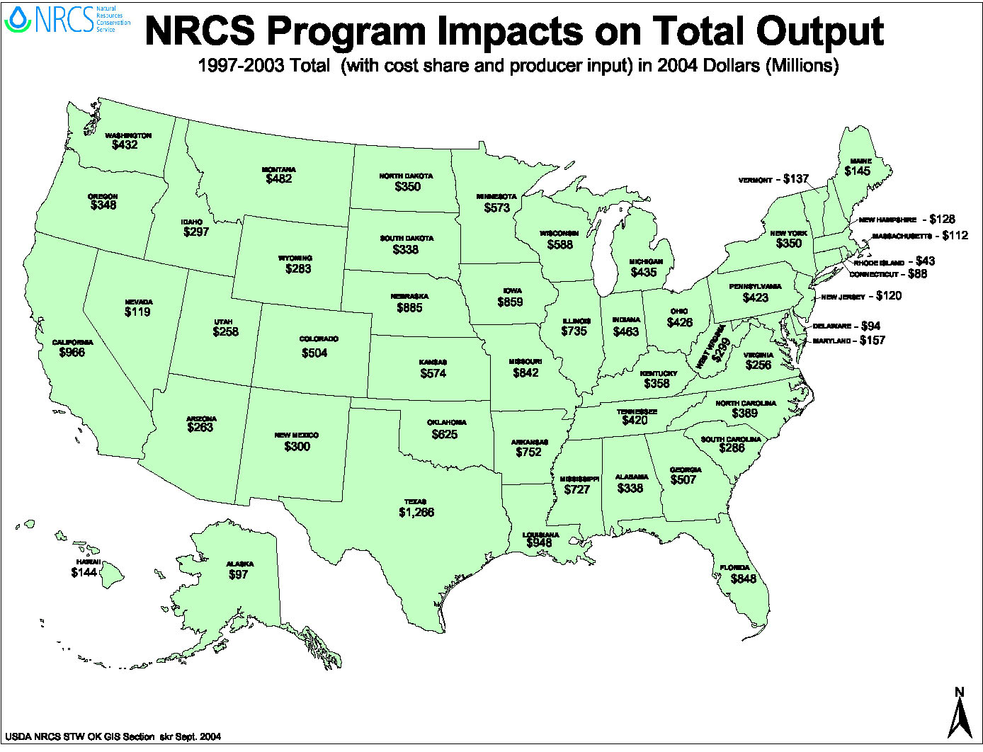

Figure 2.
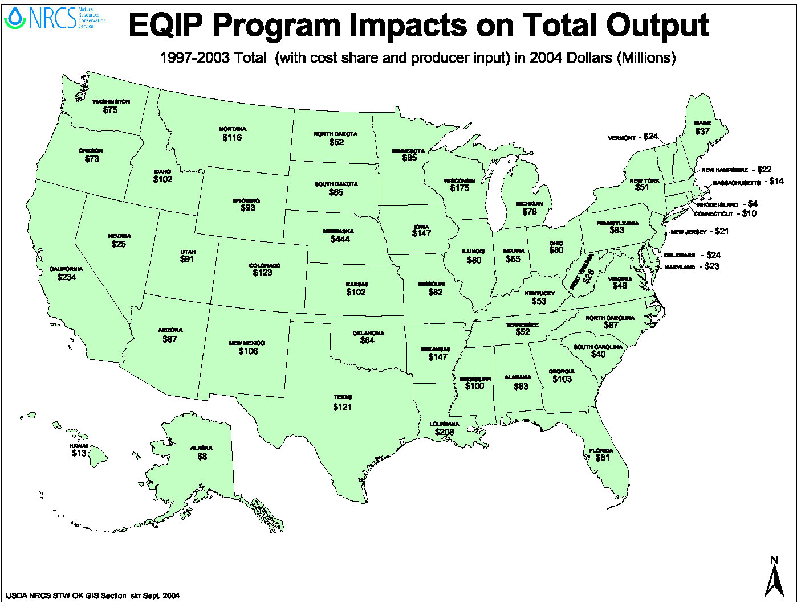

NRCS program and matching private expenditures in Utah of $103 million for the 1997-2003 period are estimated as having generated approximately $258 million in new production of goods and services. This reflects the output multiplier showing that for every $1 spent in Utah as a result of NRCS programs, the multiplier effect generated $2.51 in output, of which $1.51 represents additional induced and indirect effects. Nationwide, NRCS program and matching private expenditures of $10.1 billion for the 1997-2003 period are estimated as having generated $25.2 billion in new production of goods and services. This shows that for every $1 spent nationwide as a result of NRCS programs, the multiplier effect generates $2.49 in output, of which $1.49 represents additional induced and indirect effects.

Figure 3 illustrates the impact of NRCS programs on the economy.

Figure 3.
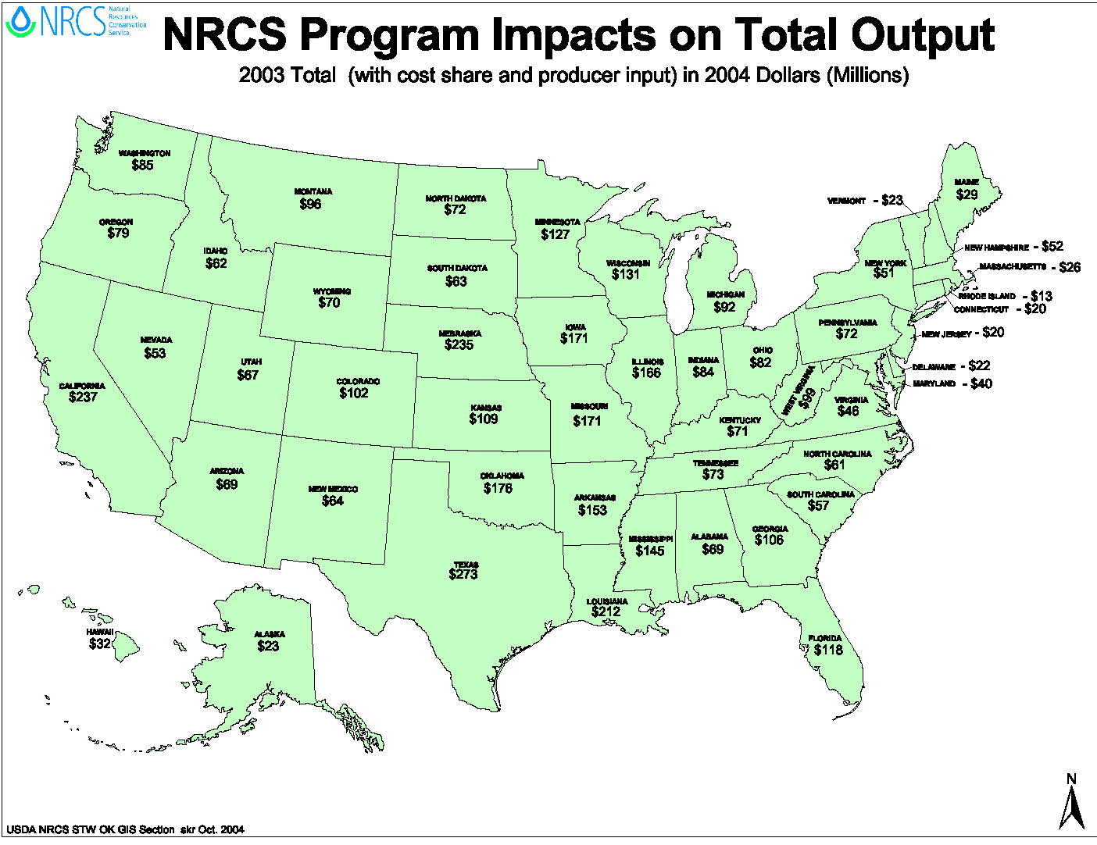

NRCS Program Impacts on Value Added Income
Value added income refers to the additional labor income (wages) and property income (rents) that are realized as a result of the increase in new economic activity spurred by the conservation program expenditures. Value-added income is sometimes call “factor income” because it represents payments for the use of the factors of production: labor, and capital. The $103 million in government and private matching outlays for the eleven NRCS programs for the years 1997-2003 generated nearly $156 million in wages and capital income. This reflects the value added multiplier for Utah showing that for every $1 spent on NRCS programs, the multiplier effect generated $1.51 in value-added income, of which $0.51 represents additional induced and indirect effects. Nationally, the $10.1 billion government and private matching outlays for the eleven NRCS programs for the years 1997-2003 generated $16.2 billion in wages and capital income. This reflects the value added multiplier at the national level showing that for every $1 spent on NRCS programs, the multiplier effect generated $1.60 in value-added income, of which $0.60 represents additional induced and indirect effects.

Figure 4 illustrates the effect of all NRCS programs on value added income for the cumulative 1997-2003 expenditures on a state by state basis. Figure 5 displays the effect of EQIP expenditures only over the same time period. Finally, Figure 6 illustrates the effect of all 2003 program expenditures.

Figure 4.
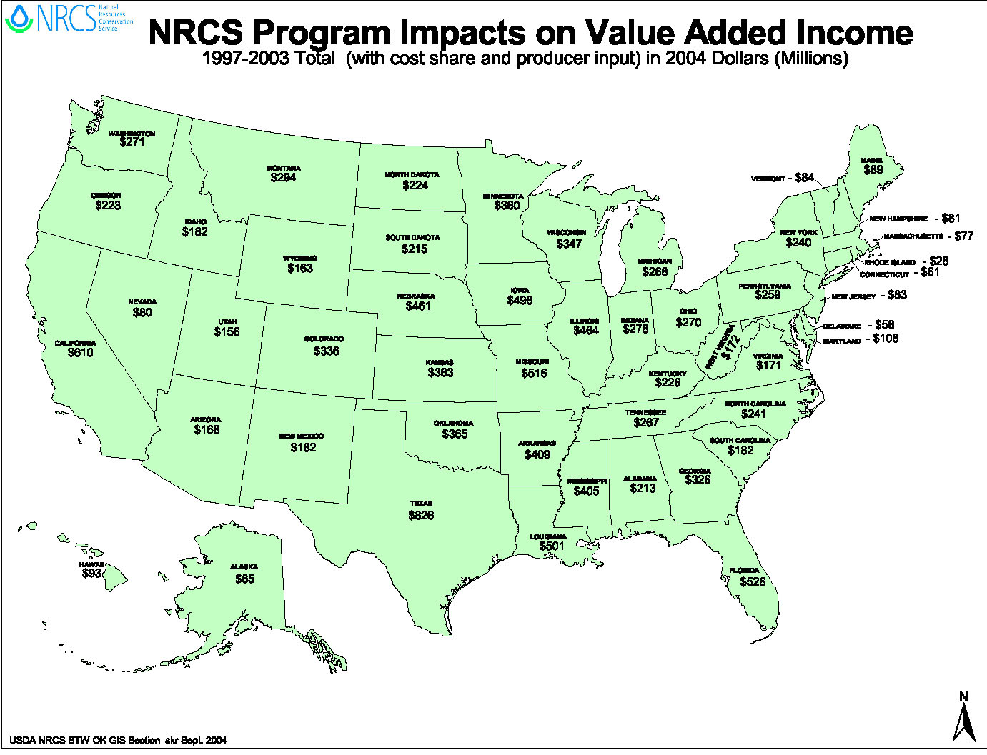

Although the effects of value added income are smaller in magnitude than total output, they are nonetheless significant because they are a measure of regional well-being, or gross regional income.

EQIP impacts are more sensitive to cost share rate within the states. The lower the cost share rates for conservation practices, the more total expenditures within the state there are due to increased producer and/or state expenditures given the same government expenditures. This is, furthermore, a function of the amount of EQIP funds initially allocated to each of the states as well as the ability of the infrastructure within each state to handle the increased demand for goods and services.

Figure 5.
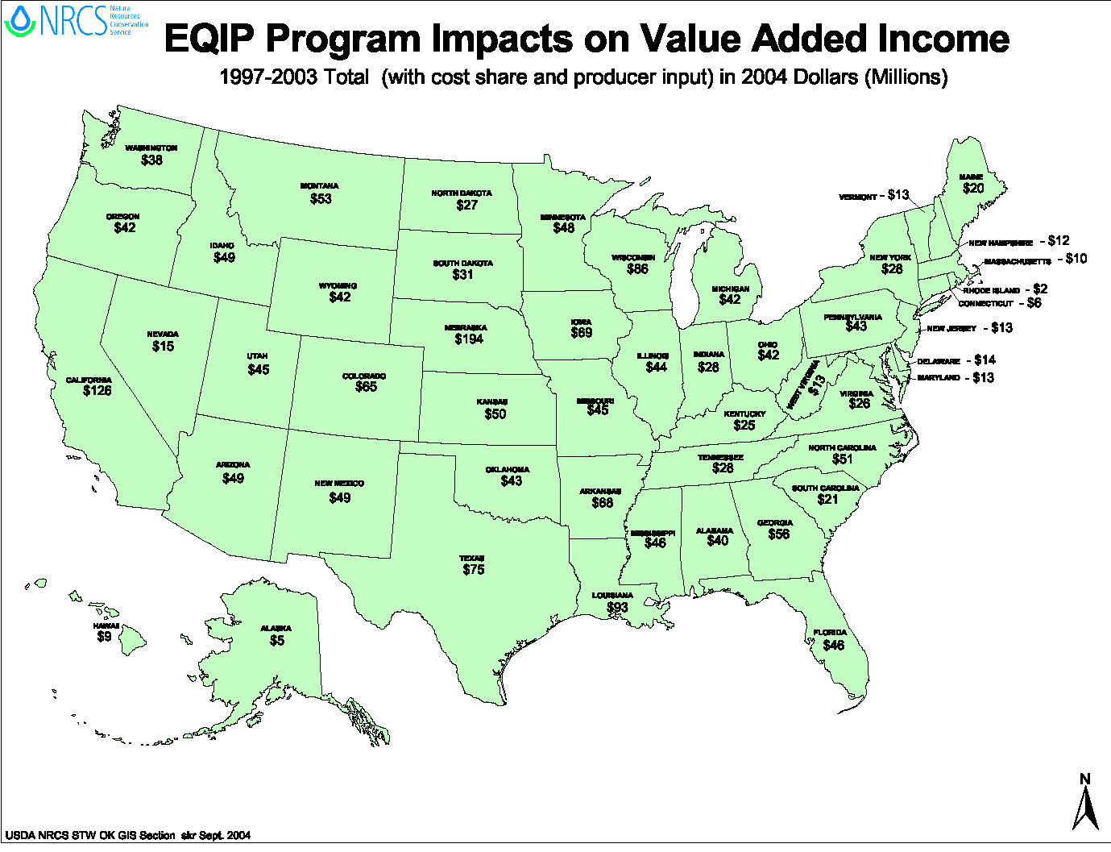

Figure 6.
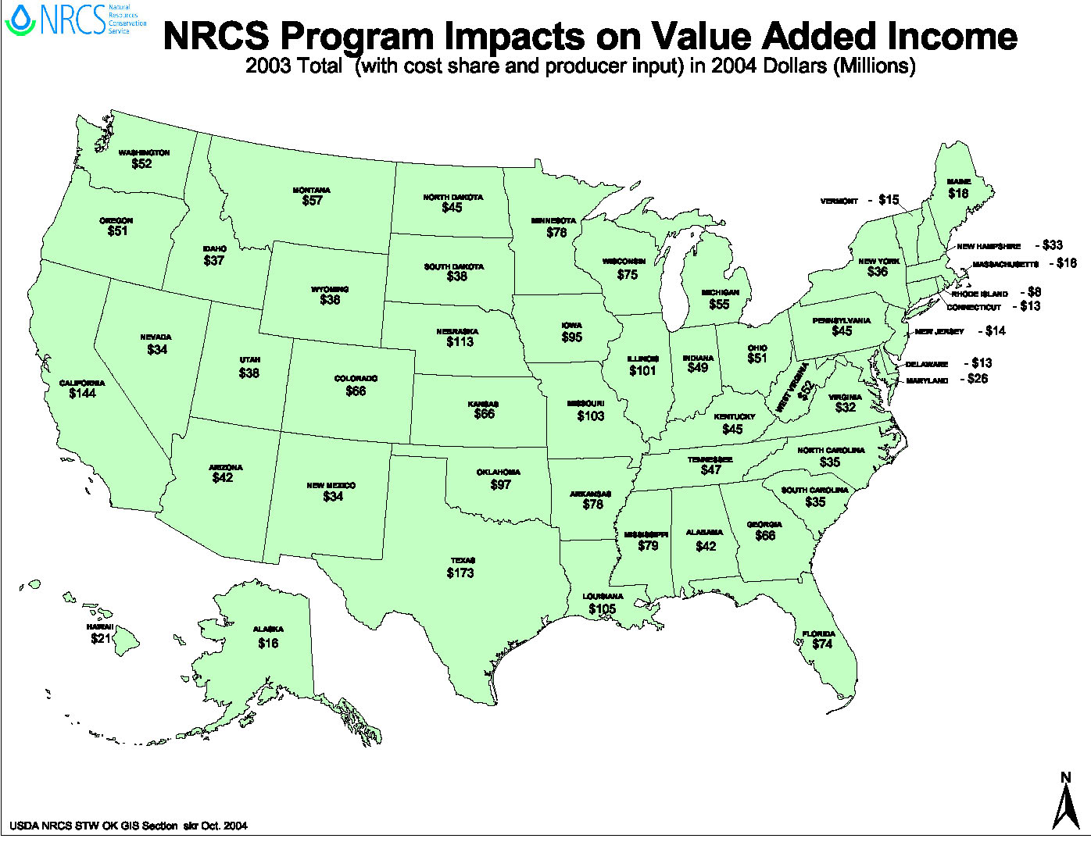

NRCS Program Impacts on Employment

Employment reflects the impact on jobs due to the increased economic activity and by increased goods and services demanded. The employment figure does not necessarily reflect the number of new jobs created due to the new economic activity, but rather the combination of new jobs created and current jobs supported via the new activity. The employment impacts are reported as the number of full and part-time jobs created or retained. Reporting the cumulative employment figure for all NRCS programs over the entire study period would be double-counting jobs, since the same set of jobs could complete a set of projects from year to year. For example, NRCS outlays for technical services in a particular state probably pays in part the annual salaries of the same local experts from year to year. Or, as an induced effect on employment, NRCS expenditures may support the same jobs in retail services in rural areas from year to year. The problem faced here is that sufficient data do not exist to distinguish between those jobs supported or maintained by these expenditures versus the new jobs created for each year. Therefore, simulating the impacts of NRCS program expenditures for the 2003 year best captures the employment impacts.

The total employment impact for Utah for fiscal year 2003 NRCS programs was 773 jobs created or supported. Nationally, the total employment impact for fiscal year 2003 NRCS programs was 50,230 jobs created or supported. The total national employment impact for the fiscal year 2003 EQIP program was 12,250 jobs created or supported. Therefore, based on the multiplier effect at the national level, EQIP alone accounts for roughly 25% of the total jobs created or supported through NRCS program funding. Figure 7 displays the employment impact for all programs in fiscal year 2003 by state and Figure 8 illustrates the employment impact of the EQIP program in fiscal year 2003 by state.

Figure 7.
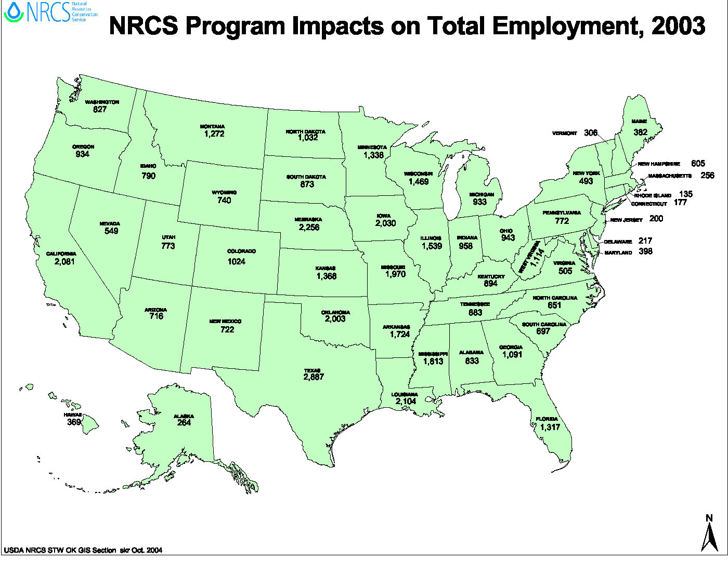

Figure 8.
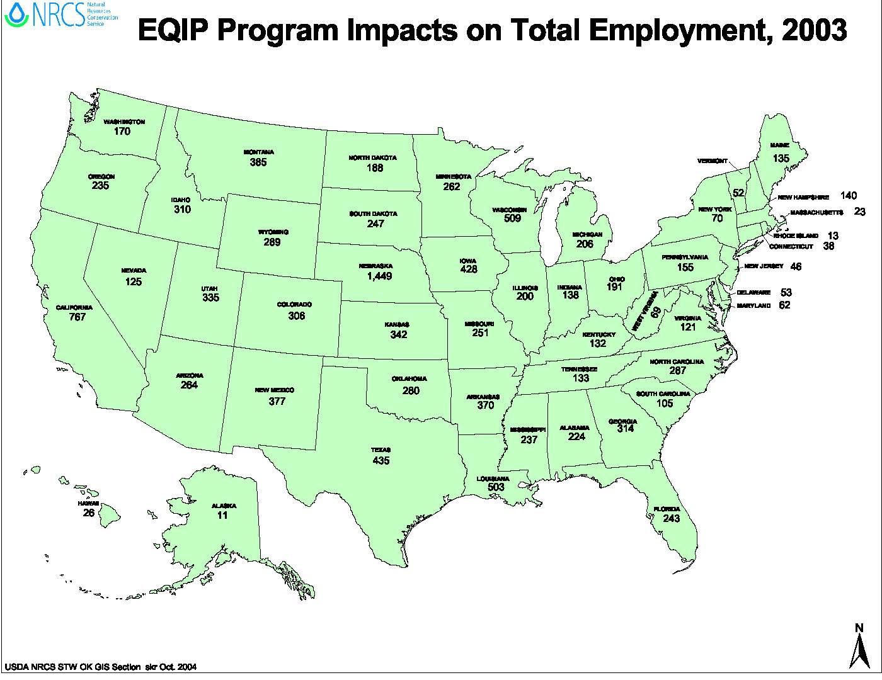

The number of jobs that NRCS program expenditures create or support represents the direct, indirect, and induced changes in labor demand and reflects the magnitudes of the potential increase in jobs. Although our simulations project increases in labor demand, changes in actual employment levels cannot be assessed by this framework since it assumes that excess supply of capital and labor are readily available to support the new labor demands. The dynamics of a local labor supply response depend on the actual level of current unemployment as well as depending on the expected duration of the jobs created. For example, if a particular region is experiencing tight labor market conditions and the new construction jobs created by a particular NRCS project are temporary in nature, then a relatively higher wage may be required in order to entice labor away from other, longer-term employment in order to get the NRCS project completed. Conversely, if the new project is perceived as part of a stream of annual projects funded by NRCS state-level outlays occurring over a period of years, then suppliers will be more likely to hire permanent new workers in order to meet this demand. In rural areas, to the extent that there exists open unemployment, NRCS projects will tend to induce the creation of new jobs. On the other hand, to the extent to which there is disguised underemployment in the form of rural workers who are visibly active but underutilized, NRCS projects will tend to contribute to job retention.

SAM modeling is not designed to provide complex analyses of labor markets. The model’s assumption that labor supply is perfectly responsive to demand shocks is the opposite of the standard assumption of full employment in local labor markets. For this reason, the employment impacts predicted by the SAM model represent, at best, the upper limit of the number of jobs created or supported by NRCS programs. Taking into account actual adjustment dynamics and the structures of local labor markets would probably mean that fewer actual new jobs would be created than predicted by the SAM model. It is not expected that the number of jobs that the model predicts will be annually maintained would be affected by local labor market conditions.

Economic Multipliers

Table 1 lists the NRCS program multiplier effects for value added income and total output over the years 1997-2003 as well as listing the aggregate multipliers both for the nation as a whole and state-by-state. The first column displays the total NRCS financial and technical assistance expenditures by state in 2004 dollars for the eleven programs. The second column in Table 1 shows total expenditures when producer cost-share contributions are included in total spending. This column represents the new expenditure shocks used in our simulations. Columns three and four show the total value added and total output impacts of total NRCS program and producer expenditures. Columns five and six show the NRCS multipliers for value added and total output. These multipliers reflect the total output and total value-added income generated from $1 of NRCS program outlays. This can be interpreted as follows, using the United States as an example: Each dollar spent on NRCS programs generates $2.49 in total output and generates $1.60 in total value-added income.

Conclusion

This analysis reveals how important NRCS program expenditures are to the national and individual states’ economies. Depending on the state, for every dollar expended by NRCS and private matching funds, a range of $1.95 to $2.96 of total output is generated, with an average of $2.49 nationally. The total employment impact for the nation for fiscal year 2003 NRCS programs was 50,230 jobs created or maintained. The total national employment impact for the fiscal year 2003 EQIP program was 12,250 jobs created or supported. Programs that provide a perceived steady stream of income and which encourage the construction of structural practices have the greatest impact on long-term employment.
Table 1. All NRCS Program Multiplier Effects for U.S. and Individual States
 | Program Expenditures (Thousands of 2004 $) |  | Economic Impacts (Thousands of 2004 $) |  | Aggregate Multipliers  for All Programs (Total)
 | NRCS Program Expenditures | NRCS Program and Matching Private or State Expenditures | Total Value Added | Total Output | Total Value Added | Total Output
UNITED STATES | $9,027,041 | $10,109,535 | $16,203,873 | $25,201,540 | 1.60 | 2.49
ALABAMA | 126,266 | 145,930 | 212,624 | 337,861 | 1.46 | 2.32
ALASKA | 43,929 | 46,296 | 65,365 | 96,584 | 1.41 | 2.09
ARIZONA | 102,677 | 120,565 | 167,505 | 263,473 | 1.39 | 2.19
ARKANSAS | 291,586 | 329,464 | 408,743 | 751,848 | 1.24 | 2.28
CALIFORNIA | 352,461 | 420,241 | 609,603 | 965,893 | 1.45 | 2.30
COLORADO | 206,125 | 231,273 | 336,000 | 504,319 | 1.45 | 2.18
CONNECTICUT | 37,773 | 39,464 | 61,085 | 88,330 | 1.55 | 2.24
DELAWARE | 35,840 | 38,354 | 58,483 | 94,406 | 1.52 | 2.46
FLORIDA | 268,349 | 286,562 | 526,059 | 847,822 | 1.84 | 2.96
GEORGIA | 173,953 | 202,223 | 326,058 | 507,281 | 1.61 | 2.51
HAWAII | 59,016 | 64,580 | 93,032 | 143,947 | 1.44 | 2.23
IDAHO | 115,234 | 144,801 | 181,595 | 296,903 | 1.25 | 2.05
ILLINOIS | 265,824 | 285,065 | 464,367 | 735,417 | 1.63 | 2.58
INDIANA | 193,527 | 201,425 | 277,770 | 462,613 | 1.38 | 2.30
IOWA | 344,793 | 385,114 | 497,639 | 859,050 | 1.29 | 2.23
KANSAS | 233,804 | 258,377 | 363,266 | 573,881 | 1.41 | 2.22
KENTUCKY | 161,172 | 173,033 | 226,253 | 357,747 | 1.31 | 2.07
LOUISIANA | 315,929 | 381,307 | 500,708 | 947,569 | 1.31 | 2.49
MAINE | 52,287 | 58,862 | 89,435 | 145,039 | 1.52 | 2.46
MARYLAND | 72,220 | 76,166 | 107,560 | 157,464 | 1.41 | 2.07
MASSACHUSETTS | 46,912 | 49,399 | 77,215 | 112,359 | 1.56 | 2.27
MICHIGAN | 179,431 | 193,861 | 267,661 | 434,694 | 1.38 | 2.24
MINNESOTA | 219,389 | 232,423 | 360,065 | 573,336 | 1.55 | 2.47
MISSISSIPPI | 307,020 | 339,917 | 405,213 | 726,872 | 1.19 | 2.14
MISSOURI | 325,825 | 348,827 | 516,159 | 841,954 | 1.48 | 2.41
MONTANA | 202,510 | 225,169 | 293,791 | 482,292 | 1.30 | 2.14
NEBRASKA | 223,115 | 377,781 | 461,359 | 884,955 | 1.22 | 2.34
NEVADA | 49,732 | 55,149 | 80,273 | 118,969 | 1.46 | 2.16
NEW HAMPSHIRE | 46,088 | 52,636 | 81,365 | 128,155 | 1.55 | 2.43
NEW JERSEY | 45,196 | 51,424 | 83,440 | 119,830 | 1.62 | 2.33
NEW MEXICO | 115,603 | 153,951 | 181,544 | 300,391 | 1.18 | 1.95
NEW YORK | 154,021 | 165,673 | 239,907 | 349,969 | 1.45 | 2.11
NORTH CAROLINA | 147,088 | 166,729 | 241,332 | 388,652 | 1.45 | 2.33
NORTH DAKOTA | 166,047 | 177,072 | 223,524 | 350,347 | 1.26 | 1.98
OHIO | 162,915 | 181,860 | 269,728 | 425,883 | 1.48 | 2.34
OKLAHOMA | 231,828 | 256,196 | 364,840 | 624,549 | 1.42 | 2.44
OREGON | 136,678 | 150,111 | 223,194 | 348,123 | 1.49 | 2.32
PENNSYLVANIA | 140,204 | 164,358 | 259,134 | 423,268 | 1.58 | 2.58
RHODE ISLAND | 17,592 | 18,468 | 28,167 | 43,434 | 1.53 | 2.35
SOUTH CAROLINA | 125,949 | 131,954 | 181,556 | 286,288 | 1.38 | 2.17
SOUTH DAKOTA | 149,340 | 160,808 | 215,053 | 338,034 | 1.34 | 2.10
TENNESSEE | 153,999 | 164,018 | 266,850 | 419,736 | 1.63 | 2.56
TEXAS | 472,493 | 498,837 | 825,890 | 1,265,870 | 1.66 | 2.54
UTAH | 91,359 | 103,012 | 155,899 | 258,378 | 1.51 | 2.51
VERMONT | 51,284 | 57,767 | 84,414 | 137,327 | 1.46 | 2.38
VIRGINIA | 111,891 | 126,017 | 171,442 | 255,559 | 1.36 | 2.03
WASHINGTON | 188,795 | 208,689 | 270,652 | 432,359 | 1.30 | 2.07
WEST VIRGINIA | 120,636 | 134,172 | 172,018 | 298,501 | 1.28 | 2.22
WISCONSIN | 198,019 | 247,692 | 347,050 | 588,313 | 1.40 | 2.38
WYOMING | 104,903 | 125,010 | 163,009 | 282,704 | 1.30 | 2.26

APPENDIX

(i) The Social Accounting Matrix Multiplier Model

The social accounting matrix (SAM) provides a snapshot view of the circular flow of economic activity in the form of double-entry accounting. In this framework, national income and product accounts and input-output production accounts are represented as expenditures (debits) and income and revenue flows (credits) in balance sheets of activities and institutions. Activities are industries and services, and institutions are households, firms, government, and the rest of the world. The SAM also serves as the basis for the SAM multiplier model.

In Appendix Figure 1, we just consider the circular flow of economic activity just among households and firms. Industries purchase intermediate goods from other industries, pay out wages and remit profits for the different labor and capital services, and take in revenue for the sale of output. In turn, households allocate a portion of their income on an array of consumption goods and savings and pay taxes. The input-output multiplier (represented by the dotted green box in Appendix Figure 1) just captures the indirect effects of firm purchases of intermediate goods and services. In the input-output model, the point of impact of the direct effects can only occur at the firm level.

Appendix Figure 1.

Households
Firms
Goods &
Services
Factors
Intermediates
SAM and Input-Output Multiplier Models
Supply
Costs
Revenue
Demand
(Linkages in an Input-Output
Multiplier Model)
(Linkages in a Social Accounting Matrix Multiplier Model)

The SAM multiplier model (represented by the dashed blue box) incorporates not only the direct and indirect input-output effects but also the induced effects of household expenditures. It endogenizes the linkage effects in the circular flow of economic activity between households and firms. The SAM multiplier model also opens up two additional points of initial impact of an exogenous expenditure: (i) income transfers to households impact households first and then reverberate through the economy; and (ii) changes in factor income first impacts the factor markets for labor and capital and then reverberates through the economy.

The SAM multiplier model represents the most general case of fixed-coefficient, linear multiplier models. It is considered the benchmark multiplier model. Extended input-output models (such as Type II, Type III, and Miyazawa multiplier models) represent partial closures of multisectoral equilibrium. These latter models either do not capture the full impacts, or, depending on the parameters used, produce approximations that may understate or overstate the true impacts. This analysis properly transfers NRCS payments directly to producer households and to the household account in the SAM models.

Two assumptions require caution in interpreting policy results using the SAM multiplier model. First, as is the case for the other fixed-coefficient, linear multiplier models, prices are assumed to be fixed in the SAM multiplier models. For the state economic models, this assumption is quite appropriate since prices are determined nationally. For the national model, this assumption causes little harm since the size of the initial expenditure shock—that is, the total of all NRCS expenditures—is very small relative to the size of the U.S. economy. Second, these models assume that supply is perfectly elastic. The assumption of perfect elasticity means that there will always be unemployed resources waiting to meet increases in demand. To put this in non-technical terms, whenever someone needs more workers, more workers will be ready and waiting. The assumptions of fixed prices and perfectly elastic supply together define a world without scarcity. Therefore, results reported here represent at best the upper bounds of the response to a positive stimulus and lower bounds to a negative stimulus.

The SAM multiplier framework is a major tool available in the regional economics toolkit. It is designed to assess the output, value-added income, and employment impacts of an exogenous stimulus. The strength of this framework is that it can do so at many different levels of sectoral detail. As noted above, this framework's weakness lies in the assumptions underlying the model. These assumptions provide the policy analyst with an imperfect, rigid framework possessing complex multisectoral and institutional detail about a particular regional economy.

By itself, what does the SAM framework leave out? Such policy issues as changes in consumer or producer surplus, benefit-cost analysis for an individual project, and imputing dead-weight losses associated with or the values of non-market natural resource goods supported by an NRCS project cannot be addressed by this framework. These policy issues exist in a microeconomic theoretic framework and are best answered using welfare economics modeling and analysis. A carefully-designed computable social welfare model utilizing the SAM as its data platform can be used to undertake aspects of welfare analysis in a multisector setting. However, the technical requirements and the levels of staff expertise required to complete such an analysis increase in orders of magnitude.

(ii) Converting Investment Demand by Sector of Destination into Investment Demand by Sector of Origin

Many of the NRCS program outlays represent expenditures in completing a project supporting an agricultural producer’s conservation plan. The task is to translate the NRCS program expenditures, expressed in terms of project demands, into expenditures on capital goods and services supplied by the industrial sectors in a state economy. This is a two step process.

The first step is to cost out these projects according to the industrial sector supplying the good or service. For example, as illustrated in Appendix Table 1, we identify 5 conservation practices funded by the EQIP program in South Dakota for the year 2000. Row 1 represents the EQIP outlays, while row 2 represents the producers’ cost shares. Different projects have different cost shares. The larger the cost share, the more EQIP pays out—summed together in row 3, the EQIP and producer cost share outlays represent the project’s total expenditures. The total expenditures represent the costs of building a pipeline or a pond or of undertaking pasture and hayland planting. For each project (lines 4a-4e), NRCS technical staff apportioned these outlays into how much was spent on the inputs: construction, manufactured goods, and/or business services. Technical assistance provided by NRCS staff is recorded as an expenditure to the government services sector. In line 5, the values of the goods or services supplied by the industrial sector are summed across all projects. Hence, in this example, NRCS and NRCS cooperators and partners spent $1,251,829 on construction, $312,957 on manufactured goods, and $251,773 on business services in order to implement these 5 projects. This is what is meant by converting investment demand by sector of destination—which sector demands the goods (in this case agriculture) into investment demand by sector of origin—which sector supplies the goods. NRCS analysts separated out the costs of materials, construction services, and business services for all of the EQIP projects that were undertaken in each state within the U.S. for each year from 1997 through 2003. Next, they added together these expenditures by sector for each state, calculating state-wide direct impacts on construction, manufactured goods, and service sectors. Together with household transfers and outlays for technical services, the values of the inputs constitute the direct effect of NRCS outlays on a state economy.

Appendix Table 1.
Investment by sector of origin
 | Project:
Expenditures: | Pasture & Hayland Planting |  | Pest Management |  | Pipeline |  | Pond | Prescribed Grazing
1. EQIP | $116,836 |  | $1,725 |  | $344,792 |  | $397,913 | $1,900
2. Producer cost share | 130,631 |  | 0 |  | 266,764 |  | 555,316 | 681
3. Total project | 247,467 |  | 1,725 |  | 611,556 |  | 953,230 | 2,581
Investment by sector of destination (suppliers of goods & services)
 |  | Sector:
Project: |  | Construction |  | Manufactured Goods |  | Business Services |  |  | Project Total
4a. Pasture & Hayland Planting |  | $0 |  | $0 |  | $247,467 |  |  | $247,467
4b. Pest Management |  | 0 |  | 0 |  | 1,725 |  |  | 1,725
4c. Pipeline |  | 489,245 |  | 122,311 |  | 0 |  |  | 611,556
4d. Pond |  | 762,584 |  | 190,646 |  | 0 |  |  | 953,230
4e. Prescribed Grazing |  | 0 |  | 0 |  | 2,581 |  |  | 2,581
5. Total |  | 1,251,829 |  | 312,957 |  | 251,773

The second step in transforming the data is to recognize that certain state economies do not possess a sufficiently varied industrial structure capable of supplying specialized capital goods. These state economies must import the capital goods. The IMPLAN software allows us to use regional purchasing coefficients to adjust how much of the demands reported in row 5 of Appendix Table 1 can be supplied by a particular state economy. If the regional purchasing coefficients approach 1.00, then most of the demands can be supplied by the state economy. As a general rural of thumb, most, if not all of construction services are supplied by firms residing in a state. If the regional purchasing coefficients approach 0.2, for example, then only 20 percent of the demand in a state economy could be supplied by local industries. For each aggregated industry sector, the aggregated regional purchasing coefficient is a weighted average of the regional purchasing coefficients of the 364 manufacturing sectors in the national and state models.

Regional Impacts of NRCS Programs Analysis Team Members:

David Buland, Economist, NRCS National Technology Support Center – Central Region
Lynn Knight, Former Senior Economist, NRCS NHQ, Washington, DC
Ted Kuntz, State Economist, NRCS Oklahoma
Gerald Schaefer, State Economist, NRCS Montana
Julie Suhr Nelson, State Economist, NRCS Utah
Charles Zelek, Economist, NRCS NHQ, Washington DC

