

Procurement Plan for the ATLAS Pixel Detector Disk Support Rings

W. O. Miller, W. K Miller
September 19,2001

 | Name: | Phone & E-Mail | Signature:
Main Author: | W. O. Miller
Approved: | William O. Miller
Abstract
This document outlines the procurement plan for the subject composite ring, which is used to support an array of 8-pixel disk sectors. This plan covers the fabrication and inspection of the production rings, as well as the qualification of the production tooling.
DESIGN ENGINEERING
ADVANCED COMPOSITE APPLICATIONS
ULTRA-STABLE PLATFORMS
110 EASTGATE DR.
LOS ALAMOS, NM 87544
PHONE 505 661•3000
FAX 505 662•5179
WWW.HYTECINC.COM
Revision Log
Rev. | Date | Author(s) | Summary of Revisions/Comments
- | Month date, year |  | Initial release.

Table of Contents
1. Introduction 4
2. Work Statement 4
2.1 Phase 1-Fabrication of Qualified C-Channels for Phase 2 4
2.2 Phase 2-Fabrication of Ring Component Parts and Qualification of Pre-Production Ring 4
2.3 Phase 3- ATLAS Pixel Detector Production Disk Support Rings 5
3. Preliminary Assembly and Inspection Procedure 5
3.1 Bond fixture (Step 1, sheet 7) 5
3.2 Face sheet #1 Alignment (Step 2, sheet 6) 5
3.3 C-Channels bonded to Face sheet #1(Step 3, sheet 5) 5
3.4 Install Face sheet #2 (Step 4, sheet 4) 6
3.5 Install the mount tabs, 4 places. (Step 5, sheet 3) 6
3.6 Installation of the Composite Ring Bushings 7
3.7 Bonding of Ring Bushings (Step 7, sheet 1) 7
3.8 Composite Ring Washers Installation (Step 7, sheet 1) 7
3.9 Packaging of the Ring 7
3.10 Inspection of the Ring at LBNL 8
3.11 Inspection Records 8
3.11.1 Inspection Record #1 – Limit Dimension for Facesheet Lying Flat on Graphite Plate 8
3.11.2 Inspection Record #2 – Limit Dimension for C-Channel Bonded to Ring Face Sheet 8
3.11.3 Inspection Record #3 – Limit Dimension for Second Face Sheet Bonded to C-Channels 8
3.11.4 Inspection Record #4 – Limit Dimension for Mount Tab 9
3.11.5 Inspection Record #5 – Limit Dimension for Bushing Seated in Graphite Fixture Counterbore 9
3.11.6 Inspection Record #6 – Limit Dimension for Washer Bonded to Face Sheet #2 9
3.12 Assembly Step Illustrations 10
4. References 13
4.1 Drawing List 13

Introduction
It is desired that the ATLAS Pixel Detector Disk Support Ring production be accomplished in three phases (reference LBNL Drawing 21F5224). The first phase is concerned with setting the appropriate “toe-in” dimensions for the matched metal/rubber mold used to fabricate the ring C-Channels. The second phase is the assembly of a pre-production ring, which is used to qualify part acceptance. This phase confirms the quality of all tooling to be used in the final production of 6-disk support rings. Phase 3 is concerned with the production of 6-rings, which are delivered to the ATLAS Pixel Detector Project

Work Statement

Phase 1-Fabrication of Qualified C-Channels for Phase 2
The vendor shall: (1) procure the necessary materials, and (2) fabricate the matched metal molds for producing the C-Channels segments, inner and outer, 2-each. Prior to molding the C-Channels, the molds will be inspected by the vendor and the inspection records submitted to LBNL for production approval. Vendor shall then mold and final machine sets of 2-each C-Channels, 2 inner and 2 outer. The vendor shall: (1) inspect the C-Channels, (2) recommend mold rework, if necessary, and (3) submit this information with recommendations to LBNL. Based on concurrence with LBNL the vendor shall modify, as required, the inner and outer mold inserts to eliminate “toe-out” of the C-Channel skirts (within “toe” limits prescribed in LBNL drawings 21F5244 and 21F5254).
After tool modifications have been accepted by LBNL, the vendor shall produce once again 2-inner and 2-outer C-Channels for final evaluation. After receiving approval from LBNL, vendor shall mold and final machine complete sets of inner (4) and outer (4) C-Channels for the Phase 2, pre-production ring.

Phase 2-Fabrication of Ring Component Parts and Qualification of Pre-Production Ring
This phase consists of several parts: (1) fabrication of precision bonding tooling and alignment jigs, (2) procurement of piece parts for 7-rings (exclusive of C-Channels), and (3) the assembly of one pre-production ring. Procurement of ring piece parts is limited to machining of the carbon-carbon ring face(s), and fabricating the sector bushings and ring mount tabs. Vendor shall procure all piece parts in phase 2 and thereby secure quantity pricing.
One pre-production ring shall be assembled using the C-Channels produced in Phase 1. The vendor shall inspect the ring and submit the ring and inspection records to LBNL for review. The vendor shall document all modifications and or deviations to the assembly procedure that were utilized in producing the pre-production ring.

Phase 3- ATLAS Pixel Detector Production Disk Support Rings
Vendor shall: (1) mold C-Channel sets for 6 rings, and (2) assemble 6-production rings using piece parts produced in phase 2, using the assembly and QC procedures approved in Phase 2.

Preliminary Assembly and Inspection Procedure
The vendor shall submit a procedure outlining the plans for assembly and bonding of the ring prior to initiating the ring assembly in Phase 2. This procedure will include dimensional inspection steps.

Bond Fixture Preparation (Step 1, sheet 7)
- A mistress gauge (fabricated by LBNL) using 5-pins is used to bond 3 sector bushings at one time. The following steps are used to set the mating bushings in the graphite tooling plate.
- Mistress gauge installs to the graphite plate from front using two 3/16” dia. pins; the 3 brass bushings are installed and bonded from rear of plate. This is done to critically position the 3-bushing pattern to itself, and less critically to the other bushing patterns.
- Bonding bushings in graphite plate to critical tolerances will be done by vendor.
- √ CMM Inspection of Graphite Bond Fixture with Bushings will be done after the bushings have been bonded in place. LBNL approval is required before proceeding.

Face Sheet #1 Alignment (Step 2, sheet 6)
- Prior to bonding – the graphite plate must be kept on a granite table during entire bonding process. Graphite plate inspected – dust, lint, dirt wiped and air-blown from surfaces.
- Face sheet #1 is placed on graphite plate, sheet 6. √ A height gauge will be used to determine that the face sheet is flat on the graphite plate –an inspection report will be filled out.
- Face sheet #1 is angularly oriented on graphite plate using four 0.281” gauge pins. Use at least 3-0.281” pins for alignment (see step 2 on sheet 6).
- √ All C-Channels will be inspected and approved prior to incorporating them into a composite ring.

Bonding of C-Channels to Face Sheet #1(Step 3, sheet 5)
- Four C-channels are clamped to their aluminum clamping tools (same process as used before for the fabrication of earlier rings).
- The C-Channel/Clamp assemblies are positioned in place using 3/16” gauge pins. A dry run fit will be done with all C-Channels in place. C-Channels should be appropriately marked to match graphite plate (so they may be removed and replaced later).
- √ When dry run fit is complete, inspect using a height gauge, measure and record the height of the top flange of all the C-Channels; determine that they all are coplanar (and at the correct height).
- All outer C-Channels and inner C-Channels are bonded in one setup. Sequentially place the C-Channels around ring circumference. After the Outer C-Channels bond adhesive is finished curing, bond the scab plates. This step is repeated for the inner channels. When bonding the C-Channels use a Caul plate to apply vertical force to the C-Channels. If the vendor chooses to bond one C-Channel at a time, LBNL requests notification of this change before proceeding.
- Apply adhesive to both surfaces when bonding C-Channels (pre-test procedure to control adhesive overflow: note the face sheet’s profile now falls short of C-Channel major/minor radius); do not remove this assembly from graphite plate to wipe away excess adhesive. If necessary use a hot-knife to remove excess adhesive after all ring bonding steps are complete.
- Note there is less clearance between C-Channel flanges in this ring. Therefore it is recommended to remove the C-Channels clamp-nuts after each set of four are bonded in place - rather than trying to remove them all after the C-Channels have been bonded in place (remove the clamp nuts, but leave the pinned clamp in place to provide external support to C-Channel during bonding). Nuts for final channel are carefully removed at bushing scallop area.

Installation of Face Sheet #2 (Step 4, sheet 4)
- Install face sheet #2. Again, 4X 0.281” pins angularly orient the second face sheet. Use at least 3- 0.281” pins for alignment. Control amount of adhesive used to prevent overflow.
- Use the Caul plate to apply constant pressure on face sheet while bonding. Note, care must be taken with excess adhesive flowing out past face sheet and adhering to Caul plate.
- √ After Face sheet #2 adhesive has cured, run the height gauge around the surface of face sheet #2(an indication of ring thickness) – fill out inspection report.
- Mark orientation of ring on graphite fixture. Remove C-Channel clamps. Plug all C-Channel clamp holes with adhesive.
- Remove ring and weigh ring.

Installation of the Mount Tabs, 4 places. (Step 5, sheet 3)
- Install the ring on graphite fixture using previous angular orientation. Use height gauge to verify ring position (compare to past data) and that it is flat on graphite fixture.
- Do a dry fit of the Mount Tabs in position and constrained by the bond blocks. Note that each bond block has a number that corresponds with its correct position on the graphite fixture.
- The critical alignment of the Mount Tabs is done using a 0.250” (thru graphite plate) and 0.125” pin (thru bond block); the bond block is positioned by two 0.187” pins (thru the graphite plate). The 0.250” dia pin positions the Mount Tab in X, Y; the 0.12” dia pin establishes the Z elevation for the Mount Tab.
- The Mount Tabs should now be ready for bonding. First, the Mount Tab is pinned to the bond block then inserted into position. *Care must be taken to prevent adhesive from getting into the 0.250” dia Mount Tab pin-hole (these 4X pin holes become a physical datum for the ring). See step 5 on sheet 3.
- Once the Mount Tabs are bonded in position, remove the bond blocks. With the ring still pinned to the graphite fixture, insert four 0.125” dia. pins into the radial holes in the Mount Tabs. √ Use a height gauge to record the height of the 4 pins - fill out inspection report.
- Remove the composite ring shell from the graphite plate (remove 0.250” dia. pins). Weigh ring.

Installation of the Composite Ring Bushings
- Push 0.120” dia. pins into graphite plate bushings.
- Install composite ring bushings on pins. Note: make sure no hair, lint or dust is in the counterbores of the graphite plate prior to installing bushings. Bushing surfaces should have been abraded and cleaned prior to bonding.
- Push all bushings flat against counterbored surface.
- √ Use a height gauge to record the height of all of the tops of the bushings relative to the graphite fixture face (all bushing heads should be coplanar) – fill out inspection report.
- Apply adhesive on the ring facing just in the bushing area of contact and the bushing flange; now re-install composite ring shell atop bushings using correct orientation (see step 6 sheet 2).
- √ Using a height gauge, verify that the surface of face sheet #2 is flat against the graphite fixture by measuring the height of ring surface. Fill out an inspection report.

Bonding of Ring Bushings (Step 7, sheet 1)
- Put the Caul plate on ring facing #2 and to apply force during bonding. Before placing the Caul plate, inspect to see that no bushing vertical height has changed.
- Do not remove ring assembly to remove excess adhesive; ring not to be removed until washers have been bonded in place.

Composite Ring Washers Installation (Step 7, sheet 1)
- Bond the Composite ring washers. The Caul plate may or not be used
- √ After the washer adhesive is dry, use the height gauge to record each washer height from the face of the graphite plate – fill out inspection reports.
- Push the 24X 0.120” pins out through the back of the graphite plate, and remove the composite ring from the graphite plate.
- Weigh and record ring mass.

Packaging of the Ring
- The ring shall be individually sealed in a polyethylene close fitting bag and stored for shipment to LBNL. The bag shall contain a copy of the inspection records for the ring assembly. The ring serial or record number shall be clearly visible for the outside.
- Ring(s) shipment to LBNL shall be in a foam-filled wooden box, with foam separators between each ring for protection.

Inspection of the Ring at LBNL
- The ring will be inspected using a LBNL CMM inspection system. All hole positions and co-planar feature of the bushing heads will be determined. The 0.125” hole position of each Mount Tab will be determined. General dimensions to determine the “per print” ring’s physical size will be taken.

Inspection Records
Dimensions are in inches, with [ ] enclosing dimension in mm’s.


Inspection Record #1 – Limit Dimension for Facesheet Lying Flat on Graphite Plate

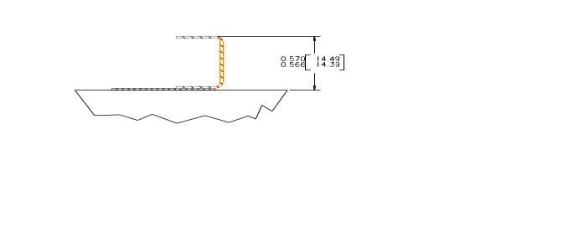

Inspection Record #2 – Limit Dimension for C-Channel Bonded to Ring Face Sheet
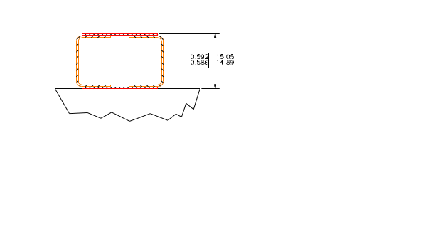

Inspection Record #3 – Limit Dimension for Second Face Sheet Bonded to C-Channels

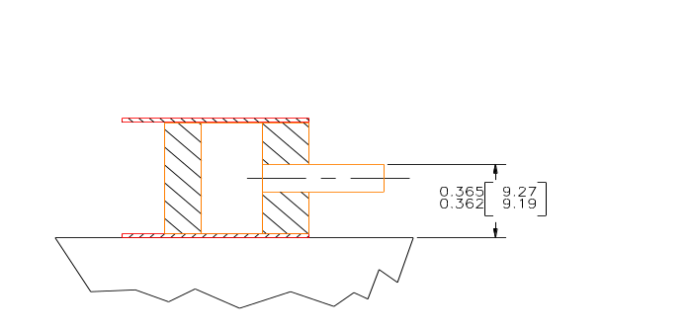

Inspection Record #4 – Limit Dimension for Mount Tab

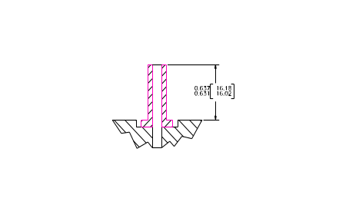

Inspection Record #5 – Limit Dimension for Bushing Seated in Graphite Fixture Counterbore

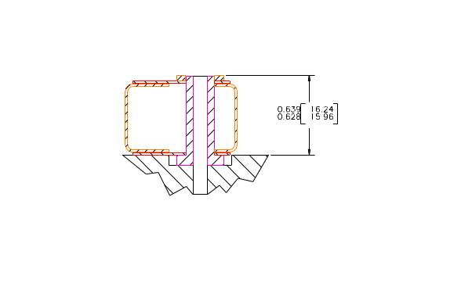

Inspection Record #6 – Limit Dimension for Washer Bonded to Face Sheet #2

Assembly Step Illustrations
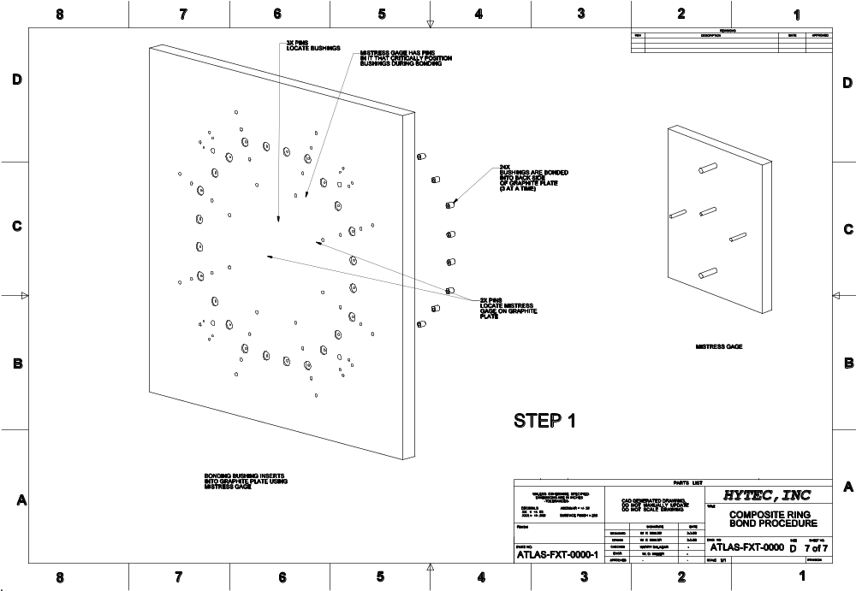
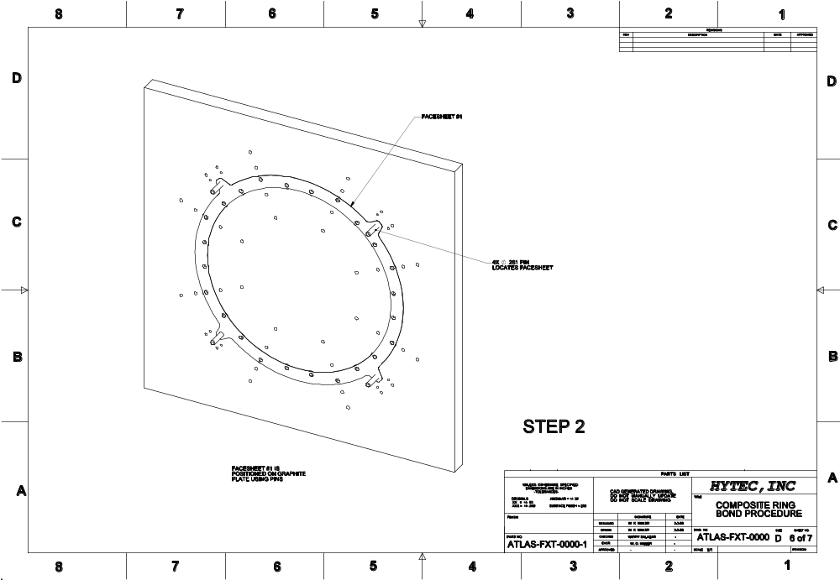
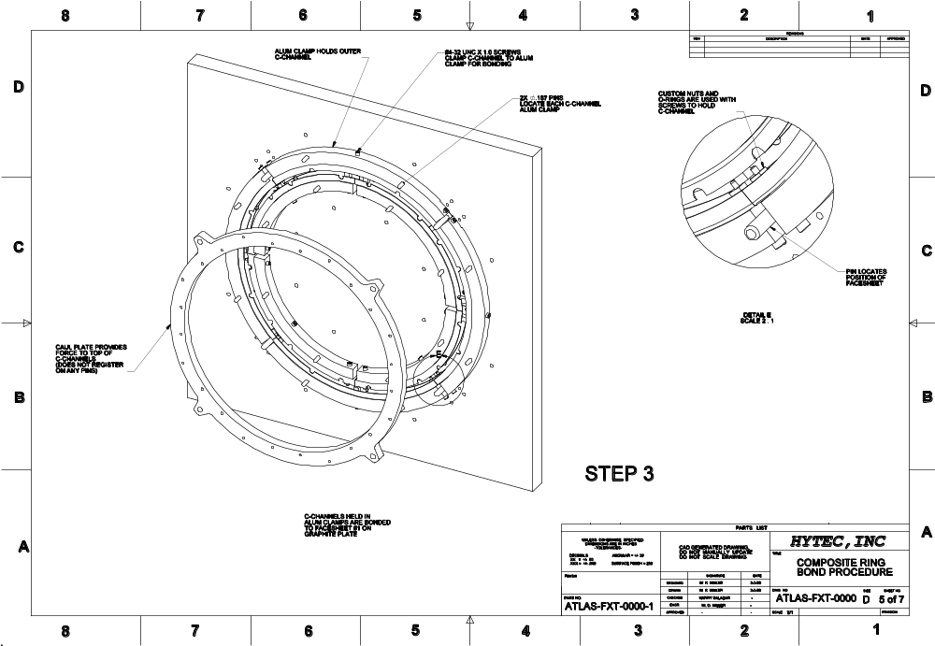
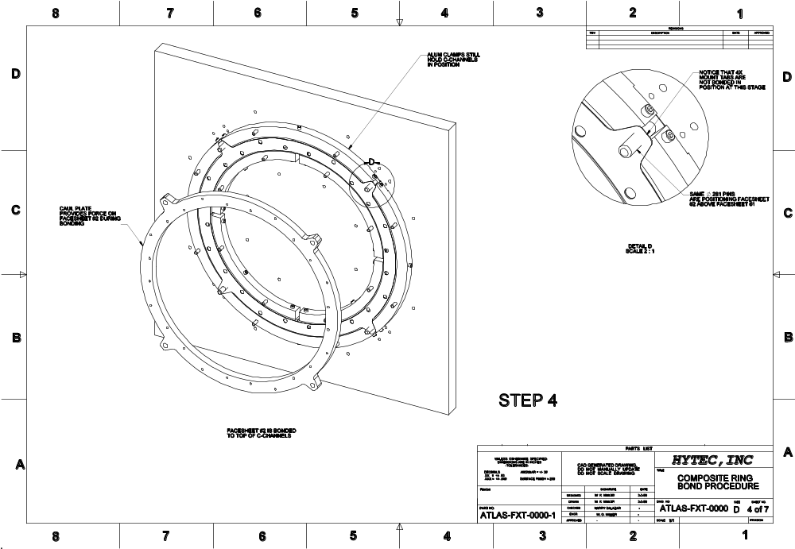
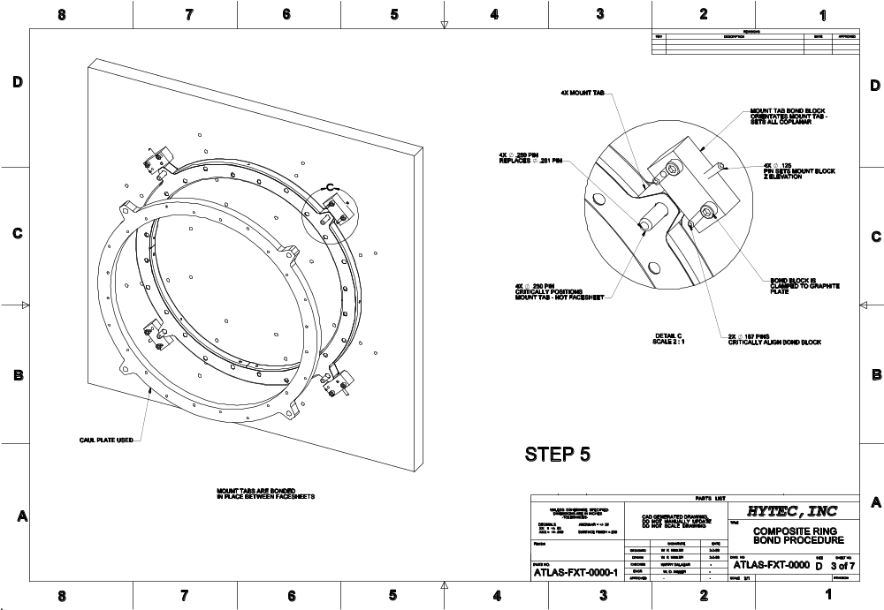
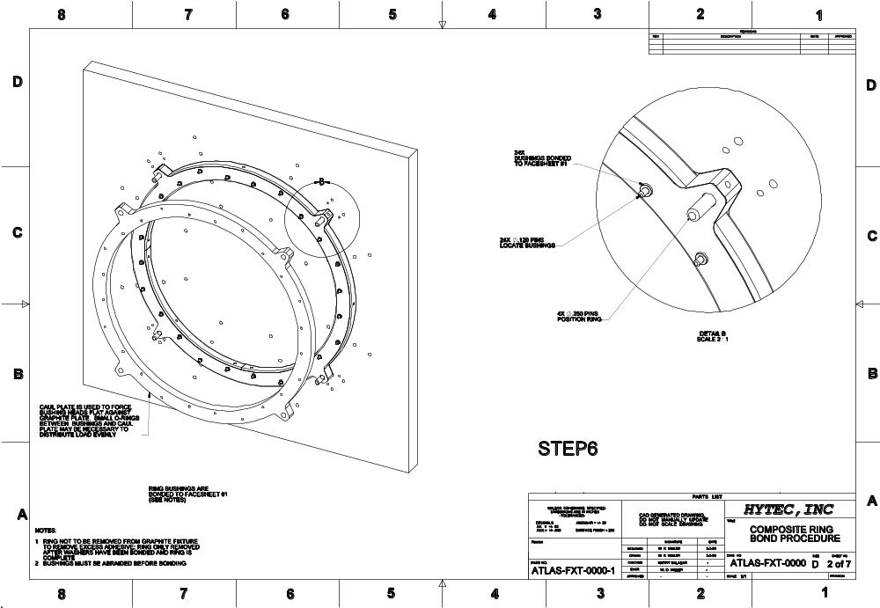
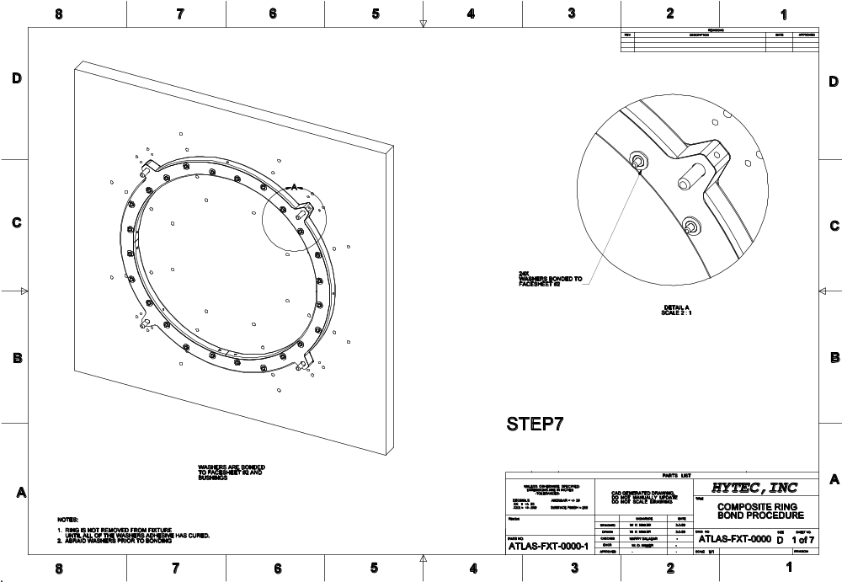

References

Drawing List

Project Number (ATLAS Drawing No) | LBNL Drawing No. | TITLE LINE 1 | TITLE LINE 2 | TITLE LINE 3
ATL-IP-ED-0059 | 21F5104 | ATLAS PIXEL DETECTOR | SECTOR MOUNTING RING TOOLING | RING BOND FIXTURE ASSEMBLY
ATL-IP-ED-0060 | 21F5114 | ATLAS PIXEL DETECTOR | SECTOR MOUNTING RING TOOLING | RING BOND FIXTURE PARTS
ATL-IP-ED-0060 | 21F5114 | ATLAS PIXEL DETECTOR | SECTOR MOUNTING RING TOOLING | RING BOND FIXTURE PARTS
ATL-IP-ED-0061 | 21F5124 | ATLAS PIXEL DETECTOR | SECTOR MOUNTING RING TOOLING | RING CAUL PLATE
ATL-IP-ED-0062 | 21F5134 | ATLAS PIXEL DETECTOR | SECTOR MOUNTING RING TOOLING | C-CHANNEL CLAMP PARTS
ATL-IP-ED-0062 | 21F5134 | ATLAS PIXEL DETECTOR | SECTOR MOUNTING RING TOOLING | C-CHANNEL CLAMP PARTS
ATL-IP-ED-0063 | 21F5144 | ATLAS PIXEL DETECTOR | SECTOR MOUNTING RING TOOLING | RING MOUNT-TAB BOND BLOCK
ATL-IP-ED-0064 | 21F5154 | ATLAS PIXEL DETECTOR | SECTOR MOUNTING RING TOOLING | C-CHANNEL MACHINING CLAMPS
ATL-IP-ED-0064 | 21F5154 | ATLAS PIXEL DETECTOR | SECTOR MOUNTING RING TOOLING | C-CHANNEL MACHINING CLAMPS
ATL-IP-ED-0065 | 21F5164 | ATLAS PIXEL DETECTOR | SECTOR MOUNTING RING TOOLING | OUTER C-CHANNEL MOLD FIXTURE ASSEMBLY
ATL-IP-ED-0066 | 21F5174 | ATLAS PIXEL DETECTOR | SECTOR MOUNTING RING TOOLING | OUTER C-CHANNEL MOLD FIXTURE PARTS
ATL-IP-ED-0066 | 21F5174 | ATLAS PIXEL DETECTOR | SECTOR MOUNTING RING TOOLING | OUTER C-CHANNEL MOLD FIXTURE PARTS
ATL-IP-ED-0066 | 21F5174 | ATLAS PIXEL DETECTOR | SECTOR MOUNTING RING TOOLING | OUTER C-CHANNEL MOLD FIXTURE PARTS
ATL-IP-ED-0067 | 21F5184 | ATLAS PIXEL DETECTOR | SECTOR MOUNTING RING TOOLING | OUTER C-CHANNEL MOLD FIXTURE PARTS
ATL-IP-ED-0067 | 21F5184 | ATLAS PIXEL DETECTOR | SECTOR MOUNTING RING TOOLING | OUTER C-CHANNEL MOLD FIXTURE PARTS
ATL-IP-ED-0067 | 21F5184 | ATLAS PIXEL DETECTOR | SECTOR MOUNTING RING TOOLING | OUTER C-CHANNEL MOLD FIXTURE PARTS
ATL-IP-ED-0067 | 21F5184 | ATLAS PIXEL DETECTOR | SECTOR MOUNTING RING TOOLING | OUTER C-CHANNEL MOLD FIXTURE PARTS
ATL-IP-ED-0068 | 21F5194 | ATLAS PIXEL DETECTOR | SECTOR MOUNTING RING TOOLING | INNER C-CHANNEL MOLD FIXTURE ASSEMBLY
ATL-IP-ED-0069 | 21F5204 | ATLAS PIXEL DETECTOR | SECTOR MOUNTING RING TOOLING | INNER C-CHANNEL MOLD FIXTURE PARTS
ATL-IP-ED-0069 | 21F5204 | ATLAS PIXEL DETECTOR | SECTOR MOUNTING RING TOOLING | INNER C-CHANNEL MOLD FIXTURE PARTS
ATL-IP-ED-0069 | 21F5204 | ATLAS PIXEL DETECTOR | SECTOR MOUNTING RING TOOLING | INNER C-CHANNEL MOLD FIXTURE PARTS
ATL-IP-ED-0070 | 21F5214 | ATLAS PIXEL DETECTOR | SECTOR MOUNTING RING TOOLING | INNER C-CHANNEL MOLD FIXTURE PARTS
ATL-IP-ED-0070 | 21F5214 | ATLAS PIXEL DETECTOR | SECTOR MOUNTING RING TOOLING | INNER C-CHANNEL MOLD FIXTURE PARTS
ATL-IP-ED-0070 | 21F5214 | ATLAS PIXEL DETECTOR | SECTOR MOUNTING RING TOOLING | INNER C-CHANNEL MOLD FIXTURE PARTS
ATL-IP-ED-0070 | 21F5214 | ATLAS PIXEL DETECTOR | SECTOR MOUNTING RING TOOLING | INNER C-CHANNEL MOLD FIXTURE PARTS
ATL-IP-ED-0071 | 21F5224 | ATLAS PIXEL DETECTOR | SECTOR MOUNTING RING | RING ASSEMBLY
ATL-IP-ED-0071 | 21F5224 | ATLAS PIXEL DETECTOR | SECTOR MOUNTING RING | RING ASSEMBLY
ATL-IP-ED-0072 | 21F5234 | ATLAS PIXEL DETECTOR | SECTOR MOUNTING RING | RING FACE SHEET
ATL-IP-ED-0073 | 21F5244 | ATLAS PIXEL DETECTOR | SECTOR MOUNTING RING | OUTER C-CHANNEL
ATL-IP-ED-0074 | 21F5254 | ATLAS PIXEL DETECTOR | SECTOR MOUNTING RING | INNER C-CHANNEL
ATL-IP-ED-0075 | 21F5264 | ATLAS PIXEL DETECTOR | SECTOR MOUNTING RING | RING MOUNT-TABS AND SECTOR MOUNT BUSHINGS

Or a representative designated by LBNL

