Abstract— A common coil design for a high-field accelerator dipole magnet using a Nb₃Sn cable with the React-and-Wind approach is pursued by a collaboration between Fermilab and LBNL. The design requirements for the cable include a high operating current so that a field of 10-11 T can be produced, together with a low critical current degradation due to bending around a 90 mm radius. A program, using ITER strands of the internal tin type, was launched to develop the optimal cable design for React-and-Wind common coil magnets. Three prototype cable designs, all 15 mm wide, were fabricated: a 41-strand cable with 0.7 mm diameter strands; a 57-strand cable with 0.5 mm diameter strands; and a 259-strand multi-level cable with a 6-around-1 sub-element using 0.3 mm diameter wire. Two versions of these cables were fabricated: one with no core and one with a stainless steel core. Additionally, the possibility of a wide (22 mm) cable made from 0.7 mm strand was explored. This paper describes the first results of the cable program including reports on cable fabrication and reaction, first winding tests and first results of the measurement of the critical current degradation due to cabling and bending.
Fabrication and Testing of Rutherford-type Cables for React and Wind Accelerator Magnets
P. Bauer, G. Ambrosio, N. Andreev, E. Barzi, D. Dietderich, K. Ewald, M. Fratini, A.K. Ghosh, H.C. Higley, S.W. Kim, G. Miller, J. Miller, J. Ozelis, R.M. Scanlan

Index Terms—Accelerator, superconducting magnet, superconducting cable, Nb₃Sn.

I. Introduction
Recently, a number of Nb₃Sn dipole magnets have been built and tested in order to demonstrate the feasibility of using a brittle superconductor with a "cosine theta" winding approach [1]. The small bending diameters associated with the poles of cosine theta cross section dipoles require that the cable be wound in the unreacted condition in order to prevent damage to the Nb₃Sn superconductor. An alternative design concept, the common coil design [2], utilizes flat pancake coils with large bending radii, and allows the consideration of a react and wind technique for fabrication of coils from Nb₃Sn or other brittle superconductors. Several designs for 11 T common coil dipoles were developed at FNAL in the past year [3]. All designs utilize Nb₃Sn wire, with a J_{c} (12 T, 4.2 K)=2000 A/mm². The key feature of these magnets is the cable, which must be designed to bend around a 90 mm radius with a low degradation of the critical current (<15%). If the wire is reacted on a spool with twice the minimum coil bending radius, the maximum bending strain in the conductor will be equal in the straight section and in the ends of the magnet. The bending strain depends on the strand diameter used for the cable. In addition, the bending strain can be smaller or larger, depending on whether the layers of strands in the cable stick together or slide during cable bending. A R&D program [4] was launched to develop the optimal cable design for a react and wind common coil dipole. The strand chosen for the program was left-over ITER type wire manufactured by IGC. To keep bending strain below acceptable levels the strand diameter was restricted to ≤0.7 mm. The material was drawn to the nominal wire sizes and sent to LBNL for cabling. With the high current requirement for the magnet (15-20 kA) a high aspect ratio cable design was pursued. The cables produced for the test program are described next.

II. Prototype cable fabrication and reaction
Three cables with width 15 mm were chosen for evaluation: (1) a 41 strand cable with 0.7 mm diameter strands, (2) a 57 strand cable with 0.5 mm strands, and (3) a 259 strand cable with 0.3 mm strands. The 259 strand cable is made in two steps--a first stage 6-around-1 cable and a second stage consisting of 37 first stage elements cabled into the standard flat Rutherford-type cable (Fig. 1).
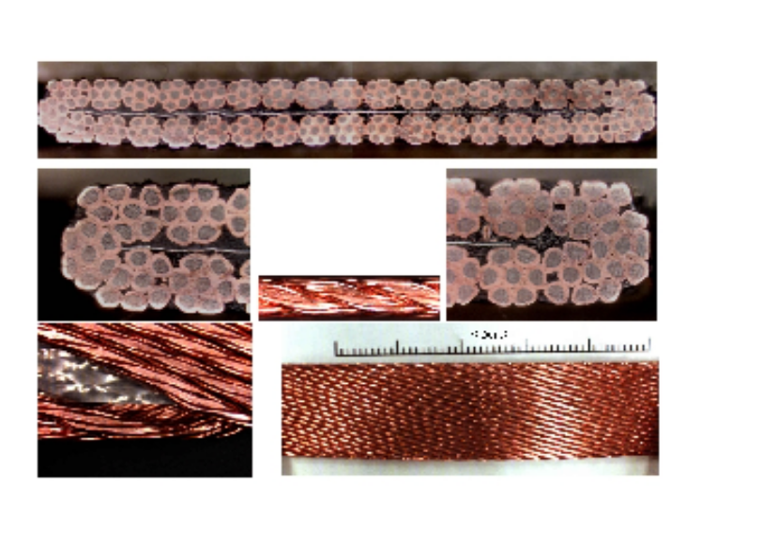Fig. 1. 0.3 mm strand cable made from 37, 6-around-1, sub-elements.
TABLE I
Cables for the react and wind cable r&d – dimensions in mm
Cable No. | Wire∅ | Str. No | Cable dimension | Core dimension | Min/max strain¹
A1 | 0.7 | 41 | 15.04x1.22 | none | 0.170 / 0.365
A5 | 0.7 | 41 | 15.04x1.24 | 0.013x12.7 | -||-
B1 | 0.5 | 57 | 15.01x0.86 | none | 0.122/0.260
B2 | 0.5 | 57 | 15.04x1.35 | 0.025x12.7 | -||-
C1 | 0.3 | 7x36 | 15.05x1.53 | 0.013x12.7 | 0.196 / 0.421²
C2 | 0.3 | 7x36 | 15.05x1.51 | none | -||-
D | 0.7 | 60 | 22.22x1.25 | none | 0.170 / 0.365
All ITER type strands have a copper to non-copper ratio of 0.85. (1) Min/max strain refers to strand alone or 2 strand inter-layer bonding for a magnet with a minimum bending radius of 90 mm. (2) strains in cable C calculated for the 0.8 mm diameter sub-element.

This, being the only way to produce a high current cable from 0.3 mm strands for our common coil magnet. In addition, a very wide (22 mm) cable, made from 60 0.7 mm strands was successfully made in view of a one-layer magnet design. Two versions of each cable were attempted (one with no core, and the other with a core of 316-L stainless steel). In addition several cable parameters were explored for each type of cable, including number of strands, amount of compaction, and strand tension. Once these parameters were optimized, cables of acceptable quality were produced for each type (listed in Table I). However, the cables with a core were somewhat problematic, and cores of varying thickness were tried before successful cables could be made. It was found that cables should either be core-dominated (thick core) or strand dominated (thin core), the intermediate region of core vs. cable thickness resulting in strand-popping or core-buckling after release of the cabling tension. At least 10 m of each type of cable were produced for testing and evaluation. Long lengths of cable B1 (260 m) and A5 (70 m) were produced for coil winding experiments.
In the react and wind approach, the strain at all stages of coil construction and operation must be considered. The first step is reaction on a metal spool. The important considerations here are (1) strand surface preparation so that the strands do not sinter together during reaction, (2) method of winding onto the reaction spool, i.e. layer or pancake winding, and (3) spool diameter. Coating the strands with a

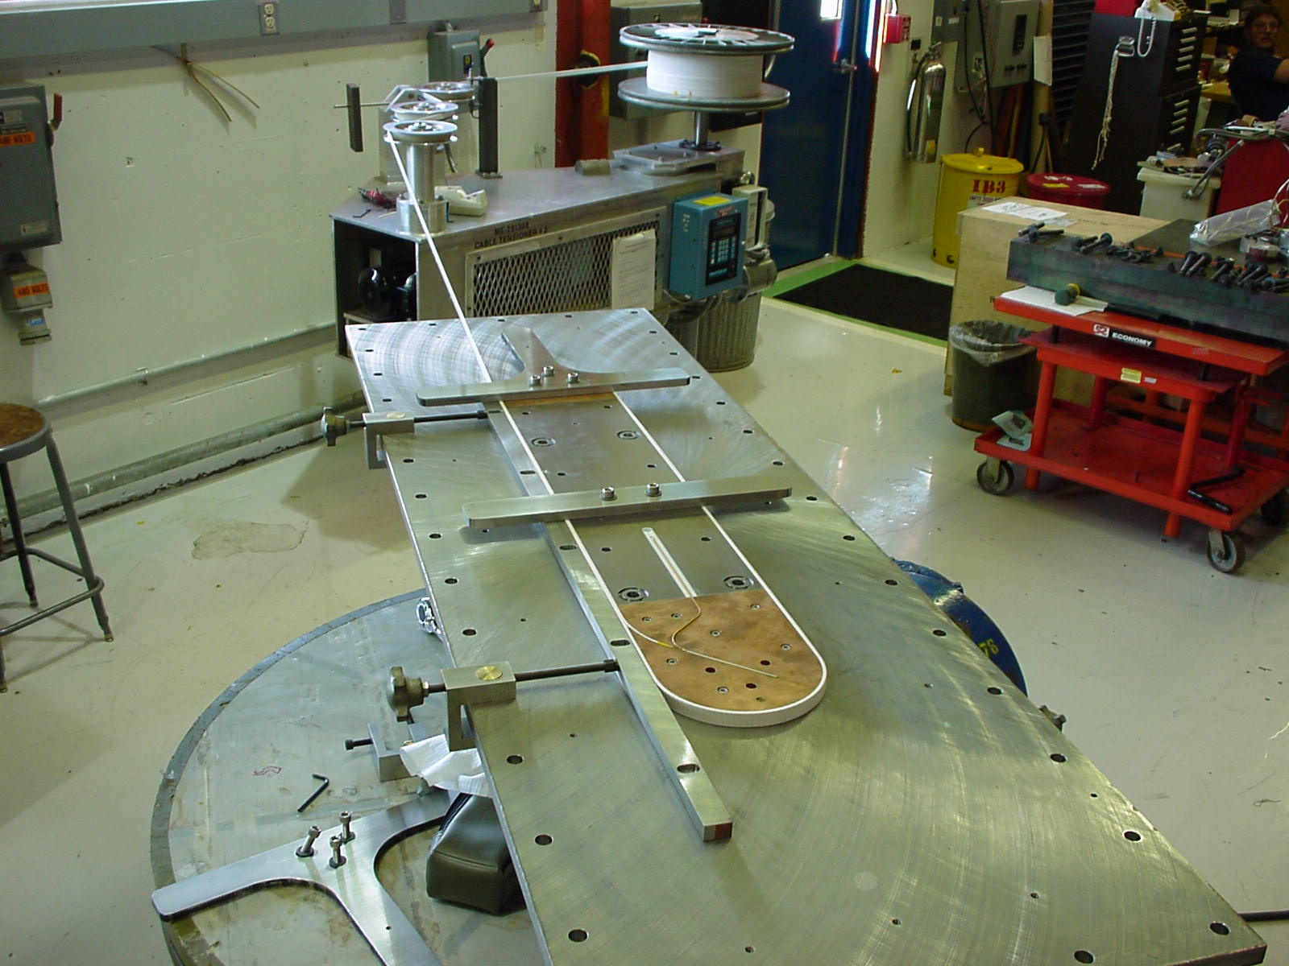
Fig. 2. Practice coil winding with cable B1.
synthetic lubricant (5% Mobil I in Naptha) during cabling was chosen as method for preventing the strands from sintering, since this method has been shown effective in previous studies [5]. Additionally the cross-contact resistance in cables with bonded strands would be very small, resulting in high loss and multipole hysteresis during ramping of the magnet. A pancake winding for heat treatment was chosen to avoid the hard way bend that is associated with the cable during layer winding. Heat treatments for all cables were successful. The synthetic oil lubricant proved to be an effective measure to prevent the sintering of the strands within the cable for all samples. After reaction, the cored cables, generated a noise during first time bending. The noise could be related to cracking or stick-slide motion of the core.
The change of cable dimensions during reaction is still being investigated. Recent measurements [6] on ITER type cables showed that in the “free” case the cable width and thickness increase by 3% and 5% and that the cable contracts longitudinally by 0.45 %. The cables listed in Table I partly confirmed these findings. However, the effect of reaction tooling on the dimensional changes of the cables is under investigation. An important result from the first heat treatment campaigns was that the cable dimensions remain uniform over the whole length of the cable.
First winding tests for the common coil magnet have started recently. An insulation procedure for pre-reacted cables was developed. The insulation is wrapped around the cable with a low wrapping tension, so that the cable is not excessively bent. The cable is supported along all the way from the spools to the insulation device to avoid bending under its own weight. As insulation an E-glass tape (60 µm) with 12.5% overlap has been chosen as the lowest cost option. A picture of the first practice coil winding is shown in Fig. 2.

III. Measurement of the cabling degradation
The cabling degradation was obtained via the comparison of critical current measurements on virgin strands and strands extracted from a cable. The measurements (Fig. 3) indicate, that the cabling degradation at 10 T in 0.5 and 0.7 mm diameter strands is 1-4% and 6-8% respectively. The 6-around-1 sub-cable was not degraded prior to cabling. After cabling the degradation of the 6-around-1 sub-cable is 16%!
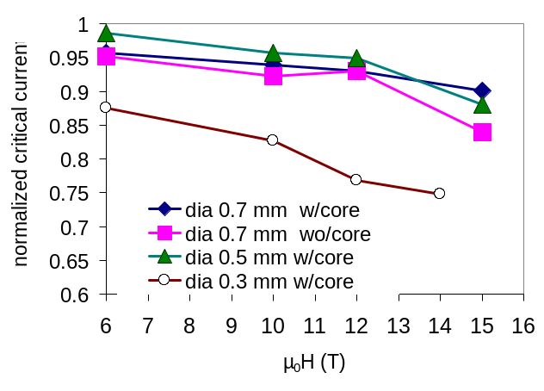
Fig. 3. Cabling degradation measurements on 0.3, 0.5 & 0.7 mm strands.
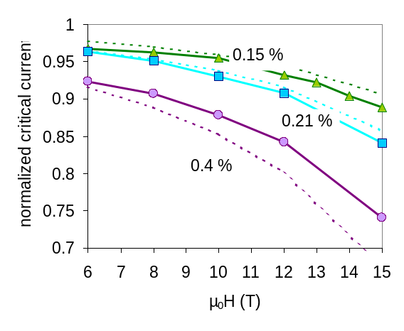
Fig. 4. Degradation of 1 mm (triangles) and 0.7 mm (squares & circles) ITER type strands due to a maximum bending strain of 0.15, 0.21 and 0.4%, compared to calculations (dashed) according to Ekin’s deviatory strain model, assuming an intrinsic filament pre-compression of 0.2%.

It was found that the cabling degradation is partly caused by a cross-sectional surface reduction of the strand during cabling [7]. It increases with magnetic field. Indications were found that the field dependent part of the cabling degradation can be described with Ekin’s deviatory strain model [8], assuming an additional compressive strain after reaction due to cabling of the order of 0.01%. Further investigation is required to support this hypothesis.

IV. Measurement of the bending degradation
Measurements of the degradation due to bending in 0.7 and 1 mm diameter ITER strands, are shown in Fig. 4. The degradation is obtained by normalizing the critical current of a bent strand on the critical current of a similar un-bent strand. The measurement procedure and the sample-holder design are described elsewhere [4]. It can be seen in the plot that the agreement with Ekin’s model (in the short twist pitch limit) [8] is good, especially at low levels of maximum strain.
A series of similar measurements on cables was started recently. To measure the critical current degradation of cables due to bending strain the following procedure was developed:

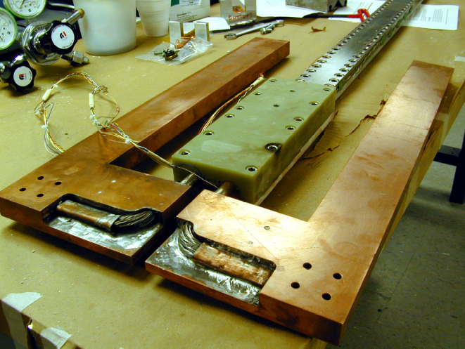
Fig. 5. Cable critical current sample-holder before insertion into test-station.
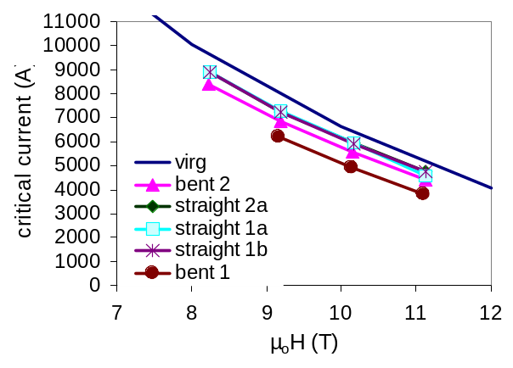
Fig. 6. Critical currents of samples of cables A5 (here with a on virgin strand measurement extrapolated to the cable level) for different fields.

The cables were reacted bent and straightened before measurement in the cable test facility at NHMFL [9]. Results were compared with those of unbent samples. Fig. 5 shows a sample-holder[10] before insertion into the test-rig. The first test results on a series of cables of type A5 (made from 0.7 mm strands), reacted straight and bent (reaction spool diameter 290 mm), are shown in Fig. 6 [11,12]. Four samples reacted in the straight condition gave similar critical currents. Four samples, reacted in the bent condition, gave varying results. The calculated maximum strain in the “bent” samples was 0.18 or 0.42%, according to whether the two layers of strands in the cable were bending independently, or not. Fig. 7 shows these results normalized to the critical current of a virgin strand (hence free of cabling degradation), extrapolated to the cable (the strand was reacted with the cables). In addition, the measured cabling and bending degradation (see Fig. 3&4) are indicated as lines. As expected, the straight samples have only cabling degradation. The best performing bent sample of this series has only a small bending degradation, indicative of a bending strain determined by a single strand diameter rather than the cable thickness. The worst performing sample is degraded by ~25%, which, is more than the bending degradation found on strands for a max
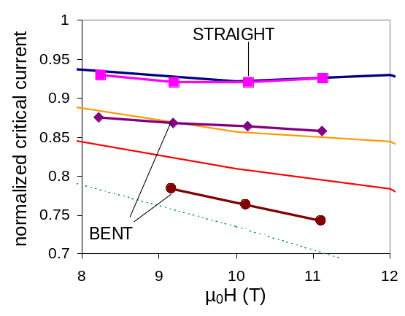
Fig. 7. Normalized Critical Current of 0.7 mm strand cables (A5) reacted straight and bent, compared to cabling and bending degradation measurements performed on strands (see Fig. 3 & 4). Upper line: cabling degradation only; 2nd and 3rd line from top: cabling plus bending degradation at 0.2% and 0.41% maximum bending strain; bottom line (dashed): bending degradation calculated^{[8]} with max bending of 0.4%.
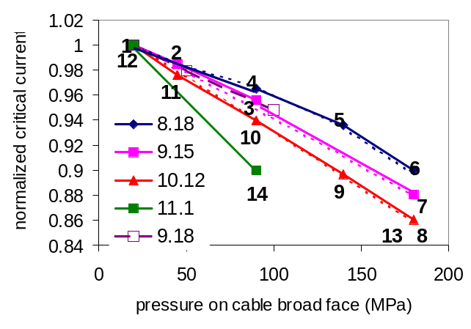
Fig. 8. Effect of transverse pressure on critical current (here normalized on its value at 20 MPa) for different fields. Sample A5 – with bending strain (full symbols), without bending degradation (open symbols). Dashed lines are calculated with Ekin’s model.

bending strain of 0.4%. However a calculated prediction of the bending degradation at that maximum strain (indicated in Fig. 7) level using Ekin’s model predicts an even larger degradation.
Similar measurements on a cable of type C2 revealed (not shown here) a small bending degradation, indicative of a strain determined by the strand diameter (0.3 mm). Unfortunately, due to a large cabling degradation (see Fig. 3) this cable type presently is not optimal. Further samples with lower packing factors will be measured next.
The n-values were 40 and higher for “straight samples” (in agreement with the n-values on the virgin strand), while in the bent samples they were ~ 20.

V. Measurement of the transverse pressure effect
Lorentz-force and vertical pre-stress, result in a large vertical pressure on the cables in a magnet. Fig. 8 shows the effect of pressure on the cable broad face on the critical current of an A5 sample (reacted bent). The pressure is applied with a hydraulic piston, provided in the magnet system of the NHMFL test station [9]. Fig. 8 shows that the critical current linearly decreases with pressure and that a degradation of ~10 % is found at 100 MPa at 11 T. The sensitivity to pressure increases with magnetic field, in agreement with Ekin’s formula for the strain sensitivity of H_{c2} (dashed lines in Fig. 8). The calculated results according to Ekin were obtained with an intrinsic pre-compression in the strands of 0.2% (as before in the calculation of the bending degradation in strands) and an “average” bending strain of 0.3%. The pressure in the model had to be three times the nominal (average) pressure indicated in the plot. This can be explained by stress-concentration effects (e.g.) at the cable-edges. The labels in Fig. 8 indicate the measurement sequence, showing the reversibility of the pressure degradation effect. The n-values were not affected by pressure. Although only limited data were taken, there are hints that the pressure effect is similar in samples with and without bending strain (see open symbols in Fig. 8).

VI. Conclusion
Fermilab and LBNL are exploring the react and wind technique with Nb₃Sn superconductor for a common coil accelerator magnet. To this end the critical current degradation of Nb₃Sn cables subject to cabling, bending and transverse pressure was measured. Procedures for the cable fabrication, reaction and insulation were developed. LBNL produced prototype cables made from 0.3, 0.5 and 0.7 mm strands with and without core. The cables were reacted on a spool using synthetic oil to keep strands from sintering. The degradation due to cabling was measured: it varies between 5-7%. First measurements of the degradation due to bending agree well with predictions from literature. The cable results correlate well with separate strand measurements of cabling and bending degradation. The doubly transposed cable has a too large cabling degradation and its design has to be improved. Hints were found, that the use of a core can result in high degradation. More measurements are required for a better understanding of this behavior. The critical current degradation due to pressure on the cable broad face after cable bending was found to be linear (~1% per 10 MPa) and reversible. The next milestones for the react and wind R&D are the completion of cable and winding tests and the test of a set of racetrack coils in a common coil configuration.

References
- S. Gourlay et al., “Fabrication and Test of Nb₃Sn Racetrack Coils at High Field”, presented at this conference.
- R. Gupta, “A Common Coil Design for High-Field 2-in-1 Accelerator Magnets”, 1997 Particle Accelerator Conference, May 1997.
- G. Ambrosio et al., “Development of a React & Wind Common Coil Dipole for VLHC”, presented at this conference.
- G. Ambrosio et al., “Study of the React and Wind Technique for a Nb₃Sn Common Coil Dipole”, ”, IEEE Trans. on Appl. Superconductivity, v. 10, No 1, March 2000.
- T.A. Painter et al., “Progress in the Manufacture of the Cable in Conduit Nb₃Sn Outsert Coils for the 45 T Hybrid Magnet”, IEEE Transactions on Magnetics 30, July 1994.
- D. Chichili, T. Arkan, I. Terechkine, “Mechanical Properties of Niobium Tin Composites”, Fermilab Conf –99/052.
- E. Barzi et al., “Strand Critical Current Degradation in Nb₃Sn Rutherford Cables”, submitted for publication to this conference.
- J.W. Ekin, “Strain Scaling Law and Prediction of Uniaxial and Bending Strain effects in Multifilamentary Superconductors”, in Filamentary A15 Superconductors, M. Suenaga and A.F. Clark, Editors, New York, Plenum Press, 1980.
- P. Bauer, D. Dietderich, “Critical Current Measurements of Superconducting Cables at the National High Magnetic Field Laboratory – Documentation/User Guide Version 1”, Fermilab, Technical Division Note, TD-99-039, Aug., 1999.
- J. Ozelis, P. Bauer, K. Ewald, “Design of a Sample Holder for Measurements of Nb₃Sn Cable Critical Current under Transverse Loading Conditions”, Fermilab, Technical Division Note, TD-99-051, Nov., 1999.
- P. Bauer, G. Ambrosio, J. Ozelis, E. Barzi, D. Dietderich, K. Ewald, G. Miller “Results of the first series of Measurements of the Critical Currents of Cables for the React&Wind Cable Development Program”, Fermilab, Technical Division Note, TD-00-049, May, 2000.
- P. Bauer, G. Ambrosio, J. Ozelis, E. Barzi, D. Dietderich, K. Ewald, M. Fratini, G. Miller “Results of the second series of Measurements of the Critical Currents of Cables for the React&Wind Cable Development Program”, Fermilab, Technical Division Note, TD-00-074, Nov, 2000.

 Manuscript received Sept 17, 2000. This work was supported by the U.S. Department of Energy. P. Bauer, G. Ambrosio, N. Andreev E. Barzi, K. Ewald, M. Fratini, S.W. Kim are with Fermilab, Batavia, IL 60510 USA (telephone: 630-840-5409, e-mail: pbauer@fnal.gov). D. Dietderich, H.C. Higley, R. Scanlan are with Lawrence Berkeley Lab, Berkeley, CA 94720 USA. G. Miller, J. Miller are with the National High Magnetic Field Lab, Tallahassee, FL 32310 USA. A.K. Ghosh is with Brookhaven National Lab, Upton, NY 11973 USA. J. Ozelis is with Jefferson Lab, Newport News, VA 23606 USA.

