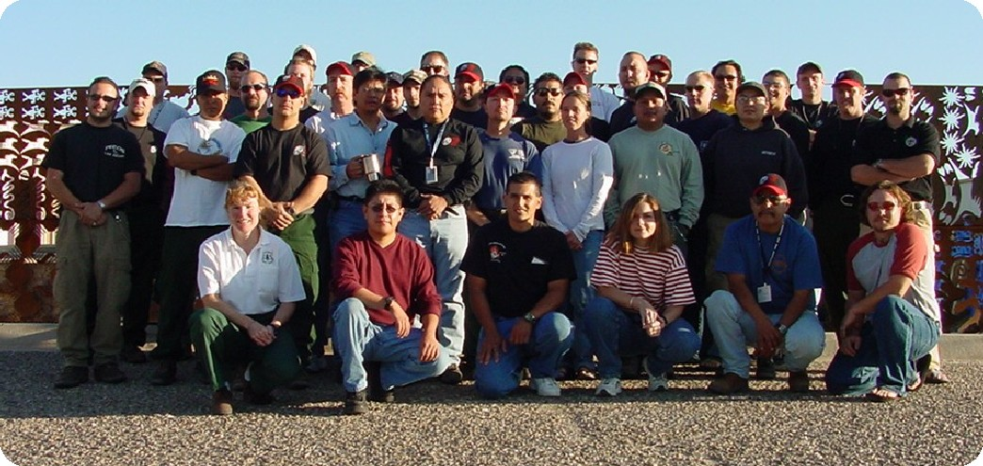

Fall 2002 Graduates

FALL 2002 GRADUATES

Field Coordinators | Agency/Unit | State
Duck, Tim | BLM, Arizona Strip Field Office | UT
Gesser, Dave | USFS, Bradshaw RD, Prescott NF | AZ
Holguin, Gabe | USFS, Nez Perce NF | ID
Juan, Lemuel | BIA, San Carlos Agency | AZ
Lovato, Sam | BIA, Southern Pueblos Agency | NM
Lyons, John | BLM, Alaska Fire Service | AK
McPhee, Kevin | USFS, Gila NF Reserve RD, | NM
Newton, Lonnie | USFS, Idaho Panhandle NF | ID
Students
Altaha, Edwin | BIA, Fort Apache | AZ
Amato, Sam | USFS, Gila NF Wilderness RD, | NM
Arguello, Alexander | USFS, Cibola NF Kiowa Rita Blanca National Grasslands, | NM
Baca, Michael | USFS, A-S NF Lakeside RD | AZ
Bagnoli, Dana | USFS, A-S NF Springerville RD | AZ
Bearden, Lyman | NPS, Lake Meredith NRA | TX
Benallie, Jay | USFS, Kaibab NF Tusayan RD | AZ
Clairmont, Darrell | BIA, Salish and Kootenai Agency | MT
Conrad, Justin | USFS, Kaibab NF North Kaibab RD | AZ
Esquibel, Ronald | BLM, Taos Field Office | NM
Fiore, Dennis | BLM, Lakeview District | OR
Flesch, Bob | BLM, Lewistown District | MT
Garcia, Nick | BIA, Mescalero Agency | NM
Hird, Rebecca | USFS, Lincoln NF Smokey Bear RD | NM
Johnson, Ryan | BLM, Arizona Strip Field Office | UT
Little, Chris | BIA, Mescalero Agency | NM
Long, Jere | BLM, Lewistown District | MT
Martinez, Anthony | USFS, Carson NF El Rito RD | NM
Martinez, Claren | USFS, Carson NF Tres Piedras RD | NM
McWilliams, Tony | USFS, Lincoln NF Sacramento RD | NM
Rader, Dylan | BLM, Elko Field Office | NV
Sahd, Kyle | BLM, Taos Field Office | NM
Sanchez, Michael | BIA, Southwest Regional Office | NM
Sponholtz, Craig | USFS, Prescott NF | AZ
Swenson, Paul | USFS, Lincoln NF Smokey Bear RD | NM
Tarbell, Blaine | BIA, Uintah and Ouray Agency | UT
Teel, Kyle | BLM, Ely District | NV
Thayer, Mark | USFS, Cibola NF Kiowa Rita Blanca National Grasslands | NM
Valdez, Andrew | USFS, Santa Fe NF Pecos/Las Vegas RD | NM
Wekothy, Heath | BIA, Southwest Regional Office | NM
Zaharias, Eric | USFS, Santa Fe NF Pecos/Las Vegas RD | NM

Southwest Fire Use Training Academy Project Participation
Fall 2002 Session

Project Name | Location | Agency | Date |  | Acres | FIRE BEHAVIOR FUEL MODEL |  | Persons  Assigned |  | Person  Hours |  | Complexity
Cherry Road RX | Verde RD,  Prescott NF | FS | 10/8-11/02 |  | 8100 | 5/9 |  | 3 |  | 143 |  | Type I  (WUI)
Hartman II RX | Pecos-Las Vegas RDs, Santa Fe NF | FS | 10/9-11/02 |  | 640 | 8/9/11 |  | 4 |  | 181 |  | Type II
Rio Salado Restoration RX | Sevilleta NWR | FWS | 10/8-9/02 |  | 100 | 13 |  | 1 |  | 16 |  | Type II
Arroyo RX | AlbuquerqueBLM | BLM | 10/10-11/02 |  | 50 | 10 |  | 1 |  | 8 |  | Type II
Lochsa RX | Kooskia RD,  Clearwater NF | FS | 10/14-19/02 |  | 106 | 12/13 |  | 5 |  | 430 |  | Type II
Maestas RX | Pecos-Las Vegas RDs, Santa Fe NF | FS | 10/15-18/02 |  | 240 | 9/11 |  | 5 |  | 180 |  | Type I  (WUI)
Benton RX | Mountainair RD, Cibola NF | FS | 10/20-21/02 |  | Out of prescription | 9 |  | 4 |  | 104 |  | Type II
Eagle Fuel Project | Smokey Bear RD,  Lincoln NF | FS | 10/28-1/02 |  | 658  (Fuels In-  ventory) | 2/9/11 |  | 6 |  | 240 |  | WUI
Kaley Cottages Pile Burn | Rocky Mountain NP | NPS | 10/27-2/02 |  | 15 | Piles (170) |  | 8 |  | 600 |  | Type II  (WUI)
Emerald Mnt. Pile Burn | Rocky Mountain NP | NPS | 11/5-7/02 |  | 5 | Piles (325) |  | 8 |  | 425 |  | Type II  (WUI)
Hole RX | Mount Lassen NP | NPS | 10/30-4/02 |  | 500 | 2/8/9/10 |  | 7 |  | 1232 |  | Type II
Red Fir – Lick Creek RX | Umatilla NF | FS | 10/23-28/02 |  | 165 | 2/9/11 |  | 4 |  | 300 |  | Type II
Gin Flat RX | Yosemite NP | NPS | 10/30-4/02 |  | 500 | 8/9/10 |  | 6 |  | 646 |  | Type II
Son of Spot | Yosimite NP | NPS | 11/02-4/02 |  | 10 | 8 |  | 6 |  | 291 |  | Type II
Maple Syrup | Medford Field Office | BLM | 10/19-1/02 |  | N/A | N/A |  | 4 |  | 130 |  | N/A
Little Walnut Piles | Silver City RD, Gila NF | FS | 11/5-6/02 |  | 5 | Piles |  | 2 |  | 43 |  | Type II  (WUI)
Show Low BC | Lakeside RD, A-S NFs | FS | 11/4-5/02 |  | 90 | 9/11 |  | 1 |  | 31 |  | Type II  (WUI)
Bonito Park | Peaks RD, Coconino NF | FS | 11/6-8/02 |  | 400 |  |  | 6 |  | 180 |  | Type II
Kyle Harrison/ DogTown/ Peach Tree/ Santa Rita RX | Smokey Bear RD,  Lincoln NF | FS | 11/11-13/02 |  | 154 | 8/10 |  | 5 |  | 180 |  | Type II
Hance RX | Grand Canyon NP | NPS | 11/6/02 |  | 382 | 9 |  | 7 |  | 73.5 |  | Type I
Watson RX | Grand Canyon NP | NPS | 11/7/02 |  | 1830 | 9 |  | 7 |  | 70 |  | Type I
Maraposa Grove | Yosemite NP | NPS | 10/28-30/02 |  | 200 | 8 |  | 8 |  | 292 |  | Type II
Pickett Snake T-Bridge Burn Plan | Medford Field Office | BLM | 11/4-8/02 |  | 97  (Burn Plan Writing Only) | 2/6/8/9/10 |  | 2 |  | 80 |  | Meadow Restoration
TOTALS |  |  |  | 14,247 |  |  |  |  | 112 |  | 5875.5

Fall 2002 Training Accomplishments

NWCG CORE CURRICULUM
Course Title | Course Hours | FUTA Trainees | Other Trainees | Total Trainees | Total Trainee Hours
RX-310, Introduction to Fire Effects | 36 | 29 | 10 | 39 | 1404
S-234, Ignition Operations | 18 | 15 | 21 | 36 | 648
RX-300, Prescribed Fire Burn Boss | 40 | 33 | 4 | 37 | 1480
S-301, Leadership and Organizational Development | 20 | 16 | 8 | 24 | 480
TOTAL | 114 | 93 | 43 | 136 | 4012

NWCG Courses Outside the 6-week Fall Session
ADDITIONAL NWCG COURSES SPONSORED
Course Title | Course Hours | FUTA Trainees | Other Trainees | Total Trainees | Total Trainee Hours
RX-410, Smoke Management Techniques | 32 | 12 | 13 | 25 | 800
S-390, Introduction to Wildland Fire Behavior Calculations | 22 | 13 | 15 | 28 | 616
TOTAL | 54 | 25 | 28 | 53 | 1416

Fall 2002 Short Courses
ADDITIONAL WORKSHOPS/TRAININGS ATTENDED
Course Title | Course Hours | FUTA Trainees | Other Trainees | Total Trainees | Total Trainee Hours
Inventory, Monitoring, & Analysis | 2.5 | 8 | 1 | 9 | 22.5
Fireline Leadership | 40 | 8 | Unknown | Unknown | 320
BEHAVE | 8 | 13 | 5 | 18 | 144
Aerial Ignition Workshop | 16 | 2 | Unknown | Unknown | 32
TOTAL | 66.5 | 31 | 6 | 27 | 518.5

