FORAGE HARVEST MANAGEMENT
Virginia Conservation Practice Job Sheet 511

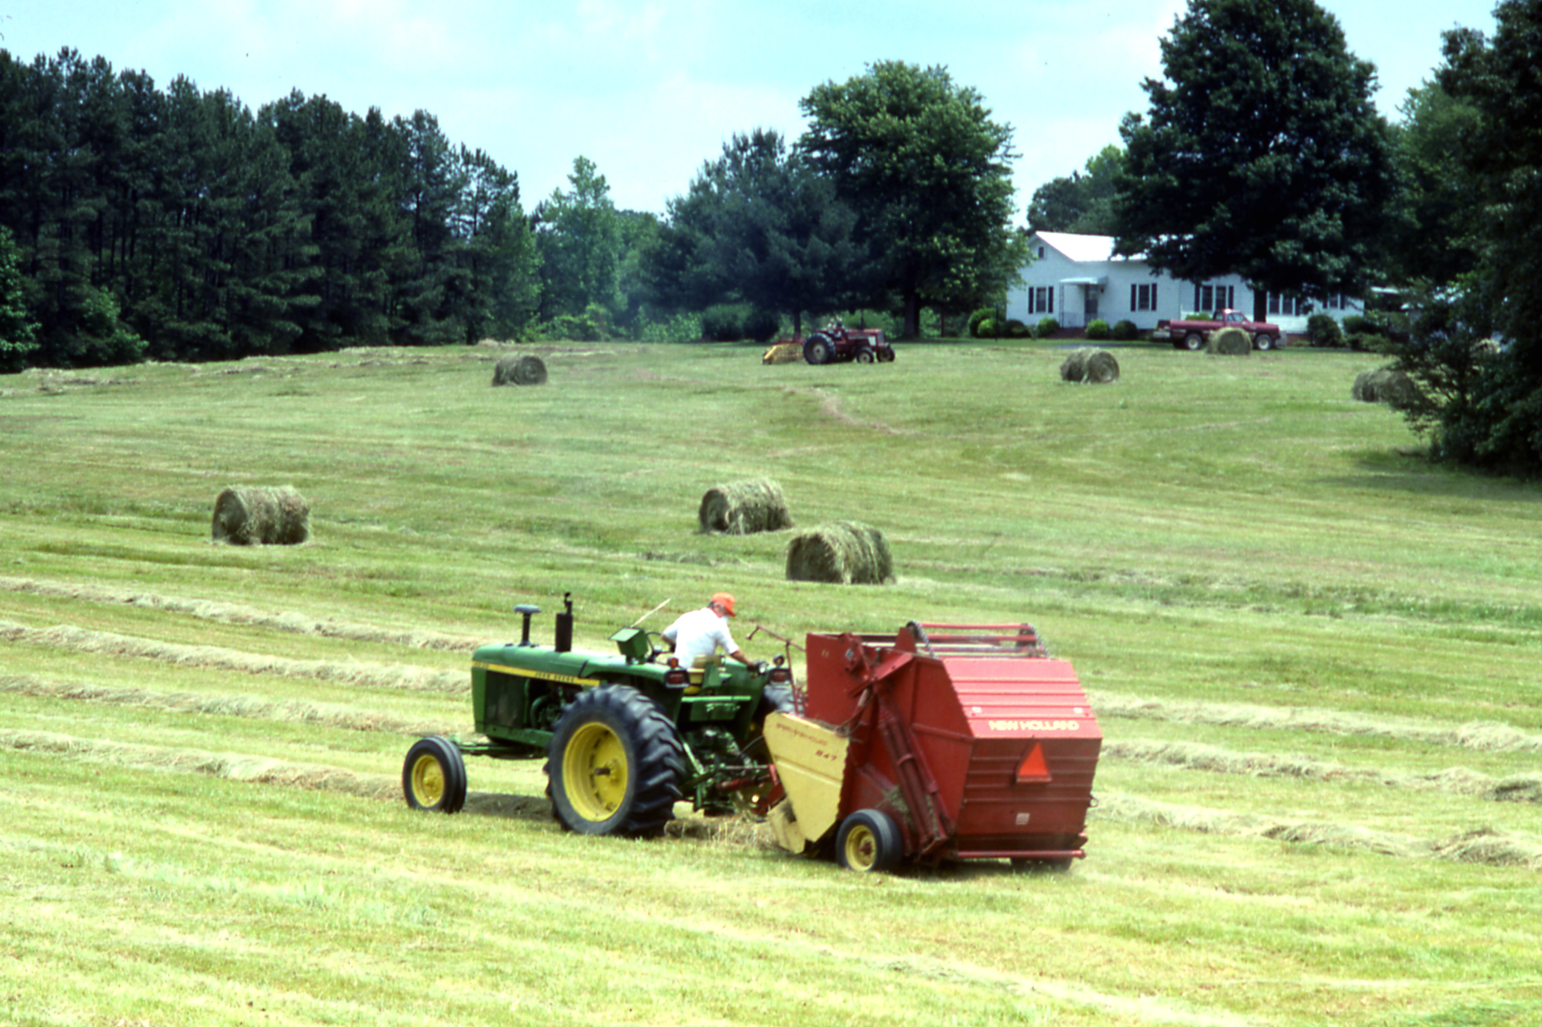
Definition
Forage Harvest Management is the management of grasses and legumes that when cut and treated appropriately provide high quality hay, silage or meets other goals of the landowner.

Purpose. Forage harvest management may include some or all of the following:
1. Optimize the economic yield of forage at the desired quality and quantity.
2. Promote vigorous plant re-growth, stand maintenance, and desired plant species composition.
3. Use forage biomass production as a soil nutrient management/uptake tool.
4. Control insects, diseases, invasive species and weeds.
5. Maintain and/or improve wildlife habitat.

Conditions where practice applies. Forage harvest management may be a component of most conservation management systems that address machine harvested forage crops to improve and/or maintain the soil, water, air, plant, and animal, including wildlife, resources, and is compatible with the owner’s objectives of high quality forage

General Harvest Specifications
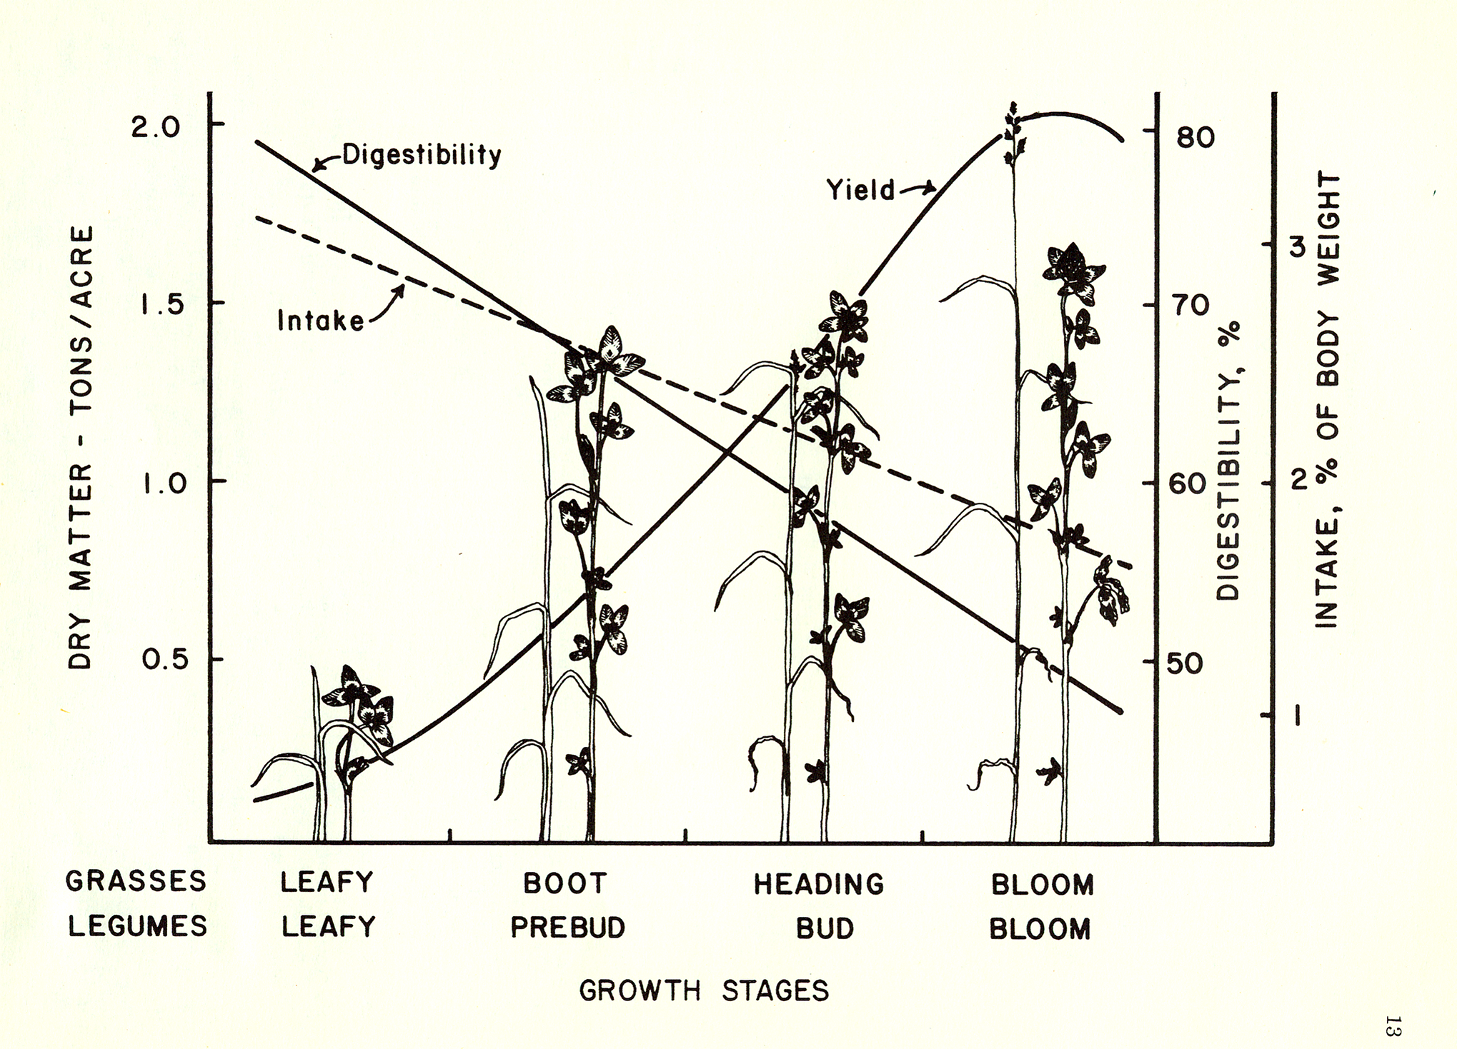
1. Forages will be harvested at a frequency and height that will maintain a desired healthy plant community.
2. Harvest forages at a maturity that provides the desired quality and quantity for the intended use.
3. Silage/haylage will be harvested within the optimum moisture range for the type of storage structure used.
4. For nutrient uptake, use harvesting strategies to maximize uptake of available/targeted nutrients.
5. For wildlife considerations, incorporate management strategies to enhance cover, nesting, and food.

As forages mature, digestibility and intake decrease. Deciding when to harvest hay is a compromise between quality and yield. The true quality test for hay is animal performance.

Forage Harvest Management Job Sheet 511

Landowner: | Farm #:
 | Tract #:

Site Specific Forage Harvest Management Information
(A) | (B) | (C) | (D) | (E) | (F)
Field No. | Field Acres | Forage Species | Growth Stage at Harvest | Minimum Stubble Height (inches) | Recovery or Rest Period (days)

Recommended Harvest Stages, Residual Height, and Recovery Time
Forages | Stage of Harvest | Minimum Stubble After Harvest (inches) | Recovery Period (days)
Alfalfa | Bud stage 1st cutting; 1/10 bloom second & later cuttings. For spring seedings, 1st cutting at mid to full bloom. | 3 | 20-25
Tall Fescue, Orchardgrass, Timothy | Boot to early head stage for 1st cut; later cuts at 4-6 week intervals. | 3-5 | 20-30
Red or Crimson Clovers | Early bloom | 2-3 | 18-25
Small Grains | Boot to early head stage
Soybeans | Mid to full bloom before leaves begin to fall
Sericiea Lespedeza | Height of 15 to 18 inches | 4-6 | 18-25
Annual Lespedeza | Early bloom before bottom leaves begin to fall | 2-3 | 20-30
Ladino or White Clover | Cut at correct stage for companion grass
Bermudagrass | 15-18 inch height for 1st cutting, every 4-5 weeks thereafter or when 15 inches high | 2-3 | 18-30
Sudangrass, Sorghum-Sudan Hybrids, Pearl Millet | Height of 30 – 40 inches
Native Grasses (Eastern Gamagrass, Indiangrass, Big Bluestem, Switchgrass) | Harvest in early boot stage at 45 day intervals | 8 | 30-45
Ryegrass | Early to full bloom | 2-3 | 14-25

Minimum Stubble Height and Regrowth Period
After harvest, it is important to leave enough leaf area on the plant to allow for plant survival and rapid regrowth. If forages are harvested below recommended minimum cutting height, regrowth is slowed, weeds may increase, productivity may decline and the stand may die.

Allow enough recovery time after harvest to allow the forages to accumulate carbohydrate reserves necessary for regrowth in the plant crown, rhizomes, stolons, or roots.

Operations and Maintenance Plan

511 Forage Harvest Management – VA O&M Plan

Before forage harvest, clear fields of debris which could damage machinery or, if ingested, harm livestock.
Operate all equipment at optimum settings to minimize loss of leaves.
Keep all machinery in good repair.
Incorporate safety in all that you do.
Maintain soil fertility and pH to recommended levels
When managing for wildlife, reduce the number of cuttings/disturbance to the area. This will affect both quality and quantity of the forage produced

"The U.S. Department of Agriculture (USDA) prohibits discrimination in all its programs and activities on the basis of race, color, national origin, age, disability, and where applicable, sex, marital status, familial status, parental status, religion, sexual orientation, genetic information, political beliefs, reprisal, or because all or a part of an individual's income is derived from any public assistance program. (Not all prohibited bases apply to all programs.) Persons with disabilities who require alternative means for communication of program information (Braille, large print, audiotape, etc.) should contact USDA's TARGET Center at (202) 720-2600 (voice and TDD). To file a complaint of discrimination write to USDA, Director, Office of Civil Rights, 1400 Independence Avenue, S.W., Washington, D.C. 20250-9410 or call (800) 795-3272 (voice) or (202) 720-6382 (TDD). USDA is an equal opportunity provider and employer."

