HVAC Air Systems

Air Change Rates

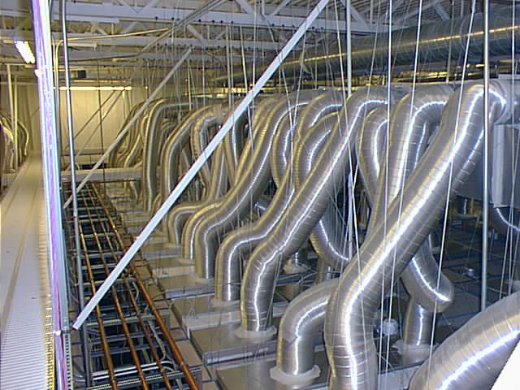

Summary
Recirculation air change rates (ACRs) are an important factor in contamination control in a cleanroom and are the single largest factor in determining fan and motor sizing for a recirculation air handling system. Air handler sizing and air path design directly impacts the capital costs and configuration of a building.
Many air change rate recommendations were developed decades ago with little scientific research to back them up. The recommended design ranges for ISO Class 5 (Class 100) cleanroom ACRs are from 250 to 700 air changes per hour (see Figure 1 for sources). Higher ACRs equate to higher airflows and more energy use, and don’t always achieve the desired cleanliness. Both new and existing systems can benefit from optimized air change rates. Frequently this equates to lower air change rates.
Benchmarking has shown that most facilities are operated at or below the low range of recommended ACRs. A Sematech study has also verified that lowered air change rates in cleanrooms are adequate in maintaining cleanliness. The actual operating ACRs documented for ten ISO Class 5 cleanrooms was between 94 and 276 air changes per hour.

Principles
- Lower air change rates result in smaller fans, which reduce both the initial investment and construction cost.
- Fan power is proportional to the cube of air change rates or airflow. A reduction in the air change rate by 30% results in a power reduction of approximately 66%.
- Lower airflow may improve the actual cleanliness by minimizing turbulence.

Approach
Designers and cleanroom operators have a variety of sources to choose from when looking for ACR recommendations. Recommendations are not based on scientific findings and consequently there is no clear consensus on an optimum ACR. For this reason, many of the established guidelines are outdated.
There are several conflicting sets of recommendations on cleanroom airflow. Articles in Cleanrooms magazine¹ have explored the different ways of measuring or describing airflow and have discussed the Institute of Environmental Sciences and Technology (IEST; Rolling Meadows, Ill.) recommendations; however, few industry observers have examined actual practices and the relationship on construction and energy costs.
There is no agreement on a recommended ACR rate. Most sources suggest a range of rates, while these ranges tend to be wide and do not provide clear guidance to designers who need to select a set ACR value to specify equipment sizes. Figure 1 shows the result of a comparative review of recommended ACRs.
Using better air change rate practices will allow designers to lower construction costs as well as reduced energy costs while maintaining the high level of air cleanliness that is required in cleanroom facilities.
Cleanrooms magazine² pointed out that many of the recommended ACRs are based on relatively low-efficiency filters that were prevalent 10 years ago. For example, today’s widely-used 99.99 percent efficient filters are three times more effective at filtering out 0.3 micron particles than the 99.97 percent filters that were common 10 years ago. Ultra-low penetration air (ULPA) filters are even more efficient than those of a decade ago.

Figure 1. Recommended Air Change Rates for ISO Class 5 (Class 100) Cleanrooms
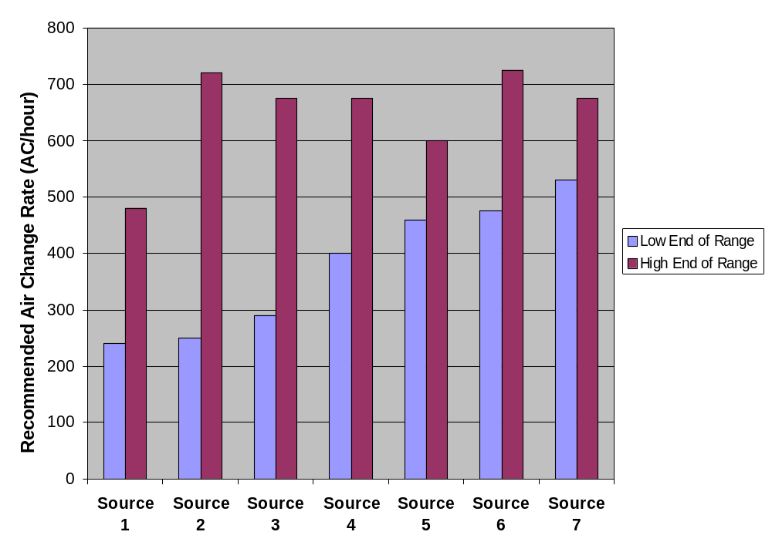
Sources:
1. IEST Considerations in Cleanroom Design (IEST RP-CC012.1)
2. Raymond Schneider, Practical Cleanroom Design
3. Cleanrooms equipment supplier
4. Faulkner, Fisk and Walton, “Energy Management in Semiconductor Cleanrooms”
5. California-based designer and cleanrooms instructor
6. Federal Standard 209B (superceded by ISO/DIS 14644)
7. National Environment Balancing Bureau, “Procedural Standards for Certified Testing of Cleanrooms,” 1996
The high end of that range is almost three times the rate at the low end, yet the impact of this difference on fan sizing and motor horsepower is radically greater. According to the fan affinity laws, the power difference is close to the cube of the flow or air change rate difference. For example, a 50 percent reduction in flow will result in a reduction of power by approximately a factor of eight or 87.5 percent. Due to filter dynamics, the cube law does not apply exactly and, typically, the reduction is between a cube and a square relationship.
Even relatively modest reductions of 10 percent to 20 percent in ACR provide significant benefits. A 20 percent decrease in ACR will enable close to a 50 percent reduction in fan size. The energy savings opportunities are comparable to the potential fan size reductions.
ACR reductions may also be possilbe when cleanrooms are unoccupied for a length of time. In most cleanrooms, human occupants are the primary source of contamination. Once a cleanroom is vacated, lower air changes per hour to maintain cleanliness are possible allowing for setback of the air handling systems. Setback of the air handling system fans can be achieved by manual setback, timed setback, use of occupancy sensors, or by monitoring particle counts and controlling airflow based upon actual cleanliness levels.
It is a common misconception that making a cleanroom more efficient will drive up construction costs. However, well-planned ACR reductions can reduce both construction and energy costs. This is a true win-win situation, which decreases the amount of work the mechanical system has to perform and offers high leverage for downsizing equipment.
Biotechnology and pharmaceutical cleanrooms are designed to meet "current Good Manufacturing Practices (cGMPs). Traditionally, high air change rates were followed without challenge because they had been previously accepted by regulators. As new information becomes available (such as case studies showing acceptable performance at lower airflows) the current Good Manufacturing Practice should be able to reflect use of lower airflow.
Best practice for ACRs is to design new facilities at the lower end of the recommended ACR range. Once the facility is built, monitoring and controlling based upon particle counts can be used to further reduce ACRs. Variable speed drives (VSDs) should be used on all recirculation air systems allowing for air flow adjustments to optimize airflow or account for filter loading. Existing systems should be adjusted to run at the lower end of the recommend ACR range through careful monitoring of impact on the cleanroom process(es). Where VSDs are not already present, they can be added and provide excellent payback if coupled with modest turndowns.

Real World Experiences (Benchmarking Findings/Case Studies)
The data from the cleanroom energy benchmarking study³ conducted by Lawrence Berkeley National Laboratory suggests that air change rates can be lower than what is currently recommended by several sources. The benchmarking data suggests that an ISO Class 5 facility could be operated with an air change rate of around 200 air changes per hour and still provide the cleanliness classification required. It can be concluded that rarely is more than 300 ACR required.
While the recommended design ranges for ACRs are from 250 to 700 air changes per hour, the actual operating ACRs ranged from 90 to 625 (see Figure 2). All of these cleanrooms were certified and performing at ISO Class 5 conditions. This shows that cleanroom operators can use ACRs that are far lower than what is recommended without compromising either production or cleanliness requirements.
This is often done to lower energy costs. However, these facilities did not take advantage of the fan sizing reduction opportunities during construction. As a result, most of the fan systems were operating at very low variable speed drive speeds.

Figure 2. Measured Air Change Rates for ISO Class 5 (Class 100) Cleanrooms
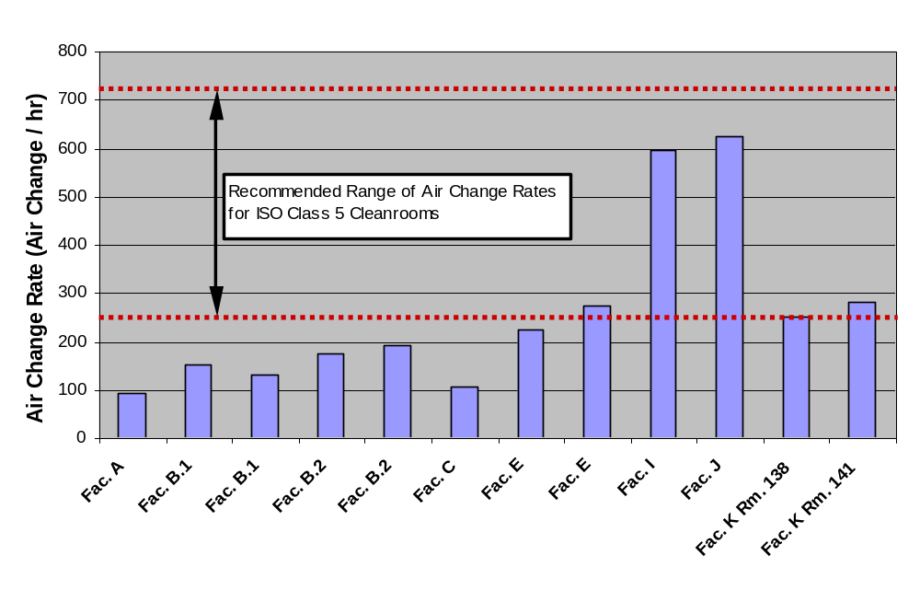
Fortunately, a growing body of data, case studies and research are available that document success. In a study by International Sematech (Austin, Texas)⁴, no noticeable increase of particle concentrations was found when air change rates were lowered by 20 percent in ISO Class 4 cleanrooms. Also, a study at the Massachusetts Institute of Technology (MIT; Cambridge, Mass.)⁵ found that in a raised-floor-type cleanroom “with a small decrease in air velocity, such facilities will decrease particle deposition and maintain air uni-directionality.”
Other success has been noted by cleanroom operators at Sandia National Laboratories (Albuquerque, N.M.). Sandia National Laboratories has successfully reduced air change rates in their state-of-the-art ISO Class 4 and 5 cleanrooms. This is especially significant since Sandia pioneered laminar flow cleanrooms in the early 1960s.

Related Best Practices
Low Face Velocity Mini-environments
Demand Control Filtration Pump & Fan Efficiency
Right Sizing Filters
Recirculation Air Handling Systems FFU Efficiency

References
- Fitzpatrick, Mike and Goldstein, Ken, “Cleanroom Airflow Measurement: Velocity, Air Changes Per Hour Or Percent Filter Coverage?” Cleanrooms magazine, May 2002; and Fitzpatrick and Goldstein, “Cleanroom Airflows Part II: The Messy Details,” Cleanrooms Magazine, July 2002.
- Jaisinghani, Raj, “New ways of thinking about air handling,” Cleanrooms magazine, January 2001.
- http://ateam.lbl.gov/cleanroom/benchmarking/index.htm.
- Huang, Tom, “Tool and Fab Energy Reduction,” Spring 2000 Northwest Microelectronics Workshop, Northwest Energy Efficiency Alliance.
- Vazquez, Maribel and Glicksman, Leon, “On the Study of Altering Air Velocities in Operational Cleanrooms,” 1999 International Conference on Advanced Technologies and Practices for Contamination Control.
- Rumsey Peter, “An Examination of ACRs: An Opportunity to Reduce Energy and Construction Costs,” Cleanrooms magazine, January 2003.
- Xu, Tim, “Considerations for Efficient Airflow Design in Cleanrooms,” Journal of the IEST, Volume 47, 2004.
- Xu, Tim, “Performance Evaluation of Cleanroom Environmental Systems,” Journal of the IEST, Volume 46, August 2003.

Resources
- IEST-RP-CC012.1, “Considerations in Cleanroom Design,” The Institute of Environmental Sciences and Technology (IEST), 1993.
- Schneider, R., “Designing Cleanroom HVAC Systems,” ASHRAE Journal V.43, No. 8, pp. 39-46, August 2001.
- ISO/DIS 14644-1, “Cleanrooms and associated controlled environments. Part 1: Classification of air cleanliness,” International Organization for Standardization, 1999.
- ISO/DIS 14644-2, “Cleanrooms and associated controlled environments. Part 2: Testing and monitoring to prove continued compliance to ISO/DIS 14644-1,” International Organization for Standardization, 2000.
- National Environment Balancing Bureau, “Procedural Standards for Certified Testing of Cleanrooms,” 1996.

