World Radiocommunication Conference (WRC-07)  Geneva, 22 October - 16 November 2007 | 
COMMITTEE 4 | Addendum 2 to Document 16-E
COMMITTEE 4 | 2 November 2007
COMMITTEE 4 | Original: Russian
Regional Commonwealth in the field of Communications
COMMON Proposal for the work of the Conference
Agenda item 1.4
Assessment of the possible impact of IMT identification in the band 470-862 MHz on
the digital terrestrial broadcasting service and other primary services
In the RCC countries, the band 470-862 MHz is currently intensively used for the broadcasting and other primary services. In the broadcasting service, moreover, the transition from analogue to digital broadcasting is being carried out in accordance with the digital frequency Plan of the Geneva-06 Agreement, and this will result in the need for additional frequency channel usage and create a situation of near full usage of the entire frequency band 470-862 MHz.
Studies on the impact on the Geneva-06 Plan of a primary allocation to the mobile service in the band 470-862 MHz and on the possibility of identifying harmonized sub-bands for IMT mobile systems have not yet been completed. This being the case, a breach of electromagnetic compatibility could occur between IMT and existing systems in that band.
The RCC countries are therefore of the view that any decision on identification of the band 470-862 MHz or parts thereof must be based on detailed technical and regulatory studies, particularly studies of electromagnetic compatibility between IMT systems and the radio facilities of the terrestrial broadcasting service and of other primary services. Such studies are already being carried out in ITU-R, in regional organizations and at the national level, although not all of the issues are as yet being covered.
The RCC countries have analysed the possible impact of identifying the band 470-862 MHz or parts thereof on the Geneva-06 digital Plan, as well as the difficulties that could arise on account of the need to protect the radio facilities of other primary services used in the RCC countries.
Table 1 and Figures 1 to 3 show the change in the number of available frequency allotments and reduction in the number of coverages in the Geneva-06 digital Plan for different identification scenarios in the band in question for IMT. Broadcasting service losses within the radio-frequency spectrum may be from 10 to 40 per cent (see Table 1), resulting in a reduction in the number of coverages in the Geneva-06 digital Plan on average from 7-8 to 3-4 (see Figures 1 to 3). This will present the RCC countries with considerable difficulties for the future development of the broadcasting service, particularly when it comes to expanding the number of programmes transmitted and introducing HDTV.
Table 2 and Figures 4 to 6 show the number of frequency assignments to the fixed service and aeronautical radionavigation service in the band 470-862 MHz requiring protection in the RCC countries under the Geneva-06 Agreement. As will be seen from the said table and figures, the considerable number of assignments indicated and significant requirements in terms of their protection will result in substantial difficulties when it comes to introducing IMT systems in neighbouring countries for all 470-862 MHz identification scenarios for IMT.
RCC/16A2/1
On the basis of their analysis, the RCC administrations do not support allocation of the band 470-862 MHz to the mobile service and its identification at WRC-07, but support the need to conduct additional studies in the period leading up to the next competent conference.
Table 1
Number of frequency allotments in the Geneva-06 digital Plan in different parts of the band 470-862 MHz (RCC countries)
Adm | 806-862 MHz  (56 MHz, 14%) |  | 790-862 MHz  (72 MHz, 18%) |  | 725-862 MHz  (137 MHz, 35%) |  | 698-862 MHz  (164 MHz, 42%) |  | 470-862 MHz  (392 MHz, 100%)
Adm | Number of allotments | % of total number of allotments in the band 470-862 MHz | Number of allotments | % of total number of allotments in the band 470-862 MHz | Number of allotments | % of total number of allotments in the band 470-862 MHz | Number of allotments | % of total number of allotments  in the band 470-862 MHz | Number of allotments | % of total number of allotments in the band 470-862 MHz
ARM | 29 | 13.9 | 29 | 13.9 | 59 | 28.2 | 70 | 33.5 | 209 | 100.0
AZE | 37 | 9.9 | 58 | 15.5 | 126 | 33.6 | 141 | 37.6 | 375 | 100.0
BLR | 19 | 9.3 | 26 | 12.7 | 61 | 29.8 | 72 | 35.1 | 205 | 100.0
GEO | 8 | 5.1 | 16 | 10.3 | 42 | 26.9 | 49 | 31.4 | 156 | 100.0
KAZ | 223 | 13.3 | 303 | 18.1 | 622 | 37.2 | 723 | 43.2 | 1 674 | 100.0
KGZ | 25 | 9.3 | 35 | 13.0 | 86 | 32.0 | 107 | 39.8 | 269 | 100.0
MDA | 10 | 17.9 | 12 | 21.4 | 18 | 32.1 | 23 | 41.1 | 56 | 100.0
RUS | 747 | 12.8 | 984 | 16.9 | 2 056 | 35.3 | 2 421 | 41.5 | 5 829 | 100.0
TJK | 43 | 11.4 | 62 | 16.4 | 132 | 35.0 | 159 | 42.2 | 377 | 100.0
TKM | 41 | 15.2 | 52 | 19.3 | 103 | 38.3 | 116 | 43.1 | 269 | 100.0
UKR | 94 | 14.8 | 123 | 19.3 | 248 | 39.0 | 282 | 44.3 | 636 | 100.0
UZB | 44 | 6.5 | 73 | 10.8 | 201 | 29.8 | 251 | 37.2 | 675 | 100.0
AVG |  | 11.6 |  | 15.6 |  | 33.1 |  | 39.2 |  | 100.0
Min |  | 5.1 |  | 10.3 |  | 26.9 |  | 31.4 |  | 100.0
Max |  | 17.9 |  | 21.4 |  | 39.0 |  | 44.3 |  | 100.0
Figure 1
Number of coverages in the band 470-862 MHz under the Geneva-06 digital Plan
(in RCC countries, in the case of NOC in RR Article 5)
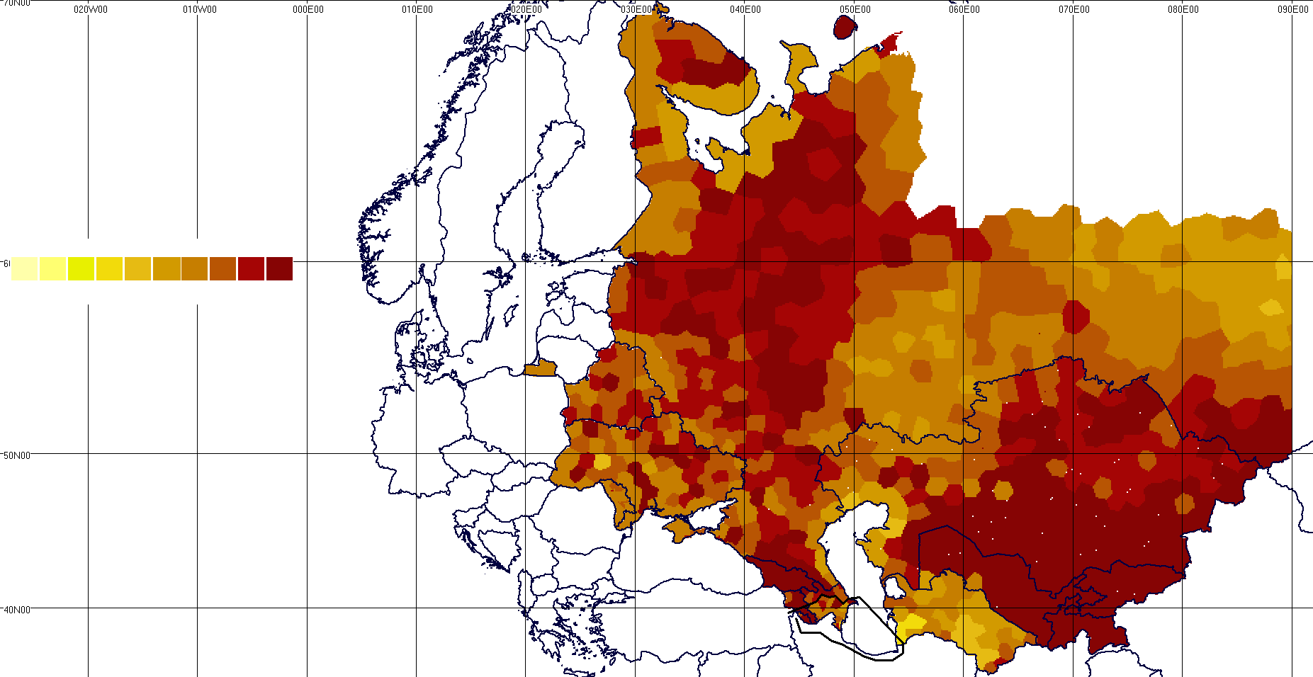
Number of coverages
1
2
3
4
5
6
7
8
9
10
RCC countries
Min: 4 coverages
Average: 7-8 coverages

Figure 2
Number of coverages in the band 470-806 MHz under the Geneva-06 digital Plan
(in RCC countries, in the case of 806-862 MHz band identification for IMT)
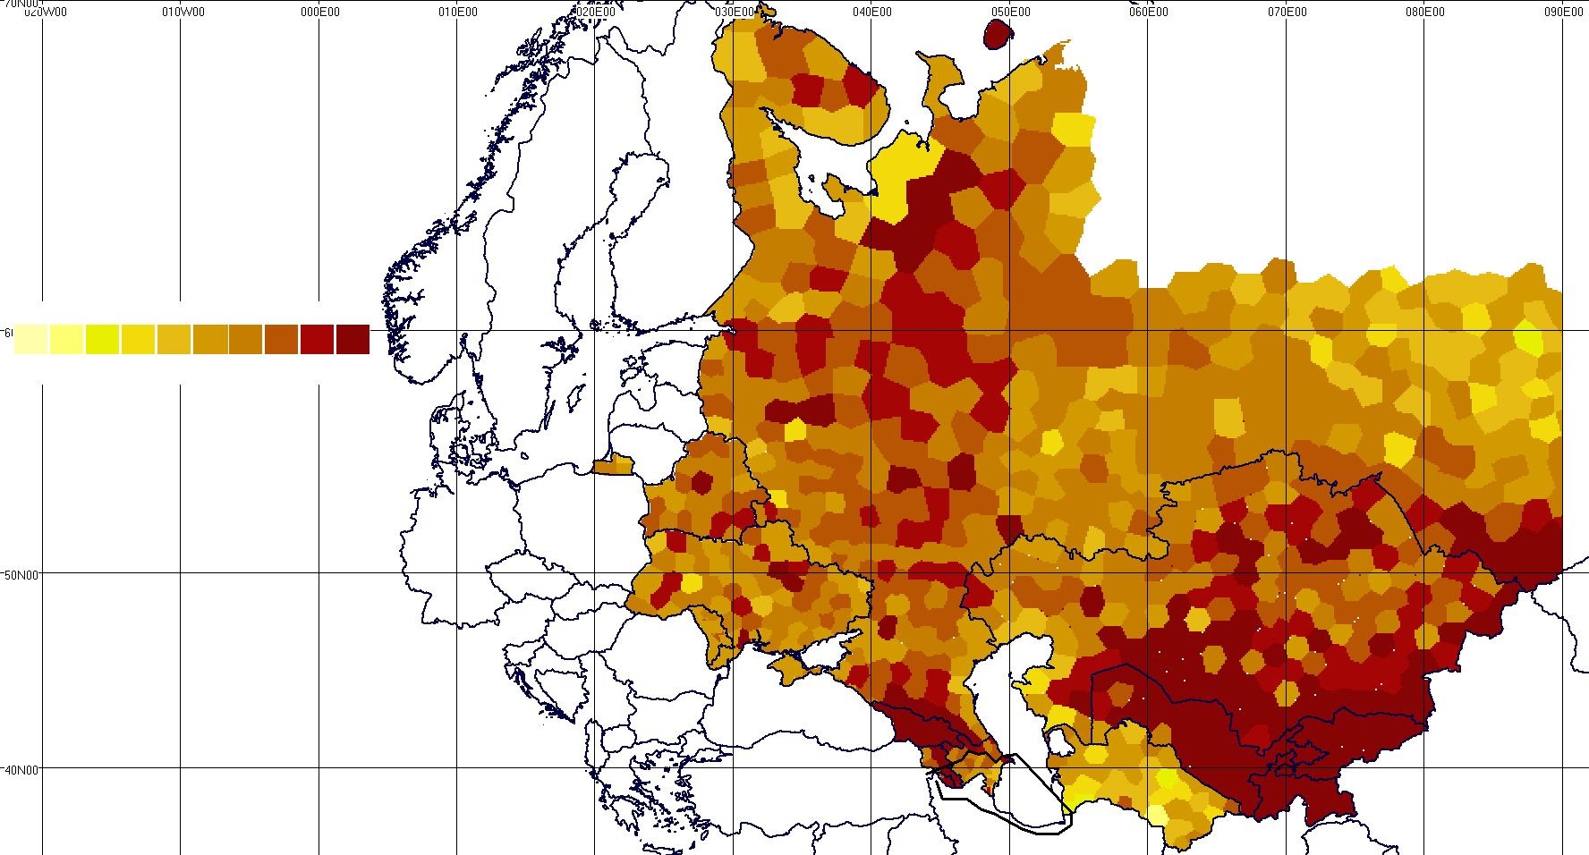
1
2
3
4
5
6
7
8
9
Number of coverages
10
RCC countries
Min: 2 coverages
Average: 4-5 coverages
Figure 3
Number of coverages in the band 470-698 MHz under the Geneva-06 digital Plan
(in RCC countries, in the case of 698-862 MHz band identification for IMT)
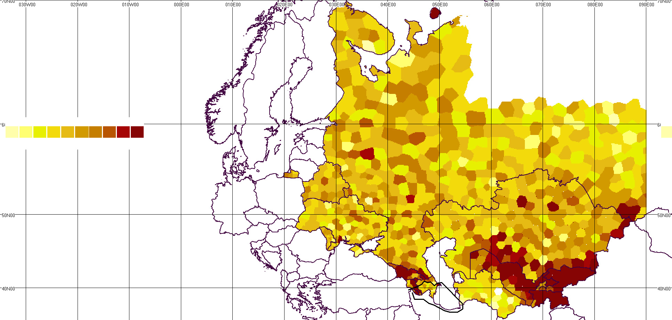
1
2
3
4
5
6
7
8
9
Number of coverages
10
RCC countries
Min: 1 coverage
Average: 3-4 coverages

Table 2
Number of assignments to FS and ARNS in the band 470-862 MHz in accordance with the Geneva-06 Agreement (RCC countries)
Adm | Number of assignments
Adm | 806-862 MHz | 790-862 MHz | 725-862 MHz | 698-862 MHz | 470-862 MHz
ARM
AZE | 0 | 0 | 0 | 0 | 3
BLR
GEO | 6 | 6 | 7 | 7 | 7
KAZ | 9 | 9 | 18 | 18 | 18
KGZ | 5 | 6 | 10 | 10 | 10
MDA
RUS | 1 042 | 1 177 | 1 330 | 1 331 | 1 420
TJK | 2 | 2 | 2 | 2 | 2
TKM
UKR
UZB | 7 | 7 | 21 | 21 | 27
Total | 1 071 | 1 207 | 1 388 | 1 389 | 1 487

Figure 4
Service area of FS and ARNS assignments in the band 698/725-862 MHz
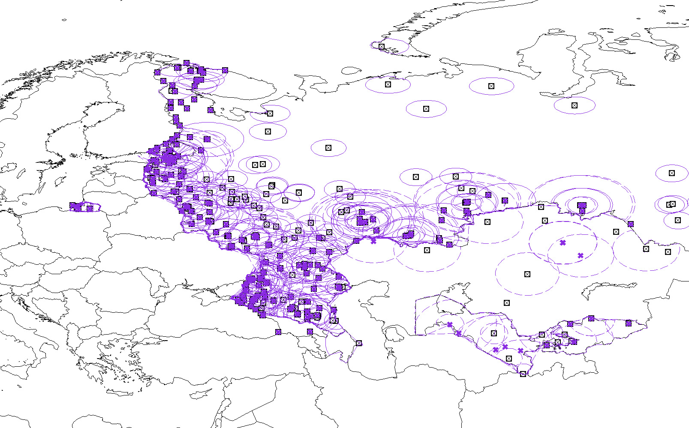
RUS
FIN
S
NOR
BLR
EST
LVA
LTU
UKR
POL
MDA
GEO
ARM
AZE
IRN
TUR
TKM
UZB
KAZ
KGZ
TJK
CHN
HNG
SVK
BUL
ROU
Max coordination distance with ARNS
(420 km)
Figure 5
Service area of FS and ARNS assignments in the band 790-862 MHz
(RCC countries, Geneva-06 Agreement)
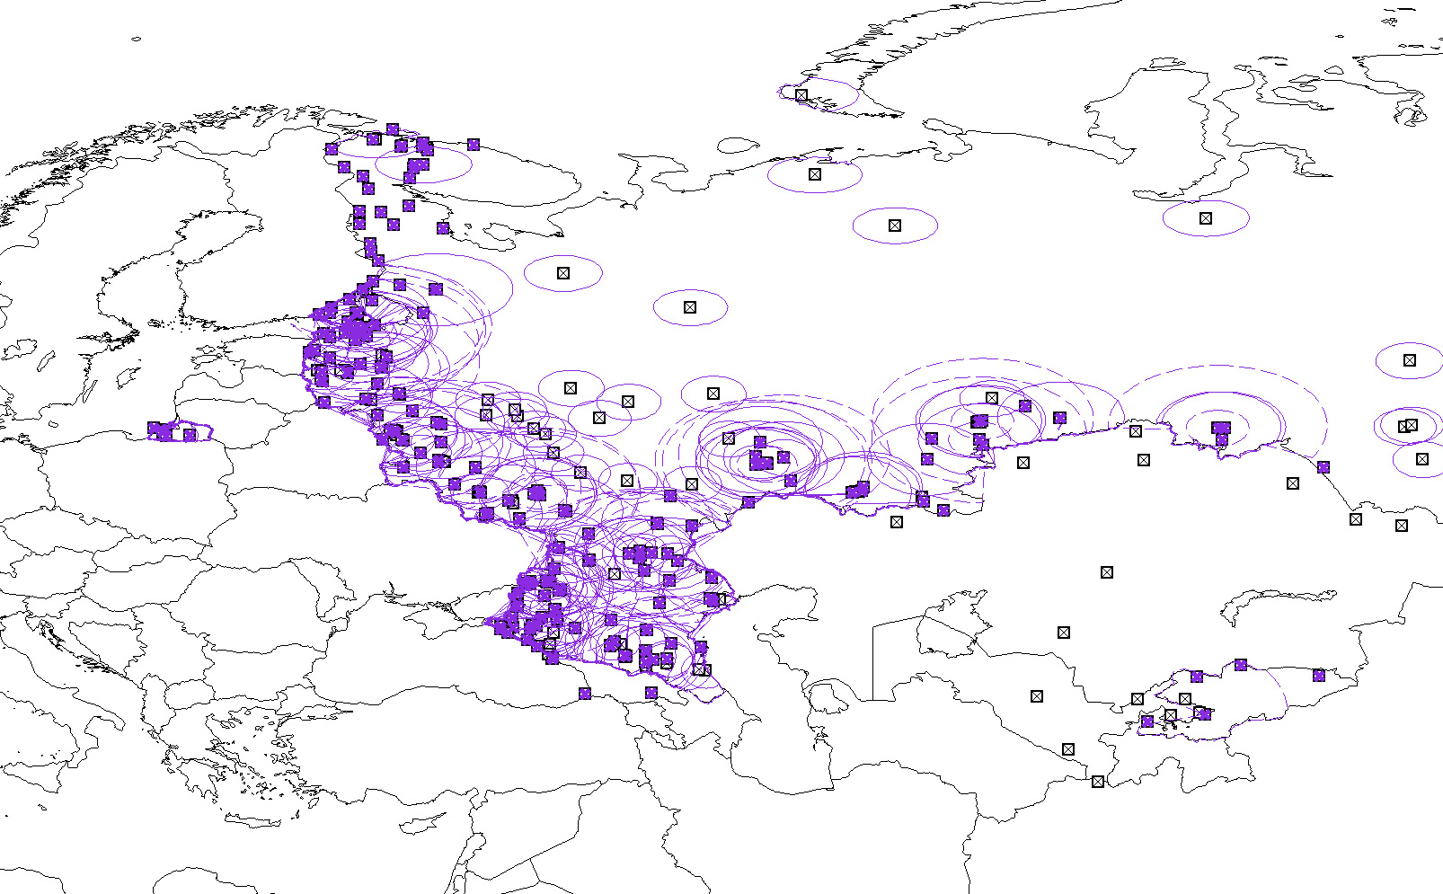
RUS
FIN
S
NOR
BLR
EST
LVA
LTU
UKR
POL
MDA
GEO
ARM
AZE
IRN
TUR
TKM
UZB
KAZ
KGZ
TJK
CHN
HNG
SVK
BUL
ROU
Max coordination distance with ARNS
(420 km)
Figure 6
Service area of FS and ARNS assignments in the band 806-862 MHz
(RCC countries, Geneva-06 Agreement)
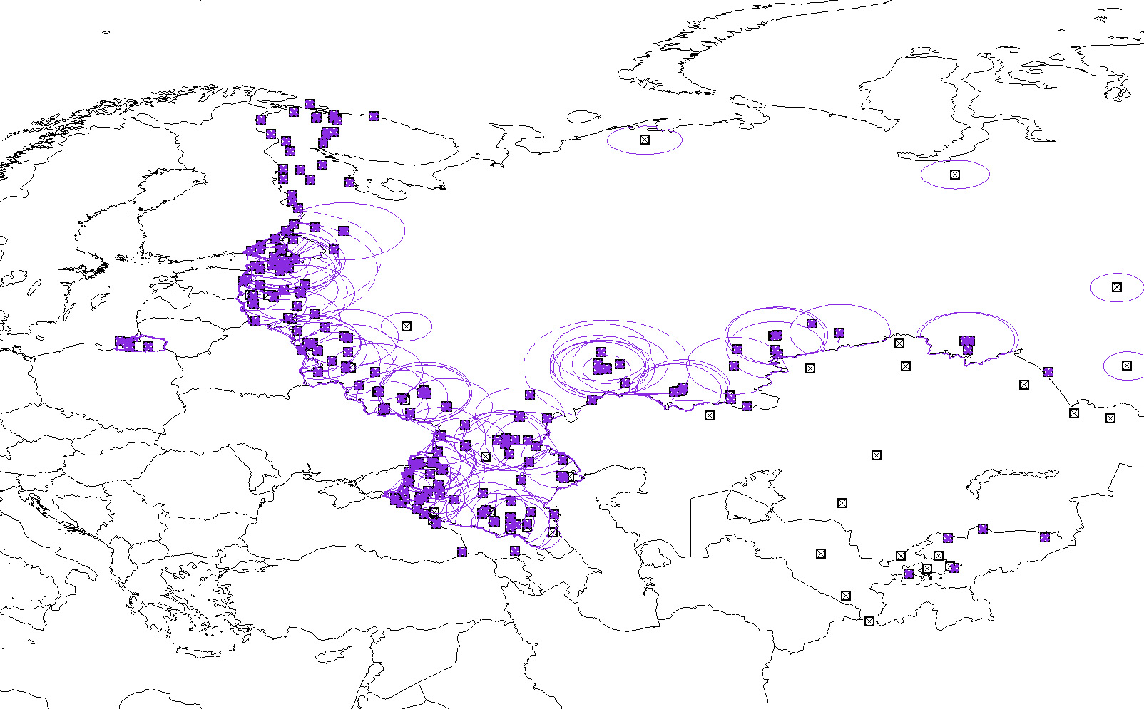
RUS
FIN
S
NOR
BLR
EST
LVA
LTU
UKR
POL
MDA
GEO
ARM
AZE
TUR
TKM
UZB
KAZ
KGZ
TJK
HNG
SVK
BUL
ROU
Max coordination distance with ARNS
(420 km)
_______________

