SURFACE TEMPERATURE HUMIDITY REFERENCE SYSTEM

(SurTHRef)

Users’ Manual
Table of Contents

Overview………………………………………………………………………………2

Corrective Maintenance……………………………………………………………….4

Depot Maintenance…………………………………………………………………....5

Shipment Notification…………………………………………………………………5

Logistics……………………………………………………………………………….6

Routine Maintenance………………………………………………………………….6

Appendix A: Bi-Weekly Procedures…………………………………………………7

Appendix B: Six-Month Procedures……………………………………………….…9

Sensor Verification Form………………………………………………….…12

Appendix C: Sensor Replacement Procedures……………………………………....14

Appendix D: LoggerNet Set-Up…………………………………………………..…21

Appendix E: PERL Script Set-Up…………………………………………………...30

Appendix F: NL-100 Set-Up……………………………………………………...…34

Appendix G: Wiring Diagrams…………………………………………………...…37

SURFACE TEMPERATURE HUMIDITY REFERENCE SYSTEM

Overview

Purpose:

The Surface Temperature and Relative Humidity Reference Station (SurTHRef) is intended to provide accurate reference values of ambient temperature and relative humidity for comparison with radiosonde pre-launch values.

References:

ECR-00319 (Modify BBSS surface reference system at SGP)
ECO-00319 (Modify the Chilled Mirror/BBSS surface reference system at SGP)

Components:

- Meteorological Instrument Shelter. The shelter is a standard NWS “Stevenson screen” modified to allow for operator access on two sides. The shelter dimensions are 20” x30” x34”.
- Instrument Shelter stand.
- Aspirated Chamber. The chamber is fabricated from white polypropylene plastics. Its dimensions are 11”x13”x18” (volume = 1.49 ft³). One end is open and covered with a removable plate containing a 7” x7.5” access port. Two muffin fans, each rated at 115 cfm are mounted at the far end. The fans produce an estimated face flow of 10.49 fps or 3.2 m/s. The chamber has 6 sensor ports on its top surface to accommodate standard temperature and relative humidity probes.
- Sonde positioning platform. A polypropylene platform is mounted approximately 1” above the bottom of the aspirated chamber. The platform is equipped with moveable guides for positioning radiosondes. A user-controlled switch is mounted on the side of the Aspirated Chamber to indicate when a radiosonde is placed in or removed from the chamber.
- Temperature and relative humidity probes.
  - Vaisala HMP45D probes – four each, one spare.
  - Rotronics MP100H probes – four each, one spare.
- Data logger. The system uses a Campbell Scientific Instruments CR23X data logger.
- Dell Computer. The computer is configured to conform to ARM Core-PC standards.
Power Requirements:

- Muffin fans use 110V AC.
- Data logger uses 110V AC through an AC/DC converter.
- Probes use 12V DC supplied by the data logger. The Vaisala probes require < 4 mA; the Rotronics probes < 10 mA.
- Enclosure heater uses 110V AC
- Enclosure cooling fan uses 110V AC
- Micro-switch uses 5V DC supplied by the data logger.

Corrective Maintenance

The Surface Temperature and Humidity Reference System, SurTHRef, is designed to require a minimum amount of routine maintenance. If the system does not operate properly or conform to the routine checks, the following action steps should be taken.

1) On-site check. The site operator should check for obvious problems like battery voltage out of operating range (9.6 to 16 V) and loose connections.

If the system is not operating, try restarting by turning off the power and then turning it back on. The program is automatically reloaded on power-up.

If one sensor is not operating properly, replace it using the Installation Manual as a guide. A spare of each sensor type has been supplied. When a sensor is replaced, verification will need to be performed and documented. Updates to the program will need to be accomplished to capture the serial number change.

2) Inform the instrument mentor. If the site operator is unable to correct the problem, inform Michael Ritsche or Barry Lesht, the instrument mentors. They may be contacted at:
Michael T. Ritsche
Argonne National Laboratory
Building 203
9700 S. Cass Ave
Argonne IL 60439
(630) 252-1554 Office
(630) 252-5498 FAX
(630) 264-2898 Home
mtritsche@anl.gov Email

Dr. Barry M. Lesht
Argonne National Laboratory
Building 203
9700 S. Cass Ave
Argonne IL 60439
(630) 252-1554 Office
(630) 252-5498 FAX
bmlesht@anl.gov Email

Depot Maintenance

Some components that have been replaced due to malfunction or being out of tolerance will be returned to the vendor and/or manufacturer for service and/or repair. Normally this will be done after consultation with the instrument mentor. Many items can and will be repaired in the Repair Lab at the Central Facility. All sensors will be returned to the SGP CF and given to George Sawyer. He will either have them repaired under warranty, repaired in-house in the Repair Lab, or send them to the appropriate vendor. If a unit or system has to be shipped to the SGP, ship to the address listed below. An ARM SGP shipment notification form ‘must’ be filled out and sent to SGP before the shipment arrives. A link to that form is attached below.

George Sawyer
ARM SGP CART Site
309600 EW 28
Billings, OK 74630
(580) 388-4053 Voice
(580) 388-4052 FAX
george@ops.sgp.arm.gov Email
http://sdsops.arm.gov/shipping/shipnote.html

The phone numbers below are the contact numbers to get the RMA numbers required for return of the sensors. Serial numbers and the reason for return are required.

Vaisala 1-888-824-7252 (follow prompts)
Rotronic 1-800-628-7101 ext. 20

Shipment Notification

All returns will be evaluated in the lab and/or repaired. If the unit cannot be repaired in the lab it will be sent to the manufacturer or appropriate vendor. An RMA number must be obtained from the vendor. A SGP PR must be filled out with all of the appropriate information including the obtained RMA number. The PR will list the quoted repair cost and/or a not to exceed cost. The PR must be signed by all of the appropriate managers and then faxed to Laurel Chapman at Argonne National Lab. When notified by Argonne that a PO is in place, pack the unit appropriately and ship it to its repair destination.

Laurel Chapman
ERD Building 203 Rm# J013
Argonne National Laboratory
9700 S. Cass Ave
Argonne IL 60439
(630) 252-2887 Voice
(630) 252-9792 FAX
lachapman@anl.gov Email

Logistics

The following expendables are used with the SurTHRef systems:

- The Vaisala HMI31/HMP35 Temperature and Relative Humidity Meter using 9V batteries.
- A desiccant pack, CSI type DSC20/4, is used in the enclosure.

The desiccant packs will require replacement approximately every two months. The site operators should maintain an adequate inventory of this item. Contact Laurel Chapman to obtain replacement packs when the supply level falls.

Routine Maintenance

Every Two Weeks

The following are required to perform the checks and preventative maintenance (See Appendix A):

- A desiccant pack.
- A second person.

If equipment of sensor replacement is required, the following additional items may be needed:

- Replacement parts or sensors
- The Users Manual
- HMI31/HMP35 Temperature and Relative Humidity probe.

Every Six Months

The following are required to perform the six-month checks, maintenance and sensor verification (See Appendix B):

- A desiccant pack.
- A second person and radios.
- HMI31/HMP35 Temperature and Relative Humidity probe.
- Assorted tools (wrenches, screwdrivers).

If equipment of sensor replacement is required, the following additional items may be needed: (see Appendix C)

1. Replacement parts or sensors
2. The Users Manual

Appendix A

Bi-Weekly Procedures

SurTHRef

Preventative Maintenance Procedures

Frequency: Bi-Weekly
Mentor: Michael Ritsche, Barry Lesht

The following procedures are for performing the scheduled bi-weekly maintenance. All results should be recorded on the PM checklist.

INSPECTION OF SITE GROUNDS NEAR THE INSTRUMENT

Visually inspect the site grounds around the instrument shelter for hazards such as rodent burrows, buried conduit trench settling, and insect nests.

Checklist Response: No problems noted.
Problem: See CM Report
Problem: See Comments

VISUAL INSPECTION OF INSTRUMENT COMPONENTS

Stevenson Screen

Check that the Stevenson Screen is in good working order. Ensure that the paint is in good shape and that all hardware (hinges, latches, etc) is in good shape. Check for excessive rust on moving metallic parts, cracked components and/or slats of the Stevenson Screen

Checklist Response: No problems noted.
Problem: See CM Report
Problem: See Comments

Conduit, Cables and Connectors

Check that all conduits and cables on the bottom of the control box are secure. Check all cables and conduits for damage. Check all sensor and electrical wires inside the control box for damage. Check the tightness of all sensor connection at the data logger. Check for water intrusion and that the fan or heater is working.

Checklist Response: No problems noted.
Problem: See CM Report
Problem: See Comments

Appendix B

Six-Month Procedures
SurTHRef

Six-Month Calibration Procedures

Frequency: Twice a year
Mentor: Michael Ritsche, Barry Lesht

To verify the accuracy and installation of the six temperature and relative humidity probes the following will need to be accomplished:

Remove the humidity cap from each of the sensors and clean or replace. The Vaisala probe humidity cap is replaced on a similar time frame to the SMOS replacement. The Rotronic humidity cap is made of wire mesh. This cap should be gently cleaned using a mild detergent and soft bristled brush. It will need to dried thoroughly before re-installation. If major damage has occurred the humidity cap should be replaced.

Verification of the sensors is done with the Vaisala HMI31/HMP35 T/RH meter. Set or hold the measuring portion of the meter inside the polypropylene aspirated chamber. Ensure that the meter is centered and at similar height to the measuring portion of the six probes. Turn on the meter and allow it to stabilize so that the meter readings are changing by less than 0.2 ºC and 1% RH. When the meter has stabilized, wait an additional five minutes before taking readings. The readings from the sensors are available inside the sonde trailer and are located on the PC in the program called BBSSRef.RTMC.

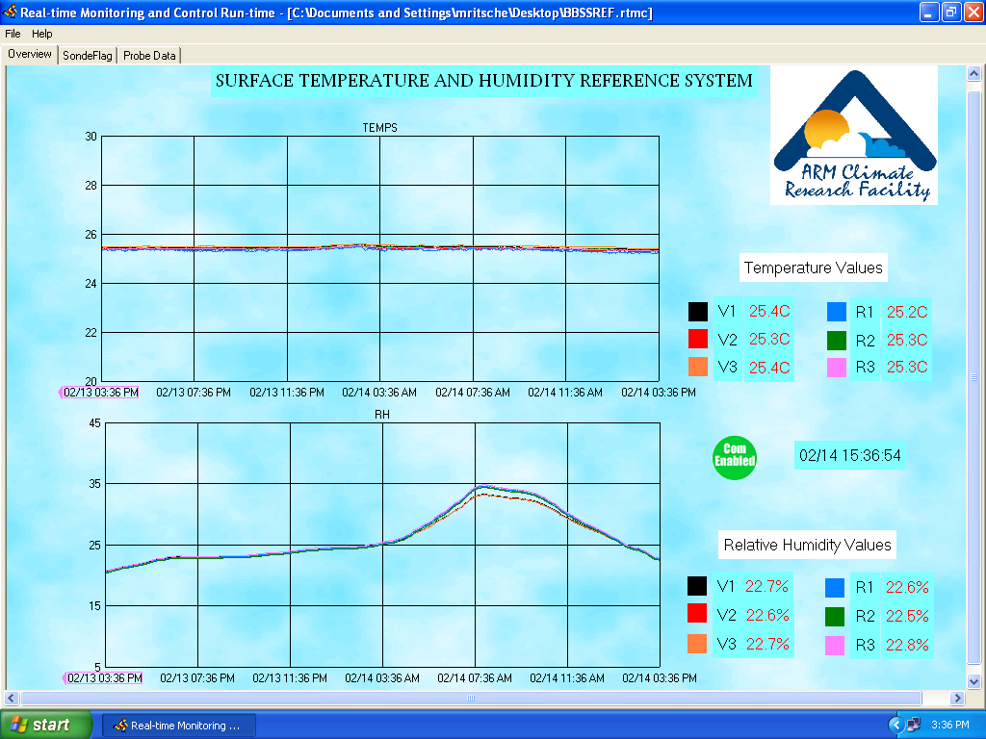

SURFACE TEMPERATURE AND HUMIDITY REFERENCE SYSTEM

SENSOR VERIFICATION

Tested by:______________________ Date: ________/_________/__________

Started: __________________GMT Ended:__________________GMT

- Vaisala HMP-45D Temperature and Relative Humidity
(The temperature readings, once stabilized should match within +/- 0.5 ºC)
(The RH readings, once stabilized should match within +/- 3% RH for 0 – 90% RH and +/- 4% for 90 – 100% RH)

V1 HMP-45D Serial Number:______________

Temperature:
HMI31 Reading:___________V1 HMP-45D Reading:_____________ P/F

RH%:
HMI31 Reading:___________V1 HMP-45D Reading:_____________ P/F

V2 HMP-45D Serial Number_______________

Temperature:
HMI31 Reading:___________V2 HMP-45D Reading:_____________ P/F

RH%:
HMI31 Reading:___________V2 HMP-45D Reading:_____________ P/F

V3 HMP-45D Serial Number________________

Temperature:
HMI31 Reading:___________V3 HMP-45D Reading:_____________ P/F

RH%:
HMI31 Reading:___________V3 HMP-45D Reading:_____________ P/F

- ROTRONIC MPH100H Temperature and Relative Humidity
(The temperature readings, once stabilized should match within +/- 0.5 ºC)
(The RH readings, once stabilized should match within +/- 3% RH for 0 – 90% RH and +/- 4% for 90 – 100% RH)

R1 MPH100H Serial Number________________

Temperature:
HMI31 Reading:___________R1 HMP-45D Reading:_____________ P/F

RH%:
HMI31 Reading:___________R1 HMP-45D Reading:_____________ P/F

R2 MPH100H Serial Number________________

Temperature:
HMI31 Reading:___________R2 HMP-45D Reading:_____________ P/F

RH%:
HMI31 Reading:___________R2 HMP-45D Reading:_____________ P/F

R3 MPH100H Serial Number________________

Temperature:
HMI31 Reading:___________R3 HMP-45D Reading:_____________ P/F

RH%:
HMI31 Reading:___________R3 HMP-45D Reading:_____________ P/F

Appendix C

Sensor Replacement Procedures

Sensor Replacement Procedures

Both the Rotronic and Vaisala probes have removable sensing units. To access the sensing unit it is necessary to remove the probe from the Aspirated Chamber.

- Turn the copper retaining screw counter clockwise to loosen and remove the sensor from the chamber.

- Grasp the sensor body firmly and remove the sensing unit.

- Replace the sensing unit with a recently calibrated unit.

- Return the sensor to the Aspirated Chamber and tighten the copper retaining screw by turning it clockwise.

- Check the BBSSRef.rtmc Overview screen to ensure the new unit is working properly and compare the new sensors readings to the readings of the other sensors in the Aspirated Chamber.

The CR23X program will need to be updated with the new sensors serial number. To change the program you will need to log onto the collector PC as administrator. Once logged on as administrator, double click on the shortcut “Shortcut to Administrative Tools” located on the desktop. Next, double click on “Services”. Find LoggerNet in the list of services and highlight by left clicking on it. On the left hand side two menu choices will show up in blue text. Choose “Stop” to stop the service.

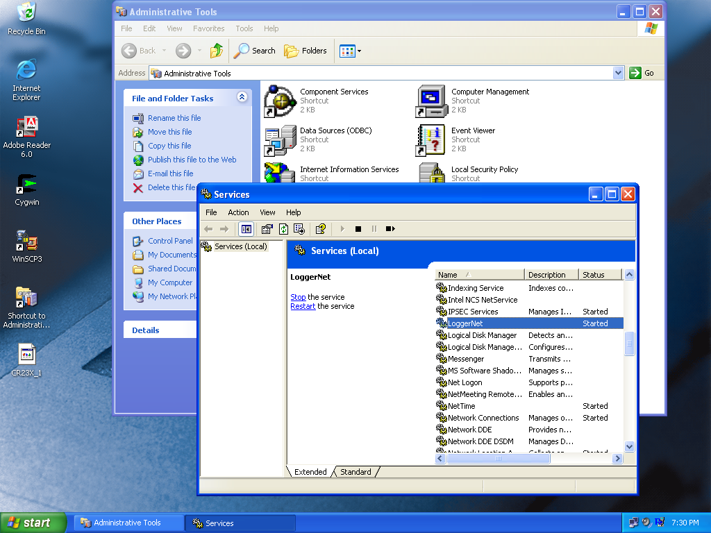

Once the service has been stopped, go to “Start” and choose “LoggerNet” to start the program. When the LoggerNet menu bar is active click on “EdLog”.

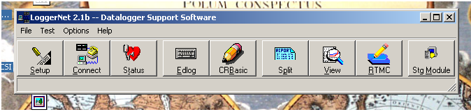

When Edlog starts go to “File>>Open” and navigate to the C:\SurTHRefPgm folder and choose the .csi program (.csi should be default) and open it. Navigate to the lower section of the program where the DAILY OUTPUT and LOGISTICS section is located.
****************DAILY OUTPUT and LOGISTICS***************************
;
;This output, once per day, captures the serial number
;of the 6 probes; three Vaisala HMP-45D's and three Rotronic MP100H.
;The Rotronic probe serial numbers are: 92781,
;92782, 92783. The Vaisala probe serial numbers are: Y3110012,
;Y3110013, Y3110014. Campbell doesn't allow for text values
;to be entered so we capture the Vaisala probes SN's as 0012, 0013, 0014.
;The locations of the probes in the box are also captured in variables called
;XXlocate, where XX corresponds to V1, V2, V3 for the Vaisala probes and R1, R2, R3
;for the Rotronic probes. The location of a particular probe and the serial number
;should match. For example, if Vaisala probe 0012 is V1 and it is in
;location 1 then the value of V1probeSN should be 0012 and the value of V1locate
;should be 1. The ranges of values for locations are 1 - 12. The number
;of the location is as follows, if looking down on top of the
;box with the open end at the bottom.
;
;
; fan fan
;
;
; 3 6
;
;
; 2 5
;
;
; 1 4
;
;
; OPEN END
;
;
;***********************************************************************

22: If time is (P92)
1: 0 Minutes (Seconds --) into a
2: 1440 Interval (same units as above)
3: 10 Set Output Flag High (Flag 0)

23: Set Active Storage Area (P80)^17083
1: 1 Final Storage Area 1
2: 2 Array ID

24: Real Time (P77)^22655
1: 1220 Year,Day,Hour/Minute (midnight = 2400)
;V1 probe serial number

25: Z=F x 10^n (P30)
1: 0012 F
2: 0 n, Exponent of 10
3: 31 Z Loc [ V1probeSN ]

;V1 probe location

26: Z=F x 10^n (P30)
1: 1 F
2: 0 n, Exponent of 10
3: 32 Z Loc [ V1locate ]

;V2 probe serial number

27: Z=F x 10^n (P30)
1: 0013 F
2: 0 n, Exponent of 10
3: 33 Z Loc [ V2probeSN ]

;V2 probe location

28: Z=F x 10^n (P30)
1: 5 F
2: 0 n, Exponent of 10
3: 34 Z Loc [ V2locate ]

;V3 probe serial number

29: Z=F x 10^n (P30)
1: 0014 F
2: 0 n, Exponent of 10
3: 35 Z Loc [ V3probeSN ]

;V3 probe location

30: Z=F x 10^n (P30)
1: 3 F
2: 0 n, Exponent of 10
3: 36 Z Loc [ V3locate ]

;R1 probe serial number

31: Z=F x 10^n (P30)
1: 92781 F
2: 0 n, Exponent of 10
3: 37 Z Loc [ R1probeSN ]

;R1 probe location

32: Z=F x 10^n (P30)
1: 4 F
2: 0 n, Exponent of 10
3: 38 Z Loc [ R1locate ]

;R2 probe serial number

33: Z=F x 10^n (P30)
1: 92782 F
2: 0 n, Exponent of 10
3: 39 Z Loc [ R2probeSN ]

;R2 probe location

34: Z=F x 10^n (P30)
1: 2 F
2: 0 n, Exponent of 10
3: 40 Z Loc [ R2locate ]

;R3 probe serial number

35: Z=F x 10^n (P30)
1: 92783 F
2: 0 n, Exponent of 10
3: 41 Z Loc [ R3probeSN ]

;R3 probe location

36: Z=F x 10^n (P30)
1: 6 F
2: 0 n, Exponent of 10
3: 42 Z Loc [ R3locate ]

Change the serial number in location 1 (see bold values above) of the appropriate instruction number for a particular probe or location. For example, if the probe located in V2 was changed go to Instruction 27 and change the serial number in location 1 of Instruction 27 (0013 above). The same holds true for moving sensors or changing the location. If the probes in located in V2 and V3 are swapped the serial numbers also have to be swapped in the program.

Once the program has been changed, click on “save” and when the warning banner comes up asking you to compile click on “yes”. If there are errors or warnings stop and contact the mentor(s). If there are no warnings proceed with loading the program to the data logger. EdLog can be closed at this time.

Go back to the main LoggerNet menu bar and click on “Connect”. When the “Connect” screen is active choose “BBSSRef” from the left hand menu location under Stations. Once the BBSSRef logger is highlighted, click on the “connect” button under Control. When communication with the logger has been established (wires connect) click on “Send” under Program. Choose the program that was just updated above (C:\SurTHRefPgm) and send it to the logger, click on “Ok” when the warning banner appears. Click on “Disconnect” under Control to stop communication with the data logger and close the “Connect” screen.

After the program has been sent, view the Overview screen of the BBSSRef.rtmc program to ensure the data appear reasonable and that everything appears to be working properly. Notify the mentor(s) of the probe and program change so that they can verify that the changes appear during the next daily output.

Once the changes have been made and the new program sent LoggerNet needs to be set as a Service again.

Close the LoggerNet menu bar and double click on “Shortcut to Administrative Services” and double click on “Services” again. Navigate to LoggerNet and choose “start” from the two choices listed in the left hand window. Once LoggerNet has started as a service close all screens and log off as administrator.

Appendix D

LoggerNet Set-Up
LoggerNet Setup

- Setup and start PC. Ensure the PC is connected to the network and the loggers and NL-100’s are connected and running.
- Create the following directories on the PC:

  - C:\ARM\bin
  - C:\SendDir\SurTHRef
  - C:\SurTHRefData
  - C:\SurTHRefPgm

- Start LoggerNet if it not already running (task bar will be on desk top if it is)
- Click on the Setup icon

- Once the Setup interface starts click on the Add Root button and choose IPPort.

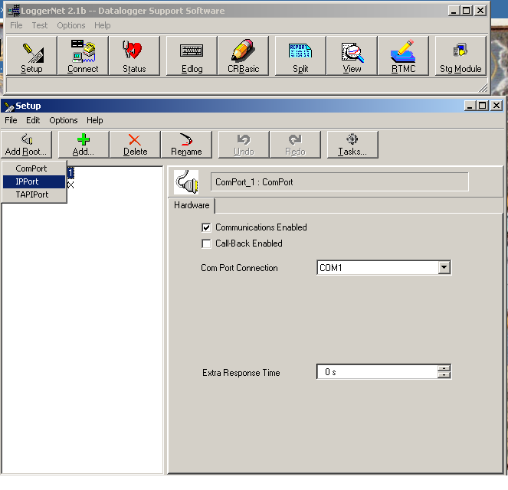

- Once the IPPort has been added, enter the IP address 198.124.98.19. Ensure the Communications Enabled box is checked. Set Extra Response time to 0 s if not already done. Call-back Enabled should not be checked.

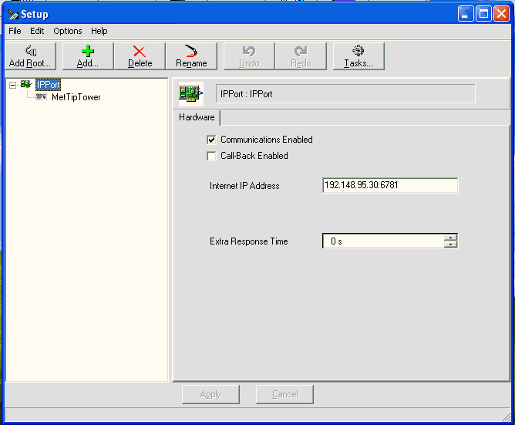

- Once the IPPort has been added you can change the name. Suggestion would be to change the name to IPPort.Sur.19. This is not necessary but may help in identification.
- Click on the Add button to add a datalogger under the IPPort. Choose CR_23X. Once you highlight the logger type, click on the Add Now button. You must click on close afterwards to shut down the Add Device window. Clicking the Add Now button will add multiple loggers if done more than once. If this occurs, highlight the unwanted loggers by clicking on them and clicking on the delete button.

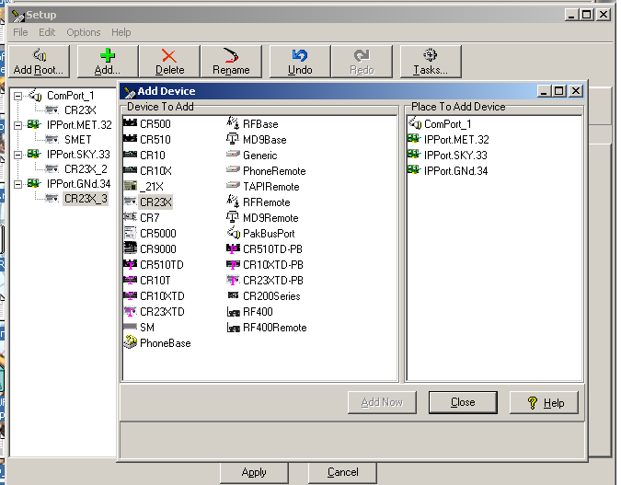

- Once the logger has been added you should rename it to SurTHRef either using the Rename button or highlighting and using right mouse button
- Left click on a logger to access the remaining connection information so that it can be reconfigured.
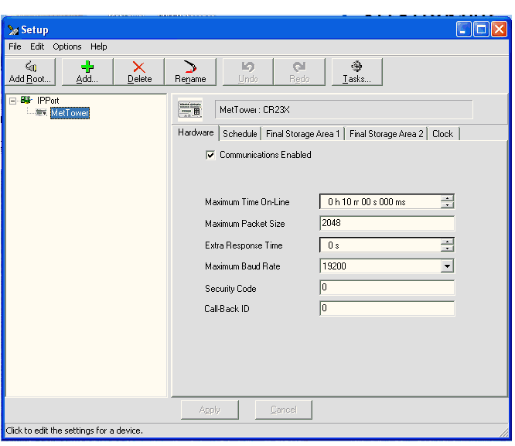

- Ensure the Communications Enabled box is checked and leave all settings under hardware tab as default.
- Click on the schedule tab and change the following settings: ensure Scheduled Collection Enabled box is checked. Change Collection Interval to 01m, rest 0’s. Change Primary Retry Interval to all 01m and Number of Primary Retries to 1. Uncheck Secondary Retry Interval and Collect Ports and Flags. Leave everything else as defaults.

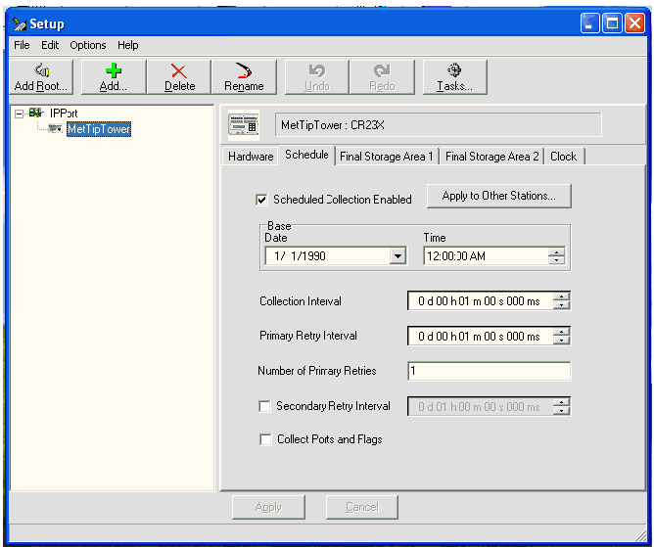

- Click on Final Storage Area 1 tab and make the following changes to the settings: check the Enable for Collections box and change the destination of the data file to the directory created in step 2 (SurTHRefData) and change the name of the data file to SurTHRef.dat. Uncheck the Use Default Name box. Under File Output Option click the Append to End of File radio button. Under Output Format click the ASCII, Comma Separated radio button. Under Collect Mode, click on Data Logged Since Last Call radio button and check the Collect All on First Call box.

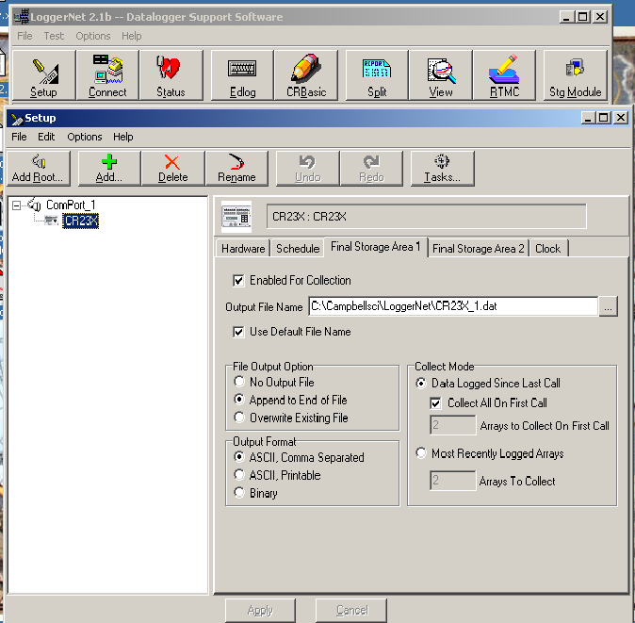

- Click on the Clock tab to make changes to the following settings: Leave Time Zone Offset as 0h 00m. Under Automated Clock Check click the box Enabled. You can leave Initial Date as default but make sure Initial Time is XX:XX:30 so that any clock check occurs at 30 sec past a minute. Set Interval to 01 d, for once per day. Set the Allowed Clock Deviation to 1 sec.

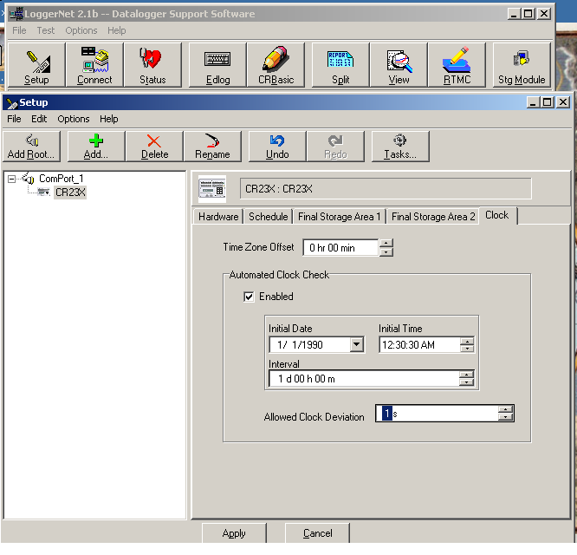

- You will not need to make any changes to the settings in the Final Storage Area 2 tab. Just ensure that the Enabled for Collections box is not checked.
- Once the above steps are complete you should be able to connect to the logger using the Connect button of the main menu.

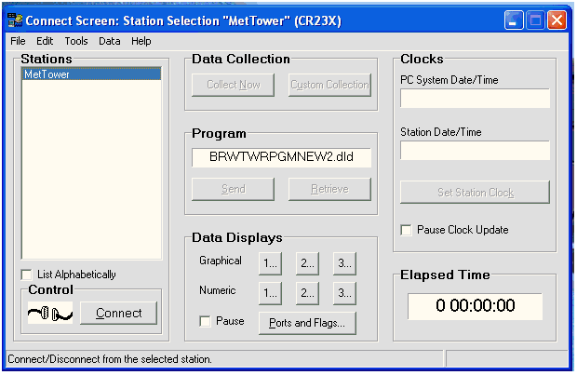

- The logger you added in the above steps will be located in the Stations menu. Highlight the logger you wish to connect to and click on the connect button on the bottom. If everything is connected and correct the wires of the Control display will connect. To send a program to the logger click on the Send button under the Program portion of the Connect screen. Navigate to the directory where the program is stored (should be C:\SurTHRefPgm) and select the appropriate program. Once the program has been selected, click on the Send button. A warning banner will be displayed stating that continuing will cause all data to be lost. Continue to send the program by clicking on the Ok button. Once the send is complete and the logger has compiled the program, another message banner will be displayed, click on Ok to finalize the transmission. Once connected and a program is running (assuming sensors connected) you can view the raw data and final stored data by clicking on the numbers in the Data Displays section of the Connect screen.

****A NOTE OF WARNING: CONNECTING TO A LOGGER USING THE CONNECT SCREEN WILL DISABLE COMMUNICATIONS TO OTHER LOGGERS ON LOGGERNET. NO DATA WILL BE COLLECTED WHILE YOU ARE CONNECTED THIS WAY. REGULAR COMMUNICATIONS WILL BE RESTORED WHEN THE CONNECTION IS SEVERED.

Appendix E

Perl Script Set-Up
PERL SCRIPT SET-UP

${DataDir} = The name of the output directory used by LoggerNet
${DataFile} = The name of the output file used by LoggerNet

${DataDir} = SurTHRefData
${DataFile} = SurTHRef.dat

1. Create directories:
- C:\ARM\bin
- C:\SendDir\SurTHRefData

2. Copy split_working_cdl.pl script to C:\ARM\bin

3. Install ActivePerl-5.8.0.806-MSWin32-x86.msi
- Choose default options
4. Schedule split_working_cdl.pl script in LoggerNet Tasks:
5. Click on Setup button on main LoggerNet task bar.
6. Click on the Task button.

8. Click on Add Scheduled button on lower left hand side of window.

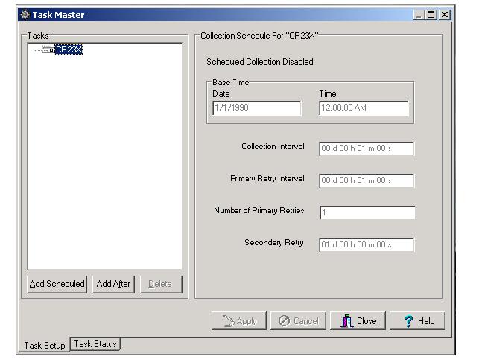

9. Rename the task in the window by right clicking on the highlighted task and rename as SplitSurTHRef

- Change the following in the “Scheduled Event” section
Base Date: any previous date (i.e. 5/7/2004)
Base Time: 12:00:50 AM

Event Interval: 0 d 01 h 00m 00 s

- In the “What Task Does” section do the following for each task.
Check box for Execute File:
File Name: C:\ARM\bin\split_working_cdl.pl
Command Line Options:
-f SurTHRef.dat –i /SurTHRefData –o /SendDir/SurTHRefData
The generic format is:
-f ${DataFile} –i /${DataDir} –o /SendDir/${DataDir}
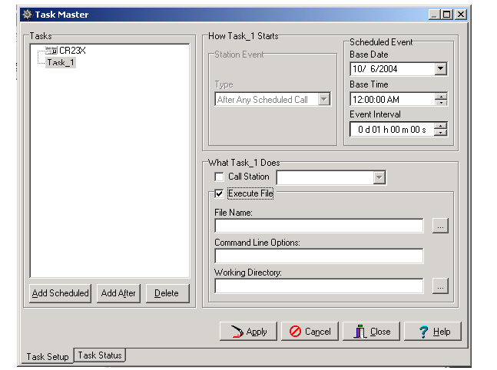

Working Directory:

C:\SurTHRefData
The generic format is:

C:\${DataDir}

When finished, click on the Apply button.

Appendix F

NL-100 Set-Up
NL-100 SET-UP

In order to communicate with the NL-100 you need a Null-modem cable and a PC or Laptop with a terminal communication package. It is assumed for the rest of this document that HyperTerminal is used. You will also need 12VDC to power the NL-100.

Connect the null modem cable to the PC and the NL-100. You will need a cable with female connections at both ends. Use gender adaptors if necessary. If this is the first time communicating with the NL-100 after receipt from factory go to step 1b.

1a. Open NL-100 by removing four screws. Connect boot jumper across both terminals.

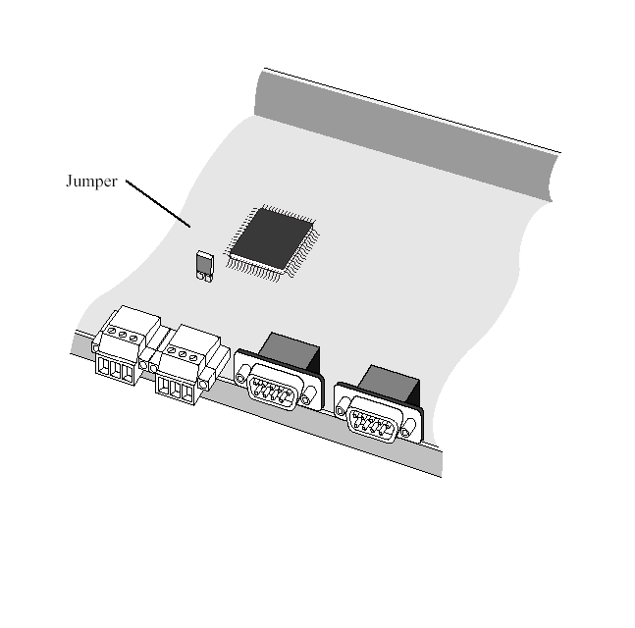
1b. Connect power to NL-100 and connect Null Modem cable.
1c. Open hyperterminal and use following settings:
baud: 115200
databits: 8
parity: none
stop bits: one
flow control: none

2. Strike the Enter button a few times to get the attention of the NL-100 once the following is returned you may continue:

NL100/105 (ver, show, edit, defaults, reset, help, bye):

3. Type E to Edit and make sure the following is set:

Tlink config [dis]
RS485 [dis]
CS I/O [dis]
RS232 Config [TCPServ]
RS232 bps [19K]
RS232 Serial Server Port [6781]

Ethernet 10-baseT [enabled]
10-baseT port IP# [198.124.98.19] **this value is logger IP address
mask [255.255.255.0]**whatever mask is used
default gateway [yes]
default gateway IP [198.124.98.1]
Pakbus node [678]
Clock neighbor node ID [0]
PakTcp Server config [dis]
PakTcp client config [dis]
Modbus/Tcp gateway config [dis]
Config monitor telnet port [23]
Telnet Session password [nl100]
Serial Server Watchdog [2]

Save

You can progress through the menu by pressing <ENTER>. If you make a mistake after entering a setting, the up arrow can be used to move backwards. If you need help for a particular setting, press the F1 key or the ? key. You can also choose to select <cancel> at the end instead of save if you want to start over.

**If the jumper was used it must be disconnected before returning the NL-100 to use. If this is not done, the NL-100 will always be at the boot prompt and will be inaccessible for remote communications.

Appendix G

Wiring Diagrams

Rotronics MP100H-1 wiring table (three sensors)

Campbell CR23X Connection | Wire Color | Function
Power Out – 12V | Green | +12V
SE18, SE20, SE22 | White | RH out
SE17, SE19, SE21 | Brown | T out
SEGnd, SEGnd, SEGnd | Gray | Ground
N/C | Blue | DIO (not used)
N/C | Yellow | Sig_0 (not used)

Vaisala HMP45D wiring table (three sensors)

Campbell CR23X Connection | Wire Color | Function
EX1, EX2, EX3 | Yellow | Pt100
DH2, DH4, DH6 | White | Pt100
DL2, DL4, DL6 | Green | Pt100
DH1, DH3, DH5 | Black | Pt100
Power Out - 12V | Blue | +12V
SE13, SE14, SE15 | Brown | RH out
Power Out - Ground | Violet | Ground
Power Out - Ground | Red | Ground
Earth Ground | Grey | Shield

Vaisala HMP45D sensor units

Sensor Identifier | Sensor Serial Number
V1 | Y3110012
V2 | Y3110013
V3 | Y3110014
V4 | Y3110015 (spare)

Rotronics MP100H-1 sensor units

Sensor Identifier | Sensor Serial Number
R1 | 92781
R2 | 92782
R3 | 92783
R4 | 92784 (spare)

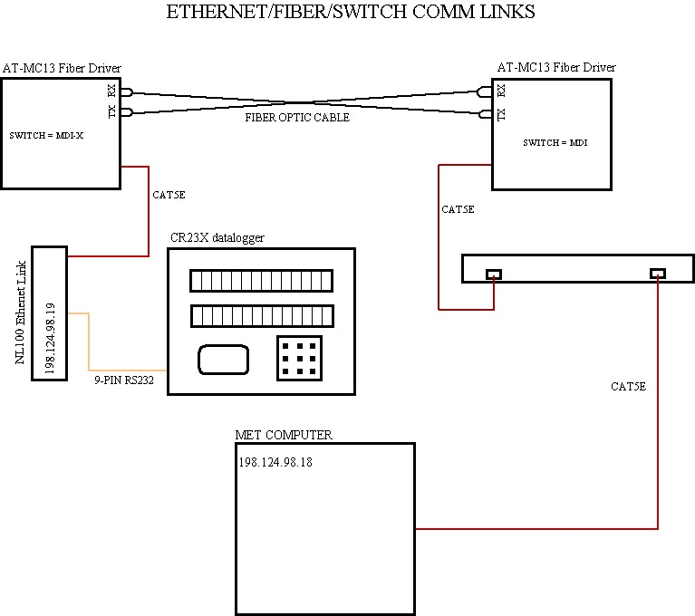

AC Power Wiring Diagram

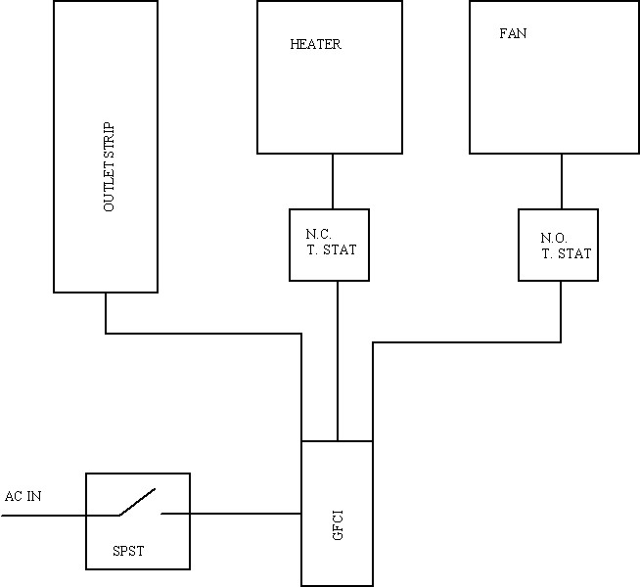

1 |  |  | 2 |  |  | 3 |  |  | 4 |  |  | 5 |  |  | 6
H | L | G | H | L |  | H | L | G | H | L | G | H | L | G | H | L | G |  |  | E1 | E2 |  | E3

100Ω 100Ω 100Ω
NL100

12V G
Wh Grn Wh Grn Wh Grn V1 Ylw
V1
Rs
Blk
Red/Vi Blu
V2
Rs
Blk
Red/Vi Blu
V3
Rs
Blk
Red/Vi Blu

V2 Ylw Red

V3 Ylw
Blk

13 | 14 |  | 15 | 16 |  | 17 | 18 |  | 19 | 20 |  | 21 | 22 |  | 23 | 24
Q | Q |  | Q |  |  | T | Q |  | T | Q |  | T | Q
+ | + |  | + |  |  | + | + | G | + | + | G | + | + | G | H |  | G |  |  | 5 |  |  | G | 12 | 12 | G
100K
Brn Wh Gry Brn Wh Gry Brn Wh Gry
R1

Grn
R2

Grn
R3

Grn
V1 Brown V3 Brown
To aspirator box

V2 Brown



