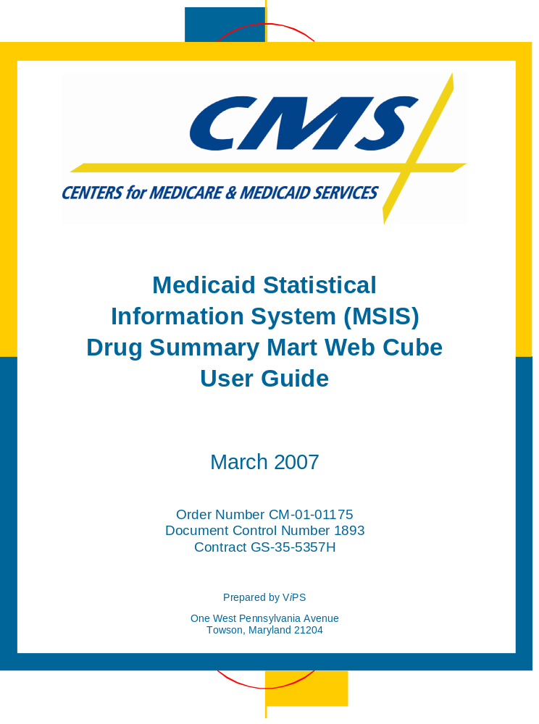

Revision | Date | Revision/Change Description | Pages Affected
1.0 | 8/2006 | Baseline | All
3.0 | 03/2007 | Applied formatting and content changes, reduced size of document. | All

Table of Contents
MSIS Drug Summary Mart
Web Cube User Guide

Introduction 2
What is MSIS? 2
Understanding Data Cubes 2
Special Note 2
Drug Summary Mart Measures 3
Opening View 3
Changing Measures 4
Calculating Measures 6
Drug Summary Mart Dimensions 8
Understanding Dimension Values 8
Changing Dimensions 8
Troubleshooting Display Problems 11
Not Applicable (NA) in Cells 11
Helpful Hints 12
Faster Response Time 12
Undo Selection 14
Additional Help 15

Appendix A: MSIS State Summary Web Cubes

Introduction
MSIS Drug Summary Mart
Web Cube User Guide

What is MSIS?
The Medicaid program began in 1965 with the passage of Title XIX of the Social Security Act. More than thirty years later, Medicaid still provides low-income and disabled Americans of all ages with access to medical and health-related services. Additionally, under the State Child Health Insurance Program – SCHIP (Title XXI) of the Social Security Act, as included in the Balanced Budget Act of 1997, coverage to children otherwise not eligible for Medicaid is administered in some States as an expansion to Medicaid.
Medicaid is a federal-state partnership. The federal government partially funds the program and establishes mandatory and optional program characteristics. The States provide the remaining program funding, choose which program options that they wish to implement, and directly administer the program in their State.
Under the Balanced Budget Act of 1997, as of 1/1/99, it is mandatory that States report Medicaid data through the Medicaid Statistical Information System (MSIS). This system requires the States to submit raw eligibility and claims data to the Centers for Medicare and Medicaid Services (CMS). MSIS data is used by CMS to produce Medicaid program characteristics and utilization information. MSIS data is made available to States and other federal agencies in order to gain greater insight into the Medicaid program.
The MSIS Drug Summary data mart consists of drug payment and claim information for each Medicaid fiscal year. The information is stored in a data cube and is viewed using Cognos PowerPlay Web.

Understanding Data Cubes
A data cube is a method of displaying dimensions and measures. One cube is provided from the MSIS Drug Summary data mart for each Medicaid fiscal year. The cube provides quarterly and annual measures and dimensions for drug claim information.
A measure is a count or summarization of Medicaid information. The measures in this MSIS data cube are Claim Count and Payments (Total Medicaid Paid Amount).
A dimension is a description or characteristic of the measure. Dimensions include State, Time, Drug Info (Based on MEDISPAN groupings), and Adjustment Indicators.

Special Note
This documentation describes the PowerPlay interface using Microsoft Internet Explorer (IE) version 5.5 or higher. See the on-line Help ? for assistance with the features and functions of the interface when using an older version of IE or another browser application.

Drug Summary Mart Measures
The measures in the Drug Summary cube are:
  - Claim Count
  - Payments

A description of each measure is listed in Appendix A: MSIS Drug Summary Mart Web Cube.

Opening View
When you open PowerPlay Web, the application displays the default view of the report. The State dimension is on the left in row format. The Annual Year dimension is listed at the top in columnar format. The default measures are Claim Count and Payments. You can now customize the display by adding dimensions, changing measures shown, filtering on dimensions, and changing the format.
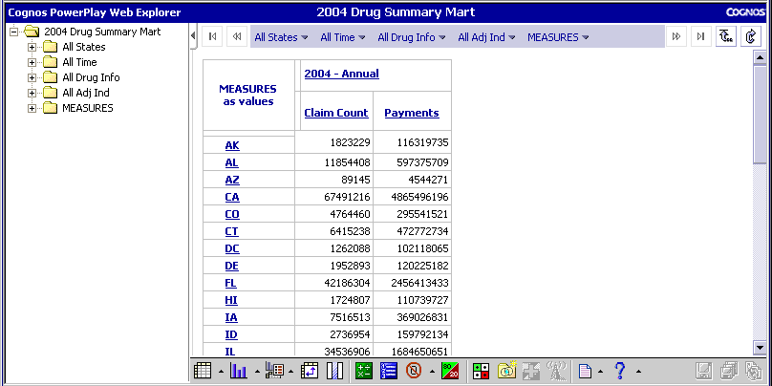
Use the Dimension Folder Panel to add or remove dimensions or measures from your report.
⬅Column drop area
⬅Row drop area

The icons on the bottom of the above view allow you to manipulate highlighted rows and columns. The functions available include Hide/Show and Calculations (which can be used to create ratios or totals). Some of these functions will be demonstrated throughout this document.

Changing Measures
The application displays the Claim Count and Payments measures by default. You can choose to view one or both measures for Annual, for any Quarter or for all time periods. You must display at least one measure.

Removing Measures
1. There are two ways to remove a measure from displaying on the page. Right click the heading of any measure. A menu displays. Select Hide/Show… OR left click on a measure to highlight it and click on the Hide/Show icon. The Hide/Show window displays.
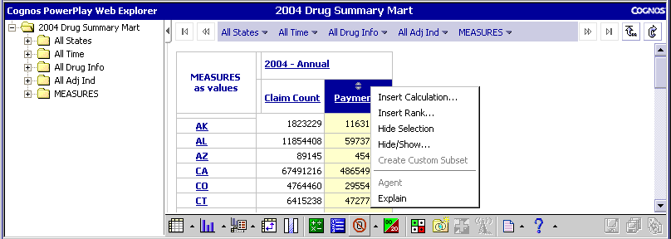
Right click a measure heading. Click hide/show.
Left click on a heading to highlight it and select the hide/show icon.
.

2. The Hide/Show dialog box will display at the bottom of the page. Click the measure you want and use the left-pointing arrow to move it to the Hidden Categories window or use the right pointing arrow to move it to the Visible Categories. Select OK to make the selection or Cancel to exit out of the Hide/Show dialog box with out making any changes.
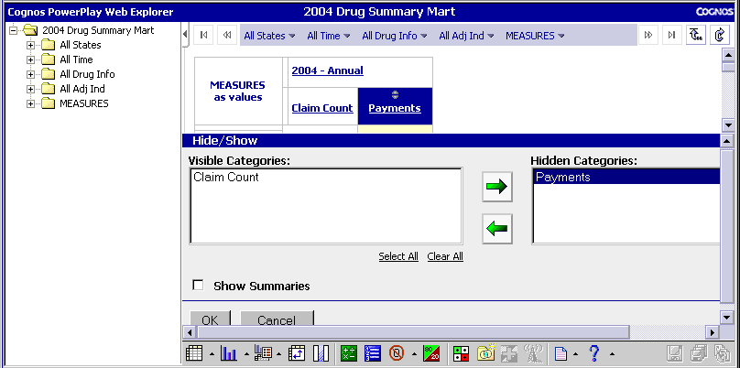
Highlight the measure you want to remove from display.
Click the appropriate arrow.
3. The display will update based on your selection. Payments has been removed as shown below.
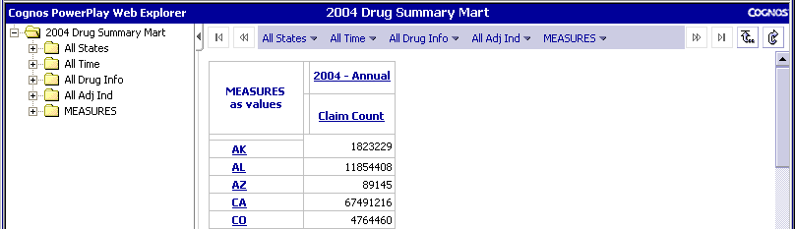

Adding Measures
1. Open the MEASURES folder by clicking on the plus sign ( + ) next to it. Drag a measure (Payments) to the column drop area by clicking on Payments, dragging it over and dropping it in the column area.
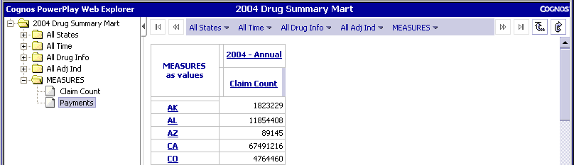
A line will appear in the column drop area.

2. The display will be updated with your selection.
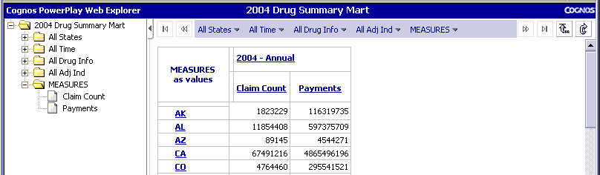

Calculating Measures
You can create new measures that are derived from the displayed values or you can produce column totals (such as a National Total). For example, follow these steps to show the Average Paid Amount per Claim.
1. There are two ways to calculate the values for a new measure. Right click the heading of any measure. A menu displays. Select Insert Calculation…OR left click on a heading to highlight it and select the Calculation icon. The Calculation window displays.
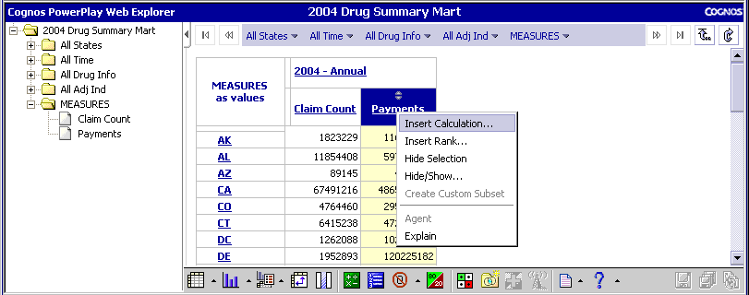
Right click a measure heading and select Insert Calculation
Left click on a heading to highlight it and select the Calculation icon.

3. From the Operation drop-down list, select Divide.
4. Type “Average Paid Amount” for the Calculation Name. This name will be used as the column heading.
5. From the first Category drop-down list, select Payments.
6. From the second Category drop-down list (after Divided by), select Claim Count.
7. When the calculation is set up the way you wish, click OK.
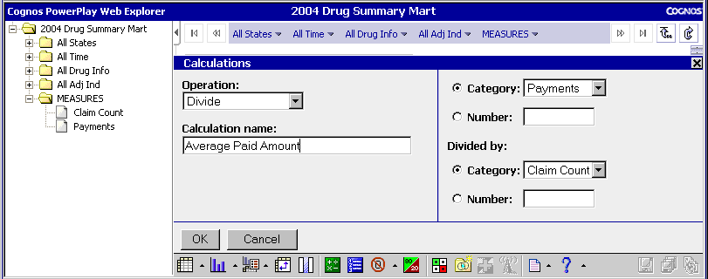
Select Divide and enter a Calculation Name.
Select Payments and divide by Claim Count.
10. The display updates based on your selection. Note that calculated measures are in italics.
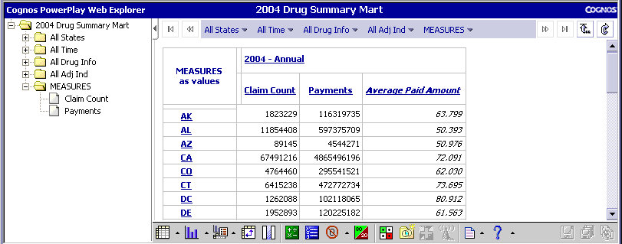
Note that the calculate function can also be used by clicking on a row, then using the calculate icon to produce column totals (such as a national total). Note also that when totaling, nesting of rows and columns is maintained in the totals.

Drug Summary Mart Dimensions

Understanding Dimension Values
The Drug Summary Mart cube structures information so that you can easily explore the interactions between different characteristics of the Medicaid drug program. The dimensions add levels of detail to this data.
The dimensions in the Drug Summary data cube contain established code values and reference information. The dimensions in the cubes are:
  - State
  - Time (Medicaid fiscal year and quarter)
  - Drug Info (Category, Group, GPI)
  - Adjustment Indicators
A description of and the valid values for each dimension are listed in Appendix A: MSIS Drug Summary Web Cube.

Changing Dimensions
When viewing the Drug Summary cube, the Time dimension must always be included and is the default view. The displayed values are doubled if the Time dimension is removed.

Adding Dimensions
1. To include all dimension values, drag and drop the folder icon onto the row or column drop area of the display. A bold narrow line appears in spots where you can place the dimension.
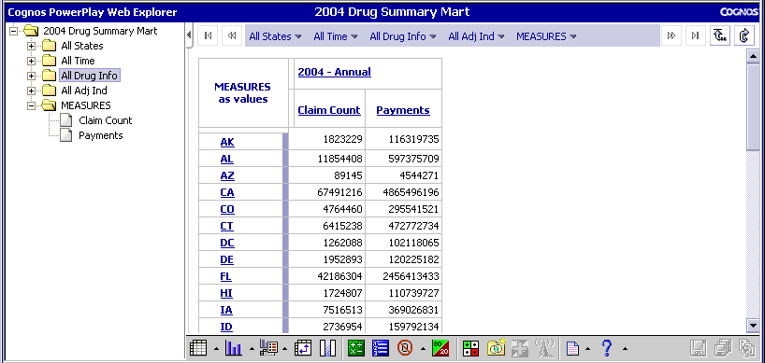
Click the dimension folder.
Drag to the drop area where you want to display the dimension.
2. The display updates based on your selection.
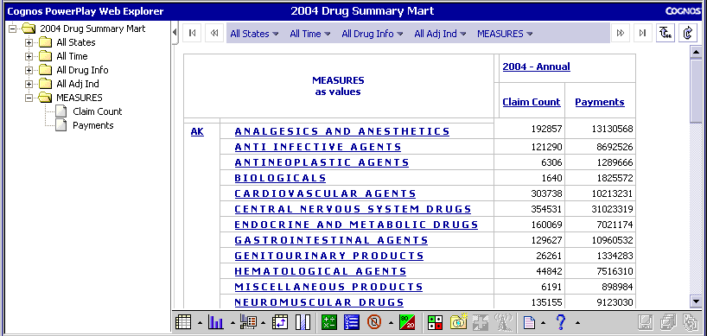
Note: The summary rows and columns can be removed if needed using the Hide/Show options as described above under Drug Summary Mart Measures.

To add only one value from a dimension to your display, follow these steps.
1. Click the plus sign ( + ) next to the folder for the dimension you want to add to the report. All values within the dimension are displayed.
2. Click on the icon next to the value and drag it to the drop area where you want it displayed.
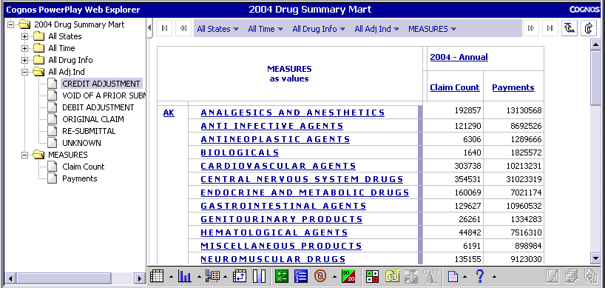
Click the plus sign to list all values in the dimension and select the value you want to display.
Drag the value to the drop area.

3. The display updates based on your selection.
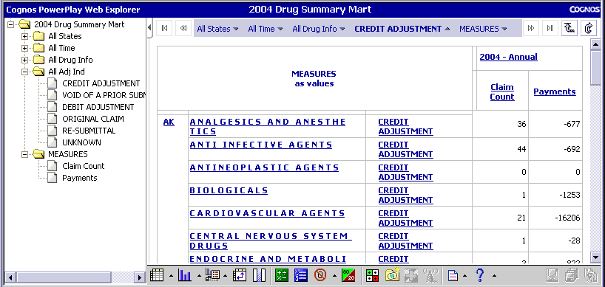

Note: If the "All Time" folder is dragged into the top row of the report heading, PowerPlay may include a summary column for All Time in the display. Because the values in the Drug Summary Mart cube have been aggregated already in an Annual column, these summaries are not valid. To remove the All Time summary column from the display, make sure that the Show Summaries box in the Hide/Show dialog box is unchecked.

Troubleshooting Display Problems

Not Applicable (NA) in Cells
"NA” in some or all of the cells means that measures have been placed in both the row and column areas. To correct this problem, delete all the measures from either the row or column area.
1. To delete a column or row, highlight the row or column drop area.
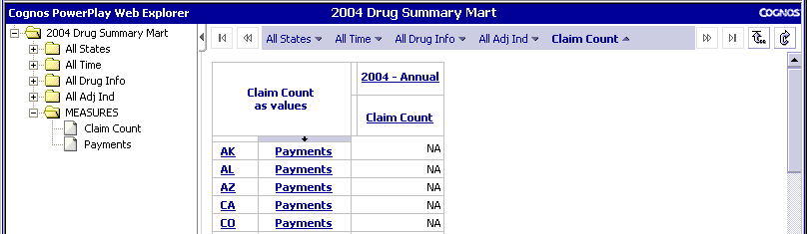
Highlight the column drop area.
2. Right click on the highlighted column drop area and select delete.
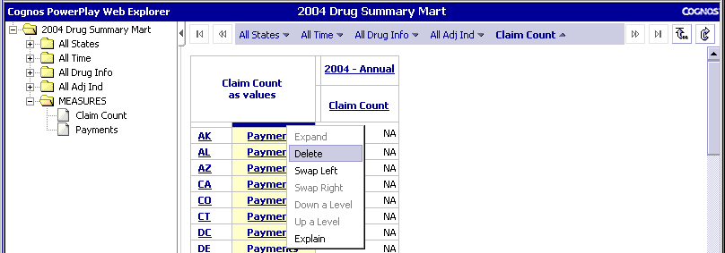
Select delete to remove the measures from the row or column area.
3. The display updates based on your selection.
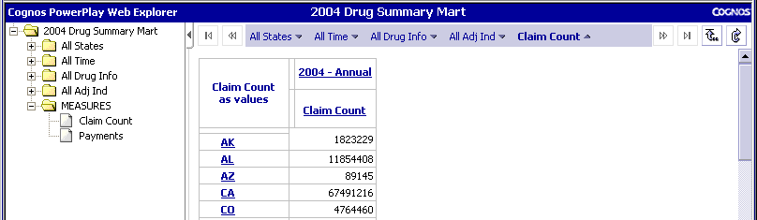

Helpful Hints

Faster Response Time
You can format the display without showing the data for each change. This makes the response time faster.
1. Click the Display Options button on the PowerPlay toolbar. A menu displays.
2. Select Get Data Later.
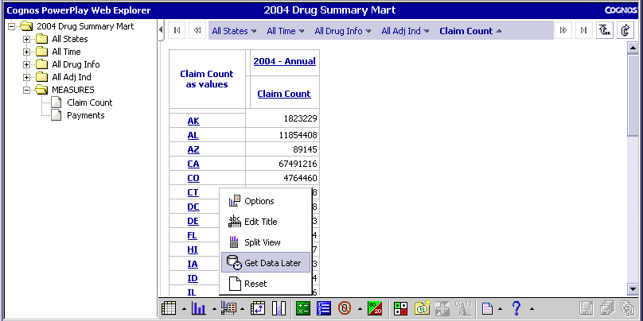
⬅Select Get Data Later
Right click Display Options

3. The middle of the display is replaced with the words Get Data.
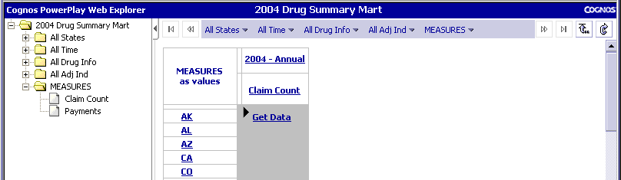
4. Format the display to show the dimensions and measures you want. Added below are the Payments measure in the columns area and the All Drug Info in the rows area.
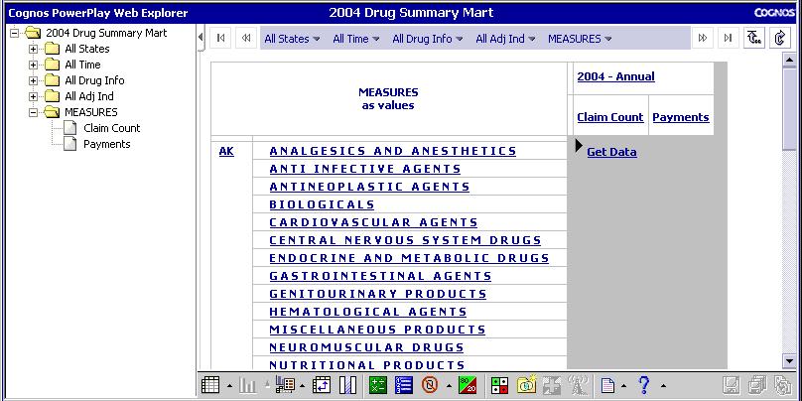

5. Click Get Data to retrieve the actual values. The display updates based on your selection.
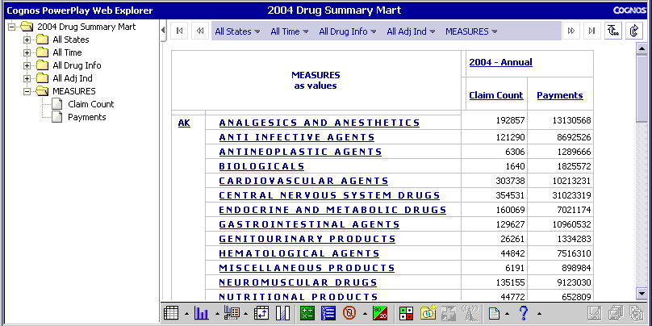

Undo Selection
1. To return to the previous view of the cube, click the browser’s Back button.
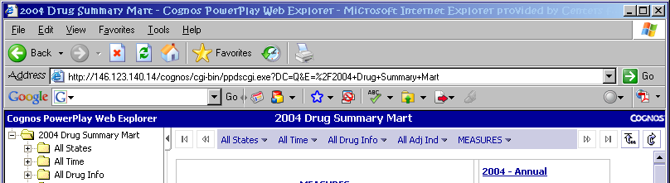
The previous view of the cube will display.

2. Alternatively, click the Reset button on the Cognos interface.
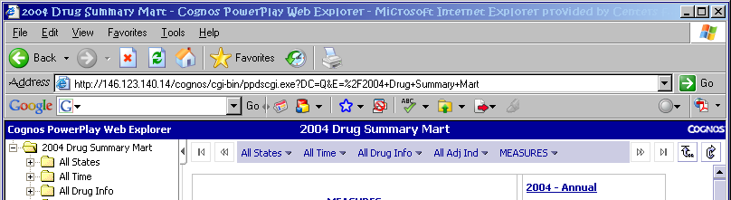
The initial view of the cube will display.

Additional Help
You can obtain further assistance by using the on-line Help function.
1. Click the Help button on the PowerPlay toolbar.
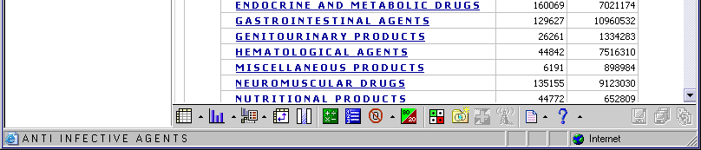

2. The PowerPlay Web Help window displays.
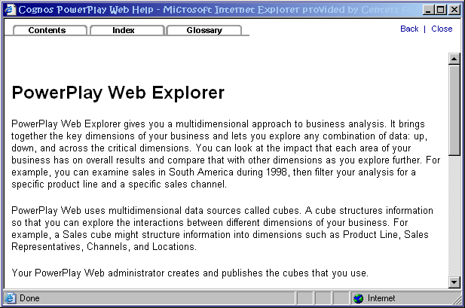

You can also send an e-mail to MSIS_Data_Marts@cms.hhs.gov. Please include your name and phone number in the message.
Notes:

- MSIS Drug Summary Mart Web Cube
MSIS Drug Summary Mart
Web Cube User Guide
This appendix describes the dimensions and measures in the Drug Summary Mart web cube.
Medicaid Drug Summary Mart Web Cube
Dimension | Description
State | The standard two-character abbreviation used by the US Postal Service for the state or territory. This dimension must always be selected. The default is All States.
Time (Period) | The fiscal year and fiscal quarter values. This dimension must always be selected. The default is all periods.  Note: The Medicaid fiscal year is from October 1 through September 30.
Drug Info | Text descriptions of Drug Info presented as follows:  D R U G C A T E G O R Y - Text of the drug category. Drug categories are presented as all uppercase with a space between each character.  drug group – Text of the drug group. Drug groups are presented as all lowercase characters.  GPI SUBSET – GPI subsets are presented as all uppercase with no spaces between the characters.
Adjustment Indicator | Indicates whether or not the claim is an adjustment. Values are:  Credit Adjustments  Debit Adjustments  Original Claim  Re-Submittal  Void of a prior submission  Re-submittal

Measure | Description
Claim Count | Total number of non-encounter claims adjudicated during the period.
Payments | Total dollar amount Medicaid paid on claims that were adjudicated.

