CLENSEMBLE 3.1 :

** Modified to add 12 hour snowfall probabilities of 1,4,8,12 inches

Introduction: CLENSEMBLE is a software package that produces a model ensemble from locally produced WRF models. There are two parts to the software; the first part dissects a subset of fields from the original grib file. These files can then be easily shared with surrounding sites. The second part of the software produces an ensemble in grib2 format from up to ten different subsets. These grids can then be ingested into both GFE and D2D.
The need for the subset comes from the fact the WRF produces over 750 forecast fields. These grib files were considered too large to transport due to current bandwidth issues. However, the vast majority of the fields are not directly useful for operational weather forecasting. Also, many useful fields can be recalculated later in AWIPS, GRADS or GEMPAK. For example, vorticity can be derived from the wind fields. WRFdissect software extracts a subset of 53 fields from the final grib file produced by the WRF. The final output is significantly smaller than the original grib file, averaging around 100 K. These files can then be shared with other WFO offices with minimal detrimental effects on the local computer network.
Part two of the software is called MAKENSEMBLE. It produces an ensemble mean of up to ten separate model inputs. The output data format is grib2. This format can be imported in AWIPS. The user has the choice to either weigh each model equally for a simple model average, or to customize each model’s weight using a single configuration file. The lists of variables produced are in table one.
In addition to the mean grib2 fields, probability fields are produced. These include most fields produced in the SREF, including QPF, wind, member spreads, Lifted Index and CAPE, table 2d. Unlike the mean grib2 fields, the probability images cannot be customized. Each model member is weighted equally. For example, if four models out of five are predicting gale force winds, the graph shows an 80 percent chance of getting gale force winds. All fields are produced in grib2 format. Listed fields in table 2b, 2c and 2d are available in D2D.

Table 1 mean fields available in d2d (grib2 files)
• Indicates derived fields in AWIPS
 | Surface | 2 m | 10 m | 1000 | 900 | 850 | 700 | 500 | 300
Temp |  |  |  |  |  |  |  |  | 
Dew P |  |  |  |  |  |  |  |  | 
Wind |  |  |  |  |  |  |  |  | 
HGT |  |  |  |  |  |  |  |  | 
Omega |  |  |  |  |  |  |  |  | 
MSLP | 
Cape | 
Radar Reflect | 
Precipitable Water | 
1 Hour QPF | 
Vorticity * |  |  |  |  |  |  |  |  | 
Divergence * |  |  |  |  |  |  |  |  | 
Temp advection* |  |  |  |  |  |  |  |  | 
Potential Temp* |  |  |  |  |  |  |  |  | 
Potential Temp Advection * |  |  |  |  |  |  |  |  | 
Dew Pt Depression * |  |  |  |  |  |  |  |  | 
Q vectors * |  |  |  |  |  |  |  |  | 
Fs vectors * |  |  |  |  |  |  |  |  | 
Geotropic wind * |  |  |  |  |  |  |  |  | 
Ageotropic Wind * |  |  |  |  |  |  |  |  | 
Deformation * |  |  |  |  |  |  |  |  | 
Preferred Ice Growth * |  |  |  |  |  |  |  |  | 
Relative Humidity * |  |  |  |  |  |  |  |  | 

Table 2a Probability GIF images created for D2D (grib2)
 | 06 | 12 | 18 | 24 | 30 | 36
Small Craft winds 21 kt |  |  |  |  |  | 
Gale Warning winds 34 kt |  |  |  |  |  | 
Storm Warning winds 48 kt |  |  |  |  |  | 

Table 2b QPF Probability Fields available in D2D
 | 6 hour period | 12 hour Period | 24 hour Period
.01 inch | 6,12,18,24,36  Hr Forecast | 12,18,24,36  Forecast | 24,36  Forecast
.05 inch | 6,12,18,24,36  Hr Forecast | 12,18,24,36  Forecast | 24,36  Forecast
.10 inch | 6,12,18,24,36  Hr forecast | 12,18,24,36  Forecast | 24,36  Forecast
.25 inch | 6,12,18,24,36  Hr Forecast | 12,18,24,36  Forecast | 24,36  Forecast
.50 inch | 6,12,18,24,36  Hr Forecast | 12,18,24,36  Forecast | 24,36  Forecast
- Inch  - Inch | 6,12,18,24,36  Hr Forecast | 12,18,24,36  Forecast | 24,36  Forecast

Table 2c New Probabilities with version3.1
Hourly |  | Hourly |  | Hourly |  | Hourly | Hourly |  | Hourly |  | Hourly
LI < 0 |  | LI < -4 |  | LI < -8 |  | Cape > 500 J | Cape > 1000 J |  | Cape > 2000 J |  | Cape > 4000 J
Hourly |  | Hourly |  | Hourly
850 MB Spread Temp |  | 500 MB  Spread  Temp |  | 500 MB  Spread  GH
 | Time period |  | 6 hour period |  | 12 hour Period |  |  | 24 hour Period
 | Member spreads |  | 6,12,18,24,36  Hr QPF spreads |  | 12,18,24,36  Hr QPF spreads |  |  | 24,36  Hr QPF spreads

Snow Probabilities
 | 12 | 18 | 24 | 36
Probability Snow  > 1 inch | X | X | X | X
Probability Snow  > 4 inch | X | X | X | X
Probability Snow  > 8 inch | X | X | X | X
Probability Snow  > 12 inch | X | X | X | X

The Eastern Great Lakes Ensemble

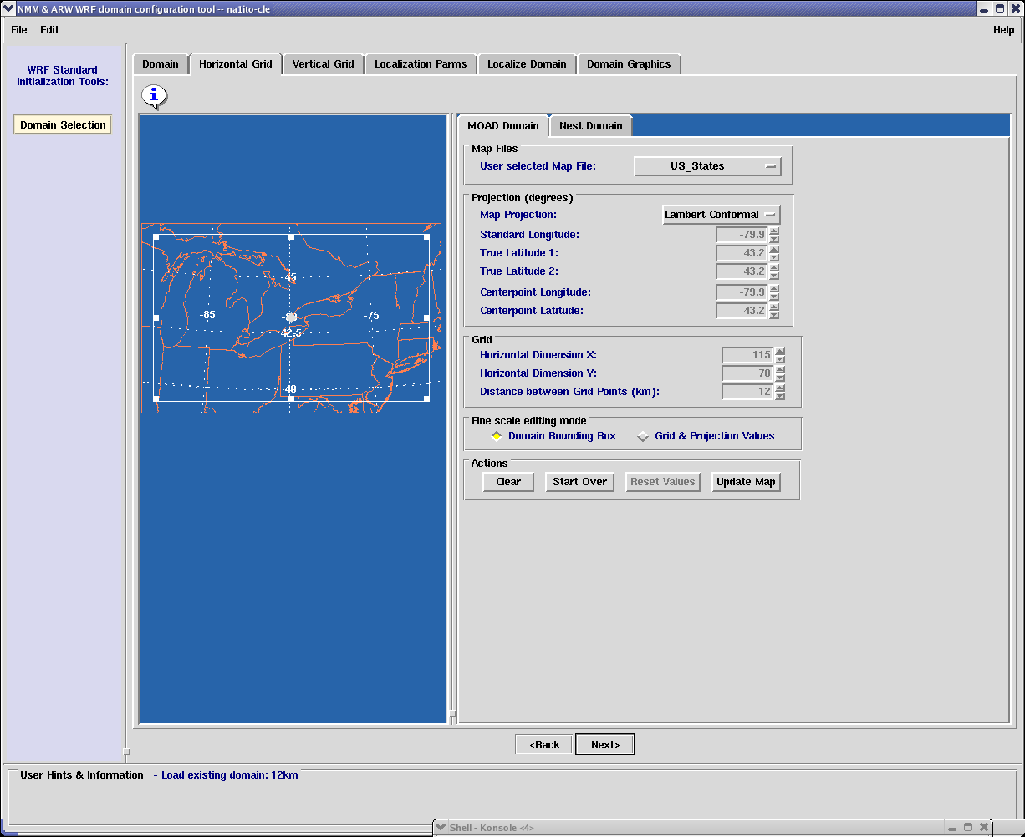
Figure 1 Example from Great Lakes Ensemble domain
Figure 1 is an example of an ensemble domain. This domain has a 12 km resolution across a large area across the eastern great lakes. Each member of the ensemble will be resized to the above dimensions using a Haines analysis. Successful testing has included adding members with resolutions ranging from 6 km to 80 km. However, the domain of any ensemble is limited to the smallest intersecting area of all the ensemble members. This means the smallest member will be the largest possible ensemble domain, but not necessarily the final ensemble domain.

Table 3 Ensemble model members (Note NEW members are being may be added in 12/08)
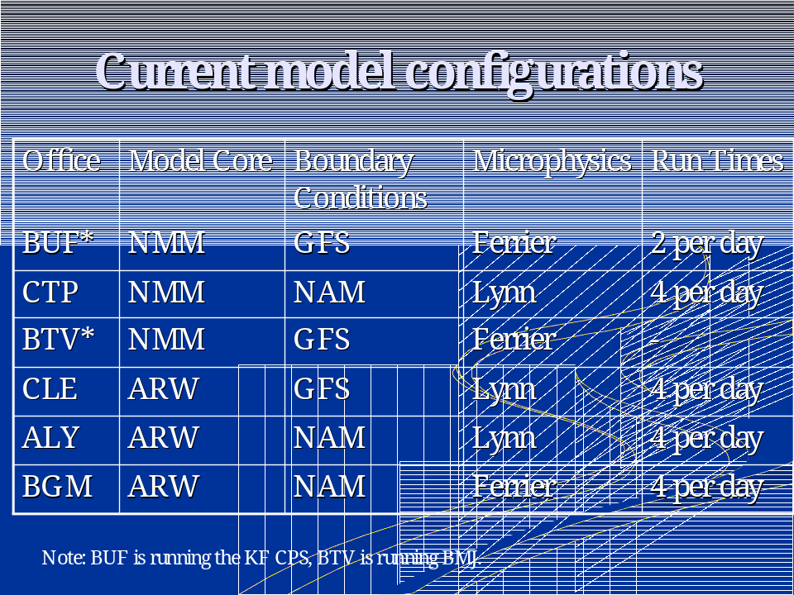

Table 3 shows each of the members boundary conditions, microphysics and model core. Each model is weighted equally. However, each model can be given a unique weight as long as the total is 100 percent. Each model has unique physics, model core and initial boundary sources.
The below image is a probabilistic field. It shows the chance of getting winds that will require a small craft warning. At this time only GIF images will be produced. Figure 2 shows the probability of getting small craft winds.

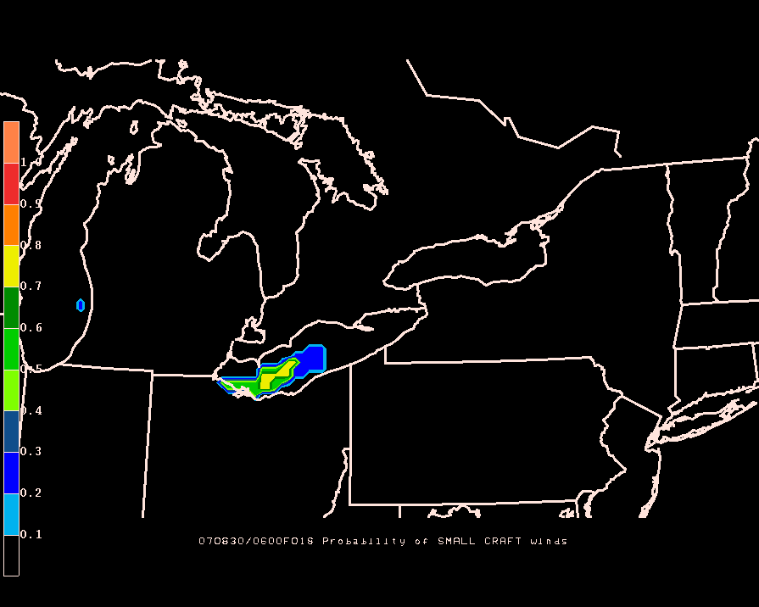
Figure 2 Probability of exceeding wind threshold that requires a small craft warning
Figure 2 is an example of a probability image. This image shows the probability getting winds strong enough that requires a small craft warning. Each model is weighted equally. Eighty percent of the model ensemble members are forecasting winds that will exceed 21 knots, requiring a small craft warning.

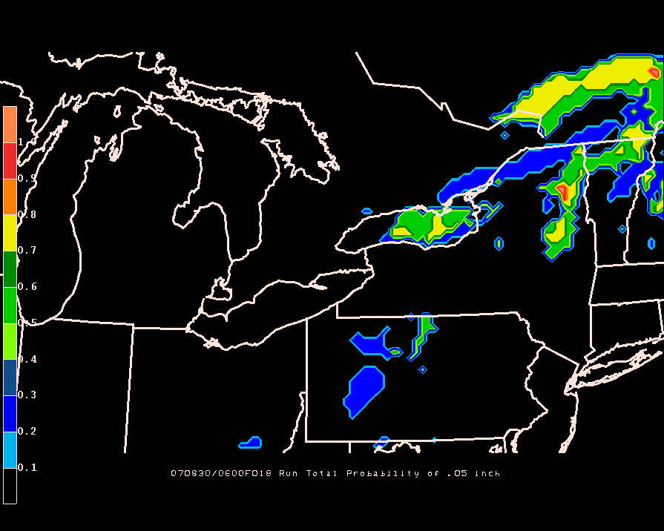
Figure 3 Probability of run total QPF > .05 inches

Figure 3 is an example of a probability image. This image shows the probability getting .05 inches of precipitation. It is an 18-hour run QPF total beginning at 0600Z. Figure 4 is an example of an ensemble 10-meter field in GFE.

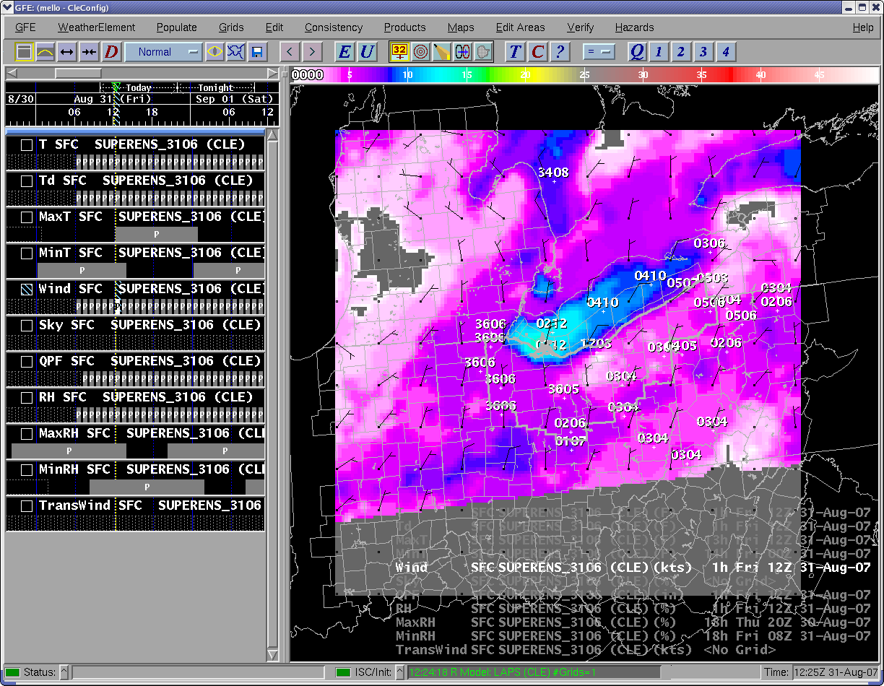
Figure 4 An Ensemble 10 meter wind field in GFE

Figure 5 and Figure 6 are probability images in D2D. The user must display the volume browser. Select the model, SUPERENS being the default, and select the fields from the Ensemble/SREF precipitation menu. See example. Each fields is the probability of reaching a certain precipitation threshold in a 6,12 or 24 hour period.

Figure 5 The Volume Browser in D2D
Figure 6 is an example of a probability field. The values range from 0 to 100 percent. This image is the chance of getting over .01 inches of precipitation in a 12-hour period.
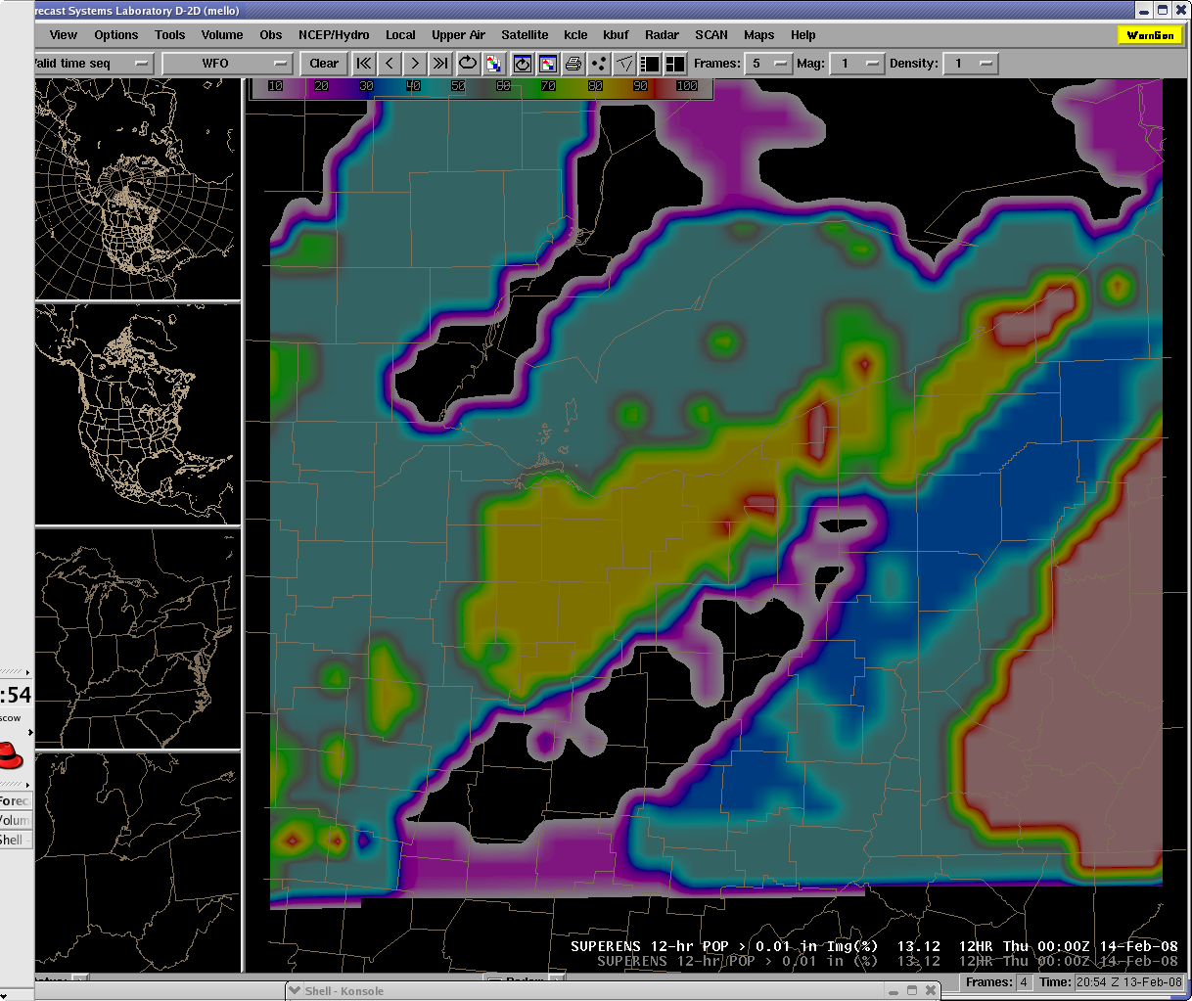
Figure 6 Probability image in D2D
Below are probability fields added with version 3 from D2D. These figures can be displayed by choosing the SUPERENS (or whatever it is named) as the model of choice in the volume Browser and using the SREF ensemble menu. Figure 7 is an example of the temperature spread of the members. This is calculated by subtracting the greatest value at each point minus the smallest value from the corresponding point. Figure 7 through Figure 10 are CAPE, LI and wind probabilities of reaching a certain threshold.

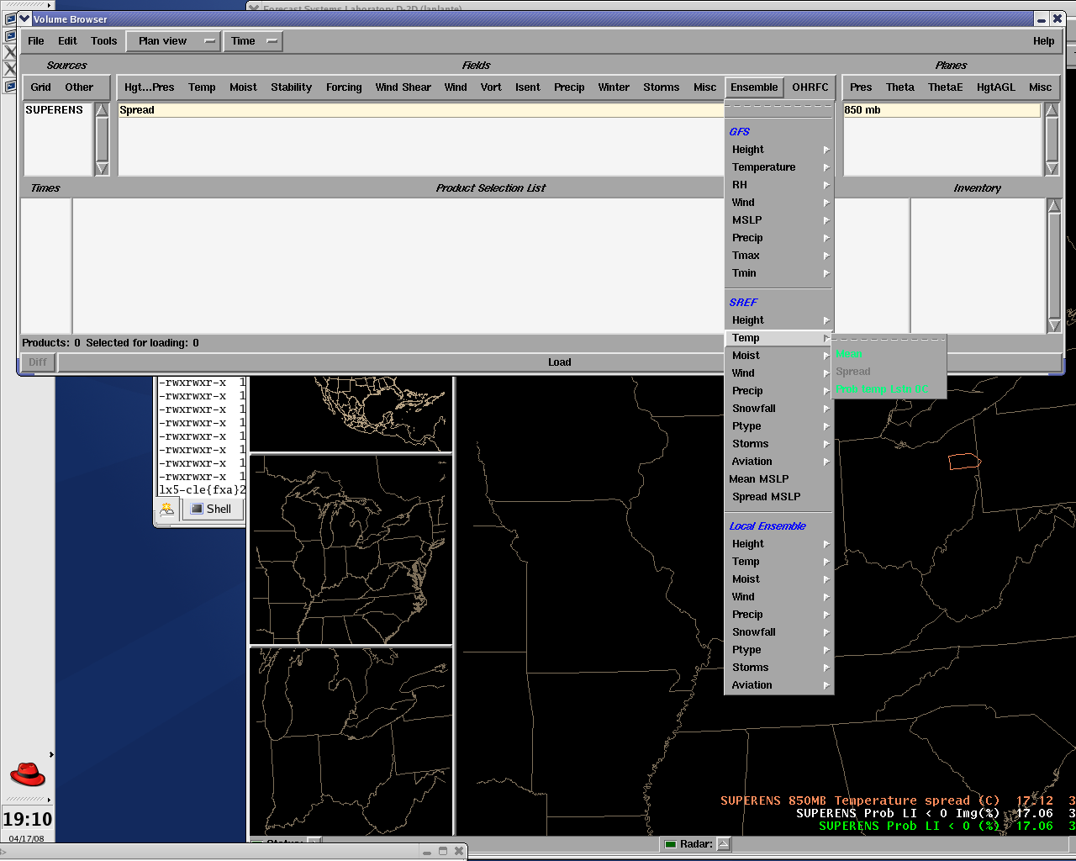
Figure 7 Examples of 850 mb Temperature Spreads

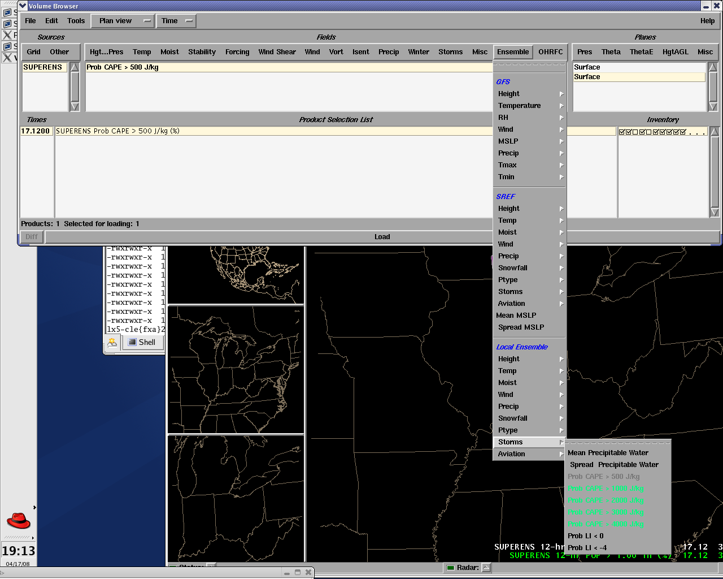
Figure 8 Example of CAPE probabilities

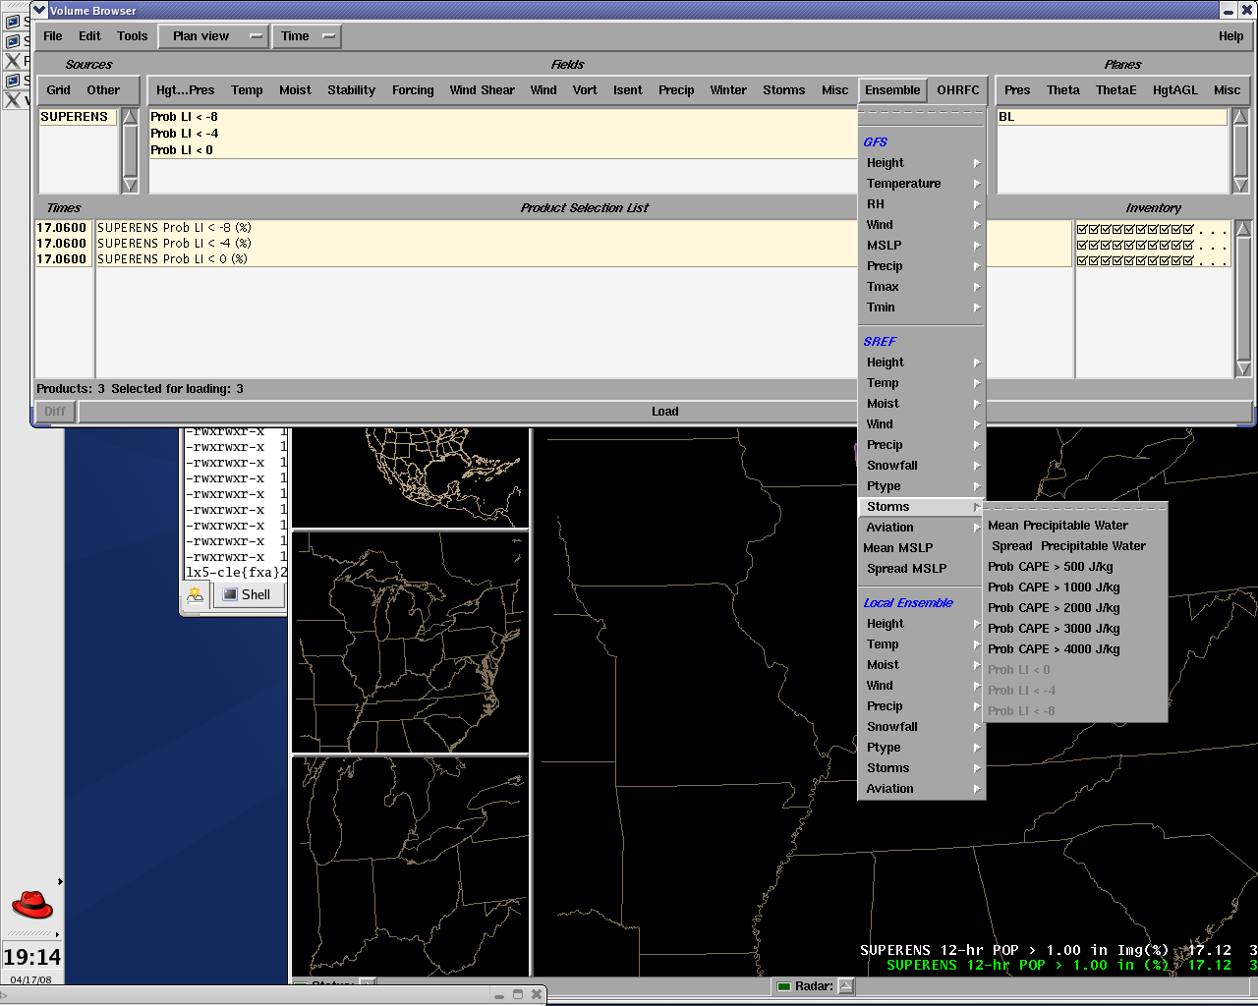
Figure 9 Example of LI probabilities
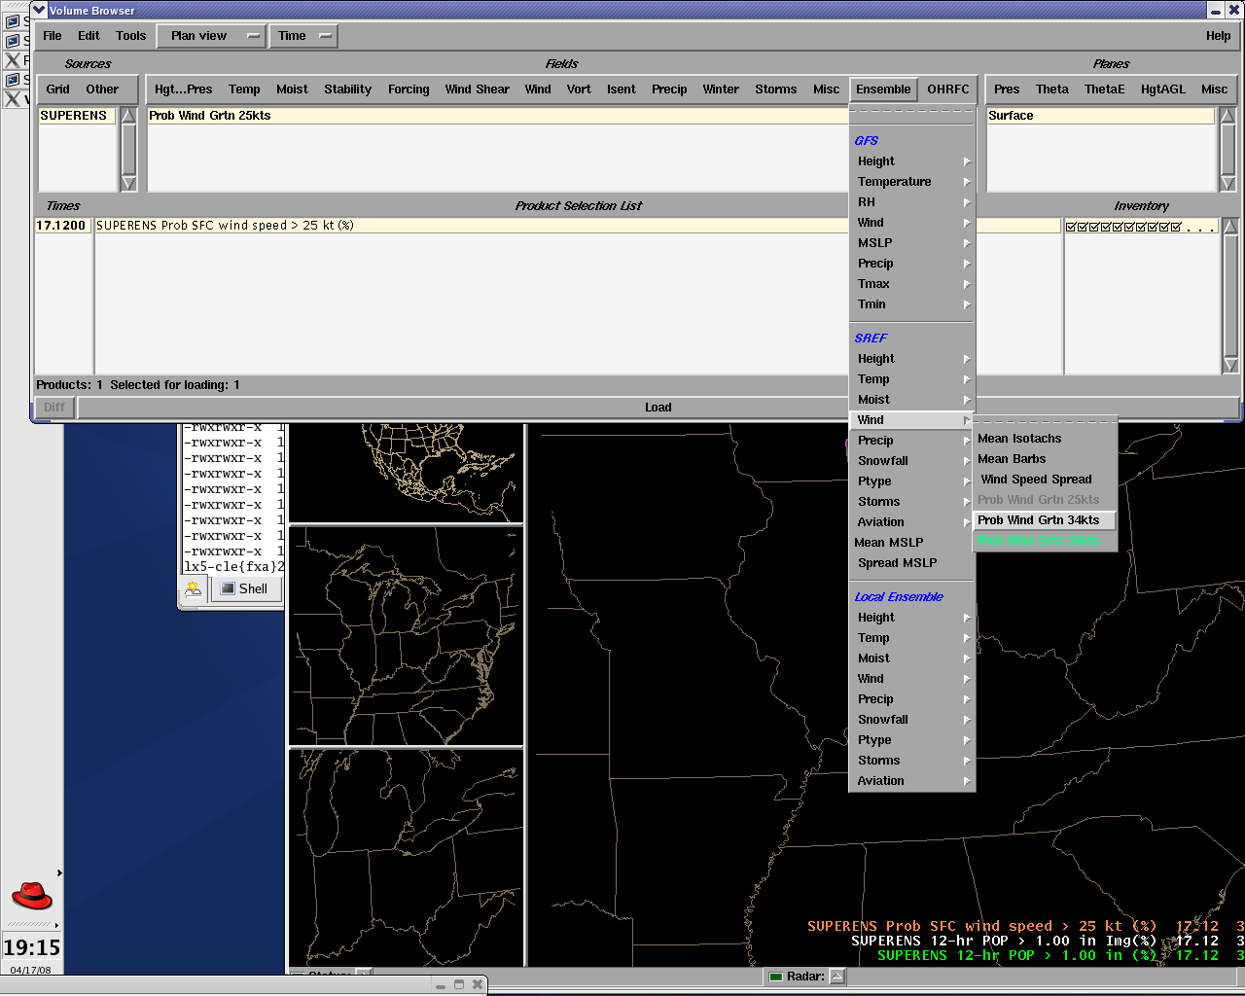
Figure 10 Example of wind probabilities

