CHAPTER IX

COMMERCIAL SPACE TRANSPORTATION

The Federal Aviation Administration’s (FAA) Associate Administrator for Commercial Space Transportation (AST) licenses and regulates U.S. commercial space launch activity as authorized by Executive Order 12465, Commercial Expendable Launch Vehicle Activities, and 49 U.S. Code Subtitle IX, Chapter 701 (formerly the Commercial Space Launch Act of 1984). AST’s mission is to license and regulate commercial launch and reentry operations to protect public health and safety, the safety of property, and the national security and foreign policy interests of the United States. In addition, the FAA licenses commercial launch sites. Chapter 701 and the 1996 National Space Policy also direct the FAA to encourage, facilitate, and promote commercial launches.

INTRODUCTION TO COMMERCIAL SPACE TRANSPORTATION

WHAT IS COMMERCIAL SPACE TRANSPORTATION?

The term “commercial space transportation” refers generally to the launch and/or reentry of an object into or from space by a private sector, non-governmental entity. Within the United States, commercial space launches are conducted by companies, such as Boeing, International Launch Services (ILS), and Orbital Sciences Corporation, using expendable launch vehicles (ELVs). Worldwide, commercial launch services are currently offered by corporations from the United States, Europe, Russia, China, and Japan.

The popular definition of “commercial launch” has evolved over time as the capabilities of commercial companies and private citizens have increased. From a legal perspective, the FAA licenses commercial launches and reentries by U.S. citizens or U.S. companies within and outside the United States that are, in general, privately or commercially procured for commercial or other payloads, including foreign payloads. The FAA may issue a launch license for a launch vehicle carrying a U.S. government payload if the sponsoring agency chooses not to have substantial involvement into launch activity. Most launches of U.S. government payloads are operated by either the Air Force or the National Aeronautics and Space Administration (NASA) using launch vehicles built under contract by commercial companies. The FAA also regulates and licenses suborbital launches and reentries, depending on certain launch profile factors.
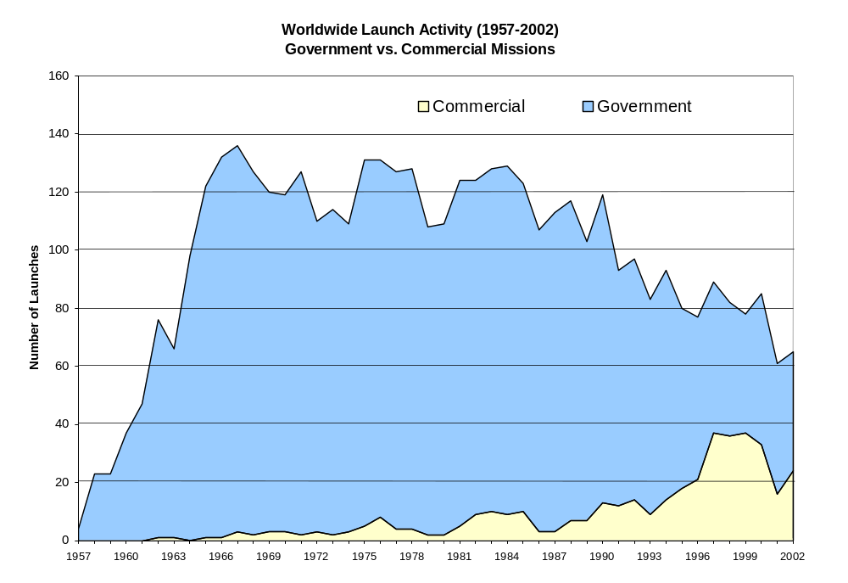

COMMERCIAL USE OF SPACE

Since the launch of Sputnik in 1957, spaceflight has largely been a government endeavor. Even though satellites serving commercial or quasi-commercial purposes entered into service in the early 1960s, the business of launching them was strictly a government affair. Many of the early commercial satellites launched were telecommunications spacecraft located in geosynchronous orbit (GSO) used to relay video and audio signals for television and telephone services.

Commercial launches of satellites that serve commercial and other purposes have steadily increased since the early 1980s. Until the mid-

1990s, commercial satellites were almost exclusively telecommunications satellites located in GSO. Since 1997, new satellite markets have opened up for commercial mobile telephones, data messaging, and remote sensing in low Earth orbit (LEO) or non-geosynchronous orbit (NGSO). Digital satellite radio services began in North America in late 2001. During 2002, 37 percent of launches conducted worldwide were commercial. Other types of commercial activity are also increasing. For example, two space tourists to date have paid for seats on Russian spacecraft for rides to the International Space Station. Public space travel is expected to increase in the future as current and new entrepreneurial companies develop passenger vehicles capable of suborbital and orbital space flights.

U.S. COMMERCIAL LAUNCH SERVICES

Until the early 1980s, all commercial satellites were launched on rockets owned and operated by the U.S. government, including the Space Shuttle. When Europe's Arianespace began offering launch services for commercial satellites in 1983, an international launch market was created and has since grown to over 15 vehicle families worldwide. Following the passage of the Commercial Space Launch Act of 1984, the U.S. government and industry began to transition from government to commercial operations for ELVs. The Commercial Space Launch Act authorized the Department of Transportation (DOT) to regulate and license commercial launch activities. (The Office of Commercial Space Transportation was later transferred from the DOT Office of the Secretary to the FAA in November 1995, where it became AST.) Commercial launches licensed by the DOT began in 1989, after the U.S. Government decided to stop launching commercial payloads on the Space Shuttle following the Challenger disaster in 1986. From 1989 through 2002, the DOT licensed 146 orbital and suborbital commercial launches.
Currently active ELVs that have orbital launch operations licensed by the FAA are:

- Atlas II, III, and V (intermediate class), all built by Lockheed Martin Corporation and marketed by International Launch Services (ILS);

- Delta II (medium class), III, and IV (intermediate class), all built by The Boeing Company and marketed by Boeing Launch Services (Delta IV heavy class is expected in late 2003);

- Zenit 3SL (intermediate class), built by KB Yuzhnoye (in Ukraine) for the Sea Launch partnership and marketed by Boeing Launch Services; and

- Pegasus XL and Taurus (small class), both built and marketed by Orbital Sciences Corporation (OSC).

New expendable and reusable launch vehicles are also being developed for commercial and other purposes.

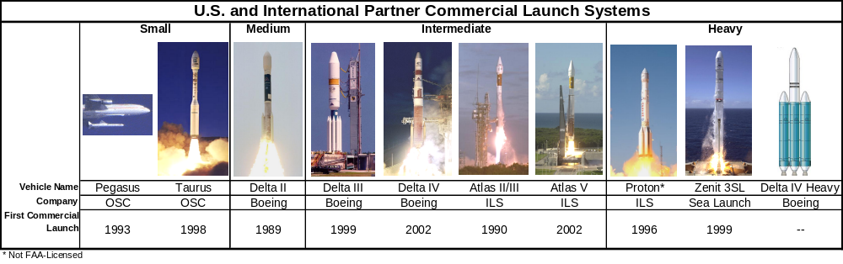
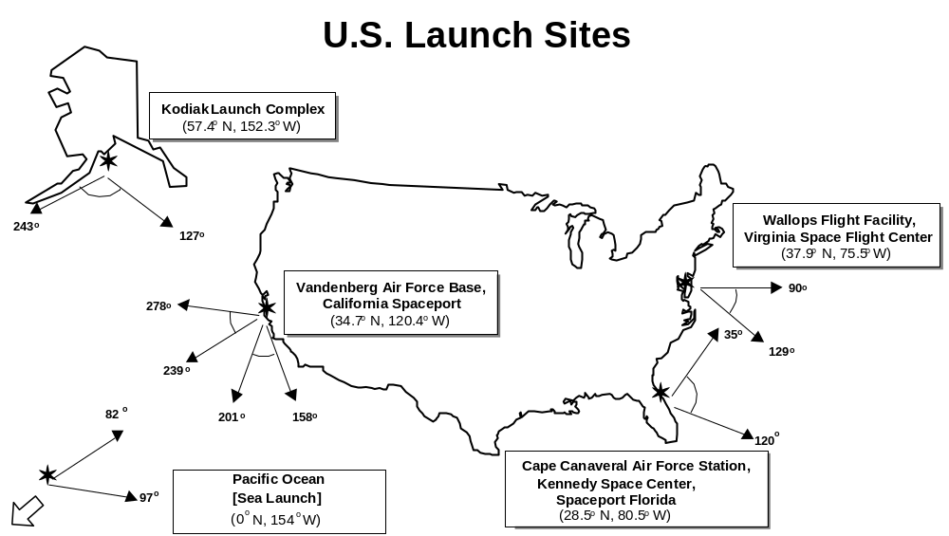U.S. commercial launches to GSO are launched from the Cape Canaveral Air Force Station (CCAFS) in Florida or from a Pacific Ocean platform by Sea Launch, a multinational corporation. Launches to NGSO can take place from any launch site such as CCAFS, Vandenberg Air Force Base (VAFB) in California, the Wallops Flight Facility in Virginia, or Kodiak Launch Complex in Alaska (see figure “U.S. Launch Sites,” above).

FAA/AST has issued four launch site operator licenses to state-run organizations to operate commercial launch sites, or spaceports. They are:

- Spaceport Florida at Cape Canaveral Air Force Station, Florida (license held by Florida Space Authority);

- California Spaceport at Vandenberg Air Force Base, California (license held by Spaceport Systems International);

- Virginia Space Flight Center at Wallops Island, Virginia (license held by Virginia Commercial Space Flight Authority); and

- Kodiak Launch Complex on Kodiak Island, Alaska (license held by Alaska Aerospace Development Corporation), the first spaceport not located on a federal range.

REVIEW OF 2002

The year 2002 was important for the United States, with two new launch vehicles successfully making their debuts after seven years of development in the joint industry-U.S. Air Force Evolved Expendable Launch Vehicle (EELV) program. The Atlas V flew for the first time on August 21, 2002. Boeing’s Delta IV launch vehicle made its first successful launch on November 20. These two new vehicles, which carried commercial satellites for their first launches, will be used to launch civil, commercial, and military payloads for U.S. and international customers.

FAA/AST licensed six orbital commercial launches in 2002, up from five during 2001. All were successful. Boeing launched a Delta II and

the first Delta IV (Medium Plus). ILS launched an Atlas IIAS, Atlas IIIB, and the first Atlas V (401 series). The Sea Launch partnership, led by Boeing, launched a Zenit 3SL.

The FAA also licensed one suborbital launch, a Terrier-Orion vehicle carrying a hypersonic test payload. The launch was conducted in Australia by Astrotech, a U.S. company.

Russian launch ranges deployed 8 vehicles for commercial missions and Europe’s Arianespace conducted 10 commercial launch campaigns from Kourou in French Guiana. China did not launch any commercial payloads in 2002. Therefore, including the 5 launches from U.S. ranges and the single flight for Sea Launch, a total of 24 orbital commercial launches were conducted during 2002. There were 65 total worldwide commercial, civil, and military launches, with commercial launches representing about 37 percent of total launches. For more details, see the Commercial Space Transportation: 2002 Year In Review report available from the FAA/AST website at http://ast.faa.gov/rep_study/yir.htm.

COMMERCIAL SPACE TRANSPORTATION FORECASTS

In May 2002, the FAA and the Commercial Space Transportation Advisory Committee (COMSTAC) published their annual forecast for commercial launch demand, the 2002 Commercial Space Transportation Forecasts. This forecast combined the COMSTAC 2002 Commercial Geosynchronousy Launch Demand Model, which covers satellites that operate in GSO, with the FAA’s 2002 Commercial Space Transportation Projections for Non-Geosynchronous Orbits (NGSO).

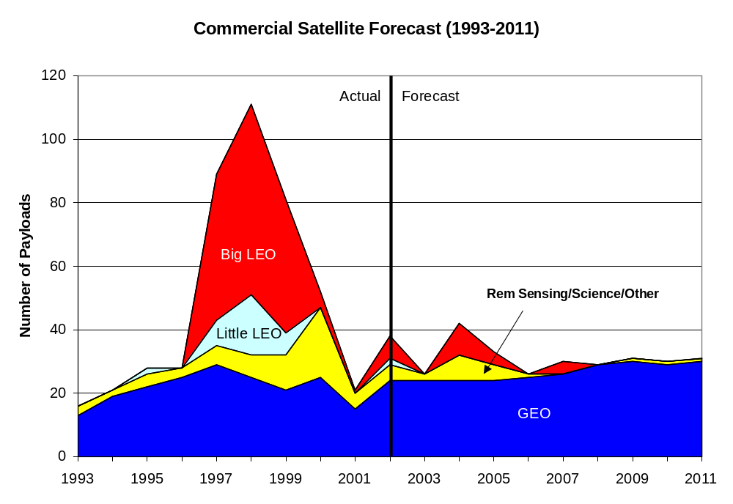
“Little LEO” systems (such as ORBCOMM) provide narrowband data communications such as e-mail and two-way paging using frequencies below 1 GHz. The FCC dubbed the systems “little” because they were at lower frequencies than Big LEO systems. Big LEO systems (Iridium and Globalstar) provide mobile voice telephony and data services in the 1-2 GHz frequency range.

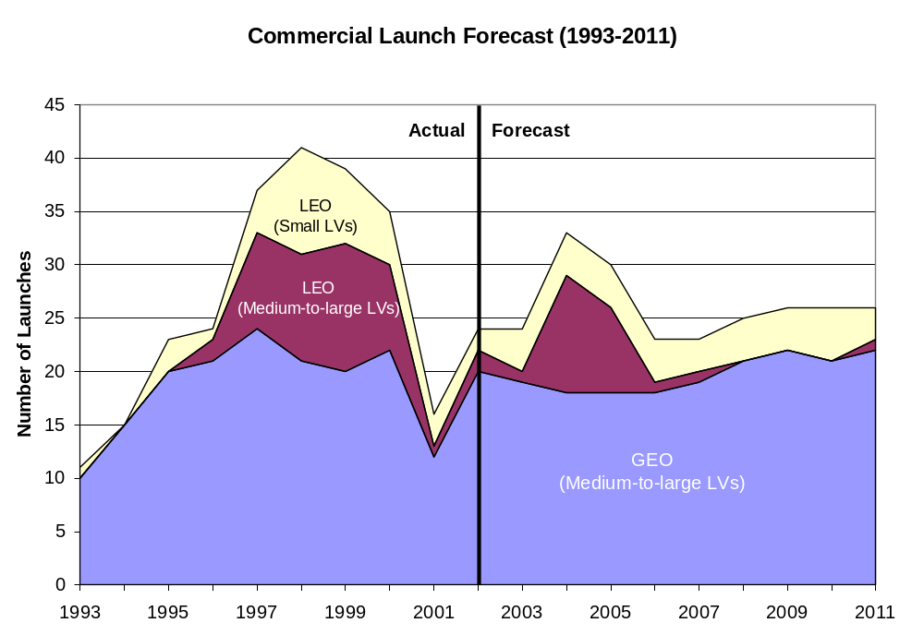

The forecast projected an average of nearly 27 commercial orbital launches worldwide annually through 2011.

The 2002-2011 forecasts project an annual average of:

- 20.5 launches of medium-to-heavy vehicles to deploy GSO satellites;

- 2.5 launches of medium-to-heavy vehicles to NGSO; and

- 4 launches to NGSO by small vehicles.

These estimates account for launching multiple manifested payloads, since commercial NGSO and some GSO payloads could be launched in groups on a single launch to reduce costs.

The forecast is based on inputs from across the international satellite and launch services industry and represents the demand for launch services for actual or projected satellite programs in a given year. The forecast is not a prediction of what will actually be launched.
Several factors can affect the year-by-year accuracy of the forecast, including satellite manufacturing delays, launch vehicle components problems, launch failure investigations, or scheduling issues. Regulatory issues, such as satellite export compliance or Federal Communications Commission (FCC) licensing, can come into play. Also, changes in national economies or the business environment can cause satellite companies to alter or cancel their development plans.

The complete forecast report is available at http://ast.faa.gov/rep_study/forcasts_and_reports.htm.

GENERAL MARKET TRENDS

The commercial space transportation market is driven largely by the demand for launches of telecommunications satellites. The development of new markets, such as satellite radio and public space travel, have yet to significantly impact launch demand. The following trends can be expected in the next few years in the commercial space launch industry:

- Continued steady demand for launch of GSO communications satellite systems and a small but increasing demand for remote sensing systems;
- A general trend toward heavier GSO communications satellites;
- A slight increase in the number of small-mass GSO satellites;
- Continued low demand for NGSO satellites, because of business difficulties faced by the first telecommunications constellations;
- Continued international competition by Europe, Russia, and China for launch services and possible new entrants into the commercial launch market from India, Japan, and Brazil;
- U.S. government development of a reusable space vehicle launched on large ELVs; and
- Continued private sector development of expendable and reusable launch vehicles.

Expendable launch vehicles are used only once, with stages falling back to Earth or remaining in orbit after use.
A spacecraft in geosynchronous orbit is synchronized with the Earth’s rotation, orbiting once every 24 hours, and appears to an observer on the ground to be stationary in the sky. GSO (also sometimes called GEO) satellites can have arbitrary eccentricity and arbitrary inclination to the Earth’s equator and are generally at an altitude of 35,852 kilometers (22,300 miles).
Non-geosynchronous orbit (NGSO) satellites are those in orbits other than GSO. They are located in LEO (lowest achievable orbit to about 2,400 kilometers), medium Earth orbit (MEO, 2,400 kilometers to GSO), and all other high or elliptical orbits or trajectories.

