WATERSHED WORKBOOK:

1.Defining a watershed
Defining a watershed is tough even for the experts. Is it only the surface of the land water runs off of? Does it include ground water? How about the water in plants and animals, bacteria, viruses, and microbes? If one really wanted to get esoteric, one could include water in bodies of animals that travel from one watershed to another.

This said, the first thing you should do with your group is to come up with a definition of a watershed, or show them a picture or map of a watershed, and figure out what makes it a watershed.
This is where a topographic map of your watershed comes into play. Point out that the blue area is the water, but all the land that extends out to the highest point on the topographic map is the watershed. Note how much bigger the land that drains into the water is than the actual water itself. This means that people far from the water are impacting our water. That’s a lot of people sending waste, chemicals or trash into that little body of water.
☺ Can you buy your way out of water pollution? Spell Evian backward and find out.

use the topography map below for the following exercises:
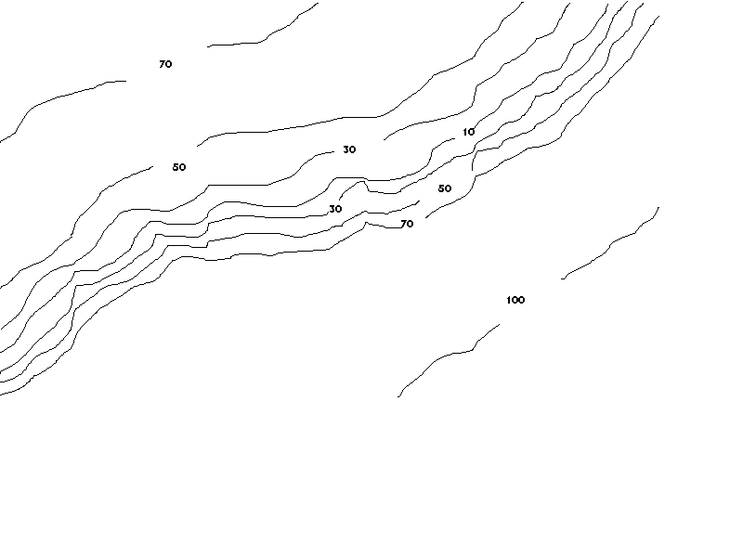

not

Note how each line has a break with a number in it. These numbers show how high the area is above the level of the sea. Answer the following questions, then check your answers on the next page

- Which part of the map is the highest?
- Find the 10 foot level. Is the land rising steeper to the right or the left?
- Which side shows a gradual rise from the 10 foot level?
- Note the elevation lines are only shown for every 20 feet of difference. Does this mean that 10 feet is as low as the land gets?
- Where would you expect to find a creek if there was one?

Answers:

1. The lower right side of the map is 100 feet. It is higher than other sections shown.
2. The right is showing a steeper rise that then levels off some.
3. The left shows a gradual rise to 30, then 50, then 70 feet.
4. No it just means 10 feet is the lowest level shown
5. Somewhere around the 10 foot elevation.

Demonstration: You can build a watershed with flour-salt clay or any of the great new clay like substances, or just plain dirt out in the playground that forms a basin in mountain ranges. Cover it with plastic and let kids see water running off into the basin and being shed outside the basin at your "mountain divides". Be sure and leave an exit in your basin to the ocean.

Demonstration: Set up model with sand, clear container and plastic sheeting. If you decide to include ground water in your definition, a good model for that can be built in a rectangular aquarium by building a sand or fine gravel slope from 0 inches elevation at one end to about half way up the aquarium at the other end. Lay plastic sheeting on this to become your "impervious rock layer". The plastic sheeting should only be about half the length of the slope. Add a few more inches of sand or gravel on top just to cover the plastic. Add dark food coloring to a cup of water to make it dark enough to see against the sand. Pour the water slowly onto the sand or gravel at the highest end so it flows into the sand not just on top. The kids can watch it run along the plastic and come out the slope about half way down. Drive along highways in the Appalachian mountains and you see the same things going on. These are springs or seeps.

See model below. This can be made in an aquarium or clear plastic box.

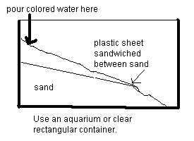

2:Where is the water?
Having explained what a watershed is, now you want to find yours.

Field Trip:To find out where to start looking, take a bucket or glass of water outside and dump it. Where does it run to? That's downhill and water always goes there. Why? Gravity. The same force that pulls waistlines, and the rest of us down, affects water. Nice to know all things are equal.

A:If you live in a culverted, concrete world, head the direction the water took and find a storm drain. Voila! Your watershed entry point!

B:If you live where nature isn't confined to boxes, head down hill until you come to an area where two slopes meet. Dry or wet, this is part of the watershed. Compare soil saturation a half block from the area to the soil in the crotch of the two slopes a few hours or a day after a storm. The soil at the bottom of the slopes will be more wet. (Use soil coreres and filter paper or paper towels to see where soil is the most damp.)

3:Where does it go?
You can, if you and the class parents are so inclined, follow your drainage until you come to the ocean. This will mean a lot of walking, some smelly places, and at least several days spent swatting mosquitoes by the time you get close to the ocean. On the other hand, it is a great way to learn we are all connected by water.

Field Trip:Follow your drainage as far as you feel comfortable using the water dumping method to determine down hill when the slope looks level. This is a great way to find out who's downstream from you. You affect these people!

4:Where does it come from?

Field Trip:Now reverse the process and find out who's up stream from you. Just pour out your water and head the opposite direction it ran. Who's upstream and what are they doing to your watershed?

Classroom activity:If you don't want to do that, call 1-888 ASK USGS (U.S. Geological Survey) and ask for topographic maps of your neighborhood. There is going to be a charge for these, so don't get carried away. These show slopes, and will enable you to find the nearest stream your water drains into. If you've never read a topographic map before, each contour(wavy)line represents a change in elevation. (see exercise above) To find drainage areas, look for areas where the lines come close together. This may not actually be a creek, but it is where water begins the journey to become a creek, a river, a Chesapeake Bay, an Atlantic Ocean. Not bad for a few lines!

Classroom activity: Make a map of your own exploration showing houses and businesses and natural areas that are along your part of the watershed.

5:What's in the Water?
Different areas have different pollution problems. In the East, we nearly all have problems with soil breaking or washing into the water, smothering bottom dwelling life forms, including submerged plants growing on the bottoms of streams. When the first people came to the area, they were in the middle of the world's largest deciduous forest. There was little exposed soil. Trees absorbed millions of gallons of rain, and their leaf litter protected the soil. Take a look around you today. How many acres of unbroken forest are left where you live? This is one reason siltation (soil washed into water) is such a problem now. Contact the Chesapeake Bay Program Office at 1-800-Your Bay and ask for more information on pollution.

One of the big offenders is auto exhaust. The air shed of the Chesapeake Bay goes out nearly to the Mississippi River and up to the Great Lakes. Air moving across land loaded with nitrous oxides ends up falling with the rain into the Chesapeake Bay and loads it with nitrogen, one of the major pollutants in the Bay. In addition, it acidifies the water, killing many marine and fresh water plants and animals.

Demonstration:You can do a quick experiment to see how bad car exhaust is. Test the p/H of water as it comes out of the tap of your home or school. Put a half cup of water in a large plastic bag and hold the bag open behind the exhaust pipe of a running car for 30 seconds or a minute. Swish the water around in the bag and test the p/H of the water in the bag now. You'll get a noticeable difference.

6:History: The key to some pollution today
Pollution isn't anything new, nor is it likely to go away. We think of pollution in terms of single discharge points, but that's only a very small part of it.
We can't always look at the obvious in finding sources of pollution. If your ground water has lead or arsenic in it (you might be able to call the health department to get this information), look and see if there are Revolution Era grave yards in your area. In the old days, they embalmed people with arsenic and buried them in lead caskets. Rain moving through the soil, leached out those chemicals and put them in the ground water. Mining operations from the distant past may also contribute heavy metal contamination. Lead can get into tap water through the water pipes used. In the old days lead pipes were used for plumbing, and even in modern times copper pipes with lead solder joining them leach lead in acid water.

One also has to look at the rocks and soil the water flows through. Arsenic, lead, mercury and many heavy metals are all naturally occurring, and may just be present in the soil. Your state geology or soils office can help you find out.

Activity:To find out historic sources of pollution, check out the history of your watershed land use. Look for businesses and dump sites, military stations, slaughterhouses, mortuaries, farms, factories. To find these you may want to try:
A: County records search
Zoning, Historic or Archeologist Office
B: Newspapers
Some of the larger ones have good libraries
C: Oral History, check with senior citizen homes to see who is a long time local resident, still clear headed, and willing to talk to students. Bring a recorder and agreed on questions written up before you come. Also check churches for long time residents.
D: Cemeteries, look for dates when a lot of people died in the same year. This could indicate an epidemic such as flu or a natural disaster. Get newspapers for that year and see what happened.
E: Census records, call and find out how many people were living there over time, what most people do for a living, this will give you an idea if your area was farms, mining, industry, or something else.

F: Parish records, this will also give you an estimate for when people came to the area and in what numbers.

7:The Present: Who puts what in the water
Activity:A: Contact local water resources or waste permit office to see what regulations exist for the dominant industry you found in your watershed
B: Have students assess their homes and school and see what they are putting in the water or landfills that might leach into the ground water. Also examine if people in the community use the landfill or if roadside dumping is the way people handle their trash. What safety precautions are used to protect the water?
C: Measure turbidity and trash that goes into the water in your area. To measure trash, you don't even have to wait for a rain. Just walk along the street and see how much trash is on the sidewalk, or in the street and gutters. All of this will end up in the water with the next rain. If you have a stream near you, wear boots and walk the stream bed. This will give you an idea of what is going downstream.
Measure turbidity by taking two pieces of white coffee filter paper or chemistry filter paper. Designate one as the control and keep this one clean. Put a piece of brown construction paper as a control, also. Assign a value of 0 to the clean filter paper and 5 to the construction paper. Take a second piece of filter paper and hold it in a stream or rain gutter for a few minutes. Now compare it to the controls. Is it closer in color to 0 or to 5. This is an estimate of how turbid, or muddy, your water is.


test sample control sample

8:Is There Life in the Water?
If your school has microscopes you can do some pretty scary stuff with your street or stream water, tap water and bottled water.
Activity:Take random samples of water from these sources and look at them under a microscope. You want things moving in the stream or street water, but not in your tap or bottled water. If you can find a good book on microscopic life in your library, see if you can identify any of the things you find.

Field trip:SOS field guide: The field guide available through the Izaak Walton League is a good one that can be used to assess health of streams. Just as people are not likely to enjoy living in Antarctica, but can, some animals may not like living in polluted water, but can. Others die as pollution increases. These animals are indicators of stream heath. If you don't have a stream near by, contact your highway department for a storm water catch basin location and get permission to do the same assessment there.

9:What Else Is There?
Field Trip:
Plants: Plants, like the aquatic animals, require certain conditions to live. Most plants die in ten or fewer years under heavy contamination of auto or other exhaust. Ailanthus altissima is one tree that will live even through dusting of cinders and diesel smoke. Use a field guide for your area to identify trees growing wild around you. Are there trees in your area? Do they like to grow in rich well drained soil or wet soil? Remember that soil compaction under lots of foot traffic or pavement or between buildings limits plant growth. Also keep in mind that all green plants require some sun to live.

Critters: Next to microscopic life forms in the soil and water, bugs are just about everywhere. Find a field guide for your area, and try to identify the habitats of bugs you find. You may have to look under logs, stones, or leaf litter to find bugs. This is an activity that kids should do with the warning that they are not to pick up the bugs. Also look for flying bugs.

Birds: If all you see in bird species are sparrows and pigeons, you either live in a concrete canyon, or you're just not watching at the right time. Birds are most active at dawn and dusk, they hide in shrubby trees and bushes in the day time. Don't expect to find them coming up to your window unless you have a bird feeder.
Activity in a Field Trip:For various reasons bird feeders are not the best way to keep bird species healthy, but they are a good way to find out what's in your neighborhood. In winter, keep a well stocked seed feeder on the ground or on a flat table, or surface for several weeks, and see what species come to eat. Use bird seed, not bread. You want birds, not feathered rodents. Birds are the winged seed bearers of most of our native species of plants, spreading the seeds. Some species such as the holly need birds to eat their seeds to sprout them. Peterson's Bird guide is an easy, well respected guide to birds.

Mammals: Looking for tracks, scat and burrows is probably the best way to find mammals in most watersheds. Even the grey squirrel is a shy animal for the most part, and will hide when approached by thirty excited school kids. If you have older students, or uncommonly self disciplined ones, you can build a blind out of netting covered with leaves, and hide in it to wait for wildlife. Most wildlife will be squirrels and mice. Even urban areas, though have fox and weasels moving into some habitats.

Activity in a Field Trip:Ask your librarian for a good book on local animal tracks, especially mice, opossum and other small mammals, and build an animal run. In an area that won't get a lot of human traffic, lay out a shallow tray of dirt, or clear an area to expose powdery soil. Loosen the soil and spray distilled water over the soil to make it moist. Cover anything man made with leaf litter or soil from the site, trying not to handle anything to avoid leaving a lot of human scent. Leave a small pile (no more than a quarter cup) of sunflower seed mixed with apple pieces in the middle of the dirt. Leave the area and come back the next day. If your dirt still has no tracks, freshen the seed/apple mix, moisten the soil with distilled water, and leave it another night. The tracks of most mammals will be very light in the soil and are not going to jump out at you as they do in the snow. Be sure you haven't missed light tracks when you check.
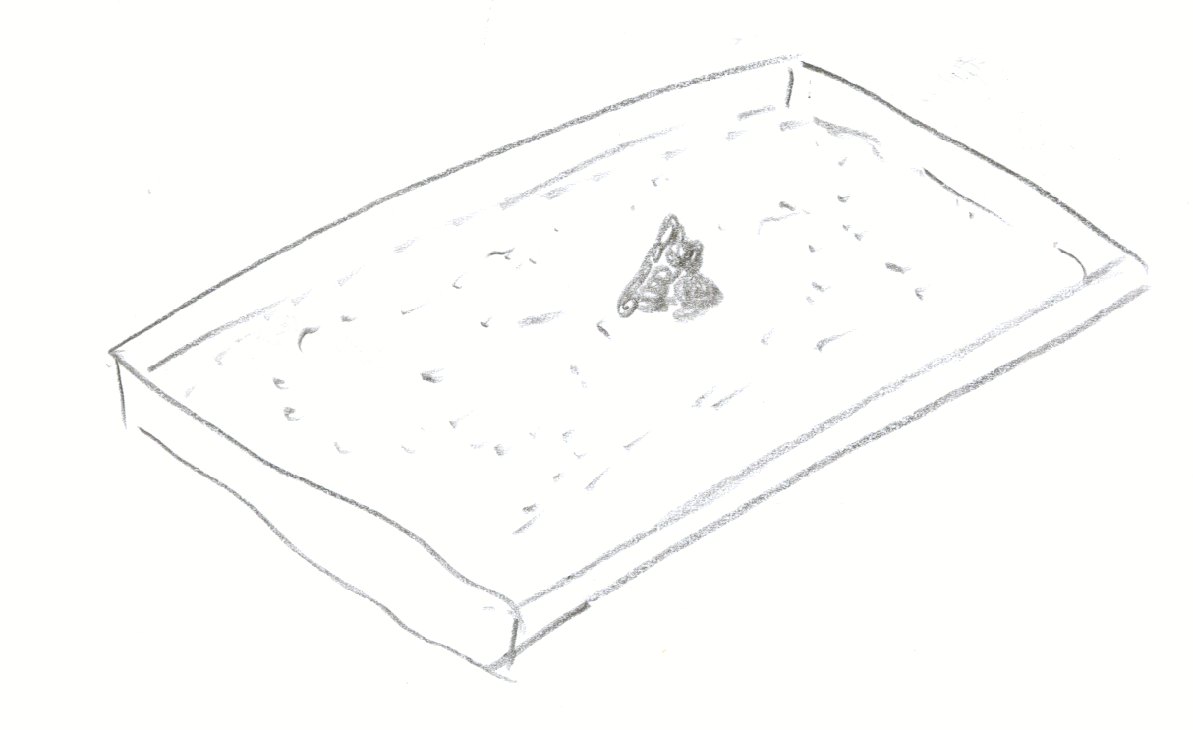Cover the edges with leaves or dirt from the site if you can.

Another sign of mammals in your watershed are "runs" they make over time traveling to water, food, cover or other shelters. There is no good way to describe a "run" except to say it is a worn path through low vegetation, that is too small to be made by humans. Rabbits and other animals habitually travel the same areas, and will eventually leave small holes about 4" diameter in vegetation where they enter shrubby areas because the animal, small as it is, is breaking off new plant growth and compacting the soil, as it walks, just as we do.

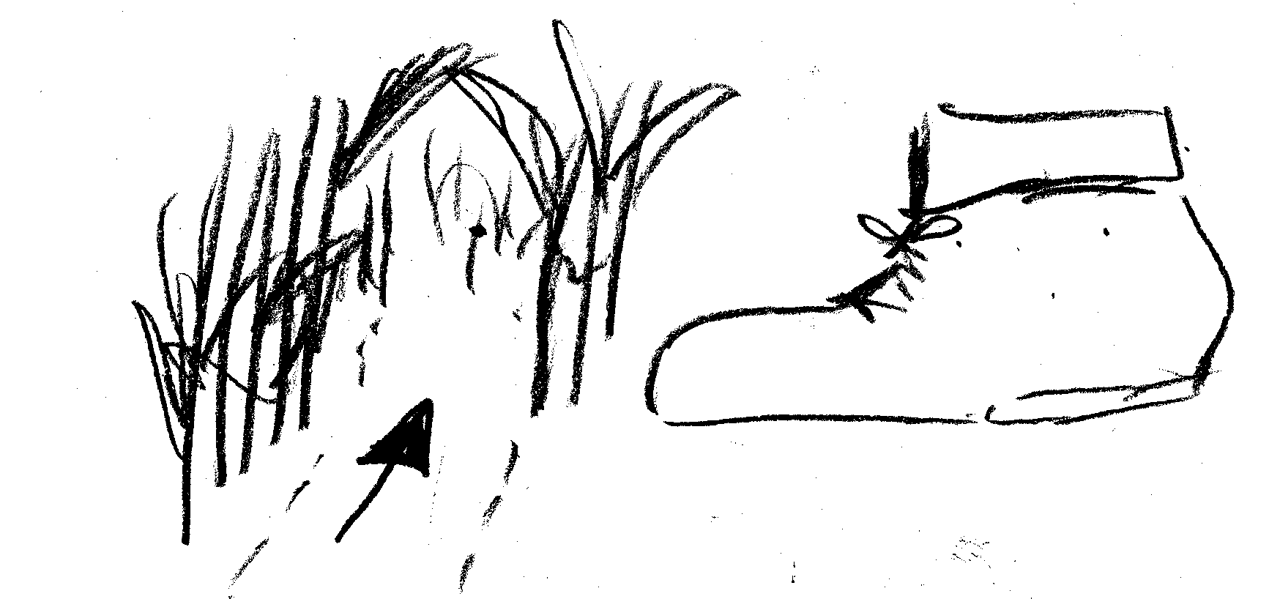Most runs are small.

You may not find any mammals in your local watershed except mice and rats around dumpsters. It's a sad commentary on our effect on other species, but a real part of life today.

Activity in a Field Trip: You may, if you are sure you and the kids can deal with it, build a simple reptile/amphibian trap. Find or build a dampish low place where it is not likely to flood regularly and lay a board or flagstone mostly over the spot leaving an inch or so opening. That’s it. That’s all you have to do except leave it alone. When you need to see what reptiles and amphibians you have in your habitat, simply lift the board. Don’t do this if there is any chance that seeing a salamander or snake is going to make you drop the board!
Our ecosystem needs reptiles and amphibians, and many are rare so we can’t afford to have even one hurt!

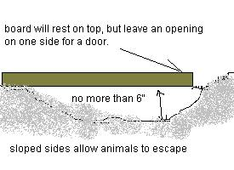
Reptile/amphibian shelter

10:What Limits Life In the Watershed:

People maximize their chances of survival and comfort, often with little thought to the ultimate effect on their environment. We know we depend on a healthy watershed, but often do things that damage it. Change is a constant, and lucky for us it is.

Field Trip: Do a point assessment of the general health of your watershed as a base to make and measure improvements. These points should be assigned based on stretches of stream bank that are at least a half city block or 100 feet long. In other words, 10 trees along a stream doesn’t count as a forest buffer, a forested block in the middle of a city does.

Walk the watershed for as far as you feel comfortable and assign points based on what you see on this list.

Give 100 points for forest buffers along streams over 100 feet wide from the stream to the edge of the woods furthest from the stream, 50 points for forest buffers of at least 35 feet along streams, and 50 points for each 100 foot square of forest not near a stream.
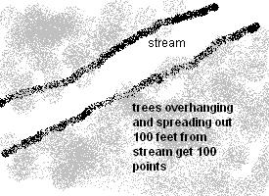

Give 100 points for wetlands along streams 100 feet wide by 100 feet long, 150 points for wetland buffers that border forest buffers, give 50 points for any healthy wetlands along streams of smaller size.

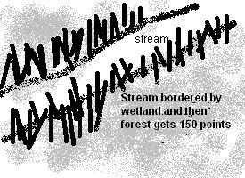

Give 30 points for tall grass, shrubs or weedy areas adjacent to streams if the vegetation is 35 feet or more from the stream edge to the far edge of the vegetation. Give 15 points for any areas of tall grass, shrubby or weedy areas over 100 feet long and 20 feet wide or more.

Bonus points
Give 1 points for every 100 feet of unculverted stream with any vegetation on the banks

Give 40 points each for regular local recycling or stream clean up programs

Give 40 points each for no trash on streets, yards or other areas.

Give 45 points for any of the following: no pesticide or fertilizer use, no parking lots or driveways, no dumping in the storm drains, no toxic chemicals or human waste released without treatment

Give 5 points for each storm drain painted with a no dumping sign

Give 10 points if fish live in the water of your watershed

Subtract points for these:

Subtract 5 points for each 100 feet of culverted stream,

Subtract 10 points for no vegetation buffers of any kind along streams for more than 100 feet

Subtract 40 points for trash in streets, yards and other areas bordering streets

Subtract 30 points for oil stains on roads, parking lots, driveways, or signs of chemicals leaking from cars or other sources.

Subtract 50 points for any of the following: dumping in storm drains, pesticide use yard signs, fertilizer use, animal or other biological waste, obvious signs of air pollution such as smoke stacks going, or cars idling, leaking septic systems, fences that block animal migrations

Subtract 60 points for unprotected soil at construction or other areas eroding into streams

There is a sample sheet at the end of the packet.

11:Improvements We Can Make:

How did your watershed stack up? Do you want to see improvement?

There are things your class can do either in the school or with permission from others:
Activities:
A. Plant native trees, shrubs, grass along streams, in vacant lots or other open areas - Contact the soil conservation office or forestry office for your county and they may supply the plants.

Get permission from land owners before starting this. If you can get permission, pull up old concrete and asphalt and plant native plants in the soil you exposed.

B. Stream and street clean ups- bring in work gloves or buy gloves for the kids and pick any or several sunny days in the fall or winter to avoid poison ivy problems

C. Plant native plants in landscaping- do this as a school by exercising your collective clout with contractors, or ask to do it on an eyesore in your watershed. Collect seeds in the fall, and plant them in the spring after refrigerating them through the winter. Your agricultural extension office can give you help for your specific area. A good place to get plants is to request permission to do a rescue in an area that is about to be bulldozed. Planting natives reduces the exotic plant problems that change soil structure and reduce biodiversity. ( Not all wild plants are native to your area. Many are a problem. Talk to your agriculture extension office or native plant society for your state to get a listing of native plants for your area.)

D. Take the watershed home- See if you can eliminate use of some hazardous chemicals or at least use them less. Save water and electricity.

E. Find out more: about legislation affecting your watershed, about your planet.

F. Write letters: to officials and the media to let them know you value your watershed.
to other schools in your larger watershed to let them know what you're doing.
to other schools in other watershed to compare results

G. If a park near you has a satellite program, get involved.

Points for stream assessment

Section points | length of section | Total points
forest buffer 100 feet wide from stream edge to outside edge of forest – 100 points for every 100’
forest buffer 35 feet wide – 50 points for every 100 ‘
forest buffer near stream but not along stream – 50 points for every 100’
wetland buffer 100 feet wide from stream edge to outside edge of wetland - 100 points for every 100’
wetland and forest buffer 100 feet wide - 150 points
wetland buffer less than 100 feet wide – 50 points
tall grass/shrub buffer greater than 35’wide – 30 points
tall grass/shrub buffer less than 35’ wide – 15 points for every 100’ length along stream
open or unculverted streams 100’long -1 point
recycle/trash removal on regular basis -40 points
no uncontained trash in streets or surrounding area - 40 points
no obvious pesticide/fertilizer/oil spills, dumping in drains – 40 points
storm drains have no dumping warning – 5 points
fish in stream – 10 points
stream is enclosed in culvert - (-5) points for every 100’
no vegetation along stream – (-10) for every 100’
trash in streets and near area – (-40)
oil stains on roads, parking lots –(-30)
signs of dumping/dog poop, pesticide, fertilizer - (-40)
erosion from near by areas –(-60)

Total potential points 206 for every 100 feet. Your stream score ________

