MADDEN-JULIAN OSCILLATION (MJO)
DIAGNOSTIC DISCUSSION

issued by

CLIMATE PREDICTION CENTER/NCEP

July 5, 2004

Synopsis: MJO activity is expected to continue to weaken during the next 2-4 weeks.

During June the eastward progression of the MJO slowed considerably as the period of the MJO increased. By the end of the month MJO-related enhanced convection was located near the international dateline while MJO-related suppressed convection was located over Indonesia and the west Pacific (Fig. 1).
Consistent with this, weaker than average easterlies (westerly anomalies) are located in the western Pacific and stronger-than-average easterlies are located in the central and east-central Pacific (Fig. 2).

Over the past several months fluctuations in equatorial easterly winds have contributed to month-to-month variability in the surface and subsurface temperatures in the equatorial Pacific. In particular, MJO-related weakening of the equatorial easterly winds initiated eastward-propagating oceanic Kelvin waves in early January and in early April 2004 (Fig. 3). The weakening of the equatorial easterly winds throughout the latter part of June has not initiated the development of an eastward propagating Kelvin wave (Fig. 3).

During mid-June the pattern of tropical convection exhibited a stationary wavenumber 1 pattern, with enhanced convection focused from the Bay of Bengal (100°E) to the Western Pacific (160°E) and suppressed convection from 60° E to 60°W (Fig. 4). Near the end of June this pattern of convection has become more disorganized (Fig. 4), consistent with further weakening of MJO activity. During late June it was hard to distinguish MJO-related enhanced convection from intense convection associated with two typhoons in the tropical western Pacific.

Both statistical and dynamical model forecasts indicate that MJO activity will continue to weaken during the next 2-4 weeks (Figs. 5-6). The Empirical Wave Propagation (EWP) model forecasts an area of enhanced convection over the east-central Pacific to propagate eastward and weaken (Fig. 5). An area of suppressed convection over the far-western Pacific is forecast to propagate eastward toward the central Pacific and maintain its intensity during the next two weeks (Fig. 5). The GFS shows a similar eastward propagation of the area of enhanced convection over the east-central Pacific over the next two weeks, but it does not show eastward propagation of the area of suppressed convection over the western Pacific. Given the observed atmospheric patterns discussed above, it is likely that MJO activity will continue to weaken during the next 2-4 weeks.

Weekly updates of SST, 850-hPa wind, OLR and features of the equatorial subsurface thermal structure are available on the Climate Prediction Center homepage at:
http://www.cpc.ncep.noaa.gov.

Climate Prediction Center
National Centers for Environmental Prediction
NOAA/National Weather Service
Camp Springs, MD 20746-4304

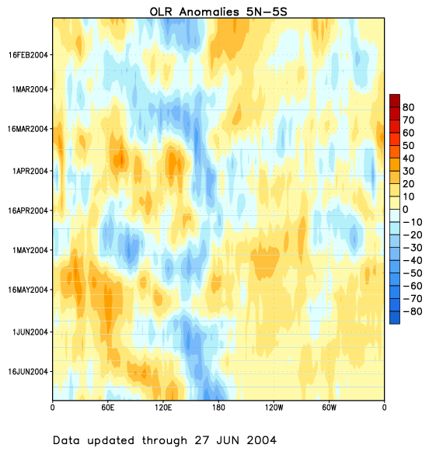

Figure 1. Time-longitude section (5°N-5°S) of anomalous Outgoing Longwave Radiation (OLR) (W m⁻²). The base period for computing anomalies is 1979-1995. Negative OLR anomalies (wetter-than-normal conditions) are indicated by blue shading while positive OLR anomalies (drier-than-normal conditions) are indicated by orange/red shading.
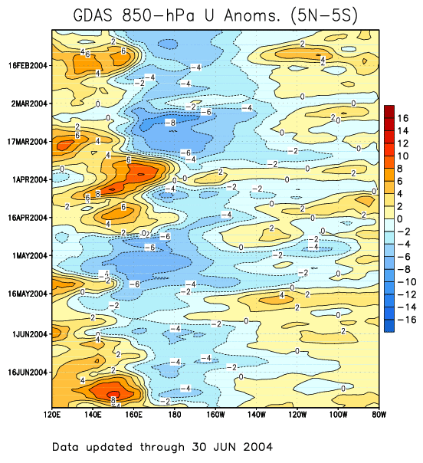

Figure 2. Time-longitude section (5°N-5°S) of anomalous 850-hPa zonal wind (m s⁻¹) (GDAS).
Contour interval is 2 m s⁻¹. Dashed contours indicate negative anomalies. The base period for
computing anomalies is 1979-1995. Stronger-than-average easterlies are indicated by blue
shading and weaker-than-average easterlies by orange/red shading.

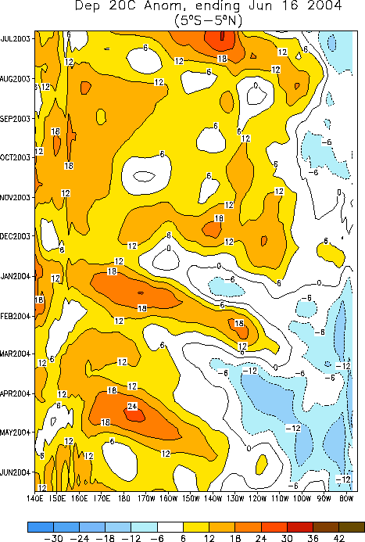

Figures 3. Time-longitude section (5°N-5°S) of anomalous depth of the 20ºC isotherm in the Pacific Ocean. The contour interval is 6 m, with positive anomalies (greater depths) indicated by orange/red shading and negative anomalies (reduced depths) indicated by blue shading.

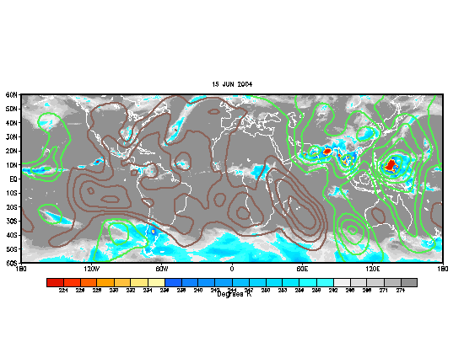
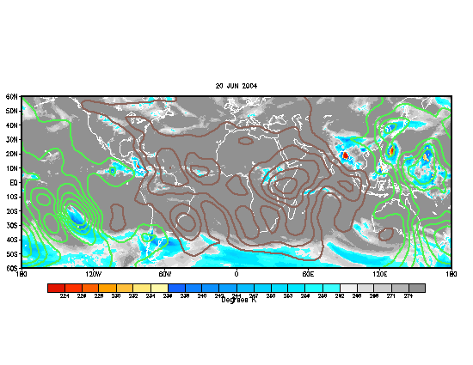

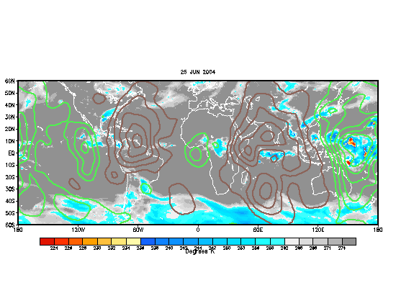
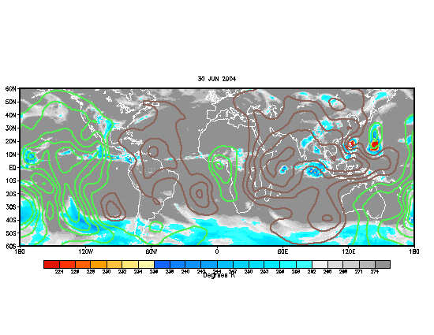

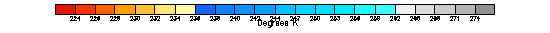

Figure 4. Daily IR Temperatures (K) and 200-hPa velocity potential anomalies (10⁶ m²s⁻¹) on 15 June, 20 June, 25 June and 30 June. Velocity potential anomalies are proportional to divergence with green (brown) contours corresponding to regions in which convection tends to be enhanced (suppressed). The base period for computing anomalies is 1971-2000.
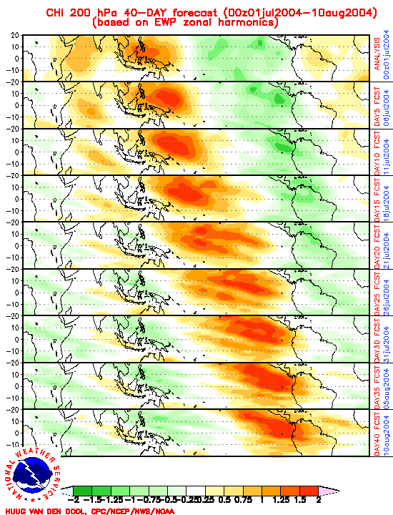

Figure 5. Forty-day forecast of 200-hPa velocity potential anomalies (10⁶ m²s⁻¹) based on EWP (Empirical Wave Propagation) zonal harmonics.

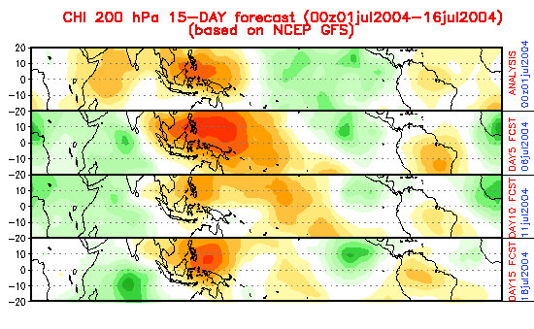
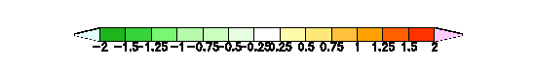

Figure 6. Fifteen-day forecast of 200-hPa velocity potential anomalies (10⁶ m²s⁻¹) based on the NCEP GFS.

