Eye's, (Ears) and Workers Compensation

James W. Stout, OD

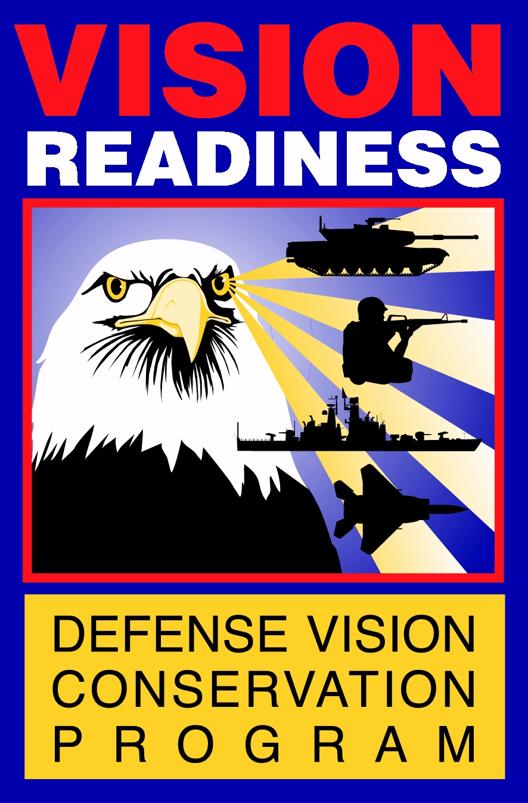

Tri-Service Vision Conservation and Readiness Program

OBJECTIVES

1. Become familiar with the Tri-Service Vision Conservation and Readiness Program.

2. Understand the basic elements of eye safety and vision in the workplace.

3. Become familiar with common workplace eye hazards and stressors.

4. Become familiar with prevention, protection, and vision enhancements in the workplace.

OUR MISSION: To optimize vision readiness of Department of Defense employees.
OUR MOTTO: Vision Ready Is Mission Ready
Application: Although our mission is specific to the Department of Defense, its precepts apply to all work environments.
TRI-SERVICE VISION CONSERVATION AND READINESS PROGRAM

ARMY

- LTC Jack Hughes, OD

- MAJ Emery Fehl, OD

- LTC Julie Tanada, OD - Europe Consultant

AIR FORCE

- Lt Col Anthony O’Koren, OD - Program Manager

NAVY

- CDR Dale Barrette, OD

CONSULTANT

- James Stout, OD

MAJOR PROGRAM ACTIVITIES

1. Revise/Develop Vision Policy & Doctrine for the Three Services and Department of Defense

2. Conduct Studies/Research to Measure Program Effectiveness and Development of Intervention Strategies

3. Provide Education and Training to Optometrists, Occupational Health Staff, and Safety Personnel

4. Assist Local Vision Conservation Programs via Consultation and On-site Visits

5. Develop Vision Information Services to Provide Current Information on Workplace Eye Protection and Efficiency

Although the primary mission of our program is to serve the Department of Defense, we provide information and assistance to government and civilian requestors.

CONTACT US:

USACHPPM
Vision Conservation and Readiness Program
Bldg. E1570, Stark Rd.
APG, MD 21010
COMM: (410) 436-2714
DSN 584-2714
FAX (410) 436-7924
Web Site: http://chppm-www.apgea.army.mil/dcpm/vision/default.asp

Dr. James W. Stout
james.stout@amedd.army.mil
(410) 436-7717 DSN 584-7717
The basic elements of vision
and eye safety in the workplace

1. Your Eyes - the Basics
- Visual Efficiency
- Potential for Injury
- Tissues at risk for injury

2. Workplace Eye Hazards and Stressors
- Office Environment
- Individual Visual Performance
- Video Display Terminals
- Illumination
- Hazards
- Industrial Operations
- Individual Visual Performance
- Illumination
- Typical Hazards -- Mechanical, Chemical, Radiant, and Biological
- Protection Methods
- Protective Equipment
- Home and Recreation
- Potential Hazards
- Protective Methods

3. Ocular Injuries: First Aid
- Mechanical Injuries
- Chemical Injuries
- Radiant Injuries
- Biological Injuries

INDIVIDUAL VISUAL PERFORMANCE

The primary factors in visual efficiency are visual acuity and visual coordination. Additional factors some professions are color vision and depth perception.

Visual acuity is the test of the ability of the eye and brain to interpret images in
E
NZ
Y L S
an accurate manner. In the US, we most often use Snellen Acuity. Without going
into excessive detail, a definition of "normal visual acuity" is the ability to discern
a 9mm high letter viewed at 20 feet. This is the 20/20 you hear about. In reality,
normal for some people is 20/25 and others is 20/15. It all depends on how close
the receptors are packed in the macula (area of the eye where images are focused)
and the optical characteristics of the cornea, lens, and vitreous of the eye.

Visual coordination is the ability of the eyes to work in a cooperative manner. Although most people think we are talking about crossed eyes here, in reality, almost everyone's eyes deviate slightly from straight ahead if given the opportunity to do so. We have found that for people doing a lot of near work, the tendency for the eyes to converge too much (point toward the nose) often precipitates headaches or other visual discomfort.

Color vision is the ability to accurately discriminate between various tasks based on how the visual system sees colors. This is critical for individuals such as those in electronics, aviation, and painting. Color discrimination deficiency is rarely a problem unless much of the work is color coded in subtle shades.

Depth perception is the ability to judge distance from the individual to an object or location. This is required primarily in professions such as aviation and air traffic control but may also affect forklift or crane operators. Good depth perception generally requires two normally functioning eyes but monocular (one-eyed) clues can provide the needed function for some jobs.

Having the visual system at its best is the way to minimize visual fatigue and reduce visual inefficiency. It also allows those in both industrial environments and office settings to perform in the most efficient and safe manner possible. The best way to maintain an efficient visual system is to get a comprehensive vision examination periodically (every one to 5 years depending on age and visual health). After age 40, annual examinations are recommended due to increased likelihood of onset of disease and focusing problems with near work.

THE POTENTIAL FOR EYE INJURY

Trauma is the sixth leading cause of blindness throughout the world. The first five causes are disease related including cataracts and glaucoma (another good reason for the routine vision examination).

Eye injuries to the civilian population of the United States are:

- Over 2.4 million eye injuries annually

- 1.25 million of these injuries are to people under 25 years of age

- 40,000 of those injuries will result in permanent visual impairment

- 1,500 of those with eye injuries will lose sight permanently in one or both eyes

Where do the injuries occur and to whom?

From the National Health Interview Survey (Eye Injuries)

-30% of eye injuries occur in and around the home
-27% of eye injuries occur in the workplace
The remaining 43% of eye injuries occur in accidents, recreation, and other locations away from home and work.

United States Eye Injury Registry (USEIR), an organization of Ophthalmologists in 37 states reports information for eye injuries requiring one or more days in the hospital for care. They found injuries occur more often to males (82% of all eye injuries) and to younger people:

Age: Under 20 19% 30-39 25% 50-59 8%
20 - 29 32% 40-49 12% over 59 5%

USEIR determined the primary places of injury were:


Work activities 27% Home activities 27% Recreation 25%

Assault 10% All Other 11%

Mechanical Injury accounts for 81% of all ocular injuries.

BRIEF EYE ANATOMY LESSON
Optic Disc


Cornea
Lens
Retina
Iris
Macula
Fovea

TISSUE INVOLVED IN EYE ACCIDENTS

Cornea 54% Eyelid 20%

Retina 46% Orbit 10%

Vitreous 44% Sclera 8%

Crystalline Lens 36% Optic Nerve 5%

Iris 34% Conjunctiva 1%
(More than one tissue may be involved in a given accident, hence totals exceed 100%.)

SPORTS-RELATED EYE INJURIES

Sport Incidence Sport Incidence
Basketball 23% Football 5%
Baseball & Softball 11% Racquetball Sports 5%
Swimming & Pool Sports 9% Ball Sports 4%

Convincing the employee to wear the correct protection when eye hazards cannot be engineered out of a task is one of the biggest problems in protecting the eyes. According to literature searches, in civilian industry, over 50% of workers sustaining eye injuries were not wearing eye protection when injured. For our military and their civil service counterparts, the non-wear when injured is over 80%. (More about protection later.)
WORKPLACE STRESSORS AND EYE HAZARDS

For most employees, there are two primary work settings:

Office based. The office may be in a high rise office tower or the back of a maintenance shop but the primary activity is the handling and processing of documents whether in hard copy or electronic format.

Industrial based. The work is more related to physical activities such as fabrication, maintenance, or manufacturing processes. Again, the setting may be a small, one-employee maintenance office or a major industrial setting.

OFFICE ENVIRONMENT

As previously discussed, one of the most important factors in performance is the visual capabilities of the employee. Vision doesn't necessarily have to be "perfect", however, it is important to have the employee see well for the type of task being performed.

The video display terminal (VDT) is probably the most loved and disliked office machine/tool today. The average employee seems to be thrilled with its capabilities while cursing its quirks.

Literature reviews suggest that 50% or more of VDT operators have at least occasional visual symptoms related to VDT use. The most pronounced symptoms were burning or aching of the eyes at work. Fortunately, these symptoms are not indicative of permanent changes or damage to the visual system.

What can be done to minimize VDT visual symptoms?

First, understand that the visual picture of the VDT is very different than paper. The characters are not as sharp and often there is a flicker to the screen. To minimize the problems with VDT use:

1. Get a thorough vision examination and be sure to tell the doctor that you use a VDT at work. Tell the doctor how far it is from your eyes to the screen. Workers with hyperopia (far sighted) or presbyopia (reduced ability to focus at near with age) will tend to have more problems with near work. Remember too, that most people read books at about 16 inches from the eyes but VDT screens are usually 28 to 30 inches away. This makes a difference optically that your eye care provider needs to know about. You might need a special pair of eyeglasses for just your VDT work distance.

2. VDT Screen Considerations -- a number of factors need to be considered to ensure the VDT screen provides the most comfortable image.
- Contrast between the letters and their background should produce sharp characters
- Color of screen and characters can be a problem. Because of the optical characteristics of the eye, blues and reds, colors at the far ends of the visible spectrum may be blurred. Black on white is still the best for most VDT word processing.
- Screen refresh rate is important. The image on the screen only appears to remain constant. In reality it is being refreshed at 60 or 70 times a second, faster than most visual systems can notice. Make sure your screen refresh rate is at least 60 times per second. The manufacturers also rate how many "pieces of information per inch" are on the screen. Your VDT monitor should be rated at 0.28 dpi (dots per inch) or better.

3. Take a break. Really! NIOSH recommends a 15 minute break for every 2 hours of VDT use. Perform a different task like filing, answering voice mail, etc. to give your visual system a break.

WORKPLACE DESIGN

The design of the work station also contributes to visual comfort as well as for the rest of the body. Some of the more critical factors to address are:

Workplace Lighting
- Make sure bright light such as the sun or lamps do not reflect off the screen into your eyes. Bright lights in the periphery may also cause discomfort. Try to keep the overall lighting a bit lower than when the office staff had to process a lot of paper documents.
- Balance brightness in the room.
- Use indirect lighting where possible.
- Block direct sunlight with drapes or blinds.
- Avoid white or very light surfaces and clothing as the reflection off them makes the screen act like a mirror with the reflection interfering with the screen image.
- Adjust the screen angle to minimize reflections.
- Anti-reflective screens can help but should not be a wholesale solution for the whole office. It works for some people, not for others. The also tend to reduce the sharpness of images on the screen.

Workstation Design & Placement

- Proper ergonomic design and adjustment can increase productivity

- Adjust workstation for individual need
- Viewing distance and direction of gaze. If you need to raise your chair or lower the screen, do it.
- A foot rest often helps with posture.
- Most new workstations have an adjustable keyboard height, use it if needed.
- Wrist rests help with hand and wrist comfort.
- Adjustable copy holders help minimize the amount of focusing they eyes need to do. Place the documents close to screen so the viewing distance will be about the same as the screen.

ILLUMINATION

Office Lighting

Illumination is another critical factor in office comfort. Generally speaking, it is better to have the overall office lighting reduced to minimize glare from the screen. Also make sure there are no light sources shining directly on the screen.

Good illumination is important in both office and industrial settings. As with many thing in life, compromise is often required. In the case of illumination, generally the more efficient the lamp type (luminaire) the poorer the color rendition has. A prime example is the yellow light used in large parking lots. You can see your way around but it is hard to tell what color your car really is.

Source/quality of lighting

- Incandescent (the standard light bulb)

- Fluorescent (common in home, office, and some industry

- High Intensity Discharge (HID) Examples are Mercury Vapor, Sodium Vapor and Metal Halide lamps.

Typical lamp efficiencies, color renditions, and uses
Luminaire Type | Lumens / watt | Color Rendition | Use
Incandescent | 17 - 23 | very good | Task and general lighting
Fluorescent | 70 - 80 | excellent | Task and general lighting
Mercury vapor | 44 - 55 | good | Warehouse, manufacturing area
Metal halide | 80 - 90 | good | Warehouse, manufacturing area
High-pressure sodium | 115 | poor | Parking lot, storage area
Low-pressure sodium | 170 | very poor | Parking lot, highway

Quantity of Illumination:

General Lighting Vs. Supplemental Lighting

General Lighting:

Direct Lighting generally produces the most efficient lighting system but is prone to producing harsh shadows and marked reflections at the work surface.

Indirect Lighting provides a diffuse lighting with minimal shadowing and reflections but is less efficient due to absorption from the reflecting surfaces.

Supplemental Lighting - where overall illumination of a work area is too low to perform detailed work, the use of supplemental lighting is often used for task lighting.

Glare on the work surface or task is a problem in the workplace. There are several types of glare problems that may need to be addressed. To minimize glare, one or more of the following actions may be necessary:

- Change position of task or light

- Use a dull or matte finish on surfaces surrounding task

- Change light source i.e. fluorescent, incandescent, HID, etc.

- Change lighting type i.e. direct, indirect, supplemental, etc.

Brightness Ratio - empirical tests have determined that having a 3:1 or 1:3 ratio is good for most near work and tasks. That means the background should be 3 times dimmer or brighter than the task.

Other Illumination Considerations:

- Worker age - older people need more light because the pupil size gets smaller and the potential for cataract development increases with age.

- Task importance

- Task difficulty

- Increased illumination can increase productivity to a point

Industrial operations

Industrial operations have more to do with nature of the work than the setting. A one person repair station on a building maintenance area is considered industrial as well as a armored personnel carrier manufacturing plant. Both have grinders, drill presses, chemicals, etc.

The principles of illumination discussed in the office setting apply equally well here. The only thing that changes in most cases is the size of the area to be illuminated.

The primary consideration for vision in the industrial setting is the hazards to the eye (and the rest of the body as well) and the protective measures needed to prevent injury. However, poor illumination can contribute to increased injury rates. The next picture illustrates how something as simple as cleaning the lights and ceiling improves lighting.

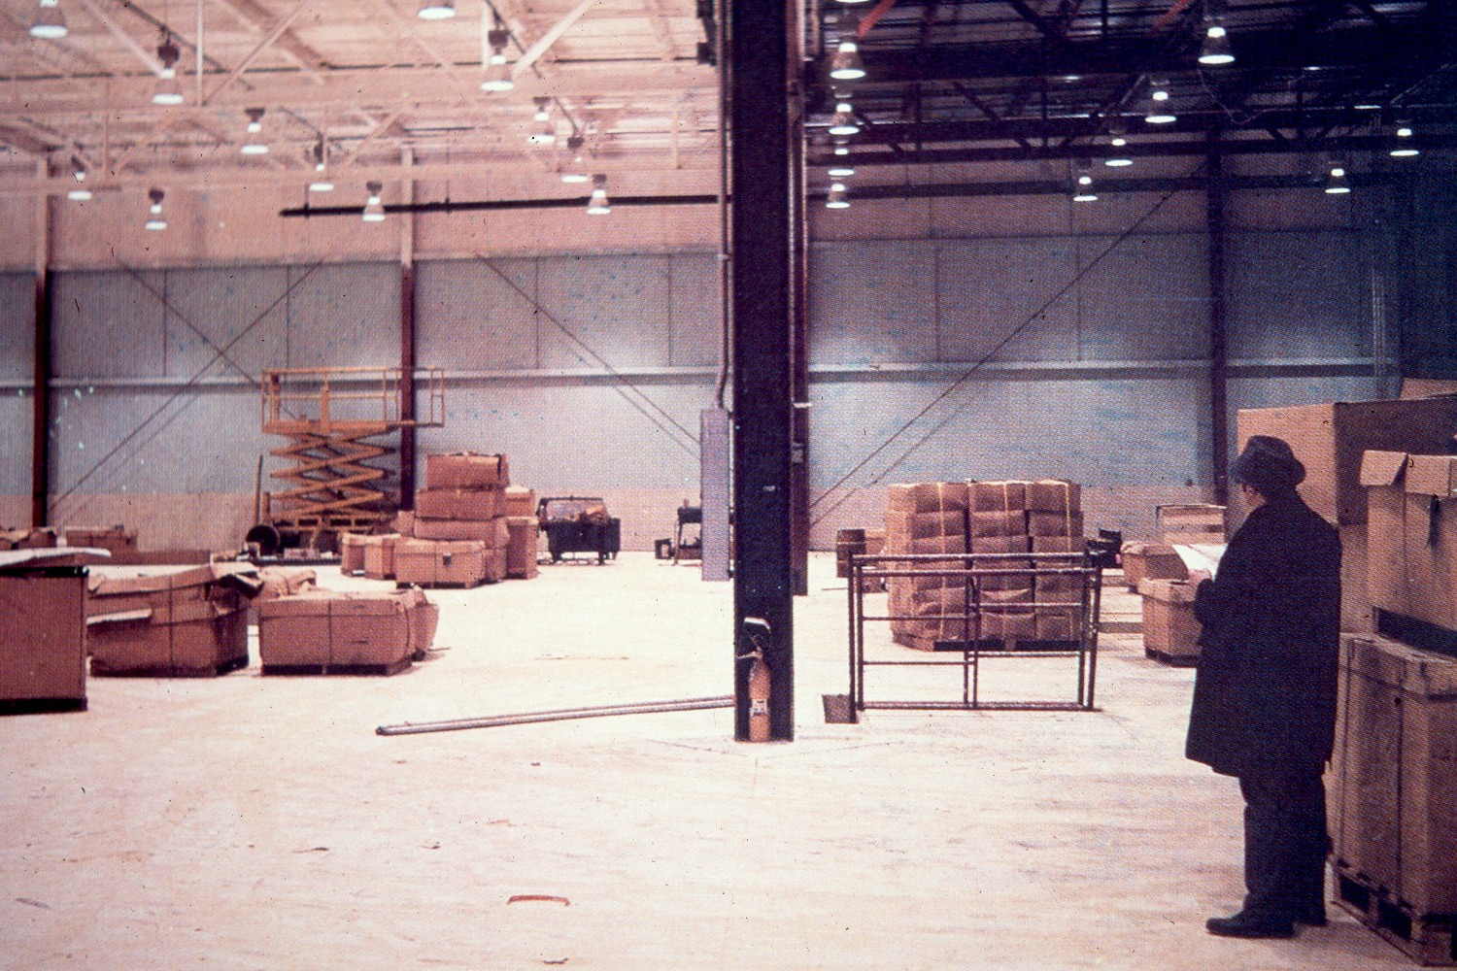

EYE SAFETY PRACTICE

Just as with other industrial hazards, there are three primary methods of protection:

1. Engineering Controls - Changing the tools or operation to eliminate or reduce the hazard. (guards, interlocked switches, protective enclosures, etc.). This is the most effective intervention.

2. Administrative Controls - Rules and practices that reduce employee exposure (signs, SOP's, etc.)

3. Personal Protective Equipment (PPE) - Protective equipment issued to the employee. This is the last resort. It is more difficult to enforce and is very individual.

As mentioned previously, between 50 and 80% of workers are not wearing eye protection when injured. Safety shields and warning signs help prevent injury by reducing hazards and increasing awareness.
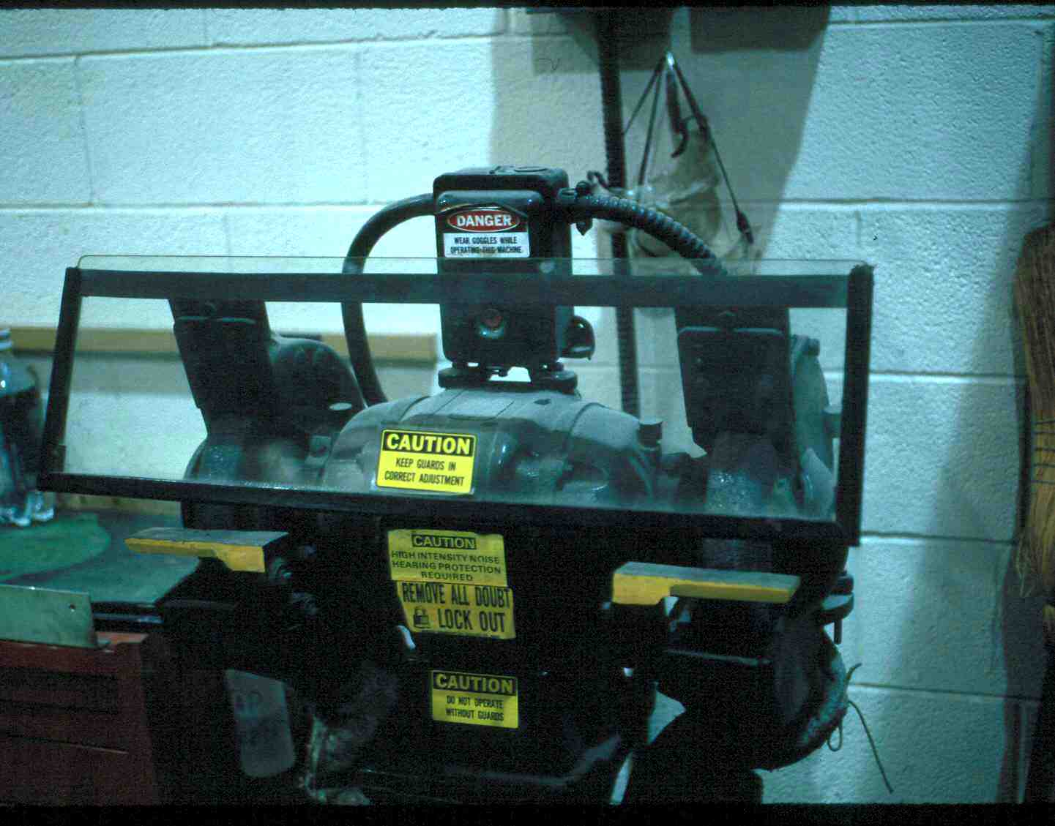
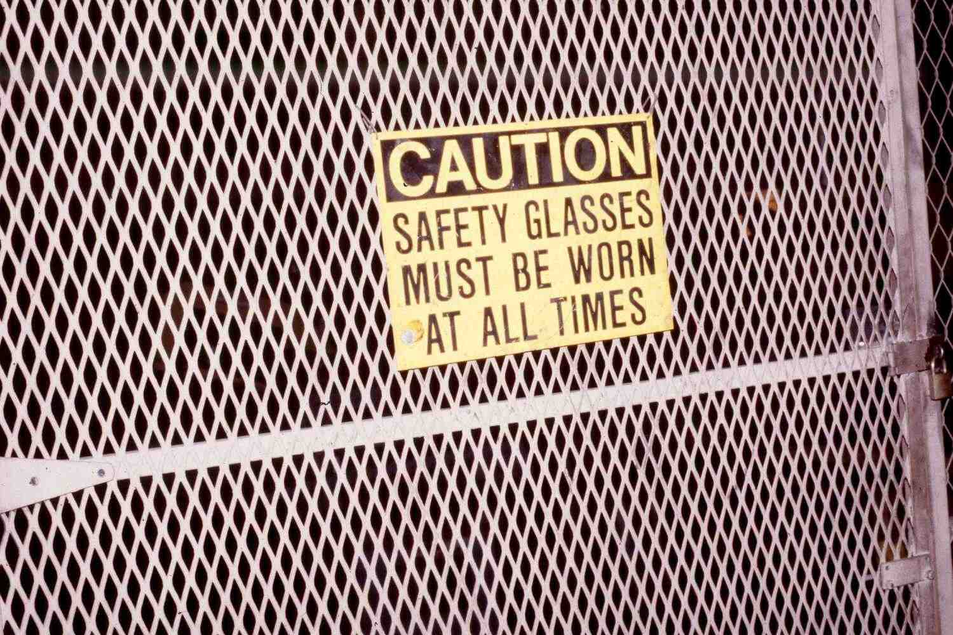
Shield

Warning Sign

ENGINEERING CONTROL ADMINISTRATIVE CONTROL

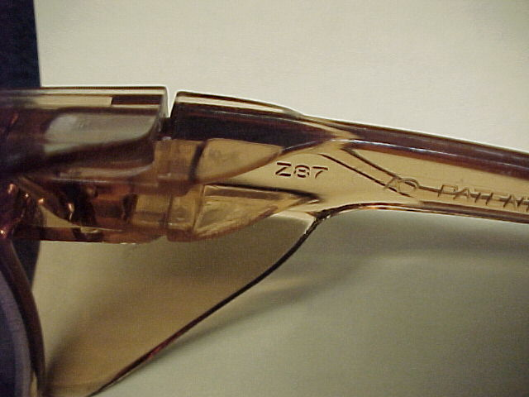


ANSI Z87 Marking

Safety Glasses with Sideshields

PERSONAL PROTECTIVE EQUIPMENT

The major classifications of eye hazard are: MECHANICAL, CHEMICAL, RADIANT, and BIOLOGICAL.

MECHANICAL (AND BALLISTIC) HAZARDS are where foreign material impacts the eye and causes damage from the force of the impact. In all cases, either the injuring agent hit the victim or the victim hit it.

Mechanical hazards/agents are described by velocity (stationary, slow moving, fast moving), physical characteristics (less than or greater than 2mm diameter, and sharp or blunt. There are some special cases such as molten metals like solder or water-filled balloons.

Common mechanical hazard agents are: metal fragments, glass fragments, wood chips, dirt, tools, etc.

Safety eyewear commonly used for mechanical hazard protection are spectacles with sideshields, impact goggles, and chemical splash goggles. These devices are available in both prescription and non-prescription forms and must meet the specifications of the American National Standards Institute (ANSI) Z87.1 Standard - Practice for Occupational and Educational Eye and Face Protection.

CHEMICAL HAZARDS are those that cause eye injury by chemical interaction with the tissues of the eye. The chemical may be in liquid, spray/vapor, or solid form. Some of the common harmful chemicals are alkali (the worst), acid, detergent, and petroleum products.

Alkali (alkaline) chemicals are found as electrolytes in Nickel Cadmium batteries, cleaning fluids, and drain and oven cleaners. These are very dangerous and in concentrated forms may penetrate the cornea within ten seconds after exposure, producing damage inside the eye.

Acid chemicals are found in rechargeable batteries (primarily automotive), chemical reagents, and some cement curing agents. The damage done to the eye is usually limited to the surface of eye tissues but may be severe in very concentrated solutions.

Petroleum products are usually found in automotive parts cleaners, fuels, and lubricants. Most of these produce mild to moderate irritation.

Detergents often contain mild acid or alkali in a form that produces irritation of the eye tissues. The effect is enhanced if the cleaner is heated.
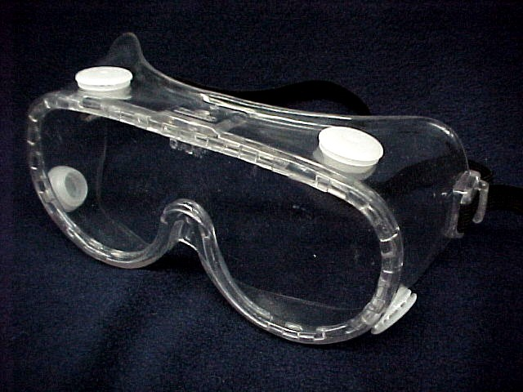
Protection for chemical hazards range
Indirect Venting
from chemical splash goggles to full
face respirators. Venting of goggles
for chemical protection must be indirect.

When a chemical does get into the eye,
the eye must be washed with water for Chemical Splash Goggles
least 15 minutes, preferably in an eyewash
Chemical Splash Goggles
designed for that purpose (ANSI Z358.1).

RADIANT ENERGY eye hazards are primarily from the ultraviolet (UV) and infrared (IR) portions of the spectrum. The most common sources are welding operations and the sun. In recent years, lasers have come into the workplace as well as the combat arena. In industry, lasers are commonly used for alignment operations and some cutting. In combat, they are used for range finding (distance measurement) and target designation.
Protection from UV and IR is by use of spectacles, goggles, or helmets with the correct tint in the lenses for the operation being performed. For lasers, the tint, energy level, and the wavelength of the spectrum must be addressed.

Biological hazards to the eye do exist, normally in the form of bacteria or viruses. Health care professions the most likely to be exposed to biological agents, but risk also exists for emergency and police personnel. Prevention is the best venue with ANSI Z87.1 or biological barriers being the accepted devices for protection. For biological exposure, wash the eyes in the same manner as for chemical injury.

The full face shield seen in many industrial operations is NOT a primary protector. With the possible exception of biological exposures, a protector meeting ANSI Z87.1 must be worn under faceshields.

Don't forget that multiple agents may be in one operation. There may be a need for Z87 Impact + Chemical + Auxiliary Protector.

MANAGEMENT OF EYE INJURIES/EXPOSURES

Mechanical Injuries:

- Do not remove penetrating foreign bodies

- Never apply pressure to an eye that may be punctured! If in doubt, DON'T.

- Transport to health care provider.

Chemical Injuries:
- Irrigate with water for 15 to 20 minutes
- Transport to health care provider after irrigating (if you can irrigate with a constant flow of water all the way to the care provider, go ahead and transport)

Radiant Injuries:
- Transport to health care provider.

Biological Injuries:
- Transport to health care provider.

In most cases, the health care provider should be an optometrist (mild to moderate injury) or ophthalmologist (mild to severe injury)

HOME AND RECREATION

As mentioned in the beginning, 25% of injuries to the eye occur at home.

For the home shop, cleaning and yard maintenance, imagine it as an extension of the industrial environment. Saws, hammers, auto mechanics and carpentry done at home are usually just a scaled down version of the industrial environment. Your local hardware store carries ANSI Z87.1 protective eyewear. Buy it and use it! Educate the children early to do the same.

PROTECTION: The same protection and patient management applies to home accidents. Use impact protection in the shop. Use chemical splash protection when cleaning the oven or using extra strong detergents.

Recreation: Most injuries come with play of football, basketball, and racket sports. Paintball is catching up. There are protectors for these activities that are found in the standards of the American Society of Testing and Materials (ASTM). They have specific standards for racket sports, baseball, and hockey. Other standards are being developed as the need arises. Look for the protectors at your sports store and use them.

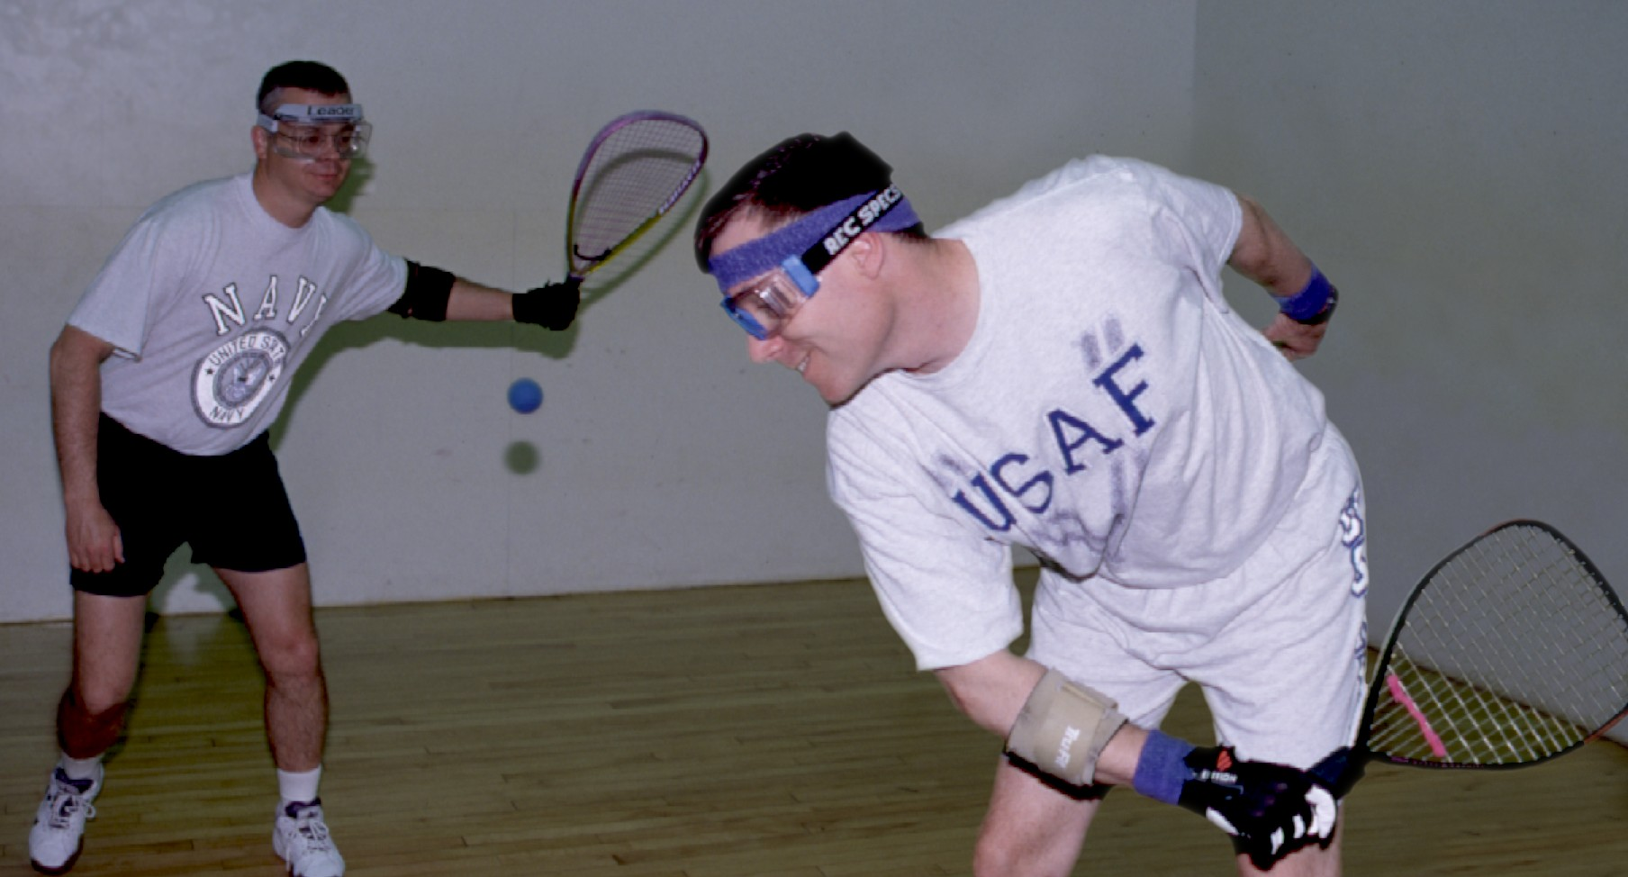

Think protection slows you down? This USAF officer was the Aberdeen Proving Ground Seniors Racquetball Champion for three straight years!

Worker's Compensation and the Eye Injury

(Current statistics related to Worker's Compensation for eye injuries will be given as a handout at the lecture.)

Injury produces paperwork!!

Prevention of injury reduces pain and disability to the worker.

It also reduces the need for Worker's Compensation payments and all the attendant "fun" involved with processing claims.

Hope you, your employees, and your families will have a clear future.

Protect your eyes so you:

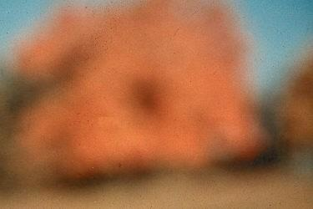
See This Not This

