Abstract—We report on the fabrication, assembly, and test of the Nb3Sn dipole magnet HD2. The magnet, aimed at demonstrating the feasibility of Nb3Sn superconductor in high field accelerator-type dipole magnets, features a 36 mm clear bore surrounded by block-type coils with tilted ends. The coil design is optimized to minimize geometric harmonics in the aperture and the magnetic peak field on the conductor in the coil ends. The maximum expected bore field of 15 T at 4.5 K is determined through critical current measurements of extracted strands. The coils are horizontally pre-stressed during assembly using an external aluminum shell pre-tensioned with water-pressurized bladders. Axial pre-loading of the coil ends is accomplished through two end plates and four aluminum tension rods. The strain in coil, shell, and rods is monitored with strain gauges during assembly, cool-down and magnet excitation, and compared with 3D finite element computations. Magnet’s training performance, quench locations, and magnetic field quality are then analyzed and discussed.
Assembly and Test of HD2, a 36 mm bore high field Nb₃Sn Dipole Magnet
P. Ferracin, B. Bingham, S. Caspi, D. W. Cheng, D. R. Dietderich, H. Felice, A. Godeke, A. R. Hafalia, C. R. Hannaford, J. Joseph, A. F. Lietzke, J. Lizarazo, G. Sabbi, F. Trillaud, and X. Wang

Index Terms—Dipole magnet, Nb₃Sn

INTRODUCTION
THE Superconducting Magnet Program at Lawrence Berkeley National Laboratory (LBNL) is continuing the development of Nb3Sn high field magnets for the next generation of HEP colliders. The superconducting dipole HD2, recently fabricated and tested at the LBNL test facility, represents the first application of block-type coils to accelerator-quality dipole magnets. The conceptual design of the magnet was described in [1], whereas the mechanical analysis of the structure and the magnet fabrication were respectively reported in [2] and [3]. In this paper, after a brief overview of the magnet design and parameters, we present the results of two magnet tests, including strain gauge measurements (recorded during assembly, cool-down and excitation), training curve and quench locations.

Magnet Design
The HD2 magnet design (Fig. 1, left) features two block-type coils wound around a titanium alloy (Ti 6Al-4V) pole.
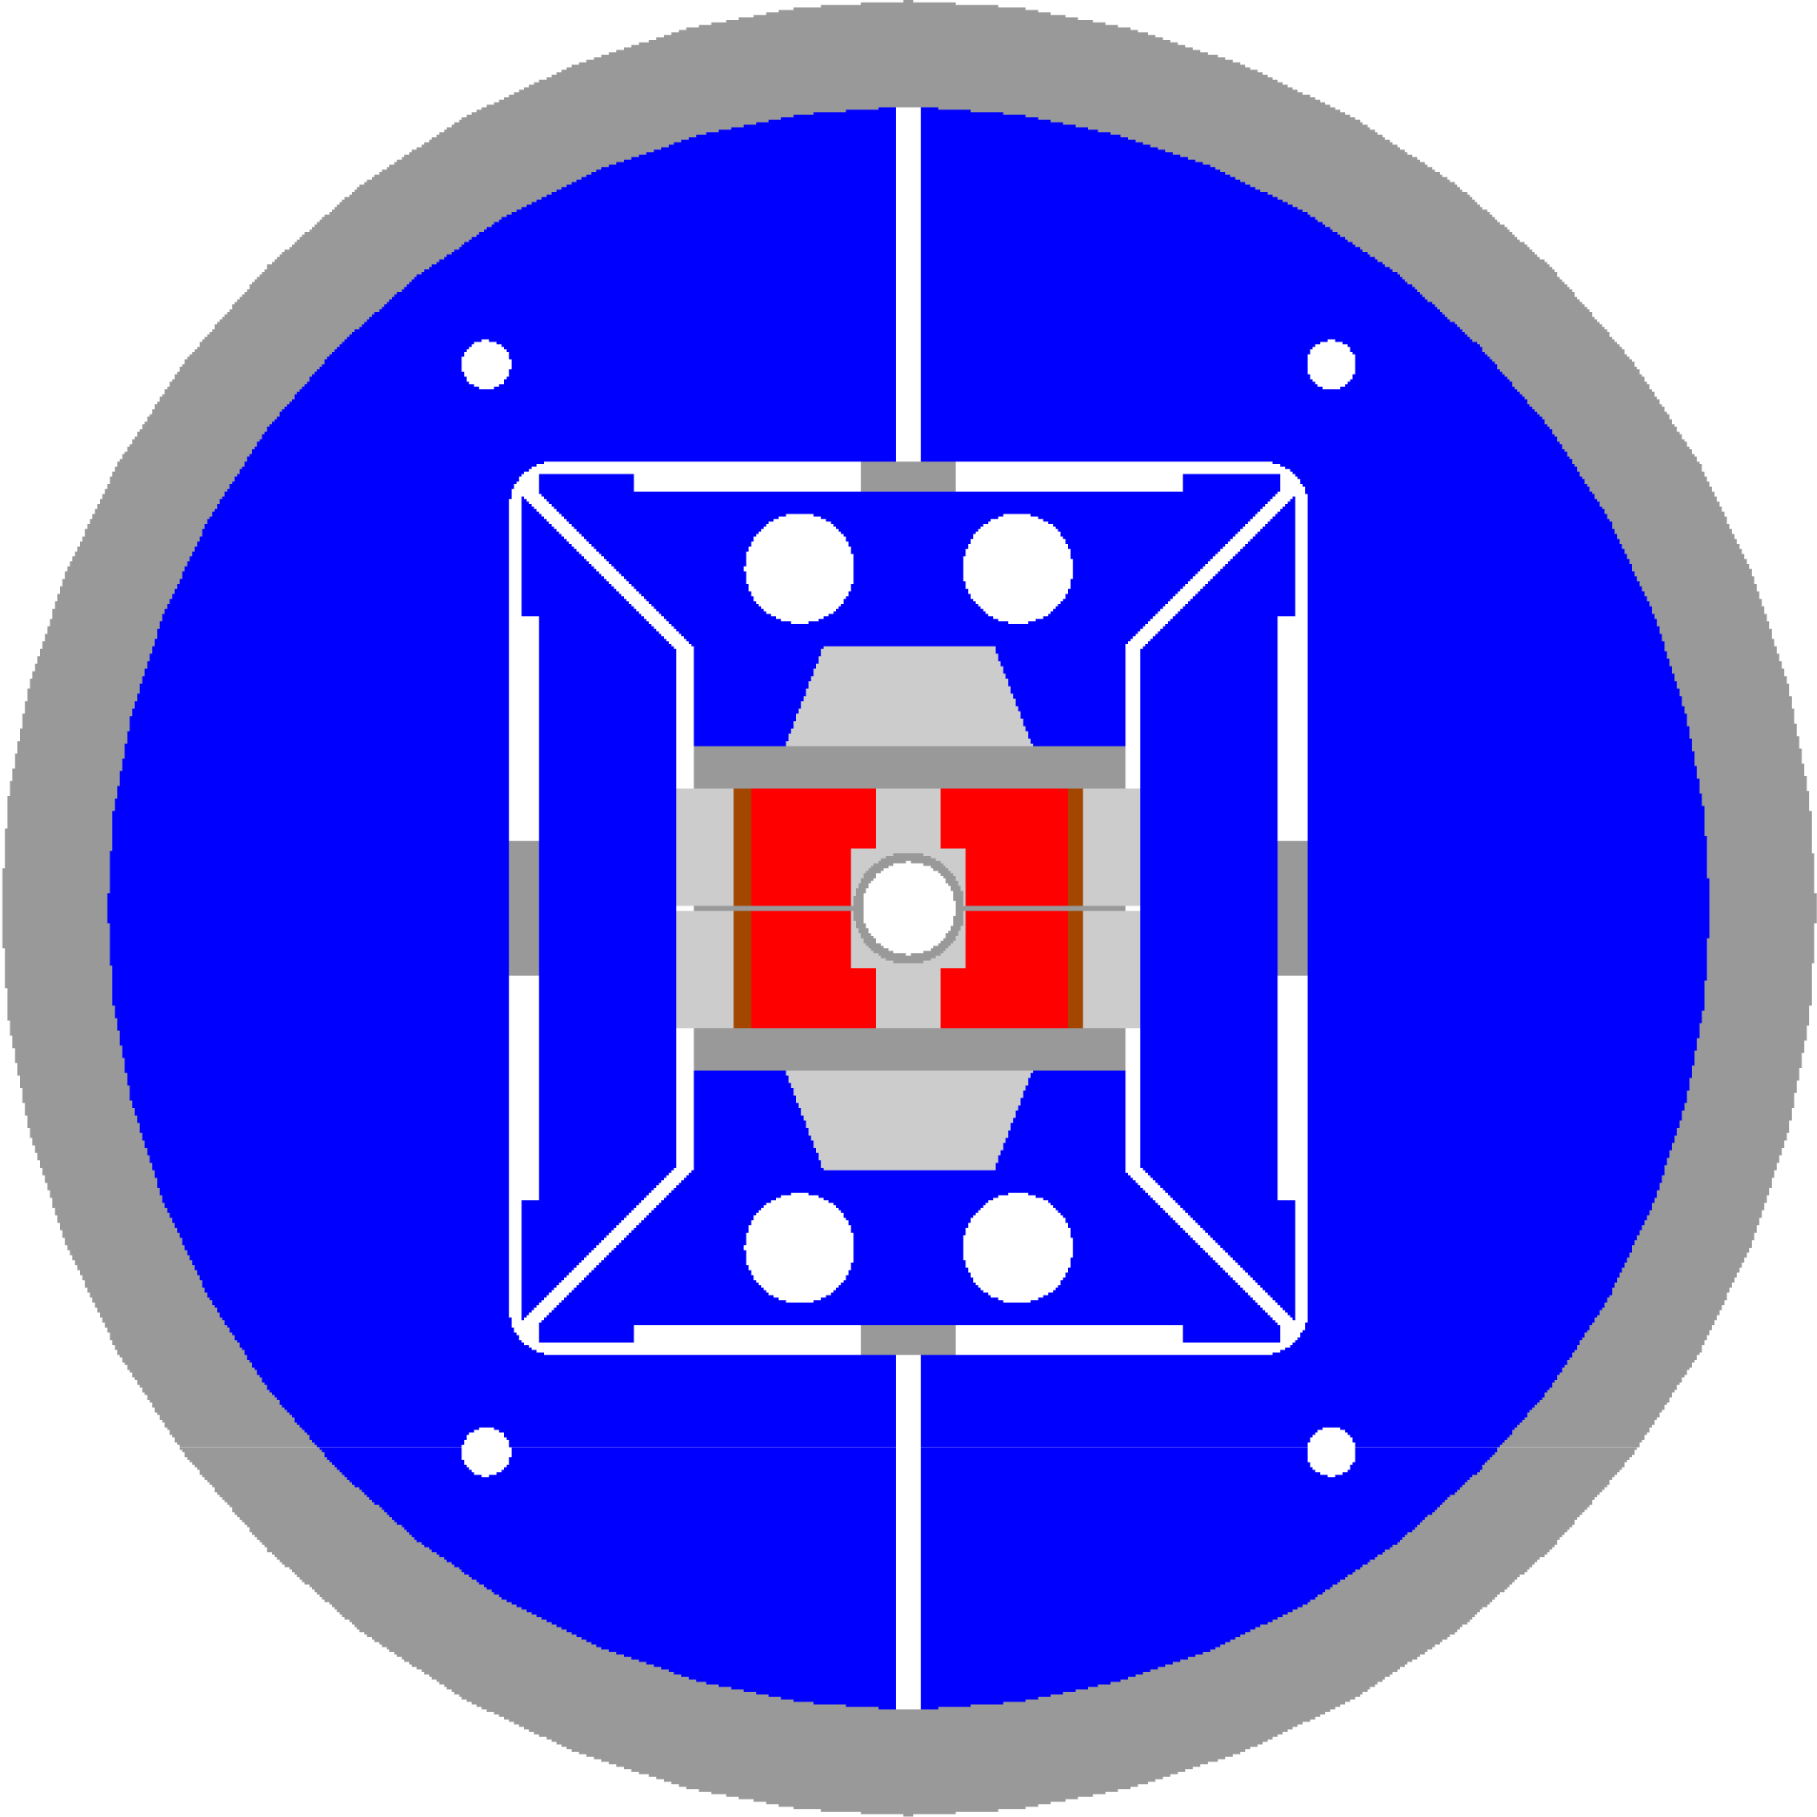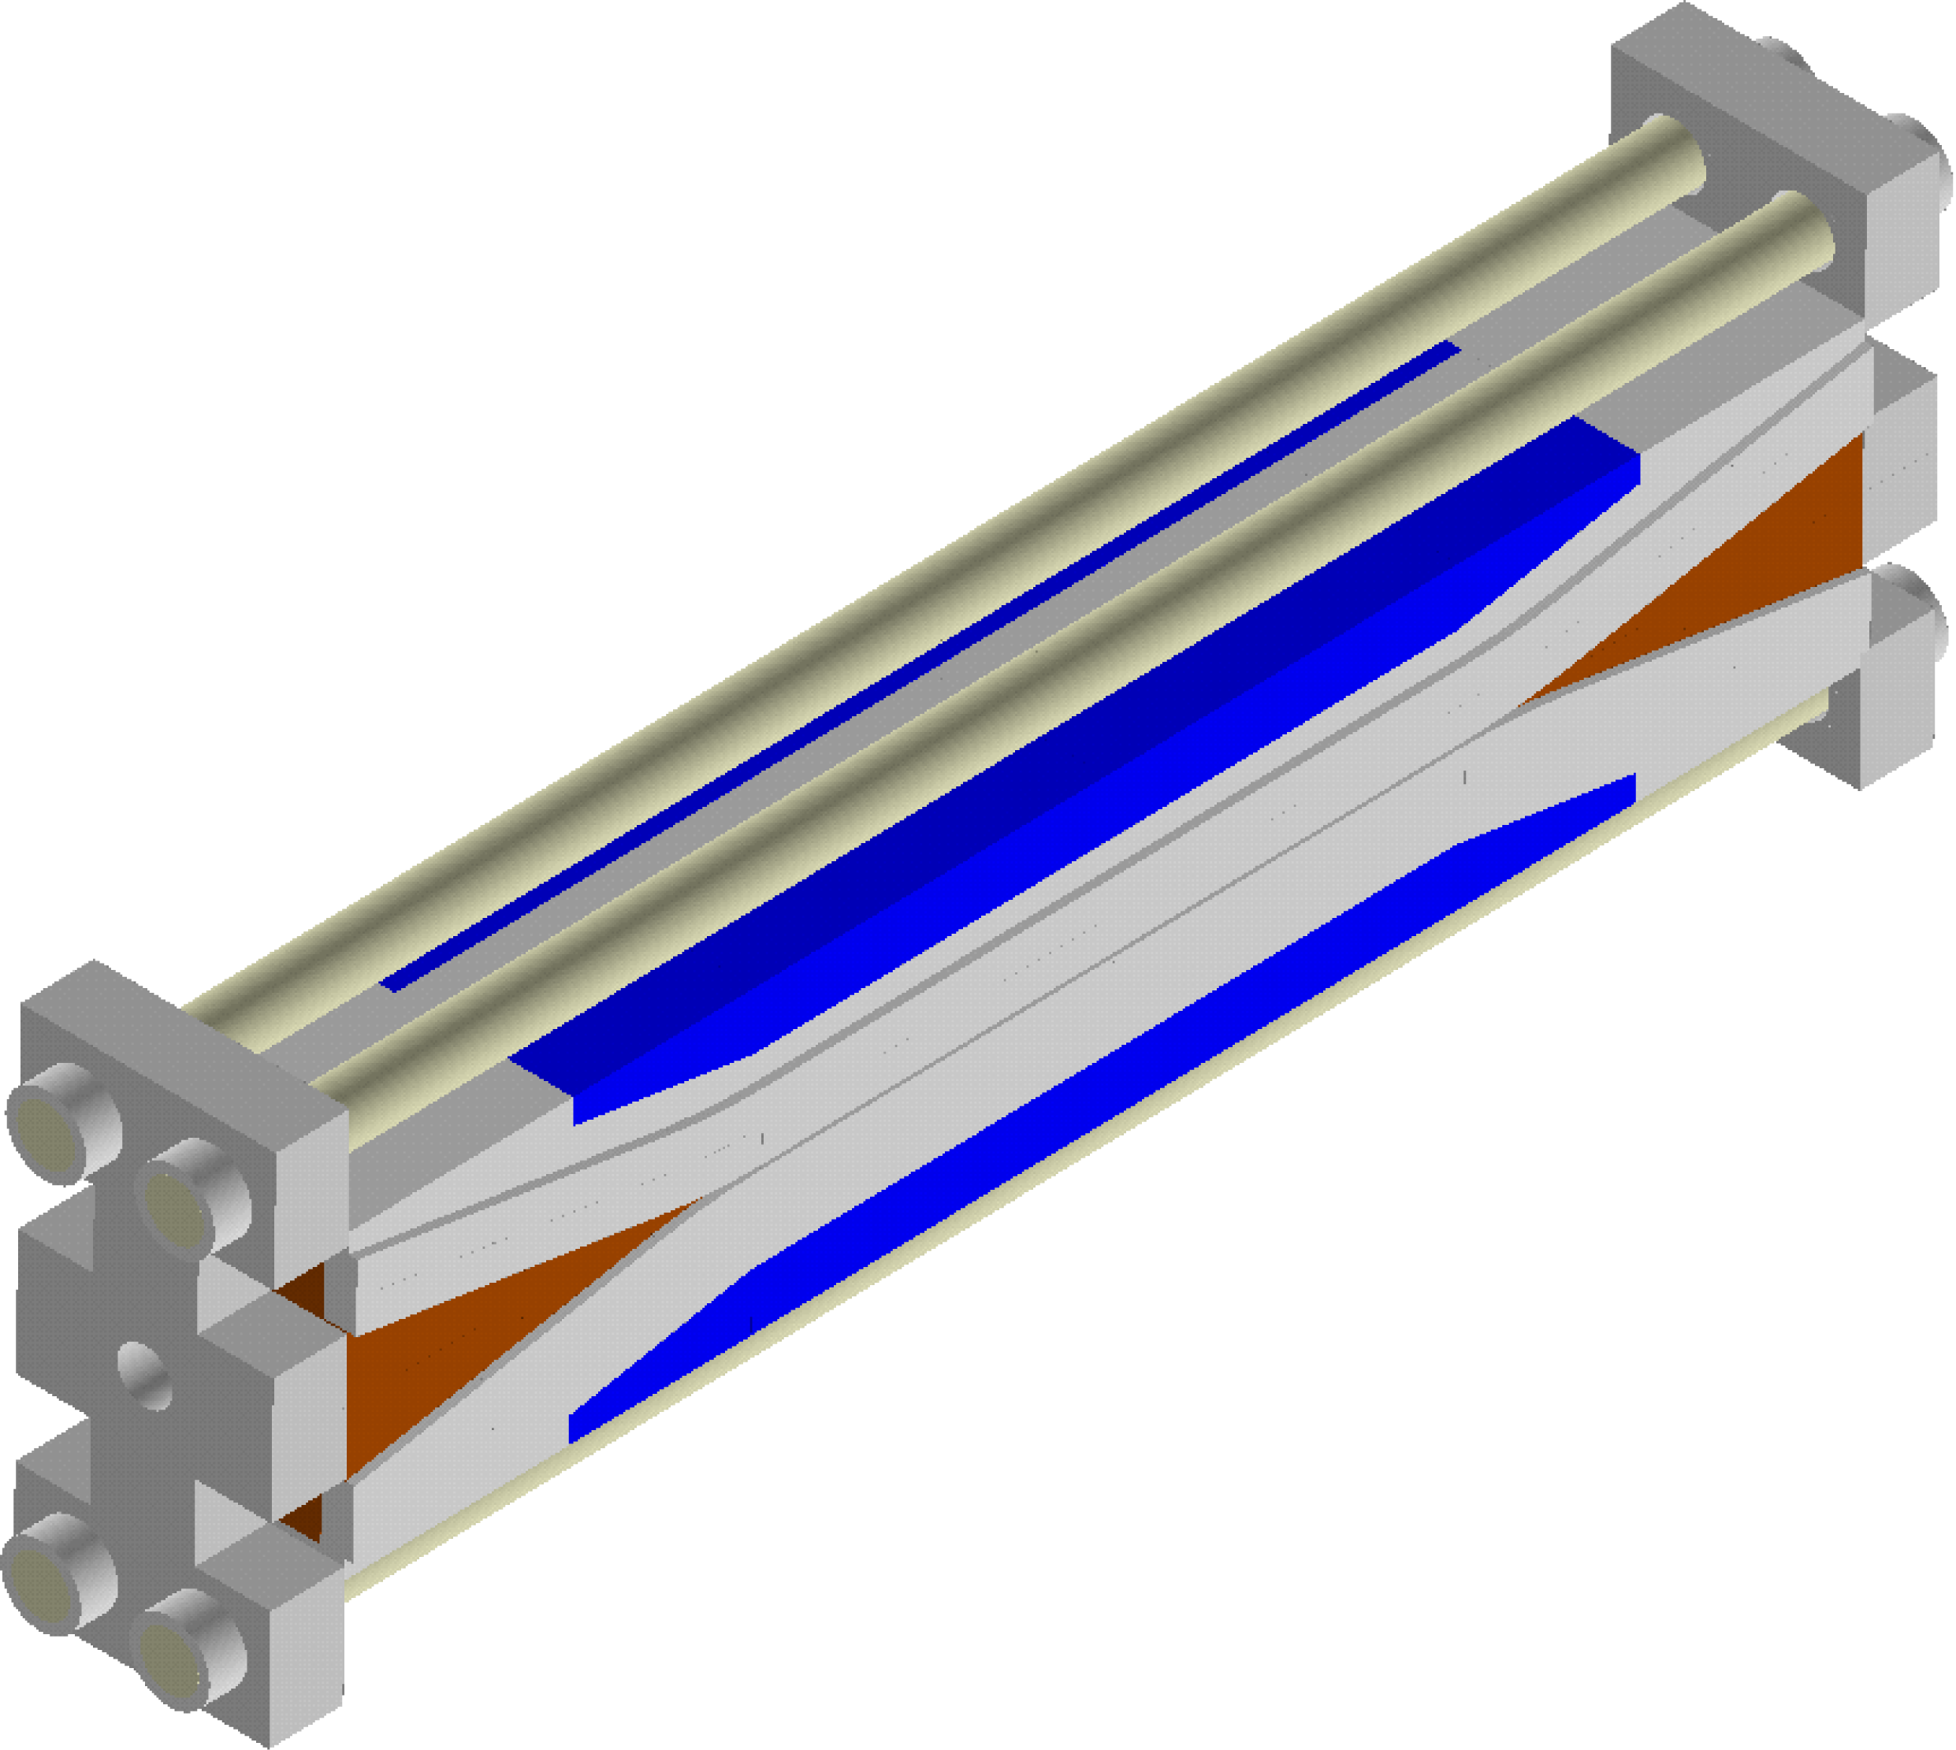
Fig. 1. HD2 cross-section (left) and coil end support system (right).

The pole includes a round cutout to provide room for a 3.65 mm thick stainless steel (Nitronic 40) bore tube with a clear aperture of 36 mm. The coil has a straight section of 481 mm and 475 mm, respectively in layer 1 and 2, and it tilts up (flares) at a 10º angle in both ends through hard-way bends, whose minimum radius is 349 mm at layer 2. After the hard-way bends, the flared region features a short straight section of 117 mm in layer 1 and 135 mm in layer 2. The tilted ends are vertically supported by aluminum-bronze wedges surrounding the bore tube. The coils are supported by horizontal and vertical pads. Vertical pushers and horizontal rails transfer the load from the pads to the coils. Two yoke halves, made of 50 mm thick iron laminations, and a 41 mm thick aluminum shell provide the external coil pre-load through vertical and horizontal interference keys. The diameter of the cold mass is 705 mm. The structure is pre-loaded with water pressurized bladders. In the end regions, 50 mm thick stainless steel endplates (Nitronic 40), connected by four 18.5 mm diameter aluminum rods, constitute the coil axial support system.

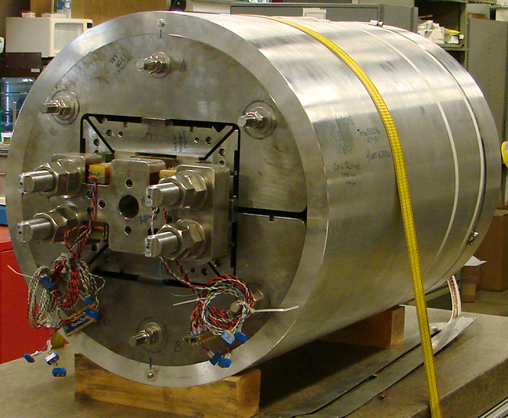
Fig. 2. HD2 assembled and pre-loaded.

Conductor and MAgnet Parameters
The two coil modules of HD2 are composed of two layers wound from a continuous length of cable made of 51 RRP strands with a 0.8 mm diameter. The cable is 22.008 mm wide and 1.401 mm thick. Three coils were fabricated: assuming strand properties from coil 1 (Fig. 2), the magnet has a maximum bore field of 15.1 T (4.2 K), with a conductor peak field of 15.9 T at a current of 17.4 kA. Coil 2 and 3 feature a short sample peak field about 0.6 T higher than coil 1.
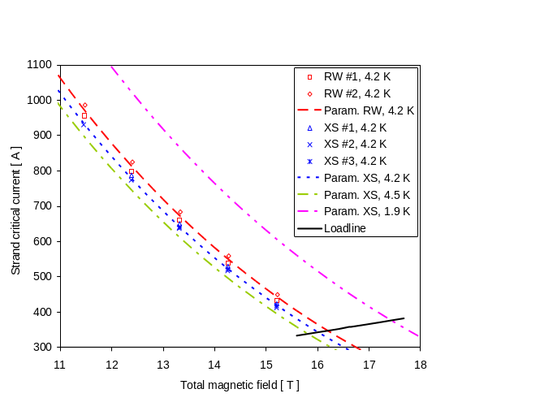
Fig. 3. Critical current (A) vs. applied field (T) measurements and parameterization curves of round (RW) and extracted wires (XS) for coil 1.
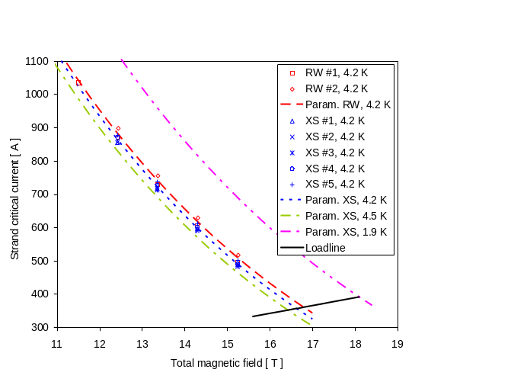
Fig. 4. Critical current (A) vs. applied field (T) measurements and parameterization curves of round (RW) and extracted wires (XS) for coil 2-3.

TABLE I Cable Parameters
Parameter | Unit | Coil 1 | Coil 2-3
Strand diameter (before reaction) | mm | 0.802 | 0.801
Process |  | RRP
Stack |  | 54/61
Non Cu % |  | 51 | 54
RRR |  | 16 | 287
Twist | mm | 13 | 14
No. strands |  | 51
Cable width (bare) | mm | 22.008 | 21.999
Cable thickness (bare) | mm | 1.401 | 1.406
Insulation thickness | mm | 0.095 | 0.095

TABLE II Magnet Parameters
Parameter | Unit | HD2a-b | HD2c
Clear aperture | mm | 36
Magnet outer diameter | mm | 705
No. turns in layer 1 (quadrant) |  | 24
No. turns in layer 2 (quadrant) |  | 30
Short sample current I_{ss} at 4.3/1.9 K | kA | 17.3/19.2 | 18.1/20.0
Bore field at 4.3/1.9 K I_{ss} | T | 15.0/16.5 | 15.6/17.1
Coil peak field at 4.3/1.9 K I_{ss} | T | 15.9/17.4 | 16.5/18.1
Fx/Fy layer 1 (quadrant) at 17.3 kA | MN/m | +2.3/-0.4
Fz layer 1 (quadrant)at 17.3 kA | kN | 90
Fx /Fy layer 2 (quadrant) at 17.3 kA | MN/m | + 3.3/-2.2
Fz layer 2 (quadrant) at 17.3 kA | kN | 126
Stored energy at 17.3 kA | MJ/m | 0.84
Inductance | mH/m | 5.6
HD2a and HD2b were assembled with coil 1 and coil 2. HD2c was assembled with coil 2 and coil 3.

Test Overview
SQ02 was assembled and pre-loaded at LBNL. The shell and the aluminum rods (see Fig. 2) were instrumented with strain gauges, and their stress conditions were monitored and recorded during all room-temperature loading, cool-down, and magnet operations (see Fig. 3). 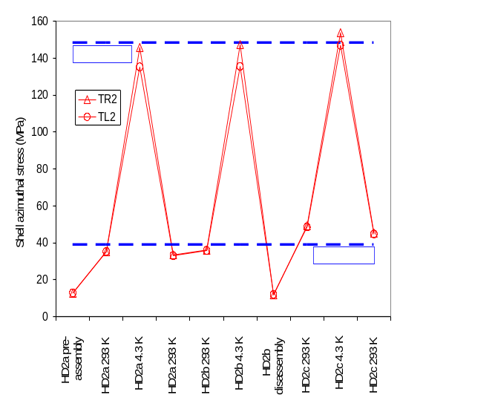
Fig. 5. Shell azimuthal stress (MPa) during assembly, cool-down and tests: measured values (markers) and model expectations (dashed lines).
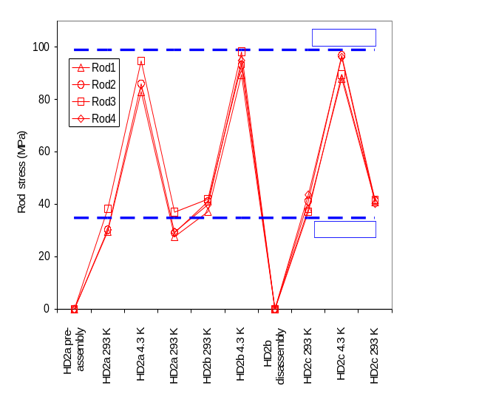
Fig. 6. Rod axial stress (MPa) during assembly, cool-down and tests: measured values (markers) and model expectations (dashed lines).

With respect to SQ01, a new room temperature loading schedule was implemented. Subsequently, this was incorporated into the TQS01 magnet loading procedure. The room-temperature pre-loading operation started with minimum stress in the outer shell, but sufficient to ensure tight contact among all magnet components (load step 1). Then, the tension in the axial rods was increased to 70 MPa (load step 2). Finally, the bladders were pressurized to bring the shell azimuthal pre-tension to 30 MPa (load step 3). This procedure, called “axial first”, minimized the friction between coils and surrounding pads during axial loading. After cool-down, the rods reached a stress of 125 MPa, corresponding to a total axial load on the magnet ends of about 270 kN, while the shell tension rose to 95 MPa. At these conditions, the computed coil compression in the straight section was about 120 MPa. SQ02 was then tested at 4.3 K, and training, ramp-rate dependence, and spot-heater induced quenches were performed through two thermal cycles. After warm-up, the magnet was re-loaded at room-temperature (SQ02b) with a rod tension of 130 MPa, maintaining the shell load at the same level. The “axial first” procedure was again applied with minimum shell tension. The magnet was then shipped to FNAL and tested. The stress reached by the rods after cool-down to 4.5 K was 190 MPa, corresponding to a total axial load on the magnet ends of about 415 kN. The test at FNAL included training quenches, both at 4.5 K and 1.8 K, and ramp-rate quenches, as well as temperature dependence studies and magnetic measurements (not part of this paper).

Test Results

Training Quenches
During the HD2a test, the magnet had a first quench at 12.0 T of conductor peak field, corresponding to 73% of the expected magnet limits and to a bore field of 11.4 T (Fig. 10). The highest current was reached at quench #18, with a conductor peak field of 14.0 T, corresponding to 87% of the expected magnet limits and to a bore field of 13.3 T. During the HD2b test the magnet had a first quench at 11.5 T of conductor peak field, corresponding to 71% of the expected magnet limits and to a bore field of 11.0 T (Fig. 10). The highest current, identical to the one recorded during the previous test, was reached at quench #31. Because of a failure of the extraction system, a higher number of MIITS where released after quench #31. As a results, coil 1 exhibit an higher ramp-rate sensitivity. After reducing the ramp rate, the magnet reached the previous maximum current quench at #39.
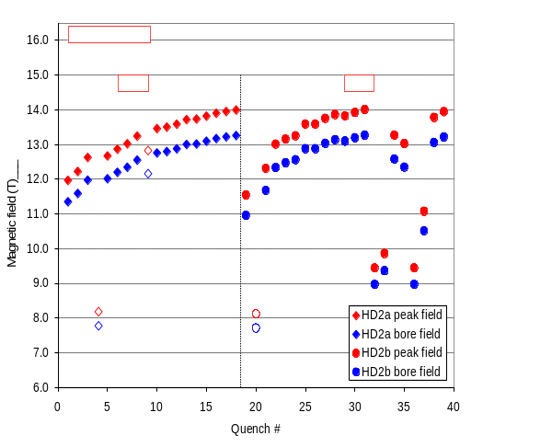
Fig. 7..

Quench Locations
Out of 14 training quenches of the HD2a test, almost all evenly distributed between the two coils, 12 were located in the layer 1 pole turn, towards the end of the straight section (Fig. 11). During the HD2b test (Fig. 12), before quench #31, 4 (6) quenches occurred in coil 1 (2). After quench #31 all quenches were located in coil 1.

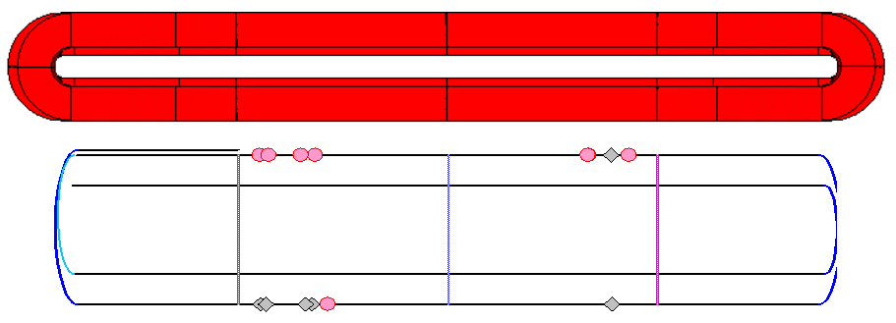
Fig. 8. HD2a quench locations: coil 1 (gray markers) and coil 2 (pink markers).
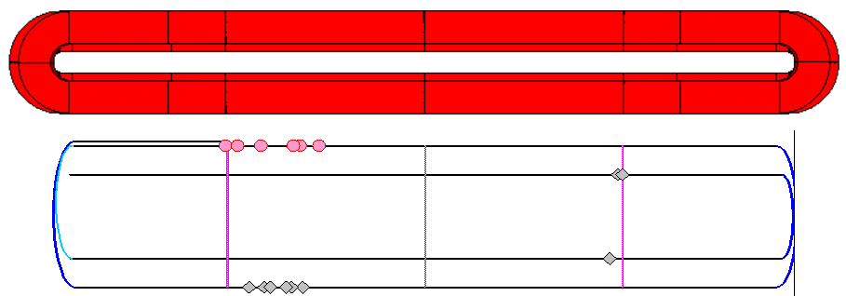

Fig. 8. HD2b quench locations: coil 1 (gray markers) and coil 2 (pink markers).

Slip stick

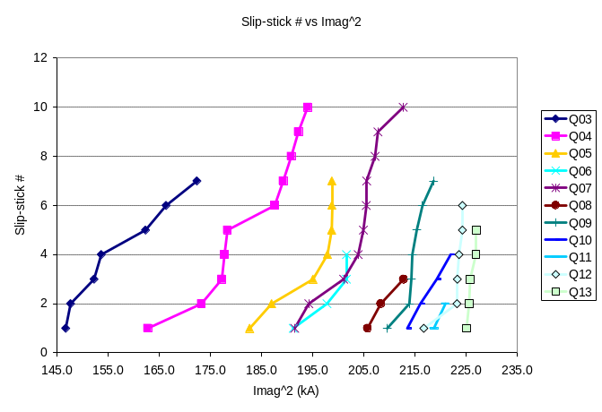
Fig. 9..

Ramp-rate dependence study

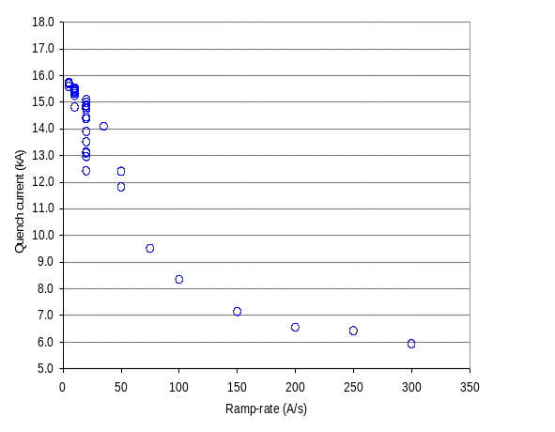
Fig. 9..

Conclusions

References
- A. F. Lietzke, et al., “Test results of HD1b, an upgraded 16 T Nb₃Sn dipole magnet”, IEEE Trans. Appl. Supercond., vol. 15, no. 2, June 2005, pp. 1123-1127.
- G. Sabbi, et al., “Design of HD2: a 15 T Nb₃Sn dipole with a 35 mm bore”, IEEE Trans. Appl. Supercond., vol. 15, no. 2, June 2005, pp. 1128-1131.
- P. Ferracin, et al. ,“Mechanical design of HD2, a 15 T Nb₃Sn dipole magnet with a 35 mm bore”, IEEE Trans. Appl. Supercond., vol. 16, no. 2, June 2006, pp. 378-381.
- S. Caspi, LBNL Internal Note, SC-MAG-691, October 1999.
- L. Chiesa, et al., “Magnetic field measurements of the Nb₃Sn common coil dipole RD3c”, in Proc. 2003 Particle Accelerator Conference, Portland, OR, 2003, pp. 170–172.
- S. Hong, et al., “Latest improvements of current carrying capability of niobium tin and its magnet applications” IEEE Trans. Appl. Supercond., vol. 16, no. 2, June 2006, pp. 1146–1151.

 Manuscript received 19 August 2008. This work was supported by the Director, Office of Energy Research, Office of High Energy and Nuclear Physics, High Energy Physics Division, U. S. Department of Energy, under Contract No. DE-AC02-05CH11231. All authors are with Lawrence Berkeley National Lab, Berkeley, CA 94720 USA (phone: 510-486-4630; fax: 510-486-5310; e-mail: pferracin@lbl.gov).).

