Procedures Manual for Approving Officials

Copyright © 1998 by American Management Systems, Inc. All rights reserved.

Copyright © 1998 by American Management Systems, Inc. All rights reserved.
Contents
Introduction 1
Overview 1
Audience for This Manual 3
Manual Organization 4
Basic Operating Procedures 5
Overview 5
Application Tools 6
PC Configuration 7
MAC Configuration 8
Database and File Servers 9
Logging on to ITAS 11
Logging off of ITAS 13
ITAS Main Window 14
Approving Official Functions Window 15
Printing a Screen in ITAS 17
Timecard Maintenance 19
Overview 19
Approving Timecards for Current Pay Period 20
Approving Timecards for Prior Pay Period 30
Leave Request Maintenance 35
Overview 35
Approving/Denying Pending Leave Requests 36
Designating Alternate Approving Official 39
Overview 39
Designating an Alternate Approving Official 40
Online Reports 43
Overview 43
Viewing Available Online Reports 44
LAO Online ATLR Report 45
LAO Online Leave Request Report 49
LAO Approved Leave Report 51
LAO Daily Sign-in/Sign-out Report 53
Glossary of Terms 57
Index 63

Introduction

Overview
The Integrated Time and Attendance System (ITAS) is a timekeeping by exception application that supports most aspects of tracking and reporting work hours and leave for federal employees.
ITAS provides users with access to real-time leave balances and ensures that users accurately record work activity by enforcing time and attendance policies and procedures specific to the Federal Government. ITAS contains rules specific to data entered by employees, Timekeepers, Approving Officials, Administrative Officers, and ITAS Administrators.
ITAS supports exception processing by creating timecards at the end of every pay period for the next pay period with each employee’s expected work schedule applying applicable holidays and leave as necessary. Specifically, the timekeeping cycle in ITAS is as follows:
- At the beginning of the pay period, each employee has a timecard with the number of regular hours per day the employee is supposed to work based on their defined work schedule.
- Throughout the pay period, the employee, Timekeeper or Administrative Officer can process exceptions (e.g., annual leave, administrative leave, etc.).
- As the Approving Official approves the leave request, ITAS applies the leave to the employee’s timecard.
- At the end of the two week cycle, the pay period is closed and ITAS creates timecards for each employee for next pay period. ITAS will include any holidays or approved leave on the appropriate timecards.
- The time and attendance information can be transmitted to the DHHS payroll at any time after the pay period is closed.
This cycle is repeated every pay period. At the end of the leave year, ITAS also performs a year-end close process. During this process, ITAS performs activities such as calculating the appropriate leave balances, determining each employee’s use or lose balances, etc.
ITAS includes functions to replace the current paper sign-in and sign-out function for agencies that implement such functions. ITAS is a flexible system that can enforce compliance of current and future attendance policies and procedures established by OPM, GAO, or other regulating Federal agencies.
These functions include:
- Capturing sign-in and sign-out data for employees each work day, weekend, and holiday.
- Tracking leave activity for all employees.
- Providing online access to current leave balances.
- Recording full-and partial-day leave absences for employees.
- Providing critical timecard data to payroll for processing biweekly payroll.
- Maintaining employee information.

Audience for This Manual
The role of the Approving Official in ITAS includes the functions of approving and denying leave requests, approving timecards and designating alternate approving officials. An Approving Official only has access to the accounts of employees who are assigned to him/her.

This manual contains specific instructions on how to perform major ITAS activities. You can also use the ITAS User’s Guide for assistance in performing ITAS functions. The ITAS User’s Guide provides step-by-step instructions on how to use a given ITAS function while this document provides instructions on how to perform major daily activities.

Procedures Manual vs. ITAS User’s Guide

Manual Organization
The table below contains an overview of each remaining section in this document. Each overview gives the section name and a brief description.

Section | Description
Basic Operating Procedures | Contains recommended hardware configuration and logon\logoff instructions.
Timecard Maintenance | Procedures for approving current and prior pay period timecards.
Leave Request Maintenance | Procedures for approving and denying leave requests.
Designating Alternate Approving Official | Procedures for designating an approving official in your absence.
Online Reports | Procedures for generating each LAO report.
Glossary of Terms | Contains a description of terms used throughout the manual.
Index | Contains an index of major topics.

Basic Operating Procedures

Overview
This section provides information on workstation setup. Minimum requirements and recommended configurations are provided for the PC, Macintosh, database server and file server. It is important to ensure that your workstation meets the minimum requirements before attempting to use ITAS.
This section also provides instructions for logging on to and logging off of ITAS. Then, it will familiarize you with the ITAS Main Window and Approving Official Functions Window. Last, it addresses printing screens in ITAS.

Application Tools
ITAS is written in OMNIS Software, Inc.’s OMNIS™7 and executes on both PC and Macintosh microcomputers in a client/server environment, accessing a Microsoft® SQL Server NT™ database. OMNIS™7 is an interpreter that requires both the run time executable and an application library. The table below illustrates the current software environments in which ITAS is operating.

Software Versions

Graphical User Interface

Client Operating Systems Supported

Data Servers Supported

Batch Programs Supported

Tool
OMNIS™ 7 3.13 for the MAC (compatible with SQL Server 6.0)
OMNIS™ 7 3.5.1
OMNIS™ 7 3.6
Windows 3.1
Windows 95
Windows NT 3.5.1 and 4.0
Apple System 7.0, 7.1, and 7.5
SQL Server for Windows NT 6.0
SQL Server for Windows NT 6.5
Microsoft Visual C++ 4.0

PC Configuration
For the PC, ITAS is an application that runs "on top of" Microsoft® Windows™, a graphical, object-oriented environment. Because ITAS runs in the Windows environment, it operates in much the same way as Microsoft Windows. The ITAS library and the OMNIS™7 executable reside on the file server.

Recommended PC Configuration
Hardware/ Software | Minimum PC Configuration |  | Recommended PC Configuration
Machine Type | 486 |  | Pentium
Speed | 33 Mhz |  | 75 Mhz
Memory | 8 |  | 16
Hard Drive | N/A |  | N/A
Printer | laser |  | laser
Monitor | VGA |  | VGA
Video Display | 800 x 600 pixels | 800 x 600 pixels
Mouse | Microsoft compatible |  | Microsoft compatible
Operating System | Windows 3.1 |  | Window 3.1 or 95

MAC Configuration
For the Macintosh and Power Macintosh, ITAS runs under Apple System Software. The application operates in the same way on the MAC as it does on the PC. If your organization is able to setup a file server that can be accessed by your MAC, both the ITAS library and the OMNIS™7 executable will reside on the file server. Otherwise, both the OMNIS™7 executable and the ITAS library must reside on your hard drive.

Recommended MAC Configuration
Hardware/ Software | Minimum Mac Configuration | Recommended Mac Configuration
Machine Type | 68030 | Power PC 601
Speed | > 20 Mhz | 90 Mhz
Memory | 8 | 16
Hard Drive | 5Mb (free space) | 5Mb (free space)
Printer | laser | laser
Monitor | High res. | High res.
Video Display | 800 x 600 pixels | 800 x 600 pixels
Mouse | Apple | Apple
Operating System | System 7.0 | System 7.5

Database and File Servers

Recommended PC Database Server Hardware Requirements
Hardware/ Software | Minimum Configuration | Recommended Configuration
Machine Type | 486 | Pentium
Clock Speed | 33 Mhz | 150 Mhz +
Memory | 64 | 128 +
Hard Drive | 2 Gb + | 6 Gb +
Printer | N/A (Network must support a laser printer) | N/A (Network must support a laser printer)
Monitor | Machine compatible | Machine compatible
Mouse | Microsoft compatible | Microsoft compatible
Operating System | Windows NT Workstation 3.5.1 | Windows NT Workstation 4.0
Database Software | Microsoft SQL Server 6.0 | Microsoft SQL Server 6.5
Backup | Tape Backup | DAT compatible

Recommended File Server Hardware Requirements
Hardware/ Software | Minimum Configuration | Recommended Configuration
Machine Type | 486 | Pentium
Clock Speed | 33 Mhz+ | 150 Mhz+
Memory | 16+ | 128+
Hard Drive | 50 Meg+ | 55 Meg+
Printer | N/A (Network must support a laser printer) | N/A (Network must support a laser printer)
Monitor | Machine compatible | Machine compatible
Mouse | Microsoft compatible | Microsoft compatible

Hardware/ Software | Minimum Configuration | Recommended Configuration
Operating System | Windows NT Workstation 3.5.1 | Windows NT Workstation 4.0
OMNIS™7 | Version 3.5.1 | Version 3.6
Backup | Tape Backup | DAT compatible
Additional Devices | CD ROM | CD ROM

Logging on to ITAS
To logon to ITAS:

- Double-click or click on the ITAS icon. The Integrated Time and Attendance System Logon Window appears.

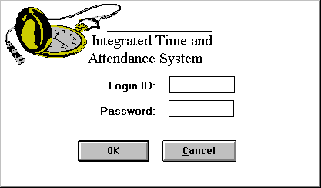

Logon Window
- Click on the “Login ID” field and enter your ID (if it is not already displayed).
- Click on or tab to the “Password” field and enter your password.
- Click on the OK button.
- ITAS displays a screen that reflects your level of access.
- If you only have access to Approving Official functions, ITAS automatically displays the Approving Official Functions Window. (Refer to the Approving Official Functions Window section.)
- If you have access to multiple functions, ITAS displays the ITAS Main Window. (Refer to the ITAS Main Window section.)

Logging off of ITAS
To logoff of ITAS:
- Return to the ITAS Main Window. (Refer to the ITAS Main Window section.)
- Click on the Exit button.
- ITAS will prompt you “Are you sure you want to exit ITAS?”. Click on the Yes button to exit.

ITAS Main Window
When you enter the correct Login ID and password in the Logon Window and have access to multiple functions, ITAS displays the ITAS Main Window.

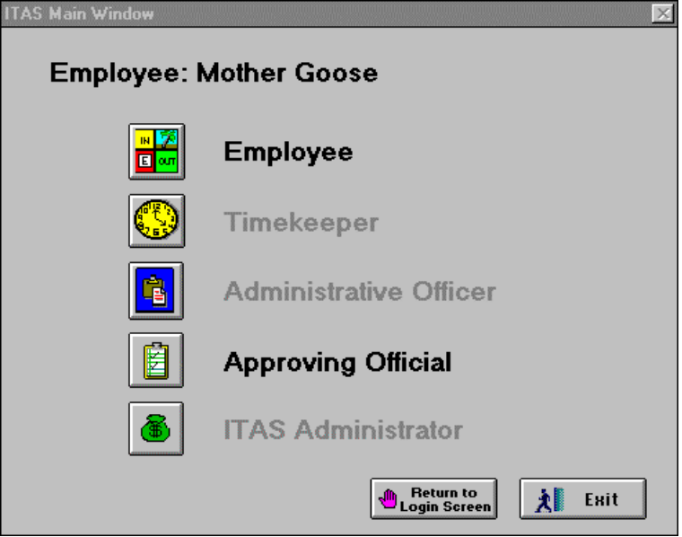

ITAS Main Window—Approving Official

- Click on the Approving Official icon. ITAS displays the Approving Official Functions Window. (Refer to Approving Official Functions Window section.)

Approving Official Functions Window
When you enter the correct Login ID and password in the Logon Window and click on the Approving Official icon in the ITAS Main Window, ITAS displays the Approving Official Functions Window.
This window provides access to all ITAS approval functions you will need to perform day-to-day.
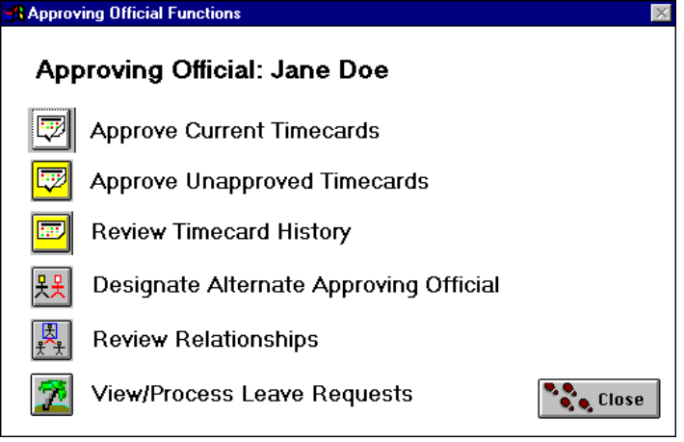

Approving Official Functions Window
- Click on the icon of the process you wish to access.
- Approve Current Timecards—Use this function to approve timecards for the current pay period.
- Approve Unapproved Timecards—Use this function to approve timecards for prior pay periods.
- Review Timecard History—Use this function to view timecards for prior pay periods.
- Designate Alternate Approving Official—Use this function to designated your alternate Approving Official.
- Review Relationships—Use this function to view relationships (i.e., employee-to-Timekeeper, employee-to-Approving Official, Timekeeper-to-alternate Timekeeper, and Approving Official-to-alternate Approving Official.)
- View/Process Leave Requests—Use this function to view, approve, or deny pending leave requests for your employees.
Instructions for the following chapters all begin with this screen.

Printing a Screen in ITAS
If there is a need to print any of the ITAS windows, you may use any technique available for printing screens to print the ITAS window.

While there are many techniques available, the following technique is one option.

- Open the window to be printed.
- Press the “Print Screen” key on your keyboard.
- Open an object viewing application. Examples are: Microsoft Word, Excel or Power Point, Adobe Pagemaker, or an accessory such as Paint or Paintbrush.
- Select “Paste” from the Edit Menu of the application you chose.
- Your window will appear on the screen. Use the Print function of the tool you chose, typically located in the File Menu, in to print the window.
NOTE: If available, it may be necessary to adjust options in the Page Setup function in order for your document to print clearly. (i.e. Adjust margins; Horizontal or vertical layout; Letter or legal size paper.)

Timecard Maintenance

Overview
As an Approving Official, it is your responsibility to approve timecards. ITAS allows you to approve and unapprove timecards for the current pay period, as well as prior pay periods.
Only approved timecards will be sent to the Department of Health and Human Services (DHHS) Payroll System. Therefore, you must have all required timecards approved prior to transmitting data to the DHHS Payroll System.
Also, if you approve a timecard and a Timekeeper subsequently makes changes to the timecard, your approval is removed. You must re-approve the timecard in ITAS.

Approving Timecards for Current Pay Period
To approve timecard(s) for the current pay period:
- Click on the Approve Current Timecards icon in the Approving Official Functions Window. ITAS displays the Approve Current Timecards Window.
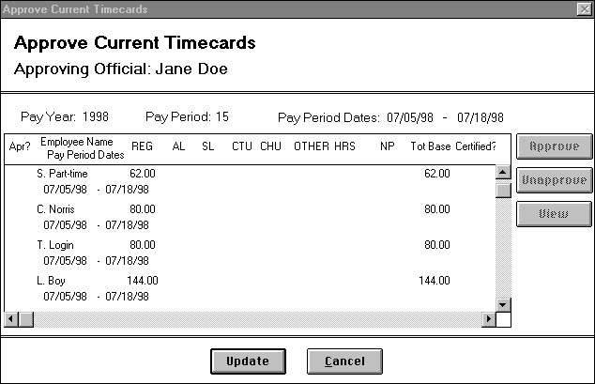

Approve Current Timecards Window
- Fields in the Approve Current Timecards Window display the following information:

Approve Current Timecards Window—Field Descriptions
Fields | Description/Action
Pay Year | Displays current pay year of the timecards.
Pay Period | Displays pay period number.
Pay Period Dates | Displays start and end dates of the pay period.
Apr? | Displays a “Y” if the timecard has been approved.

Fields (cont.) | Description/Action
Employee Name/Pay Period Dates | Displays employee name and beginning and ending timecard dates.
REG | Displays total number of regular hours included on the timecard for the specified employee.
AL | Displays total number of annual leave hours used by the employee for the specified pay period.
SL | Displays total number of sick leave hours used by the employee for the specified pay period.
CTU | Displays total number of compensatory hours used by the employee for the specified pay period.
CHU | Displays total number of credit hours used by the employee for the specified pay period.
OTHER HRS | Displays total number of other leave hours used by the employee for the specified pay period. Other types of leave comprise one or more of: military leave, holiday, administrative leave, court leave (e.g., jury duty), home leave, continuation of pay, time off incentive award, and others.
NP | Displays number of non-paid hours. An “A” preceding the number indicates use of absent without leave (AWOL). An “L” indicates use of leave without pay (LWOP). An “S” indicates use of suspension (SUSP). An “F” indicates use of leave under the Family Medical Leave Act. An “M” indicates use of multiple leave types.
Tot Base | Displays total number of base hours the employee has for the pay period.
Certified? | Displays “Y” if the employee has certified his/her timecard.
N/S | Displays number of night differential or Sunday differential hours worked for the day.
E/H | Displays number of hazard differential or environmental differential hours worked for the day.
Fields (cont.) | Description/Action
OT | Displays total number of overtime hours the employee worked for the specified pay period.
HP | Displays total number of holiday pay hours the employee earned for the specified pay period.
CTE | Displays total number of compensatory hours earned by the employee for the specified pay period.
CHE | Displays total number of credit hours earned by the employee for the specified pay period.
- Select all timecards or one timecard as follows:
- All Timecards. While holding down the CTRL key, press the letter A. Or, click on the first row and, while holding down the shift key, use the scroll bar or down arrow to move to the last row of the list and click on the last row.
- One Timecard. Click on the row you wish to process, using the scroll bar or arrow keys to navigate.
- After selecting the row(s), select one of the following actions:
- Approve Timecard(s). Click on the Approve button and the Update button to approve timecards and complete the process.
- Unapprove Timecard(s). Click on the Unapprove button and the Update button to unapprove timecards previously selected for approval.
- View Summary/Detail Timecard Data. Click on the View button to view summary or detail timecard information. ITAS displays the View Timecard Summary Window.
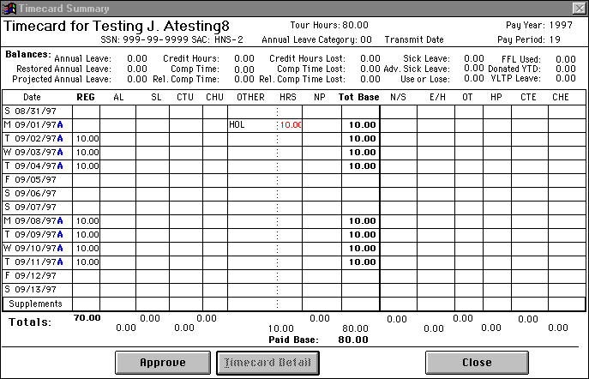

View Timecard Summary Window
- Fields on the View Timecard Summary Window display the following information:

View Timecard Summary Window—Field Descriptions
Fields | Description/Action
Tour Hours | Displays total number of hours the employee is required to work for the pay period.
FLSA Employee | Displays “FLSA Employee” if the employee must adhere to FLSA rules. ITAS only displays this field if the employee must adhere to FLSA rules.
Pay Year | Displays pay period year for the timecard you are viewing.
Separation Date | Displays date employee separated from the agency. ITAS only displays this field if the employee has a separation date in his/her employee profile.
SSN | Displays social security number for the timecard you are viewing.
SAC | Displays standard accounting code.
Annual Leave Category | Displays annual leave accrual category.
Transmit Date | Displays date the timecard you are viewing was transmitted to the Department of Health and Human Service’s payroll system.

Fields (cont.) | Description/Action
Pay Period | Displays pay period number for the timecard you are viewing.
Balances | Displays current leave balances. These balances reflect all leave earned and used, and all supplements processed during the pay period.
Date | Displays day and date in the pay period. Next to the date is one of the following indicators:  A Indicates the system automatically generated hours and the employee did not sign-in or sign-out for the day.  M Indicates the employee changed the time automatically generated by the system during sign-in or sign-out.  T Indicates the Timekeeper made changes to information for the day.  * Indicates a supplement exists for the day.  [ ] A blank may indicate the employee signed in and signed out for the day and did not make any changes to the system generated time.
REG | Displays number of regular hours worked for the day.
AL | Displays number of annual leave hours used for the day. The letter preceding the number indicates the kind of leave used.  R Restored annual leave.  B Both annual leave and restored annual leave.  F Leave used under the Family Medical Leave Act.  M Multiple leave types.
SL | Displays number of sick leave hours used for the day. An “F” preceding the number indicates the employee used leave under the Family Medical Leave Act.

Fields (cont.) | Description/Action
CTU | Displays number of compensatory time hours the employee used for the day. An “R” preceding the number indicates religious compensatory time is used. A “B” indicates that both compensatory time and religious compensatory time are used.
CHU | Displays number of credit hours used for the day.
OTHER HRS | Displays number of other leave hours used for the day. Other types of leave comprise one or more of the following: military leave, holiday, administrative leave, court leave (e.g., jury duty), home leave, continuation of pay, time off incentive award, and others.
NP | Displays number of non-paid hours. An “A” preceding the number indicates use of absent without leave (AWOL). An “L” indicates use of leave without pay (LWOP). An “S” indicates use of suspension (SUSP). An “F” indicates use of leave under the Family Medical Leave Act. An “M” indicates use of multiple leave types.
Tot Base | Displays number of base hours applied to the employee’s tour for the day.
N/S | Displays number of night differential or Sunday differential hours worked for the day.
E/H | Displays number of hazard differential or environmental differential hours worked for the day.
OT | Displays number of overtime hours worked for the day. This column will include the various types of overtime such as On Call, Callback, Overtime, etc.
HP | Displays number of holiday pay hours earned for the day. This is also referred to as holiday worked hours.

Fields (cont.) | Description/Action
CTE | Displays number of compensatory time hours earned for the day. An “R” preceding the number indicates religious compensatory hours are earned. A “B” indicates that both compensatory time and religious compensatory time are earned.
CHE | Displays number of credit hours earned for the day.
Supplements | Displays total number of supplement hours for each category applied for the pay period. Double-click on this row to view a supplement.
Totals | Displays total number of hours applied for the employee’s tour of duty for the day.
Paid Base | Displays number of hours the employee will receive pay for the pay period.
- While in this window you can perform one of the following:
- Approve Timecard. Click on the Approve button. ITAS returns to the Approve Current Timecards Window. Click on the Update button to approve the timecard.
- View Detail Timecard Data for specified day. Select a row and click on the Timecard Detail button or double- click on a row to view timecard information. ITAS displays the View Timecard Detail Window.
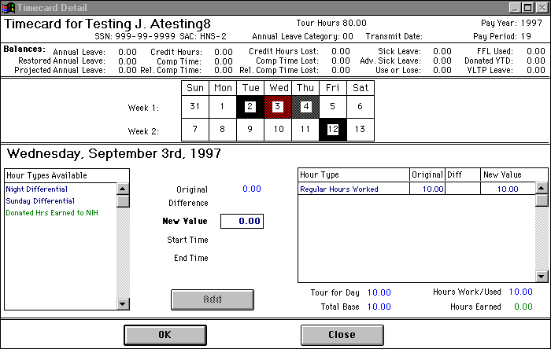

View Timecard Detail Window
- Fields on the View Timecard Detail Window display the following information:

View Timecard Detail Window—Field Descriptions
Fields | Description/Action
Tour Hours | Displays total number of hours the employee is required to work for the pay period.
FLSA Employee | Displays “FLSA Employee” if the employee must adhere to FLSA rules. ITAS only displays this field if the employee must adhere to FLSA rules.
Pay Year | Displays pay period year for the timecard you are viewing.
Separation Date | Displays date employee separated from the agency. ITAS only displays this field if the employee has a separation date in his/her employee profile.
SSN | Displays social security number for the timecard you are viewing.
SAC | Displays standard accounting code.
Annual Leave Category | Displays annual leave accrual category.
Transmit Date | Displays date the timecard you are viewing was transmitted to the Department of Health and Human Service’s payroll system.

Fields (cont.) | Description/Action
Pay Period | Displays pay period number for the timecard you are viewing.
Balances | Displays current leave balances. These balances reflect all leave earned and used during the pay period and all supplements processed during the pay period.
Bi-weekly pay period calendar | Displays days for the two weeks in the pay period. Highlighted day(s) were selected in the View Timecard Summary Window. You can select other days by clicking on the day(s) in the “Week 1” and “Week 2” boxes.
Date | Displays day and date in the pay period.
Hour Types Available list | Displays hour types or categories available for the day.
Original | Displays number of original hours assigned to the category for the day.
Difference/  Supplements | Displays difference between the “Original” hours and the “New Value” hours you entered.
New Value | Displays “0.00”.
Start Time | Displays start time for the partial leave.
End Time | Displays end time ITAS calculated based on the number of hours and the start time you entered.
Shift List | Displays shift the employee worked that day. ITAS only displays this list for FWS and Title 38 employees.
Hour Type list | Displays categories assigned for the day.
Tour for Day | Displays number of tour hours for the day.
Total Base | Displays total number of base hours the employee worked for the day.
Hours Worked/Used | Displays number of hours the employee worked or used for the day.

Fields (cont.) | Description/Action
Hours Earned | Displays number of extra hours the employee earned for the day.
- Click on the OK button to return to the View Timecard Summary Window.
- Click on the Approve button. Then click on the Close button to return to the Approve Current Timecard Window.
- Click on the Update button to complete the process.

Approving Timecards for Prior Pay Period
To approve timecard(s) for a prior pay period:
- Click on the Approve Unapproved Timecards icon in the Approving Official Functions Window. ITAS displays the Select Timecards Window.
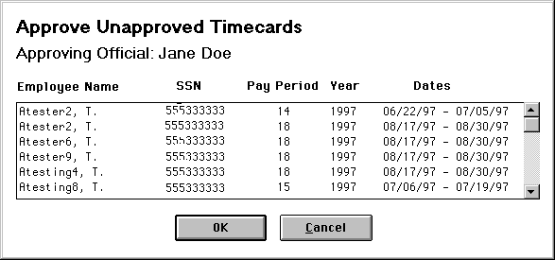

Select Timecards Window
- Fields in the Select Timecards Window display the following information:

Select Timecards Window—Field Descriptions
Fields | Description/Action
Employee Name | Displays first initial and last name of employees with unapproved timecards.
SSN | Lists social security numbers of employees with unapproved timecards.
Pay Period | Lists pay period for unapproved timecards.
Year | Lists year for unapproved timecards.
Dates | Lists pay period dates for unapproved timecard.
- Select one or more employees from the “Employee Name” list. When you have made your selections, click on the OK button. ITAS displays the Approve Unapproved Employee Timecards Window.
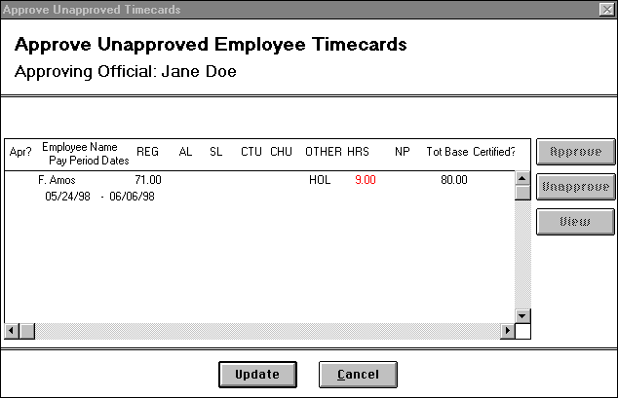

Approve Unapproved Employee Timecards Window
- Fields on the Approve Unapproved Employee Timecards Window display the following information:

Approve Unapproved Employee Timecards Window—Field Descriptions
Fields | Description/Action
Apr? | Displays a “Y” if the timecard has been approved.
Employee Name/Pay Period Dates | Displays employee name and beginning and ending timecard dates.
REG | Displays total number of regular hours included on the timecard for the specified employee.
AL | Displays the total number of annual leave hours used by the employee for the specified pay period.

Fields (cont.) | Description/Action
SL | Displays total number of sick leave hours used by the employee for the specified pay period.
CTU | Displays total number of compensatory hours used by the employee for the specified pay period.
CHU | Displays total number of credit hours used by the employee for the specified pay period.
OTHER HRS | Displays total number of other leave hours used by the employee for the specified pay period. Other types of leave comprise one or more of: military leave, holiday, administrative leave, court leave (e.g., jury duty), home leave, continuation of pay, time off incentive award, and others.
NP | Displays number of non-paid hours. An “A” preceding the number indicates use of absent without leave (AWOL). An “L” indicates use of leave without pay (LWOP). An “S” indicates use of suspension (SUSP). An “F” indicates use of leave under the Family Medical Leave Act. An “M” indicates use of multiple leave types.
Tot Base | Displays total number of base hours the employee has for the pay period.
Certified? | Displays “Y” if the employee has certified his/her timecard for the selected pay period.
N/S | Displays number of night differential or Sunday differential hours worked for the day.
E/H | Displays number of hazard differential or environmental differential hours worked for the day.
OT | Displays total number of overtime hours the employee worked for the specified pay period.
HP | Displays total number of holiday pay hours the employee earned for the specified pay period.
Fields (cont.) | Description/Action
CTE | Displays total number of compensatory hours earned by the employee for the specified pay period.
CHE | Displays total number of credit hours earned by the employee for the specified pay period.

- Select all timecards or one timecard as follows:
- All Timecards. While holding down the CTRL key, press the letter A. Or, click on the first row and, while holding down the shift key, use the scroll bar or down arrow to move to the last row of the list and click on the last row.
- One Timecard. Click on the row you wish to process, using the scroll bar or arrow keys to navigate.
- After selecting the row(s), select one of the following actions:
- Approve Timecard(s). Click on the Approve button and the Update button to approve timecards and complete the process.
- Unapprove Timecard(s). Click on the Unapprove button and the Update button to unapprove timecards previously selected for approval.
- View Summary/Detail Timecard Data. Click on the View button to view summary or detail timecard information. (Refer to the Approving Timecards for Current Pay Period section of this chapter for instructions and descriptions of these windows.)

Leave Request Maintenance

Overview
As an Approving Official, one of your primary responsibilities will be to approve or deny leave requests from employees. Your approval must be given before leave will appear on an employee’s timecard.
You can approve leave for:
- A future pay period.
- The current pay period.
- A past pay period.
You can deny:
- Any pending leave request.
- A future leave request that was previously approved.
As you approve leave for the current pay period, it will immediately appear on the employee’s timecard. When you approve leave for a prior pay period, it will appear on the timecard as a “Supplement”.
You can perform this function as the primary Approving Official or as an alternate Approving Official.

Approving/Denying Pending Leave Requests
To approve or deny pending leave requests:
- Click on the View/Process Leave Request icon in the Approving Official Functions Window. ITAS displays the View/Approve Leave Request Window.
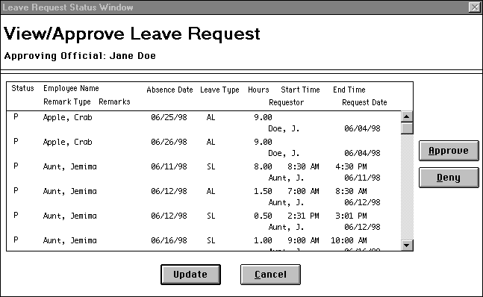

View/Approve Leave Request Window
- Fields on the View/Approve Leave Request Window display the following information:

View/Approve Leave Request Window—Field Descriptions
Fields | Description/Action
Status | Displays status of the leave request.
Employee Name | Displays name of employee requesting the leave.
Absence Date | Displays date the employee is requesting leave.
Leave Type | Displays leave category abbreviation that will be used for the request.

Fields (cont.) | Description/Action
Hours | Displays number of hours the employee is requesting for leave.
Start Time | Displays start time for each partial day leave request.
End Time | Displays end time for each partial day leave request.
Remark Type | Displays “FFL” if leave is Family Friendly Leave Act, ”FMLA” if leave is Family Medical Leave Act, or “VLTP” if leave is being donated through the Voluntary Leave Transfer Program.
Remarks | Displays remark associated with the leave request. ITAS only displays a remark if the employee is using leave under the Family Friendly Leave Act, the Family Medical Leave Act, or the Voluntary Leave Transfer Program.
Requestor | Displays name of the person who processed the leave request.
Request Date | Displays date the requestor processed the leave request.
- Select the request you want to process. Click on the Approve or Deny button, as appropriate. Click on the Update button.
- ITAS will prompt you “Would you like to save your changes to the timecards?”. Click on the Yes button to complete the process.

Designating Alternate Approving Official

Overview
From time-to-time it may be necessary for you to designate an employee as your alternate Approving Official. ITAS automatically displays the list of employees that you can designate as your alternate. ITAS will not include employees who are already Timekeepers or alternate Timekeepers in the list.
If you are trying to designate an employee who is not in the available list of employees, you must first remove their Timekeeper or alternate Timekeeper designation.

Designating an Alternate Approving Official
To designate your alternate Approving Official:
- Click on the Designate Alternate Approving Official icon in the Approving Official Functions Window. ITAS displays the Designate Alternate Approving Officials Window.
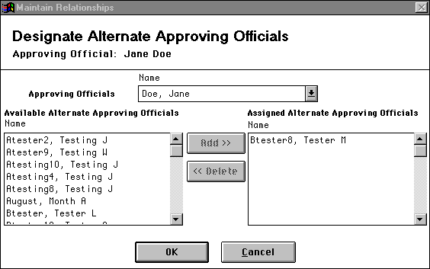

Designate Alternate Approving Officials Window
- Fields on the Designate Alternate Approving Officials Window display the following information:

Designate Alternate Approving Officials Window—Field Descriptions
Fields | Description/Action
Approving Officials | Displays your name.
Available Alternate Approving Officials | Lists all employees in your division who you can designate as your alternate.
Assigned Alternate Approving Officials | Lists all employees within your division currently designated as your alternate Approving Official.
- Select one of the following actions:
- Assign Additional Alternates. To assign additional alternates, select an alternate Approving Official from the “Available Alternate Approving Officials” list by clicking on the employee’s name. Click on the Add button to add the selected employee to the “Assigned Alternate Approving Officials” list.
- Remove Alternates. To remove an alternate Approving Official designation, click on the alternate’s name in the “Assigned Alternate Approving Officials” list. Click on the Delete button to remove the name from the list.
- Click on the OK button to complete the process.

Online Reports

Overview
The following sections provide procedures for viewing and printing online reports generated by ITAS. As a Leave Approving Official, you have access to the Online ATLR, Online Leave Request, Approved Leave, and Daily Sign-In/Sign-Out Reports.

Viewing Available Online Reports
To view available online reports:
- Click on the Reports option on the menu bar. ITAS displays the Reports Pull-Down Menu listing all available reports.
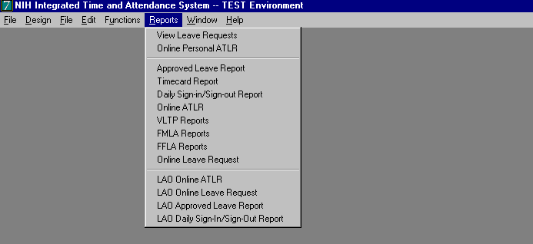

Reports Pull-Down Menu
- Click on the report you want to create. As a Leave Approving Official, you can run any of the following reports:
- LAO Online ATLR—Contains information on the current Administrative Time and Leave Record for the employee and year you specify.
- LAO Online Leave Request—Contains a list of all leave requests processed for your employees.
- LAO Approved Leave Report—Contains a list of all leave requested and approved by employees assigned to you.
- LAO Daily Sign-In/Sign-Out Report—Contains a list of all employees assigned to you with their sign-in and/or sign-out times for the specified date you enter.

LAO Online ATLR Report
The LAO Online ALTR Report contains information currently on the Administrative Time and Leave Record for a selected employee.

To review the report:
- Click on the Reports option on the menu bar.
- Click on the LAO Online ALTR option. ITAS displays the Reports Menu⎯ Employee Selection Window.
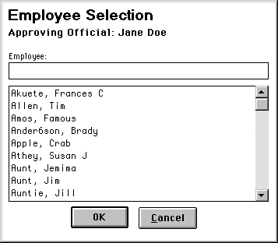

Employee Selection Window
- Select the employee for the report and click on the OK button. ITAS displays the Reports Menu⎯ Online ATLR Report Year Window.
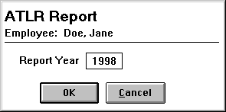

Online ATLR Report Year Window
- Enter the pay year for the report and click on the OK button. ITAS displays the Reports Menu⎯ Online ATLR Report Window.
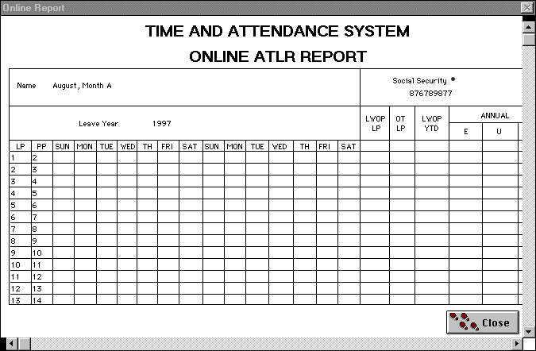

Online ATLR Report Window
- View the report by clicking on the horizontal and vertical scroll bars. The report displays the following information.

LAO Online ATLR Report—Field Descriptions
Fields | Description/Activity
Name | Displays name of employee you selected.
Social Security # | Displays the employee’s social security number.

Fields (cont.) | Description/Activity
Leave Cat. | Displays employee’s annual leave accrual category.
Max C.O. | Displays maximum number of annual leave hours the employee can carry over to the next leave year.
SCD | Displays employee’s service computation date (the date the employee began working for the federal government).
Leave Year | Displays year for the employee’s leave report.
LWOP LP | Displays number of leave without pay hours used for a given pay period.
OT LP | Displays number of overtime hours the employee used for a given pay period.
LWOP YTD | Displays number of leave without pay hours used for the leave year.
Annual | Contains employee’s annual leave activity.
E | Displays number of annual leave hours the employee earned for the specified pay period.
U | Displays number of annual leave hours the employee used for the specified pay period.
BAL | Displays annual leave balance as of the end of the specified pay period.
Sick | Contains employee’s sick leave activity.
E | Displays number of sick leave hours the employee earned for the specified pay period.
U | Displays number of sick leave hours the employee used for the specified pay period.
BAL | Displays sick leave balance as of the end of the specified pay period.
COMP | Contains employee’s compensatory time activity.
Fields (cont.) | Description/Activity
W | Displays number of compensatory time hours the employee worked for the specified pay period.
U | Displays number of compensatory time hours the employee used for the specified pay period.
BAL | Displays employee’s compensatory time balance as of the end of the specified pay period.
HRS WRK PP | Displays number of regular hours the employee worked for the specified pay period.
AL C/O HRS | Displays number of regular hours that will be added to the part-time employee’s total base next pay period when calculating the number of annual leave hours to accrue for the employee.
SL C/O HRS | Displays number of regular hours that will be added to the part-time employee’s total base next pay period when calculating the number of sick leave hours to accrue for the employee.
LP | Displays leave period number. A given leave year will only have 26 pay periods.
PP | Displays pay period number in the leave year specified for the report.
Day Abbreviations | Displays day abbreviation for the 14 days in each pay period.
- Click on the P in the upper right corner of the window to print the report.
- When you finish viewing the report, simultaneously press the [CTRL-F4] keys.

LAO Online Leave Request Report
The LAO Online Leave Request Report contains a list of all leave requests in process for your employees.
To view the report:
- Click on the Reports option on the menu bar.
- Click on the LAO Online Leave Request option. ITAS displays the Online Leave Request Report Window.

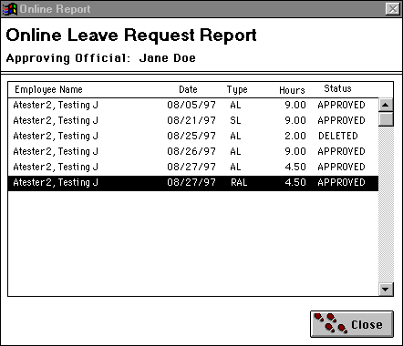

Online Leave Request Report Window

- Fields on the Online Leave Request Report Window display the following information:

Online Leave Request Report Window—Field Descriptions
Fields | Description/Action
Employee Name | Displays name of employee that has approved scheduled leave.
Date | Displays date for employee’s approved leave.
Type | Displays abbreviation for leave category the employee is taking (e.g., SL means sick leave, AL means annual leave).
Hours | Displays number of hours the employee will use for leave.
Status | Displays status of the leave request as approved, deleted, denied, or pending.

- View the report by using the vertical scroll bar.
- When you finish viewing the report, click on the Close button.

LAO Approved Leave Report
The LAO Approved Leave Report contains a list of all leave requested by your employees and approved by the Approving Official.
To review the report:
- Click on the Reports option on the menu bar.
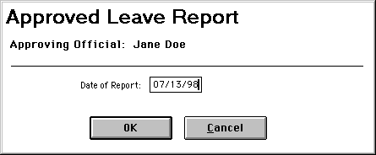
- Click on the LAO Approved Leave Report option. ITAS displays the Reports Menu⎯Approved Leave Date Window.
- Enter the date ITAS will use to select the approved leave for the report. ITAS includes all approved leave for employees after the date you specify.

Approved Leave Date Window
- Click on the OK button. ITAS displays the Reports Menu⎯Approved Leave Report Window.
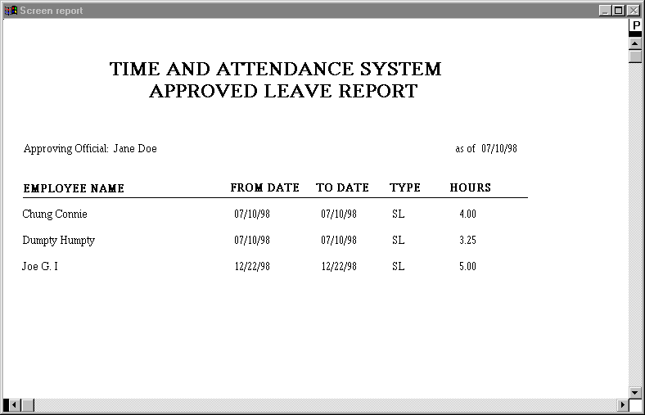
- View the report by clicking on the horizontal and vertical scroll bars. The report displays the following information.

Approved Leave Report Window

Approved Leave Report—Field Descriptions
Fields | Description/Action
Employee Name | Displays names of employees that scheduled leave that was approved by their Approving Official.
From Date | Displays beginning date for the leave.
To Date | Displays ending date for the leave.
Type | Displays abbreviation for the leave category the employee is taking (e.g., SL means sick leave, AL means annual leave).
Hours | Displays the number of hours the employee will use for leave.
- Click on the P in the upper right corner of the window to print the report.
- When you finish viewing the report, simultaneously press the [CTRL-F4] keys.

LAO Daily Sign-in/Sign-out Report
The LAO Daily Sign-in/Sign-out Report contains a list of all employees and their sign-in and/or sign-out times.
To view the report:
- Click on the Reports option on the menu bar.
- Click on the LAO Daily Sign-in/Sign-out Report option. ITAS displays the Reports Menu⎯ Select Date for Daily Sign-in/Sign-out Record Window.
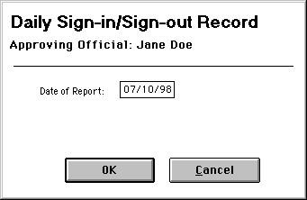
- Enter the date for the report.

Select Date for Daily Sign-in/Sign-out Record Window
- Click on the OK button. ITAS displays the Reports Menu⎯Daily Sign-in/Sign-out Report Window.
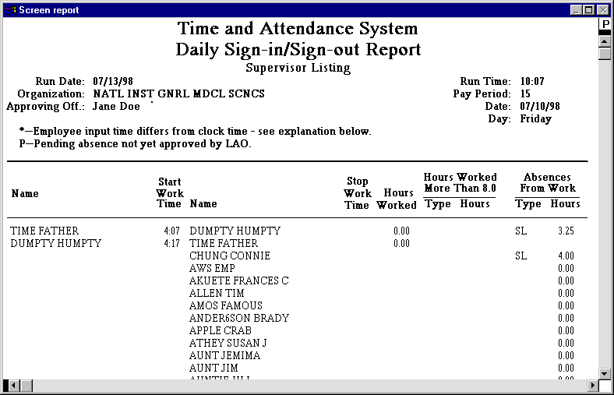
- View the report by clicking on the horizontal and vertical scroll bars. The report displays the following information.

Daily Sign-in/Sign-out Report Window

Daily Sign-in/Sign-out Report—Field Descriptions
Fields | Description/Activity
Run Date | Displays date the report was generated.
Run Time | Displays time the report was generated.
Organization | Displays name of the organization.
Pay Period | Displays pay period for the report.
Approving Off. | Displays name of the Leave Approving Official supporting the employees.
Date | Displays date for the sign-in and sign-out information.
Day | Displays day of the week for the sign-in and sign-out information.
Explanation | Displays reason the employee entered for changing either the sign-in or sign-out times.
Name | Displays names of the employees in the order of their sign-in time.

Fields (cont.) | Description/Activity
Start Work Time | Displays each employee’s sign-in time. There will be an * next to the time if the employee changed the time in the Sign-In Window.
Name | Displays names of the employees in the order of their sign-out time.
Stop Work Time | Display each employee’s sign-out time. There will be an * asterisk next to the time if the employee changed the time in the Sign-Out Window.
Hours Worked | Displays total number of hours the employee worked for the day.
Hours Worked More than Tour | Contains distribution of excess hours each employee worked for the day.
Type | Displays category abbreviation associated with the excess hours the employee worked for the day.
Hours | Displays number of hours the employee assigned to the category for the excess hours the employee worked for the day.
Absences from Work | Contains distribution of hours the employee was absent from work for the day.
Type | Displays category abbreviation associated with the absent hours the employee missed for the day.
Hours | Displays number of hours the employee assigned to the category for the absent hours the employee missed for the day. A “P” beside the number of hours denotes pending leave.
- Click on the P in the upper right corner of the window to print the report.
- When you finish viewing the report, simultaneously press the [CTRL-F4] keys.

Glossary of Terms
The following is a glossary of terms that appear in this document. Many are common to descriptions of graphical user interfaces and the Windows environment.

Term | Description
Button  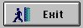 | A shaded rectangle on a window that, when clicked with the mouse, performs a task.
Click | To quickly press and release the mouse button. This term is used to describe actions performed with command buttons.  Windows Users: Press left mouse button (or right, if applicable).  Mac Users: Press the mouse button.
Command Buttons | Command buttons initiate an immediate action using information you supply.
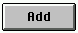 | Click on the Add button to add the selected or entered information to a list or to insert new information.
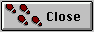 | Click on the Close button to close the current window.
 | Click on the Cancel button to close the window without processing your request and return to the previous window.

Term (cont.) | Description
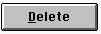 | Click on the Delete button to delete a selected row from a list.
 | Click on the Modify button to process data changes you made in the window.
 | Click on the OK button to access information you requested, confirm an action, respond to an informational message, or respond to a dialog box.
 | Click on the Remove button to move an item from one list to another or remove the highlighted item from the system.
Dialog Box  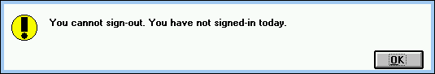 | Dialog boxes are special windows that provide information (e.g., system messages) or request information (e.g., data ITAS needs to complete a command). You cannot close a dialog box until you click on the OK button or enter required information. Once you enter your selection, the dialog box closes automatically and completes the command that invoked it.
Double Click | Click the mouse button twice in rapid succession. When you double-click on an icon associated with an application, Windows launches or starts the application.

Term (cont.) | Description
Drag | Hold the mouse button down after clicking on it as you move the mouse.
Drop Down List Box | A drop-down list box looks like a normal text box, except the end of the text box contains an arrow button. By clicking on the arrow, the box “drops down” displaying a list of options.
Gray Out | Fields or objects viewed on screen, but not available to a user, appear in gray. Their labels are lighter than labels of other fields/objects on the screen and are non-enterable.
Help Bar | The help bar is located at the bottom of each ITAS window. Help text (for a field, button, or icon) appears in this bar when the mouse is positioned on the field, button, or icon.
Icon   | A small picture (graphical representation) used to represent an application or ITAS menu option. For example, the palm tree displayed as an option on several menus represents the Process Leave Request function.

Term (cont.) | Description
List Box  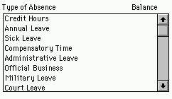 | List boxes contain a column of available items from which to select. If there are more items than can fit in the box, the list is “scrollable.” Scroll through the entire list using the vertical scroll bars located on the box’s right side. To choose an item in a list box, click on the item.
Menu/Menu Bar | Menus are lists of commands that typically appear in a bar across the top of a window. ITAS also employs Menu Windows in which icons appear next to menu options. Each access level has a different menu. In addition, each name on the bar at the top of the screen is a menu.
Message Bar | An area for messages, typically at the bottom of a window.
Radio Buttons | Small circles that appear as a group of mutually exclusive choices. Within each group, you may only select one radio button. When you click on the radio button, the circle becomes black. Change options by clicking on another radio button.
Scrollable List  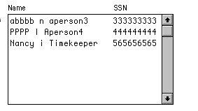 | Contains a column or columns of available items from which you can select. A list is “scrollable” when there are more items than can fit in the box. Scroll through the entire list using the vertical scroll bars located on the box’s right side.

Term (cont.) | Description
Select | Click on an item with the selection cursor. The selected item can appear highlighted, as a dotted rectangle, or both.
Selecting a List Item | To choose an item in the list box, click on the row. When the row darkens, it has been selected.
Text Box  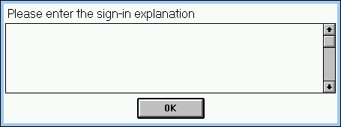 | Text boxes are rectangular boxes in which you enter textual information, such as the name of a document. Often a text box contains default information. In these cases, you can accept the default text, or type in new text.
Window | Screens that display information and objects the user reviews, enters, or manipulates to accomplish ITAS functions.

Index

A
Alternate Approving Official
Designating an, 39
L
Leave Requests, 35
Approval/Denial, 36
Logoff, 13
Logon, 11
O
OMNIS™7, 6
P
Printing, 17
R
Reports
Approved Leave, 51
ATLR, 45
Daily Sign-in/Sign-out, 53
T
Timecard, 19
Current Pay Period Approval, 20
Prior Pay Period Approval, 30
U
User’s Guide, 3

