Testing NCIEdit Tab
September 25th 2006
Maleh hernandez

0) Some performance values to consider
After creating a new annotation property to the Blood concept, I select the concept “Bile Salt New Concept” | 22 sec
To go from the concept Urine to the Synovial Fluid | 15 sec
To create a new concept | 52sec  54 sec  55 sec  1 min 11 sec
To save changes from an existing concept | 16 sec (I wonder why I got this, is too different than the rest!!)  1 min 53 sec  51 sec  1 min 34 sec  1 min 49 sec  1 min 01 sec
To create a new class (I intentionally put spaces in the “Label” field and of course got the message: “Label cannot contain blank spaces”) | 1 min 8 sec  1 min 01 sec  1 mi 08 sec

1) When we create a new class and it does already exist, can we prevent the user before he/she enters preferred name, definition and hits ok?

2)The system does not allow creating a FULL_SYN annotation property that already exists, but if I modify an existing property I can make it identical to another one that already exists. Is it possible to prevent the user from duplicating properties?

3) I deleted the following property from the concept “Breast Fluid or Secretion” :
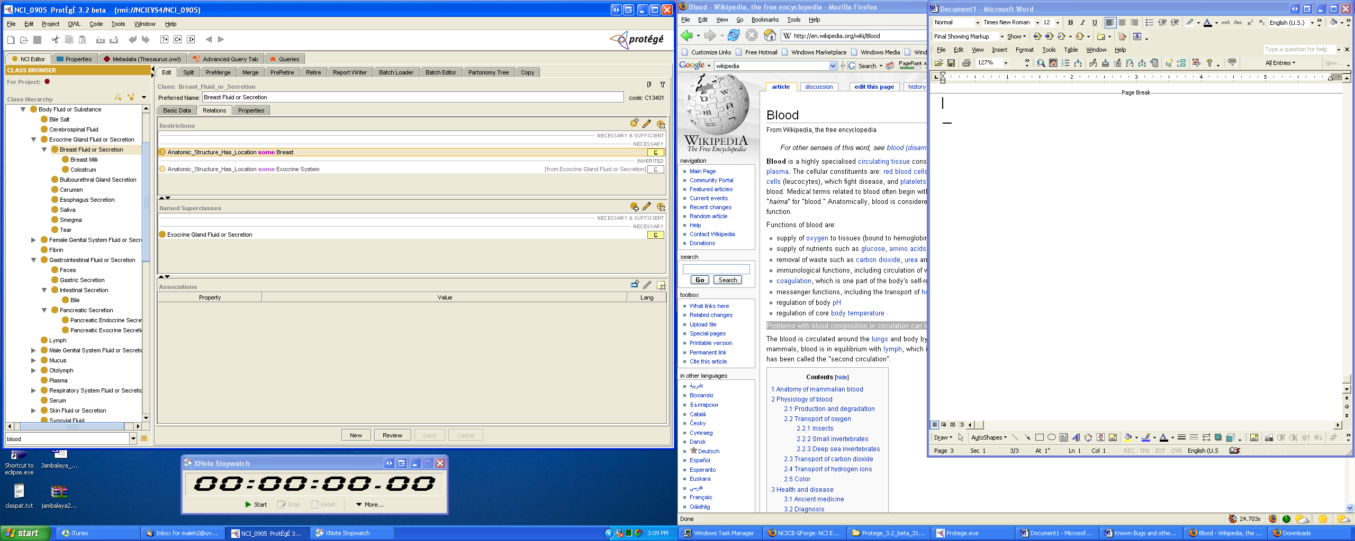

I wanted to define it again, but when I search for the concept Breast, the search is giving me 100 matches and the concept Breast is not found.

4) The bug “[#2735] Inconsistency when displaying Qualifiers values” although is not critical, is still present in this version.

Testing NCIEdit Tab
September 26-28th 2006
Maleh hernandez

5) In the Edit tab, when creating a new restriction if I hit “Create data type property” and then cancel the creation of the restriction, the data type property is created anyways.

6) I can not define a ‘necessary&sufficient” restriction, the newly create restriction appears under “necessary” restrictions. I tried to convert it to n&s but as we now, we can not convert a “necessary” restriction to “necessary & sufficient” yet. While saving the newly created restriction there was not message confirming the action. After browsing other concepts, I came back to this one and I realized that the restriction was not saved.

This is the output in the console:
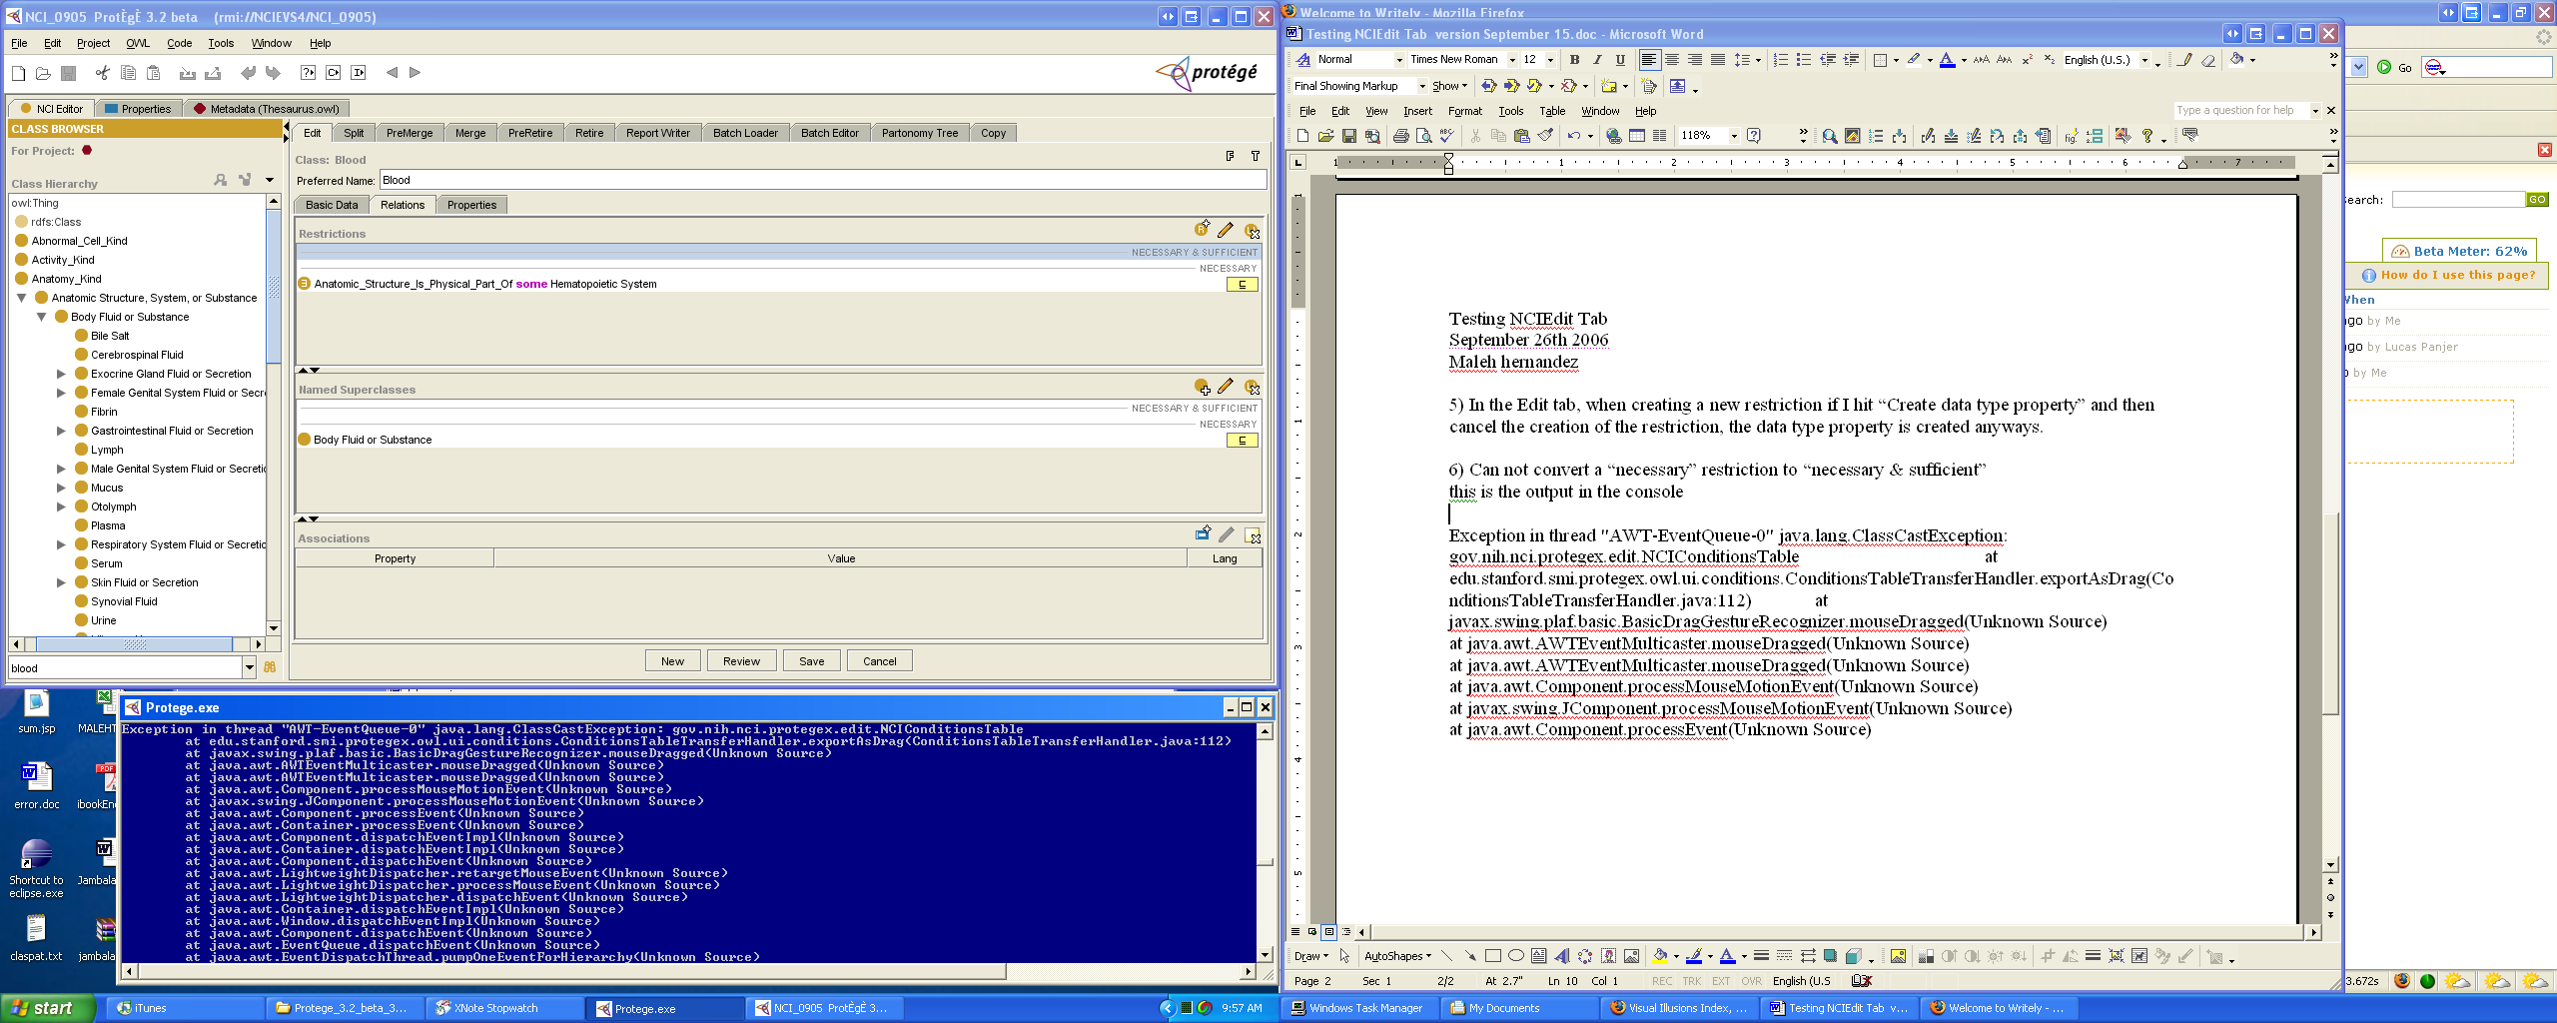
7) When adding a new restriction, if the concept I want to use to be the “filler” does not exist, the system does not notify it to the user. Example, as filler I search for the concept “hemaotitp”. By default the “filler” was set to “owl:Thing”

8) I was adding a restriction using a newly created property, the application went frozen.

9) To split a concept takes 15 sec, 11 sec, 10 sec, 14 sec
10) To split a concept, if the name of the new concept is wrong, I got the following message, but there is not way of correcting the name error

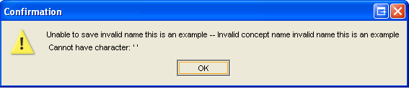

11) To merge concepts takes 14 sec, 20 sec

12) When I merge two concepts the restrictions disappear. Example, I cloned the concepts blood and urine, the clones are called newBlood and newUrine, then I “premerge” them and then I “merge” them. For some reason the original restrictions corresponding to each concept are not taken into the surviving concept newUrine.



