Hong Kong Shopping Sprees Mean Big Business for Retailers. Are American firms missing out?

By Swee-keng Cheong
April 12, 2007

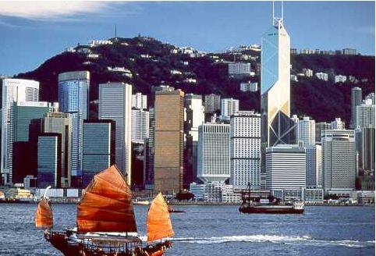

“ We see Asia as a big territory and in a few years we
believe it will play
the part Europe does today for
company growth,”

Carlos Alberini

President and Chief Operating Officer, Guess

While shopping in any shopping mall or shopping district in Hong Kong, I can’t help but ask, where are the American brands? Sure, there are a few brands here and there, but they are overshadowed by the plethora of Italian, French, Japanese and other Asian and European brands.

Hong Kong is an important – yet often overlooked – market-entry point for retail in Asia.

- Hong Kong’s tax-free status means shopping is cheaper here than in neighboring markets – like mainland China or Japan
- Hong Kong was visited by 21 million tourists in 2006, including 13.5 million from mainland China, who shop, shop, shop!!!
- Hong Kong’s vibrant music, movie, television and print media continue to influence fashion trends throughout Asia
- Hong Kong’s domestic population of 7 million has one of the highest average disposable incomes in the region

Hong Kong’s retail market is vibrant. Retail sales valued at US$28 billion at the end of 2006 were up 7.3%, boosted by domestic expenditures and tourist spending. A Tax Free World Association (TFWA) survey conducted in 2005 found Hong Kong, followed by Macau, to be the two most popular destinations for Mainland Chinese outbound travelers. The survey also revealed that “shopping is definitely considered to be a ‘must-do’ by most outbound Chinese travelers, especially when they travel to Hong Kong.” Fashion goods (purchased by 53% of the Chinese travelers,) cosmetics (50%,) and confectionery (50%) were ranked among the top 3 shopping purchases for the Chinese travelers in the survey. The 13.5 million Mainland Chinese tourists that visited Hong Kong in 2006 spent an average of US$584 per person.

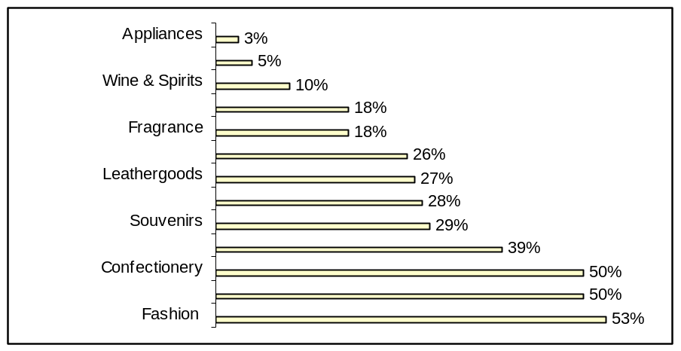
Source: 2005 TFWA-ACNielsen Chinese Traveller Study

To tap the lucrative Mainland Chinese consumer spending market, several of the world’s leading luxury brands such as Louis Vuitton, Prada, Bvlgari, and Giorgio Armani have opened flagship stores in Hong Kong. Miuccia Prada, owner of the Prada selected Hong Kong for the location of its second largest store in Asia (after Japan) as Hong Kong “increasingly represents a launch pad into the Chinese market; it creates the trends and acts as a showcase for this market.” A Hong Kong presence paves the way for expansion into China.

H&M’s recent Hong Kong store opening should serve as a wake-up call for American retailers. With queues that stretched for blocks down Hong Kong streets, shoppers waited for hours to enter H&M on their opening day. The
buzz around this high profile opening was carefully orchestrated with city-wide marketing blitz featuring advertisements on almost every available space in the city .

Stefan Persson, H & M’s Chairman said at the store opening that they had kept Madonna’s line of clothing especially for Hong Kong as “…this is an important moment for us because Hong Kong is such a fashionable city.” Nils Vinge, Head of Investor Relations at H&M reiterated that “Hong Kong is fashion-oriented and the people are big fashion spenders…” H & M chose Hong Kong as the first city to launch its Asia stores.

Macau: The Next Retail Wave
Just 25 miles away from Hong Kong and an hour’s ferry ride is Macau, “Asia’s Las Vegas.” Las Vegas Sands Corp. is developing Cotai Strip in Macau modeling it on the Las Vegas Strip. The Cotai Strip is anchored by the 3,000-suite Venetian Macau Resort-Hotel and 7 other hotels (Conrad, St. Regis, Shangri-La, Holiday Inn, Four Seasons, Regal, Renaissance,) are under construction. Add to that, a 20,000-seat entertainment center, a convention and exhibition center, and over a million sq. ft. of retail space, and
the stage is set for some serious shopping. Macau visitor arrivals are expected to increase from 16.67million in 2004 to 23.61million, following the opening of the Venetian Macau and its convention and exhibition center in July 2007. Macau is less than 5 hours away from almost two-thirds of the world’s population, and almost the whole of Mainland China. Information on The Venetian Macau is available at http://www.venetianmacao.com/eng/gcs_main.html

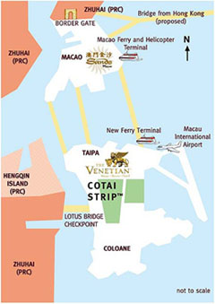
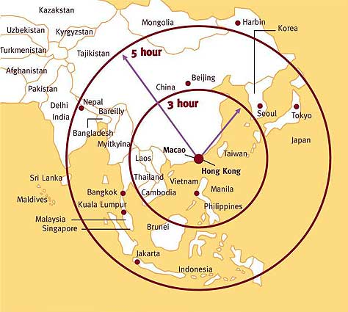

For companies who are targeting Chinese consumers, Hong Kong and Macau present exciting and unique opportunities.

Formats for market entry include finding a local distributor /licensee, setting up an office to run the stores (and leveraging Asia sourcing offices) or franchising. The U.S. Commercial Service in Hong Kong can help American companies identify possible partners/licensees, and investors, and provide customized research information for all market entry needs: information on

local tastes and spending patterns, logistics and supply chain support services, retail real estate services, and marketing and advertising strategies.
Check this website on our services www.buyusa.gov/hongkong/en/servicesforus.html or contact

Ms Swee-keng Cheong at
swee-keng.Cheong@mail.doc.gov for more information.

Telephone: (852)2521-5233

Picture showing the queues from the opening of the new H&M store in Hong Kong on March 10, 2007. 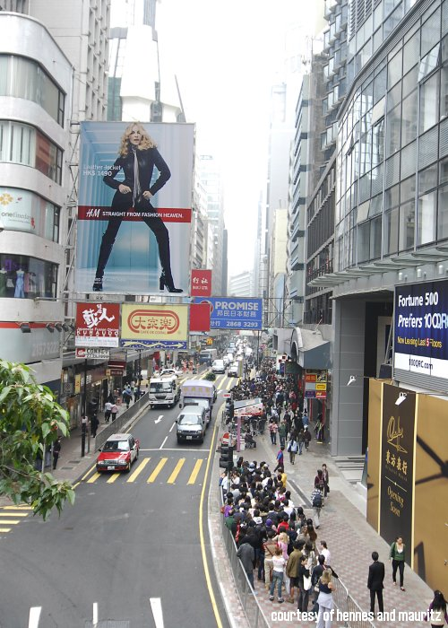

M by Madonna: Madonna takes over Hong Kong
Advertisements on the opening of the new H&M store in Hong Kong and the debut of the M by Madonna collection were placed in many subway stations, bus stops, and streets.
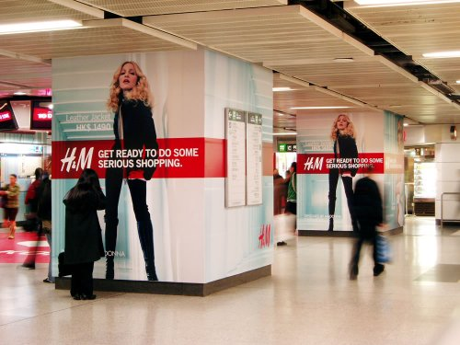
“In 10 years, Chinese luxury consumers will catch up with their counterparts in Japan”

Goldman Sachs Report on Global Luxury Sales 2006

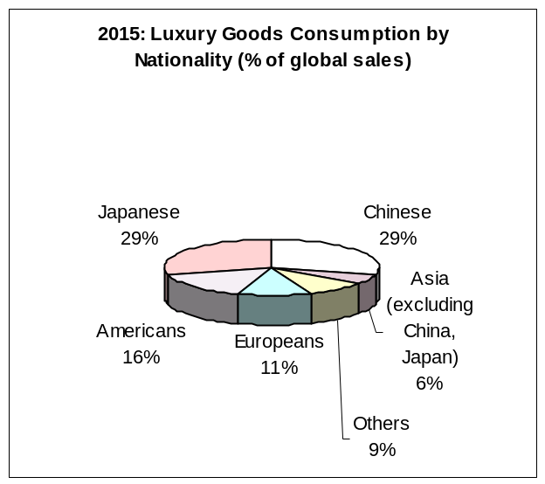

“Hong Kong is a hub. If you succeed in Hong Kong, you are halfway to success in the rest of the region.”
Newman Tsang, General Manager
Mini Cooper Hong Kong

“Hong Kong has always been a very strong and competitive market leader in terms of style and influence, not just among the region but also worldwide.”
Abigall Walters
Four Seasons Hotel public relations director

“Macau is a sleeping market,…in terms of numbers of tourists, it has not yet caught up with Hong Kong but has great potential”
Michele Norsa
Chief Executive, Salvatore Ferragamo

“Hong Kong is a profitable market and we are selling well, and so there is no reason to wait”
Masanobu Furuta’s comments on Muji’s plan to open 5 stores in Hong Kong in the next few years.
Senior Managing Director
Ryohin Keikaku (Muji’s owner)

