TABLE OF CONTENTS

Map of Northeastern Wisconsin 3
Glacierland RC&D Information 4
Directory Information 5
Glacierland RC&D's Grazing Specialist Information 6
Useful Contacts 7
Questionnaire Results and Statistics 9
Grazier Directory 11
Quick Reference Sheets 35
Index 41

GLACIERLAND COUNTY LISTINGS

Brown 11
Calumet 12
Door 13
Fond Du Lac 14
Kewaunee 18
Manitowoc 20
Oneida Nation 24
Outagamie 24
Sheboygan 29
Winnebago 31

OTHER PARTICIPATING COUNTIES

Columbia 13
Dodge 13
Forest 17
Green Lake 17
Jefferson 18
Marathon 22
Marinette 22
Oconto 22
Portage 26
Sauk 26
Shawano 27
Trempealeau 30
Walworth 30
Washington 30
Waupaca 30
Waushara 31

MAP OF COUNTIES INCLUDED IN SURVEY
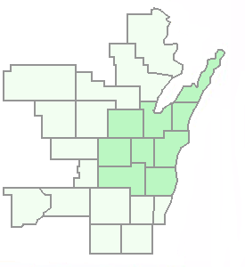
MARINETTE
OCONTO
SHAWANO
DOOR
KEWAUNEE
BROWN
OUTAGAMIE
WAUPACA
MARATHON
PORTAGE
MANITOWOC
CALUMET
WINNEBAGO
WAUSHARA
SHEBOYGAN
GREEN
LAKE
FOND DU LAC
OZAUKEE
WASHINGTON
DODGE
WAUKESHA
JEFFERSON
COLUMBIA
SAUK
KEY

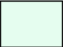
- Other Participating
Counties*
- Counties within the
Glacierland RC&D
* Map does not include Forest, Florence, Trempealeau, or Walworth Counties

Oneida Nation

Glacierland Resource Conservation and Development (RC&D)

"Making Things Happen"

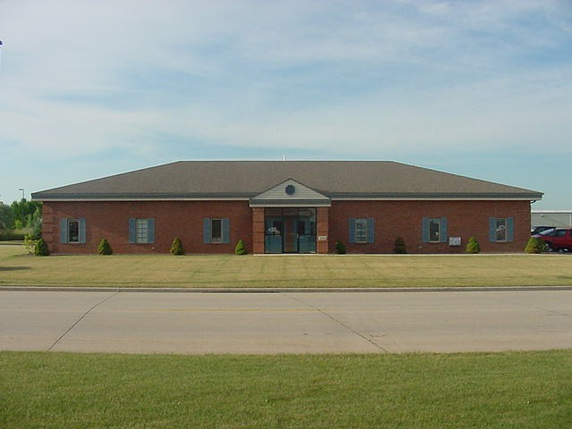
The Glacierland Resource, Conservation and Development (RC&D) is a rural development, non-profit organization. It's primary focus is on the conservation, development, and utilization of area resources. The Glacierland RC&D program coordinates local efforts of Brown, Calumet, Door, Fond Du Lac, Kewaunee, Manitowoc, Outagamie, Sheboygan, and Winnebago Counties, as well as the Oneida Nation. Glacierland RC&D seeks solutions to the social, economic, and environmental needs of our region.
Glacierland RC&D is working hard to help the graziers of Northeastern Wisconsin. Glacierland RC&D, in conjunction with other organizations, has sponsored numerous pasture walks, hosted a grazing workshop taught by grazing expert and professor at the University of Missouri, Jim Gerrish, and assembled the grazier directory you are reading right now. Glacierland RC&D realizes the economic and environmental benefits of grazing and we feel these projects are the first step to spread that message to other areas in Wisconsin.
GLACIERLAND RC&D FIELD OFFICE IN GREEN BAY
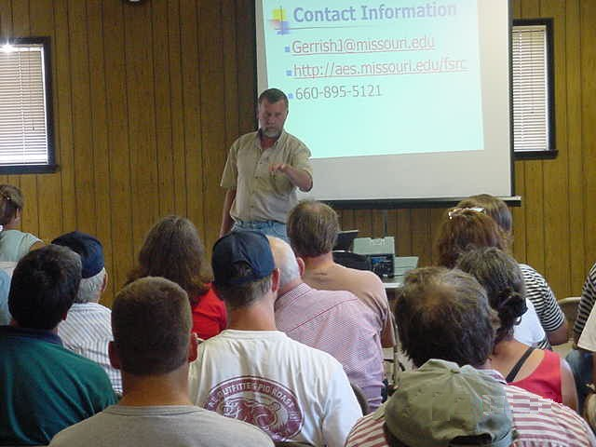
Glacierland RC&D not only supports graziers but all citizens of the rural community. Glacierland RC&D is working on over 50 projects right now, ranging from hosting chainsaw safety workshops to sponsoring Hmong farmer outreach programs. "We pride ourselves on our 'grass roots' approach to addressing the issues which concern citizens like yourself," says Jim Costello, Glacierland RC&D President. The Glacierland RC&D council, made up of representatives from across Northeastern Wisconsin, prioritize the issues brought forth by local citizens and forms a plan using partnerships with various agencies and organizations to carry the plans out. The staff at Glacierland RC &D is very dedicated but we can't do it without your help and input. If you have a concern, want more information, or want to help out in anyway, please see the contact information on the following page.
NATIONALLY RENOWNED GRAZING SPECIALIST, JIM GERRISH, SPEAKS TO NORTHEASTERN WISCONSIN GRAZIERS
ABOUT THIS DIRECTORY

This directory was designed to strengthen the communications between graziers in the counties within the Glacierland RC&D area and its neighboring counties in Northeastern Wisconsin. It was compiled using information from a questionnaire that was distributed through the mail and at many pasture walks throughout the year. All of the data was entered into a database using Microsoft Access. The directory is divided into three main sections: statistics from the questionnaire, the directory itself, and reference sheets that refer back to the directory. The entries are organized by county and then by last name in alphabetical order. Microsoft Word and Excel were used to extract the data from the original Microsoft Access database and put into the format you will see on the following pages. The directory is easy to update and there is less room for error because the data only needs to be entered once in a simple-to-use spreadsheet.
This directory was made possible through a grazing land conservation initiative grant. As of right now, funds are sufficient to keep Glacierland RC&D involved in grazing but some day, a time may come when someone or some other organization may need to take the lead on this project. Everyone can help keep this project afloat by informing your elected officials and representatives about the importance of this directory and grazing itself. Anyone with a modest knowledge of Microsoft office software can request a free copy of the database on disk and use the information as they see fit. In the meantime, Glacierland RC&D will keep the database as up-to-date as possible. We hope you find this directory useful and beneficial to your grazing operation.

Glacierland Resource Conservation and Development (RC&D)
3086 Voyager Drive, Suite 1
Green Bay, WI 54311
Telephone: (920) 465-3006 (3009) Fax: (920) 465-3010
E-Mail: greg.hines@wi.usda.gov

Greg Hines - Glacierland RC&D Coordinator
Rick Adamski - Grazing Specialist
Ben Wollin - Grazier Directory Developer
Mary Ellen Besaw - Administrative Assistant

Please feel free to contact the Glacierland RC&D office to:

- request a free copy of this directory, the grazier database and mailing list on disk, or a pamphlet about Glacierland RC&D
- add a name, change the data, or make suggestions for future additions of this directory
- be put on the grazier mailing list for updates and happenings in the Northeastern Wisconsin grazier community
- volunteer or become a sponsor for Glacierland RC&D
- voice any other concerns or questions

Glacierland RC&D encourages everyone to take advantage of our services or help us out in any way. Without your support, many of our projects would not be possible.

A website for Glacierland RC&D is being developed and will contain a downloadable version of this directory as well as other pertinent grazing information. To get to the website, go to www.wi.nrcs.usda.gov and click on the RC&D link.

MEET GLACIERLAND RC&D's NEW GRAZING SPECIALIST!

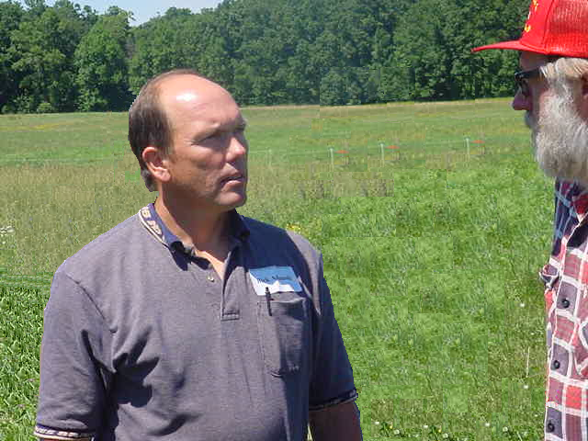

RICK ADAMSKI

I am pleased to introduce myself as the new grazing specialist for Glacierland RC&D and for all of Northeastern Wisconsin. My name is Rick Adamski. My wife, Valerie Dantoin-Adamski and I own and operate a grass based dairy farm in southeastern Shawano County. The farm has been in the Adamski family for over 100 years. My parents live right across the road from us and help us operate the farm. Our children, Andrew (8) and Gena (6) help feed the cats, dogs, pony, and our pig. We have been using managed grazing since 1987. We grow pasture almost exclusively (this year we are growing some sorghum-sudangrass), and we buy other forages, grains, and bedding for our herd of 86 cows, 28 bred heifers, and 42 calves. All of these animals get the majority of their dry matter needs from pasture.

We have done demonstrations and have regularly held field days to promote the idea of managed grazing. Our most recent project has been the introduction of a cheddar cheese made from milk from grazing cows. This is done to emphasize the health benefits of grass based dairy products. We have combined with 4 other farms from Eastern Wisconsin to form the Wisconsin Dairy Graziers Cooperative.

I have graduated from UW-Stevens Point with degrees in Soil Science and Resource Management. I have dedicated my farming career to promoting an agriculture that works with nature.

I hope to be able to help anyone from Northeastern Wisconsin with grazing questions. I will be available for on farm visits or phone consultation. I can be contacted through the Glacierland RC&D office at 920-465-3006.

Central Wisconsin River Graziers
(Lincoln. Langlade, and Marathon Counties)
Paul Daigle
Marathon County LCD
210 River Drive
Wausau, WI 54403-5447
(715) 261-6000

Columbia County Graziers
Robert and Karen Breneman
N5953 County Rd G
Rio, WI 53960
(920) 348-5504

Laura Paine
UW Extension
PO Pox 567
Portage, WI 53901
(608) 742-9680

Dodge County Graziers
John Bohonek
Dodge County LCD
127 East Oak Street
Juneau, WI 53039
(920) 386-3662

Fond-O-Grass Graziers
(Fond Du Lac, Sheboygan, and Manitowoc Counties)
Mike Rankin
UW Extension, UW Center
400 Campus Drive
Fond Du Lac, WI 54935
(920) 929-3171

Fox River Graziers
Tom and Sue Wrchota
5200 O'Reilly Road
Omro, WI 54963
(920) 685-6964

Golden Sands RC&D
(Central Wisconsin)
1462 Strongs Ave.
Stevens Point, WI 54481
Phone: (715) 343-6215
Fax: (715) 345-5358
ebertb@co.portage.wi.us

GrassWorks, Inc.
Paul Nehring
210 River Drive
Wausau, WI 54403
(715) 261-6009
pmnehring@mail.co.marathon.wi.us
Lakeshore Technical College
1290 North Avenue
Cleveland, WI 53015-1414

Greg Booher
Phone: (920) 693-1241
greg.booher@gotoltc.com

Bryce Larson
Phone: (920) 693-1645
Bryce.larson@gotoltc.com

Lumberjack RC&D
(Northern Wisconsin)
Brian Spencer
518 W. Somo Ave.
Tomahawk, WI 54487
Phone: (715) 453-1265
Fax: (715) 453-1882
E-Mail: spencb@dnr.state.wi.us

Northeast Wisconsin Sustainable Farmers Network
(Door, Kewaunee, and Brown Counties)
John Bobbe
9896 County Road D
Brussels, WI 54204
(920) 825-1369

Northland Graziers
(Marinette, Oconto, Shawano, and Florence Counties)
Greg Williamson
W5213 Hilldale Drive
Porterfield, WI 54159
(715) 789-3060

Pri-Ru-Ta RC&D
(Northwestern Wisconsin)
John Witherspoon
850 N Eighth St.
Medford, WI 54451
Phone: (715) 748-2008
Fax: (715) 748-4841
E-Mail: spoon@main.tds.net

River County RC&D
(Western Wisconsin)
Pam Herdrich
1101 W Clairemont Ave, Ste 1C
Eau Claire, WI 54701-6161
Phone: (715) 834-9672
Fax: (715) 834-8663
pam.herdrich@wi.usda.gov

Sauk County Grazing Network
Karl Hakanson
UW Extension
505 Broadway, Suite 232
Baraboo, WI 53913
(608) 355-3258

Southwest Badger RC&D
(Southwestern Wisconsin)
Steve Bertjens
310 E. Main Street
Platteville, WI 53818
Phone: (608) 348-3235
Fax: (608) 348-4088

Waupaca/Portage County Grazing Group
Greg Blonde
UW Extension
811 Harding Street
Waupaca, WI 54981
(715) 258-6230

USDA-NRCS
Brian Pillsbury
Grazing Lands Specialist
505 Broadway, Room 232
Baraboo, WI 53913
(608) 355-4470

Questionnaire Results and Statistics

The data shown below comes from 130 questionnaires filled out by graziers all over Northeastern Wisconsin. Glacierland RC & D was very pleased with the response. We hope this data gives you a better picture on the grazing situation in our area.

Total Questionnaires Filled Out: 130

Note: The numbers in parenthesis on the right side of the page indicate how many graziers filled in a response for that particular question out of all the questionnaires.

Average # of years that a grazier has been grazing: 8.12 (128 /130)

LENGTH OF TIME THAT GRAZIERS HAVE BEEN GRAZING
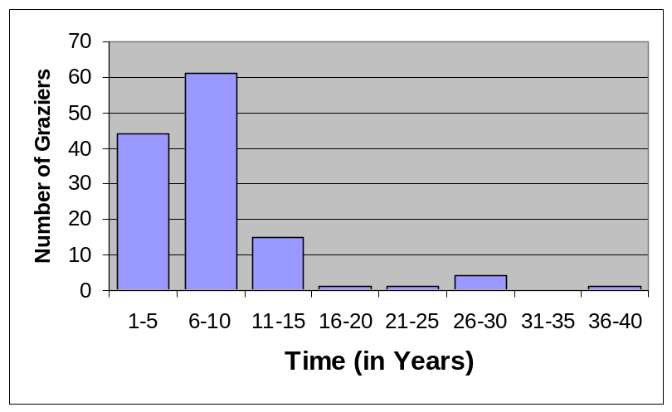

Average # of Cows on a farm with Cows: 94.10 (107 /130)

NUMBER OF COWS GRAZED PER FARM
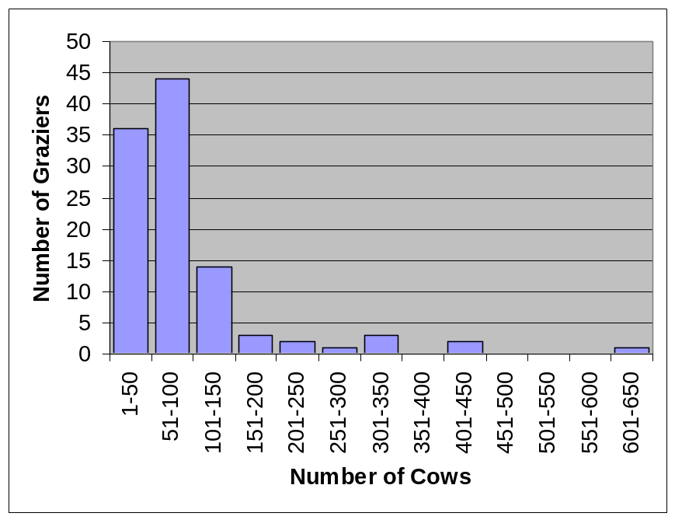
Percentage of graziers in a grazier network: 43.08% (56 /130)

Percentage of Graziers with Holstein Cows: 63.85% (83 /130)
Average # of Holsteins on a farm with Holstein Cows: 104.24 (56 /130)

NUMBER OF HOLSTEIN COWS GRAZED PER FARM
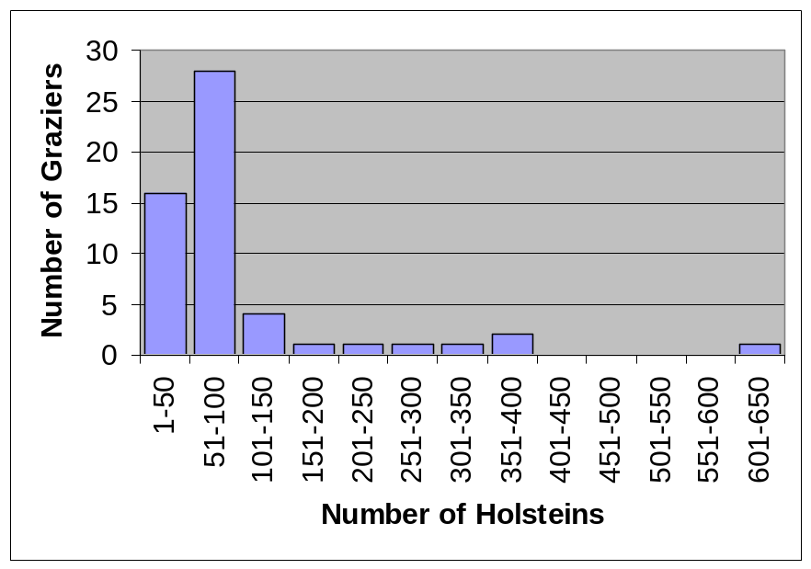

Percentage of Graziers with Beef Cows: 30.77% (30 /130)
Average # of Beef Cows on a farm with Beef Cows: 58.77 (23 /130)

NUMBER OF BEEF COWS GRAZED PER FARM
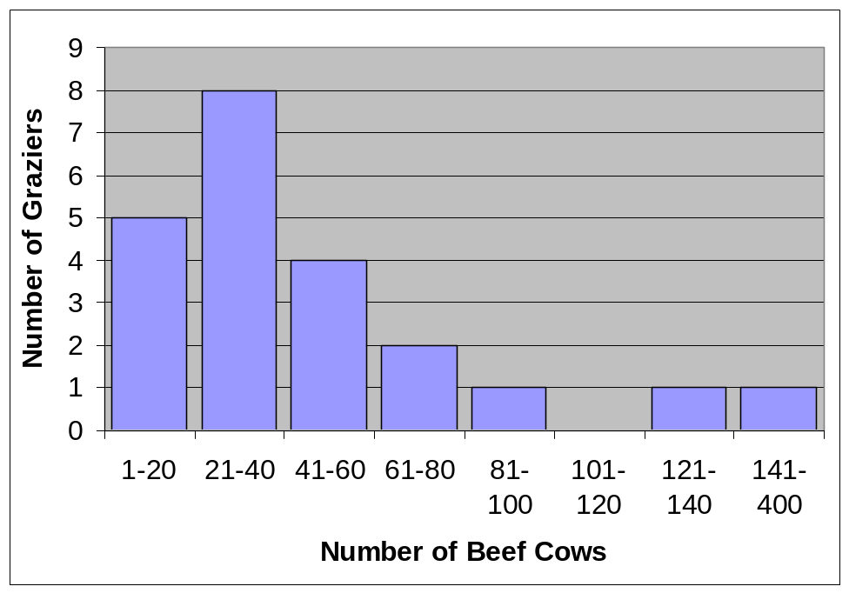

Hans Herzog
2485 Mill Road
Greenleaf, WI 54126
Phone: (920) 864-2177
E-Mail: ledgecrestdairy@mybluelight.com

BROWN
Has been a grazier for 1 year(s). Currently grazing 40 Holstein Cows and Poultry.

James M. Kehoe
2523 S Cty Rd P
Luxemburg, WI 54217-9358
Phone: (920) 863-6117
E-Mail: Pat764@cs.com

BROWN
Has been a grazier for 9 year(s). Current member of Grassworks grazing network. Currently grazing 275 Holstein Cows.

Jerry Potts
4092 Allen Rd.
Green Bay, WI 54311
Phone: (920) 863-2223
E-Mail: elkhillsranch.com

BROWN
Has been a grazier for 11 year(s). Currently grazing 175 Exotic Cows.

Tim Seiltz
4608 Redwood Dr.
Pulaski, WI 54162
Phone: (920) 865-7554
E-Mail: timsfarm@netnet.net

BROWN
Has been a grazier for 2 year(s). Currently grazing 12 Beef Cows.

Sam Vainisi
5587 State Hwy 29
Denmark, WI 54208
Phone: (920) 863-3609

BROWN
Has been a grazier for 9 year(s). Currently grazing 200 Deer.

Joe Wavrunek
6244 State Hwy 29
Luxemburg, WI 54217
Phone: (920) 863-8774
E-Mail: wauchern@aol.com

BROWN
Has been a grazier for 4 year(s). Currently grazing Holstein Cows.

Wayne Craig
N600 Plymouth Trail
New Holstein, WI 53061
Phone: (920) 894-4201
E-Mail: kwcraig@direcway.com

CALUMET
Has been a grazier for 8 year(s). Current member of Fond O' Grass grazing network. Operates a Swing 15 Milk Parlor. Currently grazing 105 Holstein and Beef Cows and Poultry.

David Geiser
N3287 Mill Rd.
New Holstein, WI 53061
Phone: (920) 849-4143

CALUMET
Has been a grazier for 7 year(s). Current member of Fond O' Grass grazing network. Operates a Double 4 Flat Milk Parlor. Currently grazing 350 Holstein Cows.

George A. Geiser
W2272 Hickory Hills Rd
Chilton, WI 53014
Phone: (920) 849-2571
E-Mail: ggeiser@tds.net

CALUMET
Has been a grazier for 5 year(s). Operates a Swing 7 Pit Parlor Milk Parlor. Currently grazing 150 Holstein Cows.

David Meuer
N2564 Hwy 151
Chilton, WI 53014
Phone: (920) 849-7816
E-Mail: themeuerfarm@juno.com

CALUMET
Has been a grazier for 7 year(s). Operates a Clay 4 Stall Freestall Milk Parlor. Currently grazing 45 Holstein, Jersey, Brown Swiss, and Cross Cows.

James Schaefer
W3892 Court Rd.
Chilton, WI 53014
Phone: (920) 849-2003
E-Mail: jchaefer@fdldotnet.com

CALUMET
Has been a grazier for 10 year(s). Current member of Fond O' Grass grazing network. Currently grazing 80 Holstein Cows.

Eric Wenig
W4830 Hwy 151
Chilton, WI 53014

CALUMET
Has been a grazier for 10 year(s). Currently grazing 60 Holstein Cows.

James Baerwolf
N417 Cty Hwy N
Columbus, WI 53925
Phone: (608) 825-2097

COLUMBIA
Has been a grazier for 8 year(s). Current member of Columbia Co. grazing network. Operates a Hemingbone Parlor Milk Parlor. Currently grazing 150 Dairy Cows.

Warren O'Brion
W4050 Palmer Rd.
Rio, WI 53960
Phone: (920) 992-3747

COLUMBIA
Has been a grazier for 12 year(s). Currently grazing 11 Beef Cows and 230 Sheep.

David W. Prochnow
W3250 Hwy 33
Cambria, WI 53923
Phone: (920) 348-5885

COLUMBIA
Has been a grazier for 6 year(s). Current member of Columbia Co. grazing network. Currently grazing 75 Beef Cows.

Sid Patey
N3941 Cty Hwy. J
Reeseville, WI 53579
Phone: (920) 927-3840

DODGE
Has been a grazier for 10 year(s). Current member of Dodge County grazing network. Currently grazing Guernsey Cows.

Carl Werner
N9129 Basswood Rd
Beaver Dam, WI 53916
Phone: (920) 885-4229

DODGE
Has been a grazier for 10 year(s). Current member of Dodge County grazing network. Currently grazing 90 Holstein Cows.

Mark Gilbert
3904 Brauer Rd.
Sturgeon Bay, WI 54235
Phone: (920) 743-7934
E-Mail: mrg7934@yahoo.com

DOOR
Has been a grazier for 11 year(s). Operates a 13 Swing Milk Parlor. Currently grazing 120 Cross Cows.

Kevin Kiehnau
6265 Kiehnau
Egg Harbor, WI 54209
Phone: (920) 743-5255
E-Mail: keyknow@doorpi.net

DOOR
Has been a grazier for 11 year(s). Current member of Northwestern grazing network. Currently grazing 100 Holstein Cows.

Gary Mosgaller
6388 Kiehnau Rd.
Egg Harbor, WI 54209
Phone: (920) 743-3708

DOOR
Has been a grazier for 10 year(s). Currently grazing 100 Holstein Cows.

Patrick Olson
6285 Salona Rd.
Sturgeon Bay, WI 54235
Phone: (920) 743-7797
E-Mail: pkolson@doorpi.net

DOOR
Has been a grazier for 30 year(s). Currently grazing 75 Holstein and Beef Cows.

David Smith
HC1 Box 377
Fence, WI 54120
Phone: (715) 336-3223

FLORENCE
Has been a grazier for 1 year(s). Currently grazing 30 Holstein Cows.

Greg Booher
140 W Waupun St.
Oakfield, WI 53065
Phone: (920) 583-3913
E-Mail: greg.booher@gotoltc.com

FOND DU LAC
Has been a grazier for 10 year(s). Current member of Fond O' Grass grazing network. Currently grazing 25 Holstein Cows.

Bruce Braun
W3583 Artesian Rd.
Fond Du Lac, WI 54935-9071
Phone: (920) 921-5600
E-Mail: knaps@execpc.com

FOND DU LAC
Has been a grazier for 6 year(s). Currently grazing 400 Laying Hens.

Dan Coehoorn
N5878 Hwy C
Rosendale, WI 54974
Phone: (920) 921-5541

FOND DU LAC
Has been a grazier for 2 year(s). Current member of Fox River Graziers grazing network. Currently grazing 55 Holstein Cows.

Dave Gessert
W1981 Cty HH
Malone, WI 53049

FOND DU LAC
Has been a grazier for 15 year(s). Currently grazing 7 Beef Cows and 90 Sheep.

Ken Gudex
W3543 State Rd. 67
Campbellsport, WI 53010
Phone: (920) 533-8015

FOND DU LAC
Has been a grazier for 7 year(s). Current member of Fond O' Grass grazing network. Currently grazing 55 Dairy Cows and Poultry and Goats.

Bob Guell
N3679 Mitchell Rd.
Campbellsport, WI 53010
Phone: (920) 477-7536

FOND DU LAC
Has been a grazier for 5 year(s). Current member of Guell Farms Inc. grazing network. Operates a Parabone Milk Parlor. Currently grazing 225 Holstein Cows.

Cliff Howard
N2056 Beechnut Dr.
Campbellsport, WI 53010
Phone: (920) 533-8413

FOND DU LAC
Has been a grazier for 8 year(s). Current member of Fond O' Grass grazing network. Currently grazing 54 Dairy Cows.

Jerry Huth
W9096 County AS
Oakfield, WI 53065
Phone: (920) 583-3223
E-Mail: jmmkhuth@thesurf.com

FOND DU LAC
Has been a grazier for 20 year(s). Currently grazing 130 Beef Cows.

Gerald Jaeger
N1387 Rolling Dr.
Campbellsport, WI 53010
Phone: (920) 533-4725
E-Mail: Jaeger@kmoraine.com

FOND DU LAC
Has been a grazier for 8 year(s). Current member of Fond O' Grass grazing network. Currently grazing 400 Holstein Cows.

Stuart Joas
N4046 Cty D
Oakfield, WI 53065
Phone: (920) 583-4313

FOND DU LAC
Has been a grazier for 9 year(s). Current member of Fond O' Grass grazing network. Currently grazing 140 Holstein and Beef Cows.

Mark A. Mueller
N352 Cty Rd. BB
Campbellsport, WI 53010
Phone: (920) 533-4635

FOND DU LAC
Has been a grazier for 10 year(s). Current member of Fond O' Grass grazing network. Currently grazing 60 Holstein Cows.

Joel Narges
N3756 Hwy 45
Eden, WI 53019
Phone: (920) 477-4207
E-Mail: dairyjoe45@yahoo.com

FOND DU LAC
Has been a grazier for 11 year(s). Current member of Fond O' Grass grazing network. Currently grazing 55 Holstein Cows.

Timothy J. Scannell
W1605 Homestead Ln.
Eden, WI 53019
Phone: (920) 477-5118

FOND DU LAC
Has been a grazier for 10 year(s). Current member of Fond O' Grass grazing network. Currently grazing 80 Holstein Cows.

DuWayne Schulz
W3965 St. Kilian Drive
Campbellsport, WI 53010
Phone: (262) 626-8749
E-Mail: DandJSchulz@hotmail.com

FOND DU LAC
Has been a grazier for 6 year(s). Current member of Fond O' Grass grazing network. Currently grazing 400 Beef Cows.

Daniel Wagner
W4748 Hwy 67
Campbellsport, WI 53010
Phone: (920) 269-4895

FOND DU LAC
Has been a grazier for 5 year(s). Current member of Fond O' Grass grazing network. Currently grazing Beef Cows.

Wayne Zills
W9476 Cty T
Rosendale, WI 54974
Phone: (920) 923-3455

FOND DU LAC
Has been a grazier for 8 year(s). Current member of Fond O' Grass grazing network. Currently grazing 53 Mixed Breed Dairy Cows.

Walt Wysocki
8109 County Line Rd.
Armstrong Creek, WI 54103
Phone: (715) 336-2351
E-Mail: acbison@cybrzn.com

FOREST
Has been a grazier for 25 year(s). Currently grazing 175 Bison.

Kalton Bauman
N2979 Cty Rds B & H
Markesan, WI 53946
Phone: (920) 394-3952
E-Mail: kbauman1@dotnet.com

GREEN LAKE
Has been a grazier for 5 year(s). Current member of Fox River Graziers grazing network. Currently grazing 60 Beef Cows and Poultry.

Jerry Friday
W3290 State Rd. 44/73
Markesan, WI 53946
Phone: (920) 398-2229
E-Mail: tgif@voyager.net

GREEN LAKE
Has been a grazier for 3 year(s). Current member of Fox River Graziers grazing network. Currently grazing 70 Beef Cows.

David Gneiser
N401 30th Dr.
Berlin, WI 54923
Phone: (920) 361-2269
E-Mail: <gneisers@yahoogroups.com

GREEN LAKE
Has been a grazier for 9 year(s). Current member of Fox River Graziers grazing network. Currently grazing 40 Holstein Cows.

James Quick
W1532 Blufften Rd.
Green Lake, WI 54941
Phone: (920) 294-6896
E-Mail: honeycreekfarm@centurytel.com

GREEN LAKE
Has been a grazier for 9 year(s). Current member of Fox River Graziers grazing network. Currently grazing 45 Beef Cows and Poultry.

Gary Swanke
W5095 Cty Rd. KK
Markesan, WI 53946
Phone: (920) 394-3197

GREEN LAKE
Has been a grazier for 6 year(s). Current member of Fox River Graziers grazing network. Currently grazing Holstein Cows.

Kevin Hildebrandt
W698 East River Drive
Oconomowoc, WI 53066
Phone: (262) 569-9602

JEFFERSON
Has been a grazier for 6 year(s). Current member of Dodge County grazing network. Currently grazing 30 Beef Cows and Poultry.

Dale Christoph
N4555 Cty Rd. V
Luxemburg, WI 54217
Phone: (920) 845-5709

KEWAUNEE
Has been a grazier for 3 year(s). Currently grazing 71 Holstein Cows.

Paul Hoagland
N7349 Red Birch Ln.
Algoma, WI 54201
Phone: (920) 837-7340
E-Mail: quietcreekranch@itol.com

KEWAUNEE
Has been a grazier for 8 year(s). Currently grazing Beef Cows, Poultry and Sheep.

Frank M. Hoida
E187 Hwy 29
Luxemburg, WI 54217
Phone: (920) 845-2076

KEWAUNEE
Has been a grazier for 4 year(s). Current member of Central Wisc. River grazing network. Currently grazing Holstein Cows.

Kevin Kadletz
N3166 Kadletz Rd.
Luxemburg, WI 54217
Phone: (920) 845-2568

KEWAUNEE
Has been a grazier for 4 year(s). Currently grazing 30 Holstein Cows.

Ken Kinstetter
E4078 Casco.W.Kew.Li.La.
Kewaunee, WI 54216
Phone: (920) 388-4595
E-Mail: libertyviewfarm@itol.com

KEWAUNEE
Has been a grazier for 8 year(s). Currently grazing 107 Holstein and Beef Cows.

Tony Knorn
E1939 Cty Hwy K
Casco, WI 54205
Phone: (920) 845-2240

KEWAUNEE
Has been a grazier for 6 year(s). Currently grazing Holstein Cows.

Grace Ann Matzke
E4964 Hwy 54
Algoma, WI 54201
Phone: (920) 487-2155

KEWAUNEE
Currently grazing 24 Jersey Cows.

Ron Paider
N1751 Co. V
Denmark, WI 54208
Phone: (920) 863-6913
E-Mail: roma-acres@juno.com

KEWAUNEE
Has been a grazier for 29 year(s). Currently grazing 50 Holstein Cows.

Perry Pavlat
E4340 Elm Rd.
Algoma, WI 54201
Phone: (920) 837-2165
E-Mail: pbhfrm@doorpi.net

KEWAUNEE
Has been a grazier for 3 year(s). Currently grazing 75 Holstein Cows.

Lee Treml
E2395 Cty Rd. A
Luxemburg, WI 54217
Phone: (920) 845-2427

KEWAUNEE
Has been a grazier for 9 year(s). Currently grazing 50 Holstein Cows.

Mike Wiericks
N6706 Crevice Rd.
Casco, WI 54205
Phone: (920) 837-7337

KEWAUNEE
Has been a grazier for 12 year(s). Currently grazing 70 Holstein Cows.

Jay Boldt
7120 CTH-C
Manitowoc, WI 54220
Phone: (920) 726-4807
E-Mail: Boldtdairy@lakefield.net

MANITOWOC
Has been a grazier for 1 year(s). Currently grazing 110 Holstein Cows.

Stephen Deibelo
15115 Lax Chapel Rd.
Kiel, WI 53042
Phone: (920) 894-1590
E-Mail: steve@deibele.com

MANITOWOC
Has been a grazier for 1 year(s). Currently grazing 25 Holstein and Beef Cows.

Todd Habermann
4511 Hwy 42
Manitowoc, WI 54220
Phone: (920) 758-2942

MANITOWOC
Has been a grazier for 1 year(s). Currently grazing Holstein and Brown Swiss Cows.

Mark Hansen
16210 Hwy M
Cleveland, WI 53015
Phone: (920) 565-3796

MANITOWOC
Has been a grazier for 8 year(s). Current member of Fond O' Grass grazing network. Currently grazing 183 Holstein, Beef, Jersey Cows and Goats.

Karl Klessig
6111 Cleveland Rd.
Cleveland, WI 53015
Phone: (920) 693-8161
E-Mail: KKlessig@excel.net
Fax: 693-3949

MANITOWOC
Has been a grazier for 10 year(s). Operates a New Zealand Swing 28 Bail Milk Parlor. Currently grazing 350 Holstein and Beef Cows.

Joe Kuitek
12827 Melnik Rd.
Whitlaw, WI 54247
Phone: (920) 755-2768

MANITOWOC
Has been a grazier for 12 year(s). Currently grazing 50 Aryshire Cows.

Tom L. Lensmire
11330 Cty Line Rd.
Cleveland, WI 53015
Phone: (920) 693-8737

MANITOWOC
Has been a grazier for 3 year(s). Currently grazing 60 Holstein Cows.

Mike Linsmeier
2033 Hwy H
Cato, WI 54230
Phone: (920) 732-3565
E-Mail: farmboys@lsol.net

MANITOWOC
Has been a grazier for 1 year(s). Currently grazing 60 Holstein Cows.

Michael Luebke
14527 Luebke Dr.
Maribel, WI 54227
Phone: (920) 863-6385
E-Mail: complete23@yahoo.com

MANITOWOC
Has been a grazier for 7 year(s). Currently grazing 50 Holstein Cows.

Tom Metz
17404 Nachtwey Rd.
Maribel, WI 54227
Phone: (920) 776-1527

MANITOWOC
Has been a grazier for 2 year(s). Currently grazing 55 Holstein Cows.

Bruce Riesterer
16231 Hilltop Rd.
Reedsville, WI 54230
Phone: (920) 775-9601

MANITOWOC
Has been a grazier for 6 year(s). Currently grazing 25 Beef Cows.

Mark Mroczenski
R773 Fir Lane
Athens, WI 54411
Phone: (715) 257-1485

MARATHON
Has been a grazier for 10 year(s). Current member of Central Wis. River Graziers grazing network. Currently grazing 80 Holstein Cows.

George Kowalski
W7255 Creek Rd.
Wausaukee, WI 54177
Phone: (715) 856-6573
E-Mail: cowpie@centurytel.com

MARINETTE
Has been a grazier for 4 year(s). Current member of Northland Graziers grazing network. Currently grazing 40 Holstein and Jersey Cows.

Thomas Nejedlo
W7826 Nejedlo Rd.
Wausaukee, WI 54177
Phone: (715) 856-5436
E-Mail: bigfarm@cybrzn.com

MARINETTE
Has been a grazier for 6 year(s). Current member of Northland Graziers grazing network. Currently grazing 85 Holstein Cows and 20 Goats.

Brent Richlen
W6190 Little River Rd.
Pestigo, WI 54157
Phone: (715) 789-3072

MARINETTE
Has been a grazier for 7 year(s). Currently grazing 60 Jersey and Mixed Dairy Cows.

Mary E. Anderson
9298 Elm Rd.
Suring, WI 54174
Phone: (920) 842-2194
E-Mail: chickensrus@ez-net.com

OCONTO
Has been a grazier for 2 year(s). Currently grazing 400 Chickens.

Tom DesJarlars Sr.
2551 Cty Rd A
Oconto, WI 54153
Phone: (920) 834-2206

OCONTO
Has been a grazier for 15 year(s). Currently grazing Beef Cows.

Cliff Fenendael
10790 Hickory Cemetary Rd.
Suring, WI 54174-9657
Phone: (920) 842-2073

OCONTO
Has been a grazier for 6 year(s). Current member of Marinette-Oconto grazing network. Currently grazing 100 Jersey Cows.

Glenn Lingard
7046 Cty Rd B
Oconto Falls, WI 54154
Phone: (920) 846-8126
E-Mail: lingarddairy@ez-net.com

OCONTO
Has been a grazier for 30 year(s). Currently grazing 100 Holstein Cows.

James Morrissey
9117 County B
Oconto Falls, WI 54154
Phone: (920) 829-5317

OCONTO
Has been a grazier for 15 year(s). Currently grazing Holstein, Beef Cows and Poultry.

Charles O'Harrow
8703 Gray Lake Rd.
Oconto Falls, WI 54154
Phone: (920) 846-2396

OCONTO
Has been a grazier for 15 year(s). Currently grazing 320 Holstein Cows.

David Olson
6366 Fredrickson Rd.
Lena, WI 54139
Phone: (920) 834-4587
Fax: 834-4587

OCONTO
Has been a grazier for 2 year(s). Currently grazing 60 Holstein Cows.

Johnny Stolk
3180 Volk Ln.
Oconto, WI 54153
Phone: (920) 834-9208

OCONTO
Has been a grazier for 6 year(s). Current member of Northland Graziers grazing network. Currently grazing 130 Holstein and Jersey Cows.

Williams Farm Co. Inc.
11008 Hwy 64 E
Suring, WI 54174
Phone: (715) 276-7655

OCONTO
Has been a grazier for 5 year(s). Currently grazing 36 Beef Cows.

Paul Yeager
13897 Pecore Rd.
Suring, WI 54174
Phone: (920) 842-2406
E-Mail: pj11yeager@ex-net.com

OCONTO
Has been a grazier for 4 year(s). Currently grazing 30 Llama.

Jill Martus-Ninitam
PO Box 365
Oneida, WI 54155
Phone: (920) 869-2718

ONEIDA NATION
Has been a grazier for 5 year(s). Currently grazing 33 Holstein, Beef, Galloway, Hereford, and Normandy.

Warren Barclay
N6912 French Rd.
Seymour, WI 54165
Phone: (920) 833-2009

OUTAGAMIE
Has been a grazier for 2 year(s). Currently grazing 45 Holstein Cows.

Paul Bernegger
N3154 Hwy 45
Hortonville, WI 54944
Phone: (920) 982-7739

OUTAGAMIE
Has been a grazier for 7 year(s). Currently grazing 650 Holstein Cows.

Michael Brugger
N9250 Cty Y
Seymour, WI 54165
Phone: (920) 833-9478
E-Mail: bruggs4@earthlink.net

OUTAGAMIE
Has been a grazier for 2 year(s). Currently grazing 11 Holstein and Brown Swiss Cows.

Robert D. Keune
W2402 Krueger Rd.
Seymour, WI 54165
Phone: (920) 788-4053
E-Mail: RJKFarm@aol.com

OUTAGAMIE
Has been a grazier for 4 year(s). Current member of Fox Valley Graziers grazing network. Currently grazing 30 Beef Cows.

Ben Muenster
N5084 French
Seymour, WI 54165
Phone: (920) 738-9182
E-Mail: olhomestead@aol.com

OUTAGAMIE
Has been a grazier for 2 year(s). Operates a Herring Bone Milk Parlor. Currently grazing 45 Holstein Cows.

Bob Schlimm
W5491 Hwy 55
Seymour, WI 54165
Phone: (920) 788-3387

OUTAGAMIE
Has been a grazier for 10 year(s). Currently grazing 100 Holstein Cows.

Eugene A. Wilkinson
N8849 Grandy Rd.
Black Creek, WI 54106
Phone: (920) 525-3965

OUTAGAMIE
Has been a grazier for 5 year(s). Operates a Surge Auto Flow dbl 6 Milk Parlor. Currently grazing 120 Holstein, Jersey, and Brown Swiss Cows.

Mark Dickmann
2155 Hillcrest Rd.
Saukville, WI 53080
Phone: (262) 284-0340

OZAUKEE
Has been a grazier for 40 year(s). Currently grazing 75 Beef and Exotic Cows.

Andy Large
4951 Six Mile Rd.
Port Washington, WI 53074
Phone: (262) 284-8993
E-Mail: kiansfarm@aol.com

OZAUKEE
Has been a grazier for 6 year(s). Current member of Fond O' Grass grazing network. Operates a Swing 8 Milk Parlor. Currently grazing 125 Holstein Cows.

Joseph H. Mueller
N6960 Hwy 57
Belgium, WI 53004
Phone: (920) 994-4069
E-Mail: jobish@aol.com

OZAUKEE
Has been a grazier for 3 year(s). Operates a Double 6 Herringbone Milk Parlor. Currently grazing 130 Holstein Cows.

John Pipkorn
12660 N. Granville Rd.
Mequon, WI 53097
Phone: (262) 242-7692
E-Mail: PIPbubanjo@aol.com

OZAUKEE
Has been a grazier for 10 year(s). Current member of Fond O' Grass grazing network. Operates a New Zealand Style in Progess Milk Parlor. Currently grazing 65 Holstein and Cross Cows.

Paul Onan
9659 Grayson Rd.
Amherst Jct, WI 54407
Phone: (715) 824-2527
E-Mail: ponan@wi-net.com

PORTAGE
Has been a grazier for 8 year(s). Current member of Waupaca-Portage grazing network. Operates a Swing 10 Milk Parlor. Currently grazing 60 Holstein and Beef Cows.

Dave Zinda
8145 6th St.
Amherst Jct., WI 54407
Phone: (715) 824-5672

PORTAGE
Has been a grazier for 4 year(s). Currently grazing 30 Beef Cows.

Ken Wolden
S4197A Buckeye Rd.
Rock Springs, WI 53961
Phone: (608) 524-6271

SAUK
Has been a grazier for 9 year(s). Current member of Sauk grazing network. Operates a Double-6 Parallel Milk Parlor. Currently grazing 160 Holstein Cows.

Rick Adamski
W2407 Hofa Park Rd.
Seymour, WI 54165
Phone: (920) 833-6704
E-Mail: radamski@itol.com

SHAWANO
Has been a grazier for 13 year(s). Operates a New Zealand Style Swing 7 Milk Parlor. Currently grazing 140 Holstein Cows.

Willis Bontrager
N3873 Valley Rd.
Bonduel, WI 54107
Phone: (715) 758-6709

SHAWANO
Has been a grazier for 1 year(s). Currently grazing 45 Holstein Cows.

Andy Cerveny
N5141 Leopolis Rd.
Leopolis, WI 54948
Phone: (715) 787-4406

SHAWANO
Has been a grazier for 2 year(s). Currently grazing 100 Holstein Cows.

John W. Dahlie
W8734 County A
Shawano, WI 54166
Phone: (715) 524-2053

SHAWANO
Has been a grazier for 5 year(s). Currently grazing 25 Beef Cows.

John DeBauch
W2720 Freebora Rd.
Cecil, WI 54111
Phone: (715) 745-2450

SHAWANO
Has been a grazier for 5 year(s). Currently grazing 50 Holstein Cows.

Mark Elsner
N683 Lawn Rd.
Seymour, WI 54165
Phone: (920) 833-7018

SHAWANO
Has been a grazier for 13 year(s). Currently grazing 60 Holstein, Jersey, Brown Swiss, Aryshire, and Cross.

William Kolaske
N1021 Lawn Rd.
Seymour, WI 54165
Phone: (920) 833-6126

SHAWANO
Has been a grazier for 7 year(s). Currently grazing Aryshire and Jersey Cows.

Ashley D. Mielke
W13638 Mavis Rd.
Marion, WI 54950
Phone: (715) 754-2183
E-Mail: farmergirl826@yahoo.com

SHAWANO
Has been a grazier for 10 year(s). Currently grazing Holstein Cows.

Robert Nett
N255 Herman Creek Rd.
Pulaski, WI 54162
Phone: (920) 833-7388

SHAWANO
Has been a grazier for 5 year(s). Currently grazing 50 Holstein Cows.

Brian Sohr
N3930 Townhall Ln.
Bonduel, WI 54107
Phone: (715) 758-8682

SHAWANO
Has been a grazier for 5 year(s). Currently grazing 45 Holstein Cows.

Joe Thelen
PO Box 327
Shawano, WI 54166
Phone: (715) 526-5228
E-Mail: miggab@frontiernet.net

SHAWANO
Has been a grazier for 30 year(s). Currently grazing 60 Beef Cows.

Steve Weerts
W8857 Cty Hwy A
Shawano, WI 54166
Phone: (715) 526-3834
E-Mail: pweerts@itol.com

SHAWANO
Has been a grazier for 5 year(s). Currently grazing 40 Beef Cows.

Wilbur E. Yoder
W5543 Lark Rd.
Shawano, WI 54166
Phone: (715) 758-6788

SHAWANO
Has been a grazier for 7 year(s). Currently grazing Holstein Cows.

Jerold Berg
W6084 St. Rd. 28
Cascade, WI 53011
Phone: (920) 528-8572
E-Mail: Bergmiseter@cs.com

SHEBOYGAN
Has been a grazier for 10 year(s). Current member of Fond O' Grass grazing network. Currently grazing 100 Holstein Cows.

Thomas Eake
601 N. Main St.
Sheboygan Falls, WI 53085
Phone: (920) 467-6089
E-Mail: Tom@Tom'sFencing.com

SHEBOYGAN
Has been a grazier for 1 year(s). Current member of Grassworks grazing network. Currently grazing Beef, Jersey, Exotic Cows and Poultry, Elk,Buffalo.

David Heidel
W6174 Cty Rd. SS
Random Lake, WI 53075
Phone: (920) 994-4044

SHEBOYGAN
Has been a grazier for 8 year(s). Current member of Fond O' Grass grazing network. Currently grazing 60 Holstein and Jersey Cows.

Geoff King
N2889 CTH W
Cascade, WI 53011
Phone: (920) 528-8773
E-Mail: gking.sai@excel.net

SHEBOYGAN
Has been a grazier for 14 year(s). Current member of Fond O' Grass grazing network. Currently grazing 300 Sheep.

Les Laack
N4668 Blueberry Rd.
Plymouth, WI 53073
Phone: (920) 893-0144

SHEBOYGAN
Has been a grazier for 9 year(s). Currently grazing 21 Holstein Cows.

Gerald Schulz
W8743 State Rd. 67
Plymouth, WI 53073
Phone: (920) 526-3512

SHEBOYGAN
Has been a grazier for 8 year(s). Currently grazing 70 Beef Cows.

Jeffrey Bawrk
W20572 Cty Rd. N
Arcadia, WI 54612

TREMPEALEAU
Currently grazing 100 Beef Cows.

Altfrid Krusenbaum
W3194 Cty Rd. D
Elkhorn, WI 53121
Phone: (262) 642-7312

WALWORTH
Has been a grazier for 11 year(s). Operates a Swingover 16 Milk Parlor. Currently grazing 220 Holstein, Beef Cows and Poultry.

Dan Arndt
9519 Camp Awana Rd.
Fredonia, WI 50021

WASHINGTON
Has been a grazier for 7 year(s). Currently grazing Beef Cows.

Ed Peters
2933 Pleasant Valley Rd.
West Bend, WI 53095
Phone: (262) 677-4840

WASHINGTON
Has been a grazier for 8 year(s). Current member of Fond O' Grass grazing network. Currently grazing 100 Holstein Cows.

Robert Eder
N3775 Ritchie Rd.
New London, WI 54961
Phone: (920) 867-2674
E-Mail: roberteder52@yahoo.com

WAUPACA
Has been a grazier for 10 year(s). Current member of Waupaca Co. Graziers grazing network. Operates a Swing 14 Milk Parlor. Currently grazing 150 Holstein, Jersey, Brown Swiss, and Cross Cows.

Matt Schweitzer
E6126 Progress Rd.
Manawa, WI 54949
Phone: (920) 596-1541

WAUPACA
Has been a grazier for 4 year(s). Currently grazing 45 Holstein, Jersey, and Brown Swiss Cows.

Richard De St. Aubin
W260 Cypress Dr.
Berlin, WI 54923
Phone: (920) 361-3046

WAUSHARA
Has been a grazier for 4 year(s). Current member of Fox River Graziers grazing network. Currently grazing 300 Hogs.

Lennie Nawakowski
N982 Cty Hwy X
Berlin, WI 54923
Phone: (920) 361-0169

WAUSHARA
Has been a grazier for 9 year(s). Current member of Fox River Graziers grazing network. Currently grazing 70 Holstein and Cross Cows and Poultry.

Albert Ihrig
5718 Grandview Rd.
Larsen, WI 54947
Phone: (920) 836-2994

WINNEBAGO
Has been a grazier for 6 year(s). Current member of Fox River Graziers grazing network. Currently grazing 60 Holstein Cows.

David Weiss
8252 Cty Rd E
Omro, WI 54963
Phone: (920) 685-6262

WINNEBAGO
Has been a grazier for 8 year(s). Current member of Fox River Graziers grazing network. Currently grazing 100 Holstein Cows.

Tom Wrchota
5200 O'Reilly Rd.
Omro, WI 54963
Phone: (920) 685-6964
E-Mail: wrchota@athenet.net

WINNEBAGO
Has been a grazier for 10 year(s). Current member of Fox River Graziers grazing network. Currently grazing 35 Beef Cows and 608 Chickens.

John Yost, III
6504 Yost Rd.
Omro, WI 54963
Phone: (920) 685-6227

WINNEBAGO
Has been a grazier for 8 year(s). Current member of Fox River Graziers grazing network. Currently grazing Holstein, Beef, and Exotic Cows.

QUICK REFERENCE

COUNTY NAME PAGE

HOLSTEIN

Brown Hans Herzog 11
Brown James M. Kehoe 11
Brown Joe Wavrunek 11
Calumet Wayne Craig 12
Calumet David Geiser 12
Calumet George A. Geiser 12
Calumet David Meuer 12
Calumet James Schaefer 12
Calumet Eric Wenig 12
Dodge Carl Werner 13
Door Kevin Kiehnau 14
Door Gary Mosgaller 14
Door Patrick Olson 14
Florence David Smith 14
Fond Du Lac Greg Booher 14
Fond Du Lac Dan Coehoorn 15
Fond Du Lac Bob Guell 15
Fond Du Lac Gerald Jaeger 16
Fond Du Lac Stuart Joas 16
Fond Du Lac Mark A. Mueller 16
Fond Du Lac Joel Narges 16
Fond Du Lac Timothy J. Scannell 16
Green Lake David Gneiser 17
Green Lake Gary Swanke 18
Kewaunee Dale Christoph 18
Kewaunee Frank M. Hoida 18
Kewaunee Kevin Kadletz 19
Kewaunee Ken Kinstetter 19
Kewaunee Tony Knorn 19
Kewaunee Ron Paider 19
Kewaunee Perry Pavlat 19
Kewaunee Lee Treml 20
Kewaunee Mike Wiericks 20
Manitowoc Jay Boldt 20
Manitowoc Stephen Deibelo 20
Manitowoc Todd Habermann 20
Manitowoc Mark Hansen 20
Manitowoc Karl Klessig 21
Manitowoc Tom L. Lensmire 21
Manitowoc Mike Linsmeier 21
Manitowoc Michael Luebke 21
Manitowoc Tom Metz 21
Marathon Mark Mroczenski 22
Marinette George Kowalski 22
Marinette Thomas Nejedlo 22
Oconto Glenn Lingard 23
QUICK REFERENCE

COUNTY NAME PAGE
Oconto James Morrissey 23
Oconto Charles O'Harrow 23
Oconto David Olson 23
Oconto Johnny Stolk 24
Oneida Nation Jill Martus-Ninitam 24
Outagamie Warren Barclay 24
Outagamie Paul Bernegger 24
Outagamie Michael Brugger 25
Outagamie Ben Muenster 25
Outagamie Bob Schlimm 25
Outagamie Eugene A. Wilkinson 25
Ozaukee Andy Large 26
Ozaukee Joseph H. Mueller 26
Ozaukee John Pipkorn 26
Portage Paul Onan 26
Sauk Ken Wolden 26
Shawano Rick Adamski 27
Shawano Willis Bontrager 27
Shawano Andy Cerveny 27
Shawano John DeBauch 27
Shawano Mark Elsner 27
Shawano Ashley D. Mielke 28
Shawano Robert Nett 28
Shawano Brian Sohr 28
Shawano Wilbur E. Yoder 29
Sheboygan Jerold Berg 29
Sheboygan David Heidel 29
Sheboygan Les Laack 29
Walworth Altfrid Krusenbaum 30
Washington Ed Peters 30
Waupaca Robert Eder 30
Waupaca Matt Schweitzer 31
Waushara Lennie Nawakowski 31
Winnebago Albert Ihrig 31
Winnebago David Weiss 31
Winnebago John Yost, III 32

BEEF

Brown Tim Seiltz 11
Calumet Wayne Craig 12
Columbia Warren O'Brion 13
Columbia David W. Prochnow 13
Door Patrick Olson 14
Fond Du Lac Dave Gessert 15
Fond Du Lac Jerry Huth 15
Fond Du Lac Stuart Joas 16
Fond Du Lac DuWayne Schulz 16
Fond Du Lac Daniel Wagner 17
QUICK REFERENCE

COUNTY NAME PAGE
Green Lake Kalton Bauman 17
Green Lake Jerry Friday 17
Green Lake James Quick 18
Jefferson Kevin Hildebrandt 18
Kewaunee Paul Hoagland 18
Kewaunee Ken Kinstetter 19
Manitowoc Stephen Deibelo 20
Manitowoc Mark Hansen 20
Manitowoc Karl Klessig 21
Manitowoc Bruce Riesterer 22
Oconto Tom DesJarlars Sr. 23
Oconto James Morrissey 23
Oconto Williams Farm Co. Inc. 24
Oneida Nation Jill Martus-Ninitam 24
Outagamie Robert D. Keune 25
Ozaukee Mark Dickmann 25
Portage Paul Onan 26
Portage Dave Zinda 26
Shawano John W. Dahlie 27
Shawano Joe Thelen 28
Shawano Steve Weerts 28
Sheboygan Thomas Eake 29
Sheboygan Gerald Schulz 30
Trempealeau Jeffrey Bawrk 30
Walworth Altfrid Krusenbaum 30
Washington Dan Arndt 30
Winnebago Tom Wrchota 31
Winnebago John Yost, III 32

JERSEY

Calumet David Meuer 12
Kewaunee Grace Ann Matzke 19
Manitowoc Mark Hansen 20
Marinette George Kowalski 22
Marinette Brent Richlen 22
Oconto Cliff Fenendael 23
Oconto Johnny Stolk 24
Oneida Nation Jill Martus-Ninitam 24
Outagamie Eugene A. Wilkinson 25
Shawano Mark Elsner 27
Shawano William Kolaske 28
Sheboygan Thomas Eake 29
Sheboygan David Heidel 29
Waupaca Robert Eder 30
Waupaca Matt Schweitzer 31

QUICK REFERENCE

COUNTY NAME PAGE

BROWN SWISS

Calumet David Meuer 12
Manitowoc Todd Habermann 20
Outagamie Michael Brugger 25
Outagamie Eugene A. Wilkinson 25
Shawano Mark Elsner 27
Waupaca Robert Eder 30
Waupaca Matt Schweitzer 31

OTHER COWS

Brown Jerry Potts 11
Calumet David Meuer 12
Columbia James Baerwolf 13
Dodge Sid Patey 13
Door Mark Gilbert 13
Fond Du Lac Ken Gudex 15
Fond Du Lac Wayne Zills 17
Oconto Paul Yeager 24
Oneida Nation Jill Martus-Ninitam 24
Ozaukee Mark Dickmann 25
Ozaukee John Pipkorn 26
Shawano Mark Elsner 27
Shawano William Kolaske 28
Sheboygan Thomas Eake 29
Waupaca Robert Eder 30
Waushara Lennie Nawakowski 31
Winnebago John Yost, III 32

POULTRY

Brown Hans Herzog 11
Calumet Wayne Craig 12
Fond Du Lac Bruce Braun 14
Fond Du Lac Ken Gudex 15
Green Lake Kalton Bauman 17
Green Lake James Quick 18
Jefferson Kevin Hildebrandt 18
Kewaunee Paul Hoagland 18
Oconto Mary E. Anderson 22
Oconto James Morrissey 23
Sheboygan Thomas Eake 29
Walworth Altfrid Krusenbaum 30
Waushara Lennie Nawakowski 31
Winnebago Tom Wrchota 31

QUICK REFERENCE

COUNTY NAME PAGE

GOATS

Fond Du Lac Ken Gudex 15
Manitowoc Mark Hansen 20
Marinette Thomas Nejedlo 22

SHEEP

Columbia Warren O'Brion 13
Fond Du Lac Dave Gessert 15
Kewaunee Paul Hoagland 18
Sheboygan Geoff King 29

EXOTIC

Brown Sam Vainisi 11
200 Deer
Forest Walt Wysocki 17
Bison
Oconto Paul Yeager 24
Llama
Sheboygan Thomas Eake 29
Deer, Elk, and Buffalo
Waushara Richard De St. Aubin 31
Hogs

Adamski, Rick 27
Anderson, Mary E. 22
Arndt, Dan 30
Baerwolf, James 13
Barclay, Warren 24
Bauman, Kalton 17
Bawrk, Jeffrey 30
Berg, Jerold 29
Bernegger, Paul 24
Boldt, Jay 20
Bontrager, Willis 27
Booher, Greg 14
Braun, Bruce 14
Brugger, Michael 25
Cerveny, Andy 27
Christoph, Dale 18
Coehoorn, Dan 15
Craig, Wayne 12
Dahlie, John W. 27
De St. Aubin, Richard 31
DeBauch, John 27
Deibelo, Stephen 20
DesJarlars Sr., Tom 23
Dickmann, Mark 25
Eake, Thomas 29
Eder, Robert 30
Elsner, Mark 27
Fenendael, Cliff 23
Friday, Jerry 17
Geiser, David 12
Geiser, George A. 12
Gessert, Dave 15
Gilbert, Mark 13
Gneiser, David 17
Gudex, Ken 15
Guell, Bob 15
Habermann, Todd 20
Hansen, Mark 20
Heidel, David 29
Herzog, Hans 11
Hildebrandt, Kevin 18
Hoagland, Paul 18
Hoida, Frank M. 18
Howard, Cliff 15
Huth, Jerry 15
Ihrig, Albert 31
Jaeger, Gerald 16
Joas, Stuart 16
Kadletz, Kevin 19
Kehoe, James M. 11
Keune, Robert D. 25
Kiehnau, Kevin 14
King, Geoff 29
Kinstetter, Ken 19
Klessig, Karl 21
Knorn, Tony 19
Kolaske, William 28
Kowalski, George 22
Krusenbaum, Altfrid 30
Kuitek, Joe 21
Laack, Les 29
Large, Andy 26
Lensmire, Tom L. 21
Lingard, Glenn 23
Linsmeier, Mike 21
Luebke, Michael 21
Martus-Ninitam, Jill 24
Matzke, Grace Ann 19
Metz, Tom 21
Meuer, David 12
Mielke, Ashley D. 28
Morrissey, James 23
Mosgaller, Gary 14
Mroczenski, Mark 22
Mueller, Joseph H. 26
Mueller, Mark A. 16
Muenster, Ben 25
Narges, Joel 16
Nawakowski, Lennie 31
Nejedlo, Thomas 22
Nett, Robert 28
O'Brion, Warren 13
O'Harrow, Charles 23
Olson, David 23
Olson, Patrick 14
Onan, Paul 26
Paider, Ron 19
Patey, Sid 13
Pavlat, Perry 19
Peters, Ed 30
Pipkorn, John 26
Potts, Jerry 11
Prochnow, David W. 13
Quick, James 18
Richlen, Brent 22
Riesterer, Bruce 22
Scannell, Timothy J. 16
Schaefer, James 12
Schlimm, Bob 25
Schulz, DuWayne 16
Schulz, Gerald 30
Schweitzer, Matt 31
Seiltz, Tim 11
Smith, David 14
Sohr, Brian 28
Stolk, Johnny 24
Swanke, Gary 18
Thelen, Joe 28
Treml, Lee 20
Vainisi, Sam 11
Wagner, Daniel 17
Wavrunek, Joe 11
Weerts, Steve 28
Weiss, David 31
Wenig, Eric 12
Werner, Carl 13
Wiericks, Mike 20
Wilkinson, Eugene A. 25
Williams Farm Co. Inc. 24
Wolden, Ken 26
Wrchota, Tom 31
Wysocki, Walt 17
Yeager, Paul 24
Yoder, Wilbur E. 29
Yost, III, John 32
Zills, Wayne 17
Zinda, Dave 26

