USDA Foreign Agricultural Service
GAIN Report

Global Agriculture Information Network
Template Version 2.09

Voluntary Report - public distribution
Date: 10/8/2004
GAIN Report Number: CH4616
CH6611
China, Peoples Republic of
Market Development Reports
Yide Lu Market: Emerging South China Powerhouse
2004

Approved by:
Keith Schneller

Prepared by:
Joshua Emmanuel Lagos

Report Highlights:
This report is the first in a series of reports on wholesale food markets located in South China. The Yide Lu Wholesale Market in Guangzhou has grown immensely since China opened its economy to the world, providing a distributional base for dry commodities, processed foods, and canned goods to almost every province in the mainland. Because of a growing demand for imported products, this market will become more significant for exporters wishing to become major players in China’s economy.

Includes PSD Changes: No
Includes Trade Matrix: No
Unscheduled Report
Guangzhou [CH3]
[CH]

History of Yide Lu

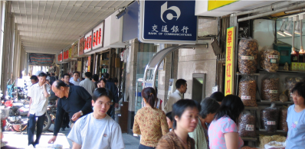
Located in the Yuexiu district of Guangzhou, Yide Lu has become one of the largest dried, processed, and canned food wholesale markets in China. The 1.2-kilometer busy commercial street owns over 2,500 private outlets and five large-scaled in-house marketing centers, which are two to three story buildings
filled with distributors.

Commerce began in Yide Lu after China opened its doors to the world economy during Chairman Deng’s leadership in the mid 1980s, and has gradually developed into a powerhouse since the early 1990s, providing distribution of imported food products to all of China.

Yide Lu Firms

Many wholesalers have been conducting business in Yide Lu for 5-10 years. In general, three types of firms exist: 1) importers/first-tier distributors; 2) first-tier distributors; and 3) second-tier distributors. Many of those businesses that are not importers have exclusive partnerships with importers in Hong Kong. First-tier and second-tier distributors sell directly to retailers; however, many of these firms have discontinued working with supermarkets due to tough payment terms and market service. According to Yide Lu wholesalers, it can take between 60-90 days to receive payment from Western style retailers, and if a certain product does not sell, it is returned to the wholesaler without compensation. Most first-tier wholesalers deal directly with second-tier distributors, who service “mom and pop” shops and traditional wet markets. In this environment, payment is expected within 20-30 days; otherwise, the transaction involves an electronic transfer or cash at the time of purchase.

Location is critical for success. Many Yide Lu firms have moved from different sites within the past several years in order to attract more business, often vying for locations that face the main street since these usually catch the attention of customers. Once an area is rented, its lease can last as long as 40 years.

Marketed Products
The Yide Lu market offers a variety of dried products such as shark fin, mussels, shrimp, mushrooms, squid, sardines, nuts, and legumes that are primarily used to make various types of Chinese soups. Many of these commodities come from Asia and the Pacific, such as Australia and Thailand, as well as South Africa, the Middle East, and Brazil. The US has a growing presence in sardines, mussels, and shark fin. Moreover, California almonds and pistachios are also readily available in this market.

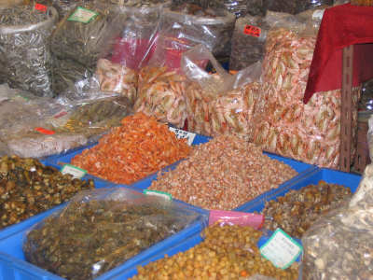

Regarding canned and processed foods, firms range from selling a lot of US products to almost none at all. Some identified items include: Kraft (parmesan cheese), Heinz tomato sauce and ketchup, Hershey’s chocolate syrup, Oregon blue berries, and Del Monte canned vegetables and fruits. Only one US wine, a red Carlo Rossi, was offered and came in two different sizes: 1.5 and 4 liter bottles. Many US branded products including candies such as Snickers are either produced locally or imported from joint ventures in Southeast Asia.

Commodity Promotion

Yide Lu distributors do not conduct any special promotions to sell imported products because they claim Chinese buyers understand the quality differences between local and foreign goods. Nonetheless, certain wholesalers stock specific commodities to meet buyers’ demands in order to differentiate themselves from their competitors. For instance, one wholesaler carries a larger quantity of Del Monte sweet corn and canned pineapple mixed in heavy syrup, and claims that he has been able to attract more clientele within this niche market than his business rivals. In addition, repeat customers can receive special deals, such as lower prices if they buy in bulk.

Gray Channel Items
Many South China food distributors have a rich history dealing with Hong Kong brokers who usually have family ties. When China was closed to the rest of the world years ago, many desperate families were forced to smuggle in food products to feed their relatives on the Mainland. Food supplies are now abundant on the Mainland, but many of these relationships still exist and many wholesome-food products from outside China arrive in the market place without proper Chinese labels.

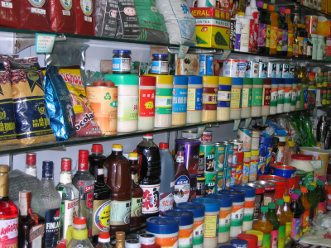

There are many food safety concerns in the China market at the present time, so many consumers are willing to pay more for well known, Western brands. However, Chinese officials have also been cracking down on illegal smuggling of food products into China to ensure food safety and to better collect tax revenues. Many exporters and importers utilize stickers to meet the Chinese labeling requirements, but it is highly recommended that US companies invest in actual Chinese labels on their food exports to China. In the coming weeks, we will prepare a report describing the foreign food registration process and current labeling requirements for processed foods.

Exporters and Business Relationships

Exporters do not necessarily conduct all of their business in Hong Kong, and often travel to Guangzhou to meet the mainland distributors and to learn more details about the market. In addition, Yide Lu wholesalers are very interested in meeting US exporters to not only discuss market issues and future purchases, but to strengthen their business relationship in order to ensure continued partnership. This has it advantages since Yide Lu firms influence what their partners in Hong Kong are willing to import. Many of these distributors praise US products for their high quality and are willing to stock more items to sell to high-end users. Several of the wholesalers also have import licenses and are eager to do more business directly, thereby, bypassing Hong Kong middlemen.

Chinese Buyers
Yide Lu attracts buyers from all parts of China, including Beijing, ShangHai, and even remote areas such as Xinjiang. Although a strong relationship exists between customers and the different wholesalers in the Yide Lu market, Chinese buyers care about two main issues: price and quality. Many customers trust the quality of the products that certain wholesalers provide and, for this reason, conduct business with only specific distributors. But price is also important. For example, one wholesaler claimed that he
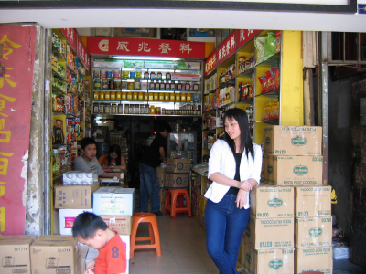

would be interested in acquiring more legal imports, but was afraid that his competitors, who primarily imported gray channel items, would take away his business. As a result, relationships are important, but price has a heavy influence.

Western style supermarkets including foreign retailers such as Wal-Mart, Carrefour, Metro, and Park'nShop are very demanding of their food suppliers. They not only require the lowest prices and most favorable payment terms, but also demand proper invoices and documentation. Therefore, many wholesalers have a strong preference to deal with wet markets that are not concerned about documentation issues, deal in cash transactions, and require very little after-sales support. Although it appears wet markets will continue to serve lower income consumers for the next few years, more and more Chinese are turning to Western style supermarkets that provide better quality products, higher hygienic standards, and more transparent prices. As the authorities continue to crack down on gray channel trade, there will be more direct imports of high quality food products with proper documentation and labeling providing more opportunities for US products.

Yide Lu Map

 | Renmin Nanlu |  |  | Renji Lu |  | Huijuan Jie |  |  | Tiancheng Lu |  |  | Haizhu NanLu |  |  |  |  |  |  |  |  |  |  |  | Laodong Lu |  |  |  |  |  |  | Jiefang Nanlu
 | Renmin Nanlu | 3/4 |  | Renji Lu | 4 | Huijuan Jie | 3/4 |  | Tiancheng Lu | 3/5 |  | Haizhu NanLu | 6/7 |  |  | 6 |  |  | 6/7 |  |  |  |  | Laodong Lu | 7/8 |  |  | 3/5/8
 | Yide Lu
 | Renmin Nanlu | 1 | 2 | Renji Lu | 3 | Huijuan Jie | 3 | 5 |  | 3 | 3/5 | Haizhu NanLu | 6 |  |  | 6  6 |  |  |  | 6  6/7 |  | 6/7 | 7/8 |  | 7/8/9 | Guacai Zhijie | 7/8/9 |  | Jinghai Lu | 3/5 |  | Jiefang Nanlu
 | Renmin Nanlu |  |  | Renji Lu |  | Huijuan Jie |  |  |  |  | 6 | Haizhu NanLu | 6 |  |  |  |  |  |  |  |  |  |  |  |  | Guacai Zhijie |  |  | Jinghai Lu |  |  | Jiefang Nanlu
 |  |  |  |  |  |  |  |  |  |  | 6 | Haizhu NanLu
 |  |  |  |  |  |  |  |  |  |  |  |  | 6
Yangting
Danjie

 |  |  |  |  |  |  |  |  |  |  |  |  | 6

Legend

- Amusement Park

- Under Construction

- Bags, Plastics, Party Supplies

- Hardware, Cooking-ware

- Toys, Jewelry

- Dry Goods: Shark Fins, Octopus, Squid, Shrimp, Mussels, Nuts (i.e. Pistachios), Mushrooms, Legumes

- Processed Foods, Canned Goods

- Confectionary

- Wine/Liquor

