
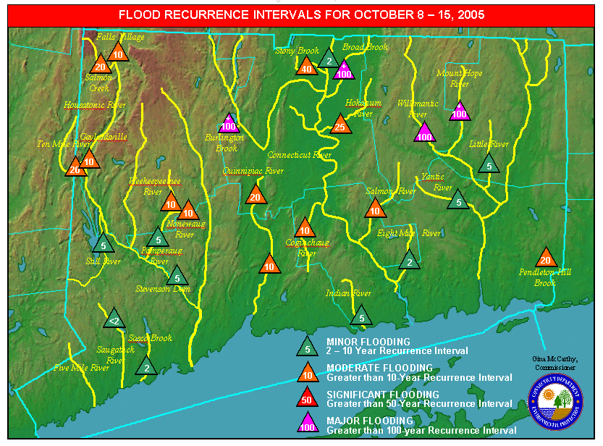

Jane Stahl
Deputy
Commissioner

Yvonne Bolton
Bureau Chief
Water Management
Bureau

Denise Ruzicka
Director
Inland Water Resources Division

Arthur Christian
State Hazard Mitigation Officer

Douglas Glowacki
Environmental
Analyst III

Author:
Douglas Glowacki

State Of Connecticut
Department Of Environmental

Protection

Gina McCarthy, Commissioner October, 2005

Bureau of Water Management
Reviewed Draft

Heavy Rains & Flooding of Sub-Regional Drainage Basins

October 7 – 15, 2005

Inland Water Resources Division

Water Management Bureau

79 Elm Street, Hartford, Connecticut 06106 Phone: 860-424-3706

TABLE OF CONTENTS

Executive Summary 1

Summary of Storm Event 1

Recurrence Interval Analysis 2

TABLES

Table 1 – Flow Recurrence Intervals for October 7 – 10, 2005 3

Table 2 – Flow Recurrence Intervals for October 14 – 15, 2005 4

Table 3 – Hourly Precipitation October 7 – 15, 2005 5

FIGURES

Figure 1 – Friday/Saturday and Storm Total Rainfall 9

Figure 2 - Connecticut Dams Which Breached or Partially Breached 10

Figure 3 - Map of Flood Recurrence Intervals for October 8 – 15, 2005 11

APPENDIX

Hydrographs of rivers monitored by the USGS in Connecticut.

EXECUTIVE SUMMARY

During the week of October 7 – 15, 2005 the State of Connecticut was struck by two very heavy rainfall events. Combined, the rainfall from these two events totaled 9 – 16 inches across the state. This rainfall resulted in major flooding of several sub-regional river basins in Hartford and Tolland Counties on October 14 – 15, 2005. Widespread moderate flooding occurred across the rest of the Connecticut. This has already been the wettest October on record since 1905 as measured at Bradley International Airport in Windsor Locks, Connecticut.

A total of 10 dams breached, were partially breached or were damaged mainly in Hartford and Tolland Counties. Several bridges failed and several dozen roads were washed out or undermined. Many homes suffered flooded basements, and evacuations were conducted in some towns due to severe flooding of urban areas and small streams. In addition the Natural Resources Conservation Service reported that they were investigating four potential Emergency Watershed Protection Projects.

Since the major flooding of June, 1982 the State of Connecticut has undertaken several measures which have greatly improved the State’s ability to respond to this flooding event. The installation of an Automated Flood Warning system in 1986, and it’s subsequent expansions in 1992, 1996, and 1998 proved invaluable during this flooding event. Recent projects that also provided critical information during the storm include the creation of an electronic inventory of high hazard dams in Connecticut and Critical Facilities Mapping. The sharing of river stage and rainfall data between Connecticut agencies, the National Weather Service and the United States Geological Survey greatly enhanced the effectiveness of the state and local flood response effort.

Since 1988 Connecticut has suffered from three major disasters requiring presidential disaster declarations. The receipt of federal funds has brought with it a commitment by the State to mitigate the effects of these disasters. The State completed Hazard Mitigation Plans in 1990, 1993 and 1999 as a result of these disasters. In 2004, Connecticut received approval from the Federal Emergency Management Agency for the most recent update of our State Natural Hazard Mitigation Plan as per the requirements of the Disaster Mitigation Act of 2000. This makes Connecticut potentially eligible for hazard mitigation funding equal to 7.5% of the total public assistance damages after a Presidentially declared natural disaster.

SUMMARY OF THE STORM EVENT

On October 7th, 2005, a low pressure system (the remnants of Hurricane Tammy) moved slowly up the eastern seaboard along a stalled frontal boundary. A wide band of heavy rainfall developed along the U.S. East Coast stretching from South Carolina to Northern New England. Heavy rainfall associated with the remnants of Tammy and a surface low that formed south of Tammy moved into Connecticut at 7:00 PM on Friday evening on October 7th. Rainfall continued heavy at times for the next 36 hours and ended on Sunday morning around 3:00 AM. Rainfall totals during the first part of this storm ranged from 4 inches in Southeastern Connecticut up to 12 inches in the Northwest Hills. Flooding from this first rainfall event was minor across most areas with flood frequencies of less than 5-years in most areas. Flooding was minor during the October 7 – 9 event due to very dry antecedent soil and river conditions prior to the storm. However, this first event set the stage for the second event leaving saturated soils and river basins at ½ to ¾ bank full conditions.

Light to moderate rainfall continued across Connecticut during the next 4 days keeping soils saturated and river channels running at ½ to ¾ bank full. On Friday October 14th, a surface low pressure system formed suddenly along a frontal boundary south of Long Island and moved Northeastward into Southern New England. A wide area of very heavy rainfall developed Friday evening and overspread all of Southern New England. Rain began falling at a rate of nearly an inch an hour at 9:00 PM in Western Connecticut. This heavy rainfall continued for 2 – 3 hours over Western Connecticut resulting in 2 – 4 inches of rainfall. As the area of heavy rain moved East it intensified and rainfall rates exceeded one

inch per hour in Central and Northeastern Connecticut late Friday night and into the early hours of Saturday morning. Rainfall totals in Central and Northeastern Connecticut ranged from 6 – 8 inches during a 7-hour period Friday night from approximately 10:00 PM to 5:00 AM Saturday morning. This extremely heavy rainfall combined with the total saturation of soils resulted in a very rare (100-year) flooding event in North Central and Northeastern Connecticut.

RECURRENCE INTERVAL ANALYSIS¹

First Event October 7 – 10, 2005

Rainfall recurrence intervals¹ were much greater than recurrence intervals for flows during the first event due to the abnormally dry conditions prior to the event. Approximately 5 inches of rainfall was absorbed by the abnormally dry soils during the first event. The average recurrence intervals for rainfall ranged from 10 – 100 years in western Connecticut, however the resulting flows only averaged between 2 – 10 years. In central and eastern Connecticut rainfall recurrence intervals ranged from 1 – 5 years with flow recurrence intervals generally below the 2 year storm. No dam failures were reported and a significant slope failure occurred in Montville, Connecticut at the Montville Commons construction site.

Second Event October 14 – 15, 2005

In the second event, the recurrence intervals for flow (see map on page 11) were generally very close to the recurrence intervals for rainfall (only seen in saturated soils). No significant soil absorption occurred and all of the heavy rainfall immediately ran off into brooks and streams. The average recurrence intervals for rainfall in Hartford, Tolland and Windham Counties met or exceeded the 100-year storm in most locations. Rainfall recurrence intervals ranged from 2 – 50 years across the rest of the state. The resulting stream flows in Hartford and Tolland counties ranged from 10 – 100+ years on several sub-regional drainage basins. Recurrence intervals generally ranged from 5 – 20 years on the remaining rivers in Connecticut.

¹ Recurrence intervals for rainfall were calculated using National Weather Service Technical Paper #40 (1963) rainfall
distribution curves for Connecticut. Recurrence intervals for flows were determined by the United States Geological Survey
office in East Hartford, Connecticut.

Table 1 - Flow Recurrence Intervals¹ for October 7 – 10, 2005

Station  Number | Station Name | Flow (CFS) | Recurrence Interval  Comments
01118300 | PENDLETON HILL BROOK NEAR CLARKS FALLS, CT. | NA | Equipment Failure
01119040 | POQUONOCK RIVER NEAR GROTON, CT. | NA | Not Available
01119500 | WILLIMANTIC RIVER NEAR COVENTRY, CT. | 1160 | <2-year
01121000 | MOUNT HOPE RIVER NEAR WARRENVILLE, CT. | 463 | <2-year
01122000 | NATCHAUG RIVER AT WILLIMANTIC, CT. | Controlled | Flood Control
01122500 | SHETUCKET RIVER NEAR WILLIMANTIC, CT. | Controlled | Flood Control
01123000 | LITTLE RIVER NEAR HANOVER, CT. | 130 | <2-year
01124000 | QUINEBAUG RIVER AT QUINEBAUG, CT. | Controlled | Flood Control
01125500 | QUINEBAUG RIVER AT PUTNAM, CT | Controlled | Flood Control
01127000 | QUINEBAUG RIVER AT JEWETT CITY, CT. | Controlled | Flood Control
01127500 | YANTIC RIVER AT YANTIC, CT. | 251 | <2-year
01172010 | CONNECTICUT R AT HOLYOKE | NA | Not Available
01184000 | CONNECTICUT RIVER AT THOMPSONVILLE, CT. | 114,000 | <5-year
01184100 | STONY BROOK NEAR WEST SUFFIELD, CT. | 393 | ≈2-year
01184490 | BROAD BROOK AT BROAD BROOK, CT. | 226 | <2-year
01186000 | WEST BRANCH FARMINGTON RIVER AT RIVERTON, CT | Controlled | Flood Control
01186500 | STILL RIVER AT ROBERTSVILLE, CT. | Controlled | Flood Control
01188000 | BURLINGTON BROOK NEAR BURLINGTON, CT. | 403 | ≈5-year
01188090 | FARMINGTON RIVER AT UNIONVILLE, CT. | Controlled | Flood Control
01189995 | FARMINGTON RIVER AT TARIFFVILLE, CT. | Controlled | Flood Control
01190070 | CONNECTICUT RIVER AT HARTFORD, CT. | Tidal | Stage 20.9 Feet
01192500 | HOCKANUM RIVER NEAR EAST HARTFORD, CT. | 1330 | ≈2-year
01192883 | COGINCHAUG RIVER AT MIDDLEFIELD, CT | 320 | <2-year
01193000 | CONNECTICUT RIVER AT MIDDLETOWN, CT. | Tidal | Stage 11.9 Feet
01193500 | SALMON RIVER NEAR EAST HAMPTON, CT. | 729 | <2-year
01194500 | EAST BRANCH EIGHTMILE RIVER NEAR NORTH LYME, CT. | 66 | Not Ranked
01194796 | CONNECTICUT RIVER AT OLD LYME, CT | NA | Not Available
01195100 | INDIAN RIVER NEAR CLINTON, CT. | 50 | <2-year
01195490 | QUINNIPIAC RIVER AT SOUTHINGTON, CT. | 506 | <2-year
01196500 | QUINNIPIAC RIVER AT WALLINGFORD, CT. | 2260 | 2-year
01199000 | HOUSATONIC RIVER AT FALLS VILLAGE, CT. | 10300 | 10-year
01199050 | SALMON CREEK AT LIME ROCK, CT. | 2020 | ≥10-year
01200000 | TENMILE RIVER NEAR GAYLORDSVILLE, CT | 4610 | 5-year
01200500 | HOUSATONIC RIVER AT GAYLORDSVILLE, CT. | 11100 | =2-year
01201487 | STILL RIVER AT ROUTE 7 AT BROOKFIELD CENTER, CT. | 1290 | =2-year
01202501 | SHEPAUG RIVER AT PETERS DAM AT WOODVILLE, CT | NA | Not Available
01203600 | NONEWAUG RIVER AT MINORTOWN, CT. | 1220 | <2-year
01203805 | WEEKEEPEEMEE RIVER AT HOTCHKISSVILLE, CT | NA | Not Available
01204000 | POMPERAUG RIVER AT SOUTHBURY, CT. | 1810 | <2-year
01205500 | HOUSATONIC RIVER AT STEVENSON, CT. | 29500 | ≈5-year
01206900 | NAUGATUCK RIVER AT THOMASTON, CT. | NA | Not Available
01208500 | NAUGATUCK RIVER AT BEACON FALLS, CT. | 7820 | Flood Control
01208950 | SASCO BROOK NEAR SOUTHPORT, CT. | 228 | ≤2-year
01208990 | SAUGATUCK RIVER NEAR REDDING, CT. | 266 | <2-year
01209761 | FIVEMILE RIVER NEAR NEW CANAAN, CT. | 30 | No Statistics
01209901 | RIPPOWAM RIVER AT STAMFORD, CT. | 910 | No Statistics

¹Recurrence and stream flow data provided by the United States Geological Survey in East Hartford, Connecticut. This is provisional data.

Table 2 - Flow Recurrence Intervals for October 14 – 5, 2005

Station  Number | Station Name | Flow (CFS) | Recurrence Interval  Comments
01118300 | PENDLETON HILL BROOK NEAR CLARKS FALLS, CT. | 290 | 20-year
01119040 | POQUONOCK RIVER NEAR GROTON, CT. | Tidal | Not Available
01119500 | WILLIMANTIC RIVER NEAR COVENTRY, CT. | 12,300 | 100-year
01121000 | MOUNT HOPE RIVER NEAR WARRENVILLE, CT. | 5,120 | +100-year
01122000 | NATCHAUG RIVER AT WILLIMANTIC, CT. | Controlled | Flood Control
01122500 | SHETUCKET RIVER NEAR WILLIMANTIC, CT. | Controlled | Flood Control
01123000 | LITTLE RIVER NEAR HANOVER, CT. | 1,080 | 5-year
01124000 | QUINEBAUG RIVER AT QUINEBAUG, CT. | Controlled | Flood Control
01125500 | QUINEBAUG RIVER AT PUTNAM, CT | Controlled | Flood Control
01127000 | QUINEBAUG RIVER AT JEWETT CITY, CT. | Controlled | Flood Control
01127500 | YANTIC RIVER AT YANTIC, CT. | 2,920 | 5-year
01172010 | CONNECTICUT R AT HOLYOKE | NA | Not Available
01184000 | CONNECTICUT RIVER AT THOMPSONVILLE, CT. | 114,000 | 2-year (On 10/10/2005)
01184100 | STONY BROOK NEAR WEST SUFFIELD, CT. | 1,700 | 40-year
01184490 | BROAD BROOK AT BROAD BROOK, CT. | NA | +100-year (Gauge Destroyed)
01186000 | WEST BRANCH FARMINGTON RIVER AT RIVERTON, CT | Controlled | Flood Control
01186500 | STILL RIVER AT ROBERTSVILLE, CT. | Controlled | Flood Control
01188000 | BURLINGTON BROOK NEAR BURLINGTON, CT. | 1,810 | +100-year
01188090 | FARMINGTON RIVER AT UNIONVILLE, CT. | 1,620 | Flood Control
01189995 | FARMINGTON RIVER AT TARIFFVILLE, CT. | 10,400 | Minor Flood Control
01190070 | CONNECTICUT RIVER AT HARTFORD, CT. | Tidal | Stage 20.7 Feet
01192500 | HOCKANUM RIVER NEAR EAST HARTFORD, CT. | 3,140 | 25-year
01192883 | COGINCHAUG RIVER AT MIDDLEFIELD, CT | 1,640 | 10-year
01193000 | CONNECTICUT RIVER AT MIDDLETOWN, CT. | Tidal | Stage 12.2 Feet
01193500 | SALMON RIVER NEAR EAST HAMPTON, CT. | 5,170 | 5-10-year
01194500 | EAST BRANCH EIGHTMILE RIVER NEAR NORTH LYME, CT. | 639 | 2-year
01194796 | CONNECTICUT RIVER AT OLD LYME, CT | Tidal | Not Available
01195100 | INDIAN RIVER NEAR CLINTON, CT. | 329 | 5-year
01195490 | QUINNIPIAC RIVER AT SOUTHINGTON, CT. | 837 | 20-year
01196500 | QUINNIPIAC RIVER AT WALLINGFORD, CT. | 3,940 | 10-year
01199000 | HOUSATONIC RIVER AT FALLS VILLAGE, CT. | 10300 | 10-year (On 10/10/2005)
01199050 | SALMON CREEK AT LIME ROCK, CT. | 2020 | 20-year (On 10/10/2005)
01200000 | TENMILE RIVER NEAR GAYLORDSVILLE, CT | 7,380 | 10-20-year
01200500 | HOUSATONIC RIVER AT GAYLORDSVILLE, CT. | 20,700 | Not Determined
01201487 | STILL RIVER AT ROUTE 7 AT BROOKFIELD CENTER, CT. | 1,820 | Not Determined
01202501 | SHEPAUG RIVER AT PETERS DAM AT WOODVILLE, CT | NA | Not Available
01203600 | NONEWAUG RIVER AT MINORTOWN, CT. | 3,250 | 10-year
01203805 | WEEKEEPEEMEE RIVER AT HOTCHKISSVILLE, CT | 3,300 | 10-year
01204000 | POMPERAUG RIVER AT SOUTHBURY, CT. | 4,490 | 5-year
01205500 | HOUSATONIC RIVER AT STEVENSON, CT. | 40,900 | 5-year
01206900 | NAUGATUCK RIVER AT THOMASTON, CT. | NA | Flood Control
01208500 | NAUGATUCK RIVER AT BEACON FALLS, CT. | NA | Flood Control
01208950 | SASCO BROOK NEAR SOUTHPORT, CT. | 252 | 2-year
01208990 | SAUGATUCK RIVER NEAR REDDING, CT. | 487 | <2-year
01209761 | FIVEMILE RIVER NEAR NEW CANAAN, CT. | NA | No Statistics
01209901 | RIPPOWAM RIVER AT STAMFORD, CT. | 903 | No Statistics
¹Recurrence and stream flow data provided by the United States Geological Survey in East Hartford, Connecticut. This is provisional data.

TABLE 3 - STORM OF OCTOBER 7 - 15, 2005 Page 1 of 4
 |  |  |  |  |  |  | HOURLY PRECIPITATION
DATE |  |  | A.M. HOUR ENDING |  |  |  |  |  |  |  |  |  |  |  | P.M. HOUR ENDING
 |  | 1 | 2 | 3 | 4 | 5 | 6 | 7 | 8 | 9 | 10 | 11 | 12 | 1 | 2 | 3 | 4 | 5 | 6 | 7 | 8 | 9 | 10 | 11 | 12 | TOTALS
 |  | SHARON WS DEVICE #705 - CONNECTICUT ALERT SYSTEM - 41:49:38 N 73:25:12 W ELEVATION 1160 FEET
 | 7 |  |  |  |  |  |  |  |  |  |  |  |  |  |  | .04 |  |  |  | .04 | .04 | .08 | .08 | .08 | .08 | 0.44
 | 8 | .08 | .08 | .20 | .08 | .20 | .24 | .20 | .43 | .43 | .31 | .08 | .20 | .55 | .28 | .20 | .31 | .47 | .39 | .31 | .35 | .63 | .71 | .75 | .75 | 8.23
 | 9 | .31 | .04 | .16 |  |  |  |  |  |  |  |  |  |  |  |  |  |  |  |  |  |  |  |  |  | 0.51
 | 10 |  |  |  |  | .04 |  |  |  |  |  |  |  |  |  |  |  |  |  |  |  |  |  |  |  | 0.04
 | 11 |  |  |  |  |  |  |  |  |  |  |  |  |  |  |  |  |  |  |  |  |  |  |  |  | 0.00
 | 12 |  | .04 |  | .04 | .04 | .08 |  | .04 |  |  | .04 | .12 | .12 | .20 | .04 | .16 | .04 |  | .04 |  |  |  |  |  | 1.00
 | 13 |  | .08 |  | .12 | .08 | .04 |  | .04 | .08 | .04 | .04 | .04 | .04 | .04 |  |  |  |  |  |  |  |  | .08 |  | 0.72
 | 14 | .08 |  |  |  |  |  |  |  |  |  |  | .04 | .04 | .16 | .31 | .24 | .35 | .24 | .08 | .35 | .87 | .79 | .20 | .08 | 3.83
 | 15 | .04 |  |  | .04 | .04 | .04 |  | .04 |  |  |  |  |  |  |  | .08 |  |  |  |  |  |  |  |  | 0.28
 |  |  |  |  |  |  |  |  |  |  |  |  |  |  |  |  |  |  |  |  |  | STORM TOTAL |  |  |  | 15.05
 | RIDGEFIELD PRECIP. DEVICE #575 - CONNECTICUT ALERT SYSTEM - 41:17:30 N 73:29:30 W ELEVATION 580 FEET
 | 7 |  |  |  |  |  |  |  | .04 |  |  |  |  | .16 | .12 |  |  |  |  | .08 | .08 |  | .04 | .04 | .04 | 0.60
 | 8 | .04 | .04 | .08 | .20 | .08 | .24 | .20 | .28 | .51 | .16 | .04 | .24 | .12 | .08 | .16 | .51 | .24 | .39 | .28 | .28 | .35 | .51 | .47 | .35 | 5.85
 | 9 | .24 | .08 |  |  |  |  |  |  |  |  |  |  |  |  |  |  |  |  |  |  |  |  |  |  | 0.32
 | 10 |  |  |  |  |  |  |  |  |  |  |  |  |  |  |  | .04 |  |  |  |  |  |  | .04 |  | 0.08
 | 11 |  |  | .08 |  |  |  |  |  |  |  |  |  |  |  |  |  |  |  |  |  |  |  |  |  | 0.08
 | 12 |  | .16 | .20 | .20 | .31 | .20 | .24 | .20 | .20 | .08 | .16 | .31 | .28 | .28 | .08 | .16 | .16 |  |  | .08 | .04 | .04 | .08 |  | 3.46
 | 13 | .08 | .04 |  |  | .12 | .12 | .20 | .20 | .20 | .16 | .16 | .16 | .04 | .04 |  |  |  |  |  |  |  | .04 | .04 | .24 | 1.84
 | 14 | .12 | .20 | .16 | .04 | .04 | .08 | .08 |  |  |  | .08 |  | .16 | .12 |  | .20 | .12 | .24 | .24 | .28 | .24 | .24 | .16 | .12 | 2.92
 | 15 |  |  |  |  | .04 | .04 | .04 | .04 | .04 |  |  |  |  |  |  |  |  |  |  |  |  |  |  |  | 0.20
 |  |  |  |  |  |  |  |  |  |  |  |  |  |  |  |  |  |  |  |  |  | STORM TOTAL |  |  |  | 15.35
 | WILTON PRECIP. DEVICE #570 - CONNECTICUT ALERT SYSTEM - 41:13:45 N 73:03:30 W ELEVATION 500 FEET
 | 7 |  |  |  |  |  |  | .04 |  |  |  |  |  | .04 |  |  |  |  |  | .16 | .04 |  | .04 | .04 | .04 | 0.40
 | 8 |  | .08 | .04 | .16 | .04 | .08 | .08 | .20 | .51 | .08 | .08 | .24 | .08 | .08 | .08 | .51 | .28 | .39 | .16 | .16 | .28 | .75 | .67 | .35 | 5.38
 | 9 | .16 | .12 |  |  |  |  |  |  |  |  |  |  |  |  |  |  |  |  |  |  |  |  |  |  | 0.28
 | 10 |  |  |  |  |  |  |  |  |  |  |  |  | .04 |  |  |  | .08 |  |  |  |  |  |  |  | 0.12
 | 11 |  | .04 | .04 |  |  |  |  |  |  |  |  |  |  |  |  |  |  |  |  |  |  |  |  |  | 0.08
 | 12 | .04 | .20 | .16 | .20 | .20 | .12 | .24 | .16 | .20 | .08 | .08 | .28 | .20 | .16 | .16 | .04 | .12 |  |  | .08 |  | .08 |  |  | 2.80
 | 13 | .08 |  | .04 |  | .04 | .12 | .16 | .12 | .08 | .24 | .16 | .12 |  |  |  |  |  |  |  |  | .04 |  |  | .24 | 1.44
 | 14 | .16 | .16 | .04 |  |  | .31 | .08 | .08 | .04 |  |  | .08 | .12 | .08 |  | .08 | .16 | .20 | .08 | .20 | .20 | .12 | .12 | .08 | 2.39
 | 15 |  |  |  |  | .04 |  | .04 |  | .04 |  |  |  |  |  |  |  |  |  |  |  |  |  |  |  | 0.12
 |  |  |  |  |  |  |  |  |  |  |  |  |  |  |  |  |  |  |  |  |  | STORM TOTAL |  |  |  | 13.01
 | FACTORY POND PRECIP. DEVICE #565 - CONNECTICUT ALERT SYSTEM - 41:15:30 N 73:26:00 W ELEVATION 329 FEET
 | 7 |  |  |  |  |  |  | .04 |  |  |  |  |  | .04 |  |  |  |  |  | .12 |  | .04 | .08 | .08 | .04 | 0.44
 | 8 |  | .04 | .12 | .08 | .16 | .08 | .12 | .28 | .59 | .24 | .08 | .20 | .12 | .12 | .16 | .51 | .28 | .31 | .16 | .28 | .20 | .79 | .47 | .39 | 5.78
 | 9 | .16 | .12 |  |  |  |  |  |  |  | .04 |  |  |  |  |  |  |  |  |  |  |  |  |  |  | 0.32
 | 10 |  |  |  |  |  |  |  |  |  |  |  |  |  |  |  | .04 |  |  |  |  |  |  |  |  | 0.04
 | 11 |  | .04 | .08 |  |  |  |  |  |  |  |  |  |  |  |  |  |  |  |  |  |  |  |  |  | 0.12
 | 12 | .04 | .12 | .12 | .24 | .35 | .08 | .24 | .16 | .16 | .04 | .20 | .20 | .20 | .12 | .12 | .16 | .08 |  |  |  |  | .12 | .04 |  | 2.79
 | 13 | .08 | .04 |  |  | .08 | .16 | .20 | .12 | .12 | .24 | .16 |  |  |  |  |  |  |  |  |  | .20 |  |  | .08 | 1.48
 | 14 | .16 | .20 | .08 | .12 |  | .16 | .04 | .16 |  |  |  |  | .20 | .04 | .08 | .08 | .20 | .08 | .16 | .20 | .24 | .04 | .24 | .08 | 2.56
 | 15 |  |  |  |  | .04 |  | .04 |  |  | .04 |  |  |  |  |  |  |  |  |  |  |  | .04 |  |  | 0.16
 |  |  |  |  |  |  |  |  |  |  |  |  |  |  |  |  |  |  |  |  |  | STORM TOTAL |  |  |  | 13.69

TABLE 3 - STORM OF OCTOBER 7 - 15, 2005 Page 2 of 4
 |  |  |  |  |  |  | HOURLY PRECIPITATION
DATE |  |  | A.M. HOUR ENDING |  |  |  |  |  |  |  |  |  |  |  | P.M. HOUR ENDING
 |  | 1 | 2 | 3 | 4 | 5 | 6 | 7 | 8 | 9 | 10 | 11 | 12 | 1 | 2 | 3 | 4 | 5 | 6 | 7 | 8 | 9 | 10 | 11 | 12 | TOTALS
 | SILVERMINE PRECIP. DEVICE #555 - CONNECTICUT ALERT SYSTEM - 41:08:00 N 73:26:15 W ELEVATION 580 FEET
 | 7 |  |  |  |  |  | .04 |  |  |  |  |  |  |  |  |  |  |  |  | .08 | .04 |  | .12 | .04 |  | 0.32
 | 8 | .04 | .20 | .12 | .24 |  | .16 | .04 | .16 | .12 | .20 |  | .16 | .12 |  | .04 | .28 | .20 | .20 | .08 | .08 | .12 | .47 | .87 | .35 | 4.25
 | 9 | .28 | .08 |  |  |  |  |  |  |  | .04 |  |  |  |  |  |  |  |  |  |  |  |  |  |  | 0.40
 | 10 |  |  |  |  |  |  |  |  |  |  | .04 |  |  |  |  |  |  |  |  |  |  |  |  |  | 0.04
 | 11 | .04 | .08 | .12 |  |  |  |  |  |  |  |  |  |  |  |  |  |  |  |  |  |  |  |  |  | 0.24
 | 12 | .16 | .12 | .20 | .16 | .31 | .16 | .28 | .35 | .20 | .08 | .20 | .24 | .24 |  | .20 | .04 | .20 | .04 |  | .04 |  |  | .04 |  | 3.26
 | 13 |  |  |  |  | .08 | .12 | .08 |  | .16 | .12 | .16 | .08 |  | .08 |  |  |  |  |  |  |  | .04 |  | .04 | 0.96
 | 14 | .20 | .20 | .16 |  | .04 | .16 | .20 | .04 | .04 |  |  | .12 | .12 | .04 | .08 | .12 | .12 | .04 | .12 | .20 | .12 | .12 | .20 |  | 2.44
 | 15 |  |  |  |  |  |  |  |  |  |  |  |  |  |  |  |  |  |  |  |  |  |  |  |  | 0.00
 |  |  |  |  |  |  |  |  |  |  |  |  |  |  |  |  |  |  |  |  |  | STORM TOTAL |  |  |  | 11.91
 | ORANGE PRECIP. DEVICE #3280 - REGIONAL WATER AUTHORITY - 41:18:12 N 73:01:50 W ELEVATION 183 FEET
 | 7 |  | .04 |  |  |  |  |  |  |  |  |  |  |  |  |  |  |  |  |  |  |  |  | .28 | .04 | 0.36
 | 8 |  |  | .35 | .12 | .12 | .16 | .08 | .04 | .24 | .28 |  | .08 | .08 | .08 | .12 | .08 | .12 | .39 | .20 | .16 | .16 | .35 | .67 | .59 | 4.47
 | 9 | .55 | .20 | .04 |  |  |  |  |  |  |  |  |  |  |  |  |  |  |  |  |  |  |  |  |  | 0.79
 | 10 | .04 |  |  |  |  |  |  |  |  |  |  |  |  | .04 |  |  | .16 |  |  |  |  | .08 | .16 | .12 | 0.60
 | 11 | .47 | .20 | .08 |  |  |  |  |  |  |  |  |  |  |  |  |  |  |  |  |  |  |  |  | .04 | 0.79
 | 12 | .08 | .12 | .28 | .12 | .08 | .00 | .08 | .16 | .20 | .20 | .20 | .20 | .20 | .12 | .24 | .08 | .04 | .04 |  |  |  |  | .12 | .04 | 2.60
 | 13 | .12 | .16 | .24 | .12 | .16 | .31 | .16 | .12 | .16 | .20 | .16 |  | .04 |  |  | .04 | .04 |  |  | .04 |  |  |  | .04 | 2.11
 | 14 | .20 | .20 | .12 | .08 | .04 | .12 | .12 | .12 | .04 |  |  |  | .04 | .08 | .04 | .12 | .04 | .12 | .16 | .12 | .24 | .12 | .24 | .20 | 2.56
 | 15 |  |  |  |  |  |  |  |  |  |  |  |  |  |  |  |  |  |  |  |  |  |  |  |  | 0.00
 |  |  |  |  |  |  |  |  |  |  |  |  |  |  |  |  |  |  |  |  |  | STORM TOTAL |  |  |  | 14.28
 | WHITNEY PRECIP. DEVICE #3190 - REGIONAL WATER AUTHORITY - 41:20:14 N 72:54:38 W ELEVATION 360 FEET
 | 7 |  |  |  |  |  |  |  |  |  |  |  |  |  |  |  |  |  |  |  |  |  |  |  | .35 | 0.35
 | 8 |  |  | .04 | .16 | .16 | .04 | .12 | .04 | .28 | .20 | .04 | .04 | .08 | .04 | .08 | .12 | .08 | .28 | .16 | .12 | .12 | .28 | .55 | .71 | 3.74
 | 9 | .35 | .35 |  |  |  |  |  |  |  |  |  |  |  |  |  |  |  |  |  |  |  |  |  |  | 0.70
 | 10 |  |  |  |  |  |  |  |  |  |  |  |  |  |  |  | .04 |  |  |  |  | .04 | .04 | .04 |  | 0.16
 | 11 | .08 | .28 | .04 |  |  |  |  |  |  |  |  |  |  |  |  |  |  |  |  |  |  |  |  | .08 | 0.48
 | 12 | .12 | .16 | .08 | .16 | .04 | .04 |  | .08 | .04 | .04 | .12 | .28 | .04 | .12 | .20 | .04 | .04 | .04 |  |  |  | .04 | .04 | .08 | 1.80
 | 13 | .16 | .24 | .16 | .08 | .16 | .20 | .04 | .08 | .16 | .08 | .08 | .04 |  |  |  | .04 |  |  | .08 |  | .04 |  |  | .04 | 1.68
 | 14 | .12 | .20 | .08 | .12 | .08 | .12 | .08 | .08 | .08 |  |  |  | .04 | .08 | .08 | .08 | .12 | .20 | .12 | .16 | .12 | .31 | .16 | .47 | 2.90
 | 15 |  |  |  |  |  |  |  |  |  |  |  |  |  | .04 |  |  |  |  |  |  |  |  |  | .08 | 0.12
 |  |  |  |  |  |  |  |  |  |  |  |  |  |  |  |  |  |  |  |  |  | STORM TOTAL |  |  |  | 11.93
 | MERIDEN PRECIP. DEVICE #545 - CONNECTICUT ALERT SYSTEM - 41:23:05 N 72:45:05 W ELEVATION 460 FEET
 | 7 |  |  |  |  |  |  |  |  |  |  |  |  |  |  |  |  |  |  |  |  |  |  |  | .35 | 0.35
 | 8 |  |  | .04 | .08 | .12 |  | .08 | .08 | .16 | .43 | .04 |  | .12 | .04 | .08 | .04 | .08 | .12 | .16 | .20 | .08 | .28 | .31 | 1.18 | 3.72
 | 9 | .83 | .63 | .04 | .04 |  | .04 |  |  |  |  |  |  |  |  |  |  |  |  |  |  |  |  |  |  | 1.58
 | 10 |  |  |  |  |  |  |  |  |  |  |  |  | .04 | .04 |  |  | .12 |  |  | .04 |  | .04 | .16 | .16 | 0.60
 | 11 | .08 | .35 | .24 |  |  |  |  |  |  |  |  |  |  |  | .04 |  |  | .04 |  |  |  |  |  |  | 0.75
 | 12 | .08 | .12 | .08 | .04 |  | .04 |  |  | .04 |  | .16 | .20 | .12 | .04 |  | .08 |  | .08 | .04 | .20 |  |  |  | .08 | 1.40
 | 13 | .20 | .08 | .24 | .20 | .16 | .12 | .08 | .08 | .04 | .08 | .04 | .08 | .08 |  |  |  |  | .08 |  |  | .08 | .04 |  | .04 | 1.72
 | 14 | .20 | .16 | .12 |  | .04 | .08 | .20 | .16 | .12 | .20 | .04 |  |  | .08 | .08 |  | .16 | .20 | .20 | .24 | .28 | .51 | .31 | .39 | 3.77
 | 15 | .75 | .08 |  |  |  |  | .08 | .08 | .04 | .04 |  |  |  |  | .04 |  |  |  |  |  |  |  |  |  | 1.11
 |  |  |  |  |  |  |  |  |  |  |  |  |  |  |  |  |  |  |  |  |  | STORM TOTAL |  |  |  | 15.00

TABLE 3 - STORM OF OCTOBER 7 - 15, 2005 Page 3 of 4
 |  |  |  |  |  |  | HOURLY PRECIPITATION
DATE |  |  | A.M. HOUR ENDING |  |  |  |  |  |  |  |  |  |  |  | P.M. HOUR ENDING
 |  | 1 | 2 | 3 | 4 | 5 | 6 | 7 | 8 | 9 | 10 | 11 | 12 | 1 | 2 | 3 | 4 | 5 | 6 | 7 | 8 | 9 | 10 | 11 | 12 | TOTALS
 | PLAINVILLE PRECIP. DEVICE #755 - CONNECTICUT ALERT SYSTEM - 41:40:00 N 72:51:21 W ELEVATION 180 FEET
 | 7 |  |  |  |  |  |  |  |  |  |  |  |  |  |  |  |  |  |  |  | .04 | .04 |  | .08 | .04 | 0.20
 | 8 | .16 |  | .20 | .08 | .20 | .12 | .12 | .08 | .04 | .12 | .04 |  | .16 | .04 | .04 | .04 | .04 | .12 | .20 | .16 | .20 | .16 | .43 | .94 | 3.69
 | 9 | .75 | .28 | .28 | .08 |  |  |  |  |  |  |  |  |  |  |  |  |  |  |  |  |  |  |  |  | 1.39
 | 10 |  |  |  |  |  |  |  |  |  |  |  | .04 |  |  |  |  |  |  | .04 |  |  |  | .04 | .08 | 0.20
 | 11 |  | .04 | .04 |  |  |  |  |  |  |  |  |  |  |  |  |  |  |  |  | .04 |  |  |  |  | 0.12
 | 12 | .04 |  |  | .04 | .08 | .12 | .04 | .04 | .04 | .08 | .04 | .12 | .16 | .08 |  |  |  | .04 |  |  | .08 | .08 | .04 |  | 1.12
 | 13 |  |  |  |  | .04 | .04 | .04 |  | .04 |  | .04 | .04 | .04 | .08 |  |  | .12 | .16 | .20 | .16 | .16 | .12 | .08 | .12 | 1.48
 | 14 | .08 | .04 | .04 | .04 |  | .12 | .16 | .16 | .04 | .08 | .04 | .04 |  | .04 | .08 | .12 | .20 | .20 | .24 | .20 | .55 | .43 | .47 | .51 | 3.88
 | 15 | .55 | .08 |  |  |  | .04 | .08 |  | .04 |  |  | .04 |  |  |  |  |  |  |  |  |  |  |  |  | 0.83
 |  |  |  |  |  |  |  |  |  |  |  |  |  |  |  |  |  |  |  |  |  | STORM TOTAL |  |  |  | 12.91
 | GAILLARD PRECIP. DEVICE #3130 - REGIONAL WATER AUTHORITY - 41:20:14 N 72:46:16 W ELEVATION 203 FEET
 | 7 |  | .04 |  |  |  |  | .04 |  |  |  |  |  |  |  |  |  |  |  |  |  |  | .04 | .20 | .16 | 0.48
 | 8 |  |  | .04 | .12 | .16 | .04 | .12 | .04 | .16 | .16 |  | .08 | .08 | .04 | .08 | .08 | .04 | .20 | .16 | .20 | .12 | .35 | .55 | .75 | 3.57
 | 9 | .20 | .12 |  |  |  |  |  |  |  |  |  |  |  |  |  |  |  |  |  |  |  |  |  |  | 0.32
 | 10 |  |  |  |  |  |  |  |  |  |  |  |  |  |  | .04 | .12 | .04 |  |  |  | .04 |  |  |  | 0.24
 | 11 |  | .04 |  |  |  |  |  |  |  |  |  |  |  |  |  |  |  |  |  |  | .08 | .04 |  | .12 | 0.28
 | 12 | .08 | .16 | .12 | .04 |  |  |  | .04 |  |  | .04 | .35 |  |  | .08 | .04 | .04 | .08 |  | .04 |  | .04 | .04 | .08 | 1.27
 | 13 | .24 | .12 | .20 | .08 | .16 | .16 | .08 | .04 | .16 | .08 | .08 |  |  |  |  |  | .04 | .04 | .08 |  |  |  | .04 |  | 1.60
 | 14 | .16 | .20 | .12 | .04 | .12 | .08 | .08 | .12 | .08 |  |  | .04 | .04 | .04 |  | .04 | .04 | .24 | .20 | .16 | .12 | .16 | .12 | .24 | 2.44
 | 15 | .28 |  |  |  |  |  |  |  |  |  |  |  |  |  |  |  |  |  |  |  |  |  |  |  | 0.28
 |  |  |  |  |  |  |  |  |  |  |  |  |  |  |  |  |  |  |  |  |  | STORM TOTAL |  |  |  | 10.48
 | MENUNGATUCK PRECIP. DEVICE #3110 - REGIONAL WATER AUTHORITY - 41:22:40 N 72:42:48 W ELEVATION 253 FEET
 | 7 | .04 |  |  |  |  |  |  |  |  |  |  |  |  |  |  |  |  |  |  |  |  |  |  |  | 0.04
 | 8 | .08 | .04 |  |  | .04 | .08 | .12 | .08 | .08 | .04 | .08 | .04 | .04 | .08 | .91 | .08 | .04 | .24 | .16 | .28 | .16 | .20 | .35 | 1.10 | 4.32
 | 9 | .24 | .20 | .12 | .04 |  |  |  |  |  |  |  |  |  |  |  |  |  |  |  |  |  |  |  |  | 0.60
 | 10 |  |  |  |  |  |  |  |  |  |  |  | .04 |  |  |  |  | .04 |  | .04 |  | .04 | .04 |  | .04 | 0.24
 | 11 |  | .04 |  |  | .04 |  |  |  |  |  |  |  |  |  |  | .04 |  |  |  |  | .04 |  |  | .08 | 0.24
 | 12 | .16 | .20 | .20 | .12 |  |  | .04 |  |  |  |  | .39 | .04 |  |  | .04 |  | .20 | .04 | .04 |  | .04 | .04 | .12 | 1.67
 | 13 | .16 | .31 | .24 | .16 | .16 | .12 | .12 | .04 | .08 | .08 | .04 | .08 |  |  |  |  | .04 | .04 | .04 | .08 | .08 |  |  | .08 | 1.95
 | 14 | .08 | .20 | .28 | .08 | .08 | .12 | .12 | .08 | .08 | .12 |  | .04 |  | .04 |  | .04 | .04 | .24 | .28 | .28 | .24 | .31 | .35 | .31 | 3.41
 | 15 | .63 | .59 |  |  |  |  |  | .04 | .04 |  |  |  |  |  |  |  | .04 |  |  |  |  |  |  |  | 1.34
 |  |  |  |  |  |  |  |  |  |  |  |  |  |  |  |  |  |  |  |  |  | STORM TOTAL |  |  |  | 13.81
 | HAMMONASSETT PRECIP. DEVICE #3100 - CONNECTICUT ALERT SYSTEM - 41:22:30 N 72:37:10 W ELEVATION 273 FEET
 | 7 |  |  |  |  |  |  |  |  |  | .04 |  |  |  |  |  |  |  |  |  |  |  |  | .04 | .08 | 0.16
 | 8 |  | .04 |  | .16 | .16 | .08 | .08 | .04 | .16 | .20 | .08 |  | .12 | .04 | .08 | .12 | .04 | .16 | .24 | .28 | .08 | .16 | .79 | .94 | 4.05
 | 9 | .28 | .12 |  |  |  |  |  |  |  |  |  |  |  |  |  |  |  |  |  |  |  |  |  |  | 0.40
 | 10 |  |  |  |  |  |  |  |  |  |  |  |  |  | .04 |  |  |  |  | .08 |  |  |  |  | .04 | 0.16
 | 11 |  |  |  |  |  |  |  |  |  | .04 |  |  |  |  |  |  |  |  |  |  | .04 |  | .04 | .20 | 0.32
 | 12 | .08 | .20 | .08 | .04 |  |  |  |  |  | .04 |  | .16 |  |  |  |  | .04 | .12 |  | .08 |  |  | .04 | .12 | 1.00
 | 13 | .20 | .12 | .16 | .12 | .12 | .04 |  | .08 | .08 | .04 | .04 | .04 |  |  |  |  |  | .08 | .12 | .04 |  |  | .04 |  | 1.32
 | 14 | .16 | .16 | .08 | .08 | .04 | .04 | .12 | .04 | .12 | .04 |  |  | .04 |  |  | .04 | .16 | .24 | .20 | .12 | .12 | .24 | .24 | .20 | 2.48
 | 15 | .71 | .55 |  |  |  |  |  |  |  |  |  |  |  |  |  |  | .04 |  |  |  |  |  |  |  | 1.30
 |  |  |  |  |  |  |  |  |  |  |  |  |  |  |  |  |  |  |  |  |  | STORM TOTAL |  |  |  | 11.19

TABLE 3 - STORM OF OCTOBER 7 - 15, 2005 Page 4 of 4
 |  |  |  |  |  |  | HOURLY PRECIPITATION
DATE |  |  | A.M. HOUR ENDING |  |  |  |  |  |  |  |  |  |  |  | P.M. HOUR ENDING
 |  | 1 | 2 | 3 | 4 | 5 | 6 | 7 | 8 | 9 | 10 | 11 | 12 | 1 | 2 | 3 | 4 | 5 | 6 | 7 | 8 | 9 | 10 | 11 | 12 | TOTALS
 | STAFFORD WS DEVICE #790 - CONNECTICUT ALERT SYSTEM - 41:58:35 N 72:23:11 W ELEVATION 880 FEET
 | 7 |  |  |  |  |  |  |  |  |  |  |  |  |  |  |  |  |  |  |  |  |  |  |  |  | 0.00
 | 8 |  |  |  |  |  |  |  |  |  |  |  |  |  |  |  | .04 |  |  |  |  |  | .04 |  | .04 | 0.12
 | 9 |  | .04 | .04 | .04 | .08 | .04 | .08 | .08 | .08 | .08 | .08 | .08 | .12 | .08 | .12 | .08 | .12 | .08 | .12 | .08 | .08 | .08 | .08 | .04 | 1.80
 | 10 | .08 | .04 | .08 |  | .08 | .08 | .04 | .04 | .04 | .04 | .04 | .04 | .04 |  | .04 | .04 |  | .04 |  | .04 |  | .04 |  | .04 | 0.88
 | 11 |  | .04 |  | .04 |  | .04 | .04 |  | .04 |  | .04 | .04 |  | .04 | .04 |  |  | .04 |  |  | .04 |  | .04 |  | 0.48
 | 12 | .04 |  | .04 |  | .04 |  |  | .04 |  | .04 |  |  | .04 |  |  |  |  | .04 |  |  |  |  | .04 |  | 0.32
 | 13 |  |  |  | .04 |  |  |  | .04 |  |  | .04 | .04 |  | .04 | .04 |  | .04 | .04 | .04 |  | .04 |  | .04 |  | 0.44
 | 14 | .04 | .04 | .04 | .04 | .04 | .04 | .04 | .08 | .04 | .04 | .08 | .04 | .08 | .08 | .04 | .08 | .08 | .08 | .12 | .08 | .16 | .16 | .16 | .20 | 1.88
 | 15 | .20  GAUGE OPENING PARTIALLY OBSTRUCTED | .20 | .28 | .31 | .31 | .31 | .28 | .31 | .28 | .28 | .24 | .28 | .24 | .24 | .20 | .20 | .20 | .16 | .16 | .12 | .12 | .12 | .12 | .08 | 5.24
 |  |  |  |  |  |  |  |  |  |  |  |  |  |  |  |  |  |  |  |  |  | STORM TOTAL |  |  |  | 11.16
 | PACHAUG WS DEVICE #850 - CONNECTICUT ALERT SYSTEM - LAT. LONG NEEDED W ELEVATION NEEDED FEET
 | 7 |  |  |  |  |  |  |  |  |  |  |  |  |  |  |  |  |  |  |  |  |  |  |  | .04 | 0.04
 | 8 | .16 |  |  | .04 | .08 | .04 |  |  | .04 |  | .12 | .04 |  |  | .04 |  | .04 |  |  |  |  |  | .04 | .28 | 0.92
 | 9 | .87 | .43 | .35 | .08 | .04 | .04 |  |  |  |  |  |  | .04 |  | .04 |  |  |  |  |  |  |  |  |  | 1.89
 | 10 |  |  |  |  |  |  |  |  |  | .04 |  | .04 |  |  |  |  |  |  |  |  |  |  |  |  | 0.08
 | 11 |  |  |  |  |  |  | .04 |  |  | .04 |  | .04 |  |  |  |  |  |  |  |  |  | .12 | .08 | .04 | 0.36
 | 12 |  | .04 | .04 |  |  |  |  |  |  |  |  |  | .04 |  |  |  | .04 |  |  |  |  |  |  | .04 | 0.20
 | 13 | .04 | .08 | .08 | .08 | .12 | .20 | .12 |  | .04 | .04 | .04 |  |  |  |  |  |  |  |  | .04 |  |  | .04 |  | 0.92
 | 14 | .04 | .12 | .20 | .12 | .08 | .04 | .08 |  | .04 | .08 | .16 | .08 |  |  |  |  | .04 | .08 | .28 | .20 | .12 | .16 | .35 | .24 | 2.51
 | 15 | .28 | .71 | .75 | .71 | .31 | .20 |  | .04 |  | .04 | .08 | .16 |  |  |  |  |  |  |  |  |  |  |  |  | 3.28
 |  |  |  |  |  |  |  |  |  |  |  |  |  |  |  |  |  |  |  |  |  | STORM TOTAL |  |  |  | 10.20
 | DEEP RIVER RES. PRECIP. DEVICE #805 - CONNECTICUT ALERT SYSTEM - 41:33:33 N 72:14:25 W ELEVATION 310 FEET
 | 7 |  |  | .04 |  |  |  |  |  |  |  |  |  |  |  |  |  |  |  |  |  |  |  |  | .08 | 0.12
 | 8 | .24 |  |  | .04 | .20 | .12 | .04 | .12 | .04 | .08 | .16 | .04 | .04 | .04 |  | .08 | .04 |  | .08 | .08 | .04 |  | .12 | .71 | 2.31
 | 9 | .71 | .35 | .12 | .04 | .04 |  |  |  |  |  |  |  |  | .04 |  |  |  |  |  |  |  |  |  |  | 1.30
 | 10 |  |  |  |  |  |  |  |  |  |  |  | .04 | .04 | .04 |  |  | .04 |  |  |  | .04 |  |  |  | 0.20
 | 11 |  |  |  |  |  |  | .04 |  | .04 |  |  |  |  |  |  |  |  |  |  |  | .04 | .04 | .04 | .12 | 0.32
 | 12 | .04 | .12 | .04 | .04 |  |  |  |  |  |  | .08 |  | .04 |  |  |  |  |  |  |  |  |  |  | .08 | 0.44
 | 13 | .12 | .12 | .12 | .16 | .04 | .08 | .20 |  |  | .04 | .12 |  | .04 |  |  |  |  |  |  | .08 | .04 |  |  | .16 | 1.32
 | 14 | .24 | .12 | .12 | .12 | .16 | .04 | .04 | .04 | .16 | .12 | .08 | .04 |  |  |  | .04 | .04 | .20 | .31 | .08 | .28 | .28 | .47 | .35 | 3.33
 | 15 | .39 | .79 | .71 | .08 |  |  |  | .04 | .04 |  |  | .08 | .04 |  |  |  |  |  |  |  |  |  |  |  | 2.17
 |  |  |  |  |  |  |  |  |  |  |  |  |  |  |  |  |  |  |  |  |  | STORM TOTAL |  |  |  | 11.51

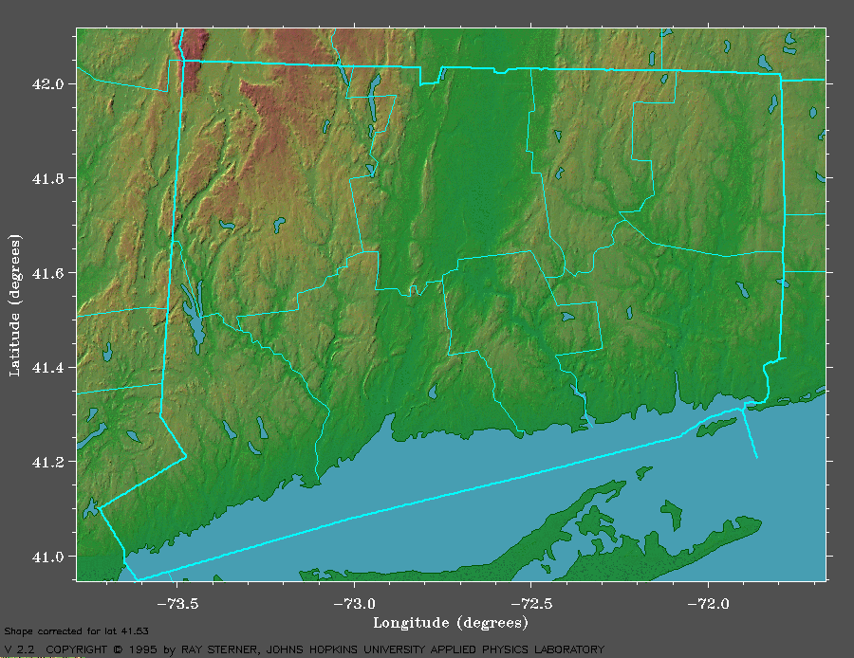
Gina McCarthy
Commissioner
DATA SOURCES

 DEP Alert System Gauge
■ NWS Co-op Observers
❒ NWS Automated Stations
FIGURE 1 - FRIDAY/SATURDAY (F/S) 10/14 – 15 & STORM TOTAL (ST) RAINFALL FOR WEEK OF OCTOBER 7 - 15
■ Staffordville 6.85” F/S
16.20 ST
❒ Mansfield 3.90” F/S
9.88” ST
❒ Windsor Locks 5.90” F/S
13.12” ST
❒ Hartford 4.33” F/S
10.51” ST
❒ Meriden 2.80” F/S
13.27” ST
❒ Danbury 2.40” F/S
12.87” ST
❒ Bridgeport 1.34” F/S
9.73” ST
❒ Groton 5.55” F/S
9.33” ST
❒ New Haven 2.36” F/S
12.05” ST
 Sharon 4.11” F/S
15.05” ST
Thomaston 4.18” F/S
13.43” ST 
 South Cheshire 4.37” F/S
16.49” ST
 Silvermine 2.44” F/S
11.91” ST
 Hammonassett 3.78” F/S
11.19” ST
Deep River Res. 5.50” F/S
11.51” ST 
Pachaug 5.79” F/S 
10.20” ST
 Ridgefield 2.94” F/S
15.35” ST
 Wilton 2.51” F/S
13.01” ST
 Factory Pond 2.72” F/S
13.69” ST
Orange 2.56” F/S
14.28” ST 
Whitney 3.02” F/S
11.93” ST 
North Cheshire 4.20” F/S 
14.29” ST
 Lake Gaillard 2.72” F/S
10.48” ST
Menungatuck 4.75” F/S
13.81” ST

State Police 4.88” F/S
 15.00” ST
 Plainville 4.71” F/S
12.91” ST
Plainfield 5.35” F/S
10.47” ST 
■ South Windsor 8.40” F/S
15.90” ST
Enfield 7.50” F/S 
15.90” ST
Burlington 7.74” F/S 
15.61” ST
■ Glastonbury 6.71” F/S
13.27” ST
■ Wethersfield 5.26” F/S
13.22” ST
■ Farmington 4.29” F/S
11.61” ST
Pomfret 6.04” F/S
13.90 ST 

Stafford 7.12” F/S
11.16 ST
AREA OF VERY HEAVY RAINFALL
AREA OF VERY HEAVY RAINFALL
New Canaan 11.45” ST
■
❒ White Plains 12.68” ST

■ Brookfield 12.79” ST

Voluntown 9.80” ST 

FIGURE 2 - CONNECTICUT DAMS WHICH BREACHED OR PARTIALLY BREACHED

Gina McCarthy,
Commissioner
B
P
D
P
B
P
B
P
D
D
D
DAM NAME OWNERSHIP LOCATION

Somerville Pond Dam DEP Somers
Windsorville Dam Private East Windsor
Mile Creek Dam Private Old Lyme
Staffordville Reservoir #3 CT Water Co. Union
Hanover Pond Dam City Meriden
ABB Pond Dam Private Bloomfield
Springborn Dam DEP Enfield
Cains Pond Private Suffield
Schwartz Pond Dam Private Suffield
Sessions Meadow Dam DEP Union
Somersville
Pond Dam
Windsorville Dam
Staffordville
Reservoir #3
P
Hanover Pond Dam
ABB Pond Dam
Springborn Dam
Cains Pond
Dam
Schwartz Pond
Dam
FULLY BREACHED

PARTIALLY BREACHED

DAMAGED
Sessions
Meadow Dam
Mile Creek Dam
D
Flood Stage at Wallingford = 7.0 FT
2.4

2.0

1.6

1.2

0.8

0.4

0.0

WEDNESDAY
SEPTEMBER 15, 1999
HYDROGRAPH FOR THE QUINNIPIAC RIVER
September 15 – 18, 1999
R
A
I
N
F
A
L
L

I
N
C
H
E
S
/
H
O
U
R

QUINNIPIAC RIVER
AT SOUTHINGTON

QUINNIPIAC RIVER
AT WALLINGFORD

SATURDAY
SEPTEMBER 18, 1999
FRIDAY
SEPTEMBER 17, 1999
THURSDAY
SEPTEMBER 16, 1999
Quinnipiac River Crested in Wallingford at 9.43 FT at 5:03 PM, September 17th
Quinnipiac River Crested in Southington at 6.76 FT at 6:45 AM, September 17th
Hokanum
River
Falls Village
Quinnipiac River
Still River
Connecticut River
Housatonic River
Gaylordsville
FIGURE 3 - FLOOD RECURRENCE INTERVALS FOR OCTOBER 8 – 15, 2005
Gina McCarthy,
Commissioner
100
5
10
50
MINOR FLOODING
2 – 10 Year Recurrence Interval

MODERATE FLOODING
Greater than 10-Year Recurrence Interval

SIGNIFICANT FLOODING
Greater than 50-Year Recurrence Interval

MAJOR FLOODING
Greater than 100-year Recurrence Interval
Willimantic
River
Mount Hope
River
Little River
5
Yantic
River
40
2
Stony Brook
Broad Brook
Burlington
Brook
Coginchaug
River
10
Salmon River
2
Eight Mile River
5
Indian River
20
10
10
Salmon
Creek
20
20
10
Ten Mile River
5
Nonewaug
River
5
Pomperaug
River
Weekeepeemee
River
Stevenson Dam
Sasco Brook
2
Saugatuck River
<2
Five Mile River
20
Pendleton Hill Brook
100
+
100
5
+
100
+
100
25
10
10
10
5

7 8 9 10 11 12 13 14 15 16 17
Rainfall readings from Staffordville Co-op Observer
Corrected to hourly readings using Pachaug and Plainville gauges.
2.00

1.75

1.50

1.25

1.00

0.75

0.50

0.25

0.00
HYDROGRAPHS FOR WILLIMANTIC AND MOUNT HOPE RIVERS

October 7th – 17th, 2005
R
A
I
N
F
A
L
L

I
N
C
H
E
S
/

2

H
O
U
R
S

Quinnipiac River Crested in Wallingford at 9.43 FT at 5:03 PM, September 17th
Quinnipiac River Crested in Southington at 6.76 FT at 6:45 AM, September 17th
R
I
V
E
R

S
T
A
G
E

I
N

F
E
E
T

16

14

12

10

8

6

4

2

0
WILLIMANTIC RIVER
AT COVENTRY

MOUNT HOPE RIVER
NEAR WARRENVILLE

APPENDIX A – USGS HYDROGRAPHS OF STATE RIVERS

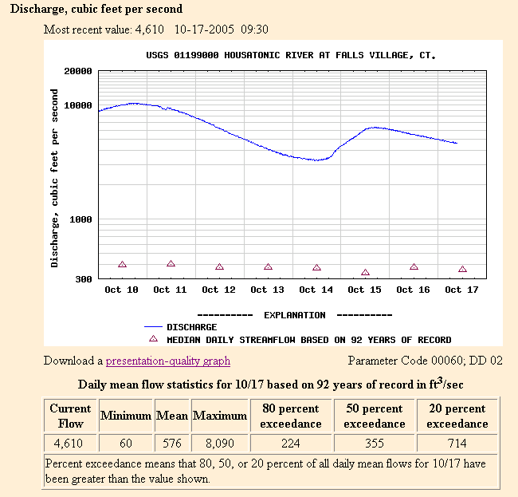
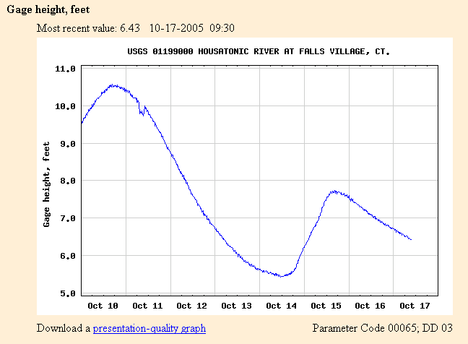
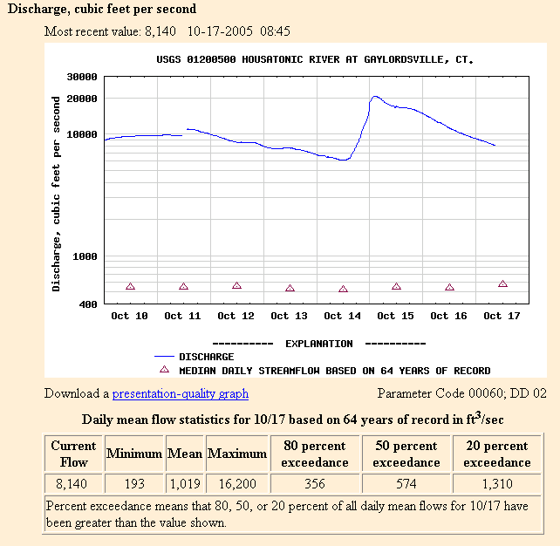
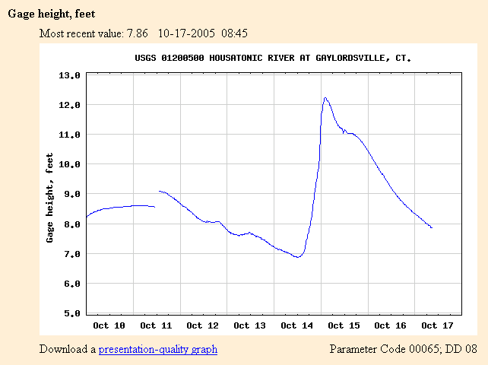
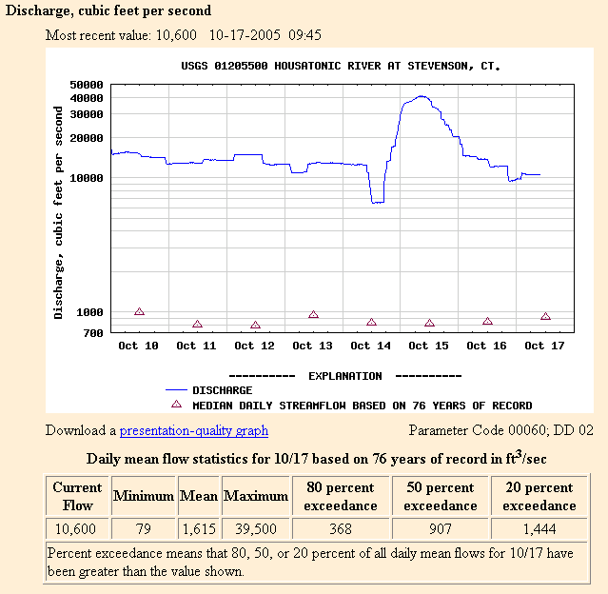
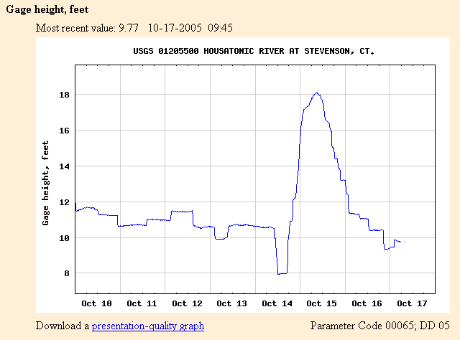
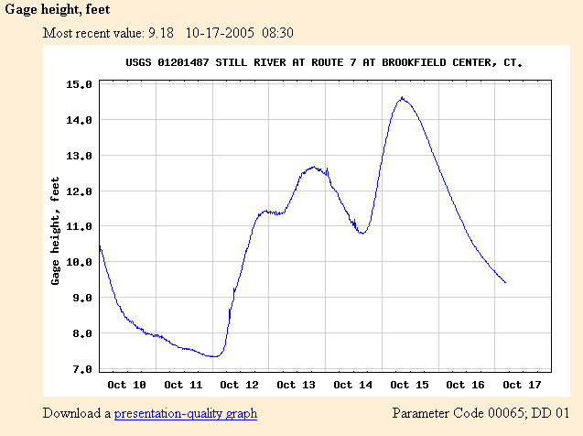
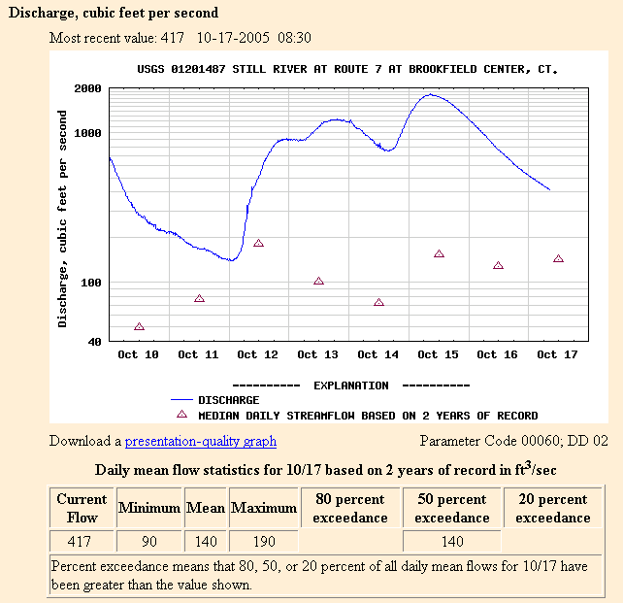
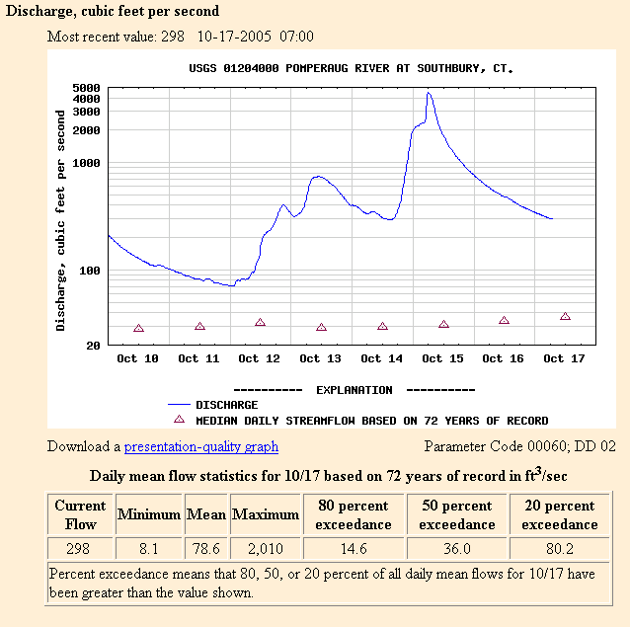
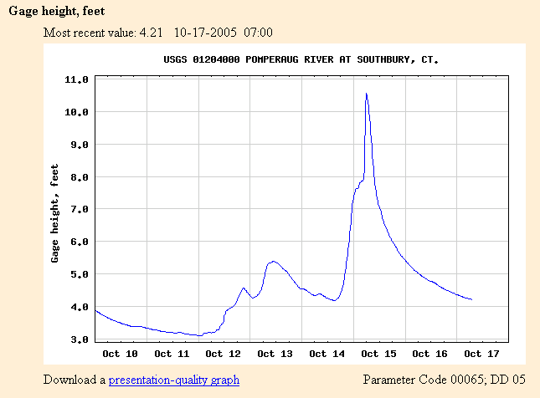
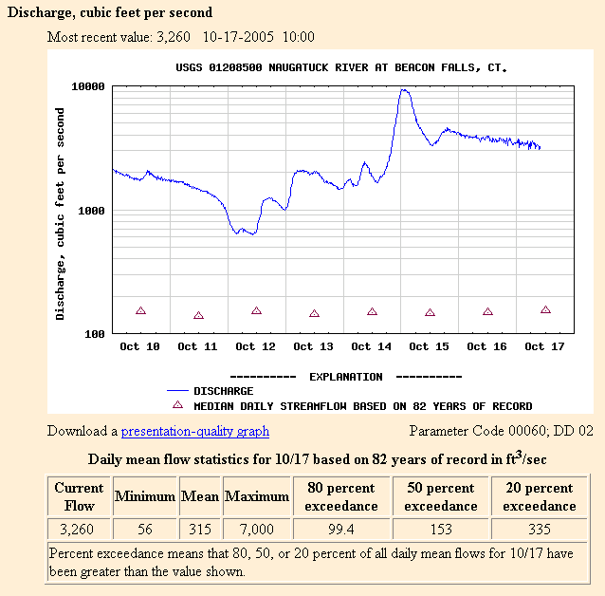
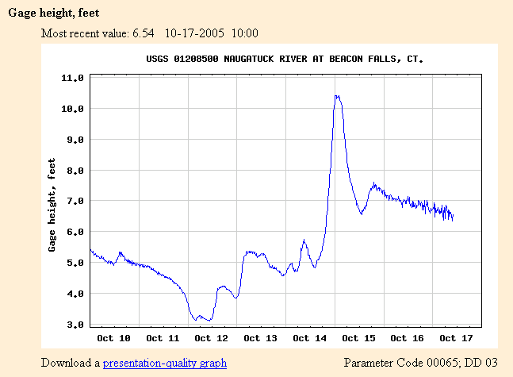
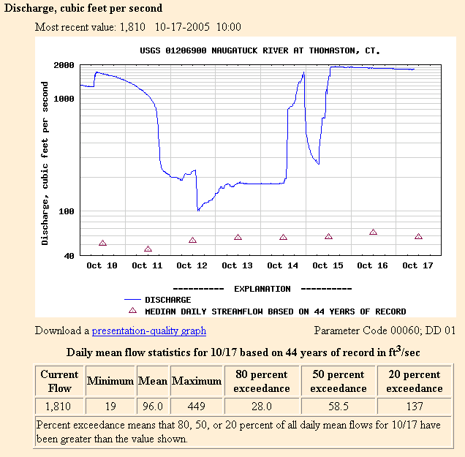
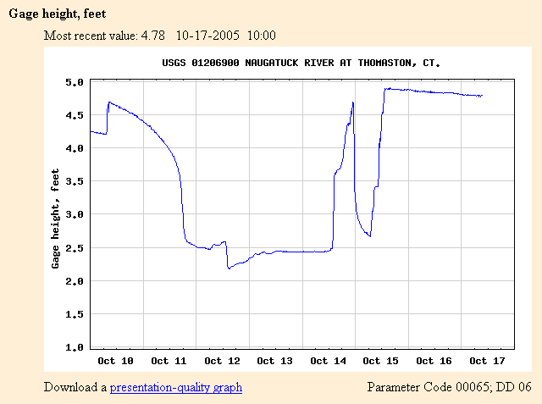
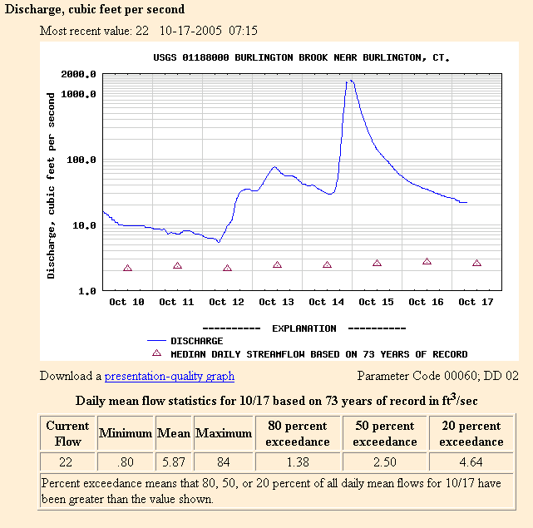
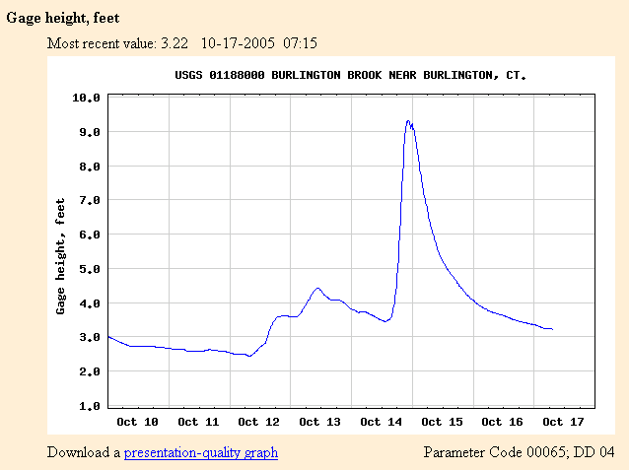
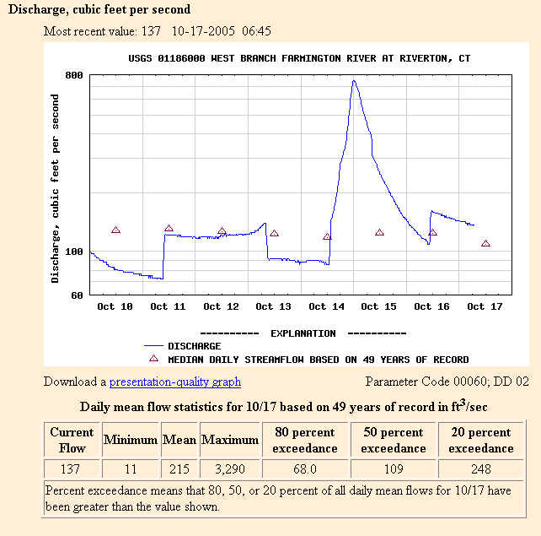
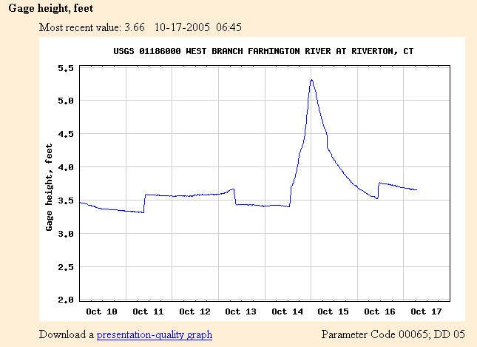
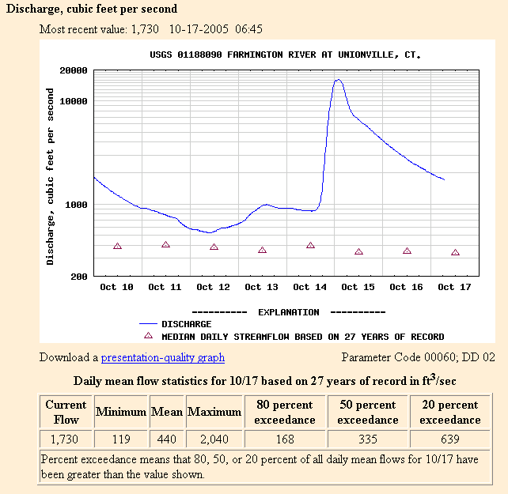
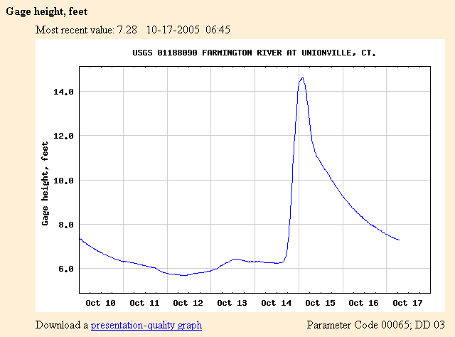
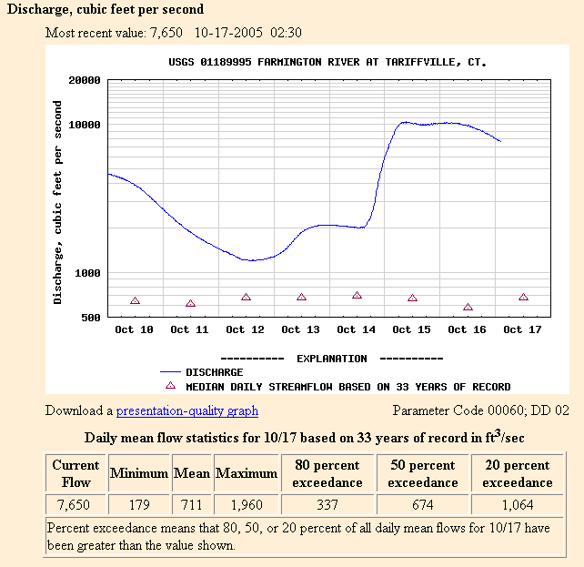
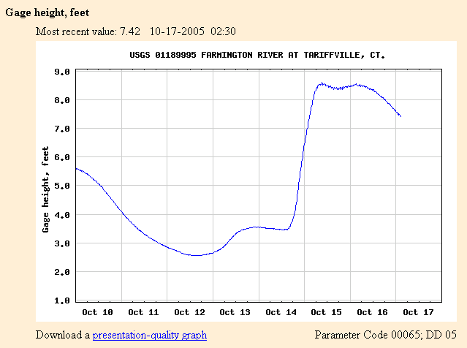
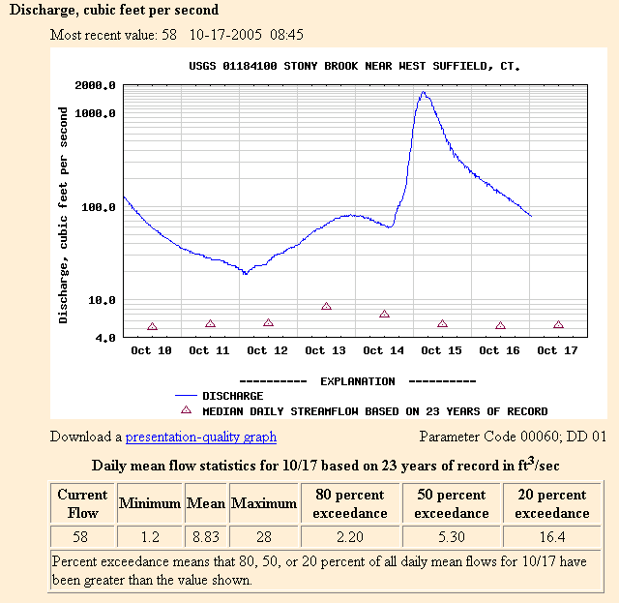
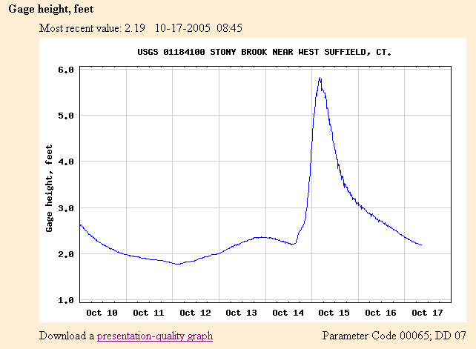
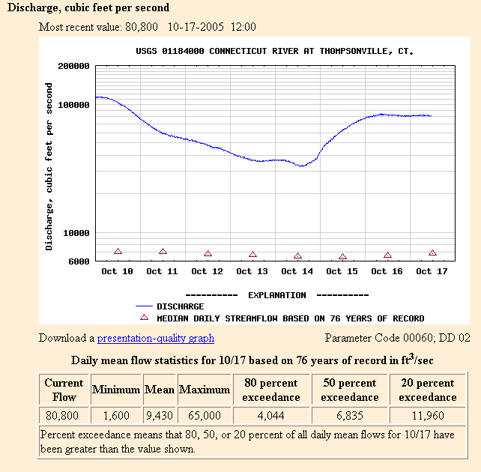
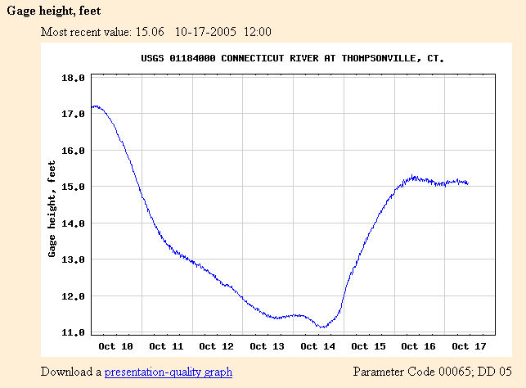
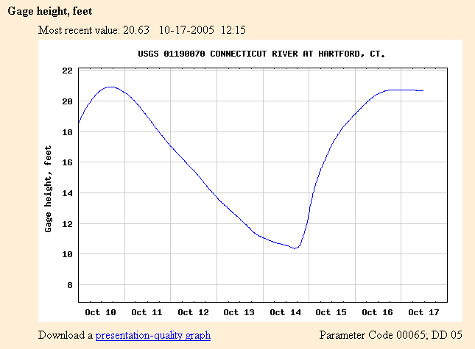
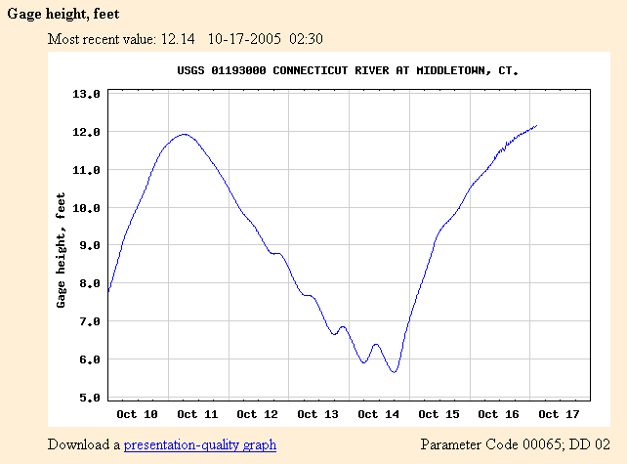
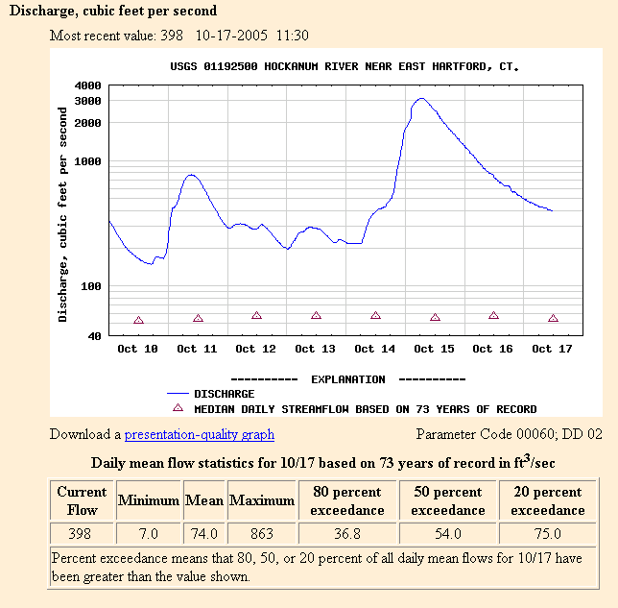
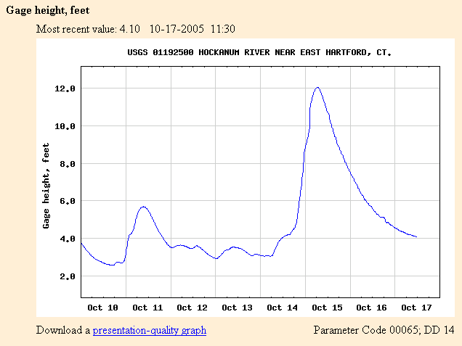
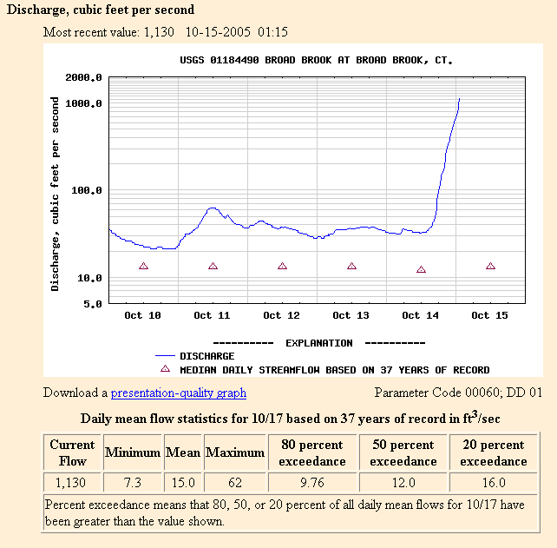
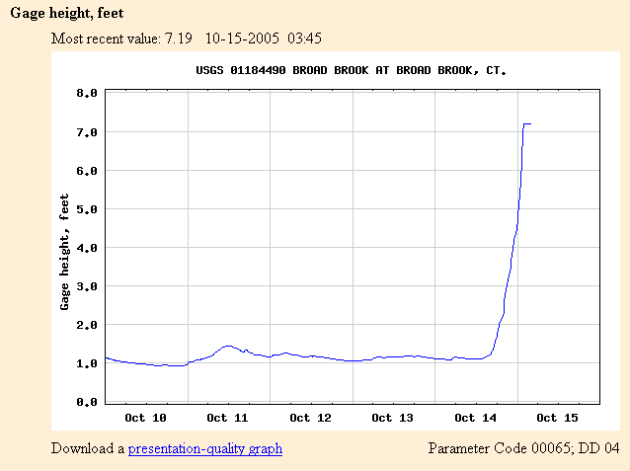
Gauge Washed Out


