
Contract No.: CSD-AOA01-S-06-00068-000
MPR Reference No.: 6309N

Results from the Administration on Aging’s Third National Survey of Older Americans Act Program Participants

Final Report

March 12, 2007

Jody Beauchamp
Lisa Trebino

Submitted to:  Social & Scientific Systems, Inc.  12th Fl., 8757 Georgia Ave.  Silver Spring, MD 20910  Project Director: Gary Moore  on behalf of:  U.S. Department of Health and Human Services  Administration on Aging | Submitted by:  Mathematica Policy Research, Inc.  600 Maryland Ave., SW, Suite 550  Washington, DC 20024-2512  Telephone: (202) 484-9220  Facsimile: (202) 863-1763  Project Director:  Jody Beauchamp

CONTENTS
Chapter Page

executive summary xiii

I INTRODUCTION 1

A. overview of the importance of services provided by the older americans act programs 1

B. aDMINISTRATION ON AGING PROGRAMS AND SERVICES 3

C. AoA Performance MeasureS 5

D. Purpose and Overview of this Report 6

II DESCRIPTION OF THE THIRD NATIONAL SURVEY 9

III DEMOGRAPHIC, SOCIOECONOMIC, AND HEALTH CHARACTERISTICS OF OAA TITLE III CLIENTS 11

A. oaa program participants are among the oldest old 12

B. oaa program participants are much more likely than other older americans to be female 14

C. oaa programs are well-targeted to african-americans but slightly less so to hispanics and other minority groups 16

D. the fraction of oaa clients living in rural areas is HIGHER THAN that OF other older adults in the united states 18

E. oaa home-delivered-meals Clients and transportation services clients are much more likely THAN other older americans to live alone 19

F. oaa program participants are more likely than others in their age group to be widowed and less likely to be married 21

III (continued)
G. oaa program participants tend to have lower levels of Educational Attainment than do other people their age 23

H. oaa program participants are more likely than other older americans to be lower Income 24

I. OAA PROGRAM PARTICIPANTS ARE LESS HEALTHY THAN OTHER OLDER AMERICANS 26

J. OAA participants have high rates of Diagnosed Health Conditions 28

K. OAA participants were more likely than other older americans to have trouble with Physical Functioning 31

IV THE OAA HOME-DELIVERED MEALS PROGRAM 37

A. Use of the OAA Home-Delivered Meals Service 37

B. Impact of the OAA Home-Delivered Meals Service 40

C. client-reported service quality in the OAA Home-Delivered Meals Service 43

V THE OAA TRANSPORTATION SERVICES PROGRAM 45

A. ABILITY TO DRIVE AND ACCESS TO OTHER TRANSPORTATION AMONG OAA Transportation services Clients 45

B. Use of the OAA Transportation Services Program 47

C. Impact of the OAA Transportation Services Program 51

D. client-reported service quality in OAA Transportation Services 53

VI OAA CAREGIVER SUPPORT SERVICES 57

A. CHARACTERISTICS OF OAA Care Recipients 57

B. CHARACTERISTICS OF OAA CaregiverS 64

C. Employment Among OAA Caregivers 66

D. The Burdens and Rewards of Caregiving as Reported by OAA Caregiver Support Clients 69

E. Amount of Care provided by the OAA Caregivers 73

F. Use of the OAA Caregiver Support Services Program 77

G. Impact of the of the OAA Caregiver Support Services Program 79

H. client-reported service quality in OAA Caregiver Support ServiceS 80

VII CONCLUSIONS and recommendations 85

REFERENCES 87

Appendix A Administration on Aging Performance Measures and Relevant Questions from the Third National Survey A.1

Appendix B Brief Description of the Health and Retirement Study B.1

Appendix C Third National Survey Variable Names, Descriptions, and Question Text C.1

TABLES
Table Page
I.1 AOA SERVICE REGIONS AND STATES IN EACH REGION 2
I.2 NUMBER OF CLIENTS SERVED AND AMOUNT SPENT ON SELECTED OAA TITLE III PROGRAMS, 2005 4

FIGURES
Figure Page
I.1 MAP OF AOA SERVICE REGIONS 2
III.1 AGE DISTRIBUTION OF OAA PROGRAM PARTICIPANTS COMPARED TO THE U.S. 60+ POPULATION IN 2005, BY SERVICE CATEGORY 13
III.2 GENDER OF OAA PROGRAM PARTICIPANTS COMPARED TO THE U.S. 60+ POPULATION IN 2005, BY SERVICE CATEGORY 15
III.3 RACIAL COMPOSITION OF OAA PROGRAM PARTICIPANTS COMPARED TO THE U.S. 60+ POPULATION IN 2005, BY SERVICE CATEGORY 16
III.4 fraction of OAA PROGRAM PARTICIPANTS living in rural areas IN 2005, BY SERVICE CATEGORY 19
III.5 FRACTION OF OAA PROGRAM PARTICIPANTS COMPARED TO THE U.S. 60+ POPULATION WHO REPORTED LIVING ALONE IN 2005, BY SERVICE CATEGORY 21
III.6 MARITAL STATUS OF OAA PROGRAM PARTICIPANTS COMPARED TO THE U.S. 60+ POPULATION IN 2005, BY SERVICE CATEGORY 22
III.7 HIGHEST EDUCATIONAL ATTAINMENT OF OAA PROGRAM PARTICIPANTS COMPARED TO THE U.S. 60+ POPULATION IN 2005, BY SERVICE CATEGORY 24
III.8 ANNUAL HOUSEHOLD INCOME OF OAA PROGRAM PARTICIPANTS COMPARED TO THE U.S. 60+ POPULATION IN 2005, BY SERVICE CATEGORY 25
III.9 SELF-REPORTED HEALTH STATUS OF OAA PROGRAM PARTICIPANTS COMPARED TO THE U.S. 60+ POPULATION IN 2005, BY SERVICE CATEGORY 27
III.10 SELECTED HEALTH CONDITIONS AMONG OAA PROGRAM PARTICIPANTS COMPARED TO THE U.S. 60+ POPULATION IN 2005, BY SERVICE CATEGORY 29
III.11 NUMBER OF REPORTED HEALTH CONDITIONS AMONG OAA PROGRAM PARTICIPANTS IN 2005, BY SERVICE CATEGORY 30
III.12 REPORTED DIFFICULTIES WITH ACTIVITIES OF DAILY LIVING AMONG OAA PROGRAM PARTICIPANTS COMPARED TO THE U.S. 60+ POPULATION IN 2005, BY SERVICE CATEGORY 32
III.13 NUMBER OF DIFFICULTIES WITH ACTIVITIES OF DAILY LIVING AMONG OAA PROGRAM PARTICIPANTS and US 60+ Population 33
III.14 PRESENCE OF EARLY AND LATE ONSET ADL difficultieS AMONG OAA PROGRAM PARTICIPANTS COMPARED TO THE U.S. 60+ POPULATION 34
III.15 REPORTED DIFFICULTIES WITH INSTRUMENTAL ACTIVITIES OF DAILY LIVING AMONG OAA PROGRAM PARTICIPANTS IN 2005, BY SERVICE CATEGORY 36
IV.1 NUMBER OF DAYS PER WEEK CLIENTS RECEIVE ONE OR MORE HOME-DELIVERED MEALS 38
IV.2 AVERAGE NUMBER OF DAYS PER WEEK THAT CLIENTS RECEIVED ONE OR MORE HOME-DELIVERED MEALS, BY AoA REGION 39
IV.3 TYPES OF FOODS USUALLY EATEN BY HOME-DELIVERED MEALS CLIENTS 40
IV.4 PROPORTION OF DAILY FOOD THAT HOME-DELIVERED MEALS REPRESENTS 41
IV.5 HOME-DELIVERED MEALS HELP CLIENTS TO… 42
IV.6 OVERALL client-reported service quality in THE HOME-DELIVERED MEALS 43
IV.7 OTHER MEASURES OF service quality WITH THE HOME-DELIVERED MEALS SERVICE 44
V.1 ABILITY TO DRIVE AND ACCESS TO AN AUTOMOBILE AMONG TRANSPORTATION SERVICES CLIENTS 46
V.2 NUMBER OF ONE-WAY TRIPS USED PER MONTH BY TRANSPORTATION SERVICES CLIENTS 48
V.3 FRACTION OF CLIENT’S TRIPS REPRESENTED BY THE TRANSPORTATION SERVICE 49
V.4 TRANSPORTATION SERVICE USE BY THE TRANSPORTATION DISADVANTAGED 50
V.5 USUAL DESTINATION WHEN USING THE TRANSPORTATION SERVICE 51
V.6 WHETHER THE TRANSPORTATION SERVICE ALLOWS THE CLIENT TO GET TO THEIR USUAL DESTINATION MORE OFTEN 52
V.7 OVERALL client-reported service quality in THE TRANSPORTATION SERVICE 53
V.8 OTHER MEASURES OF service quality in THE TRANSPORTATION SERVICE 54
VI.1 AGE DISTRIBUTION OF THE CARE RECIPIENTS 58
VI.2 GENDER OF CAREGIVER AND GENDER OF CARE RECIPIENT 59
VI.3 SUBJECTIVE HEALTH STATUS OF CARE RECIPIENTS, AS REPORTED BY THEIR CAREGIVERS 59
VI.4 MOST COMMON HEALTH CONDITIONS AMONG CARE RECIPIENTS, AS REPORTED BY THEIR CAREGIVERS 61
VI.5 NUMBER OF HEALTH PROBLEMS AMONG CARE RECIPIENTS 62
VI.6 REPORTED DIFFICULTIES WITH ACTIVITIES OF DAILY LIVING AMONG CARE RECIPIENTS, AS REPORTED BY THEIR CAREGIVERS 63
VI.7 NUMBER OF REPORTED DIFFICULTIES WITH ACTIVITIES OF DAILY LIVING AMONG CARE RECIPIENTS, AS REPORTED BY THEIR CAREGIVERS 64
VI.8 RELATIONSHIP OF CAREGIVER TO CARE RECIPIENT 65
VI.9 TYPES OF ACTIVITIES THAT CAREGIVERS ASSIST WITH 66
VI.10 EMPLOYMENT STATUS OF CAREGIVERS, BY GENDER 67
VI.11 EFFECTS OF CAREGIVING ON EMPLOYMENT 69
VI.12 Percent of Caregivers Reporting that Caregiving Created their health problems OR MADE PROBLEMS WORSE, by type of problem 70
VI.13 BIGGEST HARDSHIPS OF CAREGIVING (3 MOST COMMON RESPONSES) 71
VI.14 AVERAGE RATINGS OF COMMON BURDENS OF CAREGIVING 72
VI.15 BIGGEST REWARDS OF CAREGIVING (3 MOST COMMON RESPONSES) 73
VI.16 DISTANCE THAT CAREGIVER LIVES FROM CARE RECIPIENT 74
VI.17 NUMBER OF HOURS OF CARE NEEDED BY CARE RECIPIENTS PER DAY 75
VI.18 HOURS OF CARE PER DAY GIVEN BY CAREGIVERS TO CARE RECIPIENTS, WEEKDAYS AND WEEKEND DAYS 76
VI.19 Hours or Care per Week Provided by Caregivers to Care Recipients, by Employment Status of Caregivers 77
VI.20 SERVICES used by CAREGIVERS 78
VI.21 THE EFFECTS OF CAREGIVER SUPPORT SERVICES ON THE DAILY LIFE OF CAREGIVER 79
VI.22 OVERALL client-reported service quality in CAREGIVER SUPPORT SERVICES 81
VI.23 OVERALL REPORTED EASE OF GETTING CAREGIVER SUPPORT SERVICES 82
VI.24 PERCENT OF CLIENTS WHO REPORTED HELPFULNESS OF CAREGIVER SUPPORT SERVICES 83

executive summary
The Administration on Aging (AoA) strives to improve the quality of life for older Americans, in part by providing services to the most vulnerable elderly that allow them to maintain their independence and avoid institutionalization. To understand how the services it provides affect clients, the AoA began to survey participants in its Older Americans Act (OAA) Title III programs in 2003, covering a range of services and performance measures. The purpose of these surveys is to gauge the use, service quality, and impact of selected services funded by the OAA. This report documents findings from the Third National Survey of Program Participants conducted in 2005 of a representative sample of OAA clients, covering home-delivered meals, transportation services, and caregiver support services programs.

Tabulations from the Third National Survey indicated that OAA programs tended to serve clients who were more vulnerable than the overall population of older Americans. Compared to a nationally representative sample of people age 60 and over in the United States, OAA home-delivered meals and transportation recipients were older and therefore more likely to be female and to live alone, but less likely to be married. OAA clients in these areas were also less educated, had lower incomes, were in worse health, and had worse physical functioning than other older Americans. Caregivers served by OAA were younger and less vulnerable than other OAA service recipients, but those they cared for were quite frail. Altogether, survey results indicated that OAA-supported home-delivered meals, transportation services, and caregiver support programs directly or indirectly provide services to those who might otherwise have been institutionalized or isolated, and assisted the frail and vulnerable elderly in maintaining their independence.

The Third National Survey found that home-delivered meals, transportation, and caregiver services funded by the OAA were very well-liked by program participants. The AoA recently established new performance measures, to be effective in 2008, which seek to achieve at least 90 percent of participants reporting service quality to be good, very good, or excellent. In the 2005 Third National Survey, 94 percent of home-delivered meals clients, 98 percent of transportation services clients, and 94 percent of caregivers reported their satisfaction to be good, very good, or excellent. Client-reported service quality in specific aspects of each program was also quite high, indicating that the programs responded well to the needs of clients.

Finally, results from the Third National Survey indicated that OAA-funded services had a meaningful impact on the lives of clients. Ninety-three percent of home-delivered meals clients reported that the meals allowed them to continue to live in their own home, and 8 out of 10 said the service allowed them to eat a greater variety of food, eat healthier food, feel better, and feel less hungry. Nearly half of transportation services recipients (43 percent) relied on the service for almost all of their rides, and used the rides to go to medical appointments, run errands, and attend social events. Among caregivers, 54 percent said that receiving OAA-funded caregiver support services enabled the care recipient to live at home for a longer period of time. These impacts on the lives of clients show that the AoA is making substantial progress towards its mission and goal of providing needed support to allow vulnerable older adults to continue living in the community.

I. INTRODUCTION

A. overview of the importance of services provided by the older americans act programs
Over the past three decades, state and federal policymakers have made concerted efforts to develop services and supports that allow older adults and those with disabilities to continue to live in the community. Programs such as Medicaid home and community-based services (HCBS) 1915c waivers and the Program of All-Inclusive Care for the Elderly (PACE) allow individuals who are eligible for nursing home level of care to continue living outside of institutional settings. Due to consumer preferences and legal decisions affirming the right of people with disabilities to live in their home or community settings, many states have begun to rebalance their long-term care systems towards community-based options. The Deficit Reduction Act of 2005 authorized the large-scale demonstration program, Money Follows the Person, to allow Medicaid funding that would normally be spent on nursing facility care to “follow the person” as he or she transitions out of institutions and into community life.
Since its inception in 1965, the Older Americans Act (OAA), administered by the Administration on Aging (AoA), has provided funding for a variety of home and community-based services to support aging individuals who want to remain in their homes or communities when disability or frailty occurs. These services are provided through the Aging Services Network, which consists of national organizations, 56 State Units on Aging, 655 Area Agencies on Aging (AAA), more than 240 tribal organizations, 29,000 community service provider organizations, and 500,000 senior volunteers (“U.S. Administration on Aging, Strategic Action Plan, 2007-2012,” Department of Health and Human Services, 2007).
The AoA is organized into regions, with the AoA office providing oversight and a regional office providing assistance to the AAAs and other organizations located in the states within its region (Figure I.1 and Table I.1). The geographic proximity and common demographics within each region may be useful for comparing the effectiveness and outcomes of AoA programs and services across the country.

FIGURE I.1
MAP OF AOA SERVICE REGIONS
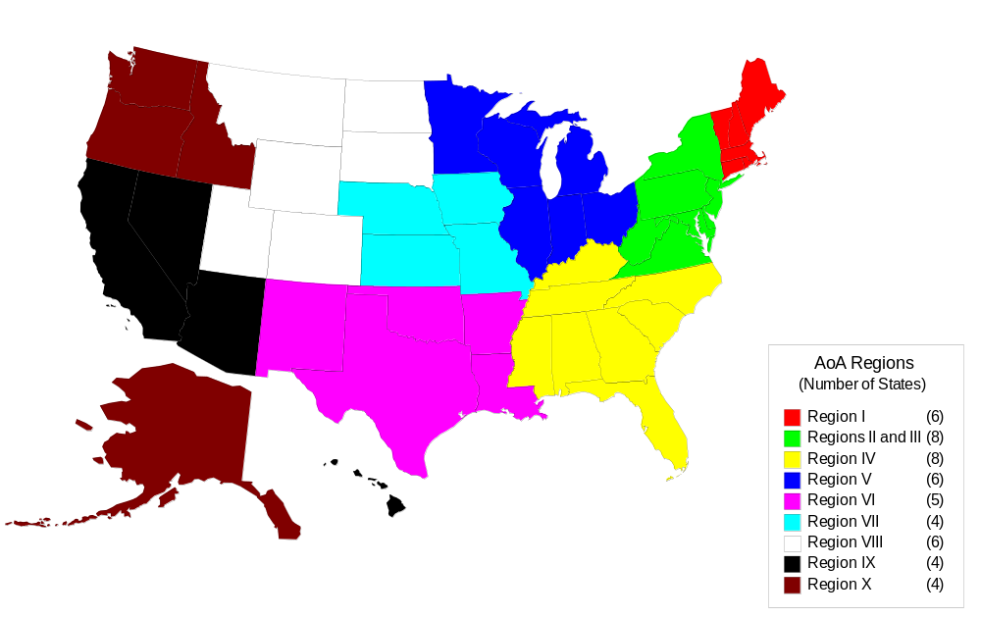
TABLE I.1
AOA SERVICE REGIONS AND STATES IN EACH REGION
Region | States
I | Connecticut, Massachusetts, Maine, New Hampshire, Rhode Island, and Vermont
II and III | New York, New Jersey, Puerto Rico, U.S. Virgin Islands, District of Columbia, Delaware, Maryland, Pennsylvania, Virginia, and West Virginia
IV | Alabama, Florida, Georgia, Kentucky, Mississippi, North Carolina, South Carolina, and Tennessee
V | Illinois, Indiana, Michigan, Minnesota, Ohio, and Wisconsin
VI | Arkansas, Louisiana, Oklahoma, New Mexico, and Texas
VII | Iowa, Kansas, Missouri, and Nebraska
VIII | Colorado, Montana, Utah, Wyoming, North Dakota, and South Dakota
IX | California, Nevada, Arizona, Hawaii, Guam, Mariana Islands, and American Samoa
X | Alaska, Idaho, Oregon, and Washington
Source: AoA web page, www.aoa.gov/prof/aoaprog/nutrition/program_anniv/contact.asp.

B. aDMINISTRATION ON AGING PROGRAMS AND SERVICES
The Older Americans Act has funding streams for each of its program categories, or “titles.” Title III of the Older Americans Act funds most of the community-based services and supports to older Americans and their caregivers. For example, Title III-B funds access services (transportation, case management, and information and referral), in-home services (personal care, chore and homemaker assistance), and community services (adult day care and physical fitness programs). Title III-C2 funds home-delivered meals and related services to seniors who are homebound due to illness, disability, or geographic isolation. Support to caregivers of people ages 60 and older are funded under Title III-E.
Although OAA Title III expenditures are small relative to the much larger sums spent by other federal programs for the elderly, such as Social Security, Medicare, and Medicaid, a large amount of services are provided to clients, particularly to those who are most frail and vulnerable. (Table I.2). Moreover, the services funded by OAA make a critical difference in the lives of older adults, frequently allowing them to continue to live on their own rather than enter institutions. For example:
- More than 900,000 clients received approximately 140 million home-delivered meals in 2005, or approximately 150 meals per client annually.
- More than 31 million one-way rides were funded in 2005.
  - 70,000 caregivers received OAA respite services in 2005, and each client received more than 100 hours of assistance on average.
TABLE I.2
NUMBER OF CLIENTS SERVED AND AMOUNT SPENT ON SELECTED
OAA TITLE III PROGRAMS, 2005
Service | Units (FY 2005)ª | Clients (FY 2005) | Title III Expenditures (FY 2005)
Home-delivered meals | 139,850,916 meals | 938,463 | $196,789,118
Transportation services | 31,332,847 rides | — | $67,595,431
Caregiver-Counseling/  Support Groups/Training | 583,790 sessions | 157,128 | $24,754,411
Caregiver-Respite | 7,563,110 hours | 69,876 | $114,282,396
Caregiver- Access Assistance | 988,696 contacts | 283,461 | $38,202,614
Caregiver-Supplemental | 971,714 units | 40,658 | $31,979,561
Source: Home-delivered meals and transportation data found in the Fiscal Year 2005 U.S. Profile of OAA Programs (http://aoa.gov/PROF/agingnet/NAPIS/SPR/2005SPR/Profiles/us.pdf). AoA staff provided the caregiver support services data.

ª The guidelines to states for filling out the AoA State Program Reports indicate the definition of a unit for each service. Supplemental caregiver services are defined to be “services provided on a limited basis to complement the care provided by caregivers. Examples of supplemental services include, but are not limited to, home modifications, assistive technologies, emergency response systems, and incontinence supplies.”

C. AoA Performance MeasureS
In addition to measuring the number of clients served and dollar amounts spent, the AoA monitors other measures of performance that indicate the efficiency and quality of service delivery and the effectiveness of its programs in serving the most vulnerable populations. Performance measures are used to comply with the Government Performance Results Act (GPRA) of 1993 and to rate the agency’s performance in the Office on Management and Budget’s Program Assessment Rating Tool (PART) process. AoA has three performance measures: (1) improve efficiency, (2) improve client outcomes, and (3) effectively target services to vulnerable populations. Each of these measures has multiple performance indicators. For home and community-based services:
- Efficiency indicators assess how many services are provided and at what cost, expressed as the number of clients served per million dollars of funds spent.
- Client outcomes indicators include consumer-assessed service quality and how effective the services are in keeping elders in their homes.
  - Effective targeting indicators assess the program’s ability to serve those who are vulnerable, such as minorities, people with disabilities, and those who are poor or live in rural areas, even if these clients are harder to reach and could reduce the number of clients served overall (“Justification of Estimates for Appropriations Committees, Administration on Aging, Fiscal Year 2008,” Department of Health and Human Services, 2007).
AoA’s strategy to demonstrating improved program performance is to show evidence of improved efficiency, improved client outcomes, improved targeting, and maintenance of high service quality.

D. Purpose and Overview of this Report
In 2005, the AoA conducted the Third National Survey of OAA Programs (henceforth, the Third National Survey) to assess how well it was improving client outcomes and targeting vulnerable clients. The survey (1) identified the quantity used of selected Title III program services by individual clients, (2) gauged the impact of service use on the lives of clients with a particular emphasis on the ability to maintain community living, and (3) assessed client-reported service quality.
The Third National Survey is one of a number of data sources that the AoA uses to assess the effectiveness and impact of the programs and services it funds. Other data sources include the National Ombudsman Reporting System (NORS), State Program Reports (SPR), and the Performance Outcomes Measures Project (POMP). The Third National Survey, however, is the only data source that provides direct feedback to AoA from clients who receive OAA-funded services; it therefore provides uniquely valuable information about the extent to which the AoA is meeting its goals. Appendix A includes the agency’s performance measures that may be evaluated using data from the Third National Survey.
This report documents findings from the Third National Survey that reflect individuals in home-delivered meals programs as well as those who receive transportation services and caregiver support services. More specifically, the report covers the following:
- The survey and the sampling methodology (Chapter II)
- A comparison of clients served by OAA programs in the three service categories—home-delivered meals, transportation services, and caregiver support services—to the entire elderly population in the United States (Chapter III)
- For each service, the quantity used by clients, the service quality reported by clients, clients for whom the service is most beneficial, and the impact of service use on client well-being (Chapters IV, V, and VI)
  - Overall themes that emerged from our analysis of the Third National Survey regarding the performance of AoA services vis-à-vis AoA goals (Chapter VII)

II. DESCRIPTION OF THE THIRD NATIONAL SURVEY
The Third National Survey follows two earlier surveys of OAA program participants. While the content and objectives of the three surveys are similar, the sample for the third is much larger, and some of the questions were revised. Because of the differences in question wording and sample sizes, the Third National Survey is the first that is suitable for a comprehensive analysis of OAA services and program participants.
The survey was conducted by telephone between April 17 and June 25 of 2005 using computer-assisted telephone interviewing (CATI) technology. A two-stage sample design was used, in which a sample of Area Agencies on Aging (AAA) were selected first, followed by a second stage selection of clients within each sampled AAA. In all, 310 AAAs of 649 total agencies were selected in the first stage, with a response rate of 88 percent. The 40 AAAs with the largest budgets were included in the sample, and the remainder were selected independently within strata based on agency budget size.
For each AAA in the sample, clients were randomly sampled by service type (home-delivered meals, transportation, and caregiver services). The number of clients selected from each AAA was proportional to the number of clients served in that particular category by that agency. The “cooperation rate” was 82 percent. This report examines responses from participants in the following three survey samples:
- 2,323 clients of home-delivered meals programs, who were asked about the number of meals received and consumed, the quality and taste of the food, and overall service quality.
- 2,520 clients receiving transportation services, who were asked about the quantity of rides used, their destination when using the service, and about a variety of other topics regarding the timeliness and responsiveness of program staff to client needs.
  - 1,075 caregivers, who were asked about the care recipient and their caregiving role, the type and the amount of support they received from OAA programs, the impact of such support on their ability to provide quality care, and the recipient’s ability to continue to live in the community. While the caregiver is the direct beneficiary of OAA services, the characteristics of the care recipient are important determinants of the burden of caregiving.
Data from and documentation of the Third National Survey and other AoA data sources are available on the new interactive AGing Interactive Database (AGID) at data.aoa.gov. The data used in this report were primarily taken from that website; Appendix C contains specific measures including variable label, question text, and the unweighted and weighted number of valid responses (i.e., responses provided by respondents that were not “don’t know” or “refuse to answer”) used in the analysis in this report.

III. DEMOGRAPHIC, SOCIOECONOMIC, AND HEALTH
CHARACTERISTICS OF OAA TITLE III CLIENTS
The AoA strives to serve vulnerable older adults, including people with disabilities, those who live in rural regions, and those who have low income (U.S. Department of Health and Human Services, 2007). Individuals in poor health or having a large number of limitations in functioning are also particularly vulnerable, as any new health problem may necessitate a move from one’s home. These vulnerable populations often have trouble accessing services.
This chapter describes the demographic, socioeconomic, and health characteristics of the clients served by OAA home-delivered meals, transportation services, and caregiver support services, and compares them to the entire American population over age 60. These comparisons highlight that the characteristics of OAA clients vary quite a bit by the type of service they receive. For example, home-delivered meals and transportation services clients appear vulnerable in almost every way when compared to the American population over the age of 60—they tend to be older, have lower educational attainment and income, and be in poorer health than other elderly Americans. On the other hand, caregivers who receive support services from OAA look less vulnerable than other service recipients, but that is in large part due to program design; caregivers often assist people who are among the most vulnerable, even if they themselves are not. Indeed, unlike other OAA service recipients, caregivers are often under the age of 60 because they are assisting those who are older. Thus, along with highlighting the relative vulnerability of many OAA program participants, another intention of this chapter is to highlight the differences between caregivers and other OAA service recipients. Chapter VI will look more closely at the vulnerability of the people that are assisted by OAA-supported caregivers.

A. oaa program participants are among the oldest old
In 2005, 16.8 percent of the nation’s population was age 60 or older. According to the U.S. Census, 26 percent of these individuals were ages 60 to 64, 37 percent were 65 to 74, 26 percent were 75 to 84, and 10 percent were ages 85 and older. Clients served by OAA home-delivered meals and transportation services programs were older on average than the American elderly population over the age of 60, as OAA clients tended to be among the oldest old (Figure III.1).
Clients receiving home-delivered meals and transportation services were twice as likely as other older Americans to be 75 and older. Seven of 10 of these clients who were at least age 60 were age 75 and older, compared to 36 percent at comparable ages in the U.S. population. Clients of home-delivered meals programs were slightly more likely to be younger than clients receiving transportation services.
OAA caregivers were younger than clients receiving home-delivered meals and transportation services, reflecting the fact that caregivers are frequently children of care recipients and also differences in eligibility for Title III-E programs versus other OAA Title III programs. Caregiver support services can be provided for those under age 60 if they care for people age 60 and older, so it is not surprising that 41.5 percent of caregivers were younger than 60. Despite this programmatic difference, a large fraction of caregivers are still among the oldest old; 24.0 percent were age 75 or older. The large proportion of caregivers at older ages means that many caregivers may themselves have health problems and frailty that accompany aging.

FIGURE III.1
AGE DISTRIBUTION OF OAA PROGRAM PARTICIPANTS COMPARED TO THE U.S. 60+ POPULATION IN 2005, BY SERVICE CATEGORY
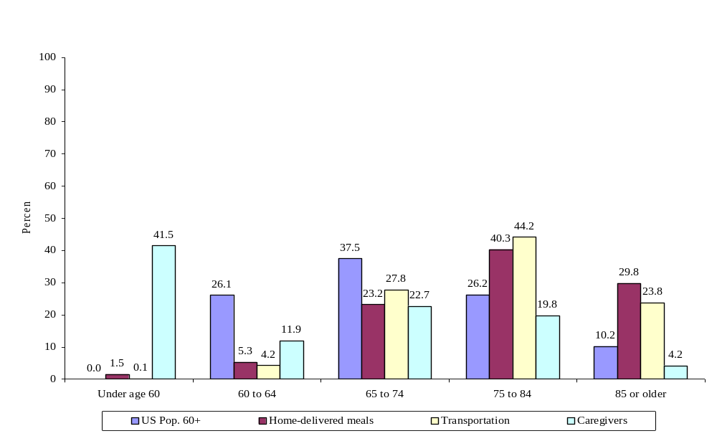
Source: Tabulations for the U.S. population provided by AoA staff based on data from the U.S. Census Bureau, Census 2006 Estimates (which includes data from 2000-2005). Data on OAA program participants from the Third National Survey of OAA Program Participants, 2005.

The greater proportion of OAA program participants in older age groups relative to the national distribution of the population age 60 and older may explain many other differences between the socioeconomic and health characteristics of OAA participants and the overall population of older adults (discussed below). For example, as individuals age, they often experience changes in marital status after a spouse dies, living arrangements, wealth, and health. Hence, an older sample would be less likely than a younger one to be married, even though the two groups might have the same proportion of married individuals if observed at the same age. Similarly, the higher average age of OAA participants may explain why OAA home-delivered meals participants appear to be less healthy than all Americans over age 60. Differences between OAA participants and the overall population age 60 and older may also be due to cohort effects; that is, the educational attainment and income of younger cohorts are generally higher that in older cohorts. Hence, the large proportion of OAA caregivers younger than 60 likely explains part of why they reported having a higher level of education than did the population over age 60.
Without a multivariate analysis that controls for age, we cannot know how much of the difference between OAA participants and the national population older than 60 is due to differences in the age distribution of the two populations. This is not to say that the differences between OAA participants and others are solely due to age differences, nor that OAA participants are not a very vulnerable population, regardless of their age. Rather, these caveats simply note that direct comparisons of the characteristics of OAA participants to other groups must be interpreted cautiously.

B. oaa program participants are much more likely than other older americans to be female
Because men have a shorter life expectancy than women, older populations are disproportionately female. Nationwide, among those age 60 and older, there are 130 women to every 100 men, implying that the population is 57 percent female (Figure III.2). Compared to the U.S. elderly population, clients of OAA services were much more likely to be female.
The majority of clients in all three OAA service categories were female. Seventy-one percent of clients receiving home-delivered meals were female, corresponding to a female-to-male ratio of 244 women to every 100 men. Eighty-four percent of clients receiving transportation services were female (a female-to-male ratio of 506 to 100) and 76 percent of caregivers were female (a sex ratio of 312 females to 100 males). These sex ratios are about two to four times higher than the female-to-male ratio in the U.S. population age 60 and older. The larger fraction of females in the transportation and home-delivered meals samples is likely a result of the fact that the sample population is old relative to the general population; women are more likely to be caregivers than men, which explains the high percentage in the OAA client group.
FIGURE III.2
GENDER OF OAA PROGRAM PARTICIPANTS COMPARED TO THE U.S. 60+ POPULATION IN 2005,
BY SERVICE CATEGORY
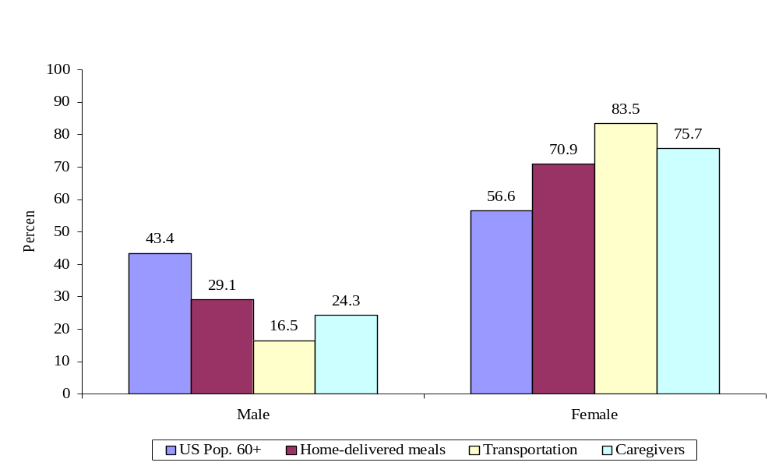
Source: Tabulations for the U.S. population provided by AoA staff based on data from the U.S. Census Bureau, Census 2006 Estimates (which includes data from 2000-2005). Data on OAA program participants from the Third National Survey of OAA Program Participants, 2005.

C. oaa programs are well-targeted to african-americans but slightly less so to hispanics
The racial composition of OAA clients is roughly comparable to the racial composition of older adult population in the United States. Most OAA service clients were Caucasian (82 percent of home-delivered-meals clients, 80 percent of transportation services clients, and 87 percent of caregivers). Statistics from 2005 for the U.S. population indicate that 81 percent of individuals age 60 and older are white or Caucasian (Figure III.3).
FIGURE III.3
RACIAL COMPOSITION OF OAA PROGRAM PARTICIPANTS COMPARED TO THE U.S. 60+ POPULATION IN 2005, BY SERVICE CATEGORY
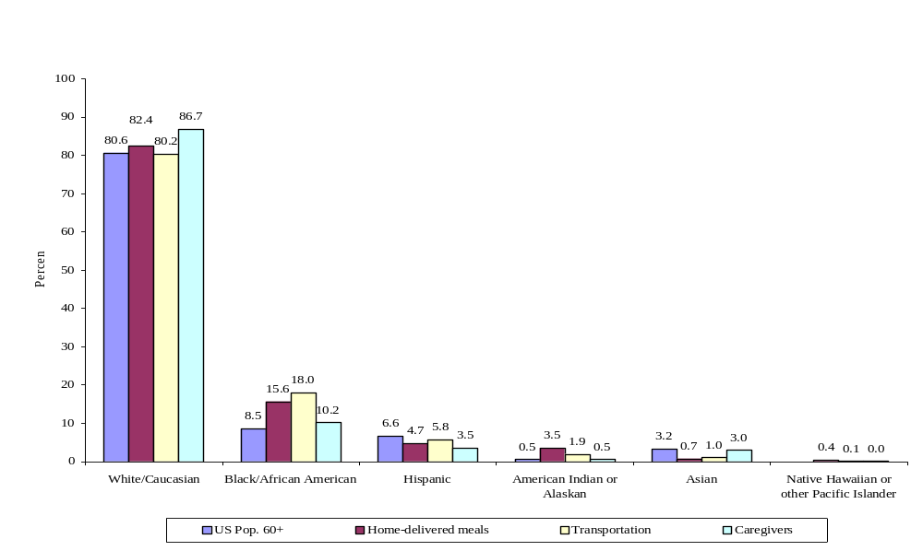
Source: Tabulations for the U.S. population provided by AoA staff based on data from the U.S. Census Bureau, Census 2006 Estimates (which includes data from 2000-2005). Data on OAA program participants from the Third National Survey of OAA Program Participants, 2005.

Although the majority of service clients were white, a sizeable fraction are in minority groups. Sixteen percent of home-delivered-meals clients, 18 percent of transportation services clients, and 10 percent of caregivers were African-American. By comparison, 9 percent of those age 60 and older in the U.S. in 2005 were African-American. The relatively larger proportion of OAA clients who are African American compared to the overall elderly population in the U.S. implies that OAA home-delivered meals and transportation services are well-targeted to African-Americans.
Compared to 7 percent of the U.S. population age 60 and older that was Hispanic in 2005, 5 percent of those who receive home-delivered meals, 6 percent of those who receive transportation services, and 4 percent of caregivers were Hispanic. Therefore, the proportion of Hispanic clients served by OAA programs is about comparable to the proportion among all older Americans, but is slightly lower than the overall population age 60 and older. This difference in participation rates among African-Americans and Hispanics compared to overall population proportions suggests that one possible goal for future targeting may be to increase the focus on Hispanic clients, who may have a difficult time accessing services due to cultural or linguistic barriers. Hispanic clients served by OAA programs tend to be younger than other racial and ethnic groups (not shown), which means that as demographics change and recent Hispanic immigrants get older and more frail, there will be additional opportunities for AoA to target its services towards Hispanic populations.
The share of minority clients among OAA service clients varies in ways that are generally consistent with the racial composition of AoA regions (not shown). Regions IV, VI, and VII, which comprise states in the South, had the highest proportion of clients that were African-American. Regions II, VI, and IX, which comprise New York, Texas, and southwestern states including California, had clients that were most likely to be Hispanic.

D. the fraction of oaa clients living in rural areas is HIGHER THAN that OF other older adults in the united states
Despite the movement of the nation’s population toward cities and metropolitan areas, almost one-quarter of the population age 60 and over still lived in a rural area in 2005. People in rural areas often have a harder time obtaining social services, as they live further from administrative offices, senior centers, and other supports; moreover, they are often otherwise disadvantaged. Because of these difficulties, older adults living in rural areas are often more vulnerable, which is why the AoA has made a commitment to increase the proportion of rural clients served (Indicator 3.3, Appendix A).
OAA program participants were much more likely to live in rural areas than the overall U.S. population age 60 and older. In fact, home-delivered meals and transportation services clients were more than twice as likely to live in a rural area than other older Americans. 56 percent of clients who received home-delivered meals and 55 percent of those who received transportation services lived in rural areas. Caregivers were slightly less likely to live in rural areas than other service recipients (45 percent lived in rural areas), but this is still a much higher fraction than in the U.S. population overall. These percentages indicate that OAA services are well-targeted to rural residents who might otherwise not have access to similar services.

FIGURE III.4
fraction of OAA PROGRAM PARTICIPANTS living in rural areas IN 2005,
BY SERVICE CATEGORY
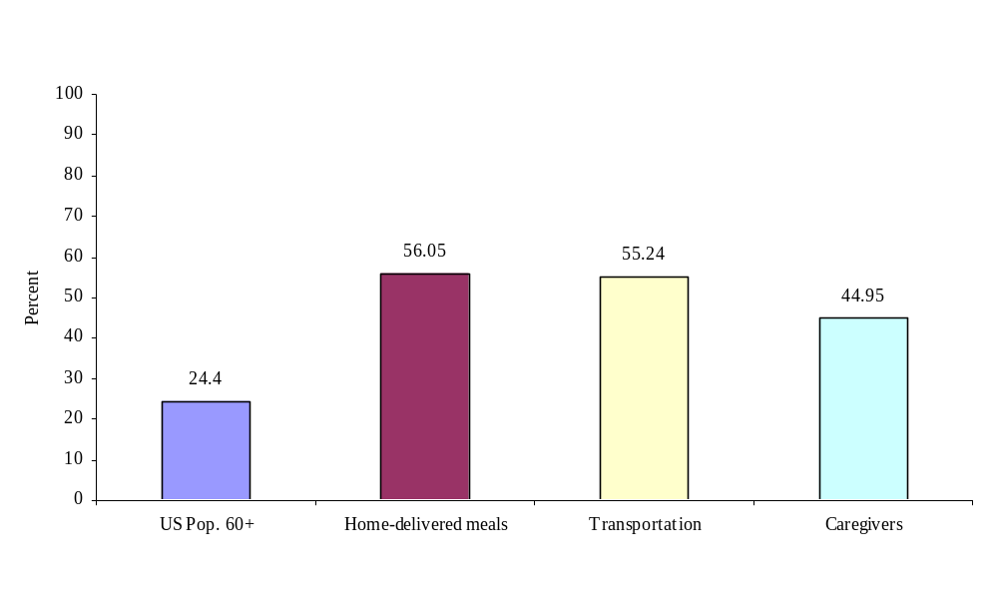
Source: Tabulations from the Third National Survey of OAA Program Participants, 2005.

E. oaa home-delivered meals Clients and transportation services clients are much more likely than other older americans to live alone
Older adults who live alone may be vulnerable to deteriorating health or institutionalization, especially if family and friends do not live nearby. These people may have difficulty getting to medical appointments and social gatherings if they are not able to drive themselves. Nationally, 26 percent of those age 60 and older in 2004 reported living alone. The fraction of OAA transportation services and home-delivered-meals clients living alone was substantially higher than in the national population, reflecting at least in part, the older average age of the sample (Figure III.5).
According to the Third National Survey, 61 percent of home-delivered meals clients, reported living alone, as did 65 percent of transportation services clients. Reflecting the different focus of the caregiver support program compared to other services asked about in the survey, only 18 percent of caregivers lived alone. Among care recipients, 71 percent lived with their caregiver; of the remaining 29 percent who did not live in the same house as their caregiver, 61 percent lived alone. Thus, even though the caregivers themselves were not generally vulnerable to the isolation associated with living alone, those that they cared for were. Females served by Title III programs were more likely to live alone than males (not shown); 38 to 50 percent of male program clients of home-delivered meals or transportation services reported living alone, compared to about two thirds (65 to 70 percent) of female clients.

FIGURE III.5
FRACTION OF OAA PROGRAM PARTICIPANTS COMPARED TO THE U.S. 60+ POPULATION WHO REPORTED LIVING ALONE IN 2005, BY SERVICE CATEGORY
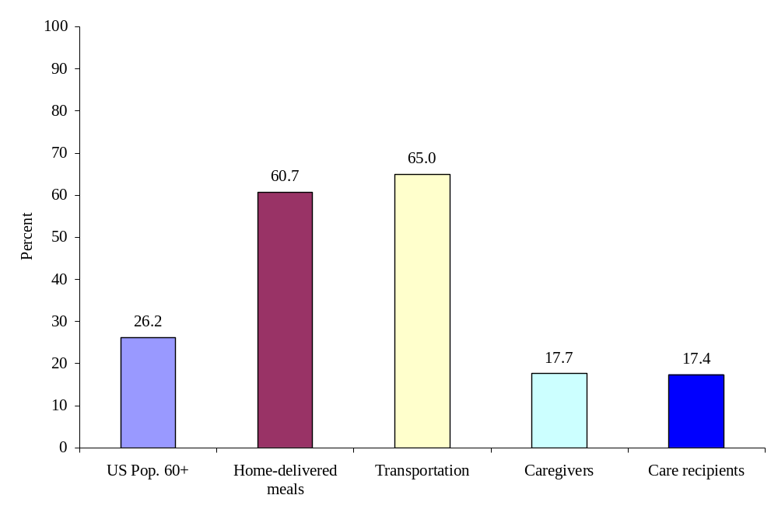
Source: Tabulations for the U.S. population from the 2004 Health and Retirement Study. Data on OAA program participants from the Third National Survey of OAA Program Participants, 2005.

F. oaa program participants are more likely than others in their age group to be widowed and less likely to be married
As people age, especially women, they are more likely to become widowed. One-quarter of the U.S. population in 2004 age 60 and older was widowed. However, among those who are not widowed, most (62 percent) are married or partnered, another 10 percent are divorced or separated, and 3 percent were never married. Rates of widowhood were much higher among clients receiving home-delivered meals and transportation services than in the elderly population overall (Figure III.6).
Among home-delivered meals clients, 24 percent were still married at the time of the survey, but the majority was either widowed (56 percent), or divorced or separated (14 percent). Six percent of clients were never married. Among transportation services clients, 17 percent were married, 60 percent were widowed, 16 percent were divorced or separated, and 8 percent had never married.
FIGURE III.6
MARITAL STATUS OF OAA PROGRAM PARTICIPANTS COMPARED TO THE U.S. 60+ POPULATION IN 2005, BY SERVICE CATEGORY
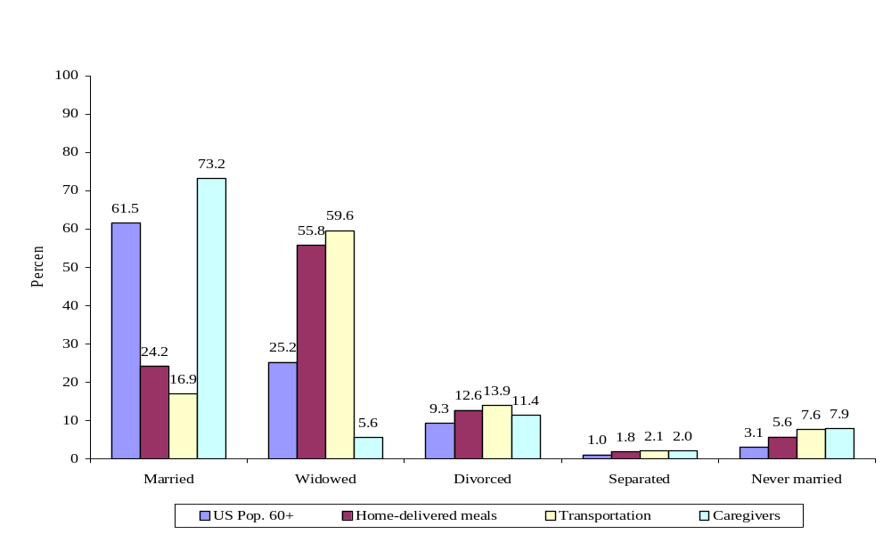
Source: Tabulations for the U.S. population from the 2004 Health and Retirement Study. Data on OAA program participants from the Third National Survey of OAA Program Participants, 2005.

The percentage of caregivers who were married was higher than the share among home-delivered meals and transportation services clients, and also higher than the share among the national elderly population. This finding reflects the fact the population of caregivers is younger than these other groups and possibly that married individuals are more likely than unmarried individuals to assume caregiving responsibilities. Seventy-three percent of caregivers were married, only 6 percent were widowed, 13 percent were divorced or separated, and 8 percent had never married.

G. oaa program participants tend to have lowER levels of Educational Attainment than do other people their age
Home-delivered meals and transportation services clients had much lower levels of education than other people their age. Forty-one percent of home-delivered meals and 36 percent of transportation services clients did not receive a high school diploma (Figure III.7). In the U.S. population ages 60 and older, 23 percent completed fewer than twelve years of schooling. At the other end of the spectrum, 21 percent of the U.S. population over 60 had a bachelor’s degree or higher, compared to 9 percent of home-delivered meals clients and 8 percent of transportation services clients. Low levels of education are often associated with lower income and wealth, along with poorer health, so these less-educated OAA clients may be among the most vulnerable.
Caregivers were more educated than home-delivered meals and transportation services clients. In part, this likely reflects cohort-related differences in educational attainment, as the caregiver sample was significantly younger than the other samples. Higher education levels among caregivers also points to the possibility that those with higher education may be better be able to take on the financial and emotional responsibilities that come with caregiving. The highest level of schooling completed was less than high school for 9 percent of caregivers and high school only for 29 percent. About 37 percent have some college education, or a trade or professional school education. Fully one-quarter have a college degree or more (12 percent have a bachelor’s degree, and 13 percent have more than a bachelor’s degree).
FIGURE III.7
HIGHEST EDUCATIONAL ATTAINMENT OF OAA PROGRAM
PARTICIPANTS COMPARED TO THE U.S. 60+ POPULATION IN 2005, BY SERVICE CATEGORY
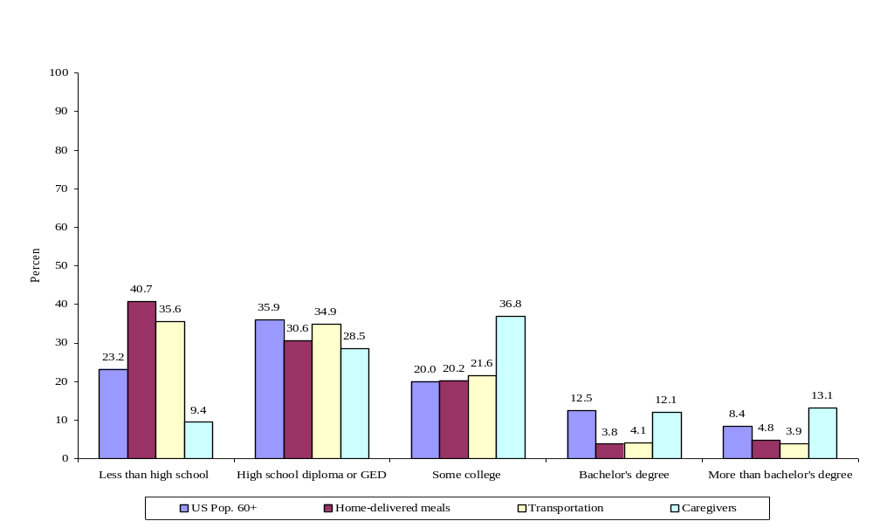
Source: Tabulations for the U.S. population provided by AoA staff using data on the highest educational attainment among the civilian non-institutionalized population from the U.S. Census Bureau Current Population Survey, 2005 Annual Social and Economic Supplement. Data on OAA program participants from the Third National Survey of OAA Program Participants, 2005.

H. oaa program participants are more likely than other older americans to be lower Income
It is likely that the low level of educational attainment among home-delivered meals and transportation services clients is partially responsible for the fact that most of these OAA clients had a very low household income. Most OAA clients lived in households with an income of less than $15,000 per year; two-thirds of home-delivered meals and transportation services clients fell into this range (Figure III.8). By comparison, 24 percent of households nationwide had an annual income of less than or equal to $15,000. Only about one-quarter of home-delivered meals and transportation services clients had annual household incomes between $15,001 and $30,000, about the same as in the older population overall (27 percent).
Compared with the U.S. population age 60 and older, far fewer OAA participants were in the upper end of the income distribution. Twenty percent of older people nationwide have an annual household income of $30,001 to $50,000, and another 29 percent earn over $50,000 per year. Because the rates of living alone were much higher among OAA program participants than in the national population, it is difficult to compare the household income of the two groups without also considering the number of people in the household, as both the income earned and the amount necessary to support multiple household members will be different than supporting only one.
FIGURE III.8
ANNUAL HOUSEHOLD INCOME OF OAA PROGRAM
PARTICIPANTS COMPARED TO THE U.S. 60+ POPULATION IN 2005, BY SERVICE CATEGORY
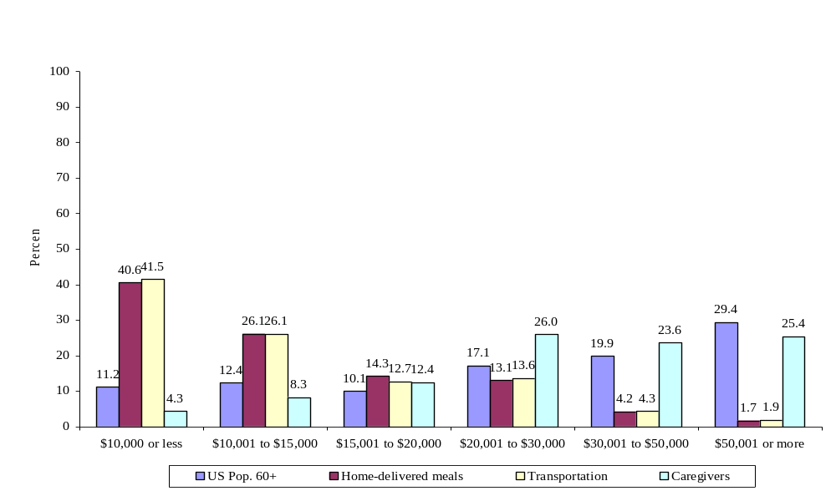
Source: Tabulations for the U.S. population provided by AoA staff based on 2005 total household income data from the U.S. Census Bureau, Current Population Survey, 2006 Annual Social and Economic Supplement. Data on OAA program participants from the Third National Survey of OAA Program Participants, 2005.

Caregivers had a much higher income than did other service clients, which reflects the fact that the former are not only younger but also that they have higher educational attainment and possibly the time and financial means to care for another person. Seventy-five percent of caregivers had an annual household income of $20,000 or more (Figure III.8). Despite having a relatively high income level on average, one-quarter of caregivers had an annual household income of $20,000 or less, and another quarter lived in households that had annual income between $20,001 and $30,000. Thus, while caregivers are in relatively better financial shape than other OAA program participants, a significant proportion is financially vulnerable. Furthermore, caregivers may also have the added financial burden supporting another person, meaning that their income might go partly to another person not residing in the household (which would not be reflected by these statistics).

I. OAA PROGRAM PARTICIPANTS ARE LESS HEALTHY THAN OTHER OLDER AMERICANS
As people age, their health declines due to adverse health events and worsening of health conditions, meaning that average self-rated health also begins to decline. Among those age 60 and older in 2004, 10 percent said they were in excellent health; 28 percent, in very good health; 32.6 percent, in good health; 20 percent, in fair health; and 9 percent said they were in poor health. OAA program participants, especially those receiving home-delivered meals, were not as healthy overall, compared with the older population nationwide (Figure III.9).
FIGURE III.9
SELF-REPORTED HEALTH STATUS OF OAA PROGRAM
PARTICIPANTS COMPARED TO THE U.S. 60+ POPULATION IN 2005, BY SERVICE CATEGORY
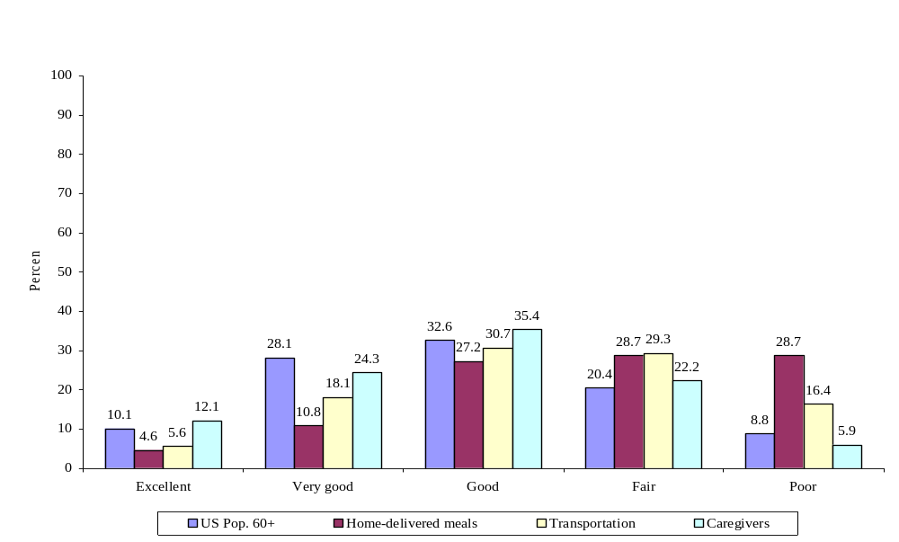
Source: Tabulations for the U.S. population from the 2004 Health and Retirement Study. Data on OAA program participants from the Third National Survey of OAA Program Participants, 2005.

Very few home-delivered meals or transportation clients reported being in excellent or very good health. Only about 5 percent in both groups said their health was excellent; 11 percent of clients receiving home-delivered meals and 18 percent receiving transportation services said their health was very good. About one in three said their health was good, and one-quarter said their health was fair (29 percent). The remainder of clients reported being in poor health (29 percent of home-delivered meals and 16 percent of transportation clients). The average self-rated health level among these groups (where 1 indicated poor health and 5, excellent health) was 2.37 for clients receiving home-delivered meals and 2.69 for those receiving transportation services. The average for individuals age 60 and older nationwide was 3.1.
Compared with clients receiving other OAA services, caregivers were healthier, reflecting their younger age and perhaps their higher socioeconomic status. Over one-third (36 percent) of caregivers reported being in excellent or very good health, and another third (35 percent) said they were in good health. However, 22 percent said their health was only fair, and another 6 percent reported being in poor health. The average self-rated health among caregivers was 3.1, the same as the average in the population nationwide. Although many of the caregivers were younger than other OAA participants (and therefore under 60), the distribution of health among caregivers was similar to that of the over-60 population across the nation. Since health declines with age, the fact that the health of caregivers is the same on average as an older group of Americans suggests that caregivers might be in relatively poor health for their age.

J. OAA participants have high rates of Diagnosed Health Conditions
The poor self-rated health of OAA program participants provides a summary measure of their overall health status and functioning. In addition to being asked about their general health, clients were also asked whether they had any specific health conditions diagnosed by a doctor. Of the long list of diagnosed conditions that participants were asked about, 10 were cited by at least 25 percent of those receiving home-delivered meals and transportation services (Figure III.10).
Almost 7 in 10 clients receiving home-delivered meals and transportation services were diagnosed with arthritis, hypertension or high blood pressure, or eye or vision problems. Almost half were diagnosed with high cholesterol. A high percentage also reported having been diagnosed with heart disease, diabetes, breathing or other lung problems, depression or anxiety, or hearing problems. The relative difference in self-rated health status between caregivers and the other two client groups is consistent with a lower rate of diagnosed health conditions among the former. Almost two-thirds of caregivers (64 percent) reported having back problems or arthritis, and 35 percent had cardiovascular conditions such as heart problems, hypertension, or a stroke (not shown). Other diagnosed health conditions among caregivers were minimal; fewer than 10 percent had breathing or other lung problems, diabetes, eye problems, or mental health issues.
FIGURE III.10
SELECTED HEALTH CONDITIONS AMONG OAA PROGRAM PARTICIPANTS COMPARED TO THE U.S. 60+ POPULATION IN 2005, BY SERVICE CATEGORY
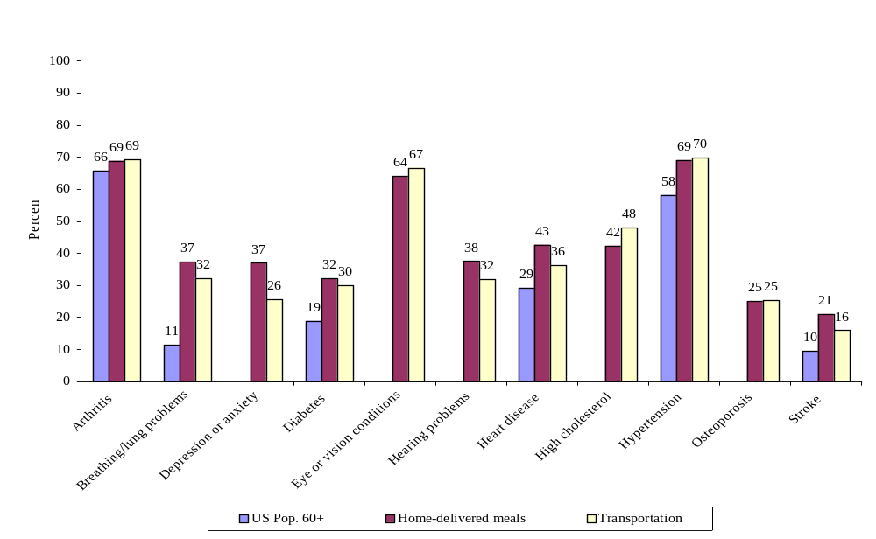
Source: Tabulations for the U.S. population from the 2004 Health and Retirement Study. Data on OAA program participants from the Third National Survey of OAA Program Participants, 2005.

While the categories and wording of the HRS questions vary slightly from those in the Third National Survey, HRS statistics provide some indication that the rates of diagnosis are much higher among OAA participants than other older Americans. For example, only 19 percent of HRS respondents over the age of 60 reported ever having been diagnosed with diabetes, compared to around 30 percent of transportation services and home-delivered meals respondents. Ten percent of HRS respondents reported ever having a stroke, compared to 16 and 21 percent of transportation services and home-delivered meals clients, respectively.
FIGURE III.11
NUMBER OF REPORTED HEALTH CONDITIONS AMONG OAA
PROGRAM PARTICIPANTS IN 2005, BY SERVICE CATEGORY
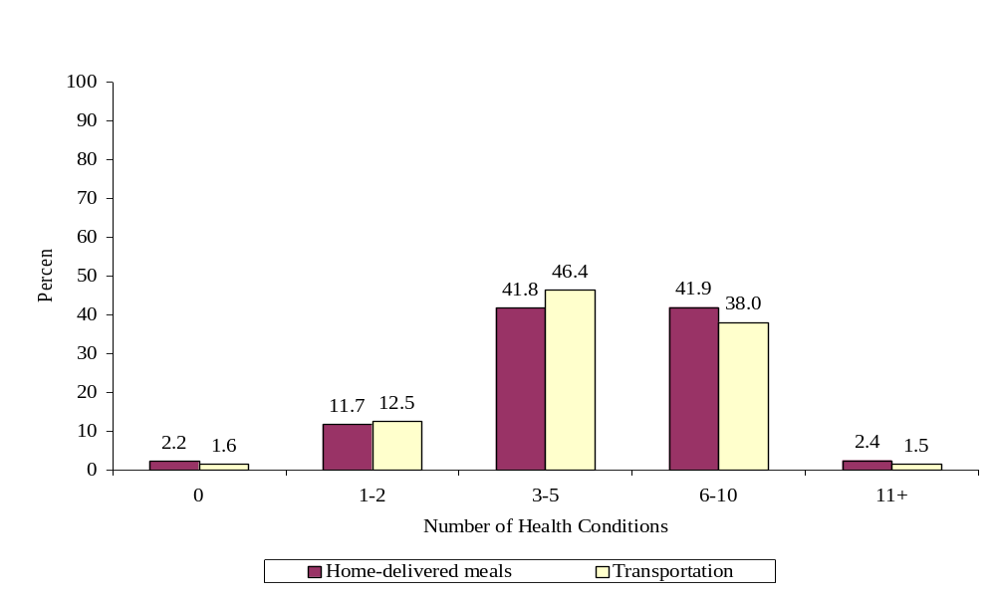
Source: Tabulations from the Third National Survey of OAA Program Participants, 2005.

Given these rates of diagnosis for individual conditions, it is not surprising that the majority of home-delivered meals and transportation services clients have multiple health conditions (Figure III.11). Forty-two percent of home-delivered meals clients and 46 percent of transportation services recipients reported having three to five diagnosed conditions. About 40 percent of these two client groups had 6 to 10 conditions. The large share of clients with multiple conditions suggests that OAA clients must manage multiple treatment regimens and prescription medications, which can be difficult for the elderly as they begin to fail physically or cognitively.

K. OAA participants were more likely than other older americans to have trouble with Physical Functioning
As important as diagnosed health conditions for maintaining independence is the extent to which an older adult can perform basic functions, also known as activities of daily living (ADLs). Six activities are normally classified as ADLs: bathing or showering, dressing, eating, getting in and out of bed or a chair, toileting, and walking. Individuals who cannot perform these activities on their own or with an assistive device such as a walker or cane need help from another person. The AoA seeks to target its services to those with severe disabilities, which might include those who have a number of functional limitations (see Indicator 3.2, Appendix A).
As shown in Figures III.12 and III.13, about one-quarter of clients receiving home-delivered meals said they did not have trouble with any ADLs, and another quarter reported only having difficulty with one ADL. Despite the proportion of clients with high functionality, a large share had difficulty walking (66 percent), bathing or showering (42 percent), getting in and out of a bed or chair (35 percent), or dressing (24 percent). Almost one third of clients had difficulty with at least three ADLs, indicating that this population needs a great deal of help to complete activities required for daily functioning.
FIGURE III.12
REPORTED DIFFICULTIES WITH ACTIVITIES OF DAILY LIVING
AMONG OAA PROGRAM PARTICIPANTS COMPARED TO THE U.S. 60+ POPULATION IN 2005, BY SERVICE CATEGORY
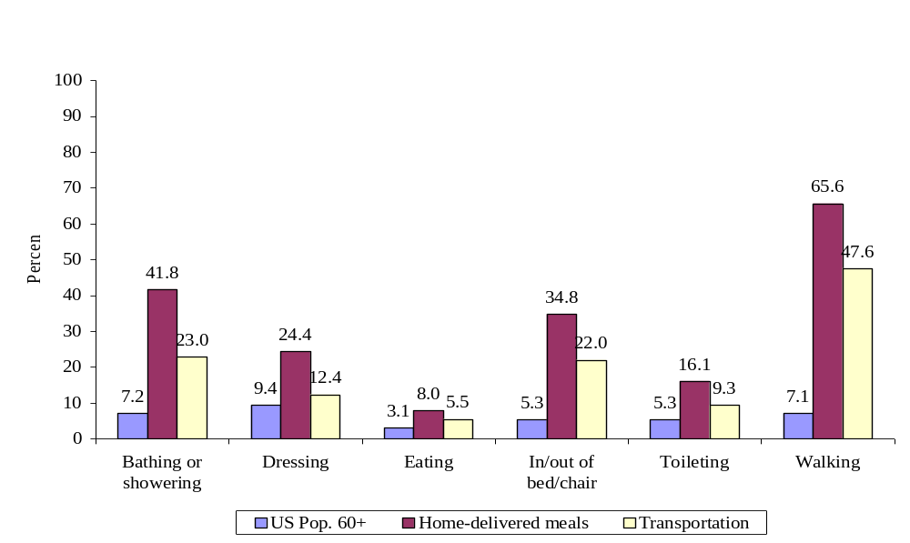
Source: Tabulations for the U.S. population from the 2004 Health and Retirement Study. Data on OAA program participants from the Third National Survey of OAA Program Participants, 2005.

Transportation services clients were less impaired than clients receiving home-delivered meals. Forty-four percent of the former reported not having any difficulties with ADLs, and one-quarter (24 percent) reported only having difficulty with one ADL. Still, a large proportion of clients said they had difficulty walking (48 percent), bathing or showering (23 percent), or getting in and out of a bed or chair (22 percent). A smaller fraction (17 percent) of transportation services clients than home-delivered meals clients had difficulty with three or more ADLs.
Compared to national rates of functional limitations in people age 60 and older, OAA participants in 2005 were quite impaired. In the 2004 HRS, only 17.7 percent of older adults had difficulty with at least one ADL, meaning that about 8 in 10 people did not. Only 7 percent had difficulty walking across the room, 9 percent had difficulty dressing, 7 percent had difficulty bathing or showering, 3 percent had difficulty eating, 5 percent had difficulty getting in and out of bed, and another 5 percent had trouble with toileting. It is likely that some of the differences between these low levels of functioning and the levels reported by OAA participants can explained by the fact that those receiving OAA services are relatively older than the U.S. population overall.
FIGURE III.13
NUMBER OF DIFFICULTIES WITH ACTIVITIES OF DAILY
LIVING AMONG OAA PROGRAM PARTICIPANTS and US 60+ Population
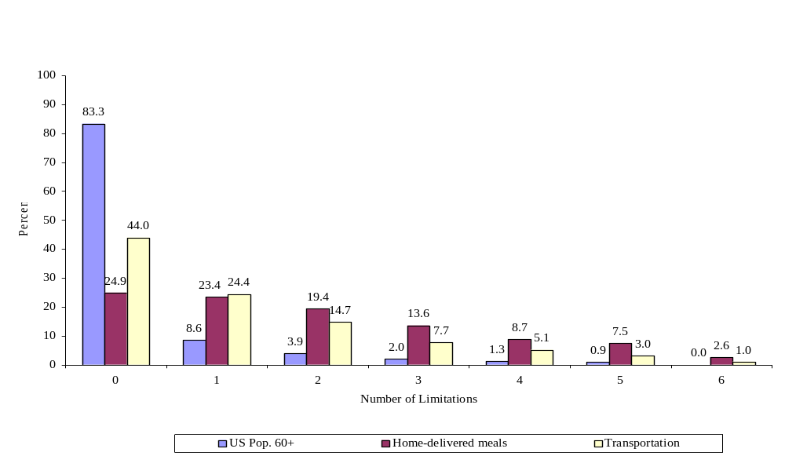
Source: Tabulations for the U.S. population from the 2004 Health and Retirement Study. Data on OAA program participants from the Third National Survey of OAA Program Participants, 2005.

Katz and colleagues (1963) offer another perspective of impairment in their categorization of ADL difficulties, by whether they occur relatively early or late in a person’s functional decline. By this definition, early onset ADLs include dressing and personal hygiene; middle onset ADLs include toileting, transferring, and locomotion; and late onset ADLs include eating and bed mobility. For this analysis, we categorized difficulty with dressing, bathing, toileting, and walking as early onset ADL difficulties, and the others as late onset ones.
Home-delivered meals clients are more likely than transportation services clients to have both early and late onset ADL difficulties, but both have rates of onset that are much higher than the rates in the overall elderly population (Figure III.14). Seventy-three percent of those receiving meals had at least one difficulty with an early onset ADL, and 37 percent reported difficulty with a late onset ADL. Similar numbers for transportation services clients were 54 and 25 percent.
FIGURE III.14
PRESENCE OF EARLY AND LATE ONSET ADL difficultieS AMONG OAA PROGRAM PARTICIPANTS COMPARED TO THE U.S. 60+ POPULATION
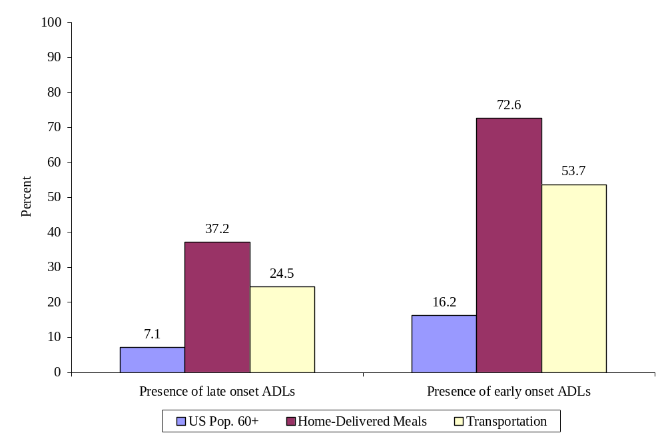
Source: Tabulations for the U.S. population from the 2004 Health and Retirement Study. Data on OAA program participants from the Third National Survey of OAA Program Participants, 2005.

Among those with at least one early onset ADL, 40 percent of home-delivered meals clients had only one difficulty and 30 percent had two ADL difficulties (not shown). This means that those with early onset ADL difficulties tended to not have problems with all four activities. Over half (55 percent) of transportation services clients with any early onset ADL difficulties had only one, and another 26 percent had two difficulties. Among those who have difficulty with at least one of the late-onset ADLs, most transportation and meals clients (85 and 88 percent, respectively) only had difficulty with one (rather than both) of the late-onset ADLs.
Instrumental activities of daily living (IADLs) are not necessary for functioning on a daily basis, but they are useful skills for independent living. They include activities such as preparing meals, performing light housework, and driving. As they did for ADLs, home-delivered meals and transportation services recipients reported high levels of difficulty with IADLs (Figure III.15). Only 17 percent of home-delivered meals clients and 33 percent of transportation services clients reported not having any trouble with IADLs.
Home-delivered meals clients most often said that the following IADLs were difficult: going outside (55 percent), driving (53 percent), using public transportation (48 percent), performing light housework (47 percent), and preparing meals (45 percent). The very high rate of difficulty with going outside shows how important home-delivered meals are to these clients.
Not surprisingly, transportation services clients had more difficulty driving an auto (48 percent) and using public transportation (35 percent) than with other IADLs. Other than these two IADLs, transportation services clients reported the most difficulty with going outside (34 percent) and light housework (28 percent).
FIGURE III.15
REPORTED DIFFICULTIES WITH INSTRUMENTAL ACTIVITIES OF DAILY LIVING AMONG OAA PROGRAM PARTICIPANTS IN 2005, BY SERVICE CATEGORY
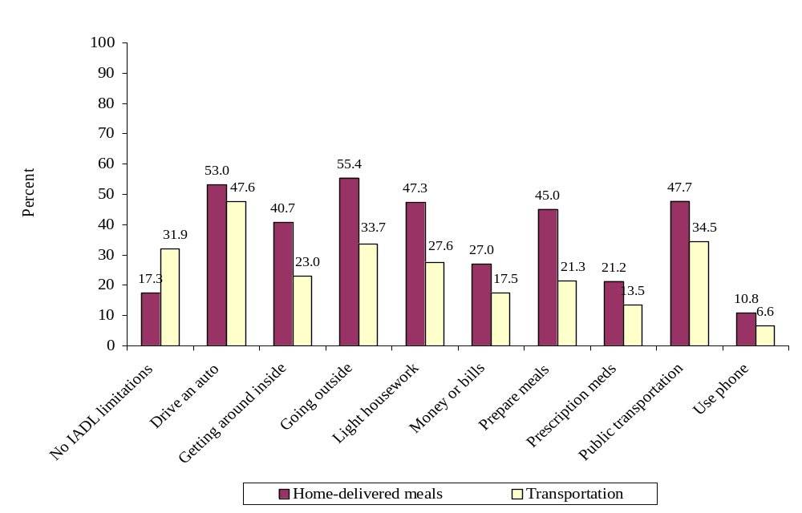
Source: Tabulations from the Third National Survey of OAA Program Participants, 2005.

IV. THE OAA HOME-DELIVERED MEALS PROGRAM
The OAA home-delivered meals program provides older adults who have health and/or mobility problems with nutritious food that might otherwise be beyond their reach. Seniors who have health problems, difficulty getting around, or are unable to drive may have trouble performing errands such as grocery shopping. Those who are financially strained may choose to eat unhealthy foods, or worse, skip meals in order to save money or pay for other important things such as prescription medications. OAA home-delivered meals make up a large, important part of the food consumed by program participants on delivery days, and recipients reported a high level service quality across all aspects of the program.

A. Use of the OAA Home-Delivered Meals Service
Most home-delivered meals clients (73 percent) received at least one hot meal in the past week (not shown), and a full 49 percent received five hot meals in the past week. The mean number of hot meals received (among those receiving at least one meal) was 4.7 per week, or about one per weekday. About one in five clients (21 percent) received at least one frozen meal in the past week, and among those, most received one to five frozen meals. The average number of frozen meals received (among those receiving at least one meal) was 4.1. About one in 10 clients (9 percent) received at least one bag meal in the past week, and the mean number of meals received by these individuals was 3.5. A much smaller share of clients (4 percent) received a nutritional supplement such as Boost or Ensure at least once in the past week. The average recipient in this group received 4.8 supplements.
The majority of clients received home-delivered meals at least five days per week (Figure IV.1). Half of clients (51 percent) received home-delivered meals five days per week on average, 2 percent received meals 6 days each week, and 8 percent received them 7 days a week. Four in five (80 percent) reported receiving only one meal on days when they did receive meals, but 10 percent reported receiving three or more meals per day.
FIGURE IV.1
NUMBER OF DAYS PER WEEK CLIENTS RECEIVE ONE OR MORE HOME-DELIVERED MEALS
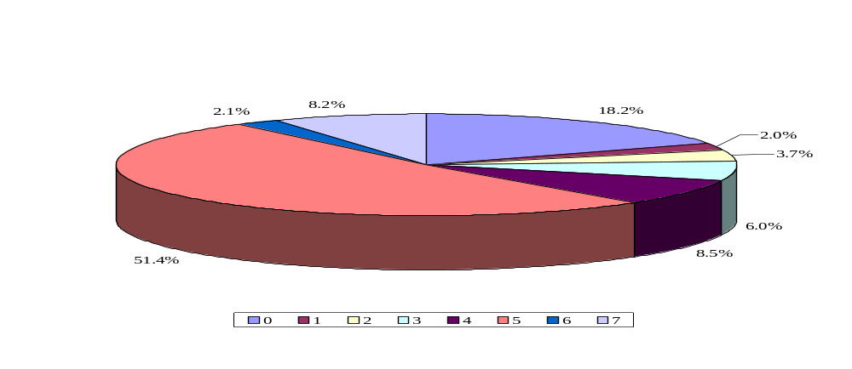
Source: Tabulations from the Third National Survey of OAA Program Participants, 2005.

The average number of days per week that meals are delivered to clients varies somewhat by AoA region (Figure IV.2). The lowest average is in Region VIII, where clients receive meals only three days per week on average. This is likely due to the vast size of these Mountain and Plains states in addition to the fact that they are largely rural. As a result, agencies may have to deliver fewer times per week. Regions II and III, which are concentrated in the East and Mid-Atlantic regions, have the highest number of days of meal delivery per week, each with more than four on average.
FIGURE IV.2
AVERAGE NUMBER OF DAYS PER WEEK THAT CLIENTS RECEIVED ONE OR MORE HOME-DELIVERED MEALS, BY AoA REGION
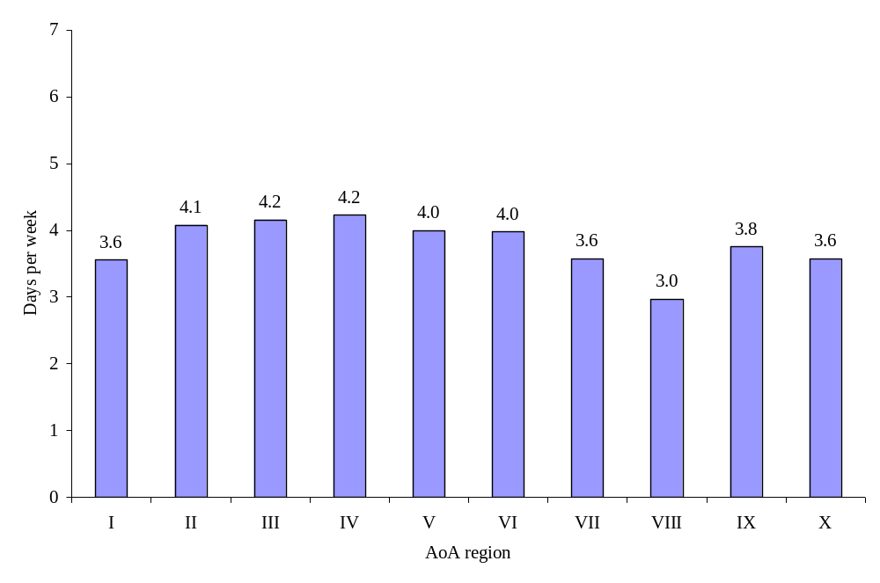
Source: Tabulations from the Third National Survey of OAA Program Participants, 2005.

The majority of clients reported that they usually ate all or most of the food that was delivered to them (Figure IV.3). Ninety-six percent of clients usually ate the meat, chicken, fish, or eggs provided; 95 percent of clients usually ate the fruit; and 95 percent usually ate the vegetables. Similarly high percentages were reported for the other types of food. Home-delivered meals clients seemed to be pleased enough with the taste of the food to usually eat it, an important measure of whether the service is useful to clients. Given food allergies and the range of food preferences, these rates of consumption are quite high.
FIGURE IV.3
TYPES OF FOODS USUALLY EATEN BY HOME-DELIVERED MEALS CLIENTS
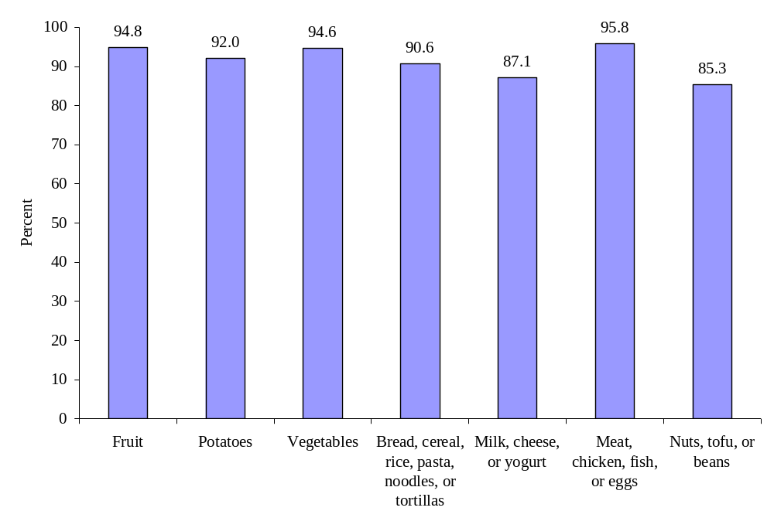
Source: Tabulations from the Third National Survey of OAA Program Participants, 2005.

B. Impact of the OAA Home-Delivered Meals Service
The home-delivered meals program has had a great impact on the quantity and quality of food consumed. About 11 percent of clients reported eating more food on days when it was delivered (not shown). Almost two-thirds (64 percent) of clients reported eating the same amount of food on days when meals were delivered as on days when they were not, but 26 percent reported that they ate less food on days when meals were delivered. This could mean that clients saved meals and ate them on days when they were not delivered or that the quality of food is high enough that clients can eat fewer food items on delivery days.
While quality may be the most salient feature of the meals, the amount of food is also not insignificant (Figure IV.4). On delivery days, about two in three clients said that the delivered food made up at least half of their food intake for the day. Another 29 percent said the meals were one-third to one-half of their total food intake, and only 6 percent said the meals were less than one-third of their daily intake.
FIGURE IV.4
PROPORTION OF DAILY FOOD THAT HOME-DELIVERED MEALS REPRESENTS
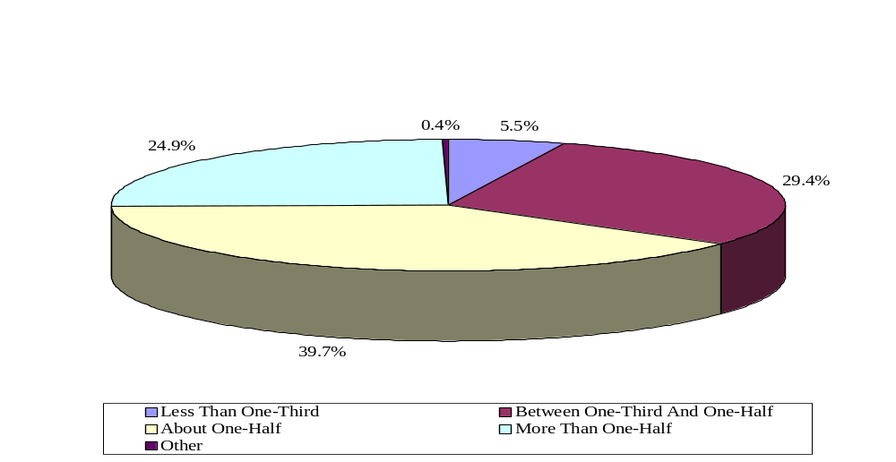
Source: Tabulations from the Third National Survey of OAA Program Participants, 2005.

The home-delivered meals program had large impacts on the lives of recipients (Figure IV.5). The measures in Figure IV.5 indicate that the meals have both improved the nutritional value of the food consumed and helped clients to maintain a higher quality of life. For instance, the majority of clients reported that the meals provided them with healthier food (82 percent) and allowed them eat a greater variety of foods (81 percent), to feel better (81 percent), to maintain a healthy weight (79 percent), and to feel less hungry (79 percent). Approximately 7 in 10 respondents reported that the meals helped to improve their health (73 percent) or to maintain a special diet (72 percent).
FIGURE IV.5
HOME-DELIVERED MEALS HELP CLIENTS TO…
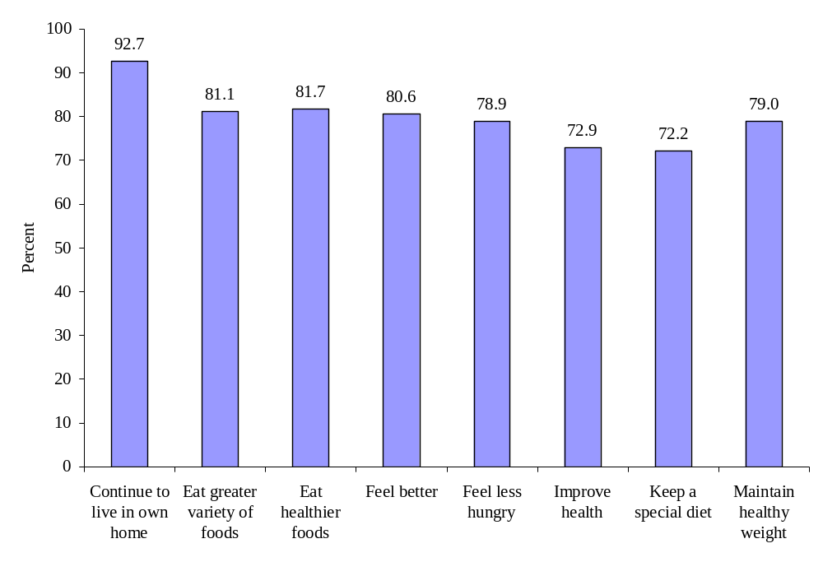
Source: Tabulations from the Third National Survey of OAA Program Participants, 2005.

One of the main goals of the AoA is to provide services to older adults that allow them to remain in their home (Strategic Objective 2.1, “U.S. Administration on Aging, Strategic Action Plan, 2007-2012,” U.S. Department of Health and Human Services, 2007). The home-delivered meals program appears to be very effective in achieving this goal; 93 percent of clients who received meals reported that the service allowed them to stay in their home. This rate did not differ much by whether the person lived alone or not, though the fraction was slightly higher among those who did not live with anyone else (not shown). Ninety-four percent of those who lived alone and 91 percent of those who did not live alone reported that the meals allowed them to remain in their home. The fraction reporting that meals allowed them to continue to live at home did not vary by age or gender (not shown).

C. Client-reported service quality in the OAA Home-Delivered Meals Service
Given such high ratings of the food delivered and the impact of the home-delivered meals service, it is not surprising that service quality was also reported to be very high (Figure IV.6). Almost all clients (94 percent) rated the program good, very good, or excellent, which exceeds the new 2008 performance measure of 90 percent reporting service quality in those categories (Indicators 2.1 and 2.9a, Appendix A). Almost one-third (32 percent) said the program was excellent overall, and another 40 percent said the program was very good. Again, almost all home-delivered meals clients reported liking the meals (95 percent), and 91 percent would recommend the program to friends, neighbors, and relatives.
FIGURE IV.6
OVERALL client-reported service quality in THE HOME-DELIVERED MEALS program
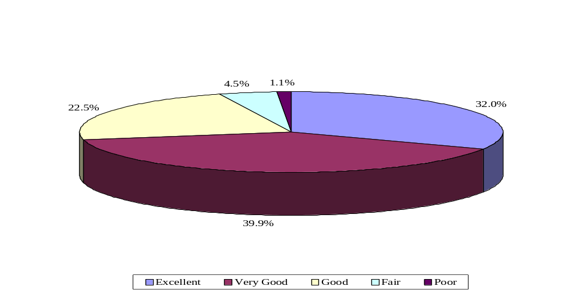
Source: Tabulations from the Third National Survey of OAA Program Participants, 2005.

Service quality in particular features of the home-delivered meals service was also reported by recipients to be quite high (Figure IV.7). For example, 99 percent of clients reported that the delivery person was friendly all or most of the time, and 99 percent reported that they were satisfied with the time of delivery all, most, or some of the time. Service quality in other aspects of the program were similarly high.
FIGURE IV.7
OTHER MEASURES OF service quality in THE HOME-DELIVERED MEALS SERVICE
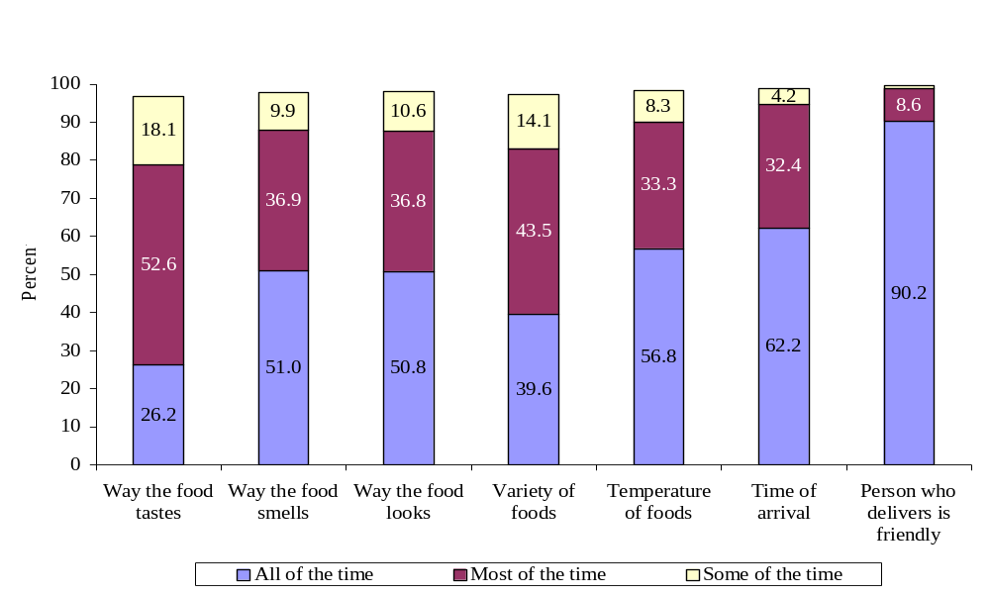
Source: Tabulations from the Third National Survey of OAA Program Participants, 2005.

V. THE OAA TRANSPORTATION SERVICES PROGRAM
From routine trips to the grocery store, pharmacy, and doctors’ offices, to rides to the local senior center and other social settings, OAA transportation services help seniors to remain both independent and socially connected. These transportation services provide a large share of all rides received by clients in a given month. The service is particularly valuable to those who were otherwise transportation disadvantaged—that is, those who did not have a car, were not able to drive, or did not have access to public transportation.
Clients were very satisfied with the transportation service overall, but there was some variation in the client-reported service quality with individual measures of service delivery. For example, one-quarter of clients said they were neither always nor usually notified when rides were cancelled. About the same fraction noted that the vans are not always easy for older adults to get in and out of, though this might expected for an older, frail population. Despite these complaints, the transportation service provided an invaluable opportunity to allow seniors the independence to get to their intended destinations without always relying on the help of friends and family

A. ABILITY TO DRIVE AND ACCESS TO OTHER TRANSPORTATION AMONG OAA Transportation services Clients
Most of the people who used the OAA transportation services were not able to drive themselves. Fewer than half (45 percent) of clients had a car in the household, and only half of those were able to drive (Figure V.1). Over half (55 percent) of clients did not have a car in the household. The fraction without a car climbed to 70 percent among those who lived alone. Overall, 77 percent of clients could not regularly transport themselves by using a car in their household.
FIGURE V.1
ABILITY TO DRIVE AND ACCESS TO AN AUTOMOBILE AMONG
TRANSPORTATION SERVICES CLIENTS
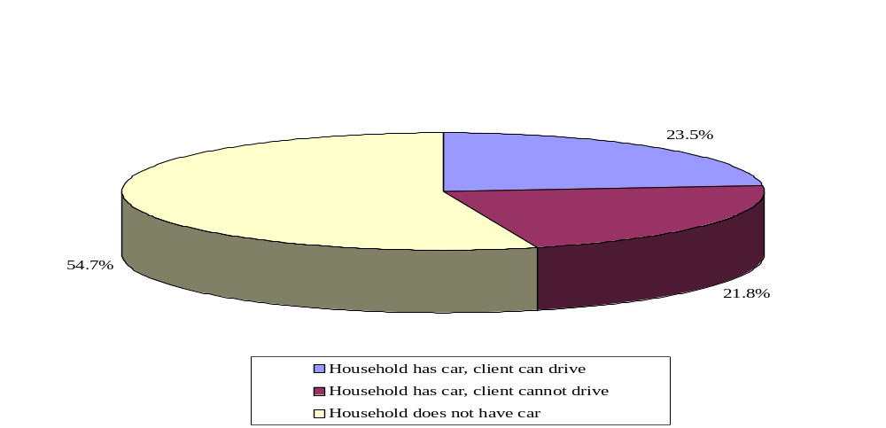
Source: Tabulations from the Third National Survey of OAA Program Participants, 2005.

The fraction of households without a car varied greatly by region (not shown), reflecting geographic differences in the availability of public transportation. Clients in Region VIII were the most likely to have a car they could drive (39 percent), while those in Regions II and IV were the least likely to have the same (14 percent).
This regional variation also points to the possibility that some older people do not have cars because they can rely on public transportation. To widen our definition of “transportation disadvantaged,” we included people who did not have a car in their household, had a car in the household but could not drive it, and, for those who did not have a car, did not have access to public transportation or had difficulty using the system. Even allowing for the possibility of public transportation use, 55 percent of transportation service clients were still transportation disadvantaged (not shown).

B. Use of the OAA Transportation Services Program
Clients who used transportation services tended to do so frequently, but the rate of use varied by whether a person was transportation disadvantaged and had whether the person had a car in their household. On average, the number of one-way trips per month among those who used the transportation service was 12.5, which is slightly more than one round-trip ride per week. One quarter of people who used transportation services took one round-trip ride or less per month, and another quarter took three to six round-trip rides monthly, one in five clients used between six and twelve rides, and one in three clients took more than 12 trips per month (not shown).
The number of trips used per month varied by whether the client was transportation disadvantaged (Figure V.2). Those who were not transportation disadvantaged were much more likely to use fewer rides per month; 41 percent of those who were not transportation disadvantaged used the service for four or fewer one-way trips per month, compared to 32 percent of those who were transportation disadvantaged. Those who were disadvantaged were much more likely to use the service for 11 or more rides per month.
FIGURE V.2
NUMBER OF ONE-WAY TRIPS USED PER MONTH BY TRANSPORTATION SERVICES CLIENTS
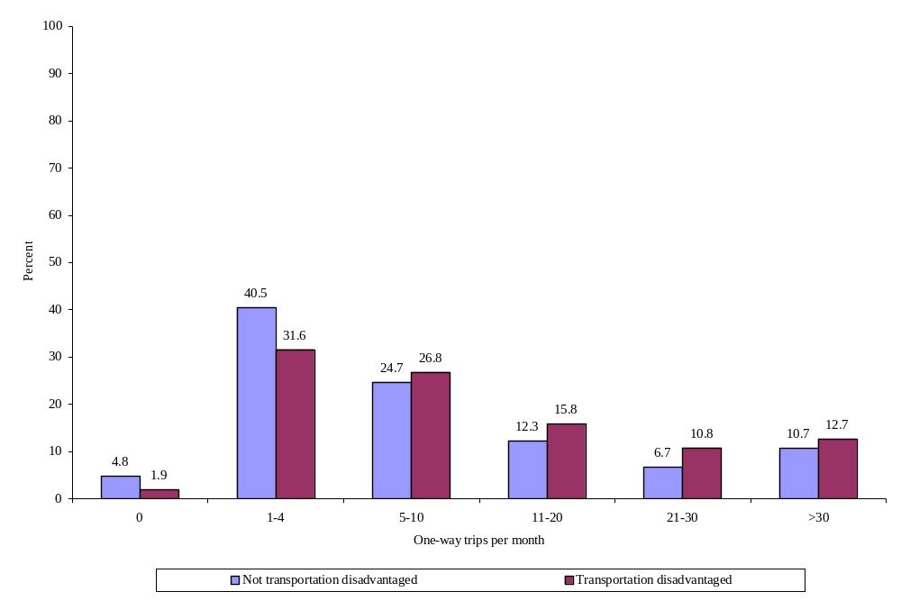
Source: Tabulations from the Third National Survey of OAA Program Participants, 2005.

Transportation services represented a significant portion of all trips made by clients (Figure V.3). About half (53 percent) all clients who had at least one ride per month on average used the service for three quarters or more of all of their transportation needs. Forty-three percent relied on the transportation service for virtually all of their travel needs, indicating the importance of the service to an independent lifestyle. Only about one in five (22 percent) service users reported that they used the service only for a few of their trips.
FIGURE V.3
FRACTION OF CLIENT’S TRIPS REPRESENTED BY THE TRANSPORTATION SERVICE
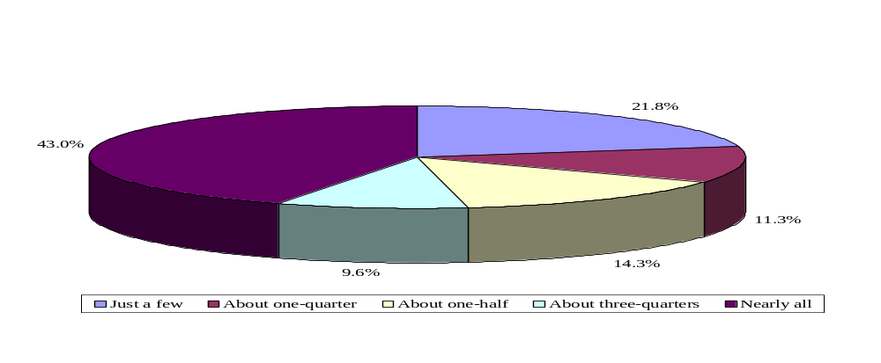
Source: Tabulations from the Third National Survey of OAA Program Participants, 2005.

Expanding the analysis to those who might have had the option of taking public transportation, we find that the number of rides used per month was higher among those who were transportation disadvantaged. About one-third (36 percent) of transportation-disadvantaged clients who used the service for at least one ride per month on average received more than 12 rides per month, compared to only 27 percent of those who were not transportation disadvantaged (not shown). Only 20 percent of transportation-disadvantaged clients received two or fewer rides per month, compared to 29 percent of other clients.
The transportation service represented a much higher fraction of rides for those who were transportation disadvantaged. About half (49 percent) of these clients who used at least one ride per month on average reported that they used the service for all of their rides, compared to only 34 percent of those who were not similarly disadvantaged (Figure V.4). At the other end of the spectrum, 28 percent of those who were not disadvantaged used the service for only a few of their rides, a much higher fraction than those who were disadvantaged (17 percent).

FIGURE V.4
TRANSPORTATION SERVICE USE BY THE TRANSPORTATION DISADVANTAGED
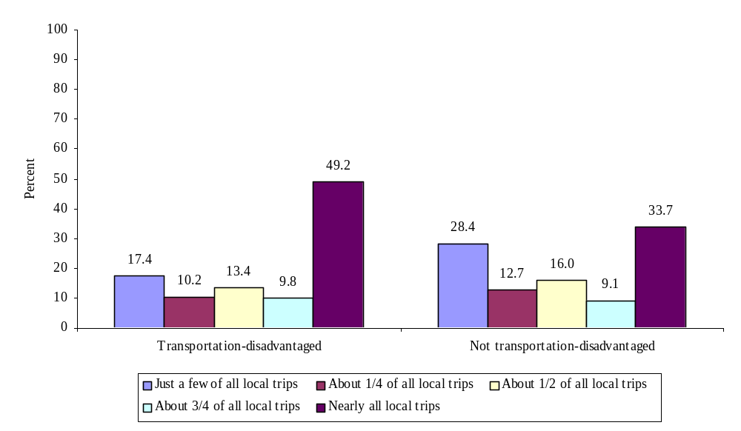
Source: Tabulations from the Third National Survey of OAA Program Participants, 2005.

Transportation services clients used the rides to get to a variety of destinations, ranging from religious services to medical appointments to work (Figure V.5). The most typical destinations included the offices of doctors and other health care providers (71 percent reported medical appointments as a usual destination when using the service). Many (39 percent) clients used the service to go shopping and to social settings, such as senior centers (42 percent), lunch programs (31 percent), and other events (27 percent).
FIGURE V.5
USUAL DESTINATION WHEN USING THE TRANSPORTATION SERVICE
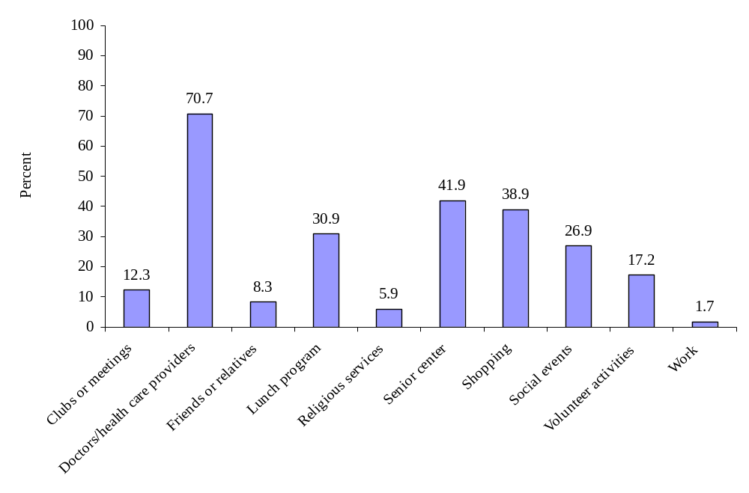
Source: Tabulations from the Third National Survey of OAA Program Participants, 2005.

C. Impact of the OAA Transportation Services Program
For the majority of destinations, clients reported that the transportation service allowed them to get to their usual destination more often than they would have otherwise (Figure V.6). The only destinations and activities for which fewer than 50 percent of clients reported being able to get to more often were appointments with health providers, visit friends and relatives, and to go shopping. These activities might be those for which transportation-disadvantaged seniors may be assisted by family, neighbors, and friends, so the transportation service may be less necessary
FIGURE V.6
WHETHER THE TRANSPORTATION SERVICE ALLOWS THE
CLIENT TO GET TO THEIR USUAL DESTINATION MORE OFTEN
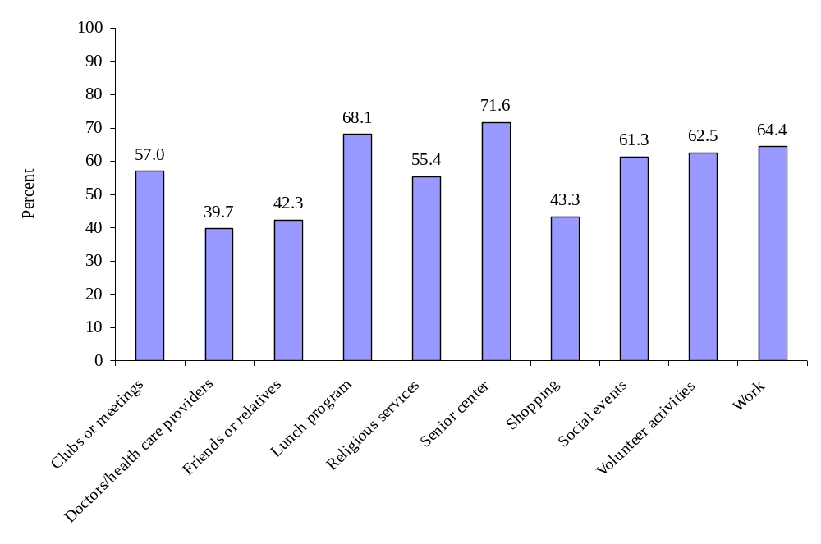
Source: Tabulations from the Third National Survey of OAA Program Participants, 2005.

for these activities than for others. However, other activities such as lunch programs, visits to a senior, social events, volunteering, and work are important paths to social involvement. More than 60 percent of clients who used transportation services reported that all of these activities were ones they could get to more often because of the service.

D. client-reported service quality in OAA Transportation Services
As it has done for other service categories, the AoA has set a new performance goal for transportation service in 2008: at least 90 percent of those using the service will rank their overall service quality as good or higher (Indicators 2.2 and 2.9b, Appendix A). This goal was easily attained in 2005 (Figure V.7), when 98 percent of transportation services clients ranked the program good, very good, or excellent.
FIGURE V.7
OVERALL client-reported service quality in TRANSPORTATION SERVICEs
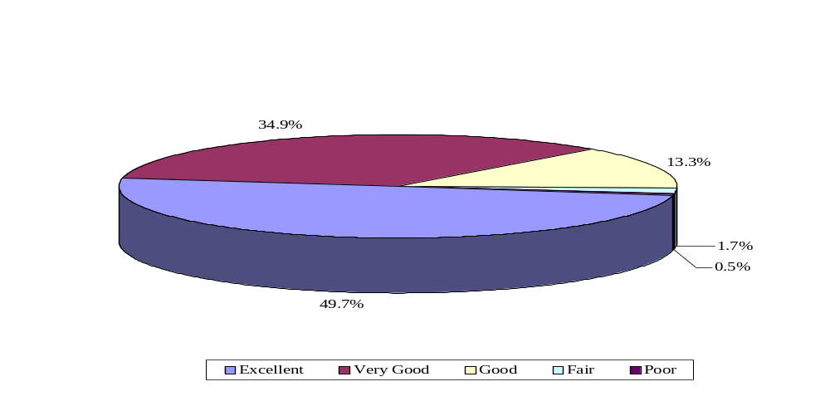
Source: Tabulations from the Third National Survey of OAA Program Participants, 2005.

Clients were generally quite pleased with most aspects of the transportation service. When asked how often the transportation service had each of 13 positive attributes, at least 75 percent of clients said the service usually or always did (Figure V.8).
FIGURE V.8
OTHER MEASURES OF service quality in THE TRANSPORTATION SERVICE
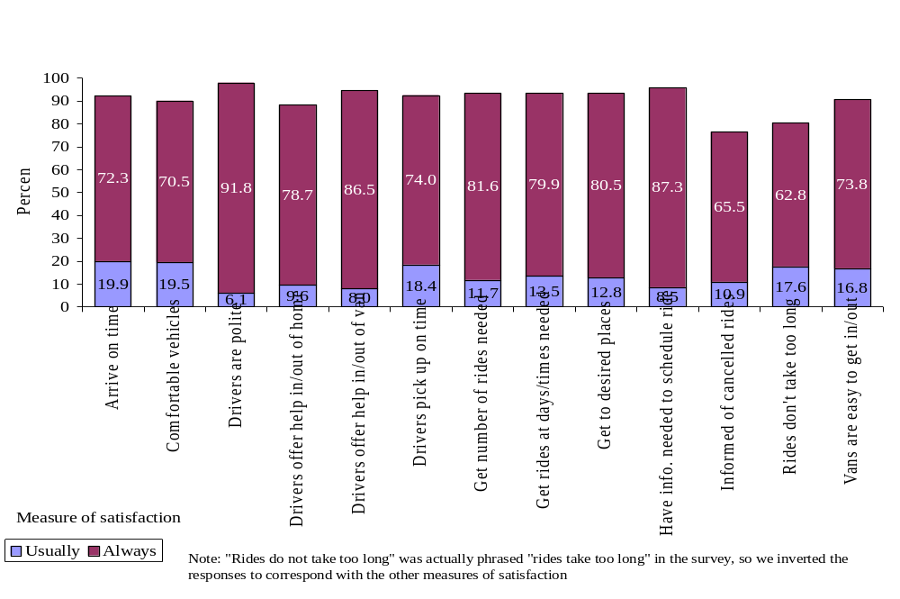
Source: Tabulations from the Third National Survey of OAA Program Participants, 2005.

Some areas were ranked quite high: 92 percent of clients said that the drivers were always polite, and 87 percent said they always had the information they needed to schedule their rides. On the other hand, individual measures of service quality pointed to possible areas for improvement. These areas tended to involve the consistency and timeliness of rides: 74 percent said that drivers always picked them up on time, 72 percent said that rides always arrived at their destination on time, and 63 percent said rides do not always take too long (meaning that more than one-third believed rides did take too long). 66 percent said they were always informed when rides were cancelled. Given that the most common destination is a medical provider’s office, timely, consistent service is very important. There also seemed to be slight dissatisfaction with the ease of getting in and out of the vehicles and the comfort level in the vehicle, which may be important considerations for more frail elderly.
The service quality reported by consumers was lower among those who were transportation disadvantaged; these people were less likely to report that the service “always” met their expectations on the above measures. However, these clients relied heavily on the service for most of their rides, so it is possible that the additional experience with the service also meant they had additional opportunities for problems to occur, making it less likely that the service “always” met their needs. We cannot, however, test this conjecture with the data we have. But even so, overall service quality reported by this group was still quite high, and the service may have a potentially greater impact on clients with fewer transportation alternatives.

VI. OAA CAREGIVER SUPPORT SERVICES
Without informal and family caregiving, many older people would be forced to move into institutional settings as their physical and cognitive capabilities declined. Filling the role of a caregiver can be more than a full-time job and often brings financial, physical, and emotional strain. The services provided by OAA caregiver support programs are intended to mitigate these effects by offering information, assistance, and respite services to the people who provide care for the most vulnerable elderly.
While caregivers were younger and healthier on average than the other two OAA service groups in the Third National Survey, they faced many burdens associated with their caregiving responsibilities, including the struggle to balance work and caregiving, to make time for their own needs, and to deal with health problems that arose or worsened because of caregiving. The caregiver support services helped these individuals cope with these burdens, and the majority reported high levels of service quality in most aspects of the program. The program also had an important impact on the lives of caregivers and care recipients; most indicated that the program allowed them to care for recipients longer and allowed their recipients to stay longer in their home.

A. CHARACTERISTICS OF OAA Care Recipients
Most care recipients in 2005 were among the oldest old; 36 percent were age 85 and older, and another 42 percent were 75 to 84 (Figure VI.1). This is a much older age distribution than
FIGURE VI.1
AGE DISTRIBUTION OF THE CARE RECIPIENTS
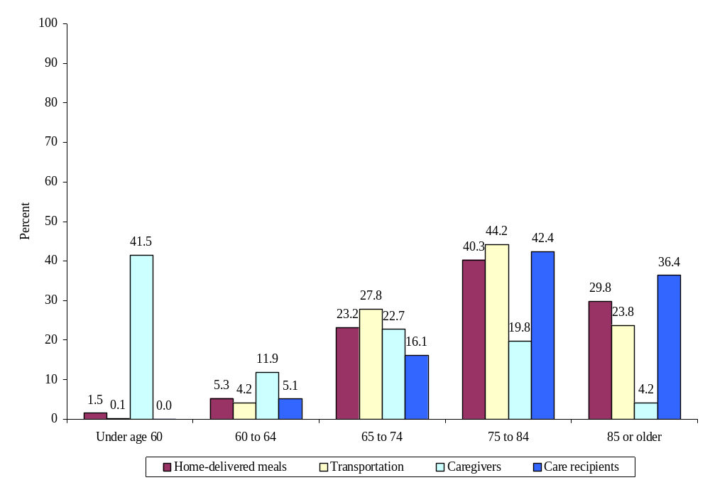
Source: Tabulations from the Third National Survey of OAA Program Participants, 2005.

in the previous two OAA client groups, meaning that caregivers are responsible for the oldest old, who are likely a frail and vulnerable population.
Slightly more care recipients were female (61 percent), which is likely to reflect the fact that women more often live longer than men and therefore need the assistance of a caregiver (not shown). Although there were higher proportions of females among both caregivers and care recipients, only 41 percent of recipients were helped by a caregiver who was the same gender (Figure VI.2). Female caregivers were about equally likely to be assisting a male as a female.
FIGURE VI.2
GENDER OF CAREGIVER AND GENDER OF CARE RECIPIENT
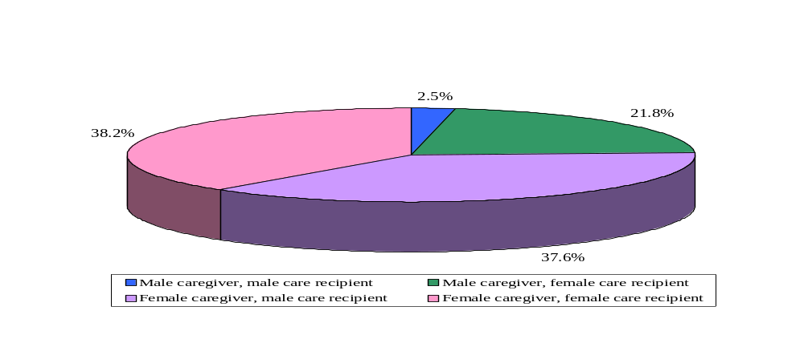
Source: Tabulations from the Third National Survey of OAA Program Participants, 2005.

Care recipients were likely to be in fair or poor health, which is not surprising, given their age and the fact that they need someone else to help them with ADLs or IADLs (Figure VI.3).

FIGURE VI.3
SUBJECTIVE HEALTH STATUS OF CARE RECIPIENTS, AS REPORTED BY THEIR CAREGIVERS
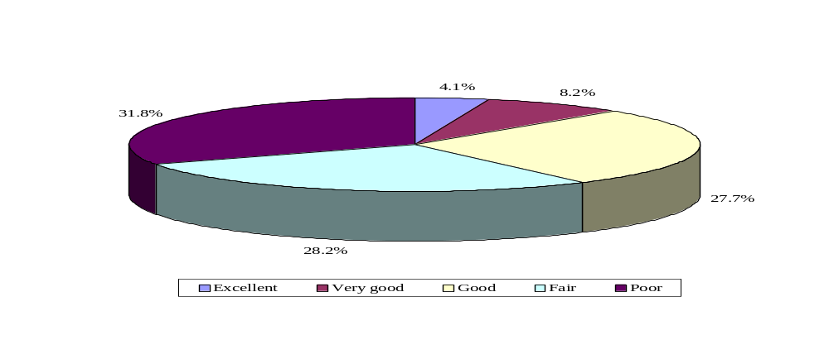
Source: Tabulations from the Third National Survey of OAA Program Participants, 2005.

About one in three (32 percent) caregivers said the person they took care of was in poor health, and 28 percent said the person was in fair health. Compared to home-delivered meals recipients (29 percent in poor health) and transportation services clients (16 percent in poor health), care recipients were most likely to be unhealthy. Considering that other OAA participants were much less healthy than the older population nationwide, care recipients were the least healthy. While 28 percent of caregivers said that the care recipient was in good health, only 12 percent said that the person was in very good or excellent health, a much smaller share than the 15 and 24 percent as self-reported by clients receiving meals and transportation services, respectively.
As the subjective rating of the care recipient’s health would suggest, many care recipients had a number of health conditions (Figures VI.4 and VI.5). Rates of hypertension, arthritis, heart disease, and vision and hearing problems were similar to rates among transportation and meals services clients. However, care recipients had high rates of Alzheimer’s disease or dementia (58 percent), depression or anxiety (60 percent), and stroke (36 percent).
FIGURE VI.4
MOST COMMON HEALTH CONDITIONS AMONG CARE RECIPIENTS,
AS REPORTED BY THEIR CAREGIVERS
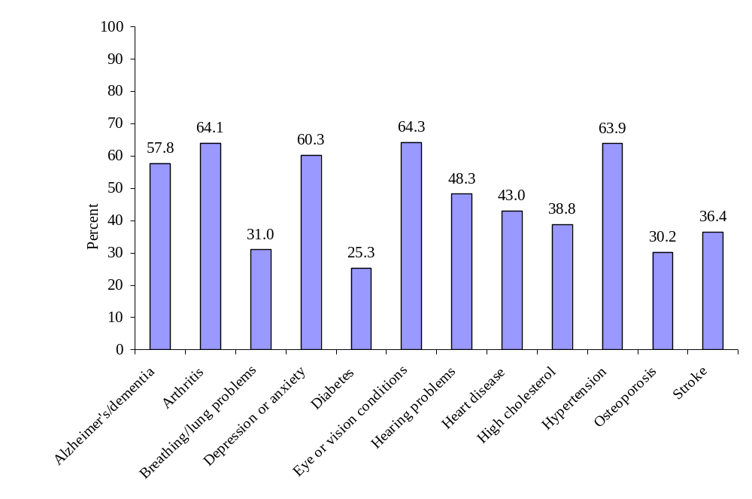
Source: Tabulations from the Third National Survey of OAA Program Participants, 2005.

FIGURE VI.5
NUMBER OF HEALTH PROBLEMS AMONG CARE RECIPIENTS
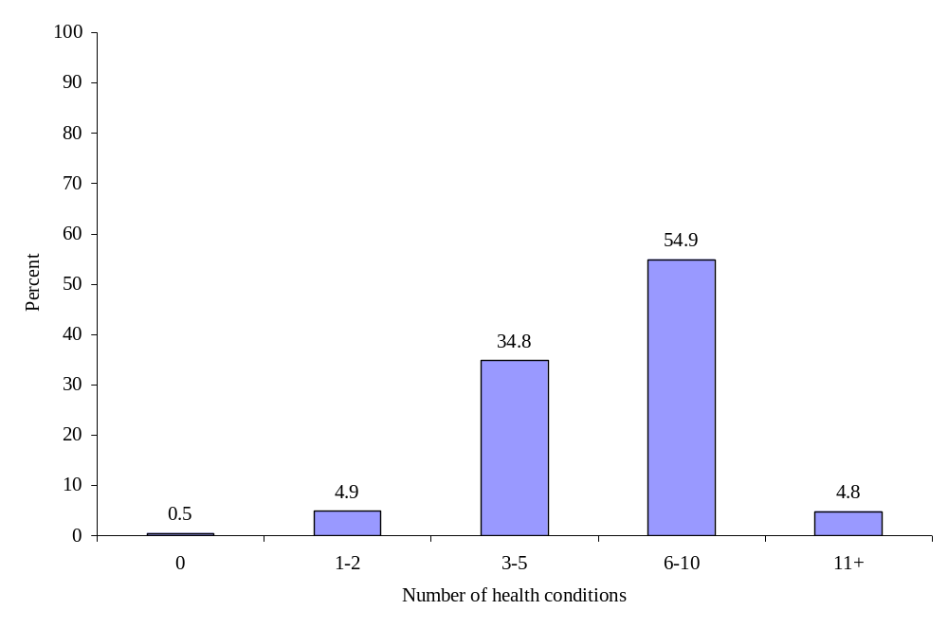
Source: Tabulations from the Third National Survey of OAA Program Participants, 2005.

Approximately 55 percent of care recipients had 6 to 10 health problems, compared to about 40 percent with 6 to 10 conditions in the other two client groups. Another 35 percent of care recipients had 3 to 5 conditions, and only about 6 percent had 2 or fewer problems, a much lower rate than among other participants. Thus, care recipients had more conditions to manage than did other program participants, probably explaining why they needed another person to help them on a regular basis.
The activities that care recipients were most likely to need help with demanded a great deal from caregivers in terms of physical exertion (Figure VI.6). Almost 8 in 10 care recipients had difficulty bathing or showering (78 percent) and walking (78 percent). About two-thirds had trouble dressing (67 percent) and getting in and out of chairs (63 percent), and over half (55 percent) had difficulty toileting.
FIGURE VI.6
REPORTED DIFFICULTIES WITH ACTIVITIES OF DAILY LIVING
AMONG CARE RECIPIENTS, AS REPORTED BY THEIR CAREGIVERS
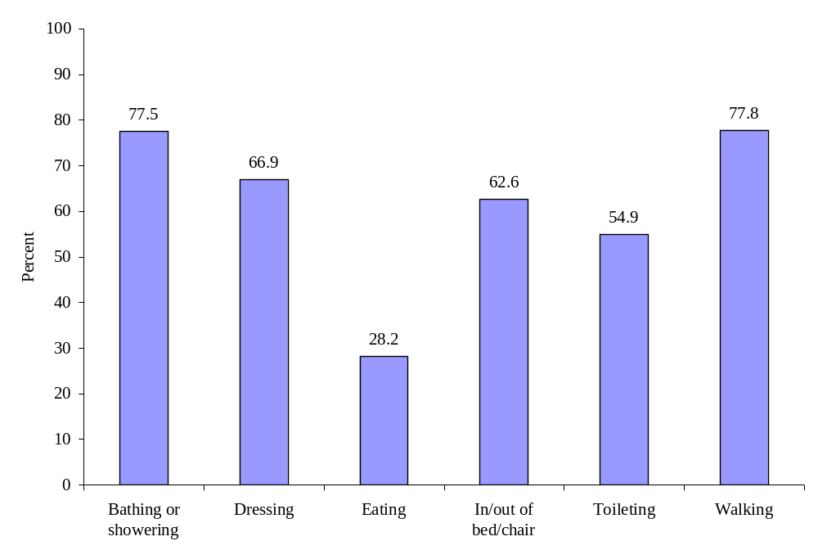
Source: Tabulations from the Third National Survey of OAA Program Participants, 2005.

Only 8 percent of care recipients did not have any trouble with ADLs (Figure VI.7). This is much lower than the share of clients receiving home-delivered meals and transportation services, 25 and 44 percent of whom reported no difficulty with any ADLs. More than half of all care recipients had trouble with four or more ADLs, and one in five (20 percent) had difficulty with all six ADLs, compared to less than 3 percent in the other samples. The high rates of ADL difficulty imply that care recipients are a very vulnerable population who would not likely be able to perform ADLs without the regular assistance of a committed caregiver.
FIGURE VI.7
NUMBER OF REPORTED DIFFICULTIES WITH ACTIVITIES OF
DAILY LIVING AMONG CARE RECIPIENTS, AS REPORTED BY THEIR CAREGIVERS
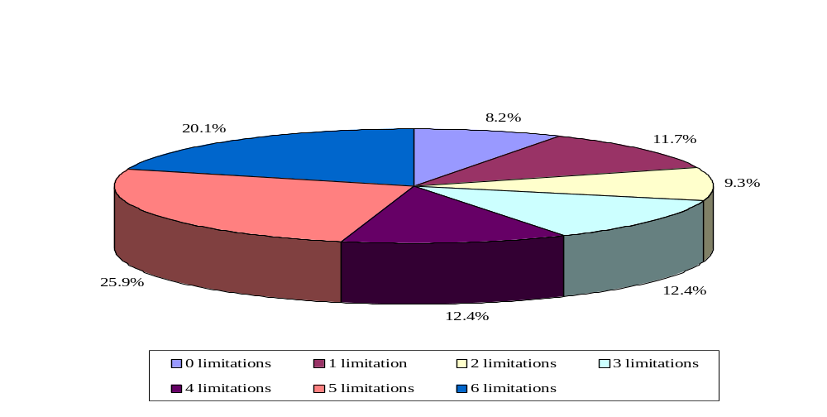
Source: Tabulations from the Third National Survey of OAA Program Participants, 2005.

B. CHARACTERISTICS OF OAA CaregiverS
Caregivers of frail older individuals are usually family members or friends who informally take on the role of providing care to an ailing loved one; indeed, 41 percent of people receiving OAA-funded caregiver support services were spouses of the care recipient (Figure VI.8). Among those caring for their spouse, it was more likely that a wife was caring for her husband, as 66 percent of spouse caregivers were female (not shown). Almost the same fraction of caregivers was a daughter or daughter-in-law (40 percent). Almost four times as many caregivers were daughters (or daughters-in-law) than sons (or sons-in-law), reflecting the tendency for women than for men to be the more likely caretaker of parents. Only 10 percent of care recipients were assisted by family or friends who were not children or spouses.

FIGURE VI.8
RELATIONSHIP OF CAREGIVER TO CARE RECIPIENT
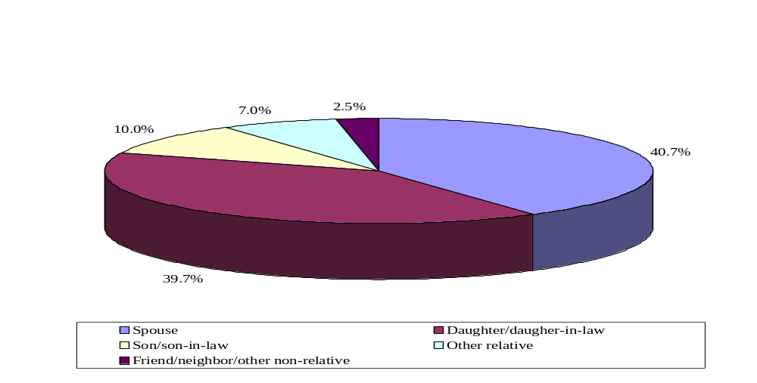
Source: Tabulations from the Third National Survey of OAA Program Participants, 2005.

Given the high reported rates of difficulty in performing ADLs, it is not surprising that three out of four caregivers reported assisting care recipients with ADLs (Figure VI.9). Even more caregivers (89 percent) reported helping with household tasks such as paying bills, writing checks, cooking meals, doing laundry, or cleaning. Eighty-eight percent of caregivers reported arranging for care from others for the recipient. Almost all caregivers (96 percent) assisted with shopping trips or visits to the doctor’s office, and many (83 percent) helped to administer prescription medications and tended to other medical needs.
FIGURE VI.9
TYPES OF ACTIVITIES THAT CAREGIVERS ASSIST WITH
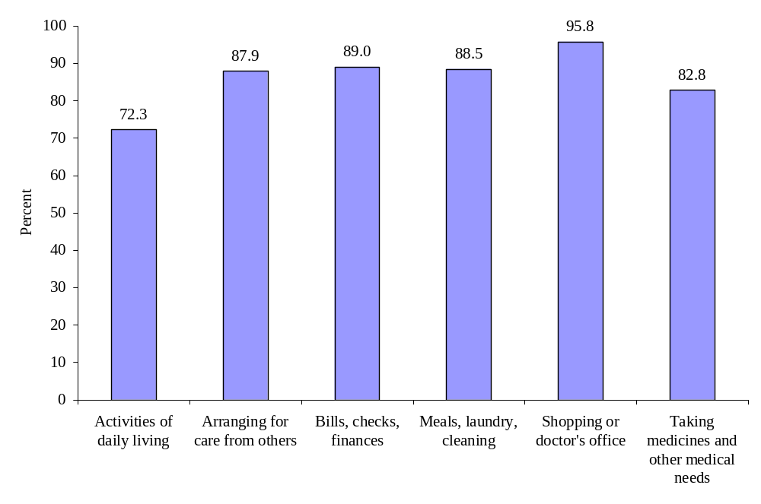
Source: Tabulations from the Third National Survey of OAA Program Participants, 2005.

C. Employment Among OAA Caregivers
Almost half (47 percent) of all caregivers served by AoA programs in 2005 were retired (Figure VI.10). About one in five (18 percent) were not working at all, and 12 percent were working part-time. The fraction of caregivers who reported being retired varied by gender; 66 percent of men said they were retired compared to only 41 percent of women. It could be that women had either been out of the workforce for a long time or had never worked outside the home. Twenty-three percent of female caregivers—but only 6 percent of male caregivers—said they were not currently working (as opposed to retired). Female caregivers were twice as likely as men to be working part-time while caregiving (13 percent versus 6 percent).
FIGURE VI.10
EMPLOYMENT STATUS OF CAREGIVERS, BY GENDER
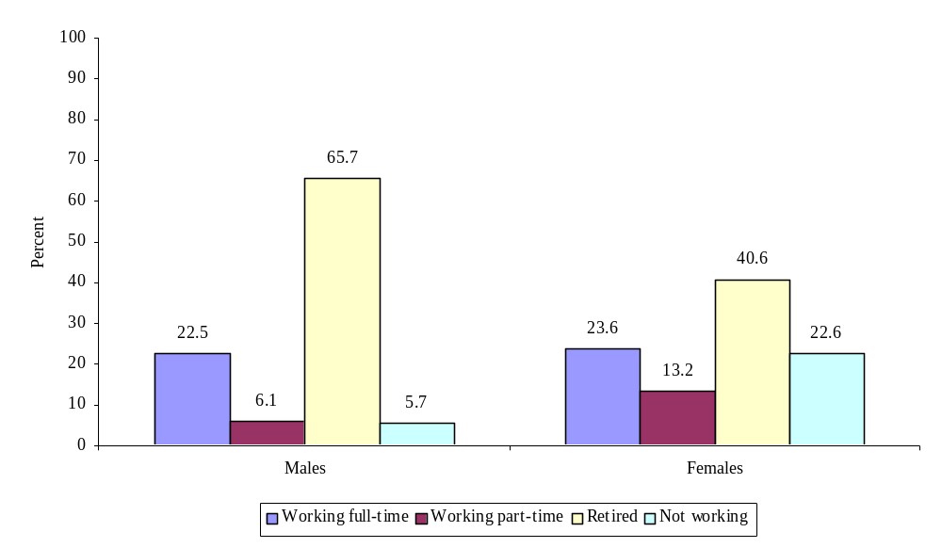
Source: Tabulations from the Third National Survey of OAA Program Participants, 2005.

Females were more likely than males to have their participation in the labor force interrupted by the responsibilities of caregiving. Of the two-thirds of caregivers who said they were either not working or retired, 27 percent said they quit their job because of caregiving responsibilities (not shown). This effect was about twice as high among women than men; 30 percent of women—but only 17 percent of men—reported that they had to quit work in order to keep up with their caregiving responsibilities.
Those who continued to work while providing care to a friend or family member faced a variety of challenges, most of which centered around making enough time for both work and caregiving. Among caregivers who were working full- or part-time, 62 percent reported that caregiving interfered with their job at some point. Among those who said this, 36 percent said it always interfered, 52 percent said it sometimes interfered, and 13 percent said it rarely or never interfered. In other words, caregiving responsibilities often interfered with the ability to hold a steady job.
These types of effects on employment are shown in Figure VI.11. Almost all (93 percent) caregivers who held a full- or part-time job indicated that they had to deal with time conflicts. A majority indicated that they had to use time off (84 percent) or worked less than normal (59 percent) in order to meet their responsibilities as a caregiver, suggesting that they may not have had time for their own needs. Four in 10 (40 percent) reported that they worked fewer hours in order to be a caregiver (possibly switching from full- to part-time work), while others took a less demanding job (27 percent) or lost a promotion (16 percent), which could have resulted in loss of current and future income. In addition to having a detrimental effect on career progression, any of these situations can have other long-term impacts, such as reduced retirement savings.
FIGURE VI.11
EFFECTS OF CAREGIVING ON EMPLOYMENT
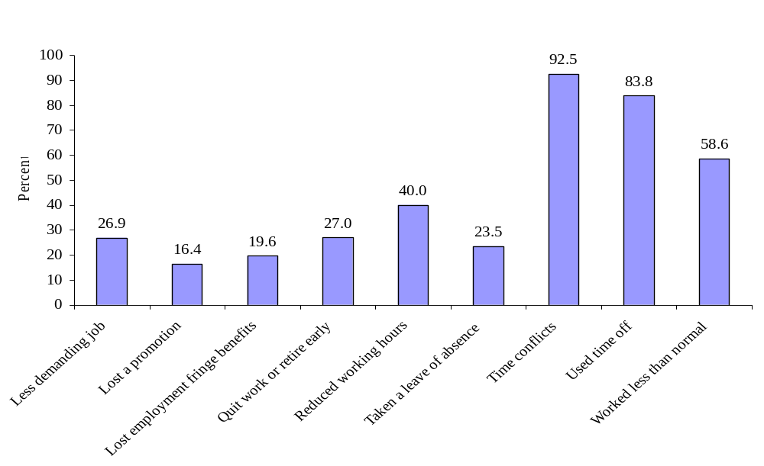
Source: Tabulations from the Third National Survey of OAA Program Participants, 2005.

D. The Burdens and Rewards of Caregiving as Reported by OAA Caregiver Support Clients
Aside from demands on time, caregiving can also take a physical toll on caregivers. More than half (56 percent) of OAA caregivers who reported having at least one health problem indicated that these problem(s) had been created or worsened by caregiving responsibilities. The extent of this effect varied tremendously by the type of health problem (Figure VI.12).
FIGURE VI.12
Percent of Caregivers Reporting that Caregiving Created their health
problems OR MADE PROBLEMS WORSE, by type of problem
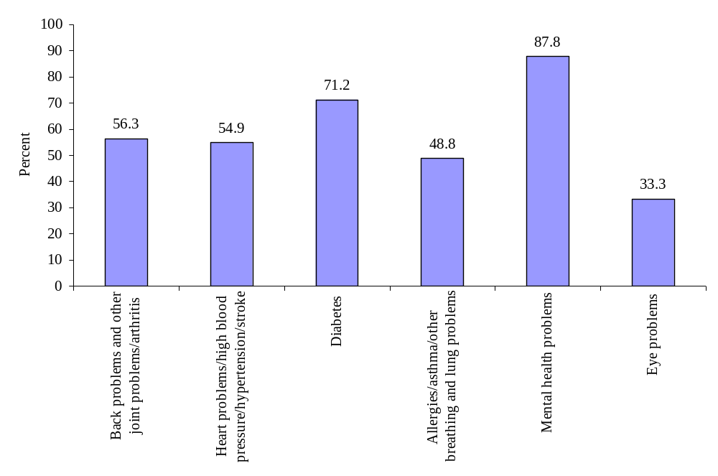
Source: Tabulations from the Third National Survey of OAA Program Participants, 2005.

As shown in the figure, 88 percent of those who said they had a mental health condition said it was created or made worse by caregiving, as did 71 percent of those who said they had diabetes. Approximately 55 percent of those with back problems, arthritis, or heart problems said their condition was created or made worse by caregiving. While these effects were not clinically confirmed, they suggest that caregivers associate their role with serious health consequences.
Along with the employment and health effects of caregiving, there are other consequences, such as stress on finances and relationships. Caregivers who participated in the survey were asked to identify the biggest hardship they experienced as a result of caregiving (Figure VI.13).
FIGURE VI.13
BIGGEST HARDSHIPS OF CAREGIVING (3 MOST COMMON RESPONSES)
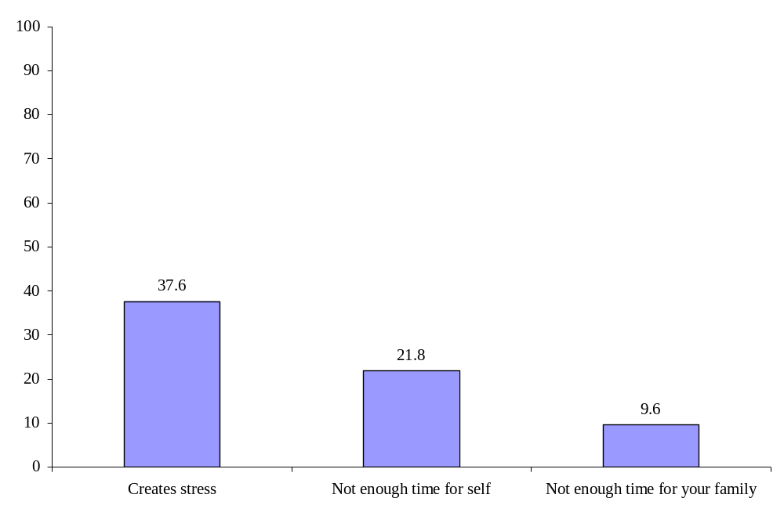
Source: Tabulations from the Third National Survey of OAA Program Participants, 2005.

By far, stress was the most common hardship, with 38 percent of respondents citing it as a problem. This could include time stress, financial stress, or stress on other relationships. The next most common hardship, cited by 22 percent of respondents, was not having enough time for oneself, while about 10 percent said that caregiving did not leave enough time for friends and family.
Using a scale of 1 to 5 where 1 represented the lowest level of strain, stress, or burden, and 5 represented the highest level, respondents were asked to report on their levels of physical strain, emotional stress, financial burden, and overall hardship brought on by their caregiving responsibilities. Emotional stress was ranked highest, while financial burden was ranked lowest (Figure VI.14).
FIGURE VI.14
AVERAGE RATINGS OF COMMON BURDENS OF CAREGIVING
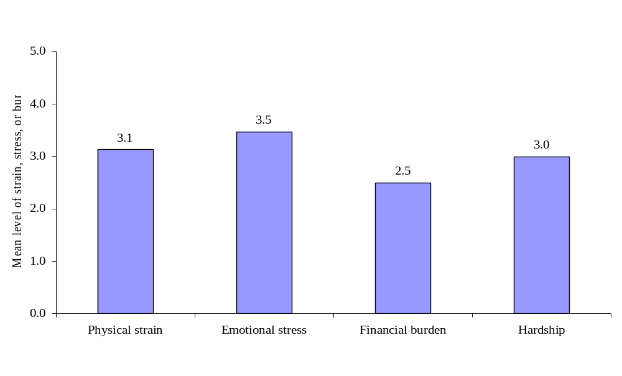
Source: Tabulations from the Third National Survey of OAA Program Participants, 2005.

The mean level of emotional stress reported was the highest of all forms of stress at 3.5, followed by physical stress at 3.1, then overall hardship at 3.0, and finally, financial stress, with an average rating of 2.5 on a five-point scale. In terms of the distribution of responses, 33 percent rated the level of financial burden as a 1, compared to only 7 percent who ranked the level of emotional stress as a 1.
While caregiving imposes several burdens on caregivers, it also has many rewards. Figure VI.15 shows the most commonly reported rewards. Topping the list was observing the effects of their help on the care recipient (45 percent of respondents). Another 39 percent reported that the greatest reward was caring for someone who had cared for them, such as a parent or a spouse. About 5 percent said that it was rewarding to help another family member.
FIGURE VI.15
BIGGEST REWARDS OF CAREGIVING (3 MOST COMMON RESPONSES)
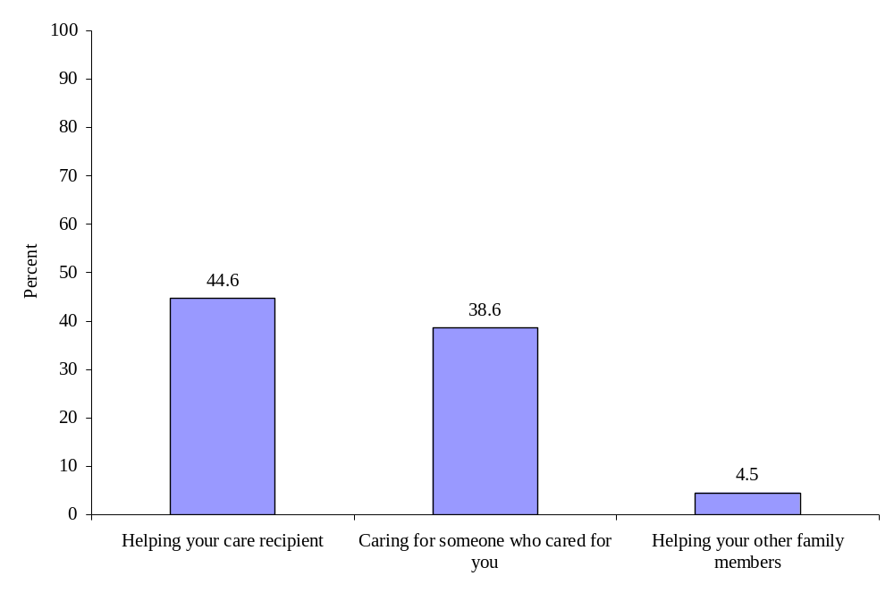
Source: Tabulations from the Third National Survey of OAA Program Participants, 2005.

E. Amount of Care provided by the OAA Caregivers
The burden of caregiving depends partly on the amount of time devoted by caregivers to their loved one. One aspect of the time commitment is the physical distance between the caregiver and the recipient. Even a daily round trip of an hour can become burdensome. This burden would increase with distance or if multiple trips per day were necessary. Figure VI.16 presents the distribution of distances between the caregiver and the person they assist.
FIGURE VI.16
DISTANCE THAT CAREGIVER LIVES FROM CARE RECIPIENT
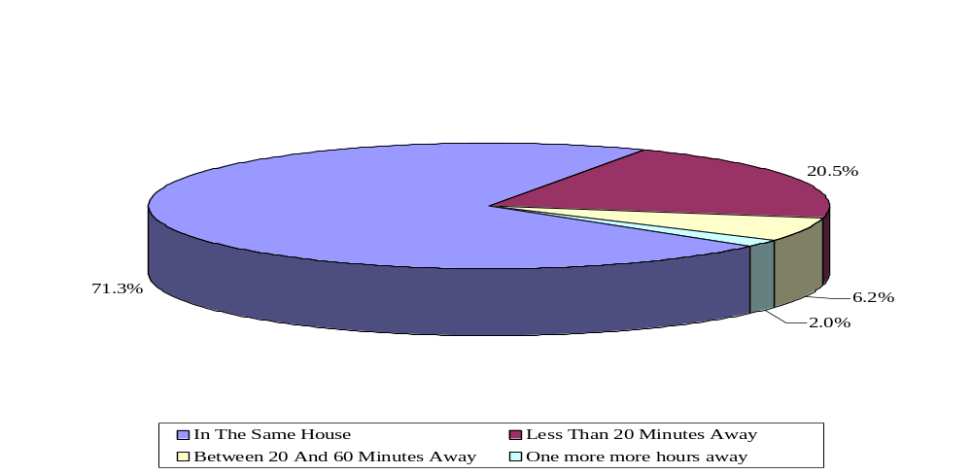
Source: Tabulations from the Third National Survey of OAA Program Participants, 2005.

The majority of care recipients lived close to their caregivers, including 71 percent who lived in the same house. Only about 8 percent lived more than 20 minutes away from their caregiver. So, time is not a burden for most caregivers. However, the close proximity of caregiver and recipient may have been precipitated by a health event or by the need to move to be closer to a family member’s home or an assisted-living facility.
While the driving distance to the recipient of care may not be particularly burdensome for caregivers served by OAA programs, the number of hours of care needed by the recipient per day was quite high (Figure VI.17). About half of care recipients (49 percent) needed more than a half day of care per day, while the remainder needed less than a half day. A large part of the time was concentrated at the extremes: 42 percent of care recipients needed 19 to 24 hours of care per day, while at the other end of the spectrum, 34 percent needed 6 or fewer hours each day. It can be very difficult to provide care for another person for more than half a day while holding a full-time job, as reflected in responses about the burden of caregiving.
FIGURE VI.17
NUMBER OF HOURS OF CARE NEEDED BY CARE RECIPIENTS PER DAY
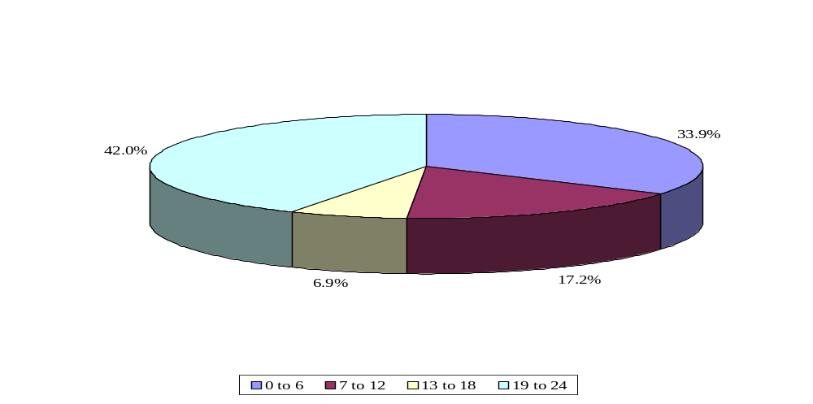
Source: Tabulations from the Third National Survey of OAA Program Participants, 2005.

Among care recipients who did not live in the same house as their caregiver, approximately 6 in 10 (61 percent) lived alone (not shown). Among care recipients who did not live alone, only 11 percent could be left alone in their home for an entire day. Most required full-time care; 65 percent of care recipients required a caregiver all of the time, and another 24 percent needed caregiver for at least part of the day.
The amount of time a care recipient needs care may differ from the amount of time that a caregiver provides it, if the caregiver is unable to devote as much time as needed or shares the caregiving responsibility with another person. The time devoted by caregivers to care recipients was concentrated at either end of the distribution, likely reflecting the needs of the recipient (Figure VI.18). A large fraction provided virtually full-time care, but many provided six or fewer hours per day.
FIGURE VI.18
HOURS OF CARE PER DAY GIVEN BY CAREGIVERS TO CARE RECIPIENTS,
WEEKDAYS AND WEEKEND DAYS
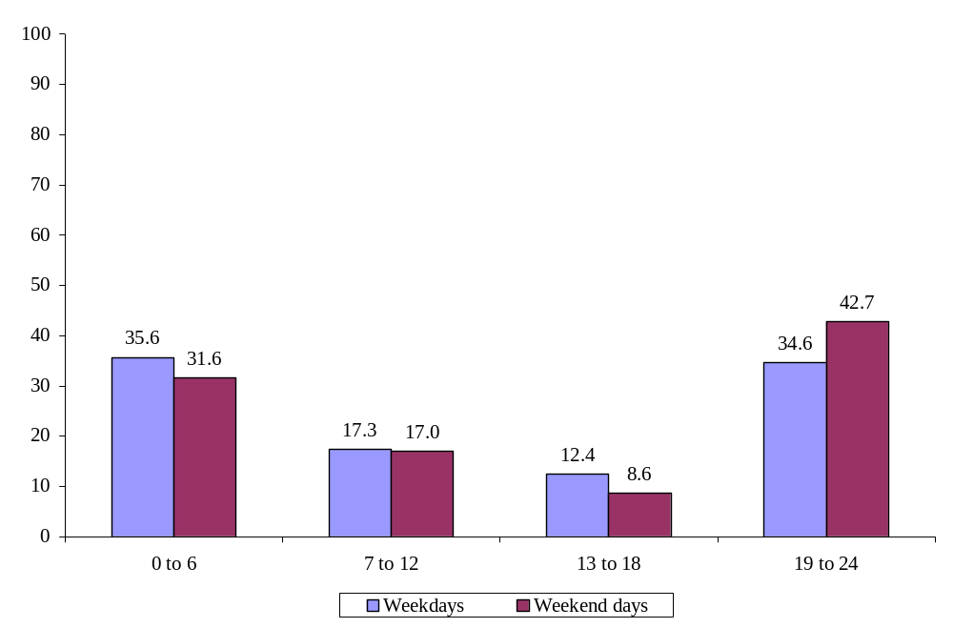
Source: Tabulations from the Third National Survey of OAA Program Participants, 2005.

More care was provided on weekends than weekdays. This could mean that caregivers who worked were able to devote more time to the care recipient on the weekend, or it might reflect the fact that paid caregiving support received by individuals during the week was not available on the weekend, at which time family or friend caregivers would take over.
The number of hours of care provided per week was correlated with whether or not the caregiver was working (Figure VI.19). Those who were retired or not working were much more likely to provide full-time care (168 hours per week) than those who were either working part- or full-time. For example, 38 percent of those who were retired and 34 percent of those not working provided round-the-clock care, compared to only 9 percent of those working part-time and 5 percent of full-time workers. Caregivers who worked at all were more likely to provide 60 or fewer hours of care per week, compared to those who were not working. Even so, 60 hours of care per week is quite a lot for people who have a job, and providing full-time care is burdensome, even for those who are not working.
FIGURE VI.19
Hours or Care per Week Provided by Caregivers to Care Recipients, by Employment Status of Caregivers
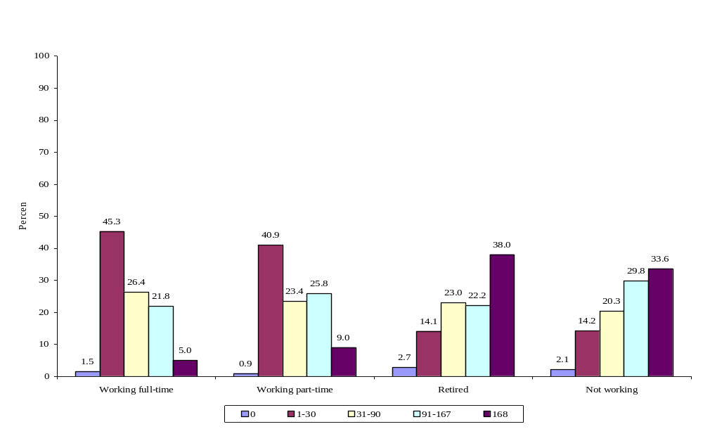
Source: Tabulations from the Third National Survey of OAA Program Participants, 2005.

F. Use of the OAA Caregiver Support Services Program
The OAA reauthorization in 2000 acknowledged the burden on caregivers by establishing the National Family Caregiver Support Program (NFCSP). The Third National Survey provides insight into which caregiving services provided by OAA programs are used the most by and are most useful to caregivers (Figure IV.20).
FIGURE VI.20
SERVICES used by CAREGIVERS
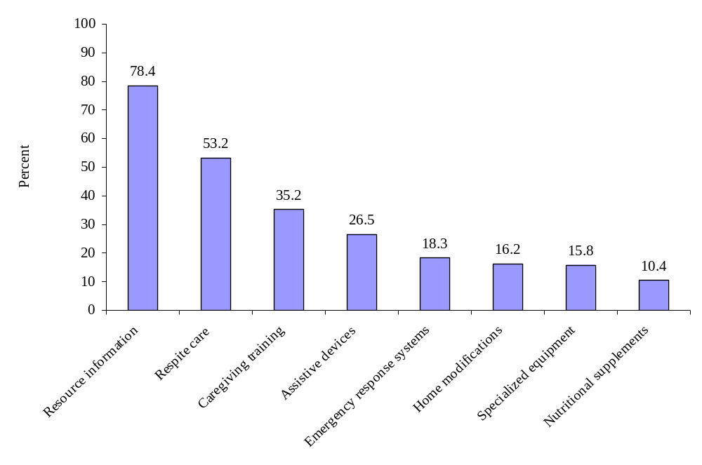
Source: Tabulations from the Third National Survey of OAA Program Participants, 2005.

Caregivers used resource information more than they used any other service; 78 percent of caregivers reported receiving information about services for managing the burdens of caregiving (Figure VI.19). Next in line was respite care, which was used by slightly more than half of all caregivers (53 percent). About one-third of caregivers (35 percent) received training in some aspect of caregiving, and about one-quarter (27 percent) received assistive devices, which could include a walker, a special toileting device, or other equipment. Services used less frequently included emergency response systems, home modifications, nutritional supplements, and specialized equipment. It is noteworthy that the overall use of services by caregivers depends not only on whether or not the clients decided to “take up” the services offered, but also on whether services were offered in the first place. The preceding rates of use are likely to reflect variation in both of these factors.

G. Impact of the of the OAA Caregiver Support Services Program
Caregiver support services affected the lives of caregivers and care recipients in meaningful and diverse ways (Figure VI.21). Nine out of 10 caregivers (91 percent) reported that the services they offered were beneficial to the care recipient. Eight in 10 caregivers (83 percent) said that the services they themselves received made it easier to care for another person. Support services also allowed about three-quarters (77 percent) of caregivers to better understand how to obtain resources and how feel less stress associated with their role, both of which allowed caregivers to function more effectively.
FIGURE VI.21
THE EFFECTS OF CAREGIVER SUPPORT SERVICES ON THE DAILY LIFE OF CAREGIVER
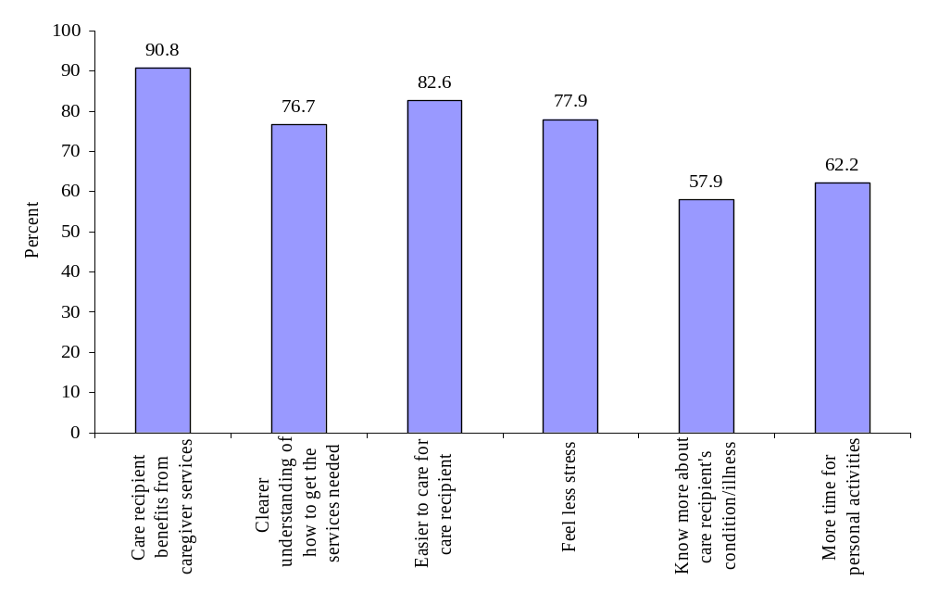
Source: Tabulations from the Third National Survey of OAA Program Participants, 2005.

Most caregivers believed that the support services they received allowed them to be a better caregiver; 72 percent said that the services helped a lot, and another 23 percent said they helped a little (not shown). Only 5 percent said the services did not help, and almost no caregivers (less than one percent) said the services made things worse. Caregivers also reported that the support services increased the length of time that they could perform their duties; 51 percent said this was definitely the case, and another 34 percent said they thought it was so (not shown).
One of the AoA goals is to increase the percent of caregivers who report that services help them care longer for older individuals (Indicator 2.5, Appendix A). While a single measure cannot answer whether this fraction will increase over time, the National Survey results indicated very high baseline responses to this question. About half of caregivers (54 percent) said that caregiver support services enabled the care recipient to live at home for a longer period of time.

H. client-reported service quality in OAA Caregiver Support ServiceS
Overall satisfaction levels with caregiver support services were very high (Figure VI.22). The vast majority of caregivers (94 percent) reported that the OAA services they received were good, very good, or excellent. Thus, in 2005, the caregiver program exceeded AoA’s new 2008 performance target, which is at least 90 percent of clients ranking the service as good to excellent (Indicators 2.3 and 2.9c, Appendix A).
FIGURE VI.22
OVERALL CLIENT SATISFACTION WITH CAREGIVER SUPPORT SERVICES
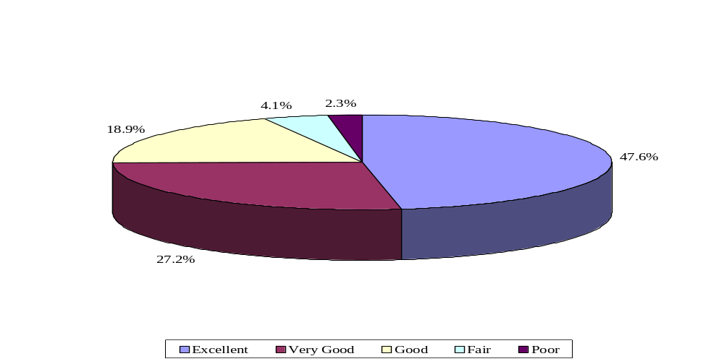
Source: Tabulations from the Third National Survey of OAA Program Participants, 2005.

Because caregiver support services come in a variety of forms that may not all be known to clients, one concern is that caregivers may have difficulty identifying and getting the services available to them. While slightly more than half of caregivers (51 percent) did not report difficulty in accessing services, others did (Figure VI.23).
FIGURE VI.23
OVERALL REPORTED EASE OF GETTING CAREGIVER SUPPORT SERVICES
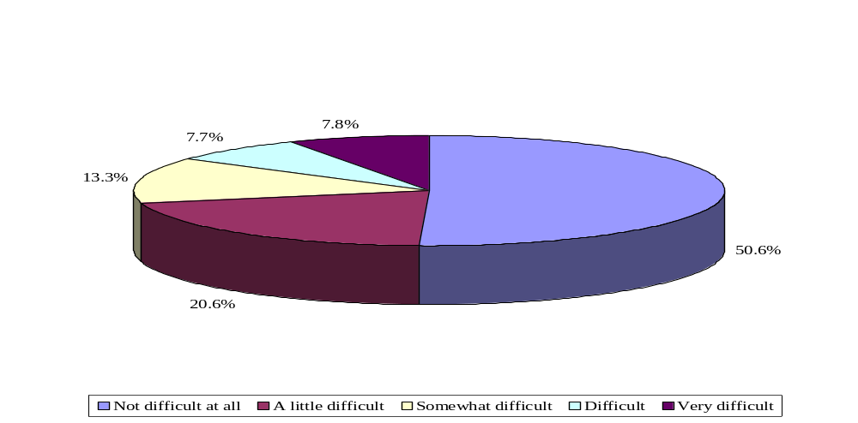
Source: Tabulations from the Third National Survey of OAA Program Participants, 2005.

About one in three caregivers (34 percent) said that they found the process of obtaining services a little or somewhat difficult, and 16 percent found it difficult or very difficult. The extent of difficulty differed little by type of service received (not shown). These numbers point to an area for improvement in AoA programs if they are to meet the performance goal in this category (Indicator 2.6, Appendix A).
The majority of caregivers reported that the services they received were helpful (Figure IV.24). About 9 out of 10 (89 percent) of those who received respite services said they helped a lot, while almost all of the rest (10 percent) said they at least helped a little. Even in information services, the category with the fewest number reporting that the services helped a lot, 70 percent said this information helped a lot, and another 24 percent said it helped a little. For all four major types of caregiver services, at least 95 percent of clients reported that the services were helpful.
FIGURE VI.24
PERCENT OF CLIENTS WHO REPORTED HELPFULNESS OF CAREGIVER SUPPORT SERVICES
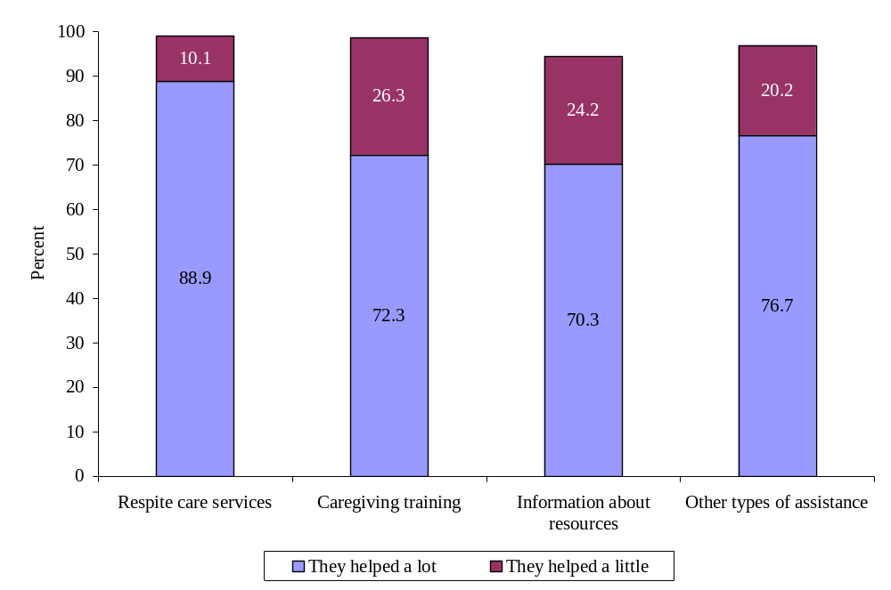
Source: Tabulations from the Third National Survey of OAA Program Participants, 2005.

VII. CONCLUSIONS and recommendations
OAA program participants appear to be more vulnerable than other Americans age 60 and older in almost every area—marital status, living situation, income, education, self-rated health, diagnosed health conditions, and functional limitations. Some of the difference between OAA participants and other elderly Americans is likely a result of the age difference between the two groups; OAA participants tend to be among the oldest old even though the programs can serve anyone age 60 and older. Indeed, serving the oldest old may be quite appropriate, given that AoA strives to serve clients who are the most vulnerable.
OAA program participants used the home-delivered meals, transportation, and caregiver support services intensively, and they reported that the services are quite helpful in allowing them to maintain their independence and remain in their homes. Overall client-reported service quality in each of these three programs was quite high. Client-reported service quality for more specific measures such as the taste of food or the politeness of drivers—was also high for most measures.
There was, however, room for improvement in a few areas. For instance, people of Hispanic origin may not be proportionately served to the same degree as African-Americans, although the fraction of Hispanic OAA clients is about the same as that in the U.S. population age 60 and older. As the Hispanic population continues to grow, additional emphasis on reaching this group may be important, and the AoA has already begun to establish partnerships with groups like the Alliance for Latino Health in order to reach the most vulnerable among this population.
In terms of service delivery, most measures of use, impact, and client-reported service quality were quite high, although there remains room for improvement in some areas. For example, one-quarter of clients who received transportation services identified that the vans were difficult to get in and out of at least some of the time. Older adults are likely have physical problems that would make it difficult to get in and out of any vehicle, and evidence from this report showed that OAA clients tended to have much higher rates of difficulty with activities of daily living than others in their age group. Even so, drivers may want to provide additional assistance to clients who appear to be having the most difficulty.
Similarly, even though service delivery in transportation is already high quality and three-quarters of clients are notified when rides are cancelled, roughly one-quarter of respondents said that they were not usually or always notified of canceled rides. Many older adults rely on transportation to get to medical appointments, and the cancellation of rides without warning may lead to fees for missed appointments, or worse, additional health problems from delayed care. Improving notification of cancelled rides could improve service quality even more than the current level.
Finally in terms of caregiver support, almost half of the caregivers reported having trouble accessing services at least to some degree. Aging Disability Resource Centers (ADRCs) are currently piloting projects that are geared toward increasing consumer ease of access or removing barriers to applying for services. The ADRCs focus on providing information and assistance to individuals in applying for community-based services, and are developing web-based resource databases, providing on-line access to applications and forms, and developing on-line decision support tools to help consumers tailor information to their situation. In addition, ADRCs are working to reduce the number of interactions required for consumers and to shorten the time from intake to eligibility determination. The expected result of these efforts will ultimately help caregivers in identifying and accessing additional resources and services.
The results in this report indicate that overall performance of and reported service quality within each of the programs is quite high, and the AoA is already making changes to address some of the specific issues raised by clients. AAAs may also want to consider using the results in this report to make changes where possible to improve their performance and service delivery. In future National Surveys, it will be possible to observe trends over time and hence areas where services improve or decline. In particular, additional surveys will allow for comparisons of actual to target AoA performance measures, many of which aim for sustained improvements in service delivery and impact.

REFERENCES
Katz, S., A.B. Ford, R.W. Moskowitz, et al. “Studies of Illness in the Aged: The Index of ADL.” Journal of the American Medical Association, vol. 185, 1963, pp. 914-919.
U.S. Department of Health and Human Services. “U.S. Administration on Aging, Strategic Action Plan, 2007-2012.” Washington, DC: DHHS, 2007. Available at [www.aoa.gov/about/strategic/AoA%20Strategic%20Action%20Plan%202007-2012.pdf]. Accessed September 17, 2007.
U.S. Department of Health and Human Services. “Justification of Estimates for Appropriations Committees, Administration on Aging, Fiscal Year 2008.” Washington, DC: DHHS, 2007. Available at [www.aoa.gov/about/legbudg/current_budg/docs/AoA%20FY%202008%
20CJ%20Final.pdf]. Accessed September 17, 2007.
Westat. “AoA Third National Survey: Technical Documentation.” Rockville, MD: Westat, 2007.

Appendix A
Administration on Aging Performance Measures and Relevant Questions from the Third National Survey

Performance Measure | Third National Survey Variable Name/  Question Text | Statistics from the 2005  National Survey
Improving Client Outcomes
Indicator 2.1: Maintain high client satisfaction with home-delivered meals. | HMRATE (HNR38): How would [you/NAME OF PARTICIPANT] rate the home-delivered meals program overall? | Excellent: 32.0%  Very good: 39.9%  Good: 22.5%
Indicator 2.2: Maintain high client satisfaction with  transportation services. | TRRATE (TR24): Next, how would [you/NAME OF PARTICIPANT] rate the transportation service that [you/s/he] received? | Excellent: 49.7%  Very good: 34.9%  Good: 13.3%
Indicator 2.3: Maintain high client satisfaction among caregivers of elders. | CGRATE (CG20): Overall, how would [you/NAME OF CAREGIVER] rate the caregiver support services that have been provided? | Excellent: 47.6%  Very good: 27.2%  Good: 18.9%
Indicator 2.5: Increase percent of caregivers who report that services help them care longer for older individuals. | CGCARLG (CG19): Have these caregiver services enabled [you/NAME OF CAREGIVER] to provide care for [CARE RECIPIENT] for a longer time than would have been possible without these services? | 54.4%
Indicator 2.6: Reduce the percent of caregivers who report difficulty in getting services. | CGDIFF (CG21): How difficult has it been for [you/NAME OF CAREGIVER] to get services from agencies for [CARE RECIPIENT]? | Not at all difficult: 50.6%  A little difficult: 20.6%  Somewhat difficult: 13.3%  Difficult: 7.7%  Very difficult: 7.8%
Indicator 2.9a: 90% of home-delivered meal clients rate  services good to excellent. | HMRATE (HNR38): How would [you/NAME OF PARTICIPANT] rate the home-delivered meals program overall? | 94.4%
Indicator 2.9b: 90% of transportation clients rate services good to excellent. | TRRATE (TR24): Next, how would [you/NAME OF PARTICIPANT] rate the transportation service that [you/s/he] received? | 97.9%
Indicator 2.9c: 90% of NFCSP clients rate services good to excellent. | CGRATE (CG20): Overall, how would [you/NAME OF CAREGIVER] rate the caregiver support services that have been provided? | 93.6%
Effective Targeting
Indicator 3.2: Increase the number of severely disabled clients who receive selected home and community-based services. | Difficulties with three or more activities of daily living (ADLs)  Note: The State Program Reports (SPRs) are now better geared to assess this measure of performance, and will be used in budget justification from Fiscal Year 2009 and onward. | Home-delivered meals: 32.6%  Transportation services: 16.8%  Care recipients: 70.8%

Source: Performance measures were taken from the Administration on Aging’s 2008 Justification of Estimates for Appropriations Committees. Statistics about performance measures in 2005 calculated from data in the Third National Survey of Program Participants in 2005.

Appendix B
Brief Description of the Health and Retirement Study

The Health and Retirement Study (HRS) is a nationally representative longitudinal dataset of the United States population over the age of 50. It is administered by the University of Michigan Institute for Social Research and is funded by the National Institute on Aging. The HRS contains a range of measures on physical and mental health, health insurance coverage, financial status (including innovative methods for measuring income and assets), family support systems, labor market status, and retirement planning.
The survey began in 1992, when it interviewed non-institutionalized sample members who were born between 1931 and 1941, as well as their spouses. These participants have been re-interviewed every other year since, most recently in 2006. Other cohorts have been added as the sample has aged, and the oldest old were included beginning in 1996, when the HRS merged with another similar data set, AHEAD. In recent years, more than 20,000 sample members have participated in each interview. While the initial survey sampled only those not in institutions, participants are followed as they move into nursing homes or other facilities. One additional caveat is that the interviews are only conducted in English and Spanish, meaning that groups who cannot complete the interviews in one of those languages are not included in the study and will therefore be under-represented. Using the sampling weights provided by the study (which are benchmarked to the March Current Population Survey of the relevant year), one can obtain estimates about the U.S. older population on a range of dimensions.
The tabulations in this report consider individuals ages 60 and over using the RAND-HRS dataset from 2004. The RAND data provide consistent measures across all waves of the HRS. This dataset, along with the raw HRS data files, are free and publicly available at http://hrsonline.isr.umich.edu.

Appendix C
Third National Survey Variable Names,
Descriptions, and Question Text

Variable Name | Variable Description | Question Text | Sample Size
Demographics, Socioeconomic, and Health Status
HDM, TS, CG: AGEC  CR: CGPAGE | Age | HDM, TS, CG: (DE2UPDATE): What is [your/NAME OF PARTICIPANT’s/NAME OF CAREGIVER’s] date of birth? [AGEC constructed from this information]  CR: (CG63B): What is {CARE RECIPIENT’s} date of birth? [CGPAGE constructed from this information] | HDM: 2,318 [983,276]  TS: 2,516 [303,269]  CG: 1,063 [580,510]  CR: 1,064 [580,805]
DERAC01 -  DERAC06 | Race | (DE5): What is [your/his/her] race? [CODE ALL THAT APPLY] | HDM: 2,240 [946,562-946,563]  TS.: 2,430 [291,277]  CG: 1,052 [579,188]
DEHISP | Hispanic | (DE4): [Are you/is NAME OF PARTICIPANT/NAME OF CAREGIVER] Spanish, Hispanic, or Latino? | HDM: 2,302 [977,150]  TS: 2,493 [301,162]  CG: 1,073 [589,854]
DEGENDR | Gender | (DE1): ASK IF NOT OBVIOUS: What is [your/NAME OF PARTICIPANT’s/NAME OF CAREGIVER’s] gender? | HDM: 2,323 [985,760]  TS: 2,520 [304,185]  CG: 1,053 [577,462]  CR: 1,075/590,714
DELIVWI | Living situation | (DE8): Does anyone else live with [you/NAME OF PARTICIPANT/NAME OF CAREGIVER]?  Note: This question was asked to all HDM, TS, and CG respondents. For the CR sample, it was only asked to respondents whose caregiver was not living in the same house. This question was used to ascertain whether or not participants lived alone. | HDM: 2,316 [982,568]  TS: 2,506 [302,535]  CG: 1,068 [586,491]  CR: 301 [167,992]
DEMARST | Martial status | (DE9): What is [your/his/her] marital status? | HDM: 2,312 [981,541]  TS: 2,506 [302,831]  CG: 1,069 [586,863]
DEEDUC | Education | (DE3): What is [your/NAME OF PARTICIPANT/s/NAME OF CAREGIVER’s] highest level of education? | HDM: 2,302 [976,399]  TS: 2,502 [302,055]  CG: 1,072 [588,770]
DEINAB  DEINBEL  DEINABOV | Income | (DE10): Which category best describes [your/NAME OF PARTICIPANT’s/NAME OF CAREGIVER’s] total household annual income during the year 2004? | HDM: 1,737 [733,842]  TS: 1,861 [223,344]  CG: 913 [494,448]
HNR, TR: PFDISA-PFDISP  CG: CGDISBB | Health Conditions | HDM, TS: (PF2): Has a medical doctor told [you/NAME OF PARTICIPANT] that [you have/s/he has] had any of the following?: Arthritis, Breathing/lung problems, Depression or anxiety, Diabetes, Eye or vision conditions, Hearing problems, Heart disease, High cholesterol, Hypertension, Osteoporosis, Cancer, Stroke, Anemia, Kidney disease, Alzheimer’s or dementia, Seizures/brain disorder, Parkinsons, Skeletal.  CG: (CG35B): What is that problem, condition, or disability? (back problems and other joint problems/arthritis, heart problems/high blood pressure/hypertension/stroke, diabetes, allergies/asthma, other breathing and lung problems, other illness, mental health, eye problems, other  Note: For HDM and TS, this question was asked to all respondents. For CG, the specific health condition questions were only asked to those who reported having any health condition. | HDM: 2,243-2,312 [952,992-985,760 ]  TS: 2,466-2,509 [279,924-304,186]  CG: 450 [250,159]
HDM, TS:  PFHLTH  CG: CGHEALTH  CR:  CGCRHL | Self-rated health status | HDM, TS: (PF1): In general, would [you/NAME OF PARTICIPANT] say [your/his/her] health is: excellent, very good, good, fair, or poor?  CG: (CG66): In general, would [you/NAME OF CAREGIVER] say [your/his/her] health is: excellent, very good, good, fair, or poor?  CR: (CG54): In general, would [you/NAME OF CAREGIVER] say [CARE RECIPIENT’s] health is: excellent, very good, good, fair, or poor? | HDM: 2,284 [970,037]  TS: 2,485 [300,067]  CG:1,072 [586,074]  CR: 1,062 [583,849]
PFBATH, PFDRES, PFEAT, PFBED, PFWC, PFWALK | ADL difficulties | HDM, TS: [Do you/Does NAME OF PARTICIPANT]…  …(PF10) have difficulty when taking a bath or shower?  …(PF11) have difficulty when dressing?  …(PF13) have difficulty eating?  …(PF9) have difficulty getting in or out of bed or a chair?  …(PF14) have difficulty using the toilet or getting to the toilet?  …(PF12) have difficulty when walking? | HDM: 2,315-2,318 [982,547-983,728 ]  TS: 2510-2,519 [303,176-304,094]
PFDRIVE, PFDFIN, PFDFOU, PFCLEN, PFDLR, PFMEAL, PFTKDG, PFUSEBUS, PFFONE | IADL difficulties | HDM, TS: [Do you/Does s(he) ]  …(PF20): have difficulty driving an automobile?  …(PF7): have difficulty getting around inside the home?  …(PF8): have difficulty going outside the home, for example, to shop or visit a doctor’s office?  …(PF17): have difficulty doing light housework, such as washing dishes or sweeping a floor?  …(PF15): have difficulty keeping track of money or bills?  …(PF16): have difficulty preparing meals?  …(PF18): have difficulty taking the right amount of prescribed medicine at the right time?  …(PF21B): If public transportation is available, have difficulty using this transportation?  …(PF19): have difficulty using the telephone?  Note: Question about public transportation was only relevant to those who reported having public transportation available. | HDM: 2,286-2,321 [971,356-984,762]  Public transportation: 984 [425,810]  TS: 2,463-2,519 [298,229-304,034 ]  Public transportation: 1,053 [131,059]

Variable Name | Variable Description | Question Text | Sample Size
Home-Delivered Meals
HMHOT | Number of hot meals received in past week | (HNR2): What is the total number of hot meals [you/NAME OF PARTICIPANT] received in the past week? | 2,323 [973,759]
HMFROZE | Number of frozen meals received in past week | (HNR3): What is the total number of frozen meals [you/NAME OF PARTICIPANT] received in the past week? | 2,323 [970,322]
HMBAG | Number of bag suppers received in past week | (HNR4): What is the total number of bag suppers [you/NAME OF PARTICIPANT] received in the past week? | 2,323 [966,138]
HMSUPP | Number of nutritional supplements received in past week | (HNR5): What is the total number of nutritional supplements, such as Boost or Ensure, [you/NAME OF PARTICIPANT] received in the past week? | 2,323 [961,298]
HMDAYSWK | Number of days each week client receives meals | (HNR7): How many days each week [do you/does s/he] receive home-delivered meals? | 2,269 [961,366]
HMDAYSPST | Number of days in the past week client eats 1+ home-delivered meal | (HNR8): How many days in the past week did [you/NAME OF PARTICIPANT] eat one or more home-delivered meal? | 2,288 [969,628]
HMMEALS | Number of meals eaten on days of home-delivered meals | (HNR9): Please tell me, on the days [you eat/s/he eats] home-delivered meals, how many meals [do you/does s/he eat]? | 2,263 [960,897]
HMNOEAT | Number of meals eaten on days without home-delivered meals | (HNR10): On the days [you don’t/NAME OF PARTICIPANT doesn’t] eat home-delivered meals, how many meals [do you/does s/he eat]? | 2,196 [936,849]
HMDYNOFD | Whether eats more/less on the days when doesn’t get home-delivered meals | (HNR11): Now think about the days when [you don’t/s/he doesn’t] eat a home-delivered meal. [Do you/Does s/he eat] about the same amount of food, more food, or less food? | 2,210 [939,180]
HMPORTN | How much of total food consumed do home-delivered meals represent on the days received | (HNR12): Think about the amount of food [you eat/s/he eats] from the home-delivered meal. On the days [you eat/NAME OF PARTICIPANT eats] a home-delivered meal, what portion of all the foods [you eat/s/he eats] in a day does this meal represent? | 2,103 [887,692]
HMEATFRT,  HMEATPOT,  HMEATVEG,  HMEATPBRD,  HMEATDAR,  HMEATMET,  HMEATBNS | Usually eat | When [you eat/he eats] the home-delivered meal, [do you/does s(he)] usually eat…  …(HNR15): the fruit that is provided?  …(HNR17): the potatoes that are provided?  … (HNR19): other than potatoes… the vegetables that are provided?  … (HNR21): the bread, cereal, rice, pasta, noodles, or tortillas that are provided?  … (HNR23): or drink the milk, cheese, or yogurt that are provided?  … (HNR25): the meat, chicken, fish, or eggs that are provided?  … (HNR27): the nuts, tofu, or beans if they are provided? | 2,289 [971,970]  2,289 [970,368]  2,285 [970,601]  2,282 [968,351]  2,279 [968,214]  2,290 [971,993]  2,263 [960,403]
HMRATE | How rates HDM program overall | (HNR38): How would [you/NAME OF PARTICIPANT] rate the home-delivered meals program overall? | 2,308 [979,404]
HNRRECOM | Whether would recommend the program to others | (HNR39): Would [you/s/he] recommend this program to [your/his/her] friends, neighbors, and relatives? | 2,313 [980,822]
HNRLIKE | Whether person likes meals | (HNR37): [Do you/Does NAME OF PARTICIPANT] like the home-delivered meals [you get/s/he gets]? | 2,267 [/962,801]
HMTASTES,  HMSMELLS,  HMLOOKS,  HMVARITY,  HMTEMP,  HMONTIME,  HNRFRND | Other measures of satisfaction | [Are you/is s/he] satisfied…  …(HNR30): with the way the food tastes?  … (HNR31): with the way the food smells?  … (HNR32): with the way the food looks?  … (HNR33): with the way the variety of the food?  … (HNR34): that the hot foods are hot and the cold foods are cold?  … (HNR35): that [your/NAME OF PARTICIPANT’s] meals arrive about the time [you expect/s/he expects] them to?  … (HNR36): that the person who delivers the meals is friendly and respectful? | 2,293 [973,837]  2,011 [847,819]  2,109 [890,281]  2,285 [967,863]  2,034 [854,485]  2,263 [959,138]  2,268 [961,882]
HMVARFD,  HMVR2FD,  HMSPECDT,  HMWEIGHT,  HMFLBTR,  HMFLBR2,  LESSHGRY,  HMSTATHM | Home-delivered meals help clients to… | Do home-delivered meals help [you/NAME OF PARTICIPANT]…  …(HNR40): eat healthier foods?  …(HNR41): eat a greater variety of foods?  …(HNR42): follow the special diet that is prescribed by [your/his/her] doctor or dietician?  …(HNR43): achieve or maintain a healthier weight?  …(HNR44): improve [your/NAME OF PARTICIPANT’s] health?  …(HNR45): feel better?  …(HNR46): feel less hungry?  …(HNR47): do home-delivered meals help [you/NAME OF PARTICIPANT] continue to live in [your/his/her] home? | 2,284 [968,834]  2,300 [/975,704]  1,569 [674,309]  2,263 [960,709]  2,278 [960,013]  2,286 [970,807]  2,267 [962,105]  2,270 [964,415]

Variable Name | Variable Description | Question Text | Sample Size
Transportation Services
TRDRIVE | Does household have a car?/If so, can participant drive? | (TR29): [Do you/Does NAME OF PARTICIPANT] ever drive that car?  Note: This question was only asked to respondents who said there was a car in working condition in the household (answered yes to TR28) | 1,113 [137,578]
TRMONTH | Number of one-way trips used per month | (TR5): About how many local one-way trips a month [do you/does NAME OF PARTICIPANT] make using this service? For example, if [you go/s/he goes] to the doctor’s office and then [come/comes] back using this service, that counts as 2 one-way trips.  Note: 470 respondents were noted to have a ‘Not Applicable’ answer to this question because they used less than one trip per month on average. | 2,004 [222,117]
TRPROP | Fraction of all of client’s one-way trips performed by transportation service | (TR6): In an average month, would [you/NAME OF PARTICIPANT] say [you rely/s/he relies] on this transportation services for: just a few of [your/his/her] local trips, about 1/4 of all [your/his/her] local trips, about 1/2 of all [your/his/her] local trips, about 3/4 of all [your/his/her] local trips, or nearly all of [your/his/her] local trips?  Note: 516 respondents were noted to have a ‘Not Applicable’ answer to this question because they used the service for less than one ride per month on average. | 1,844 [221,201]
TRACT01 –  TRACT10 | Usual destination of transportation services | (TR25): [Do you/Does NAME OF PARTICIPANT] use [your/his/her] transportation service to get to:  …work?  …doctors and health care providers?  …shopping?  …volunteer activities?  …senior center?  …lunch program?  …friends, neighbors, and relatives?  …social events and recreation activities?  …clubs and meetings?  …religious services? | 2,519 [304,031]  2,517 [303,794]  2,514 [303,215]  2,508 [302,709]  2,514 [303,362]  2,514 [303,274]  2,513 [303,375]  2,515 [303,808]  2,513 [303,378]  2,518 [303,805]
TRACTB01 –  TRACTB10 | Whether transportation allows participant to go to places more | (TR25B): Because of the transportation service, [do you/does NAME OF PARTICIPANT] go to ___ more often?  …work  …doctors and health care providers  …shopping  …volunteer activities  …senior center  …lunch program  …friends, neighbors, and relatives  …social events and recreation activities  …clubs and meetings  …religious services  Note: These questions were only asked to respondents who reported using the transportation service to get to each particular destination (in TR25). | 47 [4,744]  1,676 [207,031]  983 [113,872]  429 [50,490]  1,048 [123,017]  777 [91,204]  200 [24,094]  617 [76,167]  287 [36,431]  138 [17,813]
TRRATE | Overall satisfaction | (TR24): Next, how would [you/NAME OF PARTICIPANT] rate the transportation service that [you/s/he] received? | 2,515 [303,580]
TRFRE05 –  TRFRE17 | Other measures of satisfaction | For the next few questions, please tell me how frequently these statements apply to [your/NAME OF PARTICIPANT’s] overall experience with [PROVIDER NAME/AGENCY NAME]? Please select one of these five responses: always, usually, sometimes, rarely, or never.  …(TR9): The vehicles are comfortable.  …(TR10): The vehicles are easy to get into and out of.  …(TR11): [You arrive/S(He) arrives] at [your/his/her] destination on time.  …(TR12): The drivers pick [you/him/her] up when they are supposed to.  …(TR13): The service calls [you/NAME OF PARTICIPANT] if [your/his/her] ride has been cancelled.  …(TR14): [You/NAME OF PARTICIPANT] can get to the places [you want/s(he) wants] or [need/needs] to go.  …(TR15): The trips take too long.  …(TR16): The drivers are polite.  …(TR17): The drivers offer to help passengers into and out of the van when they need it.  …(TR18): The drivers help passengers into and out of their homes when they need it.  …(TR19): [You get/NAME OF PARTICIPANT gets] the number of rides [you need/s/he needs] from this service.  …(TR20): [You get/S(He) gets] rides at the times and on the days [you need/s/he needs] them.  …(TR21): [You have/NAME OF PARTICIPANT has] the information [you need/s/he needs] to schedule and take [your/his/her] local trips. | 2,471 [298,050]  2,472 [299,317]  2,470 [298,931]  2,486 [299,703]  1,259 [147,958]  2,446 [295,483]  2,399 [290,464]  2,508 [302,731]  2,401 [291,540]  1,949 [236,715]  2,435 [294,199]  2,453 [296,460]  2,369 [287,302]

Variable Name | Variable Description | Question Text | Sample Size
Caregiver Support Services
CGACTI01 –  CGACTI06 | Types of activities that caregiver assists with | (CG2): I’m going to read several activities that some people need help with. [Do you/Does NAME OF CAREGIVER] help [CARE RECIPIENT] with…  … activities like dressing, eating, bathing, or getting to the bathroom.  …medical needs such as taking medicine or changing bandages.  …keeping track of bills, checks, or other financial matters.  …preparing meals, doing laundry, or cleaning the house.  …going shopping or to the doctor’s office.  …arranging for care or services provided by others. | 1,074 [589,795]  1,075 [590,714]  1,073 [589,984]  1,075 [590,714]  1,075 [590,714]  1,068 [588,356]
CGWORK | Employ-ment status of caregiver | What is [your/NAME OF CAREGIVER’s] current employment status? | 1,069 [589,338]
CGQUIT | Quit work because of caregiving role | (CG23): Did [your/his/her] caregiving responsibilities cause [you/him/her] to quit work or retire early?  Note: This question was only asked to those who said they were not working or retired (answered retired or not working to CG22). | 717 [382,788]
CGINTRFR | Caregiving ever interfered with job | (CG24): Has providing care for [CARE RECIPIENT] interfered with [your/NAME OF CAREGIVER’s] job?  Note: This question was only asked to those who said they were working full- or part-time (answered full-time or part-time to CG22). | 347 [202,258]
CGINTJB | Caregiving ever interfered with job | (CG25): How frequently has providing care for [CARE RECIPIENT] interfered with [your/NAME OF CAREGIVER’s] job?  Note: This question was only asked to those who were working full- or part-time and reported that caregiving has interfered with job (answered full- or part-time to CG22 and yes to CG24). | 196 [124,489]
CGYOU03 –  CGYOU11 | Other effects of caregiving on employment | (CG26): Because of providing care for [CARE RECIPIENT], [have you/has NAME OF CAREGIVER]…:  …taken a less demanding job?  …changed from full-time to part-time work?  …reduced [your/his/her] official working hours?  …lost some of [your/his/her] employment fringe benefits?  …had time conflicts between working and caregiving?  …used [your/his/her] vacation or personal time or sick leave to provide care?  …taken a leave of absence to provide care?  …lost a promotion?  …worked less than [your/NAME OF CAREGIVER’s] normal hours last month because of providing care for [CARE RECIPIENT]?  Note: These questions were only asked to those who said that caregiving interfered with their job (answered always, usually, or sometimes to CG25). | 170 [108,792]  169 [108,524]  169 [108,099]  170 [108,792]  170 [108,792]  167 [108,205]  169 [108,555]  168 [108,151]  168 [107,260]
RGENDER | Descriptive statistics of care recipients: gender | (CG64): (DON’T ASK IF OBVIOUS) What is [CARE RECIPIENT’s] gender | 1,075 [590,714]
CGPAGE | Descriptive statistics of care recipients: age | (CG63): We have [CARE RECIPIENT’s] date of birth as [MM,DD,YYYY]. Is that correct? If not, (CG63B): What is [CARE RECIPIENT’s] date of birth? | 1,064 [580,805]
CGCRHL | Descriptive statistics of care recipients: health status | (CG54): In general, would [you/NAME OF CAREGIVER] say [CARE RECIPIENT’s] health is: excellent, very good, good, fair, or poor? | 1,062 [583,849]
PFDISACG –  PFDISOCG | Health conditions of care recipients | (CG55): Has a medical doctor told [you/NAME OF CAREGIVER] that [CARE RECIPIENT] has any of the following?  …Alzheimer’s/dementia?  …arthritis?  …breathing/lung problems?  …depression or anxiety?  …diabetes?  …eye or vision conditions?  …hearing problems?  …heart disease?  …high cholesterol?  …hypertension?  …osteoporosis?  …stroke? | 1,057 [580,135]  1,063 [584,892]  1,070 [588,128]  1,052 [576,499]  1,069 [587,353]  1,064 [585,289]  1,069 [587,710]  1,058 [579,511]  1,042 [568,612]  1,067 [587,210]  1,051 [572,750]  1,061 [581,328]
PFBATHC,  PFDRESC,  PFBEDC,  PFWCC,  PFWALKC,  PFEATC | Care recipient difficulties with activities of daily living | Does [s(he)] have difficulty…  …(CG58): when taking a bath or shower?  …(CG59): when dressing?  …(CG57): getting in or out of bed or a chair?  …(CG62): using the toilet or getting to the toilet?  …(CG60): walking?  …(CG61): eating? | 1,068 [588,072]  1,074 [590,075]  1,067 [582,373]  1,068 [586,142]  1,071 [589,128]  1,071 [587,740]
CGHLTH | Caregiving led to worsened health problems | (CG36): [Have your/Has NAME OF CAREGIVER’s] caregiving activities created or worsened any of these conditions or problems or disabilities?  Note: This question was only asked to those who said they had a health problem, physical condition, or disability (answered yes to CG35). | 442 [245,371]
CGDIF | Biggest hardship | (CG33): What is the biggest difficulty [you have/NAME OF CAREGIVER has] faced in caring for [CARE RECIPIENT]? | 1,002 [544,488]
CGBEST | Biggest reward | (CG28): In [your/NAME OF CAREGIVER’s] experience as a caregiver, what would [you/s(he)] say is the most positive aspect of caregiving? | 1,018/559,774]
CGPSTRN,  CGEMSTRS,  CGFINHD,  CGHDSHP | Other burdens of caregiving | (CG29): Think of a scale from 1 to 5, where 1 is “not a strain at all” and 5 is “very much of a strain.” How much of a ______ would [you/NAME OF CAREGIVER] say that caring for [CARE RECIPIENT] is for [you/him/her]?  …physical strain?  …emotionally stressful?  …financial burden?  …hardship? | 1,073 [589,085]  1,071 [589,301]  1,063 [584,899]  1,057 [/576,404]
CGMINUT | How far away the caregiver lives from the care recipient | (CG38): How far away [do you/does NAME OF CAREGIVER] live from [CARE RECIPIENT]? | 1,075 [590,714]
CGALONE | Whether care recipient lives alone | (CG39): Does [CARE RECIPIENT] live alone?  Note: This question was only asked to those who were not living in the same house as the care recipient (answered something other than “in the same house” to CG38. | 301 [167,991]
CGLFTLN | Whether care recipient could be left alone for a whole day | (CG40): Can [CARE RECIPIENT] be left alone for an entire day?  Note: This question was only asked to those whose care recipient did not live alone (answered yes to CG39). | 884 [488,057]
CGHRS | Amount of care the care recipient needs per day | (CG41): In [your/NAME OF CAREGIVER’s] judgment, how many hours per day of help, care, or supervision does [CARE RECIPIENT] need? | 1,037 [572,252]
CGHRSWK | Amount of care the caregiver provides on weekdays | (CG42): In a typical 24-hour week day, how many hours [do you/does NAME OF CAREGIVER] provide help, care, or supervision for [CARE RECIPIENT] in person? | 1,047 [575,148]
CGHRSWD | Amount of care the caregiver provides on weekends | (CG43): In a typical 24-hour weekend day, how many hours [do you/does NAME OF CAREGIVER] provide help, care, or supervision for [CARE RECIPIENT] in person? | 1,044 [574,752]
CGRSPT | Service use among caregivers | (CG5): [Have you/Has NAME OF CAREGIVER] received Respite Care, which allows [you, the caregiver/NAME OF CAREGIVER], a brief period of rest or relief while temporary care is provided to [CARE RECIPIENT] either in [your/his/her] home or someplace else? | 1,067 [587,969]
CGSUP01 –  CGSUP05 | Service use among caregivers | (CG14): Has the National Family Caregiver Support Program provided any other Supplemental Services to complement the care [you provide/s/he provides], such as…:  … home modifications?  …nutritional supplements, such as Ensure or Boost?  …assistive devices, such as walkers, canes or crutches?  …emergency response systems?  …specialized equipment, such as CPAP, Apnea machines, hospital bed, wander guard, or other equipment? | 1,072 [586,473]  1,069 [588,437]  1,061 [584,473]  1,064 [586,507]  1,070 [589,194]
CGEDU | Service use among caregivers | (CG11): [Have you/Has NAME OF CAREGIVER] received caregiver training or education, including counseling or support groups, to help [you/him/her] make decisions and solve problems in [your/his/her] role as a caregiver? | 1,067 [586,823]
CGINFO | Service use among caregivers | (CG9): Has someone, such as [your/NAME OF CAREGIVER’s] caseworker, case manager or other AAA staff person, helped [you/him/her] or given [you/him/her] information to connect [you/him/her] to available services and resources? | 1,056 [583,665]
CGRATE | Overall ranking of caregiver support services | (CG20): Overall, how would [you/NAME OF CAREGIVER] rate the caregiver support services that have been provided? | 1,070 [588,670]
CGDIFF | Overall ease of getting services | (CG21): How difficult has it been for [you/NAME OF CAREGIVER] to get services from agencies for [CARE RECIPIENT]? | 1,028 [564,835]
CGRSPTHP | Effective-ness of services | (CG8): To what extent have the respite care services [you have/NAME OF CAREGIVER has] received helped [you/him/her] as a caregiver?  Note: This question was only asked to those who have received respite care (answered yes to CG5). | 588 [305,263]
CGEDUHLP | Effectiveness of services | (CG13): To what extent have the caregiver training, education, counseling, or support group services [you have/NAME OF CAREGIVER has] received helped [you/him/her] as a caregiver?  Note: This question was only asked to those who received caregiver training or education (answered yes to CG10). | 313 [201,501]
CGINFOHP | Effectiveness of services | (CG10): To what extent has the help or information [you have/NAME OF CAREGIVER has] received helped [you/him/her] connect to available services and resources?  Note: This question was only asked to those who were able to connect to available services and resources (answered yes to CG9). | 797 [444,074]
CGSUPHLP | Effectiveness of services | (CG15): To what extent have the [INSERT ALL SERVICES IN CG6E THAT ARE YES] [you have/NAME OF CAREGIVER has] received helped [you/him/her] as a caregiver?  Note: This question was only asked to those who received a supplemental service (answered yes to any part of CG14). | 550 [294,021]
CGAFECA –  CGAFECF | Effect of caregiving on daily life of caregiver | (CG17): As a result of the caregiver services [you have/NAME OF CAREGICER has] received, [do you/does s/he]…  …have more time for personal activities?  …feel less stress?  …find it easier to care for [CARE RECIPIENT] ?  …have a clearer understanding of how to get the services [you/NAME OF CAREGIVER] and [CARE RECIPIENT] need?  …know more about [CARE RECIPIENT’s] condition or illness?  …think that [CARE RECIPIENT] benefits from the caregiver services [you receive/NAME OF CAREGIVER receives]? | 1,060 [582,583]  1,060 [580,932]  1,056 [574,856]  1,052 [581,485]  1,058 [582,457]  1,062 [581,090]
CGHELP | Whether services led to being a better caregiver | (CG18): Overall, to what extent have these caregiver services helped [you/her/him] to be a better caregiver? | 1,061 [580,855]
CGCARLG | Whether services enabled caregiving for a longer time | (CG19): Have these caregiver services enabled [you/NAME OF CAREGIVER] to provide care for [CARE RECIPIENT] for a longer time than would have been possible without these services? | 1,044 [575,704]
CGDFPLC | Whether service enabled care recipient to continue to live at home | (CG47): In [your/NAME OF CAREGIVER’s] judgment, if the services that [you/NAME OF CAREGIVER] and [CARE RECIPIENT] have received had not been available, would [CARE RECIPIENT] be able to continue to live in the same residence? | 1,024 [561,413]

The Strategic Action Plan can be accessed online at www.aoa.gov/about/strategic/ AoA%20Strategic%20Action%20Plan%202007-2012.pdf
While technically two regions, Regions II and III work together from an operational standpoint.
OAA also authorized caregiver support services to be provided to those over 60 who care for dependents under age 60, such as grandchildren or children with disabilities.
The 2008 Congressional Budget Justification notes that “…in an effort to improve efficiency and quality, entities could attempt to focus their efforts toward individuals who are easy to serve and easy to please. Instead, the targeting measure gauges AoA’s effectiveness in ensuring those receiving services are the most needy as envisioned by the OAA.” This document can be found online at: http://www.aoa.gov/about/legbudg/current_budg/docs/ AoA%20FY%202008%20CJ%20Final.pdf.
To make this comparison, we used the U.S. Census and other nationally representative survey data from the Health and Retirement Study, or HRS (see Appendix B for an overview of the data set).
Westat (2007) provided information about the sampling methods and response and completion rates. All of the analyses conducted for this report use survey sampling weights calculated by Westat, which permit an estimation of program effects on all OAA clients in these service categories, rather than only those interviewed in the survey.
The cooperation rate was calculated by Westat (2007) as the sum of those who completed the interview plus those who were ineligible for survey participation divided by the sum of those people plus people who refused to complete the interview.
Throughout the report, percentages are rounded to the nearest percent. This means that summed percentages that do not add to 100 percent are due to rounding.
U.S. Census Bureau, Census 2006 Estimates (data for 2005).
Note that the age distribution is only among the 60+ population so as to make the age ranges comparable to those served by OAA programs. Caregivers are often younger than 60 because the person they are caring for is over age 60, and therefore the caregiver is eligible for OAA caregiver support services.
While OAA home-delivered meals and transportation services programs usually serve the population ages 60 and older, some respondents to the survey report being under age 60. Some of this is likely reporting error, but may also be attributable to individuals who are spouses of someone 60 and older (and are therefore eligible for Title III services) or adults with disabilities living in affordable housing where congregate meals are offered.
Estimates from the U.S. Census.
Respondents were allowed to indicate more than one race; therefore, totals may sum to more than 100%. Native Hawaiian/Other Pacific Islander not reported because none of the samples had more than 0.5 percent in that category. Also, this category was not included in the Census data.
The Third National Survey was conducted in English and Spanish and attention was paid to facilitating interviews with Hispanic clients, so the smaller Hispanic population in the survey compared to the U.S. elderly population does not appear to be due to the language in which the survey was conducted. While the margin of error from the survey data does not rule out the fact that the proportion of the sample that is Hispanic is the same as in the U.S. elderly population, it also does not indicate that the proportion would be as much above the population proportion as was the case for African-Americans (either in absolute or percentage terms).
Indeed, AoA recently announced a new partnership with the Alliance for Hispanic Health and Latino Communities to maximize the effectiveness of community interventions to improve the quality of life for older Hispanics.
Estimates from the 2000 Census indicated that 22.6% of the 60+ population lived in a rural area in 2005 (provided from AoA staff based on data from the American FactFinder system). Calculations from the 2005 American Community Survey (ACS) indicated that this percentage was slightly higher, 24.4%.
The percentage rural reported here used the definition of urban/rural adopted in the 2000 Census. This definition counts people who do not live in an unrbanized cluster or an urbanized area as rural residents. This differs from another commonly used measure to define rural residence, which relies on metropolitan statistical areas (MSAs). Unlike the MSA definition, the new urbanized definition identifies areas within MSAs that may not be urbanized. For this reason, the fraction rural is much higher under the urbanized definition than it is under the MSA definition for OAA program participants. For example, using the MSA definition, 35.7 percent of home-delivered meals clients, 37.2 percent of transportation services clients, and 25.8 percent of caregivers would be categorized as rural. However, in all of these cases, the percentage rural would still be higher than that in the overall elderly population using a similar definition of rural residence.
Calculations from the 2004 HRS, weighted to produce population estimates. Among those 65 and older population in 2004 (from the 2006 statistical profile on the AoA webpage): 30.1 percent of the non-institutionalized elderly lived alone, 38.4 percent of elderly women and 19.2 percent of elderly men.
For home-delivered meals clients, transportation services clients, and caregivers, living alone was assessed from a question asking how many other people the participant lived with. For care recipients, the caregiver was first asked if he/she lived in the same house as care recipient. If not, an additional question of whether the care recipient lived alone was asked.
While the survey collected information that would allow for the calculation of poverty thresholds, these data were not available on the AoA AGID system at the time this report was written. Therefore, comparisons of household income are made as proxies to poverty status.
The health conditions asked about in the 2004 HRS were sufficiently different (due to categorization of multiple conditions, different conditions, and different question wording) that the comparison to the National Survey data is not exact. We mean for these comparisons to only be illustrative, not definitive proof of health differences between the samples. In both the HRS and Third National Survey, a question asks whether the person has ever been diagnosed, which does not mean the condition is still present. This table only considers the most common health conditions out of a much larger list asked of OAA participants (contained in Appendix C).
Questions in this section were not asked of caregivers. See Section VI of the report for a discussion of analogous information for care recipients.
The HRS IADL categories are different enough from those in the Third National Survey to make a direct comparison implausible.
Many of those in the 10 percent who reported 3 or more meals per day reported receiving 5 or 7 meals, which appear to be weekly deliveries, rather than meals delivered for a single day.
It is important to note that reservations are not a required component of service provision, and that some services provided in this category do not have a mechanism for notifying clients who use the route. This means that at least some fraction of the people who report not being notified of canceled rides were not using a service with a scheduled reservation. For example, clients who use a shuttle service that makes regular stops would not be notified if the service were delayed or canceled, since the service would not know which clients to contact.
Note that whether these differences were statistically significantly different from zero was not tested for the purposes of this report.
Note that whether these differences were statistically significantly different from zero was not tested for the purposes of this report.
Respondents were allowed to select as many as were relevant, so the total across all categories sums to far more than 100 percent.
These questions only include people who report using the service (above), so sample sizes for some categories may be quite small.
“Rides do not take too long” was actually phrased “rides take too long” in the survey, so we inverted the responses to correspond with the other measures of satisfaction.
All descriptions of care recipients are provided by their caregivers, who responded to the survey.
The reauthorization in 2000 of the Older Americans Act included a provision to allow caregiver services to be provided to grandparents who are the primary caregivers of their grandchildren under 18, which has become increasingly common in the wake of dual-earner households and divorce. However, judging from the age distribution of care recipients, it is clear that this group was not included (at least in any significant way) in the National Survey in 2005.
The health of care recipients was reported by their caregivers, whereas the health status of other survey participants was self-reported. It is not clear how this difference might bias the results presented here.
The question wording allowed individuals who previously reported that caregiving interfered with their employment to say that it “rarely or never” interfered. Because “never” does not make sense in this context, we assume these responses are “rarely.”
Note: Percentages are among those reporting working full- or part-time.
There was an additional question that asked about whether the driver assisted clients, but this question about assistance to other passengers, and not the client him or herself. Future revisions to the National Survey will attempt to better gauge service quality on this and other measures.
The question related to transportation services did not ask clients specifically whether the rides that were canceled were reserved rides.
Sample size indicates the number of valid (non-missing and not ‘don’t know’ or ‘refused’) responses. First number is unweighted number of survey responses, bracketed number indicates the weighted count of AoA service recipients. “HDM” denotes home-delivered meals sample, “TS” denotes transportation services sample, “CG” denotes caregivers and “CR” denotes care recipients.
Questions in this section were asked of all respondents in the surveys where the sample size is indicated, unless otherwise noted. If the sample size is not indicated for a particular group (HDM, TS, CG, or CR), the question was not asked to or about that group.
All questions in the home-delivered meals survey were asked of all respondents. Variations in sample size are due to people responding that the question did not apply, they did not know the answer, or refused to answer the question.
Questions in the transportation services survey were asked of all respondents unless otherwise noted. Other variations in sample size are due to people responding that the question did not apply, they did not know the answer, or refused to answer the question.
Questions in the caregiver survey were asked of all respondents unless otherwise noted. Other variations in sample size are due to people responding that the question did not apply, they did not know the answer, or refused to answer the question.

