Chapter 1

Vehicle and Axle-Load Scales

Objectives

After you have studied this chapter, you should be able to:

1. Describe the basic design of vehicle and axle-load scales and some special features of the scales.

2. Describe the basic construction and use of mechanical weighbeam scales, mechanical dial scales, and electronic digital indicator scales used in weighing vehicles and axle-loads.

3. Describe special features of electronic digital indicator scales, including: on-off switch, zero-setting mechanisms, tare mechanisms, and push-button print.

4. Explain the meaning of the following terms:

analog type  automatic-indicating scale  axle-load scale  balance indicator  beam scale  digital type  graduation  indicating element  indicator  load cell  load-receiving element  nose-iron  pit  pivot  poise  reading face  reading-face capacity | recording element  remote indicator  scale division, value of (d)  scale section  steelyard rod  tare  tare mechanism  trig loop  type registering weighbeam  unit weight  vehicle scale  weighbeam  weighbridge  weighing element  zero-load balance  zero-setting mechanism

These terms are printed in bold type when first introduced.

General Considerations

In every commercial transaction involving the weighing of a commodity, accurate weights and proper weighing practices protect both the buyer and the seller. The buyer has a right to equity; the seller has a right to fair value. The livelihoods of those who produce, transport, or purchase products and materials customarily shipped by truck depend on accurate measurement of the weights of those goods.

The weights and measures official is responsible for seeing that scales used to weigh vehicles and their loads, and scales used in enforcement of laws concerning axle loads, perform properly and that weighing practices protect the interests of all parties.

Applications and Design

Vehicle scales are scales adapted to weighing highway, farm, or other large industrial vehicles (except railroad freight cars), loaded or unloaded. Sometimes called "motor truck scales,” vehicle scales are used in buying and selling commodities, and for determining fees for transporting loads. The sale of farm crops, minerals, timber products, petroleum, and chemicals can take place based on weights obtained on a vehicle scale. Charges for transporting goods are also determined with a vehicle scale. Fees of household movers and motor freight haulers are set in this way. Some vehicle scales are designed to be movable from one location to another. Figure 1-1 shows several vehicle scales in use.

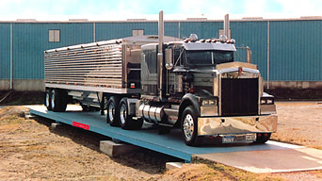

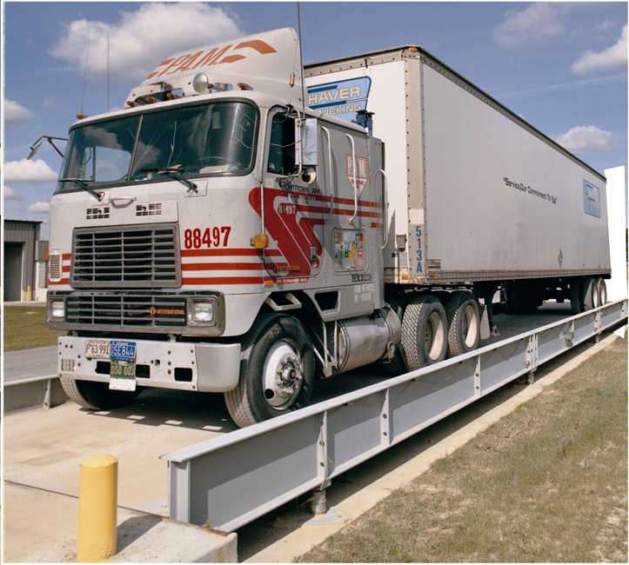

Figure 1. Vehicle Scales in Use

An axle-load scale is a specific type of vehicle scale. According to NIST Handbook 44, an axle-load scale is "a scale permanently installed in a fixed location, having a load-receiving element specially adapted to determining the combined load of all wheels (1) on a single axle or (2) on a tandem axle of a highway vehicle.” As can be seen in Figure 1-2, only a portion of the vehicle (in this case, the front wheels of a truck) actually rests on the scale platform, while the rest of the truck rests on the pavement surface. Most axle-load scales are permanently installed in a fixed location. Portable devices, called "axle-load weighers” or "wheel-load weighers” are also used but they are not covered in this module.

Axle-load scales are used primarily for enforcement of State highway and traffic laws, and in collecting data for government agencies. In fact, Handbook 44 requirements apply only to axle-load scales in these applications.

A.2. Wheel-Load Weighers, Portable Axle-Load Weighers, and Axle-Load Scales. The requirements for wheel-load weighers, portable axle-load weighers, and axle-load scales apply only to such scales in official use for the enforcement of traffic and highway laws or for the collection of statistical information by government agencies.
Handbook 44 Scales Code, Paragraph A.2.

Handbook 44 does not specifically prohibit the use of axle-load scales in commercial use. However, as you will learn in detail in Chapter 3, it does require that when vehicles are weighed in commercial applications, weighing must be performed in a single draft — that is, that the entire vehicle must be resting on the load-receiving element at the same time (unless the vehicle can be separated into parts, each of which can be weighed as a single draft). "Split weighing,” the practice of determining the gross weight of a vehicle by adding the weights of successive drafts of different portions of the vehicle on a single axle-load scale, does not produce sufficiently reliable accuracy for commercial use, and so is not permitted.

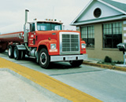

Figure 1-2. Axle-Load Scale in Use

For this reason, a single axle-load scale would not be suitable for weighing vehicles in commercial applications. Two or more axle-load scales can be installed in line and used for commercial weighing by adding the indicated weights, provided that the entire vehicle is weighed at the same time. However, in such an application, the entire system, comprising all the individual scales that are used for single-draft weighing, would be considered to be a vehicle scale. Special requirements for inspecting and testing multiple scales used in this way will be described in Chapters 3 and 4.

Their different uses also determine basic differences in size and capacity between vehicle and axle-load scales:

• The platform of a vehicle scale must be long enough to hold the longest vehicle to be weighed (typically 5.4 m [18 ft], and sometimes 21 m [70 ft] or more). In contrast, the platform on an axle-load scale is relatively short (1.2 m [4 ft] to 3 m [10 ft]).

• In general, the capacity of vehicle scales is also greater than that of axle-load scales. Vehicle scales have capacities ranging from 18 to 90 metric tons (20 to 100 tons), while most axle-load scales have capacities of 27 metric tons (30 tons) or less.

Major Components of Vehicle and Axle-Load Scales

Vehicle and axle-load scales have the same basic components:

• load-receiving element. This is the deck upon which the vehicle (in the case of an axle-load scale, the portion of the vehicle being weighed) rests during weighing.

• weighing elements. The weighing elements convert the force of the vehicle's weight, which bears upon the load-receiving element, into a mechanical or electrical signal, which is used to drive the indicating elements (see below). The weighing elements may be mechanical, electrical, or a combination of electrical and mechanical.

• indicating elements. The indicating elements receive the signal generated by the weighing elements and produce a visual representation of the weight. Indicating elements may also be either mechanical or electrical.

• recording elements. While not required by Handbook 44, devices that make a permanent record of the weight registered are usually found on vehicle and axle-load scales.

• approach(es). This is the traffic surface, and all its supports, over which vehicles will normally move when approaching or leaving the scale.

• foundation. The structure or surface upon which the weighing elements rest.

Foundation

In order to provide accurate measurement, the weighing elements must rest upon a firm, level surface. This is provided by a permanent foundation of concrete and/or other structural material, installed in such a manner that it will not be affected by unstable soil conditions such as those caused by freezing of the ground, heaving of the soil, and a high water table.

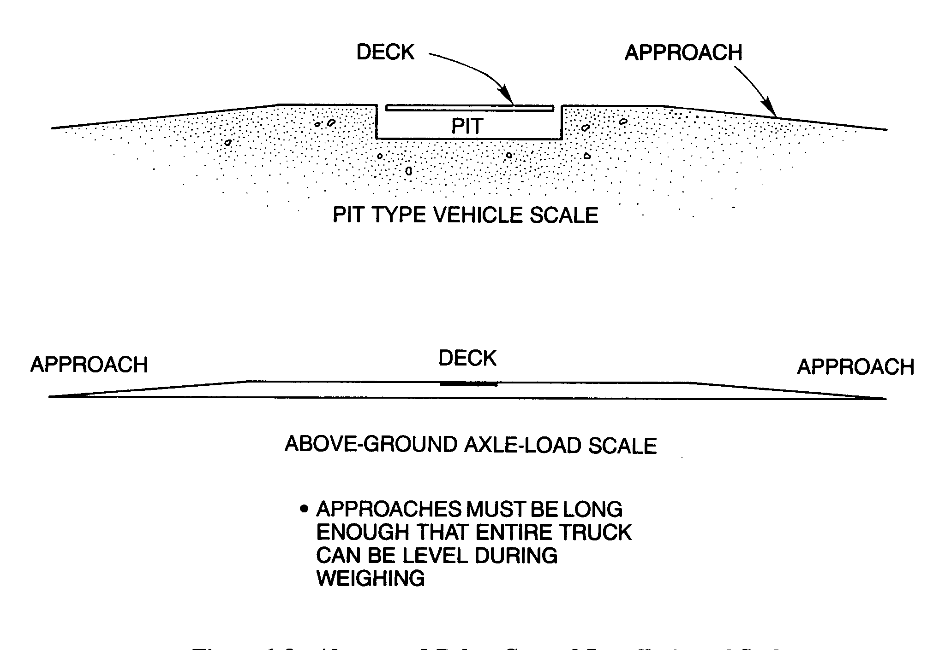
Figure 1-3. Above- and Below-Ground Installation of Scales

If the scale is designed so that the load-receiving deck is at approximately ground level, the weighing elements will sit below ground, in a scale pit, as shown in the upper drawing in Figure 1-3. Alternatively, the scale may be installed so that the deck is above ground level, with the surface of the foundation at approximately ground level, as shown in the lower drawing. In either case, access must be provided to the elements of the scale that are below the deck for purposes of maintenance and inspection.

Approaches

Abrupt or jarring force applied to the weighing elements as a vehicle moves onto the deck could also affect accuracy. It is, therefore, essential that the vehicle move smoothly onto the deck, and that any load the vehicle is carrying be reasonably stable (a shifting load could also result in abrupt or jarring force on the weighing elements). For this reason, the portion of the approach(es) adjacent to a vehicle scale must be smooth, straight, level, and in the same plane as the scale platform to prevent jarring of the vehicle and its contents.

As can be seen in Figure 1-3, the approaches to a scale often begin with a slight slope, even if the deck is at approximately ground level. The reason for this is to facilitate drainage of rainwater away from the deck. In the case of axle-load scales, a portion of the vehicle actually rests on the approach during weighing. Since accurate weighing requires that the load be applied to the weighing elements vertically, it is essential that the portion of the approach immediately adjacent to, and level with, the deck be long enough to make it possible for the entire vehicle to be in the same horizontal plane.

As you will learn in Chapter 3, Handbook 44 includes specific requirements regarding the construction and dimensions of approaches relative to the dimensions of the deck for both vehicle and axle-load scales.

Load-Receiving Elements

The deck of a vehicle or axle-load scale must be of a sufficient size in terms of length and width to accommodate the longest and widest load that will be applied to it. Since the wheel-width of most trucks is around 2.4 m (8 ft), decks for both vehicle and axle-load scales are generally at least 3 m (10 ft) wide. As mentioned earlier, since axle-load scales measure only the weight on a single or tandem axle, their decks are usually only about 3 m (10 ft) long. In contrast, a vehicle scale deck must be long enough to accommodate the longest vehicle that will be weighed on it, which can be 21 m (70 ft) or more.

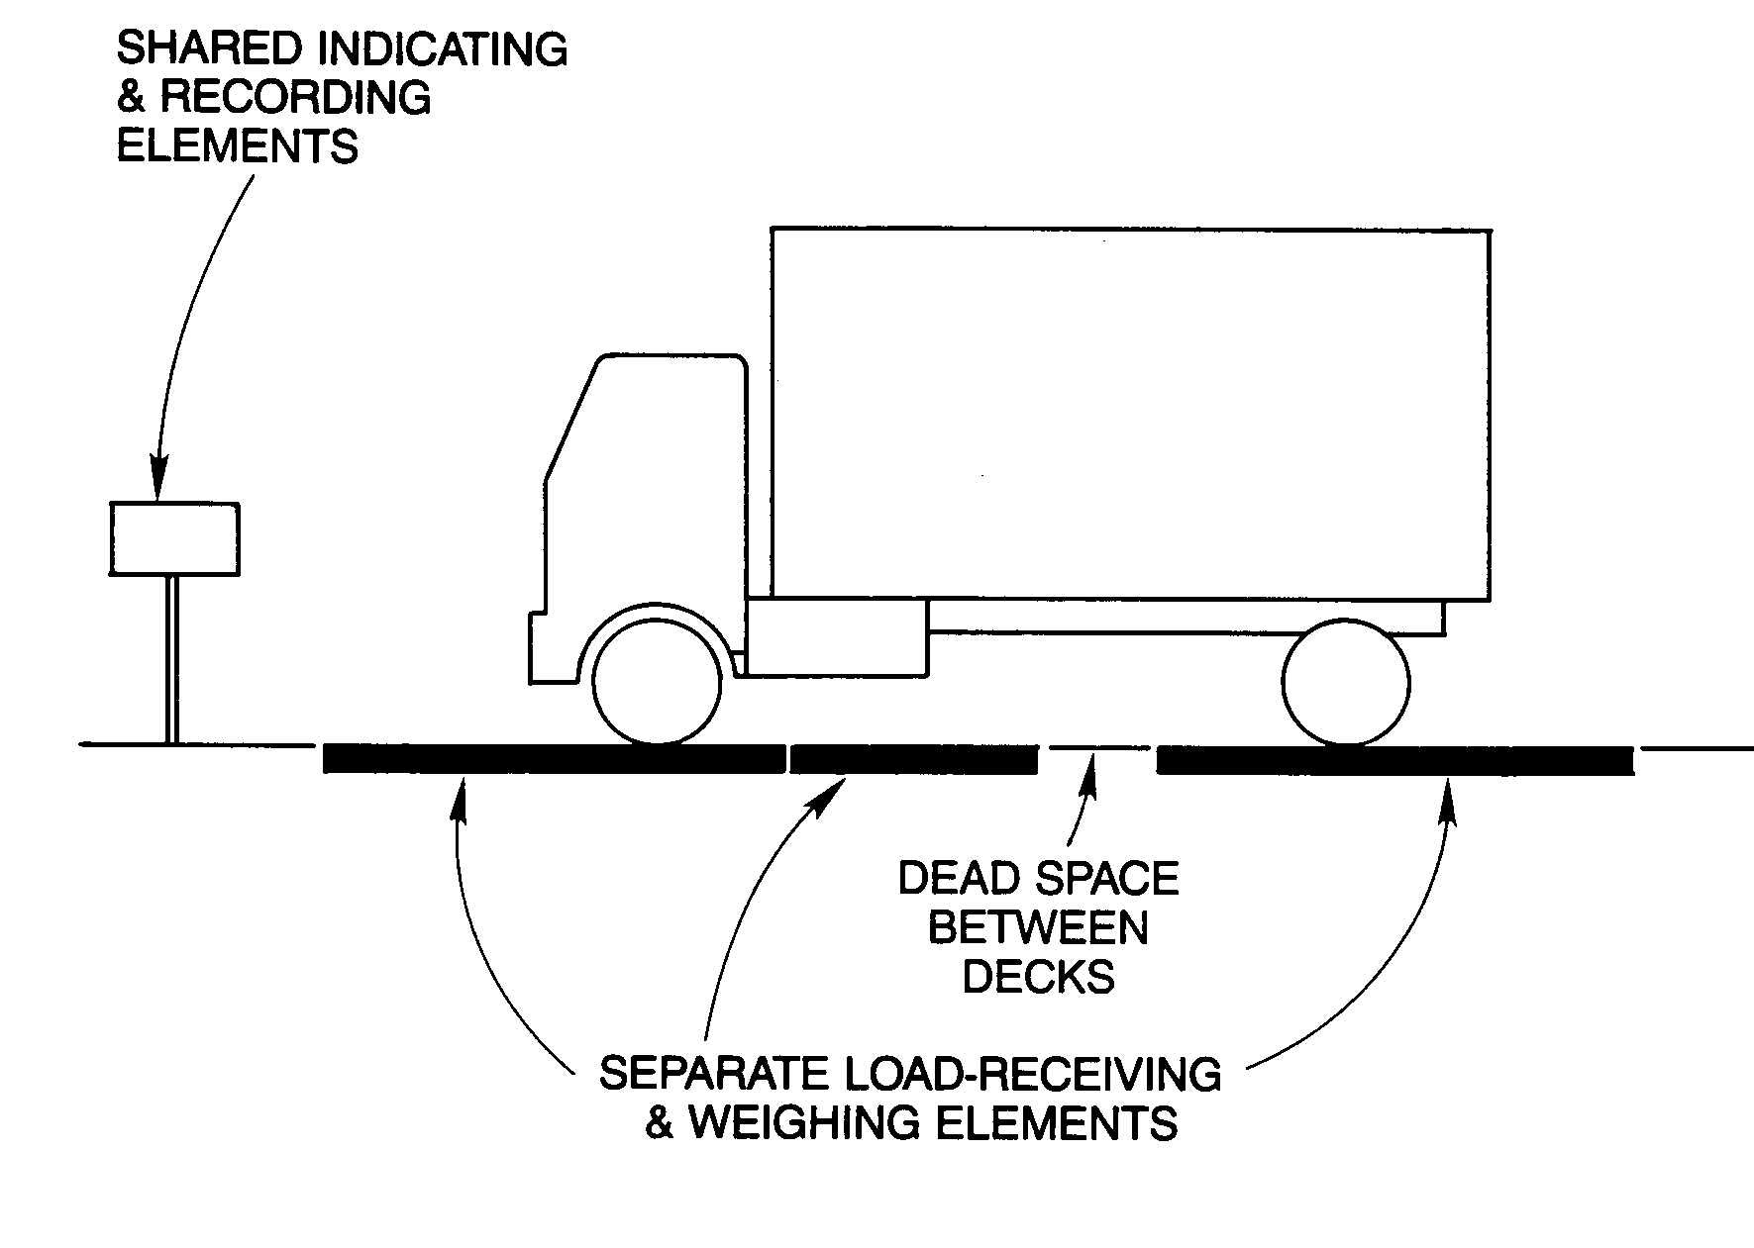
Figure 1-4. Multiple Scale Vehicle Weighing
In cases where there is a need to know individual axle weights as well as the total weight of a vehicle, multiple scales may be used for single-draft weighing. As shown in Figure 1-4, a number of scales, each with its own load-receiving and weighing elements, are configured in line. The separate indicators may be joined with a totalizer to show the individual and combined weights, or a single indicator may be used that shows the weight on each scale and the total weight.

In this type of installation, even though each individual scale has its own load-receiving deck, for a given weighing, the combined load-receiving element would be considered to comprise all the separate decks. Note that in the example there is some dead space between successive scale decks; this area is not part of the scale and cannot be used for weighing (no part of the vehicle could be resting on this area during weighing). Here, the load patterns of the vehicles may be more critical than the length of the longest vehicle, since it must be possible to position any vehicle that is to be weighed so that none of its wheels are resting on dead space. In most cases, you will find installations where the load-receiving elements are adjacent to each other without dead space in between.

The scale deck itself is often supported by a structure called the weighbridge, an example of which can be seen in Figure 1-5. Since the weighbridge bears directly upon the load-bearing points of the weighing elements (see below), it is generally considered to be a part of the load-receiving element.

Weighing Elements

Figure 1-5 illustrates a typical lever system that is characteristic of a vehicle or axle-load scale with mechanical weighing elements. The lever system supports the deck and reduces the force from the load on the deck by a precise factor (the lever multiple) and transmits that force to the indicating element. The indicating element (weighbeam or dial) balances the force and indicates the weight value. It is not essential for you to study the theory of levers for the purpose of this module. However, if you want to know more about lever systems, ask your instructor to review these topics with you.

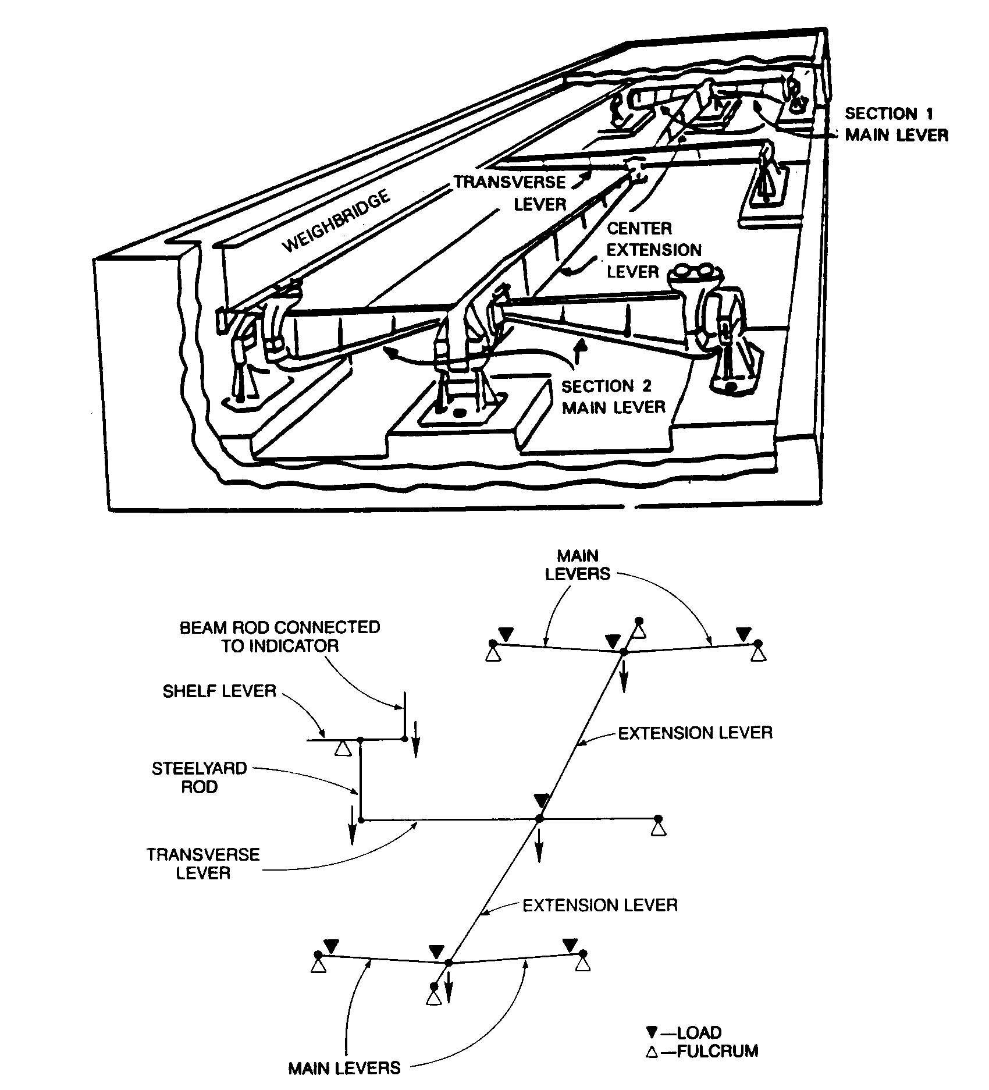
Figure 1-5. Typical Mechanical Weighing Elements of a Two-Section Vehicle or Axle-Load Scale.

Note that the weighbridge rests upon four load-bearing points. Each of these points is directly above the load pivot of a main lever (these are 2nd Class levers, with the load point between the fulcrum and the power point). The power points of each pair of main levers bear on the load point of an extension lever. The extension levers sum the force of the main levers and transmit it to the transverse lever, which sums the force of the extension levers and transmits the load to the indicating elements, usually through a vertical steelyard rod (see schematic below the drawing, and Figures 1-9 and 1-11). The scale may also be equipped with a shelf lever, generally a low-multiple lever, which receives the load from the platform lever system via the steelyard rod and transmits its output to the indicating element by means of a beam rod (see schematic).

One additional feature of mechanical weighing elements should be mentioned, since it provides a means of adjustment that will affect the registered weight. Most lever systems, like the one shown in Figure 1-5, are equipped with nose-irons. A nose-iron is an assembly that includes the power pivot of a lever and has a movable mount, so that the position of the pivot on the power arm can be adjusted by a small amount. Since this adjustment will lengthen or shorten the power arm of the lever by a small amount, the lever multiple will also be changed. One or more of the levers in a mechanical vehicle or axle-load scale may be equipped with nose-irons. Nose-iron adjustments are made when the scale is calibrated, and are not performed during normal operation. As you will learn in a later chapter, specific requirements are included in Handbook 44 to prevent nose-irons from facilitating fraud.
Electronic weighing elements of vehicle and axle-load scales usually consist of devices called strain gauge load cells (to be distinguished from pneumatic or hydraulic type load cells). These operate on the principle that the resistance of a conductor to electric current varies proportionally with the mechanical stress that is applied to the conductor: compressive stress (pressing or squeezing) decreases resistance, tension (stretching) increases resistance. In a strain gauge load cell, like the one depicted in Figure 1-6, several conductive grids (the strain gauges) are fixed to a column of metal upon which the force of the load-receiving element bears directly. The force is transmitted from the metal column to the strain-gauges. A current of known voltage is supplied to the strain gauges, so that the output voltage of the grid, which is transmitted to the indicating element by cable, can be used as a signal to indicate the force applied to the cell.

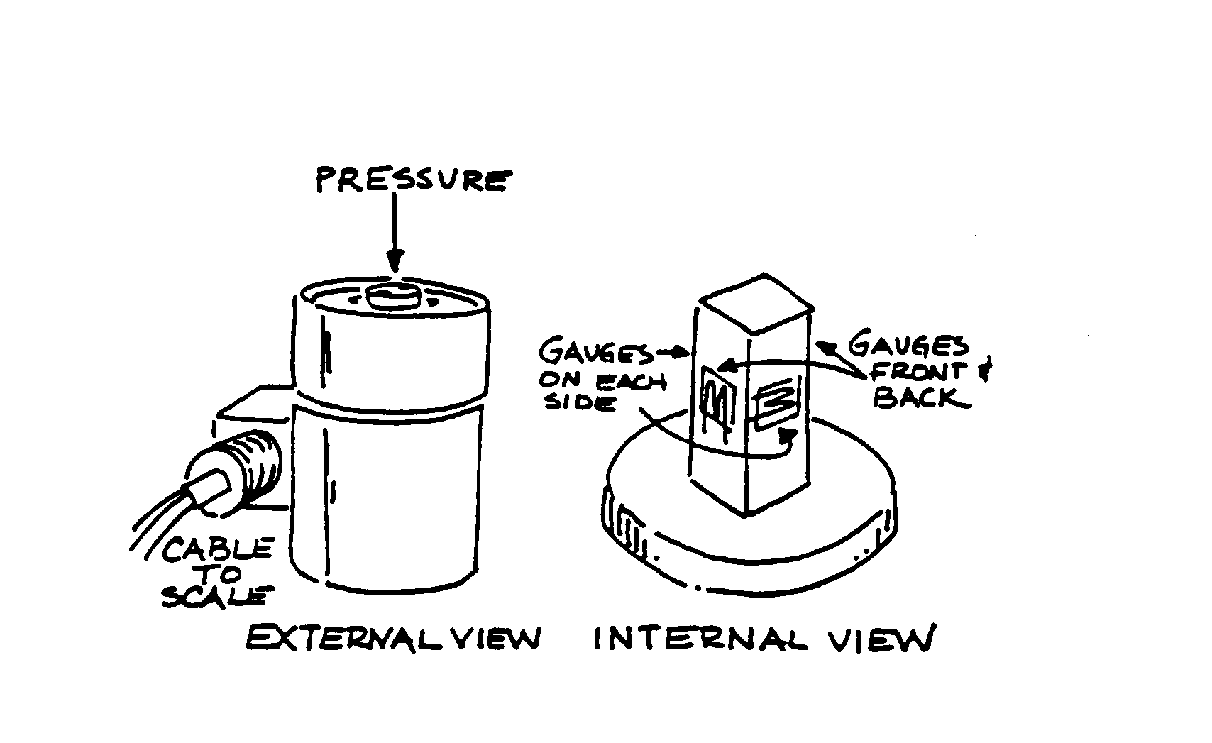
Figure 1-6. Strain Gauge Load Cell.

The example of fully electronic load cell weighing elements in Figure 1-7 shows the weighbridge on load cells. Signals from the cells are transmitted to junction boxes or the indicating element, where they are electronically summed.

Some vehicle and axle-load scales employ a combination of mechanical and electronic elements. These are commonly referred to as electromechanical scales. A typical electromechanical system might consist of a platform lever system similar to that shown in Figure 1-5. However, instead of transmitting the mechanical force of the system to the indicating elements, the transverse lever would bear upon a strain gauge load cell, the signal from which would drive an electronic indicating system.

A scale section of a vehicle, axle-load, livestock, or railway track scale consists of two main load supports, usually transverse (crosswise) to the direction in which the load is applied. Thus, each pair of levers in the mechanical scale and each pair of load cells in the electronic scale constitutes a section. Another way to determine the number of sections is to count the number of load-bearing points and divide by two.

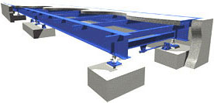
Figure 1-7. Electronic Weighing Elements of a Typical Multi-Section
Vehicle or Axle-Load Scale.

Figure 1-8 illustrates the conventional method of numbering load-bearing points and scale sections: facing the scale from the side on which the indicator is located, number load-bearing points starting in the far left corner and proceeding in a clockwise direction; number sections from left to right. Note that a section includes only the portion of the deck that is directly over the pair of load-bearing points, plus the space between them. Most axle-load scales are two-section scales. Vehicle scales may have two sections or more. The number of sections needed is generally determined by the length and capacity of the deck.

Figure 1-8. Diagram of a Two-Section Scale

During the examination of a vehicle or axle-load scale, you will need to determine both the number of sections and the concentrated load capacity (CLC) of the scale. In the case of vehicle and axle-load scales, the CLC is the maximum axle-load concentration (for a group of two axles with a centerline spaced 1.2 m (4 ft) apart and an axle width of 2.4 m (8 feet) for which the weighbridge is designed as specified by the manufacturer. The CLC rating is for both test and use. As you will learn, the nominal capacity of a vehicle, axle-load, or livestock scale placed in service in 1989 or later is limited by the CLC and the number of sections. This will be covered in more detail in Chapters 4 and 6. For scales manufactured prior to 1989, the section capacity may be used as the CLC. The section capacity is the maximum weight that can be applied to a single section of a scale. While the scale may be rated at 45 metric tons (100,000 lb) capacity, an individual section may only be capable of sustaining a load of 22.6 or 27.2 metric tons (40,000 or 60,000 lb) directly over a section.

Indicating Elements

Three basic types of indicators are used with vehicle and axle-load scales: weighbeams, dial indicators, and digital electronic indicators. The first two are used exclusively with scales incorporating mechanical weighing elements; digital scales can be used either with fully electronic or electromechanical systems. Thus, vehicle and axle-load scales may be classified by the design of their weighing and indicating elements:
• mechanical scales with a full-capacity weighbeam,

• mechanical scales with dials,

• mechanical scales with electronic digital weight indicators (electromechanical scales), and

• fully-electronic scale systems.

Figure 1-9 shows a typical weighbeam assembly for a vehicle or axle-load scale, although not all of the elements depicted are required to be on every weighbeam. You should study this drawing while you read the following description.

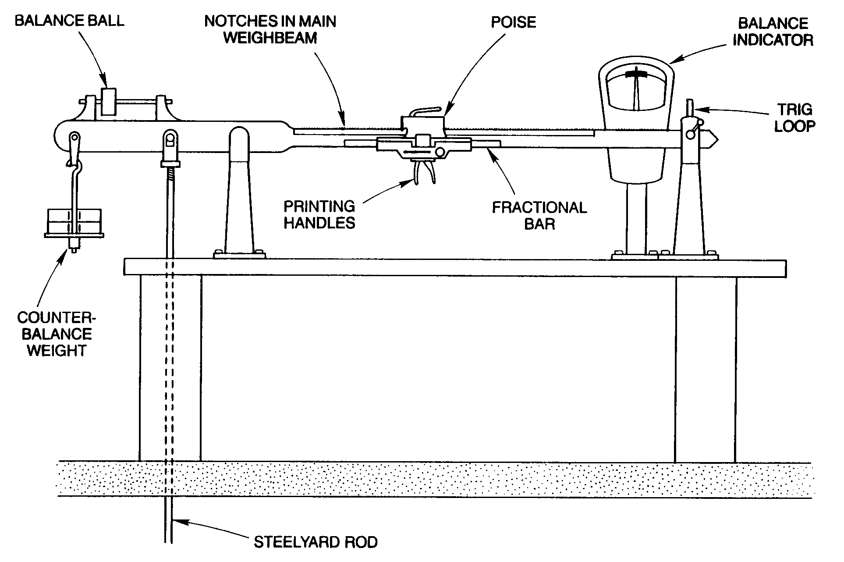
Figure 1-9. Typical Weighbeam Assembly

The weighbeam itself is actually both a weighing and an indicating element. As the final lever in a mechanical scale (that is, the lever furthest removed from the load-receiving element), the weighbeam is a weighing element. In addition, the position of the weighbeam indicates the balance condition of the scale: when the weighbeam is perfectly horizontal, the load on the scale is balanced, that is, supported entirely by the weighing elements.

Weighbeams are referred to as non-automatic indicators, because the scale operator must perform actions to obtain the measurement: weight must be applied to the power arm of the weighbeam until it balances the load on the deck. The load could be balanced by applying counterpoise weights to the tip of the weighbeam. The weight of the load would then be the total counterpoise weight times the lever multiple of the system when the weighbeam is in a balance condition. However, this method could involve the manipulation of a number of relatively small counterpoise weights for any given weighing, plus some computation, and would thus be prone to operator error. In addition, the fact that the counterpoise weights would have to be readily removable and replaceable from the hanger could facilitate fraud. A more efficient and secure method involves balancing the load by moving a sliding poise that is fixed to the weighbeam in a position that balances the applied load. Since the length of the power arm (and, thus, the scale multiple) varies with the position of the sliding poise, a single weight can be used to balance a considerable range of loads. In addition, graduations can be provided on the weighbeam, so that the multiplied weight required to balance the load can be read directly, without computation.

In fact, although the sliding poise can be used in conjunction with counterpoise weights, most vehicle and axle-load scales with weighbeam indicators are full-capacity weighbeams (see Figure 1-9). This means that all loads that are weighed on the scale can be balanced by the position of the weighbeam poise, without having to add or remove counterpoise weights. The counterbalance weights and balance ball are used to obtain a balance condition when there is no load on the deck, and are not manipulated during weighing. In fact, on a full-capacity weighbeam, all weights used to obtain a zero-load balance should be designed so that they cannot be readily manipulated and so facilitate fraud. Specific requirements relating to these elements will be described in detail in Chapter 3. Most full-capacity weighbeam vehicle scales have a nominal capacity of 100,000 or 120,000 lb.

Now let us consider the weighbeam as an indicating element. As said earlier, the balance condition of the scale is indicated when the weighbeam is perfectly horizontal. In fact, when a load is applied to the deck, the tip of the weighbeam will move upward. When the poise is moved to a position that balances the load, the weighbeam will oscillate, or move up and down for some period before coming to rest. This movement, referred to as the travel of the weighbeam, is limited by the trig loop. The trig loop is a loop of metal, oval or oblong, through which the tip of the weighbeam passes; when the oscillating beam contacts the top or bottom of the trig loop it comes to a stop, indicating an out-of-balance condition. When the scale is balanced, the weighbeam tip should oscillate within the trig loop, touching neither limit. When the trig loop is properly adjusted, the oscillating tip of the balanced weighbeam should travel the same distance from the top and bottom limits before reversing direction.

The balance condition is usually determined by the operator by observing the travel of the weighbeam tip within the trig loop. However, you may find some weighbeam scales that are equipped with balance indicators, like the one shown in Figure 1-9. These indicators generally include a dashpot to damp the weighbeam oscillations, and thus provide a quicker indication of the balance condition than observing the trig loop. In the example shown, when the arrow coincides with any point within the black band, the scale is balanced. Another type of balance indicator includes graduations which are numbered to represent weight values by which the scale deviates from a balanced condition. Because of the graduations, this latter type of balance indicator must be treated as a dial indicator during field examinations.

Figure 1-10 shows a detail of the graduated weighbeam and poise. In fact, this is a double poise, consisting of a main poise and a fractional bar. For the moment, consider only the main poise. The graduations on the weighbeam are the vertical lines extending from the top of the weighbeam. Each graduation is numbered. Note that the upper left edge of the poise is shaped to form an edge and pointer. In the example, the edge and pointer are aligned with the graduation marked "31.”

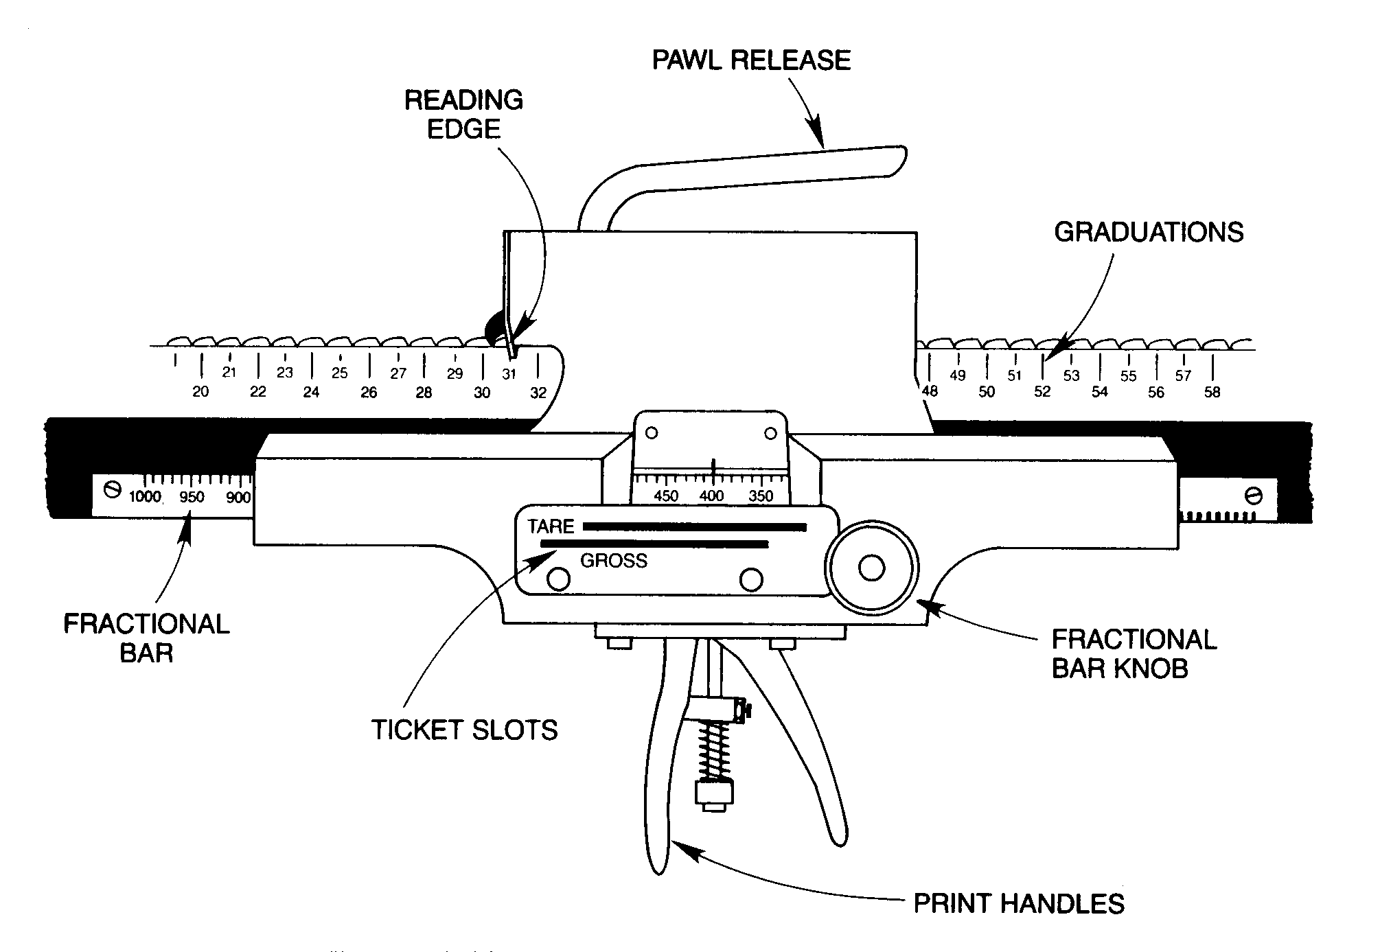
Figure 1-10. Type-Registering Weighbeam Poise

The top of the weighbeam is notched, and the poise is equipped with a pawl, a spring-loaded tooth that locates the poise and locks it in place when the pawl is directly over a notch. The handle on top of the poise operates the pawl: when pressed down, the spring pressure on the pawl is released, permitting the poise to slide on the weighbeam. When the handle is released, the spring pressure is applied to the pawl, which then engages the next notch, locating and locking the poise at that point. The notches on top of the weighbeam are located so that when the pawl locates in one, the edge and pointer indicator will align exactly with a graduation. Each graduated interval on this weighbeam represents 1,000 pounds effectively applied through the lever system to balance the load. According to the indicator on the main poise, 31,000 lb has been applied.

Next, consider the fractional bar, which is really a secondary poise that is positioned relative to the main poise. Once the main poise has been positioned, the fractional bar knob is turned until the balance condition is indicated. Turning the knob moves a weight bar (the fractional bar) either toward the load pivot or toward the power pivot. This adjustment affects the power arm, and thus the lever system multiple in the same way as moving the main poise does, but to a much smaller degree per unit of distance that the fractional bar is moved. The graduated intervals on this fractional bar each represent 10 lb; the reading shown in the example is 400 lb. Since 10 lb is the value of the smallest graduated interval on this scale, it is also considered the scale division for this scale, designated "d.” The scale division, like the section capacity or CLC, must be determined during the examination of a vehicle or axle-load scale.

The capacity of the fractional bar (that is, the maximum amount of effective counterforce that can be applied by adjusting the bar position) is equal to the value of the graduated intervals on the main poise, minus one scale division — 990 lb. Note that the fractional bar is also graduated and that the cutout in the main poise through which these graduations are visible also forms a pointer. When the weighbeam is balanced, the operator adds the indications on the two poises to obtain the total gross weight of the load to the nearest 10 lb, in this case, 31,400 lb.
This poise is also equipped to produce a recorded representation of the weight. We will consider this feature below, under Indicating Elements.

Figure 1-11 shows the major elements of a typical dial indicator that is used with vehicle and axle-load scales. The force of the load, reduced by the lever system, is transmitted by the steelyard rod to a shelf lever, which is enclosed in a cabinet directly below the indicator. The output of the shelf lever, transmitted by a beam rod, actuates the mechanical dial mechanism, usually a double pendulum, which acts as a counterforce. The displacement of the counterforce mechanism by the applied load drives the dial hand shaft by means of a rack and pinion. Dashpots are used to reduce oscillation of the indicator, and also to protect the indicator from mechanical shock when the load is applied. As with weighbeam scales, a balance ball is provided on the butt of the shelf lever for adjusting the system to a zero-load balance condition.

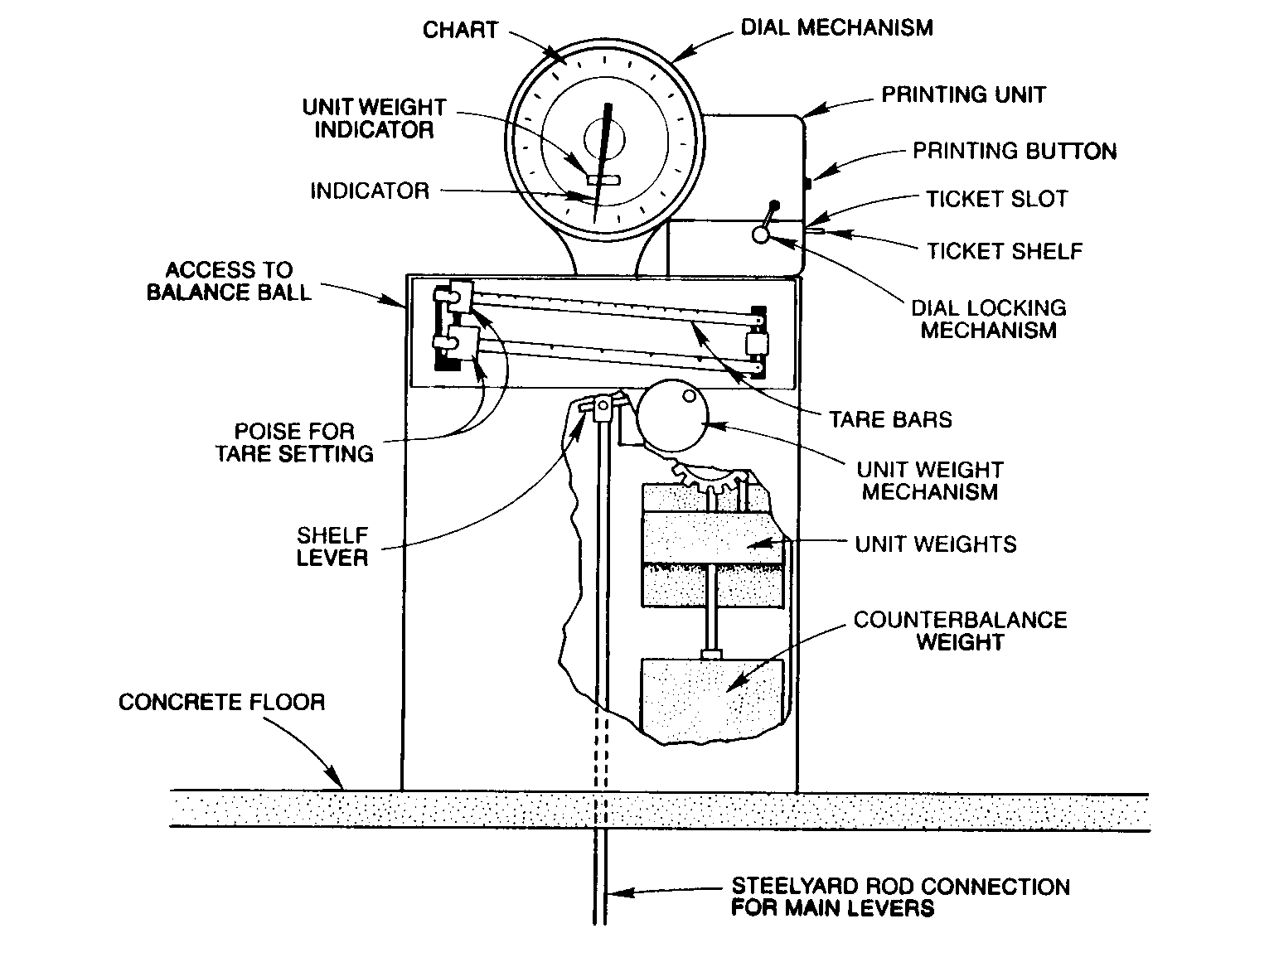
Figure 1-11. Elements of an Automatic-Indicating Dial Scale

The shelf lever, is functionally similar to a weighbeam. One reason why a shelf lever is needed on this type of scale is related to the limitations of the dial mechanism, which is only capable of indicating over a range that is considerably less than the capacity of a vehicle scale. Typically, a dial will have a capacity, called the face capacity, of 20,000 lb. In order to utilize the dial for large capacity scales, counterforce must be applied to the shelf beam when the load exceeds the face capacity of the dial. This is accomplished by the application of unit weights, which are enclosed within the sealed cabinet, and are applied or removed from the shelf lever by a mechanism that is actuated by the scale operator.

Each unit weight, when applied to the shelf lever, provides a counterforce that is equivalent to the face capacity of the dial. The scale will have sufficient unit weights to balance the nominal capacity of the scale, minus the face capacity. When one or more unit weights are applied, an indication of the total unit weight counterforce is shown in a window on the dial face, referred to as the range window, as shown in Figure 1-12.

For example, consider a mechanical vehicle scale with a nominal capacity of 100,000 lb, equipped with a dial indicator with a face capacity of 20,000 lb, and smallest graduated intervals on the dial face representing 20 lb (similar to that shown in Figure 1-12). A vehicle with a gross weight that is estimated to be between 50,000 and 60,000 lb is to be weighed. Because the estimated weight is between two and three times the face capacity of the dial, two 20,000-lb unit weights would be applied. The range window would then indicate 40,000 lb. When the vehicle load is applied to the scale, the operator adds the weight indicated by the dial to the amount shown in the range window to determine the total weight.

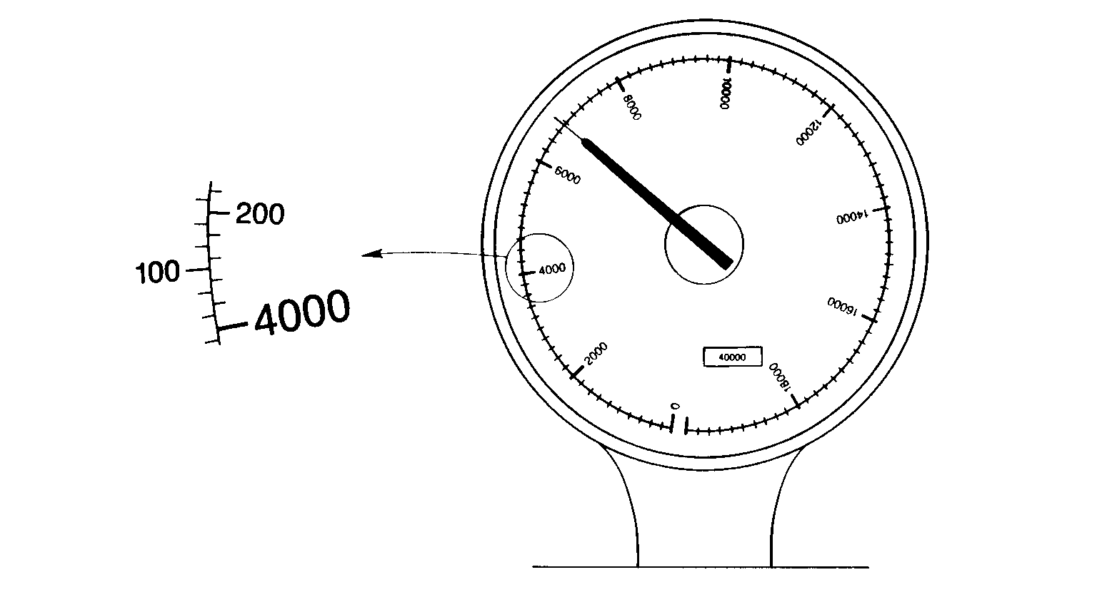
Figure 1-12. Dial Face with a Single Range Window

Some dial scales are equipped with automatic unit weights. The scale senses the amount by which the load exceeds the face capacity of the dial and automatically applies the appropriate number of unit weights. Regardless of whether the unit weights are applied by the operator or by such a mechanism, scales equipped with dial indicators are considered to be automatic-indicating scales, since the indicator itself is actuated by a mechanism, and not, like the poise on a weighbeam, by the operator.

Another function of the shelf lever is to provide tare capability. Again, the operation is similar to that of the weighbeam: one or more poises on one or more graduated bars fixed to the shelf lever are used to balance the tare (that is, the unloaded vehicle). With these poises in place, when the loaded vehicle is positioned on the scale, the indicated weight will be the net weight.

Finally, notice that the system shown in Figure 1-11 is equipped with a counterbalance weight. A counterbalance is a weight that is applied, to the butt end of the shelf lever to produce the effect of a load of a known weight on the platform. The counterbalance weight, like the unit weights, is sealed within the cabinet, and is applied or removed using external controls. The counterbalance weight provides the installer with a means of balancing out the dead weight of the platform. Fine zero adjustments are made using a balance ball that is inside the cabinet and is accessed through a hole in the side of the cabinet. A tool such as a screwdriver is used to make adjustments.

Mechanical vehicle scales have been used for over 100 years, while the electromechanical and electronic scales have only been in use since the development of load-cell technology in the 1960s. Most new installations are electronic, and many mechanical systems have been adapted to electromechanical scales. One major reason for the popularity of electronic equipment is that electronic indicating elements provide greater and more extensive capabilities than mechanical indicators:

• The electrical signal produced by the weighing elements (load cells) is transmitted to the indicating elements by cable rather than by a mechanical linkage. This makes it possible to install remote readouts and to interface the scale with other electronic devices, such as computers and printers, which may also be efficiently located at remote stations.

• Electronic indicators have processing and memory capabilities, making it possible to enter correction and calibration factors from a control console rather than having to perform mechanical adjustments.

• Two or more electronic scales can be connected to a single indicator, which can display weight registration for each scale, and can also display a totalized weight. This capability greatly simplifies single draft weighing using multiple scales.

• Extensive tare capabilities are available, as will be described below.

In addition, because electronic digital indicators display quantities and descriptors in numbers and letters, they are generally easier to read than dials or weighbeams. As you have learned, mechanical indicators, especially on large-capacity scales like vehicle and axle-load scales, often require the operator to observe and sum two indications in order to determine the scale registration, and thus may be more prone to operator errors in arithmetic and transcription.

Before considering some of the features of electronic indicators, it is important that you understand the distinction between analog devices and digital devices. Most mechanical indicators, like those described above, are analog devices.

Analog type. A system of indication or recording in which values are presented as a series of graduations in combination with an indicator, or in which the most sensitive element of an indicating system moves continuously during the operation of the device.
Handbook 44 Definition of an Analog Device

You will recall that both the weighbeam and dial indicator have graduations that are used with indicators (the edge and pointer on the weighbeam poise, and the pointer on the end of the dial hand). In both types of mechanical indicator, larger quantities are indicated in increments (by the notched weighbeam bar and unit weight range window). However, as stated in the definition, indication on the most sensitive elements of both indicators (the fractional bar and dial face scale) are continuous: the indicators pass through an infinite number of intermediate indications between graduations, even if it is not practically possible to read with accuracy to more than one or two subdivisions of the graduated intervals. For example, the value of the graduated interval on the weighbeam fractional bar illustrated in Figure 1-10 is 10 lb. It will often be the case, however, that the beam will be balanced when the pointer is between graduations. Depending upon the sensitivity of the weighbeam, it may be possible to accurately read the indication to the nearest 5 lb. The value represented by the smallest graduated interval on an analog device (10 lb in this example) is the scale division, conventionally designated "d.”

In contrast, digital indicating devices display quantities in numbers, and indicate values incrementally, the increment being the scale division, "d.”

Digital type. A system of indication or recording of the selector type or one that advances intermittently in which all values are presented digitally, or in numbers. In a digital indicating or recording element, or in digital representation, there are no graduations.
Handbook 44 Definition of a Digital Device

Most vehicle and axle-load digital indicators have scale divisions of 10 kg (20 lb), and so are not capable of indicating except in multiples of 10 kg (20 lb.) The electronic system is designed to "round” values to the nearest increment. For example, if a digital indicator registers a load of 15, 000 kg (30,000 lb) and a 5 kg (15 lb) weight is added to the load, the indicator will register 15,010 kg (30,020 lb), rounding the value to the nearest value that it is capable of displaying.

Most strain gauge load cells produce an analog signal (the output voltage varying with the applied load). This signal must be converted to a digital signal by an electronic device that is part of the indicating element (an analog-to-digital or A/D converter). The digital signal is then converted to a displayed weight value by a microprocessor. It is during this conversion that the "rounding” occurs. Some designs of load cells are also completely digital.

It might seem from this description that analog indicators are more accurate than digital indicators. This is not the case: if the scale division is appropriate to the application, both types are equally accurate. However, the difference between the two devices can be significant from the point of view of test procedures. In cases where tolerances are not exact multiples of the scale division, the "zone of uncertainty” created by the rounding feature of a digital indicator must be taken into account. This factor will be discussed in greater detail in Chapter 6.

Figure 1-13 illustrates a typical electronic digital indicator console. If the scale is installed outdoors, this type of unit would probably be located in an area where it could be sheltered from the weather, such as the operator's shed. An auxiliary indicator — usually a 'scoreboard’ display — would be provided in this case near the scale platform, where it could be seen by the driver during the weighing.

The display window across the upper portion of the console will have a liquid crystal or light-emitting diode (LED) number and label display. The label shown to the right (here, LB GROSS) would automatically change if the operator selected another weight parameter (e.g., TARE). The system might also be programmed to display prompts for the operator in this window.

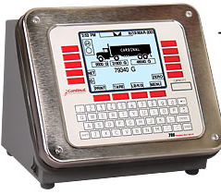
Figure 1-13. Electronic Digital Indicator

The numeric keypad below the display window is used by the operator to enter values or codes that are used to select display modes or features. The remaining buttons on the console are used to activate features, many of which are available only on electronic indicating devices. The most common of these features (and the ones with which you will be most concerned during field examinations of vehicle and axle-weight scales) are:

• On-Off Switch. This switch controls the power supply. Sometimes it will also perform the system segment check that tests all the lights in the digital display and verifies whether each is working. Some on-off switches are designed to shut off power only to the display, thereby keeping the electronic circuitry warmed up.

• Zero-Setting Mechanism. This device makes adjustments to maintain the scale in a zero-load balance condition. The semi-automatic zero-setting mechanism requires a single action by the operator. An example is the push-button zero, common on electronic scales. The scale may also have an auxiliary "center of zero” indicator that shows when zero-load balance has been achieved to within one-fourth scale division or less. Push-button zero mechanisms should not be used to set tare: since the tare function would not be indicated on the display, this practice could facilitate fraud.

• Tare Mechanism. A tare mechanism balances out material on the scale deck not to be included in the net weight. For vehicle scales, this means the tare mechanism serves to subtract the weight of the vehicle itself from the total or gross weight. Two types of tare mechanism are common with vehicle scales having electronic digital weight indicators: push-button and keyboard tare. You may also find some scales with thumbwheel or dial tare.

With push-button tare, the empty vehicle is placed on the scale, and the indicator shows its weight. Then the operator presses and releases the tare button and the indicator shows a weight of "zero,” and indicates that the display is "net weight.” When the same truck, now loaded, is on the scale, the indicator will show only the weight indication for the load: the net weight. In some systems, the gross or tare weight may be stored in memory, along with a tag that associates the weight with a specific vehicle; the operator can retrieve the entered weight when the vehicle returns to the scale to determine the net weight. This makes it possible to weigh other vehicles while one that has been weighed is being loaded or unloaded.

With keyboard tare, first the weight of the tare material (empty vehicle) is determined. This value is entered on a keyboard pad, using the digits 0-9, and the tare key on the pad is pressed. On some systems, the tare value then shows in the weight display for verification. On other keyboard tare systems, the tare value is displayed on a separate tare display.

A thumbwheel (or dial) tare mechanism also requires that the weight of the tare material be determined separately. Then thumbwheels are turned until each digit in the tare weight is correctly shown in the window or next to the indicator line of the thumbwheels. Once the numbers have been set, this weight value will automatically be subtracted from the gross weight on the deck.

These tare-taking capabilities are convenient for the operator, and minimize the risk of operator error (especially the semi-automatic push-button tare). However, they can be abused. Whatever the tare mechanism, every digital scale must have some means to indicate when tare has been taken.

• Push-button Print. This device activates a printer that can record weight values.

Recording Elements

Although not required by Handbook 44, devices that make a permanent, printed record of the transaction are found on most vehicle and axle-load scales. A wide range of printer designs is available.

The weighbeam depicted in Figure 1-9 is known as a type-registering weighbeam because the registered weight can be impressed onto a ticket by means of type that is cast onto surfaces of the main beam and fractional bar. On the detail drawing of the poise shown in Figure 1-10, note that there are two slots in the side of the poise, one marked 'TARE,’ the other 'GROSS.’ When a ticket is inserted into one of the slots and the handles beneath the poise squeezed together, an impression is made on the ticket of the weight corresponding to the current position of the poise and fractional bar.

The tare and gross ticket slots are offset so that both tare and gross weights can be impressed on the same ticket. An empty vehicle may be weighed and the registered weight impressed on a ticket placed in the TARE slot; the device will also impress the word ‘tare’ next to the quantity. When that vehicle is loaded and weighed again, the same ticket is inserted in the GROSS slot and another impression made; the second impression will be made above the first, and automatically labeled as gross weight. The operator must then manually subtract the tare from the gross weight to determine the net weight. Note that the impressed weight will be in numbers that are multiples of the scale division. The type-registering printer is thus a digital device use in conjunction with analog weighing and indicating elements. As you will learn, Handbook 44 requires that all recorded representations be digital.

Ticket printers can also be used in conjunction with mechanical scales with dial indicators.

Digital printers are similar in design and operation to the dot-matrix and inkjet printers that are used with computers. They are actuated by the same signal that produces the digital visual indication, and the two should thus agree exactly. If tare/gross weight is stored in system memory, the ticket can be printed in a single operation.

Summary

Axle-load scales are used to determine the weight of single and tandem axles of highway vehicles in connection with the enforcement of traffic and highway laws. Vehicle scales are used to determine the weight of many different types of vehicle loads where sale price of goods or materials is determined by weight, or where the fee for transfer of goods is determined by their weight. Vehicle scales are generally larger and have greater weighing capacity than axle-load scales.

Some vehicle and axle-load scales work on the principle of the lever and are referred to as mechanical scales. These scales have various kinds of indicators: the most common are weighbeams and dials. Scales using strain gauge load cells as the weightsensing element have electronic digital indicators. Scales that use only load cells are fully electronic. However, mechanical scales can be adapted for use with electronic digital indicators by having an element of the lever system bear upon a strain gauge load cell; these are known as electromechanical scales.

The function and operation of special features frequently found on electronic vehicle and axle-load scales must be understood before examining these devices in the field. These features include: on-off switch, zero-setting mechanisms, tare mechanisms, and push-button print.

