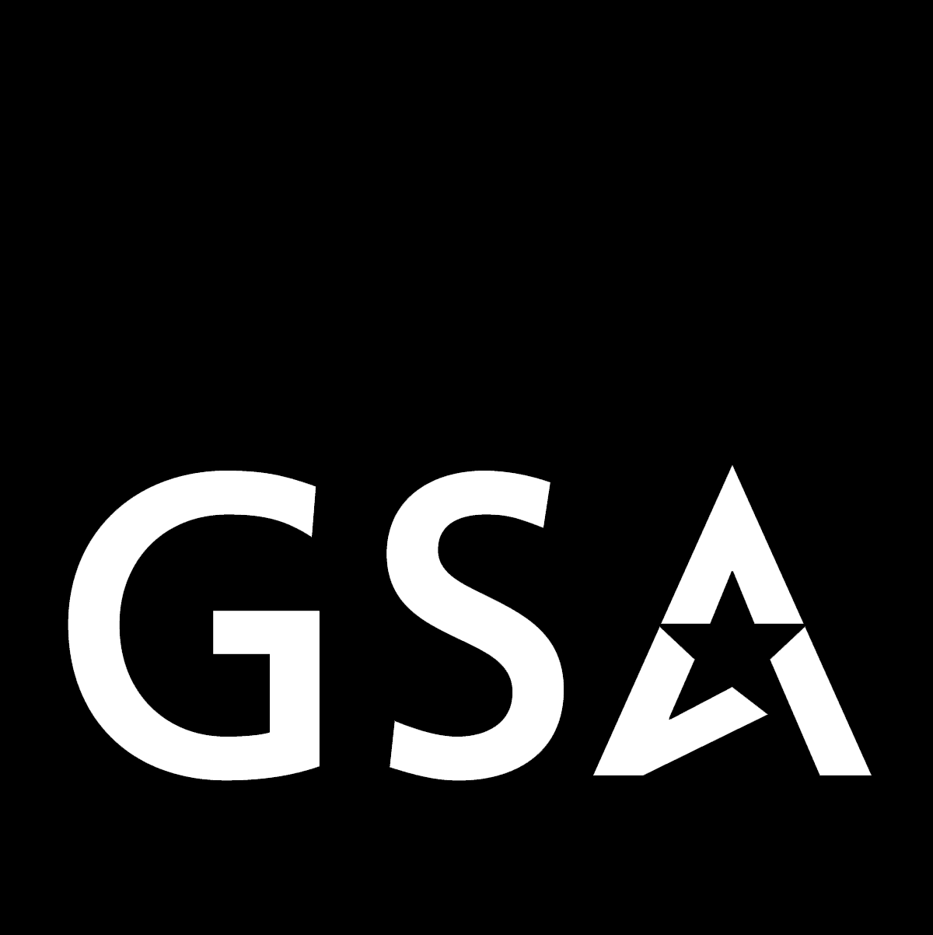 Federal Supply Service

Disposition
THE NEWSLETTER DEVOTED TO THE INITIATIVES OF THE GSA PROPERTY MANAGEMENT PROGRAM
“The first source of supply!”
AUTUMN 2003 DN-No. 30
>>>>>>>>>>>>>>>>>>>>>>>>>>>>>>>>>>>>>>>>>>>>>>>>>>>>>>>>>>

GSA PROPERTY WOWS CROWDS AT EXPO!
Okay. Granted. It wasn’t exactly a reenactment of the 1836 battle of the Alamo, but it must be acknowledged that when a small army of property managers from across the U.S. descended upon San Antonio this past May, a bit of educational glory was achieved—at the GSA 2003 Expo! That’s right! The national property management team, with representatives hailing from Central Office as well as GSA Region’s 3, 4, 7, 8, and 9, wowed the crowds that attended their training classes with a combination of informative curriculum and exciting presentations. The team used a multi-discipline approach in their classes, employing everything from pamphlets to video slides and from music to audience-participation, to instruct the attendees. In a diverse series of classes, including Property Management for Beginners, Personal Property E-Solutions, Advanced Topics in Property Disposal, GSA Auctions® Your Internet Disposal Solution, and others, the team informed the audiences about the virtues of the GSA property management program and the significant advantages that agencies can achieve by using it. Many of the attendees of the property training classes at the Expo included a battery of representatives from various branches of the military, as well as a regiment-size group of civilian agency employees and contractors who invaded and retreated from the classrooms with their enthusiasm intact. Overall, if course evaluation forms were any indication, the property team gave new meaning to the expression “Remember the Alamo” by providing great solutions to agency property needs, with an “educational” and “entertaining” program that won’t soon be forgotten. (See page 3 for more Expo news.)

* * * * *

Property Proverbs
“A teacher affects eternity; he can never
tell where his influence stops.”
- Henry Adams
* * * * *
VA RECOGNIZES PROPERTY ASSOCIATES!
Mid-Atlantic Region Property Management associates, Robert Kitsock and George Stanley, were recognized this past summer by the Department of Veterans Affairs in an award ceremony at the Veterans Affairs (VA) national headquarters in Washington, D.C. The two Area Property Officers were recognized for making significant contributions over the past few years to “Operation New Hope,” the VA’s Homeless Veterans Support Program. The duo was responsible for actively
screening and coor-dinating the transfer of tens-of-millions of dollars of excess federal clothing items from federal agencies to homeless veterans, nationwide. The Secretary of Veterans Affairs, the honorable Anthony J. Principi, presented the associates with personal awards and plaques that distinguished them for their efforts. The plaques read, in part, “Through your efforts, homeless veterans throughout the United States have benefited and survived cold winter days and nights. It is people like you who have enabled the clothing program to continue to provide aide to our nation’s homeless veterans.”
Autumn
- Property Wows Expo
- VA Awards APO’s
- Property Wizards
- New Sales Reg’s
- “X” For GSAXcess™
- Fed-State Partnership
- Property Diplomats

PROPERTY -- BY THE BOOK . . . . . . . 
“How may we sell personal property to State and local governments?

“You may sell Government personal property to State and local governments through—
(a) Competitive sale to the public;
(b) Negotiated sale, through the appropriate State Agency for Surplus Property (SASP); or
(c) Negotiated sale at fixed price (fixed price sale) through the appropriate SASP (This method of sale can be used prior to a competitive sale to the public, if desired.)
(41 CFR, Part 102-38.340)
GSA SCHOOL OF WIZARDING!
No! The institution is not Hogwarts, the curriculum is not magic, and the instructors show no semblance to Albus Dumbledore or Professor McGonagall (for you Harry Potter fans). Lately, however, many property associates are starting to look like veritable “wizards of the workshop,” by developing innovative training strategies that are projected (or, shall we say “divined”) to result in increased customer satisfaction. Although the classes are not likely to make the Daily Prophet, they are surely informing military and civilian employees about the great advantages of GSA personal property solutions. Over the past few months, property associates nation-wide have been fine-tuning their efforts at venues like GSA-101 seminars, property workshops, customer visits, and the GSA Expo, to show the clear benefits of using GSA as the property management source. While their efforts are not exactly magic (nor controlled by the Imperius Curse), the presentations do share key com-ponents that makes them extraordinarily effective—they are simple and direct, and as such show the basic facets of property that resonate with customers, including—
-GSAXcess™—a new face on property management*
-FEDS—behind-the-scenes key to transactions
-GSA Auctions®—exciting sales with exciting results
-Special Programs—Washington, DC-area gems
A review of the basic aspects of property can and does have an impact. By outlining them at various venues, associates show how GSA maintains effective “cradle-to-grave” management of assets through the shiny, new GSAXcess™—a new image that can ensure agencies get the “the best bang for the buck.” Likewise, any class review of the Federal Disposal System (FEDS) illustrates the advantage of an inventory system that allows both disposing and requesting property in one national database . . . increasing agency solutions exponentially. And no talk of “exposure” can resist GSA Auctions®, one program that once seen is believed—since it translates into great sales returns for agencies. If nationwide agencies seem enthusiastic about these “national” solutions, then, likewise, their Washington-area counterparts certainly will be too. After all, a local gem like the Personal Property Center in Springfield, Virginia, can’t stay hidden for long, since it acts as a storage, screening, restoration, and selling facility—all, from one location! So, maybe this curriculum really is magic and property associates are wizards simply using a GSA-variation of an old Hogwarts’ tenet—“GSA will provide help to anyone who asks for it.” To learn more, just open the door to the next informative GSA property management class nearest you. It’s easy: “Alohomora!”
Congratulations!!!
Special recognition is rightfully due to
Region 4 Sales Contracting Officer
Jenny Mooney
for being named
“GSA Person of the Year”
by the Users & Screeners Association (USA).
Jenny is known for providing that extra degree of service to customers, whether they need help for
property transfers, donations, or sales.
Way to go, Jenny, for making all your
GSA property associates proud!

HEY! GET YOUR NEW SALES REG’S HERE!
Yep! That’s right! We’ve got hot dogs, cotton candy, cold drinks, and more! Okay. So, maybe we don’t have to sound like stadium vendors to inform customers about what we’re offering, but we’re excited just the same. That’s because the GSA has just published regulations on the sale of personal property that are not only new and revised, but are in an effective new format designed to make life easy for property customers. The regulations, which became effective August 26, 2003, when published in the Federal Register, were previously contained in the Federal Property Management Regulations, Part 101-45. Now, they have been updated, streamlined, clarified, and moved to a new home in the Federal Management Regulation, Part 102-38, where they are presented in a plain language “question and answer” format. This format (an example of which can be found on page one of this newsletter) is intended to inform customers on the sale of personal property by anticipating—and even suggesting—the types of questions and related answers they will need to know about the property process. The adoption of the new format is part of a trend within the GSA Property Management Division to address issues with simple, easy-to-use, and informative methods that are direct and uncomplicated. So, go ahead, grab a hot dog (or a cheese-steak if you’re in Philadelphia) and a cold drink and review the latest sales regulations (you can find them at gsaxcess.gov*). You’ll not only discover innovative ways for agencies to handle that “hard to move” excess and surplus property that’s cluttering up their work spaces, but you may also catch yourself saying—“Hey! I was just about to ask that same question!” And just think, with the new format, you’ll get the answer too! Now, that’s what you call cotton candy for the mind. Sweet!
* See more on GSAXcess on page 3 of this issue.

GSAXcess™—“X” MARKS THE SPOT!
Are you exhausted from shielding kids from “X” rated spam; tired of seeing another motor-head film with XXX in the title; jaded by pirates maps with “X” marking the treasure? Then be weary no more! That’s right! GSA has something “X-traordinary” for you that will invigorate your spirit and revise the negative image of that ominous “X” in your mind. It’s called GSAXcess™, and it’s revolutionizing the world of property—by simplifying things for customers. And we don’t just mean outside customers like auction bidders and the general public, but also those dedicated workers who labor in federal, state, and non-profit organizations struggling to find, transfer, donate, and dispose of federal personal property. Ah! Now you may think that this is just another elaborate government panacea, or even something amazing out of Stevenson’s Treasure Island. But then you would be mislead by melodrama and confused by custom, because the GSA Property Management Division is abandoning the complicated and embracing the easy. GSA has embarked on a new user-friendly portrayal of property on its web site, including a new introductory page, new mechanisms for conducting transactions, new categories of property—38 and rising, new drop-down boxes, new item-counters for states, new and customized search devices, less formal sign-in requirements, more descriptive and simplified “links” to persons and programs, new fields for motor vehicles like “VINs”, new “shopping cart” technology, and, yes, even photographs. Sounds better already, doesn’t it? Well, these changes are on the way. In fact, the property division is doing X-actly what you X-asperated users have been requesting for so long. So, enjoy the X-citing, new look of property management, or go to the property web site at gsaxcess.gov for a further X-planation. Just remember all you land lubbers—“X” marks the spot!

WE’RE OFF TO SEE THE EXPO!
Speaking of X-citement, it’s time to mark your calendar and plan to attend the premier forum on property management:

The GSA Expo 2004
Orlando, Florida *** May 11-13, 2004

The GSA Property Management Division is offering its customers an exciting array of classes—many of which have CEU credits—that provide special insight into the world of property, including courses for beginners, on advanced topics, e-solutions, GSAAuctions®, GSAXcess, surplus, and others. So check the GSA web site at www.gsa.gov for updates on this fabulous forum. We’ll see you there in 2004.
SOME KEY POINTS OF GSAXcess . . .
FEDS Still The Engine That Drives the Car
Just when you felt comfortable using FEDS (i.e., the Federal Disposal System) to get you to your property destination, along comes GSAXcess™ to change the scene. Well, not exactly. That reliable, old program known as FEDS—that seems to do it all, is still churning behind the scenes like a Chevy “stove pipe” six. In fact, it’s as effective as ever and fine-tuned to handle all your property needs. So, don’t be distressed about trading in the jalopy for a newly named model, because FEDS is still the engine that drives the car. And for help in your travels, including user assistance, password resetting, and troubleshooting, just contact the number/address below. FEDS, i.e. GSAXcess, will be there.
GSAXcess/FEDS Help Desk
-Staffed 8 AM to & 7PM (EST)
-Call 1-866-FEDSGSA
(1-866-333-7472)
-E-mail: gsaxcesshelp@gsa.gov

GSA’s Natural Selection: “Search by State!”
Yes, we know! It’s about time the property division “evolved” enough to show items per state in its system. Well, guess what. Evolution is here! In an answer to your requests, GSA has devised options to help you be more selective in your property searches in the new GSAXcess. You can now simply click your way to a screen that displays the “Nationwide Property Items by State.” If more than 50 items appear in a state on the screen, the second screen shows a “Statewide Property Items by Category.” If less than fifty appear, the second screen displays a more general “Selected Property Items List,” for all items in that State. In either case, you win! It’s like natural selection! You can now search where you want—quickly and efficiently. Let’s face it. It’s a jungle out there. So, use this easy Darwinian solution—and live to search another day. Now, that’s living!

≡GONE WITH THE WIND≡
No! We are not going to reprise Martha Mitchell’s great anti-bellum novel in four sentences. But we will say that gone are the old days in property when people would “screen” for items, or see “F7” as a condition code, or wait until after the “surplus release date” to donate property. That’s because this antique verbiage is being replaced with wording that will help you “select” property, search for “useable” items, and inform you when excess “screening ends,” rather than forcing you to rely on those tedious codes and outdated slogans. Yes, there’s definitely a wind of change in GSA and it’s blowing your way. Learn more at gsaxcess.gov
PROPERTY PARTNERS WITH STATES
The Property Management Division renewed its commitment with state governments this past summer at the National Association for State Agencies for Surplus Property (NASASP) summer conference in Montpelier, Vermont. The division reaffirmed its link with the NASASP through several key presentations made by property personnel, including Deidre Huber, Director of the Property Management Division; Dave Robbins, Chief of the Utilization and Donations Branch; and Joe Hvorecky, Director of the Mid-Atlantic Region Property Management Division. The presentations focused on the special relationship that exists between GSA and the various state operations under the NASASP. They also emphasized the need to share responsibility for program performance and to maintain communications for operational updates, program coor-dination, and training opportunities. The State Agencies for Surplus Property (SASP’s)—that form the operating parts under the NASASP—represent an integral part of the nationwide property management system by providing excellent service and value to public and non-profit groups operating throughout the country and U.S. territories.

FIREMAN PRAISE PROPERTY PERSONNEL!
The Schuylkill County Volunteer Firefighters’ Association of Pennsylvania recently recognized personnel associated with the GSA Property Management Program at its 48th Annual Convention in Tremont, Pennsylvania. The association, representing 123 volunteer fire companies, recognized GSA Area Property Officer, Robert Kitsock, and USDA-Pennsylvania Foresters Michael Mazur and Michael Mroczka for their efforts in locating and transferring fire-fighting equipment for use by volunteer fire companies. The equipment, which included trucks, fire-fighting apparatus, and other items, helped to minimize property losses, reduce insurance costs, and enhance public safety in the county located in eastern Pennsylvania. Association president, Thomas Slane, stated “our association can think of no better example of a federal-state-local partnership than this.”

PROPERTY AIDS INTERNATIONAL DIPLOMACY
The property management program was on the leading edge of enhancing GSA’s mission in an inter-regional partnering effort supporting the upcoming Presidential G-8 Summit in Sea Island, GA. The support was a coordinated effort between the Region 3 and 4 property programs to obtain summit furniture from GSA resources. The furniture, including desks, credenzas, chairs, file cabinets and other items, was located at the Personal Property Center in Virginia and shipped well in advance of the “initial logistical planning” date of November 1, 2003, set by summit planners. The summit, which is scheduled for June 2004, will shed an international spotlight on many aspects of the U.S. government—and the property program, through its supportive role, will help that light shine a little brighter.

And for those of you just joining us for the first time . . .

FRIENDS, ROMANS, LEND ME YOUR EARS . . .
Or your eyes! Because—with apologies to Julius Caesar and his famous “friends, Romans, countrymen” speech—you won’t believe your eyes when you see the hottest federal website for selling surplus property . . . GSA Auctions®. And just what is GSA Auctions®? Well, it may just be the solution to all your property disposal needs. GSA Auctions® is a state-of-the-art Internet website launched January 17, 2001, by GSA to auction federal surplus & exchange/sale property. The site, GSAAuctions.gov, offers the general public the chance to bid electronically on agency assets, ranging from common items such as office equipment, to items like airplanes, machinery, scientific devices, and vehicles. The auction is web-enabled, allowing you to bid on items nationwide using safe, innovative, and user-friendly technology. And while the GSA Auctions® has been a public success—resulting in over 47,000 items sold and 1.5 million bids in just over 2-1/2 years—it’s with federal agencies that it has produced perhaps its greatest appreciation. That’s because GSA Auctions® has proven its value by streamlining sales, increasing agency options, and generating over $70 million in proceeds in its short history. This has translated into enhanced efficiency and revenue for federal agencies and almost limitless potential for their futures . . . all from the once mundane task of disposing property. In fact, while results are dramatic, it’s what is behind the scenes (or shall we say behind the “toga?”) that is responsible for the success of the auction. That’s because many agencies are getting sales results that far exceed expectations—by 500-600% in some cases—due to key facets built into the GSA process, including a trained staff, a cradle-to-grave asset management system, a “direct marketing” philosophy, a modern fiscal program, and an equitable agency fee structure that charges “nothing” unless an item is sold. Indeed, GSA Auctions® represents the outstanding solution for managing your property— epitomizing the federal goal of being good for government and good for the people. So, if you’re interested in the hottest government website—and can avoid any impatient remarks about “fiddling while Rome burns”—then contact GSA and ask about GSA Auctions®. You may end up saying, “Hail Caesar!” And hail GSA Auctions® too!
Editor’s Note: I lift my lamp beside the golden door!
Give me your sentences, your paragraphs, your huddled manuscripts yearning to breathe free.
Send your property stories, activities, & deeds to me
and you’ll be enlightening the property world!
robert.kitsock@gsa.gov

≡ Disposition Newsletter ≡ 
Robert Kitsock, Editor, Hummelstown, PA
Phone: (717) 566-1064, Fax: (717) 566-1065
robert.kitsock@gsa.gov

