Abstract—A 2-m long superconducting model of an LHC Interaction Region quadrupole magnet was wound with stabrite coated cable. The resulting low interstrand resistance and high AC losses presented the opportunity to measure magnet quench performance in superfluid as a function of helium temperature and heat deposition in the coil. Our motivation was to duplicate the high radiation heat loads predicted for the inner triplet quadrupoles at LHC and study the coil cooling conditions in the magnet. At the Magnet Test Facility in Fermilab’s Technical Division, the magnet quench performance was tested as a function of bulk helium temperature and current ramp rate near the planned high luminosity interaction region field gradient of 205 T/m. AC loss measurements provided a correlation between current ramp rate and heat deposition in the coil. Analysis indicates that the results are consistent with there being little participation of superfluid helium in the small channels inside the inner layer in the heat removal from the coil. However magnet performance will be limited by the outer coil pole turn in LHC at a current level well above the operating current.
Thermal Studies of a High Gradient Quadrupole Magnet Cooled with Pressurized, Stagnant Superfluid
L. Chiesa, S. Feher, J. Kerby, M. Lamm, I. Novitski, D. Orris, J. P. Ozelis, T. J. Peterson, M. Tartaglia, A. V. Zlobin

Index Terms—cryogenics, magnet, superconductivity

Introduction
THE United States contribution to the Large Hadron Collider (LHC) at CERN includes half of the high gradient quadropole magnets for the four interaction regions. These quadrupoles will work in a hard radiation environment produced by secondary particles coming from collision points, which will generate high heat depositions in the coil and other parts of the magnet [1]. To provide reliable magnet operation at the expected level of heat deposition, special attention was paid to the magnet thermal design including coil cooling conditions and heat extraction from the cryostat [2], [3]. In particular, special channels 2×0.05 mm² were introduced in the outer wrap of the inner-layer cable insulation to increase the wet perimeter of turns by penetration of superfluid helium inside the coil [4]. However, in the course of the short model R&D program [5] it was found that coils must be cured at high pressure and relatively high temperature in order to achieve a high coil compaction with the required elasticity modulus. That certainly affects the
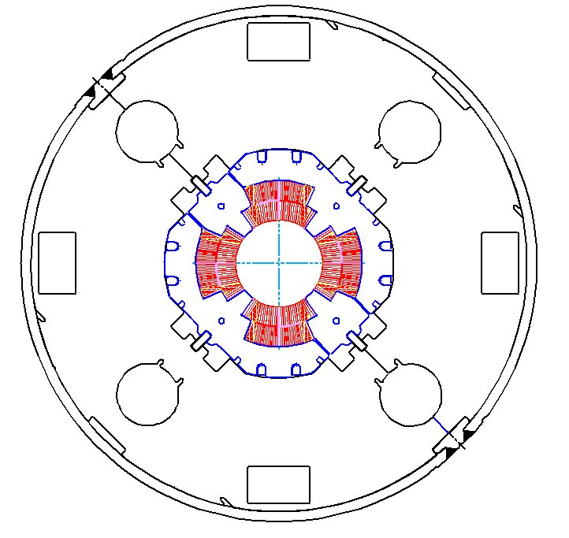
Fig. 1. High gradient quadrupole cross section.

size of the channels and reduces their efficiency. The practical importance of this problem along with the expected variations in helium temperature in the magnet cryostat during operation motivated us to study experimentally the real coil cooling conditions in these magnets.
A special short model magnet (HGQ08) was wound with stabrite coated cable. The resulting low interstrand resistance and high AC losses allowed us to measure magnet quench performance in superfluid helium as a function of its temperature and heat deposition in the coil. The results of these studies are reported in this paper.

HGQ Thermal Design Parameters
The cross section of the high gradient quadrupole cold mass developed at Fermilab for the LHC IR is shown in Fig.1. The inner coil is cooled by conduction through the cable insulation to superfluid HeII in the annular channel. The outer coil is cooled by conduction through the ground insulation and collar laminations and also through the inner coil. The heat transferred to the superfluid in the annular space between the beam tube and inner coils is removed via radial heat transport through gaps in the collars and yoke to the yoke holes. Heat from the magnet is removed to the external heat exchanger via superfluid heat transport through the holes in the iron yoke and special cryostat pipes.

The details of pressure drop and heat transfer calculations for the piping and heat exchangers, which connect the inner
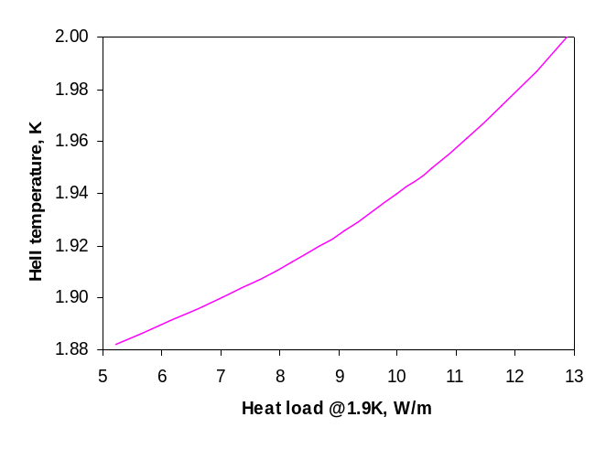

Fig. 2. Predicted temperature in pressurized helium II in the iron yoke holes in the warmest part of Q1 in IP5-left, the warmest inner triplet magnet string.

triplet quadrupoles to the LHC cryogenic system, are reported in [3]. Fig. 2 is a plot of predicted temperature in pressurized helium II in the iron yoke holes in the warmest cross-section of an inner triplet assembly. With the expected total heat load to the cold mass of 6 to 12 W/m (corresponding to about 2 to 5 W/m in the coil), the temperature of superfluid helium in the yoke holes will be in the range of 1.9 K to 2.0 K. The helium temperature at the coil is calculated to be only a few mK higher than the helium temperature in the yoke holes.

The azimuthal distribution of the radiation heat power in the magnet reaches maximum in the midplane turns of the coil (see Fig.3 below). Table I shows the temperature rise and operational margin for these turns for two different coil cooling conditions calculated using a simple analytical model [4]. Only radial heat transfer in the coil was assumed in this calculation.

TABLE I
Calculated Temperature Rise and Operation Margin
for Midplane Turns and Different Coil Cooling Conditions

Cooling | Pmax | Inner layer |  | Outer layer
Channels | (mW/g) | ΔT_{cbl}, K | ΔT_{c}/ΔT_{cbl} | ΔT_{cbl}, K | ΔT_{c}/ΔT_{cbl}
open | 0.6 | 0.11 | 21.8 | 1.3 | 2.85
closed | 0.6 | 1.09 | 2.17 | 2.8 | 1.32

Operational margin is defined here as a ratio ΔT_{c}/ΔT_{cbl} at nominal field gradient G = 205 T/m for the mid-plane turns, where
ΔT_{c} = T_{c}-T_{HeII} − critical temperature margin,
ΔT_{cbl} = T_{cable}- T_{HeII} − temperature rise in cable.
“Channels open” assumes that small channels in the insulation, filled with superfluid, exist within the inner coil. “Channels closed” refers to the gaps in the insulation within the inner coil being closed (filled or blocked by cable insulation during coil fabrication). Heat loads in the analysis are based on early radiation induced heat deposition estimates [1]: a peak power density of 0.6 mW/g corresponding to 0.08 W/m in the inner-layer midplane turn of the superconducting coil and 0.026 W/m in the outer layer midplane turn. The
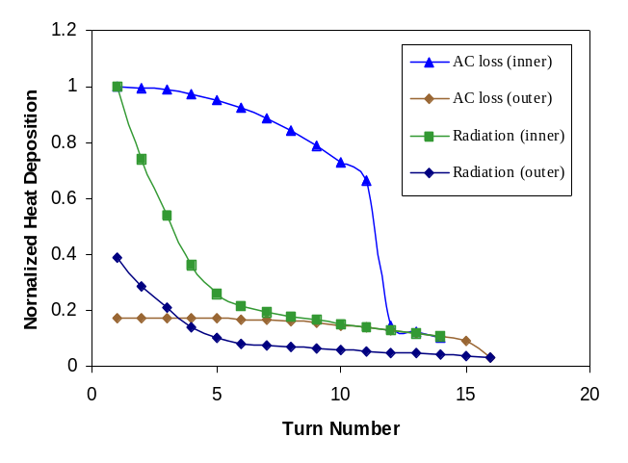
Fig. 3. Heat deposition versus coil turn number for AC losses in these tests (dI/dt=100 A/s) and for expected radiation heating in the LHC. AC loss and radiation heat depositions are normalized to the corresponding heat depositions at the midplane in the inner coil.

temperature margin at the nominal field gradient of 205 T/m is calculated to be 2.4 K for the inner layer coil and 3.7 K for the outer layer coil, with a HeII temperature of 1.9 K.

One can see from Table I that for either cooling condition, warming of the outer layer of cable should limit magnet performance.

Experimental Verification
sThe experimental verification of the HGQ coil cooling conditions (thermal design parameters) is based on measurements of the sensitivity of the magnet critical current to the AC loss heat depositions in the coil. Experimental studies were performed on the special HGQ short model (HGQ08) with high AC losses in the coil.
The calculated distribution of AC losses in this model magnet is shown in Fig.3. For a comparison the expected distribution of radiation heat deposition is also plotted in Fig.3. One can see that AC losses, like the radiation heat deposition, are maximal in the midplane turns of the inner layer. However, AC losses are more uniformly distributed azimuthally in each layer than the radiation heat depositions.

Tests were conducted in the large cryostat called the Vertical Magnet Test Facility (VMTF) [6]. The magnet was placed in the superfluid helium bath with a 3 mm annular space inside the magnet bore. The magnet quench performance was tested as a function of helium temperature and ramp rate.

Fig. 4 is a plot of quench currents measured at different temperature of HeII bath versus current ramp rate. All quenches at current ramp rates above 50 A/s were detected in the midplane turns of the inner layer as predicted by the heat distribution plotted in Fig.3.
AC loss measurements provided a correlation between the current ramp rate and the coil heat deposition due to AC loss heating. The system used to perform the AC loss measurements [7] included two HP3458A digital multi-meters (DMMs) with matched low pass input filters, a power supply controller, a GPIB bus, and an embedded VME computer for

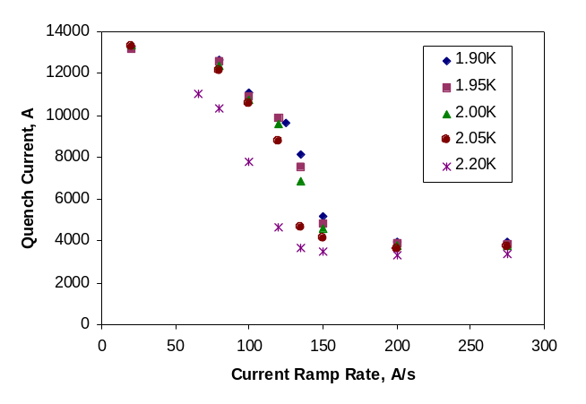
Fig. 4. Measured magnet quench current versus current ramp rate.

controlling the measurement. The two DMMs were used to measure the current and magnet voltage. They both were configured for a 60Hz sample rate and single line-cycle integration. One DMM measured the magnet voltage via voltage taps on the coil while the second DMM measured the current, which was sensed by a Holec Transductor. Since the power deposited by AC losses is small compared with the change in stored energy, both DMMs were synchronized to integrate over the same interval in order to prevent any errors that would be incurred from small timing differences. The technique employed for measuring AC losses was strictly digital, and with no bucking. This was accomplished by digitizing the signals with the DMMs and then digitally integrating the product of the current and voltage over a closed current loop once the measurement was complete.
At each current ramp rate, five energy loss measurements were made for ramps from 500 A to a peak current of 6500 A and back. These were averaged to yield a net energy deposited in the magnet versus ramp rate. Similar measurements were made with ramps to 4000 A and 3500 A. By subtracting the energy losses for different peak currents and dividing by the time difference for the cycles, we subtracted out the ramp acceleration and deceleration effects. Dividing by the 1.8 m coil length gives specific power per magnet unit length.
Results for power deposited in the coil by AC heating versus current ramp rate are plotted in Fig. 5.
Systematic measurement errors for these data are quite small, less than 10%, and their RMS spread is about the size of the deviation of the points from the curve on the plot. The curve is a quadratic fit, which is then used to convert current ramp rates to power.

Magnetic field gradient at quench versus average AC heat load in the coil (Fig. 6) was obtained by converting quench current to magnetic field gradient and converting current ramp rate to heat load to the data shown in Figs. 4 and 5.
Figs. 4 and 6 illustrate one important conclusion from this study, which is that helium temperature of 2.05 K or lower had little effect on quench current and quench field gradient. One can also see what appears to be breakdown of the superfluid heat transport in the annular space at a heat load of 40 W/m.
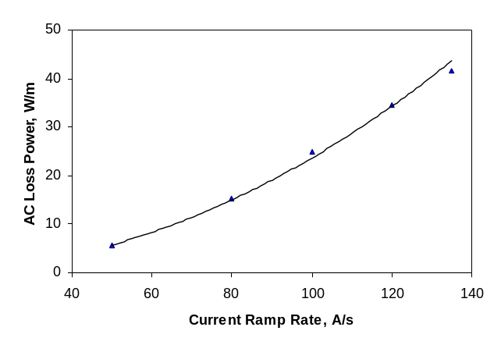
Fig. 5. Measured AC loss power versus ramp rate for HGQ08.

For the AC loss limit at 1.9 K from Fig. 6 of 20 W/m total, and using the distribution presented in Fig.3 we estimate 0.19 W/m into the midplane turn of the inner layer, where quenches initiated. The 0.19 W/m measured limit divided by 0.08 W/m from the Table I analysis yields a 2.37 heat load margin for the inner layer assuming a linear relationship between the power dissipation in the cable and its temperature rise. The margin of 2.37 is in good agreement with the calculated temperature margin of 2.17 for the inner layer with poor coil cooling conditions at 1.9 K HeII temperature.
This result allows one to conclude that the channels in the inner-layer cable insulation are practically blocked. Visual inspection of the slice of collared coil cross-section confirms this conclusion.

Operation Margin in the LHC
Experimental studies described above provided the information concerning the real coil cooling conditions in the coil. To improve and update the HGQ thermal analysis a 2-D ANSYS® steady thermal model has been developed. The model includes inner and outer coils, ground insulation, and stainless steel collars. Real azimuthal and radial distributions of radiation heat depositions and
the heat load value updated for the nominal LHC luminosity in Fermilab’s magnets of 0.4 mW/g have been used [8].
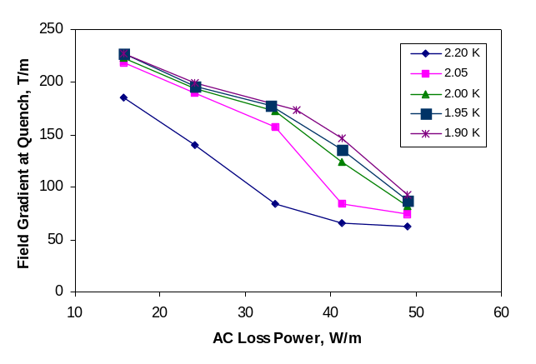
Fig. 6. HGQ08 field gradient at quench versus heat load.

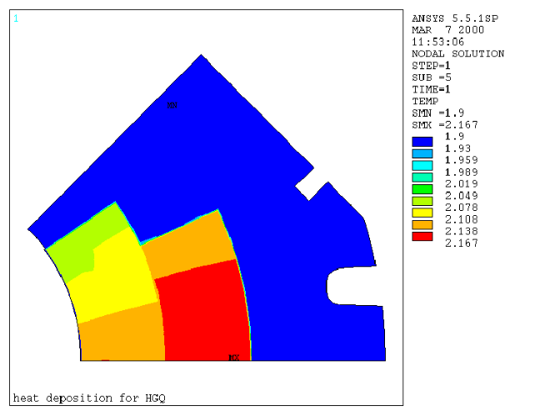
Fig. 7. Temperature distribution in the HGQ coil at nominal LHC radiation heat deposition.

Fig. 7 shows the calculated temperature distribution in the HGQ coil with predicted nominal LHC radiation heat deposition. Data analysis shows that radial and azimuthal temperature gradients are very small in spite of strong radial and azimuthal dependence of radiation heat deposition in the coil (see Fig.3). The calculated azimuthal temperature gradient between the midplane and pole turns in the inner layer is ~60 mK and ~30 mK in the outer layer. The radial temperature gradient in both layers is less than 5 mK. These results show that the coil’s azimuthal thermal conductivity is an effective mechanism for temperature averaging the radiation-induced heat which is locally deposited into the inner and outer midplane turns. This mechanism has the additional benefit of helping to involve a large amount of the coil surface into the transfer of radiation heat to the HeII bath.

The results of calculation of turn operation margin for the radiation heat depositions corresponding to LHC nominal luminosity are reported in Fig. 8. The operation margin of the inner layer is 11 and determined by the midplane turns. The operational margin of the outer layer is 7 and determined by
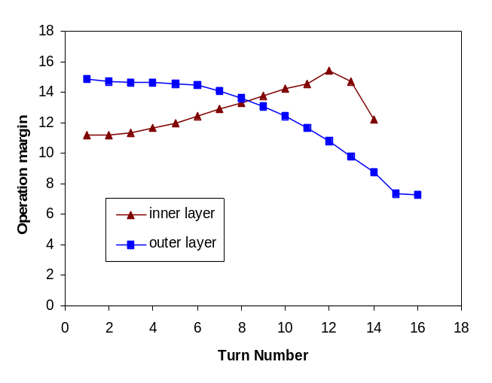
Fig. 8. Operation margin for inner and outer turns at nominal field gradient of 205 T/m.

the pole turns. Thus, the outer layer determines the magnet operational margin that is 7 for the nominal LHC luminosity. This margin is also sufficient to provide the reliable magnet operation at expected ultimate LHC luminosity, which is expected to be a factor of 2.5 higher.

Summary and Conclusion
The experimentally determined inner-layer operation margin (relative to 0.6 mW/g heating) of 2.37 and the fact that quench current does not change significantly with helium temperature are consistent with the AC heating thermal model result for closed channel cooling. These results imply that channels in the inner-layer insulation are blocked. The blocking of cooling channels with insulation in the assembled magnet was visually checked and confirmed in a mechanical model. However, the relatively large azimuthal thermal conductivity of the coil helps to involve whole coil surface in the transfer of heat deposited in the midplane turns to the HeII bath.

A thermal analysis of coil cooling based on closed cooling channels, effective azimuthal thermal conductivity in the coil, and heat deposited as predicted due to secondary particles in LHC shows that the outer layer would limit the magnet operation margin to seven times the predicted nominal heat load. Thus, we conclude that the high gradient quadrupoles developed at Fermilab for the LHC interaction regions have sufficient temperature margin for stable operation even in the hard radiation environment of LHC at nominal and ultimate beam luminosity.

Acknowledgment
The authors thank the Fermilab Technical Division, Engineering and Fabrication Department staff who built magnet HGQ08, and the Development and Test Department staff who set up and ran the tests.

References
- N.V. Mokhov and J.B. Strait, “Towards the Optimal LHC Interaction Region: Beam-Induced Energy Deposition”, Proc. of Particle Accelerator Conference (PAC’97), Vancouver, Canada, May 12-17, 1997.
- R. Bossert et al., “Development of a High Gradient Quadrupole for the LHC Interaction regions”, IEEE Transactions on Applied Superconductivity, v. 7, No. 2, June 1997, p. 751.
- R. Byrns et al., “The cryogenics of the LHC interaction region final focus superconducting magnets,” Proc. of the 17th International Cryogenic Engineering Conference, Bournemouth, UK, 1998.
- Y. Huang et al., “Thermal Design of a High Gradient Quadrupole for the LHC Interaction regions”, IEEE Transactions on Applied Superconductivity, v. 7, No. 2, June 1997, p. 578.
- N. Andreev et al., “Status of the LHC inner triplet quadrupole program at Fermilab”, this conference.
- T. J. Peterson, R. J. Rabehl, and C. D. Sylvester, “A 1400 liter 1.8 K test facility,” Advances in Cryogenic Engineering, Vol. 43A, New York: Plenum Press, 1998, pp. 541-548.
- J. P. Ozelis et al., "AC Loss Measurements Of Model And Full Size 50mm SSC Collider Dipole Magnets At Fermilab". IEEE Transactions on Applied Superconductivity, Vol. 3, No. 1, March 1993, pp 678-681.

- N. Mokhov, Fermilab, Batavia, IL, private communication, 1999.

 Manuscript received September 18, 2000. This work was supported by the U.S. Department of Energy. All authors are with Fermilab, P.O.Box 500, Batavia, IL 60510, USA, J. Ozelis is with Jefferson Lab, 12000 Jefferson Avenue, Newport News, VA 23606, USA

