CIVIL AIR PATROL
QUICKEN® HANDBOOK
FOR UNITS BELOW WING LEVEL
Civil Air Patrol gratefully acknowledges the contributions of Jennifer Brenner, CA Wing Director of Finance, and Capt. Ira Rosenberg, of CA Wing Squadron 56, for having the vision to utilize Quicken® for financial reporting for units below Wing level. The initial draft of this manual was developed several years ago and the squadrons of CA Wing have been successfully utilizing Quicken® for several years.

This publication was revised to provide assistance to all Finance Officers of units below Wing level, and Wing and Region Directors of Finance in performing their duties. Any comments or suggestions should be directed to your Wing Director of Finance, your Wing Financial Analyst or to fm@capnhq.gov.

TABLE OF CONTENTS

Installation and Set Up 4
Getting Started 6

Entering Checks 8

Entering Deposits 13

Bank Transfers 15

Reconciling Your Accounts 16

Reports 25

Year-End Requirements 34

Back Ups 35

INSTALLATION AND SET UP

1. Copy the four Quicken® files to a directory on your computer where you can easily find them. The files are:

FY06UnitMaster.IDX
FY06UnitMaster.QDF
FY06UnitMaster.QEL
FY06UnitMaster.QPH

2. Install Quicken® according to the instructions you received with your Quicken® package.

3. Once Quicken® is installed you should open your new unit files. From the upper left-hand corner select “File” then select “Open.”

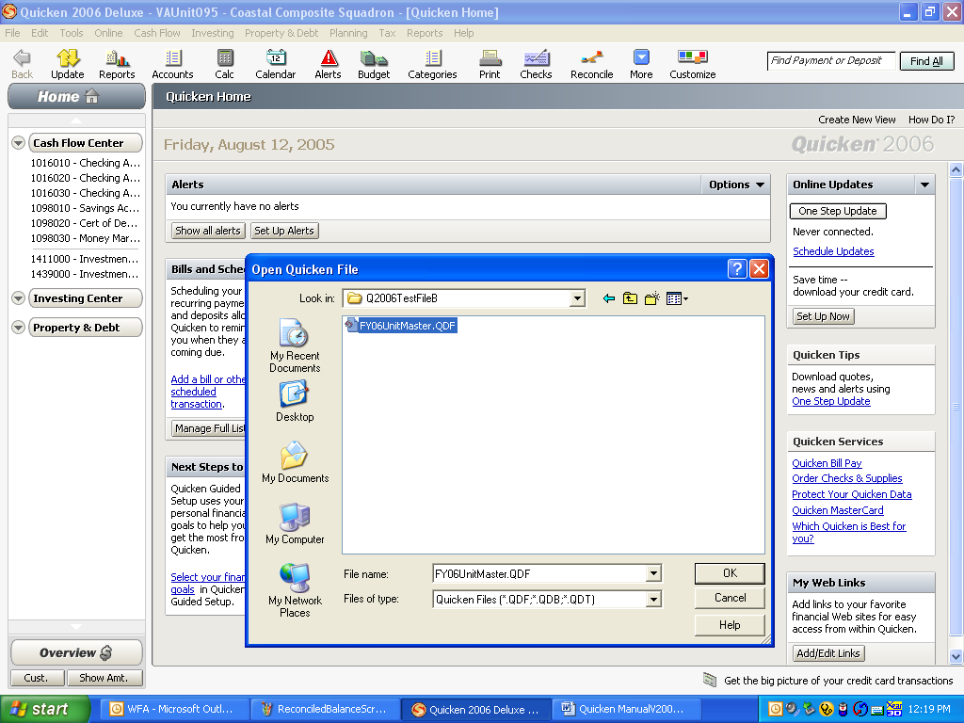

4. You will need to rename the Quicken® data file to include your wing, unit number and unit name in the following format: Two-letter wing identifier plus three-digit unit number plus unit name. An example would be: VA095 – Coastal Composite Squadron.

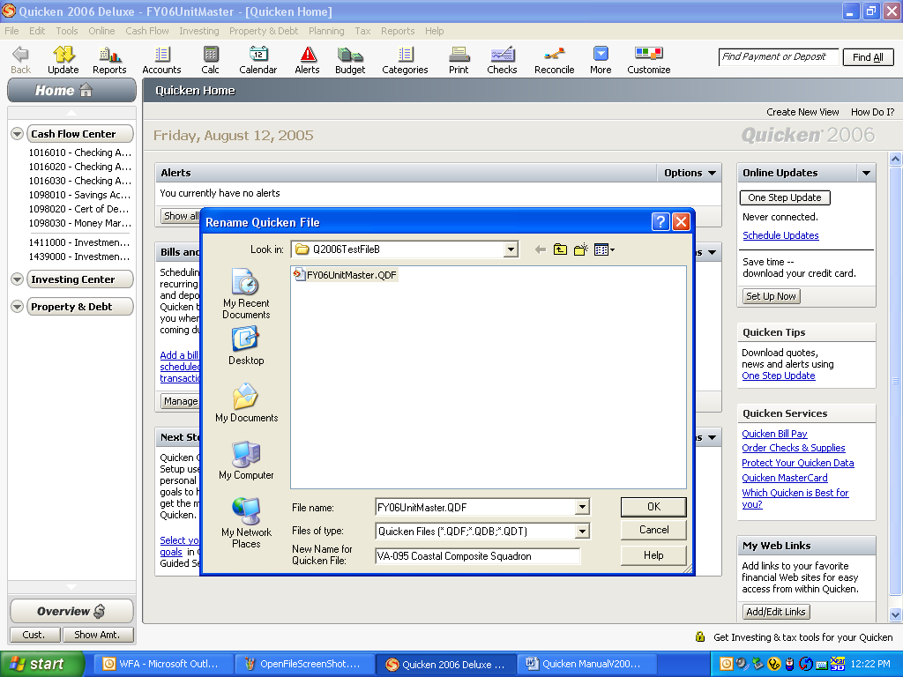

5. Once the file has been renamed, the new name will appear at the top of your screen.
GETTING STARTED

1. You need to rename your bank accounts in Quicken®. Select “Cash Flow” on the top toolbar. Select “Cash Flow Accounts.” Select “Checking Account #1.” Select “Overview.” Select “Edit Account Details.”

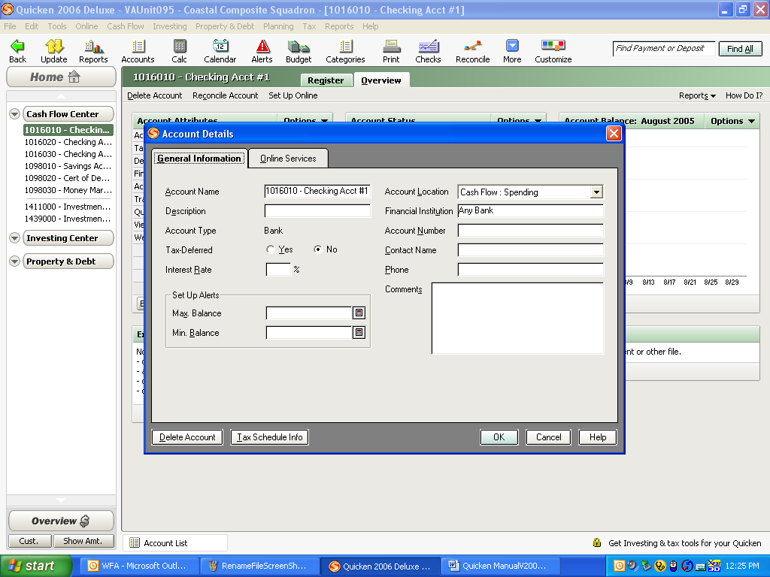

2. From this screen you can rename the checking account, change the bank name, enter the account number and add a contact name and phone number. If you have more than one checking account or if you have any savings or CD accounts you should change them the same way.
3. Once you have changed all your account names you need to enter beginning balances. Select “Cash Flow” from the top tool bar. Select “Cash Flow Accounts.” Select the account you wish to add a beginning balance for. Select “Register.”

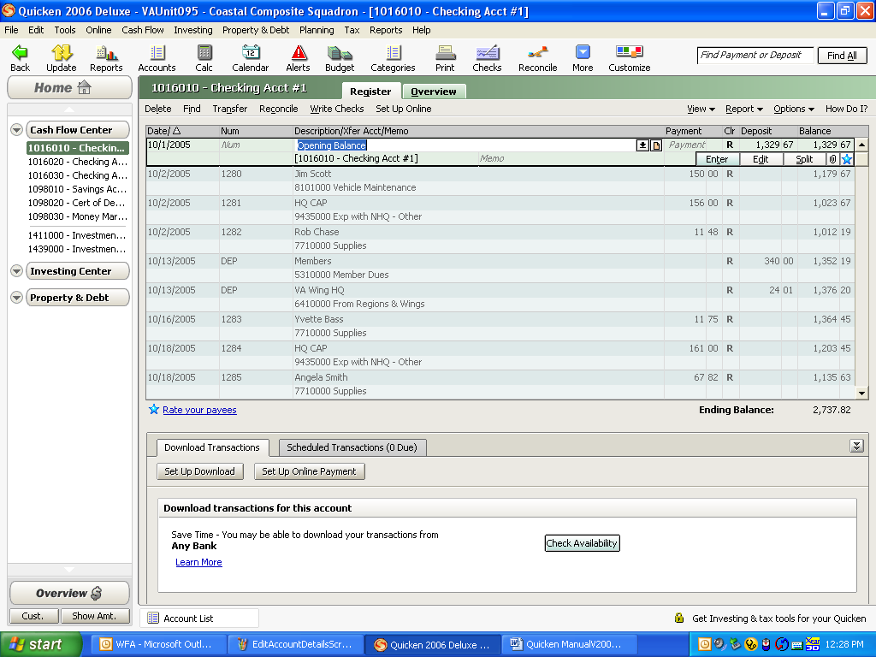

4. On the first line where it says “Opening Balance” change the date to 10/1/05. Tab to the “Deposit” area. Enter the bank balance from your bank statement at 9/30/05. Quicken® will ask if you wish to record a transfer back into the same account. Answer “yes.” If you have any outstanding checks or deposits that have not cleared your bank you need to enter those, also.

5. Once you have entered all your opening cash balances and any outstanding items you are ready to enter transactions.

ENTERING CHECKS

1. You may either handwrite checks and then enter them in Quicken® or enter payment details and then print checks. If you wish to print checks directly from Quicken® follow these steps.

2. Click on the “Checks” icon. The following screen will appear.

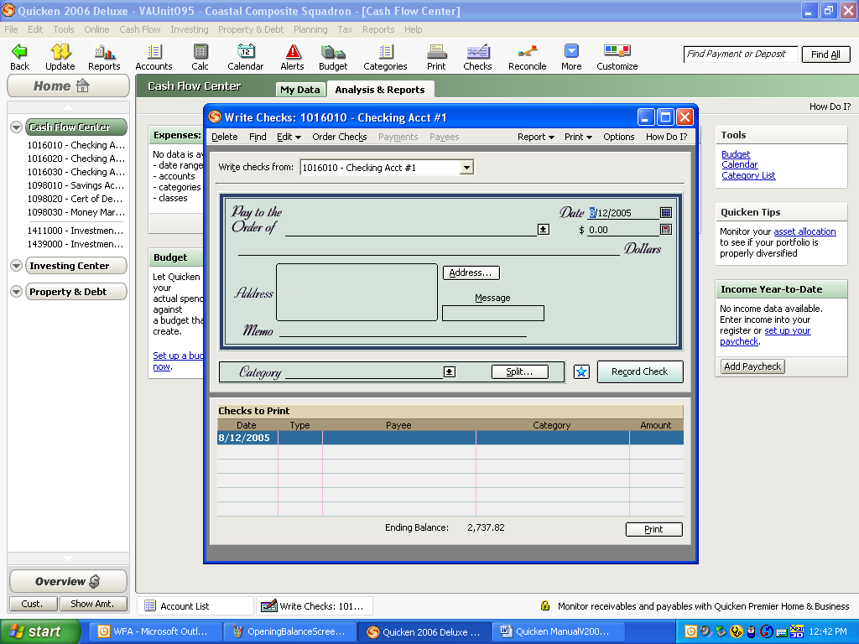

2. Select the appropriate checking account you wish to use. Enter the payee’s name. Enter the amount. Enter the payee’s address.
3. Select the correct category from the list. These categories are predetermined and must not be changed. You may add subcategories if you would like to track things in greater detail, but in order for the consolidation to occur at year-end, these main categories must not be changed. If you need to use more than one category on a single check select “Split” and you can enter as many categories as you need.

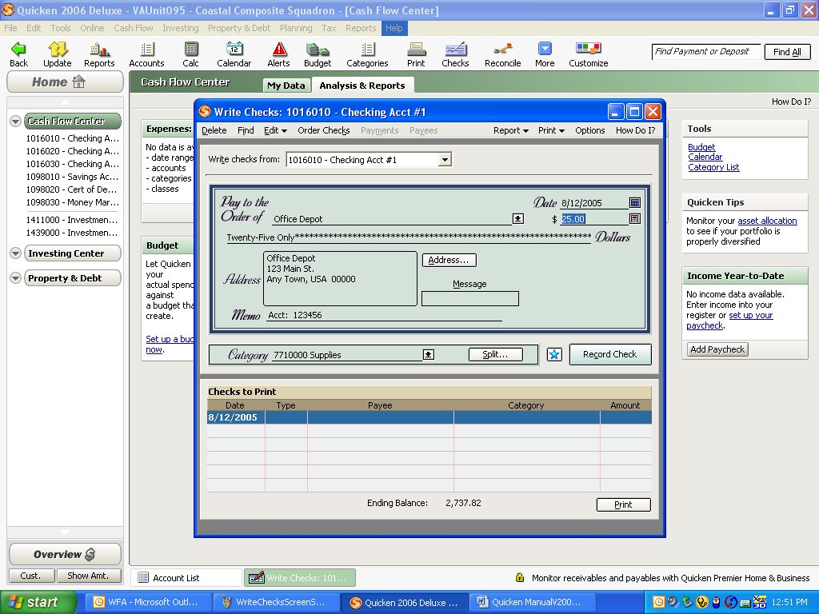

4. When you are finished click “Record Check.” You may keep entering checks and then print or you may print each one individually. When you print the checks make sure you start with the correct check number and the correct check style.

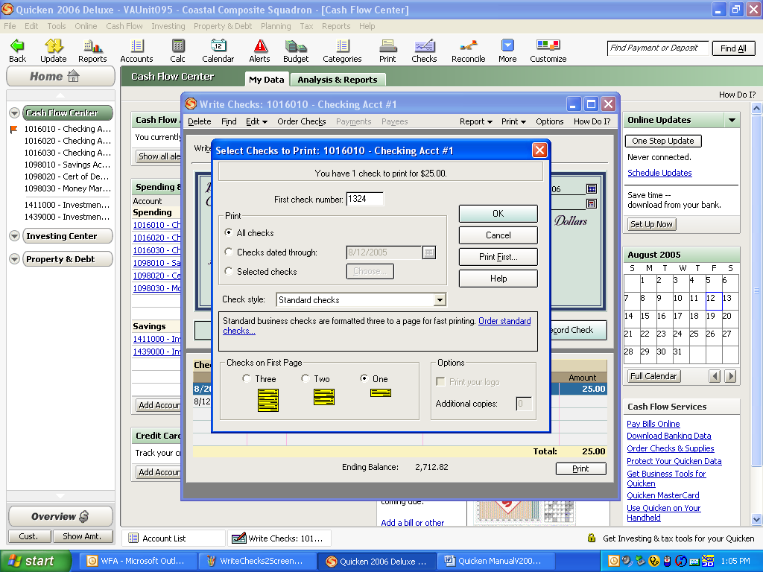

5. If you are going to handwrite checks you will still need to enter them into Quicken®. Select “Cash Flow,” select the correct bank account, and then select “Register.” Select an empty transaction at the bottom. Enter the date, number, payee, amount, category and memo.

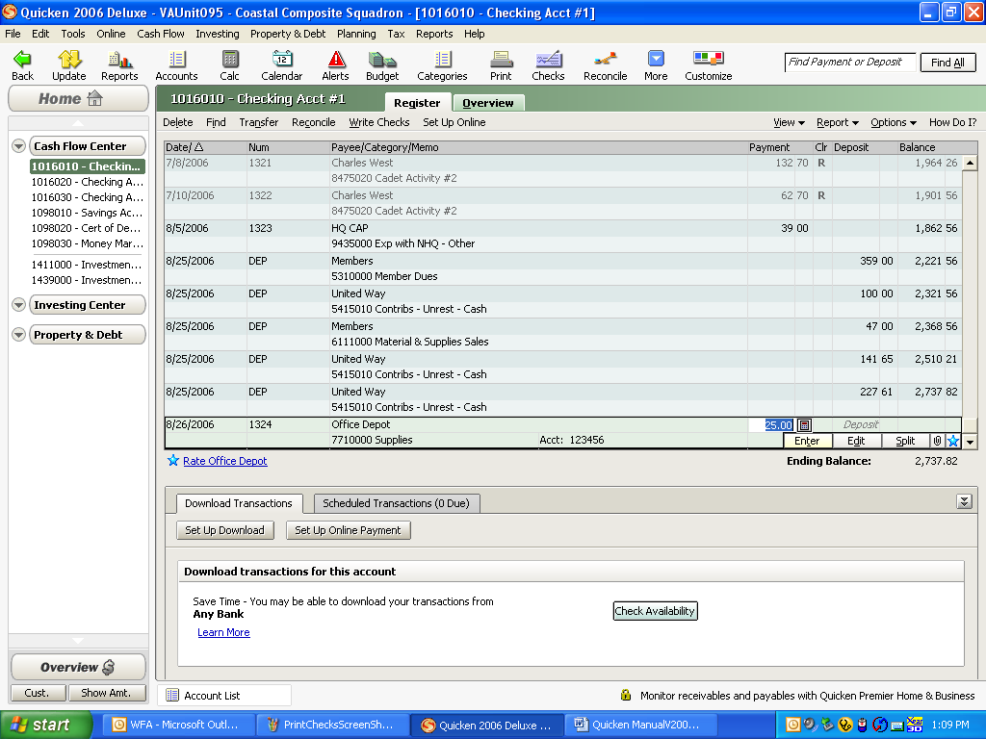

6. If you need to enter more than one category, select “Split.” You can then enter multiple categories as needed. When you finish, click on “OK” to save the split and return to the check register. Click on “Enter” and your check is now recorded.

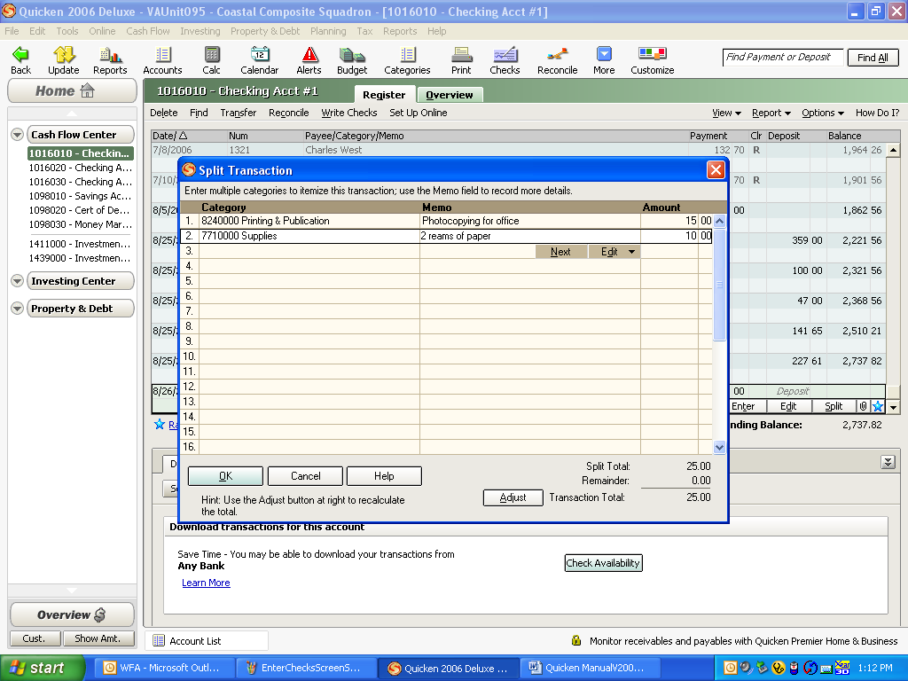

ENTERING DEPOSITS

1. To enter bank deposits select “Cash Flow,” select the correct bank account, and then select “Register.” Select an empty transaction at the bottom. Enter the date, select deposit, enter the name on the received check into the payee field, enter the deposit amount, select the correct category from the list, enter a memo, and then click “Enter.”

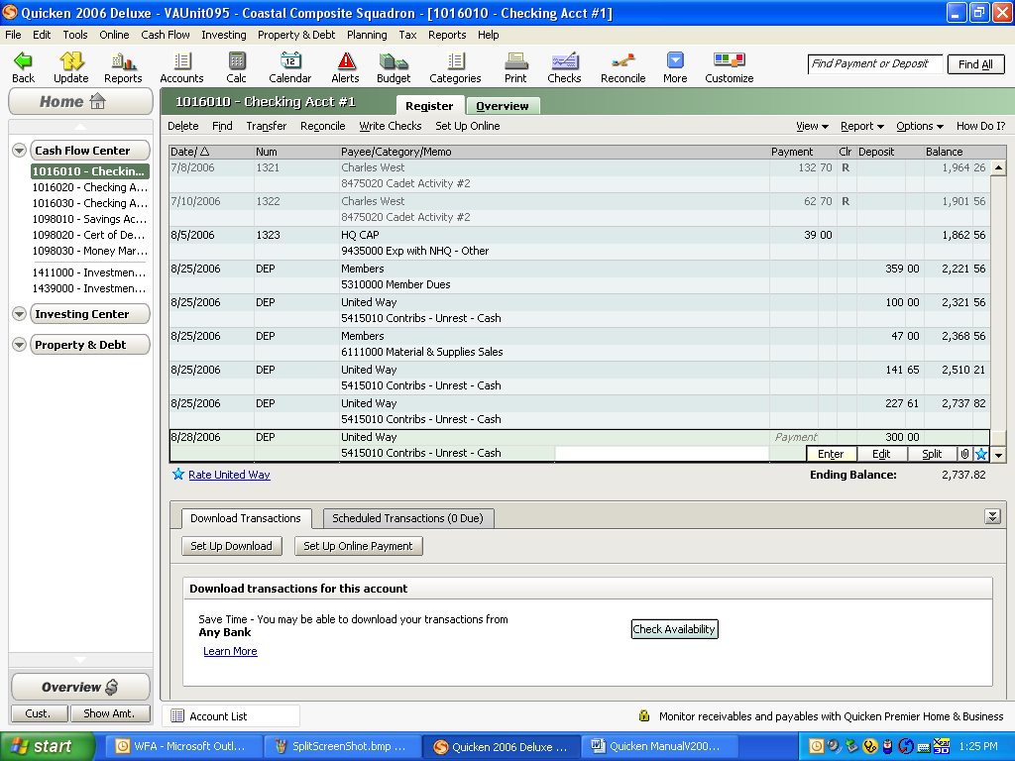

2. If you have received several member checks at the same time and they will be posted to the same category, you may wish to create a customer name called “Members.” You can then split the deposit and list every payee/customer name in the memo field using the same category. If you have multiple checks and they need to be posted to different categories (income accounts) it would be more appropriate to enter each check separately.

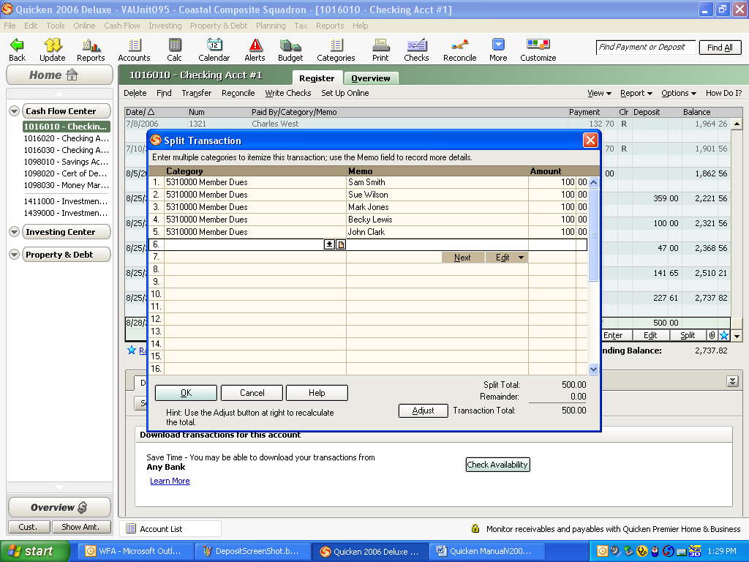

BANK TRANSFERS

1. If you need to transfer funds between two accounts, such as savings to checking, select “Cash Flow,” select your savings account, and then select “Register.” Select “Transfer” at the top of the register screen. Select the account you are transferring the money from, the account you are transferring the money to, the date and then the amount. Click “OK” when you are done. We do not recommend the use of the “transfer” function within Quicken®. We recommend that the transaction be entered into each bank account independently.

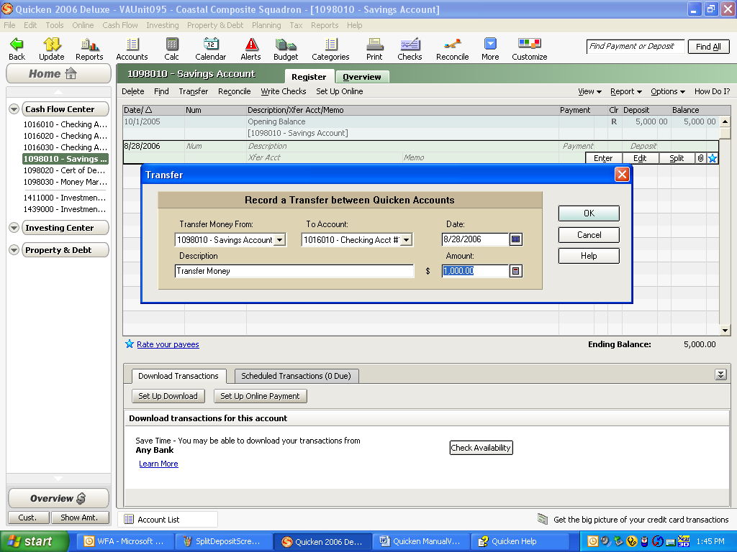

RECONCILING YOUR ACCOUNTS
1. You must reconcile all your bank accounts whenever you receive a statement. Most banks send bank statements monthly and the reconciling the bank should be a high priority task.

2. Select the first account you wish to reconcile from the list.

3. Verify that the opening balance agrees with the ending balance on your previous reconciliation.

4. Enter the ending bank balance from your current statement.

5. Enter the ending date on your bank statement. The statement ending date can be found on the bank statement.

6. If you have any bank service charges, enter the amount, the date of the charge and select Account 9405000 – Bank Fees as the correct category.

7. If your account has earned interest, enter the amount, the date the interest was earned and select Account 5410000 – Interest Income as the correct category. Select “OK.”

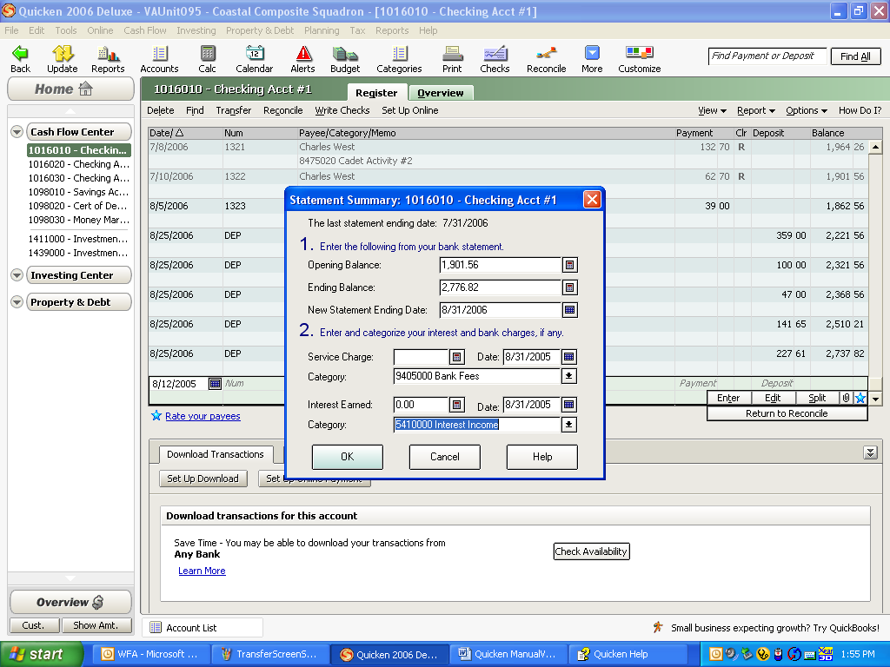
8. Place check mark next to the checks that have cleared and then the deposits that have cleared. When you are done the difference at the bottom must be zero. If it is not zero, you must investigate why it is not and correct it. Never click “Finished” unless you have a zero difference. If you need help, contact the wing director of finance.

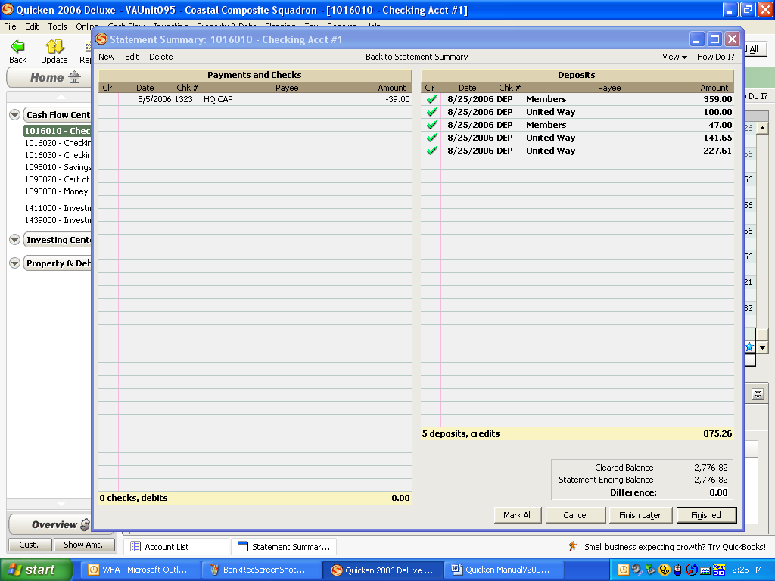

9. When the difference is zero, click “Finished.” The reconciliation complete screen appears. Select “Yes” to print the report.

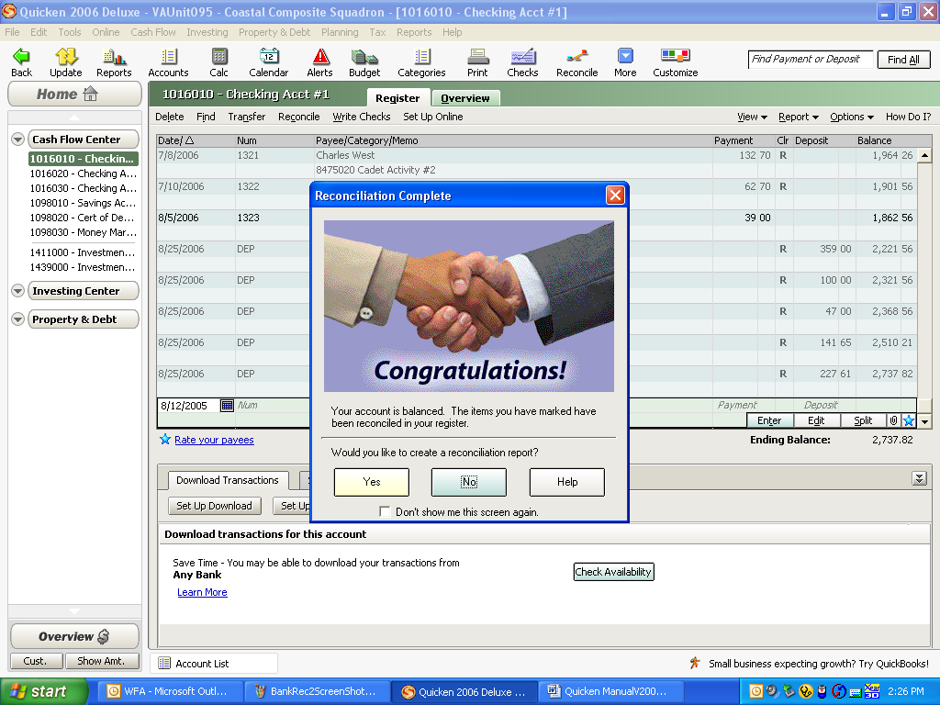

10. The next screen will ask you to name the report. The format for the name should be similar to the example given below. Make sure the date is the same as the ending date on the bank statement. Select “All Transactions.” Select “Print.”

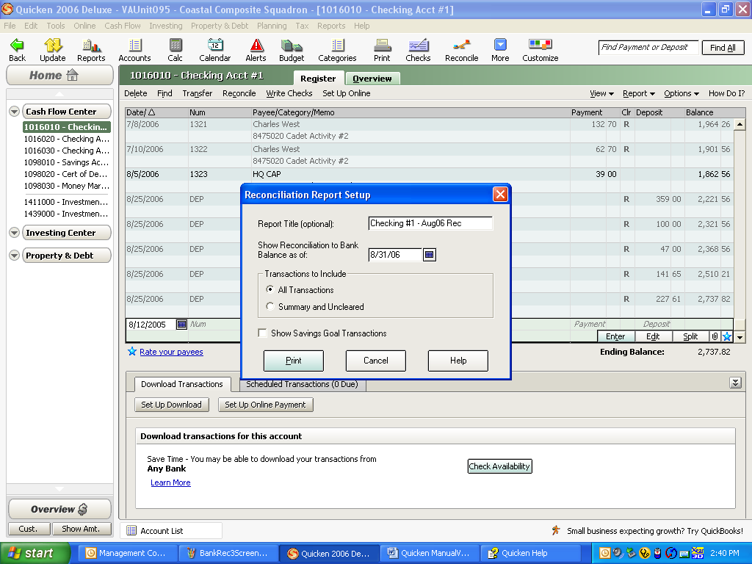

11. The finished report should be attached to the bank statement and filed.

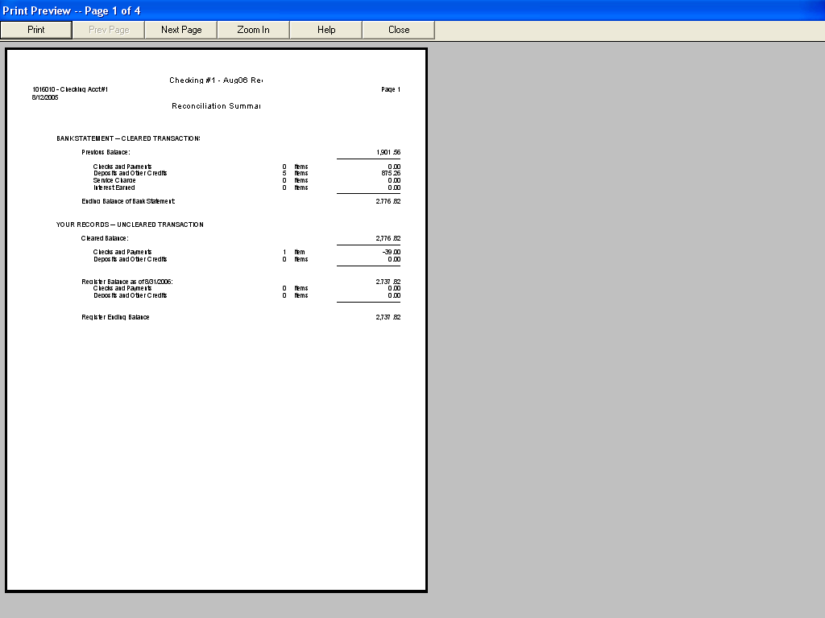

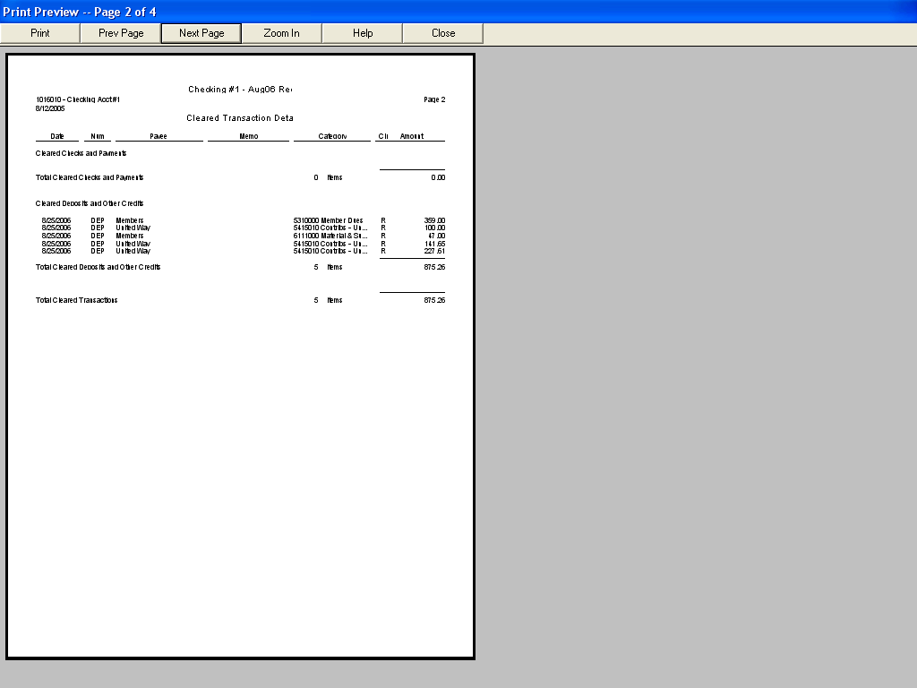

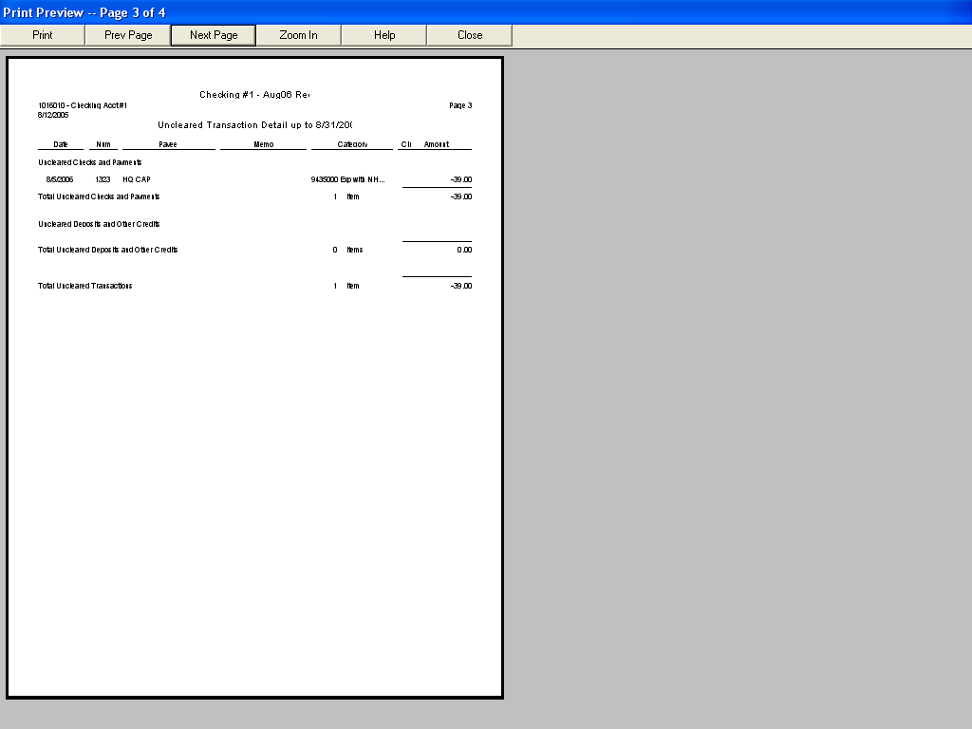

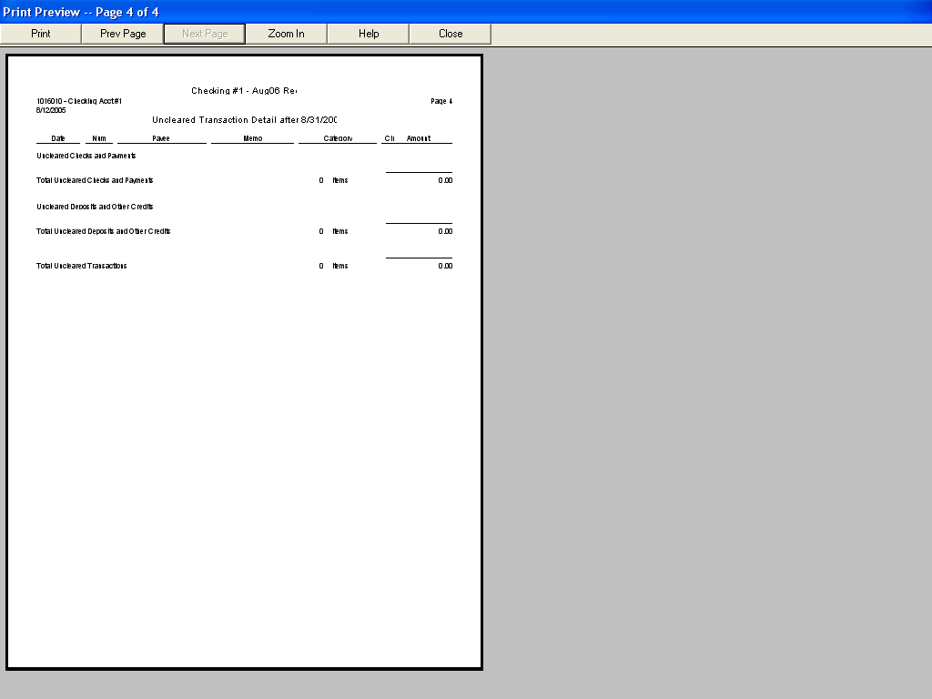

12. If you have outstanding checks that are older than 90 days you need to investigate. If you need to reissue the check because it was lost, void the check, if it was written in the current fiscal year, and reissue a new check. If the check was written in a previous fiscal year (CAP’s fiscal year runs from 1 October through 30 September) you should follow the instructions in Step #14.
If you have deposits that are older than 30 days you should investigate to see why the deposit has not been credited on the unit’s bank account.

13. To void a check, select it in the check register, select “Edit” from the toolbar, select “Transaction”, and then select “Void Transaction.” This will set the amount to zero and will place a “cleared” check mark on the entry. When you do your next bank reconciliation the voided check will already have a green check mark next to it in the reconciliation register. Just enter the replacement check as a new check as explained on page 8.

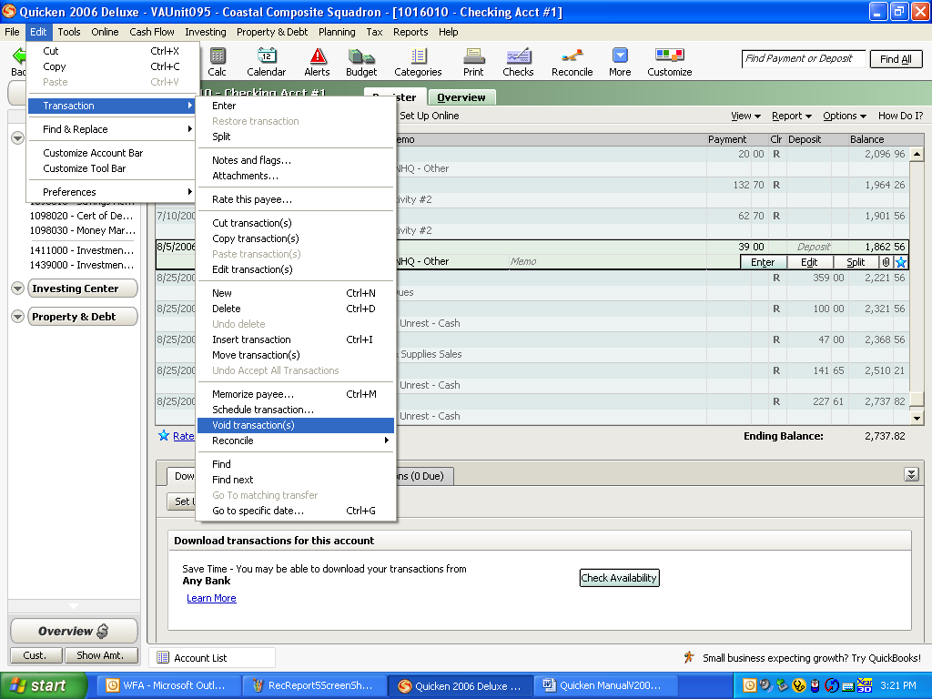

14. If the check that needs to be voided is from a previous fiscal year you cannot just go in and void it. You should note the check number, payee, and amount. Open the check register from which the original check was written. Enter 1 October as the date and the payee’s name. Since this is a correction of a prior year entry this makes it easier to find in a subsequent year. Enter the amount in the deposit column. Select Account 5420000 – Miscellaneous Income as the category. In the memo field enter “Voiding check #____. When you do your next bank reconciliation you will need to check both the old check that you are voiding and the new deposit you just entered. When you are done the voided check and the new deposit cancel each other out.

REPORTS

1. To print the CAP Form 173-2 report, select the “Reports” icon.

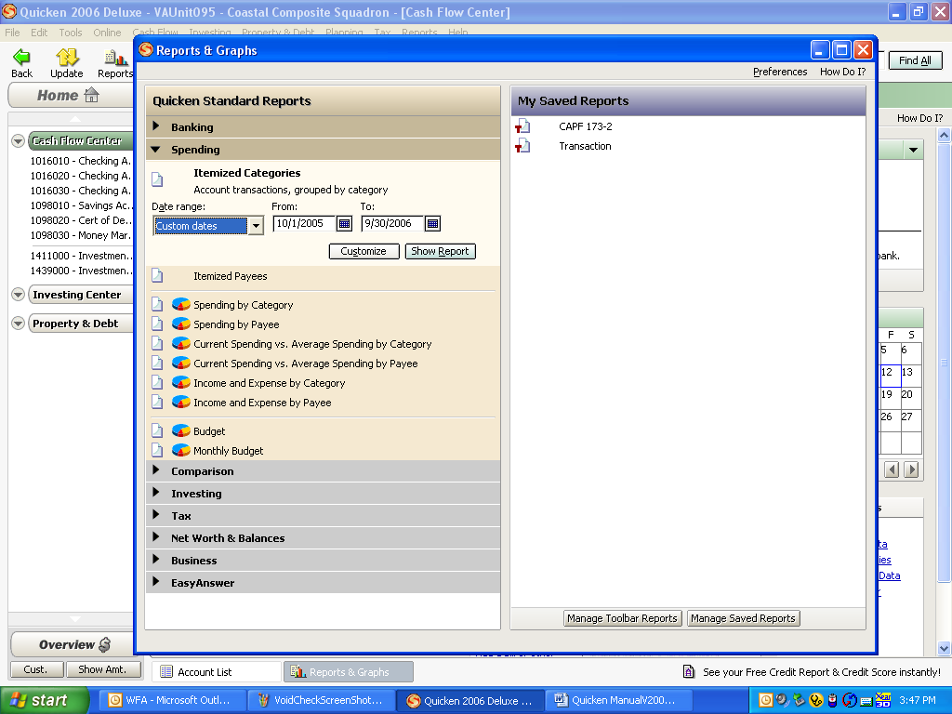

2. On the right-hand side under “My Saved Reports” select “CAPF 173-2.”

3. Select either “Current Year” or “Custom Dates” and enter the current fiscal year dates.

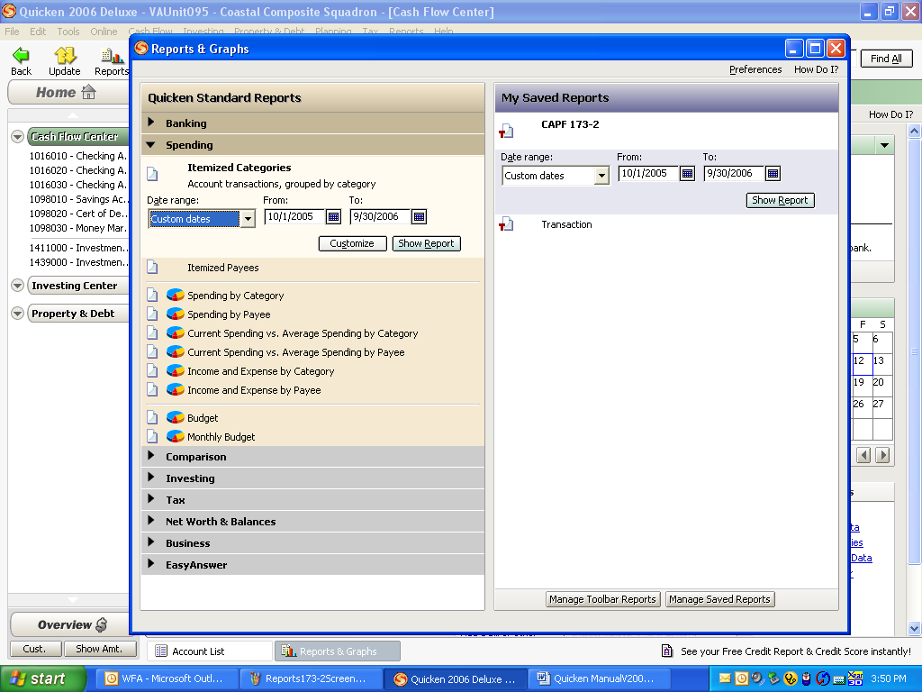

4. Click on “Show Report.” You should check to ensure that all income and expenses have been categorized. Double-clicking on this report on the “uncategorized income or expense” line and re-categorizing is all it needs to fix the problem

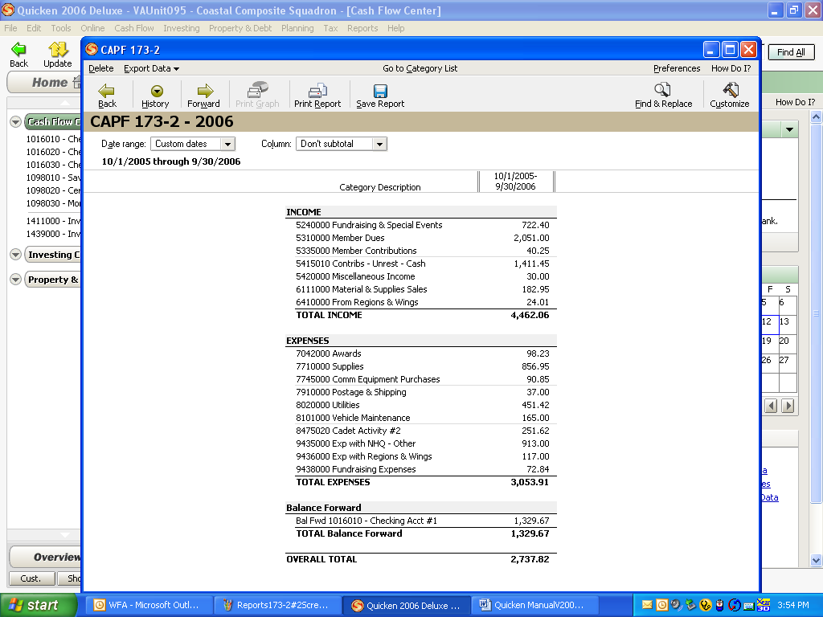

5. Select “Customize” in the upper right-hand corner. When the next screen appears, ensure that the “Display” tab is highlighted. Under “Title” change the name to the following format: Two-letter state identifier – Unit Name – Current Fiscal Year – CAPF 173-2.

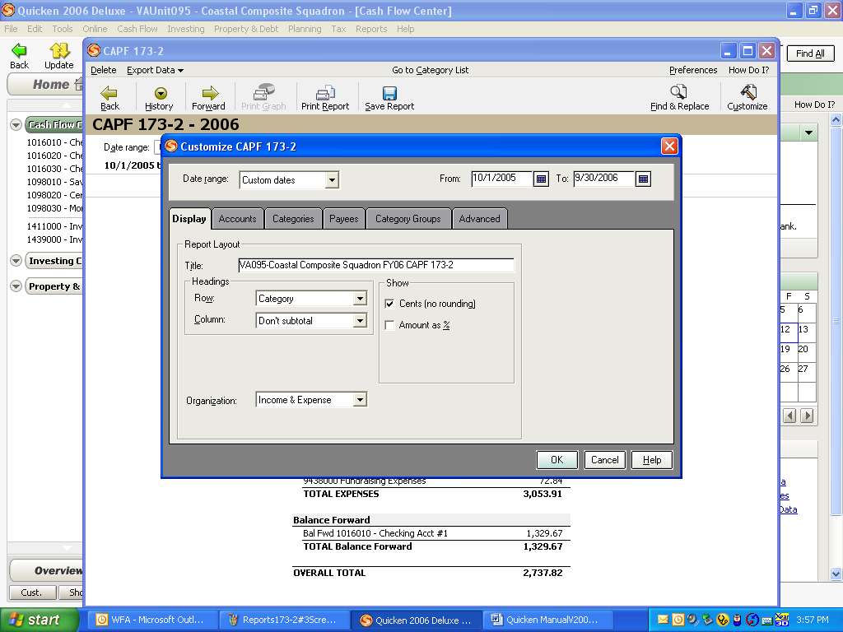

6. Under the “Accounts” tab click on “Mark All.” Repeat for the “Categories,” “Payees” and “Category Groups” tabs.

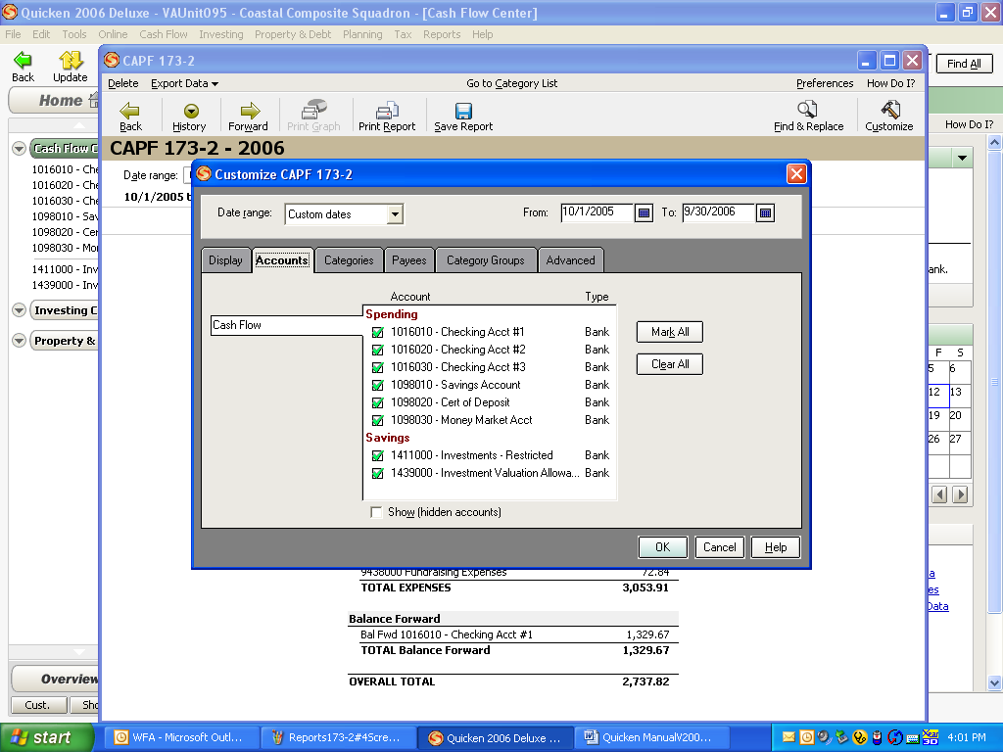

7. On the “Advanced” tab, ensure that “Amounts” is set to all; all items under “Status” are checked; “Transaction Types” is set to “All Transactions;” “Transfers” is set to “Include All;” and “Subcategories” is set to “Show All.”

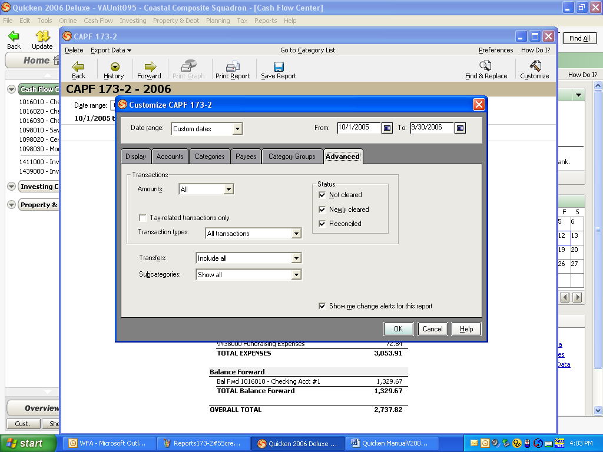

8. Your final report will look like the next example. The “Balance Forward” number should be your beginning balance at October 1. The “Overall Total” should be your ending reconciled bank balance at September 30.

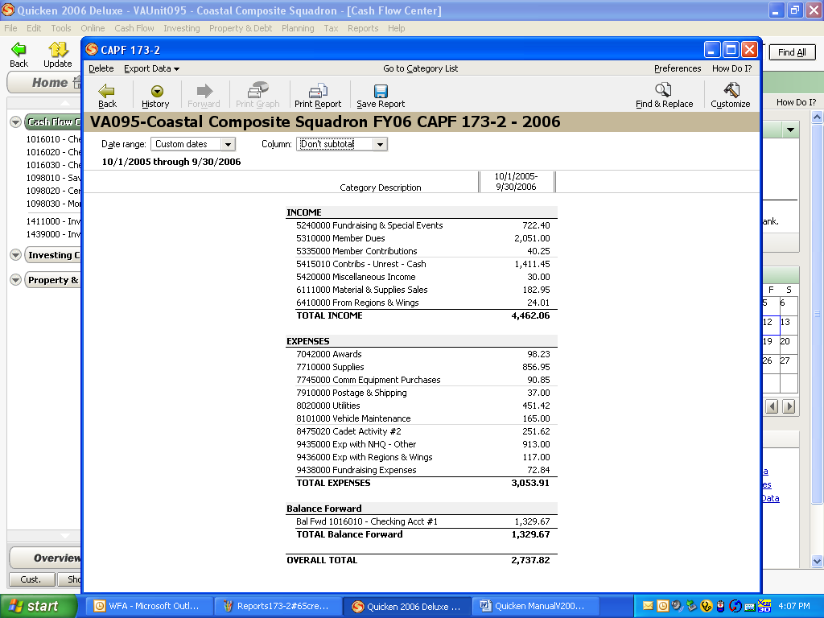

9. If you would like to see all the detail behind the income and expense categories, you can print a Transaction Report. Click on the “Reports” icon. On the right-hand side under “My Saved Reports” select “Transaction.” For the date range, select “Custom Dates” and then enter 10/1/05 to 9/30/06. Click on “Show Report.”

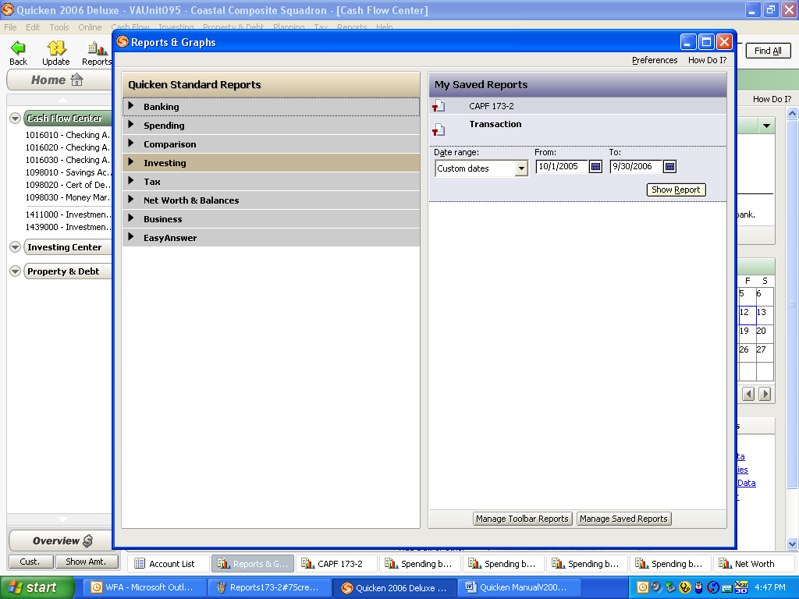

10. The new report will contain the same items as the CAPF 173-2, but all the detail will be shown.

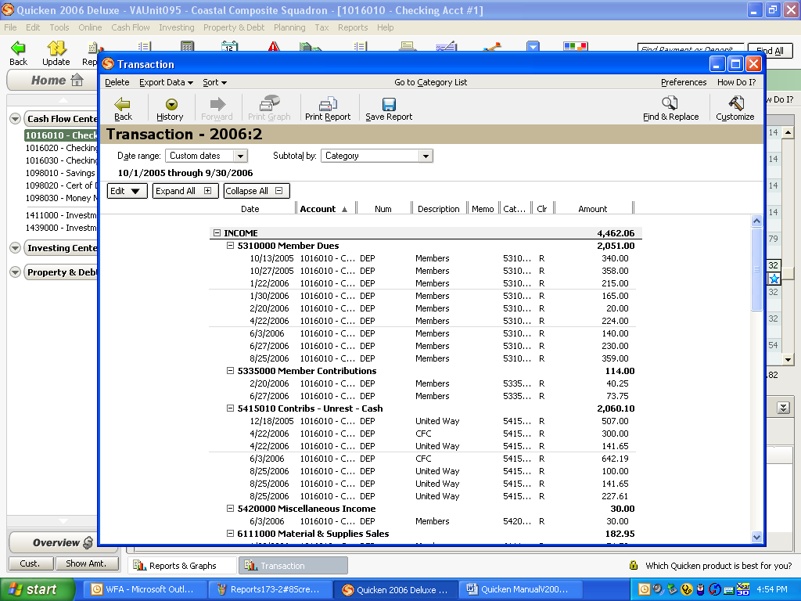

11. All reports may be exported to an Excel spreadsheet. From the report screen select “Export Data.” Click on “Report to Excel Compatible Format.” Save the report to your computer and give it an appropriate name. You will then need to open Excel, find the file (it will have a .txt extension), and open it up. You can also save reports as PDF files.
YEAR-END REQUIREMENTS

1. Your wing director of finance may require additional items, but the minimum required reports should include:

a. a photocopy of bank statements showing the balances at 9/30 for each account

b. a photocopy of the reconciliation report for each account

c. a CAPF 173-2 report The report should be signed and dated by the unit Finance Officer and the Squadron or Group Commander.. Additionally, the
report should note the unit number, a contact phone number, an email address and a mailing address.

- All year-end reports must be submitted to your respective wing headquarters by November 1 each year. If Wings consolidate reporting by groups, then squadrons should have all of their data to the group by 1 November. The Groups should forward these consolidations to the Wing by 15 November.

BACK UPS

1. You should make a back up of your files after each use. You may use whatever medium is easiest, whether it is a thumb drive, CD, DVD, floppy disk, etc. The back up should be stored at some other location than where you actually enter your unit’s data. This practice will ensure that your data is secure in the event of a fire, system malfunction, or natural disaster.

